A STUDY TO ASSESS THE EFFECTIVENESS OF OIL PULLING ON CONSTIPATION AMONG ADOLESCENT STUDENTS
AT SELECTED COLLEGE HOSTEL, COIMBATORE

Abstract

Introduction: This study aimed to assess the effectiveness of oil pulling in relieving constipation among adolescent students in a selected college hostel in Coimbatore. A pre-experimental design with a pre-test and post-test approach was adopted, wherein students performed daily oil pulling using coconut oil for four weeks. Aims: To evaluate the effectiveness of oil pulling in relieving constipation among adolescent students at a selected hostel in Coimbatore. Methods: A pre-experimental one-group pre-test post-test design was used. The study included 60 first- and second-year nursing students from a selected college hostel in Coimbatore, chosen through non-probability purposive sampling. On Day 1 socio demographic data and baseline constipation levels were collected using the Modified Wexner Constipation Scale. Students were instructed to swish 10 ml of coconut oil in the mouth for 10 minutes daily, preferably on an empty stomach, for four weeks. After the intervention period, constipation levels were reassessed using the same scale. Data were analyzed using descriptive and inferential statistics. Results & Conclusion: A paired Student's ‘t’ test was used to compare pre- and post-test constipation levels. The mean constipation score significantly decreased from 1.85in the pre-test to 0.75 in the post-test, indicating a marked improvement in bowel function. The paired ‘t’ value was 8.12 with a p-value of 0.001, demonstrating high statistical significance (p < 0.001). These results indicate that oil pulling is an effective, safe, and non-invasive method for relieving constipation among adolescent students. The findings support the hypotheses that regular coconut oil pulling improves bowel health in this students.

Introduction

Constipation is common and characterized by persistent symptoms lasting more than six months, not attributable to an underlying cause such as medication side effects or a medical condition. It is not linked to abdominal pain, thereby differentiating it from irritable bowel syndrome. In adults, primary causes may include dietary factors such as inadequate fiber or fluid intake and reduced physical activity. In children, contributing factors are consist of low-fiber and low-fluid diets, underlying medical issues, and reluctance to use the bathroom. Among the elderly, insufficient dietary fiber, inadequate fluid consumption decreased physical activity, medication side effects, hypothyroidism, and obstruction due to colorectal cancer. (Wassom MC 2023)
Statement of the problem
A Study to assess the effectiveness of oil pulling on constipation among adolescent students at selected college hostel, Coimbatore.
1.3 Objectives
- To assess the pre and post test level of constipation among adolescent students.
- To evaluate the effect of oil pulling on constipation among adolescents students.
- To find out association between level of constipation with selected demographic variables.
1.4 Operational definition
Assess: It refers to the process of gathering the data and evaluating the effectiveness of specific nursing intervention on oil pulling among adolescent students with constipation which will be measured by using Modified Wexner Constipation Scale.
Effectiveness: In this study, effectiveness refers to the changes in the level of constipation before and after oil pulling among adolescent students.
Oil pulling: Oil pulling involves swishing 10 ml of coconut oil in the mouth for 10 minutes, then spitting it out. In this research, oil pulling is done daily, empty stomach, for a duration of four weeks.
Constipation: Constipation means having less than three bowel movements in a week or having difficulty passing stool for 2–3 days. It is measured in this study by using the Modified Wexner Constipation Scale.
Adolescent students: Adolescent students refer to 18–19-year-old boys and girls studying in I and II yearB.SC (N), who are staying in the selected college hostel in Coimbatore.
College hostel: The college hostel is a student living facility within the selected college in Coimbatore, where students stay during the academic year.
Hypotheses
H₁- There is a significant difference between level of constipation before and after oil pulling among adolescent students
H₂- There is a significant association between the selected demographical variable and post test level of constipation among adolescent students
Assumption
- Coconut oil acts as a mild laxative
- Coconut oil pulling may be an effective method to reduce the constipation
- It regulates the normal pattern of bowel movement
Delimitation
The study is delimited to
- Sample size was 60
- Duration was 4 weeks only
- Hostel students
Projected Outcome :Oil pulling will reduce the severity of constipation among adolescent students.
Conceptual Framework : Modified WidenBach’s helping art of Clinical Nursing Theory (1964)
REVIEW OF LITERATURE
Goyal O, Nohria S, Dhaliwal AS, Goyal P, Soni et al.,( 2023).A cross-sectional descriptive study was conducted among college students aged 17–19 years in Punjab, India, to assess the prevalence of constipation and its associated lifestyle factors. The study included a sample size of 120 students selected from colleges using convenient sampling technique. The statement of the problem focused on understanding how lifestyle habits influence constipation among adolescents. Data were collected using the Rome IV diagnostic criteria and a self-administered lifestyle questionnaire. The study setting was selected colleges in Punjab. Findings showed a prevalence of constipation of 28.3% among participants. Skipping breakfast and low dietary fiber intake were significantly associated with constipation (p<0.05).The authors concluded that lifestyle modification and dietary education could help reduce constipation in adolescents
Ramachandran et al., (2025) conducted a pilot study in Coimbatore. The study assessed the effect of coconut oil pulling on oral malodor and plaque. The sample included college students aged 17–21 years. The research setting was Coimbatore city. Participants were selected by convenience sampling technique. Tools used were plaque index and halitosis scores. After 14 days of oil pulling, there was a significant reduction (p<0.05).The authors concluded coconut oil pulling is an effective, affordable adjunct to oral hygiene
Ramachandran et al.., (2025) conducted a quasi-experimental study among nursing students aged 17–19.The study aimed to assess the effect of coconut oil pulling on functional constipation. A total of 40 participants were included in the sample. The setting was a nursing college hostel in Coimbatore. Participants were selected using purposive sampling technique. The Modified Wexner Constipation Score was used as the research tool. Results showed a significant reduction in constipation scores (p<0.05).The authors concluded that coconut oil pulling may enhance salivary enzyme activity and promote gut motility.
MATERIALS AND METHODS
Research Approach: A quantitative approach was adopted.
Research Design and Settings: A quasi-experimental pre-experimental one-group pre-test post-test design was used selected college hostel, Coimbatore.
Population: The target population for the study comprised of adolescent nursing students who were residing in the PPG College of Nursing Hostel, Coimbatore, who experienced symptoms of constipation. The accessible population included nursing students present in the hostel during the time of data collection period.
Sampling& sample size: Non probability, Purposive sampling was used with 60 students

Criteria for Sample Selection
Inclusion criteria:
The adolescent students who were
- Aged group between 18 and19 years.
- Decreased bowel motility for last three days
- Mild to moderate level of constipation
- Willing to participate in the study
- Available during the period of data collection
- Nursing students of male and female
Exclusion criteria:
The adolescent students who were
- Recurrent and digestive issues
- Jaw pain
- Increased tooth sensitivity
- Allergic to oils
- On homeopathic treatment

Variables: The independent variable in the present study was oil pulling and dependent variable was level of constipation among adolescent students at selected hostel, Coimbatore.
Description of Instrument and Tool: Includes three sections as follows: Section A (Socio-demographic data),Section B (Modified Wexner Constipation Scale)
Content Validity: It was validated by medical guide and nursing experts
Reliability: Modified Wexner Constipation Scale was applied consistently by using Test-Retest Method, r=0.7
Ethical Consideration: Approved by Institutional Ethical Committee of PPG Group of Institution and Written informed consent obtained.
Pilot Study:
It was conducted at PPG College of Occupational therapy with 6 patients. Results showed that there was a significant reduction in severity of constipation, it was feasible to proceed to main study.
Procedure for Data Collection:
- Preparation: Explain study, obtain consent, The investigator instruct oil pulling technique that involves swishing 10 ml of coconut oil in mouth for 10 minutes then spitting it out. Oil pulling is done daily, ideally in the morning for a duration of four weeks. The post-test level of constipation was reassessed by using same Modified Wexner Constipation Scale.
- Evaluation: Post-test of constipation was assessed Modified Wexner Constipation Scale
Techniques of Data Analysis &Interpretation: Descriptive statistics summarized demographic and clinical data, while inferential statistic (paired t-test, independent t-test, and chi-square) assessed differences and associations in constipation among adolescent students

Results and Discussion
Table No.4.1: Frequency and percentage distribution of pre &post test level of constipation among adolescent students.
n=60
Level of Constipation | Pre test |  | Post test
Level of Constipation | (f) | Percentage  (%) | (f) | Percentage (%)
Normal(0-7) | 0 | 0% | 8 | 13.3%
Mild (8-14) | 19 | 31.7% | 38 | 63.3%
Moderate (15-20) | 41 | 68.3% | 14 | 23.4%
Severe (22-28) | 0 | 0% | 0 | 0%

In this table shows that frequency and percentage distribution of constipation levels before and after the intervention reveal a significant improvement in participants' bowel health. During the pre test, none of the student normal range of bowel function, while a substantial proportion experienced varying degree of constipation 19 (31.7%) had mild, 41 (68.3%) had moderate constipation, no students had severe constipationIn post test , following the intervention, there was a marked shift in these levels. In post–test the 8 number of students with normal bowel function dramatically to 8(13.3%),indicating a positive response to the intervention. Those with mild constipation decreased to 38 (63.3%), while moderate cases slightly marked decreased after intervention to 14 (23.4%) ,no students had severe constipation either the pre-test or post-test Overall, the post-test results suggest a clear improvement in the students' constipation status, with a substantial reduction in severity and an increase bowel function.

Table 4.2: Mean and standard deviation of pre & post test among adolescent students.
Experimental Group | Mean | Standard deviation | Paired ‘t’ test & p-Value | P=0.001  df= 59  ( S)
Pretest | 1.85 | 0.82 | t –Value=8.12  p=0.001 | P=0.001  df= 59  ( S)
Posttest | 0.75 | 0.68 | t –Value=8.12  p=0.001 | P=0.001  df= 59  ( S)
* Significant at p<0.0001

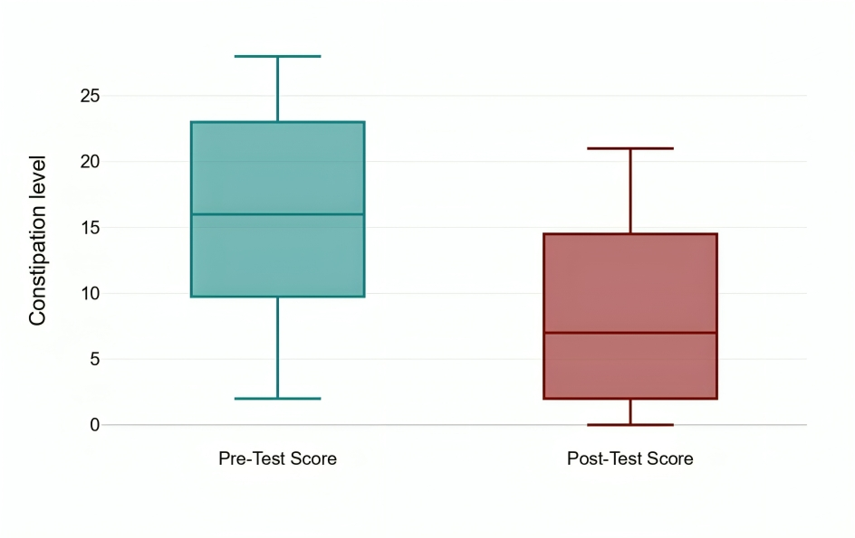

MAJOR FINDINGS
- The study involved 60 students aged 18–19 years, with a nearly equal gender distribution (53.3% females, 46.7% males). Most were first-year students from Hindu, Christian, and Muslim backgrounds.
- Students came from varied income groups, with 36.7% from high-income families, 33.3% from middle-income, and 30% from low-income households. The majority had lived in hostels for more than six months.
- Dietary patterns showed that 40% were vegetarians, 31.7% followed a mixed diet, and 28.3% were non-vegetarians. However, 40% consumed junk food daily, and only 26.7% had a regular intake of fresh fruits.
- Prior to the intervention, 31.7% experience mild,68.3% moderate and no students had severe constipation
- After the oil pulling intervention, 8 students (13.3%) achieved normal bowel function ,indicating marked improvement in bowel regularity. 38(63.3% ) had mild constipation, and 14 (23.3%) had moderate constipation to remained moderately constipated. This indicate that oil pulling was effective in improving bowel health and reducing the severity of constipation among adolescent students
- The mean constipation score significantly decreased from 1.85 to 0.75
(p = 0.001), indicating the effectiveness of the oil pulling intervention in improving bowel health.
- Gender, fiber rich diet, water intake per day, physical activity, previous history of constipation, practice of oil pulling of this study showed a statistically significant association with post-intervention. while no significant associations were found with age, year of study, religion, family income, father occupation ,duration of hostel stay, type of diet, eating junk food, fresh fruit, previous use of laxative, other remedies
- In conclusion, oil pulling proved effective in enhancing bowel function among adolescents, particularly in alleviating constipation.
Recommendations for Further Study: Future research should extend the intervention duration, include follow-up assessments, and involve diverse populations to enhance generalizability. Comparative studies with other non-pharmacological methods, like fiber or probiotics, are also recommended.
Nursing Implications :The present study has implication for nursing practice, nursing education, nursing administration and nursing research.
Nursing Education: Oil pulling effectively reduces constipation among adolescents and should be included in nursing curricula. Nurse educators must promote awareness of its benefits as a simple, non-invasive, and cost-effective intervention. It can be easily integrated across various healthcare settings.
Nursing Administration : Administrators should encourage the incorporation of oil pulling into routine gastroenterology care. This practice supports improved physiological outcomes and enhances holistic patient management.
Nursing Practice: Oil pulling should be adopted as a regular nursing intervention to prevent constipation complications. Nurses need proper knowledge, skills, and critical thinking to implement it effectively in care routines.
Nursing Research: Oil pulling is an evidence-based approach for managing constipation in adolescents. Further long-term and multi-setting studies are recommended to validate and expand its clinical effectiveness.
Limitations: The study’s small sample size (60 students) from a single institution limits generalizability and external validity. Self-reported data may have introduced bias, and the short intervention period was insufficient for long-term assessment. Uncontrolled confounding factors may also have influenced the outcomes.
Conclusion: Oil pulling significantly improved bowel function and reduced constipation among adolescent hostel students. The intervention showed statistical significance, with gender influencing outcomes, confirming oil pulling as an effective, evidence-based approach to enhance adolescent bowel health.
Acknowledgment: The authors thank the principal ,students, staff, and research mentors for their support
Conflict of Interest: The authors declare no conflicts of interest.

References
1.Wassom MC. Primary constipation in different age groups: causes and clinical perspectives. 2023
2.Goyal O, Nohria S, Dhaliwal AS, Goyal P, SoniRK, Chhina RS, et al. Prevalence, overlap, and risk factors for Rome IV functional gastrointestinal disorders among college students in northern India. Indian
3.Ramachandran K, Subramanian R, Kumar V. Effect of coconut oil pulling on oral malodor and plaque among college students aged 17–21 years in Coimbatore: a pilot study. Pilot Oral Health Res J. 2025;
4.Ramachandran K, Ramesh S, Lakshmi P. Effect of coconut oil pulling on functional constipation among nursing students aged 17–19 years: a quasi-experimental study. Nurs Health Res J. 2025;
5.Huang L, Guo M, Huang J, Wu H. Prevalence and risk factors of functional constipation among Chinese college students. J Int Med Res. 2019;47(8):3915–23.
6.Misra S, et al. Low socioeconomic class is a risk factor for upper and lower gastrointestinal symptoms: a population-based study. Scand J Gastroenterol. 2016;41(6):657–66.
7.Fleischer J, Hussain S, Rahman A. Association between dormitory living and functional gastrointestinal disorders in university students. Bangladesh Med J. 2018;47(4):205–12.
8.Ng K, Fong D, Pang J, Ching JY, Wong CK, Chan FK. Prevalence and risk factors of functional constipation in young adults: a study among Hong Kong university students. J Gastroenterol Hepatol. 2012;27(8):1392–6.
9.Slavin JL. Position of the Academy of Nutrition and Dietetics: health implications of dietary fiber. J AcadNutr Diet. 2013;113(7):983–94.
10.Ahmed R, Joseph T, Meera S. Assessment of hydration, physical activity, and oil pulling practices among college students: Implications for digestive health. J Public Health Lifestyle Med. 2023;18(2):95–102.

