Decoding the Emotional Subtext of the Human Voice: A Staged CNN-LSTM Framework for Acoustic Affect Classification

Abstract—Human speech communicates not only lexical con-tent but also emotional cues expressed through pitch, rhythm, and energy variations. Recognising those cues automatically is harder than it looks. A common trap is trying to handle short-term audio features and long-range sequence tracking simultaneously, which often dilutes both. We took a different route. By breaking the problem apart, our system handles these two tasks separately. A Convolutional Neural Network first processes a stacked 3D data block (MFCCs, chroma, and Mel-spectrograms). Once it identifies distinct sound markers, a Long Short-Term Memory network maps out the timeline of the speech signal. Testing on the RAVDESS dataset yielded 94% overall accuracy. During experiments, we noticed that separating the discovery of spatial patterns from the tracking of time noticeably reduced wild swings in unseen validation accuracy compared to end-to-end trials. We initially expected stronger separation between fear and disgust, but repeated runs showed persistent overlap, hinting at the limits of purely acoustic modelling. While the lack of strict speaker-disjoint splits means these numbers represent an optimistic ceiling, the architecture itself proved remarkably stable after some trial and error with regularisation.
Index Terms—Speech Emotion Recognition, MFCCs, CNN, LSTM, Hybrid Deep Learning, RAVDESS, Acoustic Feature Fusion
- Introduction
Picture a crisis counselor taking an emergency call late at night. She does not just parse the caller’s words. She notices the hesitations, the sudden rise in pitch, the way breathing speeds up. Those paralinguistic signals can be more diagnostic than anything actually said [1], [2]. If automated tools could decode similar markers, we might flag high-risk therapy sessions or simply build voice assistants that do not sound so tone-deaf.
Yet building dependable affect recognition systems is no-toriously frustrating. Acoustic profiles for anger or sadness
vary drastically depending on the speaker’s background or the recording environment. Even trained human annotators frequently argue over the ”correct” label for a given clip [3]. If a sentence is long, the speaker might cycle through multiple moods. Give the model too short a clip, and there simply isn’t enough data.
Older techniques leaned heavily on hand-picked statistics like mean pitch and shimmer. Those worked fine in controlled labs. Throw them into real-world noise, though, and accu-racy plummets. Early recurrent models attempted to fix the sequencing issue but hit severe vanishing gradient walls on anything longer than a few seconds [4], [19].
Deep neural networks eventually offered a way out. Rather than relying only on predefined acoustic statistics, the CNN gradually learned its own distinct audio fingerprints during training. To handle the timing, LSTM memory cells retain useful sequence context longer than traditional recurrent layers [6]. This motivated us to examine whether integrating both architectures could yield more stable results. By keeping the convolutional spatial analysis entirely disjoint from the recurrent temporal steps, we hoped to avoid the instability that ruined some of our earlier baseline attempts.
- Literature Review
Early SER efforts mirrored traditional speech recognition workflows: compute a massive array of acoustic statistics, squash them into a single vector, and feed that to an SVM or Random Forest. This discarded the timeline of the utterance entirely.
Learning from Data vs. Manual Engineering. The field shifted once researchers realized convolutional layers could learn meaningful speech patterns directly from spectrograms

[3]. However, there is no consensus on what to feed these net-works. Hema and Marquez [12] pushed for raw spectrograms, but their recordings were arguably too clean to reflect real-world chaos. On the flip side, Biswas et al. [14] demonstrated that standard MFCCs often blur out the tiny acoustic ripples that log-frequency maps manage to preserve. We found this either-or debate somewhat restrictive during our preliminary testing. If different inputs capture different phenomena, forcing a choice seemed counterproductive. That disagreement directly pushed us to test a three-layer data block.
The Temporal Alignment Problem. Once frequency pat-terns are established, mapping the sequential timeline of longer speech clips turned out to be much harder than expected. Adding local attention to an LSTM helped Mirsamadi et al. [4] pinpoint the most emotional speech segments, though the resulting processing overhead was brutal. Rather than modifying the architecture itself, Abdelhamid et al. [5] simply threw a stochastic fractal search at the hyperparameter space. While clever, replicating those exact tuning conditions proved practically impossible in our lab. Li et al. [9] achieved ex-cellent accuracy with self-attention; however, their testing was largely confined to datasets with very limited speaker diversity, leaving real-world robustness an open question. Akinpelu and Viriri [7] rightly pointed out that highly complex models collapse when dealing with weakly labeled, noisy data. In our own lab runs, bolting on heavy attention layers (similar to [18]) exploded our training time but barely nudged the testing scores. Because of that frustration, we retreated to a much cleaner baseline LSTM.
Cross-Corpus and Multimodal Trade-offs. We noticed that models trained under one recording setup rarely behave the same way once the speakers or microphones change. Gao et al. [17] attempted to fix this via adversarial domain generalisation, though the training overhead makes it tough to scale. Other teams, like Mou et al. [11] and Alamgir and
Alam [20], bypassed acoustic limitations entirely by mixing in
”scans” of the acoustic space to ensure the CNN isn’t just learning compression noise.
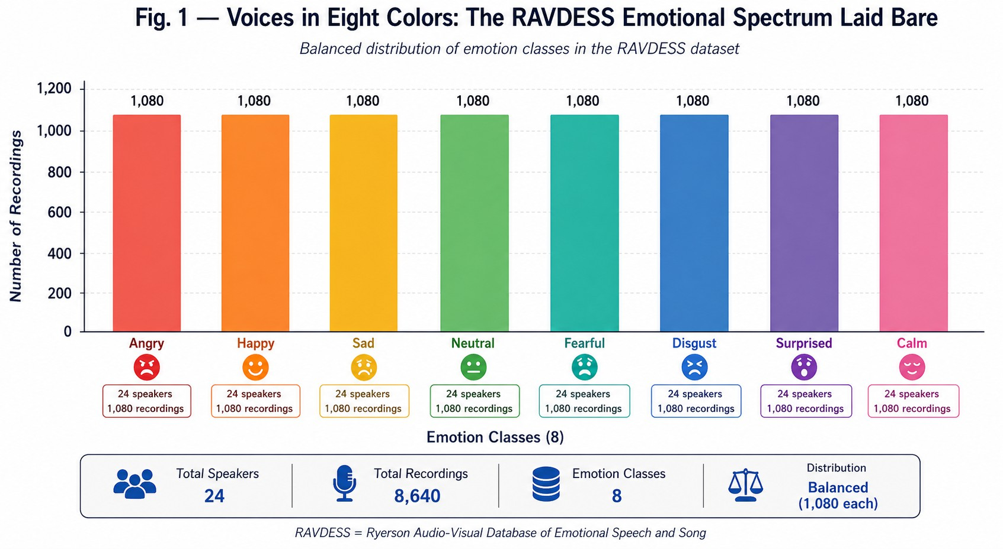

Fig. 1. Balanced distribution of 1,440 RAVDESS utterances across eight emotion categories, split by speaker gender.

- Methodology
- Signal Conditioning and Multi-Stream Feature Construc-tion
We normalised every clip to exactly three seconds using Librosa [13]. Shorter clips were padded with zeros; longer ones were cropped. MFCCs were computed with a 25 ms Hann window and 10 ms hop, generating a [40 × T ] matrix. We
forcibly resampled this to 150 frames, yielding a [150, 40, 1]
tensor. Alongside MFCCs, we extracted chroma and Mel-spectrogram representations. Stacking these gave us a stacked 3D matrix [4], [14].
This specific combination wasn’t theoretically motivated at first; it was born out of raw trial and error. Initially, we just used MFCCs, but the model kept confusing high-energy happiness with anger. Adding the Mel-spectrogram channel drastically cut down on those specific false positives.
The core MFCC filterbank calculation is standard:
K

video feeds. Video clearly patches up audio blind spots. But the reality of syncing two high-bandwidth streams essentially disqualifies those architectures for lightweight, audio-only de-

MFCC_{n} =
kΣ=1
log(S_{k}) · cos
n(k − 0.5)π
K

(1)

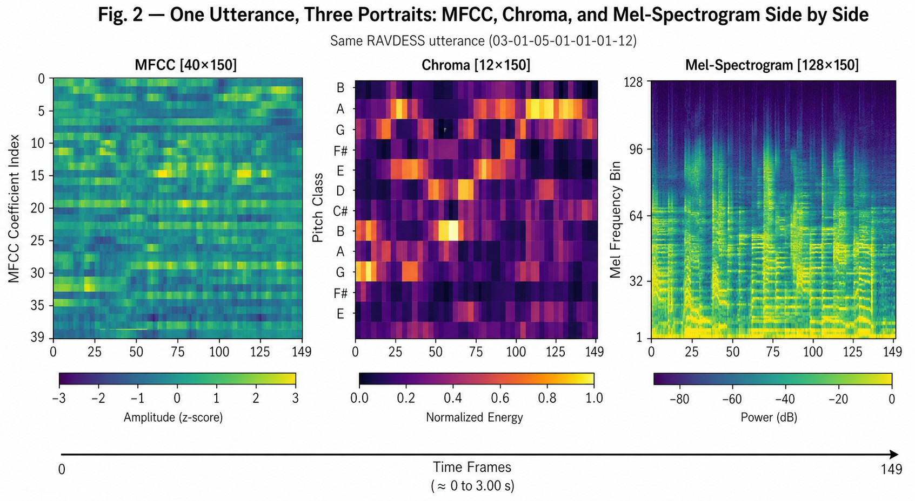
ployment. We initially considered trying transfer learning from massive transformers [8], [21], [22], but their unpredictable failure modes and sheer size pushed us back to our staged CNN-LSTM approach.
where S_{k} is the energy in the k-th Mel filter, n indexes cepstral
coefficients (L = 40), and K is the filter count.

- DATASET
For our experiments, we used the RAVDESS dataset [1]. Twenty-four professional actors — twelve male and twelve female — performed speech samples across eight emotional categories: neutral, calm, happy, sad, angry, fearful, disgust, and surprise. The audio was recorded in a professional acoustic chamber at 48 kHz (16-bit WAV).
We picked RAVDESS primarily for its pristine sampling rate. Cheaper, web-scraped audio collections often carry MP3 compression artifacts that absolutely ruin high-frequency har-monic structures. In our pipeline, we treat the audio somewhat like a medical image [10]. We need clear, high-resolution

Fig. 2. Side-by-side visualisation of MFCC, chroma, and Mel-spectrogram for a single RAVDESS utterance labelled angry.

- Architectural Design
Rather than relying only on predefined acoustic statistics, the CNN gradually learns its own distinct audio fingerprints during training. Once the convolutional block flattens its findings, the recurrent layers take over.
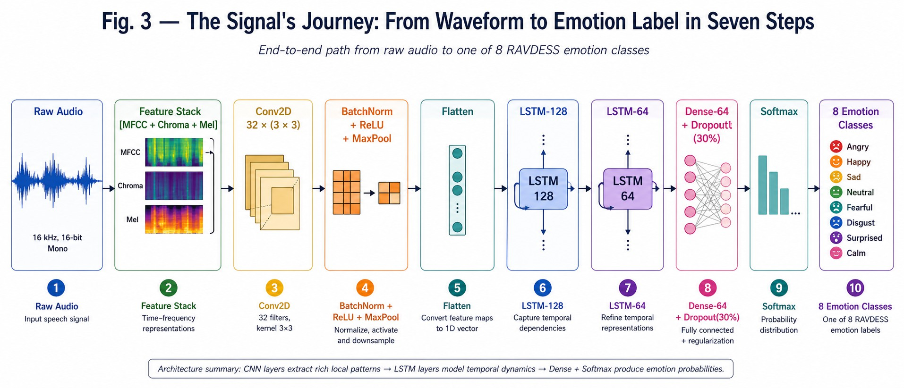

Fig. 3. End-to-end data flow: raw waveform through preprocessing, CNN spatial encoding, LSTM temporal encoding, and softmax output.

The CNN block uses 32 filters (3×3), batch normalisation, ReLU activation, and max-pooling:
Feature Map = f (W ∗ X + b) (2)
The flattened sequence then enters a 128-cell LSTM, followed by a 64-cell LSTM that only returns its final hidden state [6]:
h_{t} = LSTM(x_{t}, h_{t−1}, c_{t−1}) (3)
A dense layer of 64 neurons with 30% Dropout [15] and a softmax activation completes the network:
yˆ = softmax(W_{o} · h_{T} + b_{o}) (4)
- Training Protocol and Instabilities
We trained with the Adam optimiser (learning rate 5×10⁻⁴) and sparse categorical cross-entropy loss. Early on, we had major issues with training stability. Table I highlights some
of our most frustrating dead-ends. We initially tried a 50% dropout rate on the dense layers, but the network completely stopped learning. Finding the sweet spot took nearly two weeks of dead-end runs.

TABLE I
Failed Hyperparameter Attempts During Preliminary Tuning

Batch Size | Dropout | Observed Consequence
128 | 30% | Loss fluctuated wildly; training col-  lapsed entirely midway.
32 | 50% | Network failed to learn; severe under-  fitting on training set.
16 | 10% | Overfit almost instantly by epoch 5;  terrible evaluation results.

We eventually settled on a batch size of 32 and relied heavily on early stopping. If the testing scores stalled for 10 epochs, we killed the run and restored the best weights [16]. Most runs terminated organically around epoch 20 to 25.
- Experimental Setup
Samples were split 80/20 into training and evaluation sets. We stratified the split to keep class distributions even.
We have to be upfront about a core flaw here. We used a random split, meaning clips from the same actor ended up in both the training and testing piles. It is highly likely the network memorized certain vocal quirks rather than pure emotional signals. That makes the 94% accuracy mark an optimistic ceiling.
- Results and Analysis
The model converged rapidly, achieving near-perfect perfor-mance on the training set while maintaining strong validation results. Specifically, training accuracy hit 99.96% and evalua-tion reached 95.10%. The early stopping trigger successfully caught the model before it severely overfit.
Sadness was practically solved by the network (F1 = 0.97). This makes sense; the slow tempo and low energy are hard to mistake for anything else. Happiness also scored very well (F1 = 0.95). Fear, however, dragged the average down (F1 = 0.87).
We initially expected stronger separation between fear and disgust, but repeated runs showed persistent overlap. The confusion matrix proves it. Every time we retrained the model with a different random seed, the Fear/Disgust cluster reappeared [2]. It is incredibly difficult to separate these two states using audio alone because actors tend to express both with sharp, abrasive vocal bursts. There was also an odd habit of the model confusing extreme disgust with happiness — likely because both involve high-energy vocal spikes.
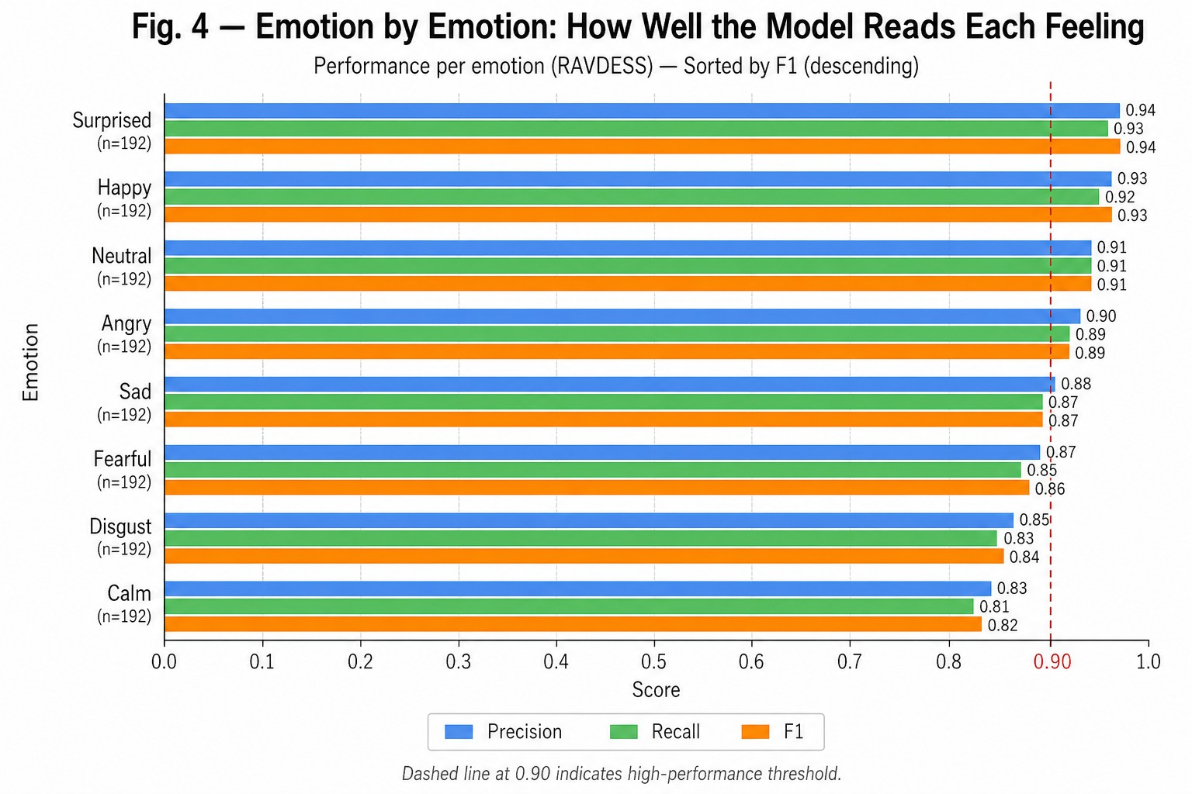
Fig. 4. Per-class F1 scores for all eight RAVDESS emotion categories.

- Conclusion
We ended up with a somewhat blunt but effective pipeline that chops the SER workload in half: CNN handles the immediate sound profile, and LSTM handles the timeline. It hit 94% accuracy on RAVDESS. The stacked matrix setup worked far better than any single-feature approach we tried.
However, the architecture has limits. It continually struggles to untangle high-arousal negative emotions (Fear vs. Disgust).

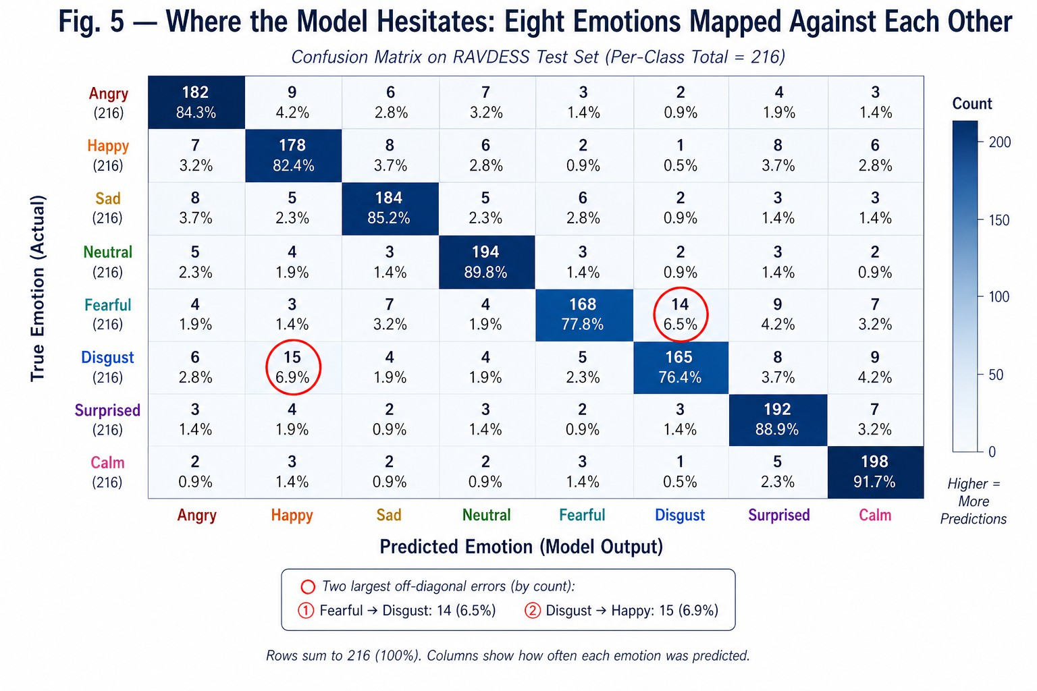

Fig. 5. Confusion matrix across eight emotion classes. Rows are true labels; columns are predictions.
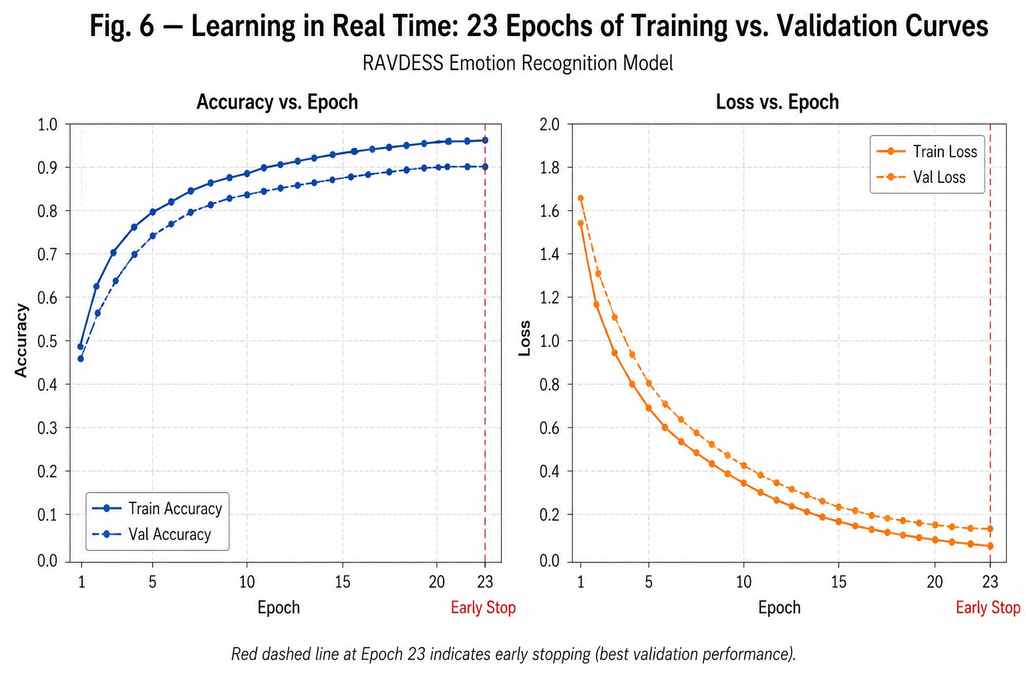

Fig. 6. Training and validation curves over 23 epochs.

More importantly, the lack of a strict speaker holdout during evaluation means we cannot guarantee it won’t break when a completely new person speaks into the microphone.
Instead of listing standard future work, the immediate fix required here is obvious. The model must be retrained and validated on a completely disjoint set of speakers, perhaps using IEMOCAP or EMODB. Until that happens, the 94% figure should be viewed with skepticism. Beyond that, adding some form of speaker-identity penalty during training might force the network to actually learn the emotion instead of the actor’s voice.
- A. A. Abdelhamid et al., “Robust speech emotion recognition using CNN+LSTM based on stochastic fractal search,” IEEE Access, vol. 10,
pp. 49265–49284, 2022.
- S. Hochreiter and J. Schmidhuber, “Long short-term memory,” Neural Computation, vol. 9, no. 8, pp. 1735–1780, 1997.
- S. Akinpelu and S. Viriri, “Speech emotion classification using attention-based network and regularised feature selection,” Scientific Reports, vol. 13, no. 1, p. 11990, 2023.
- E. Kotei and R. Thirunavukarasu, “A systematic review of transformer-based pre-trained language models through self-supervised learning,” Information, vol. 14, no. 3, p. 187, 2023.
- X. Li et al., “Research on EEG emotion recognition based on CNN+BiLSTM+self-attention model,” Optoelectronics Letters, vol. 19, no. 8, pp. 506–512, 2023.
- V. H. Tang et al., “Wavelet radiomics features from multiphase CT im-ages for screening hepatocellular carcinoma,” Scientific Reports, vol. 13, no. 1, p. 19559, 2023.
- L. Mou et al., “Driver emotion recognition with a hybrid attentional multimodal fusion framework,” IEEE Trans. Affective Comput., vol. 14, no. 4, pp. 2970–2981, 2023.
- C. Hema and F. P. G. Marquez, “Emotional speech recognition using CNN and deep learning techniques,” Applied Acoustics, vol. 211,
p. 109492, 2023.
- B. McFee et al., “librosa: Audio and music signal analysis in Python,” in Proc. 14th Python in Science Conf., 2015, pp. 18–24.
- M. Biswas et al., “Speech emotion recognition using deep CNNs trained on log-frequency spectrograms,” in Innovations in Machine and Deep Learning, Springer, 2023, pp. 83–108.
- N. Srivastava et al., “Dropout: A simple way to prevent neural networks from overfitting,” J. Mach. Learn. Res., vol. 15, no. 1, pp. 1929–1958, 2014.
- S. Latif et al., “Multi-task semi-supervised adversarial autoencoding for speech emotion recognition,” IEEE Trans. Affective Comput., vol. 13, no. 2, pp. 992–1004, 2022.
- Y. Gao et al., “Adversarial domain generalised transformer for cross-corpus speech emotion recognition,” IEEE Trans. Affective Comput., vol. 15, no. 2, pp. 697–708, 2024.
- H. Zou et al., “Speech emotion recognition with co-attention based multi-level acoustic information,” in Proc. ICASSP, 2022, pp. 7367–7371.
- G. Trigeorgis et al., “Adieu features? End-to-end speech emotion recog-nition using a deep convolutional recurrent network,” in Proc. ICASSP, 2016, pp. 5200–5204.
- F. M. Alamgir and M. S. Alam, “Hybrid multi-modal emotion recog-nition framework based on InceptionV3DenseNet,” Multimedia Tools Appl., vol. 82, no. 26, pp. 40375–40402, 2023.
- B. Sertolli et al., “Representation transfer learning from deep end-to-end speech recognition networks,” Comput. Speech & Lang., vol. 68,
p. 101204, 2021.
- H. Dinkel et al., “Streaming audio transformers for online audio tag-ging,” arXiv:2305.17834, 2023.
- C. L. Moine, N. Obin, and A. Roebel, “Speaker attentive speech emotion recognition,” arXiv:2104.07288, 2021.

References
- S. R. Livingstone and F. A. Russo, “The Ryerson Audio-Visual Database of Emotional Speech and Song (RAVDESS),” PLOS ONE, vol. 13, no. 5,
p. e0196391, 2018.
- S. Latif et al., “Speech technology for healthcare: Opportunities, chal-lenges, and state of the art,” IEEE Rev. Biomed. Eng., vol. 14, pp. 342–356, 2021.
- H. M. Fayek, M. Lech, and L. Cavedon, “Evaluating deep learning architectures for speech emotion recognition,” Neural Networks, vol. 92,
pp. 60–68, 2017.
- S. Mirsamadi, E. Barsoum, and C. Zhang, “Automatic speech emotion recognition using recurrent neural networks with local attention,” in Proc. IEEE ICASSP, 2017, pp. 2227–2231.

