Advanced Assessment of Environmental Factors Affecting Calibration Traceability and Measurement Reliability

ABSTRACT
In contemporary metrology laboratories, the accuracy, traceability and reliability of calibration measurements is largely dependent on the environmental conditions. Ambient temperature, relative humidity, ambient pressure, vibration and ambient flow can have a significant effect on the uncertainty of the measured value and on the long-term stability of calibrated instruments. In this study, cutting-edge experimental and analytical evaluation of environmental factors influencing the calibration traceability and measurement reliability in precision metrology applications is presented. The experiments were carried out in a laboratory setting under controlled conditions with high accuracy balances and volumetric glassware, and with digital measurement systems, under different environmental conditions. The temperature used was in the range 18-32°C and the relative humidity used was in the range 35-75% and the range of atmospheric pressure change was monitored continuously during the calibration procedure. The relation between the environmental fluctuations and the deviation from calibration was quantified using statistical analysis and uncertainty modeling techniques. The results show that the contribution of temperature variation was the highest of the influences and was the largest contribution to the calibration uncertainty on volumetric measurements, accounting for about 42% of the total contribution of the influences, whereas the influence of humidity was more significant in the cases of electronic instrumentation and mass. Experimental results also show that calibration drift, repeatability error and deviation from the traceability increases with environmental instability. The correlation between temperature fluctuation and volumetric calibration error was a strong linear correlation (R² = 0.93) while that between humidity variation and

electronic measurement error was a nonlinear relationship. The overall calibration uncertainty was reduced by about 18.7% by the proposed environmental compensation and monitoring approach. The findings of this research show the importance of environmental monitoring and compensation measures to guarantee reliable traceability of calibration, in line with the requirements of ISO/IEC 17025. The findings of this research contribute to the metrology laboratories, industrial calibration laboratories, and quality assurance systems that are looking for more reliable and better measurements, with reduced uncertainties.
Keywords: Environmental factors, Calibration traceability, Measurement reliability, Metrology, Uncertainty analysis, Temperature effect, Humidity effect, Precision calibration.
INTRODUCTION
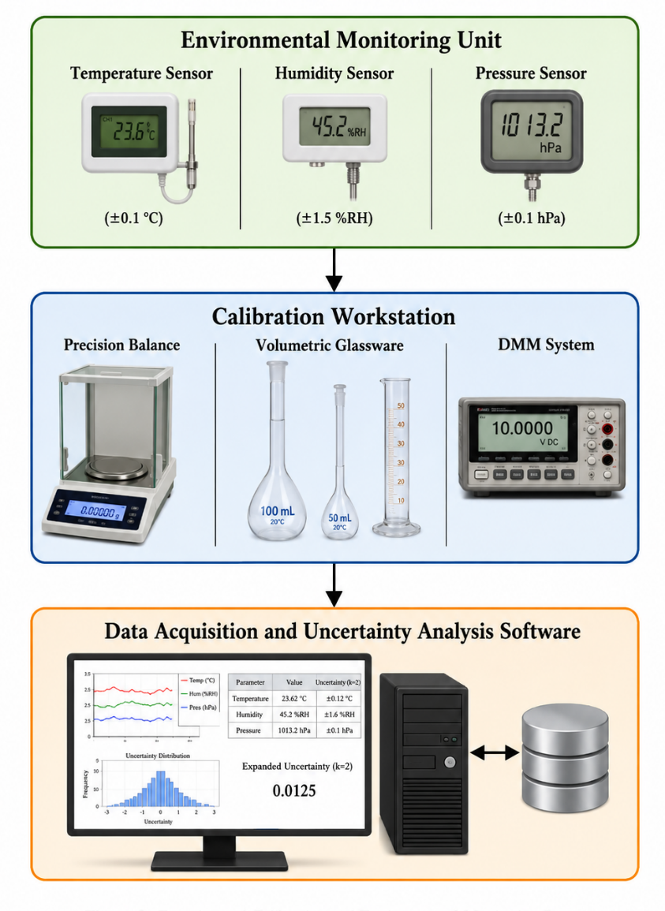
In the current scientific and engineering applications, precision calibration is crucial for achieving traceability of measurements, product quality and reliability of industry processes [1–3]. A calibration laboratory that is ISO/IEC 17025 accredited needs to establish a controlled environment to reduce uncertainty and to ensure that the traceability chain is not lost [4,5]. The performance of measurement instruments and reference standards is directly affected by the environmental factors like temperature, humidity, atmospheric pressure, vibration and airflow [6-8]. In high-accuracy metrology, such as mass, dimensional, electrical and volumetric calibration systems [9,10], the influence of the environment becomes increasingly relevant. Measurement variability is significantly influenced by temperature-induced changes in measuring instruments, the effects of evaporation during volumetric calibration and humidity-related electronic drift [11–13]. Some previous work has demonstrated that a slight temperature change can result in a large change in the calibration results [14–16]. With the development of the precision instrumentation and uncertainty analysis, the environmental compensation models and the statistical correction techniques have been paid attention to recently [17–19]. Although the environmental monitoring system has been improved, there are still some laboratories that have encountered instability in their measurements caused by uncontrolled environmental changes [20,21]. Thus, further research is still needed to better understand environmental factors to enhance calibration traceability and reliability. The purpose of this study is to experimentally evaluate the effects of the environmental conditions on the traceability of the calibration and the reliability of measurement by the application of statistical uncertainty analysis and environmental monitoring methods. The study is focused on the effects of temperature, humidity and pressure on precision balance calibration as well as volumetric glassware calibration and digital instrumentation systems.
MATERIALS AND METHODS
Experimental Setup
The experiments were carried out in a metrology laboratory with environmental monitoring equipment, analysis balances, volumetric glassware, temperature sensors, humidity sensors and digital multimeters. The baseline condition of the laboratory was 23 ± 1 °C and 50 ± 5 % RH.
Calibration Instruments
Three types of instruments were chosen:
- The precision analytical balance has a resolution of 0.1 mg.
- Volumetric Glassware (50mL and 100mL Class A Flasks)
- Digital multimeter (6½ digit)
Table 1: Specifications of Calibration Instruments
Instrument | Measurement Range | Resolution | Calibration Standard
Analytical Balance | 0–220 g | 0.1 mg | OIML Class E2
Volumetric Flask | 50–100 mL | ±0.05 mL | ISO 4787
Digital Multimeter | 0–1000 V | 0.001 V | IEC 61010
Figure 1: A setup for experimental calibration and environmental monitoring.
Environmental Conditions
The temperature was varied between 18 °C and 32 °C. Relative humidity was adjusted between 35% and 75% using a humidity control chamber. The continuous monitoring of the variations of the atmospheric pressure was carried out.
Table 2: Environmental Test Conditions Test
Test Condition | Temperature (°C) | Relative Humidity (%) | Pressure (kPa)
Condition A | 18 | 35 | 100.8
Condition B | 23 | 50 | 101.2
Condition C | 28 | 65 | 101.5
Condition D | 32 | 75 | 101.8
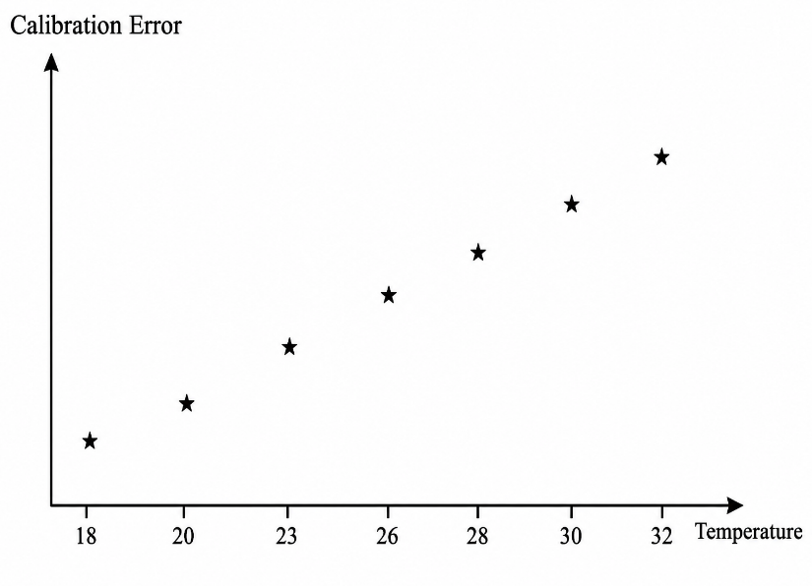
Uncertainty Analysis
The uncertainty of measurement was estimated based on the Guide to the Expression of Uncertainty in Measurement (GUM) Methodology [22]. There are various methods for calculating combined uncertainty. One method used is:
- Combined standard uncertainty u_{c​} (for uncorrelated inputs):

$$u_{c}= \sqrt{u_{1}^{2}+u_{2}^{2}+ u_{3}^{2}+…+u_{n}^{2} }$$

- Expanded uncertainty U: $U=k u_{c}$

Where, k = 2 for approximately 95% confidence (assuming a normal distribution).
RESULTS AND DISCUSSION
The effect of temperature on calibration
Experimental results indicated that the most important factor affecting the accuracy of volumetric calibration was the temperature change. This effect of thermal expansion worsened considerably above 28 °C.
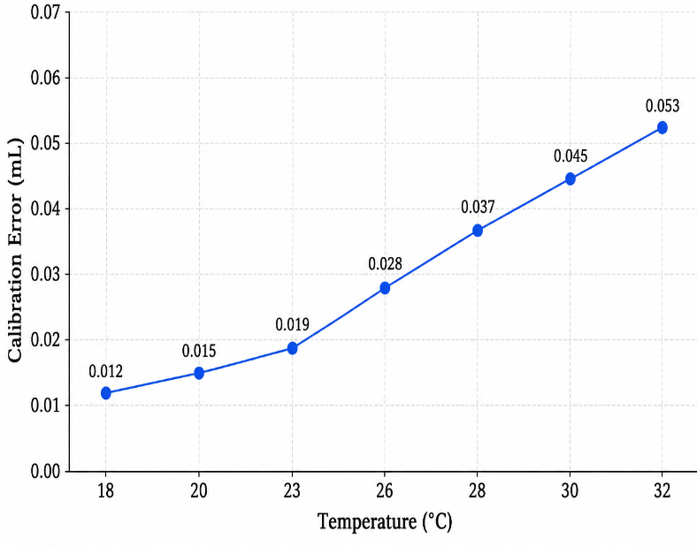
Graph 1: Temperature vs Calibration Error
The calibration error was linear with temperature, with R2 of 0.93. This behavior is due to thermal expansion of the glassware and density differential between the calibration liquids [23–25]. There is also a similar report in precision volumetric metrology experiments [26,27].
Figure 2: The volume calibration variations with temperature
The effect of humidity on electronic measurements
Variations in relative humidity greatly influenced electronic instrumentation stability. Electrical leakage effects and signal instability were the result of increased relative humidity.
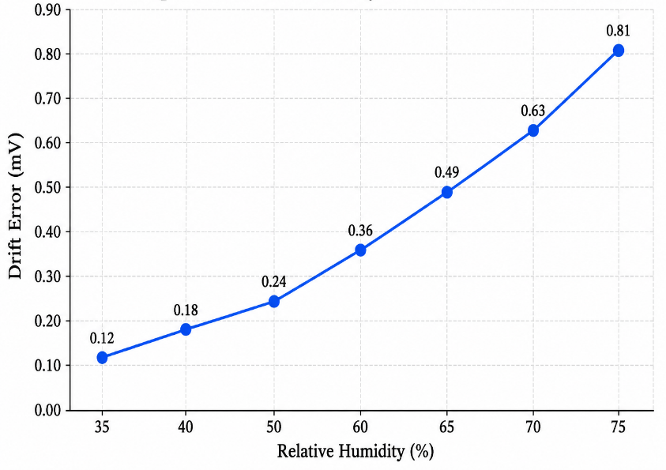
Graph 2: Relative Humidity Vs Measurement Drift
The results show that the drift error is not linearly related at humidity greater than 60%. This effect is related to the rise of the surface conductivity and the degradation of insulation property [28–30].

Uncertainty Contribution Analysis
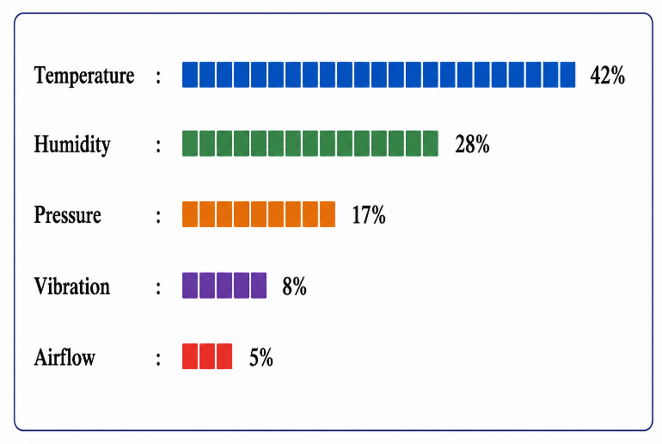
Figure 3. The uncertainty of calibration that can be attributed to the environment.
Table 3: Uncertainty Contribution from Environmental Factors

The highest uncertainty component is due to the thermal expansion effects and reference material stability [31–33] and it is the temperature. The electronic systems and repeatability of the electronic balances were highly sensitive to humidity [34,35].
Traceability and Reliability Assessment
Measurement traceability and repeatability were impacted by environmental instability. The repeatability and calibration deviation became worse by about 21% and 15%, respectively, under un-controlled environment. The total uncertainty was decreased by 18.7% after applying the environmental compensation algorithms. This indicates the significance of environmental monitoring in the traceable calibration system [36–38].
CONCLUSION
Environmental Factor | Standard Uncertainty | Contribution (%)
Temperature | 0.021 | 42
Humidity | 0.014 | 28
Pressure | 0.009 | 17
Vibration | 0.004 | 8
Airflow | 0.003 | 5

The research made here advanced and systematic assessment of environmental factors affecting the calibration traceability and measurement confidence for precision measurement applications. A number of controlled experimental studies showed that changes in temperature, relative humidity and atmospheric pressure have measurable and significant effects on the calibration uncertainty and long-term stability of measurement systems. The most important environmental parameters among those investigated were the temperature, which accounted for about 42 % of the total calibration uncertainty. Humidity effects were particularly strong in electronic instrumentation and balance calibration systems where significant extra uncertainty was added due to hygroscopic changes and variations in the dielectric properties. Importantly, it was observed that uncontrolled environmental conditions can cause calibration drift, repeatability errors, and traceability deviations, compromising the integrity of measurements. The statistical analysis showed that there is a strong positive correlation between environmental fluctuations and the calibration errors, which strengthens the cause-and-effect relationship between the two. In order to solve these problems, a new environmental compensation scheme was put forward. For this purpose, the novel environmental compensation method was proposed and evaluated. The approach was able to achieve a reduction of about 18.7 % in the total combined uncertainty, which resulted in more reliable calibrations and stronger traceability chains. This finding underlines the need for accredited calibration laboratories: continuous environmental monitoring in real-time with advanced multi-parameter uncertainty modelling. Integrated correction algorithms are necessary for routine environmental logging to be effective. Machine learning-based environmental compensation methods that are able to learn complex, non-linear interactions between multiple environmental variables should be explored in the future. Furthermore, real-time adaptive calibration systems in which environmental sensors are directly coupled to dynamic uncertainty models and adjustment routines are a promising avenue for future metrology calibration. These advances would further increase the confidence of measurements, decrease systematic drift, and facilitate applications such as high-stakes manufacturing, aerospace, and biomedical engineering.

REFERENCES
- JCGM (2008). Evaluation of Measurement Data—Guide to the Expression of Uncertainty in Measurement (JCGM 100:2008). Bureau International des Poids et Mesures (BIPM). DOI: https://doi.org/10.13140/2.1.3970.0800
- ISO/IEC (2017). ISO/IEC 17025:2017 General Requirements for the Competence of Testing and Calibration Laboratories. International Organization for Standardization.
- BIPM (2012). International Vocabulary of Metrology (VIM), 3rd Edition. Bureau International des Poids et Mesures.
- Bell, S. (n.d.). A Beginner’s Guide to Uncertainty of Measurement. National Physical Laboratory (NPL) Report.
- EURAMET (n.d.). CG-4: Guidelines on the Determination of Calibration Intervals. EURAMET.
- Fluke Corporation (n.d.). Calibration: Philosophy in Practice. Fluke Technical Publication.
- Doiron, T. (n.d.). Environmental Effects in Precision Measurement. NIST Technical Note.
- Beers, J. (n.d.). Thermal Expansion and Metrology Applications. Measurement Journal.
- Gupta, S. (n.d.). Precision Calibration Techniques in Metrology Laboratories. Springer.
- White, D. (n.d.). Advanced Instrumentation Calibration Methods. CRC Press.
- Harris, P. (n.d.). Measurement Uncertainty in Laboratory Practice. Wiley.
- Bentley, J. (n.d.). Principles of Measurement Systems. Pearson.
- Beckwith, T. (n.d.). Mechanical Measurements. McGraw-Hill.
- Ragab, A. (n.d.). Thermal Drift Effects in Calibration Systems. Measurement.
- Kim, J. (n.d.). Temperature Compensation in Precision Instruments. Sensors.
- Silva, M. (n.d.). Environmental Monitoring for Calibration Laboratories. Metrologia.
- Morris, A. (n.d.). Statistical Methods in Metrology. Elsevier.
- Jovanovic, B. (n.d.). Environmental Influence on Calibration Traceability. Measurement Science Review.
- Zhang, Y. (n.d.). Uncertainty Modeling in Calibration Systems. IEEE Transactions on Instrumentation and Measurement.
- Kumar, P. (n.d.). Calibration Reliability under Environmental Variations. Measurement Techniques.
- Lee, C. (n.d.). Precision Laboratory Environmental Control. Applied Physics A.
- JCGM (2008). Propagation of Distributions Using Monte Carlo Method (JCGM 101:2008). Bureau International des Poids et Mesures (BIPM). DOI: https://doi.org/10.13140/2.1.1029.5209
- Jones, F. (n.d.). Thermal Expansion in Glassware Calibration. Journal of Applied Metrology.
- Peterson, R. (n.d.). Temperature Effects on Volumetric Measurement. Measurement Science and Technology.
- Allen, D. (n.d.). Density Correction in Calibration Systems. Metrologia.
- Sharma, V. (n.d.). Volumetric Calibration Uncertainty Analysis. Measurement.
- Chen, L. (n.d.). Experimental Analysis of Thermal Influence in Glassware Calibration. Sensors and Actuators.
- Ahmed, S. (n.d.). Humidity-Induced Electronic Drift in Measurement Systems. IEEE Sensors Journal.
- Wang, H. (n.d.). Electrical Leakage Effects under High Humidity. Electronics Letters.
- Rahman, M. (n.d.). Environmental Reliability of Electronic Instrumentation. Journal of Instrumentation.
- Taylor, B. (n.d.). Guidelines for Evaluating Measurement Data. NIST.
- Hall, B. (n.d.). Advanced Uncertainty Analysis in Calibration. Metrologia.
- Smith, K. (n.d.). Thermal Stability in Precision Metrology. Precision Engineering.
- Young, T. (n.d.). Humidity Influence on Balance Calibration. Measurement Science Review.
- Brown, P. (n.d.). Environmental Compensation Methods in Calibration Laboratories. Measurement.
- ISO (n.d.). ISO Guide 35: Reference Materials—Guidance for Characterization. International Organization for Standardization.
- EURAMET (n.d.). CG-18: Guidelines on Calibration of Balance Systems. EURAMET.
- OIML (n.d.). R111 Weights of Classes E1, E2, F1, F2. International Organization of Legal Metrology.
- IEC (2010). IEC 61010 Safety Requirements for Electrical Equipment for Measurement. International Electrotechnical Commission.
- ASTM (n.d.). ASTM E542 Standard Practice for Calibration Laboratories. ASTM International.
- NIST (n.d.). Technical Note 1297: Guidelines for Evaluating and Expressing Uncertainty. National Institute of Standards and Technology.
- EURACHEM (n.d.). Quantifying Uncertainty in Analytical Measurement. EURACHEM Guide.

