The physico-chemical and microbiological properties of soil and analyzing the vegetation cover of Tamarix forests in Iran desert
Abstract

Tamarix is a short shrub that grows mostly in desert and arid areas. This beautiful shrub grows in saline and alkaline areas and along rivers and streams. In addition to preserving the vegetation of desert areas, this tree also has medicinal and therapeutic properties. It has a long life. It grows in most areas. It is considered a beautiful and ornamental tree. Various parts of this plant are used.
The tamarix tree is propagated through seeds, cuttings, and suckers. In seed cultivation, after preparing the gtamarix tree seeds, we soak them in lukewarm water for 24 to 48 hours, then prepare a pot and fill it with suitable soil. Then we plant the seeds at a suitable depth in the soil, cover them with a thin layer of soil, water the plant, and keep it moist until germination. After a while, the seeds germinate and emerge from the soil.We Considering the positive impact of the tamarix shrub on the soils of the study area by increasing organic matter in the soil, which results in improving the nutrient cycle and encouraging microbial activity and biomass, the preservation and restoration of this valuable shrub is vital. This is because one of the most important roles of the soil microbial population, especially bacteria, is the decomposition of plant residues, resulting in the mineralization of organic matter, the release of essential nutrients, and an increase in different properties of soil.

Keywords: microbial biomass, carbon, soil erosion, tamarix tree

Introduction
Tamarix is ​​an old tree. This tree lives a long time because its roots reach the surface water of the earth. In some tropical regions, it has lived for more than thousands of years. Often, the maximum height of these trees reaches 10 to 15 meters. Tamarix is ​​a beautiful tree with narrow, pointed, and tightly packed leaves. The branches of this tree secrete a substance called angbin, which contains sucrose, which is a peroxide, and due to the saltiness of its leaves, only camels, camelids, and mountain goats use it, but it is unsuitable for feeding other animals. It is from the Tamarix family and grows in various parts of the world, including the deserts of Iran figure 1.
The most suitable place for its growth and multiplication is hot and dry desert areas and salty soils. This plant is very resistant to changes in air temperature. In addition, the most suitable soil for the growth of the Gaz plant is loamy soil. Near the sea, coastal sands, and around rivers are suitable places for the growth of the Gaz plant. This plant also grows well next to streams, salty and sandy lands, wet ditches, and river beds.
Introduction to the tamarix tree and its various uses
Scientific name: Tamarix) from the Tamarisk family. Tamarisk is a salt-loving tree native to the arid regions of Eurasia and Africa and includes 55 species, of which about 35 species are found in the Middle East and 23 species are found in Iran Table 2.
About 23 species of tamarisk trees grow in Iran, the most famous of which are:
• Shahgaz, the most robust and oldest species, sometimes exceeding 15 meters.
• Korgaz (tamarix Shahi), a relatively tall but narrower type than Shahgaz
• Shorgaz (tamarix Sonbele Bland) grows on the edges of salty rivers and ravines.
• Yalqon with the scientific name Tamarix palazii, which is found around Karaj.
• Tamarix tetrander, which grows around Shiraz.
• Temis, which is seen in the northern forests of Iran.
Shahgaz, a special and famous species of Gaz in southern Iran, is an ancient tree. This tree has a long life span because its roots reach the surface water of the earth. It is said that in some tropical regions it has lived for more than a thousand years. The maximum height of this tree often reaches 10 to 15 meters. tamarix is a tree with narrow, sharp, and tightly packed leaves and a salty taste that is not even fed to animals.
Distribution range of the tamarix tree
In Iran, it grows mostly in saline lands and arid and semi-arid areas, and on the road between Tehran city and Isfahan, Kashan, Yazd, Shiraz, Kerman and Shahdad, to Zahedan and Bandar Abbas, as well as in Gotvand, Khuzestan, Bazfat, the Gav Khouni Swamp, and also in the northern regions of Khorasan from Atrak river and Bojnourd and Shirvan to Jajrud and Bahram, and the saline lands south of Karaj and Shahdasht, and also on the edge of Lake Urmia, such as Sharafkhaneh. Its minimum height in Bahram is 1100 meters and its maximum is 2200 meters on Mount Siraj in Kerman.

Industrial uses of the tree
The tamarix tree has many benefits and is used in industrial products, construction, and also has high therapeutic properties. Some of them are as follows: It can be used in supplementary paste for mixing with high-quality pastes. It is possible to use Gaz wood chips mixed with other wood chips or pure in the production of particleboard
The thick and long trunks of tamarix are used for use in the roofs of stables and pens (especially in mountainous areas), scaffolding for hair trees, at the entrances of rooms and doors of houses, and their purchase and sale is used among rural residents. The use of Gaz is suitable for industrial uses, and in the cultivation of forest stands with Gaz, it is also possible to improve the quality of wood. Similarly, the use of Gaz wood chips in the production of particleboard, whether mixed with other species or pure, seems appropriate if its crushing is economical on a commercial production scale.
Medicinal uses of the tamarix tree (keyrodin 2009)
1. Its nature is warm and dry.
2. To relieve chronic coughs, mix the bark of this plant with cinnamon and drink it as a brew.
3. To relieve stomach pain due to cold, brew 4 grams of the bark of the plant and sweeten it with sugar and drink it.
4. Gargling the infusion of this plant is beneficial for the teeth.
5. To relieve toothache, pound the bark of the gaz tree, mix it with vinegar and gargle.
6. Gargling the pounded bark of this plant with vinegar eliminates the smell of stench and pus from the gums.
7. To eliminate bad breath, pound the bark of this plant softly, dip a wick in it and place it in the nose.
8. To treat hemorrhoids, mix the bark of this tree with cinnamon and drink it as a brew.
9. The infusion of the bark of this tree with cinnamon eliminates excessive sperm secretion.
10. Use the infusion of this plant to remove bloody mucus from the chest.
11. The bark of this tree is harmful to the spleen and liver and should be consumed with chewing gum.
12. To treat diarrhea, brew 8 grams of the bark of this tree in 300 cc of boiling water and drink three glasses a day.
13. Pregnant women should avoid eating the gaz plant.
14. A decoction of the bark of this plant is useful for controlling jaundice.
The gaz tree can also have other uses and capabilities, for example, in areas that are now devoid of life and property, the large presence of this tree can reduce the size of deserts and, in a sense, eliminate desertification. The gaz tree is also an effective tool in stabilizing and keeping the soil together and preventing their transfer.
In Iran, it grows mostly in saline lands and arid and semi-arid areas, and on the road between Tehran and Isfahan, Kashan, Yazd, Shiraz, Kerman and Shahdad, to Zahedan and Bandar Abbas, as well as in Gotvand, Khuzestan, Bazfat, the Gav Khouni Swamp, and also in the northern regions of Khorasan from Atrak and Bojnourd and Shirvan to Jajrud and Bahram, and the saline lands south of Karaj and Shahdasht, and also on the edge of Lake Urmia, such as Sharafkhaneh. Its minimum altitude in Bahram is 1100 meters and its maximum is 2200 meters on Mount Siraj, Kerman.

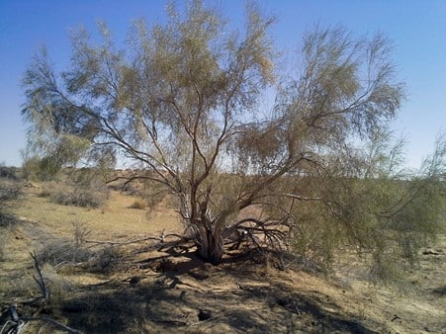
Figure 1: Tamarix growing in the Iranian desert
Background and Objective: Gaz shrub, as one of the most important plants in arid and semi-arid areas, can have a great impact on the activity of the soil microbial community and in this way, by making the nutrient cycle more efficient, it can increase soil fertility. Also, this shrub, as a natural and adaptive vegetation cover in the study area, plays an important role in soil protection and controlling wind erosion. The aim of this study was to investigate the effect of natural azalea shrubs on the microbial activities and biomass of desert soils in the Farrokh Abad region of Dehloran County,Semnan Province. Materials and Methods: Plan experimental show in figure 1 and 2. All soil microbial activity measurement by Asgharzadeh, methods 2010 . In order to investigate the biological properties of the soil, sampling of the surface soil (0-5 cm depth) under the azalea shrub canopy and the open space was carried out using a systematic random method. The total number of soil samples was 62, of which 31 samples were from under the canopy and 31 samples were outside the azalea shrub canopy. After collecting the soil samples and transferring them to the laboratory, soil biological analyses including microbial biomass carbon and nitrogen,(Nelson 1986). basal respiration, substrate-induced respiration, microbial yield, metabolic yield, and soil organic carbon were performed on the samples. Statistical analyses such as one-way analysis of variance and correlation coefficient were performed with SAS 9.1 software. The t-test was used to compare the average of the biological properties of the soil. Soil microbial respiration and biomass analysis bt Anderson et al. method 1982 and 1990.all soil enzymes activity concluded by kheyrodin hamid methodes 2014.
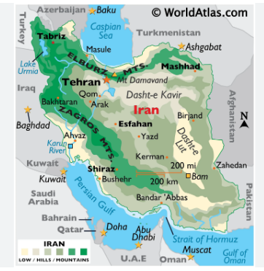
Figure 2: shows a image of map in Iran.

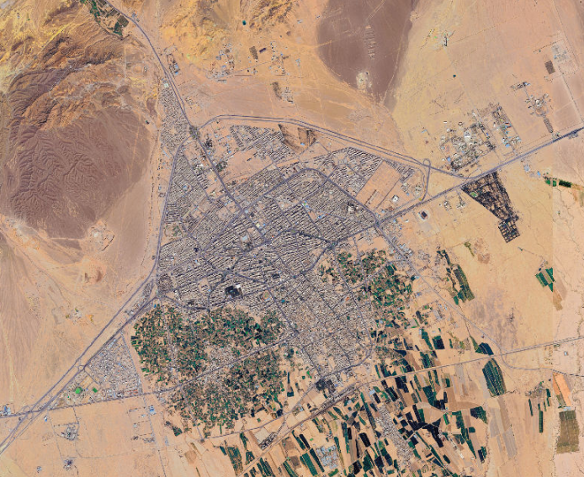
Figure3 shows a satellite image of the city of Semnan in Iran.

Results:
The results showed in table 1 and 2 and figure 3 and 4 . The result demonstrated that there was a significant difference at the 1% level between the biological characteristics of the soil under the canopy of the azalea shrubs and the open space. The highest amount of soil organic carbon (16.2%) was observed under the azalea canopy compared to the open space. Microbial biomass carbon (654 mg carbon/kg) and microbial biomass nitrogen (79 mg nitrogen/kg) were significantly higher under the azalea shrubs than outside the canopy. Also, the basal and stimulated respiration rates were significantly higher under the azalea shrubs than outside the canopy (p<0.01). Basal respiration under the azalea canopy showed a positive correlation with metabolic gain (qCO2), while this parameter showed a negative correlation with soil organic carbon. Conclusion: In general, the results of this study showed that the biomass and microbial activity of the soil under the canopy increased, which indicates the importance of azalea shrubs in the study area. For example, the highest microbial biomass carbon was observed under the tamarix canopy compared to the open space the result was similar result Yang et al. 2025. Therefore, in order to increase the quality and health of the soil and combat soil erosion, it is necessary to restore and protect the Gaz shrub in the study area. For this purpose, the General Directorate of Natural Resources and Watershed Management of Ilam Province and non-governmental organizations can participate in the cultivation and restoration of this native species and other native species (kheyrodin 2016).

Table 1: Show statistics of the resultes
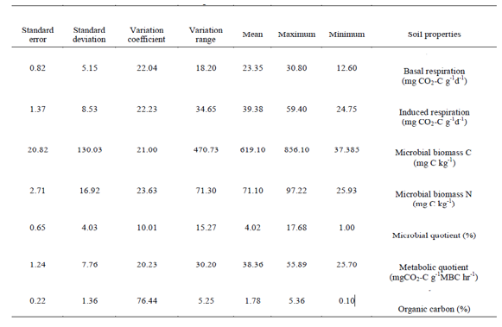
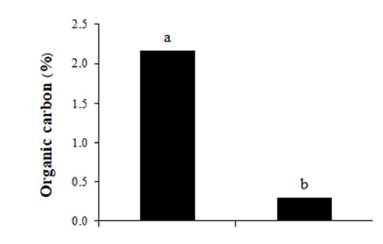

Figure 3- Soil organic carbon status under and outside the canopy of the azalea shrub.
Discussion
Climatic conditions are among the factors affecting the establishment of vegetation in arid and desert areas. In these areas, fertile and fertile soils also play an important role in the emergence and development of vegetation and forest cover (34). Rangeland plants favorably change the microclimate around them. For example, they can increase the moisture retention capacity and water permeability of the soil, accelerate the nutrient cycle, and modulate temperature and wind speed (6 and 28). Accordingly, considering the climatic conditions in desert areas, it is essential to understand the relationship between soil characteristics and the natural plant species of the area, and by understanding and planting the most suitable species, we can have the greatest success in restoring vegetation.
Table 2: Different Tamarix in Iran desert kheyrodin and kamyabi 2014.
Tamarix stricta  Tamarix leptopetala  Tamarix aphylla  Tamarix hispida  Tamarix gallica  Tamarix ramosissima  Tamarix chinensis  Tamarix parviflora  Tamarix senegalensis  Tamarix africana  Tamarix alii  Tamarix amplexicaulis  Tamarix androssowii  Tamarix aralensis  Tamarix aravensis  Tamarix arceuthoides  Tamarix aucheriana  Tamarix austromongolica  Tamarix baluchistanica  Tamarix boveana  Tamarix brachystachys  Tamarix canariensis  Tamarix dalmatica  Tamarix dioica  Tamarix dubia  Tamarix duezenlii  Tamarix elongata  Tamarix ericoides  Tamarix eversmannii  Tamarix florida  Tamarix gansuensis  Tamarix gennessarensis  Tamarix gracilis  Tamarix hampeana  Tamarix hohenackeri | Tamarix jordanis  Tamarix karelinii  Tamarix kasakhorum  Tamarix kermanensis  Tamarix komarovii  Tamarix korolkowii  Tamarix kotschyi  Tamarix kutchensis  Tamarix laxa  Tamarix leptostachya  Tamarix litwinowii  Tamarix macrocarpa  Tamarix mascatensis  Tamarix meyeri  Tamarix mongolica  Tamarix negevensis  Tamarix nilotica  Tamarix octandra  Tamarix pakistanica  Tamarix palaestina  Tamarix passerinoides  Tamarix pycnocarpa  Tamarix sachensis  Tamarix salina  Tamarix sarenensis  Tamarix smyrnensis  Tamarix sultanii  Tamarix szowitsiana  Tamarix taklamakanensis  Tamarix tarimensis  Tamarix tenuissima  Tamarix tetragyna  Tamarix tetrandra  Tamarix jintaensis  Tamarix usneoides
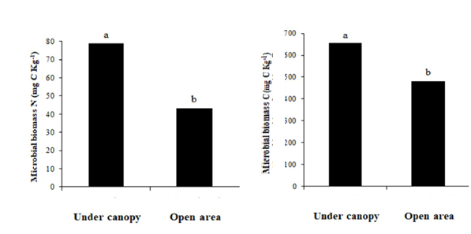
Figure 4- Microbial biomass carbon (a) and soil microbial biomass nitrogen (b) under and outside the canopy of agave shrub.

Table 3. Correlation coefficients between soil biological properties under canopy (white color) and open area
(gray color).
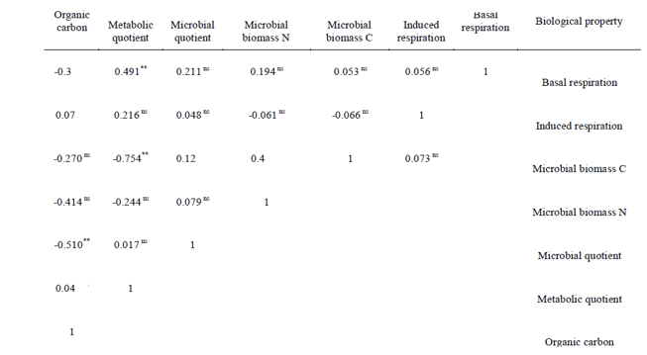
* and ** are significant at 5 and 1% probability levels and ns not significant, respectively.

Figure 4 , concluded that the highest microbial biomass of carbon and nitrogen (654 and 79 mg/kg soil, respectively) was obtained in the soil under the canopy of the azalea shrub, which was 64.82% higher in 36 and 01% compared to the soil outside the canopy, respectively. In addition The highest microbial yield (qmic) was obtained in the soil under the canopy cover (11.2%), and the open space soil had the lowest microbial yield (2%) at 16%.. The highest metabolic efficiency was observed in the soil under the canopy cover at 40 mg (qCO2) per gram of microbial biomass carbon per hour of CO2. Little research has been conducted in arid regions on the microbial fraction (qmic). Microbial efficiency indicates the state of soil organic matter after the addition of organic matter.

In conclusion We addition some properties of the tamarix tree
1. Its nature is warm and dry.
2. To relieve chronic coughs, mix the bark of this plant with cinnamon and drink it.
3. To relieve stomach pain due to cold, brew 4 grams of the bark of the plant and sweeten it with sugar and drink it.
4. Gargling the infusion of this plant is beneficial for the teeth.
5. To relieve toothache, pound the bark of the Gaz tree, mix it with vinegar and drink it.
6. Gargling the pounded bark of this plant with vinegar eliminates the smell of stench and gum pus.
7. To eliminate bad breath, pound the bark of this plant softly, dip a wick in it and put it in the nose.
8. To treat hemorrhoids, mix the bark of this tree with cinnamon and drink it.
9. Gargling the bark of this tree with cinnamon eliminates excessive sperm secretion.
10. To remove bloody mucus from the chest, use the infusion of this plant.
11. The bark of this tree is harmful to the spleen and liver, and should be rubbed with mastic.

Acknowledgments
We would like to thank Dr.M.Nasiri, the president of Semnan University, for approving the research project of Castor Oil in the Semnan University in research Council and for financial cooperation and personnel assistance.

References
1-Anderson, J.P.E. 1982. Soil respiration in: Methods of Soil Analysis, Part 2: Chemical and Microbiological Properties, edited by Page, AL., R.H. Miller, and D.R. Keeney. Agronomy Monograph. 9: 831-871.

2-Anderson, T.H., and Domsch, K.H. 1990. Application of eco-physiological quotients on microbial biomasses from soils of different cropping histories. Soil Biology and Biochemistry. 22: 251-255.

3-Asgharzadeh, A. 2010. Laboratory methods of soil biology. Tabriz University Press. Tabriz, Iran, 755p. (In Persian)

4-Kheyrodin, H. 2009. Isolation and identification of new eleven constituents from medicinal plant. International Journal of Nutrition and Metabolism. Vol 1. Pages: 14-19

5-Kheyrodin, H.2016. Importance of Wheat farming in Iran. Annals of Agricultural and Environmental Sciences. Vol.1. pages: 40-48

6-Kheyrodin, H. 2014. Methodology for measurement of enzyme activity in soil. World J Biol Med Sci. Vol. 1. Pages: 18-25.

7-Kheyrodin. H. 2025. Chemical and Medical Castor Oil Composition. International Journal of Clinical Chemistry and Laboratory Medicine. 10(1). 8-11

8-kheyrodin , H. and kamyabi S. 2014. Adictionary of soil science. Semnan azad university publication

9-Nelson, D.W., and Sommers, L.P. 1986. Total carbon, organic carbon and organic matter, in Buxton, D.R., (Eds.), Methods of soil analysis Part 2. Chemical and microbiological properties. American Society of Agronomy, Madison, USA, Pp: 539-579.

10-Yang, K., Zhu, J., Zhang, M., Yan, Q., and Sun, O.J. 2010. Soil microbial biomass carbon and nitrogen in forest ecosystems of Northeast China: a comparison between natural secondary forest and larch plantation. J. Plant Ecol. 3: 175-182

