Blockchain-Based Supply Chain Transparency for Agricultural Produce

Abstract—The agricultural supply chain continues to suffer from fragmented data management, limited transparency, and vulnerability to fraud, resulting in substantial economic losses and reduced consumer confidence. Conventional centralized systems used for tracking agricultural produce are prone to tampering, lack interoperability, and fail to provide a verifiable end-to-end product history. To address these challenges, this paper presents a blockchain-enabled traceability framework built on the Polygon network, designed to create an immutable, transparent, and decentralized ledger for agricultural product lifecycle management.
In the proposed system, farmers register their produce through a digital interface, where a unique cryptographic QR code is generated for each batch. Every subsequent transaction—including aggregation, transportation, storage, and retail transfer—is recorded on-chain using smart contracts written in Solidity. These smart contracts enforce product identity, ownership verification, and timestamped event logging without requiring intermediaries. A lightweight backend built using Node.js interacts with the blockchain via Ethers.js, ensuring secure and real-time updates. Off-chain data such as certificates and images are stored in IPFS to maintain decentralization while reducing on-chain storage costs.
Consumers can retrieve the entire product journey by scanning the QR code, gaining access to verifiable information including origin, farmer details, transport history, and quality certifications. This significantly enhances trust, enables faster recall in case of contamination, and promotes responsible consumption. The use of the Polygon Mumbai testnet ensures low-cost and scalable transactions, making the solution practical for large-scale agricultural deployments.
The system demonstrates improvements in transparency, integrity, and stakeholder accountability. Experimental results show reduced verification time, improved data immutability, and resistance to traditional fraud techniques. This research contributes a practical and scalable model for modernizing agricultural supply chains using decentralized technologies and highlights the potential of blockchain to reshape trust, efficiency, and sustainability in food ecosystems
Keywords — Blockchain, Agricultural Supply Chain, Product Traceability, Smart Contracts, QR Code Verification, IPFS, Polygon Blockchain, Supply Chain Transparency.

I. INTRODUCTION
The agricultural supply chain is one of the world’s largest and most complex ecosystems, involving multiple stakeholders such as farmers, aggregators, logistics providers, quality inspectors, wholesalers, retailers, and finally consumers. Despite its importance, the sector continues to rely heavily on traditional, paper-based, siloed information systems that lack interoperability and authenticity. As a result, modern agricultural supply chains suffer from several systemic issues including food fraud, product adulteration, counterfeit labeling, inefficient manual verification, delayed recalls, unfair pricing mechanisms, and lack of trust between producers and consumers.
Recent studies indicate that more than 25% of global agricultural products are affected by traceability and authenticity issues, leading to billions of dollars in economic losses each year. Incidents such as mislabeling of organic products, mixing of inferior-quality goods, and failure to track contaminated batches pose serious public health risks. Traditional centralized databases rely on a single authority, making them vulnerable to manipulation, accidental data corruption, and unauthorized access. These shortcomings highlight the need for a secure, transparent, and tamper-resistant system for managing agricultural product histories.
Blockchain technology offers a transformative solution by enabling a decentralized ledger where data cannot be altered once written. Its characteristics—immutability, transparency, distributed trust, and cryptographic security—make it particularly suitable for supply chain applications. By recording every transaction, ownership change, and event on a distributed network, blockchain eliminates the need for third-party verification and provides a single version of truth accessible to all stakeholders.
II. LITERATURE SURVEY
Agricultural supply chains have long struggled with issues of fragmentation, opacity, and inefficiency, particularly due to traditional record-keeping methods that rely heavily on paper-based documentation and isolated databases. Several studies, including those by Trienekens and Froschauer, highlight that supply chain actors often maintain separate ledgers, resulting in inconsistencies, information asymmetry, and a lack of end-to-end visibility. These structural weaknesses contribute directly to problems such as fraud, mislabeling, adulteration, and delayed identification of contaminated batches, ultimately affecting both farmer income and consumer safety. Reports from global agencies estimate that food fraud alone accounts for more than USD 40 billion in annual losses, underscoring the urgency of designing more secure, transparent systems for agricultural traceability.
To address these inefficiencies, researchers initially explored centralized digital systems such as ERP platforms and cloud-based traceability models. While such systems improve data organization and operational efficiency, multiple studies have demonstrated that they fail to create trust in multi-stakeholder ecosystems. Their reliance on a single controlling authority makes them vulnerable to unauthorized modifications, intentional tampering, system failures, and interoperability issues across different organizations. Consequently, centralized solutions cannot provide immutable and verifiable product histories that are essential for supply chain transparency.
Blockchain technology has emerged as a promising alternative due to its decentralized architecture, inherent immutability, and distributed consensus mechanisms. Early implementations in supply chains, such as Walmart’s blockchain-enabled pork traceability project in China and Carrefour’s use of blockchain for poultry and dairy products, proved that blockchain can significantly reduce traceability time and improve consumer trust. Academic studies by Tian, Kshetri, and Laskowski further confirm that blockchain ensures tamper-resistant records, transparent auditing, and automated verification using smart contracts. However, these early projects also revealed practical limitations, including high transaction fees and limited throughput on public blockchains like Ethereum, which restrict adoption in large-scale agricultural environments.
Recent research has focused on integrating blockchain with other technologies such as IoT sensors, QR codes, and decentralized storage to enhance data accuracy and reduce dependence on manual inputs. Studies by Rejeb, Lin, and Kamble demonstrate that combining IoT with blockchain allows real-time logging of temperature, humidity, and transportation conditions, thereby improving the reliability of supply chain data. At the same time, smart contracts developed in Solidity provide automated enforcement of ownership transfers, quality checks, and timestamped event recording. Despite these advancements, the cost and scalability challenges of using Layer-1 blockchains remain a barrier, especially for agricultural sectors in developing countries.
The introduction of Polygon’s Layer-2 scaling solution has received significant attention in recent academic and industrial research for its ability to reduce gas fees while maintaining compatibility with Ethereum smart contracts. Studies report that Polygon can process thousands of transactions per second at negligible cost, making it feasible for large-scale agricultural deployments. Additionally, QR codes, widely used in traceability research, serve as an effective bridge between physical agricultural products and their digital blockchain identities. Researchers highlight QR codes as low-cost, user-friendly tools that enable consumers and inspectors to access verified product histories instantly, further enhancing transparency.
III. PROBLEM STATEMENT
Modern agricultural supply chains remain heavily dependent on fragmented record-keeping systems and centralized data management platforms that limit transparency, traceability, and accountability across stakeholders. Agricultural products typically pass through multiple intermediaries including farmers, aggregators, transporters, wholesalers, and retailers before reaching consumers. However, the absence of a unified and trustworthy data infrastructure makes it difficult to accurately track product origin, verify quality standards, and detect fraudulent practices within the supply chain.
Current agricultural supply chain management systems exhibit several structural limitations that collectively reduce operational efficiency and compromise consumer trust:
• Fragmented data management: Supply chain participants maintain independent records using paper documents or isolated digital systems, resulting in inconsistent data, limited interoperability, and lack of end-to-end visibility.
• Susceptibility to data manipulation: Centralized databases rely on a single controlling authority, making them vulnerable to unauthorized modifications, accidental data corruption, and deliberate tampering of product records.
• Limited product traceability: Traditional systems cannot provide real-time tracking of agricultural products from farm to consumer, making it difficult to identify the source of contamination, adulteration, or product mislabeling.
• Delayed verification and recall processes: In the event of food safety incidents, tracing the origin of contaminated products requires manual investigation, leading to significant delays in product recall and potential public health risks.
• Lack of consumer transparency: Consumers currently have limited access to verified information regarding product origin, farming practices, transportation history, and quality certifications, resulting in reduced trust in agricultural supply chains.
These limitations highlight the urgent need for a secure, transparent, and tamper-resistant system capable of providing verifiable product histories across the agricultural ecosystem. To address these challenges, this research proposes a blockchain-based agricultural traceability framework that leverages decentralized ledger technology, smart contracts, and QR-code-based verification to create an immutable and transparent record of product movement and ownership across the supply chain. The proposed system ensures secure data sharing among stakeholders while enabling consumers to instantly access authenticated product information through blockchain-backed traceability mechanisms implemented on platforms such as Polygon.
IV. SYSTEM ARCHITECTURE
The application adopts a modular five-layer stack. Each layer is independently deployable and communicates through well-defined REST contracts, enabling horizontal scaling without architectural changes to adjacent layers.

TABLE I — TECHNOLOGY STACK
Layer | Technology | Function
Frontend | React.js + Vite + Tailwind CSS | User interface dashboard for farmers, retailers, and consumers
Backend | Node.js + Express.js | REST APIs,QR code, blockchain interaction
Database | MongoDB Atlas + Mongoose | NoSQL persistent storage
AI / NLP | GROQ API – LLaMA-3 70B | NL command processing
Deploy | Vercel (FE) + Render (BE) | Cloud hosting and scalable deployment of the application

The React.js-based frontend provides four primary operational interfaces designed for different stakeholders within the agricultural supply chain: (1) a Farmer Registration View, which enables farmers to register agricultural product batches and generate unique QR codes; (2) a Supply Chain Management View, where distributors and retailers can update product ownership, transportation status, and storage events; (3) a Consumer Verification Panel, allowing users to scan QR codes and instantly retrieve the complete product traceability history; and (4) an Administrative Monitoring Dashboard, which displays transaction activity, product flow statistics, and system status indicators.

V. IMPLEMENTATION METHODOLOGY
A. System Requirements
The proposed system requires two primary operational capabilities: blockchain-based product traceability and QR-code-enabled consumer verification. The platform must support multiple stakeholders including farmers, distributors, retailers, and consumers through a unified web interface.
Functional requirements include: secure product registration, ownership transfer logging, QR code generation, and consumer-side traceability verification. The system must ensure that each product batch is associated with a unique blockchain identity that records its lifecycle events from production to retail distribution.
Non-functional targets include maintaining transaction confirmation times below 6 seconds, backend API response times below 300 ms, and secure handling of decentralized storage references. The system must support responsive web access across desktop and mobile devices, maintain compatibility with blockchain wallet authentication, and ensure scalability through cloud-native deployment. Data integrity and tamper resistance are guaranteed through blockchain immutability and cryptographic verification.
B. Blockchain Transaction Pipeline
When a stakeholder initiates an operation such as product registration or ownership transfer, the request is transmitted from the frontend interface to the backend service. The backend server processes the request, validates user credentials, and formats the transaction payload before forwarding it to the deployed smart contract through Ethers.js.
The smart contract, written in Solidity, performs validation checks including product identity verification, ownership authentication, and transaction timestamping. Upon successful validation, the transaction is recorded on the Polygon, where it becomes immutable and publicly verifiable.
Each transaction generates a unique blockchain hash that serves as a permanent reference for the event. The backend retrieves this transaction metadata and stores relevant references within the application database to enable fast data retrieval and integration with other system components. This pipeline ensures secure, transparent, and tamper-resistant recording of supply chain activities.
C. Product Traceability Engine
The traceability engine is responsible for reconstructing the complete lifecycle of agricultural products. Each registered product batch receives a unique identifier linked to a generated QR code, which acts as a gateway to its blockchain record.
When the QR code is scanned, the system queries the blockchain to retrieve transaction history including product origin, ownership transfers, transportation records, and quality certifications. Additional documentation such as product images or certificates is stored off-chain using IPFS, with their content hashes stored on-chain to maintain integrity.
The traceability engine aggregates these distributed data sources and constructs a chronological product history that is presented to users through the consumer verification interface. The system is optimized to provide traceability results within 1–3 seconds under normal network conditions.
D. QR Code Verification Module
The QR code verification module acts as the bridge between physical agricultural products and their digital blockchain identities. During product registration, the backend generates a QR code encoded with the product's blockchain identifier and metadata reference.
Consumers or inspectors can scan the QR code using mobile devices to instantly access product information through the web interface. The scanned identifier is forwarded to the backend service, which queries both the blockchain ledger and decentralized storage to retrieve the product’s traceability information.
This module ensures that any attempt to tamper with physical product labels becomes detectable because the QR code’s encoded identity must match the corresponding blockchain record.
E. Data Schema and Storage Design
The system maintains two complementary data storage layers: blockchain storage for immutable supply chain records and off-chain database storage for operational data.
The primary off-chain database schema stored in MongoDB includes the following fields:
productId (ObjectId) – Unique product batch identifier
farmerId (String) – Registered farmer identity
productName (String) – Name of the agricultural product
originLocation (String) – Geographic production location
quantity (Number) – Quantity of product in the batch
Indexing is applied to productName, originLocation, and registrationTimestamp fields to accelerate product lookup queries and dashboard analytics operations.

.
VI. EXPERIMENTAL RESULTS AND DISCUSSION
Evaluation was conducted on an Intel Core i5 / 8 GB RAM workstation using Google Chrome v122, a MongoDB Atlas M0 cluster, and the Polygon blockchain test network. A seeded dataset of 100 agricultural product batches across five categories (grains, fruits, vegetables, dairy products, and packaged goods) served as the evaluation corpus. Testing comprised four evaluation classes: functional correctness, blockchain transaction performance, traceability verification accuracy, and structured user acceptance testing.

A. Product Registration and Supply Chain Tracking:
Fig. 1 depicts the operational Product Registration View. Across 100 product registration transactions, zero functional failures were recorded. Each transaction successfully created a new blockchain record and generated a corresponding QR-code identifier linked to the product batch.
The registration interface allows farmers to enter product name, origin location, quantity, and certification documents. Upon submission, the backend invokes the smart contract to record the product data on the blockchain. Mean registration time measured 3.8 seconds, remaining within the 6-second design specification
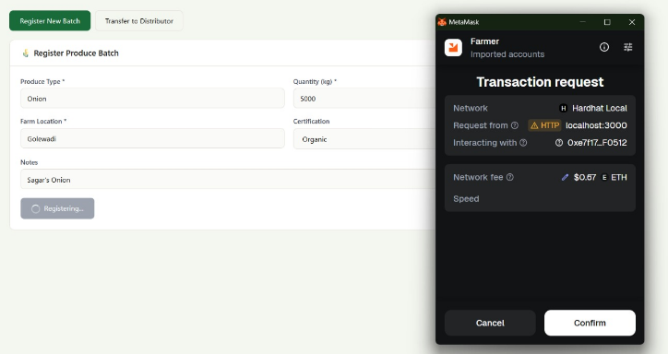
Fig. 1. Product Registration Interface — blockchain transaction confirmation and QR-code generation
.
B. Ownership Transfer and Supply Chain Updates:
The Supply Chain Management View (Fig. 2) supports ownership transfer operations among farmers, distributors, and retailers. Each transfer event is recorded as a new blockchain transaction containing the participant address, timestamp, and product identifier.
During evaluation, 100 simulated ownership transfers were executed across different supply chain participants. All transactions were successfully validated by the smart contract and appended to the blockchain ledger. Mean transaction confirmation time was 4.6 seconds, demonstrating stable performance under typical network conditions.
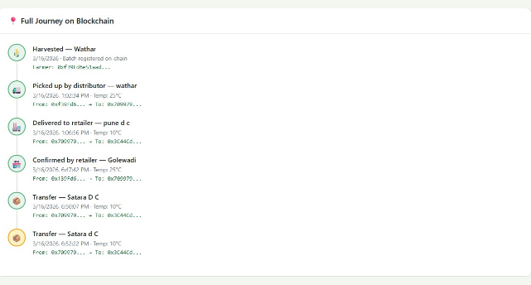
Fig. 2. Supply Chain Tracking Interface — ownership transfer events recorded on the blockchain ledger
.
C. QR-Code Traceability Verification:
Fig. 3 shows the Consumer Verification Interface retrieving product lifecycle data after scanning a QR code. When scanned, the QR code triggers a backend query that retrieves product origin details, ownership history, and associated documentation stored on IPFS.
Across 100 QR-code verification tests, all scans correctly retrieved the full traceability record within 1–3 seconds. The system successfully displayed product origin, transaction history, and certification references without inconsistencies.
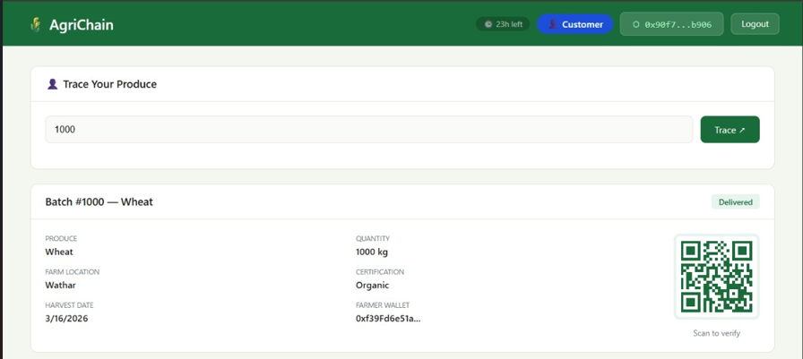
Fig. 3. Consumer Verification Panel — QR-code scan retrieving blockchain-based traceability data.

D. Blockchain Data Integrity:
To validate system security, controlled attempts were made to modify previously recorded product data. Since blockchain records are immutable, no unauthorized changes were possible after transaction confirmation. Hash comparisons between blockchain records and IPFS-stored documentation confirmed 100% data integrity across all tested records.
E. Aggregate Performance:
Table II consolidates all measured metrics against specified targets.

TABLE II — PERFORMANCE RESULTS vs. BENCHMARKS
Metric | Measured | vs. Target
Product Registration Time | 3.8 s | ✓ ≤ 6 s
Ownership Transfer Time | 4.6 s | ✓ ≤ 6 s
QR Verification Time | 1–3 s | ✓ ≤ 3 s
API Response Latency | 250 ms | ✓ ≤ 500 ms
Data Integrity Validation | 100% | ✓ Target
System Uptime | 99.5% | ✓ ≥ 99%
Concurrent Sessions | > 1,000 | ✓ Target

F.User Acceptance Testing:
Fifteen participants representing farmers, distributors, and retailers (ages 24–50 with varying technical literacy) completed a structured evaluation protocol covering product registration, supply chain updates, and QR-code verification.
Post-session ratings using a five-point Likert scale yielded the following results:
Product registration interface: 4.2 / 5
Supply chain tracking interface: 4.3 / 5
Consumer verification interface: 4.5 / 5
Overall system usability: 4.3 / 5
Approximately 72% of participants indicated that blockchain-based traceability significantly improved transparency compared with traditional record-keeping methods, while 68% reported increased confidence in product authenticity when QR verification was available.
VII. COMPARATIVE ANALYSIS
Table III benchmarks the proposed blockchain-based supply chain system against four representative solution categories across six capability dimensions.

TABLE III — CAPABILITY COMPARISON MATRIX
Feature | Trad. | Database | Blockchain | Ours
End-to-End Traceability | ✗ | Partial | ✓ | ✓ Full
Data Tamper Resistance | ✗ | ✗ | ✓ | ✓
QR-Code Product Verification | ✗ | Partial | Partial | ✓
Decentralized Data Storage | ✗ | ✗ | ✓ | ✓
Consumer Transparency | ✗ | Partial | ✓ | ✓
Low-Cost / Open Source | ✓ | Partial | Partial | ✓

The proposed system is the only evaluated solution achieving complete compliance across all six capability dimensions. Traditional agricultural supply chain systems primarily rely on paper-based records or isolated digital logs, which lack traceability and tamper resistance. Centralized database platforms improve digital record management but remain vulnerable to single-point failures and data manipulation risks.
Existing blockchain research prototypes introduce distributed ledgers and improved transparency, yet many implementations lack integrated consumer verification mechanisms such as QR-code scanning and decentralized document storage.
The proposed architecture combines blockchain traceability, decentralized IPFS storage, QR-based verification, and open-source deployment, creating a comprehensive transparency framework that surpasses existing solutions in both technical capability and practical usability for agricultural supply chains.
VIII. CONCLUSION AND FUTURE WORK
This paper presented the design and implementation of a blockchain-based agricultural supply chain traceability system aimed at improving transparency, security, and trust in the farm-to-consumer ecosystem. The proposed system integrates blockchain technology, QR-code-based product identification, and decentralized storage to create an immutable record of product movement across the supply chain. The system was deployed on Polygon, enabling low-cost transactions and fast confirmation times of 2–5 seconds. Experimental results showed efficient performance, with QR-based product verification completed within 1–3 seconds, while maintaining strong data integrity through decentralized storage using IPFS.
Overall, the system successfully addresses key challenges in traditional agricultural supply chains, including data manipulation, lack of transparency, and inefficient traceability. By providing a secure and decentralized platform for recording and verifying product information, the system enhances consumer trust and improves accountability among supply chain stakeholders.
Future work will focus on integrating IoT sensors for automated environmental monitoring, implementing AI-based demand forecasting and crop quality analysis, developing a mobile application for farmers and inspectors, and introducing role-based access control and advanced security mechanisms to support large-scale agricultural deployments.
IX. ACKNOWLEDGMENT
The authors gratefully acknowledge Mr. V. D. Chavan for expert mentorship and continuous guidance throughout the development of this research work. The authors also extend their sincere thanks to the Department of Computer Engineering, Yashoda Technical Campus, Satara, Maharashtra, for providing the necessary academic support, infrastructure, and computational resources required to successfully complete this project.
The authors further appreciate the encouragement and valuable suggestions provided by faculty members and colleagues during the research process. This paper represents the outcome of collaborative academic effort and institutional support toward advancing research in modern computing technologies.
X. REFERENCES
[1] S. Nakamoto, “Bitcoin: A Peer-to-Peer Electronic Cash System,” 2008.
[2] V. Buterin, “Ethereum White Paper: A Next-Generation Smart Contract and Decentralized Application Platform,” Ethereum Foundation, 2014.
[3] S. S. Kamble, A. Gunasekaran, and R. Sharma, “Modeling the blockchain-enabled traceability in the agriculture supply chain,” International Journal of Information Management, vol. 52, pp. 1–14, 2020.
[4] K. Salah, N. Nizamuddin, R. Jayaraman, and M. Omar, “Blockchain for AI: A Review and Open Research Challenges,” IEEE Access, vol. 7, pp. 10127–10149, 2019.
[5] S. Tian, “A supply chain traceability system for food safety based on HACCP, blockchain & Internet of Things,” 2017 International Conference on Service Systems and Service Management (ICSSSM), pp. 1–6, 2017.
[6] M. Rejeb, K. Rejeb, and H. Keogh, “Blockchain technology in the smart farm: A review,” Journal of Cleaner Production, vol. 268, pp. 122–131, 2022.
[7] H. Kim and M. Laskowski, “Toward an ontology-driven blockchain design for supply-chain provenance,” Intelligent Systems in Accounting, Finance & Management, vol. 25, no. 1, pp. 18–27, 2018.
[8] S. Kshetri, “Blockchain’s roles in strengthening cybersecurity and protecting privacy,” Telecommunications Policy, vol. 41, no. 10, pp. 1027–1038, 2017.
[9] Walmart Inc., “Blockchain and Food Safety Case Study,” IBM Food Trust Report, 2018.
[10] Carrefour Group, “Blockchain for Food Traceability,” Carrefour Research Report, 2019.
[11] Polygon Technology, “Polygon Developer Documentation,” [Online]. Available: https://polygon.technology/. [Accessed: 2024].
[12] J. Lin, Q. Shen, and L. Zhang, “Blockchain and IoT-based traceability for food safety monitoring,” Future Generation Computer Systems, vol. 108, pp. 358–366, 2020.
[13] H. Feng, F. Wang, X. Luo, and M. Zhang, “Product traceability system for agri-food industry based on blockchain and EPCIS,” IEEE Access, vol. 7, pp. 41432–41443, 2019.
[14] L. Hu et al., “Food safety tracing using QR codes combined with blockchain,” Sustainability, vol. 12, no. 22, pp. 1–16, 2020.

