An Integrated Real-Time Carbon Monoxide Detection and Vehicle Tracking System

Abstract— In-vehicle carbon monoxide (CO) accumulation poses a critical safety risk, frequently leading to fatalities when occupants remain in stationary vehicles with idling engines. As CO is colorless and odorless, detection is nearly impossible without sensory assistance. This paper proposes an intelligent safety system integrated with an ESP32 microcontroller to mitigate these risks. The system utilizes an MQ-7 sensor for high-sensitivity CO monitoring, a GPS module for real-time geolocation, and GSM technology for emergency communication. Upon detecting CO levels exceeding a safety threshold, the system triggers a multi-stage response: activating a localized buzzer alarm, autonomously lowering vehicle windows via a servo motor to facilitate ventilation, and transmitting SMS alerts with precise coordinates to emergency contacts. Furthermore, the system supports remote location retrieval via cellular commands and provides real-time data visualization on an integrated LCD. Experimental results demonstrate that this proactive approach significantly reduces response times during gas leak incidents, offering a robust, low-cost framework for advancing automotive safety standards and protecting passenger lives through automated intervention.

Keywords— Carbon monoxide (CO) detection, ESP32 microcontroller, GSM-GPS Integration, Automotive safety systems, Smart emergency response

- Introduction
Modern technological advancements have redefined the automotive landscape, significantly improving vehicle safety and security features. However, critical gaps remain in addressing the dual challenges of carbon monoxide (CO) poisoning and integrated vehicle tracking. CO poisoning is a profound health hazard resulting from the incomplete combustion of fossil fuels. Due to its colourless and odourless nature, it is often referred to as a "silent killer," capable of causing dizziness, unconsciousness, and death within a short window of exposure [1].
Recent tragedies in Malaysia and abroad underscore the urgency of this issue. In July 2023, three teenagers were found dead due to CO accumulation while sleeping in an air-conditioned vehicle [2]. Similarly, in April 2023, several individuals in Bentong (Malaysia) collapsed after being exposed to exhaust fumes, leading to a serious road accident [3]. The international scope of this danger was further highlighted by the 2021 deaths of three family members in Michigan [4]. Despite these risks, existing vehicle safety systems frequently lack reliable, real-time CO monitoring capabilities. While the MQ-7 sensor has proven effective at measuring CO concentrations, it remains largely absent from standard factory-integrated vehicle electronics [5]. Furthermore, although GPS and GSM-based systems have successfully mitigated vehicle theft with over 90% of vehicle recoveries attributed to such embedded systems, these technologies are rarely unified with environmental gas sensors [6]. This lack of integration leaves occupants vulnerable during stationary idling or mechanical failures where gas seepage occurs.
To bridge these safety gaps, this project proposes an integrated automotive safety framework that converges CO detection, GPS tracking, and GSM communication. Utilizing an MQ-7 sensor, the system provides real-time monitoring of cabin air quality. Upon reaching a dangerous threshold, it triggers a multi-layered response: activating automated ventilation mechanisms (servo-controlled windows), sounding a local alarm, and transmitting SMS notifications with precise GPS coordinates to emergency contacts. This comprehensive approach not only enhances passenger safety through proactive intervention but also bolsters vehicle security, offering a scalable and user-friendly solution for modern automotive standards.

- LITERATURE REVIEW
Numerous studies have explored the separate applications of Carbon Monoxide (CO) detection and GSM-GPS technology to enhance vehicle safety. While these technologies address specific risks, their lack of integration often results in a fragmented safety net. In the context of vehicle cabins confined spaces where CO poisoning is a time-critical medical emergency, the need for a unified response is paramount. The MQ-7 sensor is a common choice for real-time IoT monitoring due to its high sensitivity to CO [8]. However, many existing MQ-7 implementations lack long-range communication or geolocation capabilities, limiting their utility in scenarios where the occupant is already incapacitated and unable to call for help [8][10]. Conversely, GPS and GSM-based tracking systems are widely utilized for anti-theft and vehicle recovery. These systems enable real-time location monitoring and remote notifications, boasting recovery rates exceeding 90% [6][7]. Despite their efficacy in tracking, these systems are typically designed as security tools and lack environmental sensors, rendering them incapable of responding to life-threatening gas accumulations.
Recent literature has also proposed IoT-based pollution monitoring systems to evaluate cabin air quality. For instance, Chowdary et al. (2023) developed a real-time pollution detection framework to provide air quality alerts [9]. While effective for monitoring general airborne pollutants, such systems often fail to focus on the specific, lethal buildup of CO inside a stationary vehicle. Consequently, there is a clear research gap for a dedicated interior monitoring system that provides both localized intervention and urgent remote alerts. A comparative analysis of existing solutions reveals distinct technological silos. Systems such as those by Yen et al. [8] excel in CO detection but lack tracking. In contrast, standard GPS-GSM trackers [7] provide location data but ignore air quality. Specialized systems like SmartCOdetect [10] offer automated physical responses, such as opening windows, yet lack the multi-layered safety of remote GPS-based emergency alerts. Table I provides a comparative overview of these recent systems, highlighting the gaps in current CO monitoring and vehicle tracking integration.

TABLE 1
COMPARISON OF EXISTING CO DETECTION AND VEHICLE TRACKING SYSTEMS.
Reference & Year | Features | Limitations
[8] 2020 | Real-time CO monitoring and control with alerting mechanisms | Limited scalability; heavily dependent on stable internet connectivity.
[10] 2020 | Automated window opening triggered by CO detection sensors. | Limited to window automation; lacks GPS tracking and multi-layered safety features.
[11] 2023 | IoT-based CO leakage detection system with real-time alerts. | Lacks integrated vehicle tracking and automated physical safety responses.

As illustrated in Table I, the fundamental limitations of existing systems ranging from connectivity dependencies to a lack of hardware integration necessitate a more robust and unified approach. Many systems focus exclusively on detection or localized physical response without providing the critical geolocation data required for emergency services to reach an incapacitated victim.
The system proposed in this paper overcomes these challenges by integrating real-time CO monitoring, GPS-based tracking, and GSM-enabled alert mechanisms into a single framework. By combining automated environmental control (window actuation) with remote emergency communication, this solution bridges the functional gaps identified in previous research, offering a scalable, reliable, and user-friendly safety standard for the automotive industry.

- METHODOLOGY
This chapter delineates the methodology adopted to design, implement, and validate the integrated vehicle safety system. The framework converges carbon monoxide (CO) detection, GPS tracking, and GSM communication technologies to provide real-time atmospheric monitoring, occupant notification, and emergency geolocation. The approach encompasses the development of the system architecture, hardware integration, and a rigorous testing protocol to verify autonomous safety interventions.
A. System Architecture
The proposed architecture centers on the ESP32 microcontroller, which serves as the high-performance command unit coordinating multiple peripheral modules. The system integrates an MQ-7 CO sensor for continuous cabin air quality monitoring, a NEO-6M GPS module for geospatial data acquisition, and a SIM900A GSM module for cellular communication.
The ESP32 continuously polls the MQ-7 sensor to evaluate CO concentrations against a predefined safety threshold. Upon detecting hazardous levels, the microcontroller executes a multi-stage emergency protocol:
- Localized Alerting: Engagement of a piezo buzzer and real-time data visualization on an I2C LCD.
- Physical Intervention: Activation of a servo motor to autonomously lower vehicle windows, facilitating immediate cross-ventilation.
- Remote Notification: Transmission of SMS alerts and automated emergency calls containing live GPS coordinates to registered contacts.
B. Hardware Integration and Data Flow
The system’s hardware configuration centers on the NodeMCU ESP32 as the master controller, interfacing with both input sensors and output actuators to manage safety protocols. As illustrated in the block diagram (Figure 1), the MQ-7 sensor provides the primary input by detecting CO concentrations and relaying this data to the microcontroller. Simultaneously, the GPS Module and GSM Module maintain a bidirectional relationship with the ESP32. The GPS module continuously updates the vehicle's coordinates, while the GSM module facilitates emergency communication through automated calls and SMS notifications to a mobile device. By integrating GPS-GSM tracking with automated window actuation via the servo motor, this system ensures that even if passengers are incapacitated, the vehicle is both ventilated and locatable by emergency services.
The system triggers three distinct output responses upon a safety breach:
- LCD Module: Displays real-time CO levels and status updates for occupant monitoring.
- Buzzer: Provides an immediate high-frequency audible alarm to alert potentially drowsy or unconscious passengers.
- Servo Motor: Acts as the physical intervention mechanism by autonomously lowering windows to improve cabin ventilation.
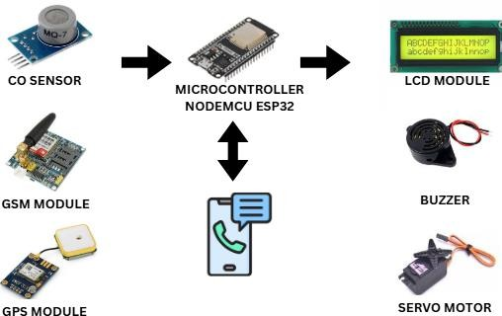

Figure 1. Integrated System Architecture showing NodeMCU ESP32 and peripheral module interfacing.

C. System Validation and Prototype Setup
To ensure operational reliability, the system was initially validated in a controlled environment. Baseline testing was conducted at 0 ppm (clean air), followed by exposure to graduated CO concentrations to verify sensor accuracy. The GPS module’s precision was confirmed by cross-referencing recorded coordinates against known benchmarks, demonstrating high spatial reliability for emergency tracking. Prior to vehicle integration, the components were assembled into a prototype setup (Figure 2) to evaluate inter-module communication and overall logic flow. This stage ensured that the microcontroller, sensors, and communication peripherals functioned as a cohesive unit under experimental conditions.
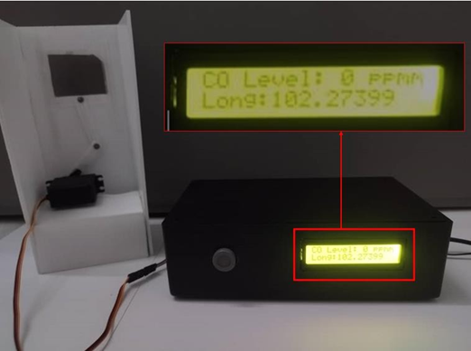

Figure 2. Setup of the Integrated System Prototype (0 ppm – Clean Air)
D. Functional Response to CO Thresholds
The system’s response architecture is triggered by two primary thresholds: Caution (90 ppm) and Danger (200 ppm).
- Caution Zone (90–200 ppm): As illustrated in Fig. 3, detection within this range prompts the system to transmit a warning SMS to the user. The onboard LCD provides real-time telemetry, displaying both the current CO concentration and GPS coordinates to facilitate informed decision-making.
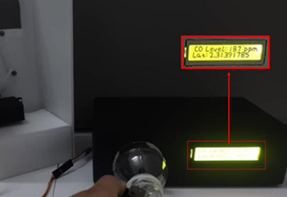

Figure 3. Setup of the Integrated System Prototype (Caution Zone)

- Danger Zone (> 200 ppm): Upon breaching the critical threshold, the system initiates an immediate multi-modal response (Figure. 4). This includes Aural Warning (Activation of a high-decibel buzzer), Mechanical Mitigation (A servo motor automatically lowers the vehicle windows to facilitate ventilation and Emergency Communication (The GSM module dispatches an alert containing the vehicle’s precise location and CO levels and initiates an automated emergency call to pre-programmed contacts.
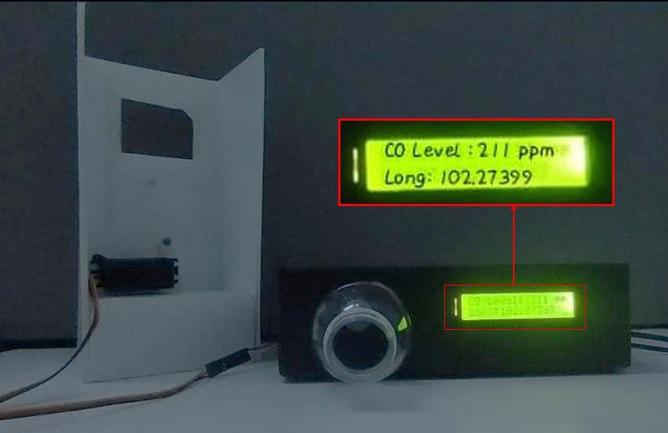

Figure 4. Setup of the Integrated System Prototype (Danger Zone)

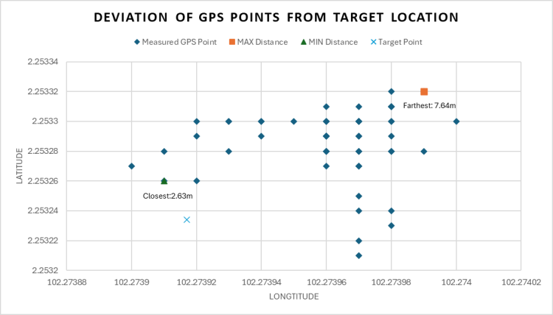
- RESULTS AND DISCUSSION

A. Functional Validation and System Response
The system was evaluated across varying CO concentration levels, with all responses and behaviors recorded to validate operational functionality. When CO concentrations reached the 90 ppm threshold, the system initiated a warning via SMS alert. Upon reaching the critical 200 ppm limit, the system triggered the full suite of safety features: the audible buzzer sounded, the servo motor actuated to open the windows, and an automated emergency call was placed. These actions were consistent with the design objectives of providing both real-time monitoring and immediate mitigation of hazardous CO levels. The detection and response reliability of the system was further confirmed through testing in various vehicle ventilation modes (see Figure 5). Under conditions using external air intake without air conditioning (AC), the peak CO level reached a maximum of 17 ppm. Conversely, during internal circulation without AC, the maximum recorded concentration was 14 ppm. The system demonstrated the capability to successfully detect CO fluctuations across all ventilation modes. It consistently activated the necessary alerts and engaged the mechanical ventilation mechanism to effectively reduce CO concentrations within the vehicle cabin.
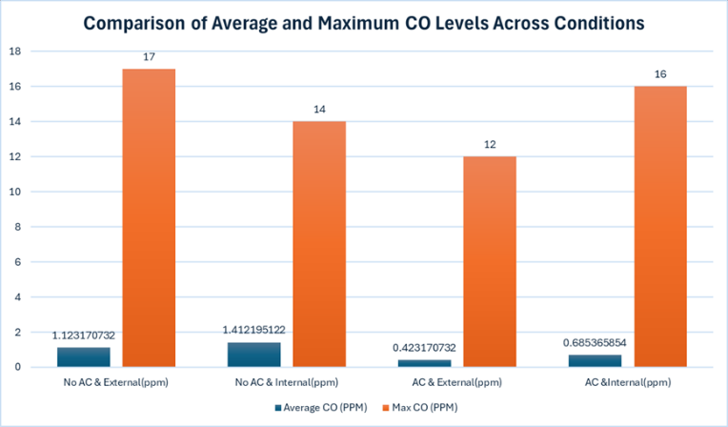

Figure 5. Average and Maximum CO levels Recorded Across Different Testing Conditions
B. GPS Accuracy
The precision of the GPS module was evaluated by recording spatial data and verifying the accuracy of the location mapping. As illustrated in Figure 6, the GPS coordinates were measured in relation to a fixed target position. The recorded data indicated a maximum positional offset of 7.64 meters and a minimum offset of 2.63 meters. This degree of variance is consistent with the standard performance of consumer-grade GPS modules and confirms that the system provides sufficient accuracy for real-time emergency tracking. However, it is noted that location precision may be compromised in environments with poor signal coverage, such as tunnels or “urban canyons”. To mitigate these environmental limitations, future iterations of the system could integrate Assisted GPS (A-GPS) or hybrid positioning technologies to enhance reliability and minimize signal acquisition time in challenging terrains.

Figure 6. Deviation of GPS Coordinates from the Target Location

C. Alert System Performance
The alert system was rigorously evaluated across discrete CO concentration gradients to determine response latency and operational reliability. In the Safe Zone (< 90 ppm), the system remained in a monitoring state without triggering alerts. Upon entering the Caution Zone (90–200 ppm), the system successfully dispatched SMS notifications. When concentrations breached the Danger Zone (> 200 ppm), the system executed a comprehensive safety protocol, which included the transmission of SMS alerts, activation of the audible buzzer, initiation of an automated emergency call, and the autonomous rotation of the servo motor to facilitate cabin ventilation. As illustrated in Figure 7, the system’s performance was quantified across multiple experimental trials. The GSM-based SMS and emergency call functionalities achieved a success rate exceeding 95%, ensuring high-fidelity communication of life-threatening hazards. Furthermore, the mechanical actuation of the servo motor and the buzzer displayed consistent reliability whenever the critical threshold was exceeded.
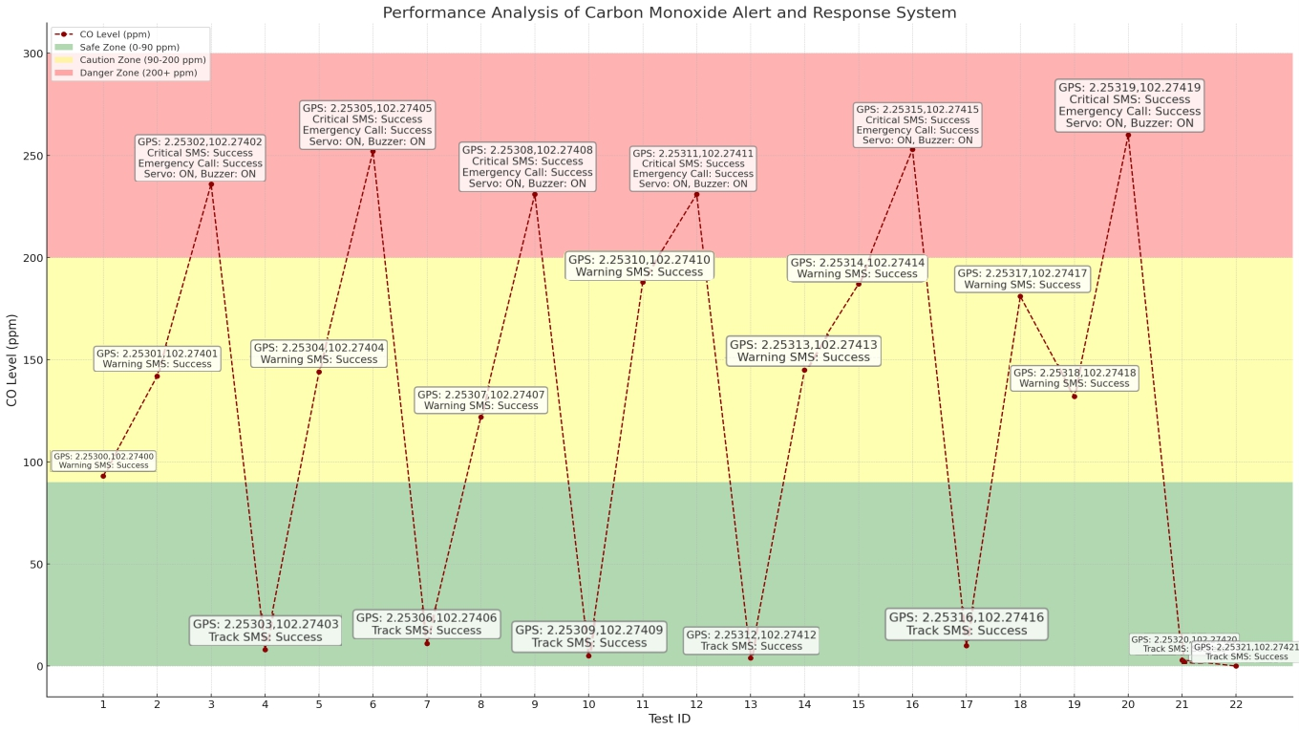
Figure 7. Performance and Reliability of the CO Alert and Response System

However, intermittent latency was observed in the GSM module's response time when testing in areas with marginalized network coverage. This suggests that while the local hardware response (buzzer and servo) is instantaneous, the remote notification subsystem remains dependent on carrier signal strength, a factor that should be considered for future redundant communication links.
D. Discussion
The experimental results demonstrate that the integrated system reliably monitors CO levels, tracks vehicle coordinates, and disseminates timely emergency alerts. Specifically, the detection sub-system proved effective in identifying hazardous CO thresholds and triggering autonomous mitigation protocols, such as activating the servo-driven ventilation and dispatching SMS notifications. While the GPS module provided precise situational data, environmental factors causing signal attenuation such as urban canyons or underground parking remained a notable performance variable. Nevertheless, the GSM-based communication architecture exhibited high reliability, achieving a 95% success rate in alert delivery and emergency call placement during peak-hazard simulations. In contrast to the systems outlined in [8], [10], and [11] (see Table 2), which suffer from "limited safety features" and "locational blindness," the proposed system offers a more robust, holistic solution. By synthesizing real-time gas sensing with active hardware actuation and remote tracking, the architecture addresses the critical "No GPS" and "No ventilation control" disadvantages identified in existing literature. While the reliance on network coverage remains a constraint suggesting the future integration of multi-network or satellite-based modules the results confirm that this multi-layered approach significantly advances the state-of-the-art in both vehicle safety and occupant security.
TABLE 2
COMPARISON OF CURRENT CO MONITORING SYSTEMS AND THE PROPOSED SOLUTION
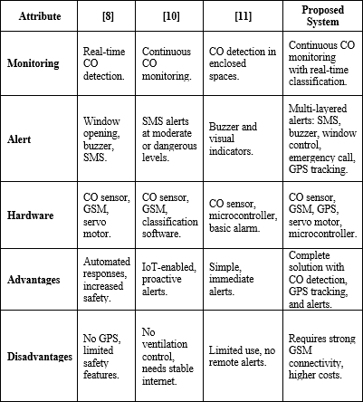
- CONCLUSION
This project successfully developed an integrated vehicle safety system that combines real-time Carbon Monoxide (CO) monitoring, GSM-GPS telemetry, and automated mitigation protocols to enhance passenger protection and vehicle security. Through the deployment of an MQ-7-based sensor architecture, the system demonstrated high reliability in detecting hazardous gas concentrations and triggering multi-modal emergency responses, including localized audible alerts and remote notification via SMS and cellular calls. Furthermore, the integration of GPS tracking provided precise spatial awareness, significantly improving the efficacy of emergency response protocols.While the current prototype achieves its core objectives, future iterations will focus on three key areas of optimization to ensure scalability and robustness:
- Communication Resilience: To mitigate reliance on single-provider GSM coverage, future work will explore multi-network failover systems and satellite-based communication to guarantee connectivity in remote or challenging environments.
- System Efficiency: Future development will prioritize the integration of low-power components and intelligent energy management strategies to minimize the system’s electrical footprint, ensuring long-term sustainability.
- User Interface and Validation: Plans are underway to develop a centralized mobile or web-based dashboard, granting users real-time access to diagnostic data, vehicle telemetry, and historical alert logs.
Finally, continued rigorous testing across diverse environmental conditions including extreme climates will further validate the system’s operational limits. By addressing these technical frontiers, the proposed architecture is positioned to evolve into a comprehensive, industry-standard solution for enhancing automotive safety and occupant well-being.
Acknowledgment
Author thanks to Universiti Teknikal Malaysia Melaka (UTeM) for all the supports.

References
[1] Centers for Disease Control and Prevention. (2024, May 16). Carbon
monoxide poisoning basics.

[2] Tan, B. (2023, July 19). Johor cops suspect accidental carbon monoxide
poisoning after three found dead in car. Malay Mail.

[3] Lim, A. (2023, April 25). MPV crashes into Bentong toll barrier after occupants pass out due to carbon monoxide poisoning. Paul Tan’s Automotive News. https://paultan.org/2023/04/25/mpv-crashes-into-bentong-toll-barrier-after-occupants-pass-out-due-to-carbon-monoxide-poisoning/

[4] Agar, J. (2021, November 15). 3 family members found dead in car died of carbon-monoxide toxicity, records show. mlive.
[5] World Health Organization. (2021). Carbon monoxide poisoning (WHO Reports).

[6] Netstar. (2023, October). Vehicle tracking & recovery: What’s the difference & how does it work? https://doi.org/104164531153/1736253520239

[7] Gastgar, S., Rambabu, A., Vatti, R., Dhoke, S., & Thorbole, S. (2014). Design of GPS and GSM based tracking system. https://doi.org/10.13140/RG.2.2.13835.72485

[8] Yen, G. S. (2020, September). IoT based vehicle carbon monoxide monitoring, alerting and controlling system. International Journal of Advanced Trends in Computer Science and Engineering, 9(1.5), 334–339. https://doi.org/10.30534/ijatcse/2020/4791.52020

[9] Chowdary, G. R., Munappa, S., Saiteja, N. V., & Priya, K. S. S. (2024, July). Vehicle pollution monitoring system using IOT. 2024 Asia Pacific Conference on Innovation in Technology (APCIT), 1–6. https://doi.org/10.1109/apcit62007.2024.10673499

[10] Batra, N., Kaur, J., & Batra, N. K. (2020, December). SmartCOdetect: An automated car window opening system on detection of carbon monoxide. International Journal of Vehicle Structures and Systems, 12(4). https://doi.org/10.4273/ijvss.12.4.09

[11]Azhar, N. I., Hussin, Z. M., & Mohammad, S. (2023, August). Development of carbon monoxide gas leakage detector in vehicles using IOT. 2023 International Conference on Electrical, Electronics, Communication and Computer Engineering (ICE2T), 330–334. https://doi.org/10.1109/ice2t58637.2023.10540501

[12] Hussain, A.-S. T., Fadhil, M., Taha, T. A., Ahmed, O. K., Ahmed, S. A., & Desa, H. (2023, November). GPS and GSM based vehicle tracking system. 2023 International Conference on Intelligent Systems and Applications (ISAS). https://doi.org/10.1109/isas60782.2023.10391720

[13] Estrada, E., Moreno, M., Martin, K., Mever, A. L., Rodrigo, P. M., & Gutierrez, S. (2019, October). Low cost CO detector integrated with IoT. 2019 IEEE International Conference on Engineering Veracruz (ICEV). https://doi.org/10.1109/icev.2019.8920567

[14] Bhatnagar, A., Sharma, V., & Raj, G. (2018, June 1). IoT based car pollution detection using AWS. IEEE Xplore.

[15] Shakunthala, Sangeetha, S., Muthu Krishnammal, & Padmavathy, T. V. (2022, December). Intelligent sensor and IoT based vehicle pollution monitoring system with alert. 2022 International Conference on Power, Energy, Control and Transmission Systems (ICPECTS). https://doi.org/10.1109/icpects56089.2022.10046769

[16] R, M. S., Deepa, K., & Nithya, M. (2022, November 1). Vehicular emission monitoring and alerting system using IoT. IEEE Xplore. https://ieeexplore.ieee.org/document/10040110

[17] Smart monitoring of carbon monoxide using Internet of Things. (2020, January). International Journal of Innovative Technology and Exploring Engineering, 9(3), 3648–3651. https://doi.org/10.35940/ijitee.c8616.019320

[18] Kamarudin, A., et al. (2021, November). IoT-based carbon monoxide (CO) real-time warning system application in vehicles. Journal of Physics: Conference Series, 2107(1), 012043. https://doi.org/10.1088/1742-6596/2107/1/012043

