“Impact of ‘Always Available’ Work Culture on Employee Mental Health and Productivity”

ABSTRACT
The study examines the impact of the “always available” work culture on employee mental health and productivity in modern organizations. With the increasing use of digital communication tools such as emails, messaging apps and virtual platforms, employees are often expected to remain connected beyond official working hours. This continuous connectivity blurs the boundaries between work and personal life, leading to potential challenges in maintaining overall well – being. The research focuses on understanding how after – hours work communication influences employees’ stress levels, mental exhaustion and ability to maintain work – life balance and how these factors affect their productivity at work. Primary data is collected through a structured questionnaire using Google Forms, targeting working professionals across various industries. The study adopts a quantitative approach and uses correlation analysis to examine relationships between variables. The findings are expected to highlight whether constant availability enhances efficiency or leads to negative outcomes such as burnout, reduced job satisfaction and decreased performance. The study aims to provide insights for organizations to design effective HR policies that promote healthy work boundaries and improve employee well – being.

Keywords: Always Available Work Culture, Employee Mental Health, Productivity, Work – Life Balance, Job Satisfaction

1. INTRODUCTION
1.1 BACKGROUND OF THE TOPIC
The nature of work in the modern digital age has gone through a tremendous change because of the fast-growing technological advancements and the utilization of the communication channels like emails, instant messaging, and virtual-collaboration tools. These innovations have helped workers to be in touch with their work anywhere and anytime. As much as this connectivity has enhanced efficiency in communication and responsiveness to the organization, it has also created an always available work culture. The always available/ always-on work culture can be defined as a state of affairs when workers are supposed to be available after they have officially finished working hours and most of the time, respond to work related messages, phone calls or even e-mails evenings, weekends or even holidays. This culture has gained even more importance with the emergence of remote and hybrid work models, in particular, post-COVID-19 when the lines between working and personal life became even more unclear. Studies have shown that although flexible work arrangements have convenience and autonomy benefits, they also pose challenges with regard to boundary management. Workers find it hard to distinguish between work and personal life and thus they are constantly involved in work. These blurred lines may lead to a higher level of stress, mental exhaustion and emotional exhaustion. Moreover, the anticipation of being available at all times may put a strain on the employees to be available at any one time even when they are not on duty. This unrelenting access can create a feeling of duty, and employees will lose the capacity to switch off and relax due to stress at work. In the long run, this will harm mental health and performance at work.

1.2 NEED/IMPORTANCE OF THE TOPIC
The growing popularity of the twenty-four-seven work culture has cast grave doubts over the welfare of workers and the sustainability of the organizations. Although organizations tend to believe that being ever-connected can increase their productivity and efficiency, there are emerging trends that indicate that this might adversely affect the organizations in the long run. The effect on the mental health of employees is one of the main problems related to this culture. Research indicates that workers who cannot detach themselves after work tend to be stressed, feeling burnt out and emotionally exhausted. These environments may cause severe health issues and diminished job satisfaction when exposed to in the long-term. Also, the lack of a proper work-life balance impact the personal relationships as well as the general quality of life of employees. Employees who are always working might lack time to rest, relax and perform personal activities that are important to them and their mental and emotional health. Organizational wise, an employee well-being may lead to low productivity, high absenteeism, and high employee turnover. Indeed, interruptions and digital overload have been identified to decrease attention and efficiency hence affecting performance adversely. Thus, the necessity to investigate the effects of the always available work culture on the employee mental health and productivity is high. Knowledge of this relationship can assist organizations to formulate good HR policies that facilitate healthy work-life balance and productivity.
1.3 THEORETICAL IMPLICATION OF THE TOPIC
There are various valuable organizational and psychological theories which can be applied to the concept of always available work culture.
To begin with, Work-Life Balance Theory suggests that people can work better when there is a distinct line between the work and personal life. Loss of this balance causes stress and dissatisfaction which impacts on the overall performance.

Secondly, Role Conflict Theory states that people in life have many roles including that of an employee, family member, and social participant. When the needs of one position disrupt another, conflict arises, resulting in stress and lack of effectiveness in either position. The continuous work in the context of the culture of the always available work places imposes on personal life, resulting in work-family conflict.

The other one is the Job Demands-Resources (JD-R) Model, which asserts that high job demands (including constant connectivity and workload) may cause burnout, unless they are balanced by resources, such as rest, autonomy, and organizational support. When workers are supposed to be on call 24/7, job demand is very high and it can lead to mental burnout and low productivity.

Also, the theory of Boundary Theory is also quite applicable to the present research. The theory is concerned with the way people cope with work/personal life boundaries. The boundaries in an always-on culture are weak or blurred and the employees cannot easily disconnect with their work, which eventually impacts their well-being. These theoretical standpoints assist in comprehending the effect of the always available work culture on the employees both psychologically and organizationally hence this study is useful in the discipline of Human Resource Management.

  - RECENT TRENDS
- The COVID-19 pandemic has led to more people adopting remote and hybrid work models in industries.
- Increase in the use of digital communication devices like Slack, Teams, and WhatsApp in work-related communication.
- Increasing demands on immediate reaction by employees, regardless of whether they are on duty or not.
- Rising incidences of work burnout and stress as a result of being available at all times.
- Difficulties in work life boundaries, where most employees report to be unable to turn off work.
- Development of the so-called always-on culture of work, which is accompanied by mental health issues and a decrease in job satisfaction.
- Introduction of policies such as Right to Disconnect in a few countries to safeguard well-being of employees.
- Increasing awareness by organizations regarding employee mental health and wellness programs.
- Increased employee demands in flexibility and improved work-life balance.
- Moving towards greater emphasis on digital detox and boundary-setting activities to eliminate stress and enhance productivity.

2. LITERATURE REVIEW
- However, when looking at this study, I felt the way people always being online change the way people behave at their employment. A group interviewed 317 employees in universities and found that employees who were inclined to overworking felt compelled to respond promptly to messages and wrestled to establish firm limits on the use of technology. Individuals who did limited their use of digital tools said they felt less urgent about remaining connected. Two things, of what material has presented itself in the figures, have struck me, the one being my being hooked on work and thus raising tension; the other being in drawing lines which brings it all down. Apparently, placing regulations on when and how often should you check on job messages could either help relieve you of the urge to keep yourself on 24/7 He says, even when you naturally feel the compulsive need to work nonstop. (Wilder, Aziz, & Wuensch, 2024)

- I have interpreted this as a sign that levels of stress caused by telepressure are fuelled by being expected to be reachable after work. The research followed 185 employees across two time points and revealed that, in cases where individuals felt a great need to be available on ICT, people also were found to feel the need to react quickly, thus leading to increased burnout and conflict between professional and personal life. Another observation that I made was that instance self-regulation could not reduce this effect. It even cemented the connection. Individuals who were more disciplined or controlled in their behaviors appeared to internalize the pressure more to increase telepressure and its effects. This implies that in a job that places a heavy emphasis on its ability to be accessed at all times, it is not sufficient to manage the habits that you have. In its own, the demand is a driver of stress and spill over to the personal life. (Kao, Chi, Thomas, Lee, & Wang, 2020)

- This study explores the relationship between constant connectivity and employee outcomes, highlighting how the expectation to remain available beyond standard work hours contributes to increased stress, emotional exhaustion, and reduced psychological recovery. The findings indicate that continuous exposure to work-related communication through digital technologies blurs the boundaries between personal and professional life, leading to work–family conflict and diminished well-being. Furthermore, the research emphasizes that while such connectivity may enhance short-term responsiveness and perceived productivity, it often results in long-term declines in efficiency due to burnout and fatigue. The study concludes by recommending organizational interventions such as clear communication boundaries and digital disconnection policies to maintain sustainable productivity and protect employee mental health. (Barber, Santuzzi, & Hu, 2023)

- This study explores the relationship between constant connectivity and employee outcomes, highlighting how the expectation to remain available beyond standard work hours contributes to increased stress, emotional exhaustion, and reduced psychological recovery. The findings indicate that continuous exposure to work-related communication through digital technologies blurs the boundaries between personal and professional life, leading to work–family conflict and diminished well-being. Furthermore, the research emphasizes that while such connectivity may enhance short-term responsiveness and perceived productivity, it often results in long-term declines in efficiency due to burnout and fatigue. The study concludes by recommending organizational interventions such as clear communication boundaries and digital disconnection policies to maintain sustainable productivity and protect employee mental health. (Grawitch, J, Gottschalk, Megan, & C, 2020)

- This study explores the relationship between constant connectivity and employee outcomes, highlighting how the expectation to remain available beyond standard work hours contributes to increased stress, emotional exhaustion, and reduced psychological recovery. The findings indicate that continuous exposure to work-related communication through digital technologies blurs the boundaries between personal and professional life, leading to work–family conflict and diminished well-being. Furthermore, the research emphasizes that while such connectivity may enhance short-term responsiveness and perceived productivity, it often results in long-term declines in efficiency due to burnout and fatigue. The study concludes by recommending organizational interventions such as clear communication boundaries and digital disconnection policies to maintain sustainable productivity and protect employee mental health. (Santuzzi, M, Barber, & K, 2025)

- This study explores the relationship between constant connectivity and employee outcomes, highlighting how the expectation to remain available beyond standard work hours contributes to increased stress, emotional exhaustion, and reduced psychological recovery. The findings indicate that continuous exposure to work-related communication through digital technologies blurs the boundaries between personal and professional life, leading to work–family conflict and diminished well-being. Furthermore, the research emphasizes that while such connectivity may enhance short-term responsiveness and perceived productivity, it often results in long-term declines in efficiency due to burnout and fatigue. The study concludes by recommending organizational interventions such as clear communication boundaries and digital disconnection policies to maintain sustainable productivity and protect employee mental health. (Makhubele, Josephine C, Mabasa, Thanyani T, & Maluleke, 2022)

- This study explores the relationship between constant connectivity and employee outcomes, highlighting how the expectation to remain available beyond standard work hours contributes to increased stress, emotional exhaustion, and reduced psychological recovery. The findings indicate that continuous exposure to work-related communication through digital technologies blurs the boundaries between personal and professional life, leading to work–family conflict and diminished well-being. Furthermore, the research emphasizes that while such connectivity may enhance short-term responsiveness and perceived productivity, it often results in long-term declines in efficiency due to burnout and fatigue. The study concludes by recommending organizational interventions such as clear communication boundaries and digital disconnection policies to maintain sustainable productivity and protect employee mental health. (Reinecke, L, Aufenanger, S, Beutel, M. E, et al., 2017)

- This study explores the relationship between constant connectivity and employee outcomes, highlighting how the expectation to remain available beyond standard work hours contributes to increased stress, emotional exhaustion, and reduced psychological recovery. The findings indicate that continuous exposure to work-related communication through digital technologies blurs the boundaries between personal and professional life, leading to work–family conflict and diminished well-being. Furthermore, the research emphasizes that while such connectivity may enhance short-term responsiveness and perceived productivity, it often results in long-term declines in efficiency due to burnout and fatigue. The study concludes by recommending organizational interventions such as clear communication boundaries and digital disconnection policies to maintain sustainable productivity and protect employee mental health. (Tarafdar, M, Cooper, C. L, & Stich, J. F, 2019)

- This study explores the relationship between constant connectivity and employee outcomes, highlighting how the expectation to remain available beyond standard work hours contributes to increased stress, emotional exhaustion, and reduced psychological recovery. The findings indicate that continuous exposure to work-related communication through digital technologies blurs the boundaries between personal and professional life, leading to work–family conflict and diminished well-being. Furthermore, the research emphasizes that while such connectivity may enhance short-term responsiveness and perceived productivity, it often results in long-term declines in efficiency due to burnout and fatigue. The study concludes by recommending organizational interventions such as clear communication boundaries and digital disconnection policies to maintain sustainable productivity and protect employee mental health. (Peters, P, den Dulk, L, & van der Lippe, T, 2010)

- This study explores the relationship between constant connectivity and employee outcomes, highlighting how the expectation to remain available beyond standard work hours contributes to increased stress, emotional exhaustion, and reduced psychological recovery. The findings indicate that continuous exposure to work-related communication through digital technologies blurs the boundaries between personal and professional life, leading to work–family conflict and diminished well-being. Furthermore, the research emphasizes that while such connectivity may enhance short-term responsiveness and perceived productivity, it often results in long-term declines in efficiency due to burnout and fatigue. The study concludes by recommending organizational interventions such as clear communication boundaries and digital disconnection policies to maintain sustainable productivity and protect employee mental health. (Riedl, R, 2013)

- This study explores the relationship between constant connectivity and employee outcomes, highlighting how the expectation to remain available beyond standard work hours contributes to increased stress, emotional exhaustion, and reduced psychological recovery. The findings indicate that continuous exposure to work-related communication through digital technologies blurs the boundaries between personal and professional life, leading to work–family conflict and diminished well-being. Furthermore, the research emphasizes that while such connectivity may enhance short-term responsiveness and perceived productivity, it often results in long-term declines in efficiency due to burnout and fatigue. The study concludes by recommending organizational interventions such as clear communication boundaries and digital disconnection policies to maintain sustainable productivity and protect employee mental health. (Bloom, N, Liang, J, Roberts, J, & Ying, Z. J, 2015)

- This study explores the relationship between constant connectivity and employee outcomes, highlighting how the expectation to remain available beyond standard work hours contributes to increased stress, emotional exhaustion, and reduced psychological recovery. The findings indicate that continuous exposure to work-related communication through digital technologies blurs the boundaries between personal and professional life, leading to work–family conflict and diminished well-being. Furthermore, the research emphasizes that while such connectivity may enhance short-term responsiveness and perceived productivity, it often results in long-term declines in efficiency due to burnout and fatigue. The study concludes by recommending organizational interventions such as clear communication boundaries and digital disconnection policies to maintain sustainable productivity and protect employee mental health. (Gajendran, R. S, & Harrison, D. A, 2007)

- This study explores the relationship between constant connectivity and employee outcomes, highlighting how the expectation to remain available beyond standard work hours contributes to increased stress, emotional exhaustion, and reduced psychological recovery. The findings indicate that continuous exposure to work-related communication through digital technologies blurs the boundaries between personal and professional life, leading to work–family conflict and diminished well-being. Furthermore, the research emphasizes that while such connectivity may enhance short-term responsiveness and perceived productivity, it often results in long-term declines in efficiency due to burnout and fatigue. The study concludes by recommending organizational interventions such as clear communication boundaries and digital disconnection policies to maintain sustainable productivity and protect employee mental health. (Allen, T. D, Golden, T. D, & Shockley, K. M, 2015)

- This study explores the relationship between constant connectivity and employee outcomes, highlighting how the expectation to remain available beyond standard work hours contributes to increased stress, emotional exhaustion, and reduced psychological recovery. The findings indicate that continuous exposure to work-related communication through digital technologies blurs the boundaries between personal and professional life, leading to work–family conflict and diminished well-being. Furthermore, the research emphasizes that while such connectivity may enhance short-term responsiveness and perceived productivity, it often results in long-term declines in efficiency due to burnout and fatigue. The study concludes by recommending organizational interventions such as clear communication boundaries and digital disconnection policies to maintain sustainable productivity and protect employee mental health. (Eurofound, 2017)

- This study explores the relationship between constant connectivity and employee outcomes, highlighting how the expectation to remain available beyond standard work hours contributes to increased stress, emotional exhaustion, and reduced psychological recovery. The findings indicate that continuous exposure to work-related communication through digital technologies blurs the boundaries between personal and professional life, leading to work–family conflict and diminished well-being. Furthermore, the research emphasizes that while such connectivity may enhance short-term responsiveness and perceived productivity, it often results in long-term declines in efficiency due to burnout and fatigue. The study concludes by recommending organizational interventions such as clear communication boundaries and digital disconnection policies to maintain sustainable productivity and protect employee mental health. (OECD, 2020)

- This study explores the relationship between constant connectivity and employee outcomes, highlighting how the expectation to remain available beyond standard work hours contributes to increased stress, emotional exhaustion, and reduced psychological recovery. The findings indicate that continuous exposure to work-related communication through digital technologies blurs the boundaries between personal and professional life, leading to work–family conflict and diminished well-being. Furthermore, the research emphasizes that while such connectivity may enhance short-term responsiveness and perceived productivity, it often results in long-term declines in efficiency due to burnout and fatigue. The study concludes by recommending organizational interventions such as clear communication boundaries and digital disconnection policies to maintain sustainable productivity and protect employee mental health. (Maslach, C, & Leiter, M. P, 2016)

- This study explores the relationship between constant connectivity and employee outcomes, highlighting how the expectation to remain available beyond standard work hours contributes to increased stress, emotional exhaustion, and reduced psychological recovery. The findings indicate that continuous exposure to work-related communication through digital technologies blurs the boundaries between personal and professional life, leading to work–family conflict and diminished well-being. Furthermore, the research emphasizes that while such connectivity may enhance short-term responsiveness and perceived productivity, it often results in long-term declines in efficiency due to burnout and fatigue. The study concludes by recommending organizational interventions such as clear communication boundaries and digital disconnection policies to maintain sustainable productivity and protect employee mental health. (World Health Organization, 2019)

- This study explores the relationship between constant connectivity and employee outcomes, highlighting how the expectation to remain available beyond standard work hours contributes to increased stress, emotional exhaustion, and reduced psychological recovery. The findings indicate that continuous exposure to work-related communication through digital technologies blurs the boundaries between personal and professional life, leading to work–family conflict and diminished well-being. Furthermore, the research emphasizes that while such connectivity may enhance short-term responsiveness and perceived productivity, it often results in long-term declines in efficiency due to burnout and fatigue. The study concludes by recommending organizational interventions such as clear communication boundaries and digital disconnection policies to maintain sustainable productivity and protect employee mental health. (Bakker, A. B, & Demerouti, E, 2017)

- This study explores the relationship between constant connectivity and employee outcomes, highlighting how the expectation to remain available beyond standard work hours contributes to increased stress, emotional exhaustion, and reduced psychological recovery. The findings indicate that continuous exposure to work-related communication through digital technologies blurs the boundaries between personal and professional life, leading to work–family conflict and diminished well-being. Furthermore, the research emphasizes that while such connectivity may enhance short-term responsiveness and perceived productivity, it often results in long-term declines in efficiency due to burnout and fatigue. The study concludes by recommending organizational interventions such as clear communication boundaries and digital disconnection policies to maintain sustainable productivity and protect employee mental health. (Sonnentag, S, & Fritz, C, 2015)

- This study explores the relationship between constant connectivity and employee outcomes, highlighting how the expectation to remain available beyond standard work hours contributes to increased stress, emotional exhaustion, and reduced psychological recovery. The findings indicate that continuous exposure to work-related communication through digital technologies blurs the boundaries between personal and professional life, leading to work–family conflict and diminished well-being. Furthermore, the research emphasizes that while such connectivity may enhance short-term responsiveness and perceived productivity, it often results in long-term declines in efficiency due to burnout and fatigue. The study concludes by recommending organizational interventions such as clear communication boundaries and digital disconnection policies to maintain sustainable productivity and protect employee mental health. (Ayyagari, R, Grover, V, & Purvis, R, 2011)

- This study explores the relationship between constant connectivity and employee outcomes, highlighting how the expectation to remain available beyond standard work hours contributes to increased stress, emotional exhaustion, and reduced psychological recovery. The findings indicate that continuous exposure to work-related communication through digital technologies blurs the boundaries between personal and professional life, leading to work–family conflict and diminished well-being. Furthermore, the research emphasizes that while such connectivity may enhance short-term responsiveness and perceived productivity, it often results in long-term declines in efficiency due to burnout and fatigue. The study concludes by recommending organizational interventions such as clear communication boundaries and digital disconnection policies to maintain sustainable productivity and protect employee mental health. (Clark, S. C, 2000)

- This study explores the relationship between constant connectivity and employee outcomes, highlighting how the expectation to remain available beyond standard work hours contributes to increased stress, emotional exhaustion, and reduced psychological recovery. The findings indicate that continuous exposure to work-related communication through digital technologies blurs the boundaries between personal and professional life, leading to work–family conflict and diminished well-being. Furthermore, the research emphasizes that while such connectivity may enhance short-term responsiveness and perceived productivity, it often results in long-term declines in efficiency due to burnout and fatigue. The study concludes by recommending organizational interventions such as clear communication boundaries and digital disconnection policies to maintain sustainable productivity and protect employee mental health. (Ashforth, B. E, Kreiner, G. E, & Fugate, M, 2000)

- This study explores the relationship between constant connectivity and employee outcomes, highlighting how the expectation to remain available beyond standard work hours contributes to increased stress, emotional exhaustion, and reduced psychological recovery. The findings indicate that continuous exposure to work-related communication through digital technologies blurs the boundaries between personal and professional life, leading to work–family conflict and diminished well-being. Furthermore, the research emphasizes that while such connectivity may enhance short-term responsiveness and perceived productivity, it often results in long-term declines in efficiency due to burnout and fatigue. The study concludes by recommending organizational interventions such as clear communication boundaries and digital disconnection policies to maintain sustainable productivity and protect employee mental health. (Kossek, E. E, Ruderman, M. N, Braddy, P. W, & Hannum, K. M, 2012)

- This study explores the relationship between constant connectivity and employee outcomes, highlighting how the expectation to remain available beyond standard work hours contributes to increased stress, emotional exhaustion, and reduced psychological recovery. The findings indicate that continuous exposure to work-related communication through digital technologies blurs the boundaries between personal and professional life, leading to work–family conflict and diminished well-being. Furthermore, the research emphasizes that while such connectivity may enhance short-term responsiveness and perceived productivity, it often results in long-term declines in efficiency due to burnout and fatigue. The study concludes by recommending organizational interventions such as clear communication boundaries and digital disconnection policies to maintain sustainable productivity and protect employee mental health. (Greenhaus, J. H., & Beutell, N. J, 1985)

- This study explores the relationship between constant connectivity and employee outcomes, highlighting how the expectation to remain available beyond standard work hours contributes to increased stress, emotional exhaustion, and reduced psychological recovery. The findings indicate that continuous exposure to work-related communication through digital technologies blurs the boundaries between personal and professional life, leading to work–family conflict and diminished well-being. Furthermore, the research emphasizes that while such connectivity may enhance short-term responsiveness and perceived productivity, it often results in long-term declines in efficiency due to burnout and fatigue. The study concludes by recommending organizational interventions such as clear communication boundaries and digital disconnection policies to maintain sustainable productivity and protect employee mental health. (Voydanoff, P, 2005)

- This study explores the relationship between constant connectivity and employee outcomes, highlighting how the expectation to remain available beyond standard work hours contributes to increased stress, emotional exhaustion, and reduced psychological recovery. The findings indicate that continuous exposure to work-related communication through digital technologies blurs the boundaries between personal and professional life, leading to work–family conflict and diminished well-being. Furthermore, the research emphasizes that while such connectivity may enhance short-term responsiveness and perceived productivity, it often results in long-term declines in efficiency due to burnout and fatigue. The study concludes by recommending organizational interventions such as clear communication boundaries and digital disconnection policies to maintain sustainable productivity and protect employee mental health. (Derks, D., & Bakker, A. B, 2014)

- This study explores the relationship between constant connectivity and employee outcomes, highlighting how the expectation to remain available beyond standard work hours contributes to increased stress, emotional exhaustion, and reduced psychological recovery. The findings indicate that continuous exposure to work-related communication through digital technologies blurs the boundaries between personal and professional life, leading to work–family conflict and diminished well-being. Furthermore, the research emphasizes that while such connectivity may enhance short-term responsiveness and perceived productivity, it often results in long-term declines in efficiency due to burnout and fatigue. The study concludes by recommending organizational interventions such as clear communication boundaries and digital disconnection policies to maintain sustainable productivity and protect employee mental health. (Mellner, C, 2016)

- This study explores the relationship between constant connectivity and employee outcomes, highlighting how the expectation to remain available beyond standard work hours contributes to increased stress, emotional exhaustion, and reduced psychological recovery. The findings indicate that continuous exposure to work-related communication through digital technologies blurs the boundaries between personal and professional life, leading to work–family conflict and diminished well-being. Furthermore, the research emphasizes that while such connectivity may enhance short-term responsiveness and perceived productivity, it often results in long-term declines in efficiency due to burnout and fatigue. The study concludes by recommending organizational interventions such as clear communication boundaries and digital disconnection policies to maintain sustainable productivity and protect employee mental health. (Schlachter, S, McDowall, A, Cropley, M, & Inceoglu, I, 2018)

- This study explores the relationship between constant connectivity and employee outcomes, highlighting how the expectation to remain available beyond standard work hours contributes to increased stress, emotional exhaustion, and reduced psychological recovery. The findings indicate that continuous exposure to work-related communication through digital technologies blurs the boundaries between personal and professional life, leading to work–family conflict and diminished well-being. Furthermore, the research emphasizes that while such connectivity may enhance short-term responsiveness and perceived productivity, it often results in long-term declines in efficiency due to burnout and fatigue. The study concludes by recommending organizational interventions such as clear communication boundaries and digital disconnection policies to maintain sustainable productivity and protect employee mental health. (Barber, L. K, & Santuzzi, A. M, 2015)

- This study explores the relationship between constant connectivity and employee outcomes, highlighting how the expectation to remain available beyond standard work hours contributes to increased stress, emotional exhaustion, and reduced psychological recovery. The findings indicate that continuous exposure to work-related communication through digital technologies blurs the boundaries between personal and professional life, leading to work–family conflict and diminished well-being. Furthermore, the research emphasizes that while such connectivity may enhance short-term responsiveness and perceived productivity, it often results in long-term declines in efficiency due to burnout and fatigue. The study concludes by recommending organizational interventions such as clear communication boundaries and digital disconnection policies to maintain sustainable productivity and protect employee mental health. (Day, A, Scott, N, & Kelloway, E. K, 2012)

3. COMPANY PROFILE & INDUSTRY PROFILE
3.1 COMPANY PROFILE
3.1.1 ABOUT THE COMPANY
Akshara Enterprises is a Bengaluru based business management and consulting firm, founded in 2023, and is in the industry of business consulting and services. The company aims at providing end-to-end business solutions to organizations in various fields. The main goal of it is to assist companies with streamlining operations, enhancing efficiency, and attaining scalable growth. In contrast to other conventional consulting companies, which offer advisory services only, Akshara Enterprises is a hands-on implementation company, focusing on management and optimization of fundamental business operations. The scope of the services offered by the company is the whole business life cycle- starting with setting up and structuring of processes, management of operations and expanding plans. This combined model allows clients to concentrate on their main competencies as Akshara is in charge of execution and performance enhancement. As a relatively young organization, the company is flexible, adaptable, and growth-oriented, which makes it a strategic partner of startups, small businesses, and emerging brands that want to gain structured growth in the competitive markets.

3.1.2 VISION AND MISSION
Vision: Be a preferred and foremost provider of integrated business solutions, enabling organizations to realize sustainable growth, operational excellence, and long-term success in a dynamic business environment.
Mission: To develop, optimize, and scale business processes through end-to-end services in production, logistics, marketing, and sales to assist brands to work smarter and grow successfully in competitive markets.

3.1.3 CORE SERVICES
Akshara Enterprises provides a broad spectrum of integrated services to support strategic and operational imperative of businesses:
- Operations Management: The company assists companies in streamlining the internal operations, enhancing workflow efficiency, and eliminating operational bottlenecks. This involves organizing systems, performance monitoring and best practices.

- Production and Logistics Management: Akshara Enterprises helps businesses in managing production cycles and supply chain activities, and provides a seamless coordination between procurement, manufacturing, and distribution. This assists in minimizing delays, cost optimization and efficient delivery.

- Marketing Strategy and Implementation: The company will assist in terms of marketing strategy, brand positioning, and campaign implementation that will allow business organizations to be more visible, win customers, and establish a solid market share.

- Sales and Business Development: Akshara Enterprises can help to generate more revenue through the identification of new opportunities, enhanced sales, and market penetration. This involves the lead generation, client acquisition plans and relationship management.

- End-to-End Business Solutions: An important dissimilarity is that it offers holistic solutions, which is to relate to many business aspects within a single framework. This helps to minimize the number of service providers and provides improved coordination between departments

3.1.4 FUNDING AND INVESTMENTS
Akshara Enterprises is a privately owned company and no information exists as far as external funding, venture capital investments or institutional financing is concerned. This implies that the company does business in a bootstrapped model whereby it uses its own resources and revenue generated in order to maintain and grow its business. This type of funding enables the company to have more control over decision-making and strategic direction, but can also slow down growth relative to venture-funded companies. As the company expands, it can consider the option of external investment or strategic partnerships to further expand operations.

3.1.5 REVENUE AND MARKET POSITION
Although there is no publicly available data on the exact financial numbers, Akshara Enterprises can be placed in the market due to its framework and products:
- It competes in a competitive and fast expanding business of consulting.
- Mainly aims at startups, SMEs and new businesses.
- Is concerned with offering execution-oriented solutions that are cost-effective.
- Located in the position of a growing company in the initial phase of market development.
One of the ways in which the company differentiates is its end-to-end service model which integrates strategy and execution. This strategy makes it have a competitive advantage over the conventional consultants who might just offer advice without the support of implementation.
Since it is a relatively young company, it is probably in the market penetration and growth stage, which is aimed at the development of a large customer base, the increase of brand awareness, and the broadening of its service offer.

3.1.6 SWOT ANALYSIS
- STRENGTHS:
  - Diversity: The company offers a wide variety of services in various business operations which gives the clients an opportunity to get many services offered by a single firm and the overall efficiency is enhanced.
  - Execution: It is very keen on execution of strategies so that ideas are not only planned but also in actual business situations, they are well implemented.
  - Flexibility: It being a young organization it can swiftly respond to changes in the market, the demands of the clients and the emerging trends without being slowed down by the structures.
  - Location: It is located in Bengaluru, which provides it access to a vibrant startup ecosystem, improved networking, and access to a large talent pool.
  - Customization: The company can create customized solutions to each customer, and this can assist in handling certain business issues more efficiently.

- WEAKNESSES:
- Recognition: The firm is a new company, so it does not have a strong brand perception and image in the market, which can have an initial impact on the trust of the clients.
- Transparency: Lack of publicly available financial and performance information may result in a lack of credibility in the eyes of potential clients or investors.
- Resources: Operating on bootstrapped model can restrict access to financial resources, technology and manpower needed to carry out large-scale projects.
- Scale: The company operates on smaller scale as compared to established consulting firms, and this could limit its capacity to undertake high-volume or complex assignments.

- OPPORTUNITIES:
- Demand: Outsourced consulting and operational support are increasingly in demand as businesses seek to enhance efficiency and save money.
- Growth: The high-speed development of startups and MSMEs in India provides a huge and growing customer base of such services.
- Efficiency: Small companies have an edge in providing flexible pricing and services as companies are adopting cost-effective and scalable solutions.
- Technology: The use of digital tools, automation and data-driven consulting is a chance to improve the quality of service and develop competitive advantage.
- Expansion: The company can diversify in other industries and geographic expansion where it can increase the market share.

- THREATS:
- Competition: The company has a stiff competition with established consulting firms and startup firms providing the same services.
- Saturation: There are some areas of consulting that are getting saturated and it is more difficult to distinguish and win clients.
- Economy: Economic slowdown or uncertainty may prompt businesses to reduce their spending on consultancy, and this will impact on the revenue.
- Talent: Recruiting and retaining top talent may be challenging, particularly when it is competing with bigger companies, which can offer a better remuneration package.
- Consistency: With the expansion of the firm, it might face difficulties in the consistency of service provision among all projects and customers.

3.2 INDUSTRY PROFILE
3.2.1 OVERVIEW
Business consulting and services industry is an industry that involves companies that offer professional advice, strategic and operational support to companies in different industries. These companies help companies enhance performance, address complicated issues, and reach the growth by providing services in strategy, operations, finance, human resources, marketing, and technology.
The consulting industry is a high-value and knowledge-based sector worldwide, and the market is projected to expand as a result of the growing need to employ specialized skills and solutions to digital transformation. The industry in India has been experiencing a high rate of growth, owing to economic growth, increased entrepreneurship and professional management practices.

3.2.2 KEY DRIVERS OF GROWTH
A number of reasons are behind the booming growth of the consulting business:
- Digital Transformation: Companies are progressively embracing digital solutions like AI, cloud computing, and data analytics, which are generating a need to hire consultants to assist them in the implementation.
- Surging Startup and MSME Ecosystem: The high rate of startup and small business in India is raising the demand of organized business counseling and business assistance.
- Complex Business Environment: The changing market dynamics and globalization demands that companies seek the advice of experts in order to be competitive.
- Regulatory and Compliance Requirement: Rising regulatory complexity creates need of specialized advisory services.
- Paying Attention to Efficiency and Cost Optimization: Organizations are resorting to consultants to streamline the operations and enhance profitability.
- Sustainability and ESG Trends: There is increasing focus on environmental and social governance, which is opening up new consulting opportunities.

3.2.3 INDUSTRY CHALLENGES
Nevertheless, despite the high growth rates, the consulting industry has a number of challenges:
- High Cost of Service: a lot of SMEs do not consult because of high costs and lengthy projects.
- Rapid Competition: Existence of international giants and customized firms provides pressure on pricing and differentiation.
- Shortage of Talent: The inability to recruit talented specialists in new areas of AI and cybersecurity.
- Measuring ROI: Clients usually struggle to measure consulting services impact.
- Technological Disruption: Automation and AI are shifting the need of the traditional consulting jobs to the demand of the specialized knowledge.
- Changing Client Expectations: Clients have shifted towards data-driven and result-oriented solutions as opposed to mere strategic advice.

3.2.4 REGULATORY ENVIRONMENT
The consulting sector is characterized by a moderately regulatory atmosphere, which is impacted by various legal and compliance frameworks:
- Corporate Laws: Consulting firms in India are provided by Companies Act, 2013.
- Taxation Policies: Goods and Services Tax (GST) are levied on consulting services.
- Data Protection Laws: The rise of the significance of data privacy laws (e.g. GDPR in the world, the Indian data protection regulations).
- Sector-Specific Rules: Financial, health and environmental consulting should adhere to industry requirements.
- ESG and Sustainability Regulations: There is growing regulatory interest in sustainability reporting, and it is leading to the need to consult on the subject.
In general, compliance is not only a limitation but a significant opportunity, with businesses turning to consultants to help them through the compliance process.

3.2.5 FUTURE OUTLOOK
The consulting industry is quite bright in the future, and its growth rates are high both worldwide and in India:
- The world consulting market will expand enormously, backed by the use of technology and innovation.
- The consulting market in India is projected to grow at a high pace to an estimated of 24 billion by 2025.
- The service delivery will become more data-driven and outcome oriented with the help of AI and automation, transforming the consulting.
- The industry will be transformed by increasing the demand in specialized consulting (AI, cybersecurity, ESG, supply chain).
- An increase in remote and hybrid consulting will increase access to markets.
- The new markets in India will be opened by expanding to Tier 2 and Tier 3 cities.
Consulting firms will be essential partners in business change, as the industry is predicted to be less advisory-based to more execution-based and technology-integrated solutions in the long term.

4. RESEARCH DESIGN
4.1 PROBLEM STATEMENT
In the current work environment, which is digital, employees are usually supposed to be always online during working hours, and even after work, in terms of emails, WhatsApp messages and work calls. This 24/7 work mentality is slowly eroding the lines between work and personal life. Although organizations strive to enhance responsiveness and productivity, being available at all times can contribute to stress, burnout, mental exhaustion, and overall poor performance. Nevertheless, the impact of this culture on the mental health and the level of productivity of the employees is not very clear. Consequently, a question arises as to whether continuous availability actually improves performance or has adverse effects on employee well-being and performance.

4.2 OBJECTIVES OF THE STUDY
- To explore the degree of always available work culture among employees.
- To examine the effect of the always available work culture on the mental health of employees.
- To determine the effects of the culture of always available work on the work-life balance of employees.
- To test how the always available work culture affects the satisfaction of employees with their jobs.

4.3 SCOPE OF THE STUDY
- The research assists companies in knowing the impact of the 24/7 nature on the well-being and performance of employees.
- It offers information to HR managers to create policies that encourage healthy work limits.
- The results can be used to create stress-reduction and employee wellness programs.
- It has an impact on the academic literature by solving a current workplace problem in the digital age.
4.4 LIMITATIONS OF THE STUDY
- Adopts convenience sampling, which might not be reflective of the whole population.
- Bases on self-reported data, which can have bias or erroneous response.
- Only restricted to employees in certain corporate and service industries.
- Time and resource limitations can impact the level of analysis.
- Only concentrates on the chosen variables (mental health and productivity).
- Fails to take into account other aspects such as organizational culture, leadership, or personal traits.

4.5 RESEARCH METHODOLOGY
4.5.1 RESEARCH METHOD
The research approach used in the study is a quantitative research method because data collection is conducted by use of a structured questionnaire which is in numerical form. It is an analysis and measurement of the correlation of always available work culture, employee mental health, and productivity with the help of statistical methods.

4.5.2 POPULATION
The study population will comprise of working professionals who are working in corporate organizations, especially those in the IT, services, and hybrid work setting where working-time digital communication is prevalent.

4.5.3 SAMPLE DESIGN
Sample Size: A sample size of 362 employees is taken to assure that there is enough data to make a dependable statistical analysis.

Sampling Unit: The sampling unit involves individual employees, who are employed in either a private or corporate organization.

Sampling Method: The study employs a convenience sampling technique as respondents are chosen depending on how they are available and willing to respond. This is an appropriate method because of time and resource limitations.

4.5.4 METHOD OF DATA COLLECTION
Primary Data: A structured questionnaire will be used to gather primary data by administering questionnaires to employees on Google Forms. The questionnaire contains demographic questions and questions based on Likert scale to measure variables.

Secondary Data: Secondary data is gathered through research papers, journals, articles, case studies, and reports on work-life balance, employee mental health, and productivity to aid the research.

4.5.5 STATISTICAL TOOL USED
Statistical tools like regression analysis are used in the study to analyze the relationship between variables. The SPSS software is used to analyze the data, and the composite scores are computed, and the relationships among variables are tested with regression coefficients.

4.5.6 INSTRUMENT FOR DATA COLLECTION USING QUESTIONNAIRE
The data collection tool is a structured questionnaire that was created with the help of Google Forms and includes demographic and Likert scale-based questions to assess the culture of always available work, mental health of employees, and their productivity.

4.5.7 HYPOTHESIS
H₀₁ (Null Hypothesis): There is no significant impact of after-hours work communication, expectation of immediate response, work pressure, digital connectivity, work-life balance disturbance, and employee mental health on employee productivity.

H₁₁ (Alternate Hypothesis): There is a significant impact of after-hours work communication, expectation of immediate response, work pressure, digital connectivity, work-life balance disturbance, and employee mental health on employee productivity.

4.5.8 TESTING OF QUESTIONNAIRE/PILOT STUDY
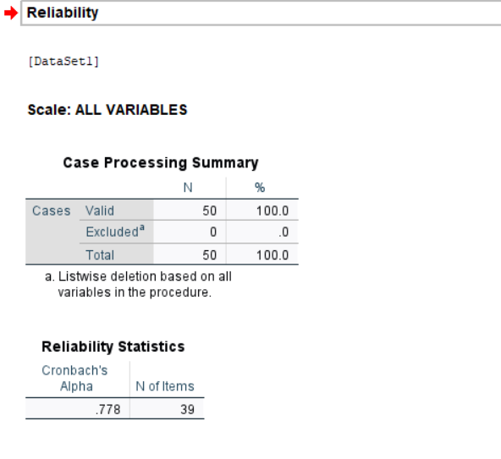
Table 4.5.7: Cronbach’s Alpha Test
These analyses were carried out on a sample of 50 valid responses, without exclusion, as the SPSS software was used to perform a reliability analysis. The results of the analysis were a Cronbach’s Alpha of 0.778 to the questionnaire items. This value demonstrates a good level of internal consistency between the items, which means that the items are highly correlated and can efficiently address the desired constructs, i.e., always available work culture, employee mental health, and productivity. A Cronbach’s Alpha value of more than 0.7 is acceptable in social science research, thus, the value of 0.778 is satisfactory to support the fact that the questionnaire applied in this research is reliable and can be further analyzed statistically. Such degree of reliability improves the validity of the results and justifies the use of the questionnaire as a good instrument used to obtain relevant data on the effects of always available work culture on employees.

4.5.8 HYPOTHESIS TESTING
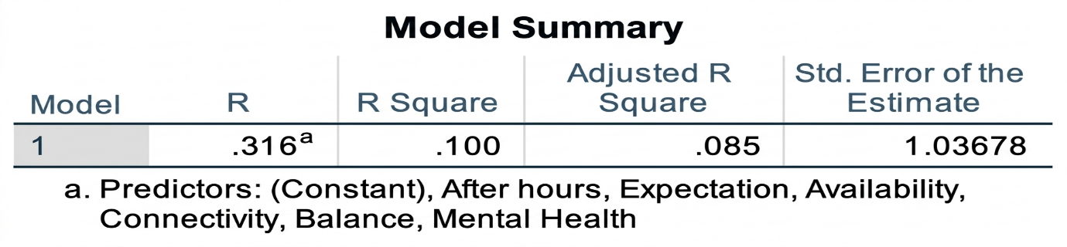
Table 4.5.8 (a): Model Summary
The model summary indicates the explanatory power of the independent variables in explaining productivity. It has a moderate relationship between the variables as shown by the R value (0.316). The value of R square (0.100) implies that 10 percent of the variability in productivity can be attributed to after-hours work, expectation, availability, connectivity, balance, and mental health, and that the rest of the variability is due to other aspects.
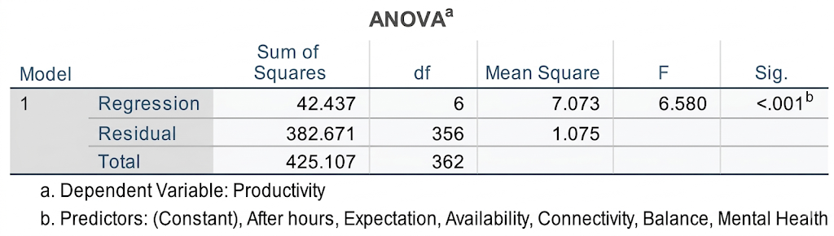
Table 4.5.8 (b): ANOVA
ANOVA table demonstrates whether the overall model is significant or not. The significance value is less than 0.001 hence the model is statistically significant. This implies that the combination of all the independent variables must be significantly important in affecting productivity.
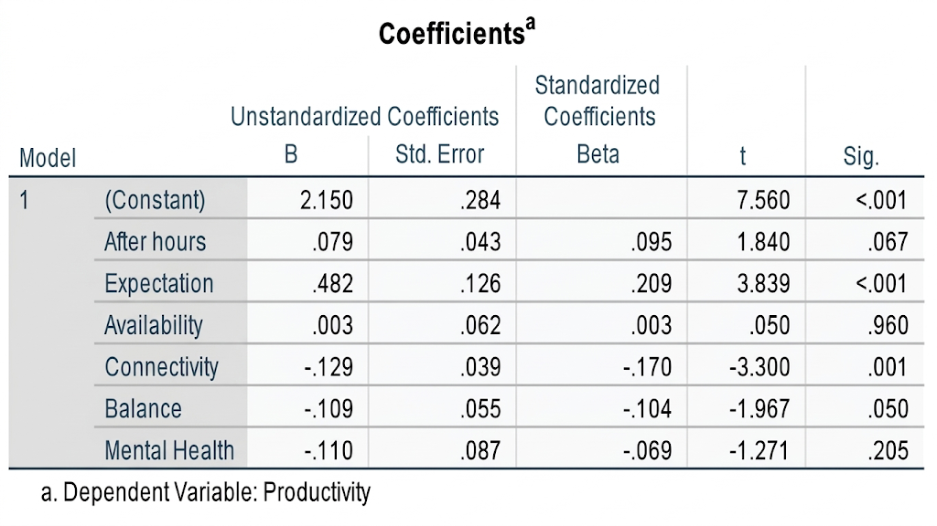
Table 4.5.8 (c): Coefficients Table
- After Hours:
- Question: How frequently do you receive work-related communication after official working hours?
- Interpretation: There is a positive, but non-significant effect of after - hours communication on productivity (Sig. = 0.067). This implies that it is not a very strong factor that determines productivity.

- Expectation:
- Question: Do you feel obligated to respond to work messages immediately, even after work hours?
- Interpretation: The positive and significant effect of expectation on productivity (Sig. < 0.001). This shows that pressure to respond increases its effect on productivity.

- Availability:
- Question: Does your organization indirectly encourage employees to stay connected beyond office hours?
- Interpretation: Availability does not have a significant effect on productivity (Sig. = 0.960). This implies that it has no impact on productivity.

- Connectivity:
- Question: Does constant work connectivity reduce your overall job satisfaction?
- Interpretation: There is a negative and significant effect of connectivity (Sig. = 0.001). This implies that productivity is decreased with increased connectivity.

- Balance:
- Question: Do you find it difficult to maintain a healthy balance between work and personal life?
- Interpretation: The negative and slightly significant effect is on work-life balance (Sig. = 0.050). This demonstrates that a lack of balance may decrease productivity.

- Mental Health:
- Question: Do you feel mentally exhausted due to constant work connectivity?
- Interpretation: Mental health is negatively, but not significantly affected (Sig. = 0.205). This implies that it does not have a significant impact on productivity in this model.
The results show that the regression model is statistically significant, and there is a moderate relationship between always available work culture and employee productivity. The model correlates only a small percentage of the variation in productivity and this implies that other factors not included in the study can contribute to the variation. Expectation is a strong positive and significant variable, whereas, connectivity is a significant negative variable on productivity. The effect of work-life balance is also negative and is insignificant to a small extent. Conversely, there is no strong effect of after-housing communication, availability, and mental health on productivity. This implies that not everything in always available work culture has the same effect on productivity and only some factors have a greater effect. In terms of these results, the alternative hypothesis is partly accepted because there are variables that have a strong influence on productivity, whereas others do not. Thus, the null hypothesis is not accepted entirely, which suggests that the relationship exists, but not across all factors, is strong.

5. DATA PROCESSING AND ANALYSIS
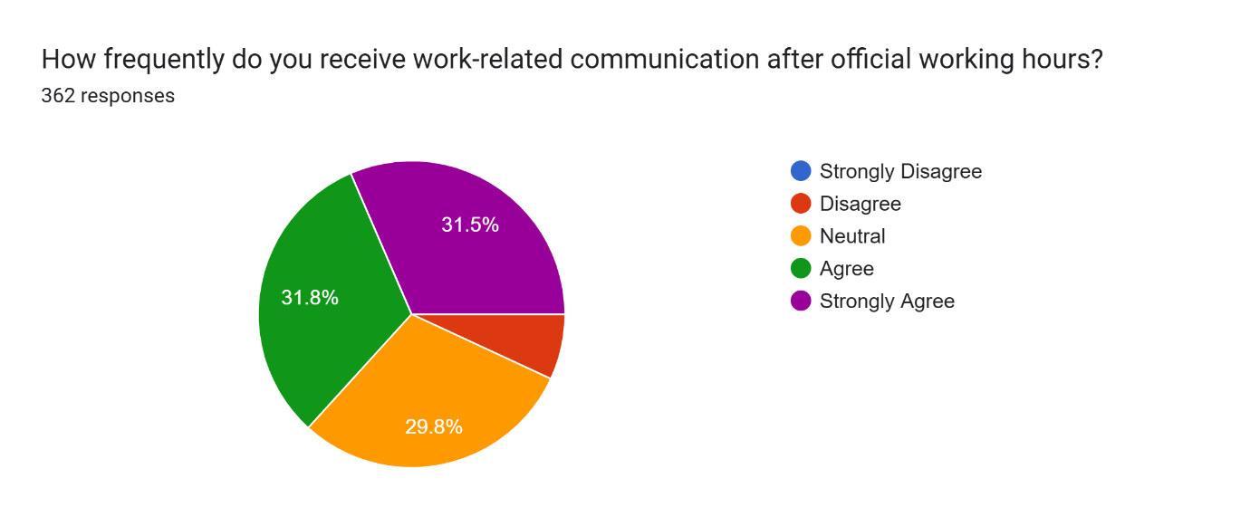
Pie Chart 1: Frequency
A large proportion of the respondents (63.3) agree or strongly agree that they often receive work communication during the after-hours. The percentage that expressly opposes this experience is extremely low. This indicates that after-hours connectivity is a prevalent phenomenon among majority of the surveyed population.
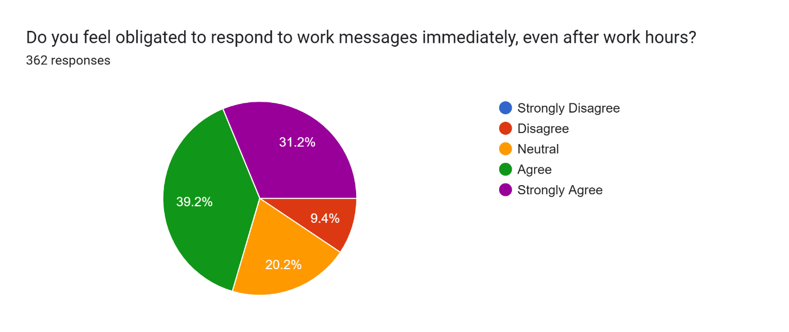
Pie Chart 2: Obligation
More than 70 per cent of workers are obligated to respond to work messages immediately, even when they are not in their duty hours. Less than 10% of the participants disagreed with feeling this pressure. This means that there was a culture of instant accessibility at any time of the day.
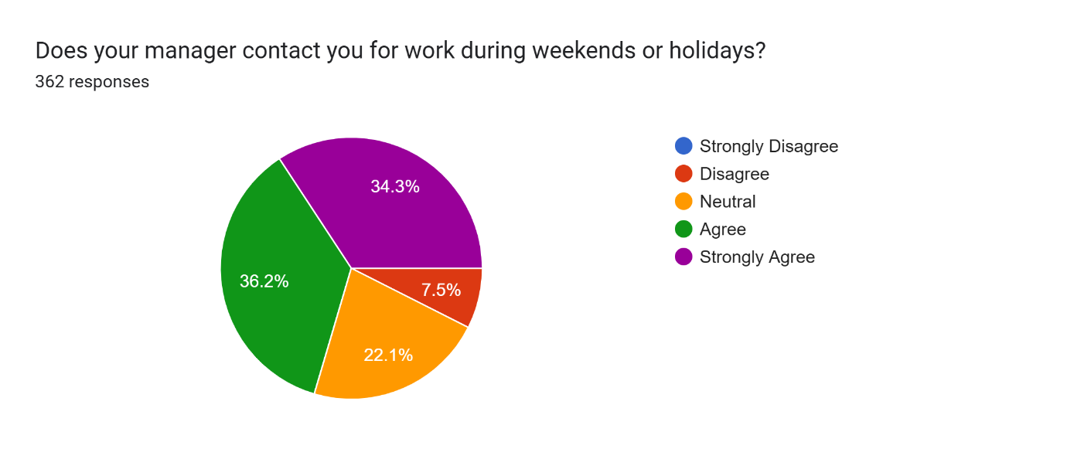
Pie Chart 3: Intrusion
The statistics indicate that three out of five respondents are called by their managers to work on weekends or when there is a public holiday. The neutral position was attributed to 22.1 and only 7.5% opposed. This underscores the fact that the professional boundaries tend to be blurred into the scheduled time off.
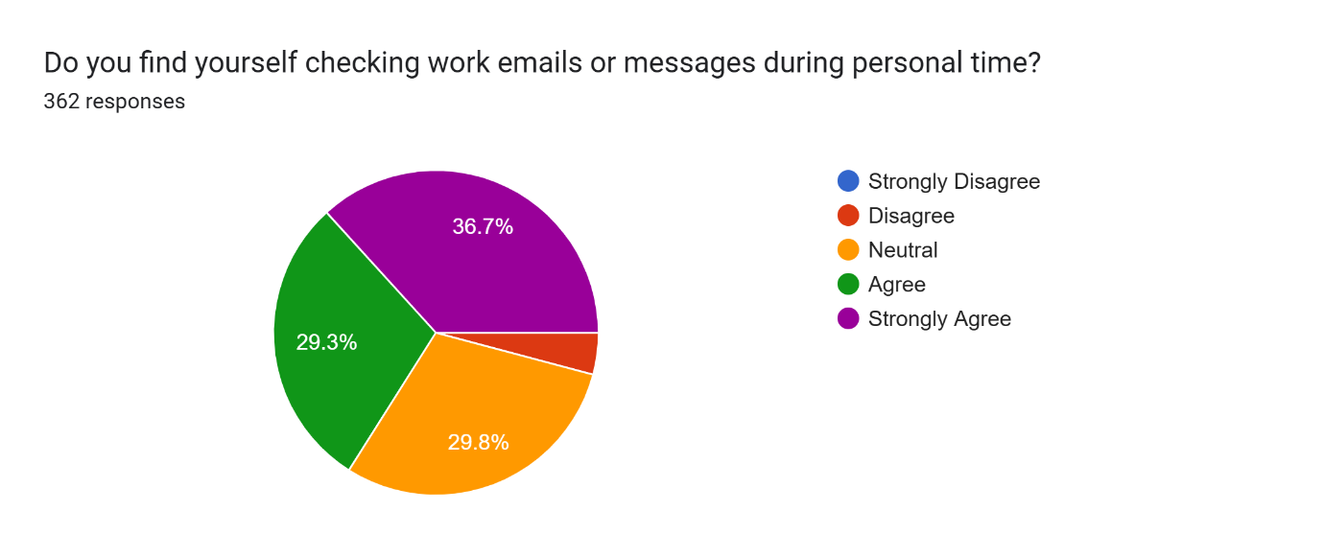
Pie Chart 4: Monitoring
Roughly 66% of individuals admit to checking their work emails or messages during their personal time. Almost 30% are indifferent to the habit, which implies that this is probably an unconscious or routine habit. Very few participants reported that they do not check work communications when they are off the clock.
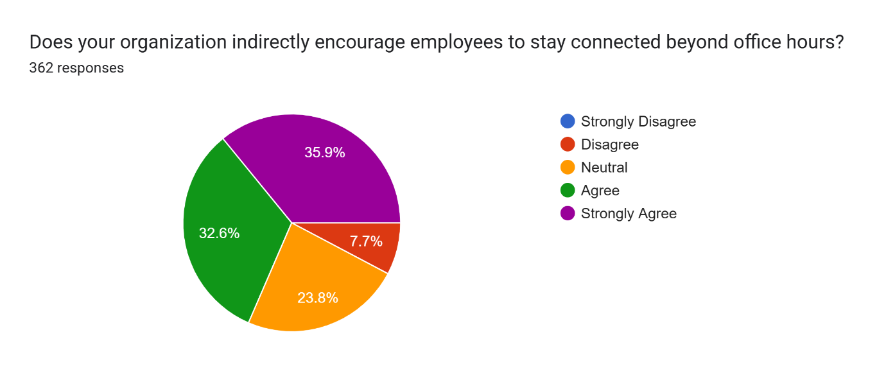
Pie Chart 5: Culture
Combined 68.5% of the respondents believe their organization indirectly encourages them to be connected outside office hours. Those who did not agree with the idea that such a culture exists were only 7.7% of the workforce. This is a direction of institutional expectations as the motivation of after-hours work.
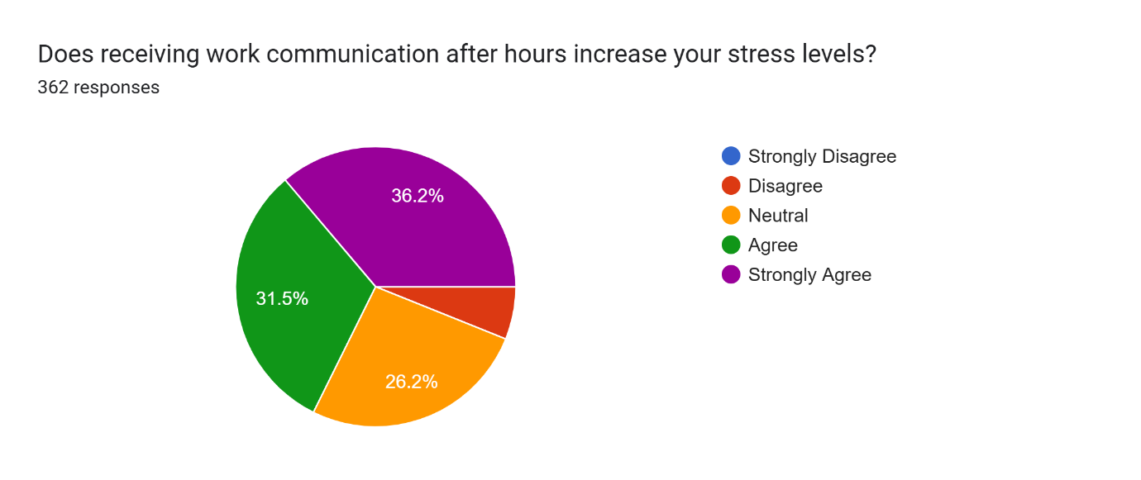
Pie Chart 6: Stress
The fact that 67.7% of the surveyed population receive work-related messages after hours adds to their stress. A quarter of the group (26.2%) was neutral about this impact. On the whole, the findings indicate a high correlation between unceasing connectedness and increased stress among employees.
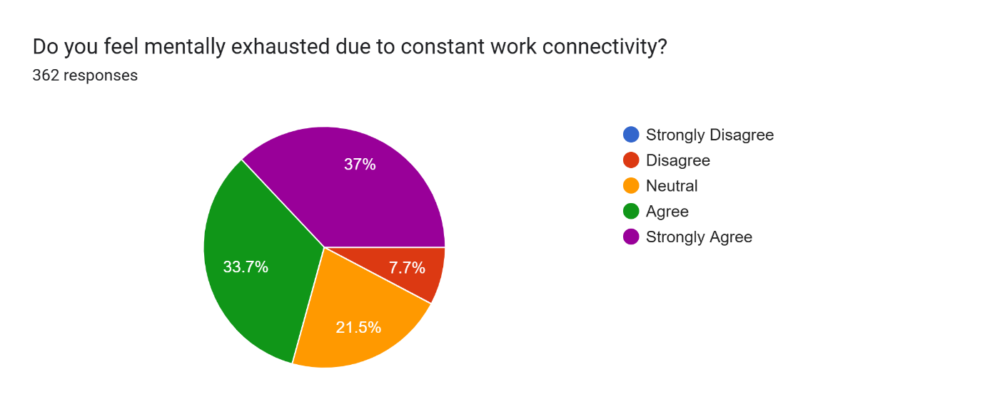
Pie Chart 7: Burnout
More than 70.7% of those who reported experiencing mental fatigue due to the constant work connection felt that they were exhausted by it. It is only a minority (7.7) that claim not to be mentally tired by these demands. This is a very high percentage indicating that there is a risk of burnout throughout the organization in the survey.
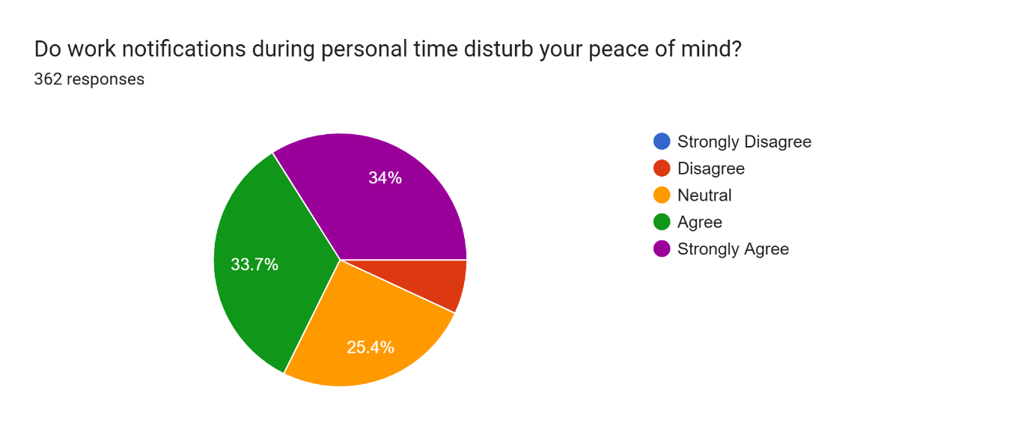
Pie Chart 8: Disturbance
Most participants (67.7% of them) find work notifications during personal time as a source of interference with peace of mind. Although 25.4% are neutral, the adverse effect on mental well-being is evident to most. This implies that it is hard to turn off when digital notifications continue.
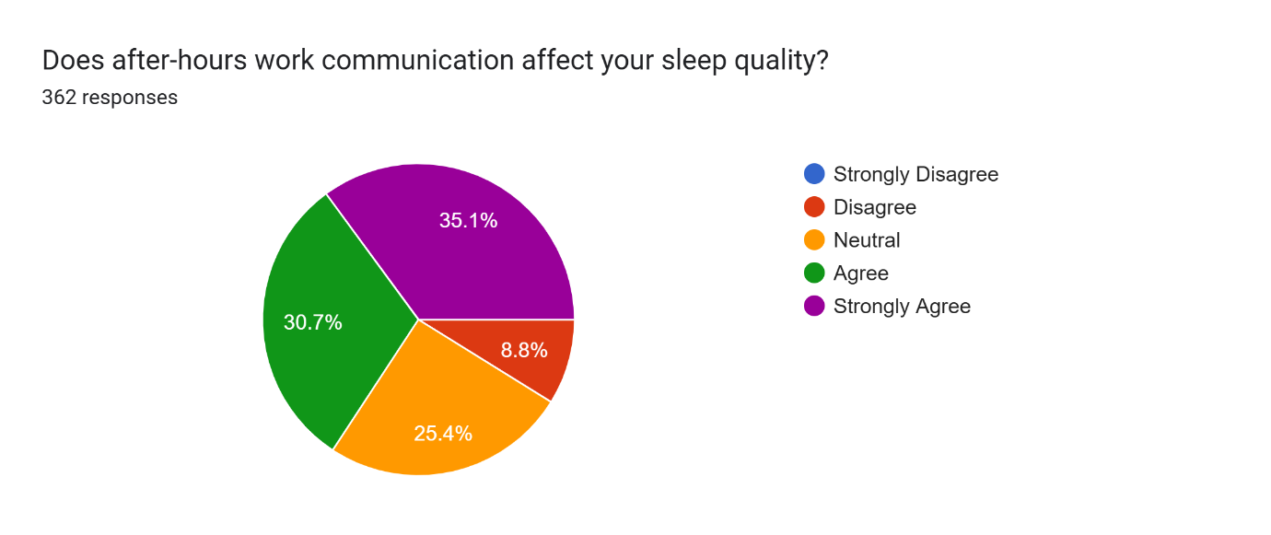
Pie Chart 9: Insomnia
About 65.8% of the respondents think that after-hours communication has a negative impact on their sleep quality. A minority of 8.8% did not agree with this statement, which underscores a major concern with regard to physical health. The statistics show that work stress accompanies most of the employees to their sleep time.
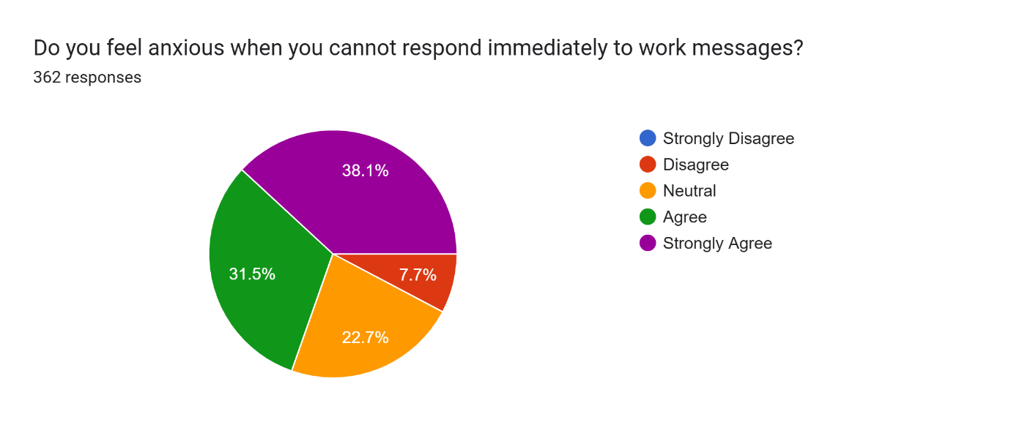
Pie Chart 10: Anxiety
A total of 69.6% of respondents experience anxiety when they are unable to respond to work messages immediately. This implies pressure to be always on is internalized. There are very few people who are at ease to take their time in replying without being anxious.
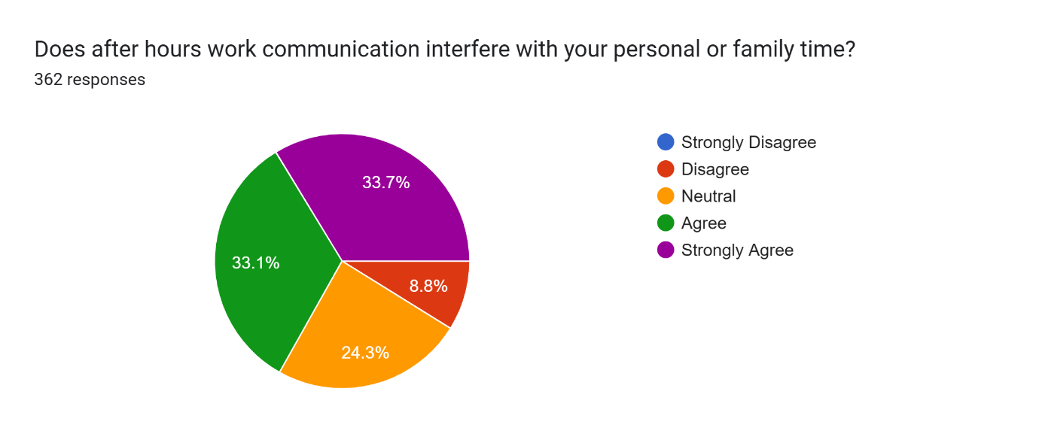
Pie Chart 11: Interference
The participants report 66.8% interruption of personal or family time. Almost a quarter (24.3) are neutral and only 8.8% are disagreeing that their personal lives are being disrupted. This demonstrates a clash between work and home.
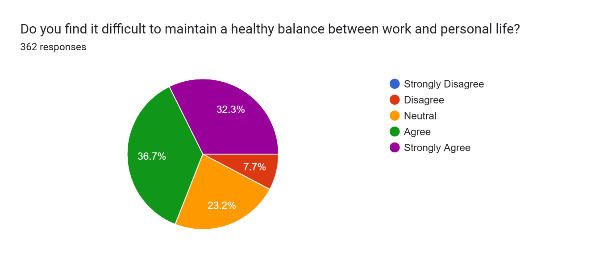
Pie Chart 12: Imbalance
It is a challenge to maintain a healthy balance as 69% of the respondents say. Balance is a primary issue with 50% of the respondents (36.7) agreeing and 27.3% strongly agreeing. It is only 7.7 per cent of the group that have no problem in keeping their work-life boundaries.
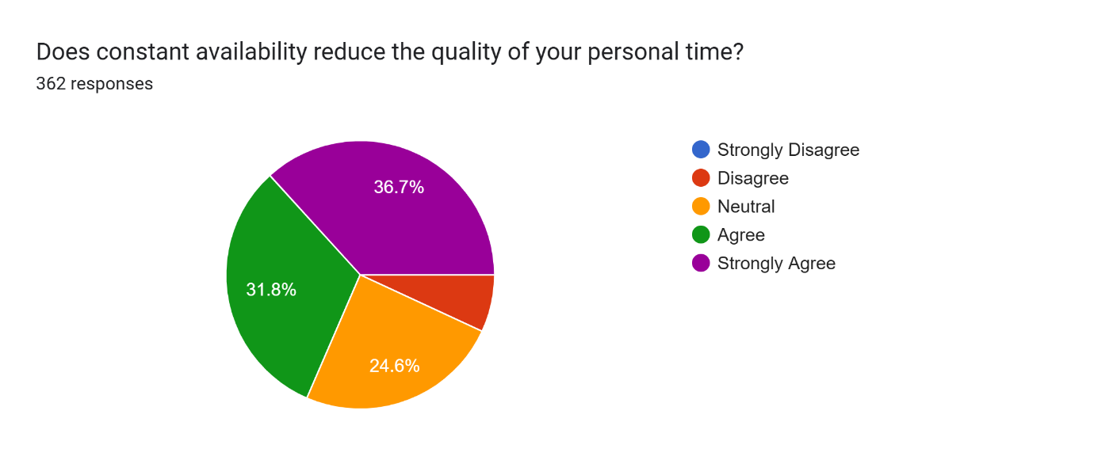
Pie Chart 13: Degradation
Always being available is seen to lower the quality of personal time by 68.5% of the workforce. Some 24.6% said they were indifferent on the issue. This means that although one is not working, the possibility of work to creep in reduces the quality of leisure.
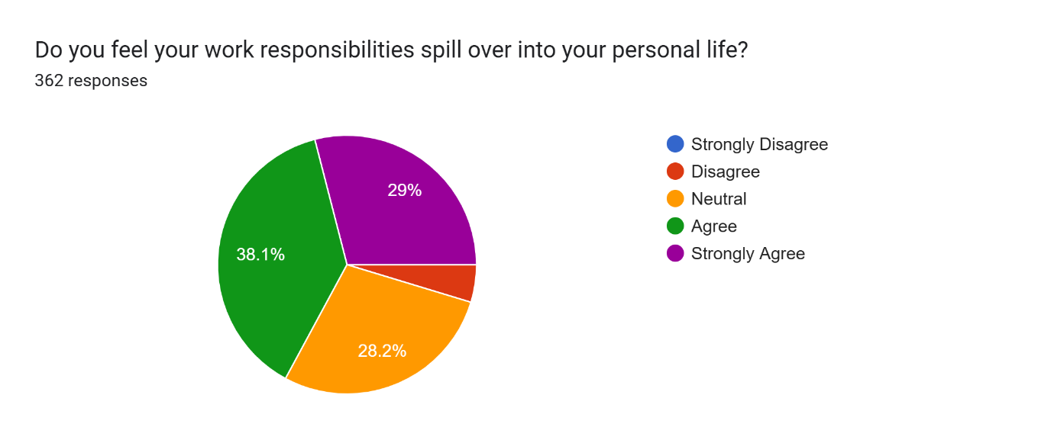
Pie Chart 14: Spillover
Most of them (67.1 percentage) believe that their work duties keep on encroaching their personal lives. This implies that office time is not well encapsulated within the scope of work. The number of respondents who believe their personal life and work to be different is very low.
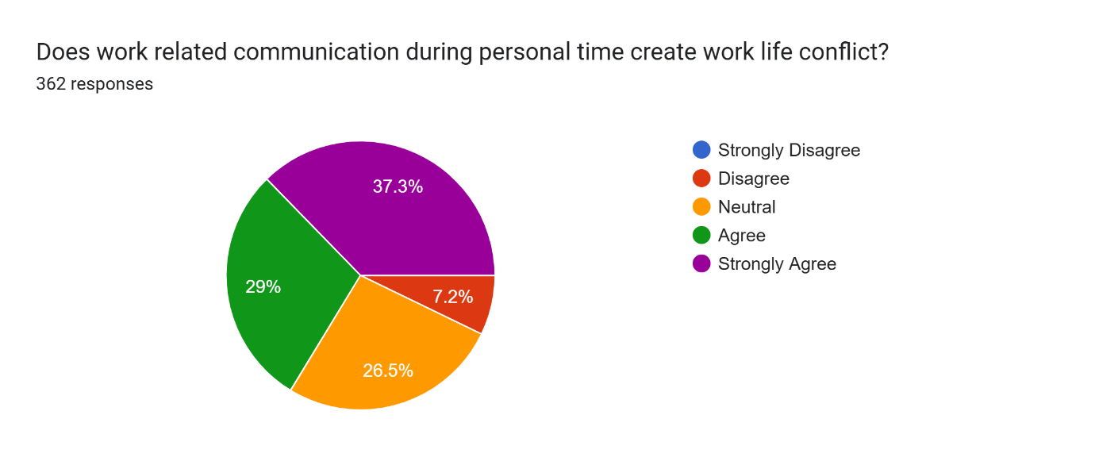
Pie Chart 15: Conflict
It is reported that 66.3% of the respondent’s experience work-life conflict due to work-related communication after work hours. More than 26% are indifferent, possibly because the conflict is considered to be an inevitable aspect of their work. Nevertheless, very few people (7.2 percent) clearly do not agree that there is a conflict.
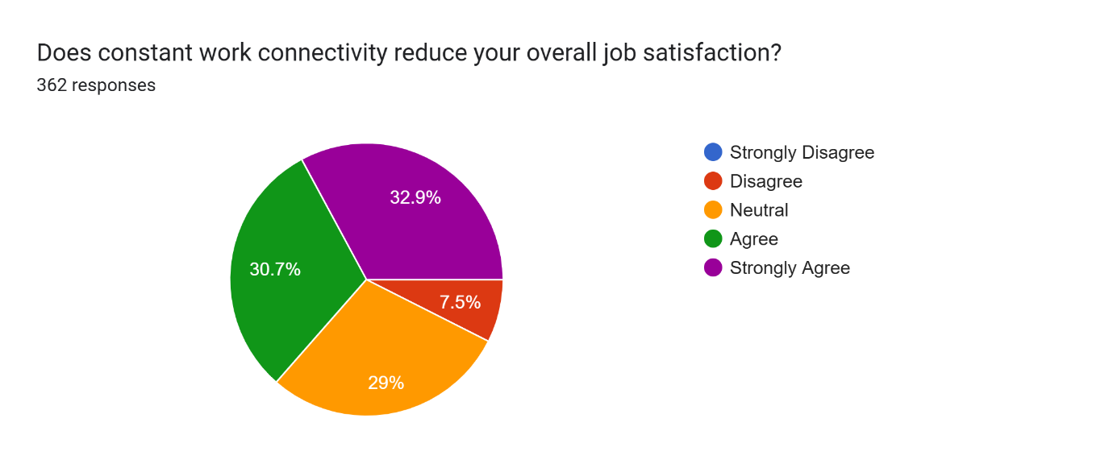
Pie Chart 16: Dissatisfaction
The ability to work anywhere at any time is attributed to lowering the overall job satisfaction by 63.6% of the respondents. Although 29 percent are neutral, the downward trend indicates that being always on ultimately causes decreased morale of the employees. Only 7.5% of them do not agree meaning they are satisfied with the connectivity.
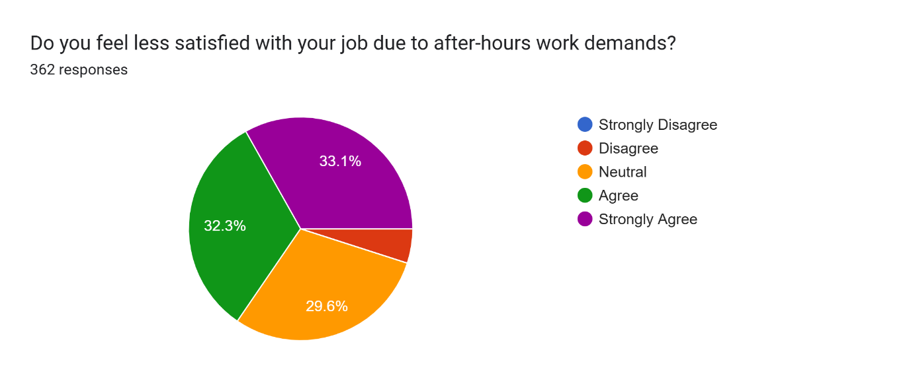
Pie Chart 17: Discontent
In particular, 65.4 percent of employees get less satisfied with their jobs due to after-hours requirements. The narrow margin between the agree and strongly agree is indicative of the pervasiveness and the vehemence of this feeling. All less than 30 percent are neutral and a very small number disagree.
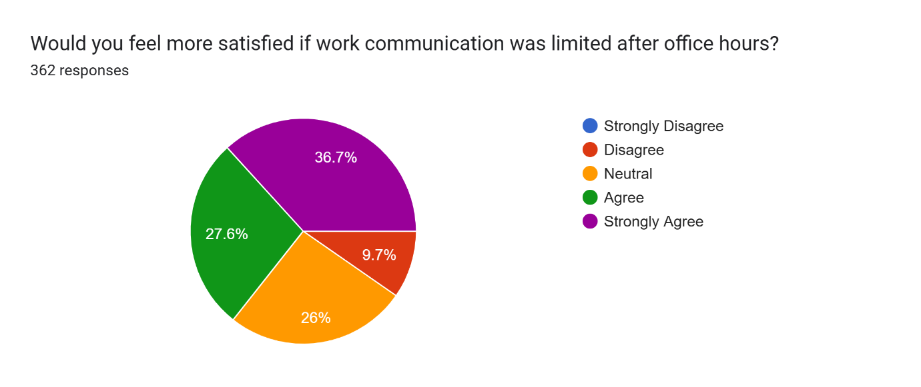
Pie Chart 18: Boundaries
A majority of 64.3% of the respondents feel that they would be more satisfied in case the after-hours communication was restricted. This implies that employees are seeking to get clear boundaries in order to enhance their job experience. Only 9.7% of people do not agree and this implies that they might favor the convenience of always being connected.
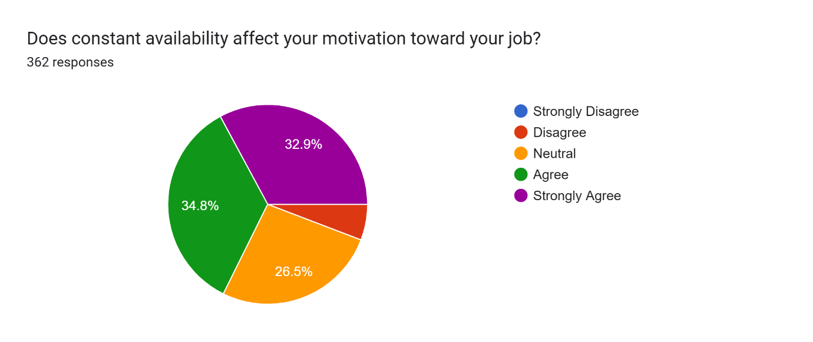
Pie Chart 19: Demotivation
The 67.7% of the surveyed group has a negative impact on motivation due to their constant availability. This information suggests that the stress to be on call can contribute to disconnection in the long run. More than 25 percent of the population is indifferent about the levels of motivation.
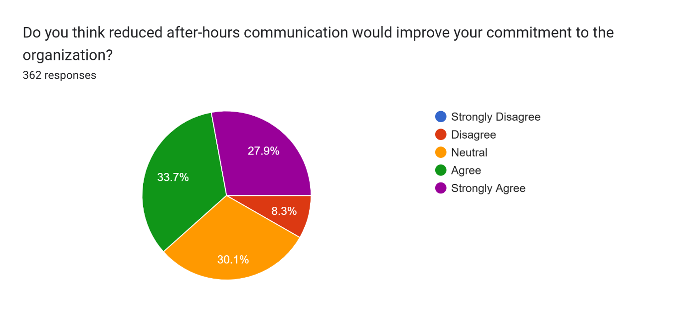
Pie Chart 20: Retention
Lastly, 61.6% of respondents feel that their commitment to the organization would actually be enhanced by reducing the after-hours communication. Approximately 30 are neutral, yet it is only 8.3% who oppose this concept. This implies that respect of boundaries may be one of the major elements in retention of employees in the long term.

6. FINDINGS
- After-Hours Communication: The research indicates that many workers get work-related messages outside of the work hours. This means that the work and personal time is becoming blurred. It is an indication of the increased culture of always being connected within organizations.

- Urge to Reply Instantly: The urge to reply to worktexts instantly is very intense among many employees, even when they are off duty. This brings about a perception of having to be available at all times. This pressure may influence the comfort and freedom of the employees in their own time.

- Organizational Culture Promotes Availability: The results indicate that the organizational culture indirectly promotes the employees to remain connected out of office hours. This does not necessarily have to be put down on paper but is embodied in work practices. This in the long run develops a culture of being always available.

- Heightened Stress Levels: Workers complain that when work communication is received late in the night, this heightens their stress levels. They do not have the time to relax because of constant disturbances. This demonstrates an obvious adverse effect of work on the psychological health.

- Mental Exhaustion Exists: The paper indicates that employees are mentally exhausted because of the ongoing connectivity. But this exhaustion was not a strong direct effect on productivity in the results of the regression. This implies that workers can work even when they are tired.

- Disruption of Personal Life: The communication of work during personal time disrupts family and personal activities. Workers struggle to take a complete break. This has an impact on their personal relationships and relaxation.

- Work-Life Imbalance: A lot of employees are not able to balance between work and personal life. The two cannot be separated as they are constantly available. This is an imbalance that may impact negatively on well-being in the long term.
- Influence on Job Satisfaction: The results indicate that the overall level of job satisfaction decreases when there is constant connectivity. Lack of boundaries may overwhelm or undervalue employees. This may cause reduced participation in the workplace.

- Drivers Productivity: Of all other variables, expectation and connectivity are important drivers of productivity. This implies that the need to react and the presence of constant connectivity contribute significantly to the performance of the employees.

- Unequal Impact of Variables: Not all factors studied have a significant effect on productivity. Such variables as availability, after-hours contact, and mental health are not strongly affected statistically. This shows that there are only certain elements of always available work culture that are critical.

7. SUGGESTIONS & RECOMMENDATIONS
- Establish Clear Work Boundaries: Organizations are supposed to specify the working hours and make sure that they do not demand more than those hours. This assists in establishing a healthy work and personal life. Boundaries enhance employee satisfaction and healthiness.

- Limit after-Hours Communication: The companies ought to minimize unnecessary communication after work hours. The next-day scheduling of important messages can be made. This enables employees to have a full-scale disconnection and recharge.

- Foster Work-Life Balance: Employers need to be proactive in supporting work-life balance by policies and practices. Employees can deal with both of them with the help of flexible schedules and the consideration of personal time. This results in improved overall performance.

- Less Response Pressure: Managers need not make expectations of instant responses beyond working hours. They should be comfortable in responding during working hours. This alleviates stress and enhances mental health.

- Encourage Mental Health: Organizations are to launch health programs, counseling, and stress management programs. Mental health of employees has been shown to increase productivity and engagement.

- Enhance Organization Policies: There should be clear policies as far as communication and availability are concerned. The employees are supposed to be informed of what is expected of them. This minimizes misunderstandings and unwarranted stress.

- Train Managers: Managers are important in work culture. They can be trained to respect boundaries of the employees to establish a more accommodating atmosphere. Effective leadership enhances satisfaction among the employees.

- Promote Digital Detox: The workers are to be motivated to take breaks between work and personal life. Digital communication can be reduced through breaks that are beneficial in reducing stress and enhancing concentration in the workplace.

- Check Workload: The companies must make sure that the employees are not overworked with work that goes beyond the working hours. Appropriate workload management is a way of maintaining the balance and avoiding burnout.

- Build Awareness in the Employees: Employees need to be informed about the need to establish limits and handle stress. They can be sensitized to have healthier work habits.

8. CONCLUSION
The study highlights that the always available work culture has become a common part of modern workplaces, where employees are expected to stay connected even beyond official working hours. The findings show that this constant connectivity affects employees in multiple ways, especially in terms of stress, work-life balance, and job satisfaction. While the regression results indicate that not all factors have a significant impact on productivity, key variables such as expectation to respond immediately and constant connectivity play an important role. Employees often continue to maintain their productivity despite feeling mentally exhausted or stressed, which suggests that the impact of such a work culture may not always be immediately visible in performance but still affects overall well-being.

At the same time, the study also makes it clear that ignoring these effects can lead to long-term negative consequences for both employees and organizations. Poor work-life balance, reduced job satisfaction, and increased stress levels can eventually lower motivation and commitment. The results show that the alternate hypothesis is partially accepted, meaning that always available work culture does influence productivity, but not all its aspects have the same level of impact. Therefore, organizations need to take active steps to create a healthier work environment by setting clear boundaries, reducing unnecessary after-hours communication, and supporting employee well-being. Maintaining this balance is important not only for improving productivity but also for ensuring long-term employee satisfaction and organizational success.

APPENDICES/ANNEXURE
QUESTIONNAIRE
- How frequently do you receive work-related communication after official working hours?
- Strongly Disagree
- Disagree
- Neutral
- Agree
- Strongly Agree

- Do you feel obligated to respond to work messages immediately, even after work hours?
- Strongly Disagree
- Disagree
- Neutral
- Agree
- Strongly Agree

- Does your manager contact you for work during weekends or holidays?
- Strongly Disagree
- Disagree
- Neutral
- Agree
- Strongly Agree

- Do you find yourself checking work emails or messages during personal time?
- Strongly Disagree
- Disagree
- Neutral
- Agree
- Strongly Agree

- Does your organization indirectly encourage employees to stay connected beyond office hours?
- Strongly Disagree
- Disagree
- Neutral
- Agree
- Strongly Agree

- Does receiving work communication after hours increase your stress levels?
- Strongly Disagree
- Disagree
- Neutral
- Agree
- Strongly Agree

- Do you feel mentally exhausted due to constant work connectivity?
- Strongly Disagree
- Disagree
- Neutral
- Agree
- Strongly Agree
- Do work notifications during personal time disturb your peace of mind?
- Strongly Disagree
- Disagree
- Neutral
- Agree
- Strongly Agree

- Does after-hours work communication affect your sleep quality?
- Strongly Disagree
- Disagree
- Neutral
- Agree
- Strongly Agree

- Do you feel anxious when you cannot respond immediately to work messages?
- Strongly Disagree
- Disagree
- Neutral
- Agree
- Strongly Agree

- Does after hours work communication interfere with your personal or family time?
- Strongly Disagree
- Disagree
- Neutral
- Agree
- Strongly Agree

- Do you find it difficult to maintain a healthy balance between work and personal life?
- Strongly Disagree
- Disagree
- Neutral
- Agree
- Strongly Agree

- Does constant availability reduce the quality of your personal time?
- Strongly Disagree
- Disagree
- Neutral
- Agree
- Strongly Agree

- Do you feel your work responsibilities spill over into your personal life?
- Strongly Disagree
- Disagree
- Neutral
- Agree
- Strongly Agree

- Does work related communication during personal time create work life conflict?
- Strongly Disagree
- Disagree
- Neutral
- Agree
- Strongly Agree

- Does constant work connectivity reduce your overall job satisfaction?
- Strongly Disagree
- Disagree
- Neutral
- Agree
- Strongly Agree

- Do you feel less satisfied with your job due to after-hours work demands?
- Strongly Disagree
- Disagree
- Neutral
- Agree
- Strongly Agree

- Would you feel more satisfied if work communication was limited after office hours?
- Strongly Disagree
- Disagree
- Neutral
- Agree
- Strongly Agree

- Does constant availability affect your motivation toward your job?
- Strongly Disagree
- Disagree
- Neutral
- Agree
- Strongly Agree

- Do you think reduced after-hours communication would improve your commitment to the organization?
- Strongly Disagree
- Disagree
- Neutral
- Agree
- Strongly Agree

