BRIDGING THE GAP: EMPOWERING TRADITIONAL ARTISANS AND ARTISTS THROUGH DIGITAL MARKETPLACES IN DEVELOPING ECONOMIES

ABSTRACT
Traditional artisans and artists in developing economies play a vital role in cultural preservation, community identity, and local livelihoods. Global studies highlight the creative economy as a driver of inclusive growth and cultural sustainability (UNESCO, 2013; UNCTAD, 2022). Despite this, many artisans continue to face economic constraints due to limited market access and geographic barriers (World Bank, 2016; OECD, 2020). Digital marketplaces offer opportunities to expand visibility and income; however, research on artisans’ lived experiences in adopting these platforms remains limited.
This study explores how digital marketplaces influence market access, visibility, and income sustainability among artisans and artists in Baguio City. A qualitative, non-experimental research design was employed, using structured surveys with open-ended response
Findings reveal that digital platforms enhance exposure and customer reach but are challenged by digital literacy gaps, platform complexity, and trust concerns. While ds from purposively selected participants. Data were analyzed using thematic analysis to identify recurring patterns and insights. Digital marketplaces provide meaningful opportunities, long-term sustainability depends on accessible systems, training, and support mechanisms. This study contributes to the literature on digital inclusion and the creative economy by offering context-specific insights to inform inclusive and culturally responsive platform development.

Keywords
Digital marketplaces; Traditional artisans; Creative economy; Digital inclusion; Developing economies; Cultural preservation; Artisans; Artists

INTRODUCTION
The creative economy plays a significant role in driving inclusive growth and cultural sustainability (UNESCO, 2013; UNCTAD, 2022). Across developing economies, traditional artisans and artists function as custodians of cultural memory, heritage transmission, and community identity. Their crafts reflect indigenous knowledge systems, intergenerational techniques, and localized social meanings. Cultural production within these communities is not solely an economic activity but a social practice embedded in history, ritual, and collective identity. UNESCO (2013) and UNCTAD (2021) emphasize that creative industries contribute to both economic development and the safeguarding of intangible cultural heritage.

Despite this, many artisans continue to face economic constraints due to limited market access and geographic barriers (World Bank, 2016; OECD, 2020). Limited infrastructure, digital skill gaps, constrained capital, and geographic isolation reduce opportunities for sustained income growth. The World Bank (2016) notes that digital technologies can expand economic participation, yet meaningful digital inclusion requires more than connectivity; it requires capability, trust, and equitable participation. Van Dijk (2020) further argues that digital inequality persists when skills and usage patterns remain uneven.

The rise of digital technologies has created new opportunities for entrepreneurship and market expansion, particularly in developing economies (Nambisan, 2017; van Dijk, 2020). Digital marketplaces have emerged as platforms that may reduce transaction costs, extend consumer reach, and facilitate participation in global value chains (Nambisan, 2017). Research on the creative economy suggests that digital platforms can enhance branding, storytelling, and niche marketing for small producers (Howkins, 2001; OECD, 2022). However, digital inequality remains a key challenge, limiting participation among marginalized groups (van Dijk, 2020; GSMA, 2021). Structural constraints such as limited digital literacy, inadequate infrastructure, platform fees, algorithmic visibility issues, and trust concerns may restrict meaningful engagement. Existing research on platform economies has primarily focused on technology driven startups, urban micro enterprises, and gig labor. Comparative empirical attention to traditional artisans, particularly those embedded within indigenous or culturally grounded communities, remains limited.

This study addresses that gap by examining digital marketplaces through a culturally grounded lens. It recognizes artisans not only as micro entrepreneurs but as cultural bearers whose practices are shaped by indigenous processes, social norms, and community traditions. The study does not seek to extract sacred or proprietary indigenous knowledge. Instead, it examines artisans’ experiences in navigating digital systems while maintaining cultural integrity and identity.

This study aims to explore the lived experiences of artisans and artists in Baguio City using digital marketplaces, focusing on market access, visibility, and income opportunities.

Literature Review

Digital Inclusion and Platform Participation
Digital inclusion theory emphasizes access, skills, and meaningful participation as interconnected components of equitable engagement (van Dijk, 2020). Access alone does not ensure empowerment. Without adequate digital literacy, support systems, and institutional trust, marginalized groups may remain excluded from digital benefits. Nambisan (2017) highlights how digital entrepreneurship reshapes value creation processes but also introduces new dependencies on platform governance and digital competencies.
Creative Economy and Cultural Production
The creative economy framework recognizes cultural production as a contributor to both economic output and social cohesion (Howkins, 2001; UNCTAD, 2021). OECD (2022) reports that creative sectors often rely on small scale producers whose sustainability depends on market customer exposure and adaptive capacity. However, digital commercialization can also introduce pressures that may affect authenticity, pricing norms, and cultural valuation.

Indigenous Knowledge and Research Ethics
Research involving culturally grounded communities requires adherence to ethical principles that respect indigenous knowledge systems and relational accountability. Smith (2012) emphasizes that research in indigenous contexts must prioritize respect, reciprocity, and community benefit. Cultural implications are therefore not excluded from this study. Rather, they are acknowledged as central to understanding how digital marketplace participation intersects with heritage preservation and identity representation. The study ensures that no sacred practices, confidential traditions, or culturally restricted knowledge are documented or disseminated.
Theoretical and Conceptual Framework
This study integrates digital inclusion theory with creative economy frameworks. Digital inclusion theory provides a lens for examining structural and skill based barriers to platform participation. Creative economy perspectives situate artisan production within broader systems of cultural and economic value. By combining these frameworks, digital marketplaces are conceptualized as socio technical systems that may enable or constrain empowerment depending on access conditions, cultural sensitivity, and support mechanisms.

Significance of the Study

This research contributes to scholarly discourse by providing qualitative, context specific evidence on how traditional artisans experience digital marketplace participation. The findings are relevant to artisans seeking sustainable market reach, policymakers designing inclusive digital initiatives, development practitioners supporting creative industries, and platform developers aiming to create culturally responsive systems. The study also contributes to literature on indigenous informed economic participation by recognizing cultural significance as integral to digital inclusion.

Objectives of the Study

The general objective of this study is to explore how digital marketplaces support traditional artisans and artists in improving market access, customer exposure, and income sustainability within developing economies.

Specifically, the study aims to:
- Examine the lived experiences of traditional artisans and artists engaging with digital marketplaces.
- Identify perceived challenges and enabling factors in the adoption and use of digital platforms.
- Analyze how participation in digital marketplaces influences artisans’ economic opportunities and income sustainability while engaging with culturally rooted practices.

MATERIALS AND METHOD

Study Design

This study employed a qualitative, non-experimental research design. Data were collected through structured survey questionnaires with open-ended responses from purposively selected artisans and artists in Baguio City who have experience using digital platforms. A total of 18 participants were included in the study. The data were analyzed using thematic analysis to identify recurring patterns and key themes. Ethical considerations were observed through informed consent, voluntary participation, and confidentiality of responses.

Population and Sample
The target population consists of traditional artisans and artists operating within a developing economy context. Participants will include individuals engaged in handcrafted goods, visual arts, or culturally rooted creative production. Approximately 15 to 25 participants will be recruited through purposive sampling to ensure relevant experience with digital marketplaces. Data collection will continue until thematic saturation is achieved.
Inclusion criteria include being at least 18 years old, actively engaged in artisan or artistic production, and having prior or current experience using at least one digital marketplace or online selling platform. Exclusion criteria include individuals not engaged in artisan production or without digital platform experience relevant to the study.

Data Gathering Tools

Data will be collected through a structured survey instrument containing both closed ended and open ended questions. The instrument will gather demographic information, types of platforms used, frequency of use, perceived economic impact, and reflections on cultural representation in digital environments. The survey will undergo review for clarity and content validity prior to administration.

Data Gathering Procedures

Participants will receive information regarding the purpose of the study and provide informed consent prior to participation. Surveys will be distributed online within a defined data collection period. Participation will be voluntary, and respondents may withdraw at any time without penalty. The study observes culturally respectful engagement practices and avoids documentation of sensitive indigenous knowledge.

Treatment of Data

Qualitative responses will be analyzed using thematic analysis. Data will be coded to identify recurring themes related to access, visibility, income sustainability, cultural representation, and perceived platform challenges. Descriptive statistics may be used to summarize selected responses. Analysis will be guided by the conceptual framework and research objectives.

Ethical Considerations

Ethical standards will be strictly observed. Participation is voluntary, informed consent will be obtained, and anonymity and confidentiality will be maintained. Data will be stored securely and used solely for academic purposes. The study complies with indigenous informed ethical principles by ensuring respect for cultural processes, avoiding extraction of restricted knowledge, and framing findings in ways that uphold cultural significance and community dignity.

RESULTS AND DISCUSSION

Overview of Findings
The findings indicate that artisans and artists recognize the potential of digital marketplaces to expand their reach and improve income opportunities. However, adoption remains influenced by varying levels of digital readiness and access to resources.

Lived Experiences of Artisans in Digital Marketplaces
Findings indicate that artisans perceive digital marketplaces as valuable tools for increasing product visibility and expanding customer reach beyond local communities. Participants reported that online platforms allowed them to showcase their work to wider audiences, beyond local markets. This aligns with previous findings that digital platforms reduce geographic barriers and enable small-scale producers to participate in broader value chains (Nambisan, 2017).
However, artists and artisans’ experiences varied depending on digital literacy and familiarity with online tools. While some participants expressed confidence and adaptability in using digital tools, others described initial difficulties in navigating platforms, managing online communication, and presenting their products effectively. Those with prior experience in social media selling demonstrated greater confidence in navigating digital platforms. These findings support digital inclusion literature, which emphasizes that access alone does not ensure meaningful participation without corresponding digital skills (van Dijk, 2020).

Challenges and Enabling Factors in Digital Adoption
Several key challenges emerged from the data. First, limited digital literacy was identified as a primary barrier, particularly in areas such as content creation, platform navigation, and online marketing. Second, concerns regarding trust and reliability of digital transactions were evident, including issues related to payment security and customer credibility. Third, logistical challenges such as shipping costs and delivery coordination were reported as constraints to scaling online sales.
Despite these challenges, enabling factors were also identified. Access to mobile technology, social media familiarity, and peer support networks facilitated entry into digital marketplaces. Participants who had prior exposure to digital tools or received informal guidance from peers demonstrated higher levels of engagement and confidence. These findings align with research highlighting the importance of support systems and capability-building in digital participation (World Bank, 2016).

Impact on Market Access, Visibility, and Income Sustainability
Participation in digital marketplaces contributed to positively influence market reach and customer exposure. Artisans reported increased inquiries, broader audience engagement, and opportunities for repeat customers. Some participants noted that digital platforms served as supplementary income channels, particularly during periods of low physical market activity.
However, income opportunities remained variable. While digital marketplaces provided additional opportunities, consistent income generation depended on factors such as platform visibility, marketing effort, and competition. These findings suggest that while digital marketplaces can enhance opportunities, they do not automatically guarantee economic stability.

Integration with Literature
The findings reinforce the role of digital marketplaces as enabling platforms within the creative economy (OECD, 2022), while also highlighting persistent inequalities in digital participation. Consistent with Howkins (2001), digital platforms support value creation through storytelling and niche marketing; however, structural barriers continue to influence outcomes. The study extends existing literature by providing empirical insights into artisan-specific experiences, emphasizing the intersection of digital access, cultural practice, and economic sustainability.

CONCLUSION AND RECOMMENDATIONS

Conclusion
This study highlights the potential of digital marketplaces to support traditional artisans and artists in improving market reach, customer exposure, and income opportunities within developing economies. It ​​provides empirical insights from a developing economy context, contributing to the limited body of research on artisan-centered digital marketplace adoption. The findings indicate that digital platforms offer significant opportunities for expanding market reach and enhancing customer exposure. Artists and artisans benefit from increased exposure and the ability to engage with broader audiences beyond geographic limitations.
However, the study also reveals that digital participation is shaped by structural and capability-related factors. Limited digital literacy, platform complexity, trust concerns, and logistical constraints continue to affect meaningful engagement. While digital marketplaces contribute to supplemental income opportunities, long-term sustainability is not guaranteed and depends on access to resources, skills, and support systems.
Overall, digital marketplaces function as enabling but not equalizing systems. Their effectiveness in empowering artisans depends on the extent to which they are accessible, inclusive, and responsive to the needs of culturally grounded producers.

Recommendations
Based on the findings, the following recommendations are proposed:
- Capacity Building Programs
Training initiatives should be developed to enhance digital literacy among artisans, focusing on platform navigation, content creation, and online marketing strategies.
- Platform Design Improvements
Digital marketplaces should incorporate user-friendly interfaces and culturally sensitive features that accommodate varying levels of digital capability.
- Support Mechanisms and Partnerships
Integrate logistical and payment support systems, and access to reliable delivery systems.
- Trust and Security Enhancements
Platforms should strengthen secure payment systems and transparent transaction processes to build user confidence.
- Future Research
Further studies may explore quantitative assessments of income impact, longitudinal effects of digital participation, and comparative analysis across different regions or platform types.

REFERENCES
REFERENCES
GSMA. (2021). The mobile internet connectivity report 2021. GSM Association. https://www.gsma.com/r/somic/
Howkins, J. (2001). The creative economy: How people make money from ideas. Penguin.
Nambisan, S. (2017). Digital entrepreneurship: Toward a digital technology perspective of entrepreneurship. Entrepreneurship Theory and Practice, 41(6), 1029–1055. https://doi.org/10.1111/etap.12254
Organisation for Economic Co-operation and Development (OECD). (2020). SMEs and digital transformation. OECD Publishing. https://doi.org/10.1787/bdb9256a-en
Organisation for Economic Co-operation and Development (OECD). (2022). The culture fix: Creative people, places and industries. OECD Publishing. https://doi.org/10.1787/991bb520-en
Smith, L. T. (2012). Decolonizing methodologies: Research and indigenous peoples (2nd ed.). Zed Books.
United Nations Conference on Trade and Development (UNCTAD). (2022). Creative economy outlook 2022. United Nations. https://unctad.org/publication/creative-economy-outlook-2022
UNESCO. (2013). Creative economy report 2013: Widening local development pathways. UNESCO Publishing.
van Dijk, J. (2020). The digital divide. Polity Press.
World Bank. (2016). World development report 2016: Digital dividends. World Bank. https://doi.org/10.1596/978-1-4648-0671-1

APPENDIX A: SURVEY QUESTIONNAIRE
Overview
You are invited to participate in a short research survey that aims to assess the feasibility of developing a digital marketplace for artisans in Baguio City. The study explores the readiness of artists and artisans to adopt digital platforms, the challenges they face, market demand, and operational needs, while also considering cultural preservation.
Your responses will help inform an academic research paper for international publication and support a graduate capstone project.
The survey takes approximately 5 to 8 minutes to complete.
Participation is voluntary, and all responses will remain confidential and will be reported only in aggregated form.

Short Survey for Artists & Artisans (5–8 minutes)
Response Scale (for Sections B–E)
1 = Strongly Disagree
2 = Disagree
3 = Neutral
4 = Agree
5 = Strongly Agree

Section A. Quick Profile (4 items)
- Primary craft type (choose one):
☐ Textile / Weaving
☐ Woodcraft
☐ Metalcraft
☐ Visual Art
☐ Jewelry
☐ Pottery / Ceramics
☐ Other: __________
- Years practicing your craft:
☐ 0–2
☐ 3–5
☐ 6–10
☐ 11+
- Main selling channel today (choose one):
☐ In-person markets or events
☐ Resellers or shops
☐ Social media (Facebook / Instagram)
☐ Online marketplace (Shopee, Lazada, Etsy, etc.)
☐ By order or direct message only
- Are you part of an artisan or artist group?
☐ Yes ☐ No
If yes, please indicate:
☐ Pasakalye ☐ Pugad ni Art ☐ Tam-awan Village ☐ Art Guild ☐ Other: __________

Section B. Readiness and Challenges
- I can manage basic online selling tasks such as posting products and replying to inquiries. (1–5)
- I am confident using digital payment methods such as GCash or bank transfer. (1–5)
- Logistics such as packing, shipping, and delivery are major challenges when selling beyond Baguio. (1–5)
- I worry about scams, unpaid orders, or online fraud when selling online. (1–5)
- I have sufficient internet access and device capability to sell online consistently. (1–5)
- If training and support are provided, I am willing to sell through a dedicated digital marketplace for artisans. (1–5)

Section C. Market Demand and User Base
- I receive inquiries or interest from buyers outside Baguio, including other provinces or overseas. (1–5)
- I believe there is strong demand for authentic Baguio artisan products online. (1–5)
- I believe a digital marketplace can increase my sales and visibility. (1–5)

Section D. Technical and Operational Requirements
- I need a platform that is easy to use on a mobile phone and simple for uploading products. (1–5)
- I need clear and transparent information on fees, pricing, and order tracking. (1–5)
- I need support for shipping logistics such as courier options, pickup support, or guidance. (1–5)
- I need secure and locally accessible payment options. (1–5)
- I need features that protect authenticity, such as verified artisan profiles and product storytelling. (1–5)

Section E. Cultural Preservation
- A digital marketplace can help preserve cultural heritage by sharing artisan stories and meanings. (1–5)
- I worry that selling online may misrepresent or commercialize cultural crafts without proper guidelines. (1–5)

Section F. Open-Ended Question
- What is the single most important feature or support you need to confidently sell online?
Answer: ________________________________________

Disclosure and Consent
Participation in this study is voluntary. You may skip any question or withdraw at any time without penalty. No personally identifiable information will be collected. All responses will be kept confidential and used solely for academic purposes, including an international journal publication and a graduate capstone project.
By submitting this survey, you confirm that you have read and understood the information above and agree to participate in this study.
☐ I agree to participate in this research.

APPENDIX B: RAW SURVEY DATA
Key Results

Table 1
Digital Readiness and Capability of Artisans
Indicator | Mean | Interpretation
Ability to manage online selling | 4.06 | High
Confidence in digital payments | 4.44 | Very High
Internet access and device capability | 4.72 | Very High
Discussion:
Artisans demonstrate strong readiness for digital participation. However, readiness does not fully translate into effective utilization, supporting the argument that access alone is insufficient (van Dijk, 2020).

Table 2
Perceived Challenges in Digital Marketplace Participation
Indicator | Mean | Interpretation
Concern about scams/fraud | 4.17 | High
Logistics and delivery issues | High | Major barrier
Platform complexity | Moderate | Barrier
Discussion:
Trust and logistics emerge as primary constraints. These findings align with research indicating that structural barriers limit digital participation (World Bank, 2016).

Table 3
Willingness to Participate in Digital Marketplaces
Indicator | Mean | Interpretation
Willingness to join with support | 4.22 | High
Belief in increased visibility | High | Strong agreement
Perceived market demand | High | Positive outlook
Discussion:
High willingness indicates strong potential adoption if barriers are addressed.

Table 4
Platform Needs and Feature Requirements
Feature | Importance
Mobile accessibility | Critical
Secure payment systems | Essential
Logistics integration | High
Cultural storytelling | High
Discussion:
Platform design must be user-centered and culturally responsive, not purely transactional.

Figure 1: Digital Marketplace Empowerment Model

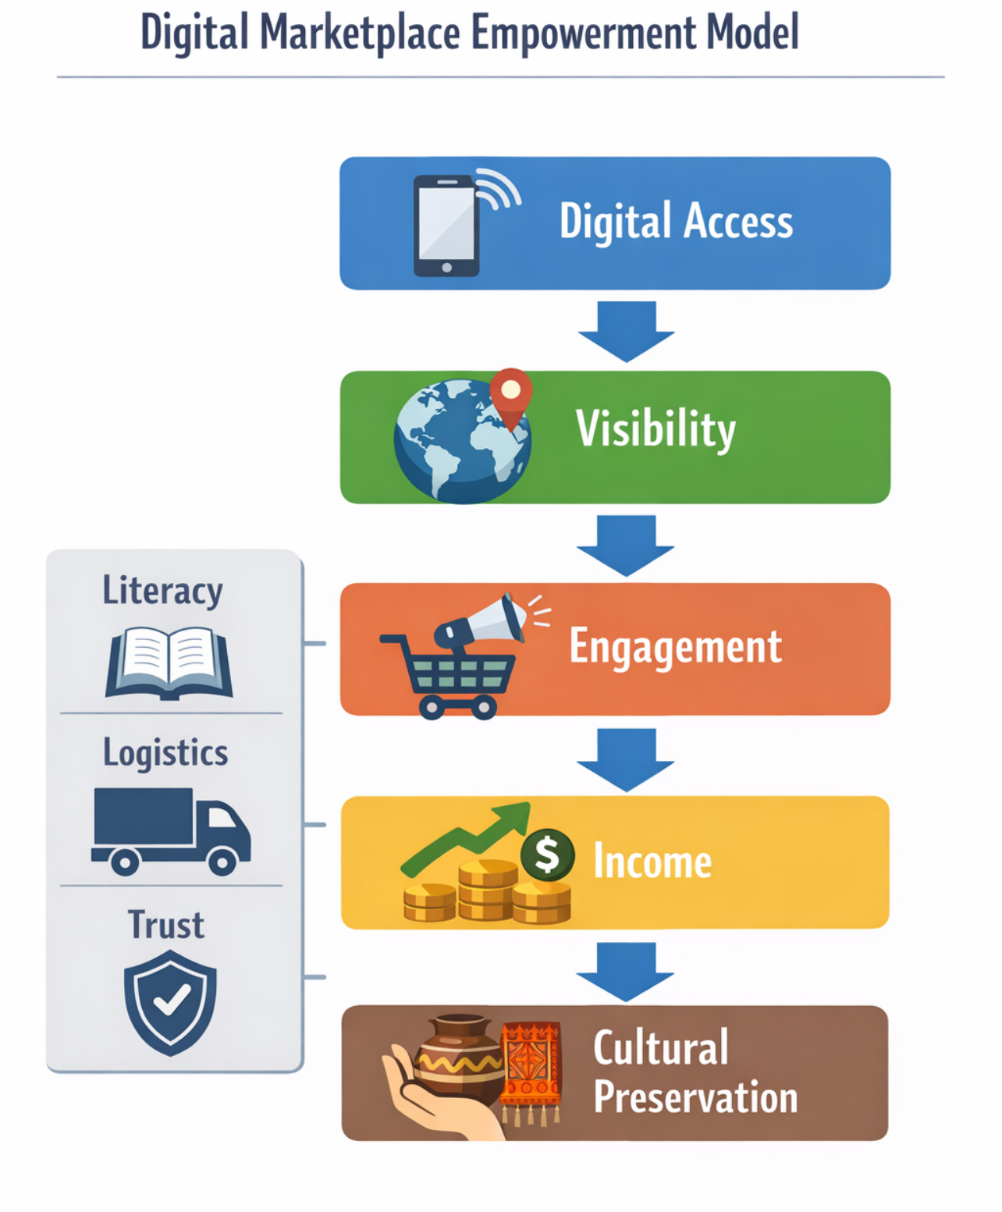

This figure illustrates how access to digital marketplaces can enhance visibility, leading to increased customer engagement and income opportunities. It also highlights that barriers such as logistics and trust can disrupt this process.

Figure 2: Digital Inclusion Framework
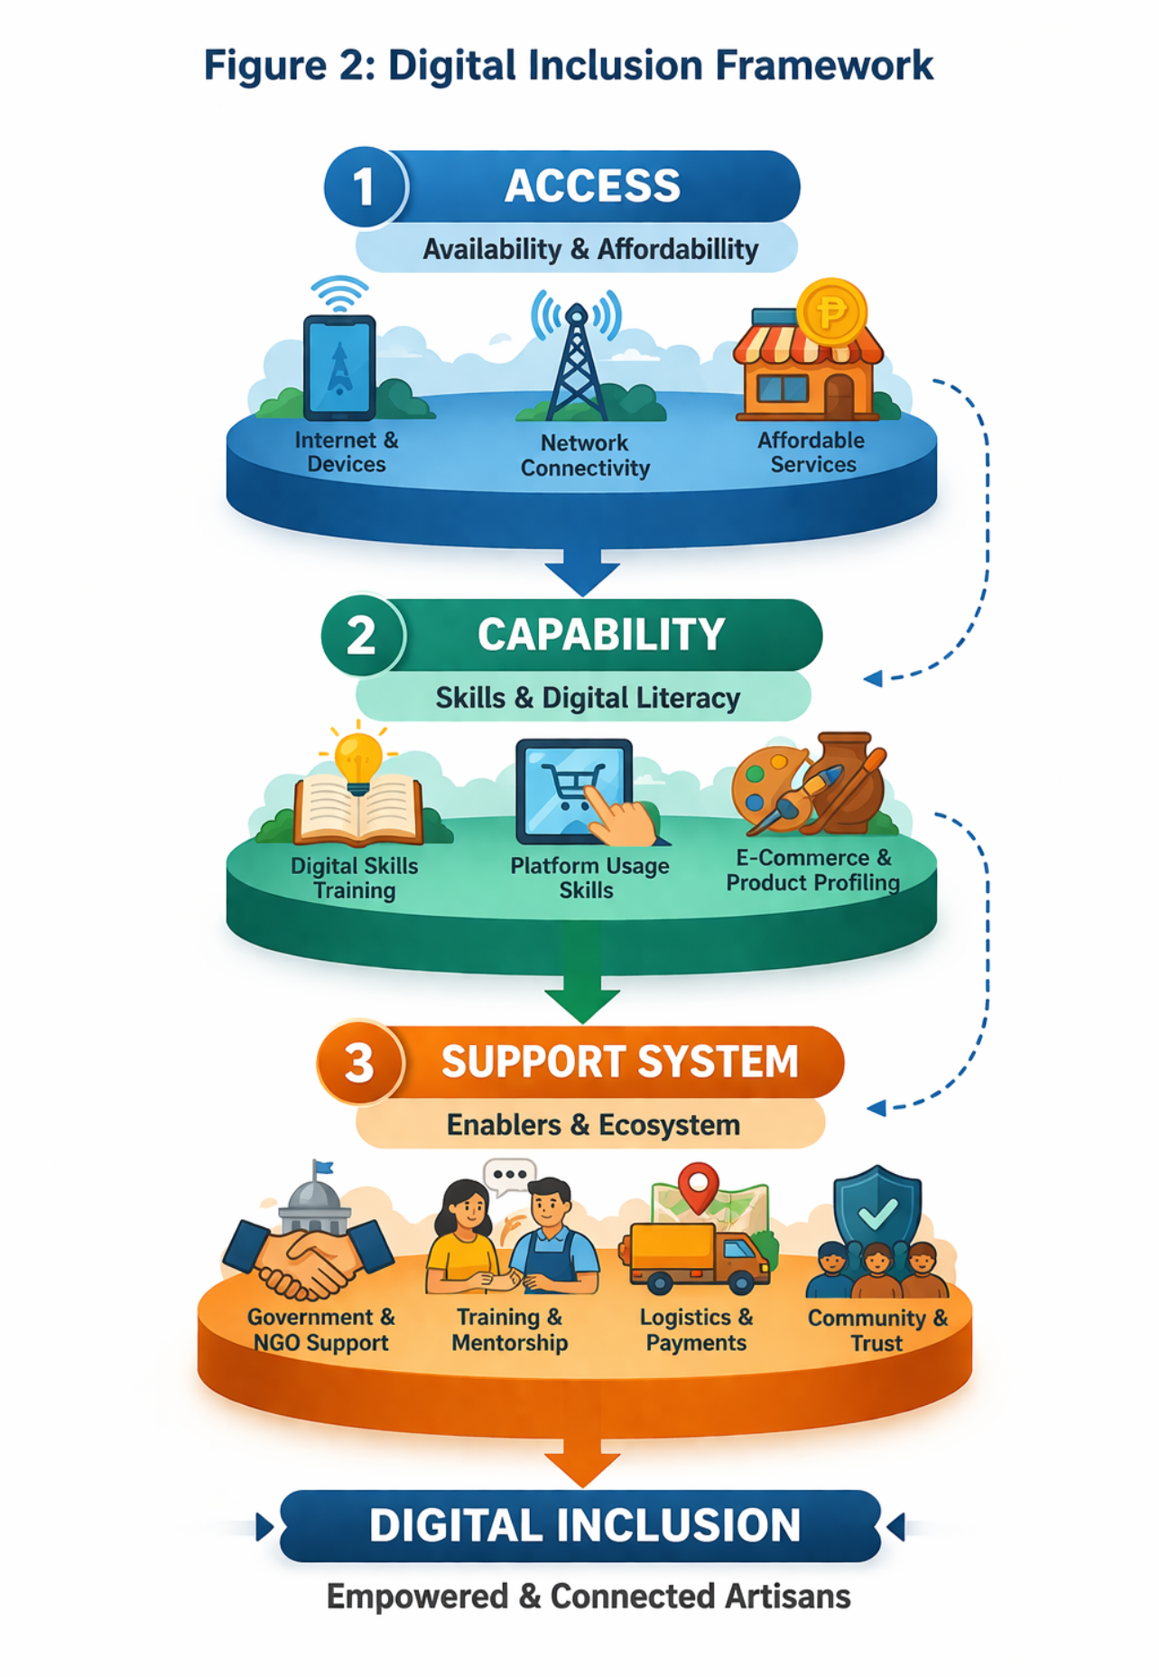
This figure shows that successful participation in digital platforms requires the integration of access, capability, and support systems. The absence of any of these elements can limit effectiveness.

Figure 3: Platform Value Proposition Model
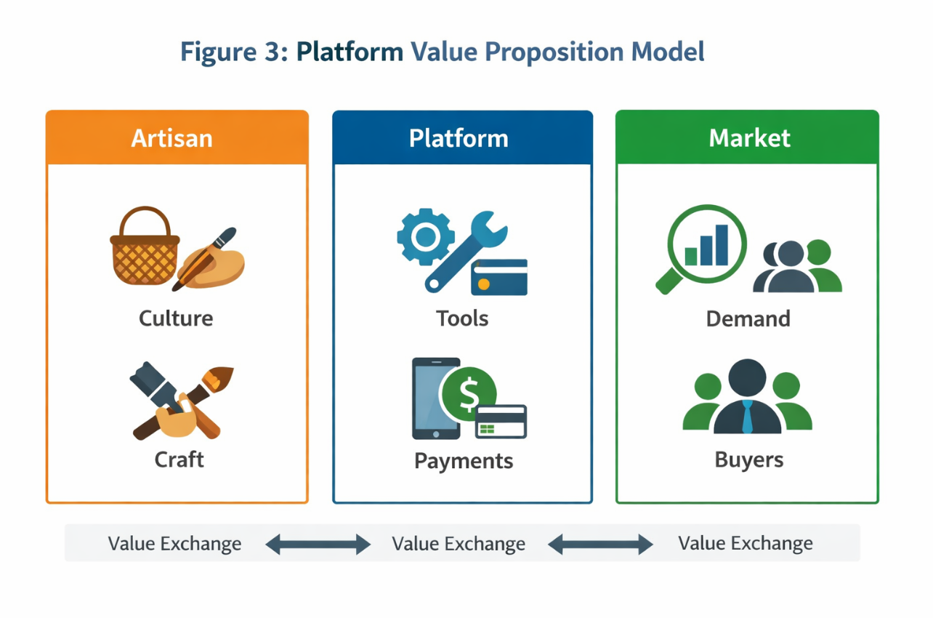
This figure presents the relationship between artisans, the platform, and the market. It demonstrates how the platform connects cultural production with consumer demand. This suggests that removing barriers is critical to unlocking the full economic potential of digital participation.

