INSTINCTIVE POWER FACTOR IMPROVEMENT OF AMIKA DISTRIBUTION NETWORK IN CALABAR

(A CASE STUDY OF AMIKA FEEDER)

Abstract
This research work investigates the effectiveness of Instinctive Power Factor Improvement (IPFI) systems in reducing losses and improving power factor conditions in distribution feeders, particularly in the Calabar AMIKA Distribution Feeder. The study employs a simulation approach using the Etap Power Systems toolbox to model the distribution feeder and simulate the performance of APFC systems under different load conditions. Kendall’s Tau-based Pearson Correlation is used as a statistical tool to analyse the correlation between losses and power factor conditions. The results show that APFC systems can significantly reduce losses across all Buses with Achibong sub-station having loss reduction of 27.7kW from an initial 47.6kW, Obutong sub-station losses drop to 30.8kW from an initial loss of 92.9kW. the result also shows a significant improvement in the power factor across all sub stations with Clement Ebri sub-station having an improved power factor of 86% from an initial 65% power factor, utility sub-station having an improved power factor of 100% from an initial 16% power factor and Nsemo sub-station with an improved power factor of 95% from 43% this has resulted in reduction of losses and improved power factor in the entire State Housing Feeder. This improve power factor conditions, results in cost savings and improved reliability of the electrical grid. The study also highlights the importance of addressing power factor issues and reducing losses in distribution feeders, particularly in areas with similar power factor conditions. Further work is recommended to validate the simulation results, investigate the impact of different types of APFC systems, and explore the economic feasibility of implementing APFC systems in distribution feeders.

- INTRODUCTION
Power factor study is a crucial analysis to determine the power factor correction requirements of a system. It is an essential step towards understanding the energy efficiency of a system and addressing issues related to low power factor Zeng et al., (2022). Power factor is a measure of how efficiently an electrical energy is converted to useful energy (work output), it is the ratio of the active power (kw) and the apparent power (kVa) consumed by a device Duan et al., (2020). This information is used to evaluate present use patterns and to determine the potential economic benefits of improving power factor. Utility rate structures usually provide significant economic incentives to reduce total kVA demand Razavi, & Elmi, (2020).
Power factor is a crucial parameter in electrical systems that measures the effectiveness of power utilization, hence, representing the ratio of real power to apparent power Hashmi et al., (2020); and Zeng et al., (2022). A low power factor results in inefficient energy use, leading to increased losses in the distribution system Lee et al., (2021). Power factor correction is essential to optimize energy utilization, reduce losses, and enhance the overall efficiency of the electrical grid Ali et al., (2020); and You and Lu, (2022). Maintaining a high power factor is essential for minimizing energy losses and ensuring the efficient operation of distribution feeders Duan et al., (2020). Calabar metropolis, like many urban centres, experiences challenges related to power factor correction in its distribution feeders related to power factor inefficiencies Zeng et al., (2022). Factors such as varying loads, the presence of reactive power, and changes in consumer behaviour contribute to suboptimal power factor levels Razavi, & Elmi, (2020); and Duan et al., (2020). This suboptimal power factor leads to increased energy losses, higher electricity bills, and decreased system reliability Shah et al., (2022).
Calabar is the capital city of Cross River State in south-eastern Nigeria. It is located near the Gulf of Guinea and serves as an important economic and cultural centre in the region. Calabar Metropolis refers to the urban area and its surroundings within the city of Calabar. The metropolis includes various neighbourhoods, commercial districts, and industrial areas that constitute the urban fabric of the city. Calabar has historical significance, and its port has played a role in trade and commerce. Today, it continues to be a hub for economic activities, tourism, and administrative functions within Cross River State.
In this study, an electrical transient analyser application was utilized to examine the automatic power factor correction (APFC) feeder line network in the southern region of Calabar, Cross River State. This network serves a 36-bus network feeder and 44 substations, which cater to a high population ratio within the city’s metropolitan area. The total population size of the Calabar metropolis is approximately 631,000, representing a 4.3% increase from 2021. In 2021, the metropolitan area population of Calabar was 605,000, which was a 4.49% increase from 2020. Prior to that, in 2020, the metro area population of Calabar was 579,000, denoting a 4.32% increase from the previous year Lee et al., (2020); and Ali et al., (2020).
The State Housing feeder which takes its source from the injection sub-station located opposite Flour Mills in Calabar feeds the large part of about 44.6 km long in the zone feeding state housing area and other sub zone within the network in Calabar, Cross River State. The computational procedure (numerical algorithms) required to determine the steady state operating characteristics of the power system network from the feeder line data received from the field and bus data was simulated with ETAP power simulator software to obtain the real time line characteristics and load condition and from the result obtained, calculations were carried out to improve the power factor of the existing feeder.
Manual power factor correction methods have limitations in adapting to dynamic and unpredictable changes in the distribution network Lee et al., (2020); Ali et al., (2020); and You & Lu, (2022). Automatic power factor correction systems offer a more responsive and efficient solution, capable of continuously monitoring and adjusting power factor levels in real-time Hashmi et al., (2020); and Zeng et al., (2022). This ensures that the distribution system operates at optimal efficiency under varying conditions. This study aims to explore and implement an Automatic Power Factor Correction (APFC) system using Kendall's Tau-based Pearson correlation. Efficient energy use is a key concern for utilities and consumers alike. Power factor, a ratio of real power to apparent power Shah et al., (2022), reflects the efficiency with which electrical power is converted into useful work. A low power factor results in increased energy consumption, higher losses, and suboptimal system performance Shah et al., (2022); Mahdavi et al., (2022); and Mishra et al., (2023). Addressing power factor issues is particularly relevant in densely populated urban areas like Calabar Metropolis where the demand for electrical power is substantial. Calabar Metropolis, despite its economic and cultural significance, faces challenges in power distribution. The distribution feeders experience fluctuating loads, leading to variations in power factor. Manual power factor correction processes are often inefficient and impractical for large-scale distribution networks. There is a need for an automated solution that can dynamically adjust power factor correction capacitors to optimize efficiency.
Kendall’s Tau is a non-parametric measure of correlation that assesses the strength and direction of monotonic relationships between variables. In the context of this study, Kendall’s Tau was employed to analyse the relationship between power factor and various operational parameters of the distribution feeders. Additionally, Pearson correlation, a parametric measure, will complement the analysis to provide a comprehensive understanding of the factors influencing power factor.
- Statement of the problem
The conventional methods of power factor correction in distribution feeders often lack adaptability to dynamic changes in load conditions, resulting in suboptimal operational efficiency. Moreover, the intricate relationships between power factor and diverse operational parameters within the distribution feeders remain insufficiently explored. The existing manual correction mechanisms are not equipped to handle the evolving demands of modern urban environments, characterized by fluctuating loads, variations in power consumption patterns, and the increasing integration of renewable energy sources. Inadequate power factor correction leads to elevated energy losses, diminished system reliability, and increased operational costs. Therefore, a comprehensive and automated approach that integrates advanced statistical measures, such as Kendall’s Tau-based Pearson correlation, is imperative to address these challenges and enhance the overall performance of the power distribution network in urban centres like Calabar Metropolis. This research aims to investigate and implement an Instinctive Power Factor Improvement (IPFI) system that leverages statistical correlation analyses to dynamically adjust power factor correction capacitors.

- Aim and Objective
The aim of this research is to propose an Automatic Power Factor Correction system for Calabar Metropolis, utilizing Kendall's Tau-based Pearson correlation.
Specific Objectives
To improve the adaptability of the power factor correction system to dynamic changes in the distribution feeder, including fluctuations in load, voltage levels, and other environmental factors and validate the performance of the developed system through rigorous simulations.

- Significance of the Study

The outcomes of this study could lead to substantial energy savings, cost reductions, and a more environmentally conscious power infrastructure. Additionally, the technological innovation embedded in the proposed APFC system positions Calabar at the forefront of smart grid advancements, contributing not only to the reliability of the urban power supply but also to the broader goals of urban development and sustainable living. This research, therefore, holds far-reaching implications for both the immediate improvement of the power distribution network and the long-term resilience and advancement of urban infrastructure in Calabar Metropolis.
- LITERATURE REVIEW
Power factor improvement is a crucial aspect of electrical power systems aimed at improving the efficiency of power delivery Razavi, and Elmi, (2020); Huang et al., (2021); and Shaheen et al., (2023). The power factor is the ratio of real power (useful power) to apparent power (total power) Montano-Martinez et al., (2021); and Shah et al., (2022). In distribution systems, a low power factor leads to increased losses and reduced efficiency Lee et al., (2021; and Montano-Martinez et al., (2021). Traditional methods of power factor correction involve the addition of reactive power through the use of capacitor banks Montano-Martinez et al., (2021); and Shah et al., (2022). However, with the advent of automated systems, the focus has shifted towards real-time, adaptive correction mechanisms Lee et al., (2021; Montano-Martinez et al., (2021); and Shah et al., (2022).Understanding the fundamentals of power factor improvement is essential for improving energy efficiency, reducing losses, and ensuring the reliable operation of electrical networks(Huang et al., 2021; and Shaheen et al., (2023).The power factor is a dimensionless quantity that represents the ratio of real power (the actual power doing useful work) to apparent power (the total power flowing in the circuit). It is expressed as a value between 0 and 1 or as a percentage. A power factor of 1 or 100% indicates a perfect conversion of electrical power to useful work, while lower values denote a less efficient use of power Razavi, and Elmi, (2020).
In many industrial and commercial applications, electrical loads exhibit inductive or capacitive characteristics, causing a phase shift between voltage and current waveforms. This phase shift results in a power factor less than unity. A low power factor has several adverse effects Lee et al., 2020; Ali et al., (2020); and You and Lu, (2022):
Increased Energy Consumption: Systems with low power factors draw more current to deliver the same amount of real power, leading to higher energy consumption and increased costs.
Voltage Drop: Low power factors contribute to voltage drop issues, affecting the voltage stability and reliability of the electrical distribution system.
Overloading of Equipment: Transformers, generators, and other equipment can become overloaded when operating at low power factors, reducing their lifespan and efficiency.
5.1. Traditional Power Factor Correction Methods
Historically, power factor correction involved the use of fixed or switched capacitor banks. Capacitors introduce reactive power into the system, compensating for the lagging power factor caused by inductive loads Hashmi et al., 2020; and Zeng et al., (2022). These traditional methods, while effective, lacked adaptability and were often unable to address dynamic changes in load conditions Lee et al., (2021).
5.2 Automatic Power Factor Correction (APFC) Systems
The evolution of power factor correction led to the development of (APFC) systems. These systems employ advanced control algorithms and real-time monitoring to dynamically adjust the compensation provided by capacitors. APFC systems offer several advantages (Huang et al., (2021); and Lee et al., (2021):
Real-time Adaptability: APFC systems continuously analyse the power factor and adjust capacitor banks in real time, ensuring optimal correction under varying load conditions.
Energy Savings: By maintaining a high-power factor, APFC systems reduce reactive power consumption, leading to energy savings and improved overall system efficiency.
Enhanced Equipment Performance: Proper power factor correction enhances the performance and lifespan of electrical equipment, reducing the risk of overloading and voltage drop issues.

θ
kVA
kw
Total Power kVA

$$θ$$

Power kw

Magnetic Power
kVAr

Figure 2.1 Phase Diagram of Power Factor
5.3 Power Factor Correction in Distribution Feeders
Power factor correction is crucial for optimizing the efficiency of power distribution systems. Traditionally, power factor correction has been achieved through the use of capacitors and other reactive power compensating devices Hashmi et al., 2020; and Zeng et al., (2022). The literature highlights various methods and technologies employed to enhance power factor correction, including static capacitors, synchronous condensers, and advanced power electronic devices Razavi, and Elmi, (2020). Power factor correction (PFC) in distribution feeders is a critical aspect of modern electrical power systems that directly influences their efficiency, reliability, and economic viability Lee et al., (2021). The power factor is defined as the cosine of the angle between the voltage and current waveforms in an alternating current (AC) circuit. Ideally, power systems aim for a power factor of 1 (or unity), indicating perfect alignment between voltage and current. However, in practical scenarios, power factors are often less than 1 due to the presence of reactive power, resulting in increased losses, reduced system capacity, and overall inefficiency Hashmi et al., (2020); and Zeng et al., (2022).
1. Importance of Power Factor Correction
The significance of power factor correction lies in optimizing the utilization of electrical power, minimizing energy losses, and improving the overall efficiency of power distribution systems. A low power factor not only results in increased energy consumption but also places additional stress on electrical components, leading to a higher demand for reactive power and potentially causing voltage instability Lee et al., (2021).
2. Traditional Power Factor Correction Methods
Historically, power factor correction has been achieved through the use of capacitors and other reactive power compensating devices. Static capacitors, in particular, are widely employed to offset the effects of inductive loads and improve power factor. These devices introduce leading reactive power into the system, effectively cancelling out the lagging reactive power associated with inductive loads Razavi, and Elmi, (2020).
3. Challenges in Traditional Methods
While traditional methods have proven effective in many cases, they are not without challenges. The static nature of these solutions often leads to over-correction or under-correction, as they are not adaptive to varying load conditions. Additionally, the manual operation and control of capacitors can be cumbersome and may not respond rapidly to dynamic changes in the power system Zeng et al., (2022).
- MATERIALS AND METHODS
The materials and methods used in carrying out the research are presented in this section.
6.1 Materials/tools
The material and tools used for the implementation of this research are discussed as follows:
Simulated Model of Electricity Distribution Network (State Housing Feeder)
Etap for development of the Calabar feeder network
Dell laptop, Latitude E6530 with specification: Windows 10 Pro, Intel Core i5 with 8GB RAM @ 2.90GHz
6.2 Method
The method used for the Automatic Power Factor Correction of Distribution Feeder in Calabar Metropolis is the Kendall's Tau-B-based Pearson Correlation. This subsection outlines the mathematical framework employed to investigate and optimize the automatic power factor correction (APFC) of the distribution feeder in Calabar Metropolis, with a specific emphasis on utilizing Kendall's Tau-B-based Pearson correlation. The mathematical methodology integrates statistical analyses and electrical engineering principles to quantify and understand the relationships between power factor and relevant electrical parameters.
6.2.1 Data Representation
Let PF_{t} represent the power factor at time t, V_{t} denote the voltage at time t, and I_{t} signify the current at time t. The collected electrical data is organized into time series datasets PF_{t}, V_{t}, I_{t}, where t represents discrete time points Nta, (2022).
6.2.2 Quantitative Analysis
1. Kendall's Tau-B:
Kendall's Tau-B assesses the strength and direction of monotonic relationships between power factor (PF) and other variables such as voltage (V) and current (I). The calculation involves determining the number of concordant (C) and discordant (D) pairs in the dataset Duan et al., (2020):
$$τ_{b}=\frac{(C-D)}{(\frac{1}{2}n\left(n-1\right)} (1)$$
where n is the number of data points. Positive $τ_{b}$ values indicate a positive correlation, while negative values suggest a negative correlation Ali et al., (2020); and You and Lu, (2022).

2. Pearson Correlation:
Pearson correlation coefficients$τ$ quantify linear relationships between variables. The formula for Pearson correlation is:
$$τ=\frac{\sum{}(PF_{t}-\underline{PF})(X_{t}-\underline{X})}{\sqrt{\sum{}{(PF_{t}-\underline{PF})}^{2}\sum{}{(X_{t}-\underline{X})}^{3}}} (.2)$$
where X represents either voltage or current, and$\underline{PF}$and $\underline{X}$denote the means of the respective variables(You & Lu, 2022).
6.2.3 Integration of Statistical Results
The results from Kendall's Tau-B and Pearson correlation analyses are integrated to provide a comprehensive understanding of the relationships between power factor and other electrical parameters. The concordance or discordance in the trends revealed by both statistical measures contributes to the robustness of the findings You and Lu, (2022).
6.2.4 Time Series Analysis
Time series analysis involves identifying patterns and trends in power factor variation over the data collection period. Techniques such as moving averages (MA) and trend line fitting (y = mx + b) are employed to reveal cyclical or seasonal influences on power factor Ali et al., (2020).
:
$$MA_{t}=\frac{1}{k}\sum_{i=1}^{k}{}{PF}_{t-1} (3)$$
$$y=mx+b (4)$$
where k is the number of data points considered in the moving average.

3.2.5 Optimization Modelling
Optimization models are constructed to propose strategies for APFC improvement based on the mathematical relationships identified. For instance, a simple model for capacitor bank optimization can be formulated as:
$$Max\left(\sum_{t=1}^{n}{}PF_{t}-PF_{target}\right) (5)$$
subject to operational constraints and configurations, where $PF_{t}-PF_{target}$is the desired target power factor.
6.2.6 Simulation Studies
Simulation studies are conducted to validate the proposed optimization models. Using the Etap simulation tools, the models are tested under different scenarios, including varying load conditions, capacitor configurations, and control strategies, to assess the robustness and effectiveness of the proposed APFC optimization strategies.
Algorithm of the Correlation Scheme
1. Input Power Data; Read power data from the distribution feeder in Calabar Metropolis.
2. Data Pre-processing (if necessary); Check for missing values or outliers. Normalize or clean the data as needed.
3. Calculate Kendall's Tau Correlation; Use a function to compute Kendall's Tau correlation for the power data.
4. Calculate Pearson Correlation; Use a function to compute Pearson correlation for the same power data.
5. Select Correction Strategy; If Kendall's Tau is significant, and Choose a correction strategy based on Kendall's Tau results. Else if Pearson Correlation is significant:
6. Implement Automatic Power Factor Correction; Apply the selected correction strategy to adjust power factor.
7. Monitor Power Factor Correction; Continuously monitor power factor changes, and Check if the correction meets the desired criteria.
8. Output Results; Present the final corrected power data, and Display any relevant results or improvements achieved.
9. End- Conclude the algorithmic process.
6.2.7 Computation of harmonic voltages and currents
The recovery inverter is connected to the rotor circuit by selecting the delay angle using equation (3.6) Mahdavi et al., (2022); and Mishra et al., (2023).
$s=\frac{ω_{s}-ω_{r}}{ω_{s}}≈-\frac{a_{m}}{a_{t}}coscos α$ (6)
Where a_{m} and $a_{t}$, are the turn ratios of the stator to rotor and transformer respectively. After the motor has reached the new steady-state speed, the stator currents can then be computed by
$\left[i_{sa} i_{sb} i_{sc} \right]=\sqrt{\frac{2}{3}}\left[1 0 -\frac{1}{2} \frac{\sqrt{3}}{2} -\frac{1}{2} -\frac{\sqrt{3}}{2} \right]\left[coscos θ -sinsin θ sinsin θ coscos θ \right]\left[i_{sd} i_{sq} \right]$ (7)
The transformer current $I_{a}^{T}$ Is obtained as;
$I_{a}^{N}=I_{a}^{S}+I_{a}^{T}$ (8)
To compute the harmonic components, according to Shah et al., (2022), only algebraic additions of the numerical values of the waveform are needed, this gives an easy evaluation. If a function f(t) with period T is known at “m” samples displaced by $∆$t, the Fourier coefficients of the nth harmonic component are evaluated by equation (3.12), with an assumption that the function is linear between any two successive sampling intervals t_{i} and t_{i+1}. Only if the step size $∆t$ is adequately small Shah et al., (2022); Mahdavi et al., (2022); and Mishra et al., (2023).
$A_{N}-jB_{N}=-\frac{2}{T{\left(\frac{2πn}{T}\right)}^{2}∆t}\sum_{I=1}^{M-1}{}Δ_{I}\left(-j\frac{2πn}{T}T_{I}\right)$ (9)
$=-\frac{2}{T{\left(\frac{2πn}{T}\right)}^{2}∆t}\sum_{I=1}^{M-1}{}Δ_{I}[cos\left(\frac{2πn}{T}T_{I}\right)-jsin\left(\frac{2πn}{T}T_{I}\right)]$ (10)
$Δ_{I}=f\left(T_{I+1}\right)-2f\left(T_{I}\right)+f(T_{I-1})$ (11)

The distortion relating to a particular harmonic content in a waveform can be expressed as the relative magnitude of the total rms harmonic current of order n to the rms amplitude of the fundamental. The total harmonic distortion factor is the ratio of the rms value of all the harmonic components together, to the rms. Amplitude of the fundamental Shah et al., (2022).
Total harmonic distortion factor = $\frac{\sqrt{I_{Th}^{2}-I_{F}^{2}}}{I_{F}}$ (12)
Where I_{f} is the fundamental rms current harmonics and I_{th} is the total current harmonics
6.2.8 Power Factor Definition
Power factor (PF for short) is the ratio between kW and kVA drawn by an electrical load where the kW is the actual load power and the kVA is the apparent load power. It is a measure of how effectively the current is being converted into useful work output and more particularly is a good indicator of the effect of the load current on the efficiency of power grid system Shah et al., (2022); Mahdavi et al., (2022); and Mishra et al., (2023). This is depicted in equation (3.13) and (3.14).
All current flow causes losses both in the supply and distribution system. A load with a PF of 1.0 results in the most efficient loading of the supply. A load with a PF of, e.g., 0.75, results in much higher losses and a higher electricity bill penalty. An improvement in pf can bring about a significant reduction in losses since losses are proportional to the square of the current Mahdavi et al., (2022).

P.F (Cos Ǿ)= K.W / KVA (13)
Or
P.F (Cos Ǿ) = True Power / Apparent Power (14)
Where;
kW is Working Power (also called Actual Power or Active Power or Real Power).
It is the power that actually powers the equipment and performs useful work.
kVAR is Reactive Power.
It is the power that magnetic equipment (transformer, motor and relay) needs to produce the magnetizing flux.
kVA is Apparent Power.
It is the “vector summation” of kVAR and kW.
The IPFI relay action is dependent on the following rules:
If 1 ≥ rvi_{s} ≥ r₁ (for all phases), then the case is normal operation with proper PF, leading to a blocking action of the APFC algorithm.
If r₂ ˂ rvi_{s} ˂ r₁ (for all phases), then the case is normal operation with low PF, resulting in an operating action of the APFC algorithm, which connects the required number of capacitor bank(s) to get the desired PF.
If r₂ ≥ rvi_{s} ≥ 0 (for any phase), then the case is abnormal operation. Thus, a blocking action of the APFC algorithm is issued.
Result of the Calabar Amika Distribution Feeder
In this work, the distribution feeder is limited to the Calabar state housing distribution feeder. The line model is presented in Figure 4.1. The distribution feeders are subjected to a simulation test to observe the losses when connected without the APFC system. The result of the distribution feeder system is presented in Figure 4.2. The time domain load flow system data are presented in Table 4.1. The power factor condition of total generation and demand is presented in Figure 4.3. The System without APFC is further compared with the application of APFC, and it is presented in Figure 4.4. The result in every unit is presented in Figure 4.5. The losses of the distribution line after the introduction of the APFC are displayed in Table 4.2. Thus, showing the difference in the line losses before and after the application of APFC. The graphical representation of the losses is further presented in Figure4.6.

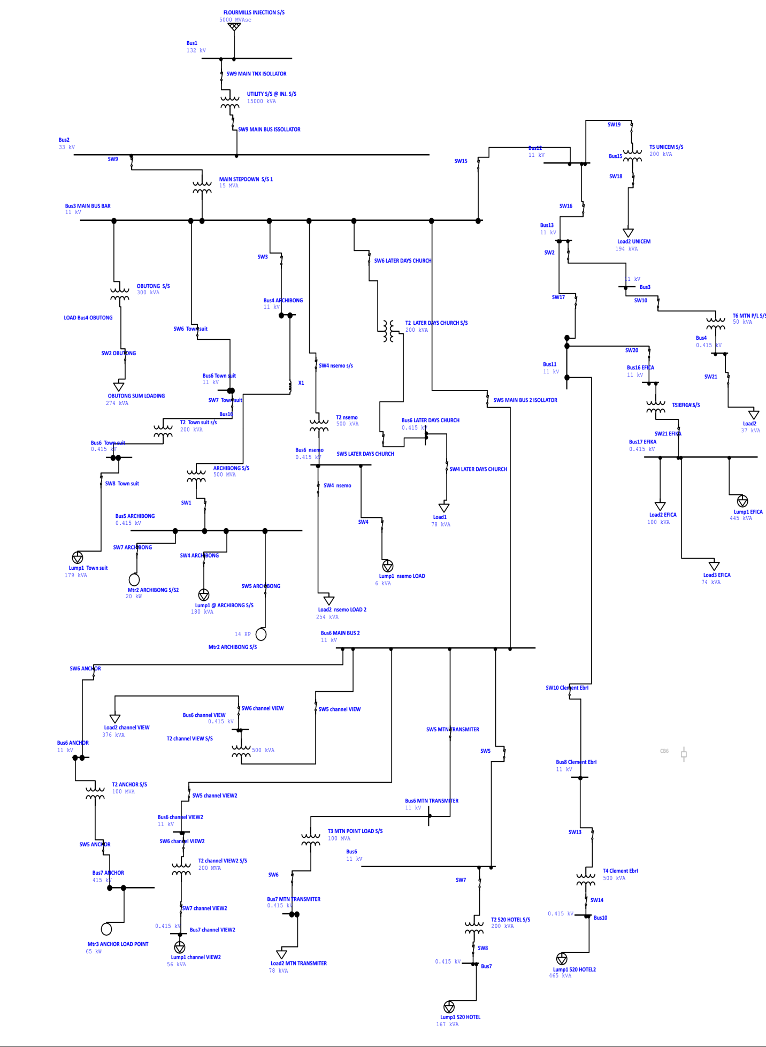
Figure: 7.1 State Housing Distribution Feeder Line Model
Table 7.1: Average load on each bus at pick period.
NAME | kW
ARCHIBONG S/S | 224kVA
MAIN STEPDOWN S/S 1 | 372kVA
OBUTONG S/S | 274kVA
T2 LATER DAYS CHURCH S/S | 78kVA
T2 Town suit s/s | 427kVA
T2 520 HOTEL S/S | 167kVA
T2 ANCHOR S/S | 87.34kVA
T2channel VIEW S/S | 376kVA
T2channel VIEW2 S/S 2 | 56kVA
T2 nsemo | 259kVA
T3 MTN POINT LOAD S/S | 78kVA
T4 Clement Ebri | 365kVA
T5 EFICA S/S | 157kVA
T5 UNICEM S/S | 194kVA
T6 MTN P/L S/S | 37kVA
UTILITY S/S @INJ. S/S | 12770.9
X1 | 0.0
Source: PHED Calabar.

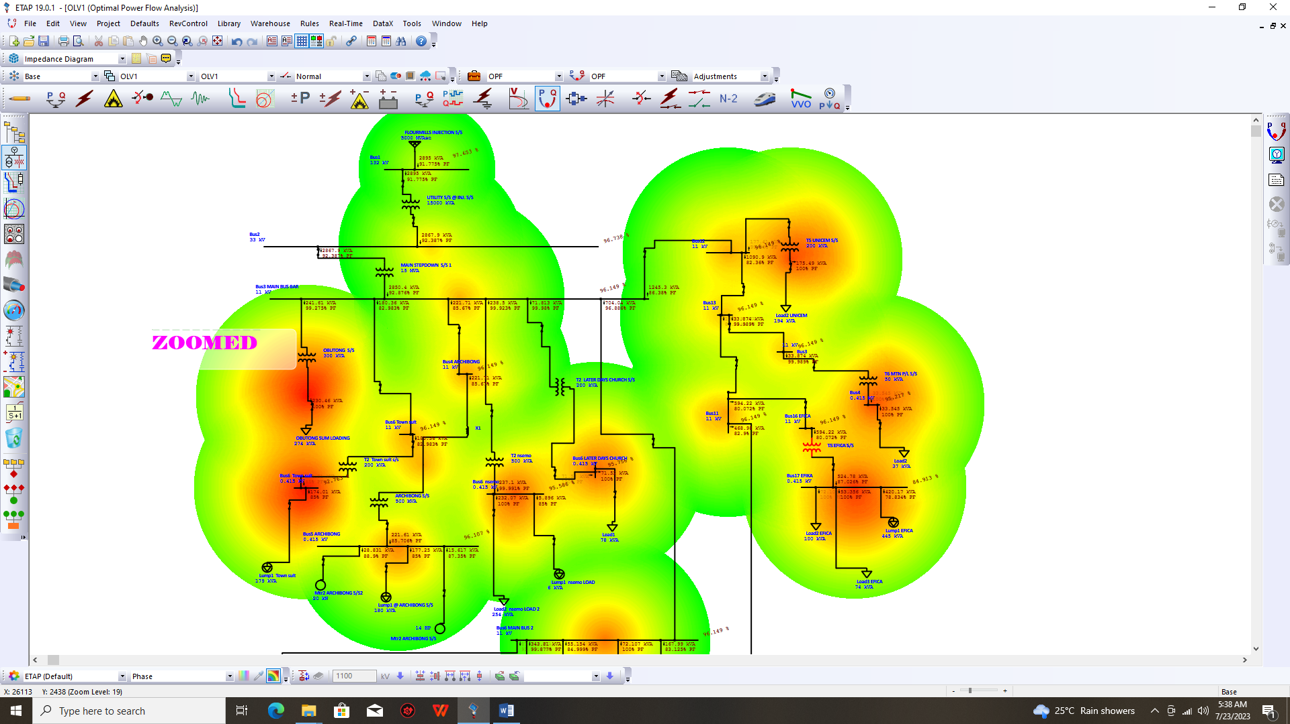
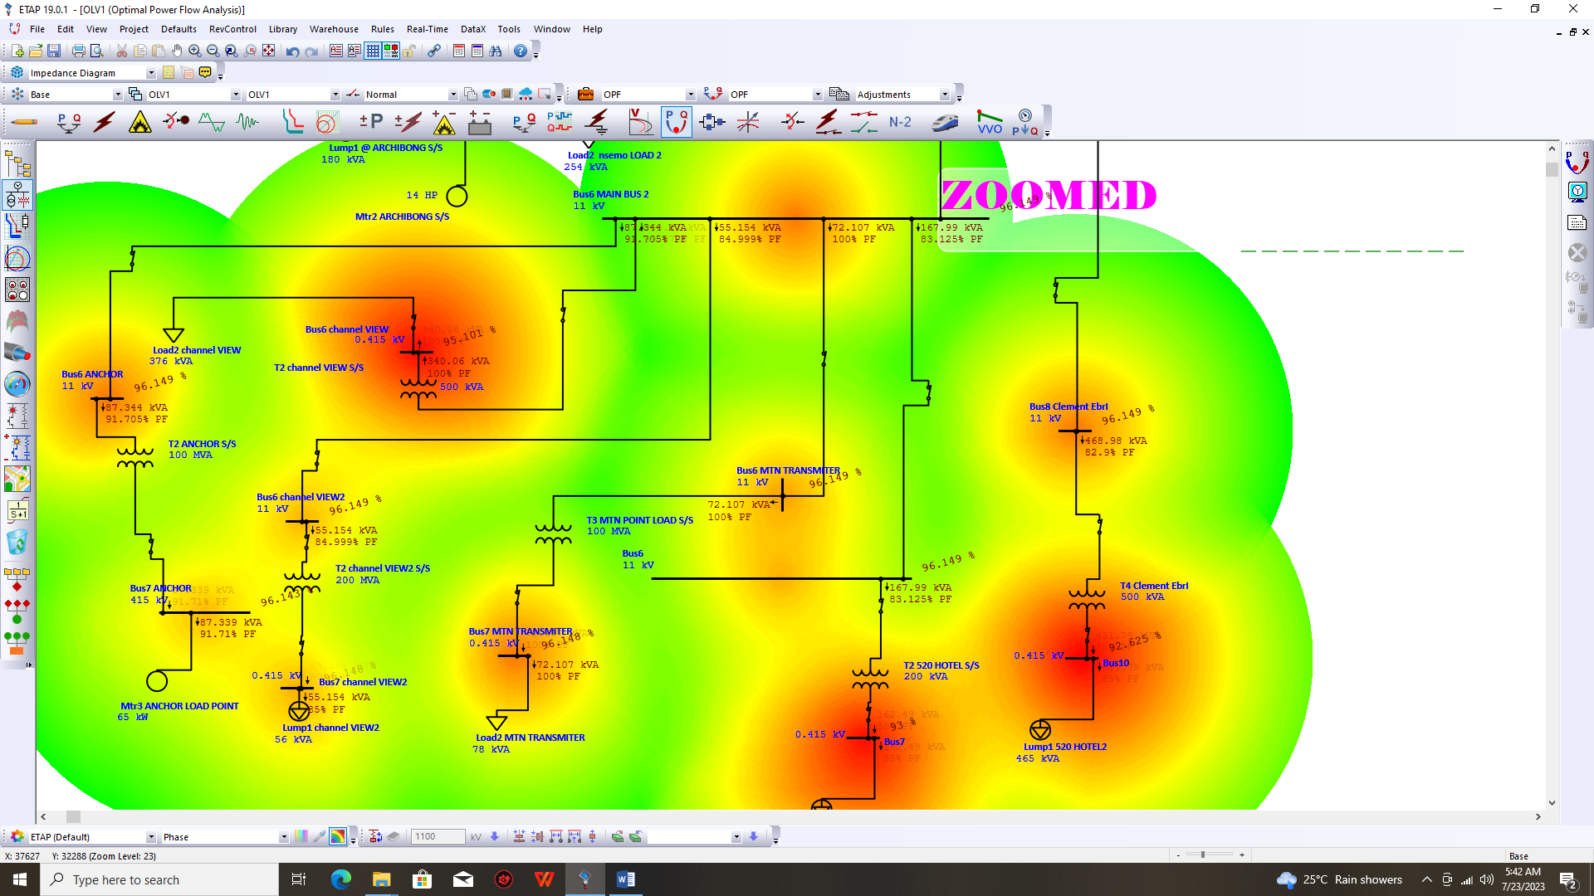
Figure: 7.2 Losses without APFC

Table 7.2 Losses before insertion of APFC
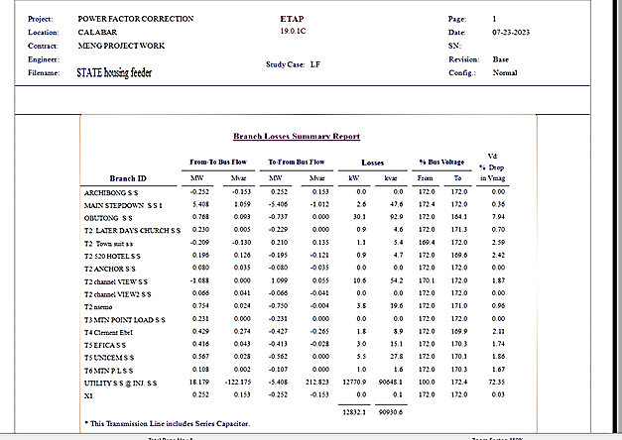
In table 7.2 the system details of losses on ideal condition is presented. This is the state at which the system records maximum failure. Hence it is regarded as the state without APFC.

The automotive power factor condition of the total generation and demand which is presented in Figure 7.3, this indicates that the power factor is low, leading to high losses in the distribution line. To address this issue, the study compares the system without IPFI with the application of IPFI, which is The results show that the introduction of IPFI significantly reduces the losses in the distribution line. Thus this is in agreement with the work of Brahma, et al., (2020); Lee et al., (2020); Ali et al., (2020); and You, and Lu, (2022).
The losses before and after the application of IPFI are displayed in Table 2 and Figure 7.6, respectively. He further illustrates the significant reduction in losses after introducing APFC as it is captured in Lee et al., (2020).
In summary, this study highlights the importance of implementing IPFI systems in distribution feeders to improve power factor conditions and reduce losses. The results presented in this study provide valuable insights into the effectiveness of APFC systems in addressing power factor issues and reducing losses in distribution feeders, particularly in the Calabar state housing distribution feeder.

8. CONCLUSION
The research titled "Automatic Power Factor Correction as a means of reducing losses in Distribution Network" investigates the effectiveness of Instinctive Power Factor Improvement (IPFI) systems in reducing losses and improving power factor conditions in the Calabar state housing distribution feeder. The study presents a simulation test on the distribution feeder without APFC, which reveals high losses and low power factor conditions. The results show that the introduction of IPFI significantly reduces losses and improves power factor conditions, as seen in the case of Obutong sub-station from 45 percent to 97 percent and also in other substations. The study's findings suggest that implementing APFC systems in distribution feeders can lead to significant reductions in losses and improve power factor conditions, particularly in the Calabar state housing distribution feeder.
The research investigates the application of Automatic Power Factor Correction (IPFI) in the context of the Calabar state housing distribution feeder. The study utilizes simulation tests to assess the losses in the distribution feeder without the APFC system, presenting the results through figures and tables. The line model in Figure 4.1 establishes the foundation for understanding the distribution feeder, and subsequent simulations without IPFI in Figure 4.2 provide a baseline for comparison. Time domain load flow data in Table 1 offers insights into the dynamic behaviour of the system. The Automotive power factor condition of total generation and demand in Figure 4.3 sets the initial power quality context. The introduction of APFC is then analysed through a direct system comparison Figure 4.4, unit-specific result, and quantified losses Table 4.2. Graphical representations visually depict the impact of IPFI on reducing losses. The research demonstrates the efficacy of APFC in optimizing the distribution feeder's performance. Improvements in power factor, reductions in losses, and enhanced system efficiency are apparent. The findings provide valuable insights for power system engineers and decision-makers seeking to enhance the overall efficiency and reliability of distribution feeders through the implementation of IPFI.

REFERENCES
Ali, F., Arbab, M. N., Ahmed, G., Ashraf, M., and Sarim, M. (2020). An SVC controller for power quality improvement of a heavily loaded grid. Mehran University Research Journal Of Engineering & Technology, 39(2), 247-256.
Al-Janabi, Z. M. K. (2022). Microcontroller-based automatic power factor correction for three-phase loads (Master's thesis, Altınbaş Üniversitesi / LisansüstüEğitimEnstitüsü).
Anyin, P. B., Odama, G. O., and Njoku, F. C. (2022) Performance Evaluation of Fuzzy Logic Controller’s Certain Membership Functions for Control of Slip Energy Recovery Drive for Improved Power Factor.
Brahma, S., Nazir, N., Ossareh, H., and Almassalkhi, M. R. (2020). Optimal and resilient coordination of virtual batteries in distribution feeders. IEEE Transactions on Power Systems, 36(4), 2841-2854.
Cetin, A., Ozen, C., Bayatmakoo, A., Kaya, K., and Poyrazoglu, G. (2022, March). A Pilot Project for Power Quality Improvements in Distribution System by a Li-ion Battery. In 2022 3rd International Conference on Smart Grid and Renewable Energy (SGRE) (pp. 1-5). IEEE.
Duan, Y., Luo, L., Li, Y., andCao, Y. (2020). The communication system and its impacts on line current differential protection in distributed feeder automation. Energies, 13(6), 1298.
Gao, Q., Han, B., Huang, X., Zhang, P., Liu, J., and Ge, L. (2021, December). Verification method of topological relationship of low voltage distribution equipment based on KNN and Pearson correlation coefficient. In 2021 International Conference on Power System Technology (POWERCON) (pp. 127-132). IEEE.
Gu, J. C., Huang, Z. J., Wang, J. M., Hsu, L. C., andYang, M. T. (2020). High impedance fault detection in overhead distribution feeders using a DSP-based feeder terminal unit. IEEE Transactions on Industry Applications, 57(1), 179-186.
Hashmi, M. U., Deka, D., Bušić, A., Pereira, L., and Backhaus, S. (2020). Arbitrage with power factor correction using energy storage. IEEE Transactions on Power Systems, 35(4), 2693-2703.
Huang, Y. C., Chang, W. C., Hsu, H., andKuo, C. C. (2021). Planning and Research of Distribution Feeder Automation with Decentralized Power Supply. Electronics 2021, 10, 362.
Ibrahim, A. H., Ashigwuike, E. C., Oluyombo, W., andSadiq, A. A. (2023). Optimal capacitor planning for power factor improvement using hybrid particle swarm and harmony search optimization. Nigerian Journal of Technological Development, 20(3), 210-226.
Jneid, J. (2020). Cluster Analysis for Medium Voltage Distribution Feeders. McGill University (Canada).

