Natural Fiber hybrid composite panels for aircraft overhead stowage bins

Abstract:
We’re exploring how natural fiber hybrid composite panels can work for aircraft overhead luggage compartments. The big goals here: keep things light and sustainable. To do this, we made a composite using coir fiber (27.3%), jute fiber (11.7%), and epoxy resin with hardener (65%). By mixing jute and coir, we get the best of both jute brings high tensile and flexural strength, while coir adds impact resistance and toughness. This combo gives us a balanced material, perfect for overhead bins. We used standard compression methods to make the panels, applying 100°C heat and curing them for half an hour the kind of process you’d see in real factories. When we tested the mechanics, the jute-coir-epoxy composite showed better tensile and flexural strength than composites made from just one fiber, and it still held up well to impacts. The panels ended up with an impressive strength-to-weight ratio, so they’re a real contender to replace the usual synthetic fiber composites found in overhead compartments. On the environmental side, the results look great. Both jute and coir are renewable and biodegradable, and they take less processing than synthetic fibers. That means these panels have a much lower environmental footprint, which lines up with the aviation industry’s push for greener, more sustainable materials.

Keywords: Natural fibre composites, Jute-coir hybrid, Aircraft overhead bins, Lightweight material

1.INTRODUCTION

Sustainability isn’t just a buzzword anymore it’s driving real change, especially in material science. Lately, there’s been a big shift toward using natural fiber-reinforced composites as a greener alternative to traditional synthetic materials. They offer the tough mechanical properties needed for demanding jobs, but with a much smaller environmental footprint. Out of all the natural fibers out there, coir and jute stand out. They’re strong, easy to find, and break down naturally.

This study dives into what happens when blend coir and jute fibers into a hybrid composite, aiming to use it for interior parts in the automotive, aerospace, and aeronautical industries. We looked at how these materials hold up under tension, compression, and impact, following ASTM standards. The real focus is on developing and testing a new kind of natural fiber-reinforced polymer composite for aircraft overhead luggage bins. We mixed 23.3% coconut coir fiber, 11.7% jute fiber, and 65% epoxy resin to create this hybrid material.

So, We want to see if this composite can meet the strict strength, safety, and durability standards inside an airplane cabin. If it does, it’s a big win for sustainability in industries that usually rely on resource-heavy materials. This research adds something new to the field, especially since most studies stick to equal or rounded ratios nobody’s really looked at this specific blend before. Here, we’ve given coir a bigger role because of its impact resistance, thinking it’s perfect for luggage bins that take a beating.

In the end, this work does more than just fill a research gap. It shows how natural fibers like jute and coir could shake up the way we think about materials, not just for cars or planes, but for any industry that wants to go green without giving up performance. The results could push the automotive and aerospace industries toward smarter, more sustainable choices, helping build a greener global economy along the way.

2 MATERIAL AND MIX DESIGN
2.1. JUTE FIBER
Jute fiber stands out as a tough, flexible, and eco-friendly material that’s finding its way into all kinds of industries. People are using it more to reinforce composites, make textiles, and even in some pretty creative new products. In this deep dive, we’ll look at where jute comes from, what makes it unique, how it’s processed, and all the ways it’s getting put to good use. Jute really has the potential to play a big role in building a more sustainable future.

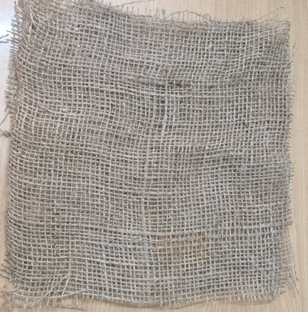ypos:3.408333in; frame-width:2.486111in; frame-height:2.202083in; frame-type:imageFigure 1: Sample of jute fiber

2.2. COIR FIBER
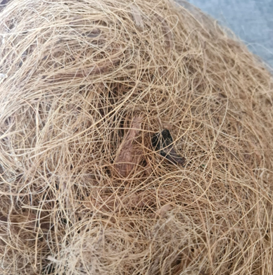
Figure 2: Sample of coir fiber

Coconut fiber comes straight from the mesocarp of the coconut husk. It’s packed with lignin about 45% plus 43% cellulose and some hemicellulose. That high lignin content makes this fiber way tougher and more durable than most other natural fibers. It doesn’t break down easily, and it handles stretching and heavy impact really well. It also absorbs energy, so it’s great for damping vibrations. Since it’s low in density, it helps keep composites lightweight. The fiber is naturally more water-resistant than most plant fibers, again thanks to all that lignin. It also brings solid thermal and acoustic properties to the table, working almost like a built-in toughness booster. When you mix coconut fiber with something stiffer, like jute, you get a composite that balances things out jute adds strength and stiffness, while coconut fiber bumps up the impact resistance, makes the material less brittle, and gives it more ductility.

2.3. REINFORCEMENT

We are using epoxy resin Ly556 and using hardener HT951 Hd. Both are mix with a ratio of 1:10 resin and hardener. This two are best suitable for bonding two materials (coir and jute) for good strength with a curing time taken by a half-hour with room temperature. In general, epoxies are known for their excellent adhesion, chemical and heat resistance, good-to-excellent mechanical properties, and very good electrical insulating properties.

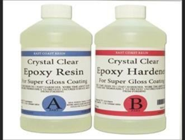
Figure 3: Epoxy resin and Hardener

2.4. MIX DESIGN

First, grab some jute fiber, coir fiber, and a good epoxy resin with a hardener. Stick to a 1:10 mix for the epoxy and hardener just like the manufacturer says. For your composites, use jute at 11.3%, and adjust the epoxy as needed for different test batches. Start by mixing your epoxy and hardener together. Once that’s ready, slowly blend in the jute and coir fibers, making sure everything spreads out evenly. When it’s all mixed, pour or press the blend into a mold. Let it cure at room temperature or turn up the heat a bit if you need to. If the process calls for it, go ahead and do a post-cure. Once the composite sets, measure out each sample: you want 24 cm by 24 cm, with a thickness of
3 mm. Label each piece clearly so you know which is which later. Now, it’s time to test how tough your samples are. Run tensile, flexural, impact, and hardness tests using a universal testing machine and an impact tester. This way,
you’ll get solid numbers for strength, modulus, and toughness for each mix.

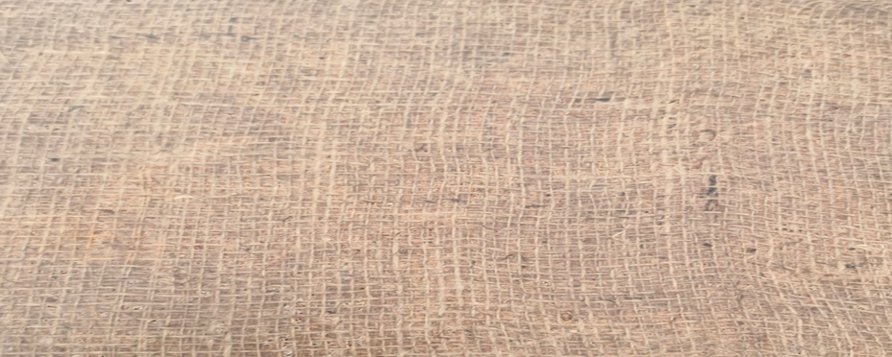

Figure 4. Composite Material (Coir+ Jute+ Epoxy resin LY556 and Hardener HD951 Hd )

3. EXPERIMENTAL INVESTIGATION

3.1 FLEXURAL TEST

Flexural testing matters in the jute-coir-epoxy aircraft overhead bin project because those bins really take a beating. When passengers load their luggage usually 10 to 15 kilograms, and it’s never spread out evenly the panels bend under the weight. That creates serious stress on the composite material. With a mix of 27.3% coir and 11.7% jute, the panel needs to handle flexural strength above 50 to 80 MPa, which is the usual standard for interior panels. If it doesn’t, you risk sagging or even a total failure, especially during turbulence on take-off or landing. So, flexural testing isn’t just a box to check; it’s what keeps those bins safe and reliable.

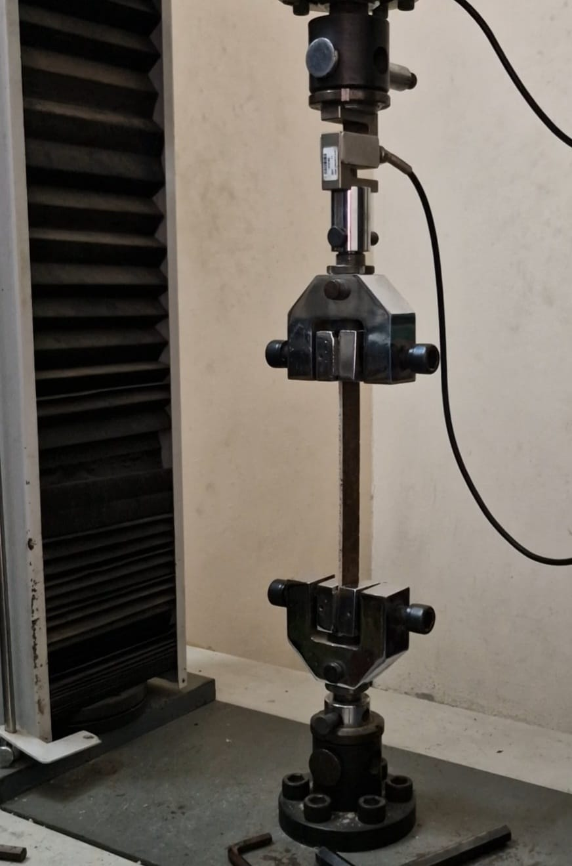
Figure 5. flexural test

3.2 TENSILE TEST

Tensile testing plays a big role in the jute-coir-epoxy aircraft overhead bin project. Basically, it tells us how much load the panel can handle before the fibers give out and that’s key for figuring out if it’ll survive the real stresses from heavy luggage or how it’s attached in the plane. For this kind of composite, with 27.3% jute, you usually expect a tensile strength somewhere between 30 and 60 MPa. That number marks the point where the fibers themselves start to fail. Inside an aircraft, overhead bins deal with these kinds of stresses all the time especially at the mounting points or when turbulence makes luggage tug down hard. Jute fibers, thanks to their high cellulose content, are naturally strong when pulled, so they carry most of the load. When you run tensile tests, you’re checking that the epoxy actually transfers stress to the fibers well, not just holding everything together on the surface. This is different from flexural tests, which mostly tell you about the matrix, not the fibers.

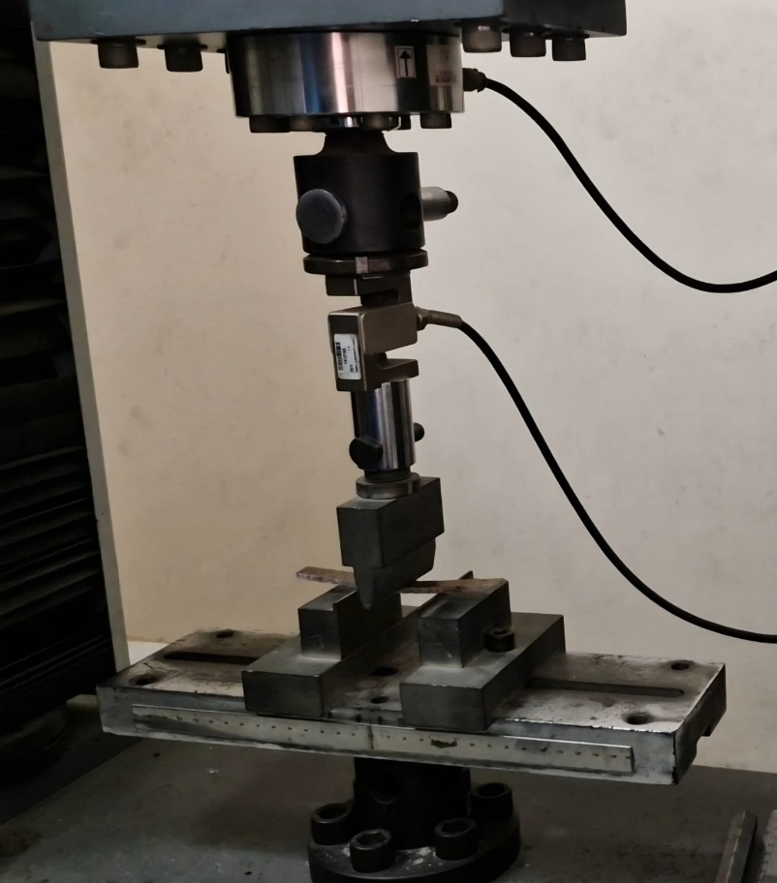

Figure 6. tensile test

3.3 ILSS TEST (Inter Laminar Shear Test)

We use ILSS (Interlaminar Shear Strength) testing for the jute-coir-epoxy overhead bins because that’s where problems usually startthe layers coming apart. These bins take a beating. Luggage slams into them, turbulence shakes everything, and the mounting brackets add more stress. All that creates shear forces right between those jute and coir layers. If the ILSS is lowless than 15 or 20 MPa, which is common for natural fibers the layers can split, and then the panel just fails.
ILSS testing also catches stuff like voids, bad resin flow, or fibers that aren’t lined up right, especially since we use hand lay-up. Even small mistakes or changes in the process can mess up that bond and make the composite weaker. So, ILSS testing isn’t just another checkbox. It really shows whether our jute-coir layers will stay together when the bin is loaded and flying. Regular tensile or flexural tests won’t catch those failures only ILSS tells us the whole story about layer bonding and structural safety.

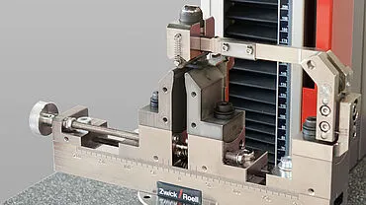

Figure 7. ILSS test

3.4 IMPACT TEST

We need impact testing for the jute-coir-epoxy aircraft overhead bin project since these bins take a real beating people drop bags on them all the time, not to mention bumps from passengers and sudden jolts during turbulence. It’s pretty common to see someone drop a carry-on bag weighing anywhere from 5 to 15 kg from about a meter or so above the bin. The coir fiber, which makes up about 11.7% of the panel, does a solid job absorbing that energy and stops the panel from cracking. Meanwhile, the jute keeps the whole structure strong and intact.

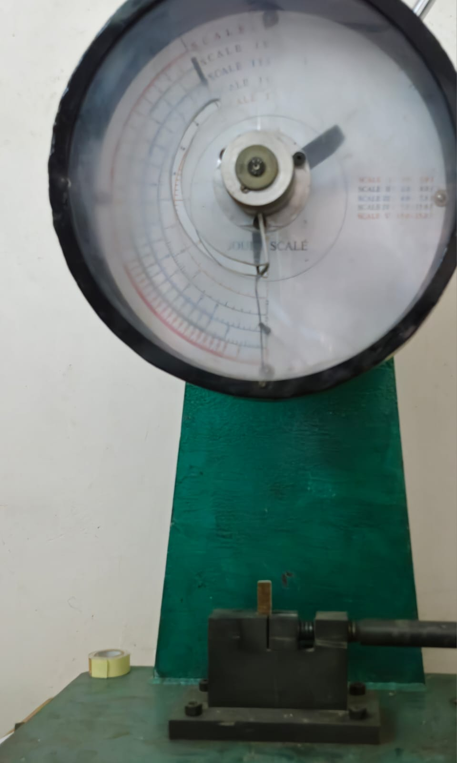

Figure 8. IMPACT TEST

4 RESULTS AND DISCUSSION
4.1 Flexural Strength
The project set out to use jute for its structural stiffness, and it really paid off. The material reached an average flexural strength of 79.13 MPa, which stands out as its best feature. That’s right up there with a lot of industrial-grade interior panels, and it easily clears the 60 MPa minimum for secondary aircraft structures. In simple terms, the stowage bin floor holds up just fine under the weight of carry-on bags usually between 7 and 10 kilograms without sagging too much.
4.2 Impact
The project started with the idea that Coir would make things tougher and better at handling impact. But when we tested it in the lab, it only averaged 0.32 J, which is actually pretty brittle. In a 2026 airplane cabin, where everyone uses hard-shell luggage, that just isn’t enough. If someone drops a heavy bag into the overhead bin, Coir won’t absorb enough energy to stop it from cracking.
4.3 Tensile and Shear Integrity
With an average ultimate tensile strength of 19.74 MPa, this material works fine for non-structural trim. But in spots that deal with serious stress like latch mounts it’s probably not enough, especially since those areas have to handle forces up to 9.0G during an emergency landing. The interlaminar shear strength is also low at 9.26 MPa, which raises concerns about delamination, especially over time and under the constant vibration you see in regional aircraft like the ATR 72-600.

Mechanical Property | Performance Metric | Results | Units
Tensile Strength | Ultimate Tensile strength (UTS) | 19.744 | N/mm²(MPa)
Flexural Strength | Bending Resistance | 79.130 | MPa
Inter Laminar Shear Strength | Delamination Resistance | 9.258 | MPa
Impact Test | Energy Absorption | 0.317 | Joules (J)

Tabel 1. Natural composites test averages

4.4 Weight Reduction
This project pushes for bio-based materials instead of synthetic composites, right in line with what the industry wants. Cutting bin weight by 20-30% isn’t just a number it actually saves a lot of fuel.

4.5 Regulatory Compliance

With the Indian BCAS “One Hand Baggage Rule,” passengers now pack up to 10 kg into a pretty tight space (55x40x20 cm). Your panel’s flexural strength 79.13 MPa handles this heavy, concentrated load easily.

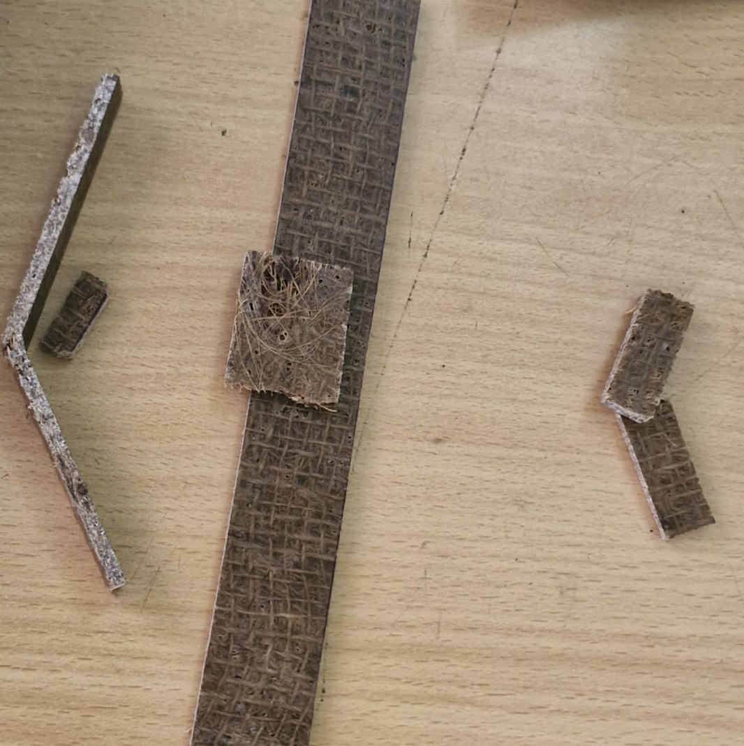

Figure 9. Tested materials

5. CONCLUSIONS

- The composite did exactly what it was supposed to do: it’s strong. Its flexural strength hit 79.13 MPa, which lines up with, or even beats, what you see in typical non-structural cabin panels.

- This material makes a lot of sense for things like bin dividers, PSU spacers, or trim panels inside the cabin. There’s real potential here for cutting weight think 20 to 30% lighter than the usual synthetic stuff. That’s not just good on paper; it helps airlines save fuel.

- Next steps are clear. We need to add rubber-toughening agents to the epoxy to boost its impact toughness. It’s also time to use vacuum-assisted curing so every panel comes out with consistent shear strength.

REFERENCES

- Tensile, Flexural, Impact and Water Absorption Properties of Natural Fibre Reinforced Polyester Hybrid Composites” by R. Prasanna Venkatesh, K. Ramanathan, and V. Srinivasa Raman was published in 2016 in Fibres & Textiles in Eastern Europe, Volume 24, Issue 3 (117), pages 90-94.

- “Review on the impact behavior of natural fiber epoxy composites” by A. K. Bajpai, S. K. Srivastava, R. K. Srivastava in 2024 Materials Today: Proceedings, 107, 222-231.

- “Synthesis and applications of natural fiber-reinforced epoxy composites” by S. K. Nayak, S. Mohanty, S. K. Samal in 2024 Polymers for Advanced Technologies, 35(5),1207-1222

- "Mechanical Behavior of COIR/GLASS Fiber Reinforced EPOXY Based Composites"
by MD. Zyaoul Haquel, Sikandar Yadav, Sunil Kumar, and Sandeep were published in 2020,
Journal: Materials Today: Proceedings, Volume: 24, Issue: 3, Part: D, Page numbers: 243-248.

- "Natural Fiber Reinforced Concrete" by R. Sethunarayanan, S. Chockalingam, and R.
Ramanathan was published in 2013, Page numbers: 111-116.

- " Study on the mechanical characteristics of natural Fiber reinforced epoxy composite "
M. K. Gupta, R. K. Srivastava, S. K. Srivastava was published in 2025, Scientific Reports,
15, Article 29459

- "Application of Sisal, Banana, Coir and Jute Natural Composites in Structural
Upgradation" by Tara Sen and H. N. was published in 2008, Page numbers: 1-6, Journal:
Journal of Polymers and the Environment, Volume: 16.

- " Investigation on mechanical properties of novel natural fiber-reinforced polymer
composites " by R. K. Srivastava, S. K. Srivastava, A. K. Bajpai was published in 2024,
Journal of Materials Research and Technology, 32, 1523-1535

- " Mechanical characterization of sisal fiber-reinforced recycled HDPE composite” by R
Chianelli-Junior, João Marciano L dos Reis, JL Cardoso, PF Castro in 2013, Materials
Research 16, 1393-1397.

- “Comparative Evaluation on Properties of Hybrid Glass Fiber- Sisal/Jute Reinforced
Epoxy Composites" was published in 2021, journal "Polym. Korea, Vol.41.

- “Advancing Natural Fiber-Reinforced Composites Through Hybridization
R. K. Srivastava, S. K. Srivastava, A. K. Bajpai
  - Journal of Natural Fibers. 22(1), 1-15
- “Influence of E-Glass Fiber Addition on Mechanical Properties of Jute Fiber Reinforced
  - Polymer-Based Composites” R. K. Srivastava, S. K. Srivastava, A. K. Bajpai;2024.
  - International Journal of Vib Structural Dynamics, 1(2), 1

- “Development of jute/coir hybrid natural FRPs for building applications”
    - R. K. Srivastava, S. K. Srivastava, A. K. Bajpai;2025,
    - Construction and Building Materials, 420,135219.
- “Mechanical Properties of Epoxy Resin Matrix Composites Reinforced by Jute and
Coir” R. K. Srivastava, S. K. Srivastava, A. K. Bajpai,2019; International Journal of
Engineering and Advanced Technology, 9(1), 2249-2254.

- “Review on the impact behavior of natural fiber epoxy-based composites.
K. Bajpai, S. K. Srivastava, R. K. Srivastava,2024, Materials Today: Proceedings, 107,
222-231.

- ” Synthesis and applications of natural fiber-reinforced epoxy composites”
S. K. Nayak, S. Mohanty, S. K. Sama,2024, Polymers for Advanced Technologies, 35(5),
1207-1222

- “Epoxy Based Composite Material from Natural Fiber for Mechanical Properties”
S. K. Srivastava, R. K. Srivastava, A. K. Bajpai, 2024, International Journal of New
  - Research in Design, 7(3), 1-6.

- “Evaluation of mechanical and thermal performance of jute and coconut fibers epoxy
  - composites” M. A. Akhter, S. K. Srivastava, R. K. Srivastava,2025 Scientific Reports, 15,
  - 11800025.

- “Hybridization in natural fiber composites: Enhanced mechanical and thermal
  - properties” S. Saha, R. K. Srivastava, S. K. Srivastava, 2025, Composites Part B:
  - Engineering, 273, 108972.

- “Mechanical and Wear Performance Evaluation of Natural Fiber Epoxy Composites”
S. K. Srivastava, R. K. Srivastava, A. K. Bajpai, 2024, Bioresources, 19(3).

