HAAR CASCADE CLASSIFIER-BASED SYSTEM FOR STUDENT ATTENDANCE THROUGH FACE RECOGNITION

Abstract
Attendance systems are essential in academic and organizational settings to track individual participation and discourage absenteeism. Traditional methods, such as paper-based attendance sheets, are tedious and susceptible to fraud, as well as impersonation and having someone else stand in for you. To resolve these problems, this study developed a haar cascade classifier-based system for student attendance through face recognition using Python and a webcam to detect and identify students in real-time. The web application applies the Haar Cascade Classifier from the OpenCV library, a machine learning-based algorithm that detects facial features. After students are enrolled, the system captures facial images, extracts features, and stores them in a database. During lectures, the system matches real-time images with the database, automatically recording attendance if a match is found. Performance evaluation showed that both enrollment and attendance processes were completed in under one minute, offering significant efficiency improvements over manual methods while usability testing with ten participants confirmed high satisfaction ratings averaging above 4.0 on a five-point Likert scale across navigation, clarity, form layout, and overall experience. This system effectively eliminates impersonation, reduces lecturer workload, and encourages punctuality, thereby contributing to improved academic integrity and institutional efficiency.
Keywords: Face Recognition, Attendance System, Haar Cascade Classifier, Web camera, Real-time Detection

How to cite: Ajala, T.B., Ukaigwe, S.C., Udemba, C.A., Oloko, R.K., & Agboola, A.R. (2026). HAAR CASCADE CLASSIFIER-BASED SYSTEM FOR STUDENT ATTENDANCE THROUGH FACE RECOGNITION.

Introduction
Organizations, the business, and education have always required an attendance system. In order to distinguish between participants and non-participants, attendance systems can be used to track or record people's attendance. This evolution has led to different approaches, such as manual, timesheet, mechanical, access control, and biometric attendance systems, due to technological developments and growing demand (Lun, 2023). The management of people's attendance at work in order to minimize losses caused by employees not attending work is called attendance management. Attendance management is different from attendance control as time clock and timesheets have traditionally been used to track attendance, but attendance management strives to foster an atmosphere where attendance is maximized (Akinduyite et al., 2013).
In order to track employee attendance whether it be automated or manual, all businesses require an attendance management system. Student attendance on a daily basis is necessary for quality control purposes. In most cases, most businesses utilize inefficient methods of manually calling out names or having employees sign pieces of paper (Karunakar et al., 2020). Nevertheless, in most cases, most automatic human recognition systems use conventional methods such as identity verification cards, passwords, and fingerprints. All these methods, however, have a few drawbacks such as loss of a verification card or forgotten password. Therefore, using a sophisticated face recognition system is the best way to guarantee complete confidentiality and preserve historical information (Bhattacharya et al., 2018). It is a swiftly expanding field that is crucial to security since it is an extremely accurate method of identifying and verifying individuals (Alhanaee et al., 2021).
Additionally, attendance is a crucial criterion that is utilized for a variety of functions in numerous academic institutions and businesses. These goals include maintaining records, evaluating students, and encouraging ideal and regular attendance in class. Most schools in developing nations demand a minimum percentage of students to attend class, however this policy has not been followed due to a number of issues with the current attendance system. This conventional approach uses books or sheets of paper to record student attendance. The attendance sheet could get lost or stolen. Impersonation can easily be done in this way. The process of taking attendance involves much time, and it may be difficult to ascertain the number of students who have attained the necessary percentage and are hence qualified to sit for the examination. A process that eliminates all these difficulties is hence required (Akinduyite et al., 2013).
The biometric system is an authentication method that uses a person's distinct physiological or behavioral traits to automatically identify them. To put it another way, it is an automatic identification of an individual based on his behavioral or physiological characteristics. Inherited characteristics that emerge throughout the early stages of human development are known as physiological features. Individuals' hands, faces, fingerprints, iris, and retinas are a few unique physiological traits that can be measured. Handwriting, vocal patterns, and keystroke dynamics are a few unique behavioral characteristics that can be measured (Omoyiola, 2018).
The study of face recognition is concerned with the manner in which biological systems recognize faces and the potential for computers to imitate this process. Various types of optical sensing mechanisms, or eyes, exist in biological systems. Optical sensing devices have evolved to suit their specific environment. In a similar vein, various visual devices are used by computer systems to collect and process faces according to the specific needs of each application. These sensors include 3D scans, infrared cameras, and video cameras (such as camcorders) (Martinez, 2023).

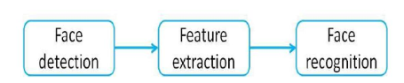
Figure 1 processes in face recognition system (Omoyiola, 2018)
One of the most effective uses of image analysis is face recognition. It is used to incorporate facial recognition data into electronic passports worldwide. In addition, it serves as a natural user interface in consumer electronics, entertainment, security, and law enforcement. By identifying the user and his identity and offering personalized services for consumer electronics, it improves the user experience (Omoyiola, 2018).

Related Work
This section gives a basic overview of some existing studies that was conducted relating to the current study by other researchers:

Biometric Process
Biometric identification refers to unique traits of a person's physique or conduct that can be leveraged for electronic authentication and granting access to devices, systems, or information. Biometrics involves analyzing unique traits of an individual using measurement and statistics. The basic usage of the system are as follows but not limited to restriction of access, identifying and recognizing people under monitored environment (Hamaamin et al., 2024). Registration or enlistment, live data acquisition, extracting and comparing patterns on template represent the techniques and operations that biometric systems depend on.
The training phase identified as enlistment or registration mode aims to collect data relating to individual identities.To give assurance that the system can withstand changes in the data for a period of time, more than one data might be carried out. In this stage, the sensor of the biometric system registers the traits of an individual, which are consquently illustrated as signatures and stored in the database. Given that the enlistment processing is performed offline, hence there is indefinite duration (Guennouni et al., 2019).
The "one-to-one" verification or authentication process involves identifying the identity of the user by matching his or her biometric data against the biometric template stored in the database. In this case, the system has to answer the request of identity verification of the user. Presently, the methods being used include the use of smart cards, a user ID or PIN number (Guennouni et al., 2019).
Identification mode involves “one-to-N” matching where the individual's identity can be established through the comparison with one of the models in the database. There might be no individual in the database. As per Guennouni et al. (2019), this approach involves the association of an identity with an individual.
The other importance of sample enrollment is to develop numerical templates that will act as benchmarks for future comparisons, and also to collect biometric data. Should there arise the need for developing a new or revised comparison algorithm, new replacement templates can be developed from the archives containing the raw samples. Efficient and effective methods of sample enrollment are necessary to ensure that samples are consistent, hence improving performance during matches of biometrics using one-to-many search (Aware, 2024).
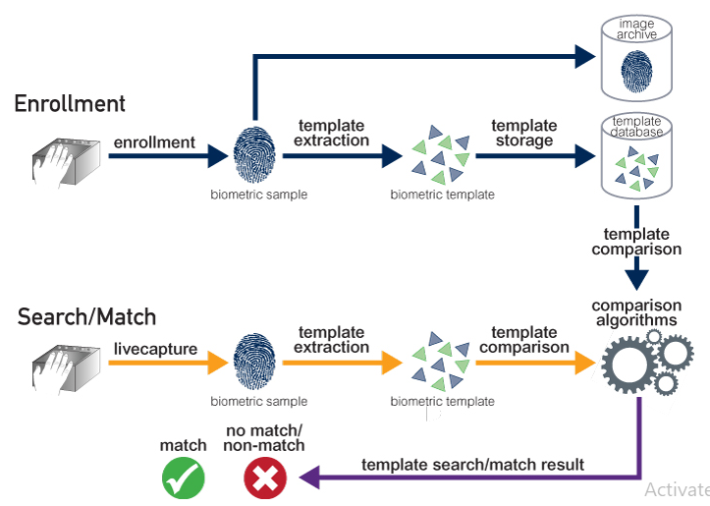
Figure 2 Biometric Process (Aware, 2024)

Types of biometric Identification
It is anticipated that systems will become more reliable and capable of delivering good results in difficult situations and in the face of counterfeiting as the use of biometric data increases. For any system to operate effectively, information security must be guaranteed. Therefore, a strict procedure is required to verify each person's identification before allowing them to access the stored data (Hamaamin et al., 2024).

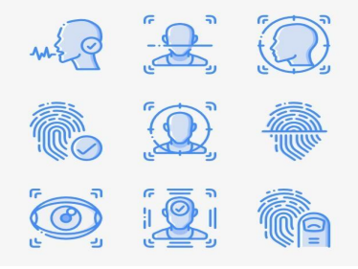
Figure 3 Types of Biometrics System (Hamaamin et. al., 2024)
Face recognition
The examination of facial characteristics and the relative positions of the lips, nose, and eyes is the foundation of face recognition. Thermal and standard video There are now two types of imaging methods for capturing facial images. Thermal imaging uses a heated wire created by the blood in the facial capillaries to create photographs of faces, while regular video is recorded by a camera (Feng, 2018).

The topic of facial recognition systems was recommended by Umalkar et al. (2023). Authors of this research study present the process of development and evaluation of an attendance system that uses facial recognition and uses real-time data for effective and accurate attendance management. This system incorporates advanced computer vision techniques and artificial intelligence tools to recognize employees/students in workspaces/classrooms.
The Attendance Management System Using Face Recognition proposed by Soundarya et al. (2021) seems to be a more appropriate model for handling the attendance of students not only in class but also in other places.
A paper written by Waghunde et al. (2021) shows an example of how automation can take place using the Class Biometric Register System (OBCARS). The objective of such a device would be to address the issue of papers that have been damaged or misplaced within various institutions of higher education.
An attendance management system using real-time face recognition technique is implemented in the project proposed by Gayatri & Yalla (2023). Computer vision techniques have been employed in the project to accurately identify and track individuals for attendance purposes. Face detection, feature extraction, and matching are among the face recognition techniques utilized in the system.
Kumara et al. (2021) suggested implementing the use of a MATLAB program along with an RFID card in managing face recognition for student attendance. Student attendance data is collected manually or through an RFID card in the research. This problem is hoped to be addressed through the implementation of a lecturer's laptop to collect attendance using face recognition software. This project will require MATLAB and a camera in recognizing faces.
A number of studies have attempted to investigate the application of facial recognition technology in managing attendance; yet, significant shortcomings have been observed in terms of the use of technologies, ease of application, portability, and usability. In this study, the development of a more interactive, portable, and user-friendly attendance system has been attempted using the Python programming language, along with OpenCV Haar Cascade Classifier, Streamlit, and SQLite3. There has also been no attempt made at Caleb University. The current study will make up for this deficiency through the use of a system with a haar cascade classifier that enables face detection to keep track of student attendance using a webcam on a lecturer’s computer and a minimalistic SQLite3 database, making the whole process efficient without necessitating costly biometric equipment. The current study will address this issue by opting for the Haar Cascade Classifier provided by the OpenCV library, which detects faces in a shorter time with lower computing demands.

Statement of the Problem

Educational institutions place a high emphasis on student attendance, and Caleb University is no exception in adhering to this principle. It is mandatory for all students to achieve a minimum attendance rate of 75% in each class or lecture in order to qualify for examination participation. The integration of biometric technology has demonstrated increased efficiency in tracking attendance. Making sure students are present is crucial to their success. Each educational institution has established a number of policies about absence as well as specific absenteeism limitations for this reason. In addition to the instructional activities, the teaching staff is inherently burdened by the enforcement of these regulations. Attendance records are utilized in schools and other educational settings for this purpose. The attendance sheet is either distributed around the classroom for students to sign, or the instructor reads the names of the students from the attendance list and places a sign for the present student (Temiz, 2022). On occasion, a different student may falsify a signature on the right student's behalf. In fact, one of the issues teachers deal with is finding more signatures than there are kids in the class. Instructors must verify the number of students participating with the number of signatures in order to prevent such issues. Someone else may attend class on behalf of a student enrolled in the course, even if the number of signatures is determined to be correct (Temiz, 2022). To ascertain whether someone unrelated to the course is participating, identities should be verified. As is evident, the entire class must pass an identification check to prevent fraudulent participation. Course time, which is extremely valuable for teachers and the classroom, is wasted as a result. We need a way to automate the student attendance system, hence this project proposed facial recognition for attendance, this system will serve as a rapid way to capture and record student attendance for the lecturer to make use of, thereby reducing the stress of taking attendance manually. It reduces absenteeism among the students in the class, when the students know that their friends cannot assist them in marking the attendance by proxy or in their absence. The proposed system will aid in regulating records and provide an accurate list of students who attend class.

Objectives of the Study

The explicit aim of the study is to develop a haar cascade classifier-based system for student attendance through face recognition. The particular objectives are:
- design a user interface to capture student attendance via face recognition,
- implement (i) using Python, OpenCV, Streamlit, and SQLite3.
- evaluate the implemented application on a couple of performance metrics.

Materials and Methods
This study adopted a prototype approach, which involves designing the dashboard for the web application, this represents the graphical user interface (GUI) to be used by the users of the system while the backend also created using SQLite to store the students’ faces that are registered on the system. The use of Streamlit (a python framework) enabled the programming of an interactive and cost-effective attendance management interface that can operate directly through a lecturer’s laptop webcam, which is suitable for academic environments. The advantage of using Streamlit is that it reduces the front-end development by using CSS bootstrap or in-line or outline CSS with Javascript. The primary advantage of using SQLite is its serverless and zero-configuration architecture, meaning it requires less setup and is a self-contained library that embeds directly into an application, storing the entire database as a single file on disk.

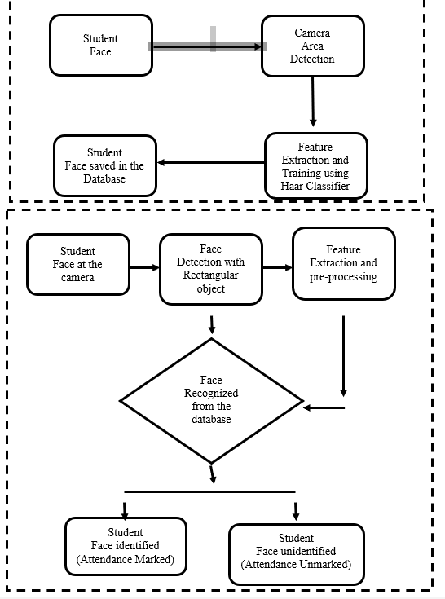
Figure 4: Architecture of the proposed system (Image Capturing & Recognition

According to Symanovich (2022), below are the basic step of facial recognition work:
1. Face detection: A camera takes a picture of the face. The person will be captured in profile view or facing straight ahead in the final shot.
2. Face analysis: The Haar Cascade technique is used to process a taken image of a face. After that, the computer looks at the person's facial geometry to find the salient features that set their face apart in the database.
3. Converting the image to data: The face capture procedure converts the analog data into a collection of distinct digital data. A facial signature is created using the data gathered via facial recognition.
4. Finding a match: A database with other registered faces is compared to the unique numerical code produced from facial attributes. If a facial signature matches a picture in a facial recognition database system, the student's attendance will be marked or their face will not be recognized.

Haar Cascade Classifier
Every stage of the Haar cascaded classifier comprises several weak classifiers. The method of boosting is employed to train the weak classifiers so that the average of predictions made by all the weak classifiers is used to generate a very accurate classifier. The classifier will then decide whether to continue with another window (negative) or report the presence of the object (positive) based on the prediction made. Since most windows do not contain anything interesting, stages are designed in such a way that they eliminate negative examples as fast as possible (Mittal, 2020).

Sequential Diagram
UML sequence diagrams (also known as interaction diagrams) illustrate how the actions are performed and how the objects interact within a specific collaboration. The main focus of sequence diagrams is time, and the interaction is illustrated through the vertical axis of the diagram representing time on what messages are being sent and at what times (Visual-paradigm, 2024). Sequence diagrams mainly depict object interactions in their specific sequence of occurrences (Bell, 2022).
Camera
Preprocessing
Feature extraction
Check student face in the database
Student
portrayed
face
Preprocess
student
face
Extract
student
face data
Student
face
features
True:
Student
attendance
marked
false
Student

Figure 5: Sequential Diagram of the proposed system
The general structure and functioning of the suggested system are depicted in the image. All of the system's parts and their interactions are depicted in this figure. The student will need to scan their face to take the attendance. The lecturer will monitor the attendance as the student sits in front of the system camera to capture their faces.

Performance Metrics
To evaluate the performance of the models, we used the following metrics:

Response time
By applying Haar Cascade Classifier on the face recognition-based attendance system, the user’s face was easily captured and recognized by the system during the marking phase.
Table 5 : Model Evaluation
 | Haar Cascade Classifier
Time taken during enrollment phase | <=20 seconds
Time taken to mark attendance | <=30 seconds
From the table above, it takes less than one (1) minute for both enrollment and attendance to be processed and completed. This is significant because it will eliminate impersonation carried out among the students, it reduces the time taken to manually write attendance in the class during lecture(s).

Usability Test

By applying five-point likery scale, we were able to score the usability test for the web application.

Table 2: 5-point Likert scale questionnaire
ID | Questions | Scale
Q1 | The web application will speed up my attendance process | 5 | 4 | 3 | 2 | 1
Q2 | The multipage options enable me to navigate the application easily | 5 | 4 | 3 | 2 | 1
Q3 | The way the frontend interface is designed is easy to comprehend | 5 | 4 | 3 | 2 | 1

Performance evaluation showed that both enrollment and attendance processes were completed in under one minute, offering significant efficiency improvements over manual methods while usability testing with ten participants confirmed high satisfaction ratings averaging above 4.0 on a five-point Likert scale across navigation, clarity, form layout, and overall experience.

Result and Discussion

The user interface is easy for use. The user loads the application on the web browser, the user uses the text and button to navigate around the interface. In the application page, the user enters input values for enrollment to take place. Thereafter, the output is generated as attendance is marked after clicking the take attendance button.

Figure 6: Screenshot of Admin Login Page

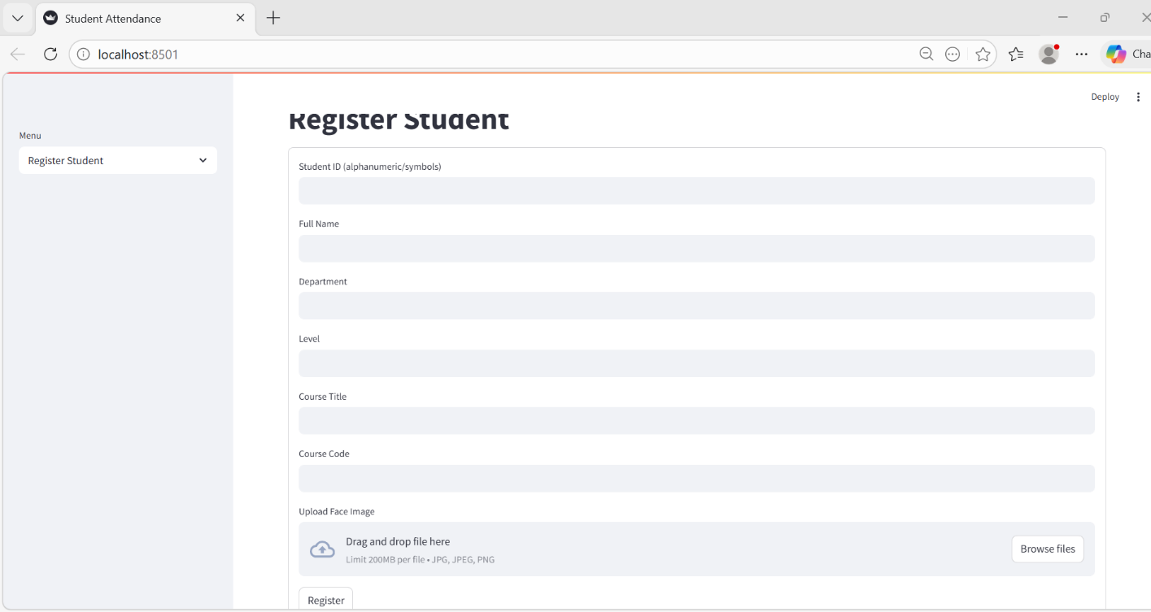
Figure 7: Screenshot of Enrollment Page
The screenshot above shows the enrollemnt page of the system, on the right is the textbox and button which the user will use to enroll himself/herself, the user enter his full name and ID number, then clicks the add new user button, a python file is generated at the taskbar, the user opens the python file and the student’s image is taken via the web camera of the machine and recorded in the system.


Figure 8: Screenshot of Marking Attendance Page


Figure 9: Screenshot of Attendance Page
The screenshot above shows the attendance page of the system, on the left is the table and button which the user will use to mark the attendance himself/herself, the user clicks the take attendance button, the student’s record is taken and the attendance is recorded in the system.

The present study modelled the webcam-based facial recognition approach of Kumara et al. (2021) but improved upon it by replacing MATLAB with Python-based open-source technologies and eliminating the dependence on RFID cards. The use of Streamlit also enabled the development of an interactive and cost-effective attendance management interface that can operate directly through a lecturer’s laptop webcam, which is suitable for academic environments.

Conclusion
This project work is of benefit to eliminate the possibility of human error in marking attendance, ensuring that the process is both precise and quick. This reduces time spent on manual attendance-taking and prevents fraudulent activities, such as proxy attendance. The automated nature of facial recognition reduces the need for manual intervention. Students just have to be present in front of a camera, and the system automatically records their attendance.
The contribution to knowledge is that the project shows how Haar Cascade Classifier Algorithm is used in face recognition for student attendance system and has contributed to the body of research on haar cascade classifier-based system for student attendance through face recognition. The current study utilized Python programming language together with OpenCV Haar Cascade Classifier, Streamlit, and SQLite3 to create a more interactive, lightweight, and user-friendly web-based attendance platform.

References

[1] Akinduyite, C.O., Adetunmbi, A.O., Olabode, O.O., and Ibidunmoye, E.O. (2013). Fingerprint-Based Attendance Management System. DOI:10.12691/jcsa-1-5-4.
[2] Alhanaee, K., Alhammadi, M., Almenhali, N., and Shatnawi, M. (2021). Face Recognition Smart Attendance System using Deep Transfer Learning. Available at: https://creativecommons.org/licenses/by-nc-nd/4.0.
[3] Aware, I. (2024). What are Biometrics? Biometric Processes. Available at: https://www.aware.com/what-are-biometrics-biometric-processes/.
[4] Bell, D. (2022). Explore the UML sequence diagram. Available at: https://developer.ibm.com/articles/the-sequence-diagram/.
[5] Bhattacharya, S., Nainala, G. S., Das, P., and Routray, A. (2018). Smart Attendance Monitoring System (SAMS): A Face Recognition Based Attendance System for Classroom Environmen, in 2018 IEEE 18th International Conference on Advanced Learning Technologies (ICALT), 2018.
[6] Feng., Z. (2018). Biometric Identification Technology and Development Trend of Physiological Characteristics. doi :10.1088/1742-6596/1060/1/012047.
[7] Gayatri, P., and Yalla, V. (2023). Real Time Facial Reconigzation Based Attendance System.
[8] Guennouni, S., Mansouri, A., and Ahaitouf, A. (2019). Biometric Systems and Their Applications. DOI: http://dx.doi.org/10.5772/intechopen.84845.
[9] Hamaamin, R.A., Ali, O.M.A., amd Kareem, S.W. (2024). Biometric Systems: A Comprehensive Review.
[10] Karunakar, M., Sai, C. A., Chandra, K., and Kumar, K. A. (2020). Smart Attendance Monitoring System (SAMS): A Face Recognition Based Attendance System for Classroom Environment, International Journal for Recent Developments in Science and Technology, vol. 4, no. 5, pp. 194-201, 2020.
[11] Kumara, P.M., Tahmasebi, M., and Sethu, D. (2021). Automatic Attendance Recording System Using Facial Recognition.
[12] Lun, H.W. (2023). Smart Event Attendance System Using Face Recognition. Faculty of Information and Communication Technology (Kampar Campus), UTAR.
[13] Martinez, A.M. (2023). Face Recognition, Overview. Available at: https://link.springer.com/referenceworkentry/10.1007/978-0-387-73003-5_84.
[14] Mittal, A., (2020). Haar Cascades, Explained. Available at: https://medium.com/analytics-vidhya/haar-cascades-explained-38210e57970d.
[15] Omoyiola, B.O. (2018). Overview of Biometric and Facial Recognition Techniques. IOSR Journal of Computer Engineering (IOSR-JCE). e-ISSN: 2278-0661,p-ISSN: 2278-8727, Volume 20, Issue 4, Ver. I (Jul - Aug 2018), PP 01-05.
[16] Soundarya, S., Ashwini, P., Rucha, W., and Gaurav, K. (2021). A Review Paper on Attendance ManagementSystem Using Face Recognition. Volume 9, Issue 11 November 2021 | ISSN: 2320-2882.
[17] Umalkar, A., Manhas, S.S., Chandiwala, I., and Bhagat, N. (2023). Face Recognition Based Attendance System Using Real Time Data. Volume 11, Issue 8 August 2023 | ISSN: 2320-2882.
[18] Visual-paradigm (2024). What is Sequence Diagram.
[19] Waghunde, P.P., Tayde, M.P., Sabalae, A.A., and Sawant, Y.B. (2021). Biometric Attendance System Using Facial Recognition.

