Ultrasonic Glasses for the Blind

Abstract— Ultrasonic Glasses for the Blind is a real-time assistive system designed to improve the mobility and safety of visually impaired individuals by providing effective obstacle detection and navigation assistance. The system employs ultrasonic sensing technology to continuously monitor the surrounding environment by transmitting high-frequency sound waves and analyzing the reflected echoes from nearby objects. The time delay between transmission and reception is used to accurately calculate the distance between the user and obstacles in real time.
An Arduino Nano microcontroller serves as the core processing unit, receiving distance data from the ultrasonic sensor and evaluating it against predefined threshold values to determine the presence of obstacles. Upon detection of an object within a critical range, the system activates an ISD1820 voice module that delivers pre-recorded audio alerts through a speaker, enabling the user to respond quickly and avoid potential collisions. The use of voice- based feedback enhances usability compared to conventional buzzer systems by providing clearer and more intuitive guidance.
The entire system is integrated into a compact and lightweight spectacle frame, making it wearable and convenient for daily use. It is powered by a rechargeable lithium battery, ensuring portability and uninterrupted operation. The device operates effectively in both indoor and outdoor environments and is not affected by lighting conditions. Ultrasonic Glasses offer a cost-effective, reliable, and user-friendly solution that significantly enhances independence and quality of life for visually impaired individuals while demonstrating the practical application of embedded systems in assistive technology.

Keywords— Ultrasonic Sensor, Arduino Nano, Assistive Technology, Embedded Systems, Obstacle Detection, Voice Module, Wearable Device, Blind Navigation.

Introduction

Navigation and environmental awareness are essential aspects of human life, enabling individuals to move safely and interact effectively with their surroundings. However, for visually impaired individuals, these tasks become extremely difficult due to the absence of visual perception. They often depend on traditional mobility aids such as white canes or assistance from others, which provide only limited support and are restricted to short-range, ground- level obstacle detection. These methods are not capable of detecting obstacles at head level or at a distance, which

increases the risk of accidents and reduces the confidence of users, particularly in unfamiliar or crowded environments. As the number of visually impaired individuals continues to rise globally, there is a growing need for advanced, reliable, and user-friendly assistive technologies that can enhance safety, independence, and overall quality of life.

With the rapid development of embedded systems, sensor technologies, and wearable electronics, smart assistive devices have emerged as effective solutions to overcome these limitations. Among the available technologies, ultrasonic sensing is widely preferred due
to its accuracy, low cost, and ease of implementation. The Ultrasonic Glasses for the Blind system is designed as a smart wearable device that integrates an ultrasonic sensor, an Arduino Nano microcontroller, and a voice output module into a compact spectacle frame. The system continuously monitors the surrounding environment, calculates the distance to nearby obstacles, and provides immediate voice-based alerts when an object is detected within a predefined range. The use of voice feedback makes the system more intuitive and user-friendly, thereby improving usability and accessibility.

- LITERATURE REVIEW

Several researchers have developed smart assistive devices for visually impaired individuals using sensors, artificial intelligence, and embedded systems.

H. M. S. Ibrahim and A. S. El-Wakeel (2024) proposed a wearable ultrasonic radar system for visually impaired navigation. The system used ultrasonic sensors for obstacle detection and improved user safety through real-time sensing.

I. A. M. A. Thannoun et al. (2025) designed ultrasonic- based smart glasses for blind people that provided audio feedback for navigation. Their work focused on low-cost implementation using embedded systems.

J. Bai et al. (2017) developed smart guiding glasses for indoor navigation using intelligent algorithms and sensors for accurate guidance and obstacle detection.

L. Narendra, B. S. Babu, and C. Manohar (2025) presented smart glasses integrated with GPS and voice assistance for independent mobility of visually impaired users.

M. A. Al-Mamun, M. S. Hussain, and A. Al-Noman (2025) proposed Edge-AI assisted smart glasses for real- time obstacle detection with improved accuracy using artificial intelligence.

P. Samuda et al. (2022) developed Arduino-based smart glasses using sensors for obstacle detection and customizable operation.

R. Bolimera et al. (2023) designed Arduino and ultrasonic sensor-based smart glasses providing real-time alerts and low-cost operation.

Most existing systems either use expensive hardware or complex AI algorithms. The proposed system focuses on simplicity, affordability, portability, and reliable obstacle detection using ultrasonic sensing technology.

PROPOSED SYSTEM

System Overview
The proposed system is a smart wearable assistive device designed for visually impaired individuals. It detects nearby obstacles using ultrasonic sensing technology and provides voice alerts to the user for safe navigation.

The system mainly consists of an HC-SR04 ultrasonic sensor, Arduino Nano microcontroller, ISD1820 voice module, speaker, rechargeable Li-Po battery, TP4056 charging module, and spectacle frame. The ultrasonic sensor continuously measures the distance between the user and surrounding objects. The Arduino Nano processes the sensor data and activates the voice module whenever anobstacle is detectedwithin apredefined range.

The complete system is lightweight, portable, and mounted on a spectacle frame, makingiteasytowearandsuitablefordailyuse.

Methodology
The proposed system operates using the following steps:

    - The ultrasonic sensor continuously emits ultrasonic sound waves

    - These sound waves strike nearby obstacles and reflect back toward the sensor.

    - The sensor measures the echo return time and calculates the distance.

    - The Arduino Nano receives and processes the distance information.

    - If the obstacle distance is less than the threshold value, the Arduino activates the ISD1820 voice module.

    - The voice module generates a pre-recorded voice alert through the speaker.

    - The user receives the audio warning and avoids the obstacle.
    - The process repeats continuously for real-time obstacle detection

Hardware Components

    - HC-SR04 Ultrasonic Sensor
The HC-SR04 ultrasonic sensor is used for detecting obstacles by measuring distance using ultrasonic waves. It contains a transmitter and receiver that work together to calculate the distance of nearby objects.

Specifications:

Operating Voltage: 5V DC Measuring Range: 2 cm to 400 cm Operating Frequency: 40 kHz Accuracy: ±3 mm
Measuring Angle: <15°

Arduino Nano
Arduino Nano acts as the main controller of the system. It processes sensor data and controls the voice alert mechanism. It is based on the ATmega328P microcontroller and is widely used in embedded applications because of its compact size and ease of programming.
Specifications:

Microcontroller: ATmega328P Operating Voltage: 5V
Digital I/O Pins: 14 Analog Input Pins: 8 Clock Speed: 16 MHz Flash Memory: 32 KB

ISD1820 Voice Module
The ISD1820 voice module is used for recording and playing voice messages. In this project, it provides voice alerts such as “Obstacle Ahead” whenever the system detects an object.

Features:

Recording Time: Up to 10 seconds Operating Voltage: 3V–5V
Built-in microphone Speaker support
Low power consumption

TP4056 Charging Module
The TP4056 charging module is used to safely charge the 3.7V Li-Po battery. It provides protection against overcharging and short circuits.

3.7V Li-Po Battery
The Li-Po battery supplies power to the complete system. It is rechargeable, lightweight, and suitable for portable wearable devices.

System Block Diagram
The block diagram below presents the complete signal and data flow of Ultrasonic Glasses for the Blind system from obstacle detection to voice output, organized across its processing stages.
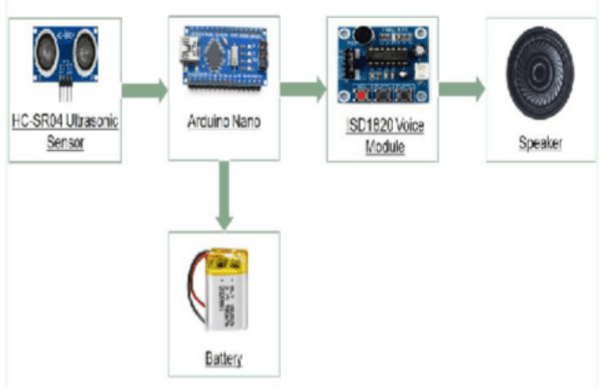

Fig. 3.1 System Block Diagram

System Workflow Analysis
The system workflow analysis describes the step-by-step process of obstacle detection and alert generation, showing how data flows from the ultrasonic sensor to the final voice output.

Step 1: Ultrasonic Signal Transmission
In the initial stage, the ultrasonic sensor generates high- frequency sound waves, typically above the human hearing range (around 40 kHz), and transmits them into the surrounding environment. These waves propagate through the air in a straight path until they encounter an object or obstacle. This stage is crucial as it initiates the sensing process and enables the system to continuously scan the environment for potential obstructions in real time.

Step 2: Echo Reception
When the transmitted ultrasonic waves strike an obstacle, they are reflected back toward the sensor. The receiving unit of the ultrasonic sensor captures these reflected signals, known as echoes. The accuracy of this stage depends on the surface and distance of the object, as different materials may reflect sound waves differently. The sensor precisely records the time interval between transmission and reception, which forms the basis for distance measurement.

Step 3: Distance Calculation
The Arduino Nano microcontroller processes the time delay between the transmitted and received signals to calculate the distance of the obstacle. This is achieved using the fundamental principle of sound wave propagation, where the total travel time of the wave is divided by two to account for the forward and return journey. This calculated distance provides real-time information about the proximity of obstacles in front of the user.

Step 4: Decision Processing
In this stage, the calculated distance is compared with predefined threshold values stored in the system. If the detected object lies within a critical range, the system interprets it as a potential obstacle. The microcontroller then decides whether to trigger an alert based on this comparison. This decision-making process ensures that only relevant obstacles generate alerts, reducing unnecessary notifications and improving system efficiency.

Step 5: Voice Output
Once an obstacle is confirmed within the threshold distance, the Arduino Nano sends a control signal to the voice module. The ISD1820 voice module then plays a pre-recorded audio message through the speaker, alerting the user about the presence of an obstacle. This voice-based feedback provides clear and immediate guidance, enabling the user to take corrective action and avoid collisions. The use of audio alerts enhances usability and makes the system more intuitive for visually impaired individuals.

CIRCUIT DIAGRAM AND CONNECTIONS

The HC-SR04 ultrasonic sensor is interfaced with Arduino Nano using Trigger and Echo pins. The ISD1820 voice module is connected to a digital output pin of Arduino Nano for voice playback control.

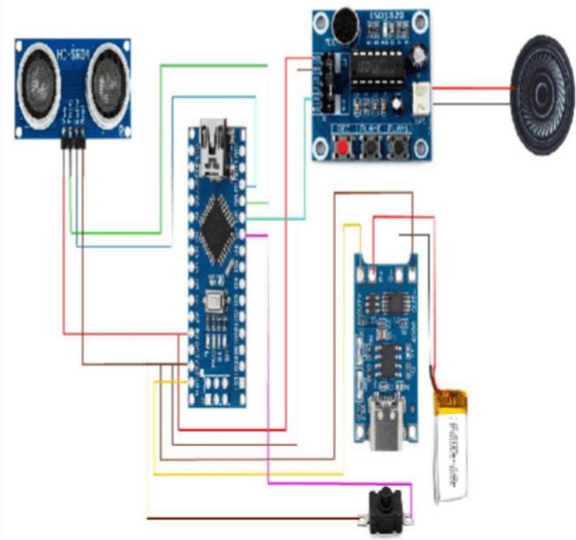

Fig. 4.1 Circuit Diagram of Ultrasonic Glasses

Sensor Connections

HC-SR04 Pin Arduino Nano VCC 5V

GND GND
TRIG D9
ECHO D10

Voice Module Connections ISD1820 Pin Arduino Nano VCC 5V
GND GND
PLAYE D8

Battery Connections
TP4056 Module Arduino Nano OUT+ VIN
OUT- GND

IMPLEMENTATION AND RESULTS

Sensor Testing

The HC-SR04 ultrasonic sensor was tested for obstacle detection and distance measurement. The sensor successfully detected obstacles within the range of 2 cm to 400 cm. The measured distance values were accurate and the response time was fast enough for real-time operation.

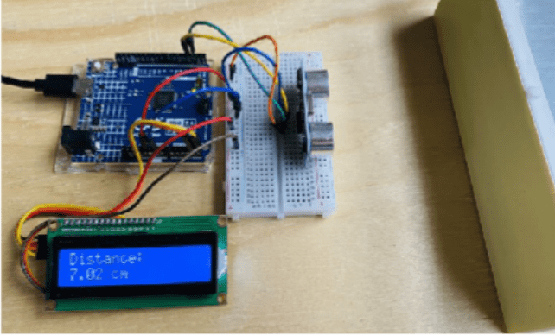
Fig. 5.1 Sensor Testing

Voice Module Testing

The ISD1820 voice module was tested with a speaker for generating audio alerts. The module successfully played the pre-recorded voice message whenever an obstacle was detected. The audio output was clear and understandable.

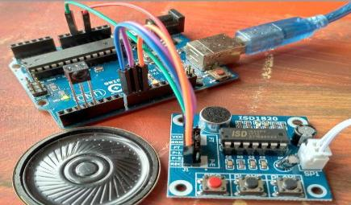
Fig. 5.2 Voice Module Testing

Power Module Testing

The system was powered using a 3.7V rechargeable Li- Po battery and TP4056 charging module. The charging module provided safe charging and stable power supply. The power consumption of the system was low, making it suitable for portable operation.

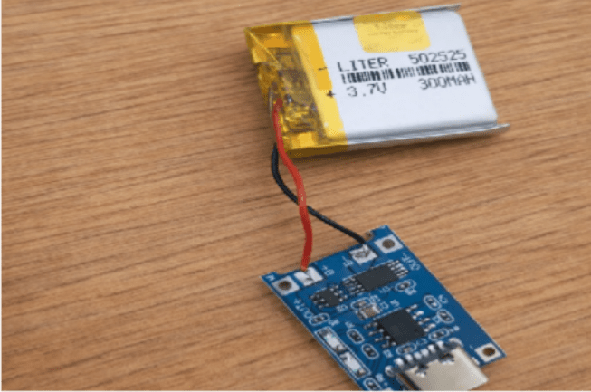
Fig. 5.3 Power Module Testing

Complete System Testing

All hardware components were mounted on a spectacle frame and tested together as a complete system. The ultrasonic sensor successfully detected obstacles in front of the user, and the Arduino Nano activated the voice alert system in real time.

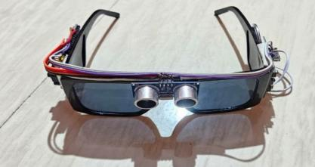
- Front View

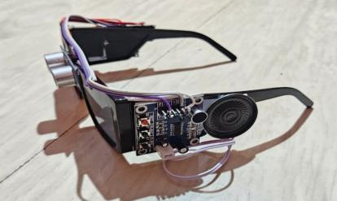
- Side View
Fig. 5.4 Complete System Testing

ADVANTAGES AND APPLICATIONS

Advantages

    - Low Cost
The project uses simple and affordable components, making it cost-effective compared to other assistive devices.

Easy to Use
The system is user-friendly and does not require any special training to operate.

Low Power Consumption
The device consumes less power and can operate efficiently on a rechargeable battery.

Real-Time Detection
The device provides instant feedback through voice alerts, ensuring quick response while walking.

Portable Device
Mounted on a spectacle frame, the device is compact, lightweight, and comfortable to wear.

Applications

    - Mobility Assistance
The device helps blind or visually impaired individuals to detect obstacles and move safely.

Indoor Navigation
It can be used inside homes, offices, and buildings to avoid obstacles like furniture and walls.

Outdoor Navigation
The system helps users walk safely on roads, footpaths, and public places.

Educational Projects
Useful for students to understand embedded systems, sensors, and real-time applications.

Low-Cost Assistive Technology
Can be used as an affordable alternative to expensive navigation systems.

FUTURE SCOPE

The proposed system can be further improved by integrating advanced technologies and additional features.

- GPS module can be added for location tracking and navigation.

- AI-based object recognition can improve obstacle identification.

- Multiple sensors can be used for better detection accuracy.

- Improved battery backup can increase operating time.

CONCLUSION

The proposed Ultrasonic Glasses for the Blind system provides an effective and reliable assistive solution for visually impaired individuals. The system uses ultrasonic sensing technology to detect nearby obstacles and generates real-time voice alerts through a speaker. The Arduino Nano efficiently controls the complete operation and ensures fast obstacle detection with quick response time.

The device is compact, lightweight, portable, low-cost, and easy to use in both indoor and outdoor environments. Experimental testing confirmed that the system successfully detects nearby obstacles and improves user safety, mobility, and independent navigation. The integration of ultrasonic sensing, embedded processing, and voice feedback makes the system practical and user-friendly for daily use.

The proposed smart glasses reduce dependency on others and help visually impaired people move more confidently and safely. The system demonstrates the effective application of embedded systems and assistive technology in solving real-life problems faced by blind individuals.

Overall, the proposed system provides a simple, low- cost, and effective assistive solution that improves the safety, mobility, and independence of visually impaired individuals. Future enhancements can further improve its performance and usability in real-world applications.

REFERENCES

- H. M. S. Ibrahim and A. S. El-Wakeel, "Design of a Wearable Ultrasonic Radar System for Visually Impaired Navigation," in Proc. 2024 IEEE Int. Conf. Commun. (ICC), 2024, pp. 310–315.

- I. A. M. A. Thannoun et al., "Designing an Ultrasonic Glasses for Blind People," ResearchGate, Mar. 2025. [Online]. Available: www.researchgate.net

- J. Bai et al., "Smart Guiding Glasses for Visually Impaired People in Indoor Environment," IEEE Trans. Hum.-Mach. Syst., vol. 47, no. 6, pp. 1026–1036, Dec.
2017.

- L. Narendra, B. S. Babu, and C. Manohar, "Smart Glasses with Voice Assistance and GPS for Independent Mobility of the Blind People," in Proc. 2025 Int. Conf. Electron. Comput. Commun. Control Technol.(ICECCC), May 1, 2025.

- M. A. Al-Mamun, M. S. Hussain, and A. Al-Noman, "Edge-AI Assisted Smart Glasses for Real-Time Obstacle Detection and Navigation," IEEE J. Biomed. Health Inform., vol. 29, no. 2, pp. 1142–1150, Feb. 2025.

- P. Samuda, N. G. Praveena, A. C. Nithiya, B. J. Komathi, J. Pavithra, and V. Kiruthika, "Arduino based Customized Smart Glasses for the Blind People," in Proc. 2nd Int. Conf. Artif. Intell. Smart Energy (ICAIS), 2022.

- P. Neelannavar, S. J. Patil, R. M. Hiremath, and V. S. Rajpurohit, "Vision Aid: Smart Glasses for Blind People," Int. J. Adv. Res. Sci. Commun. Technol., vol. 5, no. 7, pp. 124–129, Mar. 2025.

- R. Bolimera, S. Vittapu, R. Sankuru, S. Reddy, M. Sravya, and S. Srinath, "Ultrasonic Sensor and Arduino- Based Smart Glasses for Visually Assisting the Blind," J. Electron. Des. Eng., vol. 9, no. 3, pp. 28–35, 2023.

- S. G. Gollagi, K. D. Bamane, D. M. Patil, S. B. Ankali, and B. M. Akiwate, "An innovative smart glass for blind people using artificial intelligence," Indones. J. Electr. Eng. Comput. Sci., vol. 31, no. 1, pp. 433–439, 2023.

- S. Tiwari, Y. S. Bhadauria, S. Mishra, S. Singh, and N. Yasmin, "Smart Glasses Using Ultrasonic Sensor and AI for Blind Person," Recent Trends Sensor Res. Technol., vol. 11, no. 2, pp. 1–9, Jul. 2024.

