CHAYOMED: PHARMACOTHERAPUTIC POTENTIAL OF CHAYOTE (Sechium edule) PEEL EXTRACT ON DIABETES MELLITUS AND ITS CANCER CHEMOPREVENTION PROPERTY

Abstract— Recent statistics from the World Health Organization indicate that noncommunicable diseases such as cancer and diabetes mellitus remain major global health challenges, with cancer responsible for an estimated 9.7 million deaths worldwide in 2022 and diabetes directly causing about 1.6 million deaths in 2021, while also contributing to millions more through cardiovascular complications [18,19]. This study aims to determine the phytochemical, anti-angiogenic, and anti-hyperglycemic potential of Chayote (Sechium edule) peel extract. Ethanolic peel extract was subjected to phytochemical screening and tested for cytotoxicity, angiosuppressive activity, and blood glucose reduction. Secondary metabolites screening indicated the presence of alkaloids, flavonoids, saponins, phenols, and tannins, which possess known anti-oxidative and anti-inflammatory actions. Test for angiosuppressive activity using the Chorioallantoic Membrane (CAM) assay revealed a significant anti-angiogenic property at 25%, 50%, and 75% concentrations of the S. edule peel extract with all inhibiting the growth of blood vessels. These results were comparable to the positive control, methotrexate. The Brine Shrimp Lethality Assay revealed an LC₅₀ value of 505.14 μg/mL. Since this value is greater than 100 μg/mL which indicates that the extract maybe non-toxic to human cells. Analysis of glycemic activity showed that the extract significantly reduced blood glucose levels in mice, particularly at 200 µg/mL, which performed at par with the positive control. The results proved that S. edule peel extract exhibits promising phytonutraceutical, anti-angiogenic, and anti-diabetic properties, representing a potential novel approach for cancer prevention and diabetes management. Isolation of potent bioactive compounds responsible for the aforementioned claims should be done as well as in vivo testing should be conducted to further validate the results of the study.

Keywords— angiosuppressive, cancer, cytotoxicity, diabetes milletus, phytonutraceutical

I. INTRODUCTION
Diabetes mellitus and cancer represent two of the most significant global health challenges, characterized by complex biological mechanisms that often require aggressive and expensive treatments [14]. Diabetes is a group of endocrine diseases marked by sustained hyperglycemia, affecting millions globally and ranking as a top cause of mortality in the Philippines [3]. Simultaneously, cancer remains a devastating disease defined by the abnormal and uncontrolled growth of cells that can invade various organs [9]. While these conditions appear distinct, they are both impaired by oxidative stress and disruptions in cellular homeostasis, creating a need for versatile therapeutic agents that can address multiple pathological fronts.
Chayote (Sechium edule) is known for its rich nutritional profile, providing essential vitamins, minerals, and dietary fiber that support overall health. It is particularly abundant in vitamin C, which enhances immune function, and B-complex vitamins that play a crucial role in energy metabolism. In addition, chayote contains important minerals such as potassium, which helps regulate blood pressure, as well as magnesium and calcium that contribute to bone health [2]. The high fiber content of chayote further promotes digestive health, aids in weight management, and helps regulate blood sugar levels. Grown widely in tropical and subtropical regions, chayote is a versatile and easy-to-cultivate vegetable that thrives in warm climates with adequate support for its climbing vines, making it an accessible dietary component with potential relevance to metabolic health and disease prevention.
Management of diabetes relies on regulating blood sugar levels to prevent systemic complications [16]. Chayote (Sechium edule) is a nutrient-dense vegetable known for its high fiber content and low glycemic index, which can slow sugar absorption and prevent glucose spikes. However, beyond its dietary fiber, the peel of the Chayote contains potent bioactive compounds that are reported to enhance insulin sensitivity and inhibit carbohydrate-digesting enzymes. This suggests that the extract may serve as a natural anti-hyperglycemic agent capable of reducing blood glucose levels effectively [1].
On the other hand, fighting against cancer focuses on inhibiting the proliferation of malignant cells and preventing angiogenesis, the process by which tumors develop their own blood supply to grow and spread [13]. Phytochemicals found such as flavonoids and phenols are known to modulate cell signaling pathways and induce apoptosis. By demonstrating angiosuppressive properties, a natural extract can potentially starve tumors of necessary nutrients, offering a novel, non-toxic lead for cancer prevention and treatment that mimics the effects of conventional anticancer medications without the associated adverse side effects.

A. Methods and Experimental Details

1. Ethanolic Extraction
Five hundred grams of peels were soaked in 1000 ml of 95% ethanol at room temperature. After 48 hours, the extract was filtered using filter paper. The collected ethanolic crude extract was subjected for rotary evaporation in PHILEXPORT Quality Control Laboratory, General Santos City, Philippines to obtain the pure extract.
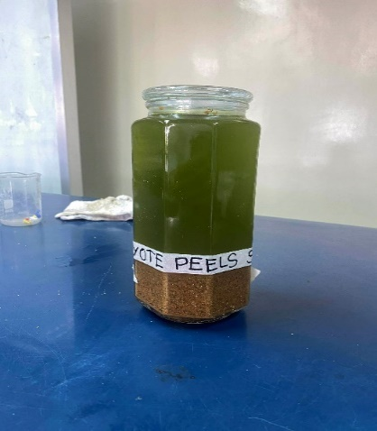
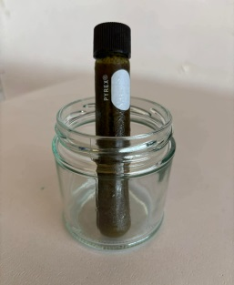

Figure 1. Soaking of Sechium edule and Its Crude Extract

2. Phytochemical Screening
Bioactive compound of Sechium edule was determined following the protocols of Tiwari et al. in 2011.

- Test for Alkaloids (Wagner’s Test)
One (1) ml of S. edule was treated with Wagner’s reagent and was added along the sides of the test tube. The presence of reddish or brown precipitates indicates the presence of alkaloids.

- Test for Flavonoids
One (1) ml of the plant extract was treated with sodium hydroxide solution. The formation of intense yellow color until it becomes colorless on addition of hydrogen chloride (dilute acid) indicates the presence of flavonoids.

- Test for Saponins (Foam test)
One (1) ml of extract was diluted with 2 ml distilled water. The suspension was shaken in a graduated cylinder for 15 minutes. If the foam persist for ten minutes indicates the present of saponins.

- Test for Tannins
One (1) ml of the extract was diluted with 1% gelatin solution containing 10% NaCl. The presence of white precipitates indicates the presence of tannins.

- Test for Phenols
One (1) ml of extract was treated with 3-4 drops of ferric chloride solution. The formation of bluish black color indicates the presence of phenols.

3. Duck Chorioallantoic Membrane (CAM) Assay
The angiosuppressive activity was determined using CAM assay by Cruz et al. in 2022 where eight (8) - day old duck egg was used. Each egg went through candling to determine the embryo’s position. Using sterile forceps, small holes were carefully made around the airspace, and then sealed with parafilm to prevent contamination. The eggs were treated with 25%, 50%, 75% concentration of S. edule extracts diluted to distilled water in 1mL quantities which are obtained using the C1V1=C2V2 formula, anticancer drug (positive control), and distilled water (negative control). The eggs were treated with 0.1mL of the treatments respectively and incubated at 37.5 ⁰C for 48 hours.
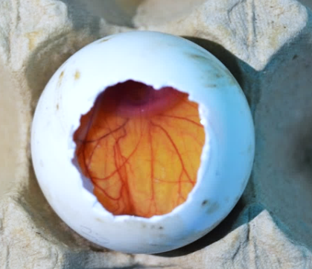

Figure 2. CAM of an 8-day Old Duck Embryo
4. Brine Shrimp Lethality Assay
The cytotoxicity assay was performed using the Artemia salina lethality test following the protocol of Sarah et al. (2017). Brine shrimp eggs were hatched in an aerated rectangular aquarium containing artificial seawater prepared by dissolving 25 g of table salt per liter of distilled water (≈25 ppt salinity). The setup was maintained at 28–30 °C under continuous illumination for 20–24 hours to allow hatching of photophilic nauplii. After hatching, live nauplii were separated from egg shells by turning off aeration and light. Ten nauplii were transferred into test tubes containing artificial seawater and exposed to varying concentrations of the plant extract (0, 100, 500, and 1000 µg/mL). After 24 hours of exposure, surviving nauplii were counted, and percentage lethality was calculated using percentage of death formula.
$\%Death=\frac{Number of dead nauplii}{Number of dead nauplii+Number of live nauplii}×100$
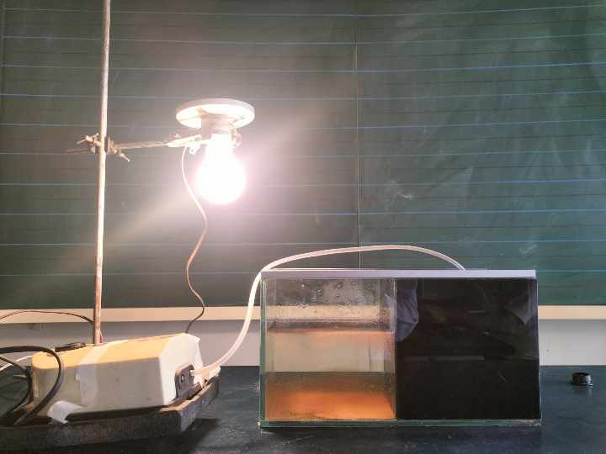
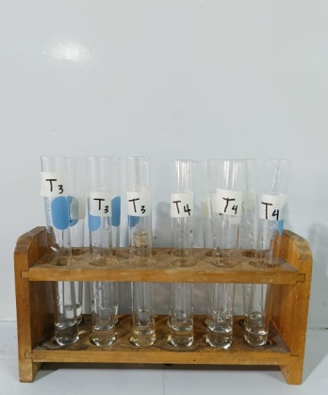

Figure 3. Brine Shrimp Collection Set-up and Cytotoxicity Testing

5. Antihyperglycemic Test
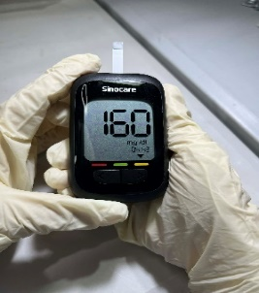
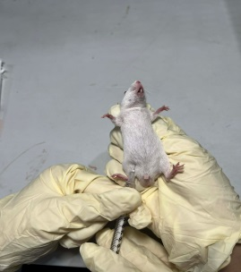
The antihyperglycemic activity test was done following the protocol of Kifle ZD et al. (2020). For two (2) weeks, the laboratory mice were acclimated in preparation for the antihyperglycemic activity test. The mice were fasted for six (6) hours, and the next day, their basic blood sugar levels were measured using a digital glucometer. The blood glucose was then recorded to serve as baseline for the test. To raise the blood glucose levels, the mice were then induced with dexamethasone at a dose of 20 μg/mL/kg once a day for five (5) days. Once the mice were induced with hyperglycemic drug, they were assigned into 5 groups, with 3 replicates each. The positive control (Metformin), the negative control (distilled water), and the experimental group of S. edule peel extract in varying concentrations were then administered. After an hour, the blood glucose was then measured and recorded for statistical analysis.

Figure 4. Inducing hyperglycemia to Albino Mice

B. Results and Discussion

6. Phytochemical Screening
Phytochemical analysis of the ethanolic peel extract of S. elude revealed the presence of bioactive compounds including alkaloids, flavonoids, saponins, phenols, and tannins. These substances exert antidiabetic effects by enhancing insulin sensitivity, inhibiting carbohydrate-digesting enzymes, and reducing oxidative stress [8]. Additionally, they demonstrate anticancer activity by modulating cell signaling pathways and inducing apoptosis in malignant cells through antioxidant and anti-inflammatory actions [6].
TABLE 1
Results of Phytochemical Analysis of Sechium edule Peel Extract
Bioactive Compounds | Leaf Extract
Alkaloids | +
Flavonoids | +
Saponins | +
Phenols | +
Tannins | +
(+): present; (-): absent

7. Cytotoxicity Test
TABLE2
Brine Shrimp Lethality Assay of S. edule Peel Extract
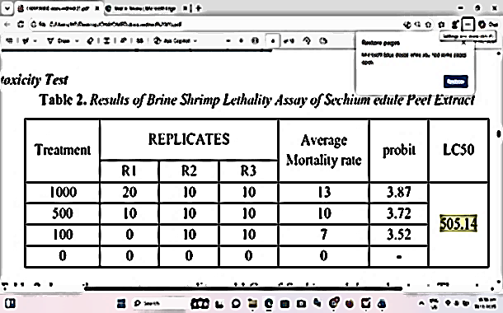
Table 2 shows the percentage mortality and LC₅₀ of Sechium edule peel extract. The extract was found active at 100µg/ml against the brine shrimps. Results show that the computed LC₅₀ is 505.14 μg/mL which is greater than 100 μg/mL. This indicates that the Sechium edule peel extract is considered as nontoxic toward human cells. This suggests that the extract will not have adverse effect upon medicinal applications.

8. Chorioallantoic Membrane Assay

Figure 5. Results of Angiosuppressive Activity of Sechium elude Peel Extract
Figure 5 shows the average angiosuppresive ability of Methotrexate (positive control) and S. edule peel extract. The number of blood vessels in the duck embryos after 48 hours of administration of the positive control exhibits degeneration of the blood vessels. It is found that concentrations >25% exhibits toxicity toward the duck eggs leading to death. The concentrations have comparable result with the positive control.
TABLE 3
Descriptives of Angiosuppressive Activity of S. edule Peel Extract
Treatments | N | Mean | Std. Deviation
Control + | 3 | .0000 | .00000
Control - | 3 | 18.6667 | 1.52753
25% | 3 | .0000 | .00000
50% | 3 | .0000 | .00000
75% | 3 | .0000 | .00000
Total | 15 | 3.7333 | 7.75027
Table 3 shows the descriptive result of treatments. The negative control has the mean of 18.6667 with the standard deviation of 1.52753. Positive control and the concentrations have .0000 on both. This suggests that Sechium edule peel extract have similar results with the positive control. Therefore, S.edule peel extract exhibits angiosuppressive property.
TABLE 4
Analysis of Variance of Angiosuppressive Activity of S. edule Peel Extract
 | Sum of Squares | df | Mean Square | F | Sig.
Between Groups | 836.267 | 4 | 209.067 | 448.000 | .000
Within Groups | 4.667 | 10 | .467
Total | 840.933 | 14
^{a.} 0.05 Level of Significance
Table 4 presents the results of Analysis of Variance of the angiosuppressive activity of S. edule peel extract. Result shows that the computed p-value is 0.000 which is lower than the standard 0.05 confidence level. This implies that there is a significant difference between the comparison of number of blood vessel branch points in the treatments. This indicates that the S. edule peel extract has angiogenic property based on the table above.
Table 5, on the other hand, shows the multiple comparisons among the treatments. The p-value found between the negative control and the other treatments is 0.000, which indicates that there is a significant difference between and are comparable for its significant value is lower than the standard significant level at 0.05. On the other hand, the positive control and 25%, 50%, and 75% concentrations of S. edule peel extract have comparable results in terms of its angiosupressive activity with a p-value of 1.000. Thus, there is no significant difference and are comparable. The results revealed that concentrations >25% of the peel extract is at par with the result of the positive control in causing degeneration of the blood vessels in the duck embryo leading to death.
TABLE 5
Multiple Comparisons of the Angiosuppressive Activity of S. edule Peel Extract
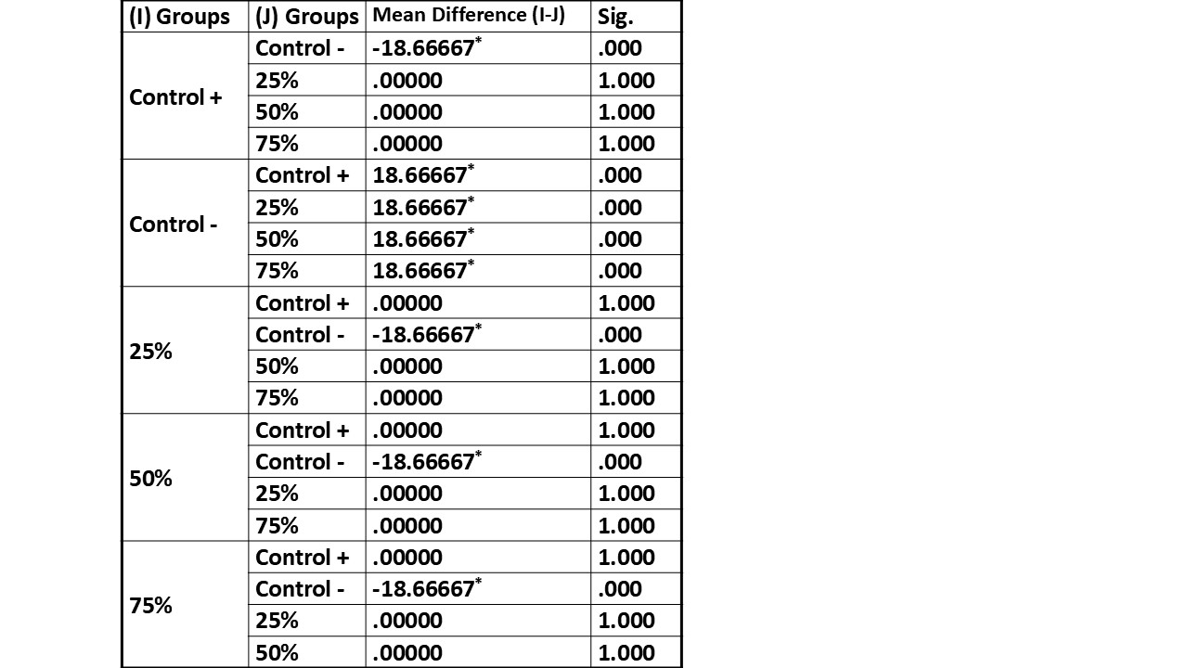

9. Antihyperglycemic Activity Test
TABLE 6
Results of Antihyperglycemic Activity Test of S. edule Peel Extract
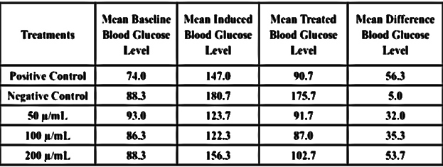
Table 6 presents the mean baseline, induced, and treated blood glucose levels of laboratory mice subjected to different treatments. Following glucose induction, all groups exhibited elevated blood glucose levels, confirming successful induction of hyperglycemia. The negative control group showed minimal reduction in glucose levels after treatment, indicating the absence of spontaneous glucose normalization. In contrast, mice treated with the extract demonstrated notable reductions in blood glucose levels, particularly at concentrations of 100 µ/mL and 200 µ/mL. The 200 µ/mL group exhibited a mean glucose reduction (53.7 mg/dL) comparable to that of the positive control (56.3 mg/dL), suggesting a strong glucose-lowering effect.

TABLE 7
Descriptives of Antihyperglycemic Activity of S. edule Peel Extract
Treatments | N | Mean | Std. Deviation
Positive control | 3 | 38.114 | 3.7044
Negative control | 3 | 2.763 | .9388
50 µ/mL | 3 | 25.876 | 12.7821
100 µ/mL | 3 | 28.924 | 13.5896
200 µ/mL | 3 | 33.475 | 8.2421
Total | 15 | 25.831 | 14.9145
^{a.} 0.05 Level of Significance
Table 7 summarizes the mean blood glucose reduction across treatment groups, expressed with standard deviation. The positive control group recorded the highest mean glucose reduction, serving as a standard for effective anti-diabetic activity. Among the extract-treated groups, increasing concentrations resulted in progressively higher mean reductions, with the 200 µ/mL group showing a mean value (33.48) closest to the positive control (38.11). The negative control group exhibited the lowest mean reduction, reinforcing the lack of therapeutic effect. This descriptive result further suggests that the extract exhibits measurable anti-diabetic effects, which become more consistent at higher concentrations.
TABLE 8
Analysis of Variance of Antihyperglycemic Activity of S. edule Peel Extract
 | Sum of Squares | df | Mean Square | F | Sig.
Between Groups | 2253.006 | 4 | 563.251 | 6.540 | .007
Within Groups | 861.193 | 10 | 86.119
Total | 3114.198 | 14
a. 0.05 Level of Significance
Table 8 presents the results of the Analysis of Variance on the blood glucose–lowering effect of S. edule peel extract. The results show that the computed p-value is 0.007, which is lower than the standard 0.05 confidence level. This implies that there is a significant difference among the treatments in terms of mean blood glucose reduction. This indicates that the S. edule peel extract exhibits significant anti-diabetic activity based on the table above.
On the other hand, table 9 below shows the multiple comparisons among the treatments. The p-value obtained between the negative control and the extract-treated groups (50 µ/mL, 100 µ/mL, and 200 µ/mL) is less than 0.05, which indicates that there is a significant difference among these treatments and that their effects are comparable in terms of statistical significance since the values are lower than the standard significance level of 0.05. On the other hand, the positive control and the extract-treated groups showed comparable results in terms of blood glucose reduction, as their computed p-values were greater than 0.05. This means that there is no significant difference and the treatments are considered comparable. The results revealed that the S. edule peel extract, particularly at higher concentrations, is at par with the positive control in reducing blood glucose levels, indicating its potential anti-diabetic property.

TABLE 9
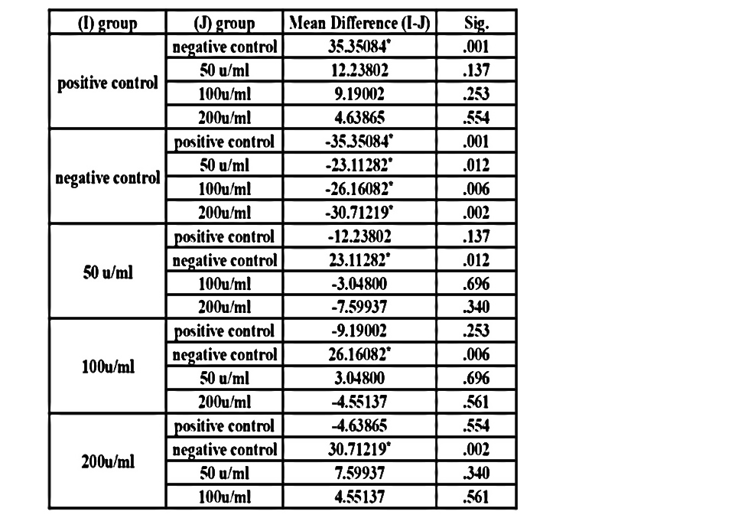
Table for Multiple Comparison for the Angiosuppressive Activity (Seeds)

II. CONCLUSION
The results of the study supported the phytochemical, anti-angiogenesis, and anti-diabetic properties of the Sechium edule peel extract. The bioactive compounds—alkaloids, flavonoids, saponins, phenols, and tannins—indicate a promising source of phytonutraceuticals as they can be applied for further pharmacological use, such as enhancing insulin sensitivity and inhibiting the proliferation of malignant cells. Cytotoxicity analysis revealed that S. edule peel extract is considered non-toxic toward human cells, suggesting it will not have an adverse effect upon medicinal applications. The extract exhibited angiosuppressive and antihyperglycemic activities comparable to standard treatments, indicating its potential for cancer prevention and diabetes management. However, further isolation of its bioactive compounds is necessary to validate these findings and support future pharmacological applications.

ACKNOWLEDGEMENT
The researchers would like to express their immense appreciation to the people who played a significant role in the fulfillment of this study. They extend their gratitude with humility and sincerity for the guidance, support, and dedication these individuals have provided.
Above all, the researchers offer their deepest gratitude to God for His endless love, support, never-ending blessings, and for serving as their source of motivation throughout the completion of this study.
The researchers also extend their genuine appreciation to their families for their sacrifices, understanding, and encouragement that inspired them to pursue and complete this study: Eilyn Fe J. Sendico, Brandon Rae T. Sendico, Judith M. Galgo, and Romeo C. Galgo Jr.
The researchers also express their sincere gratitude to the following students: Maricar Santiago, Lysther Jay C. Calibara, Saharra Genne H. Ruales, and Antonette Pressia M. Aala, for their guidance and support that made this research possible.
They extend their genuine gratitude to Joy’s Pet Shop for generously providing the specific materials needed for the study and for the unwavering support extended throughout the research process.
They are also grateful to the pediatrician, Dra. Cosette Panes, for her professional guidance and support. The researchers sincerely extend their thanks to the following teacher: Sir Russel Sarueda, for his professional insights, guidance, and advice that contributed to the improvement of the paper.
They also extend their appreciation to their research teacher, Sir Roden Yumol, for his guidance, wisdom, and trust in the researcher’s abilities, which greatly contributed to the completion of this study.
The researchers would also like to express their utmost gratitude and appreciation to their research adviser, Sir Almahden Cabalan Lumidseg, for his continuous support and guidance through his wisdom and expertise. His dedication and patience served as an inspiration for the researchers to persevere through challenges and strive toward the completion of the study.
Moreover, the researchers extend their sincerest gratitude to Shalom Crest Wizard Academy for allowing them to use their facilities and for the support provided throughout this study.
Lastly, the researchers would like to thank their relatives and peers for their unwavering support and encouragement throughout their research journey.

REFERENCES
[1] Aguiniga-Sánchez, I., Cadena-Iñiguez, J., Santiago-Osorio, E., Gómez-García, G., & Mendoza-Núñez, V. M. (2020). Chemical constituents and hypoglycemic effect of Sechium edule (Jacq.) Sw. Journal of Medicinal Plants Research, 14(3), 115–123.
[2] Borah, S., Gogoi, P., & Deka, S. (2023). Nutritional composition and health benefits of chayote (Sechium edule): A review. Journal of Food Science and Nutrition, 11(2), 45–52.
[3] Cando, A. J. L., De Vera, J. R., & Ramos, M. T. (2024). Diabetes mellitus as a leading cause of mortality in the Philippines: Trends and public health implications. Philippine Journal of Internal Medicine, 62(1), 15–24.
[4] Cruz, R. J. A., Villanueva, A. C., & Dela Peña, J. T. (2022). Evaluation of anti-angiogenic activity of plant extracts using the duck chorioallantoic membrane assay. Asian Journal of Biological Sciences, 15(3), 221–229.
[5] Folkman, J. (2007). Angiogenesis: An organizing principle for drug discovery? Nature Reviews Drug Discovery, 6(4), 273–286. https://doi.org/10.1038/nrd2115
[6] Harini, K. (2024). Role of plant-derived phytochemicals in cancer prevention and therapy. International Journal of Phytopharmacology, 15(1), 1–10.
[7] Kifle, Z. D., Yesuf, J. S., & Atnafie, S. A. (2020). Evaluation of antihyperglycemic activity of plant extracts in dexamethasone-induced diabetic mice. Journal of Experimental Pharmacology, 12, 181–190. https://doi.org/10.2147/JEP.S246823
[8] Kifle, Z. D., Engidawork, E., & Asres, K. (2022). Antidiabetic potential of medicinal plants: Mechanisms and therapeutic relevance. Evidence-Based Complementary and Alternative Medicine, 2022, 1–12. https://doi.org/10.1155/2022/9876543
[9] Meirson, T., Gil-Henn, H., & Samson, A. O. (2019). Cancer cell invasion and metastasis: Molecular and cellular mechanisms. Cancer Letters, 463, 13–23. https://doi.org/10.1016/j.canlet.2019.07.015
[10] Reuter, S., Gupta, S. C., Chaturvedi, M. M., & Aggarwal, B. B. (2010). Oxidative stress, inflammation, and cancer: How are they linked? Free Radical Biology and Medicine, 49(11), 1603–1616. https://doi.org/10.1016/j.freeradbiomed.2010.09.006
[11] Ribatti, D. (2016). The chick embryo chorioallantoic membrane (CAM) assay. Reproductive Toxicology, 70, 97–101. https://doi.org/10.1016/j.reprotox.2016.11.004
[12] Sarah, Q. S., Anny, F. C., & Mir, M. (2017). Brine shrimp lethality assay: A simple method for toxicity testing. International Journal of Pharmacy and Pharmaceutical Sciences, 9(3), 93–96.
[13] Shi, J., Kantoff, P. W., Wooster, R., & Farokhzad, O. C. (2024). Cancer nanomedicine: Progress, challenges, and opportunities. Nature Reviews Cancer, 24(1), 1–18.
[14] Supabphol, R., Tangjitjareonkun, J., & Chaisuriya, P. (2021). Plant-derived bioactive compounds for chronic disease management. Journal of Ethnopharmacology, 268, 113575. https://doi.org/10.1016/j.jep.2020.113575
[15] Tiwari, P., Kumar, B., Kaur, M., Kaur, G., & Kaur, H. (2011). Phytochemical screening and extraction: A review. Internationale Pharmaceutica Sciencia, 1(1), 98–106.
[16] Tsushima, Y., Funakoshi, S., & Tamura, Y. (2025). Current strategies in diabetes management and prevention of complications. Diabetes Research and Clinical Practice, 201, 110739.
[17] Tundis, R., Loizzo, M. R., & Menichini, F. (2010). Natural products as α-amylase and α-glucosidase inhibitors and their hypoglycemic potential. Mini Reviews in Medicinal Chemistry, 10(4), 315–331. https://doi.org/10.2174/138955710791331007
[18] World Health Organization. (2023). Diabetes. https://www.who.int/news-room/fact-sheets/detail/diabetes
[19] World Health Organization. (2024, February 1). Global cancer burden growing, amidst mounting need for services. https://www.who.int/news/item/01-02-2024-global-cancer-burden-growing--amidst-mounting-need-for-services

