A MuSk is A Must: BIODEGRADABLE AND DISPOSABLE FACEMASK FROM MUSA SPP (BANANA) PSEUDOSTEM

Abstract— The primary raw materials for the manufacturing of the facemasks are non- biodegradable synthetic polymers derived from petrochemicals. Disposable face masks are made of plastic, which does not biodegrade easily. This study aims to determine the effectiveness of the Banana Pseudo Stem Face Mask. Candle testing was conducted to determine the filtering ability. This was attained by blowing a candle while wearing a mask; the amount of air that escapes from your mask determines the result. MuSk Fabric is effective for a strong prevention from a simulation for everyday respiratory exchanges and interactions such as coughs and conversations. Particle filtration is what helps block droplets and particles from traveling through your mask. This test determines if it can preserve the respiratory system against the non-desirable air droplets and aerosols such as the viral or pollution particles. MuSk Fabric particle filtration testing, indicating that the particles did not pass through. It indicates that MuSk Fabric has the potential to preserve the respiratory system against the non- desirable air droplets and aerosols such as the viral or pollution particles. Using a 0.5 mL Pasteur pipette, water was dropped onto the surface of each three MuSk Fabrics and Abaca Face Mask. A 1000x USB Microscope took a close-up photo upon contact. On average, MuSk Fabrics obtained a higher contact angle of 162° over the 131° calculated for the Abaca Face Mask. Independent Sample T-test was confirmed that this difference is statistically significant at an alpha of 0.05. Biodegradability of MuSk Fabric shows significant results which indicates that MuSk Fabric is biodegradable. These results demonstrate that MuSk is effective its use as an alternative face mask.

Keywords— biodegradable, disposable, face mask, MuSk, pseudo stem
I. INTRODUCTION
Since the Covid-19 pandemic began, face masks and other personal protective equipment have become essential. The COVID-19 pandemic resulted in numerous changes around the world, including social separation and the requirement of wearing a face mask in public areas. Medical professionals advised using a face mask to prevent the virus from spreading and reducing the number of infections around the world [5]. Disposable face masks can help us to fight the COVID-19 but when single-use masks are not disposed of properly, they pose an environmental risk it can also bring various negative impacts on the environment.
Disposable face masks are made of plastic, which do not biodegrade easily. Garbage mounds increasingly comprise abandoned contagious waste face masks as a result of the COVID-19 outbreak [10]. Initially, discarded masks may expose trash collectors, litter pickers, or members of the public who come across the litter to coronavirus. According to environmentalists, 129 billion face masks have been used and discarded globally [11]. This is a possible environmental hazard that could turn into the next plastic crisis. The Philippines has generated 52,000 metric tons of medical waste since the start of the lockdown in March 2020, according to the Department of Environment and Natural Resources [3].
Banana is one of the world's most well-known and useful plants. Banana fibers are good absorbent, highly breathable, quickly dry with high tensile strength, biodegradable and have no negative effect on environment. Banana fibers are generally versatile since it is widely used in making textiles, papers, and the like. A study shows that one of the most useful plants in the world is the Banana (Musa) plant. Almost all of the parts of it can be utilized and can be used to make innovations towards making new products that can be used everywhere [7]. Over synthetic fiber, banana fibers are 100% biodegradable and environment friendly in terms of disposal and production [6].
According to this related study from production of eco bag using banana stem fiber, even banana can help in replacing plastic bag using its stem fiber [8]. In this study, they produce an Eco bag that uses banana fibers, to use sodium hydroxide to loosen the pseudo stem and separate its fibers and use this to help reducing plastic bags to the community. It also states Surgical face masks as a potential source for microplastic pollution in the COVID-19 scenario. This issue is due to the improper handling of plastic waste as part of the solid wastes.

A. Methods and Experimental Details

1. Collection of Materials
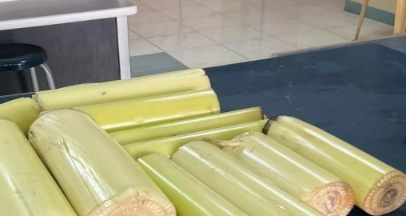
The primary materials used in the study were Musa spp Banana Pseudo stem and honeybee wax and the abaca masks. The researchers obtained the banana Pseudo Stem in General Santos City, South Cotabato. Honeybee wax and Abaca masks were bought in a local shop. Candle Testing, contact angle test, water absorption time and particle filtration tests were done in the school laboratory of Shalom Crest Wizard Academy. 10 stalks of Musa spp Banana Pseudo Stem were collected and brought to the science laboratory of Shalom Crest Wizard Academy.
Figure 1. Collected Musa spp Banana Pseudo Stem Stalks

2. Production of MuSk Fabric
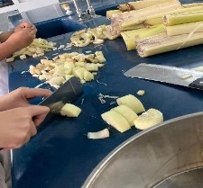
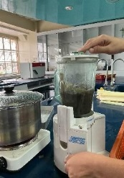
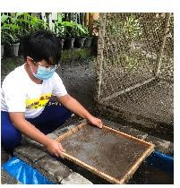
The Banana pseudo stem was cut into pieces for the first and third layers of the Musk fabric. The Banana Pseudo Stem fiber was extracted for the Musk fabric's second layer. The extract was boiled for 2 hours in order to soften the pseudo stem. After boiling, the boiled extract was placed and blended through a blending machine until a soft texture was achieved. Afterward, the crushed extract was strained with a silk screen into a basin of water and waited for it to be dried to form a banana pseudo stem fabric. A Honey-Bee wax was applied to the Musk Fabric as an added material for better water repellency.

Figure 2. Production of MuSk Fibers Using Banana Pseudo Stem

3. Candle Testing
Candle testing was conducted to determine the filtering ability. This was attained by blowing a candle while wearing a mask; the amount of air that escapes from your mask determines the result. Five replicates of the MuSk fabric were tested by blowing the flame of the candle at a distance of 15cm If the flame did not flicker or blow out, the mask you are wearing is effective because the particles did not pass through.


Figure 3. Blowing of Candle While Using MuSk

4. Contact Angle Measurement
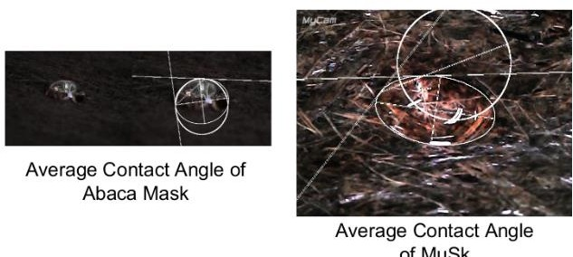
Contact angle measures the ability of a liquid to wet the surface of a solid. The shape that a drop takes on a surface depends on the surface tension of the fluid and the nature of the surface (linseis, n/a). Complete wetting is present with a contact angle of 0° if the liquid runs evenly on the solid surface.

Figure 4. Measurement of Contact Angle of Liquid in MuSk Surface

5. Hydrophobicity or Water Absorption Test
Using a 0.5 mL Pasteur pipette, water was dropped onto the surface of each five Musk Fabrics and Abaca Face Mask. A 1000x USB Microscope took a close-up photo upon contact. ImageJ, an image analysis software, was used in conjunction with a contact angle plug-in to obtain the contact angle between the tangent line of the circle and the surface line. A surface must be greater than 90° in order to be considered as hydrophobic. Absorption time was also measured for both the MuSk Fabric and Abaca Face Mask replicates to determine the amount of time it takes for the water droplet to be dissolved in the material
Phytochemical Screening
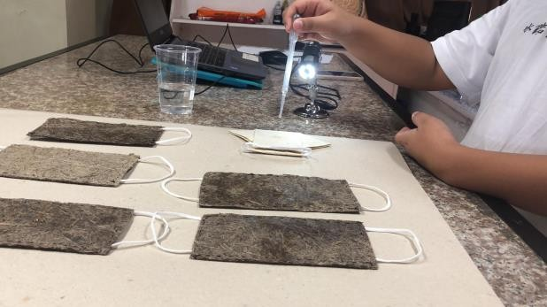

Figure 5. Testing the Hydrophobicity Property of MuSk Surface

6. Particle Filtration Test
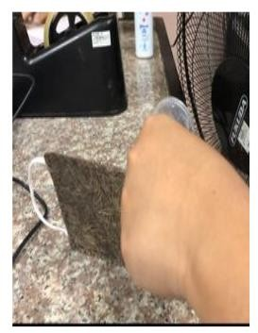
Particle Filtration is what helps block droplets and particles from traveling through your mask. This test determines if it can preserve the respiratory system against the non- desirable air droplets and aerosols such as the viral or pollution particles. The aerosols can be pollution existence in the air, or the infectious airborne viruses initiated from the sneezing, coughing of the infected people [9]. Respiratory droplets can be of various sizes made of droplets that are <5 μm and droplets that are greater than 5 μm [2].

Figure 6. Testing the Filtration Capacity of the MuSk Fiber
The particle filtration testing involved three MuSk Fabrics using a plastic container as a tube with a hole at the end, and the MuSk fabric attached to it. Powder was placed inside in the container, and a blower was used to blow the powder out to see if the particles passed through the MuSk Fabric.

7. Biodegradability Test
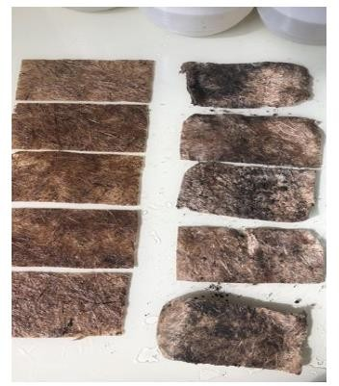
The Biodegradability test is to see how fast and easily can an object biodegrade. Since the primary raw materials for the manufacturing of the facemasks are nonbiodegradable synthetic polymers derived from petrochemicals which could cause environmental problems, it is important that MuSk is biodegradable. The test was conducted by leaving five MuSk in soil and burying it inside of a pot. Another five MuSk were submerged in water. The researchers left MuSk buried and submerged for 3 weeks.

Figure 7. Testing the Biodegradability of the MuSk Fiber

B. Results and Discussion

8. Candle Testing
Five replicates of MuSk fabric were tested by blowing the flame of the candle at a distance of 15cm; and what was observed, the candle flame did not flicker or blow out in all samples. It is demonstrated that MuSk Fabric is effective for a strong prevention from a simulation for everyday respiratory exchanges and interactions such as coughs and conversations.
TABLE 1
Results of the Candle Testing
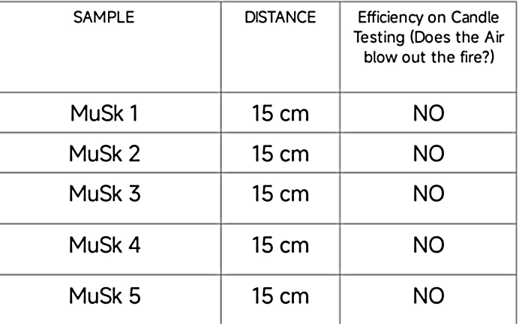

9. Hydrophobicity and Water Absorption Testing
A surface must be greater than 90° in order to be considered as hydrophobic. The means of contact angle are shown in Figure 9. On average, MuSk Fabrics obtained a higher contact angle of 162° over the 130° calculated for the Abaca Face Mask.
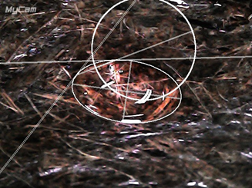
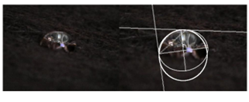
MUSK
ABACA

Figure 8. Droplet of Water in Contact with Different Fibers

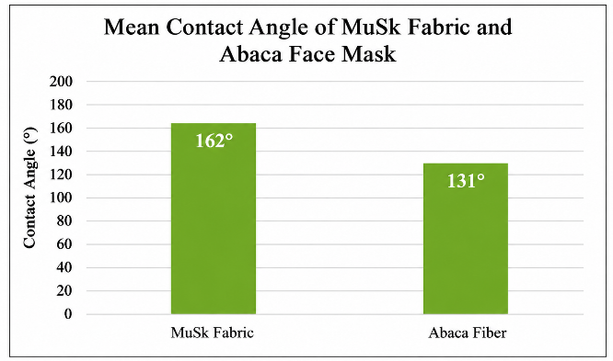
Figure 9. Mean Contact Angle of MuSk and Abaca Face Mask

Absorption time was also measured for both the MuSk Fabric and Abaca Face Mask samples. In this study, it is defined that the amount of time it takes for the water droplet to be dissolved in the material. The table below shows the means calculated for MuSk Fabric and Abaca Face Mask samples. The time was obtained for five Fabric samples, 40 minutes, is larger than what was observed for Abaca Face Mask. This indicates the strong barrier capacity of the MuSk Fabric.
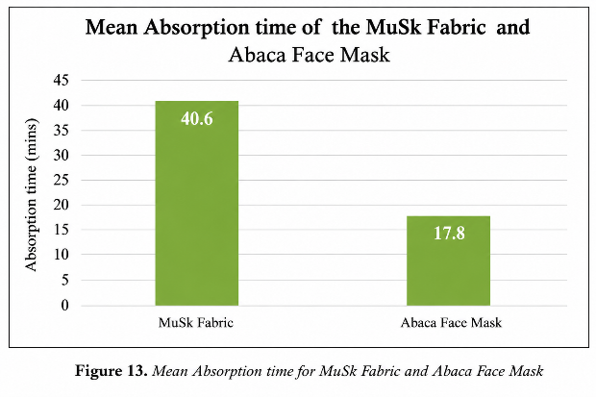
Figure 10. Mean Absorption Time of MuSk and Abaca Face Mask

10. Particle Filtration Testing
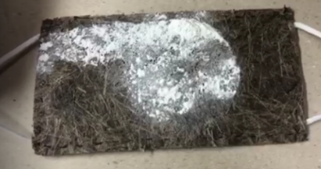
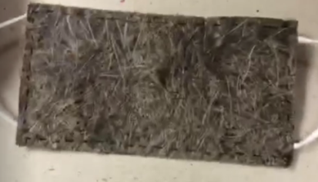
By observation, the particles did notpass through MuSk. In Figure 11, there indicates the inner and outer layer of MuSk Fabric after the particle filtration test. Therefore, it shows that MuSk has a blocking capability that preserves the respiratory system against the non-desirable air droplets and aerosols such as the viral or pollution particles.
Outer Layer
Inner Layer

Figure 11. Result of the Particle Filtration Testing

11. Biodegradability Testing
After the test was conducted, the results showed that MuSk has a potential to be biodegradable. Since the researchers observed that after 3 weeks MuSk showed that it was able to biodegrade. And because MuSk can easily biodegrade it has no environmental risk. Unlike normal facemask which cannot biodegrade easily. This is important information, because it means MuSk can help reduce pollution.
TABLE 2
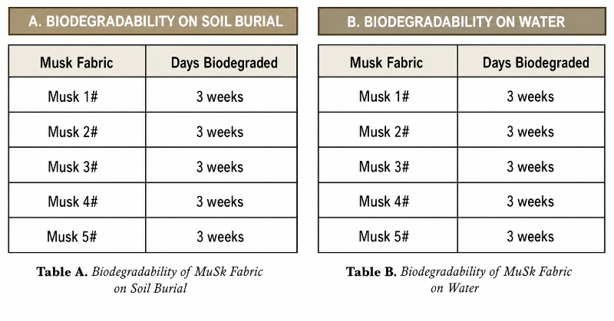
Results of the Biodegradabilty Test in Soil and Water

II. CONCLUSION
The purpose of this study is to determine the effectiveness of the MuSk, a Biodegradable Disposable Facemask derived from Musa spp Banana Pseudo Stem, specifically by candle testing, hydrophobicity testing, particle filtration testing, and biodegradability testing. Candle testing was performed on each of the five MuSk Fabrics, and observation revealed that the MuSk Fabric did not flicker or blow out the candle flame. This shows that it has a good filtering ability and an effective covering. It can be said that the MuSk effectively blocked the flow of air, implying that air cannot easily seep interior. In the angle testing test in connection to hydrophobicity, MuSk Fabrics have an average contact angle of 162° as compared to the 131° contact angle of the Abaca face mask. This would indicate lower hydrophilicity and higher barrier capacity. Therefore, MuSk demonstrates its potential to be hydrophobic and has higher barrier capacity.

ACKNOWLEDGEMENT
This research endeavor was made possible through the unwavering support and inspiration of numerous individuals who guided the researcher through the unique challenges and obstacles presented by the pandemic.
Foremost, the researcher extends profound gratitude to his family and relatives, with special recognition for his parents, Dr. Lyanne Kristoff M. Jover and Sandra May H. Jover. Their steadfast love, financial assistance, and constant encouragement provided the vital motivation needed to maintain a positive outlook during difficult times.
The researcher is deeply indebted to his research advisers Mr. Roden C. Yumol, Freshel Arra A. Egkao, Almahden C. Lumidseg, and Mr. John Malayang for their generous investment of time, effort, and mentorship. Their patience and selfless dedication served as a primary inspiration to bring this study to fruition. Additionally, sincere appreciation is extended to Shalom Crest Wizard Academy and its faculty for their institutional support and for providing essential critiques that refined the quality of this work.
Further gratitude is shared with friends and classmates for their technical assistance, valuable feedback, and personal support. Ultimately, the researcher acknowledges that this achievement was made possible through the wisdom, strength, and grace provided by the Almighty. It is through His divine blessings that this project reached its successful conclusion.
REFERENCES
[1] Aragaw, T. A. (2020). Surgical face masks as a potential source of microplastic pollution in the COVID-19 scenario. Marine Pollution Bulletin, 159, 111517. https://doi.org/10.1016/j.marpolbul.2020.111517
[2] ACS Nano. (2020). Aerosol filtration efficiency of common fabrics used in respiratory cloth masks. ACS Nano. https://pubs.acs.org/
[3] Department of Environment and Natural Resources (DENR). (2021). Medical waste generation in the Philippines during the COVID-19 pandemic.
[4] Linseis. (n.d.). Contact angle measurement. Retrieved from https://www.linseis.com/en/wiki/contact-angle/
[5] Rab, S., Javaid, M., Haleem, A., & Vaishya, R. (2020). Face masks are new normal after COVID-19 pandemic. Diabetes & Metabolic Syndrome: Clinical Research & Reviews, 14(6), 1617–1619. https://doi.org/10.1016/j.dsx.2020.08.021
[6] Rossol, E. (2019). Banana fiber and its environmental advantages.

[7] Subagyo, A., & Chafidz, A. (2018). Banana pseudo-stem fiber: Preparation, characteristics, and applications. In Banana Nutrition – Function and Processing Kinetics. IntechOpen. https://doi.org/10.5772/intechopen.76944
[8] Sumondong, M. J. (n.d.). Paper bag made from banana stem: An alternative way to reduce plastic bags.
[9] Tcharkhtchi, A., Abbasnezhad, N., Seydani, M. Z., Zirak, N., Farzaneh, S., & Shirinbayan, M. (2021). An overview of filtration efficiency through the masks: Mechanisms of the aerosols penetration. Bioactive Materials, 6(1), 106–122. https://doi.org/10.1016/j.bioactmat.2020.08.002
[10] University of Southern Denmark. (2021). Disposable face masks and environmental risks during COVID-19.
[11] World Health Organization (WHO). (2021). Global analysis of health care waste in the context of COVID-19. https://www.who.int
[12] Ahmed, M. B., Zhou, J. L., Ngo, H. H., Guo, W., Chen, M., & Nguyen, D. D. (2021). Progress in the preparation and application of modified cellulose-based materials for wastewater treatment. Science of the Total Environment, 690, 122–134. https://doi.org/10.1016/j.scitotenv.2019.07.145
[13] Nanda, S., Patra, B. R., Patel, R., Bakos, J., & Dalai, A. K. (2020). Innovations in applications and prospects of bioplastics and biopolymers: A review. Environmental Chemistry Letters, 20(1), 379–395. https://doi.org/10.1007/s10311-020-01084-9
[14] Sharma, S., Batra, S., & Gupta, D. (2021). Banana fiber reinforced biodegradable composites and their applications: A review. Materials Today: Proceedings, 44, 4378–4384. https://doi.org/10.1016/j.matpr.2020.10.826
[15] Prata, J. C., Silva, A. L. P., Walker, T. R., Duarte, A. C., & Rocha-Santos, T. (2020). COVID-19 pandemic repercussions on the use and management of plastics. Environmental Science & Technology, 54(13), 7760–7765. https://doi.org/10.1021/acs.est.0c02178
[16] Avossa, J., Carleo, B., Boccia, G., Borriello, A., Diana, S., & Esposito, E. (2021). Sustainable and biodegradable materials for face mask production: Current advances and future perspectives. Materials, 14(23), 7480. https://doi.org/10.3390/ma14237480

