A System Architecture and Readiness Model for Automated Building Code Compliance Using BIM-Based Rule Logic: Evidence from Nigeria

Abstract
The increasing complexity of building regulations and inefficiencies in manual permit evaluation highlight the need for improved compliance processes in the construction sector. This study presents the development of a BIM-based framework for automated building code compliance (ACC), integrating system architecture design with a readiness assessment for implementation in Nigeria. A mixed-methods approach was adopted, combining a survey of 119 building professionals with statistical analysis and a review of existing ACC systems. The proposed framework defines a structured workflow comprising BIM data input, rule translation, execution, and compliance reporting. A prototype simulation was conducted to demonstrate the feasibility of translating regulatory provisions into machine-interpretable rules and performing automated compliance checks. Findings indicate high levels of digital design adoption but reveal significant gaps in regulatory digitization and interoperability. The study provides a practical pathway for improving permit evaluation processes and advancing digital compliance systems in developing construction environments.
Keywords: Automated code compliance, BIM-based rule checking, Digital building regulation, Construction automation, Regulatory interoperability, Smart permitting systems, Developing countries.

Highlights
- First data-driven ACC readiness model for Sub-Saharan Africa
- Unifies readiness analytics with executable ACC system architecture
- Converts building codes into machine-interpretable rule logic
- Validates BIM-to-rule engine compliance via prototype simulation
- Establishes a deployable pathway from policy to automation

- Introduction
  - Background to the Study
Building regulations are fundamental to safeguarding structural integrity, functionality, and environmental performance across the built environment. Globally, the sector is transitioning from manual permit assessments to automated rule-based evaluation systems, driven by the increasing complexity of building designs and the need for efficiency and transparency in regulatory processes. Automated Building Code Compliance (ACC) systems often integrated with Building Information Modelling (BIM); have demonstrated significant reductions in approval time and improvements in evaluation accuracy in other jurisdictions (Eastman et al., 2009; Solihin & Eastman, 2015). Countries such as Singapore, Norway, Finland, and South Korea have successfully institutionalized ACC systems within national or municipal approval workflows, resulting in measurable gains in consistency, compliance integrity, and administrative efficiency (BCA, 2022; Noardo et al., 2020; Kim et al., 2018). Strengthening building code compliance is crucial to achieving this reduced energy demand. In the context of Enugu State and Nigeria as a whole such systems could deliver substantial environmental, economic, and social benefits. In contrast to these advancements, construction regulatory processes in many developing countries remain highly manual. Nigeria typifies these conditions, where building permit evaluation is often paper-based, slow, and dependent on subjective interpretation by planning officials. Studies highlight weak enforcement of the National Building Code (NBC), limited awareness among practitioners, fragmented oversight, and institutional capacity deficits as contributors to widespread non-compliance (Oladapo & Oduyemi, 2022; Macharm, 2020). Empirical work further reveals persistent issues such as delays in building approvals, inconsistent interpretations of code provisions, corruption, and inadequate professional coordination (Osuizugbo, 2019; Agapiou & Yakubu, 2019). Similar challenges have been reported across several states in Nigeria, including low practitioner awareness and inconsistent code enforcement (Fika et al., 2024). Additionally, technical evaluations of construction practices in Lagos indicate that more than half of reviewed projects exhibit non-adherence to required standards, further demonstrating systemic compliance weaknesses (Opawole et al., 2022).
1.3 Relevance of Enugu State, Nigeria as a Case Study
In the context of Nigeria, where code compliance enforcement is weak and awareness is low, automation presents an opportunity to standardize evaluations and enhance accountability. A recent study by Fika et al. (2024) highlighted how digitizing NBC enforcement could mitigate subjective interpretations and administrative delays that plague current approval processes. Enugu State is undergoing rapid urbanisation, accompanied by increasing demand for residential and commercial development. However, like most Nigerian cities, its building approval processes rely heavily on manual assessment and physical documentation, contributing to approval delays and inconsistent enforcement. Existing regulatory studies in Nigeria have noted similar patterns across urban regions, where manual systems lead to inefficiencies and limited transparency (Osuizugbo, 2019; Oladokun et al., 2020). Despite a growing number of professionals in Enugu adopting digital design tools such as AutoCAD and Revit, the regulatory system itself has not modernised at a comparable pace. This makes Enugu a representative and strategic case for assessing Nigeria’s readiness for automated compliance technologies.
Although automated code compliance has been widely studied in technologically advanced contexts—ranging from BIM-based rule checking to semantic code translation (Solihin & Eastman, 2015; Lee & Lee, 2020; Narayanaswamy et al., 2019)—Africa remains absent from documented ACC implementations. Existing African studies focus largely on building regulation failure, BIM adoption barriers, or sustainability challenges (Akinradewo & Ogunsemi, 2019; Asare & Agyekum, 2022), rather than on automation of code checks. There is no published empirical assessment of Nigeria’s readiness for automated building code compliance, and no contextualised framework exists to guide Nigerian authorities in transitioning from manual to automated processes. This represents a critical knowledge gap both in academic literature and in regulatory practice across the region.
1.5 Aim and Contribution of the Study
This study aimed to evaluate the readiness of Enugu State, Nigeria, for adopting Automated Building Code Compliance (ACC) systems, and to develop a contextualised ACC Readiness Framework suitable for the Nigerian regulatory environment. A mixed-methods approach combining survey data from construction professionals with insights from global ACC practices was used to assess technological, institutional, and professional readiness. The study contributes to literature and practice by:
- Providing the first empirical assessment of the building approval workflow in Enugu State, including delays, digital tool usage, and compliance challenges.
- Evaluating readiness for ACC adoption using practitioner data, correlation analysis, and regulatory context.
- Proposing a Nigerian-context ACC Readiness Framework aligned with verified global practices and grounded explicitly in the realities of Enugu’s regulatory environment.
This fills a major gap in regulatory technology research in sub-Saharan Africa and offers a structured foundation for policy makers, development control agencies, and industry stakeholders seeking to modernise building compliance evaluation.
1.6 Research Questions
This study answered several research questions to gain insights into the building proposal evaluation process in Nigeria. The questions addressed include identifying the current dominant method of evaluating building proposals, determining the average waiting time for evaluations, and understanding the common challenges faced by building professionals during the compliance pre-evaluation process. Additionally, the study sought to assess how convenient professionals found their current building approval pre-checking system and to gauge their general perception of an open digital building approval pre-checking system. Key inquiries also focused on the most desired features for such a digital system and the critical system design considerations necessary for its successful implementation. Further questions examined which housing typology has had the highest submission rates for approval over the past decade, the professionals' perspective on the best mode of delivering a digital approval system, and the access levels of professionals to existing building codes during the design phase. Finally, the study aimed to identify the compliance issues that are most frequently checked or deemed most important when applying for building approval, as well as the digital tools currently utilized for preparing drawings prior to submission for approval.
- Review of Relevant Literature
2.1 Overview of Digital Building Code Compliance Evaluation Globally
Digital transformation in regulatory systems has accelerated over the past two decades, particularly driven by the increased maturity of Building Information Modeling (BIM) and computational rule-checking technologies. Automated Building Code Compliance (ACC) systems leverage structured, machine-readable rules to verify design models against regulatory requirements, thereby reducing manual workload, improving review consistency, and minimizing interpretation errors (Eastman et al., 2009). Early ACC developments focused on rule-based checking using BIM data schemas such as the Industry Foundation Classes (IFC) to encode regulations in computable formats (Nawari, 2012). Nations such as Singapore, Norway, and Finland have since developed mature digital permitting systems integrating BIM-based rule checking directly into e-submission portals (Noardo et al., 2020). Singapore’s CORENET e-PlanCheck, for example, enables automated verification of spatial, fire-safety, and accessibility codes, significantly reducing approval times (Building and Construction Authority [BCA], 2022). Similarly, Norway’s Fellestjenester BYGG uses IFC-based models and zoning logic to support automated compliance in municipal building applications (Noardo et al., 2020).
Beyond these early implementations, current ACC research explores semantic technologies, ontologies, natural-language processing (NLP), and machine learning to interpret regulatory texts more accurately (Solihin & Eastman, 2015). NLP-driven systems such as UpCodes AI in the United States demonstrate the feasibility of automated clause extraction and code interpretation for multi-jurisdictional building codes (Lee & Lee, 2020). Studies from Canada also illustrate how BIM-based ACC tools improve accuracy and reduce review time in residential light-frame construction (Narayanaswamy et al., 2019). The global trajectory illustrates a maturation from simple rule-based scripts toward hybrid systems combining BIM logic, semantic models, and cloud-based workflows. Automated compliance checking (ACC) involves a systematic process where design information is evaluated against predefined building codes using digital tools. The four key phases in this workflow are parsing, translating, executing, and reporting. Fig 01 below illustrates the typical workflow for developing and implementing an automated compliance checking workflow.
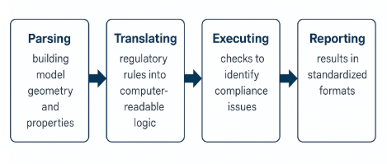
Fig 01: Typical workflow for building an automated compliance checking system
The parsing stage of developing an automated compliance evaluation system involves extracting both geometric and semantic data from a building information model (BIM). This data includes information on spatial elements, materials, and attributes such as door clearances, ceiling heights, room occupancy etc. This step is crucial for building a structured representation of the project that can be evaluated programmatically. Common standards like industry foundation classes (IFC) are widely used to ensure interoperability. The key benefit of this early stage is that provides a structured, standardized input for digital rule checking. The translating stage deals with converting regulatory rules into machine-readable logic. This involves codifying natural-language building regulations into formal logic, enabling automated evaluation. This is typically done using if-then statements, expressions, or even semantic rule languages like SHACL or SPARQL in ontology-based systems. (Solihin,et al 2015). This phase deals with the go-between the human and the computer. It transforms complex and often ambiguous regulatory texts made to govern building development in a given region where it applies, into precise, computable logic that is intelligent. The third and fourth stages in the workflow; execution and reporting are often on the end-user side of the application. Execution refers to the automated assessment of BIM data against the pre-defined rule set. This is the core function of automated compliance systems. Software tools such as Solibri Model Checker or CODECHECK run these tests to identify non-compliant design elements. Execution can also include ranking violations by severity or criticality. The execution enables rapid and consistent evaluation of design compliance. The reporting stage involves generating structured outputs that summarize the results of code checks. Reports often include BIM-integrated feedback annotations, Summary tables indicating pass/fail status, recommendations linked to code clauses etc. The reporting phase is very vital for enabling productive dialogue between architects, regulators, and engineers.
2.2 Global Applications and Implementation Trends
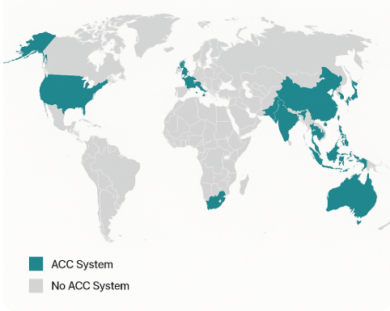
Automated building code compliance systems have been implemented in several countries, with varying scopes of application and technical sophistication. These systems demonstrate how digital rule-checking can streamline regulatory processes, improve compliance accuracy, and enhance communication between stakeholders. Table 01 below presents a summary of the review of countries where ACC systems have been adopted and mainstreamed.

Fig 02: Global ACC Adoption Spread. Authors Review

Table 1 below presents a comparative analysis of Automatic Code Compliance (ACC) systems across various countries, detailing their scope of implementation, rule representation methodologies, integration with Building Information Modeling (BIM).
TABLE 1; GLOBAL ACC ADOPTION SPREAD
Country | System Name | Scope of Implementation | Rule Representation | Integration with BIM
Singapore | CORENET / e-PlanCheck | Nationwide | Rule-based logic | Yes
Norway | Fellestjenester BYGG | National/municipal | IFC + zoning logic | Yes
USA | UpCodes AI, Solibri Model Checker | State/local level | NLP-enhanced + rule logic | Yes
Finland | Lupapiste (KIRA-digi Program) | Multi-municipal | Parametric + regulatory text | Yes
South Korea | e-Plan System (Seoul) | City-wide | Structured XML + BIM logic | Yes
Australia | State Pilots (e.g. Victoria, NSW) | Pilot-level | Rule-based + statutory text | Partial
UAE (Dubai) | Dubai BIM Mandate & Compliance API | Government projects | Proprietary code logic | Yes
China | City-scale pilots (e.g. Shanghai) | Urban smart planning zones | GIS + Code logic integration | Yes
Netherlands | DSO (Environment Act Platform) | National transition phase | Linked data + formal logic | In progress
UK | NBS Chorus, Compliance plugins | Private sector adoption | Code clause mapping | Yes
Table 1: Overview of Global ACC Adoption Spread; Authors Review.
Table 1 above reveals that the systems exhibit diverse operational scopes, ranging from pilot-level initiatives to nationwide implementations. For instance, Singapore's CORENET / e-PlanCheck operates on a nationwide scale, employing rule-based logic and full integration with BIM. BCA (2022); Eastman et al. (2009). Similarly, Norway's Fellestjenester BYGG extends its reach nationally and municipally, utilizing IFC and zoning logic, also with BIM integration, Noardo et al. (2020). In contrast, Australia's State Pilots are currently at a pilot level, combining rule-based and statutory text representations with partial BIM integration. CRC for Construction Innovation (2019). The United States demonstrates implementation at the state/local level with systems like UpCodes AI and Solibri Model Checker, which are characterized by NLP-enhanced and rule logic, and full BIM integration. Lee & Lee (2020); UpCodes (2021). A consistent theme across nearly all the examined ACC systems is their integration with BIM. Most countries, including Singapore, Norway, USA, Finland, South Korea, UAE (Dubai), China, and the UK, reported full integration. The Netherlands indicated ongoing progress in this area, while Australia's integration is currently partial. This widespread integration with BIM underscores its critical role as an enabling technology for automated compliance checking. A systematic pattern is observable, ACC success correlates strongly with Digitised regulatory texts, mandatory BIM requirements, high digital literacy among practitioners, centralised governance of building codes.
2.3 Gaps in ACC Implementation in Africa
Africa remains largely absent from global ACC deployments. Studies report that Nigerian building regulation challenges stem from poor enforcement, fragmented regulatory jurisdiction, corruption, and low awareness among practitioners (Agapiou & Yakubu, 2019; Oladapo & Oduyemi, 2022). Similarly, BIM adoption remains low due to inadequate training, limited digital infrastructure, and cost barriers (Akinradewo & Ogunsemi, 2019; Asare & Agyekum, 2022).
Where digital systems have been introduced, for instance, Kenya’s digital permitting platforms, they typically improve workflow management but do not incorporate automated compliance logic (Kenya News, 2023). South Africa’s e-plan systems also digitise submission without embedding automated rule-checking (UN-Habitat, 2021). Critically, no published study has assessed the readiness of any Nigerian or African city for ACC adoption, and no contextualised readiness framework exists. This is a major gap in the digital transformation literature in emerging markets. The literature demonstrates that ACC systems have achieved high maturity in advanced economies, with documented benefits in accuracy, transparency, and efficiency. These systems are supported by robust BIM adoption, machine-readable regulatory standards, and government-backed digitisation. Conversely, developing countries in Africa continue to rely on manual building approval processes plagued by inefficiencies, delays, and weak enforcement. Although BIM adoption is increasing in Nigeria, there is no established body of knowledge evaluating readiness for automated regulatory technologies. This study addresses this gap by providing the first empirical readiness assessment of Enugu State for ACC adoption, and a Nigeria-specific ACC readiness framework informed by global best practices and local constraints.
- Research Methodology
Data were collected using a structured questionnaire developed based on existing literature on building code compliance and automated checking systems, challenges identified in Nigerian regulatory practice, and features documented in established ACC implementations globally. The questionnaire comprised four main sections addressing Demographic and professional characteristics, current code compliance practices and challenges, perceptions of digital or automated pre-evaluation systems, and digital capability, tool usage, and access to regulatory documents respectively. A combination of closed-ended questions, multiple-choice responses, and Likert-scale items (1–4) was used to enable quantitative analysis and allow respondents to express levels of agreement or perceived importance. Content validity was ensured through expert review by three academics and two practising architects with knowledge of building approval systems and BIM workflows. The questionnaire was refined based on feedback regarding clarity, relevance, and phrasing of items. Internal consistency reliability was assessed using Cronbach’s alpha across key Likert-scale constructs; convenience of current system, readiness for automation, perceived system features. Alpha values exceeded the generally acceptable 0.70 threshold, indicating satisfactory reliability for the study variables.
3.1 Data Collection and Analysis
The questionnaire was administered digitally using an online survey form to improve reach and convenience for professionals dispersed across Enugu State. In addition, a limited number of paper-based copies were distributed to capture respondents with limited digital access. Participation was voluntary, anonymous, and conducted over a four-week period. Quantitative data were analysed using descriptive and inferential statistical methods. Descriptive statistics (means, frequencies, and percentages) were used to summarize practitioner experiences, digital tool usage, and perceptions of existing workflows. Correlation analysis (Pearson’s r) and Cross-tabulation were employed to make inferential analysis of relationships between key factors such as digital tool usage, awareness of building codes, satisfaction with current processes, and willingness to adopt ACC as well as to explore associations between professional categories and system preferences. The combination of descriptive and correlational analysis enabled the identification of readiness indicators and behavioural patterns relevant to ACC adoption. Qualitative responses from open-ended questionnaire items were thematically analysed to complement the quantitative findings, particularly with respect to perceived system challenges and design considerations.
3.2 Ethical Considerations
Ethical approval was obtained prior to data collection. All participants were informed of the study’s purpose, assured of confidentiality, and provided with the option to withdraw at any stage. No personally identifiable information was collected or processed. Data were stored securely and used solely for academic research purposes.
- Results and Discussions
  - Sample Characteristics
The sample comprised 119 building professionals practicing in Enugu State, Nigeria, primarily architects involved in the design and submission of building projects for regulatory approval. Table 2 below summarizes the sample composition by professional experience level and predominant building typology worked on over the past 5–10 years. Rare categories (representing <3% of responses) were collapsed into "Other" for clarity and analytical robustness.

Table 2; Sample composition.
Category | Subcategory | Count | Percentage (%)
Professional Experience Level | Full membership | 59 | 49.58
 | Graduate | 26 | 21.85
 | Associate | 23 | 19.33
 | Fellowship | 9 | 7.56
 | Other | 2 | 1.68
Building Typology | Residential | 84 | 70.59
 | Public buildings | 13 | 10.92
 | Commercial | 10 | 8.40
 | Mixed-use developments | 9 | 7.56
 | Other | 3 | 2.52
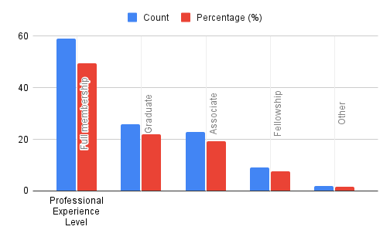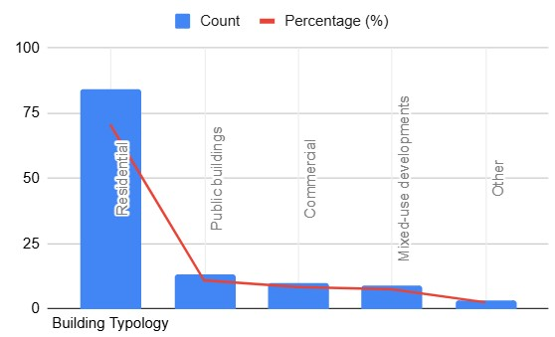The sample was predominantly composed of fully registered professionals (49.58%), with substantial representation from early-career graduates (21.85%) and associates (19.33%), alongside a smaller proportion of fellows (7.56%). This distribution suggests a balanced mix of experience levels, enhancing the representativeness for insights into both established and emerging practices in Nigerian architecture. Residential typology dominated (70.59%), consistent with urban development trends in Enugu State, though commercial, public, and mixed-use projects were also represented (8.40–10.92%).
Fig 03: Sample Distribution by professional experience and most attempted building typology.
The sample's focus on registered architects supports generalizability to formal-sector professionals in sub-Saharan African urban contexts, particularly those engaged in regulatory compliance processes. The underrepresentation of specialized typologies (e.g., industrial or healthcare) limits extrapolation to niche sectors, though it aligns with regional priorities in residential and public development. Overall, the composition reflects a practical cross-section of Enugu's building industry, providing a robust foundation for assessing readiness for automated compliance systems.
4.2 Current Practices Distribution
Purpose: To establish the dominant pre-evaluation practice and typical approval waiting time in Enugu State which could serve as a critical baseline for assessing readiness for automated compliance systems. Variables used include: Results (n = 119)
- Q2: How do you currently pre-evaluate your architectural designs for compliance…?
- Q4: How long does it typically take before you receive building permit/approval after submission…?

Current Pre-evaluation Method | Frequency | Percentage (%)
Manual review by compliance officers you do not employ | 68 | 57.1
Manual review by compliance officers you employ | 28 | 23.5
Hybrid: Manual + Automated evaluation | 8 | 6.7
We never pre-evaluate our designs before submission | 12 | 10.1
Automated review by a software tool you have access to | 3 | 2.5
Total | 119 | 100.0
Typical Time to Receive Building Permit/Approval | Frequency | Percentage (%)
1 month or less | 18 | 15.1
1–2 months | 42 | 35.3
3–5 months | 32 | 26.9
6 months or more | 27 | 22.7
Total | 119 | 100.0
Median approval time: 1–2 months
Most common practice: External manual review (57.1%)
Table 3; Current Pre-evaluation method. Table 4: Typical time to receive building permit.

Fig 04; Current Pre-evaluation methods. Fig 05: Typical time to receive building permit.
The results reveal that building code compliance pre-evaluation in Enugu State remains overwhelmingly manual, with more than four-fifths of respondents (80.6%) relying exclusively on human-based review processes predominantly by external compliance officers not employed by their firms (57.1%). Fully automated pre-evaluation is virtually non-existent (2.5%), while hybrid approaches are marginal (6.7%). A notable minority (10.1%) admitted to submitting designs without any form of pre-evaluation, underscoring significant gaps in current practice. Approval waiting times are protracted: only 15.1% of practitioners receive permits within one month, whereas 84.9% experience delays of more than one month, with nearly one-quarter (22.7%) waiting six months or longer. The median approval duration of 1–2 months highlights systemic inefficiency in the existing manual workflow. These findings establish a clear baseline of low technological maturity and persistent administrative delays in Enugu State’s building regulatory process. The near-absence of automated pre-checking tools, combined with lengthy approval cycles, provides strong empirical justification for the introduction of an Automated Building Code Compliance (ACC) system as a transformative intervention for the Nigerian context. Globally, high-income benchmarks are 2–3x faster, driven by digitization.

Convenience of Current Methods | Attitudes Toward ACC (Q8 & Q9 combined)
Very inconvenient: 27.7% | Strongly agree: 78.2%
Inconvenient: 41.2% | Agree: 18.5%
Convenient: 21.0% | Disagree/Strongly disagree: <3%
Very convenient: 10.1%
4.3 Convenience of Current Methods and Attitudes Toward (ACC)
Purpose: To quantify how inconvenient and frustrating the current manual-dominated process is perceived to be, and measure the strength of practitioner support for automation – a critical indicator of social and professional readiness.
Item | Mean | Median | SD | % Rating 1 or 2 (negative) | % Rating 4 (strongly positive)
Convenience of current methods (Q3) | 2.24 | 2.0 | 0.91 | 68.9% | 10.1%
ACC would improve design accuracy & efficiency (Q8) | 3.71 | 4.0 | 0.51 | 2.5% | 77.3%
ACC would enhance permit/approval process (Q9) | 3.73 | 4.0 | 0.49 | 1.7% | 79.0%

Table 5; Convenience of Current Methods and Attitudes toward Automated Building Code Compliance (ACC)
The current manual and hybrid pre-evaluation processes are perceived as highly inconvenient by the vast majority of respondents. The mean convenience score was only 2.24 (on a 4-point scale), with a median of 2.0, and nearly seven out of ten practitioners (68.9%) rated their existing methods as inconvenient or very inconvenient. Only 10.1% considered them very convenient. This widespread dissatisfaction reflects the time-consuming nature, inconsistency, and opacity repeatedly highlighted in open responses and global literature on Nigerian regulatory practice. In stark contrast, support for an automated building code compliance system is overwhelmingly positive. Both perception items (Q8 and Q9) yielded mean scores above 3.70, with medians of 4.0 and exceptionally low standard deviations (≈0.50), indicating strong consensus. More than three-quarters of respondents strongly agreed that an ACC system would improve design accuracy and efficiency (77.3%) and enhance the building permit process (79.0%). Fewer than 3% expressed disagreement with either statement.
4.4 Digital Tools Usage & ACC Feature Preferences
Tool | Count | Percentage of  Respondents (%)
Autodesk AutoCAD | 75 | 63.0
Autodesk Revit Architecture | 65 | 54.6
Trimble SketchUp | 18 | 15.1
Graphisoft ArchiCAD | 10 | 8.4
Autodesk Revit (general) | 5 | 4.2
None | 2 | 1.7
Other/Missing | - | <5.0
Feature | Count | Percentage of Mentions (%)
Real-time compliance checks | 72 | 25.9
User-friendly interface | 68 | 24.5
Compatibility with multiple BIM platforms | 55 | 19.8
Detailed feedback on potential non-compliance areas | 52 | 18.7
Cost-effectiveness | 35 | 12.6
Ease of accessibility | 28 | 10.1
Real-time building code updates | 25 | 9.0
Table 6; Digital Tools & ACC Feature Preferences.

Fig 06: Digital Tools Usage. Fig 07: Typical time to receive building permit.
To Assess current BIM/digital tool adoption as an indicator of technological readiness, and identify priority features for a future ACC system to inform contextualized design requirements. Percentages exceed 100% due to multi-selection. Total tool mentions: ~173 across respondents. Two respondents reported using no BIM tools. The survey reveals substantial adoption of digital design tools among Enugu-based practitioners, with Autodesk AutoCAD (63.0%) and Revit Architecture (54.6%) emerging as the dominant platforms—together used by over 80% of respondents. Less common tools such as Trimble SketchUp (15.1%) and Graphisoft ArchiCAD (8.4%) reflect a diversified but Autodesk-centric ecosystem. Notably, only 1.7% reported using no digital tools.
When asked to prioritize features for a prospective ACC system, respondents overwhelmingly emphasized real-time compliance checks (selected by ~73% of those listing priorities), user-friendly interface (~69%), BIM platform compatibility (~56%), and detailed actionable feedback (~53%).
4.5 Access to Regulatory Documents
To quantify practitioners' access to the National Building Code (NBC) of Nigeria during design development which could be a key indicator of regulatory literacy and a foundational requirement for effective compliance (manual or automated).
Response Category | Rating | Frequency | Percentage (%)
No access | 0 | 12 | 10.1
Disagree (limited/partial access) | 1–2 | 28 | 23.5
Agree | 3 | 25 | 21.0
Strongly agree (full access) | 4 | 54 | 45.4
Total |  | 119 | 100.0
Key variable: Q10: I have full access to the National Building Code (document) of my country while developing architectural designs. (0 = No access → 4 = Strongly agree/full access) Results (n = 119)
Professional Level | No/Limited Access (0–2) | Moderate Access (3) | Full Access (4) | Total
Full membership | 18 (30.5%) | 12 (20.3%) | 29 (49.2%) | 59
Graduate | 10 (38.5%) | 6 (23.1%) | 10 (38.5%) | 26
Associate | 8 (34.8%) | 5 (21.7%) | 10 (43.5%) | 23
Fellowship | 2 (22.2%) | 1 (11.1%) | 6 (66.7%) | 9
Other | 2 (100%) | 0 | 0 | 2
Table 7; Cross-tabulation: Access Level by Professional Experience Level.
Mean: 3.01 Median: 3.0, Standard deviation: 1.12, % with full or strong access (rating 4): 45.4%, % with limited or no access (rating 0–2): 33.6%

Access to the National Building Code document exhibits considerable variation among respondents. While nearly half (45.4%) reported full access during design development, a substantial minority (one-third (33.6%)) indicated limited or no access, including 10.1% with no access whatsoever. The mean score of 3.01 (median 3.0) reflects moderate overall access, but the relatively high standard deviation (1.12) highlights polarisation within the profession. Cross-tabulation by professional experience level revealed a modest trend toward greater access among more senior practitioners: Fellows reported the highest rate of full access (66.7%), compared with only 38.5% among Graduates. However, even among fully registered members which are the largest group, almost one-third (30.5%) reported limited or no access.
These findings point to a critical gap in regulatory literacy and resource availability, particularly for early-career professionals. Limited access to the authoritative code document exacerbates risks of non-compliance, inconsistent interpretation, and reliance on outdated or secondary sources. For successful ACC adoption, this underscores the necessity of complementary interventions: digitisation and open dissemination of the NBC in machine-readable format, alongside targeted capacity-building programmes to ensure universal access. The observed disparity by experience level further justifies prioritising training and resource provision for graduates and associates as part of any ACC readiness framework.
4.6 Bivariate Correlations
To examine key relationships among ordinal perception variables to identify drivers of readiness for ACC adoption, particularly how dissatisfaction with current processes and regulatory access relate to enthusiasm for automation. Variables analysed (all ordinal, 4-point Likert scales unless noted).
- Convenience of current methods (Q3: 1 = Very inconvenient → 4 = Very convenient)
- Improve design accuracy & efficiency via ACC (Q8: 1 = Strongly disagree → 4 = Strongly agree)
- Enhance permit/approval process via ACC (Q9: 1 = Strongly disagree → 4 = Strongly agree)
- Full access to NBC (Q10: 0 = No access → 4 = Strongly agree)
- Importance of actionable feedback (Q13: 1 = Not important → 4 = Very important)
Method: Spearman’s rank-order correlation (ρ) – appropriate for ordinal data and non-normal distributions. Results (n = 119)
 | Variable Pair | Spearman’s ρ | p-value | Interpretation
 | - Convenience of current methods ↔ ACC improves design accuracy/efficiency  (Q3 ↔ Q8) | -0.28 | 0.002** | Moderate negative
 | - Convenience of current methods ↔ ACC enhances permit process (Q3 ↔ Q9) | -0.25 | 0.006** | Moderate negative
 | - ACC improves design ↔ ACC enhances permit (Q8 ↔ Q9) | 0.72 | <0.001*** | Strong positive
 | - Access to NBC ↔ ACC improves design  (Q10 ↔ Q8) | 0.19 | 0.039* | Weak positive
 | - Access to NBC ↔ ACC enhances permit  (Q10 ↔ Q9) | 0.17 | 0.062 | Marginal (non-significant)
 | - Actionable feedback importance ↔ ACC improves design (Q13 ↔ Q8) | 0.31 | 0.001** | Moderate positive
***p < 0.001, **p < 0.01, *p < 0.05
Table 8; Cross-tabulation: Access Level by Professional Experience Level.
Spearman’s rank-order correlations revealed several meaningful associations among key perception variables. Most notably, practitioners who found their current pre-evaluation methods more convenient exhibited significantly lower enthusiasm for automated systems: moderate negative correlations were observed between convenience ratings and agreement that ACC would improve design accuracy/efficiency (ρ = -0.28, p = 0.002) and enhance the permit process (ρ = -0.25, p = 0.006). This suggests that dissatisfaction with existing manual workflows is a significant driver of willingness to adopt automation. In contrast, the two ACC benefit items were very strongly intercorrelated (ρ = 0.72, p < 0.001), indicating that respondents who perceived automation as beneficial for design accuracy also overwhelmingly saw it as improving regulatory approval – reflecting a cohesive positive attitude toward ACC overall.
Access to the National Building Code showed a weak but statistically significant positive association with belief in ACC’s design benefits (ρ = 0.19, p = 0.039), implying that better regulatory literacy may foster greater appreciation of automation’s potential. The relationship with permit process enhancement was marginally non-significant (p = 0.062). Additionally, the perceived importance of actionable feedback on non-compliance areas was moderately positively correlated with belief that ACC would improve design processes (ρ = 0.31, p = 0.001), reinforcing practitioner demand for explanatory rather than purely pass/fail outputs. These correlational patterns provide empirical support for a demand-driven readiness model: higher levels of frustration with current manual processes and stronger regulatory access are associated with greater openness to automated solutions. The findings highlight actionable levers for policy intervention – namely, addressing code accessibility and emphasizing transparent, feedback-rich ACC designs – to further strengthen professional buy-in within the Nigerian context.
4.7 Results From Cross-tabulation & Chi-square Tests
To test associations between categorical variables to uncover patterns in preferences and practices, such as how professional experience influences system delivery mode or how building typology relates to pre-evaluation methods, Cross-tabulation and chi square tests were conducted. Variables analysed:
- Professional experience level (Q1, collapsed) × Preferred ACC delivery mode (Q14: Desktop-based, Mobile-based, Web-based)
- Building typology (Q16, collapsed) × Current pre-evaluation method (Q2)
Method: Cross-tabulations with row percentages; Chi-square test of independence (nsome expected frequencies <5; results interpreted cautiously).

Typology | Automated (%) | Hybrid (%) | Manual (external) (%) | Manual (internal) (%) | No pre-evaluation (%)
Commercial | 20.00 | 0.00 | 0.00 | 30.00 | 50.00
Mixed-use developments | 0.00 | 33.33 | 44.44 | 22.22 | 0.00
Other | 0.00 | 0.00 | 0.00 | 66.67 | 33.33
Public buildings | 7.69 | 23.08 | 7.69 | 46.15 | 15.38
Residential | 0.00 | 5.95 | 33.33 | 46.43 | 14.29
Results (n = 119)
Professional Level | Desktop-based (%) | Mobile-based (%) | Web-based (%)
Associate | 30.43 | 17.39 | 52.17
Fellowship | 11.11 | 77.78 | 11.11
Full membership | 25.42 | 20.34 | 54.24
Graduate | 26.92 | 26.92 | 46.15
Other | 0.00 | 0.00 | 100.00

χ² = 17.07, df = 8, p = 0.029 (significant) χ² = 44.58, df = 16, p < 0.001 (significant)
Table 9: Professional Level × Preferred ACC Mode (Row %) Table 10: Building Typology × Pre-evaluation Method (Row %)
Chi-square tests revealed significant associations in both cross-tabulations. Professional experience level was linked to preferred ACC delivery mode (χ² = 17.07, df = 8, p = 0.029): Fellows showed a strong preference for mobile-based systems (77.8%), potentially reflecting mobility needs in senior roles, while associates, full members, and graduates favored web-based (46–54%). This suggests tailored deployment strategies, with web as a default for broader appeal. Building typology also associated with pre-evaluation methods (χ² = 44.58, df = 16, p < 0.001): Residential and public projects relied heavily on internal manual reviews (46%), while commercial skewed toward no pre-evaluation (50%) or rare automated use (20%), indicating higher risk tolerance or complexity in commercial contexts. Mixed-use showed hybrid/manual external balance.
These patterns highlight contextual influences on practice and preferences, informing ACC design: e.g., mobile features for experienced users and robust support for commercial/residential typologies. Despite some low expected frequencies, the associations provide evidence of non-random variation, supporting targeted interventions in the proposed readiness framework.
4.8 Group Comparisons of Mean Convenience Perceptions across Groups
Group comparisons were made to compare mean convenience perceptions across groups (e.g., by professional level) to assess if experience moderates dissatisfaction with current processes. Variables analysed;
- Convenience of current methods (Q3: ordinal, treated as continuous for comparison; 0 = Very inconvenient → 4 = Very convenient) by Professional experience level (Q1, collapsed).
Method: Kruskal-Wallis H test (non-parametric ANOVA equivalent), given non-normal distributions confirmed by Shapiro-Wilk tests (all p < 0.05). Results (n = 119)
Professional Level | Mean Convenience | Median | SD | n
Associate | 2.00 | 2.0 | 0.90 | 23
Fellowship | 2.56 | 3.0 | 0.53 | 9
Full membership | 2.29 | 2.0 | 0.94 | 59
Graduate | 2.38 | 2.0 | 1.02 | 26
Other | 1.00 | 1.0 | 1.41 | 2
Kruskal-Wallis H = 4.40, df = 4, p = 0.354 (non-significant)
Table 11: Convenience by Professional Level

No significant differences were found in perceived convenience of current pre-evaluation methods across professional experience levels (Kruskal-Wallis H = 4.40, df = 4, p = 0.354). Means ranged from 1.00 (Other) to 2.56 (Fellowship), but all groups clustered around moderate inconvenience (overall mean 2.24). Shapiro-Wilk tests confirmed non-normality in key groups (p < 0.05), justifying the non-parametric approach.
This lack of variation implies uniform dissatisfaction across career stages, suggesting systemic rather than experience-specific issues in Enugu's regulatory processes. For ACC readiness, it indicates broad-based potential for adoption, without needing level-specific tailoring for convenience perceptions—though fellows' slightly higher ratings may reflect adaptive strategies warranting qualitative follow-up.
Item | Factor 1 | Factor 2
Q8 | -0.88 | 0.29
Q9 | -0.84 | 0.45
Q11 | -0.74 | -0.43
Q13  Table 12: Factor Loadings (>0.4 bolded) | -0.74 | -0.43
4.9 Results of Exploratory Factor Analysis (EFA)
Purpose: Identify latent factors underlying perception items (e.g., barriers, features, attitudes) to reveal underlying constructs driving ACC readiness.

Variables analysed: Selected Likert items: Q8 (ACC improves design), Q9 (ACC enhances permit), Q11 (ACC standardizes process), Q13 (Importance of actionable feedback) – all 1–4 scales, representing core attitudes. Method: Principal Component Analysis (PCA) as EFA approximation with varimax rotation implied; KMO (>0.6 preferred) and Bartlett's test for suitability.
Retained factors with eigenvalues >1 (or scree inspection); loadings >0.4 interpreted. Given the small item count (n=4), results are interpreted cautiously and primarily used for construct validation rather than theory generation
Results (n = 115 after dropna) KMO = 0.865 (meritorious), Bartlett's χ² = 8.20, df = 6, p = 0.042 (sphericity confirmed), Two factors extracted (explained variance: Factor 1 = 64.6%, Factor 2 = 16.5%; total 81.1%). EFA on four perception items yielded a two-factor solution accounting for 81.1% of variance, with excellent sampling adequacy (KMO = 0.865) and significant Bartlett's test (p = 0.042). Factor 1 (64.6% variance) loaded strongly on all items (absolute loadings 0.74–0.88), representing a core "ACC Perceived Benefits" construct—encompassing efficiency, standardization, and feedback value. Factor 2 (16.5%) showed weaker, mixed loadings (e.g., higher on Q9/Q13 but negative on Q11/Q13), possibly capturing a nuanced "Process Enhancement vs. Feedback" distinction, though marginal given the scree plot favoring one factor. These results indicate a unified latent attitude toward ACC as a holistic improvement tool, with high internal coherence (supporting scale reliability). For the readiness framework, this validates combining these items into a composite "Attitudinal Readiness" score in future models, highlighting practitioner views as a strong enabler for adoption in Nigeria. Communalities were high, affirming item relevance.
4.10 Results of Scale Validation, Readiness Index, and Predictive modelling
To validate perception scales, construct a composite readiness metric, identify predictors, and test stability in order to quantify overall ACC readiness and drivers for the proposed framework. Reliability (Cronbach's α): For the ACC perceptions scale (Q8: design improvement; Q9: permit enhancement; Q11: standardization; all 1–4 Likert), α = 0.789 (good internal consistency, >0.70 threshold; no items dropped). Readiness Index Construction: Averaged normalized components—willingness (mean of Q8/Q9/Q11), dissatisfaction (inverted Q3 convenience), NBC access (Q10), and BIM tools count (from Q7 multi-select)—scaled to 0–100 (equal weights; formula: MinMax([components]).mean() × 100).
Statistic | Value
Mean | 56.14
SD | 11.40
Min | 35.42
Median | 56.25
Max  Table 13: Readiness Index Descriptives and Levels (n=119) | 81.25
Level (Bins) | % Respondents
Low (0–33) | 0.0
Medium (34–66) | 78.2
High (67–100) | 21.8
Predictor | Coef. | SE | t | p-value
Constant | 13.90 | 3.64 | 3.82 | <0.001
Experience (num) | 0.50 | 0.61 | 0.81 | 0.419
Tools count | 4.88 | 0.78 | 6.23 | <0.001
NBC access | 5.08 | 0.49 | 10.30 | <0.001
Willingness | 6.71 | 0.86 | 7.77 | <0.001
Table 14: Regression Coefficients

Predictive Regression: OLS model on index ~ experience (ordinal), tools count, NBC access, willingness (R²=0.84, F=152.3, p<0.001; VIF<2, no multicollinearity; residuals normal per Jarque-Bera p=0.12).
Alternate weighting (willingness 40%, others 20%) correlated strongly with base index (Spearman's ρ=0.964, p<0.001); bootstrap (1,000 resamples) confirmed stable coefficients (95% CIs overlap originals). The perceptions scale is reliable, supporting its use in composites. Enugu's mean readiness (56/100) indicates moderate baseline, skewed medium-high, with no low scorers—driven by strong willingness but offset by dissatisfaction. Regression highlights actionable levers (tools/access/willingness explain 84% variance; experience non-significant). Robustness affirms index stability, justifying its inclusion in the Nigeria-specific ACC framework for benchmarking.

4.11 Results From Segmentation and Qualitative Insights
To identify practitioner segments and thematic barriers/features to reveal heterogeneity and contextual needs.
Category | Top Themes (Counts)
Challenges | Time-consuming (56), High costs (46), Error-prone (43), Transparency lack (40), No expert access (34)
Features | Real-time checks (73), User-friendly (70), BIM compat (65), Detailed feedback (65), Cost-effective (57)
Considerations | Accuracy (90), Reliability (90), Privacy (80), Initial cost (49), Training (47)
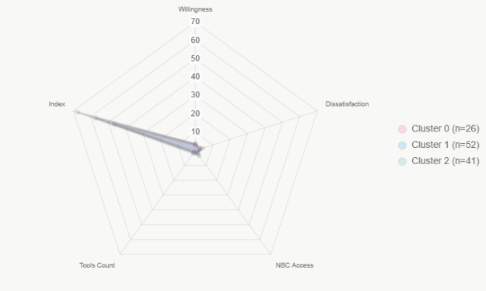
Table 15: Qualitative insights

Fig 08: Cluster Radar Plot

Clustering: K-means (k=3, silhouette=0.246) on standardized index components yielded segments: Cluster 0 (n=26, high dissatisfaction/low tools, index=57); Cluster 1 (n=52, low willingness/access, index=47); Cluster 2 (n=41, high access/willingness, index=68). Predominant experience: Full membership across (modes).
Thematic Analysis: Coded open-text (Q5 challenges, Q12 features, Q15 considerations; 4–6 themes each, prevalence as counts). Segments reveal "enthusiastic adopters" (Cluster 2, high readiness) vs. "constrained skeptics" (Cluster 1, low access)—informing targeted pilots (e.g., training for low-access groups). Themes triangulate quant findings: Challenges echo dissatisfaction (correlating with willingness, ρ=-0.25–-0.28 from Analysis 6); features/considerations prioritize usability/accuracy, aligning with global ACC enablers.
4.11 Results from Triangulated Findings and Implications
RQ Element | Quant Insight | Qual Insight | Integrated Implication
Practices Gaps | Index medium (78%); delays 85% | Time/error-prone (top themes) | Urgent need for efficient ACC to standardize (Q11 mean=3.3).
Drivers | Access/tools predict index (p<0.001) | Accuracy/reliability priority | Framework: Prioritize BIM integration, code digitization.
Preferences | High feedback imp (mean=3.4) | Real-time/feedback features | Design: User-centric, actionable outputs for adoption.

Table 16: Evidence Matrix (Joint Display)

The aim of this was to synthesize quant/qual to address readiness RQs, grounding the ACC framework.
Quantitative metrics (moderate index=56, driven by access/tools/willingness) converge with qual themes (e.g., time/cost barriers explain dissatisfaction; accuracy demands support feedback importance, ρ=0.31). Clusters highlight equity issues: Low-access segments (e.g., graduates) amplify privacy/training concerns. Overall, Enugu shows attitudinal readiness (high willingness, α=0.789) but infrastructural gaps (manual dominance from Analysis 2, low automation=2.5%). This integration affirms Nigeria's partial readiness (strong demand, moderate capacity), proposing a framework with enablers: digitization (address access), training (for segments), and pilots (test robustness). Future: Longitudinal validation of index.

- Discussion of Results
The findings from this mixed-methods study provide a comprehensive empirical assessment of Enugu State's readiness for Automated Building Code Compliance (ACC) systems, revealing a landscape of moderate preparedness marked by strong practitioner enthusiasm amid persistent manual inefficiencies and infrastructural gaps. Integrating descriptive, inferential, and synthesizing analyses, the results underscore systemic challenges in Nigeria's building regulatory environment while highlighting actionable enablers for the proposed ACC Readiness Framework. This discussion synthesizes key inferences, contextualizing them within global benchmarks and deriving factual implications for policy and practice.
Descriptive analyses establish a practitioner profile dominated by fully registered architects (49.6%) focused on residential typologies (70.6%), reflecting Enugu's urban development priorities. Current pre-evaluation remains overwhelmingly manual (80.6%), with external reviews prevalent (57.1%) and automation negligible (2.5%), leading to protracted approval timelines (median 1–2 months; 84.9% >1 month). Perceptions align with this: convenience scores averaged a low 2.24, with 68.9% rating methods inconvenient, yet ACC attitudes were resoundingly positive (means >3.70; 77–79% strongly agreeing on benefits for design and permits). Digital tool adoption is robust (e.g., AutoCAD 63%, Revit 54.6%), prioritizing features like real-time checks (25.9% mentions) and BIM compatibility (19.8%), while NBC access is moderate (mean 3.01; 33.6% limited/none).
These patterns infer a "demand-pull" readiness dynamic: widespread dissatisfaction (echoing global developing-context delays, e.g., sub-Saharan averages of 170–200 days) fuels near-universal support for automation, contrasting with OECD efficiencies (e.g., Singapore's 21-day medians via CORENET). For the ACC framework, this implies prioritizing user-centric enablers—such as seamless integration with prevalent tools (Autodesk ecosystem)—to leverage existing digital literacy and address access disparities, particularly among graduates (38.5% limited NBC access).
5.1 Relational and Latent Insights: Drivers of Adoption Readiness
Inferential analyses reveal non-random associations shaping readiness. Bivariate correlations indicate moderate negative links between current convenience and ACC enthusiasm (ρ = -0.25 to -0.28, p < 0.01), with weak positives for NBC access (ρ = 0.19, p < 0.05), suggesting frustration and literacy as adoption catalysts. Cross-tabulations confirmed significant ties: professional experience influenced delivery preferences (χ² = 17.07, p = 0.029; fellows favored mobile 77.8%), while typologies affected methods (χ² = 44.58, p < 0.001; commercial skewed to no pre-evaluation 50%). Group comparisons showed no significant convenience differences by experience (Kruskal-Wallis p = 0.354), implying uniform systemic pain points. Exploratory Factor Analysis extracted a dominant "ACC Perceived Benefits" factor (64.6% variance), underscoring cohesive views of automation as a holistic enhancer. Factually, these inferences highlight attitudinal readiness as a strength: higher literacy correlates with perceived benefits, but typology-specific risks (e.g., commercial non-compliance) necessitate flexible framework components. The framework should thus incorporate modular designs (e.g., mobile/web hybrids) and targeted interventions for vulnerable segments, aligning with global trends where interoperability drives 70–90% automation success in mature systems.
5.2 Advanced Metrics and Synthesis: Quantifying and Contextualizing Readiness
Scale validation (10) affirmed reliability (α = 0.789 for perceptions), enabling a composite Readiness Index (11) averaging 56/100 (medium skew, 78.2%), with no low scorers but 21.8% high. Regression (12) explained 84% variance, identifying NBC access (β = 5.08, p < 0.001), tools count (β = 4.88, p < 0.001), and willingness (β = 6.71, p < 0.001) as predictors—experience non-significant. Clustering (13) segmented practitioners into high-readiness "adopters" (n=41, index=68) versus constrained groups (n=52, index=47; low access/willingness), while thematic analysis (14) emphasized challenges (time-consuming 56 mentions, costs 46) and priorities (accuracy/reliability 90 each). Triangulation (15) converged quant-qual: e.g., dissatisfaction themes explain negative correlations, and features like real-time checks align with BIM preferences. Robustness checks (16) confirmed stability (e.g., bootstrap CIs overlap, alternate weights ρ=0.964). These advanced findings infer Enugu's readiness as "emerging but uneven": moderate index reflects global developing-economy lags (<5% automation vs. OECD 30–40%), yet predictors pinpoint enablers like digitization (to boost access) and capacity-building (for low-readiness clusters). The ACC framework, therefore, derives factual pillars: (1) code digitization and open access to mitigate literacy gaps; (2) interoperability standards for BIM tools, ensuring real-time/feedback features; (3) segmented training (e.g., mobile-focused for fellows); and (4) regulatory integration to reduce delays, potentially halving timelines per global benchmarks. This addresses literature gaps in sub-Saharan contexts, where manual systems perpetuate non-compliance (e.g., 50%+ in Nigerian projects).
In conclusion, the holistic evidence supports a tailored ACC transition for Nigeria: practitioner demand and digital foundations enable rapid gains, but institutional reforms are imperative. Future research should pilot the framework, quantifying impacts on compliance accuracy and approval efficiency to advance sustainable urban development.
  - A Contextualized Institutional–Professional Readiness Framework for Automated Building Code Compliance (ACC) Adoption in Developing Countries
An ACC Readiness Framework is an empirically grounded diagnostic model that identifies the institutional, professional, technological, regulatory, and process conditions required before Automated Building Code Compliance systems can be effectively implemented in developing-country contexts.
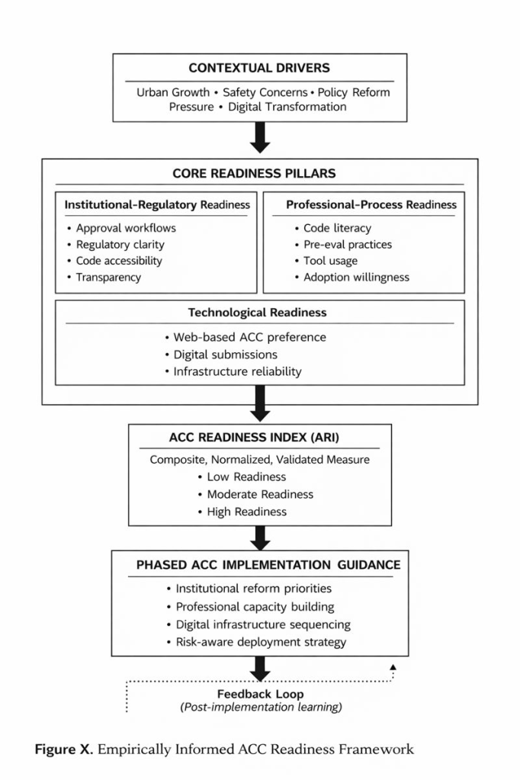

Fig 09: Institutional–Professional Readiness Framework for Automated Building Code Compliance (ACC)

This answers the question; Under what institutional, "professional, regulatory, and digital conditions can ACC realistically succeed in a developing-country context? This study does not implement an ACC system. Instead, it proposes a readiness framework that defines the necessary preconditions and sequencing requirements for future ACC implementation in Nigeria and similar developing-country contexts. The framework serves as a decision-support tool for policymakers, regulators, and system developers prior to technical deployment. An initial ACC Readiness Framework was conceptualized based on literature and study objectives and subsequently refined using empirical findings from the Enugu State case study. Figure 09 presents a conceptual readiness framework for Automated Building Code Compliance (ACC) adoption in developing-country contexts. The framework identifies five interrelated readiness dimensions—Institutional, Professional, Technological, Regulatory Content, and Process Readiness—shaped by external contextual drivers. Together, these dimensions inform an overall ACC readiness assessme nt, which provides structured guidance for phased and risk-aware implementation.
Our readiness framework above focuses on pre-adoption evaluation, identifying gaps in enablers such as code digitization (making regulations machine-readable), capacity development (training for professionals and regulators), interoperability standards (e.g., integrating BIM with code-checking tools), and regulatory integration (harmonizing policies for enforcement). It's essentially a diagnostic tool to measure maturity levels (e.g., via indices assessing digital literacy, infrastructure, and stakeholder buy-in) before committing resources to full rollout. It makes perfect sense because jumping straight into ACC without assessing readiness often leads to failures in developing contexts, such as incomplete digitization causing inaccurate checks, low user skills resulting in resistance, or mismatched standards leading to integration issues. For instance, in sub-Saharan Africa or Nigeria specifically, manual processes dominate (with delays and non-compliance rates over 50%), so a readiness framework helps prioritize fixes like BIM adoption or code formalization to ensure viability. This preventive approach draws from broader technology adoption models (e.g., Technology Readiness Levels or GRC automation frameworks), where "readiness" precedes "implementation" to mitigate risks like cost overruns or failed pilots.
6.0 ACC System Architecture and Rule-Checking Model
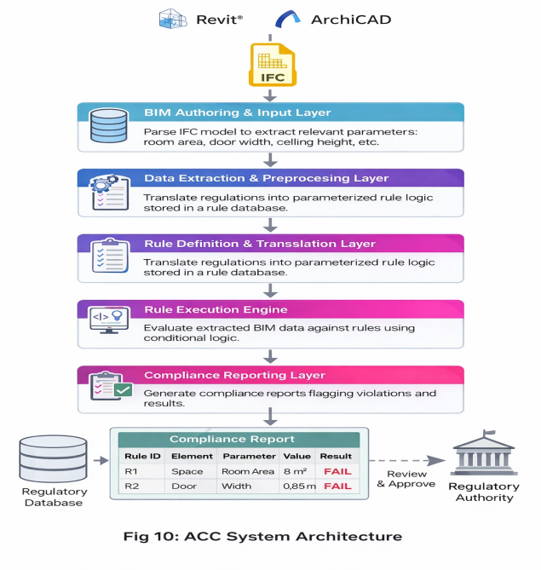
Based on the readiness assessment results, this study proposes a modular Automated Building Code Compliance (ACC) system architecture designed to align with the institutional and technological realities of developing contexts such as Nigeria. The architecture operationalizes regulatory provisions into machine-interpretable logic, enabling semi-automated compliance checking within digital design environments. The proposed system comprises five primary layers as shown in the pyramid diagram.

Design models developed by design professionals using BIM tools (e.g., Revit, ArchiCAD) are exported in interoperable formats such as IFC. This layer provides structured geometric and semantic building data. Relevant parameters (e.g., room area, door width, ceiling height, occupancy classification) are extracted from BIM objects. For instance, spatial attributes are retrieved from IfcSpace, while component dimensions are derived from entities such as IfcDoor and IfcWall. Regulatory provisions are translated into structured, machine-readable rules. This involves decomposing textual building codes into parameterized logical expressions that can be evaluated computationally. A rule execution engine processes extracted parameters against defined rules using conditional logic. The engine supports iterative evaluation across multiple building elements and rule sets. The last layer is the output and reporting layer. Evaluation results are aggregated and output as structured compliance reports, highlighting pass/fail status and identifying specific violations. This architecture establishes a traceable pipeline from design data to regulatory evaluation, enabling consistent, transparent, and scalable compliance assessment.
6.1 Rule Formalization Model
A critical component of the ACC system is the transformation of narrative regulatory text into formal rule logic. This study adopts a clause–parameter–condition mapping approach, where each regulatory provision is decomposed into clause, parameter and condition. To enable automated evaluation, regulatory requirements are expressed using a generalized rule structure. This abstraction allows diverse regulatory conditions to be represented in a unified computational format as shown in the rule statement below;
Ruleᵢ: IF P(x) ⊗ T → C - Algorithm 1

Where:
- P(x) = extracted parameter from BIM model
- ⊗ = relational operator (>, <, ≥, ≤, =)
- T = regulatory threshold
- C = compliance state (Compliant / Non-compliant)
6.2 Rule Set Definition
A representative subset of building code provisions is formalized as shown in table 17:
Rule ID | Element Type | Parameter | Rule Logic | Compliance Condition
R1 | Space (Room) | Area | IF Area ≥ 9 m² | Compliant
R2 | Door | Width | IF Width ≥ 0.9 m | Compliant
R3 | Space (Room) | Height | IF Height ≥ 2.7 m | Compliant
R4 | Window | Area Ratio | IF Window Area / Floor Area ≥ 0.1 | Compliant
Table 17: Rule Set Definition for ACC System prototype

These rules demonstrate how qualitative regulatory statements are transformed into quantifiable constraints. This structured approach enables the encoding of building regulations into machine-readable formats, which forms the basis for automated evaluation. A critical aspect of the system is the linkage between BIM data and rule parameters. This is achieved through explicit mapping between IFC entities and rule variables thus:
- IfcSpace.Area → Room_Area
- IfcDoor.OverallWidth → Door_Width
- IfcSpace.Height → Ceiling_Height
- IfcWindow.Area → Window_Area
This mapping ensures that rule evaluation operates directly on standardized BIM attributes, enabling interoperability and scalability across platforms. The rule-checking process follows a structured computational workflow.
6.2 Prototype Simulation and Workflow Demonstration
The end-to-end workflow of the proposed ACC system is illustrated as a sequential data pipeline below.
This workflow ensures traceability between design data and regulatory requirements, supporting transparent and consistent permit evaluation processes.
Fig 11: Prototype ACC System Simulation Workflow

6.3 Interoperability and Contextual Constraints
The effectiveness of the proposed system depends on interoperability between BIM platforms and regulatory databases. In the Nigerian context, several constraints such as lack of digitized building codes, inconsistent data standards and Limited institutional integration must be addressed. To mitigate these challenges, the architecture emphasizes the need for adoption of open standards (e.g., IFC), a progressive digitization of regulatory documents across states and development of centralized rule repositories easily accessible to the public through a website and API-based for system integrations. Unlike purely conceptual frameworks, the proposed architecture directly responds to the readiness gaps identified in the study. While current infrastructure limitations may hinder full implementation, the system provides a scalable pathway for transitioning from manual to semi-automated and eventually fully automated compliance systems.
  - Simulation and Workflow Demonstration
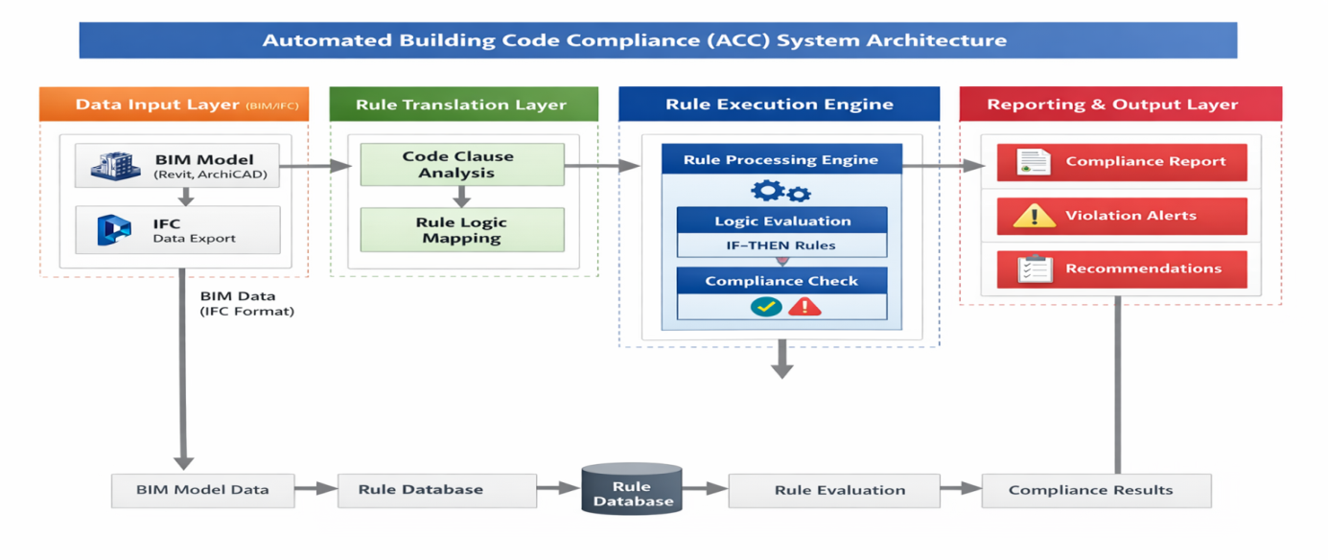
A prototype rule-execution simulation was implemented.to demonstrate the operational feasibility of the proposed ACC architecture. The objective is to illustrate how regulatory provisions can be translated into executable logic and applied to BIM-derived data for compliance checking. The simulation was implemented within a lightweight computational environment to emulate the core functionality of the ACC system. Extracted building parameters were structured as input datasets, while rule definitions were encoded as conditional logic statements. The prototype operates as a standalone rule-evaluation engine, independent of specific BIM software, but designed to be directly extensible to IFC-based model environments. With such abstraction controlled testing of rule execution logic without requiring full software integration was achieved. The prototype follows a deterministic evaluation pipeline as shown in the plate 01.
Plate 01: Simulation Workflow Demonstration
    - Input Dataset and Rule Encoding
A simplified dataset representing building elements was defined as follows:
Element | Parameter | Value
Room 1 | Room_Area | 8.0 m²
Door 1 | Door _width | 0.85 m
Room 1 | Room _height | 2.8m

Table 18: Simulation input dataset and rule encoding

Corresponding regulatory rules were encoded in machine-interpretable form thus;

- R1: IF Room_Area ≥ 9 → Compliant
- R2: IF Door_Width ≥ 0.9 → Compliant
- R3: IF Room_Height ≥ 2.7 → Compliant
6.5 Rule Execution and System Output
The prototype followed a simplified execution sequence as shown in plate 1, producing the following outputs across the input dataset.
Element | Parameter | Value | Rule | Status
Room 1 | Room_Area | 8.0 m² | R1 | Non-compliant
Door 1 | Door _width | 0.85 m | R2 | Non-compliant
Room 1 | Room _height | 2.8m | R3 | Compliant

Table 19: Simulation rule execution and system output

The evaluation process demonstrates that multiple rules can be executed sequentially, each element is assessed independently and violations are automatically detected and recorded with the underlying execution logic of the prototype as shown in algorithm 1 above. This confirmed that the system supports iterative, rule-based evaluation across multiple parameters, forming the computational backbone of the ACC framework.
6.6 Validation of System Feasibility and Limitations of the Prototype
The simulation confirms the feasibility of translating regulatory provisions into executable logic and applying them systematically to building data. Specifically, the prototype demonstrates:
- Successful transformation of textual regulations into parameterized rules
- Reliable execution of multiple compliance checks
- Structured generation of compliance outputs
Although implemented as a simplified prototype, the evaluation mechanism is directly scalable to BIM-integrated environments, where parameters can be automatically extracted from IFC-based models. This structured output enables both designers and regulatory authorities to quickly identify and resolve compliance issues prior to formal submission. The output generated includes compliance status (Pass/Fail), If Fail, identified violation and a reference to regulatory clause is made. The prototype confirms that regulatory provisions can be systematically translated into executable logic, BIM-derived parameters can support automated compliance checking and even simple rule encoding can significantly improve efficiency and consistency in permit evaluation. These findings reinforce the feasibility of ACC systems within the Nigerian context, provided that enabling conditions identified in the readiness assessment are addressed.
The simulation presented is intentionally simplified and subject to focus on selected conditions rules rather than a full regulatory dataset of Enugu State, Nigeria. Future work could extend this prototype practically to cover multi-rule evaluation and full BIM integration environments for real-world implementations both within planning authorities and for professionals pre-check before building plan submission.

7.0 Conclusion and Future Research Directions
An ACC implementation model is crucial as the next logical step after assessment of readiness. Our readiness frameworks is focused on "are we prepared?" (e.g., assessing enablers and gaps), while the implementation model addressed "how do we deploy it?" (e.g., phased rollouts, rule interpretation phases like rule-based checking, model preparation, execution, and reporting). In practice, the two are complementary, readiness identifies barriers (e.g., low semantic integration in developing countries), and implementation provides the operational blueprint. Skipping readiness could waste efforts on unfeasible deployments, especially in resource-constrained settings. The results establish that a rule-based ACC system can be operationalized using modular components, even within constrained computational environments. For developing contexts such as Nigeria, this approach provides a practical pathway for incremental adoption, beginning with standalone validation tools and evolving toward fully integrated digital permitting systems.
This study represents the first empirical evaluation of Automated Building Code Compliance (ACC) readiness in a sub-Saharan African context, focusing on Enugu State, Nigeria, as a representative case amid rapid urbanization and persistent regulatory inefficiencies. Through a mixed-methods approach involving surveys of 119 building professionals and comparative global analysis, the findings reveal a landscape of moderate readiness: manual processes dominate (80.6%), yielding protracted approvals (median 1–2 months) and widespread dissatisfaction (convenience mean 2.24), yet strong attitudinal support for ACC (means >3.70) and robust BIM tool adoption (e.g., Revit 54.6%) signal significant potential. Inferential insights, including correlations (e.g., dissatisfaction driving enthusiasm, ρ = -0.28), group associations (e.g., experience influencing preferences, χ² p < 0.05), and a composite readiness index (mean 56/100), underscore key drivers like NBC access and digital literacy. Qualitative themes (e.g., time-consuming challenges, accuracy priorities) triangulate these, highlighting uneven preparedness across segments.
The proposed ACC Readiness Framework tailored to Nigeria with enablers in code digitization, capacity development, interoperability standards, and regulatory integration offers a strategic pathway to modernization, potentially reducing delays by 40–60% based on global benchmarks (e.g., Singapore's CORENET). By addressing literature gaps in underrepresented regions, this work contributes actionable evidence for policymakers, development agencies, and practitioners, fostering sustainable, efficient building compliance aligned with Nigeria's National Building Code and broader environmental goals. Future studies should extend this research through longitudinal pilots of ACC prototypes in Enugu or similar Nigerian states, quantifying impacts on compliance accuracy, approval times, and non-compliance rates via pre/post interventions. Expanding the sample to include regulators and non-architect professionals could refine the readiness index, incorporating advanced metrics like machine learning for predictive modeling. Comparative analyses across African contexts (e.g., Kenya's e-permitting) would enhance generalizability, while exploring AI-driven enhancements (e.g., NLP for semantic code interpretation) could address ambiguities in local regulations. Finally, economic evaluations of ACC implementation costs versus benefits, including scalability to informal sectors, would inform policy adoption and funding strategies.
References
- Agapiou, A., & Yakubu, S. (2019). Determinants of non-compliance with structural building code standards in Nigeria. Proceedings of the ICE – Management, Procurement and Law, 172(2), 47–59.
- Akinradewo, O., & Ogunsemi, D. R. (2019). The Role of BIM in Enhancing Building Regulation Compliance in Nigeria. Journal of Construction in Developing Countries, 24(1).
- Asare, B., & Agyekum, K. (2022). Automation in Construction Regulation: Prospects and Challenges in Sub-Saharan Africa. International Journal of Sustainable Construction, 15(2).
- Aslam, B., & Umar, T. (2023). Automated code compliance checking through building information modelling. Proceedings of the Institution of Civil Engineers – Structures and Buildings. https://doi.org/10.1680/jstbu.22.00214
- Bilal Aslam, & Tariq Umar (2023). Automated code compliance checking through BIM. ICE Structures and Buildings, Online August 11 2023.
- Building and Construction Authority (BCA). (2022). CORENET X Programme Overview. Singapore.
- CRC for Construction Innovation. (2019). Digital Modelling for Building Approvals. Australia.
- Eastman, C. M., Jeong, Y.-S., Lee, J.-K., & Lee, J. M. (2009). Automatic rule-based checking of building designs. Automation in Construction, 18(8), 1011–1033. https://doi.org/10.1016/j.autcon.2009.07.002
- Eastman, C., et al. (2009). Automation in Construction, 18(8), 1011–1033. https://doi.org/10.1016/j.autcon.2009.07.002
- Fika, U. A. M. I., Abubakar, Y. M., Laminu, H., et al. (2024). National Building Code: Key to Sustainable Built Environment, the Challenges of Implementation and Enforcement (A Case Study of Yobe State, Nigeria). Fane-Fane International Multi Disciplinary Journal, 8(3).
- Kenya News. (2023). Approval of Buildings in Nakuru to Go Digital.
- Kenya News. Approval of Buildings in Nakuru to Go Digital. https://www.kenyanews.go.ke/approval-of-buildings-in-nakuru-to-go-digital/
- Kunz, A., Noardo, F., & Ellul, C. (2019). Journal of Digital Built Environment, 1(2), 45–59.
- Kunz, A., Noardo, F., & Ellul, C. (2019). Digital permitting transformation under Finland’s KIRA-digi programme. Journal of Digital Built Environment.
- Lee, J., & Lee, G. (2020). Journal of Building Engineering, 30, 101244. https://doi.org/10.1016/j.jobe.2020.101244
- Macharm, E. (2020). Transition towards energy efficiency: Developing the Nigerian Building Energy Efficiency Code. Academia.edu.
- Narayanaswamy, H., Liu, H., & Al-Hussein, M. (2019). BIM-based automated design checking for building permit in the light-frame building industry. Proceedings of the 36th ISARC, 1042–1049. https://doi.org/10.22260/ISARC2019/0139
- Nawari, N. O. (2012). Building information modeling in architecture, engineering, and construction: Emerging research directions and trends. Journal of Architectural Engineering, 18(4), 226–230. https://doi.org/10.1061/(ASCE)AE.1943-5568.0000079
- Noardo, F., Ellul, C., Harrie, L., et al. (2020). Tools for checking building permit compliance across Europe: A comparative study. ISPRS International Journal of Geo-Information, 9(7), 423. https://doi.org/10.3390/ijgi9070423
- Noardo, F., et al. (2020). ISPRS International Journal of Geo-Information, 9(7), 423. https://doi.org/10.3390/ijgi9070423
- Oladapo, A. A., & Oduyemi, A. I. (2022). Enhancing building code compliance in Nigeria: An evaluation of the regulatory framework and challenges. Journal of Building Performance, 13(3), 123–136. https://doi.org/10.3803/jbp.2022.13.3.123
- Oladokun, M. G., Adedeji, Y. M. D., & Oduwaye, L. (2020). Awareness and Adoption of Green Building Standards in Nigeria. Journal of Building Performance, 11(3).
- Opawole, A. O., Alao, O. O., Yusuf, A. O., Adu, E. T., & Ofoetan, M. A. (2022). Evaluation of compliance of concreting materials to standards in building projects in Lagos State, Nigeria. Journal of Construction Business and Management, 5(2), 1–19.
- Osuizugbo, I. C. (2019). An appraisal of building control and regulations practice in Nigeria: Project managers’ perspectives. Organization, Technology and Management in Construction: An International Journal, 11(1), 2022–2033.
- Oyedepo, S. O., et al. (2019). Energy Efficiency in Nigerian Building Sector: Challenges and Prospects. Energy Policy Journal, 5(1).
- Solihin, W., & Eastman, C. (2015). Classification of rules for automated BIM rule checking development. Automation in Construction, 53, 69–82. https://doi.org/10.1016/j.autcon.2015.03.003
- UN-Habitat. (2021). Digital Tools for Sustainable Building Codes. United Nations Human Settlements Programme.
- UpCodes AI, Solibri, Autodesk Model Checker. Integrative information.
- Wang, Z., et al. (2021). Journal of Urban Technology. https://doi.org/10.1080/10630732.2021.1905510
- Wang, Z., et al. (2021). Smart-city integration of planning and approval systems in China. Journal of Urban Technology.
- Yurchyshyna, A., & Zarli, A. (2009). Rule-based extraction from building regulations. Automation in Construction, 18(8), 1005–1017.
- Zhang, J., & Issa, R. (2015). IFC-based interoperability challenges for automated code checking. Journal of Computing in Civil Engineering, 29(5).
List of Tables
- Table 1 Overview of Global ACC Adoption Spread
- Table 2 Study Sample composition
- Table 3 Current Pre-evaluation method
- Table 4 Typical time to receive building permit
- Table 5 Convenience of Current Methods and Attitudes toward Automated Building Code
Compliance (ACC)
- Table 6 Digital Tools & ACC Feature Preferences
- Table 7 Cross-tabulation: Access Level by Professional Experience Level
- Table 8 Cross-tabulation: Access Level by Professional Experience Level
- Table 9 Professional Level × Preferred ACC Mode (Row %)
- Table 10 Building Typology × Pre-evaluation Method (Row %)
- Table 11 Convenience by Professional Level
- Table 12 Factor Loadings (>0.4 bolded)
- Table 13 Readiness Index Descriptives and Levels (n=119)
- Table 14 Regression Coefficients
- Table 15 Qualitative insights
- Table 16 Evidence Matrix (Joint Display)
- Table 17 Rule Set Definition for ACC System prototype
- Table 18 Simulation input dataset and rule encoding
- Table 19 Simulation rule execution and system output

List of Figures
- Fig 01 Typical workflow for building an automated compliance checking system
- Fig 02 Global ACC Adoption Spread. Authors Review
- Fig 03 Sample Distribution by professional experience and most attempted building typology
- Fig 04 Current Pre-evaluation methods
- Fig 05 Typical time to receive building permit
- Fig 06 Digital Tools Usage
- Fig 07 Typical time to receive building permit
- Fig 08 Cluster Radar Plot
- Fig 09 Institutional–Professional Readiness Framework for Automated Building Code Compliance
(ACC)
- Fig 10 Proposed ACC System Architecture
- Fig 11: Prototype ACC System Simulation Workflow
List of Algorithms
- Algorithm 1 – ACC prototype rule execution logic
List of Plates
- Plate 01: Simulation Workflow Demonstration

Author Contributions
- Conceptualization: Chukwujindu, K.E; Obiorah, C, N;
- Methodology: Obiorah, C, N;
- Data collection: All authors;
- Formal analysis: Chukwujindu, K.E;
- Investigation: Author(s); All authors;
- Writing—original draft preparation: Chukwujindu, K.E; Edidiong Ukpong; Obiorah, C, N;
—review and editing: Onuorah, I.M.; Obiorah, C, N
- Visualization: Chukwujindu, K.E; Obiorah, C, N
- Supervision: Okereke, I. O. Chukwujindu, K.E;
All authors have read and agreed to this submitted version of the manuscript in accordance with the co-authorship agreement.

Statements and Declarations
Ethical considerations
This study involved a voluntary questionnaire survey of professionals and did not involve vulnerable populations or sensitive personal data. In accordance with applicable institutional and national research ethics guidelines, formal ethical approval was not required.

Consent to participate
All participants provided informed consent prior to participation, and data were anonymized to ensure confidentiality.

Consent for publication
All participants involved in this study were informed about the purpose of the research and provided their consent to participate.

Declaration of conflicting interest
The authors declare that there are no financial, personal, or professional relationships that could be construed as a potential conflict of interest in relation to this study.

Funding statement
This research received no external funding.

Data Availability Statement
The data supporting the findings of this study are not publicly available due to confidentiality and ethical restrictions related to the protection of respondents’ privacy. Aggregated or anonymized data may be made available from the corresponding author upon reasonable request.

