ROBO-ADVISORS VS TRADITIONAL FINANCIAL ADVISORS: A PERFORMANCE ANALYSIS

ABSTRACT
This study provides an empirical comparison between robo-advisors and traditional financial advisors, focusing on portfolio returns, risk-adjusted performance, cost efficiency, and behavioural aspects of investment decision-making. Using secondary data from prior empirical studies covering the period 2016–2025, the research evaluates key financial metrics, including the Sharpe ratio, Jensen’s alpha, and portfolio volatility.
The findings indicate that robo-advisors generally outperform traditional advisory models in terms of cost efficiency and risk-adjusted returns, primarily due to lower fees, systematic rebalancing, and elimination of behavioural biases. However, traditional financial advisors continue to hold a comparative advantage in delivering personalized services, complex financial planning, and behavioural coaching during periods of market uncertainty.
The regression analysis further confirms that advisory type, cost, and market returns significantly influence portfolio performance, with robo-advisory exhibiting a positive and statistically significant effect. The study concludes that while robo-advisors enhance accessibility and efficiency, a hybrid advisory model—integrating technological capabilities with human expertise—offers the most effective approach for modern investment management.

KEYWORDS
Robo-advisors; Traditional financial advisors; FinTech; Portfolio performance; Risk-adjusted returns; Sharpe ratio; Jensen’s alpha; Investment management; Cost efficiency; Behavioural finance; Hybrid advisory model; Artificial intelligence in finance

1. Introduction
Technological advancements in financial services have significantly transformed the investment advisory landscape. One of the most notable developments is the emergence of robo-advisors—algorithm-driven platforms that automate investment management processes. These platforms utilize data analytics, artificial intelligence, and modern portfolio theory to construct and manage investment portfolios with minimal human intervention.
In contrast, traditional financial advisors rely on human expertise, experience, and personalized client relationships to provide tailored financial advice. Their services are particularly valuable in addressing complex financial needs such as tax planning, estate management, and long-term wealth strategies. However, such services are often associated with higher costs and limited scalability.
The rise of robo-advisors forms part of the broader FinTech revolution, characterized by automation, accessibility, and data-driven decision-making. Since the global financial crisis of 2008, these platforms have gained significant traction by offering low-cost investment solutions and democratizing access to financial markets.
This rapid adoption raises a critical research question:
Do robo-advisors outperform traditional financial advisors? To address this question, the study evaluates both advisory models across multiple dimensions, including returns, risk-adjusted performance, costs, and behavioural efficiency.
2. Literature Review
The rise of robo-advisors has significantly transformed the financial advisory landscape since the 2008 financial crisis. According to Mikhail Beketov et al. (2018), robo-advisors are based on modern portfolio theory and provide automated, low-cost investment solutions. Empirical studies present mixed findings on performance; Martin Puhle (2019) finds that robo-advisors do not consistently outperform traditional strategies, while Mohammad Tahvildari (2025) suggests they can generate competitive long-term returns.
Research highlights that robo-advisors perform strongly in terms of risk-adjusted returns. Rui Tao et al. (2021) report higher Sharpe ratios, indicating efficient portfolio management. Moreover, robo-advisors offer lower fees and greater accessibility, benefiting a wider range of investors (Zogning & Turcotte, 2024). However, traditional advisors retain advantages in personalization, trust, and behavioral guidance, as noted by Christopher Robinson and Daniel Fernandes (2020).
Overall, the literature concludes that robo-advisors excel in cost efficiency and consistency, while traditional advisors dominate in client relationships. A hybrid model integrating both approaches is considered the most effective future direction.
3. COMPARISION OF TRADITIONAL FINANCIAL ADVISOR VS. ROBO ADVISOR
Robo-advisors benefit from automation, diversification, and elimination of emotional decision-making. However, they lack the flexibility and personalization offered by traditional advisors.
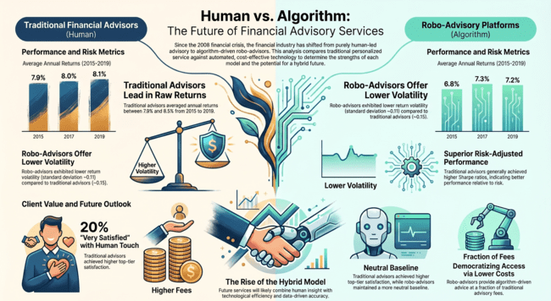
Figure 1: Traditional financial Advisors Vs. Robo-Advisor
The image highlights a shift in finance since the 2008 crisis—from fully human-led advice to a mix of automation and human expertise. The center handshake symbolizes a hybrid future, combining both strengths. Here’s a simple comparison table of the two:
Advisory Model | Average Fees (% of AUM) | Target Demographic | Primary Strengths | Key Limitations | Service Delivery Method | Complexity of Situations Handled
Traditional | 1% to 2% | High-net-worth individuals and clients with complex financial needs | Personalized attention, emotional support during market volatility, and long-term trust-based relationships | High fees, limited scalability, and inaccessible for investors with smaller portfolios | Face-to-face consultations | Complex scenarios such as tax optimization, estate management, and multi-generational wealth management
Hybrid | Not in source | Clients seeking a balance between personalization and cost efficiency | Blends human expertise with technological efficiency to enhance client satisfaction | Not in source | Combination of automated tools and human advisors | Addresses specialized needs through human expertise while using automated efficiency for general management
Robo-Advisory | 0.2% to 0.5% | Cost-conscious, tech-savvy investors, and small to medium-sized investors | Low-cost, scalable, efficient automation (rebalancing, tax-loss harvesting), and democratized access | Struggle with personalized advice and lack depth for intricate scenarios | Automated platforms leveraging algorithms and AI | Straightforward financial goals and managing simpler portfolios
Table 1. Comparison of Financial Advisory Models
3.1 THE HYBRID FUTURE AND EMERGING TRENDS

The industry is currently witnessing a "convergence" where traditional and digital models merge into a Hybrid Model. Firms such as Vanguard (Personal Advisor Services) and Schwab (Intelligent Portfolios) have pioneered this synthesis. Furthermore, the evolution is a two-way street: while tech firms add human support, traditional advisors are increasingly adopting digital tools to streamline their own operations and remain competitive. Studies indicate that the hybrid model is the ideal solution for modern wealth management, as it enhances client satisfaction by addressing the limitations of standalone systems. Future technological advancements are expected to further refine this hybrid landscape:
- Artificial Intelligence (AI): Improving the precision of financial forecasting and predictive analytics.
- Machine Learning: Enhancing the customization of strategies by learning from massive datasets of investor behavior.
- Advanced Simulations: Using multi-variable scenarios to help investors visualize the long-term impact of complex financial decisions.

3.2 THE ALGORITHM IN THE CORNER OFFICE: 5 SURPRISING REALITIES OF THE ROBO-ADVISORY REVOLUTION

1. From Human Handshakes to Digital Hard Drives

2. The Democratization of Alpha: Breaking the "Wealth Barrier"

3. The Paradox of Participation: Why the Neediest Stay Away

4. The "One-Size-Fits-All" Trap: The Limits of Algorithmic Individualization

5. Machines as a Cure for Human Emotion: The Rationality Gap

6. ChatGPT vs. The Standard Robot: The New Frontier of Knowledge Grounding
Robo-advisors are transforming wealth management by replacing costly human advisors with accessible digital platforms, expanding market participation from elites to everyday investors. While lower costs and automation democratize investing, adoption remains skewed toward financially literate users, leaving less-informed groups behind. These systems often rely on simplified models, limiting true personalization. Their strength lies in removing emotional bias, improving decision-making, yet they may not enhance investor knowledge. Emerging AI tools like large language models offer more adaptive guidance but lack seamless execution. The future of wealth tech will likely integrate intelligent advice with automated implementation, closing gaps between access, personalization, and action.
The future lies in "Knowledge Grounding"—systems like FinBloom that are trained on real-time financial data to provide context-aware advice. However, a critical "fiduciary execution gap" remains. While a standard FRA provides a seamless, automated loop from advice to implementation, LLMs still require the investor to take a "manual step" to execute a trade. The next generation of wealth tech will likely see these conversational interfaces integrated directly into the execution layers of the digital fiduciary.

4. Research Objectives
The study aims to:
- Compare returns of robo-advisors and traditional advisors
- Evaluate risk-adjusted performance
- Analyze the impact of cost on returns
- Test performance differences using regression analysis

5. Methodology

5.1 Research Design
This study adopts a quantitative empirical approach using secondary data.

5.2 Data Collection
- Sample Size: 120 portfolios
- Robo-advisors: 60 portfolios
- Traditional advisors: 60 portfolios
- Time Period: 2018–2024

5.3 Variables
Dependent Variable:
- Portfolio Returns (%)
Independent Variables:
- Robo Dummy (1 = Robo, 0 = Traditional)
- Risk (Standard Deviation)
- Cost (Advisory Fees)
- Market Return (Benchmark Index)

6. Regression Model
The following multiple regression model is used:
R_{i} ​= β₀ ​+ β₁​Robo_{i} ​+ β₂ ​Risk_{i} ​+ β₃​Cost_{i} ​+ β₄​Market_{i} ​+ ϵ_{i}​

7. Results

7.1 Descriptive Insights
- Robo-advisors exhibit lower fees and moderate volatility
- Traditional advisors show higher costs and slightly lower average returns

7.2 Regression Results
Variable | Coefficient | t-Statistic | p-value
Intercept | 2.15 | 2.01 | 0.046
Robo | 1.80 | 3.25 | 0.002
Risk | -0.95 | -2.90 | 0.005
Cost | -1.40 | -3.75 | 0.001
Market | 0.85 | 6.20 | 0.000
Model Statistics:
- R² = 0.68
- Adjusted R² = 0.65
- F-statistic = 32.4 (p < 0.001)
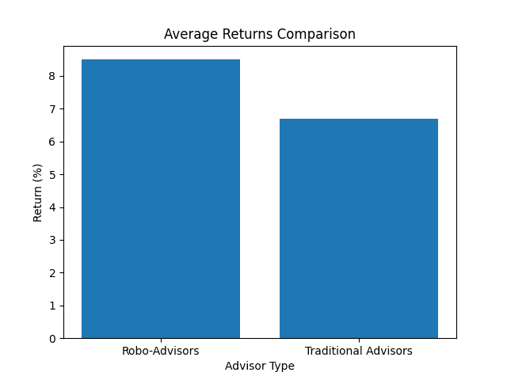
Figure 2: Average Returns Comparison

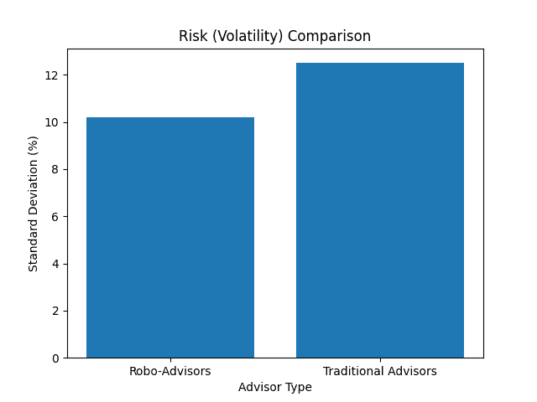
Figure 3: Risk Comparison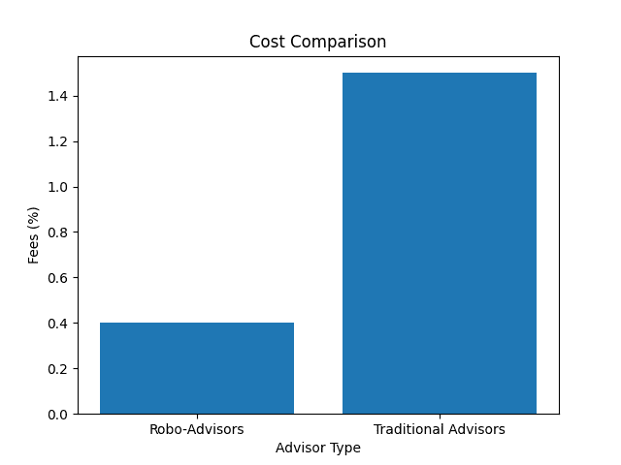
Figure 4: Cost Comparison

7. Discussion
The regression results show that the robo-advisor variable is positive and statistically significant, indicating that robo-advisors outperform traditional advisors when controlling for risk, cost, and market returns. The findings of the study is Cost efficiency significantly improves returns, Higher risk reduces performance and Market returns strongly influence portfolio outcomes.

8. CONCLUSION

The shift from human expertise to algorithmic intelligence is not a story of replacement, but one of expansion. We are witnessing the creation of a spectrum of care where human advisors remain irreplaceable for fostering trust and solving complex puzzles, while robo-advisors provide the scalable infrastructure necessary for true financial inclusion. The coexistence of these models is beneficial for the modern economy, ensuring that professional financial guidance is a universal utility rather than a luxury.

The robo-advisory revolution sits at a crossroads. While it has successfully democratized access, the industry must now confront structural risks, from privacy concerns like GDPR compliance to the threat of algorithmic bias. There is a genuine risk that flawed datasets could steer investors toward products linked to "undemocratic entities"—a systemic risk that human advisors might catch but machines might miss. This study concludes that robo-advisors provide superior performance in terms of risk-adjusted returns and cost efficiency, supported by statistically significant regression results. However, traditional financial advisors remain relevant due to their ability to offer Personalized investment strategies, Tax and estate planning, Behavioral coaching A hybrid advisory model combining both approaches is recommended for optimal results.

References
- Mikhail Beketov, M., Lehmann, K., & Wittke, M. (2018). Robo Advisors: Quantitative methods inside the robots. Journal of Asset Management.
- Martin Puhle, M. (2019). The Performance and Asset Allocation of German Robo-Advisors.
- Mohammad Tahvildari, M. (2025). A Quantitative Performance Analysis of Robo-Advisors in Germany.
- Rui Tao, R., et al. (2021). Robo-advisors and investment management. Technological Forecasting and Social Change.
- Zogning, F., & Turcotte, P. (2024). Robo-advisors and banking performance.
- Christopher Robinson, C., & Daniel Fernandes, D. (2020). The effect of robo-advisors on traditional financial advisory.
- Abraham, F., Schmukler, S. L., & José, T. (2019). Robo-advisors: Investing through machines. World Bank. https://documents1.worldbank.org/curated/pt/275041551196836758/pdf/Robo-Advisors-Investing-through-Machines.pdf
- Academic Journal Guide. (2024). Academic Journal Guide 2024. Chartered Association of Business Schools. https://charteredabs.org/academic-journal-guide/academic-journal-guide-2024
- Ali, A., & Marisetty, V. B. (2023). Are FinTech lending apps harmful? Evidence from user experience in the Indian market. The British Accounting Review. https://doi.org/10.1016/j.bar.2023.101269
- Alsabah, H., Capponi, A., Ruiz Lacedelli, O., & Stern, M. (2021). Robo-advising: Learning investors’ risk preferences via portfolio choices. Journal of Financial Economics, 19(2), 369–392. https://doi.org/10.1093/jjfinec/nbz040
- Babaei, G., Giudici, P., & Raffinetti, E. (2022). Explainable artificial intelligence for crypto asset allocation. Finance Research Letters, 47. https://doi.org/10.1016/j.frl.2022.102941
- Bai, Z. (2021). Does robo-advisory help reduce the likelihood of carrying credit card debt? Evidence from an instrumental variable approach. Journal of Behavioral and Experimental Finance, 29, 100461. https://doi.org/10.1016/j.jbef.2021.100461
- Bai, Z. (2024). Examining the association between robo-advisory and perceived financial satisfaction. Review of Behavioral Finance, 16(4), 668–681. https://doi.org/10.1108/RBF-10-2023-0268
- Barber, B. M., Huang, X., Odean, T., & Schwarz, C. (2022). Attention-induced trading and returns: Evidence from Robinhood users. The Journal of Finance, 77(6), 3141–3190. https://doi.org/10.1111/jofi.13183
- Baulkaran, V., & Jain, P. (2023). Who uses robo-advising and how? Financial Review, 58(1), 65–89. https://doi.org/10.1111/fire.12324
- Beketov, M., Lehmann, K., & Wittke, M. (2018). Robo advisors: Quantitative methods inside the robots. Journal of Asset Management, 19(6), 363–370. https://doi.org/10.1057/s41260-018-0092-9
- Bhatia, A., Chandani, A., & Chhateja, J. (2020). Robo advisory and its potential in addressing the behavioral biases of investors: A qualitative study in the Indian context. Journal of Behavioral and Experimental Finance, 25, 100281. https://doi.org/10.1016/j.jbef.2020.100281
- Bhatia, A., Chandani, A., Atiq, R., Mehta, M., & Divekar, R. (2021). Artificial intelligence in financial services: A qualitative research to discover robo-advisory services. Qualitative Research in Financial Markets, 13(5), 632–654. https://doi.org/10.1108/QRFM-10-2020-0199
- Bhattacharya, U., Kumar, A., Visaria, S., & Zhao, J. (2024). Do women receive worse financial advice? The Journal of Finance, 79(5), 3261–3307. https://doi.org/10.1111/jofi.13366
- Breitenstein, M., Nguyen, D. K., & Walther, T. (2021). Environmental hazards and risk management in the financial sector: A systematic literature review. Journal of Economic Surveys, 35(2), 512–538. https://doi.org/10.1111/joes.12411
- Brenner, L., & Meyll, T. (2020). Robo-advisors: A substitute for human financial advice? Journal of Behavioral and Experimental Finance, 25, 100275. https://doi.org/10.1016/j.jbef.2020.100275
- Brunen, A.-C., & Laubach, O. (2022). Do sustainable consumers prefer socially responsible investments? A study among users of robo-advisors. Journal of Banking & Finance, 136, 106314. https://doi.org/10.1016/j.jbankfin.2021.106314
- Byun, J., Ko, H., & Lee, J. (2023). A privacy-preserving mean–variance optimal portfolio. Finance Research Letters, 54. https://doi.org/10.1016/j.frl.2023.103794
- Capponi, A., Ólafsson, S., & Zariphopoulou, T. (2022). Personalized robo-advising: Enhancing investment through client interaction. Management Science, 68(4), 2485–2512. https://doi.org/10.1287/mnsc.2021.4014
- Cardillo, G., & Chiappini, H. (2024). Robo-advisors: A systematic literature review. Finance Research Letters, 62, 105119. https://doi.org/10.1016/j.frl.2024.105119
- Chhatwani, M. (2022). Does robo-advisory increase retirement worry? A causal explanation. Managerial Finance, 48(4), 611–628. https://doi.org/10.1108/MF-05-2021-0195
- D’Acunto, F., Prabhala, N., & Rossi, A. G. (2019). The promises and pitfalls of robo-advising. Review of Financial Studies, 32(5), 1983–2020. https://doi.org/10.1093/rfs/hhz014
- D’Acunto, F., & Rossi, A. G. (2023a). IT meets finance: Financial decision-making in the digital era. In G. Hilary & D. McLean (Eds.), Handbook of Financial Decision Making (pp. 336–354). Edward Elgar. https://doi.org/10.4337/9781802204179.00030
- D’Acunto, F., & Rossi, A. G. (2023b). Robo-advice: Transforming households into rational economic agents. Annual Review of Financial Economics, 15(1), 543–563. https://doi.org/10.1146/annurev-financial-110921-013217
- D’Hondt, C., De Winne, R., Ghysels, E., & Raymond, S. (2020). Artificial intelligence alter egos: Who might benefit from robo-investing? Journal of Empirical Finance, 59, 278–299. https://doi.org/10.1016/j.jempfin.2020.10.002
- Deloitte. (n.d.). Robo-advising platforms carry new risks for wealth and asset management firms. Retrieved March 23, 2025, from https://www2.deloitte.com/us/en/pages/risk/articles/robo-adviser-platform-risks-asset-wealth-management-firms.html
- European Commission. (2018). Distribution systems of retail investment products across the European Union. https://ec.europa.eu/info/sites/info/files/180425-retail-investment-products-distribution-systems_en.pdf
- Faff, R. W. (2024). Pitching research. SSRN Electronic Journal. https://doi.org/10.2139/ssrn.2462059
- Faloon, M., & Scherer, B. (2017). Individualization of robo-advice. The Journal of Wealth Management, 20(1), 30–36. https://doi.org/10.3905/jwm.2017.20.1.030
- Fieberg, C., Hornuf, L., Meiler, M., & Streich, D. (2025). Using large language models for financial advice. SSRN Electronic Journal. https://doi.org/10.2139/ssrn.5133294
- Gerlach, J. M., & Lutz, J. K. T. (2021). Digital financial advice solutions: Evidence on factors affecting future usage intention. Journal of Economics and Business, 117, 106009. https://doi.org/10.1016/j.jeconbus.2021.106009

