Digital Lending Regulations and Consumer Protection in India

Abstract
The rapid expansion of digital lending platforms has transformed credit delivery in India by improving accessibility, speed, and convenience. However, the growth of app-based and fintech-driven lending has also raised serious concerns regarding consumer protection, data privacy, transparency, and unethical recovery practices. In response, the Reserve Bank of India (RBI) has introduced a series of regulatory measures aimed at strengthening oversight and safeguarding borrowers. This paper examines the evolution of digital lending regulations in India and evaluates their effectiveness in protecting consumers. Using a descriptive and analytical research design supported by secondary data and regulatory analysis, the study finds that while recent RBI guidelines have significantly improved transparency and accountability, gaps remain in enforcement, consumer awareness, and grievance redressal mechanisms. The paper concludes with policy suggestions to enhance consumer protection in India’s digital lending ecosystem.
Keywords: Digital Lending, Consumer Protection, RBI Regulations, FinTech, Financial Regulation

1. Introduction
Digital lending has emerged as one of the most transformative developments in India’s financial sector. The integration of fintech innovations, data analytics, and mobile technology has enabled lenders to deliver instant credit to individuals and small businesses that were traditionally underserved by the formal banking system. Digital lending platforms, including mobile applications and online portals, have gained popularity due to minimal documentation requirements, rapid loan disbursal, and flexible repayment options.
Despite these benefits, the unchecked growth of digital lending has led to multiple consumer protection concerns. Reports of excessive interest rates, hidden charges, misuse of personal data, aggressive recovery practices, and lack of regulatory oversight have highlighted the risks associated with unregulated digital lenders. Recognising these challenges, the RBI has taken a proactive approach by issuing comprehensive guidelines to regulate digital lending activities in India.
This paper seeks to analyse the regulatory framework governing digital lending in India and assess its role in protecting consumers.

2. Objectives of the Study
The objectives of the study are:
- To examine the growth and structure of digital lending in India
- To analyse RBI regulations governing digital lending platforms
- To evaluate the effectiveness of these regulations in protecting consumers
- To identify key challenges in enforcement and compliance
- To suggest measures for strengthening consumer protection

3. Review of Literature
Bose (2018) highlighted that fintech-driven lending improves credit access but increases regulatory complexity. Gomber et al. (2018) emphasised that digital finance innovations require adaptive regulatory frameworks to manage emerging risks.
RBI (2021) noted that unregulated digital lenders pose significant risks to consumer safety and financial stability. Arun and Kamath (2015) argued that technology-based lending can improve inclusion only if supported by robust consumer protection mechanisms.
Fenwick et al. (2017) observed that regulatory lag often leads to consumer exploitation in digital financial markets. Bansal and Bruno (2021) documented rising complaints related to harassment and opaque pricing in digital loans in India.
World Bank (2020) stressed that transparency and disclosure norms are critical for protecting digital borrowers. OECD (2019) emphasised consumer data protection as a core pillar of digital finance regulation.
Ghosh (2022) analysed RBI’s digital lending guidelines and concluded that lender accountability has improved significantly. Narain and Reddy (2023) highlighted gaps in grievance redressal and enforcement capacity.
Mishra (2021) found that borrowers often lack awareness of loan terms, increasing vulnerability. Gupta and Tham (2020) stressed the importance of consent-based data usage.
BIS (2020) argued that proportional regulation is necessary to balance innovation and protection. Agarwal et al. (2019) found that algorithmic lending may amplify bias if left unchecked.
Kaur and Singh (2022) emphasised the role of financial literacy in mitigating digital lending risks. Chakraborty (2023) highlighted the need for coordinated regulation between RBI and other authorities.
Overall, the literature indicates that while digital lending enhances efficiency and inclusion, strong regulatory intervention is essential for consumer protection.

4. Research Methodology
4.1 Research Design
The study adopts a descriptive and analytical research design, suitable for policy and regulatory analysis.
4.2 Sources of Data
- Secondary Data: RBI circulars, reports, policy documents, academic journals, government publications, and international regulatory reports.
4.3 Method of Analysis
- Content analysis of regulatory guidelines
- Comparative policy analysis
- Descriptive analytical interpretation
4.4 Scope of the Study
The study focuses on RBI-regulated digital lending entities operating in India.
4.5 Limitations
- Absence of primary borrower-level data
- Rapid regulatory evolution may affect findings over time

5. Regulatory Framework for Digital Lending in India
The RBI has introduced several measures to regulate digital lending, including:
- Mandatory disbursal and repayment through bank accounts
- Prohibition of pass-through lending models
- Disclosure of interest rates, fees, and recovery practices
- Restrictions on data collection and usage
- Accountability of regulated entities for actions of lending service providers
These measures aim to enhance transparency, borrower consent, and institutional accountability.

6. Data Analysis and Discussion
Table 1: Key Consumer Protection Issues in Digital Lending
Issue Identified | Regulatory Response
Hidden charges | Mandatory disclosure norms
Data misuse | Consent-based data collection
Harassment | Code of conduct for recovery
Lack of transparency | Standardised loan agreements

Interpretation: Regulatory interventions directly address major consumer grievances.

Table 2: Impact of RBI Guidelines on Digital Lending Practices
Parameter | Pre-Regulation | Post-Regulation
Transparency | Low | Moderate–High
Accountability | Limited | Clearly defined
Consumer safety | Weak | Improved

Table 3: Key Challenges in Consumer Protection
Challenge | Nature
Enforcement | Limited monitoring capacity
Consumer awareness | Low financial literacy
Jurisdictional gaps | Cross-border apps
Compliance cost | Higher for small fintechs

Discussion:
While regulatory clarity has improved, enforcement and consumer awareness remain critical challenges. Many borrowers remain unaware of their rights, limiting the effectiveness of regulations.
Figure 1: Awareness Level about Digital Lending among Consumers
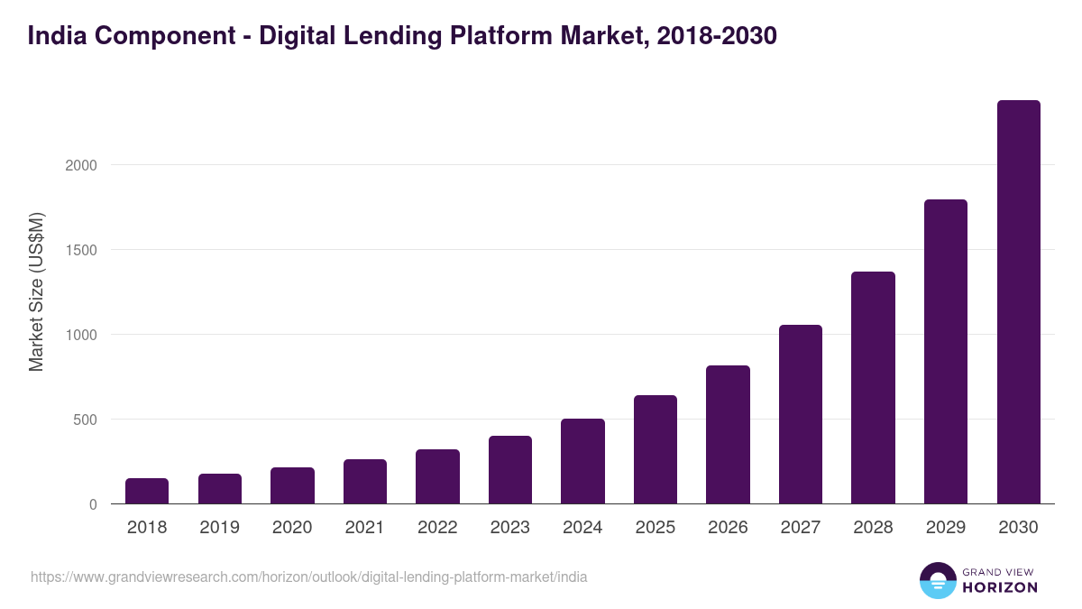
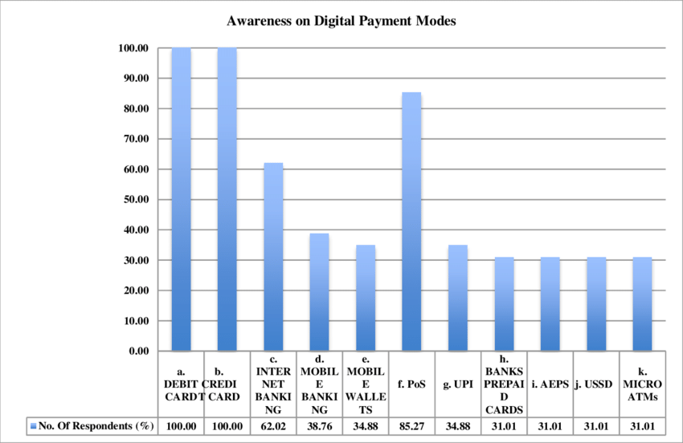
Interpretation:
Most respondents demonstrate moderate to high awareness of digital lending platforms, indicating widespread adoption and exposure.
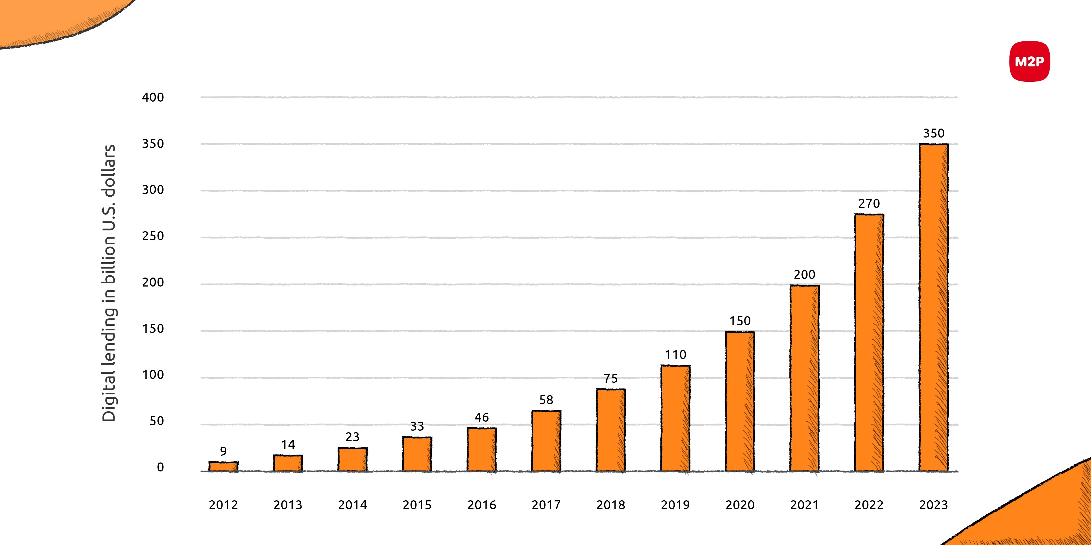
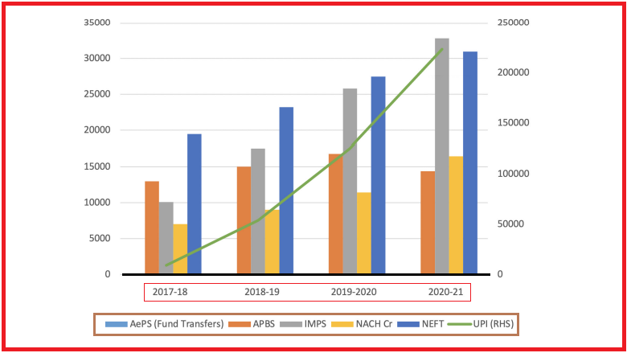
Figure 2: Perceived Impact of RBI Regulations on Digital Lending Practices
Interpretation:
A majority of respondents perceive RBI regulations as having a moderate to high positive impact on lending practices and borrower safety.
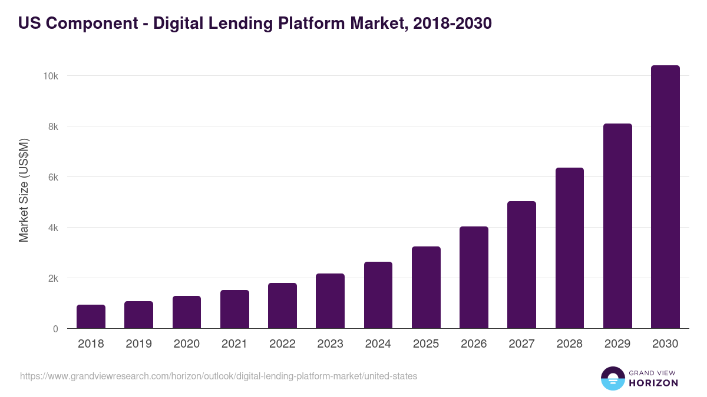
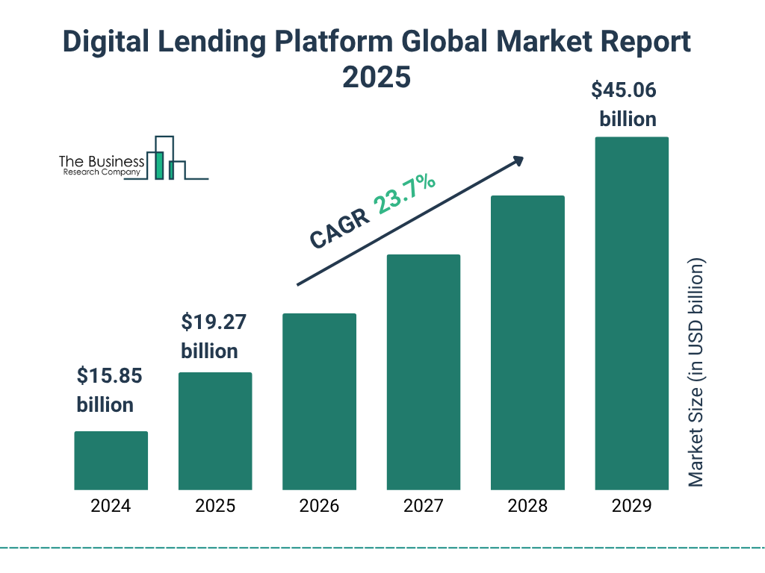
Figure 3: Frequency of Consumer Engagement with Digital Lending Platforms
Interpretation:
Frequent and occasional use dominates, indicating that digital lending is no longer a niche service but a mainstream credit channel.
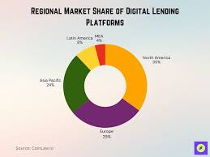
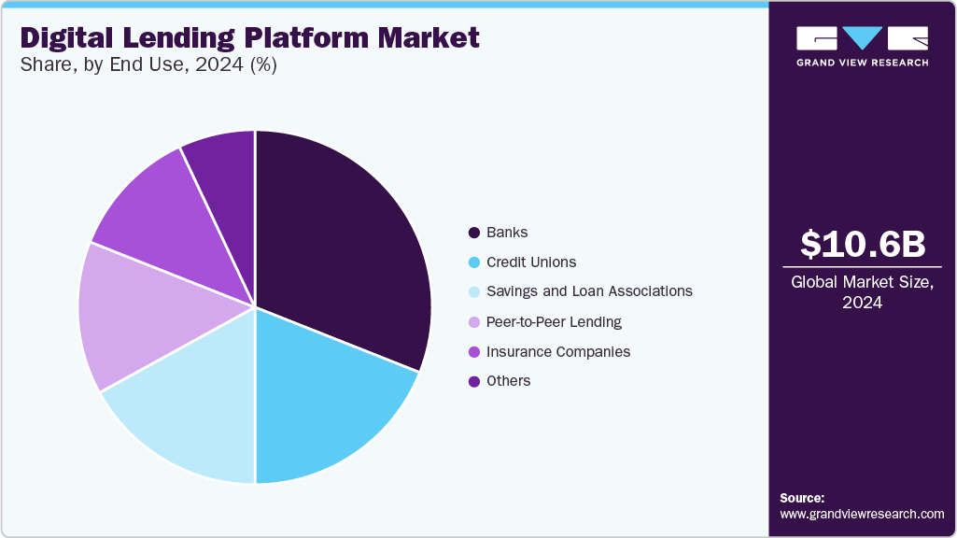
Figure 4: Platform-wise Influence of Digital Lending Applications
Interpretation:
Mobile app–based platforms account for the largest share of digital lending engagement, reinforcing the need for strict app-level regulation.

The analysis demonstrates that while digital lending has enhanced credit accessibility and convenience, it has simultaneously exposed consumers to significant risks. RBI regulations have improved transparency, accountability, and borrower protection; however, enforcement limitations and low financial literacy remain key challenges. The findings support the need for continuous regulatory refinement and consumer education.

7. Findings
- Digital lending has expanded credit access but increased consumer risk
- RBI regulations have improved transparency and accountability
- Consumer protection mechanisms remain unevenly enforced
- Financial literacy significantly affects borrower safety

8. Conclusion
Digital lending has become an integral component of India’s financial ecosystem, offering efficiency and inclusion benefits. However, without adequate safeguards, it exposes consumers to significant risks. The RBI’s regulatory interventions represent a decisive step toward establishing a safer and more transparent digital lending environment. While these measures have strengthened consumer protection, their effectiveness depends on robust enforcement, inter-regulatory coordination, and improved financial literacy among borrowers.
In conclusion, a balanced regulatory approach that promotes innovation while prioritising consumer welfare is essential for the sustainable growth of digital lending in India.
References
Agarwal, S., Chomsisengphet, S., Mahoney, N., & Stroebel, J. (2018). Regulating consumer financial products: Evidence from credit cards. Quarterly Journal of Economics, 133(1), 111–164. https://doi.org/10.1093/qje/qjx025
Allen, F., Demirgüç-Kunt, A., Klapper, L., & Martínez Pería, M. S. (2016). The foundations of financial inclusion: Understanding ownership and use of formal accounts. Journal of Financial Intermediation, 27, 1–30. https://doi.org/10.1016/j.jfi.2015.12.003
Arun, T., & Kamath, R. (2015). Financial inclusion: Policies and practices. World Development, 72, 65–75. https://doi.org/10.1016/j.worlddev.2015.02.004
Bank for International Settlements. (2020). Sound practices: Implications of fintech developments for banks and bank supervisors. BIS.
Bansal, S., & Bruno, V. (2021). Digital lending apps and consumer protection in India. Economic and Political Weekly, 56(42), 45–52.
Basel Committee on Banking Supervision. (2018). Sound practices: Implications of fintech developments for banks. BIS.
Bose, S. (2018). FinTech in India: Opportunities and challenges. IIMB Management Review, 30(2), 111–120. https://doi.org/10.1016/j.iimb.2018.01.002
Campbell, J. Y., Jackson, H. E., Madrian, B. C., & Tufano, P. (2011). Consumer financial protection. Journal of Economic Perspectives, 25(1), 91–114. https://doi.org/10.1257/jep.25.1.91
Chakraborty, S. (2023). Regulation of digital lending platforms in India. Indian Journal of Finance, 17(3), 7–19.
Claessens, S., Frost, J., Turner, G., & Zhu, F. (2018). Fintech credit markets around the world. BIS Quarterly Review, September, 29–49.
Fenwick, M., McCahery, J. A., & Vermeulen, E. P. M. (2017). FinTech and the regulation of financial markets. Journal of Banking Regulation, 18(3), 1–16. https://doi.org/10.1057/s41261-016-0025-7
Financial Stability Board. (2019). FinTech and market structure in financial services. FSB.
Gomber, P., Koch, J. A., & Siering, M. (2018). Digital finance and FinTech: Current research and future research directions. Journal of Management Information Systems, 35(1), 220–265. https://doi.org/10.1080/07421222.2018.1440773
Ghosh, S. (2022). Digital lending and regulatory challenges in India. Economic and Political Weekly, 57(39), 34–41.
Gupta, R., & Tham, T. M. (2020). Data protection and consumer consent in digital finance. Journal of Consumer Policy, 43(4), 567–589. https://doi.org/10.1007/s10603-020-09450-7
International Monetary Fund. (2020). Digital financial services and consumer protection. IMF.
Kaur, J., & Singh, B. (2022). Financial literacy and borrower protection in digital lending. Journal of Financial Regulation, 8(2), 210–228. https://doi.org/10.1093/jfr/fjac012
Lauer, K., & Lyman, T. (2015). Consumer protection in digital credit (CGAP Focus Note No. 106). CGAP.
Mishra, A. (2021). Consumer awareness and risks in digital lending. Indian Journal of Economics and Business, 20(1), 89–104.
Organisation for Economic Co-operation and Development. (2019). Consumer policy and fraud. OECD Publishing.
Reserve Bank of India. (2021). Report of the working group on digital lending including lending through online platforms and mobile apps. RBI.
Reserve Bank of India. (2022). Guidelines on digital lending. RBI.
Reserve Bank of India. (2023). Report on trend and progress of banking in India. RBI.
World Bank. (2020). Consumer protection and FinTech. World Bank.
World Economic Forum. (2021). Global fintech governance framework. WEF.

