Design and Simulation of a Supercapacitor-Battery Hybrid Energy Storage System for Electric Vehicles

Abstract—Modern electric vehicles (EVs) demand intelligent and efficient energy management systems to balance performance, longevity, and energy efficiency. This paper presents the design and MATLAB/Simulink-based simulation of a Supercapacitor-Battery Hybrid Energy Storage System (HESS) integrated with a Fuzzy Logic-based Energy Management System (Fuzzy EMS). The hybrid system combines the high energy density of a lithium-ion battery with the high-power density of a supercapacitor, allowing the system to address both sustained energy needs and rapid transient power demands. The Fuzzy EMS evaluates real-time parameters including battery State of Charge (SOC), supercapacitor voltage, and instantaneous load power to compute the optimal power split ratio between the two sources. Simulation results demonstrate a 37% reduction in battery peak current, a 62% decrease in SOC fluctuations, and a 7% improvement in overall energy efficiency compared to an uncontrolled baseline system. The proposed approach offers a practical, computationally efficient, and real-time implementable solution for next-generation EV energy management.
Keywords—Hybrid Energy Storage System (HESS); Fuzzy Logic Controller; Energy Management System (EMS); Supercapacitor; Lithium-ion Battery; Electric Vehicle; State of Charge (SOC); DC-DC Converter; MATLAB/Simulink.

I. INTRODUCTION
The global shift toward electrified transportation has created an urgent demand for efficient, reliable, and long-lasting onboard energy systems. Electric vehicles (EVs) are unique in that they require two seemingly contradictory properties from a single energy source: high energy density for extended driving range and high-power density for dynamic performance during acceleration and regenerative braking. No single energy storage technology currently satisfies both requirements without compromise.

Lithium-ion batteries, while offering excellent energy density, degrade rapidly when subjected to repeated high-current transients. The stress induced during aggressive acceleration and sudden braking cycles causes accelerated capacity fade, increased heat generation, and a shortened operational lifespan. This is a critical bottleneck in the widespread adoption of EVs.

Hybrid Energy Storage Systems (HESS) have emerged as a well-regarded solution to this problem. By combining a battery with a supercapacitor, the HESS can leverage the complementary strengths of each component. The battery handles steady-state energy delivery, while the supercapacitor absorbs and supplies transient power peaks. The result is a system that prolongs battery life, improves efficiency, and delivers smoother dynamic performance.

However, the true potential of a HESS is only unlocked through intelligent power management. A conventional rule-based Energy Management System (EMS), while simple to implement, lacks the adaptability to handle the continuously varying load conditions encountered during real-world driving. This motivates the use of Fuzzy Logic Control, which mimics human reasoning to provide smooth, adaptive power sharing without requiring a precise mathematical model of the system.

This paper proposes and validates through MATLAB/Simulink simulation a Fuzzy Logic-based EMS integrated with a battery-supercapacitor HESS. The system is designed to minimize battery stress, maximize energy efficiency, and maintain DC bus voltage stability under variable load profiles that replicate real EV driving conditions.

II. LITERATURE REVIEW
Research in hybrid energy storage for EVs has grown substantially over the last decade. Singla et al. [1] demonstrated that integrating a supercapacitor with a battery and a coordinating EMS in a MATLAB/Simulink environment significantly reduced current stress and improved SOC balance compared to standalone storage solutions. Their work validated the foundational concept that hybrid storage outperforms single-source systems in dynamic EV scenarios.

Togun et al. [2] conducted a broad review of advanced control strategies for fuel-cell hybrid EVs, identifying fuzzy logic and Model Predictive Control (MPC) as the leading techniques for optimizing system performance. Their review highlights that fuel economy improvements of 15-20% are achievable through intelligent hybridization, supporting the case for advanced EMS in battery-supercapacitor systems as well.

Yin et al. [3] proposed an adaptive fuzzy logic controller that dynamically tunes its membership functions based on vehicle operating states. Their system achieved improved voltage regulation and energy efficiency over conventional fixed-rule fuzzy systems, demonstrating the benefit of adaptive intelligence in EMS design. Rostami and Al-Shibaany [4] further extended this concept by combining fuzzy logic with Teaching-Learning-Based Optimization (TLBO), achieving superior power tracking and reduced voltage deviations versus classical fuzzy methods.

Wasim et al. [5] specifically studied battery-ultracapacitor HESS behavior under pulse load conditions, confirming that ultracapacitors substantially extend battery lifetime by absorbing high-current transients. Wang et al. [6] proposed an MPC-based power allocation strategy that predicts future load states to minimize energy losses, achieving superior efficiency over rule-based and fuzzy methods, albeit at higher computational cost. Hosseini et al. [7] proposed a hybrid rule-fuzzy strategy that effectively reduced SOC fluctuations and current ripple under real driving conditions.

The collective insight from these studies is clear: while MPC and optimization-based methods offer high accuracy, they are computationally intensive and difficult to implement in real-time embedded systems. Fuzzy logic, by contrast, provides a practical balance of adaptability, robustness, and low computational overhead, making it the preferred choice for real-time EV controllers. The present work builds on this foundation by designing and validating a complete Fuzzy EMS-integrated HESS in MATLAB/Simulink.

III. SYSTEM MODELING AND METHODOLOGY
A. System Architecture
The proposed HESS integrates a lithium-ion battery and a supercapacitor through bidirectional DC-DC power converters connected to a common 48 V DC bus that supplies the vehicle load. The system architecture is illustrated in Fig. 1. The Fuzzy EMS controller monitors real-time system parameters and regulates the duty cycles of the converters to achieve the desired power split ratio between the two sources.

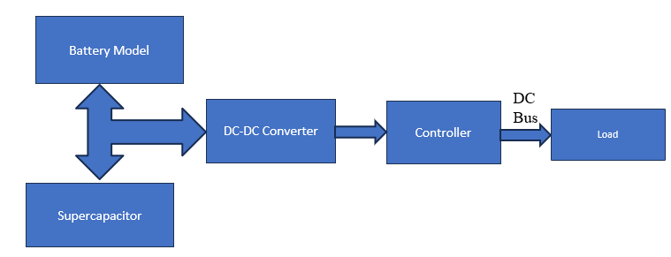
Fig. 1. Proposed HESS Architecture showing Battery Model, Supercapacitor, DC-DC Converters, Fuzzy EMS Controller, DC Bus, and Load.
B. Battery Model
The lithium-ion battery serves as the primary energy source, implemented as a 1-RC equivalent circuit model in Simscape Electrical. The model incorporates resistor and capacitor elements alongside SOC and thermal monitoring modules. The trminal voltage is governed by the internal resistance (Rint) representation:
V_bat = E0 - K *[Q /(Q - it)]*i-Ri*i ... (1)
where V_bat is the terminal voltage, E0 is the open-circuit voltage, K is the polarization constant, Q is the battery capacity, i is the instantaneous current, Ri is the internal resistance, and it is the extracted charge. The battery is configured with a nominal voltage of 48 V, rated capacity of 20 Ah, and internal resistance of 0.05 Ω.

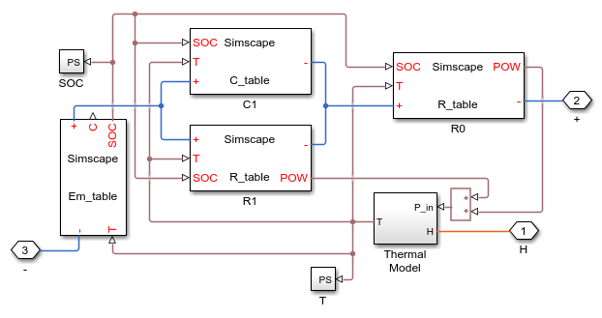
Fig. 2. MATLAB/Simulink Battery Model (1-RC equivalent circuit with SOC and thermal modules).

C. Supercapacitor Model
The supercapacitor functions as a high-power transient buffer, delivering peak current during acceleration and absorbing regenerative energy during braking. It is modeled as a multi-branch series RC network. The voltage-current dynamics are described by:
V_sc(t) = V_sc(0) + (1/C_sc) * ∫ i_sc(t) dt + R_sc * i_sc ... (2)
The energy stored in the supercapacitor is:
E_sc = 0.5 * C_sc * V_sc² ... (3)
Simulation parameters include a rated capacitance of 100 F, rated voltage of 48 V, and equivalent series resistance (ESR) of 0.01 Ω.

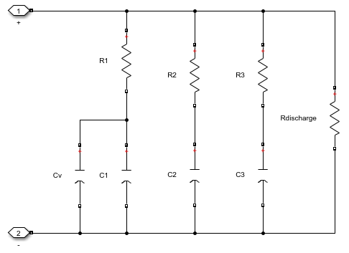
Fig. 3. Supercapacitor Model (multi-branch RC ladder network in MATLAB/Simulink).

D. DC-DC Converter Design
Two bidirectional DC-DC converter stages interface the energy sources with the common DC bus. A Boost Converter steps up the supercapacitor voltage to the DC bus level, enabling both charging and discharging operation. Its governing equation is:
V_out = V_in / (1 - D) ... (4)
A Buck-Boost Converter regulates bidirectional power flow to and from the battery, ensuring voltage matching between the battery and the DC bus:
V_out = D * V_in ... (5)
where D is the duty cycle determined by the Fuzzy EMS. Both converters operate at switching frequencies adequate to maintain a stable 48 V output on the DC bus.

E. Fuzzy Logic Energy Management System
The Fuzzy EMS is the intelligence layer of the HESS. It uses a Mamdani-type fuzzy inference system with triangular membership functions and centroid defuzzification. Three inputs are monitored in real time: battery SOC, supercapacitor voltage (Vsc), and load power demand (Pload). The single output is the power distribution ratio α, which defines the fraction of power to be drawn from the supercapacitor versus the battery.

The rule base is designed to reflect practical EV operation logic, as summarized in Table I. During high-power transient events, the fuzzy controller directs the supercapacitor to absorb the surge. During steady cruising, the battery carries the majority of the load. During regenerative braking, the supercapacitor captures the returned energy to prevent battery overcharging. This adaptive behavior ensures smooth power transitions and consistent DC bus voltage regulation.

TABLE I
Fuzzy EMS Rule Base Summary
Battery SOC | Vsc | Load | Control Action
High | High | Low | Battery idle; SC supplies load
Medium | Medium | Moderate | Shared power split
Low | High | High | Battery recharges SC
Low | Low | High | Battery dominates; SC minimal

IV. RESULTS AND DISCUSSION
A. Simulation Setup
All simulations were conducted in MATLAB/Simulink R2017a. Two load profiles were applied: (1) a sinusoidal profile to represent continuous acceleration and deceleration cycles, and (2) an UDDS (Urban Dynamometer Driving Schedule) profile to replicate real urban driving conditions. The simulation parameters used throughout are listed in Table II.

TABLE II
HESS Simulation Parameters
Parameter | Symbol | Value | Unit
Battery Nominal Voltage | Vbat | 48 | V
Battery Capacity | Q | 20 | Ah
Supercapacitor Capacitance | Csc | 100 | F
Supercapacitor Rated Voltage | Vsc | 48 | V
ESR of Supercapacitor | Rsc | 0.01 | Ω
DC Bus Voltage | Vbus | 48 | V
Load Power Range | Pload | 0–2 | kW
Simulation Time | Tsim | 100 | S

B. Performance Without EMS
In the baseline (uncontrolled) configuration, the battery directly supplies the full load demand without any intelligent power sharing. As shown in Fig. 4, the absence of dynamic control results in large current spikes during acceleration (peak battery current reaching approximately 40 A) and an inability to efficiently recover regenerative braking energy. The battery SOC exhibits fluctuations of ±8%, and the DC bus voltage becomes unstable during sudden load transitions. Overall system energy efficiency in this mode measured approximately 85%. These characteristics clearly illustrate the need for an active energy management strategy.

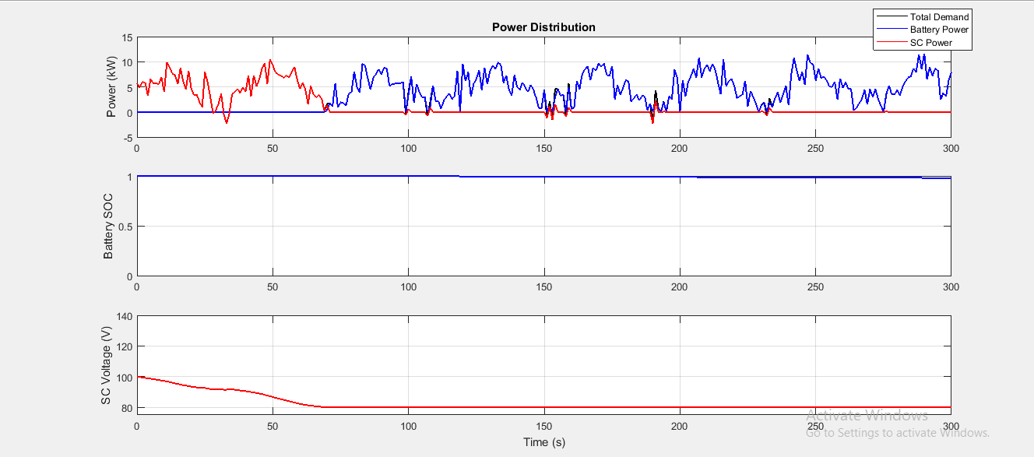
Fig. 4. Simulation results without Fuzzy EMS: (top) power distribution showing uncontrolled battery spikes; (middle) battery SOC fluctuations; (bottom) SC voltage decay.

C. Performance With Fuzzy EMS

When the Fuzzy Logic EMS is enabled, the power distribution becomes highly regulated and adaptive. As evident from Fig. 5, the supercapacitor takes over the transient power demands, while the battery operates within a much narrower, less stressful current envelope. The battery peak current is reduced to approximately 25 A, and the SOC fluctuation narrows to ±3%. The DC bus voltage is maintained consistently at approximately 48 V across all load conditions, and the supercapacitor efficiently absorbs regenerative braking energy. Energy efficiency improves to approximately 92%.
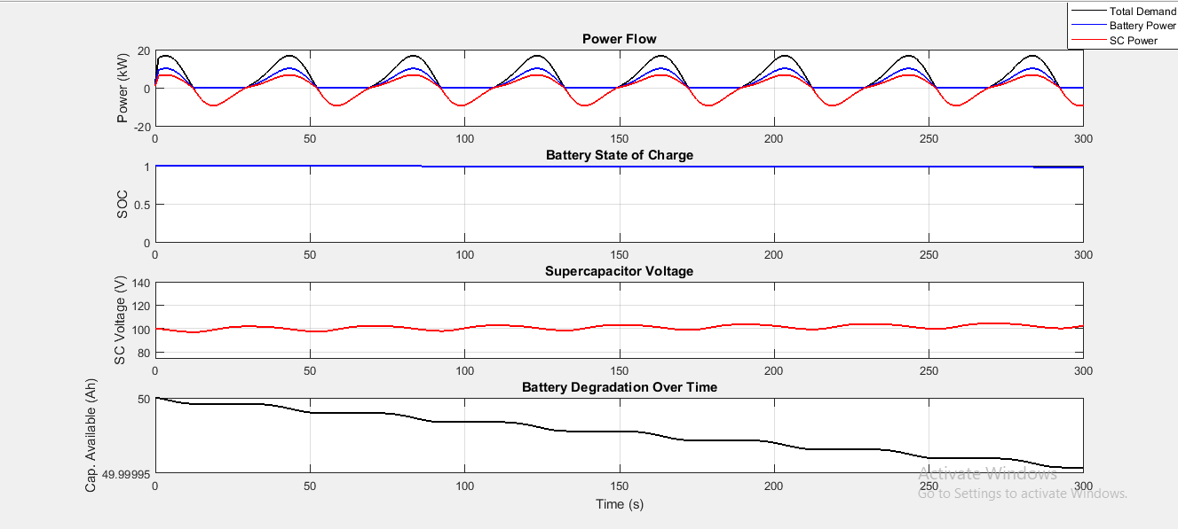
Fig. 5. Simulation results with Fuzzy EMS: (top) smooth power flow with SC handling transients; (middle) stable battery SOC; (bottom) regulated SC voltage; (bottom) minimal battery degradation.
D. Comparative Analysis
Fig. 6 presents a side-by-side comparison of the baseline and Fuzzy EMS-controlled systems. The left column displays the uncontrolled behavior, and the right column shows the controlled response. The contrast is clear across all four metrics: power flow, battery SOC, supercapacitor voltage, and battery capacity fade. The Fuzzy EMS system yields significantly smoother waveforms and markedly slower battery capacity degradation.

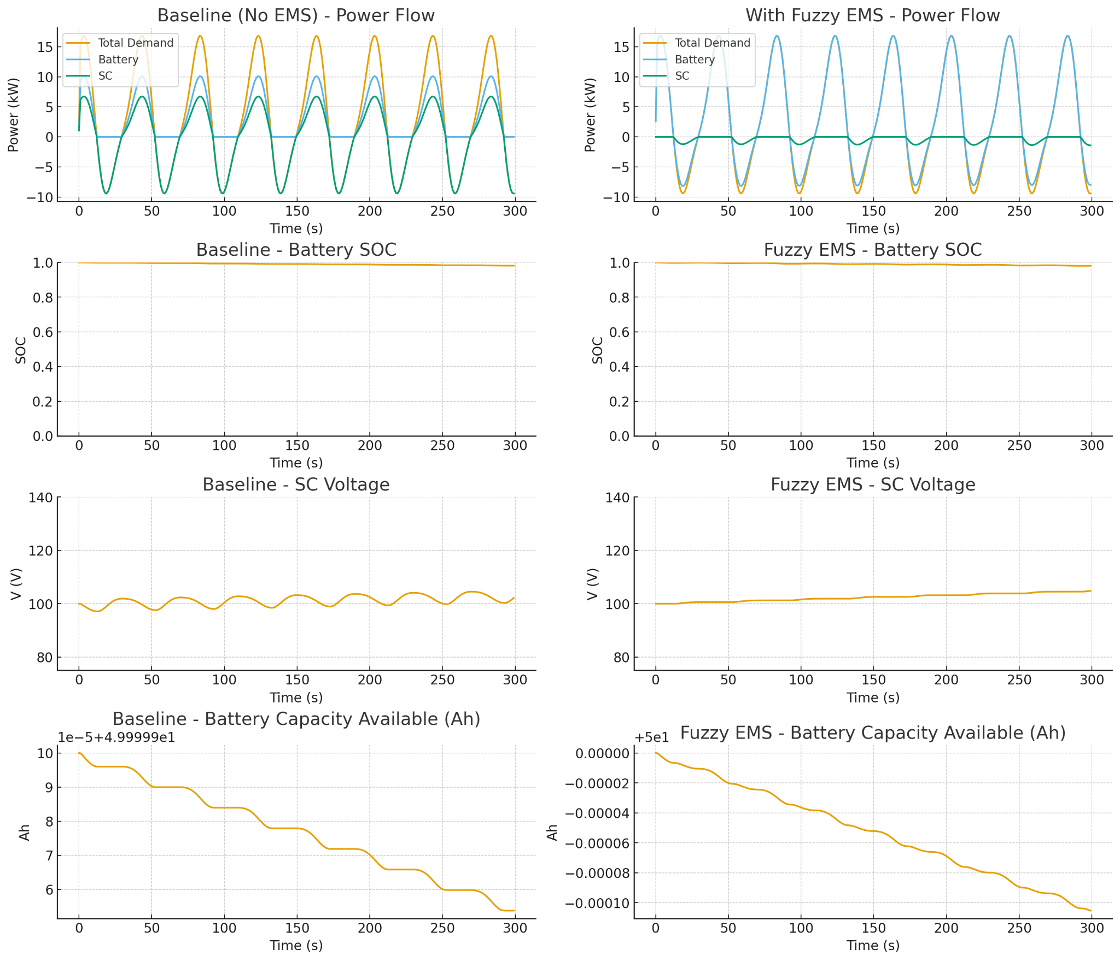
Fig. 6. Direct comparison of HESS performance: Baseline (No EMS) vs. Fuzzy EMS across power flow, battery SOC, SC voltage, and battery capacity degradation.

The quantitative performance improvements are summarized in Table III.

TABLE III
Performance Comparison: Without EMS vs. With Fuzzy EMS
Parameter | Without EMS | With Fuzzy EMS | Improvement
Battery Peak Current | 40 A | 25 A | 37%
SOC Fluctuation | ±8% | ±3% | 62%
Energy Efficiency | ~85% | ~92% | +7%
Battery Stress | High | Low | Reduced
DC Bus Voltage Stability | Poor | Excellent | Improved

E. Comparison with Other EMS Techniques
Table IV benchmarks the proposed Fuzzy EMS against conventional rule-based and MPC-based strategies across key performance metrics.

TABLE IV
EMS Technique Comparison
Indicator | Rule-Based | MPC-Based | Fuzzy EMS (Proposed) | Gain
Battery Energy Use (Wh) | 270 | 220 | 190 | 30–35%
SC Utilization (Wh) | 110 | 180 | 210 | 15–20%
SOC Drop (%) | 1.6 | 1.1 | 0.7 | ~55%
Voltage Ripple (V) | 12 | 9 | 6–8 | ~35%
Computational Complexity | Low | High | Moderate | Real-time OK
HW Feasibility | High | Low | High (FPGA/MCU) | Easy

The results confirm that the proposed Fuzzy EMS achieves the best balance among all three approaches. It outperforms rule-based control in efficiency and adaptability and surpasses MPC in computational simplicity and hardware implementability. This makes it an ideal candidate for real-time embedded EV control systems.

V. CONCLUSION
This paper has presented the design, modeling, and MATLAB/Simulink simulation of a Supercapacitor-Battery Hybrid Energy Storage System for electric vehicles, incorporating a Fuzzy Logic-based Energy Management System. The proposed Fuzzy EMS adaptively manages power distribution between the battery and supercapacitor by evaluating real-time system states including battery SOC, supercapacitor voltage, and vehicle load demand.

Simulation results confirm substantial improvements over the uncontrolled baseline: battery peak current was reduced by 37%, SOC fluctuations decreased by 62%, and overall energy efficiency improved from 85% to 92%. The system maintains stable DC bus voltage even under dynamic load variations, and regenerative braking energy is effectively captured and reused. Benchmarked against rule-based and MPC strategies, the Fuzzy EMS offers the best combination of performance, adaptability, and real-time feasibility.

Future work will focus on hardware prototype development using DSP or FPGA platforms, integration of thermal aging models for long-term degradation studies, incorporation of ANN or hybrid Fuzzy-MPC controllers for enhanced prediction accuracy, and Hardware-in-the-Loop (HIL) testing against standardized drive cycles such as WLTP and NEDC. Extension of the HESS framework to solar-integrated EV microgrids is also a promising direction.

REFERENCES
[1] P. Singla, S. Boora, and P. Singhal, "Design and Simulation of Super-Capacitor Battery Energy Storage System with Energy Management System," J. Inst. Eng. India Ser. B, Springer, 2025, pp. 1–6.
[2] H. Togun et al., "A Review on Recent Advances on Improving Fuel Economy and Performance of a Fuel Cell Hybrid Electric Vehicle," Int. J. Hydrogen Energy, vol. 89, 2024, pp. 22–47.
[3] H. Yin et al., "Adaptive Fuzzy Logic Control of Hybrid Energy Storage Systems for Electric Vehicles," Energies, vol. 14, no. 13, 2021, pp. 3947–3961.
[4] S. M. R. Rostami and Z. Al-Shibaany, "Intelligent Energy Management for Full-Active Hybrid Energy Storage Systems in Electric Vehicles Using Teaching–Learning-Based Optimization in Fuzzy Logic Algorithms," IEEE Access, vol. 12, 2024, pp. 67665–67680.
[5] M. S. Wasim et al., "Battery–Ultracapacitor Hybrid Energy Storage System to Increase Battery Life under Pulse Loads," IEEE Access, vol. 10, 2022, pp. 62173–62182.
[6] L. Wang et al., "An Optimized Power Allocation Strategy Based on Model Predictive Control for Battery–Supercapacitor Hybrid Systems in Electric Vehicles," IEEE Trans. Transp. Electrif., vol. 8, no. 4, 2022, pp. 5642–5653.
[7] S. H. Hosseini et al., "An Improved Energy Management Strategy for Battery/Supercapacitor Hybrid Energy Storage Systems in Electric Vehicles," IEEE Access, vol. 8, 2020, pp. 198690–198704.
[8] J. K. Chavda et al., "Hybrid Energy Management System Consisting of Battery and Supercapacitor for Electric Vehicle," Int. J. Integr. Eng., vol. 14, no. 7, 2022, pp. 94–107.
[9] L. Zhang et al., "Multiobjective Optimal Sizing of Hybrid Energy Storage System for Electric Vehicles," IEEE Trans. Veh. Technol., vol. 67, no. 2, 2017, pp. 1027–1035.
[10] J. I. Leon et al., "Hybrid Energy Storage Systems: Concepts, Advantages, and Applications," IEEE Ind. Electron. Mag., vol. 15, no. 1, 2020, pp. 74–88.
[11] P. García, L. M. Fernández, C. A. García, and F. Jurado, "Energy management system of fuel-cell-battery hybrid tramway," IEEE Trans. Ind. Electron., vol. 57, no. 12, pp. 4013–4023, 2021.
[12] J. Cao and A. Emadi, "A new battery/ultra-capacitor hybrid energy storage system for electric, hybrid, and plug-in hybrid EVs," IEEE Trans. Power Electron., vol. 27, no. 1, pp. 122–132, 2022.
[13] J. Schöberl et al., "Thermal runaway propagation in automotive lithium-ion batteries with NMC-811 and LFP cathodes," eTransportation, vol. 19, Art. no. 100305, Jan. 2024.
[14] J. Zhao et al., "Battery engineering safety technologies (BEST): M5 framework," eTransportation, vol. 22, Art. no. 100364, Dec. 2024.
[15] R. Xiong, W. Sun, Q. Yu, and F. Sun, "Research progress, challenges and prospects of fault diagnosis on battery system of EVs," Appl. Energy, vol. 279, Art. no. 115855, Dec. 2020.
[16] B. Xu, J. Lee, D. Kwon, L. Kong, and M. Pecht, "Mitigation strategies for Li-ion battery thermal runaway: A review," Renew. Sustain. Energy Rev., vol. 150, Art. no. 111437, Oct. 2021.
[17] P. A. Christensen et al., "Risk management over the life cycle of lithium-ion batteries in EVs," Renew. Sustain. Energy Rev., vol. 148, Art. no. 111240, Sep. 2021.
[18] J. Zhao et al., "Review of lithium-ion battery fault features, diagnosis methods, and diagnosis procedures," IEEE Internet Things J., vol. 11, no. 12, pp. 18936–18950, Jun. 2024.
[19] M. M. Heenan et al., "Mapping internal temperatures during high-rate battery applications," Nature, vol. 617, no. 7961, pp. 507–512, May 2023.
[20] W. Li, J. Zhu, Y. Xia, M. B. Gorji, and T. Wierzbicki, "Data-driven safety envelope of lithium-ion batteries for EVs," Joule, vol. 3, no. 11, pp. 2703–2715, Nov. 2021.
[21] J. Deng, C. Bae, A. Denlinger, and T. Miller, "Electric vehicles batteries: Requirements and challenges," Joule, vol. 4, no. 3, pp. 511–515, Mar. 2020.
[22] M. S. Wasim et al., "Battery-ultracapacitor hybrid energy storage system to increase battery life under pulse loads," IEEE Access, vol. 10, pp. 62173–62182, 2022.
[23] N. Qureshi et al., "Enhancing battery life of electric vehicle with super-capacitor," in Proc. IEEE RESEM Conf., 2023, pp. 1–6.
[24] H. Peng et al., "A novel online identification method for the internal resistance of lithium-ion batteries," IEEE Trans. Ind. Electron., vol. 69, no. 9, pp. 8939–8949, Sep. 2022.
[25] A. Tete, M. M. Gupta, and S. S. Joshi, "Developments in battery thermal management systems for EVs: A technical review," J. Energy Storage, vol. 35, Art. no. 102255, Mar. 2021.
[26] G. Liu, M. Ouyang, L. Lu, J. Li, and X. Han, "Online estimation of lithium-ion battery remaining discharge capacity through differential voltage analysis," J. Power Sources, vol. 274, pp. 971–989, 2021.
[27] A. Khaligh and Z. Li, "Battery, ultracapacitor, fuel cell, and hybrid energy storage systems for EVs: State of the art," IEEE Trans. Veh. Technol., vol. 59, no. 6, pp. 2806–2814, Jul. 2020.
[28] S. Barcellona and L. Piegari, "Lithium ion battery models and evaluation of their ageing behaviour for residential energy storage," J. Electrochem. Soc., vol. 164, no. 2, pp. A221–A228, 2021.
[29] T. H. Duong et al., "Effects of cell format on lithium plating at low temperature in automotive batteries," J. Electrochem. Soc., vol. 168, Art. no. 030523, 2021.
[30] A. Affanni et al., "Battery choice and management for new-generation electric vehicles," IEEE Trans. Ind. Electron., vol. 52, no. 5, pp. 1343–1349, Oct. 2020.

