A Study on the Morphology of Pigeon

Abstract
Pigeons (Columba livia) are among the most diverse and widespread avian species, with more than 350 recognized breeds worldwide. Despite their significance in agriculture, ornamental culture, and scientific studies, the morphological features of many indigenous breeds remain poorly documented. This study focuses on three distinct pigeon varieties—Zarad Chotiyal, Neela Chandna, and Lalband Ghagra. Morphological and morphometric traits were recorded to highlight differences in size, plumage, and structural adaptations. Results reveal distinct variations in body weight, coloration, feather structure, and sexual dimorphism. The findings reinforce the role of artificial selection in shaping pigeon phenotypes and emphasize the importance of conserving traditional Indian breeds. This study contributes to a baseline morphological database for further research in taxonomy, genetics, and conservation of domestic pigeons.
Keywords: Columba livia, morphology, morphometry, domestic pigeons, Zarad, Neela Chandna, Lalband Ghagra
Introduction
Pigeons (Columba livia) have fascinated humans for centuries due to their roles in communication, ornamental breeding, sport, and scientific research. They display remarkable phenotypic diversity in plumage, morphology, and behaviour. According to previous researches, more than 350 breeds exist today, shaped through artificial and natural selection. Charles Darwin used pigeons as a model to demonstrate natural and artificial selection, highlighting their immense morphological variation. In India, several indigenous pigeon breeds such as Zarad, Neela Chandna, and Lalband Ghagra represent unique morphological adaptations and cultural heritage. However, systematic documentation of these breeds remains limited.
The present study aims to:
1. Describe and compare the morphological characteristics of selected pigeon breeds.
2. Identify morphometric traits that distinguish these breeds.
3. Contribute to a baseline morphological database for future taxonomic and conservation studies.

Distribution of Pigeon Breeds
- Zarad Chotiyal Pigeon
Origin: Gujarat, India. Distribution: Commonly found in Western India (Gujarat, Rajasthan) and parts of Uttar Pradesh through traditional breeding.
Remarks: Known for homing ability and ornamental value.
- Neela Chandna (Roshan Chirag) Pigeon
Origin: North India (estimated since the 18th century).
Distribution: Predominantly in Uttar Pradesh, Delhi, Punjab, and Haryana. Also kept by hobbyists in Pakistan.
Remarks: Valued for tumbling flight and as a traditional carrier pigeon.
- Lalband Ghagra Pigeon
Origin: Developed during the Mughal era, especially in Delhi under Bahadur Shah Zafar.
Distribution: Widely spread in Uttar Pradesh (Varanasi, Agra, Lucknow), Tamil Nadu, and Kerala. Also popular in Pakistan, where it is locally known as "Banarsi Ghagra.
" Remarks: Notable for sexually dimorphic plumage; males are greyish (“Ghagra”), females reddish (“Lalband”).

Materials and Methods:
The study was conducted on 7 pigeons (4 females and 3males) from local breeders, covering three varieties: Zarad Chotiyal, Neela Chandna, and Lalband Ghagra.
Morphological characteristics recorded: Plumage colour and patterns, Eye colour, Beak size, shape, and colour, Presence or absence of crest and trotter (foot feathering), Wing and tail markings.
Morphometric characteristics recorded: Body weight (gm), Body length (cm), Wing length (cm), Tail length (cm), Beak length (cm), Leg length (cm), Thoracic perimeter (cm). Measurements were taken using a weighing balance and measuring tape.

Different varieties of pigeon used and their number:
Pigeon variety | ♂ | ♀ | Young one ♀
Zarad Chotiyal | 1 | 1 | 1
Neela Chandna | 1 | 1 | 1
Lalband Ghagra | 1 | - | -

Results:
Morphological Observations:
- Zarad Chotiyal: reddish-brown plumage with white markings, females showed crest/braid-like feathers on the head (Figure :1).
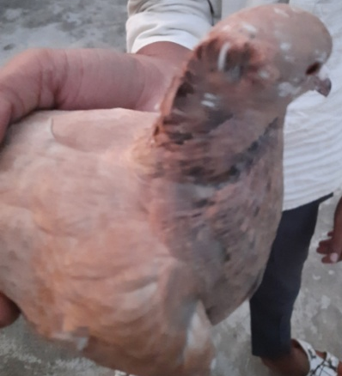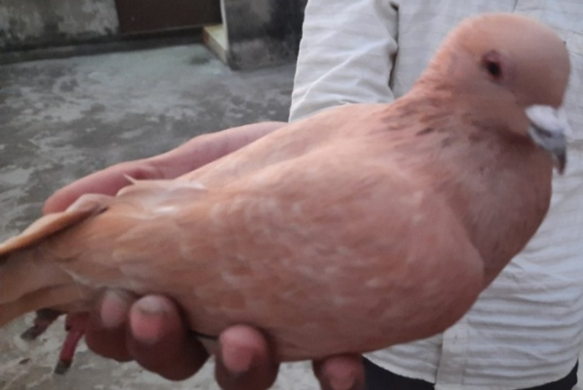
B
A
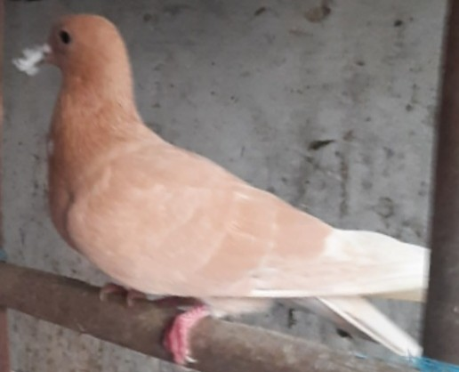
C
Figure 1. (A. Zarad Chotiyal female, B. Zarad male, C. Zarad Squab pigeon)
- Neela Chandna: iridescent neck feathers, deep orange eyes, broad wings adapted for f light, black-and-white plumage with bar patterns (Figure :2).

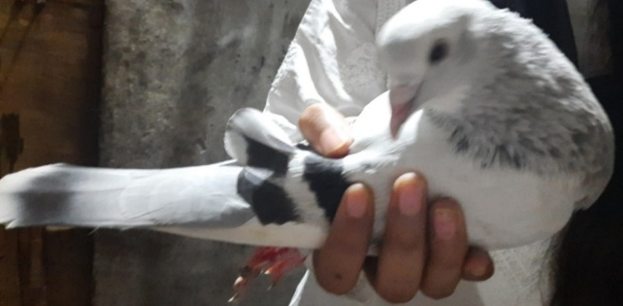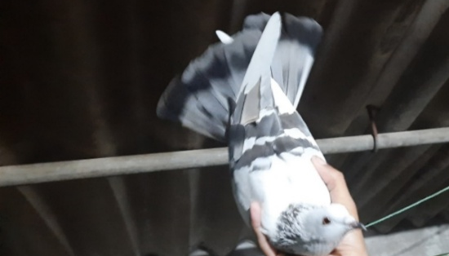
B
A

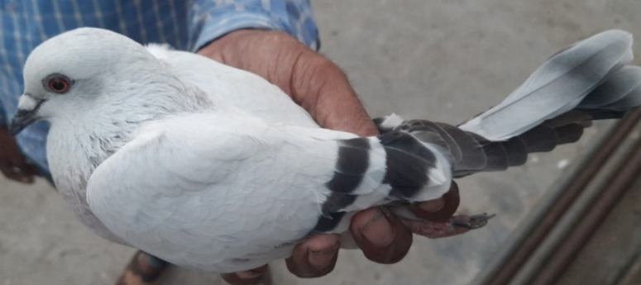
C

Figure 2. (A. Neela chandna female, B. Neela chandna male, C.Neela chandna squab pigeon)

- Lalband Ghagra: sexually dimorphic coloration; males (Ghagra) grayish with faint purple sheen, females (Lalband) reddish bars on wings (Figure :3).

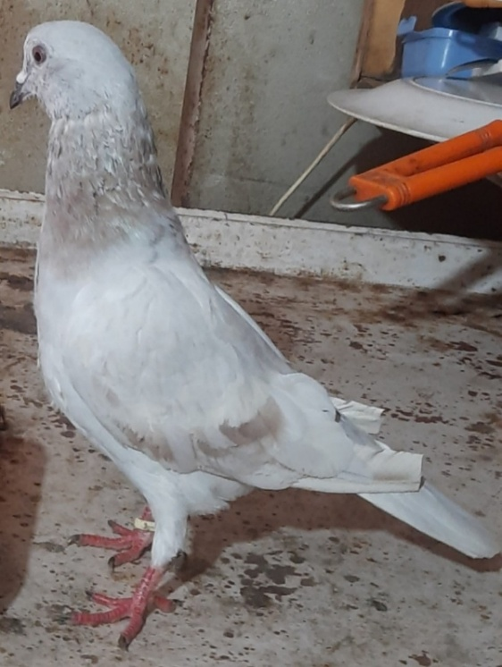

Figure 3. Lalband Ghagra male pigeon.
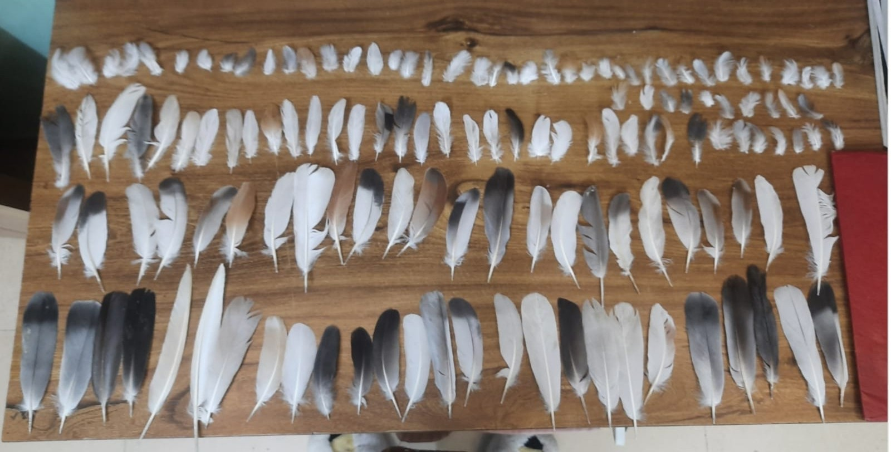

Figure 4: Feathers of Pigeon species

Morphometric Data:
Table 1: Table showing the Morphometric characteristics of the pigeon species
Pigeon  species | Body weight  (grams) | Body  length  (cm.) | Leg  length  (cm.) | Height  (cm.) | Wing  length  (cm.) | Beak  length  (cm.) | Tail  length  (cm.)
Zarad chotiyal Female | 340 | 30 | 11 | 19 | 21.6 | 1.2 | 12
Zarad Male | 400 | 33 | 12 | 20 | 22 | 1.2 | 13
Zarad Squab | 220 | 22.9 | 10 | 17 | 19 | 0.1 | 10
Neela chandn Female | 340 | 30 | 11 | 18 | 19 | 1.2 | 12
Neela Chandn Male | 390 | 33 | 13 | 21 | 21.6 | 2.5 | 13
Neela Chandn squab | 270 | 25 | 10 | 17 | 15.2 | 1.2 | 10
Lalband Ghagra Male | 360 | 30 | 13 | 20 | 8.5 | 2.1 | 13

Discussion
The morphological diversity among Zarad, Neela Chandna, and Lalband Ghagra highlights the impact of selective breeding. In Zarad Chotiyal pigeon the Crest-like head feathers resemble traits linked to the EphB2 gene mutation, which influences feather orientation (Domyan et al., 2014). Neela Chandna belonging to the tumbler group, these pigeons show adaptations for prolonged flight, supporting earlier reports on homing and racing pigeons (Levi, 1974). Lalband Ghagra pegion exhibits rare sexually dimorphic plumage, suggesting possible sex-linked inheritance, a feature scarcely reported in pigeons (Stringham et al., 2012). Morphometric data supported general avian patterns of sexual dimorphism, with males being larger and heavier than females (Senar et al., 1997). The distinct morphologies reflect cultural preferences and selective pressures. Domestic pigeon still holds a unique charm for both fanciers and naturalists. The genetics of its colours alone support a quarterly news letter for scientists and enthusiasts (Bodio, 2009).

Most show pigeons would not survive long in the wild, but their descendants, common street pigeons inhabit cities and cliffs everywhere in the world. Except for their variable colours, and slightly larger size, they resemble the wild rock pigeon, which they have displaced in all but the most remote places. Some scientists consider them to be a super dove, a bird stronger and more adaptable than even its wild ancestors (Bodio, 2009) Evolution of course is never stasis. Darwin wrote, there is hardly any exception to the rule that those characters vary most which are now most valued and attended by fanciers, and which consequently are now being improved by continued selection.
Historical studies of domestic breeding practices in the eighteenth and nineteenth century confirm that besides selection, the techniques of inbreeding and cross breeding were much more important than Darwin’s interpretation allowed for. And they still are today. This calls for the consideration of the pedagogic use of Darwin’s analogy also (Theunissen,2011).

Conclusion
This research documented the morphological and morphometric traits of three indigenous pigeon varieties—Zarad Chotiyal, Neela Chandna, and Lalband Ghagra. Each displayed unique features shaped by artificial selection and cultural practices. The findings underscore the importance of conserving traditional pigeon breeds, both for biodiversity and as part of cultural heritage. Future research should expand to genetic studies, breeding practices, and ecological impacts of domesticated pigeons.

Acknowledgement
The authors would like to thank the principal St. John’s College, Agra for providing necessary facilities.

References:
- Bartels, T. (2003). Variations in the morphology, distribution, and arrangement of feathers in domesticated birds. Journal of Experimental Zoology Part B, 295B (2), 117–129.
- Bodio S.J (2009) Darwin’s other bird- The Domestic Pigeon. Living Bird Magazine, Colonell Lab of Ornithology.
- Domyan, E. T., et al. (2014). Epigenetic basis of feathered head crests in domestic pigeons. Science, 344(6183), 562-565.
- Johnston, R. F., & Janiga, M. (1995). Feral Pigeons. Oxford University Press. Levi, W. M. (1974). The Pigeon. Levi Publishing Co.
- Levi, W. M. (1977). Encyclopaedia of Pigeon Breeds. Levi Publishing.
- Shapiro, M. D., & Domyan, E. T. (2013). Domestic pigeons. Current Biology, 23(8), R302–R303.
- Stringham, S. A., et al. (2012). Divergence, convergence, and ancestry of feral populations in the domestic rock pigeon. Current Biology, 22(4), 302-308.
- Theunissen B. 2011 Darwin and his pigeons. The Analogy between artificial and Natural selection Revisited. Journal of the History of Biology 45(2): 179- 212.

