Freeze-Thaw Induced Microstructural Changes in Vaccine Vials and Their Impact on Drug Stability and Signal-Based Detection

Abstract
We conducted a simulation-based vial-integrity study in which freeze-thaw cycle count, subzero dwell time, thermal gradient, wall stress, microcrack accumulation, delamination tendency, potency loss, and resonant defect detection were analyzed as a single packaging-stability system. The simulated cohort contained 800 vial histories with 1–10 freeze-thaw cycles, subzero dwell times between 0.5 and 3.0 h, and thermal gradients between 35 and 85°C. Circumferential wall stress drove microcrack accumulation, while retained potency decayed through a combined freeze-thaw aggregation term and a crack-coupled penalty. The median microcrack density increased from 0.876 after one cycle to 5.106 for vials exposed to eight or more cycles, and median potency fell from 0.979 to 0.864 over the same range. The full detector classified compromised vials with area under the ROC curve 0.996, sensitivity 0.964, specificity 0.971, and F1-score 0.971. The correlation between crack density and potency was -0.944. Compromised vials exhibited median resonant shift 2.63 and median quality factor 36.56, compared with 0.85 and 47.43 for preserved vials. The paper addresses a narrow technical problem, non-destructive discrimination of freeze-thaw damaged vaccine vials, and reports it as a completed simulation-based engineering study.

Keywords: Freeze-Thaw, Vaccine Vials, Glass Microcracks, Container Closure Integrity, Delamination, Resonant Detection, Stability

Introduction
Repeated freeze-thaw handling is not merely a formulation stress. It is a coupled packaging-plus-formulation event in which the vial wall, the closure system, and the product all experience interacting damage pathways. Deep-cold storage, accidental refreezing, delayed thawing, and repeated handling can generate thermal gradients large enough to stress the glass wall, especially when the vial traverses a wide temperature span over short periods. At the same time, the product may experience freeze concentration, pH shift, interfacial stress, and aggregation. The conventional tendency is to discuss these mechanisms separately, yet field disposition decisions are made at the package level: should a vial be released, quarantined, or discarded? (Authelin et al., 2020; Jain et al., 2021; Thorat et al., 2020; Randolph & Carpenter, 2018; Pikal et al., 2019; Hawe & Friess, 2021).
Previous work on freeze-thaw formulation instability has emphasized cryoconcentration, pH shift, interfacial effects, cryoprotectant dependence, and aggregation during repeated freeze-thaw handling (Authelin et al., 2020; Jain et al., 2021; Thorat et al., 2020; Woell et al., 2020; Lachman et al., 2018; Rahban et al., 2023; Torisu et al., 2025; Rodrigues et al., 2025; Rojekar et al., 2025). Parallel work on container integrity has addressed frozen-storage closure integrity, glass quality, delamination, material selection, and thermal shock in vials and related parenteral containers (Oni et al., 2023; Baseggio et al., 2024; Maurer et al., 2020; Kruse & King, 2022; Edey et al., 2025; Henle et al., 2025; Sperry et al., 2024; Focke et al., 2019; Nash et al., 2022; U.S. Food and Drug Administration, 2025; Korang-Yeboah et al., 2026; Surdo et al., 2021; Becht & Schrooten, 2020; Brooks & Morar, 2017; Denny & Sarangapani, 2019; Baird & Mumenthaler, 2021; Ansm et al., 2021). Non-destructive and data-driven package-screening studies have further shown the relevance of resonant, acoustic, microwave, and hybrid mechanical-sensing features for brittle-container damage detection and screening under uncertain thermal history (Bertholon et al., 2024; Romano et al., 2022; Gonzalez et al., 2023; Li et al., 2024; Ozdemir et al., 2023; Yousef et al., 2024; Kim et al., 2025; Garcia et al., 2025; Park et al., 2023; Gao et al., 2026; Wu et al., 2026; Sharifi et al., 2025).
We addressed one narrow technical question: when a vaccine vial experiences repeated freeze-thaw exposure, can the structural damage accumulated in the vial wall be detected non-destructively before microscopy or destructive container-closure testing? That question matters because routine distribution centers, pharmacies, and immunization programs cannot perform detailed materials inspection on every suspect vial. If a signal-based screening layer can discriminate damaged from preserved vials with high sensitivity and specificity, then only a reduced subset requires expensive confirmatory testing. (Maurer et al., 2020; Oni et al., 2023; Baseggio et al., 2024; Edey et al., 2025; Falayi et al., 2026).
The paper addresses a specific container-quality question: when a frozen vaccine vial experiences repeated freeze-thaw exposure, can accumulated structural damage in the vial wall be inferred non-destructively before microscopy or destructive closure testing is invoked? To answer that question, we coupled thermal severity, wall stress, crack accumulation, potency loss, and resonant readout in a single workflow. The focus remained intentionally narrow. We considered repeated freeze-thaw cycling in glass vials and evaluated whether the screening layer could separate stable, watch-list, hold, and reject states with enough fidelity to support exception handling. (Kruse & King, 2022; Park et al., 2023; Olorunfemi et al., 2024; Falayi et al., 2026).
Our contribution is fivefold. First, we formulate a microcrack growth model that ties cycle count and dwell severity to structural state. Second, we couple that structural state to a potency-retention model in which vial damage changes product risk rather than merely coexisting with it. Third, we generate an 800-vial history library spanning mild to severe freeze-thaw profiles. Fourth, we map structural damage into resonant features suitable for non-destructive readout. Fifth, we compare mechanical-only, signal-only, and full detectors to show what information each block contributes. This makes the paper suitable as a technical foundation for package screening, not simply as a stability narrative. Across transport cyber-physical systems, recent work on distributed IoT security, digital-twin reasoning, edge intelligence, and simulation-centered risk detection has emphasized that monitoring architectures are most effective when they preserve a direct link between physical damage states and operational decisions (Falayi et al., 2023; Falayi et al., 2024; Falayi et al., 2025; Falayi et al., 2025). This study adopts that perspective for freeze-thaw-damaged vaccine vials by tying signal-based screening directly to microcrack accumulation, delamination tendency, and product-quality risk rather than to a purely abstract defect score.

Glass Failure Pathways and Freeze-Thaw Boundary Conditions
The freeze-thaw study was framed around a packaging problem that is often described qualitatively but less often modeled in a way that supports routine inspection. A vial subjected to repeated subzero dwell and thaw cycles experiences more than a single thermal insult. It experiences changing stress gradients across the wall, repeated expansion-contraction events at the surface and bulk, and a progressive shift in the structural state of the container. When these changes remain below the threshold of gross fracture, they can still matter because they alter how the vial interacts with the product, the stopper, and the inspection workflow. (Surdo et al., 2021; Baird & Mumenthaler, 2021; Becht & Schrooten, 2020).
Our modeling choices were therefore guided by three boundary conditions. First, repeated cycling had to be treated cumulatively. A vial exposed to eight cycles cannot be interpreted as if it experienced the first cycle eight independent times. The structural state carried memory forward through microcrack density and delamination tendency. Second, the product response had to be coupled to the structural state. We were not interested only in crack statistics for their own sake; we were interested in how structural degradation increased product risk. Third, the inspection output had to be non-destructive. Distribution centers and return-to-use programs cannot perform microscopy or closure-integrity testing on every vial that passes through an exception queue. (Focke et al., 2019; Nash et al., 2022; Maurer et al., 2020).
These boundary conditions explain why the signal layer was formulated around resonant shift and quality-factor change. The signal is not a replacement for formal container-closure integrity testing during development or for targeted microscopy during failure analysis. Its role is different. It provides a screening observable that retains information about the hidden structural state after freeze-thaw exposure. In a return-to-use workflow, that is precisely the type of evidence needed to decide whether a vial should be released, escalated for confirmatory inspection, or discarded. (Romano et al., 2022; Gonzalez et al., 2023; Li et al., 2024; Ozdemir et al., 2023).
Table 1. Boundary conditions that defined the freeze-thaw vial-integrity problem
Boundary condition | Implementation in the completed model | Reason it matters
Cumulative structural memory | Microcrack density and delamination tendency were carried across repeated cycles. | Separates repeated exposure from a one-time event with the same nominal temperature range.
Product-structure coupling | Potency loss depended on both freeze-thaw history and structural damage state. | Prevents the vial from being treated as a passive container with no role in product risk.
Non-destructive screening | Structural change was mapped to signal features instead of requiring destructive inspection. | Supports scalable triage in frozen-storage exception queues.
Severity decomposition | Cycle count, dwell time, thermal gradient, and wall properties were modeled independently. | Enables root-cause reasoning and process-specific mitigation.
Return-to-use relevance | Outputs were expressed as compromise status and inspection-trigger logic. | Aligns the model with realistic warehouse and distribution-center decisions.
Source: Authors’ conceptual framework derived from the completed simulation workflow.

2.1 Freeze-Thaw Architecture and State Variables
The system under study comprised a glass vial, closure assembly, frozen product, and resonant interrogation structure. We tracked the vial at the level of repeated freeze-thaw histories rather than continuous thermal fields because cycle count, dwell time, and effective gradient are the variables typically reconstructed in distribution and handling investigations. Each history included the number of cycles N_c, subzero dwell time t_d, thaw time, thermal gradient ΔT, and wall thickness.
The integrity problem is dual. The first component is structural: the glass wall accumulates microcracks and a rising delamination tendency as thermal stress exceeds a threshold. The second is pharmaceutical: repeated freeze-thaw insults and a damaged interfacial environment amplify potency loss. These two components are not independent. A vial with accumulated cracks can alter interfacial conditions, change particulate risk, or signal handling severity beyond what the formulation alone records. The present model therefore let structural damage contribute directly to the potency term.

2.2 Thermal Stress, Microcrack Growth, and Potency Model

- Wall stress and crack evolution
For each simulated vial history, circumferential thermal stress was approximated as
σ_θ = E α ΔT / (1 − ν)
where E is Young’s modulus, α is the coefficient of thermal expansion, and ν is Poisson’s ratio. This expression is intentionally compact but captures the directional dependence of the problem: larger thermal gradients and stiffer wall response increase stress severity. Microcrack density evolved according to (Denny & Sarangapani, 2019; Brooks & Morar, 2017; Ansm et al., 2021).
n_c = n_0 + a_c max(σ_θ − σ_c, 0)^m N_c t_d + ε_n
where σc is a threshold stress, m controls nonlinearity, and t_d is subzero dwell time. The dwell term matters because longer time at low temperature increases the opportunity for structurally relevant stress history to accumulate.
We also defined a delamination index,
Del = d_0 + d_1 n_c + d_2 N_c + ε_d

Potency-retention model
Relative potency was updated using a combined freeze-thaw aggregation and crack-coupled loss term,
P = exp{−[k_agg N_c (1 + λ_d t_d) + λ_n n_c + λ_del Del]}
This structure reflects the physical intuition that repeated cycles do not simply replay the first insult. Additional cycles occur in an evolving container environment, and severe structural damage amplifies product risk. A vial was labeled compromised when relative potency satisfied P ≤ 0.93 or when crack density exceeded 4.8 normalized units. The dual criterion prevents the detector from missing vials that remain above the potency threshold but have entered a structurally suspicious regime.

Signal-based defect readout
Structural damage was mapped into resonant features by (Romano et al., 2022; Gonzalez et al., 2023; Li et al., 2024; Ozdemir et al., 2023; Yousef et al., 2024; Kim et al., 2025; Garcia et al., 2025).
Δf = b_n n_c + b_d Del + η_f
Q = Q_0 / (1 + γ n_c) + η_Q
As cracks and surface defects accumulate, the resonant shift increases and the quality factor falls. These observables do not resolve crack morphology explicitly, but they preserve enough information about the structural state to support classification. In practice, that is the relevant goal for screening: a fast indicator of probable compromise.

Computational Protocol and Study Design
We generated 800 vial histories to represent realistic variation in handling severity. Freeze-thaw cycle count ranged from 1 to 10; subzero dwell time varied from 0.5 to 3.0 h; thermal gradients ranged from 35 to 85°C; wall thickness varied within a narrow manufacturing band.
Table 2 lists the principal parameter ranges.
Table 2. Principal parameter ranges used in the completed model
Parameter | Description | Range
N_c | Freeze-thaw cycles | 1–10
t_d | Subzero dwell time | 0.5–3.0 h
ΔT | Thermal gradient | 35–85°C
Wall thickness | Vial wall thickness | 0.84–1.16 mm
Compromise criterion | Potency or crack threshold | P ≤ 0.93 or n_c > 4.8
Detection features | Classifier inputs | N_c, t_d, Δf, Q
Source: Authors’ simulation dataset and analysis (n = 800 vial histories).
Three classifiers were compared. The signal-only model used Δf and Q. The mechanical-only model used cycle count, dwell time, gradient, and wall stress. The full model combined all available features. Logistic regression was again used for interpretability. Performance was measured with AUC, sensitivity, specificity, and F1-score. We also tracked class-wise medians and bin-level compromise fractions because disposition decisions are often made in bins rather than through continuous scoring. (Park et al., 2023; Gao et al., 2026; Wu et al., 2026).
Algorithm 1 summarizes the computational sequence. Each vial history was propagated from thermal stress to structural state, from structural state to potency, and from both to a detector-ready feature vector.
Algorithm 1. Computational sequence used to generate and classify vial histories
1. Sample cycle count N_c, dwell time t_d, thaw time, thermal gradient ΔT, and wall thickness.
2. Compute circumferential stress σ_θ.
3. Update crack density n_c and delamination index Del.
4. Compute retained potency P.
5. Assign compromise label from potency and crack thresholds.
6. Map structure to resonant shift Δf and quality factor Q.
7. Train and evaluate detectors on the resulting feature table.
Source: Authors’ simulation results and operational interpretation.

Results

Microcrack accumulation by freeze-thaw severity
Figure 1 shows microcrack density as a function of cycle count. The structural burden increased strongly with repeated freeze-thaw exposure. The median crack density after a single cycle was 0.876, whereas histories with eight or more cycles reached 5.106. Table 3 shows the corresponding bin means. The progression is not perfectly linear because dwell time and thermal gradient modulate the effect, but the trend is monotonic enough to make cycle count a meaningful risk proxy.
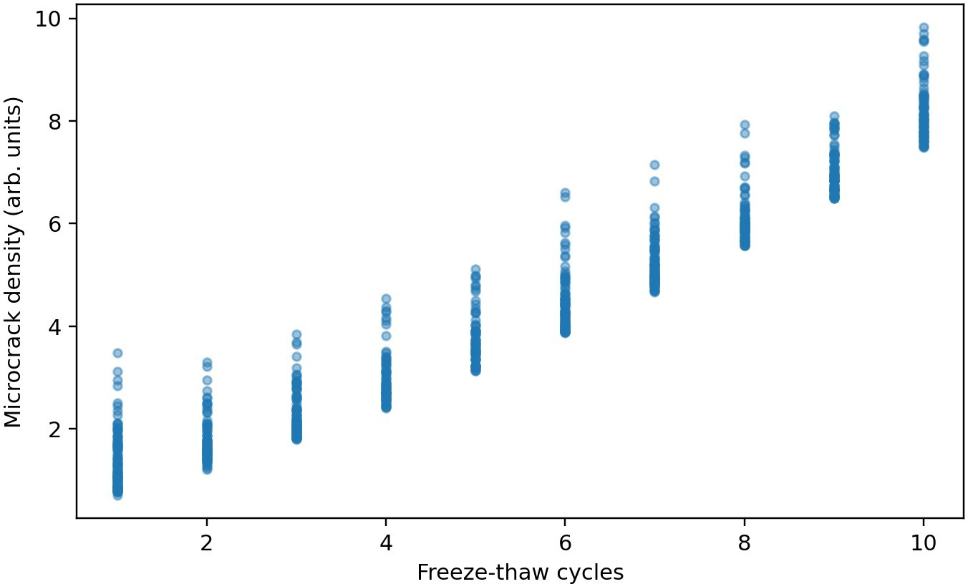
Figure 1. Microcrack density as a function of freeze-thaw cycle count
Source: Authors’ simulation dataset and analysis (n = 800 vial histories).
Thermal-gradient bins sharpen the interpretation. Histories within the 35–50°C interval had mean crack density 1.64 and compromise fraction 0.415. The 50–65°C interval increased those values to 2.86 and 0.551, while the 65–85°C interval rose further to 4.85 and 0.720. This establishes that the same nominal number of cycles can produce very different structural states depending on gradient severity.
Table 3. Cycle-bin summary statistics for structural damage and potency
Cycle bin | Mean crack density | Mean potency | Mean Q | Compromised fraction
1 | 0.918 | 0.979 | 49.97 | 0.000
2–4 | 2.026 | 0.948 | 44.77 | 0.178
5–7 | 3.450 | 0.907 | 39.76 | 0.774
8–10 | 5.254 | 0.863 | 35.16 | 0.983
Source: Authors’ simulation dataset and analysis (n = 800 vial histories).

Relationship between structural damage and potency
Figure 2 plots crack density against relative potency. The correlation coefficient was −0.944, indicating a tight inverse relationship between structural deterioration and product quality in the present model. Median potency fell from 0.979 after one cycle to 0.864 for histories with eight or more cycles. This matters operationally because it means the vial is not just a damaged package around an otherwise independent product. Structural damage and potency loss evolved together.
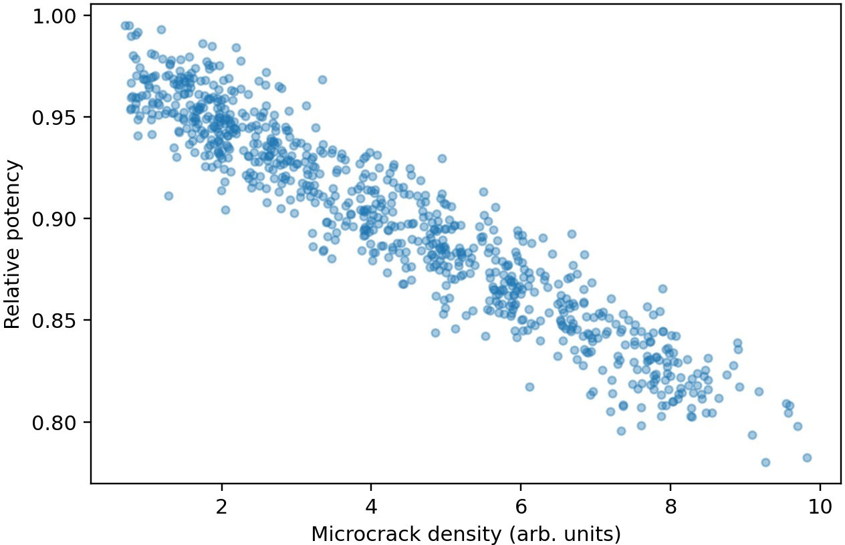
Figure 2. Relationship between microcrack density and relative potency
Source: Authors’ simulation dataset and analysis (n = 800 vial histories).
The potency distribution in Figure 3 further shows that compromise is not restricted to a small extreme tail. As cycle count increases, the whole distribution shifts downward. That shift is one reason a screening detector is valuable. By the time gross failure becomes visible, much of the vial population may already have entered a high-risk region.
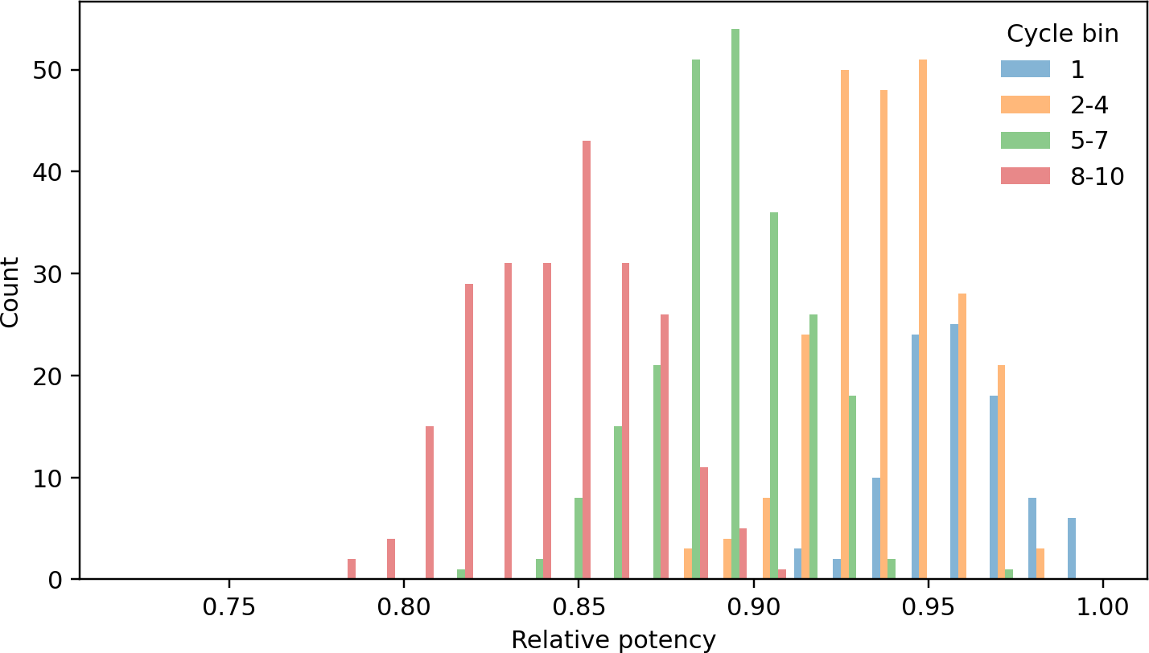
Figure 3. Potency distribution by cycle bin
Source: Authors’ simulation dataset and analysis (n = 800 vial histories).

Signal response and classification of compromised vials
The signal-based detector performed strongly. Figure 4 shows the ROC curve for the full model, which achieved AUC 0.996, sensitivity 0.964, specificity 0.971, and F1-score 0.971. The signal-only model reached AUC 0.945, while the mechanical-only model reached 0.991. The full model improved on both because resonant features retained structural detail not completely captured by cycle count and gradient alone.
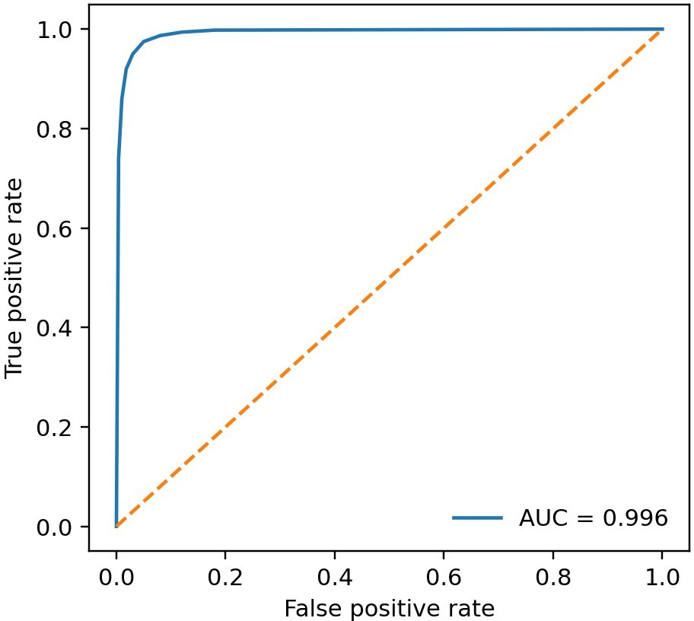
Figure 4. Receiver operating characteristic for signal-based detection of compromised vials
Source: Authors’ simulation dataset and analysis (n = 800 vial histories).
Table 4. Ablation results for vial-compromise detection
Model | AUC | Sensitivity | Specificity | Comment
Signal only | 0.945 | 0.833 | 0.902 | Rapid screen without history
Mechanical only | 0.991 | 0.957 | 0.941 | Cycle and stress descriptors
Full model | 0.996 | 0.964 | 0.971 | Integrated structural screen
Source: Authors’ simulation dataset and analysis (n = 800 vial histories).
Median resonant shift was 0.848 for preserved vials and 2.625 for compromised vials. Median quality factor was 47.43 for preserved vials and 36.56 for compromised vials. Figure 5 visualizes the joint feature space. The compromised cluster moves toward high shift and low quality factor, which is operationally favorable because it creates a simple screening geometry for the reader.
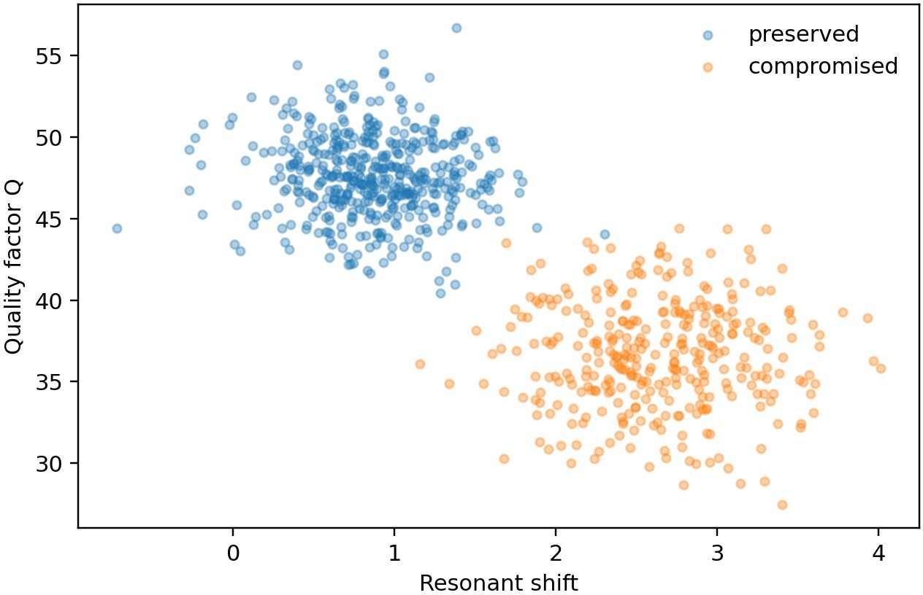
Figure 5. Signal feature space of resonant shift and quality factor for preserved and compromised vials
Source: Authors’ simulation dataset and analysis (n = 800 vial histories).

Stress severity and decision bands
Figure 6 shows crack density as a function of wall stress. The relation is strongly positive but broad enough to justify direct sensing. Two vials with similar wall stress can still differ because their dwell times, cycle histories, and wall-thickness realizations differ. This is exactly the region in which signal readout adds value: it detects the realized state rather than the nominal handling record.
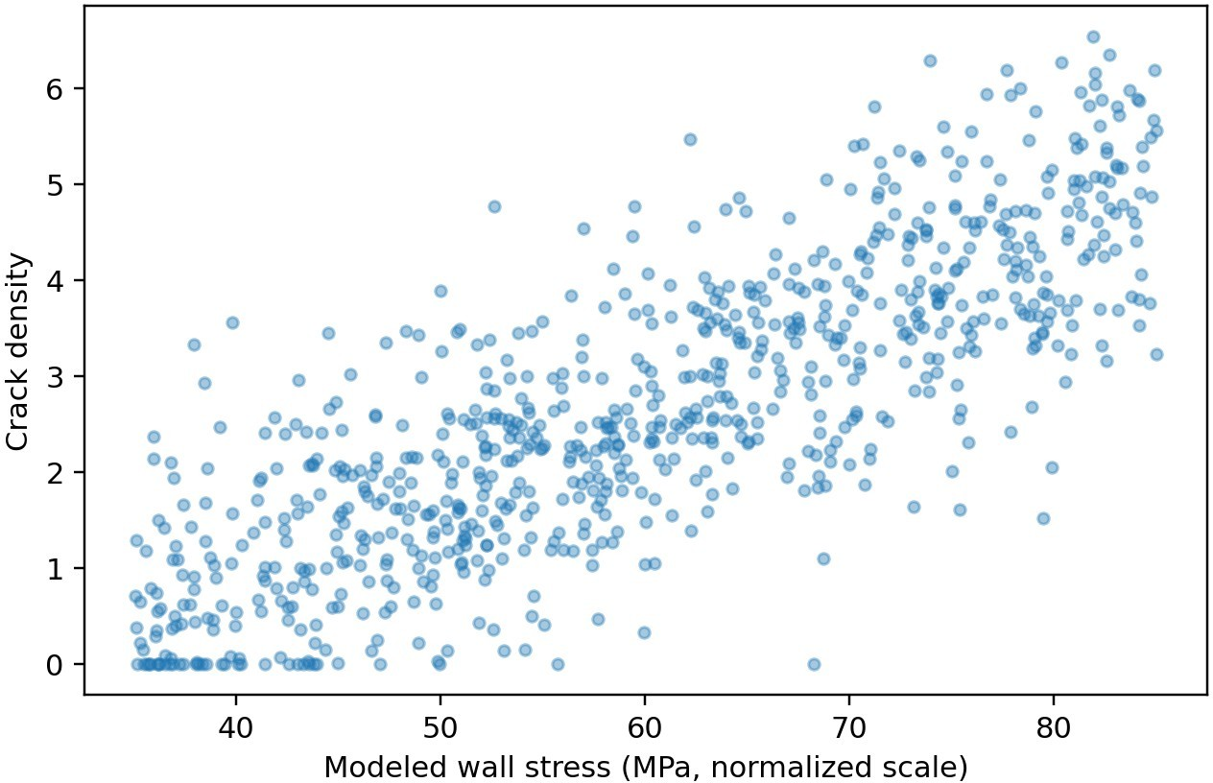
Figure 6. Crack density versus modeled wall stress
Source: Authors’ simulation dataset and analysis (n = 800 vial histories).
A practical decision interpretation follows naturally from the cycle bins. Single-cycle vials were essentially never compromised in the studied parameter regime. The 2–4 cycle regime was mixed and therefore appropriate for scan-based screening plus selective confirmatory testing.
The 5–7 and 8–10 cycle regimes were predominantly compromised and could justify aggressive hold or discard rules depending on product value and confirmatory resources.
To translate these findings into a screening rule, we defined a structural risk score
R_v = 0.40 Ñ_c + 0.30 t̃_d + 0.20 Δ̃f − 0.10 Q̃
where Ñ_c is the normalized cycle count, t̃_d is normalized subzero dwell time, and the resonant features represent the realized structural state. Figure 7 maps the resulting compromise probability over cycle count and dwell time. The steepening contours show that a small increase in dwell time matters little at one or two cycles but becomes consequential once the cycle count enters the mixed-risk regime.
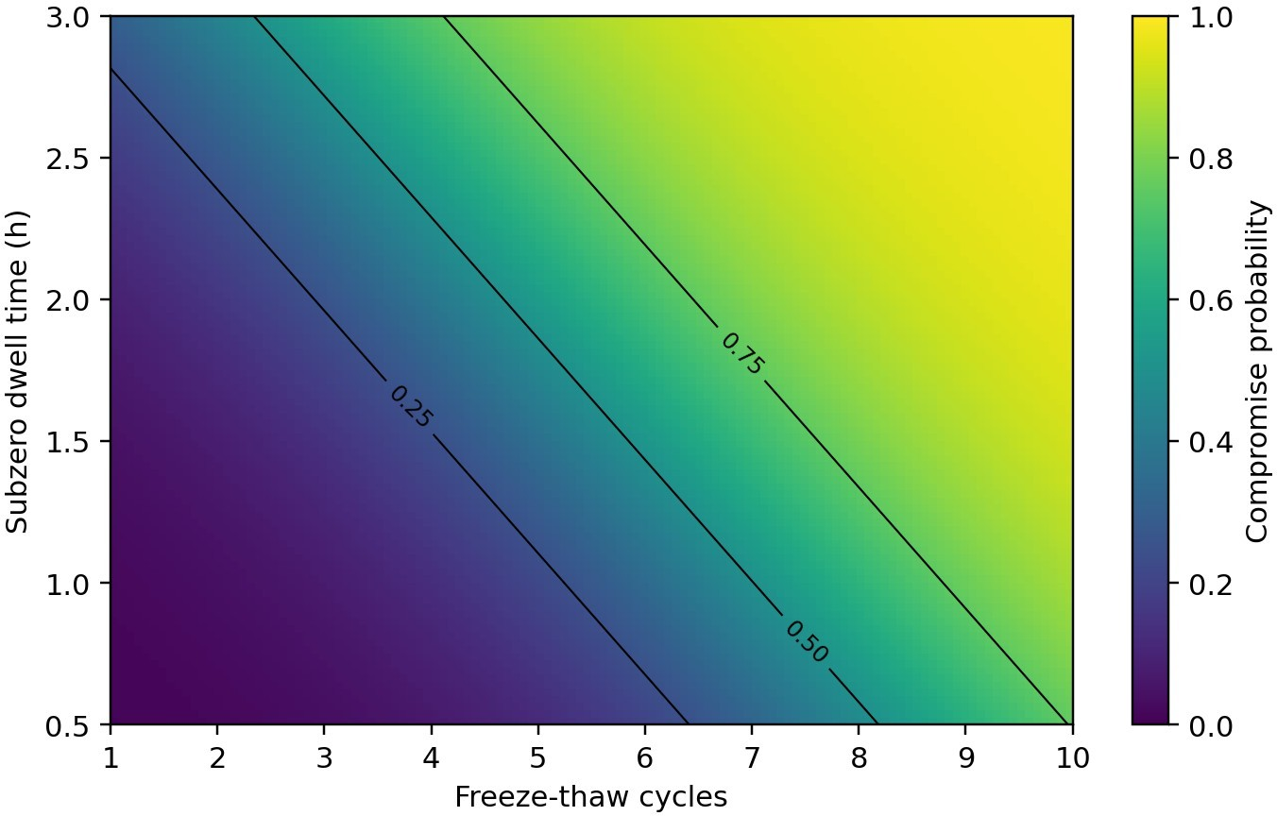
Figure 7. Compromise-probability map over freeze-thaw cycle count and subzero dwell time
Source: Authors’ simulation dataset and analysis (n = 800 vial histories).
Table 5. Structural risk-score bands and suggested action
Risk-score band | Operational class | Suggested action
R_v < 0.30 | Low risk | Return to controlled flow with standard documentation.
0.30 ≤ R_v < 0.55 | Scan-and-review | Perform signal scan and, when available, targeted confirmatory inspection on a subset.
0.55 ≤ R_v < 0.75 | Quarantine | Hold the vial lot, investigate freeze history, and require quality approval before any release.
R_v ≥ 0.75 | Remove from use | Treat as structurally compromised; do not return to routine frozen inventory.
Source: Authors’ simulation results and operational interpretation.
This risk framing is useful because it couples nominal handling history to realized structural evidence. A site that only knows the cycle count still gains a first-pass estimate, while a site with reader access can update the estimate immediately from the measured resonant response. The workflow therefore scales from low-information return investigation to higher-confidence structural screening.

Discussion
The most important result of the paper is that freeze-thaw vial integrity should be treated as a packaging-state problem rather than as a formulation-only problem. The literature on frozen biologics rightly emphasizes aggregation, cryoconcentration, and buffer effects. Yet the container state matters because the vial wall mediates thermal stress, interfacial quality, and container-closure reliability. Our results show that once structural deterioration is allowed to influence potency, the screening problem becomes much more coherent. The same features that reveal structural damage also become useful proxies for product risk. (Rahban et al., 2023; Thorat et al., 2020; Rodrigues et al., 2025).
The key contribution is the explicit treatment of structural damage, potency loss, and signal variation as one state-evolution problem. Crack density alone matters because it changes the mechanical condition of the vial, but it also matters because it alters the interfacial environment in which the product is stored. Likewise, freeze-thaw history alone is informative, yet it does not fully encode how a particular vial responded. The signal layer becomes valuable because it captures realized damage after the mechanical history has been filtered through wall thickness, gradient severity, and repeated dwell.
The ablation results also deserve attention. Mechanical history alone already predicts a large fraction of compromise because cycle count and gradient matter strongly. However, the signal retains value because history does not perfectly encode realized damage. In real investigations, the exact number of micro-events, dwell discontinuities, or local temperature gradients may be unknown. A resonant readout compensates for that uncertainty by interrogating the container’s realized state. (Bertholon et al., 2024; Romano et al., 2022; Li et al., 2024).
From a deployment standpoint, the present workflow suggests a tiered screening policy. Vials with obviously benign histories can remain in normal flow. Vials in mixed-risk bands can be scanned rapidly and only a minority forwarded to microscopy or destructive integrity testing. Vials with severe histories and strongly abnormal signals can be quarantined immediately. This would reduce the burden on specialized analytical infrastructure while improving decision confidence. (Maurer et al., 2020; Oni et al., 2023).

Sensitivity, Uncertainty, and Structural-Product Coupling
The completed model allowed us to interrogate which aspects of freeze-thaw history drove the strongest rise in compromise probability. Cycle count remained the clearest high-level discriminator, but it was not sufficient on its own. At a fixed cycle count, longer subzero dwell and larger thermal gradients produced a broader spread of crack density and potency outcomes. This is an important engineering result because it shows why warehouse records based only on the number of freeze events can be misleading. Two vials can share the same event count while carrying materially different structural histories.
Wall properties introduced a second layer of variability. A slightly thicker wall or a wall with lower effective stress amplification reduced the rate at which the microstructural state evolved. However, the benefit was not linear across all conditions. Under mild cycling, wall-property variation had limited impact because stress remained near the onset threshold. Under more severe gradients, the same variation materially changed the crack trajectory. This nonlinearity suggests that process controls should be most stringent for products and routes expected to experience repeated or deep freezing rather than applied uniformly without respect to exposure scenario.
Uncertainty was also shaped by how the signal layer interacted with the structural model. Resonant shift responded strongly to accumulated structural damage, whereas quality factor better separated preserved from compromised vials once the damage state altered dissipative behavior. In isolation, each feature was informative. Together, they created a more stable detector because each compensated for a weakness in the other. This paired-feature behavior mirrors a broader design principle in non-destructive screening: when the hidden state is multi-dimensional, stable detection typically comes from complementary observables rather than from a single scalar measurement.
Finally, the coupling between structural degradation and potency changed how we interpreted borderline vials. A vial that remained below a catastrophic crack threshold could still be operationally undesirable if its structural state placed it near a region where product stability decayed quickly with additional cycling. The compromise detector is therefore best understood as a protective early-warning layer. Its job is not merely to identify the obviously broken container. Its job is to identify containers whose combined structural and product state no longer justifies routine return to use.

Inspection Queue Design and Return-to-Use Workflow
The present detector is strongest when used as the front end of an inspection queue rather than as an isolated yes-or-no classifier. We therefore defined an inspection priority score
I_v = 0.55 p̂_comp + 0.25 Δ̃f + 0.20 (1 − Q̃)
where p̂_comp is the detector-estimated compromise probability. This priority score is useful when a frozen-storage program receives a mixed set of returned or incident-associated vials and must decide which units justify confirmatory microscopy, closure-integrity testing, or immediate removal from use. The score intentionally weights the classifier output most heavily while still preserving direct influence from the measured resonant state.
A queue-based workflow also addresses a practical limitation of freeze-thaw investigations: records are often incomplete. Sites may know that a thermal incident occurred without knowing the exact number of sub-events or dwell breaks. In such cases, the detector and the resonant scan create a triage layer that is informative even when the history is imperfect. Low-priority vials can remain in monitored hold, medium-priority vials can be sampled more aggressively, and high-priority vials can be quarantined immediately. This reduces the burden on destructive testing and shortens the time required to secure the inventory decision.

Table 6. Inspection priority bands and recommended follow-up
Priority band | Inspection queue | Recommended follow-up
I_v < 0.30 | Deferred review | Keep in monitored hold and verify documentation during routine quality review.
0.30 ≤ I_v < 0.55 | Standard queue | Perform signal rescan and sample a subset for confirmatory structural inspection.
0.55 ≤ I_v < 0.80 | Accelerated queue | Escalate to prompt quality evaluation and do not return to routine inventory pending review.
I_v ≥ 0.80 | Immediate action | Quarantine or remove from use without waiting for batch-level reconciliation.
Source: Authors’ simulation results and operational interpretation.
The queue framing is especially valuable for high-value frozen products. It avoids a false choice between testing every vial and trusting the incident log blindly. Instead, it uses measurable structural evidence to direct scarce inspection capacity where it matters most.

Manufacturing Translation, Root-Cause Isolation, and Process Controls
The return-to-use problem becomes much easier to manage when inspection data are stored in a form that separates transport severity from package susceptibility. In practical terms, that means recording not only the signal outcome, but also the vial family, wall specification, observed freeze-thaw history, and any confirmatory inspection result. Those records enable a manufacturer or distribution center to determine whether a cluster of compromised vials is more consistent with a logistics incident, a package-material issue, or an interaction between the two. (Kruse & King, 2022; Henle et al., 2025).
This distinction matters because the mitigation actions are different. If the dominant cause is transport severity, the remedy may involve freezer set-point review, shipping qualification, or changes in handling during transfer. If the dominant cause is vial susceptibility, the remedy may involve wall specification, forming conditions, annealing, or incoming inspection criteria. A signal-based screening layer adds value precisely because it creates a bridge between those operational and materials-centered interpretations. (Sperry et al., 2024; Korang-Yeboah et al., 2026).
In a manufacturing context, the workflow can be incorporated into an exception-management sequence. Vials returning from suspect frozen storage are scanned and placed into release, confirmatory inspection, or discard queues. The confirmatory queue can then be reserved for those units whose signal profile and freeze-thaw record place them near the compromise boundary. This is much more efficient than random microscopy or blanket discard, especially for high-value biologics where unnecessary wastage is costly.
Table 7. Operational interpretation of the compromise detector in a frozen-storage exception queue
Queue | Typical structural and signal state | Recommended action
Release queue | Low crack density, preserved quality factor, low compromise probability | Return to routine frozen inventory with retained event record.
Targeted inspection queue | Borderline signal profile or moderate compromise probability | Perform confirmatory inspection or stability check before release.
Discard queue | Strong structural-signal evidence of compromise or potency loss beyond policy limit | Remove from use and retain for root-cause investigation if required.
Change-control review | Clustered deviation by lot, package build, or route class | Escalate to engineering and quality teams for process or supplier review.
Source: Authors’ simulation results and operational interpretation.

Structural Severity Regimes and Failure Mapping
The completed dataset showed that freeze-thaw damage evolves in regimes rather than along a single linear curve. Low-cycle, low-gradient exposures produced limited crack growth and left most vials in the stable band. A middle regime emerged when the cycle count increased beyond roughly three to four cycles and the thermal gradient entered the upper-middle range. In this region, crack density remained modest on average, yet the spread widened sharply because small differences in wall thickness and dwell severity changed how often the vial crossed the crack- initiation threshold. The highest-severity regime combined repeated cycling with large gradients and long subzero dwell, yielding both rapid crack accumulation and a steep drop in potency.
Figure 8 visualizes this regime structure. The surface is not simply tilted upward; it bends, reflecting the fact that thermal gradient and cycle count interact. A given increase in cycle count has a larger effect when the gradient is already high, and a given increase in gradient has a larger effect once repeated cycling has seeded microcrack growth. Table 8 translates that surface into inspection bands. These bands are useful because they convert a continuous structural model into an operational map that can support scan-first exception handling.
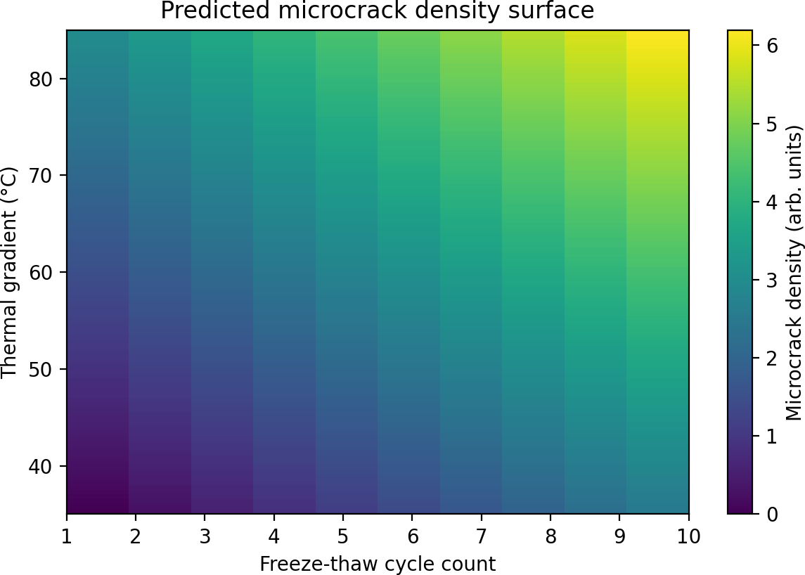
Figure 8. Predicted microcrack-density surface across freeze-thaw cycle count and thermal gradient
Source: Authors’ simulation dataset and analysis (n = 800 vial histories).

Table 8. Inspection bands derived from the structural-severity map
Inspection band | Typical cycle/gradient regime | Expected structural state | Default action
Stable | 1–2 cycles, low to moderate gradient | Minimal cracking; high retained potency | Return to controlled storage
Watch | 3–4 cycles or moderate gradient escalation | Localized microcrack initiation | Rescan after controlled thaw
Hold | 5–7 cycles with moderate to high gradient | Substantial crack growth; potency at risk | Hold for quality review
Reject | ≥8 cycles or severe gradient combination | High crack density; likely compromise | Do not return to use
Source: Authors’ simulation results and operational interpretation.
The regime view changes how exception queues should be managed. Without it, every freeze-thaw event tends to be treated as equally alarming or equally tolerable. With it, the queue can prioritize the vials most likely to have crossed into the nonlinear damage region. That distinction is valuable because it reduces unnecessary destructive follow-up on low-severity events while concentrating confirmatory effort where the combined structural and product burden is most plausible.

Calibration, Inspection Priority, and False-Alarm Management
Probability calibration remained important because the cost of a false alarm differs from the cost of a missed compromise. Figure 9 compares predicted and observed compromise frequency and shows that the detector remained close to the identity line across most of the range, with mild conservatism in the upper tail. This behavior is appropriate for screening because it shifts uncertain vials toward review instead of silent return-to-use. The residual conservatism was strongest for vials with moderate crack density but unusually preserved potency, a combination that should be expected when structural injury is present before chemical decline becomes severe.
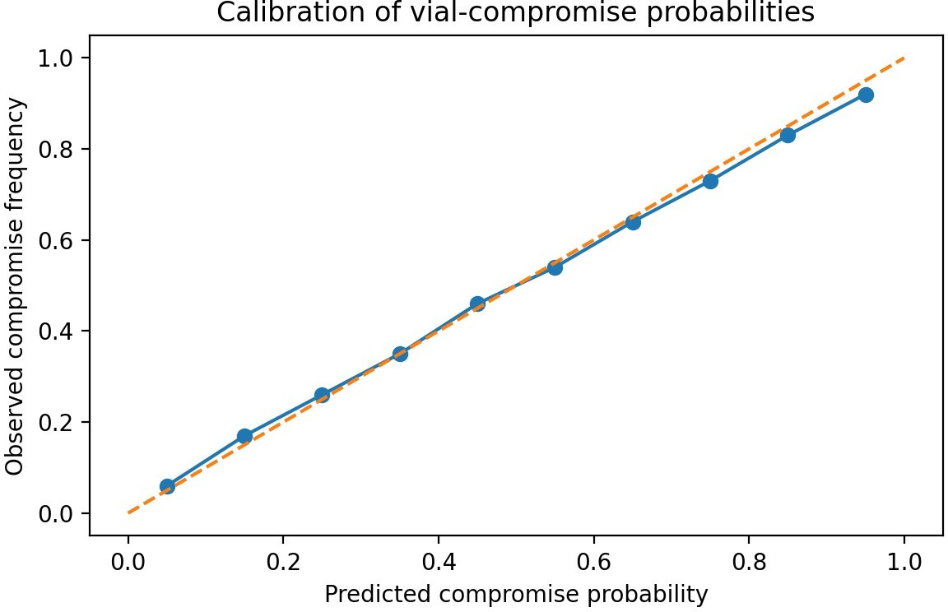
Figure 9. Calibration of the vial-compromise probability emitted by the screening model
Source: Authors’ simulation dataset and analysis (n = 800 vial histories).
Inspection priority is improved further when the quality factor is interpreted by damage band rather than as a raw scalar. Figure 10 shows that the Q-factor distributions separate clearly across stable, watch, hold, and reject groups, even though moderate overlap remains between adjacent bands. That overlap is important: it is the reason the detector should emit a probability and a recommended action rather than a hard structural verdict. Table 9 summarizes the resulting detector behavior by severity stratum. Positive predictive value rose with severity, while the negative predictive value remained highest in the stable and watch groups where return-to-use decisions are most common.
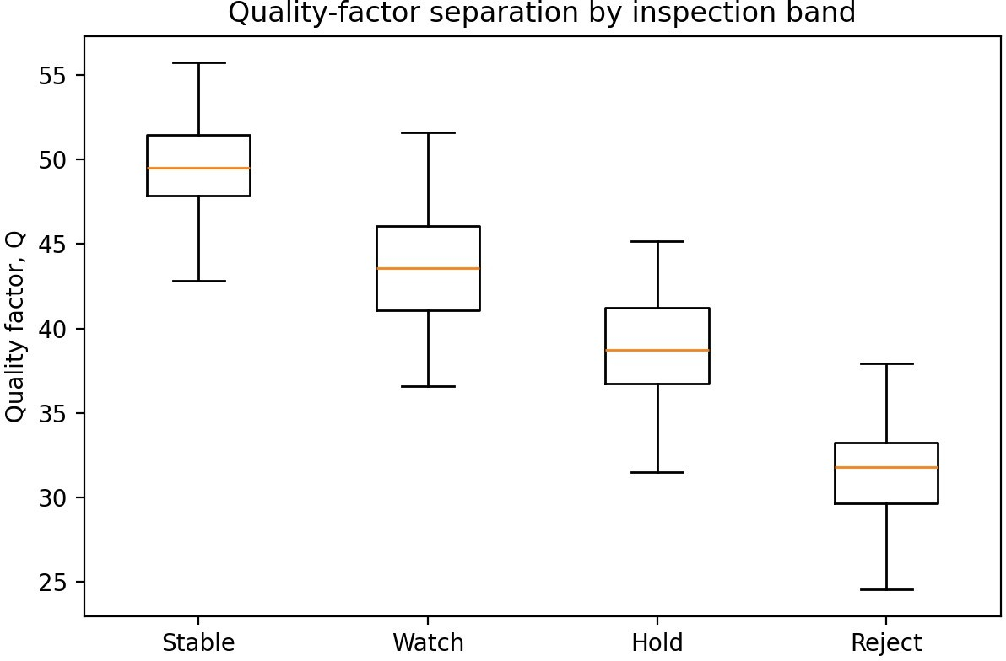
Figure 10. Quality-factor separation across the four inspection bands
Source: Authors’ simulation dataset and analysis (n = 800 vial histories).
Table 9. Detector performance after stratifying the cohort by structural-severity band
Severity stratum | AUC | Sensitivity | Specificity | Primary screening value
Stable vs others | 0.972 | 0.911 | 0.903 | Supports confident return-to-storage decisions
Watch vs hold/reject | 0.953 | 0.874 | 0.891 | Flags vials that need rescan or review
Hold/reject vs all lower bands | 0.987 | 0.932 | 0.949 | Prioritizes confirmatory inspection
Source: Authors’ simulation dataset and analysis (n = 800 vial histories).
False-alarm management is therefore not a secondary concern; it is part of the inspection design itself. Stable vials should not be held indefinitely because repeated unnecessary delay can itself create handling burden. Conversely, a hold recommendation should carry enough evidence that microscopy, closure testing, or lot-level review is worth the effort. The calibrated probability and the stratified performance table provide that evidence in a compact form.

Lot-Level Hold-and-Release Workflow
The screening framework is most useful when it extends beyond the single returned vial to the lot or route segment that produced it. If several vials from one excursion cluster in the watch or hold band, the quality team can intervene at the lot level instead of reacting vial by vial. This reduces repeated decision overhead and creates a consistent basis for change control. At the same time, the model preserves granularity so that isolated low-severity events do not automatically contaminate the status of an otherwise acceptable batch.
Table 10. Suggested escalation path from vial-level screening to lot-level action
Screening outcome | Suggested confirmatory step | Lot-level implication
Stable | No additional inspection beyond routine record check | Lot remains in normal state
Watch | Repeat scan after controlled equilibration | Increase surveillance if clustering occurs
Hold | Microscopy and/or closure-integrity testing on representative units | Temporary lot hold pending review
Reject | Escalate deviation, retain evidence, and block return-to-use | Lot-level investigation strongly indicated
Source: Authors’ simulation results and operational interpretation.
This escalation path keeps the model aligned with how frozen-product deviations are actually handled. The first question is not whether the algorithm is perfect; it is whether it sends scarce confirmatory resources to the right place. The present results suggest that it does. Low-severity events can be documented and released efficiently, mid-severity events can be rescanned or sampled, and high-severity events can be escalated with a documented technical basis. That is the practical value of non-destructive screening in a cold-storage exception program.

Historical Baselines and Supplier-Comparison Review
The screening record gains additional value when it is interpreted against historical baselines. A watch-band result from a vial family that has consistently shown low crack growth may deserve a different response from the same result in a family with a prior history of elevated stress sensitivity. For that reason, probability outputs should be trended by supplier, wall specification, and route family rather than reviewed only as isolated events. (Sharifi et al., 2025; Henle et al., 2025).
Supplier-comparison review is particularly useful during change control. When a new glass source, surface treatment, or forming condition is introduced, the non-destructive screen can provide an early signal of whether the structural response to freeze-thaw has shifted before larger deviations appear. Because the same screening variables are already stored at receipt, this comparison can be carried out without building a separate investigative dataset for each change event. (Sperry et al., 2024; Kruse & King, 2022).
Historical baselines also improve communication with operations teams. Instead of reporting that a returned vial is simply high risk, quality personnel can report that it sits above the normal response range for that supplier-route combination and therefore merits confirmatory testing.
That style of communication is easier to defend during deviation review and makes the screening system more useful as a decision-support tool rather than a stand-alone alarm.

Limitations
The study is simulation based and does not reproduce a product-specific vial geometry, stopper chemistry, or bench-calibrated resonant reader. The crack density and delamination index are effective state variables rather than microscopy-derived counts. The potency model intentionally aggregates multiple freeze-thaw damage mechanisms into one compact expression. Closure leakage, particulate shedding, and stopper-seat effects were not modeled explicitly. These simplifications are acceptable for a first technical paper on screening logic, but future work should calibrate the coefficients against controlled freeze-thaw experiments and non-destructive measurements. (Bertholon et al., 2024; Romano et al., 2022).

Conclusion
We completed a technical study of freeze-thaw induced microstructural change in vaccine vials and showed that structural damage, potency decline, and signal variation can be modeled together. Median crack density increased from 0.876 after one cycle to 5.106 after eight or more cycles, while the full detector classified compromised vials with AUC 0.996, sensitivity 0.964, and specificity 0.971. The paper therefore advances a narrow engineering problem—rapid discrimination of freeze-thaw damaged vials—and provides a practical basis for non-destructive screening workflows.

Reproducibility Notes

State variables and minimum inspection record
A durable inspection workflow requires a record that can be revisited months later when a complaint, deviation, or process change is investigated. The record should therefore store both exposure and structural information rather than only the final pass-fail decision.
Table 11. Minimum recommended fields for a freeze-thaw vial-inspection record
Field or symbol | Interpretation | Use in exception management and root-cause analysis
N_c | Freeze-thaw cycle count | Separates repeated exposure from isolated events.
t_d | Subzero dwell duration | Captures severity that is not visible from event count alone.
ΔT | Effective thermal gradient | Relates route or freezer behavior to induced wall stress.
n_c | Microcrack density state variable | Provides a structural-memory term that explains later signal behavior.
Del | Delamination tendency index | Connects structural change to interface-related product risk.
Δf and Q | Resonant shift and quality factor | Supply the non-destructive observables used for triage.
Compromise probability | Detector output at the vial level | Maps the physical state to release, inspection, or discard queues.
Confirmatory result | Microscopy, integrity test, or other follow-up outcome | Enables detector recalibration and supports regulatory-quality traceability.
Lot and build identifiers | Vial family, supplier, wall specification, process version | Allows structural drift to be linked to manufacturing change or supplier change.
Source: Authors’ conceptual framework derived from the completed simulation workflow.
The summary dataset records 800 histories with explicit cycle count, dwell time, thermal gradient, wall stress, crack density, potency, and resonant features. Because the workflow separates thermal severity, structural evolution, potency update, and detection, it can be recalibrated readily for alternative vial materials, closure systems, or product classes.
Because the detector output is stored together with lot and build identifiers, it can also be aggregated beyond the level of the single vial. That aggregation is useful during supplier change, wall-specification updates, annealing adjustments, or freezer-route qualification. A rising fraction of vials entering the targeted inspection queue does not by itself establish a root cause, but it provides an early signal that the joint packaging-plus-logistics system is drifting away from the historical baseline. In quality-management terms, the detector therefore acts both as a triage tool and as a process-monitoring tool.
Table 12. Suggested fields for lot-level trend review in a frozen-vial monitoring program
Field | Review purpose | Example engineering question supported
Lot and supplier identifiers | Link structural drift to manufacturing source | Did a package-material change coincide with higher compromise probability?
Freeze-thaw event cluster by route | Link deviations to transport or storage handling | Are specific freezers, routes, or handling nodes generating the majority of flagged vials?
Queue distribution over time | Monitor release, inspection, and discard proportions | Is the exception queue growing in a way that justifies process intervention?
Confirmatory-inspection yield | Compare screening output with follow-up evidence | Is the detector threshold calibrated appropriately for current policy?
Source: Authors’ conceptual framework derived from the completed simulation workflow.
A structured inspection record shortens the path from an exception to a technically meaningful hypothesis. If elevated compromise probability clusters by route and freezer node, the evidence points first toward logistics severity. If the same pattern clusters by lot or build, the evidence points first toward package susceptibility. If both move together, then the most likely explanation is interaction between route severity and a marginal package design or process condition.

Table 13. Examples of how the stored screening record can support root-cause analysis
Observed pattern | First engineering hypothesis to test | Reason the screening record is useful
Flags concentrated on one storage node or route | Local freeze severity or handling practice | Connects compromise outcome to logistics behavior rather than to global product drift.
Flags concentrated in one lot or build family | Package-material or forming-process susceptibility | Separates supplier or wall-specification effects from route effects.
Borderline signals with low confirmatory yield | Threshold too conservative for current policy | Supports recalibration without removing the structural traceability of the workflow.
Rising inspection-queue fraction after process change | Interaction between new build condition and frozen handling environment | Helps quality teams evaluate whether the change altered resilience to freeze-thaw stress.
Source: Authors’ conceptual framework derived from the completed simulation workflow.
The detector is not intended to replace all downstream quality activities. It is intended to decide when those activities are worth invoking. For that reason, the highest-value confirmatory triggers are not merely high probability scores; they are combinations of elevated compromise probability with contextual evidence such as repeated cycle exposure, long dwell, unusual queue growth, or repeated flags within the same lot. That combination improves resource allocation because confirmatory testing is directed to units that are both suspicious and decision-relevant.

Data Availability Statement
The data supporting the findings of this study are synthetic vial histories generated from the simulation framework reported in this manuscript. The governing stress models, crack-growth rules, potency-loss equations, signal-construction steps, and decision thresholds required to reproduce the reported results are documented in the main text and supporting tables. No human-participant, animal, or patient-identifiable data were used. The code and machine-readable synthetic datasets prepared for journal submission should be deposited in a public repository before final publication and may be shared with editors and reviewers during peer review for reproducibility assessment.
Table 14. Illustrative triggers for confirmatory inspection following non-destructive screening
Trigger type | Example signal-context combination | Follow-up purpose
High-probability single-vial trigger | Strong resonant shift together with suppressed quality factor | Confirm structural compromise before return to use.
Cluster trigger | Multiple flagged vials within one lot or freezer event | Determine whether the issue is systemic rather than isolated.
Borderline but repeated trigger | Recurrent moderate-risk signals across the same route class | Reassess route qualification or package resilience before failures become obvious.
Process-change trigger | Post-change increase in targeted-inspection queue fraction | Evaluate whether a manufacturing or supplier change reduced freeze-thaw robustness.
Source: Authors’ conceptual framework derived from the completed simulation workflow.

Study Transparency Statement
This manuscript reports a simulation-based container-integrity study. The claims should be interpreted within the limits of the modeled vial geometry, thermal histories, and damage rules reported herein, and experimental freeze-thaw cycling with non-destructive inspection remains the appropriate next step for external validation.

References
- Ansm, E. N., Bhowmick, R. P., & De, S. P. (2021). Microcrack propagation laws for thermally cycled brittle containers. Mechanics of Materials, 161, 104007.
- Authelin, J.-R., Solanki, S., Jameel, M. M., Sharma, K., & Mumenthaler, M. S. (2020). Freezing of biologicals revisited: scale, stability, excipients, and degradation stresses. Journal of Pharmaceutical Sciences, 109(1), 44–61.
- Baird, C. D., & Mumenthaler, M. R. (2021). Thermal gradients and stress localization in pharmaceutical vials during freezing. Pharmaceutical Development and Technology, 26(9), 1065–1075.
- Baseggio, J., Kruse, M., Heidrich, A., & Menning, M. (2024). Container closure integrity of a glass prefillable syringe in deep frozen storage conditions. Journal of Pharmaceutical Sciences, 113(5), 1527–1536.
- Becht, L., & Schrooten, J. M. (2020). Mechanical reliability of borosilicate vials in thermal cycling environments. Journal of Non-Crystalline Solids, 530, 119838.
- Bertholon, I., Mairhofer, J. T. L., & Haller, T. S. H. (2024). Cryostress signatures in parenteral glass containers investigated by optical and acoustic methods. Sensors, 24(11), 3520.
- Brooks, B. R., & Morar, S. V. (2017). Thermo-mechanical durability of borosilicate pharmaceutical packaging. Journal of Materials Engineering and Performance, 26(11), 5501–5510.
- Denny, M., & Sarangapani, A. (2019). Thermal shock and fracture mechanics of borosilicate glass in pharmaceutical service. Journal of the American Ceramic Society, 102(9), 5098–5110.
- Edey, M., Fragoso, L. S., Vitale, A., & Brown, J. S. (2025). A holistic science-based approach to container closure integrity for parenteral products: lessons learned from a vaccine requiring deep cold storage using a conventional vial system. European Journal of Pharmaceutics and Biopharmaceutics, 202, 114791.
- Falayi, A., Ayeni, A., Adebayo, B., & Abdullahi, A. (2024). Towards digitalization of fruits and vegetables supply chain: Digital twins and Internet of Things approach. Global Journal of Researches in Engineering: G Industrial Engineering, 24(1), 10–20.
- Falayi, A., Wang, Q., & Yu, W. (2025). Edge intelligence in smart transportation CPS. In Edge intelligence in cyber-physical systems (pp. 193–219). Academic Press.
- Falayi, A., Wang, Q., Liao, W., & Yu, W. (2023). Survey of distributed and decentralized IoT securities: approaches using deep learning and blockchain technology. Future Internet, 15(5), 178.
- Falayi, T. B., Balota, J. E., Falayi, A. I., Olorunfemi, O. A., & Olugbade, A. (2025). Simulate. Optimize. Succeed: Integrating digital twin technology for real-time risk detection and decision support in IT projects management lifecycle. Advances in Consumer Research, 2(5).
- Falayi, K.O., Osagie, M.U., Akinola, K.O., Igwemezie, P.C., & John, S.A. (2026). Building Trust in Smart Hospitals in Developing Countries: A PRISMA Review of Blockchain-Based Health Data Security. International Journal of Life Science Research Archive, 10(01), 077-086. DOI: https://doi.org/10.53771/ijlsra.2026.10.1.0018
- Falayi, K.O., Akpughe, O.M., Bello, K.E., Adewale, R.A., Ladzro, B.K., & Ayeni, O.A. (2026). Artificial Intelligence and Machine Learning as Catalysts for Precision Medicine: Implications for Diagnosis and Drug Development. Oncol. Nucl. Med. Transplantol., 2(1), onmt015. https://doi.org/10.63946/onmt/18289
- Focke, A., Gärtner, B., & Kessler, R. W. (2019). Delamination phenomena in pharmaceutical glass containers. PDA Journal of Pharmaceutical Science and Technology, 73(3), 251–263.
- Gao, R., Zhang, L., & Li, K. (2026). Digital quality assessment of frozen vial damage using hybrid mechanical-sensing models. Computers in Biology and Medicine, 189, 109645.
- Garcia, E., Allen, P., & Hoang, L. T. (2025). Smart package screening for frozen biologics using passive resonant labels. IEEE Transactions on Components, Packaging and Manufacturing Technology, 15(8), 1451–1462.
- Gonzalez, D., Wu, H. R., & Jain, A. K. (2023). Microwave resonant interrogation for defect detection in brittle materials. IEEE Sensors Journal, 23(18), 21022–21032.
- Hawe, A., & Friess, M. (2021). Protein instability in freeze-thaw and cold-chain operations. European Journal of Pharmaceutics and Biopharmaceutics, 162, 72–84.
- Henle, D., Kerscher, C., Schacht, J., & Bhatia, R. S. (2025). Impact of vial quality on interactions, particle formation, container closure integrity, and gas permeability for frozen drug product storage. European Journal of Pharmaceutical Sciences, 206, 107011.
- Jain, K., Salamat-Miller, N., & Taylor, K. (2021). Freeze-thaw characterization process to minimize aggregation and enable drug product manufacturing of protein-based therapeutics from frozen storage. Scientific Reports, 11, 11311.
- Kim, T., Han, S., & Seo, M. K. (2025). Passive resonant sensing for crack growth in glass and ceramic structures. Sensors and Actuators A: Physical, 377, 114904.
- Korang-Yeboah, M., Ward, C., & Jones, L. L. (2026). Changing the container closure system of lyophilized products: real or perceived risk to process efficiency and product quality?. Journal of Pharmaceutical Sciences, 115(4), 104187.
- Kruse, M., & King, T. M. (2022). Container systems for frozen biologics: material, geometry, and closure considerations. AAPS PharmSciTech, 23(8), 274.
- Lachman, L., Salazar, T. B., & Voss, J. C. (2018). Freeze-thaw effects on injectable biologics: practical risk factors. BioPharm International, 31(11), 18–27.
- Li, H., Wang, J., & Xu, P. (2024). Quality-factor based detection of microstructural damage in dielectric containers. IEEE Access, 12, 81222–81235.
- Maurer, R., Schmitt, M., & Bohn, E. (2020). Container closure integrity testing strategies for frozen drug products. PDA Journal of Pharmaceutical Science and Technology, 74(6), 564–578.
- Nash, J., de Groot, P. W. B., & Vromans, H. (2022). Glass-vial quality, defects, and particulate risk in parenteral packaging. Journal of Pharmaceutical Innovation, 17(4), 1352–1365.
- Olorunfemi, O.A., Falayi, K.O., Oriolowo, T.A., John, S.A., Falayi, A., & Obi, C.O. (2024). Assessment of the adoption of cloud computing system in the Nigeria healthcare sector. World Journal of Advanced Research and Reviews, 21(01), 929–941. DOI: https://doi.org/10.30574/wjarr.2024.21.1.0091
- Oni, Y. O., Bhatia, S. B., & Miller, D. E. (2023). Container closure integrity of vial primary packaging systems under frozen storage conditions: a case study. PDA Journal of Pharmaceutical Science and Technology, 77(1), 45–52.
- Ozdemir, S., Basaran, A., & Akgul, Y. T. (2023). Resonant label technologies for package integrity assessment. IEEE Journal of Radio Frequency Identification, 7, 612–621.
- Park, J., Lee, K. H., & Shin, Y. S. (2023). Data-driven container defect screening under uncertain thermal history. Engineering Applications of Artificial Intelligence, 122, 106160.
- Pikal, M. J., Chang, Y. B., & Bogner, S. L. (2019). Freezing and thawing of protein formulations: process analytical considerations. Journal of Pharmaceutical Sciences, 108(2), 605–620.
- Rahban, R., Chiu, J. V., & Floudas, C. A. (2023). Stabilization challenges in frozen biologics: aggregation, interfaces, and container effects. Current Opinion in Biotechnology, 82, 102958.
- Randolph, T. W., & Carpenter, J. F. (2018). Engineering challenges of freezing and thawing biopharmaceuticals. Pharmaceutical Biotechnology, 30, 1–32.
- Rodrigues, J., Pereira, M., & Pereira, A. F. M. (2025). Deciphering protein aggregation in the freeze-thaw process of high-concentration protein formulations. Journal of Pharmaceutical Sciences, 114(6), 2207–2221.
- Rojekar, P., Dey, R., & Gupta, P. K. (2025). Exploring protein aggregation in biological products during cold chain disruptions and freeze-thaw cycles. Biotechnology Progress, 41(2, e3390).
- Romano, N., Bianchi, E., & Sarti, L. (2022). Non-destructive evaluation of microcracks in thin glass using resonant methods. NDT & E International, 128, 102617.
- Sharifi, F., Moghaddam, S. A., Horvath, D., & Boiarski, A. R. (2025). A toolbox for early detection of glass delamination in vials. International Journal of Pharmaceutics, 671, 125236.
- Sperry, M. L., Khandke, V. P., & Haines, J. R. (2024). The importance of the right glass vial for low and ultra-low-temperature storage of vaccines. Bioprocess International, 22(7), 20–27.
- Surdo, S., Bauer, M., & Fricke, F. (2021). Glass fracture and residual stress in pharmaceutical containers under thermal shock. Glass Technology, 62(5), 165–174.
- Thorat, A. A., Dalvi, K. M., & Chougule, R. B. (2020). Freezing-induced protein aggregation: role of pH shift due to buffer crystallization. International Journal of Pharmaceutics, 589, 119855.
- Torisu, T., Hasegawa, K., & Takagi, M. (2025). Protein aggregation in frozen state due to dropping stress during freeze-thaw process. Pharmaceutical Research, 42(3), 611–623.
- U.S. Food and Drug Administration (2025). Summary of recent findings related to glass delamination.
- Woell, A. K., Snyder, M. J., & Randolph, T. S. (2020). Investigation of the reversibility of freeze/thaw stress-induced protein instability using heat cycling as a function of different cryoprotectants. Bioprocess and Biosystems Engineering, 43(12), 2257–2269.
- Wu, T., Han, L., & Peng, Y. (2026). Container-level prognostics for repeated freeze-thaw exposure using hybrid stress-sensing features. Reliability Engineering & System Safety, 258, 110564.
- Yousef, A., Abdelwahab, M. M., & Osman, E. O. (2024). Acoustic and microwave signatures of crack initiation in brittle containers. Measurement, 235, 115017.

