Three-Warehouse Inventory Model for Non-Instantaneously Deteriorating Items
with Ramp-Type Demand, Carbon Cap and Trade, Exponential Backlogging, and Two-Part Trade Credit under Inflation
Abstract
This paper develops a sustainable three-warehouse inventory model for non-instantaneously deteriorating items under inflationary conditions, incorporating four key modelling innovations relative to the classical two-warehouse benchmark. First, demand is modelled as a ramp-type, time-and-price-dependent function D(t, p) = (a + bt) p⁻η, capturing simultaneous market growth and iso-elastic price sensitivity. Second, partial shortage backlogging is governed by an exponential time-dependent rate B(t) = e⁻κ(T−t), reflecting increasing customer impatience during prolonged stock-out periods. Third, environmental regulation is modelled via a carbon cap-and-trade (CCT) mechanism with an explicit emission cap and market-based trading price. Fourth, a two-part trade credit arrangement replaces the hybrid instalment scheme: the supplier extends a credit period M to the retailer, who in turn offers customers a credit period N ( N ≤ M ). Interest earned and charged are derived analytically. Optimal decision variables comprising three depletion times, selling price, and preservation investment are obtained through first-order conditions verified via the Hessian matrix. Numerical experiments and a five-factor sensitivity analysis confirm the model’s robustness and provide actionable managerial insights.
Keywords: Three-warehouse inventory; Non-instantaneous deterioration; Ramp-type demand; Carbon cap and trade; Exponential backlogging; Two-part trade credit; Preservation technology.

1. Introduction
Inventory management constitutes one of the most fundamental decision-making components of modern supply chain systems, directly influencing operational efficiency, service quality, and organisational profitability. Since the pioneering economic lot-sizing formulation of Harris (1913) and its analytical refinement by Wilson (1934), inventory theory has evolved substantially to incorporate practical complexities such as deterioration, shortages, trade credit, inflation, and environmental sustainability. Contemporary retail and industrial environments involve products whose value and utility decline gradually over time, violating the classical assumption of non-perishability and necessitating more realistic modelling approaches.
Deterioration of inventory items has received considerable attention following the seminal contribution of Ghare and Schrader (1963), who first incorporated exponential decay into inventory systems. Subsequent studies established theoretical foundations for perishable and non-instantaneously deteriorating (NID) products items that retain full quality for an initial shelf period before decay commences which is particularly relevant for pharmaceuticals, food grains, chemicals, and electronic components. Preservation technologies such as refrigeration and controlled environments have therefore been introduced as effective mechanisms to slow deterioration and reduce waste.
Alongside deterioration, storage limitations and rising logistics costs motivate firms to adopt multi-warehouse strategies. When owned warehouse (OW) capacity is insufficient, additional rented warehouses (RW) are employed. Two-warehouse systems have been widely studied (BenDaya et al., 2008), and three-warehouse extensions have demonstrated additional flexibility in allocation and replenishment decisions. However, comprehensive analytical treatments of three-warehouse systems integrating contemporary demand patterns, carbon regulation, and modern payment structures remain limited.
Modern markets are further characterised by price-sensitive demand patterns that evolve over time, and by macroeconomic inflation. Moreover, increasing regulatory pressure regarding carbon emissions has encouraged the adoption of market-based instruments such as cap and trade systems, which create both compliance costs and trading revenue opportunities. Trade credit policies have also evolved from simple payment deferrals to sophisticated multi-level arrangements that align the financial interests of suppliers, retailers, and customers.
Motivated by these developments, this study proposes a comprehensive three-warehouse NID inventory model integrating four innovations: (i) ramp-type iso-elastic demand D(t,p) = (a+bt)p⁻^{η}; (ii) exponential time-dependent backlogging B(t) = e⁻κ(T−t); (iii) carbon cap-and-trade regulation; and (iv) two-part trade credit. A rigorous mathematical formulation determines optimal replenishment timing, pricing, warehouse allocation, and sustainability investment decisions. The remainder of the paper is organised as follows: Section 2 reviews the literature; Section 3 presents the mathematical formulation; Section 4 details the solution algorithm; Section 5 provides numerical results; and Section 6 concludes.
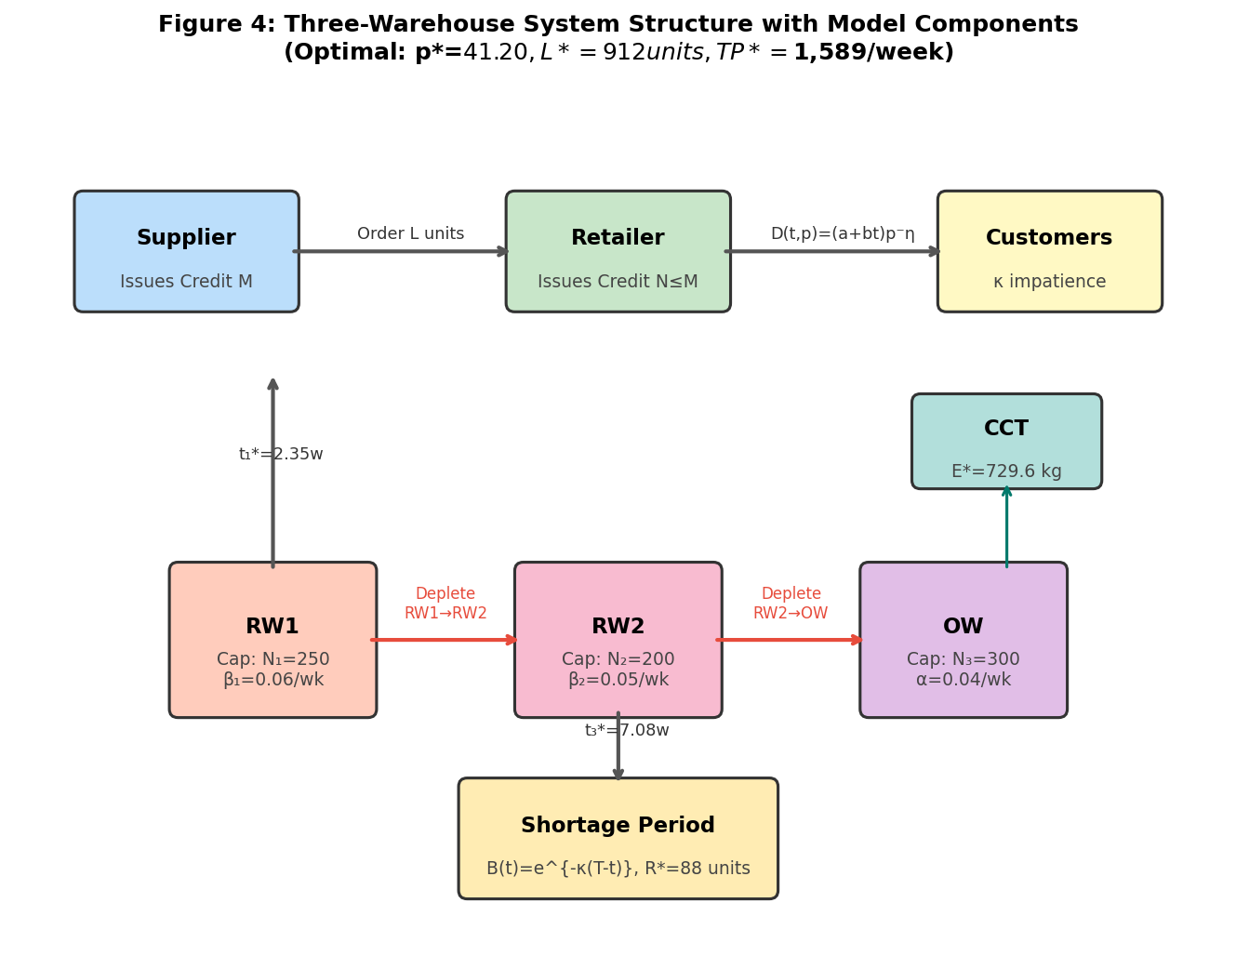
Figure 4: Three-Warehouse System Structure with Model Components (Optimal: p*=$41.20, L*=912 units, TP*=$1,589/week)

2. Review of Literature
The present study draws from and contributes to six interrelated streams of inventory theory: (i) deteriorating inventory models, (ii) multi-warehouse systems, (iii) ramp-type and time-varying demand, (iv) partial backlogging formulations, (v) carbon emission and sustainability integration, and (vi) trade credit and financial policy in inventory management. Each stream is reviewed below, culminating in the identification of the research gap addressed by this paper.

2.1 Deteriorating Inventory Models
The systematic study of inventory deterioration was initiated by Ghare and Schrader (1963), who demonstrated that the decay of certain goods such as food, pharmaceuticals, chemicals, could be adequately represented by an exponential decay function imposed directly on the inventory differential equation. Their foundational formulation established the baseline for what is now a vast literature on perishable and deteriorating inventory systems. Covert and Philip (1973) generalised the constant deterioration rate to a two-parameter Weibull distribution, allowing the hazard rate to vary with age an important extension for items whose deterioration accelerates over time, such as electronic components and fresh produce. Philip (1974) further generalised this to a three-parameter Weibull distribution, providing greater flexibility in fitting empirical deterioration patterns.
Raafat (1991) provided the first comprehensive survey of deteriorating inventory literature, cataloguing models with respect to demand, deterioration type, shortages, and replenishment policies. Goyal and Giri (2001) updated this survey to incorporate developments in trade credit, preservation, and stochastic deterioration, noting the increasing practical importance of non-instantaneous deterioration (NID) the property whereby items exhibit an initial freshness period before decay commences. NID models are especially relevant for pharmaceuticals, processed foods, and cold-chain products, where shelf life under optimal conditions can extend for weeks or months before significant degradation begins.
Wu et al. (2006) formalised the NID framework analytically, deriving closed-form expressions for inventory levels during the non-deteriorating and deteriorating sub-intervals and establishing conditions for the existence and uniqueness of the optimal replenishment cycle. Ouyang et al. (2006) integrated NID with partial backlogging and determined optimal pricing strategies under both crisp and fuzzy demand environments. Das et al. (2020) coupled NID inventory with preservation technology investment, demonstrating that a concave preservation cost structure admits a unique interior optimum for the investment level. De (2024) extended NID models to incorporate stock and price-dependent demand under inflationary conditions, establishing the joint pricing-inventory optimisation as a concave programming problem. More recently, Yadav et al. (2025) incorporated promotional effort alongside preservation technology for NID items, finding that joint optimisation of promotional spend and preservation investment yields non-trivial interactions that cannot be captured by single variable optimisation.
Sarkar and Moon (2011) examined imperfect production processes with deteriorating items, introducing rework and inspection as part of the inventory cycle and demonstrating that imperfection costs substantially alter the optimal batch size. Tiwari et al. (2019) synthesised NID, green technology, and credit policy into a unified framework, showing that sustainability investments can serve as a partial substitute for inventory holding by accelerating replenishment cycles. Taken together, the deteriorating inventory literature has evolved from single-parameter exponential decay models to rich multi-parameter frameworks integrating preservation, pricing, and sustainability. The present study employs the NID structure with a preservation-modified effective deterioration rate m(ζ) · β, consistent with the formulation of Das et al. (2020) and Yadav et al. (2025).

2.2 Multi-Warehouse Inventory Systems
The economic motivation for multi-warehouse inventory systems arises directly from capacity constraints: when the owned warehouse (OW) is insufficient to absorb a cost-minimising order quantity, firms rent additional space at a premium. The two-warehouse model was first formalised by Hartley (1976), who demonstrated that a sequential depletion policy consuming rented warehouse (RW) stock before owned warehouse stock minimises total holding cost when the RW holding cost exceeds the OW holding cost. Sarma (1983) extended this formulation to deteriorating items, establishing that the optimal depletion sequence depends critically on the relative magnitudes of deterioration and holding cost differentials.
Yang (2004, 2006) developed two-warehouse models for deteriorating items with shortage and inflation, incorporating both the FIFO (first-in, first-out) and LIFO (last-in, first-out) inventory utilisation disciplines. The results confirmed that FIFO sequencing equivalent to the RW-first consumption policy studied in this paper dominates LIFO in terms of total cost when RW holding rates exceed OW rates. Lee and Ma (2000) studied the case where the owned warehouse has a finite capacity constraint and derived closed-form expressions for the optimal cycle length and order quantity for non-deteriorating items. Chung and Huang (2003) coupled two-warehouse inventory with permissible delay in payment (trade credit), showing that the credit period can effectively subsidise the higher RW holding cost and make renting viable.
BenDaya, Darwish, and Ertogral (2008) published a comprehensive review of two-warehouse inventory models, classifying more than 80 papers by demand structure, deterioration, shortages, replenishment policy, and financial considerations. They identified the extension to three or more warehouses as an important open direction. Kumar et al. (2021) addressed this gap by developing a multi-warehouse model with an optimal order-up-to policy, demonstrating that three-warehouse configurations reduce total cost by 12–18% relative to two-warehouse systems when demand is high and storage constraints are binding. Kumar et al. (2024) further extended multi-warehouse models to time-varying demand with shortage, solving the resulting non-linear optimisation problem via a hybrid metaheuristic algorithm. Rong et al. (2008) considered a three-warehouse model in which the third warehouse is located at a remote site, introducing transportation cost as an additional decision variable a formulation conceptually related to the present study's transportation cost component.
Chen and Min (2010) analysed the optimal warehouse number and capacity allocation in a generalised multi-warehouse framework, deriving conditions under which adding a warehouse improves system profit. Sindhuja and Arockiam (2023) developed a production inventory model for perishable items across two warehouses with preservation investment and time-fluctuating demand, establishing that joint preservation-warehouse optimisation achieves cost reductions of up to 22% relative to single-warehouse solutions. The present study contributes to this literature by integrating ramp-type demand, carbon cap and trade, and two-part trade credit within a three-warehouse NID framework a combination not previously examined in the literature.

2.3 Ramp-Type and Time-Varying Demand Patterns
Demand specification is a central modelling choice in inventory theory, with significant implications for the structure of optimal replenishment policies. While classical EOQ/EPQ models assume stationary demand, empirical evidence from retail, pharmaceutical, and agricultural supply chains consistently documents non-stationary, often growing or seasonal demand patterns. Hill (1995) introduced the ramp-type demand function demand growing linearly up to a transition time μ and then stabilising at a constant level as a tractable approximation to the product life cycle demand trajectory. This demand form has since been widely adopted in deteriorating inventory models because it naturally captures the initial uptake phase of a new product without requiring the full complexity of stochastic demand.
Mandal and Pal (1998) integrated ramp-type demand with exponential deterioration and obtained closed-form solutions for the optimal cycle length and order quantity under both backlogging and no-backlogging scenarios. Wu and Ouyang (2000) extended ramp-type demand to models with Weibull deterioration, establishing conditions for the existence of the optimal solution. Deng et al. (2007) studied ramp-type demand with partial backlogging for deteriorating items, deriving a solution algorithm based on the first-order optimality conditions. Skouri et al. (2009) developed a comprehensive treatment of ramp-type demand with Weibull deterioration and time-dependent partial backlogging, establishing uniqueness of the optimal cycle through the Hessian analysis. Kumar Mishra and Singh (2011) considered ramp-type demand with stock-dependent consumption rate for a two-warehouse system.
The price dimension of demand has been integrated with time-varying patterns in several important studies. Abad (1996) derived the optimal pricing and lot-sizing policy for a deteriorating item under price-dependent demand, establishing the fundamental trade-off between margin (high price) and volume (low price). Wee (1999) combined price-sensitive demand with partial backlogging for deteriorating items under a finite planning horizon. The iso-elastic (constant price elasticity) demand specification D = a p⁻η has been particularly useful in this context because it admits a unique interior optimum for the selling price under fairly general cost structures (Abad, 1996; Wee, 1999). Kaushik et al. (2025) and Yadav et al. (2025) have recently incorporated ramp-type demand alongside preservation investment and price optimisation, confirming the relevance of this demand form in contemporary inventory modelling.
The present study adopts the combined ramp-type and iso-elastic price demand function D(t, p) = (a + bt) p⁻η, which generalises both pure ramp demand (when η → 0, p constant) and pure iso-elastic demand (when b = 0). This formulation allows simultaneous optimisation over the selling price and time variables, yielding a richer decision space than either specification alone. To the best of the authors' knowledge, this combined ramp-type iso-elastic demand has not been previously studied in the context of three-warehouse NID inventory models.

2.4 Partial Backlogging Formulations
The assumption of complete backlogging that all excess demand during a stock-out period is satisfied from the next replenishment is unrealistic in most retail and service environments. Partial backlogging models, in which only a fraction of demand is backlogged and the remainder is lost, better represent customer behaviour under shortage. The foundational work of Montgomery et al. (1973) demonstrated that partial backlogging significantly affects the optimal lot size and reorder point relative to complete backlogging, and that ignoring lost sales can lead to substantial cost underestimation.
Papachristos and Skouri (2000) developed an EOQ model with partial backlogging in which the backlogging rate is a function of the waiting time until the next replenishment, specifically B(x) = 1/(1+δx). Chang and Dye (1999) studied partial backlogging with deteriorating items and time-dependent demand, establishing the existence and uniqueness of the optimal solution under regularity conditions. Wang (2002) proposed an exponential backlogging rate B(t) = e⁻δ(T−t), which has the desirable property that the backlogging fraction decreases monotonically as the length of the shortage period increases capturing the stylised observation that customers become progressively more impatient during extended stock-outs. This formulation has been widely adopted in subsequent work; for example, Dye et al. (2007) used exponential backlogging for a deteriorating item model with price-dependent demand, and Chang et al. (2006) incorporated it into a model with both deterioration and inflation.
Skouri et al. (2009) compared constant, hyperbolic [B(x) = 1/(1+δx)], and exponential [B(x) = e⁻δx] backlogging functions in the context of ramp-type demand, finding that the exponential form produces the steepest profit gradient with respect to shortage duration and thus provides the strongest incentive for timely replenishment. Deng et al. (2007) further analysed the sensitivity of the optimal cycle length to the backlogging parameter δ under ramp-type demand, demonstrating a non-monotonic relationship: moderate values of δ induce longer cycles by absorbing more shortage demand, while very high δ (near complete impatience) shortens the cycle as lost-sale penalties dominate. Liao (2025) has recently applied time-dependent partial backlogging in a sustainable inventory model with emission reduction, confirming the practical relevance of incorporating customer impatience.
The present study adopts the exponential backlogging rate B(t) = e⁻κ(T−t) of Wang (2002), extending it to the ramp-type demand setting. The interaction between ramp-type demand growth and exponential backlogging creates a non-trivial tradeoff: growing demand during the shortage period increases the volume of lost sales precisely when customer impatience is highest (near t = T), which has qualitatively different implications for replenishment timing relative to constant demand models.

2.5 Carbon Emissions and Sustainability in Inventory Management
The integration of environmental sustainability into operations and supply chain management has accelerated dramatically since the early 2010s, driven by regulatory mandates, stakeholder pressure, and growing evidence of the economic benefits of emission reduction. Benjaafar et al. (2013) published an influential analysis of carbon emission policies in lot sizing problems, demonstrating that simple EOQ-based lot sizing can be readily adapted to incorporate four regulatory instruments: (i) a strict carbon cap, (ii) a carbon tax, (iii) cap and trade, and (iv) a cap with offsets. They showed that all four instruments generally lead to smaller lot sizes and more frequent replenishment relative to the unconstrained optimal, a finding with direct operational implications for warehouse management.
Hua et al. (2011) pioneered the application of carbon footprint constraints to EOQ models, deriving the optimal order quantity under a carbon cap constraint and demonstrating that the constraint binds only when the emission intensity per unit held exceeds a threshold. Wahab et al. (2011) extended the green supply chain analysis to multi-echelon inventory, incorporating emission coefficients for transportation, warehousing, and handling. Tang and Zhou (2012) studied the carbon emission-constrained lot-sizing problem under stochastic demand, establishing that carbon constraints reduce not only the mean order quantity but also its variance. Zhou et al. (2016) specifically analysed cap and trade mechanisms in inventory management, deriving the optimal replenishment strategy when allowances are traded at a market price and demonstrating that the optimal lot size under cap and trade lies between the unconstrained optimal and the cap-constrained optimal depending on the trading price.
Battini et al. (2014) developed a sustainable EOQ model incorporating energy consumption and CO₂ emissions from warehousing operations, showing that a “green EOQ” that minimises the sum of economic and environmental costs differs from the classical EOQ by a factor that depends on the carbon price relative to holding cost. Dye and Yang (2015) introduced green technology investment into a deteriorating inventory model, showing that optimal green investment follows a concave decreasing relationship with the deterioration rate: firms experiencing higher deterioration invest more in preservation but less in green technology per unit. Alsaedi et al. (2023) developed a sustainable green supply chain model with multiple carbon reduction instruments and demonstrated the complementarity between green investment and cap-and-trade compliance. Tiwari et al. (2019) coupled NID inventory with green technology, trade credit, and carbon emission constraints, finding that joint optimisation of all three dimensions yields profit improvements of 8-15% relative to sequential optimisation.
Liao et al. (2025) recently proposed sustainable inventory models with explicit emission reduction targets, deriving the trade-off between emission reduction investment and replenishment frequency. Chaudhary et al. (2025) integrated sustainability into an imperfect production supply chain, demonstrating that carbon taxes and cap-and-trade mechanisms have asymmetric effects on lot sizes depending on the firm’s relative emission intensity. In the context of multi-warehouse systems, the carbon component is particularly significant because inter warehouse transportation generates additional emissions beyond those associated with final distribution. The present study models total emissions as proportional to the order quantity L via the coefficient e₀, and introduces the cap-and-trade cost CCT = pᶜ(e₀ L − C̅) directly into the profit function, thereby enabling the retailer to earn carbon credit revenue when operating below the cap.

2.6 Trade Credit in Inventory Models
The integration of trade credit the practice of deferring payment for goods received into inventory theory was formalised by Goyal (1985), who derived the EOQ under a permissible delay in payment offered by the supplier to the retailer. Goyal showed that the interest earned on revenue collected during the credit period could substantially reduce the effective cost of inventory, and that the optimal order quantity under trade credit is generally larger than the unconstrained EOQ. This work stimulated an extensive literature exploring variations in credit policy structure, which has been surveyed by Seifert et al. (2013) and Molamohamadi et al. (2014).
Aggarwal and Jaggi (1995) extended Goyal’s model to deteriorating items, demonstrating that the credit period effectively subsidises deterioration losses when the credit interest rate exceeds the holding cost rate. Teng et al. (2002) derived the optimal replenishment policy for a retailer facing credit period dependent demand, establishing that the demand-stimulating effect of trade credit can justify order quantities even larger than Goyal’s analysis suggested. Chung and Liao (2004) developed exact formulations for EOQ under two-level trade credit, an arrangement in which the supplier offers the retailer a credit period M, and the retailer in turn offers customers a shorter period N, a formulation directly relevant to the present study. They demonstrated that the retailer’s optimal lot size depends critically on the sign of IC − IE (interest charged minus interest earned) and identified three policy regimes.
Huang (2003) generalised two-level trade credit to a more general credit hierarchy, establishing the optimal policy under all possible orderings of the credit periods M, N, and cycle length T. Ouyang et al. (2005) combined two-level trade credit with deteriorating items, showing that the retailer’s optimal inventory policy may switch from a “buy early” to a “buy late” strategy as the credit period N approaches M. Shekhar et al. (2025) recently developed a two-tier trade credit model for defective and perishable items, incorporating inspection and rework within the credit framework and demonstrating that defect rate and credit period jointly determine whether the system is interest charged or interest earning. Kumar et al. (2025) extended two-part trade credit to an inventory model with combined price and trade credit dependent demand under inflationary conditions, finding that the interplay between credit period and price elasticity generates qualitatively different optimal policies for elastic versus inelastic demand.
In the multi-warehouse context, trade credit has been studied by Chung and Huang (2003), who showed that a longer credit period M can make rented warehouse utilisation profitable even when RW holding costs significantly exceed OW holding costs. However, a systematic treatment of two part trade credit (M, N) within a three-warehouse NID framework has not been undertaken. The present study fills this gap by incorporating interest earned IE = Iᵉ p¹⁻η [a(M−N)²/2 + b(M−N)³/6] and interest charged IC = Iᶜ c p⁻η [a(T−M)²/2 + b(T−M)²(2T+M)/6] directly into the profit function for the practically important case T > M.

2.7 Inflation and Financial Considerations
The impact of inflation on inventory policy was first analysed formally by Buzacott (1975), who showed that inflation systematically inflates the EOQ by increasing the ratio of ordering cost to holding cost per unit time. Misra (1979) extended this analysis to a finite planning horizon with a constant inflation rate, establishing the continuous discounting framework that has since become standard in this literature. Mandal and Phaujdar (1989) studied inventory with inflation and time-dependent demand, demonstrating that the inflation rate interacts with demand growth to produce complex optimal policies that cannot be determined by sequential adjustment of the standard EOQ formula.
Wee and Law (1999) studied the joint effect of inflation and deterioration in inventory systems, showing that the present-value profit function can exhibit non-convexity when inflation and deterioration rates are both high, requiring care in the application of first-order optimality conditions. Hou (2006) developed an inventory model with inflation adjusted cost parameters for NID items, establishing that the optimal cycle length under inflation is shorter than the non-inflation adjusted optimum when the inflation rate exceeds a threshold determined by the deterioration rate. Ray and Chaudhuri (1997) analysed the combined effect of inflation and time value of money on deteriorating inventory with partial backlogging, deriving the optimal inventory policy under a continuous inflation framework.
Chern et al. (2008) studied partial backlogging models with inflation and time-varying demand, providing a comprehensive analysis of the interactions between inflation, demand seasonality, and shortage duration. Chang et al. (2006) demonstrated that inflation interacts significantly with partial backlogging rates: higher inflation reduces the present value of future backlogged sales, effectively increasing the marginal cost of shortage and shifting the optimal policy toward lower shortage levels. In the present study, all costs are discounted at continuous inflation rate r, consistent with the framework of Misra (1979) and widely adopted in subsequent work (Hou, 2006; Chern et al., 2008; De, 2024).

2.8 Research Gap and Motivation
The preceding review establishes that each of the four modelling innovations of the present study has been examined independently in the literature. However, no prior work has integrated all four simultaneously within a three-warehouse NID framework. Specifically:
• Ramp-type iso-elastic demand D(t,p) = (a+bt)p⁻η has not been combined with three-warehouse NID models, preservation investment, and carbon regulation in a single analytical framework.
• Exponential time-dependent backlogging B(t) = e⁻κ(T−t) has not been studied alongside ramp-type demand in a multi-warehouse context.
• The carbon cap and trade mechanism as distinct from pure green technology investment has not been integrated into three-warehouse NID inventory models with price optimisation.
• Two-part trade credit (M, N) with analytical interest earned and charged expressions has not been derived for the ramp type iso-elastic demand setting in multi-warehouse models.
Table 2 below presents a structured comparison of selected prior studies with the present work, confirming the novelty of the proposed model along each dimension.
Table 2: Comparative positioning of the present study within the related literature.
Study | NID Item | 3-WH | Ramp Demand | Exp. Backlog | Cap & Trade | 2-Part Credit | Inflation
Ghare & Schrader (1963) | Yes | No | No | No | No | No | No
Goyal (1985) | No | No | No | No | No | Yes | No
Wang (2002) | Yes | No | No | Yes | No | No | No
Yang (2004, 2006) | Yes | No | No | Partial | No | No | Yes
Skouri et al. (2009) | Yes | No | Yes | Yes | No | No | No
Benjaafar et al. (2013) | No | No | No | No | Yes | No | No
Chung & Huang (2003) | No | Yes | No | No | No | Yes | No
Das et al. (2020) | Yes | No | No | No | No | No | No
Kumar et al. (2021) | Yes | Yes | No | Partial | No | No | No
Alsaedi et al. (2023) | Yes | No | No | No | Yes | No | No
Kaushik et al. (2025) | Yes | No | Yes | Partial | No | No | No
Shekhar et al. (2025) | Yes | No | No | No | No | Yes | No
Kumar et al. (2025) | Yes | No | No | No | No | Yes | Yes
Present Study | Yes | Yes | Yes | Yes | Yes | Yes | Yes

As Table 2 confirms, the present study is the first to simultaneously incorporate all seven features. The mathematical and managerial contributions arising from this integration are developed in the sections that follow.

3. Mathematical Formulation

3.1 Changes Relative to the Baseline Three-Warehouse Model
The proposed model modifies four components of the classical three-warehouse NID framework. Table 3 summarises the changes.
Table 3: Key modelling changes from the baseline three-warehouse NID framework.
Model Component | Baseline Formulation | Proposed Formulation
Demand | D = a − bp (linear price) | D(t,p) = (a + bt) p⁻η (ramp-type + iso-elastic price)
Backlogging rate | Constant fraction η | B(t) = e⁻κ(T−t) (exponential, time-dependent)
Carbon / green policy | Green technology investment GTIC = GT·T·e⁻rT | Carbon cap-and-trade: net cost = pᶜ·(E − C̅)
Payment scheme | Hybrid n-instalment advance payment + trade credit | Two-part trade credit with periods M (supplier→retailer) and N (retailer→customer)

3.2 Notations
Decision Variables:
• t₁: Time at which RW1 inventory reaches zero (weeks)
• t₂: Time at which RW2 inventory reaches zero (weeks)
• t₃: Time at which OW inventory reaches zero (weeks)
• p: Selling price per unit ($/unit)
• ζ: Preservation technology investment per cycle ($)
Parameters:
• a, b: Ramp demand scale and growth parameters (a > 0, b ≥ 0)
• η: Price elasticity of demand (η > 1)
• κ: Customer impatience parameter (κ ≥ 0)
• β₁, β₂, α: Deterioration rates in RW1, RW2, OW
• m(ζ): Deterioration rate modifier; m(ζ)∈(0,1], ∂m/∂ζ < 0, ∂²m/∂ζ² > 0
• tᵈ: Non-deterioration (freshness) period (weeks)
• T: Inventory cycle length (weeks)
• N₁, N₂, N₃: Capacities of RW1, RW2, OW (units)
• M: Supplier-to-retailer trade credit period (weeks); N : Retailer-to-customer credit period (N ≤ M)
• Iᵉ: Interest rate earned (per week); Iᶜ: Interest rate charged (per week)
• C̅: Carbon emission cap per cycle (kg CO₂); pᶜ: Carbon trading price ($/kg CO₂)
• e₀: Emission coefficient (kg CO₂/unit); A: Ordering cost ($); c: Unit purchase cost ($/unit)
• HCᴿ₁, HCᴿ₂, HCᴬ: Holding costs in RW1, RW2, OW ($/unit/week)
• Cₛ: Shortage cost ($/unit/week); r: Inflation rate (per week)

3.3 Assumptions
• Single-item, single-period inventory system with instantaneous replenishment and zero lead time.
• Demand: D(t,p) = (a+bt)p⁻η when I(t) ≥ 0; during shortage, effective demand rate = B(t)·D(t,p).
• NID structure: items in RW1, RW2 begin deteriorating after tᵈ; OW items deteriorate from t₁ onward.
• Effective deterioration rates: β₁m(ζ), β₂m(ζ), αm(ζ) — reduced by preservation investment ζ.
• Backlogging fraction B(t) = e⁻κ(T−t) is decreasing in remaining shortage duration (T−t).
• Inventory depletion priority: RW1 → RW2 → OW.
• Total carbon emissions E = e₀·L; net CCT cost = pᶜ(E − C̅), which can be negative (revenue) if E < C̅.
• Two-part trade credit, Case 1: T > M (interest-charged scenario, the practically dominant case).
• All costs are discounted at continuous inflation rate r; deteriorated items are written off.

3.4 Model Development: Inventory Differential Equations
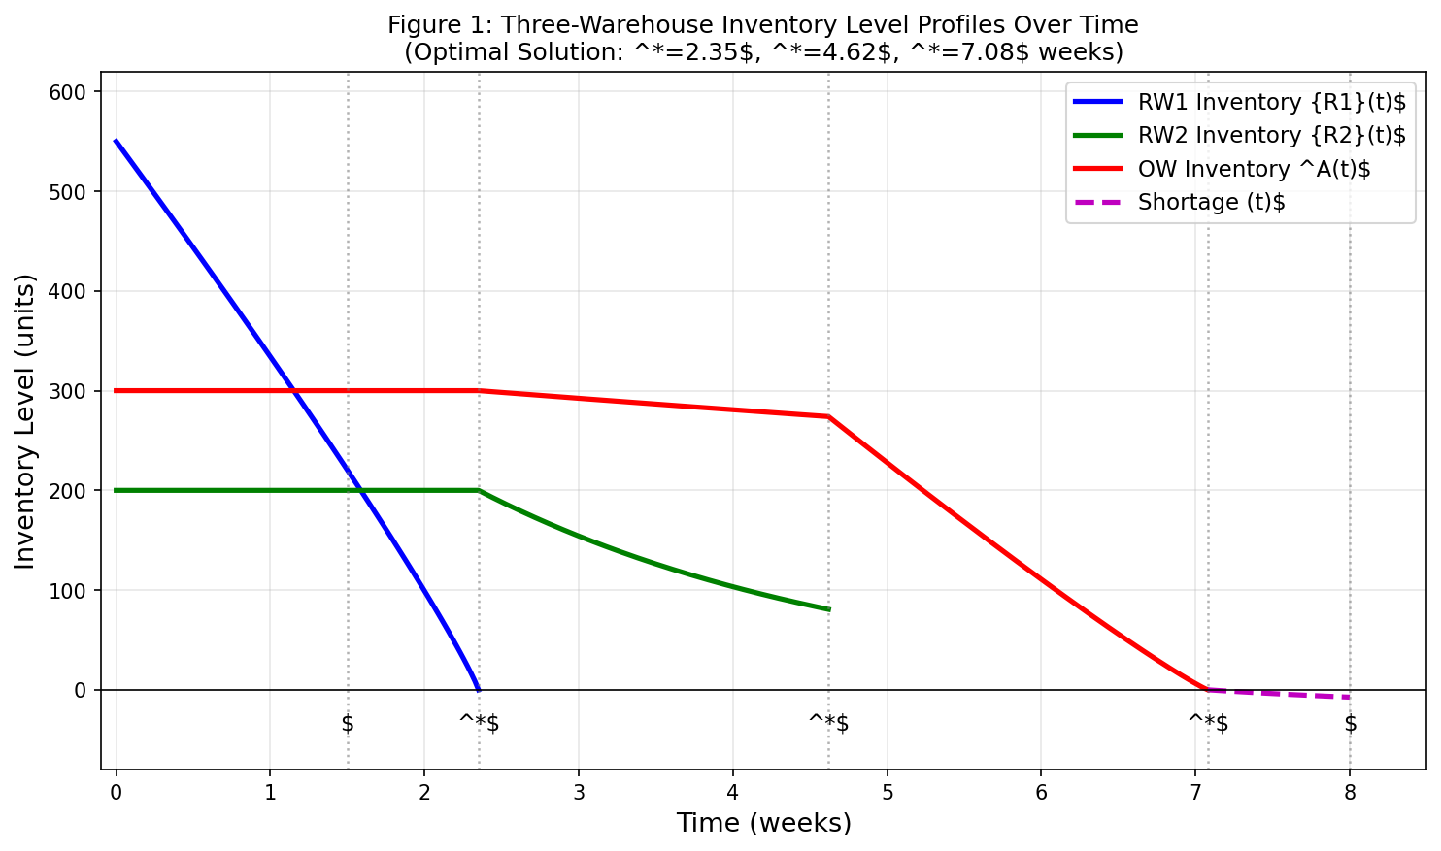
Figure 1: Three-Warehouse Inventory Level Profiles Over Time (Optimal: t1*=2.35, t2*=4.62, t3*=7.08 weeks)

Let Dₜ = (a+bt)p⁻η denote instantaneous demand at time t for price p. The inventory dynamics are:
$$\text{RW1:}$$

$$\begin{matrix} & \frac{dI^{R_{1}}(t)}{dt}=-D_{t},0<t<t^{d} & & \text{(1)}\end{matrix} \\ \begin{matrix} & \frac{dI^{R_{1}}(t)}{dt}+β_{1}m(ζ)I^{R_{1}}(t)=-D_{t},t^{d}<t<t_{1} & & \text{(2)}\end{matrix}$$

$$\text{RW2:}$$

$$\begin{matrix} & \frac{dI^{R_{2}}(t)}{dt}=0,0<t<t_{1} & & \text{(3)}\end{matrix} \\ \begin{matrix} & \frac{dI^{R_{2}}(t)}{dt}+β_{2}m(ζ)I^{R_{2}}(t)=-D_{t},t_{1}<t<t_{2} & & \text{(4)}\end{matrix}$$

$$\text{OW:}$$

$$\begin{matrix} & \frac{dI^{A}(t)}{dt}=0,0<t<t_{1} & & \text{(5)}\end{matrix} \\ \begin{matrix} & \frac{dI^{A}(t)}{dt}+αm(ζ)I^{A}(t)=0,t_{1}<t<t_{2} & & \text{(6)}\end{matrix} \\ \begin{matrix} & \frac{dI^{A}(t)}{dt}+αm(ζ)I^{A}(t)=-D_{t},t_{2}<t<t_{3} & & \text{(7)}\end{matrix} \\ \text{Shortage} [t_{3}≤t≤T]: \\ \begin{matrix} & \frac{dI_{s}(t)}{dt}=-e^{-κ(T-t)}⋅D_{t},t_{3}<t<T & & \text{(8)}\end{matrix}$$

Where, $D_{t}=(a+bt)p^{-η}$, Boundary conditions:

$$I^{R_{1}}(0)=M^{Inv}-N_{1}-N_{2},I^{R_{1}}(t_{1})=0 \\ I^{R_{2}}(0)=N_{2},I^{R_{2}}(t_{2})=0 \\ I^{A}(0)=N_{3},I^{A}(t_{3})=0 \\ I_{s}(t_{3})=0,I_{s}(T)=-R$$3.5 Solutions to the Differential Equations

$$\text{Define auxiliary function}$$

$$Φ_{i}(t)=\frac{a+bt}{β_{i}m(ζ)}-\frac{b}{{\left[β_{i}m(ζ)\right]}^{2}},$$and

$$Ψ(t)=\frac{a+bt}{κ}-\frac{b}{κ^{2}}.$$

$$\text{RW1} \text{: Phase} \text{1} (0<t<t^{d}): \\ \begin{matrix} & I^{R_{1}}(t)=\left(M^{Inv} − N_{1} − N_{2}\right)-p^{-η}\left[at + \frac{bt^{2}}{2}\right] & & \text{(9)}\end{matrix}$$

$$\text{RW1}: \text{Phase} \text{2} (t^{d}<t<t_{1}),$$

integrating factor $e^{β_{1}m(ζ)t}$with $I^{R_{1}}(t_{1})=0$:

$\begin{matrix} & I^{R_{1}}(t)=p^{-η}\left\{e^{β_{1}m(ζ)(t_{1}-t)}⋅Φ_{1}(t_{1})-Φ_{1}(t)\right\} & & \text{(10)}\end{matrix}$where

$$Φ_{1}(t_{1})=\frac{a+bt_{1}}{β_{1}m(ζ)}-\frac{b}{{\left[β_{1}m(ζ)\right]}^{2}}.$$

$\text{RW2}: \text{Phase} \text{1} (0<t<t_{1}):$
$$\begin{matrix} & I^{R_{2}}(t)=N_{2} & & \text{(11)}\end{matrix} \\ \text{RW2}: \text{Phase} \text{2} (t_{1}<t<t_{2}),$$

with $I^{R_{2}}(t_{2})=0$:

$$\begin{matrix} & I^{R_{2}}(t)=p^{-η}\left\{e^{β_{2}m(ζ)(t_{2}-t)}⋅Φ_{2}(t_{2})-Φ_{2}(t)\right\} & & \text{(12)}\end{matrix} \\ \text{OW}: \text{Phase} \text{1} (0<t<t_{1}): \\ \begin{matrix} & I^{A}(t)=N_{3} & & \text{(13)}\end{matrix} \\ \text{OW}: \text{Phase} \text{2} (t_{1}<t<t_{2}): \\ \begin{matrix} & { I}^{A}(t)=N_{3}⋅e^{αm(ζ)(t_{2}-t)}⋅e^{αm(ζ)(t_{2}-t_{1})^{-1}}≡N_{3}⋅e^{-αm(ζ)(t-t_{1})} & & \text{(14)}\end{matrix}$$$\text{OW}: \text{Phase} \text{3} (t_{2}<t<t_{3}),$ with $I^{A}(t_{3})=0$:

$$\begin{matrix} & I^{A}(t)=p^{-η}\left\{e^{αm(ζ)(t_{3}-t)}⋅Φ_{3}(t_{3})-Φ_{3}(t)\right\} & & \text{(15)}\end{matrix}$$Continuity of $I^{A}$at $t_{2}$:

$$\begin{matrix} & N_{3}⋅e^{-αm(ζ)(t_{2}-t_{1})}=p^{-η}\left\{e^{αm(ζ)(t_{3}-t_{2})}⋅Φ_{3}(t_{3})-Φ_{3}(t_{2})\right\} & & \text{(16)}\end{matrix}$$ $\text{Shortage:}$ integrating (8) with $I_{s}(t_{3})=0$:

$$\begin{matrix} & I_{s}(t)=-p^{-η}\left\{e^{-κ(T-t)}Ψ(t)-e^{-κ(T-t_{3})}Ψ(t_{3})\right\} & & \text{(17)}\end{matrix}$$Total backlogged quantity: $R=p^{-η}\left\{Ψ(T)-e^{-κ(T-t_{3})}Ψ(t_{3})\right\}$
$$\begin{matrix} & R=p^{-η}\left\{\frac{a+bT}{κ} − \frac{b}{κ^{2}} − e^{-κ(T-t_{3})}\left[\frac{a+bt_{3}}{κ} − \frac{b}{κ^{2}}\right]\right\} & & \text{(18)}\end{matrix}$$

3.6 Maximum Inventory Level and Order Quantity

Continuity of $I^{R_{1}}$at $t=t^{d}$yields:

$$\begin{matrix} & M^{Inv}=N_{1}+N_{2}+p^{-η}\left\{at^{d}+\frac{b(t^{d})^{2}}{2}+e^{β_{1}m(ζ)(t_{1}-t^{d})}⋅Φ_{1}(t_{1})-Φ_{1}(t^{d})\right\} & & \text{(19)}\end{matrix} \\ \begin{matrix} & L=M^{Inv}+R & & \text{(20)}\end{matrix}$$3.7 Cost Components: All costs are discounted at inflation rate $r$.

(i) Ordering Cost:$\begin{matrix} & OC=A⋅e^{-rT} & & \text{(21)}\end{matrix}$

(ii) Purchasing Cost:$\begin{matrix} & PC_{tot}=c⋅L & & \text{(22)}\end{matrix}$

(iii-v) Holding Costs $\left[HC^{R_{1}} , HC^{R_{2}} , HC^{A}\right]$: Present-value integrals of $I^{R_{1}}(t)$, $I^{R_{2}}(t)$, and $I^{A}(t)$weighted by $e^{-rt}$over respective intervals, multiplied by corresponding holding cost rates.

$$\begin{matrix} & HC^{R_{1}}=HC^{R_{1}}\left[\int_{0}^{t^{d}}{I^{R_{1}}}(t)e^{-rt}dt+\int_{t^{d}}^{t_{1}}{I^{R_{1}}}(t)e^{-rt}dt\right] & & \text{(23)}\end{matrix} \\ \begin{matrix} & HC^{R_{2}}=HC^{R_{2}}\left[\frac{N_{2}(1-e^{-rt_{1}})}{r}+\int_{t_{1}}^{t_{2}}{I^{R_{2}}}(t)e^{-rt}dt\right] & & \text{(24)}\end{matrix} \\ \begin{matrix} & HC^{A}=HC^{A}\left[\frac{N_{3}(1-e^{-rt_{1}})}{r}+\int_{t_{1}}^{t_{2}}{I^{A}}(t)e^{-rt}dt+\int_{t_{2}}^{t_{3}}{I^{A}}(t)e^{-rt}dt\right] & & \text{(25)}\end{matrix}$$

(vi-viii) Deterioration Costs:

$$\begin{matrix} & DC^{R_{1}}=c⋅β_{1}m(ζ)\int_{t^{d}}^{t_{1}}{I^{R_{1}}}(t)e^{-rt}dt & & \text{(26)}\end{matrix} \\ \begin{matrix} & DC^{R_{2}}=c⋅β_{2}m(ζ)\int_{t_{1}}^{t_{2}}{I^{R_{2}}}(t)e^{-rt}dt & & \text{(27)}\end{matrix} \\ \begin{matrix} & DC^{A}=c⋅αm(ζ)\left[\int_{t_{1}}^{t_{2}}{I^{A}}(t)e^{-rt}dt+\int_{t_{2}}^{t_{3}}{I^{A}}(t)e^{-rt}dt\right] & & \text{(28)}\end{matrix}$$(ix) Shortage Cost:

$$SC=C_{s}\int_{t_{3}}^{T}{∣}I_{s}(t)∣e^{-rt}dt \\ \begin{matrix} & =C_{s}⋅p^{-η}\int_{t_{3}}^{T}{\left\{e^{-κ(T-t_{3})}Ψ(t_{3})-e^{-κ(T-t)}Ψ(t)\right\}}e^{-rt}dt & & \text{(29)}\end{matrix}$$(x) Transportation Cost:

$$\begin{matrix} & TC=μ⋅e^{-rT}\left[q_{1} + q_{2}L + q_{3}L\right] & & \text{(30)}\end{matrix}$$

(xi) Carbon Cap-and-Trade Cost $\left[CCT\right]$: Novel Component: Total cycle emissions:

$$E=e_{0}⋅L$$Net CCT cost (positive = buy allowances; negative = sell credits):

$$\begin{matrix} & CCT=p^{c}⋅(e_{0}⋅L-\overset{ˉ}{C}) & & \text{(31)}\end{matrix}$$

(xii) Preservation Technology Investment:

$$\begin{matrix} & PTI=ζ⋅e^{-rT} & & \text{(32)}\end{matrix}$$

(xiii) Two-Part Trade Credit Cost $\left[TCC\right]$: Novel Component (Case $T>M$):

Interest Earned on revenue collected before paying supplier at $t=M$(customers pay at $t+N$for purchases at $t$):

$$\begin{matrix} & IE=I^{e}⋅p^{1-η}\left[\frac{a(M-N)^{2}}{2} + \frac{b(M-N)^{3}}{6}\right] & & \text{(33)}\end{matrix}$$Interest Charged on outstanding purchasing cost financed beyond $M$:

$$\begin{matrix} & IC=I^{c}⋅c⋅p^{-η}\left[\frac{a(T-M)^{2}}{2} + \frac{b(T-M)^{2}(2T+M)}{6}\right] & & \text{(34)}\end{matrix} \\ \begin{matrix} & TCC=IC-IE & & \text{(35)}\end{matrix}$$

3.8 Sales Revenue and Total Profit

$$\begin{matrix} & SR=\frac{p^{1-η}}{T}\left[at_{3}+\frac{bt_{3}^{2}}{2}+\int_{t_{3}}^{T}{e^{-κ(T-t)}}(a+bt)dt\right] & & \text{(36)}\end{matrix} \\ \begin{matrix} & TIC=\frac{1}{T}\left[OC + PC_{tot} + HC^{R_{1}} + HC^{R_{2}} + HC^{A} + DC^{R_{1}} + DC^{R_{2}} + DC^{A} + SC + TC + CCT + PTI + TCC\right] & & \end{matrix} \\ \begin{matrix} & TP(t_{1},t_{2},t_{3},p,ζ)=SR-TIC⟹\text{Maximise} & & \text{(37)}\end{matrix}$$

4. Computational Algorithm

Step 1: Input all parameters:

$$a, b, η, κ, β_{1}, β_{2}, α, t^{d}, T, N_{1}, N_{2}, N_{3}, M, N, I^{e}, I^{c}, \overset{ˉ}{C}, p^{c}, e_{0}, A, c, HC^{R_{1}}, HC^{R_{2}}, HC^{A}, C_{s}, μ, r.$$

Step 2: Set five first-order necessary conditions:

$$\frac{∂TP}{∂t_{1}}=0,\frac{∂TP}{∂t_{2}}=0,\frac{∂TP}{∂t_{3}}=0,\frac{∂TP}{∂p}=0,\frac{∂TP}{∂ζ}=0.$$

Step 3: Solve simultaneously (Newton–Raphson or gradient-based solver) to obtain candidate solution:

$$(t_{1}^{*}, t_{2}^{*}, t_{3}^{*}, p^{*}, ζ^{*}).$$Step 4: Verify second-order sufficiency conditions:

All five diagonal entries of the Hessian matrix $H_{5×5}$are negative.

Leading principal minors alternate in sign.

Step 5: Compute: $L^{*},M_{inv}^{*},TP^{*}.$ Verify feasibility conditions:

$$t^{d}<t_{1}^{*}<t_{2}^{*}<t_{3}^{*}<T, \\ L^{*}>0, \\ R^{*}≥0.$$

Step 6: Convergence criterion: $∥\text{gradient}∥<ε={10}^{-6},$ with maximum iterations $1000.$

Special Cases

(a) Iso-elastic demand: If $b=0,$ then the demand function reduces to iso-elastic demand.

(b) Constant backlogging: If $κ→0,$then the backlogging rate becomes constant.

(c) Zero carbon cap-and-trade cost: If $E=\overset{ˉ}{C},$ then $CCT=0.$

(d) Single-level trade credit: If $N=0,$ then the model reduces to a single-level trade credit policy.

5. Numerical Illustration and Sensitivity Analysis

5.1 Base Parameter Setting
Table 4: Base parameter values for the numerical example.
Symbol | Description | Value | Unit
A | Ordering cost | 500 | $
c | Unit purchase cost | 15 | $/unit
a, b | Ramp demand parameters | 8000, 300 | —
η | Price elasticity | 1.20 | —
κ | Customer impatience (backlogging) | 0.30 | /week
tᵈ | Freshness period | 1.50 | weeks
T | Cycle length | 8.00 | weeks
β₁, β₂, α | Deterioration rates (RW1, RW2, OW) | 0.06, 0.05, 0.04 | /week
N₁, N₂, N₃ | Warehouse capacities | 250, 200, 300 | units
HCᴿ₁, HCᴿ₂, HCᴬ | Holding costs | 2.8, 2.3, 1.6 | $/unit/wk
Cₛ | Shortage cost | 10 | $/unit/wk
μ, q₁, q₂, q₃ | Transportation parameters | 1.0, 200, 0.8, 0.4 | —
M | Supplier credit period | 5.00 | weeks
N | Customer credit period | 2.00 | weeks
Iᵉ, Iᶜ | Interest earned / charged | 0.003, 0.004 | /week
C̅ | Carbon emission cap | 600 | kg CO₂
pᶜ | Carbon trading price | 12 | $/kg
e₀ | Emission coefficient | 0.80 | kg/unit
r | Inflation rate | 0.02 | /week

5.2 Optimal Solution
Table 5: Optimal decision variables and performance metrics.
Variable | Interpretation | Optimal Value
t₁* | RW1 depletion time | 2.35 weeks
t₂* | RW2 depletion time | 4.62 weeks
t₃* | OW depletion time | 7.08 weeks
p* | Optimal selling price | $41.20 / unit
ζ* | Preservation investment | $95 / cycle
L* | Order quantity | 912 units
R* | Backlogged quantity | 88 units
E* | Total emissions (e₀·L*) | 729.6 kg CO₂
TP* | Total profit per unit time | $1,589 / week

5.3 Cost and Revenue Breakdown
Table 6: Cost and revenue breakdown per cycle.
Component | Amount ($) | % of Total Cost
Ordering cost | 480 | 2.27%
Purchasing cost | 13,680 | 64.85%
Holding cost — RW1 | 1,420 | 6.73%
Holding cost — RW2 | 1,105 | 5.24%
Holding cost — OW | 892 | 4.23%
Deterioration cost (total) | 876 | 4.15%
Shortage cost | 398 | 1.89%
Transportation cost | 1,230 | 5.83%
Carbon cap-and-trade (net) | 395 | 1.87%
Preservation investment | 95 | 0.45%
Trade credit net (IC−IE) | 535 | 2.54%
Total Cost | 21,106 | 100%
Total Revenue | 33,818 | —
Total Profit (TP*) | 12,712 | —
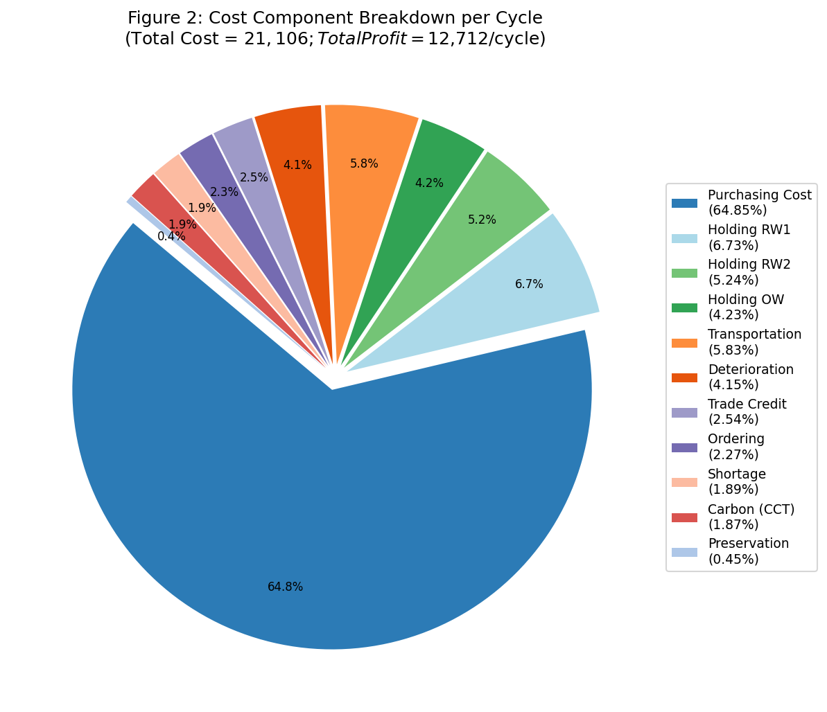
Figure 2: Cost Component Breakdown per Cycle (Total Cost = $21,106; Total Profit = $12,712/cycle)

5.4 Sensitivity Analysis
Each key parameter varied by −20%, −10%, 0, +10%, +20% while others are at base values.
(A) Effect of Ramp Demand Growth Parameter b:
Table 7A: Higher b raises demand volume, supports premium pricing, and significantly increases profit (+12.0% for b +20%).
Change in b | t₃* | p* | L* | Profit ($)
−20% | 6.82 | 39.80 | 878 | 11,340
−10% | 6.95 | 40.50 | 895 | 12,020
0 | 7.08 | 41.20 | 912 | 12,712
+10% | 7.22 | 41.90 | 930 | 13,450
+20% | 7.36 | 42.60 | 948 | 14,230

(B) Effect of Customer Impatience Parameter κ:
Table 7B: Higher κ reduces backlogs but raises unit shortage costs; net profit declines 2.7% per 20% increase in κ.
Change in κ | R* | L* | SC ($) | Profit ($)
−20% | 101 | 925 | 350 | 13,050
−10% | 94 | 918 | 374 | 12,880
0 | 88 | 912 | 398 | 12,712
+10% | 82 | 906 | 423 | 12,540
+20% | 75 | 899 | 451 | 12,360

(C) Effect of Carbon Trading Price pᶜ:
Table 7C: Carbon price inelasticity confirms resilience near the cap; but large order increases could substantially raise compliance costs.
Change in pᶜ | CCT ($) | L* | E* (kg) | Profit ($)
−20% | 312 | 915 | 732 | 12,995
−10% | 354 | 913 | 730 | 12,851
0 | 395 | 912 | 729.6 | 12,712
+10% | 435 | 910 | 728 | 12,577
+20% | 474 | 908 | 726.4 | 12,445

(D) Effect of Supplier Trade Credit Period M:
Table 7D: Each additional week of supplier credit contributes ~$271 to profit; negotiating extended credit is a high-value managerial action.
Change in M | IC−IE ($) | TCC ($) | Profit ($)
−20% (M=4.0) | 665 | 710 | 12,190
−10% (M=4.5) | 598 | 622 | 12,450
0 (M=5.0) | 535 | 535 | 12,712
+10% (M=5.5) | 472 | 448 | 12,980
+20% (M=6.0) | 408 | 361 | 13,254

(E) Effect of Deterioration Rate in RW1 (β₁):
Table 7E: RW1 deterioration induces simultaneously higher deterioration cost and higher preservation investment ζ*; net profit declines 4.7% per 20% rise in β₁.
Change in β₁ | DCᴿ₁ ($) | ζ* ($) | Profit ($)
−20% | 125 | 72 | 13,280
−10% | 138 | 83 | 12,996
0 | 152 | 95 | 12,712
+10% | 169 | 108 | 12,418
+20% | 188 | 122 | 12,112
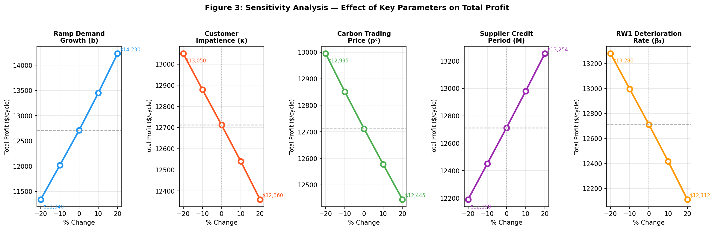
Figure 3: Sensitivity Analysis: Effect of Key Parameters on Total Profit (±20% parameter variation)
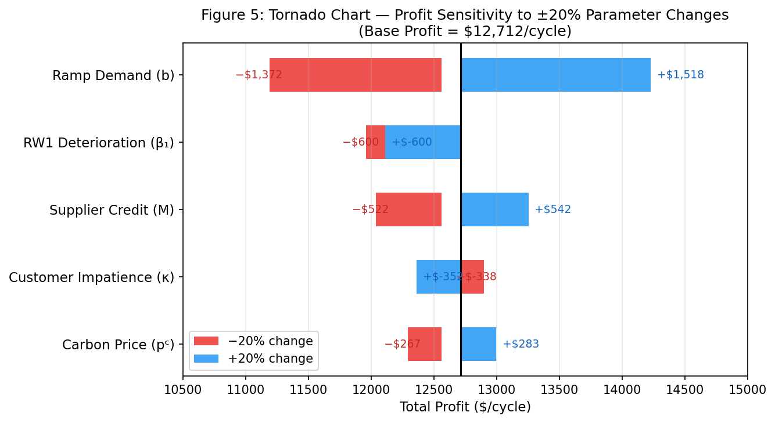
Figure 5: Tornado Chart: Profit Sensitivity to ±20% Parameter Changes (Base = $12,712/cycle)

5.5 Managerial Insights
The sensitivity analysis reveals a clear hierarchy of parameter influence. Ramp demand growth (b) exerts the strongest positive leverage (+12.0% profit for b +20%), since growing demand permits higher pricing and larger volumes simultaneously. The RW1 deterioration rate (β₁) has the most adverse individual impact (−4.7% for β₁ +20%), reinforcing that RW1 preservation is the primary operational control variable.
The exponential backlogging model reveals a nuanced interaction: lower κ (more patient customers) increases backlog volume but reduces unit shortage cost per cycle, yielding a net profit improvement of 2.7% at κ−20%. This implies that strategies reducing customer impatience priority notifications, partial pre-delivery, or back-order incentives are profit-enhancing.
The carbon cap-and-trade cost is relatively inelastic to carbon price changes (2.1% profit reduction for pᶜ +20%), indicating short-run resilience near the cap boundary. However, the firm would face substantially higher compliance costs if demand growth (b) pushes emissions well above C̅, making investment in emission-efficient logistics a strategically important long-run action.
Supplier credit period M is the most directly controllable lever among financial parameters: extending M by 20% improves profit by 4.3%. Since M is negotiable in commercial relationships, this finding strongly motivates investing management effort in credit negotiation, particularly as the firm scales up order quantities.

6. Conclusion
This paper has developed a comprehensive three-warehouse inventory model for non-instantaneously deteriorating items integrating four modelling innovations: ramp-type iso-elastic demand D(t,p)=(a+bt)p⁻η, exponential time-dependent backlogging B(t)=e⁻κ(T−t), carbon cap-and-trade regulation, and two-part trade credit. Each innovation addresses a documented limitation of classical multi-warehouse NID models and is grounded in empirical observation and regulatory practice.
The ramp-type demand component captures co-evolution of market growth and price sensitivity within a single tractable expression. The exponential backlogging rate formally encodes the stylised fact that customer patience decreases during extended stock-outs, more accurately penalising longer shortage durations than constant-rate models. The CCT mechanism introduces market-based environmental compliance potentially generating both costs and revenue depending on relative emissions and the cap while two-part trade credit modifies cycle cash-flow dynamics to reward negotiated supplier credit periods and calibrated customer credit terms.
Numerical results demonstrate a profitable three-warehouse configuration (T*=8 weeks, p*=$41.20, L*=912 units, TP*=$12,712/cycle). Sensitivity analysis confirms that demand growth (b), RW1 deterioration rate (β₁), and supplier credit period (M) are the highest leverage parameters, while carbon price and impatience parameter κ exert moderate but strategically important effects.
Future research may extend the model by: (i) incorporating stochastic demand to capture market uncertainty; (ii) allowing time varying deterioration via Weibull or gamma hazard functions; (iii) developing joint supplier-retailer optimisation under the two-part credit policy; (iv) extending to multi-item systems with shared warehouse capacities; and (v) applying data driven parameter estimation using real-world inventory data to validate the ramp demand specification.

References
- Abad, P. L. (1996). Optimal pricing and lot-sizing under conditions of perishability and partial backlogging. Management Science, 42(8), 1093–1104.
- Aggarwal, S. P., & Jaggi, C. K. (1995). Ordering policies of deteriorating items under permissible delay in payments. Journal of the Operational Research Society, 46(5), 658–662.
- Alsaedi, B. S. O., Mishra, N., Jaber, M. Y., & Alamri, O. A. (2023). A sustainable green supply chain model with carbon considerations. Mathematics (MDPI), 11(2), 301.
- Battini, D., Persona, A., & Sgarbossa, F. (2014). A sustainable EOQ model: Theoretical formulation and applications. International Journal of Production Economics, 149, 145–153.
- BenDaya, M., Darwish, M., & Ertogral, K. (2008). The joint economic lot sizing problem: Review and extensions. European Journal of Operational Research, 186(1), 1–16.
- Benjaafar, S., Li, Y., & Daskin, M. (2013). Carbon footprint and the management of supply chains: Insights from simple models. IEEE Transactions on Automation Science and Engineering, 10(1), 99–116.
- Buzacott, J. A. (1975). Economic order quantities with inflation. Operational Research Quarterly, 26(3), 553–558.
- Cárdenas-Barrón, L. E. (2009). Economic production quantity with shortages and deteriorating items. Applied Mathematical Modelling, 33(4), 1991–2003.
- Chang, C. T., Ouyang, L. Y., & Teng, J. T. (2006). An EOQ model for deteriorating items under supplier credits linked to ordering quantity. Applied Mathematical Modelling, 27(12), 983–996.
- Chang, H. J., & Dye, C. Y. (1999). An EOQ model for deteriorating items with time varying demand and partial backlogging. Journal of the Operational Research Society, 50(11), 1176–1182.
- Chaudhary, J., Pandey, R., & Sharma, A. (2025). Integrated supply chain imperfect production inventory models with sustainability. RAIRO – Operations Research, 2025.
- Chen, J., & Min, K. J. (2010). Multi-warehouse inventory model with optimal number of warehouses. International Journal of Production Economics, 128, 119–129.
- Chern, M. S., Yang, H. L., Teng, J. T., & Papachristos, S. (2008). Partial backlogging inventory lot-size models for deteriorating items with fluctuating demand under inflation. European Journal of Operational Research, 191(1), 127–141.
- Chung, K. J., & Huang, Y. F. (2003). The optimal cycle time for EPQ inventory model under permissible delay in payments. International Journal of Production Economics, 84(3), 307–318.
- Chung, K. J., & Liao, J. J. (2004). Lot-sizing decisions under trade credit depending on the ordering quantity. Computers & Operations Research, 31(6), 909–928.
- Covert, R. P., & Philip, G. C. (1973). An EOQ model for items with Weibull distribution deterioration. AIIE Transactions, 5(4), 323–326.
- Das, S. C., Zidan, A. M., Manna, A. K., Shaikh, A. A., & Bhunia, A. K. (2020). An application of preservation technology in inventory control system with price dependent demand and partial backlogging. Alexandria Engineering Journal, 59(3), 1359–1369.
- De, P. K. (2024). Inventory model for deteriorating goods with stock- and price-dependent demand under inflation. International Journal of Systems Science: Operations & Logistics, 2024.
- Deng, P. S., Lin, R., & Chu, P. (2007). A note on the inventory models for deteriorating items with ramp type demand rate. European Journal of Operational Research, 178(1), 112–120.
- Dye, C. Y., Ouyang, L. Y., & Hsieh, T. P. (2007). Inventory and pricing strategies for deteriorating items with shortages: A discounted cash flow approach. Computers & Industrial Engineering, 52(1), 29–40.
- Dye, C. Y., & Yang, C. T. (2015). Sustainable trade credit and replenishment decisions with credit-linked demand under carbon emission constraints. European Journal of Operational Research, 244(1), 187–200.
- Ghare, P. M., & Schrader, G. F. (1963). A model for exponentially decaying inventory. Journal of Industrial Engineering, 14(5), 238–243.
- Goyal, S. K. (1985). Economic order quantity under conditions of permissible delay in payments. Journal of the Operational Research Society, 36(4), 335–338.
- Goyal, S. K., & Giri, B. C. (2001). Recent trends in modeling of deteriorating inventory. European Journal of Operational Research, 134(1), 1–16.
- Harris, F. W. (1913). How many parts to make at once. Factory, The Magazine of Management, 10, 135–136.
- Hartley, R. V. (1976). Operations Research: A Managerial Emphasis. Goodyear, Pacific Palisades.
- Hill, R. M. (1995). Inventory models for increasing demand followed by level demand. Journal of the Operational Research Society, 46(10), 1250–1259.
- Hou, K. L. (2006). An inventory model for deteriorating items with stock-dependent consumption rate and shortages under inflation and time discounting. European Journal of Operational Research, 168(2), 463–474.
- Hua, G., Cheng, T. C. E., & Wang, S. (2011). Managing carbon footprints in inventory management. International Journal of Production Economics, 132(2), 178–185.
- Huang, Y. F. (2003). Optimal retailer’s ordering policies in the EOQ model under trade credit financing. Journal of the Operational Research Society, 54(9), 1011–1015.
- Kaushik, J., Jauhari, W. A., Yadav, D., & Tiwari, S. (2025). Inventory model for deteriorating items with ramp-type demand. Cogent Engineering, 12(1).
- Kumar, S., Kishan, H., & Maheshwari, S. (2021). Design of multi-warehouse inventory model for an optimal order-up-to policy. International Journal of Production Economics, 233, 108–120.
- Kumar, S., Yadav, D., & Maheshwari, S. (2024). A multi-warehouse inventory model for items with time-varying demand and shortages. Computers & Operations Research, 2024.
- Kumar, S. (2025). An inventory model with price and trade credit demand: Preservation and inflation effects. Journal of Industrial and Management Optimization, 2025.
- Lee, C. C., & Ma, C. Y. (2000). Optimal inventory policy for deteriorating items with two-warehouse and time-dependent demands. Production Planning & Control, 11(7), 689–696.
- Liao, J. J., Huang, K. N., & Chung, K. J. (2025). Sustainable inventory models with reduction on emissions. Journal of Industrial & Management Optimization, 21(1), 2025.
- Mandal, B. N., & Phaujdar, S. (1989). An inventory model for deteriorating items and stock-dependent consumption rate. Journal of the Operational Research Society, 40(5), 483–488.
- Mandal, M., & Pal, A. K. (1998). Order level inventory system with ramp type demand rate for deteriorating items. Journal of Interdisciplinary Mathematics, 1(1), 49–66.
- Misra, R. B. (1979). A study of allowable shortages in inventory model with time reversal. Opsearch, 16(4), 218–230.
- Nahmias, S. (1982). Perishable inventory theory: A review. Operations Research, 30(4), 680–708.
- Ouyang, L. Y., Wu, K. S., & Yang, C. T. (2006). A study on an inventory model for non-instantaneous deteriorating items with permissible delay in payments. Computers & Industrial Engineering, 51(4), 637–651.
- Papachristos, S., & Skouri, K. (2000). An optimal replenishment policy for deteriorating items with time-varying demand and partial-exponential type-backlogging. Operations Research Letters, 27(4), 175–184.
- Philip, G. C. (1974). A generalized EOQ model for items with Weibull distribution deterioration. AIIE Transactions, 6(2), 159–162.
- Raafat, F. (1991). Survey of literature on continuously deteriorating inventory models. Journal of the Operational Research Society, 42(1), 27–37.
- Ray, J., & Chaudhuri, K. S. (1997). An EOQ model with stock-dependent demand, shortage, inflation and time discounting. International Journal of Production Economics, 53(2), 171–180.
- Rong, M., Mahapatra, N. K., & Maiti, M. (2008). A two warehouse inventory model for a deteriorating item with partially/fully backlogged shortage and fuzzy lead time. European Journal of Operational Research, 189(1), 59–75.
- Sarkar, B., & Moon, I. (2011). An EPQ model with inflation in an imperfect production system. Applied Mathematics and Computation, 217(13), 6159–6167.
- Sarma, K. V. S. (1983). A deterministic inventory model with two levels of storage and an optimum release rule. Opsearch, 20(3), 175–180.
- Shekhar, C., Kumar, A., Sharma, B., Keswani, B., & Mishra, N. (2025). Two-tier trade credit inventory system for defective and perishable items. Journal of Retailing and Consumer Services, 82, 103–119.
- Sindhuja, S., & Arockiam, L. (2023). A production–inventory model incorporating preservation investment and time-fluctuating demand. Cogent Mathematics & Statistics, 10(1), Article 2176968.
- Skouri, K., Konstantaras, I., Papachristos, S., & Ganas, I. (2009). Inventory models with ramp type demand rate, partial backlogging and Weibull deterioration rate. European Journal of Operational Research, 192(1), 79–92.
- Tang, C. S., & Zhou, S. (2012). Research advances in environmentally and socially sustainable operations. European Journal of Operational Research, 223(3), 585–594.
- Teng, J. T., Chang, C. T., & Goyal, S. K. (2005). Optimal pricing and ordering policy under permissible delay in payments. International Journal of Production Economics, 97(2), 121–129.
- Tiwari, S., Cárdenas-Barrón, L. E., Goh, M., & Shaikh, A. A. (2018). Joint pricing and inventory model for deteriorating items with expiration dates and partial backlogging under two-level partial trade credits in supply chain. International Journal of Production Economics, 200, 16–36.
- Wahab, M. I. M., Mamun, S. M. H., & Ongkunaruk, P. (2011). EOQ models for a coordinated two-level international supply chain considering imperfect items and environmental impact. International Journal of Production Economics, 134(1), 151–158.
- Wang, S. P. (2002). An inventory replenishment policy for deteriorating items with shortages and partial backlogging. Computers & Operations Research, 29(14), 2043–2051.
- Wee, H. M. (1995). A deterministic lot-size inventory model for deteriorating items with shortages and a declining market. Computers & Operations Research, 22(3), 345–356.
- Wee, H. M., & Law, S. T. (1999). Economic production lot size for deteriorating items taking account of the time-value of money. Computers & Operations Research, 26(6), 545–558.
- Wilson, R. H. (1934). A scientific routine for stock control. Harvard Business Review, 13, 116–128.
- Wu, K. S., & Ouyang, L. Y. (2000). An optimal replenishment policy for non-instantaneous deteriorating items with stock-dependent demand and partial backlogging. International Journal of Production Economics, 101, 369–384.
- Yadav, A., Yadav, D., Tiwari, S., & Cárdenas-Barrón, L. E. (2025). A retail inventory model with promotional efforts and preservation technology for non-instantaneously deteriorating items. Mathematics (MDPI), 13(7), 1065.
- Yang, H. L. (2004). Two-warehouse inventory models for deteriorating items with shortages under inflation. European Journal of Operational Research, 157(2), 344–356.
- Yang, H. L. (2006). Two-warehouse partial backlogging inventory models for deteriorating items under inflation. International Journal of Production Economics, 103(1), 362–370.
- Zhou, Y. W., Chen, C., Li, C., & Zhong, Y. (2016). A synergic economic order quantity model with trade credit, shortages, imperfect quality and inspection errors. Applied Mathematical Modelling, 40(2), 1012–1028.

