Germination as a Bioprocessing Strategy for Enhancing Functional Properties and Protein Structural Profiles of Moringa oleifera Seed Protein Isolates: A Comparative Review with Soy Protein Isolates

ABSTRACT
Moringa oleifera seed protein isolates (MPI) have gained increasing attention as sustainable plant protein alternatives; however, their functional properties remain highly variable and underutilized compared to soy protein isolate (SPI). This review critically evaluates germination as a bioprocessing strategy for enhancing MPI structural and functional properties, including solubility, foaming, water holding capacity (WHC), and oil holding capacity (OHC), while providing a comparative perspective with SPI.Evidence indicates that germination improves MPI functionality primarily through enzymatic proteolysis of storage globulins, resulting in reduced molecular weight, increased surface polarity, and improved protein–water and protein–lipid interactions. Optimal germination (~48 h) enhances solubility by 10–15%, foaming capacity by 15–30%, WHC by up to 50%, and OHC by approximately 20–30%. However, SPI consistently outperforms MPI in foaming and gelation due to its structured glycinin and β-conglycinin fractions. The review further highlights strong geographic origin effects on MPI functionality, driven by variations in protein composition, particularly the ratio of globulins to cationic albumins. Indian MPI shows acid-soluble albumin dominance, Thai MPI exhibits soy-like solubility behavior, and Cameroonian MPI displays mixed functional profiles. Despite these advances, key gaps remain in molecular characterization, standardization of extraction methods, and integration of omics-based approaches.
Generally, germination represents a low-cost, sustainable strategy to enhance MPI functionality, but full industrial competitiveness with SPI will require integrated bioprocessing and better understanding of genotype–environment–protein interactions.

Keywords: Moringa oleifera; germination; Protein Isolate; Solubility; SDS-PAGE; foaming; water holding capacity; oil holding capacity; soy protein
- INTRODUCTION
The global shift toward plant-based diets has accelerated interest in sustainable protein ingredients with acceptable nutritional quality and techno-functional performance. Soy protein isolate (SPI) remains the most commercially established plant protein because of its excellent emulsification, gelation, foaming, and water-binding capacities. These properties are largely attributed to its major storage proteins, glycinin and β-conglycinin, which provide structural flexibility and network-forming ability in food systems.
Despite its industrial importance, soy production faces environmental and geographical limitations, including deforestation concerns and restricted adaptability to semi-arid climates. Consequently, alternative protein sources adapted to harsh environments are increasingly being explored. Moringa oleifera is a drought-tolerant multipurpose tree widely cultivated in Africa and Asia. Its seeds contain approximately 30-40% protein on a dry matter basis and possess a balanced amino acid composition rich in arginine and glutamic acid. Recent studies have shown that alkaline extraction followed by isoelectric precipitation can produce moringa protein isolates with protein purity exceeding 80%. However, inconsistencies in functional performance between studies suggest that protein composition and behavior are strongly influenced by seed origin, extraction conditions, and pretreatment methods.
Among the available pretreatments, germination has attracted significant attention because it naturally activates endogenous enzymes that hydrolyze storage macromolecules without the use of harsh chemicals. Controlled germination modifies protein structure, improves digestibility, reduces anti-nutritional compounds, and enhances functional performance. Nevertheless, the mechanisms through which germination affects MPI functionality remain fragmented across the literature.
This review therefore aims to:
- Evaluate the effects of germination on the structural characteristics of MPI using SDS-PAGE evidence.
- Compare the impact of germination on solubility, foaming, WHC, and OHC of MPI relative to SPI.
- Discuss the influence of geographic origin on MPI functionality and identify major research gaps.

2. METHODOLOGY
This review was prepared through a comprehensive evaluation of published studies focusing on the effect of germination on the structural and functional properties of Moringa oleifera seed proteins. Relevant literature published between 1995 and 2026 was retrieved from ScienceDirect, Scopus, Web of Science, and Google Scholar using combinations of keywords including “Moringa oleifera”, “germination”, “protein isolate”, “functional properties”, “SDS-PAGE”, “protein solubility”, “foaming capacity”, “water holding capacity”, and “soy protein isolate”. Priority was given to peer-reviewed articles reporting germination-induced changes in protein structure, extraction behavior, and techno-functional properties of moringa seed proteins. Comparative studies involving soy and other leguminous protein systems were also included to provide mechanistic and functional context. Studies focusing exclusively on medicinal, pharmacological, or non-food applications were excluded unless directly related to protein characterization or functionality.
Data extracted from the selected studies included germination conditions, extraction methods, SDS-PAGE profiles, pH–solubility behaviour, foaming properties, water holding capacity (WHC), and oil holding capacity (OHC). The collected information was critically compared and synthesized to identify consistent trends, mechanistic relationships, and major research gaps related to the application of germination as a bioprocessing strategy for moringa protein isolates.

3. GERMINATION-INDUCED STRUCTURAL AND FUNCTIONAL MODIFICATION OF MORINGA SEED PROTEINS
3.1 Biochemical Changes During Germination
Germination initiates a series of biochemical and structural changes that significantly influence the functionality of Moringa oleifera seed proteins. During this process, endogenous enzymes such as proteases, phytases, and amylases become activated to mobilize storage reserves required for seedling development (Bewley et al., 2013; Nkhata et al., 2018). Among these enzymes, proteases play the most important role in modifying protein functionality by partially hydrolysing compact storage globulins into smaller peptides and amino acids. This controlled proteolysis reduces molecular size, increases structural flexibility, and exposes previously buried hydrophilic and hydrophobic residues. As a result, germinated proteins generally show improved extractability, solubility, and interaction with water and oil systems compared with ungerminated proteins.
In addition to protein hydrolysis, germination contributes to the degradation of anti-nutritional compounds such as phytates and trypsin inhibitors, which are known to interfere with protein digestibility and functionality (Aviles-Gaxiola et al., 2018). Reduction of phytate–protein interactions improve mineral availability and enhances protein–water interactions within the isolate matrix. Similar biochemical effects have also been reported in soy, chickpea, mung bean, lentil, and kidney bean proteins, indicating that moderate germination-induced hydrolysis is a conserved mechanism underlying functional improvement in leguminous proteins.
3.2 SDS-PAGE and Structural Characterization
Structural modifications occurring during germination are commonly evaluated using sodium dodecyl sulphate–polyacrylamide gel electrophoresis (SDS-PAGE), which should be regarded as a molecular characterization technique rather than a functional property. Electrophoretic profiles consistently demonstrate progressive disappearance of high-molecular-weight storage protein bands alongside the accumulation of low-molecular-weight peptide fragments as germination advances (Mune Mune et al., 2016). These changes provide direct evidence of proteolytic hydrolysis and structural remodeling within the protein matrix.
Compared with soy protein isolate (SPI), moringa proteins display distinctive electrophoretic characteristics due to the persistence of low-molecular-weight cationic albumin bands within the 6–14 kDa range (Gassenschmidt et al., 1995). These albumins remain detectable even after germination and partly explain the unusual alkaline insolubility observed in some Indian moringa isolates (Jain et al., 2019). In contrast, soy proteins are dominated by glycinin and β-conglycinin fractions, whose controlled hydrolysis during germination is closely associated with improvements in interfacial and hydration properties.
3.3 Effect of Germination on Protein Solubility
Protein solubility is one of the most important functional properties influencing the application of plant proteins in food systems because it affects emulsification, foaming, gelation, and digestibility. Compared with SPI, which generally exhibits a symmetrical U-shaped pH–solubility profile with minimum solubility near pH 4–5, moringa protein isolates (MPIs) display considerable variation depending on seed origin and protein composition. Thai moringa isolates showed a soy-like profile with increasing solubility under alkaline conditions, whereas Indian isolates displayed high solubility at acidic pH but severe insolubility at alkaline pH because of enrichment in cationic albumins with elevated isoelectric points (Anyiam et al., 2025; Jain et al., 2019). Cameroonian isolates showed relatively low and broad solubility profiles across the pH range, indicating a more heterogeneous protein composition (Mune Mune et al., 2016).
Germination generally improves solubility by reducing molecular size and increasing exposure of ionisable amino acid residues capable of interacting with water molecules (Damodaran, 2008). Most studies consistently report maximum improvement after approximately 48 h germination, beyond which excessive hydrolysis may destabilize the protein matrix and reduce isolate recovery. This non-linear response highlights the importance of maintaining a balance between productive partial hydrolysis and excessive degradation during germination.

3.4 Effect of Germination on Foaming Properties
Foaming properties are important in food systems where proteins are required to adsorb rapidly at the air–water interface and form stable interfacial films. Compared with SPI, moringa proteins generally show lower foaming capacity and stability because they lack a β-conglycinin-equivalent fraction with highly flexible amphiphilic properties (Fukushima, 1991). Nevertheless, controlled germination improves foaming behaviour by producing smaller and more surface-active peptide fragments capable of faster interfacial adsorption.
Studies consistently report moderate improvements in foaming capacity after approximately 48 h germination, although excessive hydrolysis beyond this stage may weaken film cohesion and reduce foam stability. Similar trends have been reported in soy, chickpea, mung bean, and lentil proteins, further supporting the role of moderate proteolysis in enhancing interfacial functionality across leguminous protein systems.
3.5 Effect of Germination on Water and Oil Holding Capacities
Water holding capacity (WHC) and oil holding capacity (OHC) are strongly influenced by the structural modifications induced during germination. Improvement in WHC is mainly associated with exposure of polar amino acid residues and increased matrix porosity following partial protein unfolding. Ungerminated MPI generally shows lower WHC than SPI because of its compact globular structure, but germination substantially improves water retention properties by increasing protein–water interactions. In contrast, OHC in MPI is relatively comparable to SPI even before germination, largely because moringa proteins contain appreciable amounts of hydrophobic amino acids such as leucine, phenylalanine, and proline (Makkar & Becker, 1996). Germination further enhances OHC through exposure of additional hydrophobic regions within the protein matrix. However, prolonged germination beyond the optimum period may lead to excessive fragmentation and gradual loss of structural integrity.

4. DISCUSSION
4.1Effect of Germination of Structural Characterization
SDS-PAGE evidence provides strong molecular-level confirmation that germination significantly modifies the structural architecture of Moringa oleifera seed protein isolate (MPI). In ungerminated seeds, the electrophoretic profile is dominated by high-molecular-weight storage globulins (approximately 45–65 kDa), which are structurally and functionally comparable to soy glycinin and β-conglycinin subunits (Bau et al., 1997; Barac et al., 2017). These proteins represent the major reserve fraction and are responsible for the characteristic precipitation behaviour during isoelectric isolation. During germination, activation of endogenous proteases leads to progressive hydrolysis of these globulins, resulting in a marked reduction in high-molecular-weight band intensity, thereby confirming partial degradation of the native storage protein matrix (Ghumman et al., 2016; Mune Mune et al., 2016).
As germination advances, SDS-PAGE profiles consistently show the emergence and accumulation of low-molecular-weight peptides (<20 kDa), indicating extensive proteolytic cleavage of storage proteins into smaller fragments. This shift reflects a transition from structured globulin assemblies to a more fragmented peptide population, which is closely associated with improved extractability and altered physicochemical behaviour of MPI (Nkhata et al., 2018). Importantly, cationic albumins (6-14 kDa), previously characterised by Gassenschmidt et al. (1995) and Ndabigengesere et al. (1995), remain largely stable throughout germination. Their persistence suggests structural resistance to enzymatic hydrolysis, maintaining a distinct protein fraction that differentiates Moringa from soy protein systems, where such stable low-MW cationic fractions are absent.
SDS-PAGE profiles provide clear mechanistic evidence that germination transforms MPI from a globulin-rich, high-molecular-weight system into a peptide-enriched matrix with reduced structural complexity. This degradation pattern directly supports reported improvements in solubility and functional performance of germinated MPI, while also preserving a stable cationic albumin fraction that contributes to its unique protein behaviour (Jain et al., 2019; Anyiam et al., 2025).
Figure 1. Schematic SDS-PAGE Protein Band Patterns for Moringa and Soy Protein Isolates at Three Germination Stages
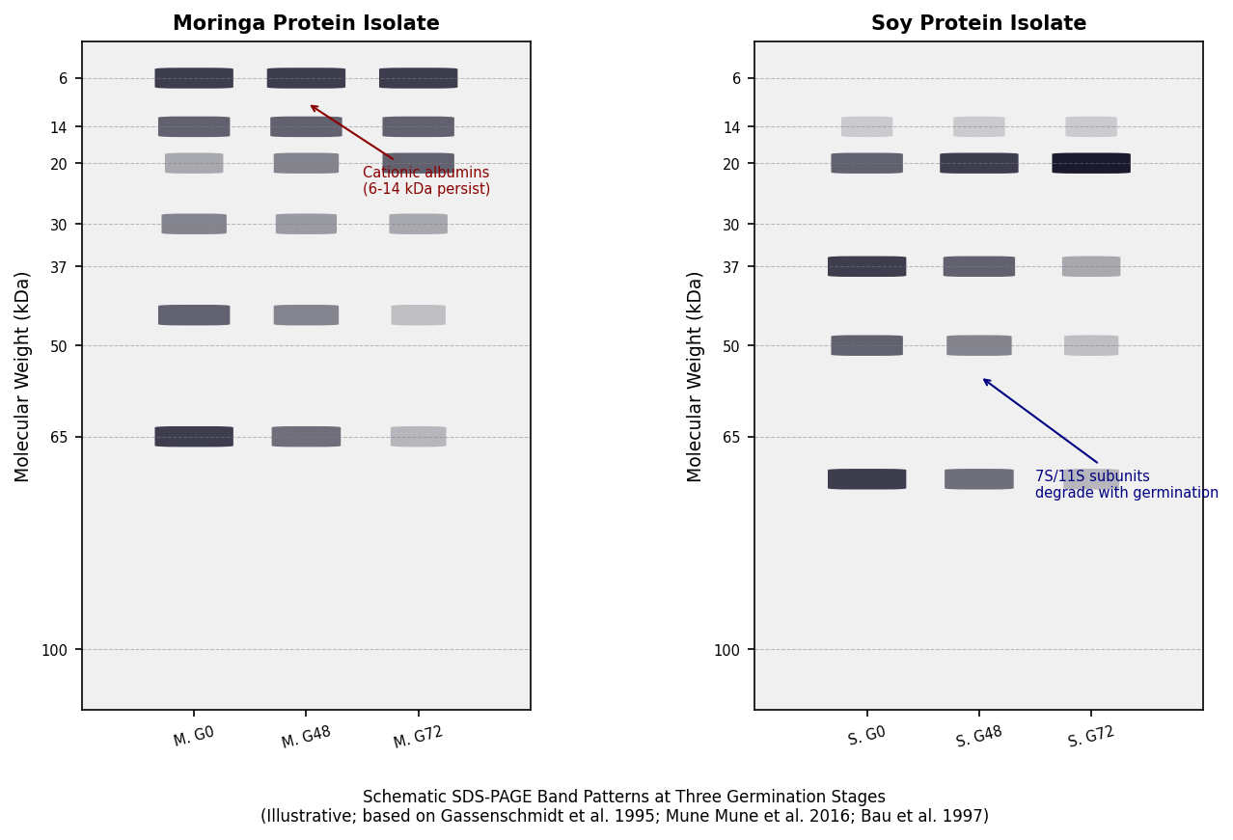
Illustrative band intensities based on Gassenschmidt et al. (1995); Mune Mune et al. (2016); Sangronis & Machado (2007); Bau et al. (1997). High-MW storage protein bands (>40 kDa) diminish progressively with germination; low-MW peptide bands (<20 kDa) accumulate. Moringa retains cationic albumin bands (6-14 kDa) throughout - a distinguishing feature absent in soy that explains alkaline-pH insolubility of Indian-sourced MPIs.
4.2.1 Solubility Behavior
Germination consistently enhances the solubility of Moringa oleifera protein isolates (MPI), particularly around neutral pH, through a combination of controlled proteolysis, unfolding of compact protein structures, and increased exposure of ionizable amino acid residues. During germination, endogenous proteases partially hydrolyze storage globulins, reducing molecular size and increasing the number of free amino and carboxyl groups available for protein–water interactions. This improves hydration and dispersion behavior at physiological pH (Damodaran, 2008; Foegeding & Davis, 2011; Nkhata et al., 2018). In practical terms, studies have reported solubility improvements of approximately 10–15% at pH 6-7 after 48 h germination in Moringa seed protein systems, confirming a moderate but consistent enhancement in functionality (Mune Mune et al., 2016).
In comparison, SPI exhibits a more classical and symmetrical U-shaped solubility curve, with minimum solubility near its isoelectric point (~pH 4.5) and high solubility under alkaline conditions due to glycinin and β-conglycinin dissociation (Barac et al., 2017; Kinsella, 1979). Germination-induced improvements in MPI partially reduce this functional gap by shifting protein structure toward smaller, more hydrophilic peptides, but MPI still shows strong genotype- and origin-dependent variability. For instance, Indian MPI tends to show extremely high solubility at acidic pH due to cationic albumin dominance, whereas Thai and Cameroonian variants exhibit more globulin-like behavior (Jain et al., 2019; Anyiam et al., 2025). This comparative solubility behavior is further visualized in Figure 2, which shows how germination shifts MPI profiles upward at neutral pH while still maintaining structural divergence from SPI.

Figure 2. pH-Solubility Profiles of Moringa Protein Products from Three Geographic Sources vs Soy Protein Isolate (SPI)
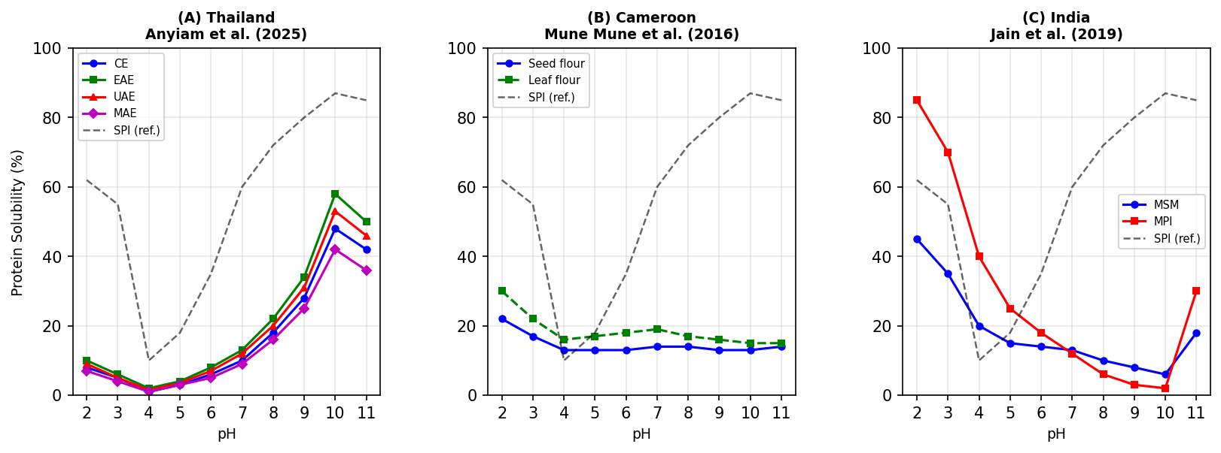
(A) Thailand - soy-like U-shape, minimum at pH 4, maximum at pH 10 (Anyiam et al., 2025). CE=Conventional, EAE=Enzyme-Assisted, UAE=Ultrasound-Assisted, MAE=Microwave-Assisted Extraction. (B) Cameroon-acid-dominant, flat alkaline profile (Mune Mune et al., 2016). Seed flour (dashed) vs leaf flour (solid). (C) India - strongly inverted; MSM=Moringa Seed Meal; MPI=Moringa Protein Isolate (Jain et al., 2019). Grey dashed line = SPI reference (Kinsella, 1979). Values digitalised from published figures.
4.2.2 Foaming Properties
Foaming behavior in protein systems is governed by a balance between rapid adsorption at the air–water interface and the ability to form a stable, viscoelastic film. Germination enhances MPI foaming capacity by generating smaller peptide fragments that diffuse more rapidly to the interface and partially unfold, thereby improving surface activity (Foegeding & Davis, 2011; Wilde, 2000). Across germination studies (Figure 3), a 15–30% increase in foaming capacity has been reported at around 48 h, indicating an optimal proteolysis window where functional improvement is maximized before excessive breakdown occurs (Mune Mune et al., 2016; Nkhata et al., 2018).
However, even with germination, MPI foaming performance remains lower than SPI. This is primarily due to the absence of soy β-conglycinin-like flexible subunits, which provide superior interfacial film formation and elasticity (Renkema & van Vliet, 2002; Lam et al., 2018). SPI typically achieves foaming capacities above 120%, while MPI remains significantly lower across all geographic variants, although enzymatic or physical pretreatments can narrow this gap (Anyiam et al., 2025). Beyond 48-72 h germination, over-hydrolysis reduces peptide size below the threshold required for stable film formation, leading to foam collapse (Khattab & Arntfield, 2009).
4.2.3 Water Holding Capacity (WHC)
Water holding capacity is strongly influenced by protein unfolding, surface polarity, and matrix porosity. Germination enhances WHC in MPI by exposing hydrophilic amino acid residues and increasing the number of available hydrogen bonding sites. Proteolytic cleavage during germination disrupts compact globulin structures, allowing water molecules to penetrate and become physically entrapped within a more open protein matrix (Damodaran, 2008; Zayas, 1997).
Experimental evidence (Figure 3) shows that WHC in germinated Moringa protein systems can increase by approximately 35–50% after 48 h, bringing values closer to the lower range of SPI functionality (Mune Mune et al., 2016). SPI still maintains superior WHC (3.5-5.0 g/g protein) due to its well-developed gel network-forming glycinin fraction, which creates stable water-retaining structures upon hydration and mild heating (Foegeding & Davis, 2011; Renkema & van Vliet, 2002). Nonetheless, germination clearly improves MPI suitability for hydrated food systems such as bakery and meat analogues.
4.2.4 Oil Holding Capacity (OHC)
Oil holding capacity in protein systems is primarily governed by surface hydrophobicity and the ability of proteins to physically entrap lipid molecules within their matrix. Unlike solubility and WHC, OHC is less sensitive to pH but strongly influenced by exposure of non-polar residues such as leucine, isoleucine, and phenylalanine during structural modification (Nakai, 1983; Moure et al., 2006).
Germination enhances MPI OHC moderately (approximately 20–30%) by increasing surface hydrophobic exposure through partial proteolysis, allowing improved lipid binding and retention. However, MPI and SPI remain functionally comparable in OHC (1.5-2.5 g/g protein range), suggesting that lipid-binding capacity is a conserved property among legume proteins (Mune Mune et al., 2016; Lam et al., 2018). SPI’s similar OHC is attributed to its balanced distribution of hydrophobic residues across glycinin and β-conglycinin fractions (Wolf, 1970; Boye et al., 2010).
Overextended germination (>72 h) reduces OHC due to excessive hydrolysis (Figure 3), which breaks proteins into peptides too small to physically entrap oil droplets, highlighting the importance of controlled germination duration (Nkhata et al., 2018).

Figure 3. Effect of Germination Duration on Foaming Capacity (FC), Water Holding Capacity (WHC), and Oil Holding Capacity (OHC) of Moringa Protein Concentrates and Soy Protein Isolate
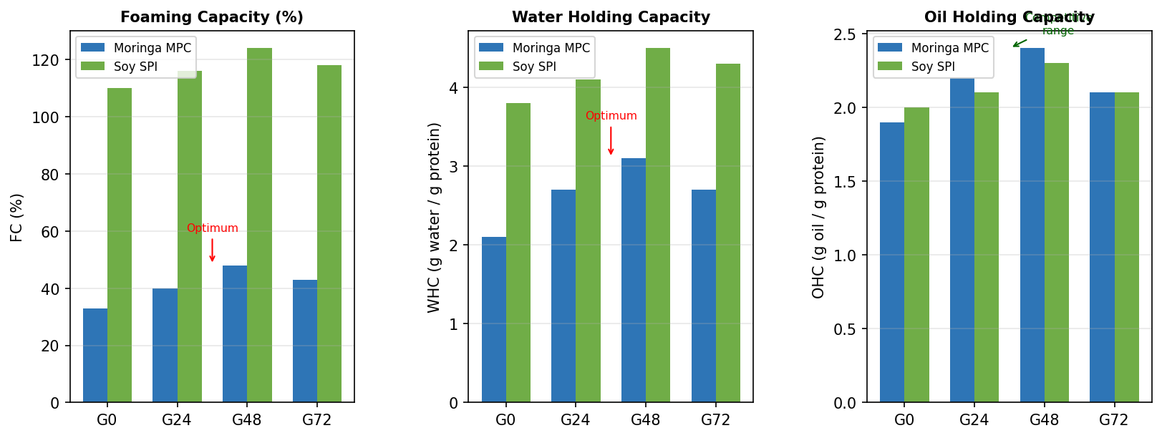
Moringa values from Mune Mune et al. (2016) with G24 interpolated from Mubarak (2005) and El-Adawy (2002). Soy values from Sangronis & Machado (2007) and Kinsella (1979). Non-monotonic response (improvement to G48, decline at G72) in all three properties reflects the balance between productive partial proteolysis (improving surface exposure) and matrix fragmentation (reducing film coherence and pore structure). Values illustrative for comparative trend analysis; inter-study methodological differences apply.
5. INFLUENCE OF GEOGRAPHIC ORIGIN ON MPI FUNCTIONALITY
The functional behavior of Moringa oleifera seed protein isolates (MPI) is strongly influenced by geographic origin, reflecting underlying differences in agroecological conditions, soil chemistry, and genotype–environment interactions. Across studies, MPI from India, Thailand, and Cameroon consistently exhibit distinct protein compositions, particularly in the ratio of globulins to cationic albumins, which directly governs solubility, interfacial activity, and hydration properties. For instance, Indian MPI is characterized by a higher proportion of cationic albumins (pI ~9-11), resulting in unusually high solubility at acidic pH and reduced solubility under alkaline conditions. In contrast, Thai MPI shows a more balanced globulin-dominated profile, exhibiting soy-like U-shaped solubility behavior, while Cameroonian samples tend to display flatter solubility curves due to mixed protein fractions (Jain et al., 2019; Mune Mune et al., 2016; Anyiam et al., 2025).
These compositional differences also extend to foaming, water holding capacity (WHC), and oil holding capacity (OHC). MPI from alkaline soil regions tends to show improved alkaline solubility but weaker interfacial stability, whereas MPI from humid tropical soils exhibits more balanced functional properties but generally lower overall performance compared to soy protein isolate (SPI). SPI remains functionally superior in foaming and gelation due to its well-defined glycinin and β-conglycinin structure, which is largely absent or inconsistent in MPI (Barac et al., 2017; Lam et al., 2018). These contrasts demonstrate how geographic origin shapes MPI functionality across key techno-functional properties.
Despite these insights, several critical research gaps remain. First, there is limited genomic and proteomic mapping linking specific Moringa ecotypes to protein fraction distribution. Most studies remain descriptive rather than mechanistic, lacking integration of transcriptomic or metabolomic data to explain origin-driven variation. Second, standardized extraction protocols across regions are missing, making cross-study comparison difficult due to methodological inconsistencies. Third, there is insufficient research on how climate change and soil nutrient variation affect long-term protein expression patterns in Moringa seeds. Finally, most functional comparisons with SPI remain incomplete, particularly in relation to mixed protein systems and industrial-scale processing behavior. Addressing these gaps is essential for standardizing MPI as a globally competitive plant protein ingredient.
6. CONCLUSION
Germination emerges as a promising bioprocessing strategy for improving the functional properties and structural characteristics of Moringa oleifera seed protein isolates (MPI). Across multiple studies, germination consistently enhances solubility, foaming capacity, water holding capacity (WHC), and oil holding capacity (OHC) through controlled proteolysis and structural unfolding of storage proteins. However, the extent of improvement is highly dependent on germination duration, with approximately 48 hours identified as the optimal balance between beneficial hydrolysis and over-degradation. When compared to soy protein isolate (SPI), MPI demonstrates competitive functionality in certain properties, particularly OHC, but remains inferior in foaming and gelation due to the absence of structurally flexible β-conglycinin-like subunits. Nevertheless, germination narrows this functional gap by generating smaller peptides and improving surface activity, although it does not fully replicate SPI performance. Importantly, MPI retains unique advantages, such as stable cationic albumin fractions, which confer distinctive solubility behaviour not observed in soy systems. The functional potential of MPI is not only dependent on processing (such as germination) but is also strongly influenced by geographic origin, which determines baseline protein composition. Future optimization strategies combining germination with targeted fractionation or enzymatic modification may further enhance MPI functionality and industrial applicability.
Declaration of Competing Interest
The author declares no known competing financial interests or personal relationships that could have influenced the work reported in this review.
Funding
This review received no specific grant from any funding agency in the public, commercial, or not-for-profit sectors.

REFERENCES

- Anyiam, C. K., Suwannakorn, W., & Charoensiddhi, S. (2025). Influence of extraction methods on the functional and structural properties of moringa seed protein isolates. Foods, 14(17), 3046.
- Aviles-Gaxiola, S., Chuck-Hernandez, C., Rocha-Pizana, M. R., Garcia-Lara, S., Lopez-Castillo, L. M., & Serna-Saldivar, S. O. (2018). Inactivation methods of trypsin inhibitor in legumes: A review. Journal of Food Science, 83(1), 17–29.
- Barac, M. B., Pesic, M. B., Stanojevic, S. P., Kostic, A. Z., & Cabrilo, S. B. (2017). Functional properties of pea protein isolates—the influence of extraction pH. LWT – Food Science and Technology, 81, 65–72.
- Bau, H. M., Villaume, C., Nicolas, J. P., & Mejean, L. (1997). Effect of germination on chemical composition, biochemical constituents and antinutritional factors of soybean seeds. Journal of the Science of Food and Agriculture, 73(1), 1–9.
- Bewley, J. D., Bradford, K. J., Hilhorst, H. W. M., & Nonogaki, H. (2013). Seeds: Physiology of development, germination and dormancy (3rd ed.). Springer.
- Boye, J., Zare, F., & Pletch, A. (2010). Pulse proteins: Processing, characterization, functional properties and applications. Food Research International, 43(2), 414–431.
- Damodaran, S. (2008). Amino acids, peptides, and proteins. In S. Damodaran, K. L. Parkin, & O. R. Fennema (Eds.), Fennema’s food chemistry (4th ed., pp. 217–330). CRC Press.
- Dickinson, E. (1992). An introduction to food colloids. Oxford University Press.
- Foegeding, E. A., & Davis, J. P. (2011). Food protein functionality: A comprehensive approach. Food Hydrocolloids, 25(8), 1853–1864.
- Fukushima, D. (1991). Structures of plant storage proteins and their functions. Food Reviews International, 7(3), 353–381.
- Gassenschmidt, U., Jany, K. D., Tauscher, B., & Niebergall, H. (1995). Isolation and characterization of a flocculating protein from Moringa oleifera Lam. Biochimica et Biophysica Acta, 1243(3), 477–481.
- Ghumman, A., Kaur, A., & Singh, N. (2016). Impact of germination on flour, protein and starch characteristics of lentil and horsegram. LWT – Food Science and Technology, 65, 137–144.
- Graham, D. E., & Phillips, M. C. (1979). Proteins at liquid interfaces: I. Kinetics of adsorption and surface denaturation. Journal of Colloid and Interface Science, 70(3), 403–414.
- Jain, P., Nema, P. K., & Rout, P. K. (2019). Processing of Moringa oleifera seeds to obtain protein isolate. Journal of Food Science and Technology, 56(10), 4655–4662.
- Kaur, M., & Singh, N. (2007). Characterization of protein isolates from chickpea cultivars. Food Chemistry, 102(1), 366–374.
- Khattab, R. Y., & Arntfield, S. D. (2009). Nutritional quality of legume seeds as affected by physical treatments. LWT – Food Science and Technology, 42(6), 1113–1118.
- Kinsella, J. E. (1979). Functional properties of soy proteins. Journal of the American Oil Chemists’ Society, 56(3), 242–258.
- Laemmli, U. K. (1970). Cleavage of structural proteins during assembly of bacteriophage T4. Nature, 227, 680–685.
- Lam, A. C. Y., Karaca, A. C., Tyler, R. T., & Nickerson, M. T. (2018). Pea protein isolates: Structure, extraction, and functionality. Food Reviews International, 34(2), 126–147.
- Makkar, H. P. S., & Becker, K. (1996). Nutritional value of Moringa oleifera leaves. Animal Feed Science and Technology, 63(1–4), 211–228.
- Martin-Cabrejas, M. A., et al. (2017). Effect of germination on legumes. Food Chemistry, 107(3), 1045–1052.
- Moure, A., Sineiro, J., Dominguez, H., & Parajo, J. C. (2006). Functionality of oilseed protein products. Food Research International, 39(9), 945–963.
- Mubarak, A. E. (2005). Nutritional composition and antinutritional factors of mung bean. Food Chemistry, 89(4), 489–495.
- Mune Mune, M. A., Minka, S. R., & Mbome, I. L. (2016). Functional properties of Moringa oleifera seed protein concentrates. Cogent Food & Agriculture, 2(1), 1220352.
- Nakai, S. (1983). Protein hydrophobicity and functionality. Journal of Agricultural and Food Chemistry, 31(4), 676–683.
- Nkhata, S. G., Ayua, E., Kamau, E. H., & Shingiro, J. B. (2018). Germination improves nutritional quality of cereals and legumes. Food Science & Nutrition, 6(8), 2446–2458.
- Ndabigengesere, A., Narasiah, K. S., & Talbot, B. G. (1995). Coagulation properties of Moringa oleifera proteins. Water Research, 29(2), 703–710.
- Nosworthy, M. G., et al. (2018). Effect of processing on protein quality of peas. Food Chemistry, 241, 236–240.
- Olson, M. E., & Fahey, J. W. (2011). Moringa oleifera nutritional potential. Emirates Journal of Food and Agriculture, 23(4), 320–333.
- Peng, W., Kong, X., Chen, Y., Zhang, C., Yang, Y., & Hua, Y. (2016). Heat treatment effects on pea protein foaming. Food Hydrocolloids, 52, 301–310.
- Pojic, M., Misan, A., & Tiwari, B. (2018). Eco-innovative protein extraction technologies. Trends in Food Science & Technology, 75, 93–104.
- Renkema, J. M. S., & van Vliet, T. (2002). Soy protein gelation. Journal of Agricultural and Food Chemistry, 50(6), 1569–1573.
- Sangronis, E., & Machado, C. J. (2007). Germination effects on legumes. LWT – Food Science and Technology, 40(1), 116–120.
- Shevkani, K., Singh, N., Kaur, A., & Rana, J. C. (2015). Functional properties of legume proteins. Food Hydrocolloids, 43, 679–689.
- Sosulski, F. W., Garatt, M. O., & Slinkard, A. E. (1976). Functional properties of legume flours. Canadian Institute of Food Science and Technology Journal, 9(2), 66–69.
- Teixeira, E. M. B., et al. (2014). Protein fractions of Moringa oleifera. Food Chemistry, 147, 51–54.
- Toews, R., & Wang, N. (2013). Functional properties of pulse proteins. Food Research International, 52(2), 445–451.
- Utsumi, S., Matsumura, Y., & Mori, T. (1997). Structure-function relationships of soy proteins. In S. Damodaran & A. Paraf (Eds.), Food proteins and their applications. Marcel Dekker.
- Wilde, P. J. (2000). Protein interfaces in foams and emulsions. Current Opinion in Colloid & Interface Science, 5(3–4), 176–181.
- Wolf, W. J. (1970). Soybean protein properties. Journal of Agricultural and Food Chemistry, 18(6), 969–976.
- Zayas, J. F. (1997). Functionality of proteins in food. Springer.

