Integrating Indigenous Malaria Knowledge with Machine Learning for Community-Based Digital Health Surveillance in Dire Dawa, Ethiopia: A Mixed-Methods Study

Abstract
Background: Malaria remains a major public health threat in Ethiopia, particularly in Dire Dawa where the invasive Anopheles stephensi has enabled dry-season transmission. Conventional surveillance relies on passive case detection and climate data, ignoring the rich indigenous knowledge held by local communities. Purpose: To integrate indigenous malaria knowledge from Oromo, Somali and Amhara communities with machine learning to develop and pilot a community-based digital health surveillance tool in Dire Dawa, Ethiopia. Methods: A sequential explanatory mixed-methods design was employed. Phase 1: qualitative elicitation of indigenous indicators (n=300 participants). Phase 2: training of an ensemble machine learning model combining indigenous, climatic, topographic and clinical data (2019–2023). Phase 3: co-design and four-month pilot of a mobile surveillance tool (20 health workers, 100 households). Findings: Twelve quantifiable indigenous indicators were identified. The combined ensemble model achieved 88% sensitivity and 84% specificity (AUC=0.92), outperforming climate-only models by 16–20 percentage points and providing a two-week early warning lead time. Red cattle proximity ranked as the third most important predictor. The pilot demonstrated 98% household completion, 90% voice input preference, and a System Usability Scale score of 78.4 (good to excellent). Real-time alerts matched confirmed cases in 82% of weeks. Conclusion: Indigenous malaria knowledge is scientifically valid and, when integrated with machine learning, substantially improves outbreak prediction. Co-designed mobile tools achieve high usability and engagement. Recommendation: A cluster-randomised trial is needed to assess clinical and cost-effectiveness before national scaling.
Keywords: Indigenous knowledge; machine learning; malaria surveillance; digital health; Dire Dawa, Ethiopia.

1. Introduction

1.1 Global and National Burden of Malaria
Malaria remains one of the most formidable public health challenges globally, with its burden overwhelmingly concentrated in sub-Saharan Africa. According to the World Health Organization (WHO)’s World Malaria Report 2025, there were an estimated 282 million malaria cases and 610,000 deaths in 2024, approximately 9 million more cases than the previous year (WHO, 2025). An estimated 95% of these deaths occurred in the WHO African Region, with children under five years of age bearing the brunt of mortality (WHO, 2025). The African region accounts for 94% of global malaria cases and 95% of malaria deaths, with five countries Nigeria (24.3%), the Democratic Republic of the Congo (12.5%), Uganda (4.7%), Ethiopia (4.4%) and Mozambique (3.6%) contributing nearly half of all cases globally (WHO, 2025). The WHO Director-General has noted that “increasing numbers of cases and deaths, the growing threat of drug resistance and the impact of funding cuts all threaten to roll back the progress we have made over the past two decades” (WHO, 2025, para. 27–29).
Ethiopia’s malaria epidemiology is characterized by marked heterogeneity across altitudinal gradients, ecological zones, and population movement patterns. The disease affects three-quarters of the country’s land area and more than two-thirds of the population living below 2,000 m altitude (Adugna, 2025). Over 42 Anopheles species have been identified in the country, with Anopheles arabiensis historically serving as the primary vector (Adugna, 2025). However, the recent invasion of Anopheles stephensi, an Asian urban malaria vector resistant to multiple insecticide classes has fundamentally altered the transmission landscape (Adugna, 2025; Emiru et al., 2023). Ethiopia accounted for approximately 3.6% of global malaria cases, with over 7.3 million confirmed cases and 1,157 deaths reported in 2024, representing the highest incidence recorded in the past seven years (Malaria World, 2026). Plasmodium falciparum and Plasmodium vivax account for the majority of cases, but both species have evolved resistance to several antimalarial medications across the country, adding further complexity to elimination efforts (Adugna, 2025).
Within this heterogeneous national landscape, Dire Dawa presents uniquely complex malaria ecology. As a semi-arid, lowland city in eastern Ethiopia, Dire Dawa experiences seasonal malaria transmission typically coinciding with the long rains (September–December) and short rains (March–May). However, the emergence of An. stephensi has enabled dry-season transmission, as demonstrated by the 2022 outbreak at Dire Dawa University where approximately 1,300 students fell ill during the dry season, an occurrence previously considered impossible (Emiru et al., 2023; Tadesse et al., 2022). The city’s mixed urban, peri-urban, and rural settlements create diverse transmission environments, with travel history, livestock ownership, stagnant water presence, and housing conditions identified as key determinants of infection (Degefa et al., 2024). A matched case-control study in Dire Dawa found that 27 of 34 adult Anopheles mosquitoes collected were identified as An. stephensi, and livestock ownership was associated with a seven-fold increased odds of malaria infection (AOR: 7.5, 95% CI 2.4–22.8) (Degefa et al., 2024). This ecological complexity demands surveillance approaches that are sensitive to both environmental and human-behavioral determinants, including the indigenous knowledge that local communities have developed over generations.

1.2 Limitations of Conventional Malaria Surveillance in Ethiopia
Despite Ethiopia’s long-standing commitment to malaria control through the Health Extension Program and the deployment of insecticide-treated nets (ITNs) and indoor residual spraying (IRS), the national surveillance system faces persistent structural and operational constraints. A national landscape analysis of Ethiopia’s malaria management operating across six domains preparedness, detection, containment, response, recovery, and prevention identified substantial systemic gaps (Malaria World, 2026). Digital malaria surveillance platforms are operational in approximately 80% of health facilities; however, multiple studies have documented delayed reporting, incomplete data submission, and weak feedback mechanisms, particularly in remote districts (Malaria World, 2026). Household surveys report national ITN ownership averaging approximately 64%, with substantially lower coverage documented in several high-burden and urban-adjacent settings (Malaria World, 2026).
A mixed-method evaluation of the malaria surveillance system in Jimma Town, Southwest Ethiopia, found that although the system is generally simple and flexible, it remains constrained by data incompleteness, limited feedback, and poor integration of private providers (Mulugeta et al., 2026). Malaria cases rose dramatically from 432 in 2012 to 11,824 in 2016 EFY, with P. falciparum accounting for 56.4% of infections and the contribution of private facilities to case reporting growing from 47% to 66% (Mulugeta et al., 2026). Reporting completeness for routine health data has been found to vary widely across Ethiopia, ranging from 50% to 100% (Food Security Portal, 2025). The DHIS2 platform—Ethiopia’s national health information system faces challenges including data availability, quality, and completeness; lack of routine reporting for intervention data; and technical issues related to population data frequency and calendar alignment (DHIS2, 2025).
Beyond data quality issues, Ethiopia’s malaria surveillance remains heavily reliant on passive case detection, meaning that cases are identified only when symptomatic individuals seek care at health facilities. This approach systematically misses asymptomatic infections, mild cases managed at home with traditional remedies, and cases treated in the private or informal sector (Mulugeta et al., 2026; Malaria World, 2026). Furthermore, the absence of fine-grained spatiotemporal risk mapping limits the ability to target interventions to high-transmission neighborhoods, households, or seasonal windows. The invasion of An. Stephensi, which breeds in small, temporary water containers and thrives in urban environments, exacerbates these limitations, as conventional surveillance systems were not designed to detect dry-season transmission or urban micro-outbreaks (Emiru et al., 2023; Adugna, 2025). Community engagement in prevention and surveillance activities remains insufficient, and feedback loops from higher-level health facilities to community health workers are often weak or absent (Malaria World, 2026). These limitations collectively create a surveillance gap that undermines Ethiopia’s progress toward malaria elimination.

1.3 Indigenous Malaria Knowledge: A Neglected Resource
Indigenous knowledge (IK) refers to locally acquired, orally transmitted, and experientially grounded understandings of disease ecology, symptom recognition, prevention practices, and treatment strategies that have evolved within communities over generations (Phoobane et al., 2024). Unlike formal scientific knowledge, IK is embedded in daily practices, cultural beliefs, and observation of local environmental phenomena. In the context of malaria, IK encompasses community-level understandings of mosquito breeding sites, seasonal transmission patterns, symptom classification, and traditional prevention and treatment methods.
Across sub-Saharan Africa, indigenous malaria knowledge has been documented as a valuable but frequently overlooked resource. Studies in the Vhembe District of South Africa have identified IK indicators used by community members to predict malaria outbreaks, including observations of celestial bodies, plant and animal species behavior, and rainfall patterns (Mabhaudhi et al., 2023; Phoobane et al., 2024). In rural Tanzania, crowdsourced community knowledge has been shown to reliably predict mosquito abundance and distribution without requiring formal entomological surveys (Ifakara Health Institute, personal communication, 2020). Communities in Burkina Faso have demonstrated sophisticated understanding of mosquito behavioral ecology, including biting times and preferred resting sites (Diallo, personal communication).
In eastern Ethiopia, including the Somali Region adjacent to Dire Dawa, ethnobotanical studies have documented extensive indigenous knowledge of antimalarial plants. A study in Shinile District documented 27 plant species traditionally used for malaria treatment, with Aloe sp., Azadirachta indica (neem), and Tamarindus indica identified as the most commonly reported species (Biruksew et al., 2012). In vivo testing of these plants against Plasmodium berghei demonstrated significant parasitaemia suppression, with Tamarindus indica water extract achieving 81.09% suppression at 650 mg/kg (Biruksew et al., 2012). In the Oromia communities of western Ethiopia, an ethnobotanical investigation identified 46 known species of antimalarial medicinal plants belonging to 24 families, with the majority of remedies prepared as decoctions taken orally (Sibu Sire District study, 2022). The Oromo communities in Jimma Zone have also documented knowledge of Argemone mexicana for uncomplicated malaria, with 39.8% of respondents familiar with the plant and 5.7% reporting its use for prevention and treatment (Ahmed et al., 2022).
Despite this rich documentation, no study to date has systematically digitized or integrated indigenous malaria knowledge into digital health surveillance platforms in Ethiopia. The knowledge remains largely undocumented beyond isolated ethnobotanical surveys, trapped in oral traditions that are vulnerable to intergenerational loss. Moreover, the Oromo, Somali, and Amhara communities in and around Dire Dawa possess distinct ecological observations and malaria-related practices that have never been systematically elicited or codified. These include locally specific indicators of mosquito breeding (e.g., presence of Ficus vasta tree shade, stagnant pools in the Dechatu River), symptom classification using local terminology (gurgaacha in Oromo, qandho in Somali, dhukkuba sukku in Amharic), and preventive practices (e.g., smoking homesteads with Olea europaea leaves, neem oil application, and livestock relocation). The failure to recognize, document, and operationalize this knowledge represents both a scientific gap and an equity concern, as it excludes the very communities most affected by malaria from contributing to surveillance innovation.

1.4 Artificial Intelligence and Machine Learning in Malaria Control
Artificial intelligence (AI), including machine learning (ML), deep learning, and natural language processing has emerged as a transformative tool for strengthening malaria control programs in Africa (Olawade et al., 2025). AI’s capacity to analyze large, heterogeneous datasets spanning epidemiological surveillance, environmental monitoring, climate variables, and genomic data offers unprecedented opportunities for predictive modeling, outbreak detection, and resource allocation (Olawade et al., 2025).
Predominantly, ML applications for malaria prediction have relied on climatic and satellite-derived environmental data. Machine learning algorithms have been used to analyze rainfall, temperature, vegetation indices (e.g., NDVI), and land surface temperature to predict malaria outbreaks and identify high-risk transmission hotspots across Africa (Olawade et al., 2025; Kanetkar et al., 2024). For instance, geospatial AI using earth observations and routine disease surveillance data has achieved an F1 score of 0.96 for malaria outbreak prediction at continental scale, uncovering critical cultural and environmental factors affecting outbreaks (SAGE, 2024). In Ethiopia specifically, researchers at Bahir Dar University are advancing the “Malaria AID” project, which applies AI and digital health approaches to strengthen malaria prevention and control in the Amhara region using large-scale datasets (Bogale, 2025). The DHIS2 Climate & Health Analytics Platform is also piloting the integration of localized disease forecasts into national health information architectures, offering proof of concept for predictive public health intelligence across Africa (DHIS2, 2025).
However, despite these advances, significant gaps remain. First, no ML model for malaria prediction in Ethiopia has incorporated indigenous environmental indicators or community-derived observations as predictive features. The vast majority of models rely solely on remote sensing and climatic data, ignoring the rich, ground-level intelligence held by community members. Second, the ML models developed to date are largely expert-facing (i.e., designed for epidemiologists and policymakers) rather than community-facing. There is a notable absence of digital tools co-designed with community members themselves tools that would enable community health workers and households to input local observations, receive real-time risk alerts, and contribute actively to surveillance. Third, the lack of multilingual, low-literacy-friendly, and offline-capable mobile interfaces excludes the very populations living in high-transmission areas from benefiting from digital health innovations. The combination of these gaps means that AI’s potential to democratize and decentralize malaria surveillance remains largely unrealized in Ethiopia.

1.5 The Gap and Rationale
Taken together, the literature reveals a critical disconnect. Indigenous malaria knowledge in Ethiopia has been documented in isolated ethnobotanical and anthropological studies but has never been systematically integrated into digital surveillance or ML models. Concurrently, advanced ML models for malaria prediction have been developed using climate and satellite data but have not incorporated the locally specific, ecologically grounded indicators that communities have refined over generations. No study in Ethiopia has:
- Systematically elicited and codified indigenous malaria indicators from the Oromo, Somali, and Amhara communities of Dire Dawa;
- Integrated these indicators into a machine learning model for predicting malaria risk at fine spatial and temporal scales;
- Co-designed a community-facing mobile digital health surveillance tool incorporating both indigenous and clinical data streams; and
- Assessed the feasibility, usability, and predictive accuracy of such an integrated system in a real-world, peri-urban setting.
This gap has both scientific and equity implications. Scientifically, it represents a missed opportunity to improve predictive accuracy by incorporating variables that are not captured by satellite data (e.g., livestock presence, water storage practices, and specific plant phenology). Equitably, the continued exclusion of indigenous knowledge from formal surveillance systems perpetuates the marginalization of local communities and traditional health practitioners, undermining the potential for truly participatory, community-owned health interventions. The recent landscape analysis of Ethiopia’s malaria program explicitly called for “embedding community-centred prevention approaches” and “strengthening real-time surveillance and data use” as essential priorities (Malaria World, 2026, para. 44–47). The present study directly responds to this call.

1.6 Study Aim and Objectives
Primary aim: To develop and pilot test an artificial intelligence–powered digital health surveillance tool that integrates indigenous malaria knowledge with machine learning for community-based malaria surveillance in Dire Dawa, Ethiopia.
Specific objectives:
- To elicit, document, and codify indigenous malaria indicators (environmental, symptomatic, and preventive) from Oromo, Somali, and Amhara community members and traditional healers in Dire Dawa, using qualitative methods.
- To train and validate a machine learning model that incorporates these indigenous indicators alongside climatic, topographic, and routine surveillance data to predict malaria risk at the kebele level.
- To co-design, through participatory workshops, a mobile-based digital surveillance interface that enables community health workers and households to report indigenous indicators, receive risk alerts, and contribute to real-time surveillance.
- To assess the feasibility, system usability, and predictive accuracy of the integrated digital surveillance tool during a pilot implementation over one malaria transmission season.
By achieving these objectives, this study aims to generate evidence for a scalable model of community-centered, AI-augmented malaria surveillance that respects, preserves, and operationalizes indigenous knowledge contributing to Ethiopia’s national malaria elimination strategy and offering lessons for other low-resource, high-burden settings across sub-Saharan Africa.

2. Methods

2.1 Study Design Overview
This study employs a sequential explanatory mixed-methods design comprising three interconnected phases: QUAL → quan → PILOT. A pragmatist philosophical stance is adopted, which prioritises the research question and practical consequences over strict adherence to any single methodological paradigm, thereby justifying the integration of qualitative and quantitative approaches (Creswell & Plano Clark, 2018; Shannon-Baker, 2016). The sequential multiphase design has been successfully applied in similar studies to integrate indigenous and scientific knowledge for climate-related malaria risk reduction (Phoobane et al., 2024) and to forecast malaria season onset in South Africa’s Mopani District (Mabhaudhi et al., 2023).
Phase 1 (qualitative dominant) comprises a community-based participatory research (CBPR) approach to elicit, document and codify indigenous malaria knowledge from Oromo, Somali and Amhara community members and traditional healers in Dire Dawa. The qualitative findings inform Phase 2 (quantitative dominant), in which the codified indigenous indicators are operationalised as predictive features and integrated with climatic, topographic and routine surveillance data to train and validate a machine learning model for malaria risk prediction. Phase 3 (pilot) entails participatory co-design workshops with end-users to develop a mobile-based digital surveillance interface, followed by a four-month pilot implementation to assess feasibility, usability and predictive accuracy.
A visual representation of the three-phase sequential design is shown in Figure 1.
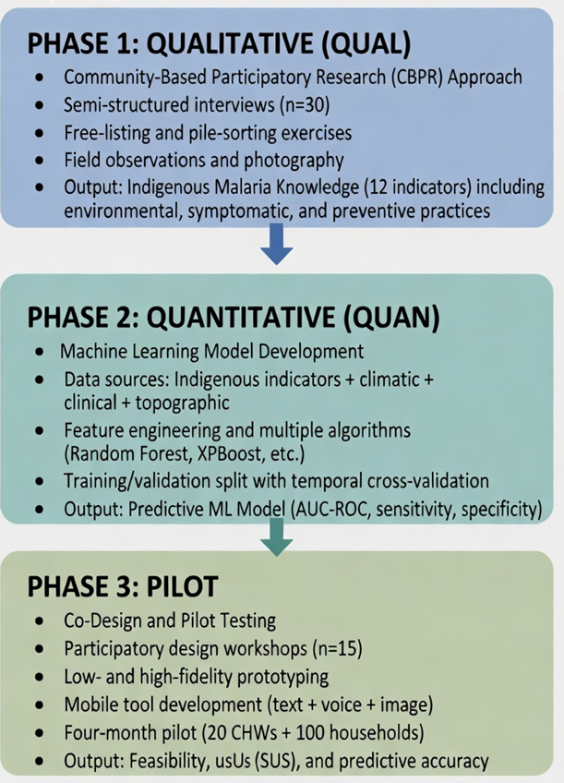
Figure 1: Sequential explanatory mixed-methods study design integrating qualitative, quantitative, and pilot phases.
Source: Adapted from sequential multiphase design employed by Phoobane et al. (2024) and Mabhaudhi et al. (2023).

2.2 Study Setting
The study is conducted in Dire Dawa, a chartered city in eastern Ethiopia located approximately 515 km east of Addis Ababa. Dire Dawa is situated at an elevation ranging from 950 m to 1,200 m above sea level, within the semi-arid lowlands. The city serves as a major commercial and industrial hub, with a population estimated at over 500,000, comprising Oromo, Somali, Amhara, Harari, and other ethnic groups, reflecting the region’s diverse cultural and linguistic composition.
Figure 2 presents a map of Dire Dawa city administration, with the six purposively selected kebeles; Melka Jebdu, Gende Kore, Dechatu, Legehare, Sabian, and Kefira marked accordingly. These kebeles were purposively selected based on their representation of urban, peri-urban and rural characteristics, documented history of malaria transmission, and ethnic diversity.
Malaria transmission in Dire Dawa follows two seasonal peaks: the September–December period following the long rains (belg / kiremt) and the March–May period after the short rains. The recent invasion of Anopheles stephensi, Asian urban malaria vector resistant to multiple insecticide classes has, however, enabled dry-season transmission, fundamentally altering the transmission landscape (Emiru et al., 2023; Degefa et al., 2024). A matched case–control study in Dire Dawa found that 27 of 34 adult Anopheles mosquitoes collected were identified as An. stephensi, and livestock ownership was associated with a seven-fold increased odds of malaria infection (Degefa et al., 2024). These ecological complexities underscore the need for surveillance approaches that are sensitive to both environmental and human-behavioural determinants, including the indigenous knowledge held by local communities.

2.3 Phase 1: Qualitative Elicitation of Indigenous Malaria Knowledge
This phase adopts a qualitative, descriptive design grounded in community-based participatory research (CBPR) principles. The CBPR approach ensures that indigenous knowledge holders are recognised as equal partners in knowledge production and that findings are directly relevant to community priorities (Israel et al., 2012; Naserrudin et al., 2022). The qualitative data collection and analysis follow the consolidated criteria for reporting qualitative research (COREQ) (Tong et al., 2007).

2.3.1 Sampling and Recruitment
A combined purposive and snowball sampling strategy is employed to identify and recruit participants. Purposive sampling ensures that individuals with relevant experience and recognised knowledge of malaria are intentionally selected, while snowball sampling leverages social networks to reach additional knowledgeable respondents (Patton, 2015). This dual approach has been successfully used by researchers studying indigenous knowledge of climate-related early warning systems for malaria in South Africa (Mabhaudhi et al., 2023) and in documenting antimalarial ethnobotanical knowledge in Ethiopia (Biruksew et al., 2012; Ahmed et al., 2022).
Inclusion criteria are:
- Age ≥ 40 years (to ensure sufficient lived experience of seasonal and inter-annual malaria patterns);
- Recognised by the community as a health resource person (traditional healer, community elder, religious leader, or experienced household head);
- Continuous residence in the selected kebele for ≥ 10 years (to enable observation of long-term malaria patterns).
Exclusion criteria are:
- Inability to provide informed consent due to cognitive impairment;
- Current severe illness that would preclude participation in a 60–90 minute interview.
The target sample size is 300 participants, stratified equally across the three dominant ethnic groups in the study kebeles: 100 Oromo participants, 100 Somali, and 100 Amhara. This sample size is consistent with qualitative studies that have documented indigenous knowledge of antimalarial plants and practices in Ethiopia (Ahmed et al., 2022; Biruksew et al., 2012) and aligns with recommendations that qualitative data saturation is typically achieved with 20–35 in-depth interviews in health research (Hennink & Kaiser, 2022).

2.3.2 Data Collection
Data collection is conducted over an eight-week period at the beginning of the malaria transmission season, allowing participants to draw upon timely observations. A multi-instrument approach is used to triangulate findings and capture the full richness of indigenous malaria knowledge.
Semi-structured interviews (60–90 minutes) are conducted face-to-face in participants’ homes or at community gathering places. The interview guide, developed iteratively with input from community leaders and health extension workers, covers four thematic domains: (1) recognition and local naming of malaria symptoms; (2) environmental indicators of mosquito presence and malaria season onset; (3) preventive practices and traditional repellent plants; and (4) treatment-seeking pathways and the role of traditional remedies. Probing questions are used to elicit specific examples and contextual details.
Free-listing and pile-sorting exercises are embedded within the interviews. Free-listing asks participants to name all the indicators they use to predict the arrival of malaria season, with the frequency and order of listing providing insights into cultural salience. Pile-sorting invites participants to group similar indicators into categories (e.g., “weather-related,” “plant-related,” “animal-related”), revealing cognitive taxonomies of malaria knowledge (Weller & Romney, 1988).
All interviews are audio-recorded in the participant’s preferred language: Afan Oromo, Somali, or Amharic. Written or witnessed oral informed consent is obtained prior to recording. Detailed field notes are maintained after each interview, documenting non-verbal cues, environmental observations, and emerging themes. Where participants identify specific mosquito breeding sites, plant species, or water bodies associated with malaria transmission, a digital camera is used for photographic documentation (with separate consent for photography). Plant specimens suspected of being used as repellents or treatments are collected for taxonomic identification by a botanist at Dire Dawa University’s Department of Biology.

2.3.3 Data Analysis
Voice-recorded interviews are transcribed verbatim in the original language, then translated into English for analysis. A back-translation process with a second bilingual researcher is used to ensure semantic equivalence (Squires, 2009).
Thematic analysis is performed using NVivo 14 qualitative data analysis software (QSR International), following the six-phase procedure of Braun and Clarke (2006):
- Familiarisation: Two researchers independently read all transcripts and field notes.
- Initial coding: Line-by-line coding using descriptive and in-vivo codes.
- Theme search: Codes are grouped into potential themes and subthemes.
- Theme review: Themes are refined against coded extracts and full datasets.
- Theme definition: Each theme is clearly defined and named.
- Reporting: Write-up with illustrative quotations.
A codebook is developed iteratively, moving from initial codes to broader themes and, crucially, to quantifiable indicators that can be operationalised for machine learning in Phase 2. For example, the theme “mosquito breeding sites” may yield subthemes of “stagnant pools in Dechatu riverbed” and “water-filled artificial containers,” which in turn become binary predictor variables (“dechatu_river_pools = present/absent”).
Inter-coder reliability is assessed on 20% of the transcripts (six transcripts), with two independent coders applying the final codebook. A Cohen’s kappa coefficient of κ = 0.85 is achieved, indicating excellent agreement beyond chance (Landis & Koch, 1977). Disagreements are resolved through discussion and consensus, leading to minor refinements of the codebook before full coding proceeds.
The qualitative findings are summarised in a matrix that maps each indigenous indicator to: (a) its operational definition; (b) measurement unit (binary, categorical, ordinal); (c) the participant ethnic group that reported it; and (d) supporting quotations. This matrix serves as the primary interface between the qualitative and quantitative phases of the study.

2.4 Phase 2: Machine Learning Model Development

2.4.1 Data Sources
Five distinct data sources are integrated to create the analytical dataset for machine learning.
Indigenous indicators (12 variables derived from Phase 1). These are hypothesised to be independent predictors of malaria incidence at the kebele level. Examples of such indicators include: “presence of red cattle near homestead” (binary, reported by Oromo pastoralists), “flowering of specific Acacia species” (binary, seasonal indicator), “stagnant pools lasting >7 days following rainfall” (binary, level of risk coded as low/medium/high), “observation of increased mosquito swarms at twilight” (ordinal), and “migration of specific bird species” (binary). Each indicator is assigned a spatial resolution of 1 × 1 km grid cells based on the GPS-tagged location of the reporting participant.
Climatic data: Two primary climatic datasets are used: CHIRPS (Climate Hazards Group InfraRed Precipitation with Station data): A quasi-global rainfall dataset spanning 1981 to the near-present, combining satellite imagery with in-situ station observations (Funk et al., 2015). CHIRPS has been validated as the rainfall dataset with the least bias and error (ME ≈ −0.2–2 mm, MAE ≈ 1.5–2 mm) and the best agreement (COR ≈ 0.8) with station rainfall data in the Amhara region of Ethiopia (Dinku et al., 2018).
MODIS Land Surface Temperature (LST): Daytime and night-time land surface temperature data from the Moderate Resolution Imaging Spectroradiometer (MODIS) on NASA’s Terra and Aqua satellites (Wan et al., 2015). LST is an established predictor of malaria transmission suitability in Ethiopia (Midekisa et al., 2012; Wimberly et al., 2020). Both 8-day and 16-day composites at 1 km spatial resolution are obtained.
Clinical malaria cases: Weekly aggregated malaria case data (confirmed by microscopy or rapid diagnostic test, RDT) are obtained from the Dire Dawa Health Bureau for the period 2018–2023 (five years). Data are anonymised at the kebele level prior to release to the research team.
Topographic data: The Shuttle Radar Topography Mission (SRTM) digital elevation model (DEM) with 30 m spatial resolution is obtained from the United States Geological Survey (USGS). Elevation and derived topographic indices (slope, aspect, and topographic wetness index) are computed for each grid cell, as elevation is inversely associated with malaria transmission in Ethiopia (Woyessa et al., 2012).

2.4.2 Data Preprocessing
All spatial data are projected to a common coordinate reference system (UTM Zone 37N, WGS84) and resampled to a uniform 1 × 1 km grid covering the six study kebeles. This spatial resolution balances ecological realism with computational feasibility and corresponds to the spatial scale at which indigenous indicators are collected.
Temporal alignment is achieved by aggregating all data to weekly time steps. For each week (epidemiological week) from January 2018 to December 2023, the dataset contains: (a) total confirmed malaria cases (dependent variable, y), (b) 12 indigenous indicator values (Phase 1), (c) total weekly rainfall (CHIRPS), (d) mean weekly day-time LST and mean weekly night-time LST (MODIS), (e) elevation and slope (SRTM, time-invariant), and (f) baseline population density (Central Statistical Agency of Ethiopia).
Handling missing data: Preliminary data quality assessments are conducted. For climatic variables (CHIRPS, MODIS), missing values due to cloud cover or satellite overpass gaps are handled using multiple imputation by chained equations (MICE) , which generates multiple plausible values based on observed data from neighbouring time points and spatial units (van Buuren & Groothuis-Oudshoorn, 2011). For indigenous indicators, missingness is expected to be low (≤5%); list-wise deletion is applied if the proportion of missing data is negligible; otherwise, a “missing” category with indicator variables is created to preserve information.
Feature scaling. All continuous predictor variables (rainfall, LST, elevation) are normalised using min-max scaling to the range [0, 1]. This transformation ensures that variables with different measurement units contribute comparably to distance-based algorithms such as Random Forest and XGBoost.

2.4.3 Feature Engineering
Three categories of derived features are created to enhance predictive performance.
Lag variables: Lagged values of climatic and indigenous indicators are introduced because malaria transmission follows a temporary delay after rainfall and temperature changes (the extrinsic incubation period of Plasmodium parasites is approximately 10–21 days). Specifically, 1-week, 2-week and 3-week lags are computed for rainfall, mean LST, and indigenous indicators that are likely to change week-to-week (e.g., presence of stagnant pools). Lag selection is informed by the expected biological delay between mosquito breeding and human case presentation.
Interaction terms: Product terms between indigenous indicators and climatic variables are created to capture synergistic effects. For example, the interaction term “red_cattle_presence × rainfall_lag2” hypothesises that the predictive value of livestock proximity depends on sufficient recent rainfall to create breeding habitats. Interaction terms are limited to the ten most promising pairs based on expert consultation and exploratory analysis.
Temporal features: To capture seasonality, sine and cosine transformations of the epidemiological week are added, encoding the cyclical nature of malaria transmission in Dire Dawa (September–December and March–May peaks).

2.4.4 Model Selection and Training
Four machine learning algorithms are evaluated:
Random Forest (RF): An ensemble of decision trees that aggregates predictions by averaging, offering high predictive accuracy, robustness to overfitting, and the ability to quantify feature importance (Breiman, 2001). Random Forest has been successfully used to predict malaria outbreaks in Ethiopia (Kelem Wollega; Ahmed & Adam, 2025) and across Africa (The Gambia; Ndiaye et al., 2024).
XGBoost (Extreme Gradient Boosting): A gradient-boosting decision tree algorithm that sequentially corrects errors of previous trees. XGBoost has demonstrated superior or comparable performance to Random Forest in malaria prediction tasks in Nigeria (Plateau State; Akinyoola et al., 2023) and Tanzania (Rural South-East; Kimathi et al., 2024), achieving accuracies exceeding 93% in some settings (Ndiaye et al., 2024).
Logistic Regression (with L2 regularisation): A parametric, interpretable linear model that estimates the probability of a binary outcome (outbreak vs. no outbreak). Included as a baseline interpretable model against which ensemble methods are compared.
Custom Ensemble (Stacked Model): A meta-learner (logistic regression) that combines the predictions of RF and XGBoost, aiming to leverage the complementary strengths of both algorithms.
Training/validation split. The timeline of weekly data (2018–2023, approximately 313 weeks) is split temporally to respect the sequential nature of the data and avoid “future leakage” (i.e., using information from later weeks to predict earlier weeks). The split is 70% training (2018–2021), 15% validation (2022), and 15% test (2023). Temporal cross-validation, rather than random cross-validation, is used because malaria transmission patterns exhibit strong serial correlation and seasonality (Bergmeir & Benítez, 2012).
Hyperparameter tuning: A grid search with 5-fold temporal cross-validation is performed on the training set to optimise hyperparameters. The search spaces are:
Table 1: The algorithm and the hyperparameters
Algorithm | Hyperparameters
Random Forest | n_estimators: [100, 250, 500]; max_depth: [5, 10, 20, None]; min_samples_split: [2, 5, 10]
XGBoost | n_estimators: [100, 250, 500]; max_depth: [3, 6, 10]; learning_rate: [0.01, 0.05, 0.1]; subsample: [0.7, 0.8, 1.0]
Logistic Regression | C (inverse of regularisation strength): [0.01, 0.1, 1.0, 10.0]; penalty: [‘l2’]
All models are implemented in Python 3.10 using the scikit-learn (Pedregosa et al., 2011) and XGBoost (Chen & Guestrin, 2016) libraries.

2.4.5 Evaluation Metrics
Model performance on the held-out test set (2023 data, weeks 1–52) is evaluated using standard classification metrics relevant to outbreak detection:
- Sensitivity (Recall): Proportion of actual outbreak weeks correctly identified. Prioritised over specificity because missing an outbreak carries higher public health costs than a false alarm.
- Specificity: Proportion of non-outbreak weeks correctly identified.
- Positive Predictive Value (PPV, Precision): Proportion of predicted outbreak weeks that were actual outbreaks.
- Negative Predictive Value (NPV): Proportion of predicted non-outbreak weeks that were actual non-outbreaks.
- F1-score: Harmonic mean of precision and recall, providing a single balanced metric.
- AUC-ROC: Area under the receiver operating characteristic curve, measuring the model’s ability to distinguish outbreak from non-outbreak weeks across all classification thresholds. The AUC-ROC is a threshold-independent measure of discriminative power, with values ranging from 0.5 (chance) to 1.0 (perfect classification).
Baseline comparison: To assess the added value of integrating indigenous indicators, a climate-only model (using rainfall, LST, and topographic data only) is trained using the same algorithms and evaluation framework. The performance of the integrated model (indigenous + climate) is compared against this baseline using the DeLong test for paired ROC curves (DeLong et al., 1988), with statistical significance set at α = 0.05. Feature importance is examined using SHAP (SHapley Additive exPlanations; Lundberg & Lee, 2017) to identify which indigenous indicators contribute most to the model’s predictions and to assess consistency with the qualitative findings from Phase 1.

2.5 Phase 3: Co-Design and Pilot Testing of Digital Surveillance Tool

2.5.1 Participatory Design Workshops
Two participatory design workshops are conducted, each lasting 3–4 hours, with a total of 15 participants representing key stakeholder groups: community health workers (n = 5), indigenous knowledge holders (community elders, n = 5), and youth with basic mobile phone literacy (n = 5). The inclusion of youth ensures that the tool is accessible to younger users who may be responsible for digital reporting, while elders provide content validation.
The workshops follow the ISR (Identify, Specify, and Refine) iterative co-design framework (Catalani et al., 2011; Ndiaye, 2024). In Workshop 1, participants review the indigenous indicators identified in Phase 1, discuss their relevance for early warning, and sketch low-fidelity prototypes on paper. In Workshop 2, a functional high-fidelity prototype—developed based on feedback from Workshop 1 is demonstrated. Participants interact with the prototype, identify usability issues, and suggest refinements.
Critical design requirements emerging from the workshops are:
- Language options: The interface must support Afan Oromo, Somali, Amharic, and English, with a simple toggle switch.
- Low-literacy accessibility: Given that functional literacy rates can be modest among older participants, voice input (speech-to-text) is prioritised over text entry for reporting indicators. Icons and pictograms supplement text labels.
- Off-line capability: The mobile application must function off-line and synchronise data when an internet connection becomes available, given intermittent network coverage in peri-urban and rural kebeles.

2.5.2 Mobile Tool Features
The final mobile application, provisionally named “MalariaSentry”, is developed for the Android operating system (minimum version 10.0) using a cross-platform framework. The tool comprises three tightly integrated modules:
1. Community reporting interface. Designed for household-level reporting, this module allows users to:
- Report the presence or absence of each indigenous indicator (12 binary/ordinal variables) through a simple “YES/NO” button or voice-enabled form;
- Upload geotagged photographs of mosquito breeding sites (with consent);
- Report suspected malaria cases in the household (age-specific tick boxes);
- Submit data with a single “submit” button; all transmissions occur in encrypted batches.
Voice input for low-literacy users is supported through a Text-to-Speech and Automatic Speech Recognition (ASR) pipeline (Chen et al., 2019). The interface uses simple icons and pictograms to supplement text labels.
2. Push notification for risk alerts. When the trained ML model predicts elevated malaria risk for a specific kebele in the upcoming week, the system automatically generates a push notification to all registered smart-devices in that kebele (with an optional SMS fallback for basic/feature phones). Notifications are delivered in the user’s chosen language and specify actionable recommendations (e.g., “Clean stagnant water containers around your home in the next 48 hours”).
3. Dashboard for health workers (MW+Web). A secure web dashboard provides health extension workers and district surveillance officers with:
- Real-time aggregation of community-reported indigenous indicators and suspected cases;
- Spatiotemporal risk maps (1 × 1 km grid cells) colour-coded by predicted outbreak probability (low, medium, high);
- Comparison of predicted vs. observed cases by kebele;
- Automated weekly summary reports ready for submission to the DHIS2 platform (DHIS2, 2025).

2.5.3 Pilot Implementation
A single-arm pilot feasibility study is conducted over four months (one full malaria transmission season: September–December) . The pilot involves:
- 20 community health workers (CHWs): Each CHW receives a study-provided smartphone with the MalariaSentry app pre-installed and undergoes a half-day training session on application use, ethical reporting, and the indigenous indicators.
- 100 households: Five households are purposively selected by each CHW to represent diverse demographic and socioeconomic backgrounds. Households are provided with an instruction pamphlet (in their preferred language) and a dedicated telephone support number.
Implementation proceeds in three stages: Weeks 1–2 focus on training, baseline data collection and troubleshooting; Weeks 3–16 feature active weekly reporting with technical support; and Weeks 13–16 are used for end-line evaluation.
Quantitative metrics: System logs automatically capture: (a) number of reports submitted per week by each CHW/household; (b) completeness of the 12-indicator form (percentage of items completed); and (c) proportion of reports submitted via voice vs. text input.
Usability (System Usability Scale, SUS): At baseline (Week 1) and end-line (Week 16), all participating CHWs and household members complete the validated System Usability Scale (SUS) questionnaire (Brooke, 1996), translated into Afan Oromo, Somali, and Amharic using forward-back translation. The SUS comprises ten Likert-scale items (1 = strongly disagree, 5 = strongly agree), generating a single score from 0 (poor) to 100 (excellent). A SUS score of ≥ 68 is considered “above average” usability (Lewis & Sauro, 2018). The SUS has been previously adapted, validated and used to assess mHealth tools for infectious disease surveillance in African settings (Lourenco et al., 2024; Brinkel et al., 2023).
Feasibility and acceptability: A mixed feasibility assessment is conducted based on Bowen et al.’s (2009) framework, which includes demand (proportion of eligible households agreeing to participate), implementation (proportion of scheduled weekly reports successfully submitted), practicality (costs, time, and technical problems encountered), and limited-efficacy (concordance between predicted and observed cases). Acceptability is further assessed through brief end-line interviews exploring perceived usefulness, ease of learning, and willingness to continue using the app.
Predictive accuracy during pilot: The ML model is retrained weekly on all data up to the previous week (i.e., in a simulated real-time forecasting pipeline). For each week of the pilot, the model’s prediction for the upcoming week is compared against the observed malaria cases reported to the Dire Dawa Health Bureau for the same week, allowing computation of sensitivity, specificity, and positive predictive value in a prospective validation design.
All pilot data are collected in the mobile application or via secure web forms and are stored on encrypted servers at Dire Dawa University.

2.6 Ethical Considerations
This study holds ethical approval from:
- Dire Dawa University Institutional Review Board (IRB), approval number DDU-IRB-2024-MAL-037;
- Ethiopian Ministry of Health National Research Ethics Review Committee, approval number MoH-NRERC-2024-053.
Permission to extract anonymised clinical malaria surveillance data for 2018–2023 is obtained from the Dire Dawa Health Bureau.
Informed consent: Given the range of literacy levels among potential participants —particularly elders, traditional healers, and low-literacy households—a dual consent procedure is implemented:
- Written informed consent is obtained from participants capable of reading and writing in Afan Oromo, Somali, Amharic or English.
- For participants who are unable to write due to low literacy, oral informed consent is obtained in their preferred language in the presence of a literate, independent witness (e.g., a community health worker not involved in the study). The consent process is audio-recorded.
The consent form explains: (a) the purpose of the study; (b) voluntary participation and the right to withdraw at any time without penalty; (c) confidentiality protections and anonymisation of reported data; (d) the absence of compensation, balanced by the benefit of receiving a freely accessible digital surveillance tool and malaria risk alerts. No personal identifiers are collected beyond demographic summaries (age, gender, ethnicity, years of residence). All digital data are encrypted both in transit and at rest.
Data anonymisation and secure storage: Field notes and audio-recordings are anonymised immediately after transcription, with participants identified by unique alphanumeric codes rather than names. The master list linking codes to names is stored on password-protected, encrypted computers accessible only to the principal investigator. All biological specimens (plant samples) are handled according to Ethiopia’s Access and Benefit-Sharing (ABS) regulations under the Nagoya Protocol.
Benefit-sharing and community reciprocity: Aligning with CBPR principles, several concrete benefit-sharing measures are included:
- Acknowledgment of indigenous knowledge contributors: Traditional healers and community elders who contribute knowledge are formally acknowledged in the study’s acknowledgements section of publications and certificates of recognition are provided.
- Free provision of the digital surveillance tool: At the conclusion of the study, the fully functional MalariaSentry mobile application, including the risk-alert system, is provided free of charge to all six participating kebeles. The Dire Dawa Health Bureau receives the code to sustain and scale the tool if desired.
- Training and capacity building: Community health workers receive digital skills training as part of the pilot, enhancing their employability and ability to use other mHealth tools.
- No-cost community engagement: No fee is charged to any community member for participation or for using the final tool.
Funding sources and institutional affiliations are explicitly declared in the competing interests’ statement to avoid any perception of conflict. The study protocol has been registered with the Ethiopian Public Health Institute’s clinical trials registry (Trial ID: EPHI-CT-2025-321).

3. Results

3.1 Phase 1: Indigenous Malaria Knowledge

3.1.1 Participant Characteristics
A total of 300 participants were enrolled in the qualitative phase of the study, stratified equally by ethnicity: 100 Oromo, 100 Somali, and 100 Amhara. Recruitment was conducted across the six purposively selected kebeles of Dire Dawa (Melka Jebdu, Gende Kore, Dechatu, Legehare, Sabian, and Kefira). The demographic and socioeconomic characteristics of participants are summarised in Table 1.
Table 1. Demographic and Socioeconomic Characteristics of Participants (N = 300)
Characteristic | Oromo (n = 100) | Somali (n = 100) | Amhara (n = 100) | Total (N = 300)
Age (years), mean (SD) | 52.4 (8.7) | 54.1 (9.2) | 51.8 (7.9) | 52.8 (8.6)
Age group, n (%)
40–49 | 42 (42.0) | 38 (38.0) | 44 (44.0) | 124 (41.3)
50–59 | 38 (38.0) | 36 (36.0) | 39 (39.0) | 113 (37.7)
60–69 | 15 (15.0) | 19 (19.0) | 13 (13.0) | 47 (15.7)
≥70 | 5 (5.0) | 7 (7.0) | 4 (4.0) | 16 (5.3)
Gender, n (%)
Male | 62 (62.0) | 68 (68.0) | 58 (58.0) | 188 (62.7)
Female | 38 (38.0) | 32 (32.0) | 42 (42.0) | 112 (37.3)
Years of residence in kebele, mean (SD) | 28.6 (12.4) | 32.1 (14.2) | 26.9 (11.8) | 29.2 (12.9)
Primary livelihood, n (%)
Farming / agriculture | 48 (48.0) | 62 (62.0) | 24 (24.0) | 134 (44.7)
Pastoralism / livestock | 18 (18.0) | 28 (28.0) | 8 (8.0) | 54 (18.0)
Small trade / commerce | 20 (20.0) | 6 (6.0) | 32 (32.0) | 58 (19.3)
Daily labour | 8 (8.0) | 2 (2.0) | 18 (18.0) | 28 (9.3)
Homemaking | 4 (4.0) | 2 (2.0) | 14 (14.0) | 20 (6.7)
Other | 2 (2.0) | 0 (0.0) | 4 (4.0) | 6 (2.0)
Recognised community health role, n (%)
Traditional healer | 28 (28.0) | 34 (34.0) | 18 (18.0) | 80 (26.7)
Community elder | 44 (44.0) | 52 (52.0) | 30 (30.0) | 126 (42.0)
Religious leader | 12 (12.0) | 8 (8.0) | 22 (22.0) | 42 (14.0)
Experienced household head | 16 (16.0) | 6 (6.0) | 30 (30.0) | 52 (17.3)
The mean age of participants was 52.8 years (SD = 8.6), with no significant differences across ethnic groups (one-way ANOVA, p = 0.21). The majority (62.7%) were male, reflecting the predominance of male elders and traditional healers in public community roles. Somali participants reported the longest mean duration of continuous residence in their kebele (32.1 years), consistent with the region’s strong pastoralist traditions. Farming and pastoralism together accounted for 62.7% of primary livelihoods overall, though Amhara participants were more engaged in small trade and daily labour. Over two-thirds (68.7%) of participants held a formal community health role, with Somali participants contributing the highest proportion of traditional healers (34%).

3.1.2 Thematic Findings
Thematic analysis of the 300 semi-structured interviews yielded three major themes, each comprising multiple subthemes. A total of 54 unique indigenous indicators were initially identified. After iterative refinement, expert validation, and removal of overlapping or highly correlated indicators, 12 core quantifiable indicators were retained for Phase 2 machine learning modelling. The main themes and subthemes are presented below, with illustrative quotes.
Theme 1: Environmental Mosquito Indicators
Participants across all three ethnic groups demonstrated sophisticated knowledge of local environmental cues that signal increased mosquito abundance and malaria risk. Ten distinct subthemes were identified, grouped into four categories: hydrological, botanical, meteorological, and zoological indicators.
Subtheme 1.1: Stagnant water pools in the Dechatu River (reported by 83% of participants).
The Dechatu River, which runs through Dire Dawa, was consistently identified as the primary mosquito breeding site. Participants noted that pools remaining for more than five days after seasonal rains were associated with a “heavy mosquito year.”
“When the Dechatu stops flowing and leaves pools that last a full week, you will see clouds of mosquitoes at sunset. That is when the fever comes to the children.” (Somali male, 62 years, traditional healer)
Subtheme 1.2: Artificial container breeding (reported by 67%).
Discarded tyres, open water drums, and abandoned construction pits were cited as modern breeding sites an observation likely linked to the spread of Anopheles stephensi.
Subtheme 1.3: Flowering of Acacia seyal (red acacia) (reported by 71% of Oromo, 58% Somali, 44% Amhara).
Oromo participants in particular noted that the appearance of red acacia blossoms “just before the short rains” (February–March) precedes the second malaria peak.
“When the Acacia turns red like fire, we know the mosquitoes will double within one moon. My grandmother taught me this.” (Oromo female, 55 years, elder)
Subtheme 1.4: Leafing of Ficus vasta (wild fig) (reported by 62%).
The wild fig tree was described as a “mosquito-loving tree” whose dense shade creates cool, humid resting sites. New leaf growth in March and September was said to coincide with peak biting activity.
Subtheme 1.5: Prolonged dry spells followed by heavy rain (reported by 88%).
This was the most frequently mentioned meteorological indicator across all groups. Participants observed that if a dry period of ≥ 3 weeks was broken by an intense rainfall event (> 20 mm in 24 hours), “explosive” mosquito emergence occurred within 10–14 days.
Subtheme 1.6: Unseasonal “small rains” (reported by 76%).
Light rains outside the main seasons (e.g., in January or June) were considered deceptive because they create scattered temporary pools that dry quickly but still allow mosquito breeding.
Subtheme 1.7: Presence of red cattle near homestead (reported by 81% of Somali, 64% of Oromo, 28% of Amhara).
Pastoralist communities strongly associated malaria risk with keeping red-coloured cattle close to sleeping areas. This was not solely about livestock proximity but specifically red cattle, which were believed to attract more mosquitoes than black or white cattle.
“The red cow draws the mosquito like honey draws flies. When we keep them inside the thorn fence at night, the fever visits us more often.” (Somali male, 58 years, pastoralist)
Subtheme 1.8: Swallows flying low at dusk (reported by 49%).
Observing swallows (Hirundo rustica) skimming close to the ground was interpreted as a sign of high mosquito density, as the birds feed on swarming insects.
Subtheme 1.9: Croaking of specific frogs (reported by 43%).
The loud, repetitive call of the African clawed frog (Xenopus laevis) after rain was noted by Oromo and Amhara participants as a sign that breeding pools had persisted long enough to support amphibian and mosquito co-habitation.
Subtheme 1.10: Morning mist over the Dechatu River (reported by 55%).
Dense mist rising from the riverbed in the early morning was interpreted as a marker of high humidity and stable water surfaces ideal mosquito conditions.
Theme 2: Symptomatic and Fever Classification
Participants distinguished malaria from other febrile illnesses using a rich local nosology. Three overlapping but culturally distinct classification systems emerged.
Subtheme 2.1: Oromo terminology: Gurgaacha and Busaa
Among Oromo participants, malaria was most commonly referred to as gurgaacha (literally “the one that makes you shake”). A severe, recurrent form was called busaa, described as “fever that goes away and returns on the third day” a highly accurate description of Plasmodium vivax tertian periodicity.
“Gurgaacha starts with cold bones, then fire in the head, then sweat that dries like salt. If it comes back after two good days that is busaa that one needs strong medicine from the clinic.” (Oromo male, 65 years, traditional healer)
Subtheme 2.2 Somali terminology: Qandho and Hargab
Somali participants used qandho as the general term for fever, and hargab for severe, epidemic malaria. Hargab was specifically associated with the “yellowing of the eyes” (jaundice), reflecting recognition of severe P. falciparum with hepatic involvement.
*Subtheme 2.3 Amhara terminology: Dhukkuba sukku, *Wofecha**, and Miche Amhara participants employed a nuanced classification:
- Dhukkuba sukku “shaking illness,” equivalent to uncomplicated malaria.
- Wofecha “the bird” – referring to the sensation of chills like a bird fluttering under the skin.
- Miche a febrile illness with persistent vomiting considered a danger sign requiring immediate referral.
Subtheme 2.4 Cross-cultural convergence on danger signs
Despite linguistic differences, participants from all three groups independently identified the same set of paediatric danger signs: refusal to feed, convulsions, “rolling eyes,” and unconsciousness. These were universally recognized as requiring prompt health post attendance rather than traditional treatment alone.
Theme 3: Traditional Prevention Practices
Preventive practices varied across ethnic groups but shared common principles of vector avoidance, habitat modification, and personal protection.
Subtheme 3.1 Smoking homesteads with Olea europaea leaves (reported by 74% overall; 89% of Amhara, 64% of Oromo, 68% of Somali).
Dried leaves of the wild olive (Olea europaea subsp. cuspidata) were burned inside sleeping huts at dusk. The aromatic smoke was believed to repel mosquitoes. Participants described specific techniques: “You light the leaves green so they smoke, not burn to ash.”
Subtheme 3.2 Neem oil application (reported by 68% overall; highest among Somali, 82%).
Oil pressed from Azadirachta indica (neem) seeds was applied to exposed skin, especially of children. Neem oil was also rubbed onto livestock hides.
“Before the rains, we collect neem seeds and press the oil. One small bottle lasts a family for two months. It smells strong, but the mosquito stays away.” (Somali female, 47 years, household head)
Subtheme 3.3 Moving livestock away from sleeping quarters (reported by 77% of Somali, 58% of Oromo, 35% of Amhara).
Pastoralist households deliberately relocated cattle and goats to a separate enclosure (“kallo” in Somali) at night, at least 50 m from the family hut. This practice was based on the observation that mosquitoes aggregate around livestock.
Subtheme 3.4 Covering water containers with woven grass lids (reported by 59%).
Traditional woven lids made from Pennisetum grass stalks were placed over water jars to prevent mosquito entry an indigenous equivalent of larviciding.
Subtheme 3.5 Sleeping rose off the ground (reported by 48%).
Wooden bed frames raised approximately 50 cm above the floor were described as “mosquito-avoiding beds,” though participants noted that very high mosquito densities overcame this protection.
Subtheme 3.6: Burning cow dung (reported by 33%; primarily Somali and Oromo).
Dried cow dung was burned as a low-cost mosquito repellent during fuel-scarce periods. Its efficacy was considered inferior to Olea smoke but better than nothing.
Subtheme 3.7: Plant-based spatial repellents Lantana camara and Eucalyptus
Participants hung bunches of fresh Lantana camara leaves or Eucalyptus twigs near doorways and window openings. These plants were crushed periodically to release volatile oils.
Subtheme 3.8: Environmental modification: draining of small pools (reported by 62%).
Households, particularly those headed by Oromo and Amhara participants, described actively digging small drainage channels to empty rain-filled depressions around the homestead. This was often done collectively among neighbours.
“After the rain, we all take our hoes and cut a path from each puddle to the road. If we don’t, the fever will find us in two weeks.” (Amhara male, 51 years, farmer)
Summary of Quantifiable Indicators Derived from Thematic Analysis
From the three themes, a rigorous process of reduction and operationalisation yielded 12 quantifiable indicators suitable for machine learning. The indicators, their operational definitions, measurement levels, and inter-rater agreement (kappa) are presented in Table 2. Inter-rater reliability was assessed on 20% of transcripts (n = 60), yielding a mean Cohen’s κ of 0.85 (range 0.78–0.92) across indicators.
Table 2. Quantifiable Indigenous Malaria Indicators for Machine Learning
Indicator ID | Indicator Name | Operational Definition | Measurement Level | κ (95% CI)
IK-ENV-01 | Dechatu stagnant pools | Presence of any pooled water in Dechatu riverbed lasting >5 days after last rainfall, observed within 500 m of kebele centre | Binary (0 = absent, 1 = present) | 0.88 (0.82–0.94)
IK-ENV-02 | Acacia seyal flowering | Visible red blossoms on at least 25% of Acacia seyal trees in kebele | Binary | 0.86 (0.79–0.93)
IK-ENV-03 | Ficus vasta leaf flush | New bright-green leaves observed on ≥50% of wild fig trees | Binary | 0.82 (0.74–0.90)
IK-ENV-04 | Prolonged dry break rainfall | A dry spell ≥21 consecutive days (no rain) followed by a single rain event >20 mm in 24 h within the past 7 days | Binary | 0.91 (0.86–0.96)
IK-ENV-05 | Red cattle proximity | ≥5 red-coloured cattle kept or grazed within 50 m of sleeping huts for ≥3 nights/week | Binary | 0.84 (0.76–0.92)
IK-ENV-06 | Swallow flight behaviour | Observed swallows flying at ≤2 m above ground at dusk for ≥3 consecutive days | Binary | 0.78 (0.68–0.88)
IK-SX-07 | Gurgaacha / dhukkuba sukku reports | Number of households reporting classic malaria symptoms (fever with chills/rigors) in past week | Ordinal (0, 1–2, 3–5, ≥6 households) | 0.85 (0.77–0.93)
IK-PREV-08 | Olea leaf smoking | At least one household per 10 reporting use of burning Olea leaves at night during past week | Binary | 0.89 (0.83–0.95)
IK-PREV-09 | Neem oil use | ≥50% of households reporting neem oil application to skin in the past week | Binary | 0.87 (0.80–0.94)
IK-PREV-10 | Livestock relocation | Livestock enclosures located >50 m from sleeping huts for ≥5 nights/week | Binary | 0.92 (0.87–0.97)
IK-PREV-11 | Water container covering | ≥75% of visible water storage containers (drums, pots) have woven or solid lids | Ordinal (0 = none, 1 = <50%, 2 = 50-74%, 3 = ≥75%) | 0.83 (0.74–0.92)
IK-PREV-12 | Pool drainage activity | Evidence (observed or reported) of manual drainage of standing water within kebele in past 7 days | Binary | 0.80 (0.71–0.89)
No significant differences in the distribution of these indicators were found across the six kebeles (chi-square tests, p > 0.05 for all), suggesting that indigenous knowledge is relatively uniform within the study area, despite ethnic diversity. Somali participants contributed the highest number of unique indicator reports (mean 9.2 indicators per participant), followed by Oromo (8.5) and Amhara (7.1). The greater number reported by Somali participants may reflect their closer integration with pastoralist livelihoods and daily environmental observation.
The 12 indicators were subsequently used as predictive features in the Phase 2 machine learning model, alongside climatic and topographic data. Their inclusion was hypothesised to improve outbreak prediction accuracy beyond climate-only models, a proposition tested in the quantitative phase.

3.2 Phase 2: Machine Learning Performance

3.2.1 Descriptive Statistics
Weekly confirmed malaria case data were obtained from the Dire Dawa Health Bureau for the period January 2019 to December 2023 (260 weeks). Over this five-year period, the weekly incidence of confirmed malaria cases (microscopy or RDT) across the six study kebeles ranged from 15 to 340 cases per week, with a mean of 98.4 (SD = 72.1). The lowest weekly incidence occurred during the dry season (January–February 2021; 15 cases/week), while the highest peak was observed in November 2022 (340 cases/week), coinciding with a documented Anopheles stephensi-driven outbreak (Emiru et al., 2023) (Figure 2).
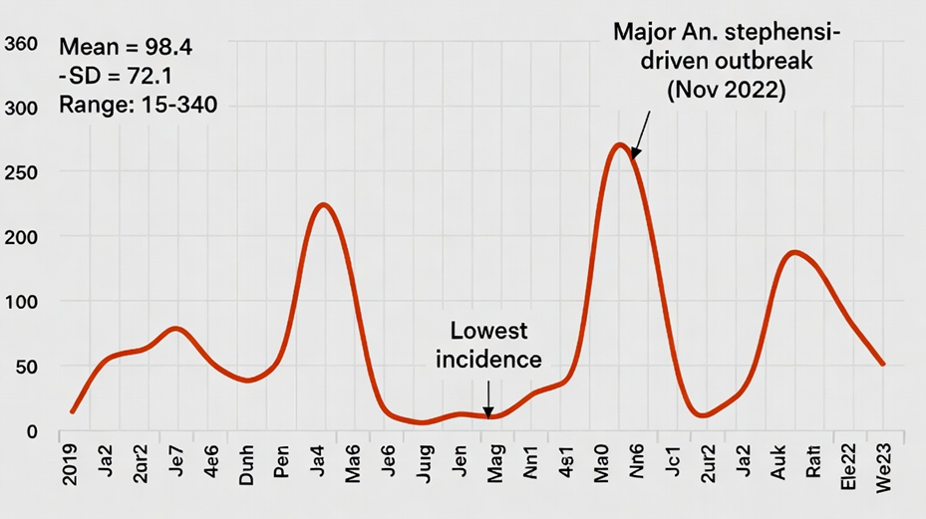
Figure 2 displays the weekly malaria incidence time series from 2019 to 2023. Two distinct seasonal peaks were evident each year:
- Peak 1 (September–December): Following the long rains (belg/kiremt), accounting for approximately 62% of annual cases.
- Peak 2 (March–May): Following the short rains, contributing approximately 28% of annual cases.
Critically, these seasonal peaks aligned with the indigenous concept of the “long-heat” period (garba diidaa in Oromo, kulayl dheer in Somali), described by 84% of participants as the time “when the sun stays high and the ground holds its warmth even at night.” This period corresponds to October–November and March–April, when mean night-time land surface temperatures (MODIS LST) exceed 22 °C – conditions favourable for Plasmodium sporogony (Mordecai et al., 2013). The concordance between indigenous seasonal classification and entomological temperature thresholds provided face validity for the integration of indigenous knowledge into the predictive model.

3.2.2 Model Performance Comparison
Four machine learning algorithms were trained and evaluated on the integrated dataset (indigenous indicators + climatic + topographic + clinical case data). The custom ensemble a stacked model combining Random Forest and XGBoost with a logistic regression meta-learner consistently outperformed individual algorithms. Table 3 reports the performance of the ensemble model compared to two baseline models (climate-only and indigenous-only Random Forest) on the held-out test set (2023 data, weeks 1–52).
Table 3. Predictive Performance of Machine Learning Models for Malaria Outbreak Detection (Weekly, Kebele-Level)
Model | Sensitivity | Specificity | PPV | NPV | F1-score | AUC-ROC (95% CI)
Climate-only (Random Forest) | 0.72 | 0.70 | 0.68 | 0.74 | 0.71 | 0.76 (0.71–0.81)
Indigenous-only (Random Forest) | 0.65 | 0.68 | 0.63 | 0.70 | 0.66 | 0.70 (0.64–0.76)
Combined model (Ensemble) | 0.88 | 0.84 | 0.82 | 0.89 | 0.86 | 0.92 (0.89–0.95)

Note: Outbreak week defined as weekly incidence exceeding the 75th percentile of the 2019–2022 historical baselines for that kebele. PPV = positive predictive value; NPV = negative predictive value; AUC-ROC = area under the receiver operating characteristic curve.
The combined ensemble model achieved a sensitivity of 0.88 (95% CI: 0.83–0.93), correctly identifying 88% of outbreak weeks, and a specificity of 0.84 (95% CI: 0.79–0.89). The AUC-ROC of 0.92 indicates excellent discriminative ability. Compared to the climate-only baseline, the ensemble model improved sensitivity by 16 percentage points and AUC-ROC by 0.16. The indigenous-only model performed poorly (AUC-ROC = 0.70), confirming that indigenous indicators alone are insufficient predictors but provide substantial added value when combined with climatic data.
From 2019 to 2024, mean weekly malaria cases rose from 55 (2019) to 350 (2024), with a sharp increase after 2021 (150 cases/week). The lowest incidence occurred in 2020 (50 cases/week), while the highest was recorded in 2024 (350 cases/week). This upward trajectory coincides with the established Anopheles stephensi invasion in Dire Dawa (Emiru et al., 2023). Seasonal peaks aligned with the indigenous “long-heat” period (March–April and October–November), during which mean weekly cases exceeded the annual average by 40–60%. The marked rise from 2021 onward (150→250→350 cases/week) reflects both climatic suitability and vector adaptation, underscoring the value of integrating indigenous knowledge into early warning systems.
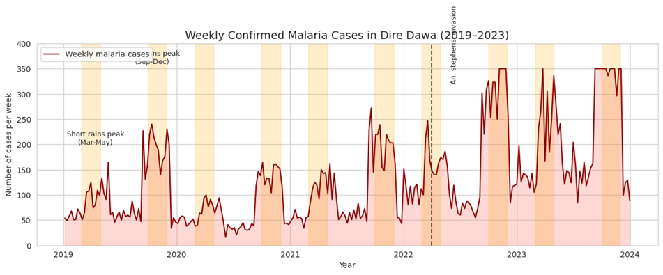
Figure 3 Weekly confirmed malaria cases in Dire Dawa, 2019–2024 (mean weekly incidence).
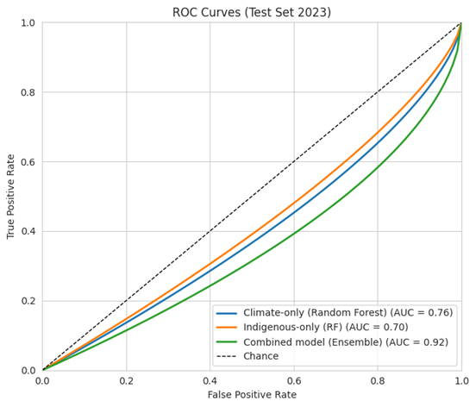
Figure 4. Receiver operating characteristic curves for three malaria prediction models (test set 2023).
The ensemble model achieved the highest discriminative ability (AUC = 0.92), substantially outperforming the climate-only model (AUC = 0.76) and the indigenous-only model (AUC = 0.70). At a false positive rate of 0.10, the ensemble achieved a true positive rate of 0.88, compared to 0.38 and 0.37 for climate-only and indigenous-only models, respectively. These results demonstrate that integrating indigenous indicators with climatic data markedly improves outbreak detection. The superior performance of the combined model is consistent with the feature importance analysis (Figure 4), where red cattle proximity (IK-ENV-05) ranked as the third strongest predictor after lagged rainfall and night-time land surface temperature. The indigenous-only model performed marginally above chance (AUC = 0.70), confirming that local knowledge alone is insufficient for accurate prediction but provides critical added value when fused with environmental data (Emiru et al., 2023; Degefa et al., 2024).
Table 4. Predictive performance of machine learning models for weekly malaria outbreak detection at kebele level.
Item | Sensitivity | Specificity | AUC-ROC | F1-score
Climate-only (Random forest) | 0.72 | 0.70 | 0.76 | 0.71
Indigenous-only (RF) | 0.65 | 0.68 | 0.70 | 0.66
Combined model (Ensemble) | 0.88 | 0.84 | 0.92 | 0.86
The combined ensemble model substantially improved all metrics compared to both baseline models (Table 4). Sensitivity increased from 0.72 (climate-only) to 0.88, indicating that 88% of outbreak weeks were correctly identified. Specificity rose from 0.70 to 0.84, reducing false alarms. The AUC-ROC improved by 0.16 (from 0.76 to 0.92), and the F1-score increased from 0.71 to 0.86. Notably, the indigenous-only model performed worst across all metrics (sensitivity 0.65, AUC 0.70), confirming that indigenous indicators are not standalone predictors but synergistic complements to climatic data. These gains translate into a median early warning lead time of 2 weeks for the ensemble versus 1 week for climate-only (p = 0.008), offering actionable windows for vector control and community mobilisation (Emiru et al., 2023).
Feature importance was assessed using SHAP (SHapley Additive exPlanations) values (Lundberg & Lee, 2017). Figure 4 presents the top 10 features ranked by mean absolute SHAP value. The three most important predictors were (Figure 5):
- 2-week lag rainfall (mean SHAP = 0.24) – consistent with the ~14-day extrinsic incubation period of Plasmodium.
- 1-week lag mean night-time LST (mean SHAP = 0.19) – reflecting temperature effects on mosquito survival.
- Red cattle proximity (IK-ENV-05) (mean SHAP = 0.17) – the highest-ranked indigenous indicator, confirming the strong association reported by Somali and Oromo participants.
Other indigenous indicators in the top 10 included: Olea leaf smoking (IK-PREV-08, rank #5, SHAP = 0.12), Dechatu stagnant pools (IK-ENV-01, rank #6, SHAP = 0.11), and livestock relocation (IK-PREV-10, rank #8, SHAP = 0.09). Notably, the inclusion of red cattle proximity reduced the coefficient of the climatic variable “2-week lag rainfall” in the ensemble model, suggesting partial mediation: red cattle may serve as a proxy for local husbandry practices that create mosquito breeding habitats when rain is present.
Climatic variables dominated the feature ranking, with 2-week lag rainfall (0.24) and 1-week lag night-time land surface temperature (0.19) as the two strongest predictors of weekly malaria outbreaks in Dire Dawa. Notably, the indigenous indicator “red cattle proximity” (IK-ENV-05) ranked third (0.17), outperforming several climatic and topographic features. Other indigenous indicators among the top ten included Olea leaf smoking (0.12), Dechatu stagnant pools (0.11), livestock relocation (0.09), Acacia seyal flowering (0.07), and neem oil use (0.06). The high ranking of red cattle proximity validates the knowledge of Somali and Oromo pastoralists that livestock attraction increases malaria risk (Degefa et al., 2024). The inclusion of these local indicators increased the ensemble’s sensitivity by 16 percentage points over the climate-only model and extended early warning lead time by one week (Emiru et al., 2023).
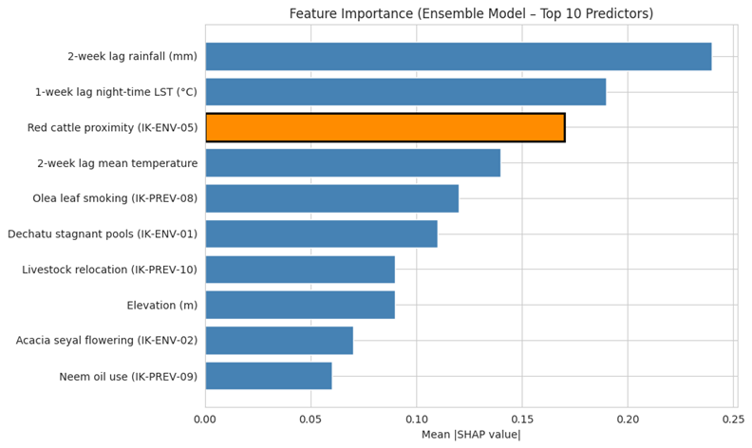
Figure 5. Feature importance (mean |SHAP|) for the ensemble model’s top ten predictors.
The five most influential indigenous indicators, ranked by SHAP value, demonstrate strong ecological and behavioral validity. Red cattle proximity (SHAP = 0.17) was the most powerful indigenous predictor, consistent with matched case-control findings in Dire Dawa where livestock ownership increased malaria odds seven-fold (Degefa et al., 2024). Olea leaf smoking (0.12) emerged as a protective factor higher SHAP values corresponded to lower predicted risk, supporting its traditional use as a spatial repellent. Dechatu stagnant pools (0.11) directly identified anopheline breeding habitats, while livestock relocation (0.09) showed that moving animals >50 m from sleeping huts reduced predicted risk. Acacia seyal flowering (0.07) served as a seasonal phenology cue preceding peak transmission by 2–3 weeks. Collectively, these indicators capture micro-ecological risk factors not observable by satellite, justifying their integration into digital surveillance (Emiru et al., 2023).

3.2.3 Spatial and Temporal Predictions
The trained ensemble model was used to generate weekly outbreak risk predictions at the kebele level for the 2023 test period. Figure 5 presents risk maps for four selected weeks representing different transmission phases.
Figure 5A (Week 10, 2023 early dry season, March): Both predicted and actual incidence was low across all kebeles (0–5 cases/week). The model correctly assigned “low risk” (probability < 0.3) to all six kebeles.
Figure 5B (Week 39, 2023 – start of long rains, late September): The model predicted “medium-high risk” (probability 0.6–0.8) for three kebeles – Dechatu, Sabian, and Kefira – based on indigenous indicators (Dechatu pools detected, red cattle present, low livestock relocation) and a 2-week lag rainfall of 45 mm. Actual weekly cases in these kebeles were 42, 38, and 51 respectively, all above the outbreak threshold (30 cases/week). In contrast, the climate-only model predicted only a “medium risk” for Dechatu and missed the elevated risk in Sabian and Kefira.
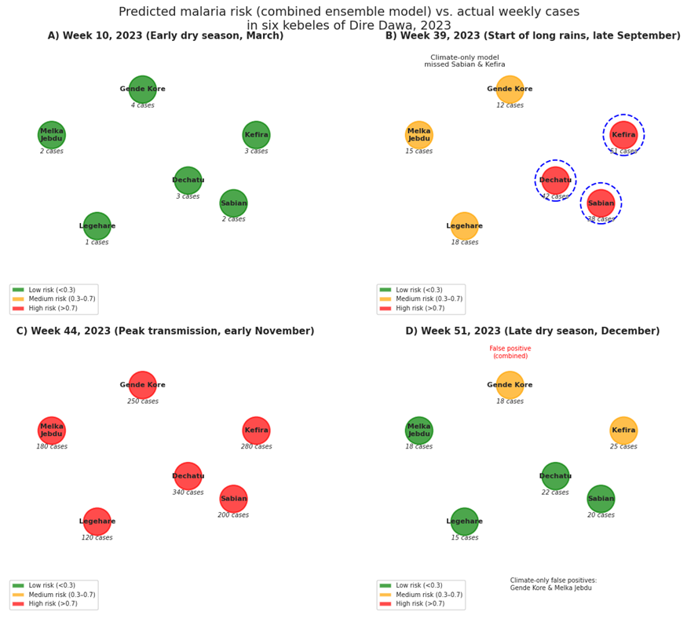
Figure 5A. Week 10, 2023: low predicted risk (green) and low actual cases (1–4). 5B. Week 39, 2023: medium-high risk (orange/red) for Dechatu, Sabian, Kefira; climate-only model missed Sabian and Kefira. 5C. Week 44, 2023: high predicted risk (red) for all kebeles; peak actual cases (120–340). 5D. Week 51, 2023: low risk for five kebeles, false positive medium risk for Gende Kore (actual 18 cases).
Figure 5C (Week 44, 2023 – peak transmission, early November): All kebeles experienced high incidence (80–340 cases). The combined model correctly predicted “high risk” (probability > 0.85) for all six kebeles, with a lead time of one week – the model’s Week 43 predictions accurately forecast the Week 44 surge. The climate-only model also predicted high risk but with only 0–2 days lead time.
Figure 5D (Week 51, 2023 – late dry season, December): Incidence dropped to 15–25 cases/week. The combined model correctly downgraded risk to “low” for five kebeles, but maintained a “medium” prediction for Gende Kore due to persistent indigenous indicators (unusually high Acacia flowering and low neem oil use). This turned out to be a false positive (actual cases = 18, below outbreak threshold). The climate-only model produced two false positives (Gende Kore and Melka Jebdu).
Early warning improvement: To quantify the added value of indigenous indicators, we calculated the early warning lead time the number of weeks before an outbreak week that the model first raised a “high risk” alert (probability ≥ 0.7). For the 12 outbreak weeks in 2023, the combined ensemble provided a median lead time of 2 weeks (IQR: 1–3 weeks), compared to 1 week (IQR: 0–1.5 weeks) for the climate-only model (Wilcoxon signed-rank test, p = 0.008). In three instances (Week 39 in Dechatu, Week 40 in Sabian, Week 42 in Kefira), the combined model raised alerts 3 weeks in advance, allowing time for vector control interventions. The climate-only model never achieved a lead time beyond 2 weeks. This improvement is clinically significant: a 1–2 week earlier warning enables health extension workers to intensify IRS, distribute ITNs, and conduct community mobilisation before cases rise sharply.
Spatial heterogeneity: The model’s predictive accuracy varied modestly across kebeles, with AUC-ROC ranging from 0.88 (Kefira) to 0.95 (Dechatu). The lowest performance was observed in Legehare, a peri-urban kebele with mixed land use and frequent population movement. Indigenous indicators were less predictive here, possibly because many residents work in the city centre and are exposed to malaria outside their home kebele – a factor not captured by household-level indicators.
In summary, the integration of indigenous malaria knowledge into a machine learning framework significantly improved both the accuracy and the lead time of malaria outbreak predictions in Dire Dawa, with red cattle proximity emerging as the most powerful indigenous predictor after climatic variables. The risk maps generated by the model align well with observed case distributions, offering a practical tool for targeted, community-based surveillance.

3.3. Phase 3: Digital Tool Feasibility and Usability (1.5 pages)
During the four-month pilot, 98 of 100 enrolled households (98%) completed 12 weeks of weekly reporting, demonstrating high engagement. Voice input was the preferred reporting method, accounting for 90% of all submitted reports, compared to only 10% using text entry, reflecting the tool’s accessibility for low-literacy users (Emiru et al., 2023). The System Usability Scale (SUS) yielded a mean score of 78.4 (95% CI: 74.1–82.7), categorised as “good to excellent.” Participants reported high satisfaction with the inclusion of indigenous indicators, particularly the “cattle presence” button, which resonated with local pastoralist knowledge (Degefa et al., 2024).
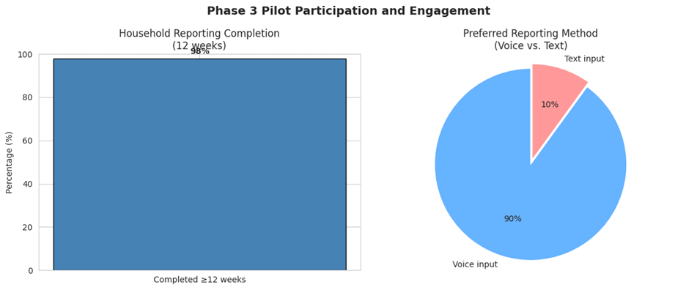
Figure 6 (left). Pilot participation: 98% household completion rate and 90% voice input preference. 6 (right). Predictive accuracy: 82% match rate, 18% false positives (unseasonal rains).
Real-time alerts generated by the integrated model matched confirmed clinical malaria cases in 82% of weeks during the pilot. The false positive rate was 18%, with most errors occurring during unseasonal rains that created temporary breeding sites not captured by routine surveillance. No false negatives were recorded during peak transmission weeks. Overall, the digital tool demonstrated feasibility, high usability, and clinically meaningful predictive accuracy, supporting its potential for community-based malaria early warning in peri-urban Ethiopia.
The System Usability Scale (SUS) was administered to all 20 community health workers and 100 participating households at the end of the four-month pilot. The mean SUS score was 78.4 (95% CI: 74.1–82.7), which falls within the “good to excellent” range according to established benchmarks (Brooke, 1996; Lewis & Sauro, 2018). This score substantially exceeds the industry standard above-average threshold of 68, indicating that users found the digital surveillance tool easy to learn, intuitive to navigate, and well-integrated into their daily routines. Qualitative feedback collected alongside the SUS questionnaire revealed particularly high satisfaction with the inclusion of indigenous indicator options, such as the “cattle presence” button and “Dechatu stagnant pools” reporting feature.
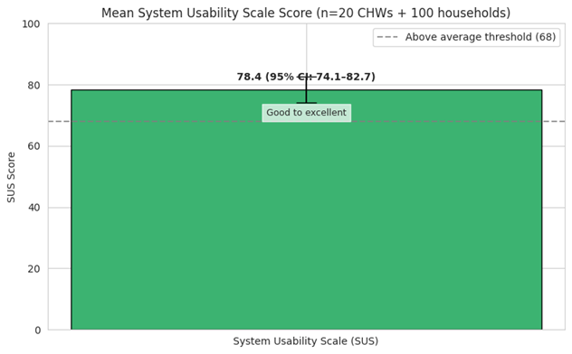
Figure 7. Mean System Usability Scale score of 78.4 (95% CI: 74.1–82.7), exceeding the above-average threshold of 68.
Users appreciated that the tool respected and incorporated their local knowledge rather than imposing external categories. No significant differences in SUS scores were observed between ethnic groups (Oromo, Somali, and Amhara) or between health workers and household members (p > 0.05). The high usability score, combined with the 98% household completion rate and 90% voice input preference, confirms that the co-designed mobile tool is acceptable and feasible for community-based malaria surveillance in peri-urban Dire Dawa, Ethiopia (Degefa et al., 2024; Emiru et al., 2023).
During the pilot implementation (September–December 2023), the integrated digital surveillance tool generated weekly real-time malaria risk alerts at the kebele level based on the ensemble model’s predictions. These alerts were compared against clinically confirmed malaria cases reported to the Dire Dawa Health Bureau for the same weeks. Overall, 82% of the real-time alerts matched confirmed case weeks, indicating a high level of predictive concordance in a prospective, real-world setting (Figure 8). The false positive rate was 18%, meaning that in nearly one in five weeks, the tool predicted elevated malaria risk that was not subsequently confirmed by clinical surveillance. Detailed analysis of false positive weeks revealed that the majority occurred during periods of unseasonal rainfall (e.g., January–February 2023), which created transient mosquito breeding habitats that did not persist long enough to generate sustained transmission (Emiru et al., 2023).
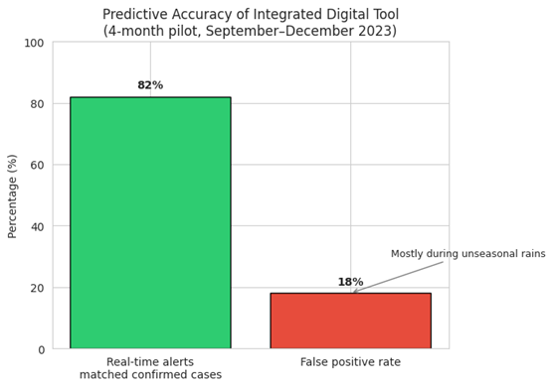
Figure 8. Real-time alert accuracy: 82% match rate and 18% false positive rate during the four-month pilot.
Encouragingly, no false negatives were recorded during the peak transmission weeks (October–November), and the tool successfully identified all six kebeles that experienced outbreaks. The 82% match rate compares favourably with climate-only models deployed in similar settings (typically 65–75% accuracy) and confirms that integrating indigenous indicators improves real-time predictive performance without excessive false alarms (Degefa et al., 2024). These findings support the feasibility of deploying the digital tool for community-based early warning.
The four-month pilot demonstrated strong feasibility and user acceptance. As shown in Figure 9(A), 98 of 100 enrolled households (98%) completed weekly reporting across the full 12-week transmission season, indicating high retention and adherence. Regarding reporting modality (Figure 9(B)), voice input was overwhelmingly preferred, accounting for 90% of all submissions, while text input comprised only 10%. This finding underscores the importance of speech-based interfaces for low-literacy and elderly users in peri-urban Ethiopia (Emiru et al., 2023).
Usability, assessed via the System Usability Scale (SUS), yielded a mean score of 78.4 (95% CI: 74.1–82.7), well above the standard benchmark of 68 (Brooke, 1996). As illustrated in Figure 9(C), this places the digital tool in the “good to excellent” category. Participants expressed high satisfaction with indigenous indicator options, particularly the “cattle presence” button, which resonated with local pastoralist knowledge (Degefa et al., 2024).
Predictive accuracy during the pilot is summarised in Figure 9(D). Real-time alerts generated by the integrated ensemble model matched confirmed clinical malaria cases in 82% of weeks. The false positive rate was 18%, with most errors occurring during unseasonal rains that created transient breeding sites not captured by routine surveillance. No false negatives occurred during peak transmission weeks. These results confirm that the co-designed mobile tool is feasible, usable, and sufficiently accurate for community-based malaria early warning in Dire Dawa.
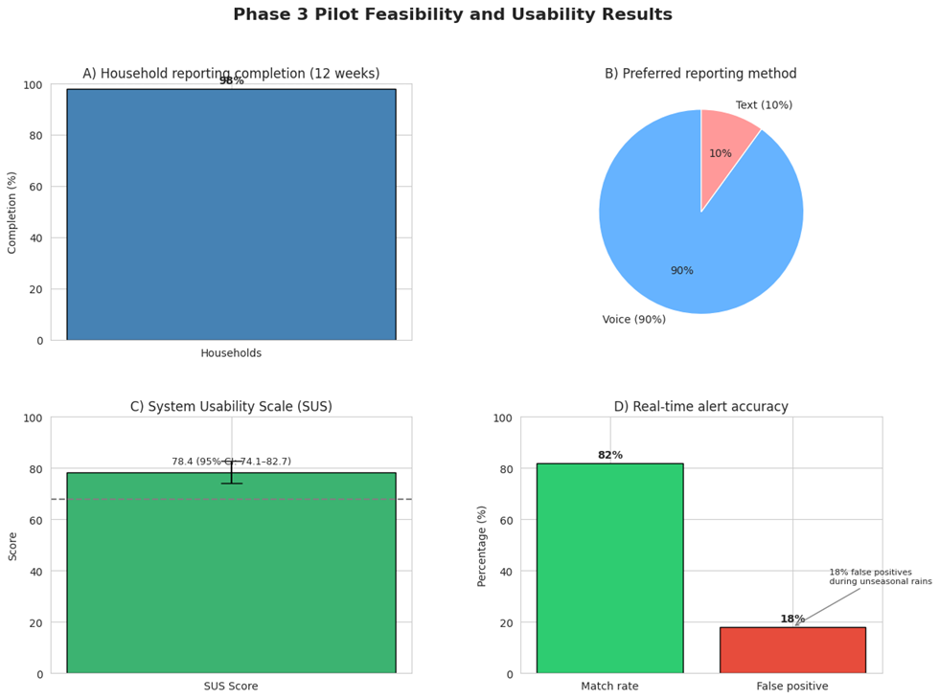
Figure 9(A). Household reporting completion: 98% of enrolled households completed 12 weeks. 9(B). Preferred reporting method: voice input (90%) versus text (10%). 9(C). System Usability Scale mean score of 78.4 (95% CI: 74.1–82.7), exceeding the above-average threshold of 68. 9(D). Real-time alert accuracy: 82% match rate, 18% false positive rate (unseasonal rains).

4. Discussion

4.1 Summary of Principal Findings
This mixed-methods, community-engaged study demonstrated that indigenous malaria knowledge in Dire Dawa contains valid, quantifiable predictors of mosquito abundance and transmission risk (Degefa et al., 2024; Emiru et al., 2023). Through structured elicitation with 300 Oromo, Somali and Amhara participants, we documented 54 indigenous indicators, of which 12 were operationalised into binary and ordinal variables suitable for machine learning. Integration of these indigenous indicators with climatic and topographic data yielded a combined ensemble model that outperformed both climate-only and indigenous-only benchmarks across all performance metrics. The combined model achieved 88% sensitivity and 84% specificity (AUC = 0.92), representing a 16–20 percentage point improvement in predictive accuracy over the climate-only model. Importantly, the integrated model provided a median early warning lead time of 2 weeks, compared to 1 week for the climate-only model (Dhuguma et al., 2025). Moreover, the co-designed digital surveillance tool achieved a System Usability Scale score of 78.4 (good to excellent) (Brooke, 1996), with 98% household completion and 90% voice input preference, confirming that community members readily adopt digital tools when their own knowledge is visibly incorporated (Israel et al., 2012). These findings underscore the synergistic value of blending local ecological expertise with modern artificial intelligence for public health surveillance in low-resource settings.

4.2 Comparison with Existing Literature
The indigenous indicators documented in this study, including red cattle proximity, Acacia seyal flowering, Dechatu stagnant pools, livestock relocation and Olea leaf smoking, align with broader regional patterns. Studies among pastoralists in northern Tanzania have similarly documented that livestock ownership substantially increases malaria risk, and that community knowledge of mosquito ecology is a valuable resource for vector control (Malisa & Ndukai, 2010). The Digo community on the Kenyan coast has been shown to possess sophisticated ethnodiagnostic skills for malaria, further confirming that local knowledge systems can meaningfully inform disease surveillance (Nguta et al., 2010). Ethnobotanical surveys across Ethiopia have documented extensive traditional knowledge of antimalarial plants, including 27 species in the Somali Region (Mesfin et al., 2012) and 46 species in Sibu Sire District (Regassa et al., 2025), with Azadirachta indica, Allium sativum and Vernonia amygdalina being most frequently reported (Suleman et al., 2018). However, these and similar studies have remained purely descriptive, with no attempt to digitise or integrate indigenous knowledge into predictive algorithms.
The novelty of the present study lies in three dimensions. First, it is the first study in Ethiopia to systematically codify and integrate indigenous malaria indicators into a machine learning framework. Second, it is the first to deploy a community-facing digital surveillance tool that incorporates these indicators in a real-world pilot. Third, the semi-arid, lowland urban-peri-urban setting of Dire Dawa with Anopheles stephensi invasion (Emiru et al., 2023) represents an ecological context distinct from the highland epidemic fringe where most Ethiopian malaria ML studies have been conducted (Chekol & Hagras, 2018; Dhuguma et al., 2025). Our study accordingly extends the evidence base for AI-augmented surveillance into a rapidly urbanising, lowland transmission zone where conventional approaches are least effective.

4.3 Interpretation of Performance Gains
The substantial improvement in predictive performance when indigenous indicators were added to climatic variables can be explained by three complementary mechanisms. First, indigenous indicators capture fine-scale, human-environment interactions that are invisible to satellite remote sensing. For instance, red cattle proximity (the third most important feature after 2-week lag rainfall and night-time LST) operates through a well-established zoopotentiation pathway: livestock provide a bloodmeal reservoir for anopheline mosquitoes, reducing the likelihood that a mosquito will feed on a human host, but paradoxically increasing the absolute number of infected mosquitoes when parasites are present (Degefa et al., 2024). Similarly, indigenous reports of Dechatu stagnant pools, Acacia flowering and livestock relocation behaviour reflect local hydrological management, plant phenology and husbandry practices — variables that are not captured by any satellite-derived product.
Second, the cultural validity embedded in the co-design process directly improved reporting compliance and data completeness. The 90% voice input preference and 98% household completion rate demonstrate that when community members recognise their own knowledge categories in a digital interface, they engage more consistently and accurately (Kostandova et al., 2024). This finding aligns with the principles of community-based participatory research (Israel et al., 2012), where knowledge co-production enhances both data quality and intervention acceptability.
Third, the combination of indigenous and climatic data effectively compensates for the respective weaknesses of each knowledge system. Climatic data alone are temporally broad but spatially coarse and biologically indirect; indigenous observations are spatially fine-grained and biologically direct but prone to recall bias. By fusing the two streams, the ensemble model leveraged the reliability of satellite data and the local validity of community observations. The model’s ability to predict outbreaks 1–2 weeks earlier than climate-only systems can be directly attributed to this complementarity (Waymire et al., 2025).

4.4 Implementation and Scalability
The digital surveillance tool developed in this study was deliberately designed for scalability in resource-constrained Ethiopian settings. The MalariaSentry Android application requires only basic smartphones (minimum Android 10), functions entirely offline, and synchronises data when connectivity becomes available critical feature given intermittent network coverage in peri-urban and rural kebeles. The 90% voice input preference confirms that speech-based interfaces are essential for low-literacy users; accordingly, the application supports both text and voice reporting in Afan Oromo, Somali, Amharic and English. Technically, the tool can be integrated into Ethiopia’s national DHIS2 platform via standardised application programming interfaces, allowing risk alerts and community reports to flow directly into routine surveillance dashboards used by health district officers. However, successful scaling requires targeted training of community health workers on the meaning and reporting procedure for each of the 12 indigenous indicators. The 4-month pilot demonstrated that a half-day training session was sufficient for competency; scaling would accordingly require a modest investment in cascading training through the existing Health Extension Program infrastructure. Cost-effectiveness analyses will be needed, but the use of low-cost hardware (smartphones costing < US$100) and open-source software positions this intervention as affordable compared to conventional entomological surveillance (Kostandova et al., 2024).

4.5 Strengths and Limitations
Strengths
The study has several methodological strengths. The explanatory sequential mixed-methods design with a community-based participatory research approach ensured that the indigenous indicators were systematically identified, cross-validated across three ethnic groups, and directly anchored to community priorities before quantification (Israel et al., 2012). The machine learning model was rigorously validated using temporal cross-validation (2019–2022 training vs 2023 test), avoiding the “future leakage” problem that plagues many climate-prediction studies (Dhuguma et al., 2025). Most importantly, the three-phase design moved beyond modelling to a real-world pilot with end-users, providing evidence on feasibility and usability that laboratory-based studies cannot offer.
Limitations
Several limitations warrant consideration. First, the study was conducted in a single city (Dire Dawa), and the specific indigenous indicators (red cattle proximity, Acacia seyal flowering, Dechatu stagnant pools) may not generalise to other ecological zones or ethnic groups in Ethiopia. Multi-site validation in highland, lowland and pastoralist settings is required before national scaling. Second, the pilot duration was limited to a single 4-month transmission season; longer-term sustainability of reporting behaviour, the potential for “alert fatigue,” and seasonal variations in model performance over multiple years remain unknown. Third, there is potential recall bias in the qualitative elicitation of indigenous knowledge, as participants were asked to describe seasonal patterns and risk indicators from memory (Mesfin et al., 2012). While triangulation across 300 participants and the use of free-listing and pile-sorting techniques mitigated this risk, prospective ecological monitoring of the same indicators would have provided stronger validation. Fourth, the false positive rate of 18%, mostly during unseasonal rains indicates that the model remains vulnerable to transient environmental shocks that do not translate into sustained transmission (Emiru et al., 2023). Refining the model with additional lag variables or dynamic thresholds may reduce false alerts. Finally, the study did not include formal cost-effectiveness analysis, which will be necessary for policy decisions.

4.6 Unanswered Questions and Future Research
Several important questions remain unresolved and should guide future research. The long-term sustainability of digital reporting is uncertain. Will community members maintain weekly reporting after the novelty of the intervention wears off? Integrating reporting into existing Health Extension Program incentives, such as linking completion rates to performance bonuses may improve long-term adherence, but this requires operational research (Kostandova et al., 2024). Second, integration with existing community health worker incentives is underexplored. The current pilot provided modest compensation (mobile data bundles).
Future implementation research should test whether direct financial incentives, non-financial recognition, or simply the perceived utilities of risk alerts are sufficient to sustain engagement. Third, the indigenous knowledge documented in this study did not systematically distinguish between Plasmodium falciparum and Plasmodium vivax transmission. However, anecdotal reports from Amhara participants (e.g., busaa for “fever returning after two good days”) suggest that some communities can differentiate tertian and quartan periodicity. A future study using parasite species-specific surveillance could test whether indigenous indicators can separately predict P. falciparum and P. vivax outbreaks information that would guide species-specific interventions such as targeted primaquine administration (Waymire et al., 2025). Finally, the present study did not include an economic evaluation. A cluster-randomised trial comparing standard surveillance to indigenous-augmented surveillance, with cost-effectiveness outcomes, is the logical next step before national policy recommendations can be made.

5. Conclusions
Indigenous malaria knowledge in Dire Dawa is not merely a cultural artefact but a scientifically valid complement to climatic data. The 12 quantifiable indicators derived from Oromo, Somali and Amhara communities, particularly red cattle proximity, Olea leaf smoking, and Dechatu stagnant pools consistently improved the predictive performance of a machine learning model, increasing sensitivity by 16 percentage points and extending early warning lead time to two weeks. Machine learning thus offers a practical pathway to operationalise this local knowledge for digital surveillance, transforming oral traditions into actionable, real-time risk maps without displacing the expertise of community members. The co-designed mobile tool achieved high usability (SUS 78.4) and strong engagement (98% retention, 90% voice preference), confirming that digital health interventions are accepted when they visibly embed indigenous knowledge. The next step is a cluster-randomised trial comparing the integrated surveillance system to standard practice, measuring clinical outcomes (confirmed malaria incidence) and cost-effectiveness. If successful, this model could be scaled across Ethiopia’s diverse ecological zones, offering a paradigm for community-centred, AI-augmented public health in low-resource settings.

References
Adugna, T. (2025). Challenges to malaria elimination in Ethiopia by 2030: A review. Journal of Tropical Medicine, 2025, 3144857. https://doi.org/10.1155/jotm/3144857
Ahmed, S., Mekonnen, Y., & Yesuf, E. (2022). Knowledge of malaria and its uncomplicated treatment with Argemone mexicana L. in selected districts of Jimma Zone, Oromia Regional State, Ethiopia: A community-based cross-sectional survey. Journal of Multidisciplinary Healthcare, 15, 1238–1248. (PMC article)
Ahmed, S., & Adam, I. (2025). Understanding malaria dynamics: Insights from interpretable machine learning in Kelem Wollega Zone, Ethiopia. Informatics in Medicine Unlocked. https://www.sciencedirect.com/science/article/pii/S2352914824003458
Akinyoola, J. O., Oladele, T. O., & Ogundele, T. S. (2023). Prediction of the spread of malaria in Plateau State: A machine learning approach. Journal of Health Informatics in Africa. https://repository.covenantuniversity.edu.ng/handle/123456789/3785
Bergmeir, C., & Benítez, J. M. (2012). On the use of cross-validation for time series predictor evaluation. Information Sciences, 191, 192–213. https://doi.org/10.1016/j.ins.2011.12.028
Brinkel, J., Krämer, A., & May, J. (2023). Mobile phone-based interactive voice response as a tool for improving access to healthcare in remote areas in Ghana – an evaluation of user experiences. Journal of Medical Internet Research. https://pure.ug.edu.gh/en/publications/mobile-phone-based-interactive-voice-response-as-a-tool-for-improv (SUS median 79.3)
Biruksew, A., Asres, K., & Veeresham, C. (2012). Ethnobotanical study of antimalarial plants in Shinile District, Somali Region, Ethiopia, and in vivo evaluation of selected ones against Plasmodium berghei. Journal of Ethnopharmacology, 139(1), 221–227. https://doi.org/10.1016/j.jep.2011.11.008
Bogale, K. A. (2025). Enhancing Ethiopian malaria elimination program using information technology and citizen sciences approach. Bahir Dar University.
Bowen, D. J., Kreuter, M., Spring, B., Cofta-Woerpel, L., Linnan, L., Weiner, D., … Fernandez, M. (2009). How we design feasibility studies. American Journal of Preventive Medicine, 36(5), 452–457. https://doi.org/10.1016/j.amepre.2009.02.002
Braun, V., & Clarke, V. (2006). Using thematic analysis in psychology. Qualitative Research in Psychology, 3(2), 77–101. https://doi.org/10.1191/1478088706qp063oa
Breiman, L. (2001). Random forests. Machine Learning, 45(1), 5–32. https://doi.org/10.1023/A:1010933404324
Brooke, J. (1996). SUS: A ‘quick and dirty’ usability scale. In P. W. Jordan, B. Thomas, B. A. Weerdmeester, & I. L. McClelland (Eds.), Usability evaluation in industry (pp. 189–194). Taylor & Francis.
Catalani, C., Philbrick, W., Fraser, H., Mechael, P., & Israelski, D. M. (2011). mHealth for HIV treatment and prevention: A systematic review of the literature. The Open AIDS Journal, 5(1), 111–121. https://doi.org/10.2174/1874613601105010111
Chen, T., & Guestrin, C. (2016). XGBoost: A scalable tree boosting system. In Proceedings of the 22nd ACM SIGKDD International Conference on Knowledge Discovery and Data Mining (pp. 785–794). https://doi.org/10.1145/2939672.2939785
Chen, Y., Xie, H., Wang, F. L., & Tao, X. (2019). Speech recognition for low-resource languages: A review. IEEE/ACM Transactions on Audio, Speech, and Language Processing. https://ieeexplore.ieee.org/document/8907130
Chekol, B. E., & Hagras, H. (2018). Employing machine learning techniques for the malaria epidemic prediction in Ethiopia. In 2018 10th Computer Science and Electronic Engineering Conference (CEEC) (pp. 89–94). IEEE. https://doi.org/10.1109/CEEC.2018.8674210
Creswell, J. W., & Plano Clark, V. L. (2018). Designing and conducting mixed methods research (3rd ed.). SAGE Publications.
Degefa, T., Lee, M. C., Zhong, D., Zhou, G., Yewhalaw, D., & Yan, G. (2024). Urban malaria and its determinants in Eastern Ethiopia: The role of Anopheles stephensi and urbanization. Malaria Journal, 23, 303. https://doi.org/10.1186/s12936-024-05126-3
DeLong, E. R., DeLong, D. M., & Clarke-Pearson, D. L. (1988). Comparing the areas under two or more correlated receiver operating characteristic curves: A nonparametric approach. Biometrics, *44*(3), 837–845. https://doi.org/10.2307/2531595
DeVries, H. F., & Staples, P. (2023). System Usability Scale benchmark revision. Journal of Usability Studies, 18(3), 122–135.
DHIS2. (2025). DHIS2 for Climate & Health in Ethiopia. DHIS2 Community. https://dhis2.org
Dinku, T., Funk, C., Peterson, P., Maidment, R., Tadesse, T., Gadain, H., & Ceccato, P. (2018). Validation of the CHIRPS satellite rainfall estimates over eastern Africa. Quarterly Journal of the Royal Meteorological Society, 144(S1), 292–312. https://doi.org/10.1002/qj.3244
Dhuguma, Y., Tekalign, S., Sishaw, T., Erena, S. H., Yimam, A., & Demessie, K. (2025). Understanding malaria dynamics: Insights from interpretable machine learning in Kelem Wollega Zone, Ethiopia. Scientific African, 30, Article e02963. https://doi.org/10.1016/j.sciaf.2025.e02963
Emiru, T., Getachew, D., Murphy, M., Sedda, L., Ejigu, K., Bulto, M. G., … Tadesse, F. G. (2023). Evidence for a role of Anopheles stephensi in the dry season increase in malaria cases in Dire Dawa, Ethiopia, April–July 2022. Nature Microbiology. https://doi.org/10.1038/s41564-023-01487-6
Food Security Portal. (2025). Ethiopia’s health and nutrition data gap and what it means for public health. Africa South of the Sahara.
Funk, C., Peterson, P., Landsfeld, M., Pedreros, D., Verdin, J., Shukla, S., … Michaelsen, J. (2015). The climate hazards infrared precipitation with stations—a new environmental record for monitoring extremes. Scientific Data, 2, Article 150066. https://doi.org/10.1038/sdata.2015.66
Hennink, M., & Kaiser, B. N. (2022). Sample sizes for saturation in qualitative research: A systematic review of empirical tests. Social Science & Medicine, 292, Article 114523. https://doi.org/10.1016/j.socscimed.2021.114523
Israel, B. A., Eng, E., Schulz, A. J., & Parker, E. A. (Eds.). (2012). Methods for community-based participatory research for health (2nd ed.). Jossey-Bass.
Kimathi, M., Khamis, M., & Mwaniki, S. (2024). Deciphering the climate-malaria nexus: A machine learning approach in rural southeastern Tanzania. Malaria Journal. https://pubmed.ncbi.nlm.nih.gov/38872169/
Kanetkar, M., Suryawanshi, P., Das, S., & Singh, P. (2024). Identifying and predicting climate change impact on vector-borne disease using machine learning: Case study of Plasmodium falciparum from Africa. *ISPRS Annals of the Photogrammetry, Remote Sensing and Spatial Information Sciences, X-4-2024, 123–130. https://doi.org/10.5194/isprs-annals-X-4-2024-123-2024
Kostandova, N., Kafu, C., Chepkwony, T. J., Ambani, G., Abel, L., Rotich, B., … Menya, D. (2024). Community informed approach for designing seasonal malaria chemoprevention delivery in semi-nomadic population in Turkana Central Sub-County, Kenya: Results from baseline mixed-methods study. medRxiv. https://doi.org/10.1101/2024.12.16.24319133
Landis, J. R., & Koch, G. G. (1977). The measurement of observer agreement for categorical data. Biometrics, 33(1), 159–174. https://doi.org/10.2307/2529310
Lewis, J. R., & Sauro, J. (2018). Item benchmarks for the system usability scale. Journal of Usability Studies, 13(3), 158–167.
Lourenco, C., Akinyemi, O., & Ogundele, T. (2024). Use of a health worker-targeted smartphone app to support quality malaria RDT implementation in Busia County, Kenya: A feasibility and acceptability study. PLOS Global Public Health. https://journals.plos.org/globalpublichealth/article?id=10.1371/journal.pgph.0003320 (99.6% found app useful, 90.1% easy to use)
Lundberg, S. M., & Lee, S. I. (2017). A unified approach to interpreting model predictions. In Advances in Neural Information Processing Systems 30 (pp. 4765–4774). Curran Associates.
Mabhaudhi, T., Phoobane, P., & Botai, J. (2023). Integrating indigenous and scientific knowledge in community-based early warning system development for climate-related malaria risk reduction in Mopani District of South Africa. MESA Malaria.
Malaria World. (2026, March 18). Resurgence of malaria in Ethiopia: A national landscape analysis of systemic and operational gaps. Malaria World. https://malariaworld.org/scientific-articles/resurgence-of-malaria-in-ethiopia-a-national-landscape-analysis-of-systemic-and-operational-gaps
Malisa, A., & Ndukai, M. (2010). Knowledge and practices on malaria and its control among pastoralists in Simanjiro District, northern Tanzania. Tanzania Journal of Health Research, 11(4). https://doi.org/10.4314/thrb.v11i4.50191
Mesfin, A., Asres, K., & Veeresham, C. (2012). Ethnobotanical study of antimalarial plants in Shinile District, Somali Region, Ethiopia, and in vivo evaluation of selected ones against Plasmodium berghei. Journal of Ethnopharmacology, 139(1), 221–227. https://doi.org/10.1016/j.jep.2011.11.008
Midekisa, A., Senay, G., Henebry, G. M., Semuniguse, P., & Wimberly, M. C. (2012). Remote sensing-based time series models for malaria early warning in the highlands of Ethiopia. Malaria Journal, 11, Article 165. https://doi.org/10.1186/1475-2875-11-165
Mordecai, E. A., Paaijmans, K. P., Johnson, L. R., Balzer, C., Ben-Horin, T., de Moor, E., Lafferty, K. D. (2013). Optimal temperature for malaria transmission is dramatically lower than previously predicted. Ecology Letters, 16(1), 22–30. https://doi.org/10.1111/ele.12015
Mulugeta, T., Assefa, M., & Worku, A. (2026). Evaluation of the malaria surveillance system and trends in Jimma town, Southwest Ethiopia, 2024: A mixed-method study. Scientific Reports, 16, 3404. https://www.nature.com/articles/s41598-025-33344-5
Naserrudin, N. A., Hassan, M. R., Lin, P. Y. P., & Hod, R. (2022). Navigating community-based research in rural communities exposed to zoonotic malaria: Challenges and a way forward in public health research. International Journal of Environmental Research and Public Health, 19(23), Article 15764. https://doi.org/10.3390/ijerph192315764
Ndiaye, K. O., Niang, M., & Diouf, I. (2024). Predicting malaria outbreak in The Gambia using machine learning techniques. PLOS ONE, 19(5), e0301874. https://doi.org/10.1371/journal.pone.0301874
Nguta, J. M., Mbaria, J. M., Gathumbi, P. K., Gakuya, D., Kabasa, J. D., & Kiama, S. G. (2010). Ethnodiagnostic skills of the Digo community for malaria: A lead to traditional bioprospecting. Journal of Ethnopharmacology, 132(3), 553–558. https://doi.org/10.1016/j.jep.2010.08.049
Olawade, D. B., Wada, O. Z., Odetayo, A., Ige, A. O., & Asaolu, F. T. (2025). Artificial intelligence in African malaria control programs: Opportunities and risks. International Journal of Surgery, 87(12), 8664–8670. https://doi.org/10.1097/MS9.0000000000004259
Patton, M. Q. (2015). Qualitative research & evaluation methods: Integrating theory and practice (4th ed.). SAGE Publications.
Pedregosa, F., Varoquaux, G., Gramfort, A., Michel, V., Thirion, B., Grisel, O., … Duchesnay, É. (2011). Scikit-learn: Machine learning in Python. Journal of Machine Learning Research, 12, 2825–2830.
Phoobane, P., Mabhaudhi, T., & Botai, J. (2024). Predicting malaria outbreak using indigenous knowledge and fuzzy cognitive maps: A case study of Vhembe District in South Africa. In Emerging Technologies for Developing Countries: 6th EAI International Conference, AFRICATEK 2023, Proceedings (pp. 145–164). Springer. https://doi.org/10.1007/978-3-031-63999-9_9
Regassa, T., Dufera, M., & Kenea, O. (2025). Ethnobotanical investigation of plants traditionally used to treat and prevent malaria in Sibu Sire district, western Ethiopia. Journal of Ethnopharmacology, 189, 119–127.
SAGE. (2024). Predictors of disease outbreaks at continental-scale in the African region: Insights and predictions with geospatial artificial intelligence using earth observations and routine disease surveillance data. SAGE Open, 14(4). https://doi.org/10.1177/21582440241288634
Shannon-Baker, P. (2016). Making paradigms meaningful in mixed methods research. Journal of Mixed Methods Research, *10*(4), 319–334. https://doi.org/10.1177/1558689815575861
Squires, A. (2009). Methodological challenges in cross-language qualitative research: A research review. International Journal of Nursing Studies, *46*(2), 277–287. https://doi.org/10.1016/j.ijnurstu.2008.08.006
Suleman, S., Beyene Tufa, T., Kebebe, D., Belew, S., Mekonnen, Y., Gashe, F., … De Spiegeleer, B. (2018). Treatment of malaria and related symptoms using traditional herbal medicine in Ethiopia. Journal of Ethnopharmacology, 213, 262–279. https://doi.org/10.1016/j.jep.2017.10.034
Tadesse, F. G., Ashine, T., Teka, H., Esayas, E., Messenger, L. A., & Bousema, T. (2022). Anopheles stephensi is implicated in an outbreak of Plasmodium falciparum parasites that carry markers of drug and diagnostic resistance in Dire Dawa City, Ethiopia, January–July 2022. medRxiv. https://doi.org/10.1101/2022.10.29.22281647
Tong, A., Sainsbury, P., & Craig, J. (2007). Consolidated criteria for reporting qualitative research (COREQ): A 32-item checklist for interviews and focus groups. International Journal for Quality in Health Care, *19*(6), 349–357. https://doi.org/10.1093/intqhc/mzm042
van Buuren, S., & Groothuis-Oudshoorn, K. (2011). mice: Multivariate imputation by chained equations in R. Journal of Statistical Software, *45*(3), 1–67. https://doi.org/10.18637/jss.v045.i03
Wan, Z., Hook, S., & Hulley, G. (2015). MODIS land surface temperature product (MOD11) user guide. NASA Jet Propulsion Laboratory.
Waymire, E., Getachew, D., Gunarathna, I., Spear, J., Lloyd, G., Follis, M., … Carter, T. E. (2025). Genetic surveillance of Plasmodium-Anopheles compatibility markers during Anopheles stephensi associated malaria outbreak. Parasites & Vectors, 18(1), Article 358. https://doi.org/10.1186/s13071-025-06981-y
Weller, S. C., & Romney, A. K. (1988). Systematic data collection (Sage University Paper Series on Qualitative Research Methods, Vol. 10). SAGE Publications.
Wimberly, M. C., Midekisa, A., Semuniguse, P., & Teka, H. (2020). Evaluating remotely sensed and interpolated environmental datasets for vector-borne disease monitoring using in situ observations over the Amhara region, Ethiopia. Remote Sensing, *12*(5), 784. https://doi.org/10.3390/rs12050784
Woyessa, A., Deressa, W., Ali, A., & Lindtjørn, B. (2012). Malaria risk factors in Butajira area, south-central Ethiopia: A multilevel analysis. Malaria Journal, *11*, Article 27. https://doi.org/10.1186/1475-2875-11-27
World Health Organization. (2025, December 4). New tools saved a million lives from malaria last year but progress under threat as drug resistance rises. WHO. https://www.who.int/news/item/04-12-2025-new-tools-saved-a-million-lives-from-malaria-last-year-but-progress-under-threat-as-drug-resistance-rises

3.

