AI-Powered Real-Time Tele-Rehabilitation System Using Computer Vision for Orthopedic Patients

ABSTRACT
This methodology presents the design and implementation of an AI-powered computer vision–based physiotherapy rehabilitation system intended to support home and remote exercise monitoring. The proposed system utilizes real-time pose estimation through a standard webcam to detect body key points, compute joint angles, and evaluate exercise performance without the need for wearable sensors or invasive devices. By integrating machine learning–based movement classification with automated visual and audio feedback, the system provides objective posture correction and repetition tracking. Session data is recorded and analyzed to generate performance metrics and progress reports, enabling quantitative assessment of rehabilitation outcomes. The results demonstrate that camera-based motion analysis can offer a cost-effective, non-invasive, and scalable solution for enhancing accessibility and consistency in physiotherapy rehabilitation.In addition to improving accessibility, the system significantly reduces the dependency on continuous clinical supervision by enabling patients to perform exercises independently at home. The use of real-time feedback ensures that users are immediately guided to correct improper posture, thereby minimizing the risk of injury and improving exercise effectiveness. The system is designed with a user-friendly interface that allows individuals with minimal technical knowledge to operate it Furthermore, the integration of automated data logging ensures accurate tracking of patient performance over time, which can be useful for long-term rehabilitation planning. The ability to generate structured reports supports better communication between patients and physiotherapists. The system also promotes consistency in exercise routines by providing continuous monitoring and reminders.
KEYWORDS: Artificial Intelligence, Computer Vision, Physiotherapy Rehabilitation, Human Pose Estimation, Real-Time Monitoring, Machine Learning, Remote Healthcare
1 INTRODUCTION
Physiotherapy rehabilitation is a critical component of recovery for patients suffering from musculoskeletal injuries, post-surgical conditions, and neurological disorders. Effective rehabilitation depends on the accurate execution of prescribed exercises, as improper posture or incomplete movements can delay recovery and increase the risk of secondary complications[1]. Traditionally, physiotherapy relies heavily on in-person supervision by trained therapists, where exercise performance is monitored through visual assessment and manual measurement techniques. While effective in clinical settings, this approach often limits accessibility and continuity of care[2].
With the increasing demand for home-based and remote healthcare solutions, there is a growing need for intelligent systems that can monitor rehabilitation exercises outside clinical environments. Conventional home exercise programs lack supervision and objective performance tracking, while device-based monitoring systems often require wearable sensors or expensive clinical equipment [3]. These factors create barriers to long-term adherence, scalability, and affordability in rehabilitation practice. Recent advancements in artificial intelligence and computer vision have enabled real-time human pose estimation using standard RGB cameras[4]. By detecting skeletal keypoints and analyzing joint movements, computer vision systems can provide quantitative motion analysis without physical contact or invasive devices. This technological progress creates opportunities for developing cost-effective and non-invasive rehabilitation monitoring systems suitable for home use.
In this context, the present work proposes an AI-powered computer vision–based physiotherapy rehabilitation system that performs real-time pose detection, joint angle computation, and exercise classification[5]. The system provides automated visual and audio feedback, tracks session performance, and generates analytical reports for progress evaluation[6]. By combining intelligent motion analysis with accessible hardware, the proposed solution aims to enhance rehabilitation effectiveness, improve patient compliance, and support scalable remote healthcare application[7].
1.1 PROBLEMSTATEMENT

Physiotherapy rehabilitation requires accurate execution of exercises to ensure effective points, analysis rehabilitation, recovery and prevent secondaryinjuries.Intraditionalsettings,continuoussupervisionbytrained physiotherapists is necessary; however, frequent hospital visits are often inconvenient, costly, and inaccessible for many patients. With the increasing demand for remote healthcare solutions, there is a needforanaffordableandaccessiblesystemthatcanmonitorphysiotherapy exercises without specialized equipment. Existing solutions often rely on wearable sensors, IoT devices, or manual supervision, which introduce complexity and scalability issues. Therefore, a computer vision– based physiotherapy rehabilitation system using standard webcams is needed to provide real-time feedback, track progress, and support consistent rehabilitationwhilereducingdependencyonconstantin-personsupervision.

2 PROPOSED METHODOLOGY
The proposed AI-powered tele-rehabilitation system follows a structured methodology that integrates computer vision and machine learning techniques to monitor and evaluate physiotherapy exercises in real time. The process begins with video acquisition, where a standard webcam is used to capture continuous video frames of the user performing exercises. These frames are then preprocessed to ensure uniformity in size, color format, and quality. Basic preprocessing steps such as resizing, normalization, and noise reduction are applied to improve the accuracy of subsequent analysis. Proper lighting conditions and correct camera positioning are maintained to ensure clear visibility of the user’s full body, which is essential for accurate pose detection.
Once the frames are preprocessed, they are passed to the pose estimation module, which utilizes a pre-trained computer vision model to detect human body landmarks. Key points such as shoulders, elbows, hips, knees, and ankles are identified and mapped into a skeletal structure. The coordinates of these landmarks are extracted for each frame and used to calculate joint angles and spatial relationships between body segments. This approach eliminates the need for wearable sensors and enables non-invasive motion tracking using only visual data. The accuracy of this module is critical, as it directly influences the quality of feature extraction and subsequent classification.
The next stage involves feature extraction, where the raw skeletal data is transformed into meaningful numerical parameters. These include joint angles, range of motion, movement speed, and repetition patterns. By analyzing changes in joint angles over time, the system detects the start and end of each exercise cycle and counts repetitions automatically. These extracted features provide a quantitative representation of the user’s movements and form the input for the machine learning model. This step ensures that exercise performance is evaluated objectively rather than relying on subjective observation.
2.1 SYSTEMARCHITECTURE
The proposed system introduces a Non-Invasive AI-Based Orthopedic Physiotherapy Rehabilitation Assistant designed to overcome the limitations of traditional physiotherapy methods. This system uses artificial intelligence, computer vision, and machine learning algorithms to assist patients during rehabilitation without any physical contact or wearable devices.
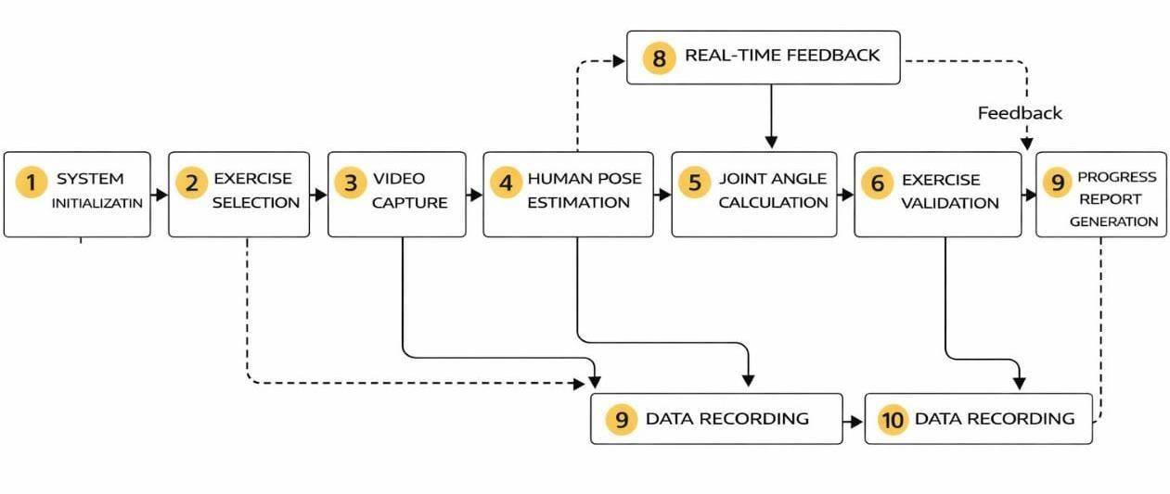

Fig 2.1 Block diagram of proposed methodology

2.2 MODULE DESCRIPTION
- Video Acquisition Module
This module captures real-time video input using a webcam or camera device. It continuously extracts frames and forwards them to the processing pipeline. Basic pre-processing such as resizing and normalization is applied to ensure consistent frame quality. The reliability of this module directly affects overall system accuracy. Proper camera positioning and adequate lighting conditions are essential for optimal pose detection performance.
- Pose Estimation Module
This module detects human body keypoints from each video frame using a pre-trained pose estimation model. Landmarks such asshoulders, elbows, hips, knees, and ankles are identified and mapped into a skeletal structure.The detected coordinates are used to calculate joint angles and spatial relationships. This module replaces wearable sensors by providing non-invasive motion tracking using computer vision techniques.
- Feature Extraction Module
The extracted skeletal data is processed to compute meaningful features such as joint angles, range of motion, movement speed, and repetition count. These features convert raw visual information into structured numerical data. This module ensures objective evaluation of exercises by quantifying movement patterns. It forms the foundation for AI-based classification and performance assessment.
- AI-Based Classification Module
This module uses machine learning algorithms to classify exercise performance as correct or incorrect. The trained model analyses extracted features and identifies posture deviations or incomplete movements. By using data-driven decision-making, the system minimizes subjective assessment errors and provides consistent evaluation across different users.
- Real-Time Feedback Module
Based on classification results, this module generates instant corrective feedback. Visual alerts, textual guidance, and audio prompts are provided to help users adjust their posture during exercise.Immediate feedback improves exercise accuracy and enhances user engagement. This module plays a critical role in replicating therapist supervision in a home environment.
- Session Tracking and Reporting Module
This module stores performance metrics for each session, including repetition count, accuracy percentage, and range of motion data. It generates progress charts and summary reports for long-term monitoring. The recorded data can be shared with physiotherapists for remote evaluation, enabling tele-rehabilitation support and personalized treatment adjustments.
3 RESULTS AND DISCUSSION
3.1 NECK ROTATION:

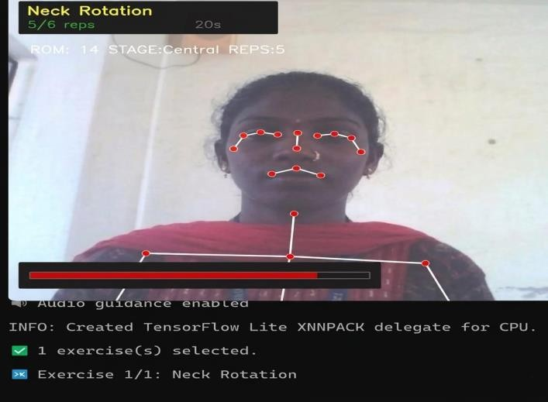

Fig:3.1 Wrong Posture

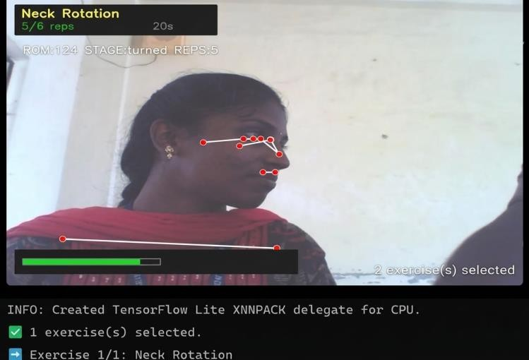

Fig:3.2 Live Session with Audio Feedback

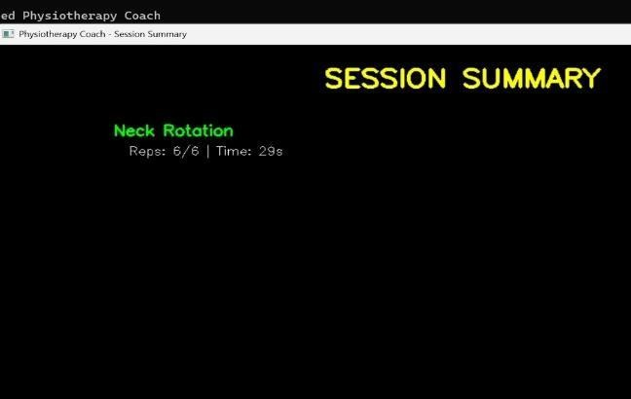

Fig:3.3 After Session Result

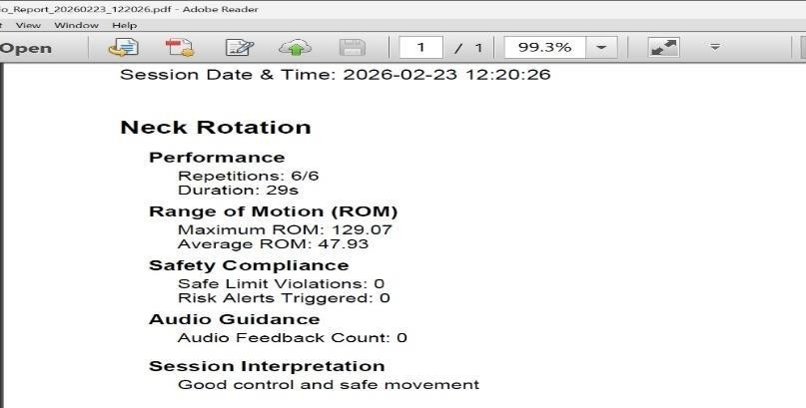

Fig:3.4Generated Document

3.2 SHOULDER EXTERNAL ROTATION
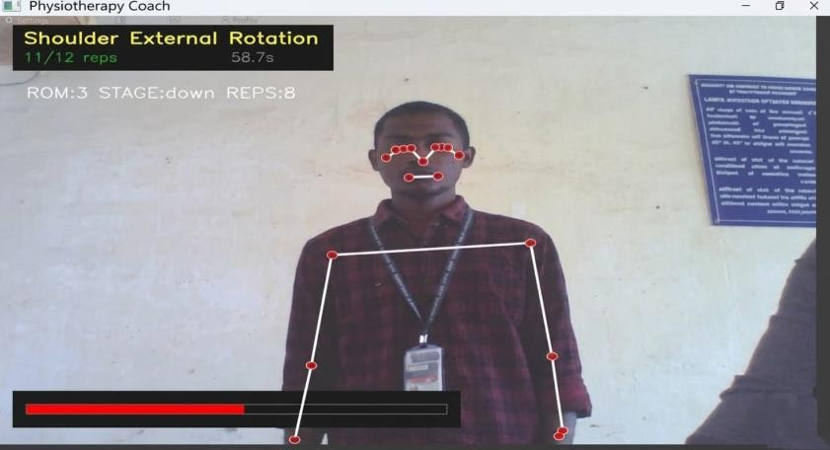

Fig:3.5 Wrong Posture
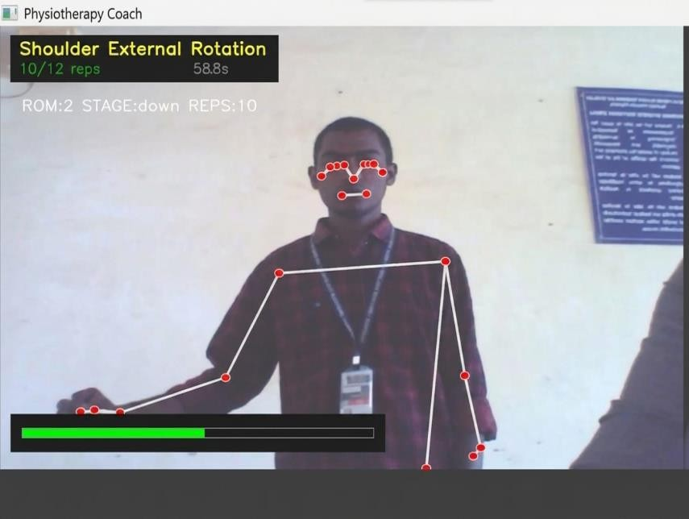

Fig:3.6Live Session with Audio Feedback

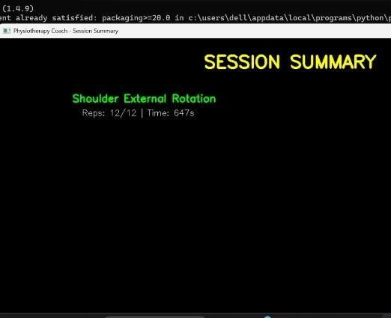

Fig:3.7 After Session Result

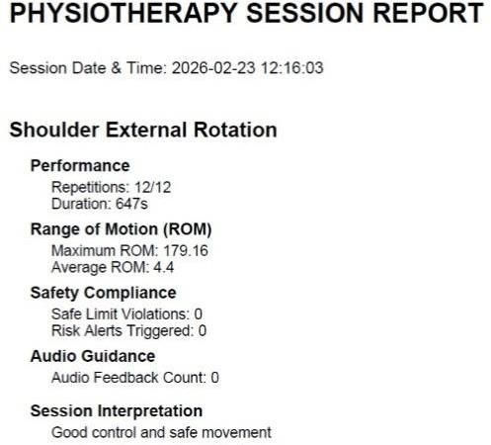

Fig:3.8 Generated Document
Table:3.1Range of Motion Evaluation for Rehabilitation Exercise

S.NO | EXERCISE | GOOD RANGE OF  MOTION(°) | BADRANGE OF MOTION(°) | SYSTEM OUTOUT (GOOD) | SYSTEM OUTPUT (BAD)
1 | Neck Rotation | 60°-80°  rotation | <50°rotation | Proper Neck Rotation | Rotate Neck Further
2 | Ankle Pumps | 15°-25°  movement | <10°movement | Good Ankle Movement | Increase Foot Movement
NeckRotation

30.00%

70.00%

Goodpeformance bad perfomance

Fig:3.9 Distribution of Neck Rotation Range

Ankle Pumps

30.00%

70.00%

Goodpeformance bad perfomance
Fig:3.10 Distribution of Ankle Pumps Range

Physiotherapy and rehabilitation play a crucial role in restoring movement and functional ability in patients recovering from injuries, surgeries, or neurological disorders. However, traditional rehabilitation methods often rely on manual observation, physical presence of therapists, and subjective assessment, which canlimitaccessibility, consistency, andscalability. Toaddress these challenges, theproposed AI-poweredcomputer visionrehabilitationsystemutilizescamera- based motion capture and machine learning techniques to objectively analyze patient movements in real time. By detecting body key points, calculating joint angles, and classifying exercise performance, the system provides automated feedback and progress tracking without the need for wearable sensors or invasive devices.

CONCLUSION
The proposed AI-powered computer vision rehabilitation system presents a non-invasive, cost-effective, and scalable solution for monitoring physiotherapy exercises in real time. By leveraging pose estimation and machine learning techniques, the system objectively analyzes joint movements, evaluates exercise correctness, and provides immediate corrective feedback without the need for wearable sensors or specialized clinical equipment. This approach enhances accessibility and supports home-based rehabilitation while maintaining quantitative performance assessment.Compared to conventional physiotherapy methods, the proposed system reduces dependency on continuous therapist supervision and minimizes subjectivity in exercise evaluation. The integration of session tracking and automated reporting further enables long-term progress monitoring and remote healthcare support. Overall, the system demonstrates the potential of AI-driven computer vision technologies in improving rehabilitation effectiveness, patient engagement, and scalability in modern healthcare environments.
FUTURE ENHANCEMENT
The proposed system can be further enhanced by integrating advanced deep learning models capable of analyzing complex movement patterns and predicting injury risks based on posture deviations over time. Incorporating 3D pose estimation instead of 2D skeletal tracking would improve depth perception and increase accuracy in joint angle measurements. Additionally, expanding the dataset with diverse patient profiles can improve model generalization and adaptability to different body types and medical conditions.Cloud integration can enable secure remote monitoring, allowing physiotherapists to access real-time patient data through a dedicated dashboard. A mobile application version can enhance portability and accessibility, making rehabilitation more convenient for users. Future development may also include personalized exercise recommendation systems, adaptive difficulty adjustment based on performance trends, and integration with wearable health devices for comprehensive patient health monitoring. These enhancements would strengthen the system’s reliability, scalability, and clinical applicability in real-world rehabilitation scenarios.

REFERENCES

[1] Z. Cao, G. Hidalgo, T. Simon, S. Wei, and Y. Sheikh, “Open Pose: Real time Multi- Person 2D Pose Estimation Using Part Affinity Fields,” IEEE Transactions on Pattern Analysis and Machine Intelligence, vol. 43, no. 1, pp. 172–186, 2021.

[2] C. Lugaresi et al., “MediaPipe: A Framework for Building Perception Pipelines,” arXiv preprint arXiv: 1906.08172, 2019.

[3] J. Shotton et al., “Real-Time Human Pose Recognition in Parts from Single Depth Images,” in Proceedings of the IEEE Conference on Computer Vision and Pattern Recognition (CVPR), 2011, pp. 1297–1304.

[4] E. Olesh, S. Yakubenko, and T. Gollan, “Automated Assessment of Upper Limb Movement Impairment Using RGB-D Camera,” in Proceedings of the IEEE Engineering in Medicine and Biology Society (EMBC), 2014, pp. 606– 609.

[5] X. Xu, R. W. McGorry, L. Chou, J. Lin, and C. Chang, “Accuracy of the Microsoft Kinect™ forMeasuringHumanMovement,” Gait&Posture, vol. 41, no. 2, pp. 557–562, 2015.

[6] B. Bonnechère et al., “The Use of Commercial Video Games in Rehabilitation: A Systematic Review,” International Journal of Rehabilitation Research, vol. 41, no. 4, pp. 277–292, 2018.

[7] S. Patel et al., “A Review of Wearable Sensors and Systems for Monitoring Motor Rehabilitation,” Journal of NeuroEngineering and Rehabilitation, vol. 9,no.1, p. 21, 2012.
[8] Ł. Kidziński et al., “Deep Learning for Human Movement Analysis in Rehabilitation,” NPJ Digital Medicine, vol. 3, no. 1, pp. 1–8, 2020.

[9] J. Wang, Y. Chen, S. Hao, X. Peng, and L. Hu, “Deep Learning for Sensor- Based Activity Recognition: A Survey,” Pattern Recognition Letters, vol. 119,
pp.3–11,2019.

[10] Y. Yang et al., “Vision-Based Rehabilitation Exercise Monitoring Using Deep Learning,” IEEE Access, vol. 9, pp. 103921–103934, 2021.

[11] S. Li and T. Sato, “AI-Based Posture Correction System Using Computer Vision,” IEEE Access, vol. 8, pp. 163947–163958, 2020.

[12] D. Dias and J. Cunha, “Wearable Health Devices—Vital Sign Monitoring Systems,” Sensors, vol. 18, no. 8, p. 2414, 2018.

[13] R. Ramakrishnan et al., “A Deep Learning-Based Exercise Recognition System Using Wearable Sensors,” IEEE Sensors Journal, vol. 19, no. 19, pp. 8970–8979, 2019.

[14] K. Chen et al., “Intelligent Home-Based Rehabilitation System Using Computer Visionand AI,” Healthcare Technology Letters, vol. 9, no. 2, pp.45– 52, 2022.

[15] C. Chen, R. Jafari, and N. Kehtarnavaz, “UTD-MHAD: A Multimodal Dataset for Human ActionRecognition Utilizing Depthand InertialSensors,” in IEEE InternationalConference onImage Processing(ICIP), 2015, pp. 168–172.

