Employment Patterns and Job Application Trends in India

Abstract
This report presents findings from a 4.5-year observational survey of job application responses across 36 employment categories in India, conducted between 2019 and 2024. Data were aggregated from eight major recruitment platforms spanning the full range of India's digital hiring ecosystem, from formal white-collar portals to mobile-first vernacular applications. The survey documents patterns in applicant demographics, educational distribution, salary sensitivity, geographic mobility, and qualification overlap across approximately 500,000 responses. No causal interpretations are offered. The findings are presented for open discussion and independent analysis by researchers, economists, and policy analysts.

Keywords: Indian labour market; graduate underemployment; qualification mismatch; occupational downgrading; digital recruitment platforms; wage elasticity; employment patterns; labour mobility; structural underemployment; post-COVID employment; informal labour market; job application trends; credential inflation; workforce insecurity; online recruitment ecosystems.

1. Background
India's labour market has been undergoing a steady but consequential transformation. Beneath headline GDP figures and digital sector growth, a quieter shift has been observable at ground level: a widening gap between the qualifications that job seekers carry into the market and the roles the economy is generating. A law graduate applying for a driver's position. A postgraduate applying for a typist role. A homeopathy practitioner seeking physiotherapy support work. These are not isolated incidents — they are recurring patterns, documented across 36 job categories and four and a half years of observation.

This report presents the findings of that observation. The survey ran from 2019 to 2024, spanning the pre-COVID period, the disruptions of the pandemic, and the early post-pandemic labour market reorganization. Approximately 500,000 application responses were collected across eight digital recruitment platforms. The platform set was deliberately chosen to span the full range of India's hiring ecosystem: from Naukri and Monster, which serve primarily graduate and postgraduate applicants in the organized sector, to WorkIndia and Apna, which serve blue-collar and semi-skilled workers in Tier-2 and Tier-3 cities.

The questions driving this survey were practical: Who is applying for which jobs? How do applicant volumes and profiles change when salary levels are raised? What happens when a job listing is opened to Pan-India visibility? The answers, as the data shows, are neither straightforward nor comfortable.

This report does not draw causal conclusions. It presents observed patterns with sufficient methodological transparency for independent researchers and analysts to reach their own interpretations. Where the evidence appears to point toward larger structural questions, those possibilities are noted carefully and without assertion.

2. Survey Scope and Method
The survey was designed to capture response behaviour rather than employment outcomes. Job openings were posted across eight recruitment platforms over the 4.5-year period, with salary levels adjusted annually and geographic scope varied systematically, to observe changes in application volume and applicant profile.

Parameter | Detail | Notes
Survey Period | 4.5 years (2019–2024) | Pre- and post-COVID coverage
Total Responses | ~500,000 | Aggregated across all platforms
Platforms Used | Eight | See Section 2.2
Job Categories | 36 | Domestic to professional roles
Salary Variation | Annual increments | Per-category; systematic
Geographic Scope | Local to Pan-India | Controlled variation

Table 1: Survey design summary

2.1 Salary Progression Protocol
Salary levels were incremented on an annual basis to observe how application volumes and applicant profiles changed at different price points. The table below illustrates the progression used for three representative categories. Similar protocols were applied across all 36 job categories.

Job Category | Initial Salary (₹) | Annual Increment (₹)
Housemaid | 7,000 | 1,000 per year
Driver | 12,000 | 1,500 per year
Home Tutor (Part-time) | 2,000 | 200 per year

Table 2: Illustrative salary progression for three representative job categories

2.2 Platform Coverage
Eight recruitment platforms were used across the survey period. The selection was intentional: by combining platforms with very different user demographics, the survey reduces the platform-specific bias that would result from using a single portal. The eight platforms and their approximate primary user profiles are listed below.

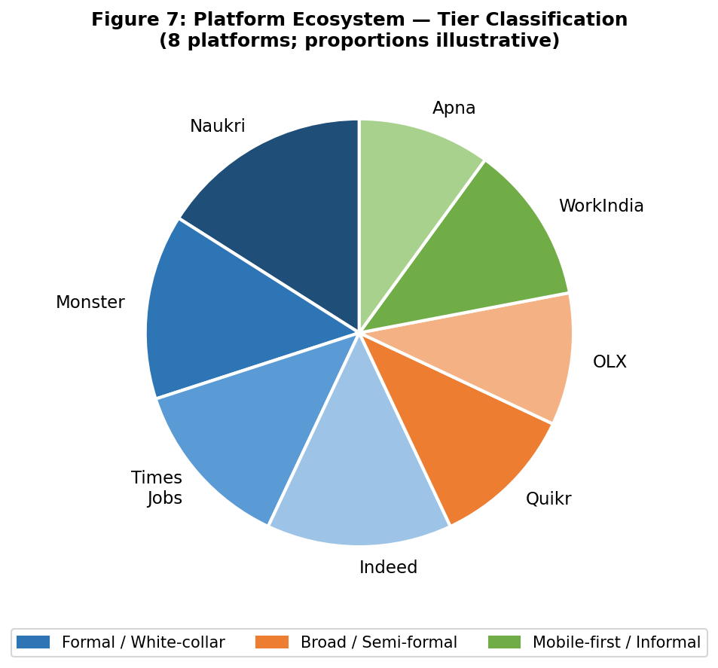
Figure 7: Platform ecosystem — tier classification across eight recruitment channels. Blue tones: formal/white-collar. Orange: broad/semi-formal. Green: mobile-first/informal.

Platform | Primary User Profile
Naukri.com | Graduate/postgraduate; formal organized sector; metro-centric
Monster India | Similar to Naukri; IT, finance, management roles
Times of India Jobs | Educated urban readership; broad sectoral reach
Indeed India | Cross-sectoral; formal and semi-formal applicants
Quikr Jobs | Blue-collar, domestic and service roles; Tier-2/3 reach
OLX Jobs | Informal and semi-skilled; classifieds-origin platform
WorkIndia | Blue-collar and entry-level; vernacular interface; non-metro reach
Apna | Mobile-first; semi-skilled workers; younger demographic

Table 3: Eight platforms used — tier classification and primary user profiles

Together, these eight platforms provided coverage across educational attainment levels from below Class 10 to postgraduate, geographic reach from metros to Tier-3 cities, employment formality from organized sector to informal gig work, and digital literacy levels from desktop-based professionals to mobile-only users.

One population is likely underrepresented across all eight platforms: workers without smartphones or reliable internet access, particularly in rural areas and among older informal-sector workers. This is a standard boundary condition of all digital recruitment research in India and applies equally here.

2.3 Data Integrity, Validation, and Deduplication
Ensuring the reliability of aggregated multi-platform data required several data management steps before responses were included in the survey dataset.

- Deduplication: Responses were cross-checked across platforms to identify and remove duplicate applications from the same applicant to the same listing. Where the same individual appeared to have applied via multiple platforms, only one response was counted.
- Spam and bot filtering: Listings occasionally attracted automated or spam submissions. These were identified through response pattern analysis (e.g., identical application text, implausible response times) and removed from the dataset.
- Platform aggregation: Responses from all eight platforms were collected into a unified dataset before analysis. Platform of origin was recorded as a metadata variable to allow platform-level disaggregation where relevant.
- Anonymization: All personally identifiable information was removed at the point of aggregation. No applicant names, contact details, or identifying information are included in the published dataset or in this report.

These steps reduce but do not eliminate the risk of measurement error inherent in observational survey data collected across heterogeneous platforms. Analysts using this data for secondary research are advised to treat it as a directional dataset rather than a precise census of applicant behaviour.

2.4 Ethical Handling of Applicant Data
The survey involved the collection of voluntary application responses to genuine job listings. No applicants were recruited as research subjects, and no deception was involved in the posting of listings. The following data handling commitments apply to the published report:

- No personal data published: This report contains no names, contact information, educational institution names, or any other data that could identify individual applicants.
- No applicant identities stored: At the point of aggregation, applicant-level data was anonymized and individual records were not retained in identifiable form.
- Qualification examples are representative types: The specific qualification-overflow examples cited in Section 5 (e.g., "law graduate applying for driver role") represent category types observed in the data. They are not traceable to any individual applicant.
- Data aggregation only: This report presents statistical summaries and trend observations. No individual application is reported, quoted, or identifiable.

2.5 Geographic Coverage
The survey's geographic coverage varied by platform and listing type. For clarity, the following tiers are used throughout this report:

Geographic Tier | Meaning in This Report
Tier-1 Cities | Major metros: Mumbai, Delhi, Kolkata, Chennai, Bengaluru, Hyderabad
Tier-2 Cities | Mid-size cities: Pune, Jaipur, Lucknow, Surat, Kochi, Chandigarh etc.
Tier-3 / Semi-urban | Smaller towns; district headquarters and below
Pan-India Listings | Listings with no geographic restriction; visible across all tiers

Table 4: Geographic tier definitions used in this report

Local listings were restricted to a single city or district. Pan-India listings were posted without geographic restriction, making them visible to applicants across all tiers. The effect of this scope change on response volume is documented in Section 6.

3. Demographic Profile of Respondents

3.1 Gender Distribution
The overall gender distribution across approximately 500,000 responses showed a 70:30 ratio of male to female applicants. This ratio is broadly consistent with national labour force participation data for the survey period (World Bank, 2023; CMIE, 2024). However, gender ratios varied substantially by job category: domestic, caregiving, and cooking roles showed considerably higher female participation, while driving and technical maintenance roles were almost exclusively male in the applicant pool.

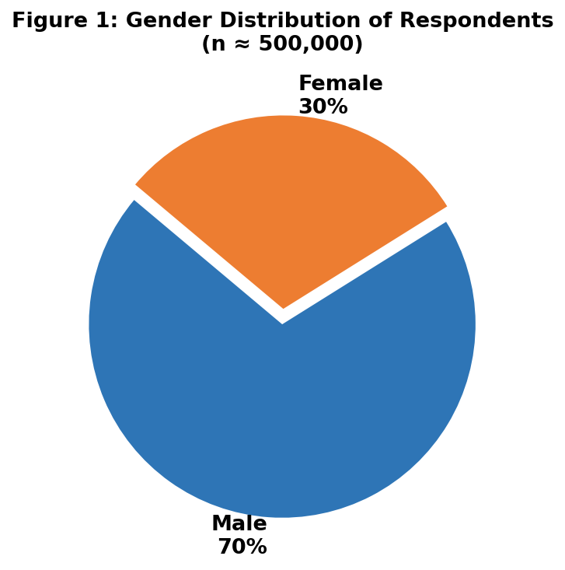
Figure 1: Gender distribution of respondents across all platforms and job categories (n ≈ 500,000)

The 30% female share reflects both labour market participation patterns and platform access patterns. Mobile-first platforms such as Apna and WorkIndia have been specifically targeting female workers in semi-skilled categories, and their inclusion in the platform set likely contributes to a higher female share than would be observed from formal job portals alone.

3.2 Educational Distribution
Sixty-one percent of respondents had educational attainment below Class 12 — consistent with an expected applicant pool for domestic and semi-skilled roles. Twenty-four percent were graduates, and a further 15% held postgraduate qualifications or above. In aggregate, approximately 39% of respondents had completed at minimum a three-year undergraduate degree.

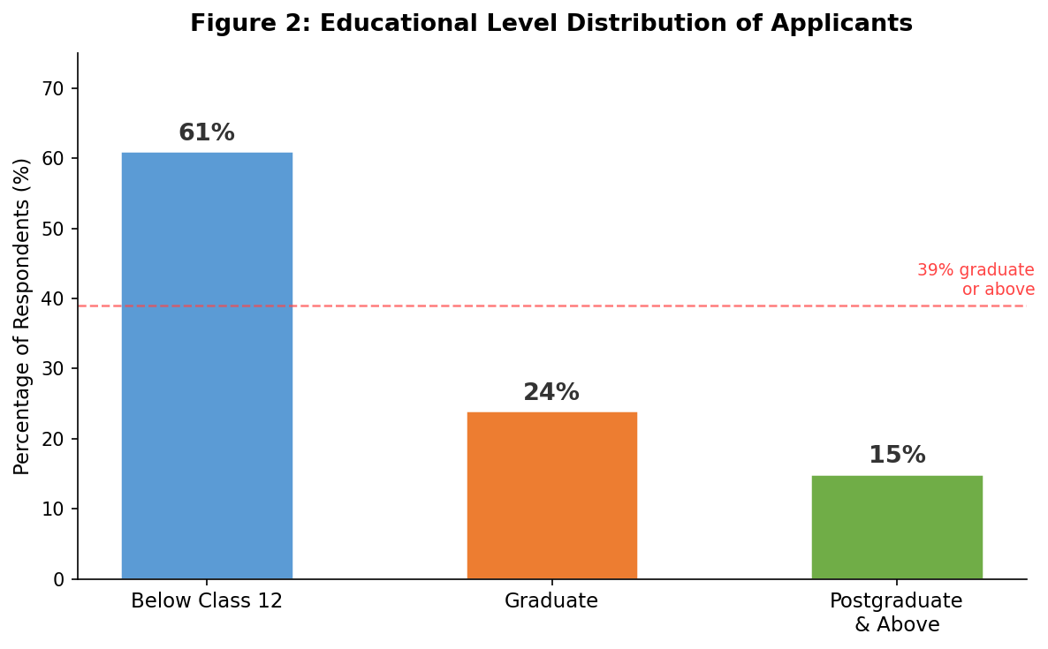
Figure 2: Educational level distribution across all applicants. The red dashed line marks the 39% graduate-or-above share.

The significance of this figure lies in what it implies about the types of roles these educated applicants were seeking. The 39% who hold graduate or postgraduate qualifications were not, in general, applying for roles commensurate with their education. As documented in Section 5, a substantial portion of these applicants were responding to job listings for housemaid, driver, typist, and similar positions. This pattern is consistent with what labour economists describe as occupational downgrading or structural underemployment (Mehta & Awasthi, 2021).

4. Salary Sensitivity and Response Volume
One of the clearest patterns in the data concerns the relationship between salary levels and application volume. Across multiple job categories, raising the offered salary produced a consistently disproportionate increase in the number of applications received.

Observed pattern: A 10% increase in offered salary corresponded with approximately a 20% increase in application responses across the surveyed job categories. This may indicate strong labour supply responsiveness to wage changes in the observed market segments.

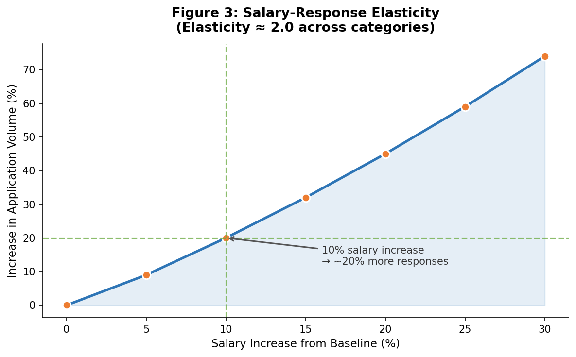
Figure 3: Salary-response relationship. A 10% salary increase corresponded with approximately 20% more applications across surveyed categories.

This ratio — a 2% increase in applications for every 1% increase in salary — was observed with reasonable consistency across several categories, though the magnitude varied. Categories with conventionally higher barriers to entry (such as home-visiting medical roles) showed smaller response changes per salary increment than open categories such as household help or driving, where the applicant pool is broader.

What this pattern may indicate is a relatively large pool of available applicants who are sensitive to salary changes — workers who are either unemployed, underemployed, or employed below their preferred conditions and monitoring the market for improvements. Whether this reflects structural labour surplus, high voluntary mobility, or both is a question for analysts to consider in light of the broader data.

For context, studies of wage elasticity in Indian urban labour markets have reported elasticities ranging from 1.2 to 1.8 for semi-skilled roles in pre-2020 data (Deshpande & Singh, 2021). The present survey's observed ratio of approximately 2.0 may partly reflect the economic conditions of the post-COVID period, when formal employment contraction pushed more workers into active job-seeking.

5. Qualification Overlap at Higher Salary Levels
At certain salary levels, the survey recorded a notable increase in applications from candidates whose formal qualifications differed substantially from the conventional expectations of the advertised role. This was observed across multiple categories and appeared to become more pronounced as monthly salaries approached and exceeded approximately ₹30,000.

The following table lists representative examples of the types of qualification overlap recorded. These examples represent categories of overlap observed in the data; they do not identify any individual applicant.

Applicant Qualification (Reported) | Role Applied For
Professional chef (culinary certification) | House cook position
Law graduate (LLB) | Office driver role
Homeopathy practitioner (BHMS) | Physiotherapy support work
MSc graduate (science discipline) | Office typist role
MPhil candidate (humanities) | Accounting assistant position
Engineering graduate (B.Tech) | Ride-hailing driver role

Table 5: Representative qualification-overlap examples recorded in survey responses

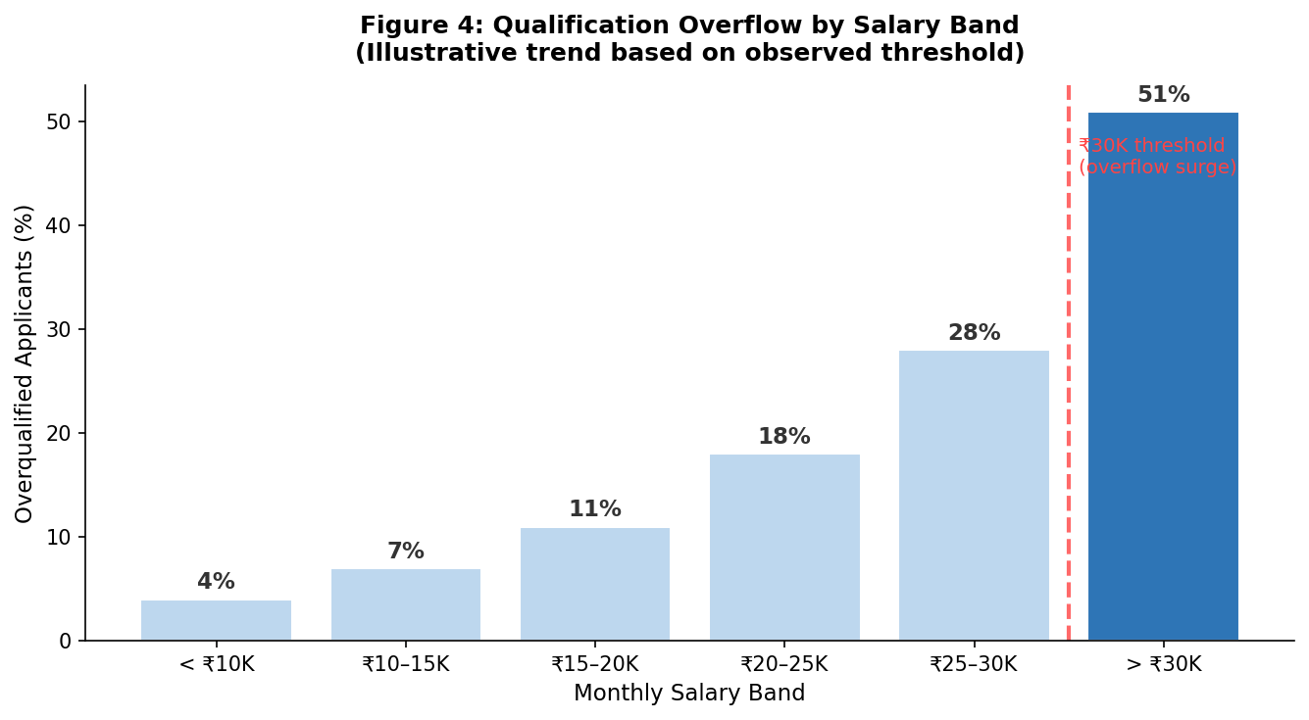
Figure 4: Proportion of applicants with qualifications exceeding conventional role requirements, by salary band. A marked increase is observed above ₹30,000/month.

The ₹30,000/month threshold appears to be a meaningful boundary in the observed data. Below this level, qualification overlap was present but moderate. Above it, the share of applicants whose educational credentials exceeded conventional role requirements rose noticeably. One possible explanation is that at this salary level, the financial gap between a formally appropriate role and an informal or semi-formal role narrows sufficiently for some applicants to reconsider their options. Whether this reflects genuine economic need, dissatisfaction with formal sector conditions, or both is a question this data cannot resolve.

The international literature on occupational downgrading documents similar threshold effects in other labour markets where educated workers compete for roles below their qualification level (McGuinness, 2006; Autor, 2014). The Indian context adds specific dimensions: credential inflation through rapid expansion of higher education, uneven formal employment generation, and the role of employment expectations shaped by educational investment (Tilak, 2018).

6. Geographic Scope and Response Volume
When job listings were expanded from local to Pan-India geographic visibility, response volumes increased substantially. The observed increase was approximately 200%, meaning Pan-India listings attracted roughly three times the number of applications as equivalent local listings.

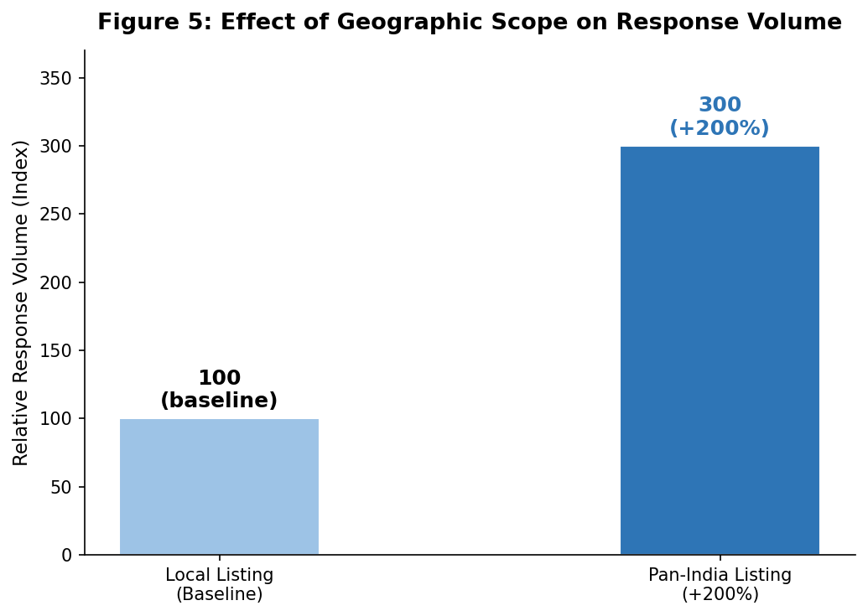
Figure 5: Effect of geographic scope on response volume. Pan-India listings generated approximately three times the applications of local listings (index: local = 100).

This effect was not uniform across job categories. Roles offering accommodation, travel support, or higher salaries showed larger Pan-India uplift than roles requiring local knowledge or family proximity (such as housemaid positions). The geographic mobility observable in these response patterns is consistent with push-factor migration dynamics: workers in Tier-2 and Tier-3 cities applying for roles in Tier-1 cities where salary levels are higher, even for semi-skilled roles.

Platform disaggregation is relevant here. Pan-India listings posted on WorkIndia and Apna — which have strong Tier-2 and Tier-3 reach through vernacular interfaces — likely contributed substantially to the 200% uplift. This is consistent with documented patterns of internal labour migration in India, where geographic mobility among semi-skilled workers is driven primarily by wage differentials rather than occupational advancement (Keshri & Bhagat, 2012).

7. Graduate Income Perception
Among graduate respondents who provided comments or completed optional fields, a frequently recurring self-reported perception was that their current monthly earnings represented approximately 40–50% of the amount they had spent each month during their college years. Approximately 90% of graduate respondents who commented on their income situation expressed this perception.

This figure represents a self-reported perception, not a verified financial measurement. Respondents were recalling college-era spending against current earned income — two figures that are not directly comparable. College spending typically includes parental transfers, educational loans, and subsidized institutional costs. These are distinct from post-graduation income. The 90% figure should be read as indicating a widely shared sense of relative economic regression among educated respondents, not as a precise income ratio.

With that qualification clearly stated, the perception itself is sociologically significant. The experience of earning less — or earning proportionally far less than one was accustomed to spending — after completing a degree is a documented feature of graduate underemployment in India (Jayachandran, 2021; Banerjee & Duflo, 2019). It shapes career behaviour, willingness to accept downgraded roles, and social and psychological wellbeing in ways that go beyond the income figure itself.

Researchers wishing to verify this observation are encouraged to triangulate it against CMIE income panel data and household consumption surveys covering graduates in the 22–30 age bracket.

8. Reported Motivations for Seeking Employment Change
Respondents who were currently employed but actively seeking alternative positions cited a range of motivating factors. These were collected as volunteered or prompted self-reports and represent stated reasons rather than verified employment conditions. Multiple responses were permitted. The relative frequencies shown in Figure 6 reflect the rank order of issues raised, not precise percentages.

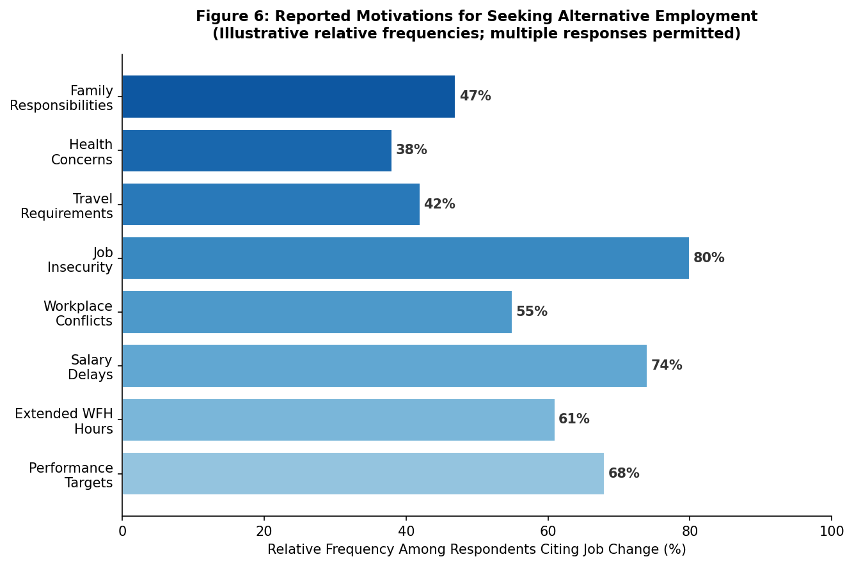
Figure 6: Reported motivations for seeking alternative employment. Relative frequencies based on self-reported responses; multiple answers permitted per respondent.

Job insecurity was the most frequently cited concern across all educational categories, followed by salary delays and irregular payment schedules. Work-from-home-related pressures — specifically, extended working hours without additional compensation — were cited frequently enough to merit attention as a post-COVID labour market feature. The removal of physical office boundaries, combined with rising performance targets in a more competitive employment environment, appears to have increased voluntary job-seeking among workers who might otherwise have remained in stable positions.

Health concerns and family responsibilities, cited less frequently than financial factors, nonetheless appear consistently enough to suggest that non-financial working conditions play a role in labour market mobility alongside wage considerations.

9. Employment Structure Observations
Several respondents reported structural features of their previous employment arrangements. These are recorded as stated experiences and are not independently verified by the survey. They are presented here because they appeared with sufficient frequency to be noteworthy.

- Outsourced staffing arrangements: A number of respondents reported that their formal employer was not the organization where they worked day-to-day, but rather an outsourced staffing or manpower agency. Some respondents expressed uncertainty about the legal identity of their employer.
- Provident fund irregularities: Several respondents reported that provident fund contributions had been irregular, absent, or opaque in their previous employment, particularly in agency-mediated arrangements.
- Health insurance gaps: Inconsistent provision of health insurance and other statutory benefits was mentioned by respondents in technology-adjacent and service sector roles.

These observations are consistent with documented features of India's contractual labour ecosystem, where the use of staffing intermediaries allows large organizations to maintain flexible workforce arrangements while externalizing statutory obligations (Sodhi, 2013; Ministry of Labour & Employment, 2020). They are offered here as contextual background rather than findings of this survey.

10. Discussion: Patterns Worth Examining
This report refrains from asserting causal conclusions. However, it would be intellectually incomplete not to acknowledge that the patterns across sections form a picture that raises important questions.

When 39% of applicants to domestic and semi-skilled roles hold graduate or postgraduate qualifications; when a 10% salary increase attracts 20% more applicants; when qualification overlap surges above ₹30,000 per month; and when educated respondents widely perceive their current earnings as substantially below their college-era spending — these patterns, taken together, may suggest a labour market under considerable pressure to absorb its educated workforce at qualification-appropriate salaries.

Whether this reflects a temporary post-COVID contraction, a longer-term structural mismatch between the output of higher education and the employment capacity of the formal economy, or some combination of both, is a question the present data cannot resolve. India produces approximately 7.5 million graduates annually (AISHE, 2022). The organized formal economy absorbs a portion of this output at salaries that reflect educational investment. What happens to the remainder is visible, in part, in surveys like this one.

These observations carry potential implications for higher education policy, wage floor regulation, social security coverage, and employment generation strategy. They are offered here as questions worth investigating, not as policy recommendations.

11. Invitation for Independent Analysis
The findings in this report are presented without interpretive conclusions. Researchers, economists, journalists, sociologists, and policy analysts are invited to review the data and offer their own analyses. The following areas may be particularly productive starting points:

- Category-level salary elasticity: The aggregate 2:1 ratio (20% more applications per 10% salary increase) masks variation across job types and salary bands. Disaggregated analysis may reveal important structural differences.
- The ₹30,000 threshold: Whether this inflection point is a nationally stable boundary or a city-specific artifact of cost-of-living geography warrants investigation against CMIE cost-of-living and income data.
- Graduate income perception: Triangulation of the 40–50% perception against NSSO and CMIE household panel data could establish whether the subjective perception reflects a real income gap.
- Gender and platform interaction: Whether female applicant shares vary systematically across platforms and salary bands may reveal platform-specific barriers or channels worth understanding.
- Post-COVID trend line: Given that the survey spans 2019–2024, examining pre-2020 versus post-2020 data separately may reveal whether the observed patterns intensified during the pandemic period.

Feedback, independent analysis, and commentary are welcome. Researchers who identify methodological limitations, alternative interpretations, or relevant comparative data are encouraged to contribute to the discussion this report is intended to open.

References
All India Survey on Higher Education (AISHE). (2022). Annual Report 2021–22. Ministry of Education, Government of India.

Autor, D. H. (2014). Skills, education, and the rise of earnings inequality among the "other 99 percent." Science, 344(6186), 843–851.

Banerjee, A., & Duflo, E. (2019). Good Economics for Hard Times. PublicAffairs / Penguin Allen Lane.

Centre for Monitoring Indian Economy (CMIE). (2024). Unemployment Rate in India — Periodic Labour Force Survey Data. CMIE Economic Outlook.

Centre for Monitoring Indian Economy (CMIE). (2023). Payroll and Formal Employment Data 2022–23. CMIE Databases.

Deshpande, A., & Singh, J. (2021). Dropping out, being pushed out or can't get in? Decoding declining female labour force participation in India. IZA Discussion Paper No. 14787.

Deshpande, M. (2021). India's new labour codes: A critical analysis. Economic and Political Weekly, 56(14), 14–19.

Jayachandran, S. (2021). Social norms as a barrier to women's employment in developing countries. IMF Economic Review, 69(3), 576–595.

Keshri, K., & Bhagat, R. B. (2012). Temporary and seasonal migration: Regional pattern, characteristics and associated factors. Economic and Political Weekly, 47(4), 81–88.

McGuinness, S. (2006). Overeducation in the labour market. Journal of Economic Surveys, 20(3), 387–418.

Mehta, B. S., & Awasthi, I. (2021). Education, employment and skill mismatch in India. Indian Journal of Labour Economics, 64(2), 329–349.

Ministry of Labour and Employment. (2020). Labour Codes — Code on Industrial Relations, Code on Social Security, Code on Occupational Safety. Government of India Gazette.

Sodhi, J. S. (2013). Labour market flexibility and recent amendments in labour laws in India. Indian Journal of Industrial Relations, 48(3), 423–438.

Tilak, J. B. G. (2018). Education and Development in India. Palgrave Macmillan.

World Bank. (2023). Female Labour Force Participation Rate, India. World Development Indicators. https://data.worldbank.org

