Assessment of Schedule Performance on Project Delivery: The Architects’ Perspective, Enugu metropolis.

Abstract
The construction industry is a critical sector in national development, contributing significantly to economic growth, infrastructure provision, and employment generation. In construction industry, there need to plan a schedule to deliver the projects being undertaken. The timely delivery of projects is combination of many peoples’ duties including the architect. This paper tried to assess the role of the architect in managing schedule and time in a construction project. Through an in-depth literature review and a survey of practicing architects (in government and private offices) involved in project design, documentation, and supervision in Enugu metropolis. The study adopts a descriptive research approach using a survey design and purposive sampling. A total of one hundred (100) was purposively selected for this survey. It recommends that architect is very necessary and be invited early to any project.
Keywords: Architects’ perspective, Assessment, project delivery, project management, schedule performance.

Introduction
The construction industry is a critical sector in national development, contributing significantly to economic growth, infrastructure provision, and employment generation. In this sector, the successful delivery of projects is traditionally evaluated based on three key performance indicators: time, cost, and quality (Atkinson, 1999). Among these, time or schedule performance remains a major challenge, particularly in developing countries such as Nigeria, where construction projects frequently experience delays and schedule overruns (Aibinu & Jagboro, 2002, Oladapo, 2007).
Project management is the process of supervising the work of a team to achieve all project goals within a given constraint, (Philips, 2004). This process consists of planning, organizing, and overseeing a project's work to achieve specific goals within set constraints of time, budget and scope, (Baratta, 2006). The main objective of project management is to produce a complete project that satisfies the client’s objectives. People involved in project management are project managers, designers, contractors and subcontractors.
Project management can be applied to any project depending on size, nature, industry or sector. This follows that there are many types of project management, not losing sight of the focus on the important goals; time, cost and quality. It is said that successful projects are completed on time within budget and according to previously agreed quality, known as the iron triangle (triple constraint), (Esselink, 2000).
Schedule performance refers to the ability of a project to adhere to its planned timeline, ensuring that activities are completed within the stipulated duration. It is commonly measured using tools such as the Schedule Performance Index (SPI), which compares the planned progress of a project with the actual progress achieved (Project Management Institute, 2017). Schedule performance refers to the evaluation and measurement of how well project activities adheres to planned schedule. Schedule performance is a metric that measures project progress and efficiency against its original timeline. Poor schedule performance often results in extended project durations, increased costs, contractual disputes, and dissatisfaction among clients and stakeholders (Sambasivan & Soon, 2007).
Architects occupy a central role in the construction process, serving not only as designers but also as coordinators of project information and, in some cases, contract administrators. Their responsibilities span from conceptual design to construction documentation and supervision, placing them in a strategic position to influence project timelines. Despite this, much of the existing literature on schedule performance tends to focus on contractors and project managers, with limited attention given to the perspectives and contributions of architects (Chan & Kumaraswamy, 1997).

An architect believes that schedule is not a promise that nothing will go wrong but a framework for deciding what to do and when to do it. The assessment of schedule performance from an architectural perspective is a complex balancing act between design integrity and production efficiency which is a measure of the velocity and quality of information transfered.
In the Nigerian construction industry especially Enugu, several factors contribute to poor schedule performance, including design changes, inadequate planning, funding delays, poor communication among project stakeholders, and regulatory bottlenecks (Mansfield, Ugwu, & Doran, 1994, Ogunsemi & Jagboro, 2006). Architects, through their roles in design coordination and information dissemination, are often directly or indirectly linked to many of these factors. For instance, late issuance of drawings, design revisions, and insufficient detailing can significantly affect project timelines.
Given the architect’s involvement across multiple stages of project delivery, it is essential to examine schedule performance from their perspective. Understanding how architects perceive, influence and respond to schedule performance issues can provide valuable insights into improving overall project delivery. This study, therefore, seeks to assess schedule performance in construction projects with a specific focus on the architect’s role and perspective within the Enugu context.
Despite advancements in project management tools and techniques, construction projects in Nigeria continue to experience poor schedule performance, resulting in frequent delays and time overruns. These delays often lead to cost escalations, disputes among stakeholders, and in some cases, project abandonment, (Aibinu & Jagboro, 2002).
The role of architects who are key participants in design development, documentation and coordination has not been sufficiently examined. Especially, as architects are responsible for critical activities such as the preparation of drawings, coordination of consultants and management of design changes, all of which directly affect project timelines. This study, therefore, seeks to assess schedule performance from the architects’ perspective in order to identify key factors influencing project timelines and propose strategies for improving timely project delivery.
The aim of this study is therefore, to assess schedule performance on project delivery from the architects’ perspective. In so doing, the following objectives will be pursued.
- Identify factors that affect schedule performance in building projects.
- Evaluate the role of architects in project scheduling and time management.
- Propose strategies for improving schedule performance in construction projects.
Research question:
- What factors influence schedule performance in the construction industry?
- What roles do architects play in project scheduling and time control?
- What strategies can be adopted to improve schedule performance?
Literature
Project management
Project management is the process of supervising the work of a team to achieve all project goals within a given constraint, (Philips, 2004). This process consists of planning, organizing, and overseeing a project's work to achieve specific goals within set constraints of time, budget, and scope, (Baratta, 2006). The main objective of project management is to produce a complete project that satisfies the client’s objectives.
People involved in project management are project managers, designers, contractors and subcontractors. Project management revolves around two words; project and management. A project has a definite beginning and end, (Nokes and Kelly, 2007). And management of such distinct production requires having or acquiring distinct technical skills and management strategies, (Cattani, Ferriani, Frederiksen and Taube, 2011). Project management therefore, is the application of knowledge, skills, tools, and techniques to project activities to meet project requirements. It’s the practice of planning, organizing, and executing the tasks needed to turn a brilliant idea (project) into a tangible product, service, or deliverable.
Approaches to project management consists of the 4Ps (plan, process, people and power) to deliver a good project, (Mesly, 2016). These can be seen as; plan (planning and forecasting activities), process (project governance of all activities), people (collaboration and communication) and power (line of authority, decision making, etc).
Project management can be applied to any project depending on size, nature, industry or sector. This follows that there are many types of project management, not loosing sight of the focus on the important goals; time, cost and quality. It is said that successful projects are completed on time within budget and according to previously agreed quality, known as the iron triangle (triple constraint), (Esselink, 2000).

Project delivery
The process of completing a construction project from inception to completion. Project delivery is how construction projects are planned and run. It refers to the comprehensive process of carrying out and completing construction projects, which is a structured approach that moves a project from concept to completion, (Mastt, 2025). It shapes how a team is organized, responsibilities defined and outcomes achieved.
Project delivery sets clear goals, follow structured steps and track performance through cost, time and quality, (Brown, 2025). It is a comprehensive process that oversees and coordinates the successful execution of a project from its initiation to closure. This involves strategic planning, organization and control of resources and activities to ensure that the project goal and objectives are achieved within specified time, budget and scope constraints, (Brown, 2025).
Project delivery impacts performance across the entire project lifecycle (feasibility study, planning, design, procurement, construction and close out); through risk allocation, team alignment and project outcomes. The people involved in project delivery are as shown in Fig 1. In the figure, they are grouped into three (A, B, C) showing when each role is needed and their work should start in any building construction project. ‘A’ is the strategic direction, project brief and performance reporting carried by the people as shown in the box. ‘B’ is contract administration, coordination and work execution oversight. While ‘C’ is for day to day site management and construction supervision, (Mastt, 2025). Once roles are clearly defined and communication is open, teams are better equipped to respond to issues and keep the project moving forward.
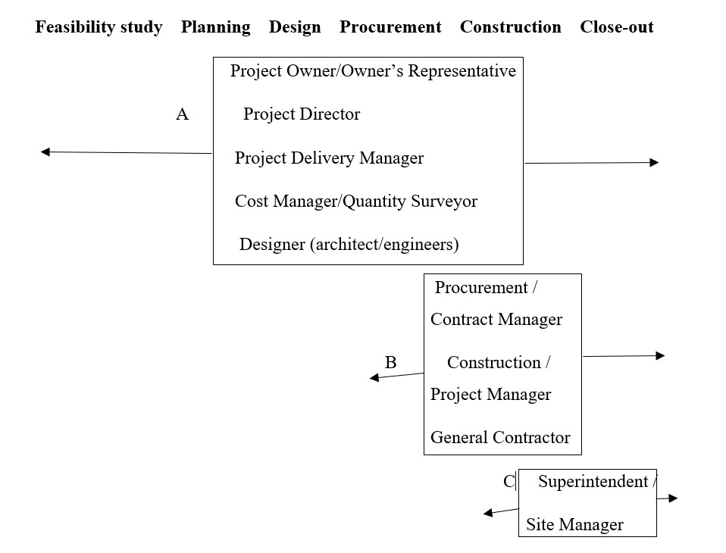
Fig. 1 Project delivery process and roles
Source: As adapted from Mastt, 2025

Schedule performance
The extent to which a project adheres to its planned timeline. Schedule performance refers to the evaluation and measurement of how well project activities adheres to planned schedule. Schedule performance is a metric that measures project progress and efficiency against its original timeline. It assesses the project’s progress in terms of meeting milestones and completing activities within the specified timeframes, (PMI, 2021). It is typically evaluated by comparing the actual progress against the planned schedule. This comparison allows project managers and stakeholders to determine if the project is ahead of schedule, on schedule, or behind schedule, (Kerzner, 2022).
To improve schedule performance generally, project managers may need to adjust project plan, allocate additional resources, or implement strategies to mitigate delays, such as fast-tracking or crashing activities, (PMI, 2021). Regular monitoring of schedule performance throughout the project’s lifecycle is important to identify potential issues early and take proactive measures to address them, (Nicholas & Steyn, 2020).
The study
This study focuses on the assessment of schedule performance in building construction projects from the architects’ perspective in Enugu. It is limited to practicing architects (in government and private offices) involved in project design, documentation, and supervision in Enugu metropolis. The study adopts a descriptive research approach using a survey design and purposive sampling. The survey design is particularly suitable for this study as it seeks to gather the opinions and experiences of architects regarding schedule performance and project delivery.
The population for this study comprises registered architects involved in building construction in Enugu. A sample size of 100 is considered adequate for this study, which was due to accessibility and time constraints. The data collected will be analysed with descriptive statistics (mean, average and frequency)
Results
The result of the survey is reported as follows. The questionnaire used was tailored to the research questions as stated above.
Table 1: Respondents’ on factors affecting schedule performance:
S/N | FACTORS | 1 | 2 | 3 | 4 | 5 | 4 + 5 | %age to total
1 | Design changes during construction | 0 | 5 | 5 | 20 | 65 | 85 | 80.75
2 | Delay in decision-making by clients | 0 | 0 | 15 | 70 | 10 | 80 | 76
3 | Inadequate funding | 0 | 0 | 10 | 5 | 80 | 85 | 80.75
4 | Poor communication among stakeholders | 5 | 10 | 10 | 65 | 10 | 75 | 71.25
5 | Ineffective project scheduling tools | 5 | 15 | 35 | 15 | 25 | 40 | 38
6 | Government regulations/approvals | 10 | 5 | 15 | 25 | 40 | 65 | 61.75
Instruction: Rate the following factors based on their impact on schedule performance.
Scale: 1 = Very Low, 2 = Low, 3 = Moderate, 4 = High, 5 = Very High

Fig. 2 Respondents’ on factors affecting schedule performance

From table 1 above the respondents were of the opinion that all the factors affect schedule performance at various degrees as shown on the table; the worst being at 81% (design changes and inadequate funding), the next is at 76% (delay in decision), followed by 71.25% (poor communication), then 61.75% (government regulations) and finally 38% (ineffective scheduling tools).
Table 2: Respondents’ on role of architects in scheduling and time management
S/N | STATEMENTS | 1 | 2 | 3 | 4 | 5 | 4 + 5 | %age to total
1 | Architects play a key role in project scheduling | 0 | 5 | 20 | 10 | 65 | 75 | 71.25%
2 | Architects influence project timelines through design decisions | 0 | 0 | 10 | 10 | 75 | 85 | 80.75%
3 | Early involvement of architects improves schedule performance | 0 | 0 | 0 | 35 | 60 | 95 | 100%
4 | Architects effectively coordinate with other consultants | 0 | 10 | 15 | 30 | 40 | 70 | 66.5%
5 | Architects use scheduling tools (e.g., Gantt charts, BIM) | 5 | 12 | 23 | 25 | 30 | 55 | 52.25%
6 | Poor architectural documentation leads to delays | 5 | 15 | 35 | 15 | 25 | 40 | 38%
7 | Architects actively monitor project progress | 0 | 0 | 10 | 10 | 75 | 85 | 80.75%
8 | Communication by architects affects project timelines | 5 | 15 | 35 | 15 | 25 | 40 | 38%
Instruction: Indicate your level of agreement.
Scale: 1 = Strongly Disagree, 2 = Disagree, 3 = Neutral, 4 = Agree, 5 = Strongly Agree

Fig. 3 Respondents’ on role of architects in scheduling and time management.
All the respondents agree that the early engagement of the architect is one sure way of time management as can be seen from the table 2 above. When the architect is engaged, it activates all the other areas the architect plan and monitor schedule and time as shown on the same table.

Table 3 Respondents’ strategies for improving schedule performance
S/N | Strategies | 1 | 2 | 3 | 4 | 5 | 4 + 5 | %age to total
1 | Adoption of BIM in project planning | 5 | 12 | 23 | 25 | 30 | 55 | 52.25%
2 | Improved communication among stakeholders | 0 | 10 | 15 | 30 | 40 | 70 | 66.5%
3 | Proper project scheduling and monitoring | 10 | 5 | 15 | 25 | 40 | 65 | 66.5%
4 | Early stakeholder involvement | 5 | 12 | 23 | 25 | 30 | 55 | 52.25%
5 | Adequate funding and financial planning | 0 | 0 | 10 | 5 | 80 | 85 | 80.75%
6 | Training and capacity building for professionals | 0 | 10 | 15 | 30 | 40 | 70 | 66.5%
7 | Use of modern project management tools | 10 | 5 | 15 | 25 | 40 | 65 | 66.5%
8 | Clear project documentation | 5 | 12 | 23 | 25 | 30 | 55 | 52.25%
9 | Strong regulatory and policy support | 0 | 10 | 15 | 30 | 40 | 70 | 66.5%

Instruction: Rate the effectiveness of the following strategies.
Scale: 1 = Not Effective, 2 = Slightly Effective, 3 = Moderately Effective, 4 = Effective, 5 = Highly Effective

Fig 4: Respondents’ strategies for improving schedule performance
Here too, the respondents were of the opinion that funding and financial planning is key to project management and delivery, where all other strategies hinge, Architects can improve project delivery timelines through effective planning, coordination, communication and the application of efficient project management practices.
Discussion
The assessment of schedule performance from an architectural perspective is a complex balancing act between design integrity and production efficiency which defers from that of the contractor which bases on resource allocation and "critical path" logic. Architects face several challenges in managing project schedules, especially in complex construction projects where multiple stakeholders, technical issues and environmental factors influence project delivery.

Therefore, there is a need to engage the architect very early in the project life, work closely with him and other professionals to ensure that the project timelines are respected and maintained.

Conclusion.
Project management is the process of supervising the work of a team to achieve all project goals within a given constraint, (Philips, 2004). People involved in project management are project managers, designers, contractors and subcontractors. The architect being part of the project team needs to be involved early in the project as was shown in the literature as reviewed, making for a smooth schedule performance and better project timeliness.
References
Aibinu, A. A., and Jagboro, G. O. (2002). "The Effects of Construction Delays on Project Delivery in Nigerian Construction Industry." International Journal of Project Management, 20(8), 593-599.
Atkinson, R. (1999). Project management: Cost, time and quality, two best guesses and a phenomenon. International Journal of Project Management, 17(6), 337–342.

Baratta, A. (2006) The triple constraint a triple illusion. PMI
Brown, L. (2025) Project delivery management; key methods and phases explained.
Cattani, G., Ferriani, S., Frederiksen, L and Taube, F. (2011) Project based organizing and strategic management. Advances in strategic management vol 28. Leeds England: Emerald. ISBN 978-1780521930
Chan, D. W. M., & Kumaraswamy, M. M. (1997). A comparative study of causes of time overruns in Hong Kong construction projects. International Journal of Project Management, 15(1), 55–63.
Esselink, B. (2000) A practical guide to localization. Amsterdam/Philadelphia: John Benjamins publishing company. ISBN: 978-9-027-21956-5
Kerzner, (2017) Project management: a systems approach to planning, scheduling and controlling. 12 edition, Wiley, Hoboken.
Mansfield, N. R., Ugwu, O. O., & Doran, T. (1994). Causes of delay and cost overruns in Nigerian construction projects. International Journal of Project Management, 12(4), 254–260.
Mastt. (2025). Managing project schedules in Mastt. Mastt Help Center. https://help.mastt.com/knowledge/managing-project-schedules-in-mastt
Mesly, O. (2016) Project feasibility: tools for uncovering points of vulnerability. CRC press. Taylor and Francis. ISBN: 9781498757911
Nicholas, J. M., & Steyn, H. (2020). Project management for engineering, business and technology (6th ed.). Routledge.

Nokes, S., and Kelly, S. (2007) The definitive guide to project management: the fast track to getting the job done on time and on budget. Pearson Education, Prentice Hall financial times. ISBN: 9780273710974
Ogunsemi, D. R., & Jagboro, G. O. (2006). Time-cost model for building projects in Nigeria. Construction Management and Economics, 24(3), 253–258.
Oladapo, A. A. (2007). An investigation into the use of ICT in the Nigerian construction industry. ITcon, 12, 261–277.
Philip, J. (2004) PMP project management professional study guide: McGraw-Hill/Osborne. ISBN: 0072230622
Project Management Institute. (2017). A guide to the project management body of knowledge (PMBOK® Guide) (6th ed.). PMI.
Project Management Institute (PMI) (2021) A Guide to the Project Management Body of Knowledge (PMBOK® Guide).
Sambasivan, M., & Soon, Y. W. (2007). Causes and effects of delays in Malaysian construction industry. International Journal of Project Management, 25(5), 517–526.

