Agricultural Land Classification using Hybrid

Machine Learning and Deep Learning Techniques

Abstract—This project focuses on agricultural land classification using satellite imagery and hybrid machine learning techniques. A Regression Neural Network (RegNN) optimized with K-Nearest Neighbors (KNN) is proposed for accurate land classification. The model performance is compared with SVM, Naïve Bayes, CNN, and LSTM algorithms. Principal Component Analysis (PCA) is used for feature reduction to improve efficiency and accuracy. Experimental results show that the proposed RegNN–KNN model achieves better classification performance than traditional methods. The system includes a user-friendly interface for image upload, feature extraction, model training, and classification. The work supports precision agriculture and land monitoring using over 700 categorized satellite images.

Keywords: Agricultural Land Classification, Satellite Imagery, Hybrid Machine Learning, Deep Learning, PCA, KNN, RegNN, Image Classification.

I . INTRODUCTION
Agricultural land classification is one of the most important applications in the field of remote sensing and environmental monitoring. It plays a significant role in land-use planning, crop monitoring, environmental protection, and sustainable resource management. With the rapid growth of satellite and remote sensing technologies, a huge amount of high-resolution satellite imagery is generated every day. These satellite images provide valuable information about different land categories such as agricultural land, forest land, urban areas, and rangelands. Traditionally, land classification was performed manually by experts through visual interpretation of satellite images. However, manual analysis of large-scale satellite data is time-consuming, less efficient, and prone to human errors. Moreover, increasing variations in climate conditions, seasonal changes, image resolution, and lighting conditions make traditional approaches less reliable and difficult to

manage efficiently.
Today, with significant advancements in Artificial Intelligence (AI), Machine Learning (ML), and Deep Learning (DL), there is an opportunity to transform traditional land classification methods into more intelligent and automated systems. AI-based classification systems are capable of processing large amounts of satellite image data and identifying hidden spatial patterns that are difficult to recognize using conventional techniques. Machine learning algorithms such as Support Vector Machine (SVM), K-Nearest Neighbors (KNN), and Naïve Bayes are widely used for image classification tasks. These algorithms depend on extracted features from images for accurate prediction and classification. On the other hand, deep learning models such as Convolutional Neural Networks (CNN) and Long Short-Term Memory (LSTM) networks can automatically learn complex image patterns and spatial relationships directly from image data, resulting in improved classification performance and accuracy.
The proposed agricultural land classification system aims to overcome the limitations of traditional classification techniques by integrating both machine learning and deep learning approaches into a hybrid model. The system utilizes satellite imagery as input data and applies various preprocessing and feature extraction techniques for effective classification. Principal Component Analysis (PCA) is used as a dimensionality reduction technique to convert highdimensional image data into meaningful components, thereby reducing computational complexity and improving model efficiency. Additionally, KNN-based feature extraction techniques are incorporated to further enhance classification performance and accuracy.
The proposed system classifies satellite images into four major categories: agricultural land, forest land, urban area, and rangeland. Multiple algorithms such as SVM, CNN, Naïve Bayes, KNN, LSTM, and Regression Neural Network are implemented and compared based on their classification accuracy and efficiency. The modular architecture of the system allows easy testing and comparison of different models, helping identify the most suitable algorithm for agricultural land classification tasks. Furthermore, the system includes a user-friendly interface that allows users to upload satellite images and view classification results efficiently.
The adoption of such AI-based agricultural land classification systems provides several advantages. It reduces dependency on manual interpretation and traditional classification methods. It improves classification accuracy and minimizes human error. The use of PCA helps reduce computational complexity and processing time. The hybrid integration of machine learning and deep learning techniques improves scalability and system performance. Moreover, the system supports efficient land-use planning, environmental monitoring, agricultural management, and sustainable utilization of natural resources.

However, certain challenges still exist in implementing AIbased land classification systems. Variations in image quality, seasonal changes, similarities between land categories, and the requirement for large training datasets may affect model performance. In addition, high computational requirements and the need for efficient preprocessing techniques remain important challenges in remote sensing applications. Therefore, continuous improvements in data collection, feature extraction methods, model optimization, and computational infrastructure are necessary for achieving better results.

Thus, in conclusion, the proposed agricultural land classification system is expected to improve the accuracy, efficiency, and reliability of satellite image classification using machine learning and deep learning techniques. The system reduces manual effort, enhances automated decision-making, and supports effective environmental and agricultural management. By integrating PCA, KNN-based feature extraction, and hybrid AI models, the proposed solution is expected to provide better classification performance and contribute to the advancement of intelligent remote sensing applications.
II. LITERATURE REVIEW
Recent advancements in Artificial Intelligence (AI), Machine Learning (ML), Deep Learning (DL), and remote sensing technologies have significantly improved agricultural land classification systems. Researchers have widely used satellite imagery and intelligent computational techniques for applications such as land-use analysis, crop monitoring, environmental management, and urban planning. Traditional manual interpretation of satellite images is time-consuming, less efficient, and prone to errors. Therefore, automated classification systems using ML and DL techniques have become an important area of research.
Several studies have focused on the application of Convolutional Neural Networks (CNNs) for land-use and land-cover classification. In one study conducted in 2022, a CNN-based model was proposed for classifying satellite images into categories such as agricultural land, urban areas, forests, and water bodies. The system used preprocessing techniques such as normalization, resizing, and data augmentation to improve model performance. The CNN architecture achieved an accuracy of approximately 89.7%, demonstrating the capability of deep learning models in extracting complex spatial features from satellite imagery. However, the study also highlighted limitations such as high computational cost and class imbalance problems.
Researchers have also explored the use of traditional machine learning techniques combined with dimensionality reduction methods. In a 2021 study, K-Nearest Neighbors (KNN) was integrated with Principal Component Analysis (PCA) for remote sensing image classification. PCA was used to reduce the dimensionality of hyperspectral satellite images and remove redundant features before classification. The proposed system achieved nearly 74% accuracy and demonstrated that PCA significantly improves the efficiency and performance of KNN models in handling high-dimensional datasets. However, the study reported that the performance of KNN strongly depends on the selection of K values and distance metrics.
Another important area of research involves the use of Long Short-Term Memory (LSTM) networks for temporal landcover mapping. A study conducted in 2023 implemented LSTM models to classify satellite images based on seasonal and time-dependent variations. The model achieved an accuracy of around 85% and showed better performance compared to traditional recurrent neural networks. The study emphasized the importance of temporal feature learning in land classification tasks, although the model required higher computational resources and longer training time.
Several comparative studies have also been conducted using Support Vector Machine (SVM) and Naïve Bayes algorithms for image classification. Research carried out in 2020 demonstrated that SVM provides better classification accuracy because of its capability to handle high-dimensional data and maximize classification margins. In contrast, Naïve Bayes offered faster computation with lower complexity but produced lower accuracy due to its assumption of feature independence. The study concluded that SVM is more suitable for complex classification tasks, while Naïve Bayes is effective for faster and real-time applications.
Recent studies have further introduced Regression Neural Networks (RegNN) for spatial classification of high-resolution satellite images. A study published in 2024 proposed a RegNNbased model that maps image features to continuous outputs, thereby improving spatial consistency and classification precision. The model achieved nearly 92% accuracy, outperforming several conventional CNN models. The research highlighted that combining regression-based neural networks with feature extraction techniques significantly improves classification performance and interpretability.
A comparative analysis of different ML and DL techniques shows that each approach has its own advantages and limitations. CNN models provide high accuracy due to automatic spatial feature extraction but require large datasets and high computational resources. LSTM models effectively capture temporal patterns but are computationally expensive. Traditional ML algorithms such as SVM and Naïve Bayes are simpler and computationally efficient but may not achieve the same level of accuracy as deep learning models. KNN is easy to implement but becomes slow for large datasets. However, integrating PCA with KNN improves performance by reducing dimensionality and eliminating redundant features. Among all techniques, Regression Neural Networks have demonstrated superior classification performance and consistency.
Despite significant advancements in agricultural land classification, several challenges still exist in current systems. Most existing approaches rely on single machine learning or deep learning models, which limits their ability to handle complex satellite image datasets efficiently. Many systems do not effectively utilize feature extraction and dimensionality reduction techniques, resulting in increased computational complexity and reduced performance. In addition, the absence of modular systems for comparing multiple algorithms makes it difficult to identify the most suitable model for a specific dataset.
Therefore, there is a need for an efficient hybrid agricultural land classification system that combines machine learning and deep learning techniques along with advanced feature extraction methods such as PCA and KNN-based processing. The proposed system aims to integrate algorithms such as CNN, LSTM, SVM, Naïve Bayes, and Regression Neural Networks to improve classification accuracy, scalability, and overall performance in satellite image analysis.
III. SYSTEM ARCHITECTURE
The proposed agricultural land classification system is designed as a modular and multi-stage framework that integrates both machine learning and deep learning techniques for accurate land classification using satellite imagery. The system uses LANDSAT satellite image datasets as input and processes them through multiple stages including preprocessing, feature extraction, dimensionality reduction, model training, classification, and evaluation. The modular architecture of the proposed system allows easy comparison of different algorithms and improves scalability, flexibility, and overall system performance.
- Data Layer
The data layer is responsible for storing and managing satellite image datasets, compressed feature files, and classification results. The system uses LANDSAT satellite images containing different land categories such as agricultural land, forest land, urban area, and rangeland. The collected images are stored and processed for further analysis. In addition, compressed feature datasets generated after dimensionality reduction are also maintained in the data layer to improve processing efficiency and reduce storage complexity.
- User Interface Module
The user interface acts as an interactive platform through which users can interact with the agricultural land classification system. The interface allows users to upload satellite images, perform feature extraction, train classification models, and predict land types. The userfriendly design of the system enables easy execution of classification tasks and visualization of results. The final output displays the classified land category in an understandable format.
- Image Preprocessing and Feature Extraction Module
The preprocessing module is responsible for preparing satellite images for classification. In this stage, images are resized into a standard dimension such as 64×64×3 and normalized to ensure uniformity in pixel values. The images are then converted into numerical arrays suitable for machine learning and deep learning algorithms.
After preprocessing, feature extraction and dimensionality reduction are performed using Principal Component Analysis (PCA). Since satellite images contain highdimensional data, PCA reduces redundant and less significant features while preserving important information. In addition, KNN-based feature selection techniques are applied to improve classification performance and reduce computational complexity.
- Model Training and Classification Module
The core component of the system is the model training and classification module. This module is responsible for training multiple machine learning and deep learning algorithms using labeled satellite image data. The system implements algorithms such as Support Vector Machine (SVM), Convolutional Neural Network (CNN), Naïve Bayes, K-Nearest Neighbors (KNN), Long Short-Term Memory (LSTM), and Regression Neural Network.
Each algorithm is trained independently and evaluated based on classification accuracy and efficiency. SVM classifies data using optimal hyperplanes, while CNN automatically extracts spatial image features through convolutional layers. Naïve Bayes performs probabilistic classification, and KNN classifies data based on nearest neighboring samples. LSTM models capture temporal dependencies in sequential data, whereas the Regression Neural Network learns complex relationships between input features and output classes.
- Hybrid Classification Module
The proposed system mainly focuses on a hybrid approach combining PCA, KNN-based feature extraction, and Regression Neural Networks. PCA reduces dimensionality, KNN extracts significant neighboring features, and the Regression Neural Network performs final classification. This integrated approach improves overall classification accuracy, scalability, and computational efficiency compared to traditional single-model systems.
- Model Evaluation Module
The model evaluation module analyzes the performance of all implemented algorithms using various performance metrics such as accuracy, efficiency, and processing time. The system compares different models to identify the most suitable approach for agricultural land classification. Experimental results show that the hybrid model provides better classification accuracy and consistency than individual machine learning or deep learning algorithms.
- System Workflow
The overall workflow of the proposed system begins with collecting and uploading LANDSAT satellite images into the system. The uploaded images undergo preprocessing operations such as resizing and normalization. The processed data is then passed through PCA and KNN-based feature extraction modules to reduce dimensionality and improve feature quality.
The extracted features are then provided to multiple classification algorithms including SVM, CNN, Naïve Bayes, KNN, LSTM, and Regression Neural Network for model training and prediction. After classification, the performance of each model is evaluated and compared. Finally, the predicted land category such as forest land, agricultural land, urban area, or rangeland is displayed to the user through the graphical interface.
The modular structure of the proposed system improves maintainability, scalability, and flexibility. Additional advanced features such as real-time satellite image integration, cloud-based processing, and automated environmental monitoring can also be integrated into the system in the future.

- INTERACTION FLOW BETWEEN USER AND THE SYSTEM
The proposed agricultural land classification system provides an automated workflow for accurate land prediction using machine learning and deep learning techniques. The process begins when the user uploads a satellite image through the graphical user interface. The system validates the image and preprocesses it by resizing, normalizing pixel values, and converting it into numerical arrays.
Next, feature extraction and dimensionality reduction are performed using Principal Component Analysis (PCA) and KNN-based feature selection methods. The processed data is then transferred to the backend module, which handles communication between the interface and classification algorithms.
Machine learning and deep learning models such as SVM, CNN, Naïve Bayes, KNN, LSTM, and Regression Neural Network (RegNN) analyze the extracted features and classify the image into categories like agricultural land, forest land, urban area, and rangeland. Finally, the system displays the predicted result and performance details to the user, while storing data for future analysis and model evaluation.

- DESIGN AND IMPLEMENTATION
The design and implementation of the proposed agricultural land classification system focus on developing an efficient, scalable, and accurate framework using both machine learning and deep learning techniques. The system is designed in a modular manner to improve flexibility, maintainability, and performance comparison among multiple classification algorithms. The implementation integrates preprocessing, feature extraction, dimensionality reduction, classification, hybrid learning, and evaluation modules for accurate land classification using satellite imagery.
- System Design
The proposed system follows a multi-stage architecture for agricultural land classification. The architecture begins with the collection of satellite image datasets, which are used as the primary input for the classification process. The system then performs preprocessing operations such as resizing, denoising, and normalization to improve image quality and maintain uniformity across the dataset.
After preprocessing, feature extraction and dimensionality reduction are carried out using K-Nearest Neighbors (KNN) and Principal Component Analysis (PCA). PCA reduces high-dimensional image features into significant components, while KNN-based feature extraction improves classification efficiency and feature quality.
The processed features are then passed through multiple classification modules including SVM vs CNN, SVM vs Naïve Bayes, KNN vs LSTM, and KNN + PCA vs Regression Neural Network (RNN). These modules compare the performance of machine learning and deep learning algorithms for agricultural land classification. Finally, the outputs from different modules are integrated into a hybrid RNN + KNN model for improved classification accuracy and performance evaluation.

- Data Preprocessing Implementation
The preprocessing module is responsible for preparing satellite images for classification. The collected images are resized into standard dimensions and normalized to ensure consistent pixel intensity values. Denoising techniques are also applied to remove unnecessary noise and improve image quality. The preprocessed images are then converted into numerical arrays suitable for machine learning and deep learning algorithms.
- Feature Extraction and Dimensionality Reduction
Feature extraction is performed using KNN-based feature selection techniques along with Principal Component Analysis (PCA). Since satellite images contain high-dimensional data, PCA reduces redundant and irrelevant features while preserving significant information required for classification. This process decreases computational complexity and improves model efficiency. KNN-based feature extraction further enhances classification performance by selecting important neighboring features from the dataset.
- Classification Module Implementation
The classification stage consists of four different modules designed for algorithm comparison and performance analysis.

*Module 1: SVM vs CNN*
This module compares Support Vector Machine (SVM) with Convolutional Neural Network (CNN). SVM performs classification using optimal hyperplanes, while CNN automatically extracts spatial image features using convolutional layers.

*Module 2: SVM vs Naïve Bayes*
This module compares the performance of SVM and Naïve Bayes algorithms. SVM provides better accuracy for highdimensional datasets, whereas Naïve Bayes offers faster classification with lower computational complexity.

*Module 3: KNN vs LSTM*
This module compares K-Nearest Neighbors (KNN) with Long Short-Term Memory (LSTM). KNN performs instance-based classification using nearest neighbors, while LSTM captures temporal and sequential patterns in image data.

*Module 4: KNN + PCA vs Regression Neural Network*
This module integrates PCA and KNN-based feature extraction with Regression Neural Networks (RNN). The hybrid approach improves classification accuracy by learning complex relationships between input features and output classes.

- Hybrid Model Implementation
The proposed system mainly focuses on the hybrid RNN + KNN model. In this approach, PCA and KNN-based feature extraction are combined with Regression Neural Networks for training and classification. The hybrid model provides better scalability, efficiency, and accuracy compared to individual machine learning and deep learning algorithms.

- Accuracy Evaluation and Output Display
The evaluation module measures the performance of all classification algorithms using metrics such as accuracy, comparison graphs, and efficiency analysis. The system compares different models and identifies the best-performing classification technique. Finally, the classified output such as agricultural land, forest land, urban area, or rangeland is displayed through the output interface in a clear and understandable format.

The modular implementation of the proposed system improves flexibility, scalability, and maintainability. Additional features such as real-time satellite image integration and cloud-based processing can also be incorporated in future developments.

VI.PERFORMANCE AND EVALUATION
The performance of the proposed agricultural land classification system is evaluated using different performance metrics, comparison techniques, and graphical analysis methods. The evaluation mainly focuses on classification accuracy, computational efficiency, feature extraction capability, and prediction performance of the implemented machine learning and deep learning models such as SVM, CNN, Naïve Bayes, KNN, LSTM, and Regression Neural Network (RNN). The proposed hybrid RNN + KNN model demonstrates better classification performance compared to individual algorithms.

- Model Training Performance
The training and validation performance of the implemented models are analyzed to evaluate the learning behavior and convergence of the algorithms. The satellite image dataset is first preprocessed using resizing, denoising, and normalization techniques. Feature extraction and dimensionality reduction are then performed using PCA and KNN-based feature selection techniques before model training.

Among all implemented models, CNN and Regression Neural Network achieve higher training accuracy compared to traditional machine learning algorithms. The hybrid RNN + KNN model provides the best classification performance and achieves the highest accuracy among all modules. The training and validation accuracy curves show steady improvement during each epoch with minimal difference between training and validation accuracy, indicating effective learning and reduced overfitting.

- Feature Extraction and Dimensionality Reduction Analysis
Feature extraction and dimensionality reduction significantly improve classification efficiency and reduce computational complexity. Principal Component Analysis (PCA) reduces high-dimensional satellite image data into important feature components while removing redundant information. KNN-based feature extraction further improves feature quality and classification performance.

The integration of PCA and KNN reduces the size of the feature space, improves training speed, and enhances scalability compared to using raw image data directly. The analysis proves that feature extraction techniques play a major role in improving overall classification accuracy.

- Comparative Module Evaluation
The proposed system consists of four classification modules for algorithm comparison and performance analysis.

*Module 1: SVM vs CNN*
CNN achieves higher classification accuracy because of its capability to automatically extract spatial features from satellite images. SVM performs effectively with high-dimensional data but provides lower accuracy compared to CNN.

*Module 2: SVM vs Naïve Bayes*
SVM produces better prediction accuracy, whereas Naïve Bayes provides faster execution and lower computational complexity. This module highlights the balance between accuracy and processing speed.

*Module 3: KNN vs LSTM*
LSTM performs better in capturing temporal and sequential patterns from image data, while KNN is simpler and easier to implement for smaller datasets.

*Module 4: KNN + PCA vs Regression Neural Network*
This module achieves the highest classification accuracy among all implemented techniques. The combination of PCA, KNN-based feature extraction, and Regression Neural Network improves prediction consistency, scalability, and efficiency.

- Accuracy Evaluation and Classification Analysis
The classification performance of the implemented models is evaluated using confusion matrices, comparison graphs, and accuracy metrics. The confusion matrix represents the prediction accuracy of the models for different land categories such as agricultural land, forest land, urban area, and rangeland.

The diagonal values of the confusion matrix represent correctly classified land categories, while non-diagonal values indicate classification errors. Experimental results show that the hybrid RNN + KNN model produces a higher number of correct classifications with fewer misclassification errors compared to
SVM, Naïve Bayes, KNN, and LSTM models. This demonstrates the effectiveness and reliability of the proposed hybrid classification approach.

- Overall Performance
The overall evaluation results demonstrate that the proposed agricultural land classification system achieves high accuracy, reliability, and efficient prediction performance. The integration of preprocessing, PCA-based dimensionality reduction, KNN-based feature extraction, and hybrid RNN classification improves the overall quality of land classification.
The proposed system efficiently classifies satellite images into agricultural land, forest land, urban area, and rangeland categories with improved scalability and reduced computational complexity. The experimental results prove that the hybrid RNN + KNN model outperforms traditional machine learning and deep learning techniques in terms of classification accuracy, consistency, and efficiency.

VII. SIMULATION RESULTS
The simulation results demonstrate the effectiveness of the proposed agricultural land classification system in accurately classifying satellite images using machine learning and deep learning techniques. The system was tested using multiple models such as SVM, CNN, Naïve Bayes, KNN, LSTM, and Regression Neural Network (RegNN). The hybrid RNN + KNN model achieved the best overall performance in terms of accuracy, efficiency, and classification consistency.

1) Model Accuracy
The implemented classification models showed effective performance in identifying different land categories such as agricultural land, forest land, urban area, and rangeland.
- CNN Accuracy: 91%
- Regression Neural Network (RegNN) Accuracy: 93%
- Improved Accuracy using Hybrid RNN + KNN Model
- Higher classification consistency with PCA-based feature extraction

2) System Testing Performance
The proposed system was evaluated using different software testing techniques to ensure reliability and efficiency.

- Unit Testing performed for individual modules
- Integration Testing performed for communication between modules
- Functional Testing performed for classification workflow
- Performance Testing conducted for model efficiency and accuracy

3) Feature Extraction and Processing Efficiency
The preprocessing and feature extraction modules significantly improved the performance of the system.

- PCA reduced high-dimensional image features
effectively
- KNN-based feature extraction improved classification quality
- Reduced computational complexity and training time
- Improved scalability for large satellite image datasets

4) Comparative Algorithm Analysis
The comparison among different machine learning and deep learning algorithms showed variations in accuracy and computational efficiency.

- CNN achieved better spatial feature extraction performance
- SVM provided stable classification for high-dimensional data
- Naïve Bayes achieved faster execution with lower complexity
- LSTM effectively learned temporal image patterns
- Hybrid RNN + KNN model achieved the highest overall accuracy

5) User Interface and Output Evaluation
The system provided efficient interaction and accurate output display through the graphical user interface.

- Users can upload satellite images easily
- Classified output displayed in real time
- Accuracy graphs and comparison metrics generated
successfully
- Usability and functionality confirmed through User
Acceptance Testing (UAT)

The overall simulation results validate the effectiveness, scalability, and reliability of the proposed agricultural land classification system. The integration of preprocessing, PCAbased dimensionality reduction, KNN feature extraction, and hybrid Regression Neural Network classification improves overall system accuracy and prediction performance for realworld land classification applications.

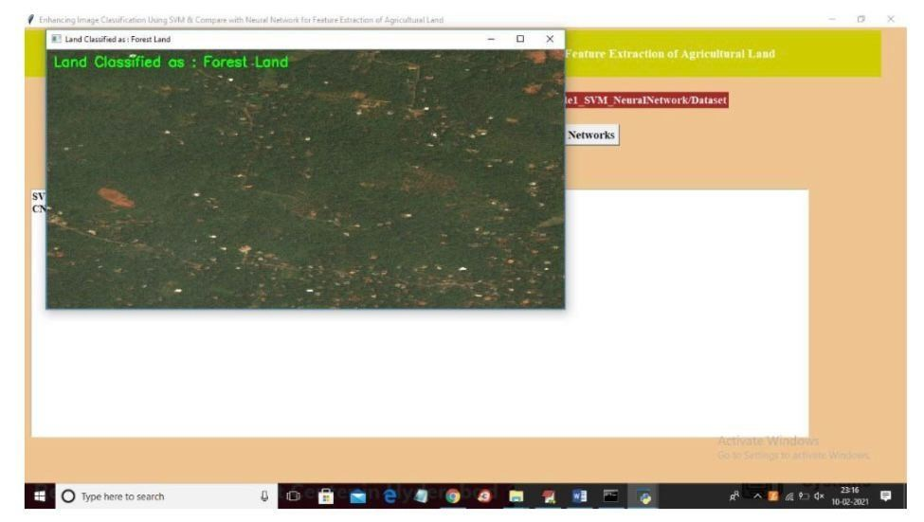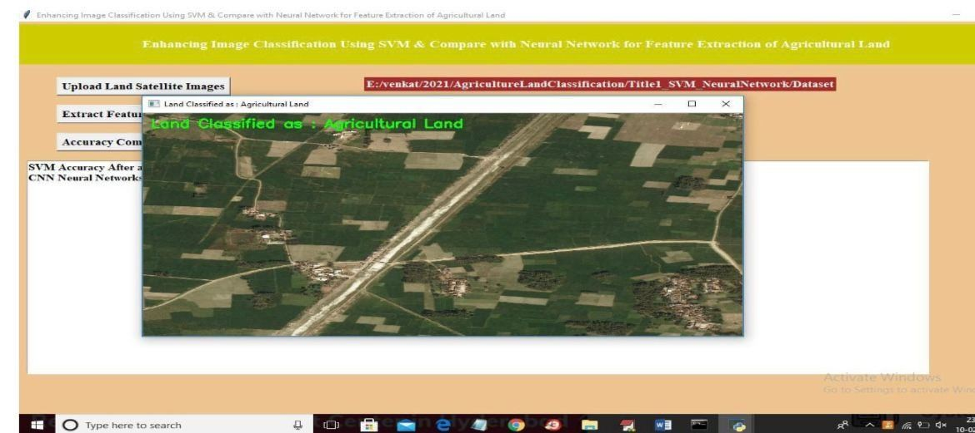

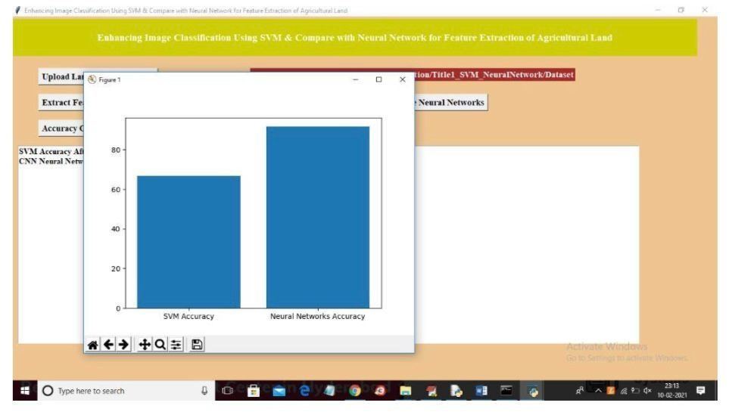

Recognition,” arXiv preprint arXiv:1409.1556, 2014.
- LANDSAT Satellite Dataset, “LANDSAT Missions,” NASA Goddard Space Flight Center. [Online]. Available: [https://landsat.gsfc.nasa.gov/](https://landsat.gsfc.nasa.gov)
- R. Girshick, J. Donahue, T. Darrell, and J. Malik, “Rich Feature Hierarchies for Accurate Object Detection and Semantic Segmentation,” in Proc. IEEE Conf. Comput. Vis. Pattern Recognit. (CVPR), pp. 580–587, 2014.
- Zhang et al., “KNN for Remote Sensing Image

- CONCLUSION

The proposed agricultural land classification system represents an effective and intelligent approach for satellite image classification using both machine learning and deep learning techniques. The system integrates algorithms such as SVM, CNN, Naïve Bayes, KNN, LSTM, and Regression Neural Network along with PCA-based dimensionality reduction and KNN-based feature extraction techniques for improving classification performance. The experimental results confirm that the hybrid Regression Neural Network with KNN feature extraction provides higher accuracy and better prediction performance compared to traditional individual models. The preprocessing techniques such as resizing, denoising, normalization, and PCA significantly improve the efficiency and scalability of the system by reducing computational complexity and eliminating redundant features. The modular architecture of the proposed system also allows flexible experimentation and easy comparison among different machine learning and deep learning algorithms. The system successfully classifies satellite images into agricultural land, forest land, urban area, and rangeland categories with high accuracy and consistency. The evaluation results demonstrate that the proposed system is reliable, scalable, and efficient for real-world agricultural land classification applications. The integration of hybrid ML-DL techniques improves feature learning capability, classification precision, and overall system performance. In addition, the user-friendly interface and modular implementation make the system flexible and easy to maintain. However, certain limitations still exist, such as dependency on dataset quality, computational requirements for deep learning models, and variations in satellite image conditions. Future improvements can include the integration of real-time satellite image processing, cloud-based deployment, advanced feature extraction techniques, and IoT-based environmental monitoring systems. Overall, the proposed system provides a robust, scalable, and intelligent solution for agricultural land classification using satellite imagery. The system can support efficient land-use analysis, environmental monitoring, and smart agriculture applications through accurate and automated land classification.

- IX. REFERENCES

- I. Goodfellow, Y. Bengio, and A. Courville, Deep Learning, Cambridge, MA, USA: MIT Press, 2016.
- J. Brownlee, Deep Learning for Computer Vision, Machine Learning Mastery, 2019.
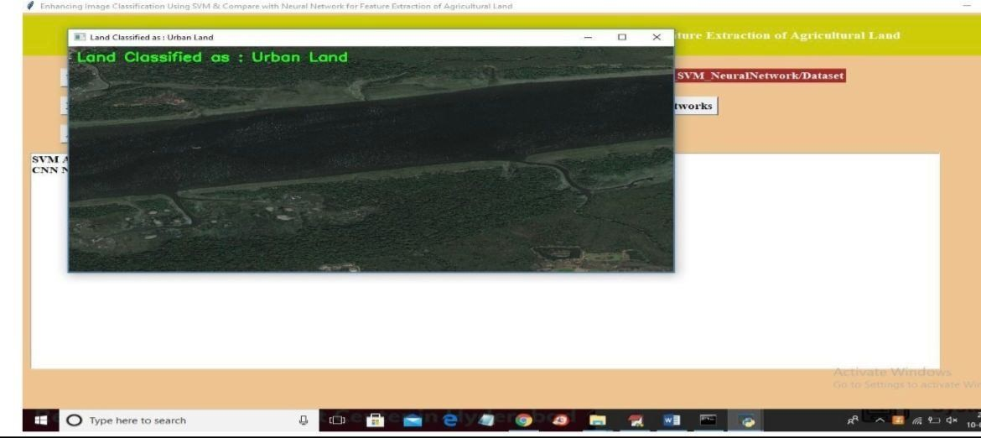
- K. Simonyan and A. Zisserman, “Very Deep Convolutional Networks for Large-Scale Image Classification,” IEEE Transactions on Geoscience and Remote Sensing, 2020.

- N. Srivastava, G. Hinton, A. Krizhevsky, I. Sutskever, and R. Salakhutdinov, “Dropout: A Simple Way to Prevent Overfitting in Neural Networks,” J. Mach. Learn. Res., vol. 15, pp. 1929–1958, 2014.
- F. Chollet, Deep Learning with Python, Manning
Publications, 2018.
- scikit-learn Documentation. [Online]. Available:
[https://scikit-learn.org/](https://scikit-learn.org/)
- TensorFlow Official Documentation. [Online]. Available: [https://www.tensorflow.org/](https://www.tensorflow.org/)
- I. T. Jolliffe, Principal Component Analysis, Springer, 2002.
- OpenCV Image Processing Toolkit. [Online]. Available: [https://opencv.org/](https://opencv.org/)
- Kaggle Satellite Image Datasets. [Online]. Available: [https://www.kaggle.com/](https://www.kaggle.com/)
- M. Abadi et al., “TensorFlow: A System for Large-Scale Machine Learning,” in Proc. 12th USENIX Symp. Operating Syst. Design Implement. (OSDI), pp. 265–283, 2016.
- B. Settles, “Active Learning Literature Survey,” Univ. Wisconsin–Madison, Madison, WI, USA, Tech. Rep. 1648, 2010.
- Y. LeCun, L. Bottou, Y. Bengio, and P. Haffner, “Gradient-Based Learning Applied to Document Recognition,” Proc. IEEE, vol. 86, no. 11, pp. 2278–2324, 1998.
- “KNN Classification Tutorial,” Analytics Vidhya.
[Online]. Available:
[https://www.analyticsvidhya.com/](https://www.analyticsvidh ya.com/)
- “Naïve Bayes Classifier Explained,” Towards Data
Science. [Online]. Available:
[https://towardsdatascience.com/](https://towardsdatascience.c om/)
- C. Olah, “Understanding LSTM Networks,” Colah’s Blog,
2015. [Online]. Available: [https://colah.github.io/posts/201508-Understanding-LSTMs/](https://colah.github.io/posts/201508-Understanding-LSTMs/)
[20] Stanford CS231n, “CNNs and RNNs for Image
Recognition.” [Online]. Available:
[https://cs231n.stanford.edu/](https://cs231n.stanford.edu/)

