COMPARISON OF THE EFFECTIVE ADSORPTION CAPACITIES OF PHOSPHATES USING SILICA MOLYBDATE AND NITRITES USING DIAZONIUM SILICA WITH RAW ACTIVATED CARBON IN WETLAND WATERS

Abstract
The functions and the quality of wetlands have adversely been affected by factors such deforestation, fertilizers, and pesticides. Pollution caused by phosphates and nitrites affect aquatic life as these anions have serious side effects even at low levels. Wetlands are vital as they play a role to supply water used for domestic and farming. Pollution in wetlands leads to eutrophication, reduce dissolved oxygen among others. The objective of the study was to compare adsorption capacities of silica molybdate and diazonium silica with activated carbon. Silica molybdate was prepared by chlorination of raw silica then aminating using ethylenediamine (EDA) followed by addition of sodium molybdate to aminated silica. Diazonium silica was prepared by reacting aminated silica with sodium nitrite. FT-IR spectroscopy was used characterize the prepared adsorbents. The adsorption capacities of the adsorbents were compared with activated carbon. The adsorbents were used to remove PO₄³⁻ and NO²⁻ ions from water collected from wetlands. FT-IR results showed adsorption bands at 854cm⁻¹ and 542cm⁻¹ attributed to Mo=O and Mo-O stretching in molybdate. Diazonium silica showed a spectra band at 1587 cm⁻¹ assign to open chain azo (N=N) group. Biosorption isotherm fitted well in Freundlich isotherm model for adsorption of phosphates. Biosorption isotherm model which fitted well for adsorption of nitrites was Langmuir model. For sorption of phosphates pseudo-first order kinetics model was best obeyed while for adsorption of nitrites pseudo-second order kinetic model was best obeyed. Adsorption capacity of phosphate was 194.53mg/g and 6.892 mg/g for nitrites as compared to activated carbon which was 8.241 mg/g for phosphates and 0.07985 mg/g for nitrites. Results obtained indicate that silica molybdate and diazonium silica are better adsorbents as compared to activated carbon.
Keywords; Phosphates, Nitrites, Silica molybdate, Diazonium silica, Activated carbon, Wetland pollution.
- Introduction
Wetlands are termed as home to a variety of plant life which includes cypress, floating ponds lilies, blue spruce among others. Wetlands supports diverse communities of invertebrates which also supports wide variety of birds and vertebrates. They are habitats of variety of carnivores including osprey and dragonflies [1]. Wetlands have varied definition’s. Wetlands are referred to as a transitional between terrestrial and aquatic systems where the water table is usually at or near the surface or the land is covered by shallow water [2]. Wetland was also referred to as areas of fen marsh, peat land or water whether natural or temporary with water being static or flowing, brackish, fresh or salt including areas of marine water, the depth of which at low tides does not exceed 6 meters [3]. Industries target water bodies by discharging industrial effluents to them leading to pollution. Waste water is harmful not only to aquatic life but also harmful to human life. [4]. Pollution in the environment should be handled in a special way as it is a serious matter affecting many organisms. Water is the mostly adversely affected environmental resources [5]. Pollution in the environment is brought by a number of pollutants such as organic and inorganic pollutants, heavy metals and organic micropollutants (OMPs). Municipal sewage, electroplating effluent, and breeding wastewater are some of the toxins that are released into the environment
There is wide application of adsorbents which are carbon based. Examples of carbon-based adsorbents includes; carbon nanotubes, activated carbon, biochar, and graphene among others. Use of carbon adsorbents is traced back in history making its origin hard to trace. Up to date a lot of studies have been done on the use of carbon adsorbents in the removing pollutants from water, soil and air. During the adsorption process in both liquid and gas phases, molecules or particles known as absorbable are attached (adsorbed) on the carbon surface (adsorbent) [6]. The first adsorbent material to be developed was activated carbon. Activated carbon is prepared from various materials which contain carbon such as; coconut shells, bones, pecan, lignite shells, waste water treatment sludge, petroleum-based materials, pulp mill, sugar, black ash and wood among others. These materials are processed to improve their adsorption properties. This is achieved by exposing materials at high temperature to remove solid mass and create pores where removed mass was located initially. The well-developed pore network is a common property of activated carbons and other types of carbon adsorbents produced in a similar way [7]). Materials with chemical properties and contains nanoscale features have a great potential for application in water treatment. Activated carbon is commonly used as point-of-use (POU) devices, where many commercial systems apply this material at home [8]. More research work has been conducted to improve the efficiency of activated carbon by modifying their specific properties so that carbon can develop affinity for the specific [9].
Key compounds of fertilizers are nitrogen and phosphorous. They can be considered a limiting nutrient’s when they are not substituted. With increasing world’s population, growth of annual demand for nitrogen and phosphorous is expected to increase according to the projection made by FAO. The long-term consumption of nitrogen and phosphate worldwide is estimated to reach 199.3 million tones that is 72.2% nitrogen and 27.8% of phosphorous in 2030 [10]. High amount of phosphates ions in water bodies leads to growth of aquatic plants e.g harmful algae as well as lowering the amount of dissolved oxygen which affects the aquatic life. Ortho-phosphate is the principle phosphorous compound found in waste water with minimal amount of organic phosphates [11]. United State Environmental Protection Agency set the maximum contaminant level for phosphate to be ≤ 20µg/L [12]. Phosphorous compounds which are mostly found in waste water are soluble. A small fraction of phosphate can be removed by precipitation. Biological treatment involves use of biochemical process to remove phosphates from waste water. There are more phosphates in water than what biochemical technology can handle. Primary and secondary waste water treatment can remove about 20-30% of phosphorous. Preferred water contains phosphorous content high above the regulated standard limits. Therefore, there is need to come up with an adsorbent which can lower the levels of phosphates in wetland waters [13]. Nitrite ions are termed as wide spread contaminants established in aqueous environment. Nitrite ions are a significant indicator of the quality of natural waters. Increase in the levels of nitrite ions in ground or surface waters is caused by agricultural activities like use of fertilizers. Another source of nitrite ion’s is from industrial effluents discharged in water bodies. Nitrite ions have adverse effects on human and some species of fish therefore its removal from water has received great attention in the recent years. Nitrite ions enter in the bloodstream of fish through the gills. In the bloodstream nitrite ions oxidizes iron in the hemoglobin molecule resulting to a product known as methemoglobin causing respiratory distress due to loss in oxygen-carrying capacity in the blood [14]. A reaction between nitrite and secondary or tertiary amines may lead to the formation of mutagenic, carcinogenic and N-nitroso compounds (Nitrosoamines) which may lead to cancer of alimentary canal. WHO have set the maximum acceptable concentration of NO³⁻ to be 50mg/L and for NO²⁻ to be 3mg/[15].
A variety of functional groups such as thiols, propyl groups, phenyl groups, vinyl and amines have been introduced into silica matrices. The mesoporous materials functionalized by these groups are applied mostly in heavy metal adsorption. [16]. Mostly explored functional group to increase adsorption capacity is the amino group. High binding affinity for metal ions and anions by diethylenetriamine (DETA) is caused by the availability of primary and secondary amine groups in its structure. Grafting various substrates using DETA has improved their chemical and physical properties [17].
- Materials and Methods

  - Materials
Raw silica sand, Ethylenediamine (EDA), sodium hydroxide (NaOH) phosphorous pentachloride (PCl₅) hydrochloric acid (HCl, 37 %), dimethyl formamide (DMF), sodium molybdate, sodium nitrite and methanol analytical grade were purchased from Sigma Aldrich and were used without any further purification. All solutions were prepared using double deionized water.
  - Preparation of Silica Molybdate
For preparation of silica molybdate three steps were involved. First step involved chlorination of raw silica where an amount of 2.0g of raw silica was put into 250cm³ three necked flask and 25 ml of DMF was added while stirring with magnetic stirrer. 1.5g of phosphorous pentachloride (PCl₅) was added dropwise to the raw silica suspended in DMF. The mixture was refluxed for 2hrs, filtered and washed with deionized water then dried under vacuum at 70℃ for 24hrs. The second step involved the amination of chlorinated silica. 5.0g of chlorinated silica was reacted directly with 25ml ethylenediamine. The resulting mixture was filtered washed and dried in a desiccator for 48hrs. The last step involved grafting of molybdate to the aminated silica. 1.0g of aminated silica was mixed with 1.0g of sodium molybdate suspended in 25ml DMF. The resulting solution was refluxed for 3hrs at 80℃. The resulting mixture was filtered by vacuum filtration, washed and dried in the desiccator for 48hrs.
2.3 Preparation of Diazonium Silica
A sample of 1.0g aminated silica was dissolved in 20ml of water placed in 100ml conical flask [18]. The solution was shaken vigorously and then placed in a beaker containing 25g of crushed ice. The resulting solution was reacted with 1.4g sodium nitrite placed in 3ml of water. The mixer was continuously shaken for a period of 5 minutes. The solution was allowed to stand with frequent shaking for 5 minutes. A solution of 5.2g of crystallized sodium acetate in 10ml was added. A yellow precipitate of diazonium silica began to form immediately. The precipitate was allowed to stand for 20 minutes with frequent shaking ensuring that the temperature does not exceed 20℃. Yellow diazonium silica was filtered on a Buchner funnel. The residue was washed with 100ml deionized water and dried at room temperature.
2.4 Characterization of Silica Based Adsorbents
Characterization were done for raw silica (RS), chlorinated silica (CS), aminated silica (AS), silica molybdate (SM) and diazonium silica (DS) using FT-IR spectroscopy. The interactions involving electromagnetic (EM) fields in the infrared region (IR) and matter were studied using FT-IR spectroscopy [19]. A mass of 1.0 mg of 32 each sample of RS, CS, AS, SM and DS was mixed thoroughly with 50.0mg of potassium bromide (KBr). Pellets were formed by grinding the mixture at vacuum. Obtained pellets were placed into FT-IR analysis machine. Adsorption spectra of the adsorbent s were determined in a wavelength range 4000cm⁻¹ to 400cm⁻¹[20].
2.5 Preparation of Phosphate Solutions
Solution of artificial orthophosphate was used during the adsorption tests. 30mg/l of pure K₂HPO₄.3HO was dissolved in distilled water to prepare a stock solution of 100ppm. Small portions of stock solution were diluted with water to prepare phosphate solutions of desired experimental concentrations. Distilled water was used throughout the experimental test. Preparation of phosphates solutions was done daily to avoid possible precipitation of phosphate species. HCl and NaOH solutions 5%v/v were used to regulate the pH. The absorbance of each phosphate solution was measured using UV-Vis spectrophotometer at maximum wavelength of 542 nm. A calibration curve was plotted between absorbance against concentration of phosphates. Beer lambert law equation was used to determine the molar absorptivity. A = Σlc equation 2.1
Where absorbance is represented by A, molar absorptivity is given by Σ (mol⁻¹ cm⁻¹), path length of the cuvette that contains the sample L (cm) and the concentration of phosphate ions in the solution is given by c (mg/l) [21]
2.6 Preparation of Nitrite Solutions
Solution of artificial sodium nitrite was used during the adsorption tests. Pure NaNO₂ was dissolved in distilled water to prepare a stock solution of 100ppm. Series of nitrite standard solutions with known concentrations were prepared to create a calibration curve. Dilution was made using distilled water throughout the experiment. HCl and NaOH solutions were used to regulate the pH. Absorbance was measured at a wavelength of 207nm. Absorbance curve was obtained and the maximum absorbance wavelength recorded [22].
2.7 Determination of Adsorption Capacities Silica Molybdate and Diazonium Silica
To investigate the adsorption capacities of silica molybdate and diazonium silica, 0.02g of functionalized silica molybdate and diazonium silica was added separately to 100 ml of while varying the initial concentration of phosphate and nitrite model solutions. Adsorption capacities experiments were done at optimum pH 6.0, temperature of 45 ± 1 ℃ .and agitated at 150 rpm at a contact time of 60 minutes for phosphates. Experiments were repeated by adding 0.02g of diazonium silica to 100ml of varying initial concentration of nitrite solution which was used as a model solution. Experimental solution was maintained at an optimum pH 3.0, temperature of 30 ± 1 ℃ and the mixture shaken at 150 rpm for 60 minutes. After the agitation period, the mixtures were filtered to obtain the filtrate which was analyzed by UV/Vis. spectrophotometer to obtain phosphates concentration. The experiments were repeated three times. The amount of phosphates adsorbed by functionalized silica molybdate and nitrites adsorbed by diazonium silica during the batch experiments were calculated using Equation 2.2
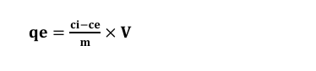equation 2.2
qe represents is the quantity of phosphates and nitrites uptake per unit functionalized silica molybdate and diazonium silica at equilibrium respectively, Ci is the initial concentration of phosphates and nitrites in ppm (mgL⁻¹), Ce gives equilibrium concentration of phosphates and nitrites in mgL⁻¹, M is the mass of the functionalized silica molybdate and diazonium silica adsorbents in grams and V represents the volume of adsorbate in litres [23, 24]. Adsorption efficiency of phosphates and nitrites in solution were calculated by applying Equation 2.3
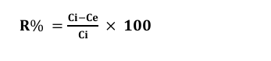Equation 2.3
R% represents the adsorption efficiency of phosphates and nitrites in the solution, Ci is the initial concentration of phosphates and nitrites while ce is the equilibrium concentration. [23]. The data obtained was analyzed using sorption models/ isotherms to determine the amount of phosphates and nitrites removal. Langmuir and Freundlich equation, Equation 2.4 and 2.5 respectively were used in determination of absorption capacities of the adsorbent [25].

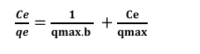Equation 2.4
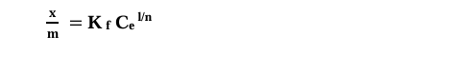
Equation 2.5

2.8 Determination of Adsorption Capacities of Commercial Activated Carbon
To investigate the adsorption capacity of commercial activated carbon, 0.02g of commercial activated carbon was added separately to 100 ml while varying the initial concentration of phosphate and nitrite model solutions. Adsorption capacities experiments were done at optimum pH 6.0, temperature of 45 ± 1 ℃ and the initial concentration varied from 20ppm-60ppm and agitated at 150 rpm at a contact time of 60 minutes for phosphates. Experiments were repeated by adding 0.02g of commercial activated carbon to 100ml and varying initial concentration of nitrite solution which was used as a model solution. Experimental solution was maintained at an optimum pH 3.0, temperature of 30 ± 1 ℃ and the mixture shaken at 150 rpm for 60 minutes. After the agitation period, the mixtures were filtered to obtain the filtrate which was analyzed by UV/Vis spectrophotometer to obtain phosphates concentration. The experiments were repeated three times. The amount of phosphates adsorbed by commercial activated carbon during the batch experiments were calculated using equation 2.6 [25].
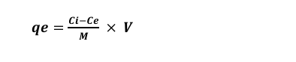Equation 2.6

- Results and Discussion
3.1 Characterization of Functionalized Silica adsorbents using FT-IR
FT-IR analysis is an important tool used to determine functional groups present in the compounds. FT-IR spectra were recorded on a FT-IR spectroscopy (FT-IR-8400 model, Shimadzu Tokyo, Japan) at 4000 - 400cm⁻¹ wave number. The results obtained were presented in the following sub-units.
3.1.1 Overlaid FT-IR Spectra of Raw silica, Chlorinated, and Aminated Silica
The Figure 3.1 shows FT-IR spectra of RS, CS and AS. It gives information about the available functional groups in RS, CS and AS. Overlaid spectra of RS, CS and AS gives clear differences in the position of their functional groups. More pronounced peaks are observed in the chlorinated and the aminated silica. The observations confirm that ethylenediamine (secondary amine) was anchored successfully on the silica material. Results reported in this study are similar with those reported on quartenized maize tassel [26].
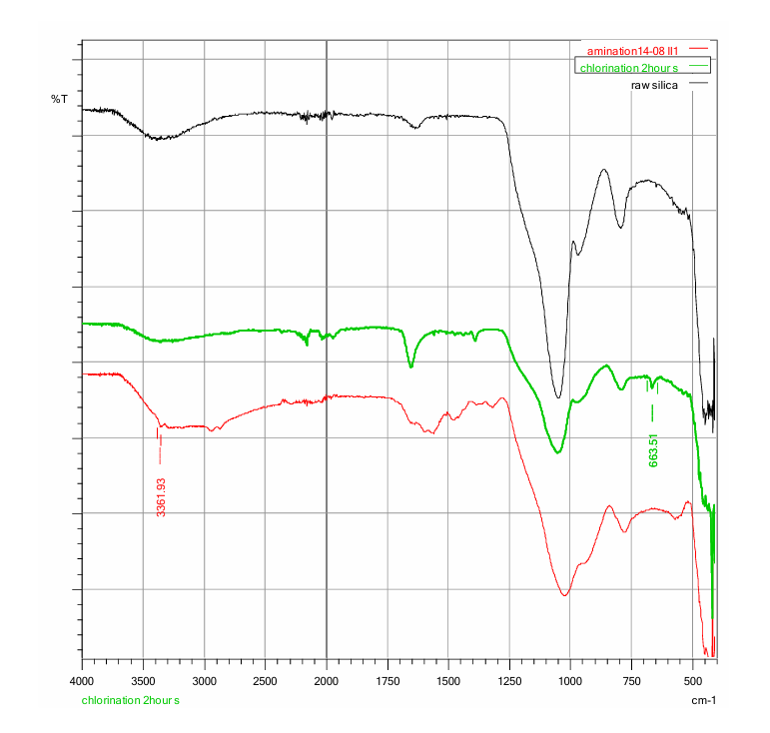
Figure 3.1: FT-IR spectra of raw silica, chlorinated, and aminated silica overlaid spectra
3.1.2 FT-IR Characterization of Aminated Silica Bounded with Molybdate
Adsorption bands at 854cm⁻¹ and 542cm⁻¹ were attributed to Mo=O and Mo-O stretching in molybdate (Figure 3.2). Peaks observed at 1388 and 1662.64cm⁻¹ were attributed with the vibration mode of Mo-OH bond and bending mode of adsorbed water [27]. Spectra peaks observed at 542, 634 and 898.97 cm⁻¹ were attributed to the adsorption of molybdate on the mesoporous silica [27].

FT-IR Spectra of Diazonium Silica 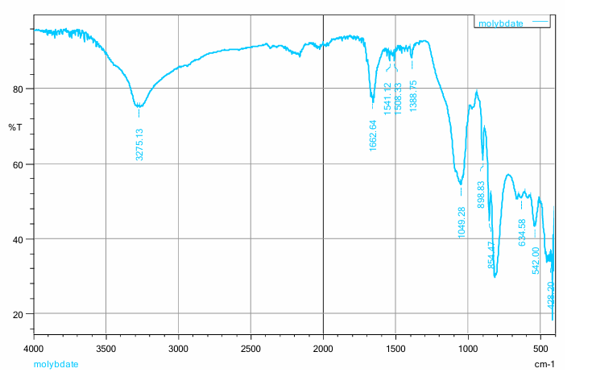
Figure 3.2: FT-IR spectra of silica molybdate
3.1.3 FT-IR Spectra of Diazonium Silica
The presence of a new open chain azo (N=N) group band in the region 1575cm⁻¹ to 1630cm⁻¹ (Figure 3.3) confirms the successful synthesis of silica diazonium salt [28]. The bands found at 791 and 1049 cm⁻¹ were due to (Si-O-Si) SiO₄ symmetric and anti-symmetric stretching modes [27]. There was a shift from 1051cm⁻¹ in raw silica to 1049cm⁻¹ in diazonium silica and the peak was assigned to (Si-O-Si). The shift may be attributed to new electronic interactions during the formation of diazo group. The presence of nitrogen atoms can lead to changes in the electronic distribution in the silica structure affecting the energy levels 48 of the electronic transitions. Shift can also be caused by the bond changes. The interaction between the silica framework and the diazo group can lead to the changes in band length and angles which can shift vibrational frequencies [29]. FTIR absorption spectra shows the disappearance band at 3361.93cm⁻¹ due to NH₂ and appearance of a new absorption band at 1575cm⁻¹ which is assigned to N=N stretching [30].
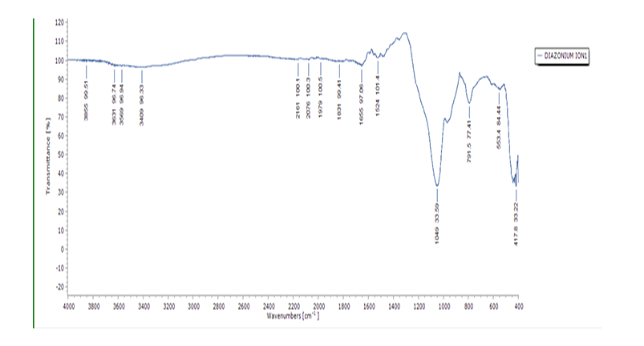
Figure 3.3: FT-IR spectra of diazonium silica
3.3 Adsorption Isotherms
Common types of adsorption isotherms are Langmuir adsorption isotherm and Freundlich adsorption isotherm. Langmuir adsorption isotherm can either be physisorption or chemisorption. Langmuir assumes that the surface is homogeneous and all sites are equivalent. Also, it assumes that there is no interaction between the adsorbate molecules on adjacent sites. Freundlich adsorption isotherm gives an empirical expression that accounts for surface heterogeneity. It assumes that the surface is inhomogeneity and there is adsorbate-adsorbate interaction [31].
3.3.1 Adsorption Capacities for Phosphates
The first theoretical treatment of nonlinear sorption is the Langmuir model which suggested that the uptake occurs on the homogeneous surface by monolayer sorption without the interaction between the adsorbed molecules [32]. The equation of Langmuir was used for adsorption equilibrium of phosphate ions into the silica molybdate. Linear equation of Langmuir is given as follows;
ce/qe = 1/q max.b + ce/q max. Equation 3.1
Ce the equilibrium concentration of the adsorbate in mg/L. Qe refers to the amount of phosphates ions adsorbed into the silica molybdate at equilibrium (mg/g) and q max (mg/g) is the Langmuir constant related to adsorption capacity and b (L/mg) is the Langmuir constant related to the energy of adsorption [33]. The linear plot of ce/qe verses ce as shown in figure 3.1 of silica molybdate showed that the adsorption process obeyed the Langmuir isotherm model according to the correlation coefficient value R₂, Qmax and b which were obtained from the slope and the intercept respectively. The essential features of Langmuir isotherm is expressed in terms of a dimensionless constant separation factor or equilibrium parameter Rl expressed as Rl = 1/ (1+b.co) [33]. The expression of Freundlich isotherm encompasses the exponential distribution of active sites and the surface heterogeneity. The constant Kf and nf numerical values were determined from the intercept and slopes of respective plots. Relative adsorption capacity of the adsorbent is indicated by the constant Kf relating to the bonding energy referred to as adsorption distribution coefficient. This value represents the quantity of the metal ions adsorbed in the adsorbent at equilibrium (Muhammad et al., 2012). Heterogeity factor is known as nf. Adsorption process is linear when nf = 1. If the adsorption process is chemical nf ˂ 1and a physical process when the value of nf ˃ 1. When the value of 1 𝑛𝑓 is less than 1 adsorption is the predominant process taking place (Muhammad et al., 2012). Langmuir plot of phosphate by silica molybdate is shown in Figure 3.1 and Freundlich plot for phosphates by silica molybdate is shown in Figure 3.2. The values of Langmuir and Freundlich constant of phosphates by silica molybdate is listed in table 3.1. Freundlich equation is better obeyed by the system than Langmuir one as is evident for the values R₂ in Freundlich model.
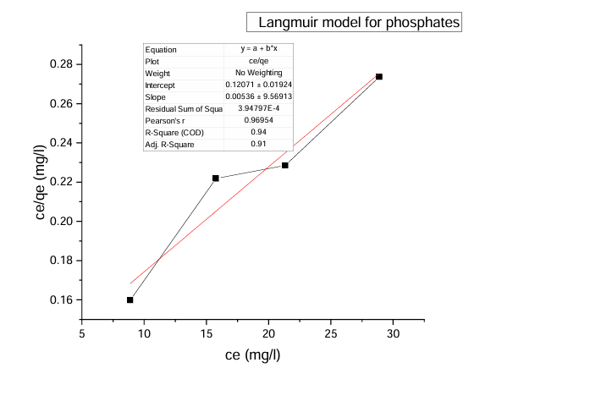
Figure 3.1: Langmuir adsorption isotherm for adsorption of phosphates ions into silica molybdate

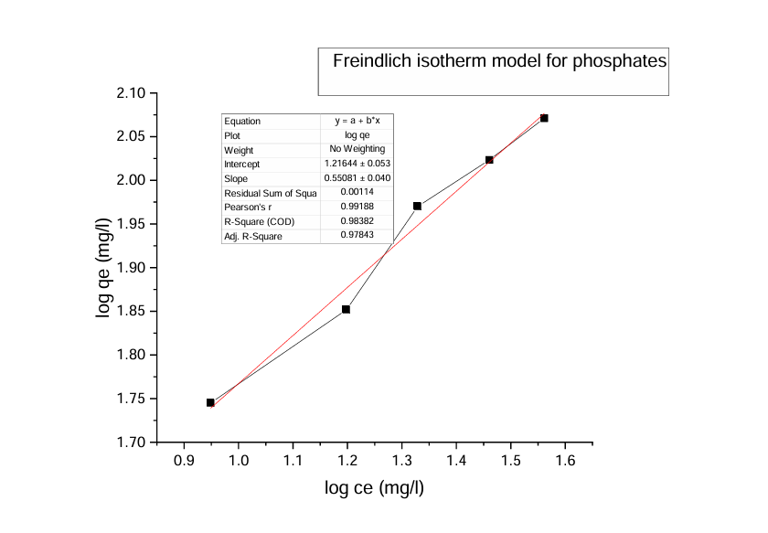
Figure 3.2: Freundlich adsorption isotherm for adsorption of phosphates ions into silica molybdate
3.3.1 Adsorption Capacities for Nitrites using Diazonium Silica
The sorption equilibrium is frequently described using the Langmuir equation. The Langmuir isotherm model assumes that the uptake of metal anions takes place on the homogeneous surface using monolayer adsorption where there is no interaction between the adsorbed ions. The model also assumes that all the surface sites are alike and can accommodate one adsorbed molecule. Another assumption is that the adsorption process is reversible and the adsorbed molecule cannot migrate across the surface or interact with the neighboring molecule. In order to get the equilibrium data, the initial concentrations of nitrites ions were varied keeping the adsorbent mass constant in each sample. Using the linearized Langmuir isotherm adsorption capacities and Langmuir constant were calculated. Adsorption capacities q(max) and Langmuir equilibrium constant kl were estimated from the slope and the intercept respectively from a plot of ce/qe versus ce figure 3.3. Adsorption capacity of nitrites (mg/g) obtained was 6.547 and kl was 0.07940. The separation factor Rl was found to between 0-1 indicating favorable biosorption process. The correlation coefficient of Langmuir isotherm model R₂ was 0.97029 as illustrated in table 3.2. shows that there is a linear relationship or correlation [34].
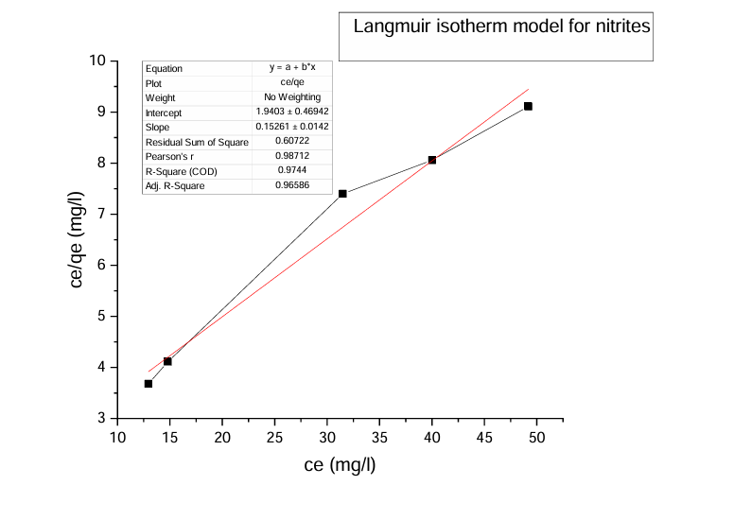Figure 3.3: Langmuir adsorption isotherm for adsorption of nitrites ions into diazonium silica

Freundlich model is interpreted as the sorption of heterogeneous surface. It is assumed that the stronger binding sites are occupied first and the binding strength decreases as the degree of occupation site increases. Freundlich constant n between 1 and 10 indicates a favorable adsorption. Larger values of n or (smaller values of 1/n) indicates stronger interaction between the adsorbent and the adsorbate. When 1/n =1 indicates linear adsorption. This is caused by very low solute concentration and low loading of the adsorbent. The value of n in this study fell in the range of 1 and 10 and the value of 1/n was less than 1. This indicates that the sorption was favorable (Anah & Astrini 2017). Freundlich isotherm model parameter Kf and nf numerical values were determined from the intercept and slopes of respective plots in figure 3.4. Kf was found to be 1.8146 representing the adsorption capacity and 1/n was found to be 0.2676 for intensity of adsorption. The correlation coefficient of Freundlich model was 0.89511 as illustrated in table 3.2 In this study Langmuir model was best fit isotherm for adsorption of nitrites ions on diazonium silica.
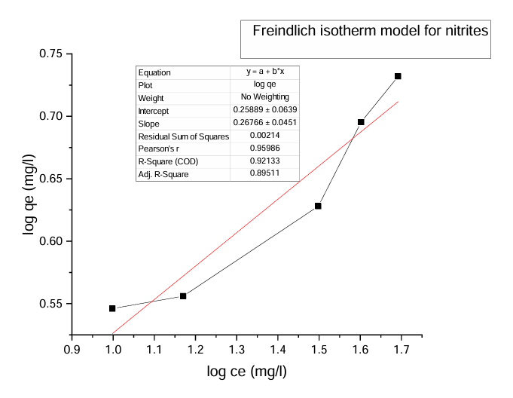
Figure 3.4: Freundlich adsorption isotherm for adsorption of nitrites ions into diazonium silica

Table 3.1 shows the results of Langmuir and Freundlich isotherms for phosphates and nitrites adsorption capacities
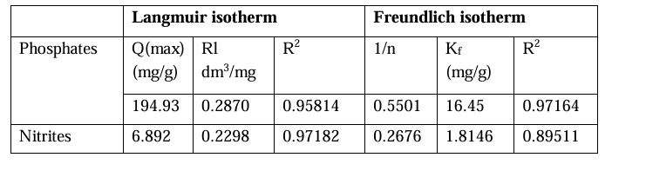
The biosorption process was well described in linear form of Freundlich equilibrium isotherm which yielded R₂ value of 0.97164 for phosphates adsorption and 0.97001 for nitrites as in Table 3.1. The adsorption intensity 1/n was less than 1 for both phosphates and nitrites sorption indicating that the sorption was favorable. Langmuir model described the sorption process poorly in phosphates as the separation factor RL was found to be between 0-1 as in table 3.1. The value indicated a favorable sorption process. A number of assumptions were contained in the Langmuir model such as all the binding sites should have an equal affinity for the adsorbate and adsorption should be monolayer, the number of adsorbed species should not exceed the total number of surface sites among others. For this reason, Langmuir model could not fit the data well as compared to Freundlich which takes into account the surface roughness [35].

Table 3.2 Comparison of adsorption capacities of silica molybdate with commercial activated carbon used for phosphates removal.
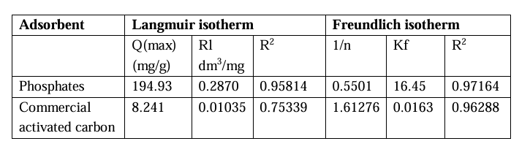
From the results obtain in the adsorption of phosphate using silica molybdate and comparing them with activated carbon (Table 3.2) shows that silica molybdate is a better adsorbent as compared to commercial activated carbon This is illustrated with higher adsorption capacity of silica molybdate. Langmuir model and Freundlich model is better obeyed in silica in molybdate as compared to commercial activated carbon. This shows that to remove phosphates from water silica molybdate is a better adsorbent.

Table 3.3 Comparison of adsorption capacities of Diazonium silica with commercial activated carbon used for nitrites removal.
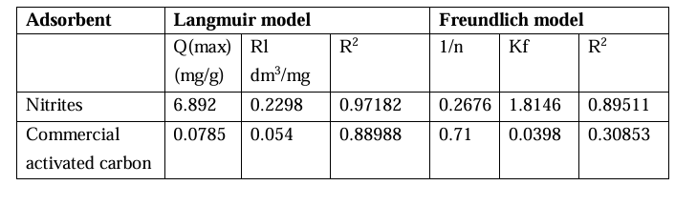
Adsorption capacities of diazonium silica were compared with commercial activated carbon as shown in Table 3.3. The results obtained indicated that silica molybdate recorded higher adsorption capacity. This shows that diazonium silica is a better adsorbent as compared to commercial activated carbon. Langmuir model and Freundlich model was best obeyed in diazonium silica as compared to commercial activated carbon indicating that the amount of adsorbate that can be adsorbed into the surface is higher as compared to commercial activated carbon. Results obtain in this study are compared to other reported results reported in literature in the adsorption of phosphates and nitrites using activate carbon as an adsorbent. From the results it can be concluded that silica molybdate and diazonium silica has higher adsorption efficiency as compared to activated carbon.

Table 3.4: Theoretical adsorption efficiency from batch adsorption experiments of silica molybdate and diazonium silica compared with reported results of activated carbon

Table 3.4 gives theoretical adsorption efficiency from batch adsorption experiments of silica molybdate and diazonium silica with other previously reported results from activated carbon used as an adsorbent for phosphates and nitrites adsorption. Based on the adsorption efficiency values it can be concluded that silica molybdate and diazonium silica are super adsorbent for the removal of phosphates and nitrites from wetland waters.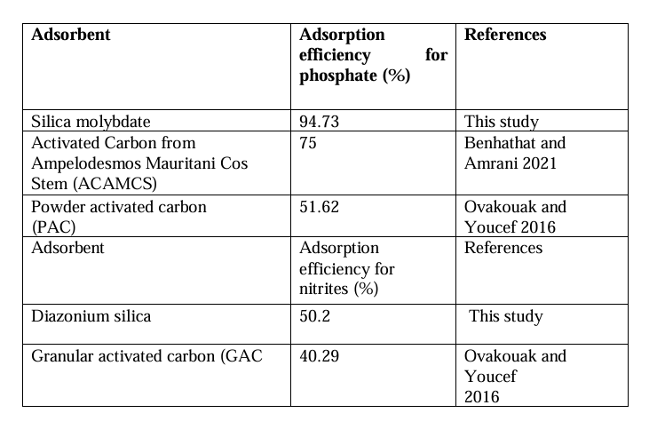
Table 3.4 gives theoretical adsorption efficiency from batch adsorption experiments of silica molybdate and diazonium silica with other previously reported results from activated carbon used as an adsorbent for phosphates and nitrites adsorption. Based on the adsorption efficiency values it can be concluded that silica molybdate and diazonium silica are super adsorbent for the removal of phosphates and nitrites from wetland waters
4.0 Conclusion
Adsorption capacities of silica molybdate and diazonium silica were compared with commercial activated carbon. For adsorption of phosphates using silica molybdate, Langmuir model gave the adsorption capacity of 194.93mg/g compared to 8.241mg/g for commercial activated carbon. The results from Freundlich model gave adsorption capacity of 16.45mg/g as compared to 0.0163mg/g of commercial activated carbon. When comparing the adsorption capacities of diazonium silica for adsorption of nitrites with commercial activated carbon. The results obtained from Langmuir model 82 was 6.892mg/g as compared to 0.0785mg/g of commercial activated carbon. In Freundlich model adsorption capacity was 1.8146mg/g as compared to 0.0398mg/g of commercial activated carbon. From the results obtain Langmuir and Freundlich model were better obeyed as they gave higher adsorption capacities for both adsorption of phosphates and nitrite ions. In conclusion the prepared adsorbents were better in terms of adsorption capacities as compared to commercial activated carbon.

Conflict of interest
The authors declare that they have no conflict of interest
Acknowledgement
Special thanks to laboratory technician’s of Chemistry Department, Murang’a University of Technology, for helping in me in obtaining FT-IR spectra for analysis of silica molybdate and diazonium silica adsorbents. Thanks to all staff members of Chemistry Department, Murang’a University of technology for assist me in various ways
References.
- Cherry, J. (2011). Ecology of Wetland Ecosystem. Nature Education Knowledge. Vol 3 (10)
- Cowardin, L., Carter, V., Golet, F., and Laroe, E. (1979). Classification of Wetlands and Deep-Water Habitants of the United States. Open Journal of Ecology. Vol 7 (6).
- Finlayson, C., and Moser, M., (1991). Wetlands. International Waterfowl and Wetland Research Bureau. ISBN 10: 0816025568.
- Kartlik, V., Selvakumar, P., Ponnusamy, S., Dai-viet, N., Jaisankar, S., Dhanabal, S., and Balakrishnan, S., (2021). Advanced Techniques to Remove Phosphates and Nitrates from Water. A review,Vol 19, 3165-3180.
- Fozia, B., Jamshed, S., Sobia, N., Syed, N. and Abbas, B. (2018). Study of Isothermal, Kinetic and Thermodynamic Parameters for Adsorption of Cadmium; An Overview of Linear and Non-linear Approach and Error Analysis. Bioinorganic Chemistry and Applications. https://doi.org/10.1155/2018/3463724
- Mohammad, S., Sahar, M., Mehrorang, G., and Hadi, H. (2021). Carbon Based Materials: a Review of Adsorbents for Inorganic and Organic Compounds. Journal of Royal Society of Chemistry, 598-627.
- Menendez, D., and Martin, G. (2006). Types of Carbon Adsorbents and their Production. (ISBN: 0-12-370536-3,) 1-48.
- Martin, J., Sweetman, S., Nick, M., Phillip, P., Krasimir, V., Sally, E., and John, H. (2017). Activated Carbon, Carbon Nanotubes and Graphene: Materials and Composites for Advanced Water Purification. Journal of Carbon Research. Vol 3 (2).
- Amalina, M., Ahmmed, S., and Abdul, H. (2012). Removal of Carbon Dioxide by Modified Activated Carbon from Palm Shell in Fixed Bed Column. Archives Des Sciences, 65, 12.
- Alemu, G., Feleke, Z., Arun, K., Andualem, M., and Melakuu, T. (2021). A Comparative Review on Nitrites and Phosphates Removal and Recovery from Aqueous Solution by Recovery. Water Infrastructure Ecosystem and Society. Vol 70 (7).
- Benhathat, A. and Amrani, M. (2021). Phosphate Removal from Water Using Activated Carbon Derived from Ampelodesmos Mauritanicus Stem: Equilibrium and Kinetic Study. Desalination and water Treatment. Vol 234 77-90.
- Wilaiwan, C., Robert, W., Kanda, P., Thanapon, S., Rafal, G., and Glen, F. (2010). Phosphate Removal by Anion Binding on Functionalized Nanoporous Sorbents. Journal of Enviromental Science Technology, 44, 3073-3078.
- Olga, R. and Elena, G. (2017). Methods for Removing Phosphates from Waste Water. Matec Web of Conferences (106)
- Ansari, R., Khoshbakht, F., and Fallah, D. (2009). Removal of Nitrite Ions from Aqueous Solutions Using Conducting Electro Active Polymers. Bentham Open Archives. DOI: 10.2174/1875180601002010001
- Hiba, N. (2012). Nitrate and Nitrite Ion Removal from Aqueous Solution by Activated Carbon Prepared from Olive Stones. Thesis dissemination.
- Srisuda, S., and Virote, B. (2007). Direct Synthesis and Characterization of Amine Functionalized Mesoporous Silica Materials and Their Applications as Formaldehyde Adsorbents. Environmental Engineering Science. Volume 25, 10.
- Xiaolei, Z., Junli, Z., Shaohong, Y., Linlin, D., Chongmin, L., Kaiwei C., Yuanli, L., and Lili, M. (2021). Selective Adsorption of CR (VI) onto Amine Modified Passion Fruit Peel Biosorbent. Processes Vol 9 790
- Ismail.A. Saputri, A. Dwiatmako, A. Susanto, B. and Nasikin, M. (2021). Synthesis of Silica Sand and their Application as Superhydrophobic Material. Journal of Asian Ceramic Societies. Vol 9 (2) 665-672.
- Aastha, D. (2017). Spectroscopic Methods for Nanomaterials Characterization, Fourier Transform Infrared Spectroscopy. Micro and Nano Technologies, 73 93.
- Ghaida, A., Tariq, A., Mika, S., and Davioud, B. (2021). Adsorption Performance of an Amine-functionalized MCM–41 Mesoporous Silica Nanoparticle System for Ciprooxacin Removal in a Batch System. Https://doi.org/10.21203/rs.3.rs.558931/v1.
- Noef, F., Ebtehal, F., and Nadia, A. (2021). Kinetics, Isotherm and Thermodynamics Studies of Efficient Adsorption of Congo Red Dye from Aqueous Solution onto Novel Cyanoquanidine-Modified Chitosan Adsorbent. Polymers 13, 4446.
- Nerdy, N. and Effendy, D. (2018). Spectrophotometric Method for Determination of Nitrite and Nitrite Levels in Broccoli and Cauliflower with Different Fertilization Treatment. Oriental Journal of Chemistry. Vol, 34, 6
- Barrera, A. (2020). Synthesis of Nanotemplated, Glucose-derived Adsorbents for the Removal of Organic and Inorganic Pollutants from Water. Open Access Theses & Dissertations. 3082. University of Texas at El Paso. https://scholarworks.utep.edu/open_etd/3082
- Mbugua W. G. (2020). Facile Remediation of Fluoride in Aquatic Media Using Modified Polyethylene Container, (Doctoral dissertation, Kenyatta University, Kenya)
- Apha, A., Mary, A. and Franson, H. (2017). Standard Methods for the Examination of Water and Wastewater, 23rd Edition, American Public health Association, American Water Works Association, Water Environment Federation. Geoscience and Environment Protection. Vol 7 (2) 20001- 3710. ISSN 55 1979.
- Mwangi, I., Ngila, J., Ndungu, P. and Msagati, T. (2014). Removal of Phenolics from Aqueous Media Using Quaternized Maize Tassels. Journal of Environmental Management, 134, Pp. 70-79
- Keyvani, A., Yeganeh, M., Rezaeyan, H. (2017). Application of Mesoporous Silica Nanocontainers as an Intelligent Host of Molybdate Corrosion Inhibitor Embedded in the Epoxy Coated Steel. Progress in Natural Science. 27 261 267.
- Marrison, J., Brandt, U., and Yeates, S. (2010). Synthesis of New Azo Compounds Based on N-(-4-Hydroxypheneyl) Maleimide and N-(-4-Methylpheneyl) Maleimide. Molecules, 15, 7498-7568.
- Studzinskii and Korobitsyna (1970). The Structure of Aliphatic Diazo-compounds and their Isomers. Russian Chemical Reviews. 30 (10)
- Khan, A., Raoof, V., and Essa, H. (2015). Synthesis, Characterization of Some New Azo Compounds Containing 1,3-Oxazepine Anthroquinone Moities and Studying their Activity Against Pathogenic Bacteria. Natural Science Research. Vol 5(22) 2224-3186.
- Jaskirat, K. (2017). Adsorption Isotherm. Research Gate. Dio, 10. 13140.
- Muhammad, B., Ibrahim, L., and Wahab, O., (2012). Thermodynamics and Adsorption Isotherm for the Biosorption of Cr(VI), Ni(II) and Cd(II) into Maize Cob. Chemsearch journal 3(1):7-12.
- Hashem, A., Abdel, E., Maavof, H., Ramadan, M. and Abo-okeil, A. (2007). Treatment of Sawdust with Polyamine for Waste Water Treatment. Energy Education Science and Technology. Vol 19 (1) 45-58
- Anah, L. and Astrini, N. (2017). Isotherm Adsorption Studies of Ni(II) ion Removal from Aqueous Solution by Modified Carboxymethyl Cellulose Hydrogel. Earth and Environmental Science. 160 012017 123456789
- Keno, D., Erastus, G., Godfrey, O., Eliakim, M. (2016). Kinetic Sorption Isotherm, Pseudo-First Order Model and Pseudo-Second Order Model Studies of Cu (II) and Pb (II) using Defatted Moringa Oleifera Powder. Journal of Phytopharmacology.
- Ovakouak, A. and Youcef, L. (2016). Phosphate removal by activated carbon. Sensor Leters. Vol 14, 1-6.

