AtmosGen: Condition-Aware Synthetic Atmospheric Data and Image Generation for Aviation Applications

Abstract

Abstract – Accurate atmospheric data is essential for weather forecasting, aviation safety, and climate research. However, real-world data collection methods such as radiosonde launches are limited by high operational costs, sparse temporal availability, and restricted geographical coverage. To address these chal- lenges, this paper proposes AtmosGen (Atmospheric Synthetic Data and Image Generator), a condition- aware synthetic atmospheric data and image generation framework that combines numerical data synthesis with atmospheric image generation. The system utilizes historical radiosonde data to generate realistic syn- thetic atmospheric parameters, including temperature, pressure, humidity, wind speed, and altitude, using machine learning-based generative models. In addition, a conditional image generation model is employed to generate atmospheric and weather-condition images corresponding to different environmental states such as clear sky, cloudy, foggy, and stormy conditions. To ensure the reliability of the generated data, a compat- ibility evaluation model is introduced, which verifies the consistency between input atmospheric conditions and the generated images using statistical similarity metrics and regression-based validation. Furthermore, a comparative analysis between original radiosonde datasets and model-generated datasets is performed using distribution analysis, correlation metrics, and downstream task performance evaluation. The proposed ap- proach reduces dependency on continuous real-time data acquisition while providing scalable, diverse, and scientifically consistent datasets. This framework is particularly useful for aviation simulations, machine learning model training, and atmospheric research where large labeled datasets are required.
Keywords: Synthetic Atmospheric Data, Image Generation, Radiosonde, Conditional GAN, Aviation Weather Simulation

Introduction

Accurate atmospheric data is essential for aviation safety, weather forecasting, and climate re- search. Aircraft operations rely on vertical atmospheric profiles such as temperature, pressure, hu- midity, and wind speed, typically obtained from radiosonde observations. Although radiosondes provide reliable upper-air measurements, they are limited by high operational costs, fixed launch schedules, sparse geographical coverage, and discontinuous data availability. These limitations create data gaps that restrict large-scale simulations and machine learning applications requiring continuous atmospheric datasets.
Recent advancements in machine learning and generative modeling have enabled the development of synthetic data generation systems capable of replicating real-world statistical patterns. Syn- thetic atmospheric datasets can reduce dependency on costly balloon launches while supporting scalable research and aviation analytics. However, generating scientifically consistent synthetic atmospheric data that preserves physical realism and statistical similarity to real observations re- mains a significant challenge.
This paper proposes a Synthetic Atmospheric and Aviation Dataset Generator using historical ra- diosonde data as the reference source. The system applies machine learning-based generative models to produce realistic atmospheric profiles, including temperature, pressure, humidity, and wind speed across altitude levels. To ensure reliability, a compatibility and comparison model is introduced to evaluate statistical similarity between original and generated datasets using correla- tion metrics and error analysis. Additionally, the framework supports condition-aware mapping between generated atmospheric parameters and corresponding weather representations.

Project Overview: Design and Functionality

The proposed Synthetic Atmospheric and Aviation Dataset Generator is designed as a structured data-driven atmospheric intelligence system. The framework transforms raw radiosonde obser- vations into validated synthetic atmospheric datasets suitable for aviation simulations, machine learning training, and meteorological research. The system follows a layered data processing ar- chitecture to ensure reliability, scalability, and statistical consistency.

Core Components

Core Focus – Synthetic Atmospheric Profile Generation
The primary objective of the system is to generate realistic atmospheric vertical profiles using

historical radiosonde data. The platform continuously models and simulates key atmospheric pa- rameters such as:
- Temperature
- Pressure
- Humidity
- Wind Speed
The system produces structured synthetic atmospheric datasets that preserve real-world statistical behavior while enabling large-scale dataset availability.

Supporting Parameters – Aviation & Environmental Factors
To enhance realism, the system integrates contextual aviation-related and environmental parame- ters, including:
- Turbulence indicators
- Wind shear patterns
- Seasonal variation
- Sensor noise simulation
This multi-parameter integration allows the system to simulate real-world atmospheric stress con- ditions affecting aviation safety and weather modeling.

Predictive & Generative Modeling
The system leverages machine learning-based generative models such as:
- Generative Adversarial Networks (GAN)
- Variational Autoencoders (VAE)
- Statistical regression models
These models learn correlations among atmospheric variables and generate synthetic profiles that replicate natural atmospheric dynamics.
Additionally, a comparison model evaluates similarity between real radiosonde data and generated datasets using:
- Mean Absolute Error (MAE)
- Root Mean Square Error (RMSE)
- Pearson Correlation Coefficient

Visualization & Decision Support

The final output includes:
- Synthetic dataset previews
- Statistical comparison results
- Correlation graphs
- Atmospheric trend visualizations
The system provides structured outputs in CSV/JSON formats and supports visual analysis of altitude-wise atmospheric behavior. These outputs assist researchers, aviation analysts, and ma- chine learning engineers in understanding atmospheric dynamics and testing predictive systems.

Existing Systems and Their Limitations

Traditional atmospheric data collection systems primarily rely on radiosonde-based observations for obtaining upper-air measurements such as temperature, pressure, humidity, and wind speed at various altitude levels. Radiosondes, which are balloon-borne instruments, have long served as a reliable source of vertical atmospheric profiling for aviation safety, weather forecasting, and cli- mate research. These observations provide high-quality in-situ measurements and are widely used in meteorological modeling and aviation planning. In addition to radiosondes, satellite observa- tions and numerical reanalysis models are also used to supplement atmospheric data collection.
However, existing systems suffer from several significant limitations. Radiosonde launches are typically conducted only once or twice daily from fixed geographical stations, leading to sparse temporal coverage and limited real-time adaptability. The operational process involves consider- able costs related to balloon equipment, sensors, and manpower, making continuous large-scale deployment economically challenging. Furthermore, many remote regions and oceanic areas lack radiosonde stations, resulting in geographical data gaps. While satellite systems provide broader coverage, they often lack the high-resolution vertical profiling accuracy offered by radiosondes. Numerical reanalysis models depend heavily on available observational inputs, and inaccuracies in input data can propagate through the modeling system.
Another limitation of current systems is their dependence on real-time physical data collection, which restricts scalability for machine learning training and aviation simulation applications that require large, continuous, and diverse datasets. The absence of synthetic augmentation mecha- nisms limits the ability to simulate rare atmospheric events such as turbulence spikes, extreme wind shear, or sudden pressure changes. Moreover, traditional systems do not provide built-in sta- tistical compatibility validation when integrating generated or interpolated data, which may lead to inconsistencies in advanced modeling environments.

Problem Statement and Objective

Accurate, continuous, and high-resolution atmospheric data is essential for aviation safety, nu- merical weather prediction, climate monitoring, and data-driven machine learning applications. Upper-air atmospheric profiles are traditionally obtained using radiosonde observations that mea- sure temperature, pressure, humidity, and wind speed across different altitude levels. While ra- diosonde data provides reliable and scientifically validated measurements, its availability is con- strained by high operational costs, limited launch frequency, sparse geographical distribution, and discontinuous temporal coverage. These limitations create significant spatial and temporal data gaps, especially in remote and oceanic regions, restricting the development of large-scale aviation simulations and advanced predictive systems. Furthermore, modern machine learning models re- quire extensive and diverse datasets for robust training, which cannot always be satisfied by limited real-world observations. Existing alternatives such as satellite data and numerical reanalysis mod- els provide broader coverage but often lack the vertical resolution accuracy and in-situ reliability offered by radiosondes. Additionally, current atmospheric data systems lack an integrated mech- anism to generate statistically validated synthetic datasets capable of preserving physical realism while supporting scalable data augmentation.
The primary objective of this research is to develop a Synthetic Atmospheric and Aviation Dataset Generator that leverages historical radiosonde observations to produce realistic and scalable syn- thetic atmospheric profiles. The system aims to model key atmospheric parameters while pre- serving statistical distributions and physical interdependencies. It further seeks to incorporate aviation-related contextual variables such as turbulence effects, wind shear patterns, and seasonal variability to enhance simulation realism. A key objective is the development of a compatibility and comparison model that evaluates similarity between original radiosonde datasets and gener- ated synthetic data using statistical validation metrics including Mean Absolute Error (MAE), Root Mean Square Error (RMSE), and correlation analysis. Another objective is to ensure logical align- ment between generated atmospheric conditions and corresponding environmental representations for improved simulation accuracy. Ultimately, the proposed system aims to reduce dependency on costly real-time data collection, improve dataset scalability, support predictive modeling, and provide a reliable atmospheric data simulation framework for aviation and research applications.

Review of Literature

Recent advancements in atmospheric and environmental monitoring have demonstrated the impor- tance of multi-parameter data integration for accurate modeling and analysis. Ma et al. (2025)

introduced an advanced atmospheric anomaly detection approach using integrated temperature and environmental parameters, improving the accuracy and reliability of atmospheric condition analysis. Their study demonstrated that combining multiple atmospheric indicators enhances the precision of environmental modeling and supports more reliable atmospheric data interpretation. This highlights the importance of multi-variable atmospheric modeling in synthetic atmospheric dataset generation systems.
Similarly, Gidey and Mhangara (2025) analyzed long-term atmospheric and environmental tem- perature relationships using satellite-based datasets and demonstrated strong correlations between atmospheric conditions and surface temperature variations. Their study emphasized the impor- tance of accurate atmospheric data modeling for predictive analysis and environmental monitoring. These findings support the need for scalable atmospheric data generation frameworks capable of preserving statistical relationships between atmospheric parameters.
Garai et al. (2022) investigated the relationship between rainfall, temperature, and environmental conditions using regression-based modeling and satellite datasets. Their results confirmed strong correlations between atmospheric variables, highlighting the importance of modeling interdepen- dencies among atmospheric parameters. This research demonstrated that atmospheric data model- ing systems must preserve statistical relationships between parameters such as temperature, pres- sure, and humidity to ensure realistic atmospheric simulation.
Londhe et al. (2023) studied atmospheric and environmental variability across different climatic zones and observed strong seasonal and regional variations in atmospheric parameters. Their re- search emphasized the importance of long-term atmospheric data analysis and demonstrated that atmospheric modeling systems must account for temporal variability to improve prediction accu- racy and simulation reliability.
Awasthi et al. (2023) examined climate sensitivity and atmospheric variability and found signif- icant relationships between atmospheric conditions and environmental changes. Their findings demonstrated that atmospheric parameters are highly sensitive to environmental variability, high- lighting the importance of reliable atmospheric modeling frameworks for predictive analysis and climate monitoring.
Dash et al. (2024) conducted a long-term study on atmospheric variability and precipitation pat- terns and observed increasing variability in atmospheric conditions across multiple regions. Their study emphasized the importance of predictive modeling and atmospheric simulation systems for improving climate monitoring and forecasting capabilities.
Rani and Kumar (2023) analyzed the relationship between atmospheric parameters and environ- mental pollutants and demonstrated the influence of atmospheric conditions such as temperature,

wind speed, and humidity on environmental stability. Their research highlighted the importance of accurate atmospheric data modeling for environmental monitoring and predictive analysis.

Project Scope

The scope of the proposed Synthetic Atmospheric and Aviation Dataset Generator is the creation of a unified atmospheric intelligence system that integrates radiosonde observations, aviation-related environmental parameters, and machine learning-based generative modeling into a single reliable framework. The system focuses on generating realistic synthetic atmospheric datasets while ensur- ing statistical consistency, physical realism, and compatibility with real-world atmospheric condi- tions. This unified framework supports aviation simulations, predictive modeling, and atmospheric research applications.
The project includes data unification and standardization as a key component. Historical atmo- spheric data collected from radiosonde archives, meteorological repositories, and environmental databases are used as primary inputs. Since atmospheric datasets may exist in different formats, resolutions, and measurement intervals, the system performs preprocessing steps including data cleaning, normalization, missing value interpolation, and feature standardization. These processes ensure that atmospheric parameters such as temperature, pressure, humidity, wind speed, and alti- tude are consistent, comparable, and suitable for machine learning-based modeling and synthetic data generation.
Another important scope of the project is the development of a compatibility validation and data reliability evaluation framework. The system introduces a comparison model that evaluates the similarity between real radiosonde data and system-generated synthetic datasets using statistical validation metrics such as Mean Absolute Error (MAE), Root Mean Square Error (RMSE), and correlation analysis. This validation ensures that the generated synthetic atmospheric profiles pre- serve statistical distributions and physical relationships. The system also incorporates data quality verification techniques such as anomaly detection, statistical consistency checks, and noise mod- eling to ensure reliable and scientifically meaningful synthetic data generation.
The project also includes predictive and trend modeling capabilities. Machine learning-based generative models such as Generative Adversarial Networks (GANs), Variational Autoencoders (VAEs), and regression-based models are trained on historical atmospheric data to learn temporal and spatial patterns. These models enable the generation of synthetic atmospheric profiles that replicate natural atmospheric variations and support simulation of different aviation and environ- mental scenarios. This allows researchers and aviation analysts to study atmospheric behavior, test predictive systems, and simulate rare or extreme atmospheric conditions.

Methodology

Building the Synthetic Atmospheric and Aviation Dataset Generator System

The development of the Synthetic Atmospheric and Aviation Dataset Generator followed a struc- tured, data-engineering-centric methodology to transform limited and fragmented radiosonde at- mospheric observations into a unified, scalable, and predictive synthetic atmospheric data platform. The system integrates historical radiosonde data, machine learning-based generative modeling, compatibility validation, and visualization to generate realistic atmospheric datasets for aviation simulations and research applications.

Problem Identification

The core issue addressed in this project is the limited availability, sparse coverage, and high opera- tional cost of real-world radiosonde atmospheric data. Atmospheric observations collected through radiosondes are often discontinuous, geographically restricted, and insufficient for large-scale sim- ulation and machine learning training. Researchers and aviation analysts must rely on incom- plete datasets, which limits accurate atmospheric modeling and predictive analysis. The proposed system acts as an atmospheric data generation and validation platform that collects historical ra- diosonde data, processes it, and generates statistically reliable synthetic atmospheric profiles. The system aims to answer key questions such as: “How can realistic atmospheric datasets be generated when real observations are limited, and how can their compatibility with real-world atmospheric behavior be ensured?” By combining historical analysis and machine learning-based generation, the system provides scalable, validated, and simulation-ready atmospheric datasets.

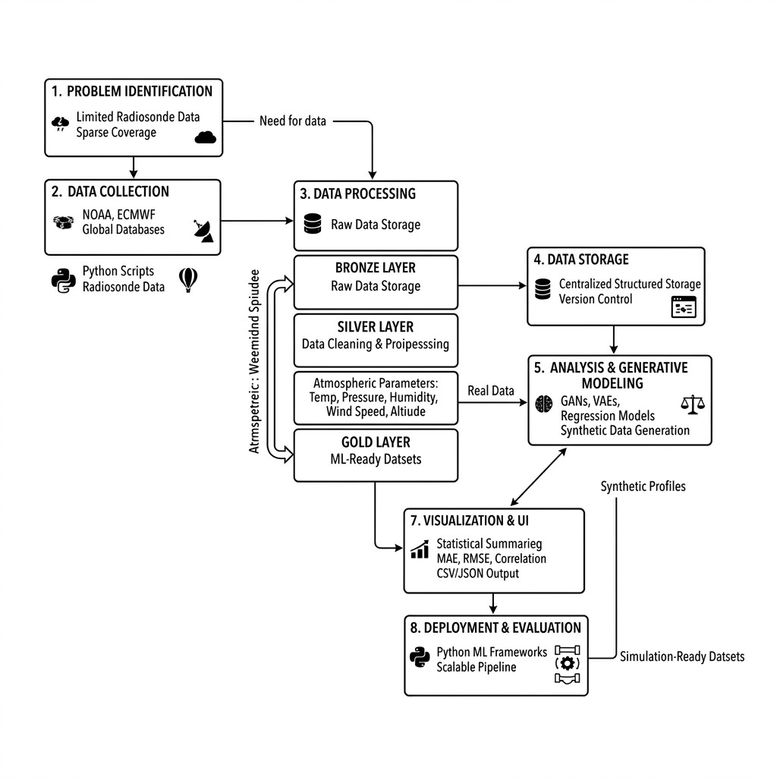
Figure 1: Block Diagram of AtmosGen

Data Collection

The system collects historical radiosonde atmospheric data from trusted meteorological reposito- ries such as NOAA, ECMWF, and other global atmospheric databases. These datasets include es- sential atmospheric parameters such as temperature, pressure, humidity, wind speed, and altitude. Python-based data extraction scripts are used to retrieve and structure atmospheric observations into tabular formats. The collected raw data is stored in the initial data layer without modification to preserve data integrity and ensure traceability. Automated pipelines are used to support incre- mental data loading, allowing new atmospheric observations to be integrated efficiently without affecting existing records.

Data Processing (The Transform Phase)

A structured layered data architecture is implemented to ensure data quality, consistency, and re- liability. The Bronze Layer stores raw radiosonde data in its original form, preserving historical records for validation and reproducibility. The Silver Layer performs data cleaning and prepro- cessing operations such as removing duplicate records, handling missing values using interpola- tion methods, normalizing atmospheric parameter ranges, and performing anomaly detection to improve dataset quality. The Gold Layer contains processed and structured datasets optimized for machine learning modeling, synthetic data generation, and analytical applications. Python libraries such as Pandas and NumPy are used for data preprocessing, while structured storage ensures effi- cient data access and management.

Data Storage and Warehousing

All processed atmospheric datasets are stored in a centralized structured storage system, ensuring efficient access, scalability, and data integrity. The structured data storage enables efficient query- ing, dataset version control, and validation processes. Incremental data loading mechanisms ensure that newly collected atmospheric data is integrated without affecting previously stored records. This centralized storage serves as the primary source for machine learning model training, valida- tion, and synthetic dataset generation.

Analysis and Generative Modeling

The system applies both descriptive and generative machine learning techniques to analyze at- mospheric patterns and generate synthetic datasets. Descriptive analysis is performed to study statistical distributions, correlations, and altitude-based atmospheric variations. Machine learning- based generative models such as Generative Adversarial Networks (GANs), Variational Autoen- coders (VAEs), and regression models are implemented to learn complex relationships between atmospheric parameters. These models generate synthetic atmospheric profiles that replicate real- world atmospheric behavior. Additionally, a compatibility and comparison model is implemented to validate synthetic data by comparing it with real radiosonde datasets using statistical metrics such as Mean Absolute Error (MAE), Root Mean Square Error (RMSE), and Pearson Correlation Coefficient. This ensures statistical consistency and physical realism in the generated datasets.

Visualization and User Interface

The generated synthetic atmospheric datasets and validation results are presented through struc- tured output and visualization tools. The system provides statistical summaries, correlation plots, and altitude-based atmospheric trend graphs to help users understand atmospheric behavior. Struc- tured dataset outputs are generated in formats such as CSV and JSON to support machine learning training, simulation, and analysis. Visualization tools enable researchers and aviation analysts to explore atmospheric patterns and validate generated synthetic data effectively.

Deployment and Evaluation

The system is implemented using Python-based machine learning frameworks and structured data pipelines to ensure efficient processing and scalability. Model evaluation is performed by com- paring generated synthetic datasets with real radiosonde data using statistical validation metrics. Compatibility validation ensures that the synthetic datasets maintain statistical similarity and phys- ical realism. System evaluation includes data pipeline validation, model performance assessment, and verification of dataset consistency. The final outcome is a scalable and reliable Synthetic At- mospheric and Aviation Dataset Generator that provides validated, realistic atmospheric datasets for aviation simulation, machine learning training, and atmospheric research applications.

Result

The proposed Synthetic Atmospheric and Aviation Dataset Generator provides an interactive plat- form for generating, visualizing, and validating synthetic atmospheric and aviation datasets using configurable parameters and machine learning models.

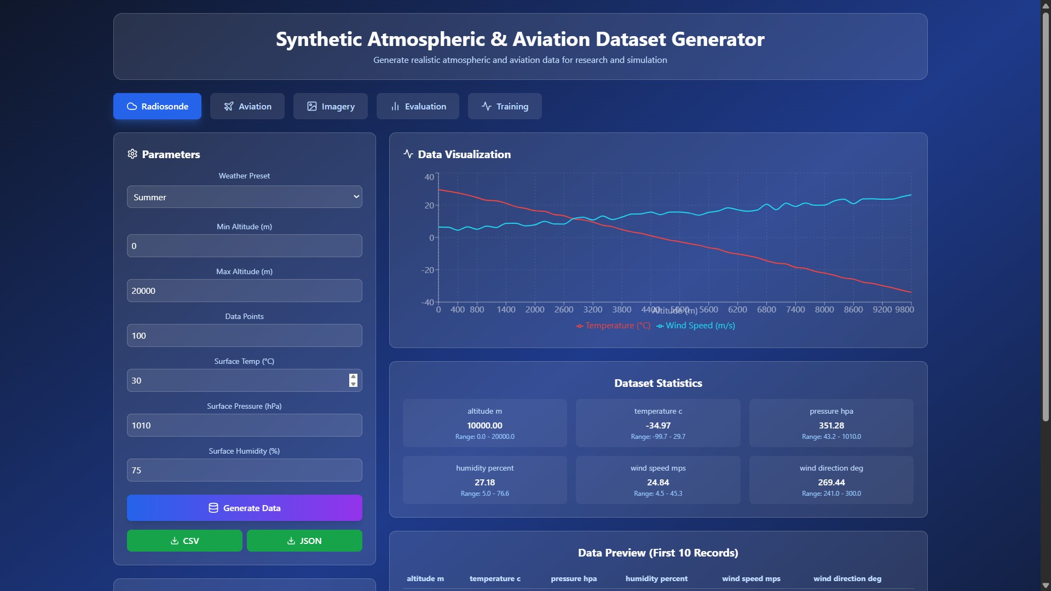
Figure 2: Radiosonde Atmospheric Dataset Generation Interface

Users can configure atmospheric parameters such as altitude range, temperature, pressure, and humidity. The system generates synthetic atmospheric profiles and visualizes temperature and wind speed variations with altitude. Statistical summaries and dataset previews are provided to validate data quality. This module ensures realistic atmospheric dataset generation for aviation and research applications.
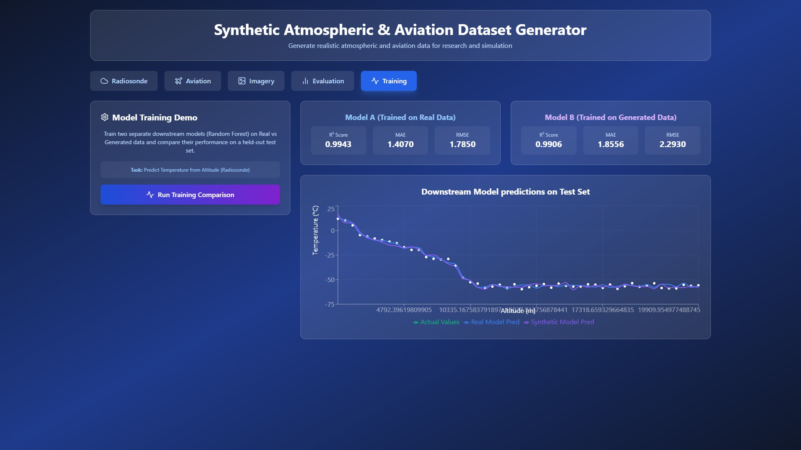
Figure 3: Training and Model Comparison Interface

This interface allows training of machine learning models using both real radiosonde data and system-generated synthetic data. Performance metrics such as R² score, Mean Absolute Error (MAE), and Root Mean Square Error (RMSE) are displayed to evaluate model accuracy. The graph compares actual temperature values with predictions from models trained on real and synthetic datasets. This demonstrates the effectiveness and reliability of the generated synthetic data for machine learning applications.
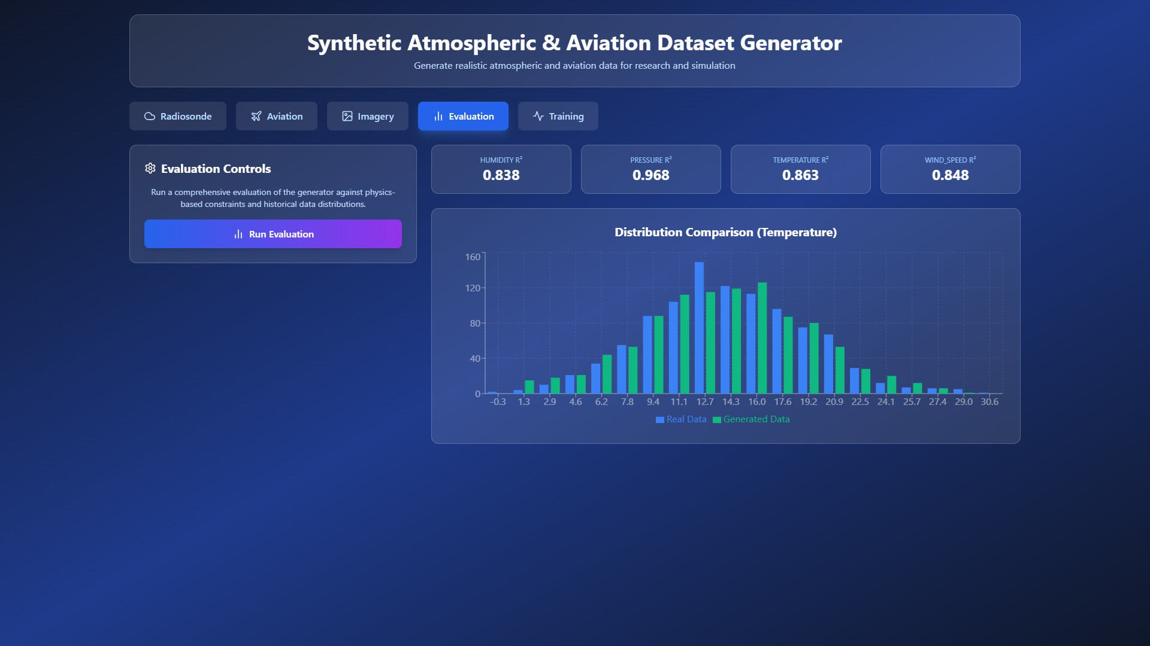
Figure 4: Dataset Evaluation and Distribution Comparison

It displays performance metrics for key atmospheric parameters such as humidity, pressure, tem- perature, and wind speed. The distribution comparison graph shows the similarity between real and generated temperature data. The close alignment between distributions confirms that the synthetic data preserves statistical properties of real atmospheric observations. This ensures the generated data is suitable for simulation and predictive modeling.

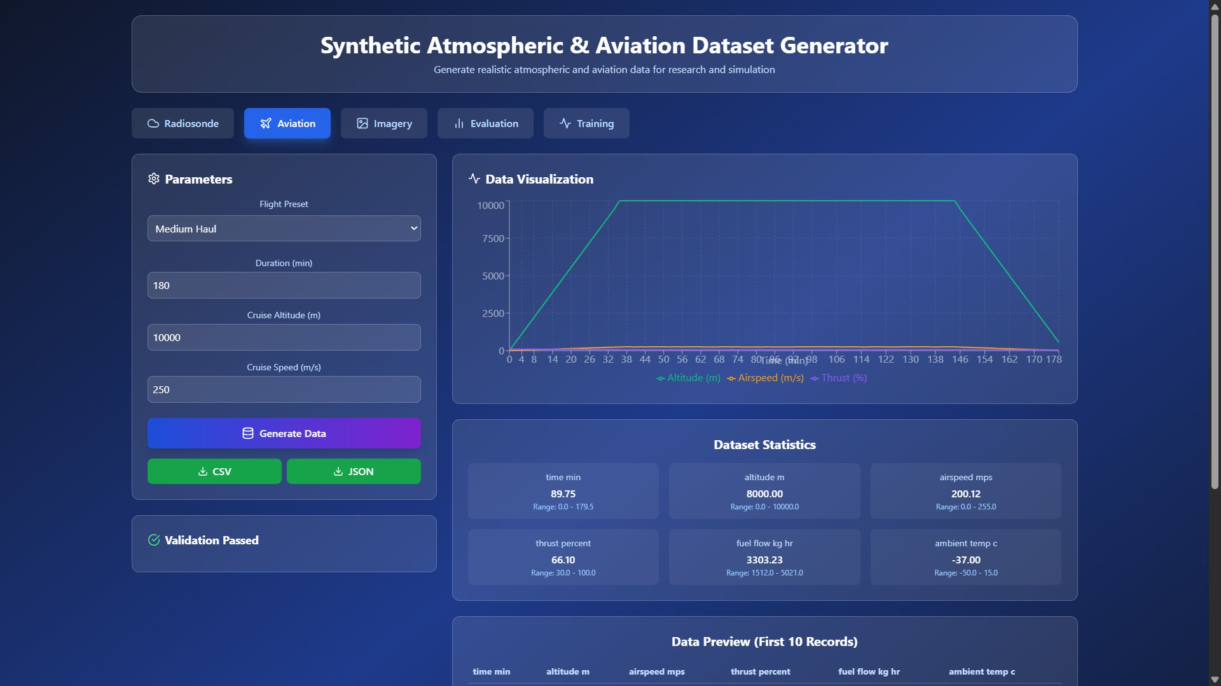
Figure 5: Aviation Dataset Generation and Visualization

This interface allows users to generate and visualize synthetic aviation flight profiles based on configurable parameters such as altitude, speed, and duration. It supports aviation simulation and performance analysis.

Conclusion

This paper presented a Synthetic Atmospheric and Aviation Dataset Generator that provides a scal- able and reliable solution for generating realistic atmospheric datasets using historical radiosonde observations. The system applies structured data preprocessing and machine learning-based gener- ative models, including GANs, VAEs, and regression techniques, to produce synthetic atmospheric profiles that preserve statistical and physical consistency with real-world data. A compatibility and comparison model was implemented using statistical validation metrics such as Mean Absolute Error (MAE), Root Mean Square Error (RMSE), and correlation analysis to ensure reliability and realism of the generated datasets. The system also provides structured outputs and visualization tools to support atmospheric analysis, simulation, and predictive modeling. By reducing depen- dency on costly and limited real-time radiosonde observations, the proposed framework enables scalable atmospheric data generation for aviation simulations, machine learning training, and re- search applications. This approach contributes toward improving atmospheric data availability and supporting advanced aviation and meteorological intelligence systems.

References

- I. Durre, R. S. Vose, and D. B. Wuertz, “Overview of the Integrated Global Radiosonde Archive,” Journal of Climate, vol. 19, no. 1, pp. 53–68, 2006. Available: https://journals
.ametsoc.org/view/journals/clim/19/1/jcli3594.1.xml
- I. Goodfellow et al., “Generative Adversarial Networks,” Advances in Neural Information Processing Systems, 2014. Available: https://papers.nips.cc/paper/5423-generative-adver sarial-nets
- D. P. Kingma and M. Welling, “Auto-Encoding Variational Bayes,” International Confer- ence on Learning Representations, 2014. Available: https://arxiv.org/abs/1312.6114
- National Oceanic and Atmospheric Administration (NOAA), “Integrated Global Radiosonde Archive (IGRA).” Available: https://www.ncei.noaa.gov/products/weather-balloon/integ rated-global-radiosonde-archive
- European Centre for Medium-Range Weather Forecasts (ECMWF), “Climate and Atmo- spheric Datasets.” Available: https://www.ecmwf.int/en/forecasts/datasets
- J. Jia, X. Zhang, and Y. Liu, “Synthetic atmospheric turbulence generation using statistical modeling,” IEEE Transactions on Aerospace and Electronic Systems, 2018. Available: https://ieeexplore.ieee.org/document/8352796
- National Aeronautics and Space Administration (NASA), “Atmospheric Science Data Cen- ter.” Available: https://asdc.larc.nasa.gov
- S. Hochreiter and J. Schmidhuber, “Long Short-Term Memory,” Neural Computation, vol. 9, no. 8, pp. 1735–1780, 1997. Available: https://www.bioinf.jku.at/publications/older/2 604.pdf
- NOAA Earth System Research Laboratories, “Radiosonde Observations and Atmospheric Profiles.” Available: https://www.esrl.noaa.gov
- Copernicus Climate Change Service, “ERA5 Global Climate Reanalysis Dataset.” Avail- able: https://cds.climate.copernicus.eu

