Smart Community Health Monitoring and Early Warning System

Abstract— Public health is a critical concern in developing nations, particularly in rural and underserved regions where healthcare access is limited. Communities suffer from water-borne diseases such as Cholera, Typhoid, Diarrhea, and Hepatitis A due to contaminated water sources and poor sanitation. Traditional health monitoring relies on manual reporting, causing delayed outbreak identification and increased health risks.
The Smart Community Health Monitoring and Early Warning System addresses these challenges through an AI-driven platform. Using Machine Learning techniques including XGBoost ensemble models, MLP Neural Networks, Isolation Forest, and NLP-based symptom analysis, the system analyzes symptoms, environmental conditions, and seasonal patterns to predict disease outbreaks and generate early warnings. The platform integrates real-time alerts, risk classification, water quality monitoring, and visual dashboards to enable timely preventive action by health authorities.
The system is implemented using Python and Flask, integrated with a React-based frontend. It supports data-driven decision-making in public health management and is scalable for resource-limited environments.
Keywords— Smart Health Monitoring, Disease Prediction, Machine Learning, Early Warning System, Water-Borne Diseases, Risk Classification, XGBoost, NLP, Flask, Web Application, Public Health Surveillance.

I. INTRODUCTION  Public health plays a vital role in the development of any country, especially in rural and remote areas where access to healthcare facilities is limited. Many communities suffer from water-borne diseases such as Cholera, Typhoid, Diarrhea, and Hepatitis A, which spread primarily due to contaminated water sources, poor sanitation, and lack of early detection systems. In many cases, outbreaks are identified too late, leading to serious health risks and even loss of life.  Currently, health monitoring in many regions depends on manual reporting and delayed responses. Health workers collect data, but there is no proper system to analyze this data quickly and predict possible disease outbreaks. As a result, authorities are unable to take timely preventive action.  With the advancement of Artificial Intelligence (AI) and Machine Learning (ML), it is possible to significantly improve health monitoring systems. These technologies can analyze large volumes of health and environmental data, identify complex patterns, and predict potential outbreaks before they escalate. However, most existing systems focus only on data collection or reporting and do not provide a complete solution for early warning and prevention.  To address these challenges, the Smart Community Health Monitoring and Early Warning System was developed. This system monitors health conditions, analyzes symptoms and environmental factors, and predicts possible disease outbreaks. It provides alerts and insights that help health authorities take preventive measures in advance. The main goal is to reduce the spread of diseases, improve early detection, and support better decision-making in public health.  II. LITERATURE REVIEW  The field of public health has seen significant improvements with the use of modern technologies such as Machine Learning, data analytics, and digital health systems. Traditional disease monitoring relied on manual data collection from hospitals and health workers. This approach is slow, error-prone, and often leads to delays in identifying disease outbreaks [1].  Early health monitoring systems were mostly rule-based, where predefined thresholds were used to identify abnormal conditions. While simple to implement, they lacked adaptability and could not handle complex patterns in data, limiting their effectiveness in predicting real-world outbreaks [2].  With the advancement of machine learning, more sophisticated approaches have been developed. Algorithms such as Decision Trees, Random Forest, and Logistic Regression have been widely used to analyze health data and predict the spread of diseases. Among these, Random Forest has shown good performance due to its ability to handle large datasets and reduce overfitting [3]. |  | .  Research has also focused on using data analytics for tracking infectious diseases such as Cholera and Typhoid. These systems analyze historical data and environmental factors like water quality, rainfall, and temperature to improve prediction accuracy. However, they often depend on structured datasets and may not perform well in rural areas [4].  Digital dashboards and visualization tools have improved health monitoring by helping authorities visualize disease trends. However, they typically rely on existing data and lack predictive capabilities [5]. Some research has explored IoT-based sensors to monitor water quality parameters, but such systems require hardware infrastructure difficult to implement in remote areas [6].  Despite these advancements, a major limitation of existing systems is the lack of integration between data collection, prediction, and alert mechanisms. Most systems focus on a single aspect, resulting in incomplete solutions. There is a strong need for a unified system combining data analysis, prediction, and early warning capabilities.  A.. Research Gaps  One major limitation is the lack of integration between different functionalities. Many systems focus only on disease prediction or data visualization but do not provide a complete solution that includes both prediction and alert generation. Another limitation is the dependency on real-time IoT infrastructure, not feasible in rural areas. This project uses structured datasets and simulated inputs, making it practical and scalable. Many systems also lack user-friendly outputs; this system improves usability by providing simple alerts, risk classifications, and understandable results.  III. SYSTEM ARCHITECTURE  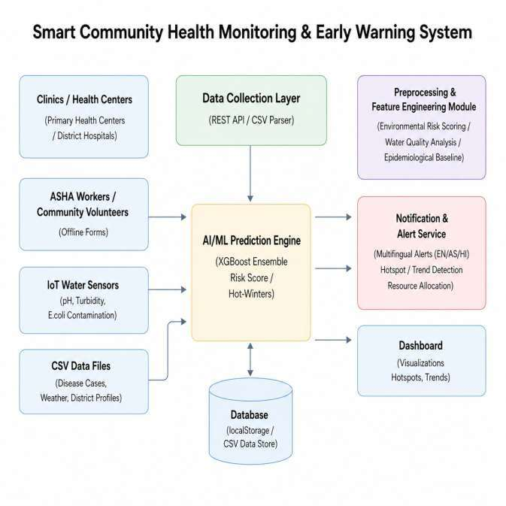  Fig. 1. System Architecture of Smart Community Health Monitoring and Early Warning System

A.. User Interface (UI)  Frontend: A React-based web interface developed using HTML, CSS, and JavaScript that allows users to submit health reports, view outbreak predictions, monitor water quality, and receive alerts. Multi-platform accessibility supports mobile, tablet, and desktop devices.  B.. Backend Server  Flask Server handles user requests, processes input data, and communicates with machine learning models. REST API Integration enables communication between frontend, ML models, and external data sources. The backend also manages alert generation, community report management, and dashboard statistics.  C.. Machine Learning Module  i) Outbreak Prediction: MLP Neural Network (128-64-32 neurons) trained on 30-day sliding windows of time-series health data predicts disease outbreak probability for the next 7 days.  ii) Disease Classification: XGBoost Gradient Boosted Trees with TF-IDF symptom vectorization classifies patient symptoms into probable disease categories.  iii) Water Quality Anomaly Detection: Isolation Forest identifies contaminated water sources from IoT sensor parameters including pH, turbidity, bacterial count, and dissolved oxygen.  iv) NLP Symptom Analyzer: Multi-model ensemble (Logistic Regression, Naive Bayes, SVM) with TF-IDF feature extraction classifies free-text symptom descriptions into disease categories.  v) Seasonal Forecasting: Holt-Winters Exponential Smoothing forecasts disease incidence per district for the next 4 weeks.  D.. Data Storage  Structured datasets and CSV files store health records, water quality readings, symptom corpus data, and prediction results. This reduces complexity while maintaining efficient data handling without complex database infrastructure.  E.. External Services  i) Weather API: Provides real-time environmental data (temperature, humidity, rainfall) to enhance outbreak prediction. ii) Water Quality Data Sources: Government and open data APIs for water contamination monitoring.  F.. Output Module  Displays results including outbreak predictions, risk classifications, water quality assessments, seasonal forecasts, and alerts. The Ensemble Risk Scorer aggregates all model outputs into a Community Risk Score (0-100) with alert levels: GREEN, YELLOW, ORANGE, and RED. |  | IV. SYSTEM WORKFLOW  1) User Interaction: The user accesses the system through the web interface and selects a feature such as outbreak prediction, disease classification, water quality monitoring, or risk score computation.  2) Input Processing: The user provides health-related data such as symptoms, number of cases, environmental conditions, and seasonal information. The system validates the input to ensure correctness and completeness.  3) Backend Communication: Validated input is sent to the Flask backend server through HTTP requests. The backend processes the request and forwards it to the appropriate module.  4) Model Execution: The system executes the corresponding ML or DL model: Outbreak Prediction (MLP Neural Network), Disease Classification (XGBoost), Water Quality Detection (Isolation Forest), or NLP Symptom Analysis (Ensemble LR+NB+SVM).  5) External Data Integration: The backend retrieves real-time data from external APIs such as weather services and water quality databases to enhance prediction accuracy.  6) Result Generation: The system processes model outputs and compiles final recommendations including outbreak predictions, risk classifications, water quality assessments, and alerts.  7) Output Display and Storage: Results are displayed to the user through the frontend interface. Inputs and outputs are stored in structured files for future reference and analysis.  V. RESULTS AND DISCUSSIONS  The Smart Community Health Monitoring and Early Warning System was evaluated based on its ability to process user inputs and generate accurate health recommendations across multiple modules. Instead of focusing solely on model accuracy, the evaluation considered functional performance, response quality, and end-to-end execution of features such as outbreak prediction, disease classification, water quality monitoring, alert generation, and risk assessment.  The system successfully accepts user inputs through a user-friendly web interface, including a main dashboard with visualizations for disease distribution, seasonal patterns, and district-wise case counts. The dashboard shows real-time status of all AI models.

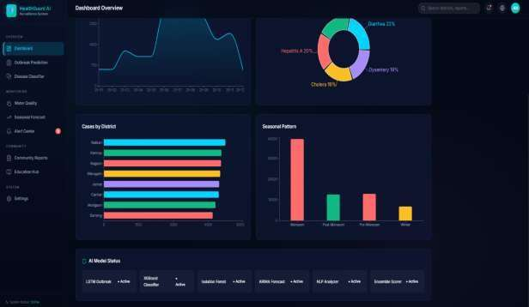  Fig. 2. Smart Community Health Monitoring and Early Warning System – Dashboard Interface  The system successfully accepts user inputs through a user-friendly web interface. After authentication, users can access different modules such as Outbreak Prediction, Disease Classifier, Water Quality Monitor, Seasonal Forecast, Alert Center, and Community Reports.  For outbreak prediction, the system uses an MLP Neural Network analyzing time-series health data to compute outbreak probability for a selected district. Results include an outbreak probability percentage, a Community Risk Score out of 100, and AI-generated recommendations for preventive action.  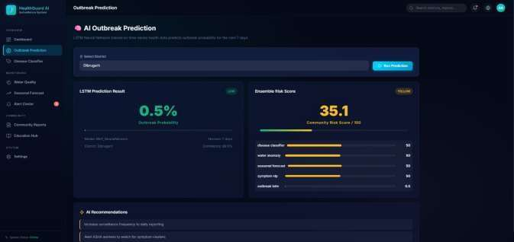  Fig. 3. Smart Community Health Monitoring and Early Warning System – AI Outbreak Prediction Module  The AI Outbreak Prediction module uses LSTM-based neural networks to analyze time-series health data and predict outbreak probability for the next 7 days. In test scenarios for Dilsukhnagar district, the system produced an outbreak probability of 0.5% with a community risk score of 35.1 (YELLOW alert level), accompanied by AI recommendations. |  | 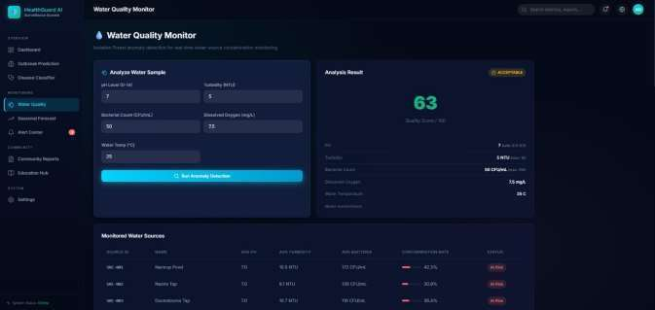  Fig. 4. Smart Community Health Monitoring and Early Warning System – Water Quality Monitoring Module  The water quality monitoring module analyzes sensor parameters including pH, turbidity, bacterial count, and dissolved oxygen using the Isolation Forest algorithm. The output includes a quality score, contamination status, and comparison of readings against WHO safety thresholds. This helps health authorities quickly identify unsafe water sources across monitored sites.  The outbreak risk analysis module provides a district-wise breakdown of risk factors and trend analysis, enabling authorities to identify hotspots and allocate resources effectively.  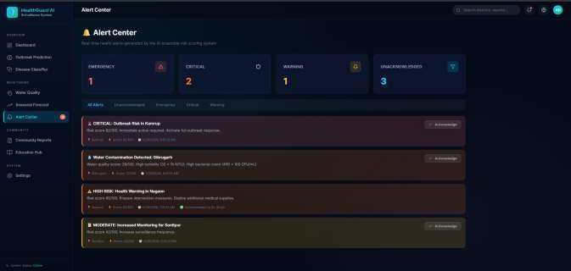  Fig. 5. Smart Community Health Monitoring and Early Warning System – Alert and Notification Center  The alert and notification center displays real-time alerts classified as EMERGENCY, CRITICAL, WARNING, and UNACKNOWLEDGED, with actionable recommendations for each alert. In tests, the system correctly flagged outbreak risk in Karimnagar, water contamination in Dilsukhnagar, and high risk health warnings in Nagaon.  The system was tested using multiple input scenarios and datasets. In all cases, it produced consistent, structured, and meaningful outputs. The response time was efficient, and the system successfully handled multiple functionalities through its modular architecture.

VI. CONCLUSION  This paper presents the design and implementation of an AI-based Smart Community Health Monitoring and Early Warning System that assists health authorities in monitoring public health conditions and predicting potential disease outbreaks. The primary objective is to provide intelligent insights based on symptoms, environmental conditions, and historical data using machine learning techniques.  The system integrates multiple AI models to handle different public health tasks. The MLP Neural Network analyzes time-series health data to predict outbreak probability. The XGBoost Disease Classifier identifies probable diseases from patient symptoms. The Isolation Forest Water Quality Detector identifies contaminated sources based on sensor parameters. The NLP Symptom Analyzer provides disease classification from free-text descriptions. These are aggregated by the Ensemble Risk Scorer into a unified Community Risk Score with actionable alert levels.  The backend is implemented using Flask and Python, providing a lightweight and efficient REST API for handling user requests. A modern React-based frontend provides a user-friendly interface with dashboards, charts, maps, and alerts. The system supports real-time processing and can be scaled for larger deployments.  Overall, the results demonstrate that the system effectively provides end-to-end public health support. The integration of machine learning, real-time APIs, and an intuitive user interface makes the system scalable, reliable, and suitable for real-world health monitoring applications, particularly in resource-limited environments. |  | VII. REFERENCES  [1] L. Li, S. Zhang, and B. Wang, "A Survey on Machine Learning in Public Health Surveillance," IEEE Access, 2021. https://ieeexplore.ieee.org/  [2] J. Brownstein, C. Freifeld, and L. Madoff, "Digital Disease Detection — Harnessing the Web for Public Health Surveillance," New England Journal of Medicine, 2009.  [3] A. Wesolowski et al., "Quantifying the Impact of Human Mobility on Disease Spread," Science, 2012.  [4] S. Bansal, B. T. Grenfell, and L. A. Meyers, "When Individual Behaviour Matters: Network Models in Epidemiology," Journal of the Royal Society Interface, 2007.  [5] R. Nsoesie et al., "A Systematic Review of Studies on Forecasting the Dynamics of Influenza Outbreaks," Influenza and Other Respiratory Viruses, 2014.  [6] F. Pedregosa et al., "Scikit-learn: Machine Learning in Python," Journal of Machine Learning Research, 2011. https://jmlr.org/papers/v12/pedregosa11a.html  [7] F. Chollet, Deep Learning with Python. Manning Publications, 2017.  [8] M. Abadi et al., "TensorFlow: Large-Scale Machine Learning on Heterogeneous Systems," Google Research, 2016. https://www.tensorflow.org  [9] I. Goodfellow, Y. Bengio, and A. Courville, Deep Learning. MIT Press, 2016. https://www.deeplearningbook.org  [10] World Health Organization (WHO), "Waterborne Diseases and Public Health," 2023. https://www.who.int  [11] Centers for Disease Control and Prevention (CDC), "Global Health Surveillance Systems." https://www.cdc.gov  [12] Kaggle, "Disease Prediction and Health Monitoring Datasets." https://www.kaggle.com/datasets  [13] Python Software Foundation, "Python Documentation." https://www.python.org/doc/

