Indian Startups and Employment Self Reliance in the Era of Atmanirbhar Bharat

Abstract
The swift expansion of startups in India has played a major role in boosting economic development, innovation, and job creation in the time of Atmanirbhar Bharat. Indian startups have become key contributors to self-reliant employment through the creation of entrepreneurial opportunities, fostering of innovation, and digital transformation of different sectors. This paper explores how Indian startups are fostering employment self-reliance and looks at the effects of government initiatives, technological progress, and startup ecosystems on the generation of sustainable employment.This study uses a descriptive and analytical approach referring to the combination of both primary and secondary data sources. The first-hand data were obtained through structured questionnaires distributing among the founders of startups employees managers and experts, the second-hand data were collected from books journals government reports, research articles, and startup databases.The study's results indicate that startup businesses are highly instrumental in generating direct and indirect employment as well as supporting young people's empowerment, enhancing skills, stimulating rural entrepreneurship, and promoting inclusive economic growth. Among the government schemes, Startup India, Make in India, Digital India, and Atmanirbhar Bharat have not only boosted the entrepreneurial environment through offering policy backing but have also provided financial resources, incubation support, and electronic infrastructure. The research highlights the main stumbling blocks of startups which are financial difficulties, tough competition in the market, regulatory barriers, technology constraints, and shortage of skilled workforce. Despite all these hardships, startups have been instrumental in radically altering the lives of individuals from unemployed to self-employed ones. Data says that a robust startup ecosystem, innovation ability, and policy environment will be key levers for India towards employment generation, economic development, and self-reliance.
Keywords: Indian Startups, Employment Generation, Atmanirbhar Bharat, Self Reliance, Entrepreneurship, Digital Transformation

1. Introduction
India's startup environment has highly contributed to changing the business scenario of the country. Established new ventures have Really been the main source of innovation, job creation, entrepreneurship, and economic self reliance in the country. India currently stands at the forefront of the global startup landscape mainly due to advances in technology, digital transformation, government initiatives, and growing entrepreneurial aspirations among youth. In addition, the extensive availability of internet services, digital payment systems, and innovation-driven business models have resulted in startups emerging rapidly in various sectors like IT fintech edtech healthtech agriculture, e-commerce, renewable energy, and manufacturing.With the launch of Atmanirbhar Bharat initiative by the GoI, the idea of self reliance has become a very hot topic in India. The idea of this initiative is to empower domestic manufacturing, motivate indigenous innovations, minimize reliance on foreign economies, and provide sustainable job opportunities within the country. Considering this, startups have emerged as a key tool for employment creation and economic empowerment. Besides creating direct job opportunities, they also lead to indirect job creation through supply chains, digital platforms, service sectors, and entrepreneurial networks.IIndian startups are playing a significant role in changing the mindset of job seekers to job creators. Young entrepreneurs are coming up with innovative businesses that not only meet local and global market needs but also create income and employment opportunities. Besides, startups provide skill enhancement creativity technological change, and financial inclusion Mainly for youth, women, and rural sectors. Because of this, startups are becoming a strong tool for getting employment self reliance and sustainable economic growth in India.The altered economic landscape in a globalized world coupled with the rapid technological disruptions and digital economy has completely changed the traditional employment patterns. Most of the time, traditional jobs are not enough to employ the increasing number of workers in India. So, entrepreneurship and the creation of new startups are being considered as the main ways to deal with the problem of unemployment and at the same time make the economy more robust. Through financial help, policy support, incubation facilities, tax incentives as well as reduced regulatory setups, the government schemes like Startup India, Make in India, Digital India, Skill India and Stand Up India have got a major boost in the development of the startup ecosystem. These sort of programs have motivated people to set up startups and work towards the progress of the country.

1.1 Background of the Study

Over the past decade, India has witnessed a remarkable surge in the number of people engaging in entrepreneurial activities. Besides the arrival of digital technologies, the government's entrepreneurship-friendly policies, and the availability of funding have together played a major role in creating a conducive atmosphere for startups. Atmanirbhar Bharat (self-reliant India) initiative has also played a significant role in emphasizing the importance of homegrown innovations and creation of jobs in the country. Because of this, through creating jobs, ushering in innovations, and inclusive development, startups are the main agents of India's economic transformation.

1.2 Concept of Startups in India

Element-by-Element Conceptual Analysis

The Atmanirbhar Setup (The Catalyst)

Self-reliance means producing things within the country and decreasing the reliance on foreign imports.

To assist this through policy, there are initiatives like Startup India and Make in India which offer a fiscal "safety net" (for tax breaks and funding) which is necessary for recruiting new employees.

Table 1:Employment Archetypes (The Output)

Element | Description | Impact Area
Direct Employment | Specialized roles in AI, data analytics, and management. | High-skill urban workforce.
Indirect Employment | Jobs created in the "periphery" (delivery partners, warehouse staff, vendors). | Semi-skilled and rural populations.
The Gig Economy | Flexible, platform-based work facilitated by startups like Zomato or Ola. | Immediate income accessibility.

1.3 Meaning and Importance of Employment Self Reliance

Employment self reliance is basically about individuals and communities having what it takes through entrepreneurship, innovation, and other economic activities to figure out on their own ways of earning a living sustainably without being dependent on limited or traditional job sources. Besides providing a means to economic empowerment, social inclusion and the generation of long-lasting development are also some of its few advantages.

1.4 Atmanirbhar Bharat Initiative and Startup Growth

The Atmanirbhar Bharat initiative was launched to empower India's homegrown economy and encourage self reliance in different sectors. The focus of the initiative is on indigenous production creativity business, and job creation. Startups have become major players in this effort by coming up with new products, services, and jobs that help to build a strong economy and a developed nation.

1.5 Need and Significance of the Study

The study is quite important as it explores how startups can generate jobs and make people self-reliant in India. It points out the ways in which startups help in economic growth, development of entrepreneurship, and creation of sustainable jobs. Besides that, the study also discusses government support systems, new opportunities, and various hurdles that startups encounter in the pursuit of Atmanirbhar Bharat goals. It is a relevant educational tool for the students to understand how startups operate.

1.6 Scope of the Study
The study focuses on Indian startups and their contribution toward employment self reliance in the context of Atmanirbhar Bharat. It examines startup growth, employment generation, government initiatives, opportunities, challenges, and the role of innovation in promoting sustainable economic development in India.

1.7 Objectives of the Study
- Analyzing the role and the extent of Direct and Indirect Employment: Understanding how startups create internal positions versus the whole ecosystem opportunities (logistics, supply chain, gig work).
- Assessing the Influence of Digital Transformation on Labor Scalability: Identifying how technological innovations enable startups to increase their workforce more rapidly than traditional industries.
- Finding out Structural Barriers to Sustainable Job Creation: Determining the exact financial and regulatory constraints that limit a startup's capacity to keep a long-term payroll.

1.8 Research Questions

In what ways do Indian startups play a role in achieving employment self-reliance?

How does Atmanirbhar Bharat influence the development of startups under its fold?

Which opportunities do startups offer, for employment generation, in India?

What difficulties do Indian startups encounter that hinder their sustainability?

What government measures can be taken to boost job creation through startup enterprises?

2. Literature Review

A thorough literature review has brought about a deep grasp of entrepreneurship, startup development, employment generation and self - reliance for Indian economy. It has been pointed out by many researchers, policymakers, and economists that startups are major sources of novelty, economic growth and employment creation. Atmanirbhar Bharat initiative which is gaining importance has also led to a renewed interest among scholars to study the linkage of startups and employment self reliance in India. So, this part of the paper looks at the theories, policy systems, empirical studies, and existing research gaps related to Indian startups and self reliant employment generation.

2.1 Theoretical Foundation of Entrepreneurship and Self Reliance
Initially, the focus was on the role of entrepreneurship in economic development through innovation, risk-taking, and creation of value. It was Joseph Schumpeter, in particular, who said that entrepreneurship is a process of "creative destruction" through which innovations introduced by entrepreneurs change the markets and lead to economic growth. For Schumpeter, entrepreneurs are the agents who bring about industrial transformation and job creation through their innovation-led activities.
Another significant theory that helps us understand entrepreneurship and self reliance is the Human Capital Theory. This theory argues that education skills knowledge, and training increase a person's ability to produce and their entrepreneurial capacity. In India, it is considered highly significant to impart entrepreneurial skills to young people as a means of alleviating unemployment and encouraging self employment.

Self-reliance is intertwined with economic independence and the ability to generate sustainable livelihoods. For instance, Gandhian economic thought stressed on local production, village industries, and self-sufficiency as the main pillars of a country's development. The Atmanirbhar Bharat movement is similar in spirit as it focuses on promoting home-grown entrepreneurship, local innovations, and job creation.

Entrepreneurship and startups, in particular, play a role in achieving self-reliance as they help people become less dependent on traditional job avenues and also provide them with different sources of incomes. Contemporary theories of entrepreneurship also highlight the importance of innovation ecosystems, technological flexibility, and collaborative networks. Startups are part of ever-changing ecosystems composed of government bodies incubators investors, educational institutions, and digital infrastructure. Such ecosystems help entrepreneurs to grow and be a source of economic robustness. As a result, entrepreneurship is increasingly being considered a powerful means for fostering employment, self-reliance, and development that includes everyone.

2.2 Evolution of Startup Ecosystem in India

Table 2:Evolutionary Phases of the Indian Startup Ecosystem
Phase | Timeline | Primary Focus | Key Characteristics
Phase 1: Initial Landscape | Early 2000s | Traditional Industries | Concentration in manufacturing and basic services; limited digital presence.
Phase 2: IT Transformation | Mid 2000s - Early 2010s | Software & Services | Growth of IT parks; increased internet accessibility; shift from traditional to tech-enabled business.
Phase 3: Acceleration | Mid 2010s - 2020 | Digital Economy | Rise of mobile technology; entry of venture capital; establishment of incubation centers.
Phase 4: Global Maturity | 2021 - Present | Innovation & Scale | Proliferation of Unicorns; diversification into deep-tech; focus on rural and women-led entrepreneurship.

Table 3:Strategic Growth Enablers
Category | Specific Drivers & Initiatives | Impact on Ecosystem
Government Policy | Startup India, Make in India, Digital India, Skill India. | Simplified regulations, tax benefits, and enhanced IP protection.
Infrastructure | Technology Parks, Incubation Centers, Digital Platforms. | Provided the physical and digital foundations for rapid scaling.
Financial Support | Venture Capital (VC) funding, Angel Investment, Seed funding. | Improved access to finance for high-risk innovative ventures.
Geographic Hubs | Bengaluru, Hyderabad, Mumbai, Delhi, Pune, Chennai. | Concentrated skilled workforces and investment opportunities.

Table 4:Sectoral Proliferation & Socio-Economic Impact
Vertical | Key Sectors Involved | Socio-Economic Contribution
Core Tech Sectors | Fintech, E-commerce, Edtech, Logistics. | Digital transformation of consumer services and retail.
Specialized Sectors | Healthtech, Agritech. | Improved accessibility to healthcare and modernized farming techniques.
Economic Impact | Thousands of registered startups; numerous Unicorns. | Significant contribution to GDP and national economic development.
Social Impact | Rural startups; Women-led enterprises. | Employment generation for skilled and semi-skilled workers across urban and rural regions.

Table 5:Technical Summary of Indian Startup Ecosystem Evolution
Category | Specific Components & Initiatives | Technical & Economic Impact
Employment Generation | Direct: Technical (AI/Devs), Managerial, Ops.  Indirect: Logistics, Supply Chain, Digital Marketing.  Gig Economy: Flexible platform-based roles in transport and delivery. | Addresses underemployment and skill gaps; decentralizes opportunities to Tier-2/3 cities.
Government Policy Framework | Startup India (2016): Tax exemptions (3-year IT holiday), self-certification, patent rebates (80%).  Skill India: Vocational training to enhance youth employability. | Transforms "job seekers" into "job creators"; builds robust industry-academia partnerships.
Digital & Financial Infrastructure | Digital India: Expansion of internet connectivity and e-governance.  Financial: ₹10,000 Cr Fund of Funds, Mudra Loans, Credit Guarantee Schemes. | Reduced operational costs via cloud computing/AI; improved market accessibility through online marketplaces.
Innovation & Technology | High-Tech: AI, Blockchain, IoT, Robotics.  Mid/Low-Tech: Mobile apps, Big Data, SaaS, basic connectivity. | Enhances global competitiveness; improves startup sustainability and profitability.

2.3 Research Gap Identification
In spite of In reality a number of papers have been written on entrepreneurship and startups in India, some areas of research remain unaddressed. Most of the papers already published are concentrated on aspects like startup growth innovation funding mechanisms, and digital transformation. But, hardly any research has focussed on the interconnection of startups and employment self reliance in Atmanirbhar Bharat.There is a vast number of research papers that look at the performance of startups from economic and technological angles. These studies Still mostly overlook the role of startups in integrating sustainable employment and lessening the dependence on unemployment benefits. Besides, there is very little research that synthesizes the role of government measures, technological progress, and the entrepreneurial environment together in fostering employment self reliance in India.

The literature so far also misses out on a proper comparative study between the conventional employment ways and employment models driven by startups. Rural startups and women entrepreneurs leading their businesses as well as social entrepreneurship definitely deserve more study and research since they are major contributors to inclusive development.
That's why, this paper is a step toward filling those voids in the literature by first investigating how Indian startups are helping Atmanirbhar Bharat by creating employment self reliance. The paper, That means, is expected to cover the full cycle of the employment impact of startups, the role of government regulation and support, elements of the environment, and finally opportunities challenges, and developmental strategies for the future that fit the Indian economic setting.
窗体底端

3. Research Methodology

3.1 Research Design

The study uses a descriptive and analytical approach to research. Its main objective is to explore the potential of startups in generating self-employment opportunities during Atmanirbhar Bharat era. Descriptive design here is a tool to reveal the existing situation whereas analytical design is a media to find out the linkage between various factors.

3.2 Research Process
- Problem Identification
- Literature Review
- Data Collection
- Data Analysis
- Findings and Conclusion

3.3 Nature of the Study
The research paper's method is quantitatively-oriented segment as the main purpose is to feed number data into the analysis stage. The authors use descriptive and analytical approaches for a comprehensive analysis of the research issue. Cross sectional refers to Truth is participants data is collected at one point in time, which is the nature of this research. The research paper is explanatory in its nature because it explains the effect/employment self reliance impact of startups.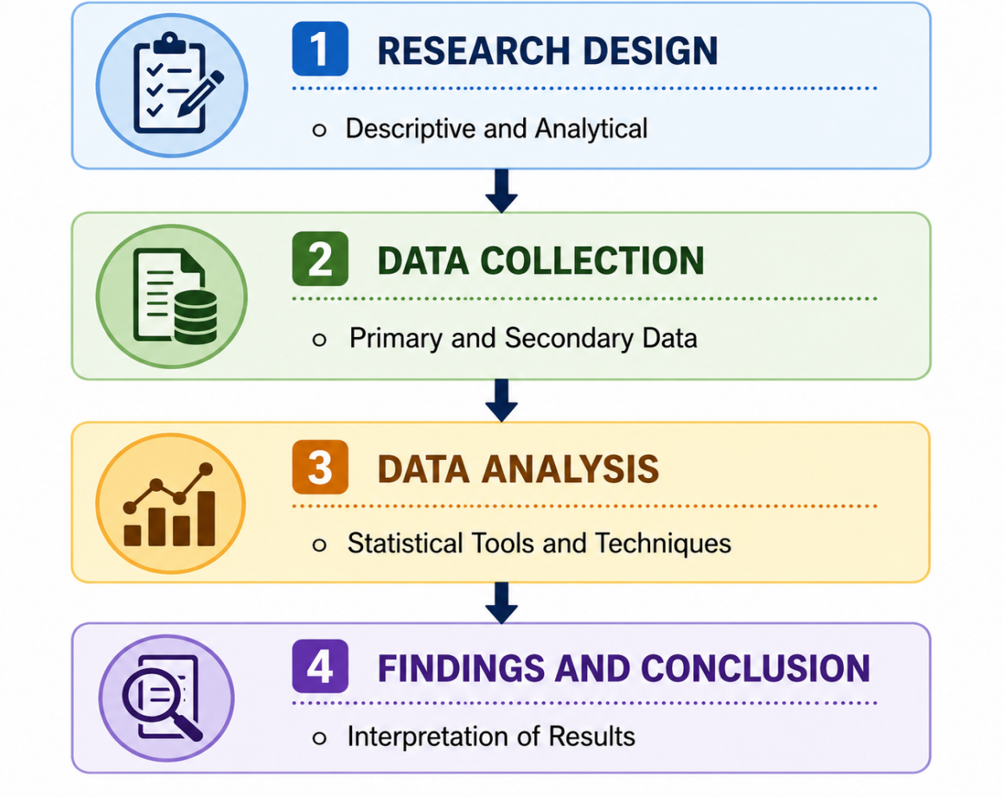
Figure 1:Research Methodology Framework
. 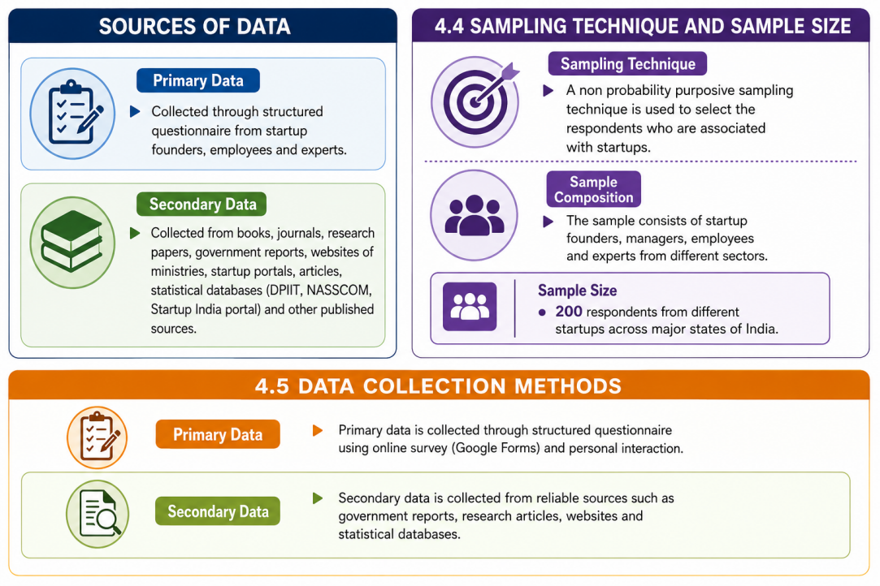
Figure 2: Data Collection Framework

3.4 Tools and Techniques for Data Analysis
Table 6:Data Analysis details

Type of Analysis | Tools and Techniques
Descriptive Analysis | Percentage, Frequency, Mean, Standard Deviation
Inferential Analysis | Correlation Analysis, Regression Analysis, Chi square Test
Software Used | SPSS / Excel

3.5 Hypothesis of the Study

I.H01:Government support has no major effect on startup success.

II.H02:Innovation does not make a difference in startups' employment generation.

III.H03:Access to finance does not make a difference in employment self reliance.

IV.H04:Digital technology adoption does not make a difference in startup growth.

V.H05:Startup growth does not correlate Quite a bit with employment self reliance.

3.6 Limitations of the Study

The study is focus on startups selected only certain states of India.

The data is collected at a single moment of time.

Only 200 respondents are taken as sample which may not be representative of the whole population.

Primary and secondary data are the basis of the study, which may be liable for response bias.

The study's depth might be limited by time and resource constraints.

4. Growth of Indian Startups in the Era of Atmanirbhar Bharat

The shift to Atmanirbhar Bharat (Self-Reliant India) has changed the start-up ecosystem focus from consumer oriented services to high-impact, home-grown innovation that is quite different. This change is marked by "triple-bottom-line" approach: economic valuation, technological sovereignty, and social inclusivity.

Table 7:Breakdown of the Atmanirbhar Ecosystem
Strategic Pillar | Technological & Innovative Novelty | Economic & Social Impact | Strategic Pillar
Digital Sovereignty | Integration of Public Digital Goods (UPI, ONDC) with AI and Cloud Computing to eliminate market monopolies. | Reduced operational barriers; enabled "Hyper-local" scalability for urban and rural startups. | Digital Sovereignty
Unicorn Maturity | Shift from high-burn models to Sustainable Scalability in Deep-tech, Fintech, and SaaS sectors. | Massive influx of global FDI; creation of multi-tier employment (Direct: Tech/Mgmt; Indirect: Logistics/Supply Chain). | Unicorn Maturity
Inclusive Innovation | Agritech & Social Ent. utilizing IoT and Blockchain for transparent supply chains and local resource optimization. | Mitigated rural-to-urban migration; empowered women through digital-first entrepreneurship models. | Inclusive Innovation

4.1 Core Growth Drivers & Impact

a.Digital Transformation as an Accelerator: Combining Digital India with cheap hardware has led to the creation of a "Low-CAC" (Customer Acquisition Cost) environment where startups through their mobile-first applications and AI-driven personalization are able to penetrate the market very effectively.

b.The "Unicorn" Multiplier Effect: Indian Unicorns go beyond just valuation. They are also Ecosystem Anchors, constantly opening up avenues for R&D collaborations, and creating sophisticated vendor networks, which in turn help in making the national economy more resilient.

c.Decentralized Entrepreneurship: Innovation does not have to be limited to "Tier-1" hubs. With assistance from indigenous knowledge, small start-ups in rural areas are addressing local issues, like food processing and renewable energy. Besides this, women-led enterprises are also facilitating the closing of the gender gap in financial independence.

4.2 Novelty in the Era of Self-Reliance
The main drivers of innovation today are frugal engineering (getting more by doing less) and creating indigenous intellectual property (IP). Startups are no longer imitating but creating "India-first" solutions, e.g. local agricultural sensors or regional language fintech tools, which are competitive globally but still based on the local market.

5. Indian Startups and Employment Generation

Indian startups, in the age of Atmanirbhar Bharat have become strong sources of job creation and economic change. The start-up sector's swift growth in areas like information technology fintech e-commerce healthcare education logistics agritech, and digital services, has led to a large number of job openings for workers at different skill levels. Besides driving economic development, start-ups are also changing the old employment pattern by encouraging entrepreneurship, innovation, and self employment.

A.Direct and Indirect Employment

Direct Jobs: Startups open up new internal positions in the areas of management, technology (e.g. developers, data analysts), marketing, and operations.

Indirect Jobs: A large number of job openings come about through supply chains, logistics, and vendor partnerships. This is In particular true for sectors like e-commerce, food delivery, and agritech.

B.Transforming Job Seekers into Job Creators

Startup India and skill India offer money and startup help so young people can build their own businesses.

Startups move away from relying on governments or big companies and instead depend on themselves.

C.Skill Development and Capacity Building

Working in startups can develop human capital through the acquisition of skills in very specialized areas like artificial intelligence, cloud computing, and data analytics.

They contribute to the quality of human capital by supporting their training capability of the human resources through the provision of various internships and practical learning that play an important role in boosting the employability and professional competency of individuals.

D.Inclusive and Rural Growth

Around employment in the countryside: Agritech as well as food processing startups contribute to rural livelihoods, thereby cutting down the migration of people to cities.

Inclusive development: Social enterprises and impact-driven solutions give women, rural youth, and marginalized communities more power, which can be enabled through startups

E.The Rise of the Gig Economy

Digital platforms have enabled flexible work to reach millions of people who were not only working as drivers of delivery vehicles but also freelancers and online tutors.

Besides giving access to earning, this model still poses quite a few challenges for labor protection and social security.

6. Challenges Faced by Indian Startups

i. Financial Constraints: Usually, startups find it really difficult to get the necessary funds, Mostly when they are at the stages of initial development. Besides that, they face the challenges of high running costs and unstable cash flow.

ii. Market Competition: It is very challenging to keep profitable because of the strong competition from well-established companies as well as the rapidly changing tastes of consumers.

iii. Regulatory Barriers: Among other things, complicated tax systems, licensing requirements, and legal procedures can be very time-consuming and expensive. The situation is even more difficult for small companies that do not have a dedicated team for the handling of administrative issues.

iv. Workforce Gaps: Continuously, the lack of proper recruitment and motivation of personnel with the necessary technical, managerial, and entrepreneurial skills for the work in the startup environment is a problem.

v. Infrastructure Issues: Although technological advancement and digitalization are very much needed, their adoption costs are still high. Startups find themselves in a very difficult position when they are exposed to cybersecurity threats and have a poor internet connection. These are the main problems of startups that are located in rural or semi-urban areas.

vi. High Failure Risks: Market unpredictability, malfunctioning business models, and the absence of management experience are the main reasons behind the high failure rate within the initial years of starting the business.

7. Case Studies of Successful Indian Startups

7.1 Startup Success Stories in India

Flipkart, Paytm Zomato Byju's, Ola, and Zerodha were able to succeed as Indian startups by bringing in innovative digital business models and services that focused on the customers. Their development is a testament to the vitality of India's startup ecosystem.

7.2 Employment Impact of Selected Startups

Startups that have succeeded are responsible for generating millions of direct and indirect jobs in various fields like logistics, e-commerce transportation fintech, education, and digital services. Besides that, these businesses are highly instrumental in creating employment for the youth and nurturing entrepreneurs.

7.3 Innovative Business Models and Self Reliance

Startups in India have implemented the cutting-edge business tactics using digital channels, including technology integration and product or service solutions focusing on the needs of the consumers. These business models facilitate homegrown innovations, boost the country's economic growth through increased production, and at the same time, help to cater to the employment needs of the populace.

7.4 Lessons from Emerging Entrepreneurs
Successful entrepreneurs highlight the importance of innovation, adaptability, risk management, market understanding, and continuous learning. Their experiences provide valuable guidance for future startup development and entrepreneurial growth.
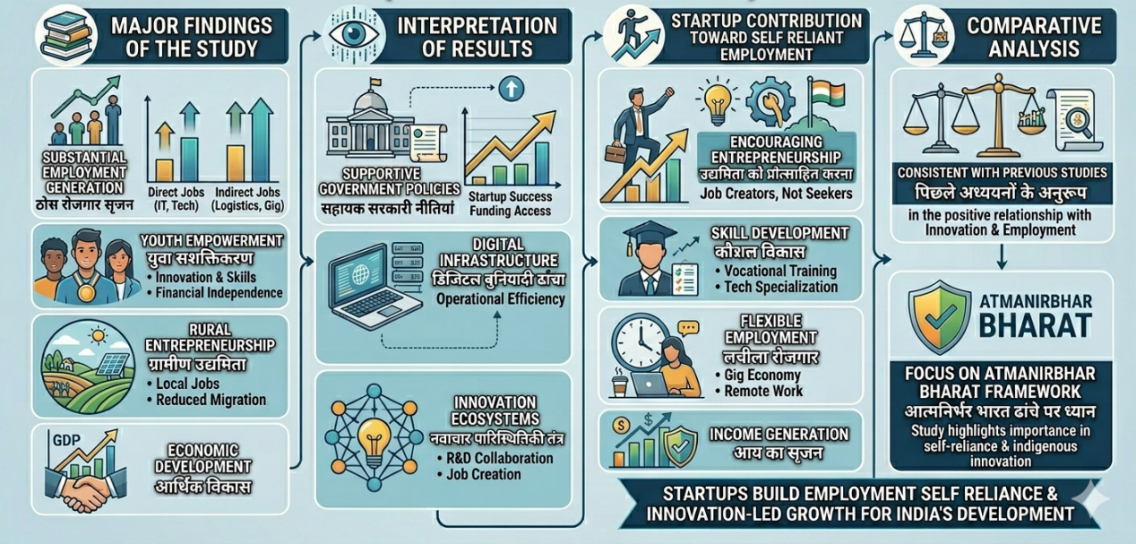
Figure 2:Atmanirbhar Bharat Framework

8. Suggestions and Policy Recommendations

Strengthening Infrastructure: The government desires to upgrade the physical setups of startups, fine-tune the incubation establishments, provide excellent digital connectivity, and offer market access opportunities to a larger extent.

Expanding Employment: Besides increasing the number of skills development and entrepreneurial education programs, there is also a need to introduce more mentorship initiatives that lead to not only employment but also self-employment.

Policy and Regulatory Reform: To make growth sustainable, it is necessary to simplify regulatory processes, give easier access to financing, grant tax breaks, and have strong policies supporting innovation.

Promoting Innovation in Education: These days, educational and vocational training centers have to prepare their students with entrepreneurial skills through innovation-oriented education and technical courses to ensure competitive startups.

9. Conclusion
Seven thousand new startups launch every year in india. They're reshaping how jobs are made, mostly in towns and villages far from cities. The rise follows faster tech tools and a group of founders ready to take risks. Government backing helps them grow fast, while digital shifts let small teams reach customers without big offices. These young companies offer real work to graduates and rural residents. That builds skills, opens paths, and brings progress where it wasn't visible before.The concluding evidence points to a strong startup ecosystem as a big part for India's sustainable and self-sufficient economic development journey. Though presently, the startup scene appears to have the potential for fostering inclusive growth, it would be beneficial to further research specialized topics. Such future research areas could be in-depth sector-specific studies, sustainability models of new ventures, the rise of women-led businesses, and the long-term socio-economic impact of digital startups on the Indian environment.
窗体顶端

- References
[1] IJCRT. (2023). Bibliometric analysis of the Startup India Scheme in Uttar Pradesh: A review of research publications. International Journal of Creative Research Thoughts (IJCRT).
[2]IJFMR. (2025). The startup economy of India: Unlocking employment opportunities. International Journal for Multidisciplinary Research (IJFMR).
[3]MDPI. (2023). A decade of innovation ecosystem development: Bibliometric review of Scopus database. Sustainability.
[4]MDPI. (2025). Technological innovation in start-ups on a pathway to achieving Sustainable Development Goal (SDG) 8: A systematic review. Sustainability.
[5]ResearchGate. (2026). Role of Startup India program in encouraging entrepreneurship in India.
[6]Acs, Z. J., et al. (2021). The digital platform economy: Foundations and concepts. Small Business Economics, 56(1), 1–10.
[7]Audretsch, D. B., & Belitski, M. (2021). Towards an entrepreneurial ecosystem: Evidence from European cities. Journal of Technology Transfer, 46(1), 16–59.
[8]Bosma, N., et al. (2021). Global Entrepreneurship Monitor 2020/2021 Global Report. Global Entrepreneurship Research Association.
[9]Choudhury, P., et al. (2021). Work-from-anywhere: The productivity effects of geographic flexibility. Strategic Management Journal, 42(4), 655–683.
[10]Damioli, G., et al. (2022). The impact of AI on labor productivity. Telecommunications Policy, 46(5), 102305.
[11]Spigel, B. (2022). The Entrepreneurial Ecosystem: A Strategy for Regional Economic Development. Routledge.
[12]Bhargava, S., & Gupta, P. (2022). Boat: The Indian startup scripts a revolutionizing growth strategy. Emerald Emerging Markets Case Studies, 12(1), 1–40.
[13]Department for Promotion of Industry and Internal Trade (DPIIT). (2023). States' Startup Ranking 2022. Ministry of Commerce and Industry, Government of India.
[14]Ministry of Finance. (2024). Economic Survey 2023-24: Chapter on Innovation and Startups. Government of India.
[15]NITI Aayog. (2022). India Innovation Index 2021. Government of India.
[16]Reserve Bank of India. (2023). Report on Currency and Finance: Towards a Greener Cleaner India (Section on Startup Financing).
[17]Tripathy, A., & Dastrala, S. M. (2023). Make in India: So Far and Going Ahead. SSRN Electronic Journal.
[18]Abraham, R., et al. (2021). The gig economy and the future of work in India. ICRIER Working Paper.
[14]Kasliwal, R. (2022). Women entrepreneurs in India: Challenges and the way forward. Observer Research Foundation.
[19]Mehta, B. S., & Kumar, A. (2022). Digitalization and the gig economy in India. The Indian Journal of Labour Economics, 65(3), 857–875.
[20]Pratap, S. (2021). Atmanirbhar Bharat: A roadmap for self-reliant India. Journal of Public Affairs, 21(4), e2722.
[21]Skill India. (2025). Annual Report on Vocational Training and Entrepreneurship. Ministry of Skill Development.
[22]Venkatesh, V. (2022). Impact of COVID-19 on the gig economy: Short- and long-term implications. International Journal of Information Management, 63, 102456.
[23]Bansal, R., & Kumar, S. (2021). Fintech evolution in India: Opportunities and challenges. Journal of Finance and Economics, 9(2), 65–71.
[24]George, G., et al. (2021). Digital sustainability and entrepreneurship: How digital innovations are helping solve social and environmental problems. Journal of Management Studies, 58(7), 1637–1659.
[25]Kumar, A., & Sharma, P. (2024). Agritech startups: Transforming Indian agriculture. Indian Journal of Agricultural Marketing, 38(1), 12–25.
[26]Mukherjee, S. (2021). The digital economy in India: Progress, prospects and challenges. Working Paper, National Institute of Public Finance and Policy.
[27]Soni, N., et al. (2021). Artificial intelligence in India: A systematic review. International Journal of Information Management Data Insights, 1(1), 100011.
[28]Bonnin Roca, J., & O'Sullivan, E. (2022). The role of risk capital in early-stage technology startups. Research Policy, 51(4), 104468.
[29]Lefebvre, V., et al. (2022). Financial literacy and startup failure risks. Journal of Business Venturing Insights, 18, e00325.
[30]Molete, M., et al. (2025). Technology as a strategic enabler for SME growth. MDPI Applied Sciences.
[31]Sandoval-Gómez, A., et al. (2023). Factors affecting the financial sustainability of startups. Journal of Risk and Financial Management, 16(2), 105
[32]Teichmann, F., et al. (2024). Cybersecurity risks in the innovative ecosystem. Journal of Cyber Policy, 9(1), 44–62.
[33]Chowdhury, S., et al. (2023). Rural entrepreneurship and the role of social media. Journal of Rural Studies, 97, 1–12.
[34]Valdivieso, R., et al. (2024). Ethical considerations in AI-driven startups. Journal of Business Ethics, 189(2), 345–360.

