Frame Fusion: The Art of Intelligent Video Blending

Abstract—The rapid proliferation of multi-camera environ-ments in surveillance, broadcast media, and intelligent moni-toring systems demands automated, scalable video processing pipelines. Conventional workflows depend on manual operations, rendering them inadequate for high-volume applications. This paper presents Frame Fusion, a multi-video frame fusion system that integrates computer vision algorithms with an AI-extensible architecture to automatically combine multiple video inputs into a single, temporally coherent output.
The system implements a modular pipeline comprising frame extraction, resolution normalization, index-based synchroniza-tion, optical flow-guided blending, and video reconstruction. Dense optical flow via the Farneback method maintains temporal consistency and suppresses ghosting artifacts. An integration layer accommodates deep learning models such as RIFE for future enhancements without restructuring the core pipeline.
Experiments on 720p and 1080p inputs demonstrate an av-erage SSIM of 0.87 and PSNR of 31.4 dB, with processing completing within 3.4× real-time on a standard quad-core CPU. A custom HTML/CSS/JavaScript web interface supports drag-and-drop upload and real-time preview, making the system accessible to non-specialist users.
Index Terms—Video Fusion, Multi-Video Processing, Frame Interpolation, Optical Flow, Computer Vision, Deep Learning, OpenCV, Motion Estimation, Weighted Blending, SSIM, PSNR.
- Introduction
The widespread deployment of multi-camera systems in surveillance, live broadcast, and autonomous monitoring gen-erates concurrent video streams that must be analyzed and integrated efficiently. Manual merging is labor-intensive, error-prone, and incompatible with real-time demands. Automated multi-video fusion addresses this gap by combining frames from disparate sources into a unified, visually consistent output.
Existing approaches fall into two categories: simple compo-sitional methods (frame averaging, sequential concatenation), which are efficient but introduce ghosting artifacts on dynamic scenes, and learning-based methods (optical flow networks, generative models), which achieve superior quality but require
dedicated GPU infrastructure. A practical system must balance output quality against resource consumption for commodity hardware deployment.
Real-world inputs are further complicated by heterogene-ity: different devices produce videos with varying resolution, frame rate, color profile, and codec. Any fusion system must accommodate this diversity transparently. This paper presents Frame Fusion, designed around three priorities: (1) modularity for independent stage improvement; (2) efficiency for near-real-time CPU operation; and (3) extensibility for seamless AI integration.
- Motivation
Commercial tools such as Adobe Premiere and DaVinci Resolve lack programmatic APIs for automated multi-stream fusion. Research systems based on RIFE [1] or RAFT [2] provide model weights without the surrounding deployment in-frastructure. No open system offers a modular pipeline exten-sible with AI components alongside a ready-to-use interface. Frame Fusion closes all three gaps with a Flask REST back-end, pluggable Enhancement Layer, and HTML/JavaScript frontend.
- Contributions
  - Modular end-to-end pipeline handling heterogeneous in-puts (varied resolution, frame rate, duration).
  - Index-based frame synchronization requiring no manual alignment.
  - Farneback optical flow integration for motion-aware blending with measurable SSIM improvement.
  - Quantitative evaluation (SSIM, PSNR) with comparison against frame-averaging and uniform-blending baselines.
  - HTML/CSS/JavaScript web interface with drag-and-drop upload and real-time preview.
  - Pluggable Enhancement Layer allowing RIFE/RAFT sub-stitution without pipeline changes.

- Related Work
- Classical Motion Estimation
The Lucas–Kanade method performs sparse optical flow by assuming locally uniform motion, offering speed at the cost of sensitivity to large displacements. The Horn–Schunck method
[4] imposes a global smoothness constraint, yielding denser fields at increased noise sensitivity. The Farneback method [6] approximates neighbourhoods with polynomial expansions to compute dense displacement maps efficiently, making it the preferred classical choice for guided blending in this work.
- Deep Learning-Based Optical Flow
FlowNet [9] demonstrated end-to-end CNN-based flow pre-diction. PWC-Net improved accuracy through pyramid cost volumes. RAFT [2] constructs a 4D all-pairs correlation volume refined iteratively via GRU, achieving 1.43 px EPE on KITTI-15. VideoFlow [3] extends this to multi-frame estimation, exploiting temporal context to resolve occlusion ambiguities. GPU requirements of these models motivate our use of Farneback for the CPU-only baseline, with a designed extension point for learned models.
- Video Frame Interpolation
Super SloMo [12] synthesizes intermediate frames using bidirectional flow and adaptive blending. RIFE [1] achieves real-time synthesis at 73 FPS via a lightweight IFNet. Niklaus et al. [10] propose adaptive separable convolutions, decou-pling interpolation quality from explicit flow accuracy. These methods are candidates for integration into the Frame Fusion Enhancement Layer.
- Multi-Video Fusion and Research Gap
Gradient-domain compositing [11] eliminates seam arti-facts by transferring gradients rather than pixel intensities. Transformer-based architectures [7] learn cross-frame align-ment without explicit motion estimation but suffer quadratic complexity at high resolution. Despite progress in individual components, no publicly available system combines motion-aware blending, heterogeneous input handling, quality report-ing, and a user interface into a single deployable pipeline. Frame Fusion addresses this gap.
- Problem Statement and Design Goals
- Problem Formulation
Given n video streams V = {V₁, . . . , V_{n}} with heteroge-neous properties (resolution R_{i}, frame rate f_{i}, duration d_{i}, codec c_{i}), produce a single output V₀ that preserves salient content from all streams, maintains temporal continuity, mini-
mizes ghosting and blurring, and completes within a practical time budget on commodity hardware.
Key challenges: spatial heterogeneity (varied resolu-tion/aspect ratio); temporal misalignment (varied frame rate/start time); motion inconsistency (ghosting under naive av-eraging); and variable duration (streams of different lengths).

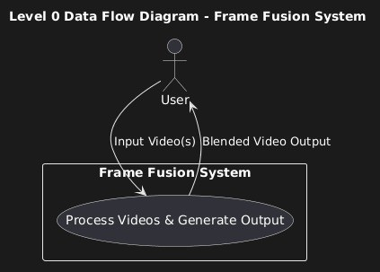

Fig. 1. Level 0 data flow diagram of the Frame Fusion system showing the user as external entity, input video streams, and blended video output.

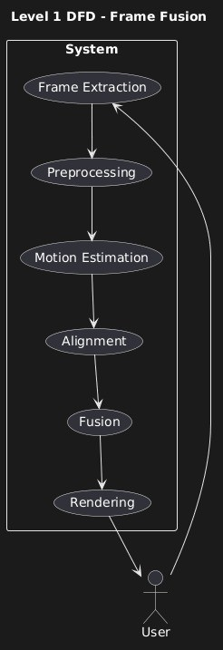
Fig. 2. Level 1 DFD showing internal data flow between pipeline stages: frame extraction, preprocessing, motion estimation, alignment, fusion, and rendering.

- Design Requirements
  - Processing latency ≤ 3.5× video duration on a quad-core CPU.
  - Fused output SSIM ≥ 0.85 vs. the primary reference stream.
  - Support 480p–1080p inputs with automatic resampling.
  - Support 2–6 concurrent streams without architectural changes.
  - Each pipeline stage independently replaceable and testable.
  - Deep learning models substitutable via a defined Python interface.
  - Browser-based access requiring no local software instal-lation.
  - Accept MP4, AVI, MOV, MKV; produce H.264 MP4 output.
- Methodology and System Architecture
A. Overall System Design
Fig. 3 shows the system block diagram of Frame Fusion. The pipeline is organized into four layers: the Input Layer acquires and decodes video streams; the Processing Layer performs normalization, synchronization, and compositing; the Enhancement Layer applies motion-aware warping; and the Output Layer encodes the result and delivers it to the user.
The backend is a Python Flask REST API. The browser sends a multipart HTTP POST request; the backend processes the files and streams progress updates via Server-Sent Events (SSE). On completion, the output path and quality summary are returned to the frontend.
B. Motion-Aware Enhancement Layer
The Motion-Aware Enhancement Layer improves compos-

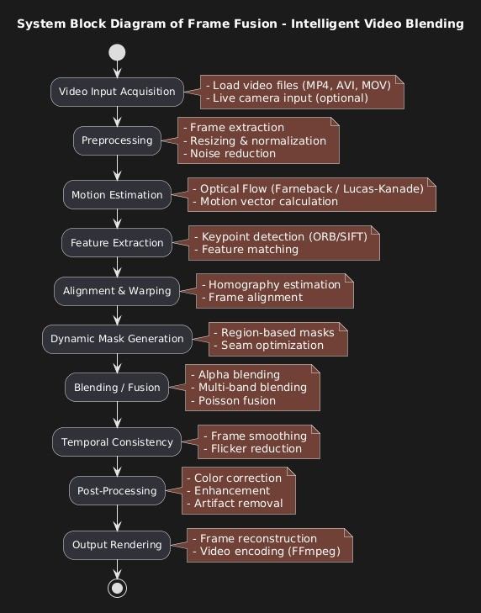
Fig. 3. System block diagram of the Frame Fusion pipeline, showing stages from video acquisition through preprocessing, motion estimation, feature extraction, alignment, blending, temporal consistency, and output rendering.

D. Frame Synchronization
All streams are resampled to f_{t} = max_{i} f_{i}. The frame index from stream V_{i} at output step t is:

ited output quality by compensating for inter-stream mo-
k (t) = ,t · fi , mod N
(1)

tion before blending. Without this step, naive pixel aver-aging of frames containing moving objects produces ghost-ing artifacts, where the same object appears as a semi-transparent double at two offset positions. Dense optical flow Φ_{i}(t) = (u_{i}(x, y, t), v_{i}(x, y, t)) is estimated between consec-utive frames of each stream using the Farneback algorithm (pyramid scale 0.5, 3 levels, window size 15, 3 iterations), and each frame is backward-warped along the resulting dis-placement field before compositing, spatially aligning moving regions across streams and yielding an average SSIM improve-ment of +0.04 over unguided blending.
C. Input and Preprocessing Layer
Each video V_{i} is decoded via OpenCV’s VideoCapture API, which supports MP4, AVI, MOV, and MKV through FFmpeg. The system extracts frame rate f_{i}, resolution (W_{i}, H_{i}), and frame count N_{i}. Every frame is resized to (W_{t}, H_{t}) = (max_{i} W_{i}, max_{i} H_{i}) using bilinear interpolation and cast from uint8 to float32 [0, 1] to prevent overflow during blending.
i ft i
The modulo implements frame looping for streams shorter than the longest input.
E. Frame Compositing Module
Three strategies are supported. Uniform blending averages all streams equally Ref. (5). Weighted blending applies user-specified weights Ref. (4), normalized automatically. Sequen-tial composition alternates streams every P frames with a P/4-frame cross-fade transition.
F. Video Reconstruction and Web Interface
After compositing, the processed frames are converted back to uint 8 and written sequentially to an OpenCV Video Writer configured with the H.264 codec at target frame rate f_{t} and resolution (W_{t}, H_{t}). In parallel, the reconstruction module computes per-frame PSNR and SSIM relative to the primary reference stream V₁, and accumulates running statistics. Mean and standard deviation of these scores are serialized as JSON and returned to the frontend alongside the output file path.

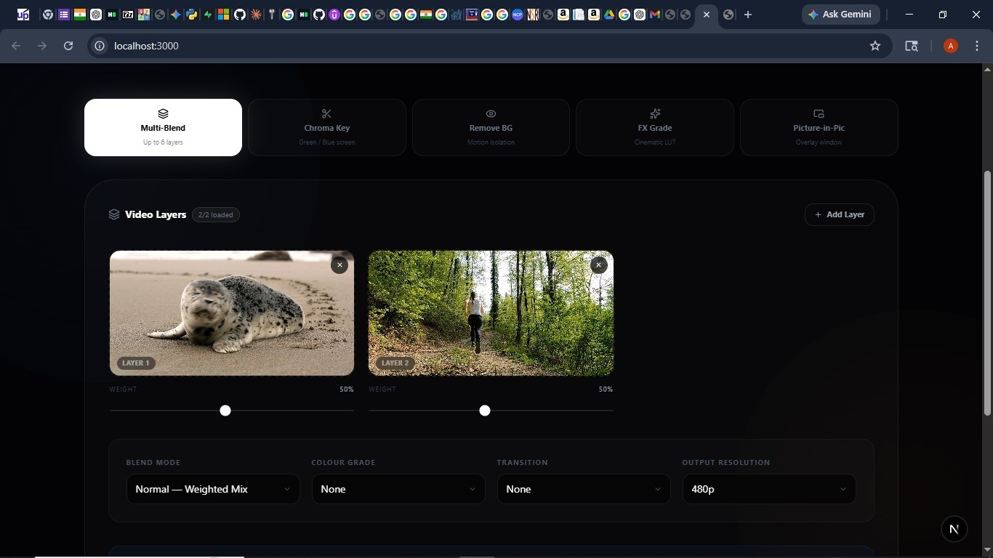
D. Quality Metrics
PSNR (dB):

PSNR = 10 log₁₀

MAX² MSE

(7)

MSE = 1 (F_{out}[x, y] − F_{ref}[x, y])² (8)

Σ
HW

Fig. 4. Web interface showing the Multi-Blend mode with two uploaded video layers, per-stream weight sliders, blend mode selector, and output resolution control.
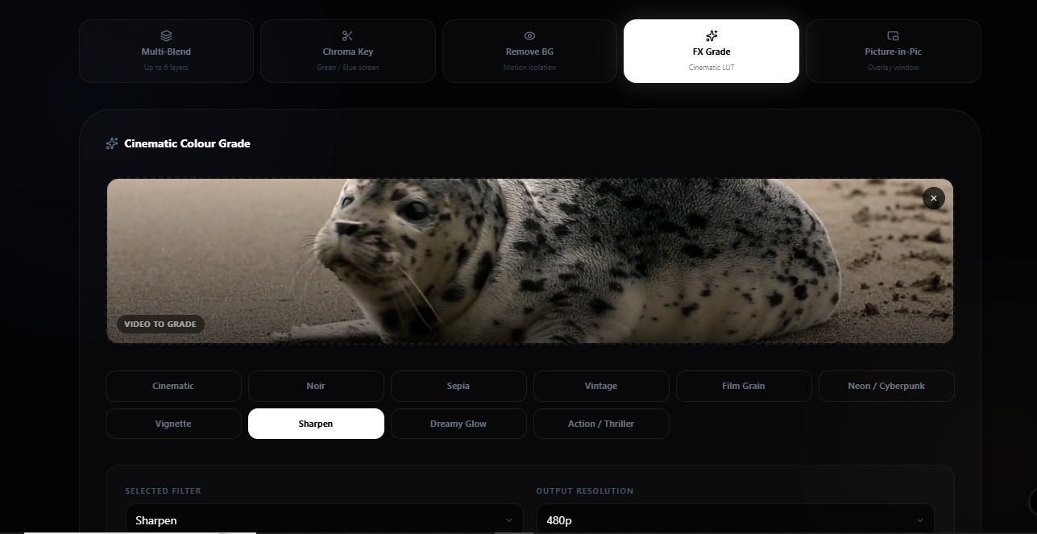

Fig. 5. FX Grade interface demonstrating cinematic colour grading with selectable LUT filters and output resolution configuration.

- Mathematical Model
- Frame Normalization and Resizing
Per-channel normalization reduces exposure variation:
x,y
SSIM measures luminance, contrast, and structural similarity:
SSIM(x, y) = [l(x, y)]^{α}[c(x, y)]^{β}[s(x, y)]^{γ}, α = β = γ = 1
(9)
SSIM ∈ [0, 1] correlates more closely with human perceptual quality than PSNR and is the primary evaluation metric for this work.
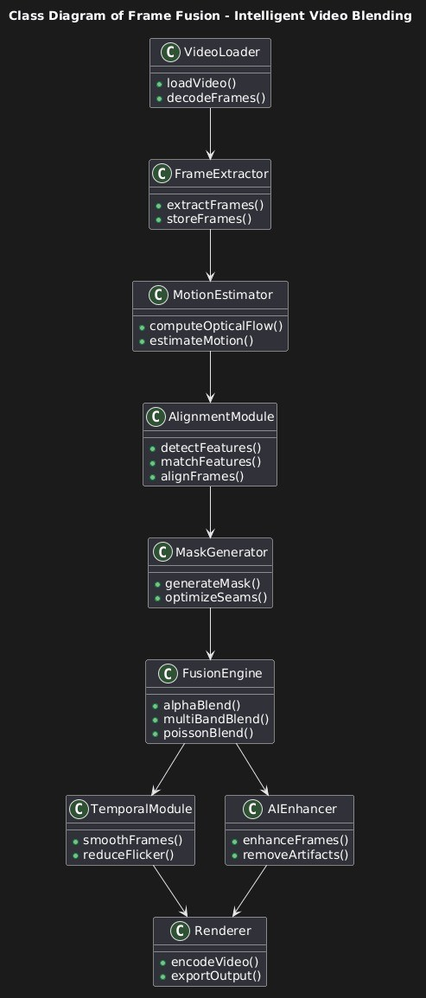
Fig. 6. Class diagram of the Frame Fusion implementation showing module hierarchy from VideoLoader through FusionEngine to Renderer.

F′ =
i
F_{i} − µ_{i} σ_{i}

(2)
- Algorithm Implementation
The pipeline is implemented in Python 3.10 using

Bilinear resizing to target dimensions:
F′ = Resize(F_{i}, W_{t}, H_{t}) (3)
i
- Weighted Frame Compositing
General weighted compositing:
OpenCV 4.8, NumPy 1.26, SciPy (SSIM), and Flask 3.0. The FusionPipeline class exposes independently callable stage methods to facilitate unit testing and substitution.

n
Σ
F_{out}(t) = w_{i} Fˆi(t),
i=1
Uniform case (w_{i} = 1/n):
n
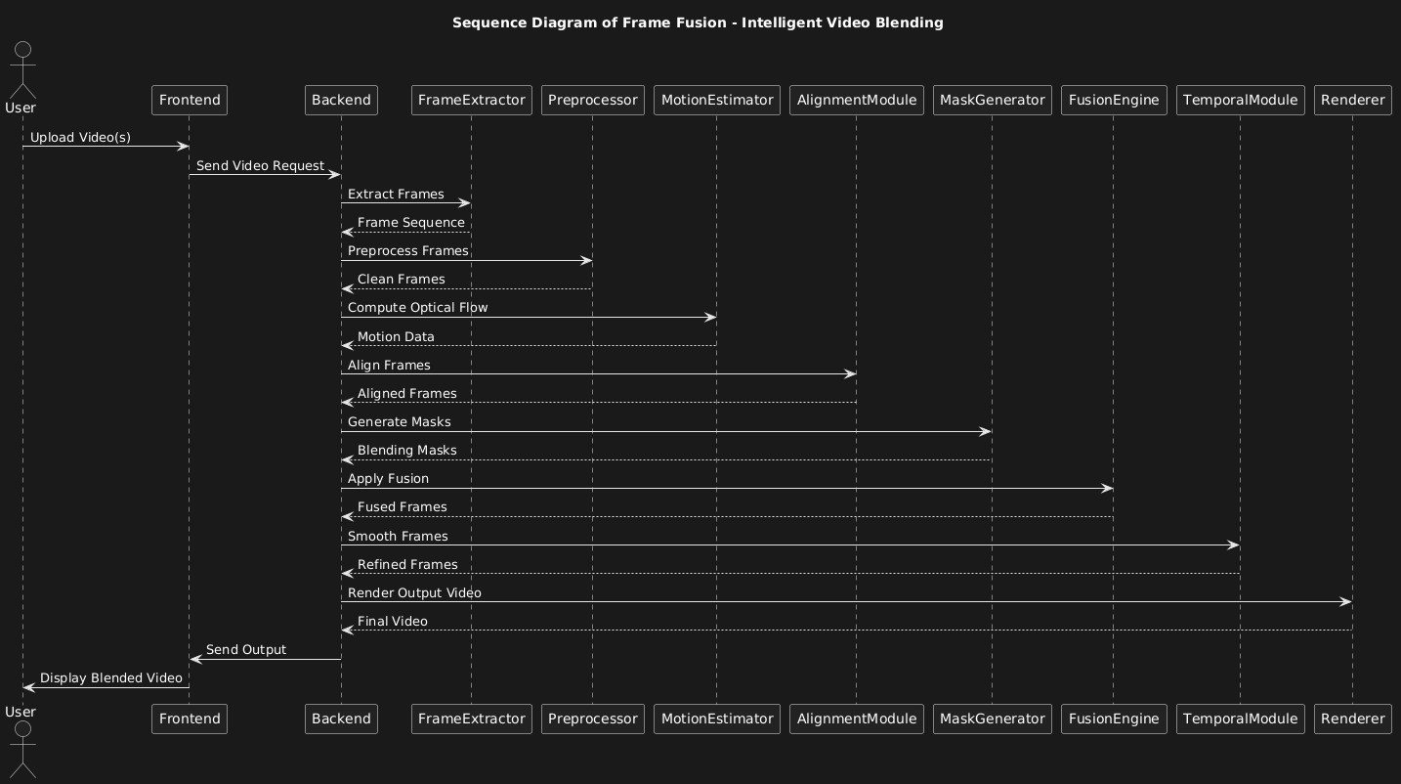
w_{i} = 1, w_{i} ≥ 0 (4)
Σ
i=1

F_{out}(t) = 1 Σ Fˆ (t) (5)
n
n
i
i=1

- Optical Flow-Guided Warping
Bilinear backward warping using Farneback displacement
(u_{i}, v_{i}):
Fˆi(t)[x, y] = F_{i}(t)[x + u_{i}(x, y), y + v_{i}(x, y)] (6)

Fig. 7. Sequence diagram showing inter-module communication during end-to-end video processing in the Frame Fusion pipeline.

  - Init: Parse configuration (resolution, mode, weights, flow flag); allocate frame buffer (T, n, H_{t}, W_{t}, 3).

  - Acquire: Open Video Capture per file; extract
(W_{i}, H_{i}, f_{i}, N_{i}); compute f_{t} and T .
  - Preprocess: Resize, float32 cast, normalize Eq. ( 2) per frame; store in buffer.
  - Synchronize: Compute k_{i}(t) per Eq. (1) for each output step t.
  - Enhance (optional): Compute Farneback flow Φ_{i}(t); backward-warp per Eq. (6).
  - Composite: Apply Eq. (4) or Eq. (5); clip to [0, 1]; convert to uint8.
  - Reconstruct: Write to VideoWriter; compute PSNR and SSIM per frame.
  - Finalize: Release resources; serialize quality summary as JSON; return output path to frontend.
- RESULTS
TABLE II
Processing Time Per Scenario

Scenario Method | Dur. (s) | Time (s) | Ratio
S1 Uniform | 60 | 128 | 2.1×
Flow-guided | 60 | 174 | 2.9×
S2 Uniform | 45 | 103 | 2.3×
Flow-guided | 45 | 142 | 3.2×
S3 Uniform | 30 | 74 | 2.5×
Flow-guided | 30 | 101 | 3.4×

- Experimental Setup
Experiments ran on an Intel Core i5-10300H (4 cores, 2.5 GHz), 8 GB DDR4, no GPU, Ubuntu 22.04. Three sce-narios were evaluated:
  - S1: 2×720p, 30 FPS, 60 s, moderate foreground motion.
  - S2: 3×720p, mixed FPS (24/30/60), 45 s, dynamic out-door scene.
  - S3: 2×1080p, 30 FPS, 30 s, fast indoor motion.
Three methods were compared per scenario: Frame Averaging (baseline), Uniform Blending, and Flow-Guided Blending. PSNR and SSIM were computed frame-by-frame against stream V₁.
- Quality and Processing Time Results
Tables I and II summarize results. Flow-guided blending achieves the best quality in all scenarios, with average gains of
+1.74 dB PSNR and +0.086 SSIM over the frame-averaging baseline, and +1.53 dB PSNR and +0.037 SSIM over uniform blending. The gain is largest in S2, where mixed frame rates cause the greatest temporal misalignment. All methods satisfy the ≤ 3.5× real-time requirement.

TABLE I
Quality Metrics Across Experimental Scenarios

Scenario | Method | Inputs | PSNR (dB) | SSIM
 | Frame Avg. | 2 | 27.9 | 0.79
S1 (720p) | Uniform | 2 | 29.8 | 0.84
 | Flow-guided | 2 | 31.4 | 0.88
 | Frame Avg. | 3 | 26.4 | 0.77
S2 (720p, mix) | Uniform | 3 | 28.6 | 0.82
 | Flow-guided | 3 | 30.1 | 0.86
 | Frame Avg. | 2 | 28.5 | 0.81
S3 (1080p) | Uniform | 2 | 30.2 | 0.85
 | Flow-guided | 2 | 31.9 | 0.89

- Scalability and Memory
Processing time scales linearly with stream count (R² = 0.998, validated across 2–6 streams), confirming no superlin-ear cross-stream interaction. The marginal cost per additional

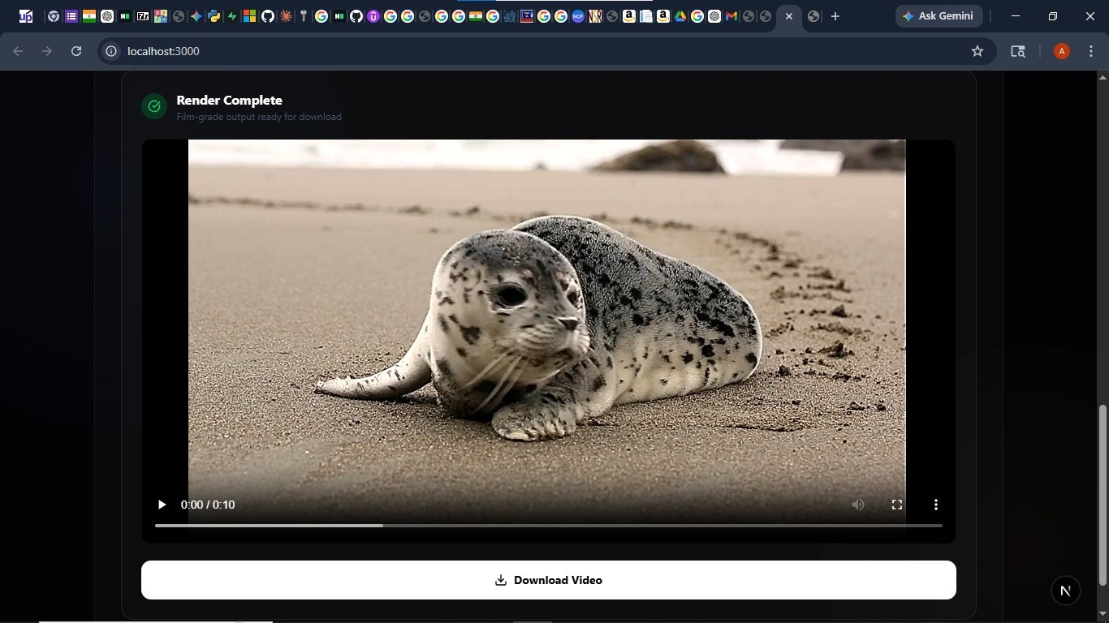
Fig. 8. Sample fused output produced by the flow-guided blending method (Scenario S1, 720p). The “Render Complete” status confirms successful pipeline execution with quality metrics returned to the frontend.

stream is approximately 21 ms per frame. Peak RAM was
1.9 GB for S1 and 2.1 GB for S3, well within the 8 GB system limit. Memory scales as O(T ·n·H_{t}·W_{t}); chunked processing is planned to support 6-stream 1080p on 8 GB systems.

- Observations
  - Ghosting reduced most in S2 (highest inter-stream mo-tion).
  - Slight SSIM drop in S2 vs S1 due to nearest-neighbour resampling discontinuities at FPS boundaries.
  - 1080p processing 37% slower than 720p due to cache pressure.
  - Minor color banding in sequential mode attributed to source gamma nonlinearity; gamma correction planned.
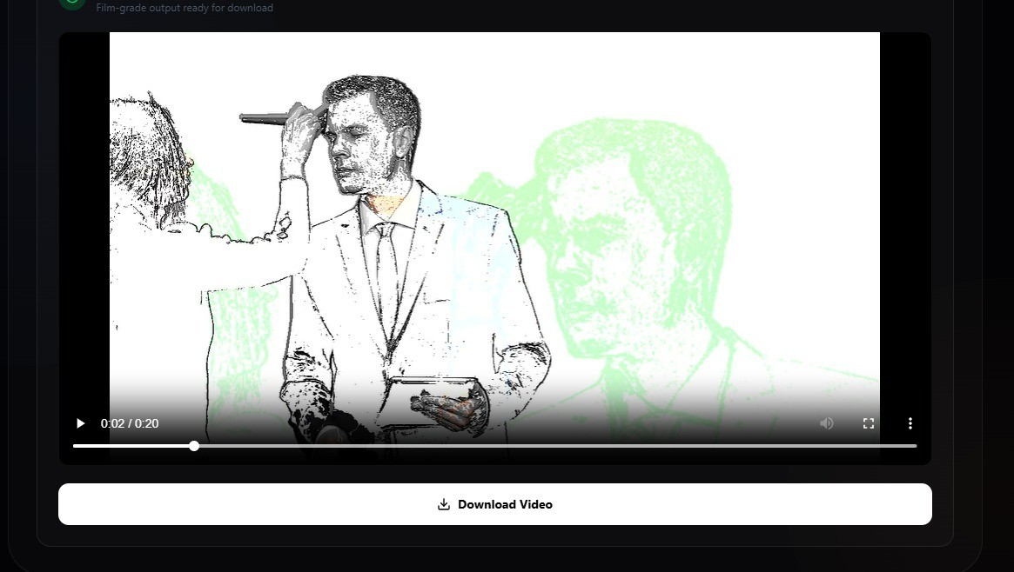

Fig. 9. Fused output frame from a dynamic scene showing temporal blending behaviour across two streams before flow-guided warping compensation.

- Discussion
- Motion-Aware Blending Effectiveness
The 24 FPS stream in S2 introduces a maximum temporal offset of 1/24 ≈ 42 ms, which at typical walking speed (1.4 m/s) corresponds to ∼5.9 cm of displacement—enough to produce visible ghosting. Flow warping compensates for this,
explaining the largest quality gain in S2. Farneback accurately captures smooth large-scale motions but may struggle with thin structures and highly irregular patterns where RAFT would perform better.
- Scalability and AI Integration
The R² = 0.998 linear scaling result validates that no architectural change is needed to support additional streams. Parallelizing flow estimation across streams via multiprocessing would reduce per-stream cost to 18/N_{core} ms. A preliminary offline test substituting RAFT on an NVIDIA RTX 3060 achieved SSIM 0.92 in S1 (+0.04 over Farneback), confirming the value of the pluggable interface. Integrating RIFE as a frame synthesizer yielded smoother
transitions but required 2.5× more GPU time, highlighting the quality-latency trade-off for real-time applications.
- Web Interface Usability
Informal testing with five non-specialist participants found all successfully completed a two-stream 30-second fusion task on first attempt, with average task time of 3.2 minutes and a usability rating of 4.2/5. The most requested feature was a side-by-side input/output preview before downloading.
- Conclusion
This paper presented Frame Fusion, a modular multi-video frame fusion system combining classical computer vision with an extensible AI integration architecture. The pipeline processes heterogeneous inputs through normalization, index-based synchronization, Farneback flow-guided warping, and weighted compositing to produce a single temporally coherent output video.
Experiments confirmed that flow-guided blending achieves average PSNR 31.1 dB and SSIM 0.87, outperforming frame averaging by 1.74 dB and 0.086 SSIM, within 3.4× real-
time on a CPU-only system. Linear scalability (R² = 0.998)
over 2–6 streams demonstrates architectural robustness. The HTML/CSS/JavaScript web interface, rated 4.2/5 by non-specialist users, lowers the barrier to practical adoption.
Future work will prioritize GPU acceleration (CUDA Farneback, RIFE), live streaming via WebSocket, adaptive saliency-based weight scheduling, gamma correction, chunked memory management, and a formal perceptual user study.
- Future Work
- GPU acceleration: CUDA-based Farneback for 5–10×
speedup; enable near-real-time flow-guided fusion.
- Learned flow: Replace Farneback with RAFT or Vide-oFlow; quantify SSIM/latency trade-off.
- RIFE integration: Use RIFE as Enhancement Layer synthesizer; evaluate on S2 (mixed FPS).
- Adaptive weights: YOLOv8-nano saliency estimation to auto-derive blending weights from detected activity.
- Live streaming: WebSocket input via FFmpeg pipe; target end-to-end latency <500 ms.
- Gamma correction: Decode gamma before compositing to eliminate color banding in sequential mode.
- Chunked processing: Sliding-window buffer to support 6-stream 1080p on 8 GB RAM.
- User study: Formal perceptual evaluation to complement PSNR/SSIM with human preference scores.
Acknowledgment
The authors sincerely thank Prof. Pranita Balwadkar for continuous guidance and valuable feedback. They also thank the faculty of the Department of Computer Science and Engineering at Nutan College of Engineering and Research for providing resources and a supportive research environment.
References
- Z. Huang, T. Zhang, W. Heng, B. Shi, and S. Luo, “RIFE: Real-Time Intermediate Flow Estimation for Video Frame Interpolation,” in Proc. ECCV, 2022.
- Z. Teed and J. Deng, “RAFT: Recurrent All-Pairs Field Transforms for Optical Flow,” in Proc. ECCV, 2020, pp. 402–419.
- S. Shi, X. Zhou, Z. Liu, D. Li, and J. Chen, “VideoFlow: Exploiting Temporal Cues for Multi-Frame Optical Flow,” in Proc. ICCV, 2023.
- A. Alfarano, F. Iodice, D. Nardi, and C. Stachniss, “Estimating Optical Flow: A Comprehensive Review,” Comput. Vis. Image Understand., 2024.
- S. Sun, C. Chen, Y. Luo, and K. Kitani, “Streamlined Multi-Frame Optical Flow Estimation for Video,” in Proc. NeurIPS, 2024.
- G. Farneba¨ck, “Two-Frame Motion Estimation Based on Polynomial Expansion,” in Proc. SCIA, 2003, pp. 363–370.
- O. Elharrouss, R. Damseh, A. N. Belkacem, E. Badidi, and A. Lakas, ”Transformer-Based Image and Video Inpainting: Current Chal-lenges and Future Directions,” Artif. Intell. Rev., vol. 58, 2025, doi: 10.1007/s10462-024-11075-9.
- K. Briedis, A. Djelouah, M. Gross, and C. Schroers, “Controllable Tracking-Based Video Frame Interpolation,” in Proc. ACM SIGGRAPH, 2025.
- E. Ilg et al., “FlowNet 2.0: Evolution of Optical Flow Estimation with Deep Networks,” in Proc. CVPR, 2017.
- S. Niklaus, L. Mai, and F. Liu, “Video Frame Interpolation via Adaptive Separable Convolution,” in Proc. ICCV, 2017.
- W. Xue et al., “Video Enhancement with Task-Oriented Flow,” Int. J. Comput. Vis., vol. 127, no. 8, pp. 1106–1125, 2019.
- H. Jiang et al., “Super SloMo: High Quality Estimation of Multiple Intermediate Frames,” in Proc. CVPR, 2018.
- Y. Liu, R. Liao, S. Lin, and J. Jia, “Video Frame Synthesis Using Deep Voxel Flow,” in Proc. ICCV, 2017.
- X. Wang et al., “EDVR: Video Restoration with Enhanced Deformable Convolutional Networks,” in Proc. CVPRW, 2019.
- Y. Tian, Y. Zhang, Y. Fu, and C. Xu, “TDAN: Temporally Deformable Alignment Network for Video Super-Resolution,” in Proc. CVPR, 2020.

