Medicinal and Therapeutic Potential of Turmeric (Curcuma longa): A Comprehensive Review

ABSTRACT
Turmeric (Curcuma longa) has been a fundamental element of traditional medicine for ages, especially in Ayurvedic and Chinese practices. The bioactive molecule curcumin has attracted considerable interest for its medicinal potential. This review examines the therapeutic qualities of turmeric, emphasizing its anti-inflammatory, antioxidant, and antimicrobial actions. Turmeric's capacity to regulate many signaling pathways, including NF-kB, MAPK, and PI3K/Akt, enhances its therapeutic efficacy in the management of chronic conditions such as cancer, cardiovascular illnesses, and neurological disorders. Furthermore, turmeric's efficacy in wound healing, intestinal health, and metabolic regulation is examined. The review also examined the problems related to curcumin's bioavailability and methods to improve its medicinal efficacy. Turmeric's diverse medical characteristics render it a viable natural substance for both preventive and therapeutic applications. Additional research is necessary to thoroughly clarify its therapeutic potential and enhance its applications in contemporary medicine.

Keywords: Turmeric, Curcuma longa, Curcumin, Anti-inflammatory, Antioxidant, Antimicrobial, Cancer, Cardiovascular disease, Traditional medicine, Therapeutic applications, Health benefits.

INTRODUCTION: People have utilized herbs and natural products to treat various diseases since ancient times. The Indian subcontinent features various flora, encompassing both fragrant and medicinal plants. Contributions must be made to assess, standardize, and validate Unani and Ayurvedic medications for their potential, safety, and efficacy before their introduction to the market as first-line therapeutic agents. Plant-based medicines are utilized in all cultures. Plant-based medications are widely employed, with numerous countries allocating 40% to 50% of their whole health budget to the development of new pharmaceuticals. Herbal medicines are presumed to exert a positive impact on health without adverse consequences.
The genus Curcuma has been utilized for many years for its therapeutic properties and has roughly 133 species globally. Curcuma longa (Haridra), Curcuma aromatica Salisb. (Vana Haridra), Curcuma angustifolia Roxb., Curcuma zanthorrhiza Roxb., Curcuma amada Roxb. (Amaragandhi Haridra), Curcuma caesia Roxb. (Kali Haridra), and Curcuma zedoaria Rose (Zedoary) are prevalent species within the genus Curcuma, distributed across various global regions. Curcuma longa Linn. (C. longa) is a prevalent tall herb that thrives in tropical and various Indian regions, commonly known as "Indian saffron" or "the Golden Spice of India" due to its extensive application in treating numerous ailments as a spice, food preservative, and coloring agent in Indian households. Curcuma longa, a perennial plant of the Zingiberaceae family, is predominantly cultivated in Asian nations. It is one of the oldest spices in India, utilized for centuries in the western and southern regions, and plays a crucial role in Ayurvedic treatments. In Ayurveda, the books Dashemani (emaciating), Kusthagna (anti-dermatosis), and Visaghna (anti-poisonous) document and address the medicinal properties of C. longa. It is referred to by various names, including Haridra in Sanskrit, Haldi in Hindi, Jianghuang (yellow ginger in Chinese), Manjal in South India, and Kyoo or Ukon in Japanese, denoting its efficacy as a treatment for jaundice (Sharma, P. V., 2000).
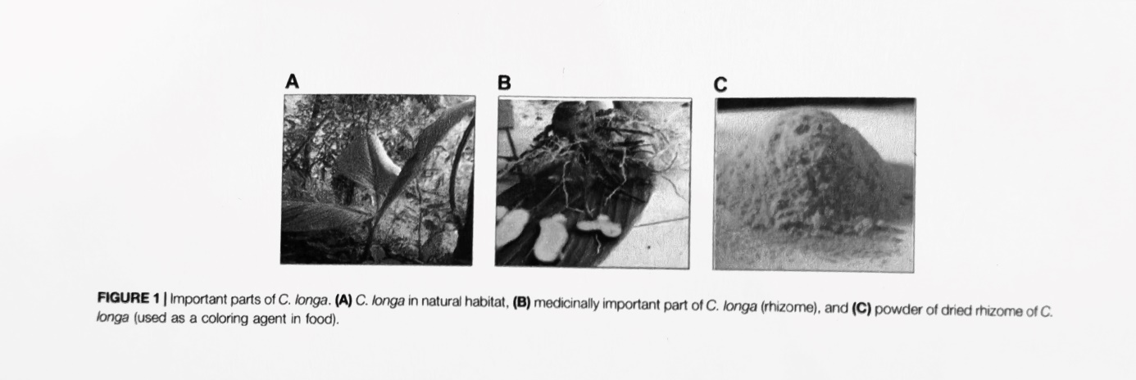
ORIGIN & HISTORY OF C. LONGA: The precise origin of turmeric remains unidentified. However, it likely originated in Southeast Asia, particularly in Vietnam, China, or Western India. It is solely recognized as a cultivated plant and has not been discovered in its natural habitat. India is the largest producer, user, and supplier; however, it is also extensively farmed in Cambodia, Bangladesh, Nepal, Indonesia, Thailand, Malaysia, West Bengal, Tamil Nadu, Maharashtra, and the Philippines (Royal Botanic Gardens Kew, 2021).
India exhibits the highest diversity of Curcuma species, with approximately 40 to 45 species identified. Thailand possesses approximately 30 to 40 species. Numerous wild species of Curcuma are also found in other countries within tropical Asia. Recent investigations indicate that the taxonomy of C. longa is contentious, with only specimens from South India being definitively classified as C. longa. The phylogeny, connections, intraspecific and interspecific variation, and the identity of other species and cultivars globally require establishment and validation. Numerous species presently employed and marketed as turmeric in different regions of Asia have been demonstrated to belong to multiple morphologically identical taxa, characterized by overlapping local nomenclature (Leong-Škornickova, Jana , 2008 ; Nair, K.P. Prabhakaran, 2013). Turmeric has been utilized in Asia for ages and is a significant component of Ayurveda, Siddha medicine, traditional Chinese medicine, and Unani (Chattopadhyay, 2004) and the animistic rituals of Austronesian peoples (Kikusawa, Ritsuko; Reid, Lawrence A., 2007; McClatchey, W., 1993). Initially utilized as a dye, it was subsequently employed for its purported medicinal effects in folk remedies (Nelson et al., 2017; "Turmeric." National Center for Complementary and Integrative Health, US National Institutes of Health, 2020).
Ayurveda is a traditional Indian system of natural healing that continues to be practiced in contemporary times. Ayurveda translates to "science of life," with "ayur" signifying "life" and "veda" denoting "science" or "knowledge." Inhaling vapors from burning turmeric has been utilized since antiquity to alleviate congestion. Turmeric juice was utilized for wound healing. Turmeric paste was utilized for several skin disorders, including smallpox, chickenpox, pimples, and shingles. Ayurvedic literature comprises more than 100 distinct words for turmeric, including jayanti, signifying "one who triumphs over ailments," and "matrimanika," denoting "as beautiful as moonlight." This material has consistently been considered auspicious across the subcontinent, among both Aryan and Dravidian cultures, and its significance may trace back to the beliefs of ancient indigenous populations. In the northern regions, turmeric is commonly referred to as haldi, a term originating from the Sanskrit word "haridra," whereas in the southern regions, it is known as manjal, a designation frequently seen in ancient Tamil literature. Turmeric possesses an extensive historical background of therapeutic application in South Asia, as referenced in Sanskrit medical texts and extensively utilized in Ayurvedic and Unani practices. Susruta's Ayurvedic compendium, originating from 250 B.C., advocates for an ointment comprising turmeric to mitigate the effects of food poisoning. Turmeric plays an important part in Indian history and religious practices. It is utilized for the veneration of the Sun God. It was utilized for the veneration of the Sun during India's solar epoch. It was referenced in the Artharveda of India. It is also donned by individuals as an element of the purifying process. The application of turmeric in India is recorded in multiple forms. Turmeric was utilized by Buddhists as well. Buddhist monks journeyed to several regions globally to dye their robes. Evidence indicates that turmeric was utilized in Chinese medicine approximately 1,000 years ago. It was referenced in the Pent-Sao of the 7th century in China. Turmeric was not incorporated into the Western world until recently. There is less evidence regarding its usage and significance in Europe. Although turmeric has long been integral to the Ayurvedic system, Western herbalists did not acknowledge its benefits until the late 20th century. By the mid-20th century, turmeric began to gain favor in the Western world as well. Currently, several research investigations and trials are conducted to ascertain its benefits. In 1280 AD, Marco Polo referred to turmeric as Indian saffron because to its use in dyeing fabrics. He stated that he discovered a plant with all the characteristics of saffron, although it is a root. Turmeric arrived in China by 700 AD, East Africa by 800 AD, and West Africa by 1200 AD, thereafter gaining global popularity. The Chinese utilize turmeric as a medicinal agent, particularly for ailments related to the spleen, stomach, and liver. It is utilized for stimulation, purification, and as an antibiotic, antiviral, and analgesic. Currently, India is the predominant producer and user of turmeric. Additional producers in Asia comprise Bangladesh, Pakistan, Sri Lanka, Taiwan, China, Myanmar, and Indonesia. Turmeric is cultivated in the Caribbean and Latin America, specifically in Jamaica, Haiti, Costa Rica, Peru, and Brazil. It is distributed in South and Southeast Asia, with some species extending to China, Australia, and the South Pacific. In the 15th century, Vasco da Gama, a Portuguese navigator, introduced this spice to the West during his expedition to India (Akram M, et al, 2010). Turmeric is regarded as a vital spice globally, particularly among Eastern cultures (Ravindran PN, et al, 2007).
In addition to its culinary application, turmeric is utilized as traditional medicine in Asian nations such as India, Bangladesh, and Pakistan due to its therapeutic characteristics(Chattopadhyay I, et al,2004).Turmeric is widely utilized in Ayurveda, Unani, and Siddha medicine as a home treatment for numerous ailments (Chattopadhyay I, et al, 2004; Abas F, et al, 2005).
CHEMICAL COMPOSITION OF C.LONGA: The chemical composition of turmeric is diverse. The qualitative and quantitative components of turmeric differ markedly according to its variety, geographic origin, source, and cultivation conditions (Heath DD, et al, 2004). This spice has yielded approximately 235 chemicals, primarily phenolic compounds and terpenoids. This collection comprises 22 diarylheptanoids and diarylpentanoids, in addition to phenylpropene, other phenolic compounds, sesquiterpenes, diterpenes, triterpenoids, sterols, monoterpenes, alkaloids, and more chemicals. The principal bioactive components of turmeric are curcuminoids, categorized as diarylheptanoids. Curcumin, the primary curcuminoid in turmeric, has been employed for medicinal purposes for centuries. The three primary curcuminoids commonly found in commercial curcumin are curcumin (71.5%), demethoxycircumin (19.4%), and bisedemethoxycurcumin (19.1%). This spice has yielded approximately 235 chemicals, primarily phenolic compounds and terpenoids. This collection comprises 22 diarylheptanoids and diarylpentanoids, in addition to phenylpropene, other phenolic compounds, sesquiterpenes, diterpenes, triterpenoids, sterols, monoterpenes, alkaloids, and more chemicals. The principal bioactive components of turmeric are curcuminoids, categorized as diarylheptanoids. Curcumin, the primary curcuminoid in turmeric, has been employed for medicinal purposes for centuries. The three primary curcuminoids commonly found in commercial curcumin are curcumin (71.5%), demethoxycircumin (19.4%), and bisedemethoxycurcumin (19.1%) (Pfeiffer, et al, 2003).
Turmeric has produced three diarylpentanoids including a five-carbon chain connecting two phenyl groups. Additional phenylpropene and phenolic compounds identified in turmeric include catebin-A, vanillic acid, and vanillin. Monoterpenes are frequently present in essential oils derived from plants and flowers (Li, et al, 2011).Turmeric comprises the following monoterpenes: p-cymene, phellandrene, terpinolene, p-cymen-8-ol, and myrcene. Dried turmeric rhizomes generally produce 1.5-5% essential oils, predominantly composed of sesquiterpenes, which contribute to the aromatic flavor and scent. The predominant sesquiterpenes in turmeric are turmerone, turmeronol A, and turmeronol B (Golding BT, 1992).
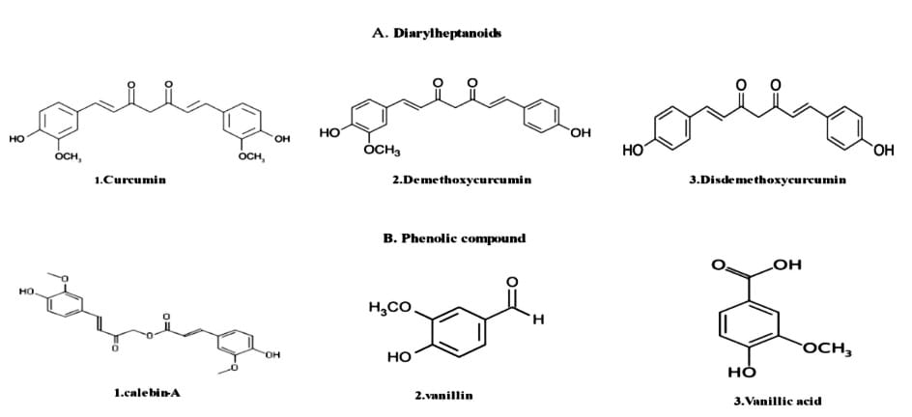
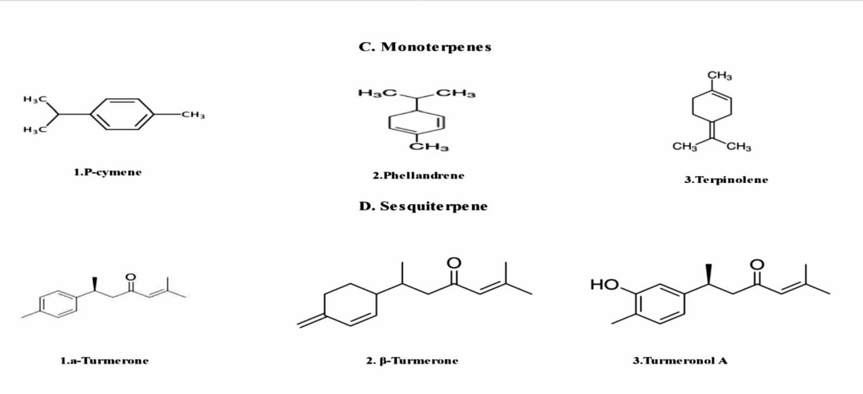
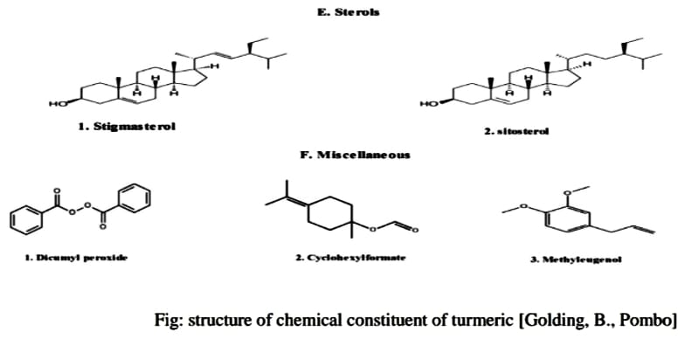
Turmeric as an indicator for acids and alkalis: Unglazed white paper is impregnated with an alcoholic solution of curcumin. This paper, after dried, is utilized for the testing of alkalis, acids, and boric acid.
The alkali and acid test indicates that the paper turns red-brown in the presence of alkalis. This turns violet upon drying, and the original yellow color is reinstated with acids.
Boric Acid Test: When the paper is immersed in a boric acid solution, it exhibits an orange-red coloration. The hue persists even when exposed to free mineral acid. Paper altered to orange by boric acid will exhibit a blue hue when dampened with weak alkali.

PHYTO-CHEMISTRY OF C. LONGA: C. longa contains fiber, carbohydrates, certain proteins and lipids (no cholesterol), vitamin C, pyridoxine, magnesium, phosphorus, potassium, and calcium, C. longa is a naturally occurring dietary item that is high in nutrients (Uma Pradeep, et al, 1993). C. longa, in its typical composition, comprises moisture (>9%), curcumin (5–6.6%), extraneous matter (<0.5%), mold (<3%), and volatile oils (<3.5%). Monoterpenes predominate in the essential oils of flowers and leaves, but sesquiterpenes are prevalent in the oils of roots and rhizomes. The oil elements are 25% tumerone, 11.5% curdine, and 8.55% ar-turmerone (Nisar, et al 2015). C. longa oil possesses anti-mutagenic properties and can inhibit the formation and excretion of urinary mutagens in cigarette smokers. The recent investigation indicates that the essential oil content in the rhizome was around 3.97%, with ar-turmerone (40%), α-turmerone (10%), and curlone (23%) identified as the predominant components by gas chromatography (Guimarães, et al, 2020). Aromatic turmerone has been utilized as an insect repellent, and its mosquitocidal properties have been demonstrated in the leaf extract. C. longa is a substantial source of polyphenolic curcuminoids, including curcumin (about 80%), demethoxycircimin (around 12%), and bisdemethoxycurcumin (Ashraf, K., 2018), include proteins, volatile oils (turmerone, atlantone, and zingiberone), carbohydrates, and resins. Curcumin, comprising 0.3%-5.4% of raw C. longa, is a thoroughly researched active compound. Table 1 delineates the primary C. longa products, their appearance, chemical composition, and use. The C. longa plant is recognized for its acidic polysaccharides (including ukonan A, B, C, and D), 4.2% volatile oils (comprising turmerone, ar-turmerone, curcumene, germacrone, and ar-curcumene as primary constituents), and 5.8% essential oils (featuring 0.6% sabinene, 0.5% borneol, 1% α-phellandrene, 1% cineole, 53% sesquiterpenes, 25% zingiberene, and 3%–4% curcumin) (Chattopadhyay, et al, 2004).
Phenolic diketone curcumin imparts a yellow hue and comprises curcumin I (94%), curcumin II (6%), and curcumin III (0.3%). Protein (6.3%), fat (5.1%), minerals (3.5%), carbs (69.4%), and moisture (13.1%) (Liao, et al, 2011). The main phytocompounds are presented in Figure 2
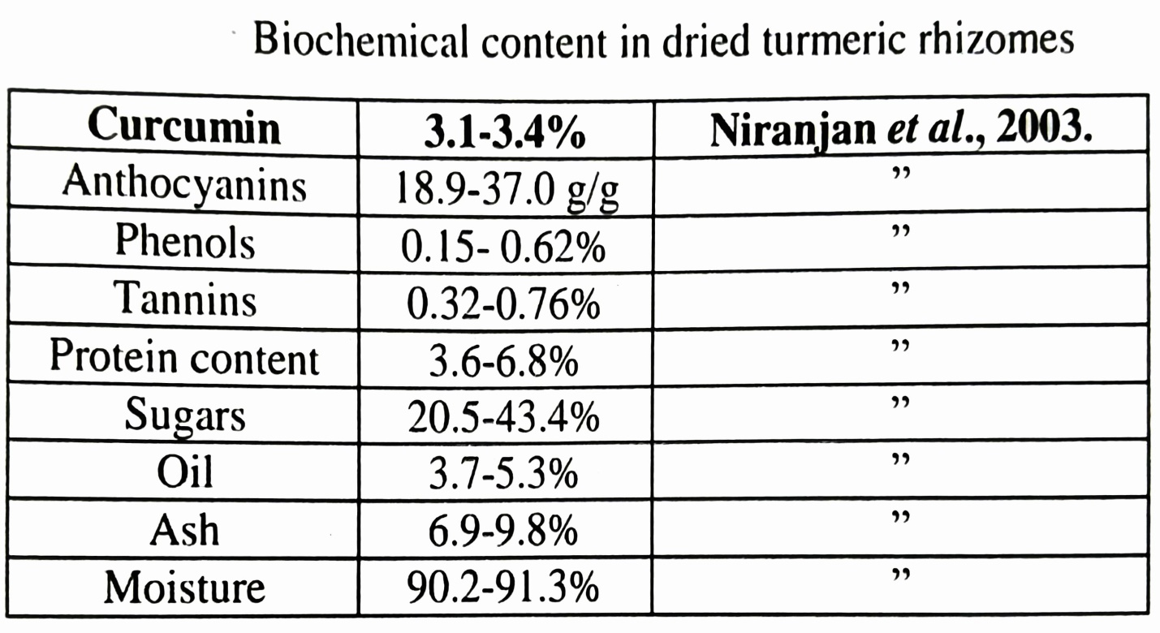.
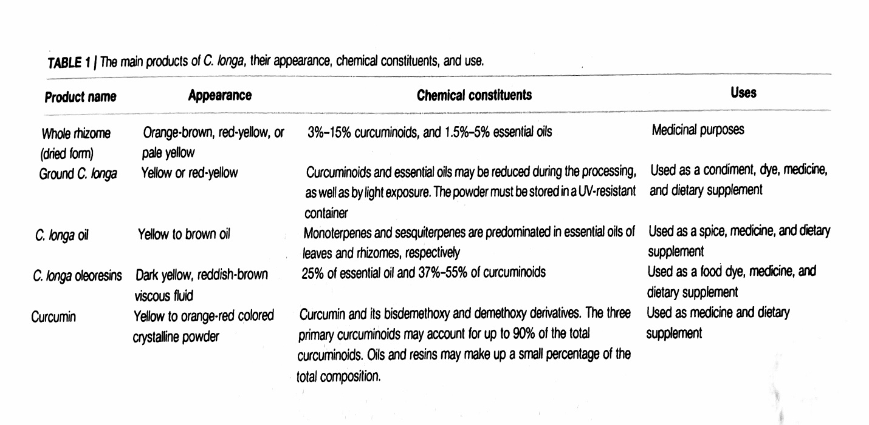

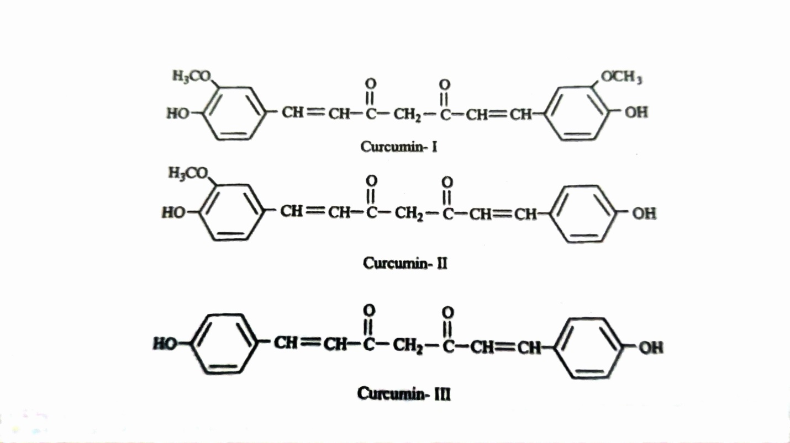

PHARMACOLOGICAL & MEDICINAL ASPECTS OF C. LONGA: In human trials, curcumin is suggested to be effective and safe, and the U.S. Food and Drug Administration has certified it as "generally regarded as safe."

- Gastrointestinal Disorders:- C. longa has historically been utilized for the treatment of digestive disorders, and clinical studies have substantiated its therapeutic benefits. Its anti-inflammatory properties have been demonstrated in preclinical studies to potentially safeguard the gastrointestinal system. Additionally, it has been proven to enhance the secretion of gastrin, secretin, and bicarbonate, as well as gastric wall mucus and pancreatic enzymes (Ammon, H. P., and Wahl, M. A., 1991). Additionally, it suppresses intestinal spasms and ulcer development induced by stress, alcohol, indomethacin, Helicobacter pylori ligation, and reserpine (Rafatullah, et al, 1990) and help enhance the condition of dyspeptic sufferers. Curcumin's efficacy in combating inflammation and its therapeutic impact on gastrointestinal disorders, including dyspepsia, Helicobacter pylori infection, Crohn’s disease, gastric ulcers, acidity, and ulcerative colitis, when administered as fresh juice, is believed to possess antihelmintic properties. Curcumin suppresses nuclear factor (NF)-κB and mitigates stomach mucosal injury in rats experiencing NSAID-induced gastropathy, leukocyte adhesions, intercellular adhesion molecule 1, and tumor necrosis factor (TNF)-α (Thong-Ngam, et al, 2012). From baseline to 8 weeks of treatment, C.longa tablets significantly decreased the prevalence of irritable bowel syndrome (IBS) and abdominal pain/discomfort scores, whereas IBS quality of life scores shown substantial enhancement (Rahimi, R., and Abdollahi, M.. 2012). In male mice with hepatic damage, curcumin mitigates acetaminophen-induced hepatitis by reducing oxidative stress and liver destruction, while also reinstating glutathione levels (Somanawat, et al, 2013).

- Inflammatory Disorders:- Inflammatory indicators encompass C-reactive proteins (CRP), complements, and fibrinogen, all of which are induced by inflammatory cytokines in response to stimulation. Sandur et al. (2007) identified curcumin, demethoxycurcumin, and bisdemethoxycurcumin as active chemicals in C. longa that inhibit TNF-induced NF-kB activation. The methoxy groups on the phenyl ring were found to be accountable for their effects. The extract of C. longa was investigated for its potential to enhance serum inflammatory indicators and alleviate mental health and mood disturbances in overweight healthy individuals (Uchio, et al, 2021). In 1995, researchers identified that curcumin possesses anti-inflammatory capabilities by blocking the pro-inflammatory transcription factor NF-κB. They also elucidated the chemical mechanism that underpins this inhibition ( Singh, S., and Aggarwal, B. B., 1995). TNF-α rapidly activates NF-κB, comprising the p50 and p65 subunits in human myeloid ML-1 cells, whereas curcumin inhibited this activation. Curcumin inhibits the binding of activator protein 1 (AP-1) factors, whereas the Sp1 binding factor remains unaltered. Curcumin suppresses the activation of NF-κB induced by phorbol ester, hydrogen peroxide, and TNF-α. Moreover, curcumin inhibits the NF-κB activation pathway following the convergence of many stimuli but prior to the phosphorylation of human I kappa B alpha. The ability of C. longa to inhibit inflammatory prostaglandin derivatives of arachidonic acid and neutrophil activity during inflammation may also suggest its anti-inflammatory properties. Curcumin is often used with bromelain to enhance absorption and anti-inflammatory efficacy. Curcumin is as effective as cortisone or phenylbutazone when administered orally for acute inflammation. C. longa administered orally significantly diminishes inflammatory edema. The therapeutic effect of curcumin in sepsis seems to be mediated by the activation of peroxisome proliferator-activated receptor gamma (PPAR-γ), resulting in the suppression of pro-inflammatory cytokines and the production and release of TNF-α (Jacob, et al, 2007). A trial including 43 kidney transplant patients shown that capsules containing 480 mg of curcumin and 20 mg of quercetin were effective in mitigating delayed graft rejection. Notable reductions in serum creatinine post-transplant were observed in 43% of control individuals and 71% of those receiving low-dose treatment. The induction of heme oxygenase, proinflammatory cytokines, and free radical scavengers associated with tissue injury likely contributed to the improved early function of transplanted kidneys (Figure 3) ( Shoskes, et al, 2006). Majority of the benefits seemed to be due to the anti-inflammatory and antioxidant properties 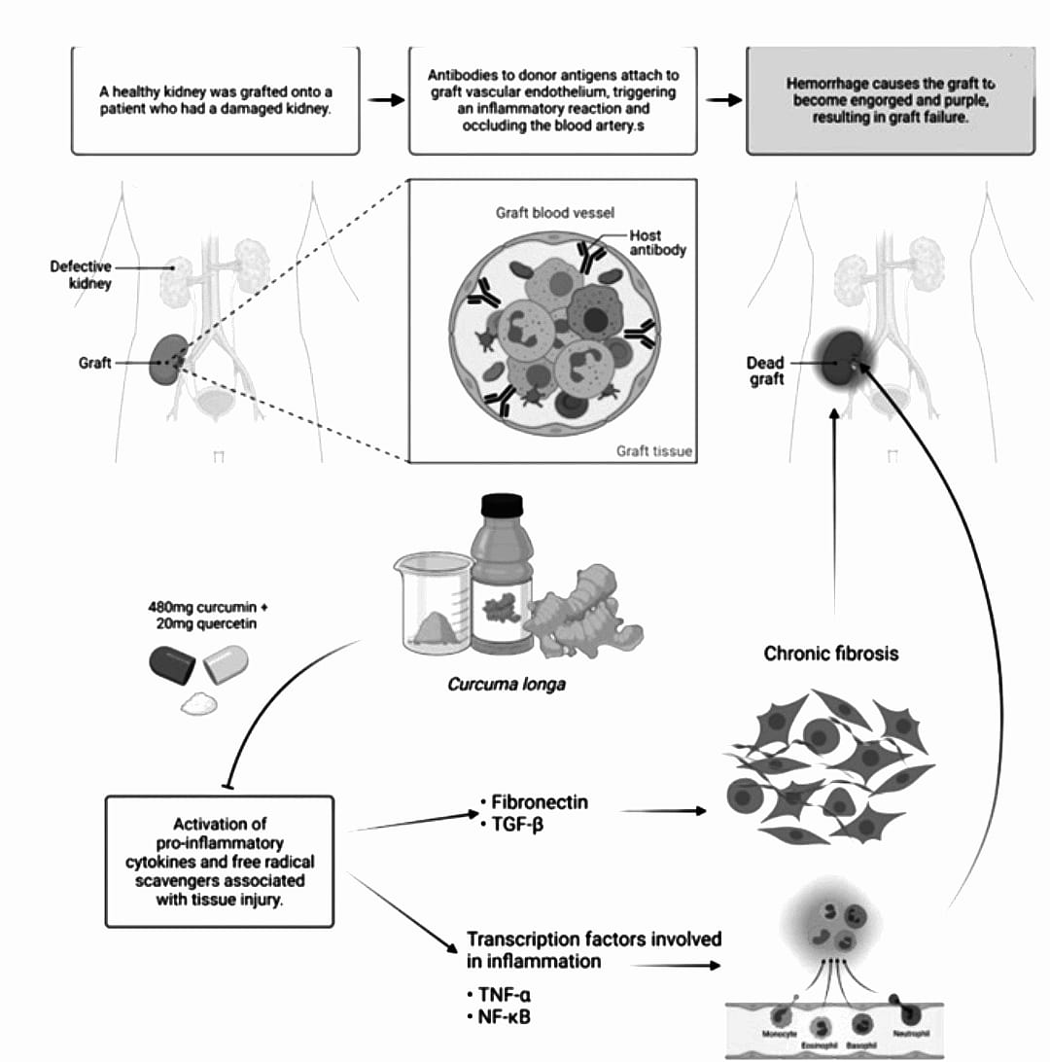of curcumin, while the quercetin in the molecule was negligible.
FIGURE 3 | Curcumin-induced antibody modification. Curcumin aids in the regulation of antibodies that cause hyperacute graft rejection by reacting with the endothelium. Dead grafts may be avoided by suppressing the expression of transcription factors and pro-inflammatory cytokines associated with fibrosis and inflammation.

- Antidiabetic Properties:- It was discovered that adipocyte differentiation was stimulated dose-dependently by a hexane extract containing ar-turmerone, an ethanolic extract containing ar-turmerone, curcumin, demethoxycurcumin, and bisdemethoxycurcumin, and an ethanolic extract from the hexane extraction residue containing curcumin, demethoxycurcumin, and bisdemethoxycurcumin. The results show that the ethanolic extract of turmeric that contains both curcuminoids and sesquiterpenoids is more hypoglycemic than either compound alone (Nishiyama T, et al, 2005; R. Essa, et al, 2019) .
After the OGTT with C. longa, the insulin change was much greater 30 and 60 minutes later. After consuming C. longa after the OGTT, the insulin AUCs were also significantly higher (Wickenberg J, et al, 2010).

- Antidepressant Properties:- Chronic moderate stress (CMS) causes rats to consume much less sucrose, have smaller medulla oblongata, higher levels of IL-6, TNF-α, CRF, and cortisol, and lower splenic NK cells activity. Ethanolic extract even made the medulla oblongata to be lower than normal in order to treat the condition that was generated in CMS. Because C. longa tends to prevent monoamine oxidase buildup in the central nervous system, it may have antidepressant properties (Yu, et al, 2002). Numerous properties of curcumin are significant in the pathophysiology of depression. While serotonin turnover, cortisol levels, and serum corticotrophin-releasing factor levels increased, the ethanolic C. longa extract stopped the decline in serotonin, noradrenalin, and dopamine concentrations (Xia, et al, 2007).
The effects of orally administered curcumin on behavior under chronic stress or depressive conditions in a rat model are significant. Curcumin administration demonstrated effects comparable to imipramine, a recognized antidepressant, and numerous authors have suggested it as a viable alternative for treating depression (Mohammed, et al, 2019; Qi, et al, 2020).

- Cardiovascular Protective Property:- Cardiovascular diseases (CVDs) appear to be a worldwide health concern associated with elevated morbidity and mortality rates. Cholesterol-lowering, atherosclerosis-preventing (Gao, et al, 2019), key preventive mechanisms against myocardial ischemia and reperfusion injury (Wang, et al, 2018). The efficacy of curcumin has been demonstrated in both preclinical and clinical investigations. Curcumin possesses anti-cardiovascular disease potential by enhancing the lipid profile of patients and may be provided independently or as a dietary supplement alongside conventional cardiovascular medications (Qin, et al, 2017). Curcumin has been observed in numerous studies to offer protection against coronary heart disease and also has anticoagulant effects (Li, et al, 2020a). The cardiovascular preventive attributes of C. longa encompass a reduction in cholesterol and triglyceride levels, a decrease in the susceptibility of low-density lipoprotein (LDL) to lipid peroxidation, and the prevention of platelet aggregation, thereby offering protection against atherosclerosis, as evidenced by animal studies, and also inhibiting thromboxane synthesis. Curcumin elevates VLDL cholesterol trans-protein plasma, resulting in heightened levels and mobilization of α-tocopherol from adipose tissue, which safeguards against oxidative stress associated with atherosclerosis. Nevertheless, the fatty acids in the mice exhibited reduced susceptibility to oxidation within the blood vessels. Oral administration of 500 mg/day curcumin for one week results in a notable decrease in serum lipid peroxide levels (33%) and total serum cholesterol (12%), while simultaneously elevating HDL cholesterol levels (29%). Curcumin may mitigate chronic heart failure by enhancing p38 MAPK, JNK, and ASK1(Cao, et al, 2018). Recent research utilized curcumin and its constituents to evaluate the efficacy of nanotechnology-based drug delivery systems in patients with cardiovascular disease (Salehi, et al, 2020).
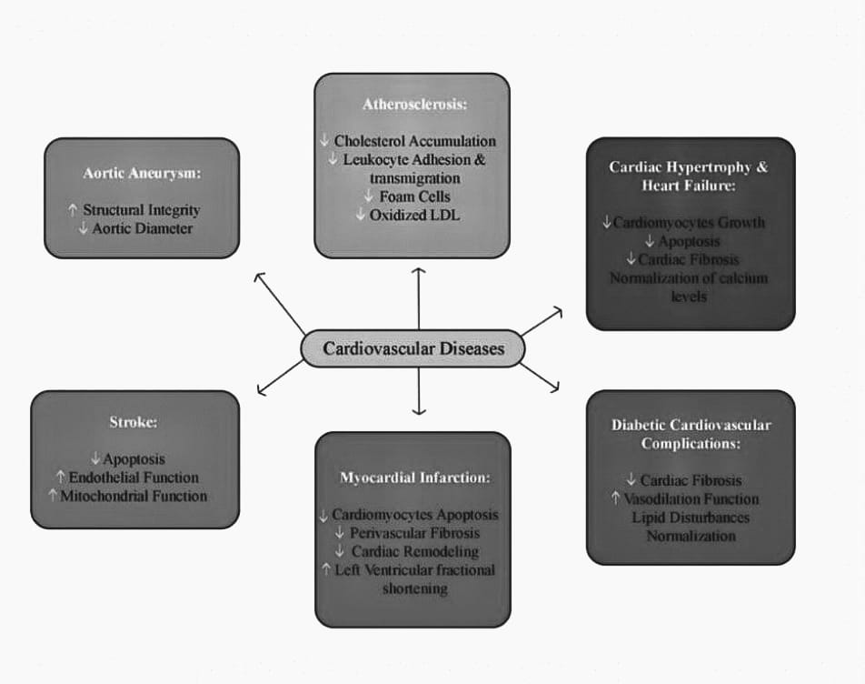FIGURE 4 | Curcumin action on cardiovascular diseases ( adapted from Li et al., 2019).
- Antibacterial Properties:- Several investigations evaluated the antibacterial efficacy of curcumin against several bacterial species, including Salmonella paratyphi, Trichophyton gypseum, Staphylococcus aureus, Streptococcus mutans, and Mycobacterium TB (Tajbakhsh, et al, 2008; Maghsoudi, et al, 2017). The extract shown antibacterial efficacy against Trichophyton longifusus, Microsporum canis, and Staphylococcus aureus, while exhibiting toxicity to Lemna minor. The C.longa-treated rabbit group had a markedly increased mean value for wound contraction, resulting in reduced inflammation and an upward trend in collagen synthesis. The ethanol extract of C. longa shown activity against Shigella flexneri, Staphylococcus epidermidis, Klebsiella pneumoniae, Lactobacillus, Pseudomonas aeruginosa, Vibrio cholerae, and Salmonella typhi (Oghenejobo, et al, 2017). Drug combinations can produce significant or attenuated pharmacokinetic effects, potentially augmenting or reducing each other's therapeutic efficacy through modulation of absorption, distribution, metabolism, and excretion (Chou, T. C. 2006). A separate study demonstrated the synergistic combinatorial effect of copper metal ions with aqueous extracts of C. longa against Paenibacillus popilliae, a recognized food spoilage bacterium, and identified phyto-constituents such as alkaloids, flavonoids, anthocyanins, steroids, and coumarins in C. longa extracts (Jassal, et al, 2015). The aqueous extract of C. longa and chitosan exhibit substantial synergism and antibacterial efficacy at concentrations of 512 μg/ml and 1,024 μg/ml against multidrug-resistant pathogens, including methicillin-resistant Staphylococcus aureus, carbapenem-resistant Pseudomonas, carbapenem-resistant Enterobacteriaceae, AmpC-producing Enterobacteriaceae, and antibiofilm producers (Etemadi, et al, 2021). The aqueous extract, curcumin component, and oil fraction of C. longa shown antibacterial efficacy against H. pylori, Streptococcus, Staphylococcus, and Lactobacillus species (Mahady, et al, 2002).

- Antifungal Activity:- Curcumin demonstrated enhancement of the efficacy of prevalent azole and polyene antifungal agents (Sharma, et al, 2008). A further study shown that C. longa oil inhibited dermatophytes and pathogenic fungi when externally applied to guinea pigs infected with dermatophytes, molds, and yeast. The guinea pigs with dermatophytes and fungal infections exhibited improvement, with lesions becoming imperceptible after 7 days of C. longa therapy. Khattak et al. (2005) investigated the antifungal, antibacterial, phytotoxic, cytotoxic, and insecticidal properties of an ethanolic extract of C. longa. Ether, chloroform, and ethanol extracts of C. longa, in addition to its oil, exhibit antifungal activity against Aspergillus flavus, Aspergillus parasiticus, Fusarium moniliforme, and Penicillium digitatum, as indicated by multiple authors (Wuthi-Udomlert, et al, 2000; Jayaprakasha, et al, 2001). The methanolic extract of C. longa demonstrated antifungal activity against Cryptococcus neoformans and Candida albicans, with minimum inhibitory concentration (MIC) values of 128 and 256 µg/ml, respectively. Curcumin exhibits antifungal activity against all tested Candida strains, with minimum inhibitory concentrations ranging from 250 to 2,000 g/L; nonetheless, it is less effective than fluconazole, as per a recent analysis. This may be due to alterations in membrane-associated ATPase activity, ergosterol synthesis, or proteinase secretion (Neelofar, et al, 2011).

- Respiratory Disorders:- C. longa and its components exert a relaxing effect on tracheal smooth muscles, indicating a potential bronchodilatory effect in patients with obstructive lung disease. They confer a protective advantage in an animal model of respiratory illnesses, influencing inflammatory cells and mediators, lung pathological changes, airway responsiveness, and immunomodulatory responses (Boskabady, et al, 2010). Curcumin has been shown in both in vivo and in vitro investigations to have antiasthmatic properties. Curcumin therapy during OVA sensitization demonstrated substantial protective effects in an OVA-induced asthma model in guinea pigs, reducing bronchial constriction and hyperreactivity (Das, et al, 2003). Bronchitis is managed with fresh rhizome juice. C. longa is boiled in milk, blended with jaggery, and utilized internally for rhinitis and cough. In instances of catarrhal cough and painful throat due to infection, a decoction of the rhizome is used for gargling, and a piece of the rhizome is lightly charred and chewed. Turmerones, curcuminoids, curcumin, and tetrahydrocurcumin are chemical constituents of C. longa that have anti-asthmatic activities, whereas Haridradhumvarti (fumes wick) is utilized for asthma and congestion relief.

- Antifertilty:- The World Health Organization has endorsed traditional medicine as a cost-effective alternative to synthetic antifertility medications. The Parkes mouse strain received an aqueous rhizome extract of C. longa orally (600 mg/kg body weight/day for 8 and 12 weeks), resulting in reversible spermatogenesis, reduced diameter of seminiferous tubules, and loosening of the germinal epithelium, thereby suggesting its potential impact on male fertility. Hembrom et al. (2015) additionally investigated the impact of an aqueous C. longa rhizome extract on sperm count, spermatozoa motility, and seminal pH in Swiss Albino male mice, resulting in infertility. The synergistic effect of curcumin and andrographolide markedly reduced the number of implants and litter size in female Sprague–Dawley rats, altered the duration of estrous cycle phases, and diminished the quantity of ovarian follicles (Shinde, et al, 2015). Petroleum ether, combined with an aqueous extract of rhizome, exhibits antifertility effects in rats through oral administration, resulting in total prevention of implantation. Curcumin diminishes human sperm motility, indicating its potential application as an intravaginal contraceptive and its antispermatogenic effects.

- Antidermatophytic Activity:- Rhizome juice serves as an antiparasitic in the treatment of many dermatological conditions, while rhizome powder is incorporated into cow's urine to alleviate internal pruritus and dermatitis (Paranjpe, P., and Pranjpe, S., 2001). Leaves possess significant potential against human pathogenic fungi due to their diverse in vitro and in vivo antifungal properties, including potent fungicidal efficacy, extended shelf life, high tolerance to inoculum density, thermostability, numerous antidermatophytic effects, and absence of side effects. Curcumin has demonstrated antimutagenic, antioxidant, free radical scavenging, anti-inflammatory, and anti-carcinogenic properties, enabling it to safeguard the skin from harmful UV-induced effects (Binic, et al, 2013).

- Anti- Allergic Activity:- Curcumin reduced the degranulation and histamine release from rat peritoneal mast cells induced by compound 48/80. Calcium absorption assessments and cAMP analyses in mast cells were employed to examine the mechanism of action. In an animal model, curcumin significantly diminished the mast cell-mediated passive cutaneous anaphylactoid response. Curcumin elevated intracellular cAMP levels and suppressed both nonspecific and selective mast cell-mediated allergic responses (Choi, et al, 2010). Curcumin markedly diminished IgE/Ag-induced passive systemic anaphylaxis, as evidenced by serum-dependent leukotriene C4, prostaglandin D2, and histamine levels, suggesting its potential utility in the development of pharmaceuticals for allergic inflammatory disorders.Curcumin markedly diminished IgE/Ag-induced passive systemic anaphylaxis (PSA), as evidenced by serum-dependent leukotriene C4, prostaglandin D2, and histamine levels, suggesting its potential utility in the development of pharmaceuticals for allergic inflammatory disorders (Li, et al, 2014). Curcumin can inhibit the expression of CD80, CD86, and class II antigens in dendritic cells and obstruct the release of inflammatory cytokines such as IL-1β, IL-6, and TNF-α from LPS-stimulated dendritic cells.

- Pregnancy / Neonates:- C. longa and curcumin significantly elevated hepatic glutathione S-transferase (GST), sulfhydryl (SH), cytochrome b5, and cytochrome P450 levels, suggesting that C. longa and/or curcumin metabolites may be transmitted via the milk supply. C. longa and curcumin are non-toxic and non-mutagenic in pregnant animals; however, further research in humans is necessary (Soleimani, et al, 2018).

THERAPEUTIC USES & PROPERTIES OF C. LONGA:
Therapeutic Uses of C. longa: Turmeric is characterized by broad, foot-long, lily-like leaves and yellow to yellowish-white blooms, originating from India, Bangladesh, and China. It possesses a potent flavor, and its yellow hue is nearly indelible once it has stained fabric. The culinary and medicinal properties of turmeric reside in the root or rhizome, which is subsequently dried and crushed into a spice.
Turmeric is advantageous in addressing gallbladder disorders, hepatitis, dyspepsia, infections, anorexia, scabies, Alzheimer's disease, arthritis, asthma, tinea pedis, boils, bursitis, breast cancer, colorectal cancer, cataracts, colic, dermatitis, diarrhea, eczema, fibrosis, cholelithiasis, flatulence, arteriosclerosis, cardiovascular disease, hypercholesterolemia, hypertriglyceridemia, inflammation, intestinal discomfort, irritable bowel syndrome, jaundice, amenorrhea, lymphadenopathy, dysmenorrhea, morning sickness, pain, psoriasis, sprains, ulcers, wounds, and candidiasis. It is also utilized for the treatment of bruising, delivery, ocular inflammation, epilepsy, fever, hemorrhage, hemorrhoids, pruritus, and ringworm.
Properties of C.longa:- Turmeric includes curcumin and curcuminoids, making it an excellent natural cure for arthritis due to its anti-inflammatory properties that can ease pain. It may also safeguard the gallbladder and liver while offering protection against cancer. Curcumin may also impede the development of cancer in breast tissue. Animal experiments demonstrate that curcumin reduced the incidence of colon cancer by about 60%. This phytochemical appears to neutralize carcinogenic molecules, inhibit malignant cellular transformations, and directly combat agents that facilitate the proliferation of carcinogens. Turmeric enhances bile flow, facilitating fat digestion and diminishing the likelihood of gallstones. It also facilitates the release of several enzymes that aid the liver in degrading and metabolizing specific harmful chemicals. Certain phytochemicals impede oxidative damage that facilitates cholesterol coagulation and adherence to arterial walls. Turmeric/curcumin is approximately fifty percent as effective as corticosteroids; however, it lacks the adverse side effects associated with corticosteroids. This substance is utilized in the treatment of arthritis, yet it may lead to fluid retention and bloating, elevated blood pressure, promote intestinal bleeding, facilitate ulcer formation, and heighten the risk of osteoporosis.

HEALTH BENEFITS OF TURMERIC IN DAILY LIFE:
- It serves as a natural antiseptic and antibacterial agent, effective in cleansing wounds and burns.
- When paired with cauliflower, it has demonstrated the ability to prevent prostate cancer and inhibit the progression of existing prostate cancer.
- Inhibited the metastasis of breast cancer to the pulmonary system in murine models.
- May inhibit melanoma and induce apoptosis in existing melanoma cells.
- Decreases the likelihood of infantile leukemia.
- It serves as a natural liver detoxifier.
- May inhibit and decelerate the advancement of Alzheimer's disease by eliminating amyloid plaque accumulation in the brain.
- May inhibit the occurrence of metastases in many types of cancer.
- It is a powerful natural anti-inflammatory that is as effective as numerous anti-inflammatory medications, yet devoid of adverse effects.
- Research is now being conducted on the beneficial effects of turmeric on multiple myeloma.
- It has been demonstrated to inhibit the formation of new blood vessels in malignancies.
Accelerates wound healing and facilitates the reconstruction of impaired skin.

NUTRITIONAL VALUES OF CURCUIN LONGA:
Nutrients | Values per table spoon (7gm)
Calories | 23.9
Water | 0.8g
Cholesterol | 0 mg
Protein | 1.5
Fat | 5.6
Fiber | 1.4
Carbs | 16.8
Calcium | 12.4mg
Phosphorous | 18mg
Iron | 2.7mg
Zinc | 0.3mg
Potassium | 13mg
Sodium | 170mg
Thiamine | 2.5mg
Riboflavin | 0mg
Betaine | 0mg
Vitamin C | 0.5mg
Folate | 2.6mcg
Choline | 3.3mg

CONCLUSION & FUTURE DIRECTIONS: Turmeric has been utilized in Ayurvedic medicine for many biological applications since ancient times. Currently, researchers exhibit enthusiasm for utilizing natural products in the treatment of numerous ailments. While some research has been conducted on potential medicinal applications, limited studies have been undertaken for drug development thus far. Curcumin is a non-toxic, very promising natural antioxidant with a broad range of biological effects. Curcumin is now accessible in its pure form, exhibiting a broad range of biological activities; thus, it would facilitate the development of new pharmaceuticals following comprehensive investigations into its mechanism of action and pharmacological effects. Cucumin is anticipated to be utilized as a novel therapeutic agent in the near future for the management of numerous diseases, illnesses, and oxidative stress.
This review contributes to the expanding evidence base endorsing turmeric as a preventive and therapeutic approach. We anticipate that further advancements in the formulation of strategies utilizing natural items will help in the fight against COVID-19 in the forthcoming years. This paper proposes using gold nanoparticles with the neutralizing antibody Ty1, which may selectively target the receptor binding region of the SARS-CoV-2 spike and directly block contact with angiotensin-converting enzyme 2. The use of curcumin and bevacizumab significantly improved the effectiveness of the suggested method, as both agents can target and effectively neutralize VEGF, thus reducing and inhibiting tumor growth.
REFERENCES:
Abas, F., Lajis, N. H., Shaari, K., Israf, D. A., Stanslas, J., & Yusuf, U. K. (2005). A labdane diterpene glucoside from the rhizomes of Curcuma longa. Journal of Natural Products, 68(7), 1090–1093.
Akram, M., Shahab-Uddin, Khan, A. A., Chani, U., Hanan, A., & Mohiuddin, E. (2010). Curcuma longa and curcumin: A review article. Romanian Journal of Biology – Plant Biology, 55, 65–72.
Ammon, H. P., & Wahl, M. A. (1991). Pharmacology of Curcuma longa. Planta Medica, 57(1), 1–7. https://doi.org/10.1055/s-2006-960004
Ashraf, K. (2018). A comprehensive review on Curcuma longa Linn.: Phytochemical, pharmacological, and molecular study. International Journal of Green Pharmacy, 11(4).
Binic, I., Lazarevic, V., Ljubenovic, M., Mojsa, J., & Sokolovic, D. (2013). Skin ageing: Natural weapons and strategies. Evidence-Based Complementary and Alternative Medicine.
Boskabady, M. H., Shakeri, F., & Naghdi, F. (2020). The effects of Curcuma longa L. and its constituents in respiratory disorders and molecular mechanisms of their action. In Studies in Natural Products Chemistry (pp. 239–269). Elsevier.
Cao, Q., Zhang, J., Gao, L., Zhang, Y., Dai, M., & Bao, M. (2018). Dickkopf-3 upregulation mediates the cardioprotective effects of curcumin on chronic heart failure. Molecular Medicine Reports, 17(5), 7249–7257. https://doi.org/10.3892/mmr.2018.8783
Chattopadhyay, I., Biswas, K., Bandyopadhyay, U., & Banerjee, R. K. (2004). Turmeric and curcumin: Biological actions and medicinal applications. Current Science, 87(1), 44–53.
Choi, Y. H., Yan, G. H., Chai, O. H., & Song, C. H. (2010). Inhibitory effects of curcumin on mast cell activation. Anatomy & Cell Biology, 43(1), 36–43.
Etemadi, S., Barhaghi, M. H. S., Leylabadlo, H. E., Memar, M. Y., Mohammadi, A. B., & Ghotaslou, R. (2021). The synergistic effect of turmeric aqueous extract and chitosan against multidrug-resistant bacteria. New Microbes and New Infections, 41, 100861. https://doi.org/10.1016/j.nmni.2021.100861
Gao, S., Zhang, W., Zhao, Q., Zhou, J., Wu, Y., Liu, Y., et al. (2019). Curcumin ameliorates atherosclerosis in apolipoprotein E deficient asthmatic mice. Phytomedicine, 52, 129–135. https://doi.org/10.1016/j.phymed.2018.09.194
Golding, B. T., & Pombo-Villar, E. (1992). Structures of α- and β-turmerone. Journal of the Chemical Society, Perkin Transactions 1, 1519–1524.
Golding, B., Pombo, E., & Christopher, J. (1982). Turmerones: Isolation from turmeric and structure determination. Journal of the Chemical Society, Chemical Communications, 363–364.
Guimarães, A. F., Vinhas, A. C. A., Gomes, A. F., Souza, L. H., & Krepsky, P. B. (2020). Essential oil of Curcuma longa L.: Chemical composition, yield variation and stability. Química Nova, 43, 909–913. https://doi.org/10.21577/0100-4042.20170547
Heath, D. D., Khwaja, F., & Rock, C. L. (2004). Curcumin content of turmeric and curry powders. FASEB Journal, 18, A125.
Hembrom, A. R., Verma, A., & Singh, V. N. (2015). Antifertility effects of rhizome of Curcuma longa on seminal parameters. Research Journal of Pharmaceutical Technology, 8(4), 404–406.
Jacob, A., Wu, R., Zhou, M., & Wang, P. (2007). Mechanism of the anti-inflammatory effect of curcumin: PPAR-γ activation. PPAR Research, 2007, 89369. https://doi.org/10.1155/2007/89369
Jassal, P., Kaur, G., & Kaur, L. (2015). Synergistic effect of Curcuma longa and Glycyrrhiza glabra. International Journal of Pharmaceutical Sciences, 7, 371–375.
Jayaprakasha, G. K., Negi, P. S., Anandharamakrishnan, C., & Sakariah, K. K. (2001). Chemical composition of turmeric oil and antifungal activity. Zeitschrift für Naturforschung C, 56(1–2), 40–44.
Khattak, S., Saeed-ur-Rehman, H. U., Ullah Shah, H., Ahmad, W., & Ahmad, M. (2005). Biological effects of indigenous medicinal plants. Fitoterapia, 76(2), 254–257.
Leong-Škornickova, J., Šida, O., Wijesundara, S., & Marhold, K. (2008). On the identity of turmeric: Typification of Curcuma longa L. Botanical Journal of the Linnean Society, 157(1), 37–46. https://doi.org/10.1111/j.1095-8339.2008.00788.x
Li, S. Y., Yuan, W., Deng, G. R., Wang, P., et al. (2011). Chemical composition and product quality control of turmeric. Pharmaceutical Crops, 2, 28–54.
Liao, V. H., Yu, C. W., Chu, Y. J., Li, W. H., Hsieh, Y. C., & Wang, T. T. (2011). Curcumin-mediated lifespan extension. Mechanisms of Ageing and Development, 132(10), 480–487.
Mahady, G. B., Pendland, S. L., Yun, G., & Lu, Z. Z. (2002). Turmeric inhibits Helicobacter pylori. Anticancer Research, 22(6C), 4179–4181.
McClatchey, W. (1993). Traditional use of Curcuma longa in Rotuma. Economic Botany, 47(3), 291–296.
Mohammed, H. S., Khadrawy, Y. A., El-Sherbini, T. M., & Amer, H. M. (2019). Antidepressant efficacy of nanocurcumin. Applied Biochemistry and Biotechnology, 187(3), 1096–1112.
Nair, K. P. (2013). The agronomy and economy of turmeric and ginger. Newnes.
Nelson, K. M., Dahlin, J. L., Bisson, J., et al. (2017). The essential medicinal chemistry of curcumin. Journal of Medicinal Chemistry, 60(5), 1620–1637. https://doi.org/10.1021/acs.jmedchem.6b00975
Neelofar, K., Shreaz, S., Rimple, B., Muralidhar, S., Nikhat, M., & Khan, L. A. (2011). Curcumin as an anticandidal agent. Canadian Journal of Microbiology, 57(3), 204–210.
Nisar, T., Iqbal, M., Raza, A., Safdar, M., Iftikhar, F., & Waheed, M. (2015). Estimation of phenolics in turmeric. Environmental Science, 15(7), 1272–1277.
Nishiyama, T., Mae, T., Kishida, H., et al. (2005). Suppression of blood glucose by curcuminoids. Journal of Agricultural and Food Chemistry, 53(4), 959–963.
Paranjpe, P., & Pranjpe, S. (2001). Herbs for beauty. Chaukhamba Sanskrit Prathisthan.
Pfeiffer, E., Huhle, S., Solyom, A., & Metzler, M. (2003). Stability of turmeric constituents. Journal of Food Engineering, 56, 257–259.
Qi, X. J., Liu, X. Y., Tang, L. M., Li, P. F., Qiu, F., & Yang, A. H. (2020). Curcumin nasal delivery system. Pharmaceutical Development and Technology, 25(3), 316–325.
Qin, S., Huang, L., Gong, J., Shen, S., Huang, J., & Ren, H. (2017). Curcumin and lipid levels: Meta-analysis. Nutrition Journal, 16, 68.
Rafatullah, S., Tariq, M., Al-Yahya, M. A., Mossa, J. S., & Ageel, A. M. (1990). Antiulcer activity of turmeric. Journal of Ethnopharmacology, 29(1), 25–34.
Rahimi, R., & Abdollahi, M. (2012). Herbal medicines for IBS. World Journal of Gastroenterology, 18(7), 589–600.
Ram, A., Das, M., & Ghosh, B. (2003). Curcumin and airway hyperresponsiveness. Biological & Pharmaceutical Bulletin, 26(7), 1021–1024.
Ravindran, P. N., Nirmal Babu, K., & Sivaraman, K. (2007). Turmeric: The genus Curcuma. CRC Press.
Ritsuko, K., & Reid, L. (2007). Proto use of turmeric. John Benjamins.
Royal Botanic Gardens Kew. (2021). Curcuma longa L. Retrieved from http://powo.science.kew.org
Salehi, B., Del Prado-Audelo, M. L., Cortés, H., et al. (2020). Curcumin nanomedicine. Journal of Clinical Medicine, 9(3), 746.
Sandur, S. K., Pandey, M. K., Sung, B., et al. (2007). Anti-inflammatory responses of curcuminoids. Carcinogenesis, 28(8), 1765–1773.
Sharma, M., Manoharlal, R., Negi, A. S., & Prasad, R. (2010). Anticandidal activity of curcumin. FEMS Yeast Research, 10(5), 570–578.
Sharma, P. V. (2000). Namarupajnanam. Satyapriya Prakashan.
Shinde, N., Chauhan, A. S., Gupta, S. K., Bodakhe, S. H., & Pandey, D. P. (2015). Antifertility studies of curcumin. Asian Pacific Journal of Reproduction, 4(3), 188–194.
Shoskes, D., Lapierre, C., Cruz-Correa, M., et al. (2006). Curcumin in renal transplantation. Transplantation, 82(5), 715.
Singh, S., & Aggarwal, B. B. (1995). Suppression of NF-kappa B by curcumin. Journal of Biological Chemistry, 270(42), 24995–25000.
Soleimani, V., Sahebkar, A., & Hosseinzadeh, H. (2018). Safety of turmeric and curcumin. Phytotherapy Research, 32(6), 985–995.
Somanawat, K., Thong-Ngam, D., & Klaikeaw, N. (2013). Curcumin and hepatitis. World Journal of Gastroenterology, 19(12), 1962–1967.
Tajbakhsh, S., Mohammadi, K., Deilami, I., et al. (2008). Antibacterial activity of curcumin. African Journal of Biotechnology, 7(21), 3832–3835.
Thong-Ngam, D., Choochuai, S., Patumraj, S., et al. (2012). Curcumin prevents gastropathy. World Journal of Gastroenterology, 18(13), 1479–1484.
Uma Pradeep, K., Geervani, P., & Eggum, B. O. (1993). Nutrient composition of Indian spices. Plant Foods for Human Nutrition, 44(2), 137–148.
Uchio, R., Kawasaki, K., Okuda-Hanafusa, C., et al. (2021). Curcuma extract improves inflammation and mental health. Nutrition Journal, 20, 91.
Wang, R., Zhang, J. Y., Zhang, M., et al. (2018). Curcumin attenuates myocardial injury. European Review for Medical and Pharmacological Sciences, 22(4), 1150–1160.
Wickenberg, J., Ingemansson, S. L., & Hlebowicz, J. (2010). Effects of turmeric on glucose and insulin. Nutrition Journal, 9, 43.
Wuthi-Udomlert, M., Grisanapan, W., Luanratana, O., & Caichompoo, W. (2000). Antifungal activity of turmeric. Southeast Asian Journal of Tropical Medicine and Public Health, 31, 178–182.
Xia, X., Cheng, G., Pan, Y., et al. (2007). Neurochemical effects of turmeric extract. Journal of Ethnopharmacology, 110(2), 356–363.
Yu, Z. F., Kong, L. D., & Chen, Y. (2002). Antidepressant activity of turmeric. Journal of Ethnopharmacology, 83(1–2), 161–165.

