Stratigraphic Succession and Geological Evolution of Jharkhand: An Overview of the Singhbhum Craton and Associated Formations

Abstract
Jharkhand possesses one of the most diversified and ancient geological terrains of India. The Singhbhum region, often regarded as a natural geological museum, preserves rock assemblages ranging from the Eoarchean to the Quaternary period. The present study reviews the stratigraphic succession of Jharkhand with special emphasis on the Singhbhum Craton, its lithological characteristics, tectonic evolution, magmatic events, sedimentary sequences, and economic significance. The stratigraphic framework begins with the Older Metamorphic Group (OMG), followed by the emplacement of Biotite Tonalite Gneiss, Iron Ore Group, Singhbhum Granite, Singhbhum Group, Dalma-Dhanjori volcanics, younger intrusive bodies, Gondwana Supergroup, Rajmahal Traps, and Quaternary deposits. The study highlights major unconformities, volcanic episodes, metamorphism, and tectonic activities responsible for shaping the present geological architecture of Jharkhand. The paper also discusses the mineral wealth associated with these formations, particularly iron ore, coal, bauxite, and other economically important minerals.
Keywords: Jharkhand Geology, Singhbhum Craton, Stratigraphic Succession, Iron Ore Group, Gondwana Supergroup, Rajmahal Traps, Precambrian Geology.

I. INTRODUCTION
Jharkhand is endowed with an exceptionally diverse geological setup comprising some of the oldest rocks of the Indian subcontinent [1-2]. The Singhbhum region of eastern India represents one of the most important Precambrian terrains and preserves evidence of crustal evolution from the Eoarchean era onward [3]. The geological formations of Jharkhand range from ancient metamorphic complexes to recent alluvial deposits, thereby providing valuable insights into tectonic, magmatic, metamorphic, and sedimentary processes through geological time.
The state is particularly significant because of the presence of the Singhbhum Craton, Iron Ore Group formations, Gondwana sedimentary basins, and Rajmahal volcanic sequences [4]. These formations not only reveal the geological evolution of eastern India but also host economically significant mineral deposits including iron ore, coal, copper, uranium, mica, limestone, and bauxite [5]. Several pioneering geologists such as Dunn, Dey, Sarkar, and Saha contributed extensively to understanding the stratigraphy and tectonics of this region [1], [2].

Map-1: Jharkhand map
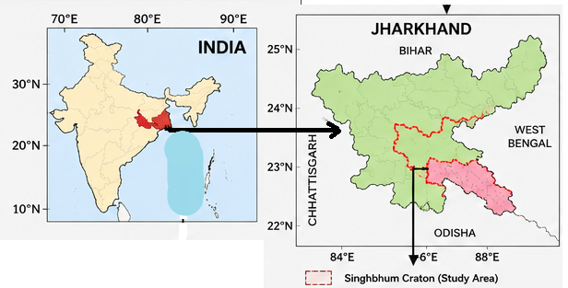

Map-2: Singhbhum Carton and Surrounding Areas
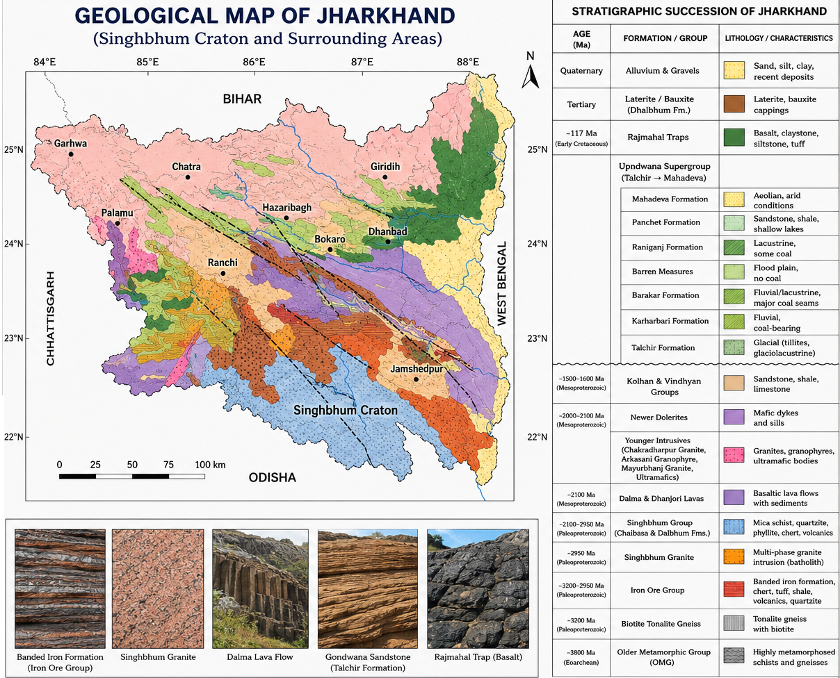
The present paper aims to present a comprehensive overview of the stratigraphic succession of Jharkhand and explain the geological evolution of the region from the oldest metamorphic basement to the youngest Quaternary deposits.

II. GEOLOGICAL SETTING OF JHARKHAND
Jharkhand lies within the eastern Indian shield and mainly consists of Precambrian crystalline rocks [3]. The major geological divisions include the Singhbhum Craton, Chhotanagpur Granite Gneiss Complex, Gondwana basins, Rajmahal volcanic province, and Quaternary alluvial deposits [4].
The Singhbhum Craton is one of the oldest stable continental blocks of India and is characterized by repeated tectonic, magmatic, and metamorphic activities [5]. The craton contains numerous granitoids, greenstone belts, volcano-sedimentary sequences, and shear zones. Major tectonic structures such as the Singhbhum Shear Zone significantly influenced mineralization and crustal deformation in the region [6].

III. STRATIGRAPHIC SUCCESSION OF JHARKHAND

A. Older Metamorphic Group (OMG)
The Older Metamorphic Group represents the oldest exposed rock formation in Jharkhand with an estimated age of nearly 3800 Ma [6]. These rocks form the Archean basement of the Singhbhum Craton.
The lithology mainly consists of highly metamorphosed schists and gneisses that experienced intense deformation and metamorphism [3]. The OMG provided the basement upon which younger formations such as the Iron Ore Group were deposited [4].

B. Biotite Tonalite Gneiss
The Biotite Tonalite Gneiss was emplaced around 3200 Ma and forms a major intrusive basement complex [6]. These rocks are predominantly tonalitic gneisses rich in biotite minerals.
The emplacement of tonalitic magma marks an important stage in early continental crust formation within the Singhbhum Craton [5]. The intrusive relationship between the tonalite gneiss and the Older Metamorphic Group indicates major crustal reworking during the Archean era [3].

C. Iron Ore Group (IOG)
The Iron Ore Group, dated between 3200 and 2950 Ma, is among the most economically significant stratigraphic units of Jharkhand [2]. The sequence comprises tuffaceous shale, phyllite, ferruginous chert, dolomite, quartzite, conglomerate, volcanic rocks, and banded iron formations (BIF) [4].
The Iron Ore Group hosts some of the richest iron ore deposits of India, especially in the Singhbhum region [5]. These rocks were deposited in volcano-sedimentary basins and later subjected to deformation and metamorphism [3]. Mafic and ultramafic volcanic rocks associated with the sequence indicate extensive volcanic activity during deposition [6].

D. Singhbhum Granite
The Singhbhum Granite was emplaced approximately 2950 Ma ago and represents a major batholithic intrusion [4]. The granite intrusion marked the culmination of Iron Ore Orogeny accompanied by deformation and metamorphism [5].
Multiple phases of granitic intrusion have been identified, indicating prolonged magmatic activity [6]. The emplacement of the granite stabilized the crust and played a significant role in shaping the tectonic framework of the region [3].

E. Singhbhum Group
The Singhbhum Group occurs north of the Singhbhum Shear Zone and extends over nearly 200 km in an east-west direction [5]. It is subdivided into the Chaibasa Formation and Dalbhum Formation.

1) Chaibasa Formation
The Chaibasa Formation consists mainly of mica schists, quartzites, and hornblende schists [2]. These rocks indicate sedimentation under marine conditions followed by regional metamorphism [3].

2) Dalbhum Formation
The Dalbhum Formation comprises carbonaceous phyllite, quartzite, chert, epidiorite, and acid volcanic rocks [4]. The presence of carbonaceous material suggests deposition in reducing environments.
The Singhbhum Group is separated from the Singhbhum Granite by a major unconformity, indicating a long period of uplift and erosion before sedimentation resumed [5].

F. Dalma and Dhanjori Volcanics
The Dalma and Dhanjori volcanic sequences were formed around 2100 Ma due to regional tectonic tension and crustal extension [6]. These formations consist primarily of basaltic lava flows and associated sedimentary rocks.
The volcanic eruptions were accompanied by deposition of terrigenous sediments [3]. These formations represent a major phase of Proterozoic volcanism within eastern India [4].

G. Younger Intrusive Bodies
Several younger intrusive bodies including ultramafic intrusives, Chakradharpur Granite, Arkasani Granophyre, and Mayurbhanj Granite were emplaced between 2000 and 2100 Ma [5]. These intrusions cut across earlier formations and represent successive phases of crustal magmatism [6]. Ultramafic intrusions are particularly important because they are associated with chromite and nickel mineralization [4].

H. Newer Dolerites
Newer Dolerites occur as dykes and sills intruding older formations [3]. These mafic intrusions represent late-stage tectono-magmatic activity and are widely distributed throughout the Singhbhum region [5].

I. Kolhan and Vindhyan Groups
The Kolhan Group was deposited unconformably over the Iron Ore Group and Singhbhum Granite around 1500–1600 Ma [4]. These formations consist of sandstone, shale, and limestone deposited under shallow marine to fluvial conditions [5].
The Vindhyan Group occurs mainly in the Garhwa district and represents relatively undeformed sedimentary sequences [6].

J. Gondwana Supergroup
The Gondwana Supergroup was deposited during the Upper Carboniferous to Jurassic period in fault-controlled basins formed due to crustal subsidence [2].
The Gondwana sequence in Jharkhand includes:
Formation | Depositional Environment
Talchir Formation | Glacial and glaciolacustrine
Karharbari Formation | Fluvial coal-bearing
Barakar Formation | Fluvial-lacustrine with major coal seams
Barren Measures | Flood plains
Raniganj Formation | Lacustrine and coal-bearing
Panchet Formation | Flood plains and shallow lakes
Mahadeva Formation | Arid and aeolian
The Gondwana formations are economically significant because they host extensive coal reserves of the Damodar Valley coalfields [4], [5].

K. Rajmahal Traps
The Rajmahal Traps were formed around 117 Ma during the Early Cretaceous period due to extensive basaltic volcanism associated with regional crustal extension [6]. The lithology includes basalt, tuff, claystone, and siltstone [3]. Intertrappean sedimentary deposits known as the Dubrajpur Formation occur between lava flows [5]. The Rajmahal volcanism is associated with the Kerguelen mantle plume and marks an important phase in the breakup of Gondwanaland [4].

L. Laterite and Bauxite Deposits
Laterite and bauxite formations developed due to prolonged tropical weathering of older rocks [2]. These deposits occur as cappings over plateaus and elevated surfaces. Bauxite deposits are economically important and are widely distributed in Jharkhand [5].

M. Quaternary Deposits
The youngest geological formations of Jharkhand consist of Quaternary alluvium, gravels, sands, and river valley deposits [4]. These unconsolidated sediments are mainly associated with present-day river systems [6].

IV. GEOLOGICAL EVOLUTION OF JHARKHAND
The geological evolution of Jharkhand reflects multiple episodes of crustal growth, tectonism, volcanism, sedimentation, and metamorphism spanning nearly four billion years [6]. The earliest crust was formed by the Older Metamorphic Group during the Eoarchean era [3]. Subsequent intrusion of tonalitic magma and deposition of volcano-sedimentary sequences led to the formation of the Iron Ore Group [4]. Orogenic deformation and granitic intrusions stabilized the Singhbhum Craton during the Archean period [5].
The Proterozoic era witnessed repeated volcanic eruptions, sedimentation, and intrusive activities represented by the Dalma-Dhanjori volcanics and younger granites [6]. During the Paleozoic and Mesozoic eras, tectonic subsidence resulted in formation of Gondwana basins where thick coal-bearing sediments accumulated [2].
Finally, the Early Cretaceous Rajmahal volcanism and subsequent tropical weathering produced extensive basaltic terrains and lateritic deposits [4]. Quaternary river processes shaped the modern geomorphology of the region [5].

V. ECONOMIC SIGNIFICANCE
Jharkhand is one of the most mineral-rich states of India due to its complex geological history [5]. Important mineral resources associated with various formations include:
- Iron ore from Iron Ore Group formations [4]
- Coal from Gondwana Supergroup [2]
- Copper and uranium associated with Singhbhum Shear Zone [6]
- Chromite and nickel from ultramafic intrusions [5]
- Bauxite from lateritic formations [4]
- Limestone, mica, and feldspar from sedimentary and granitic rocks [3]
These mineral resources form the backbone of the industrial economy of Jharkhand.

VI. CONCLUSION
The stratigraphic succession of Jharkhand records a long and complex geological history extending from the Eoarchean to the Quaternary period [6]. The Singhbhum Craton preserves some of the oldest crustal components of India and provides valuable evidence regarding continental crust formation, tectonic evolution, volcanism, and sedimentation [5].
The succession includes ancient metamorphic complexes, iron-bearing volcano-sedimentary sequences, granitic intrusions, Proterozoic volcanics, Gondwana sedimentary basins, Rajmahal flood basalts, and recent alluvial deposits [4]. Major unconformities between formations indicate repeated tectonic uplift and erosion [3].
Apart from its scientific importance, the geology of Jharkhand is economically significant due to its vast mineral wealth [2]. Continued geological investigations in the region are essential for understanding Precambrian crustal evolution and for sustainable utilization of mineral resources.

REFERENCES
[1] J. A. Dunn, “Regional geological mapping of Singhbhum and surrounding region,” Geological Survey of India, 1929 and 1940.
[2] J. A. Dunn and A. K. Dey, “The geology and petrology of eastern Singhbhum and surrounding areas,” Memoirs of the Geological Survey of India, vol. 69, pp. 281–456, 1942.
[3] S. N. Sarkar and A. K. Saha, “A revision of the Precambrian stratigraphy and tectonics of Singhbhum and adjacent regions,” Quarterly Journal of the Geological, Mining and Metallurgical Society of India, vol. 34, pp. 97–136, 1962.
[4] S. N. Sarkar and A. K. Saha, “The present status of Precambrian stratigraphy, tectonics and geochronology of Singhbhum-Keonjhar-Mayurbhanj region, Eastern India,” Indian Journal of Earth Sciences, S. Ray Volume, pp. 37–65, 1977.
[5] S. N. Sarkar and A. K. Saha, “Structure and tectonics of the Singhbhum-Orissa iron ore craton, eastern India,” in Recent Researches in Geology, vol. 10, S. Sinha-Roy, Ed. Delhi, India: Hindustan Publishing Co., 1983, pp. 1–25.
[6] A. K. Saha, Crustal Evolution of Singhbhum-North Orissa, Eastern India, Memoir of the Geological Society of India, no. 27, 1994.

