WEAPON DETECTION AND ALERT SYSTEM USING YOLO DEEP LEARNING TECHNIQUE
.

Abstract

Gun-related violence poses a major threat to public safety and well-being worldwide. Traditional surveillance systems rely on human monitoring, which is prone to fatigue and delayed response. This paper proposes a smart surveillance system for real-time weapon detection using deep learning techniques. The system employs the YOLOv3 algorithm to detect guns, rifles, and fire from video streams with high accuracy. It also captures the location of incidents and stores data for further analysis. A multi-system architecture is implemented using socket programming to simulate real-world integration. The proposed model ensures fast detection with reduced computational cost. It enhances response time and minimizes human dependency in surveillance tasks. The system can be extended to autonomous security and robotic applications. Experimental results demonstrate its effectiveness in improving public safety and security systems.

Keywords
YOLO, Deep Learning, Weapon Detection, Computer Vision, Surveillance System

I. INTRODUCTION
Gun-related violence is a major concern affecting public safety, health, and economic stability acrossthe world A significant number of deaths occur each year due to firearm-related incidents.
Exposure to such violence often leads to psychological trauma, especially among children.
Children who witness or experience violence may suffer from long-term mental health issues.
Handheld guns are commonly used in crimes such as robbery, burglary, and assault.
Early detection of suspicious activities can help reduce such crimes effectively.
Traditional surveillance systems depend on human monitoring, which is prone to fatigue and delays.
Continuous observation over long periods reduces attention and increases chances of missing critical events.
Advancements in machine learning and computer vision have enabled automated surveillance systems.Deep learning techniques, especially convolutional neural networks, improve object detection accuracy.
The availability of large datasets and powerful GPUs has accelerated these developments.
This research proposes a smart surveillance system for real-time weapon detection.
The system uses the YOLOv3 algorithm to detect guns, rifles, and fire efficiently.
It also identifies incident locations and stores data for further analysis.
The proposed system enhances security, reduces human effort, and supports future robotic surveillance applications.The developed system aims to minimize computational complexity while maintaining real-time performance, making it suitable for deployment in smart surveillance environments. Furthermore, the proposed approach can be extended to autonomous security systems and surveillance robots for enhanced threat detection. Experimental results demonstrate the effectiveness of the system in improving response time and reducing reliance on manual monitoring, thereby contributing to safer and more efficient security infrastructures.

OBJECTIVES
The main objectives of the proposed system are:
- Real-time detection of weapons from live camera feeds
- High detection accuracy with minimal false positives
- Automatic image capture upon detection
- Alert generation via buzzer and email notification
- Storage of detection data for future analysis

LITERATURE SURVEY
Several studies have explored weapon detection using deep learning:
- YOLOv3-based systems provide high accuracy and faster detection compared to earlier models.
- YOLOv4 combined with CNN improves detection efficiency and supports email alerts.
- YOLOv8-based systems achieve improved Mean Average Precision (mAP ≈ 0.78) and real-time usability.
These works highlight the effectiveness of YOLO models in surveillance applications.

A. System Architecture Diagram

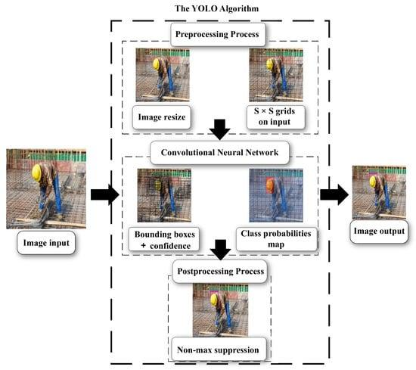

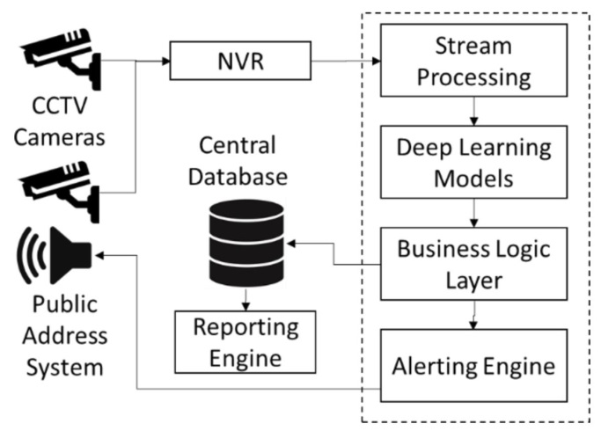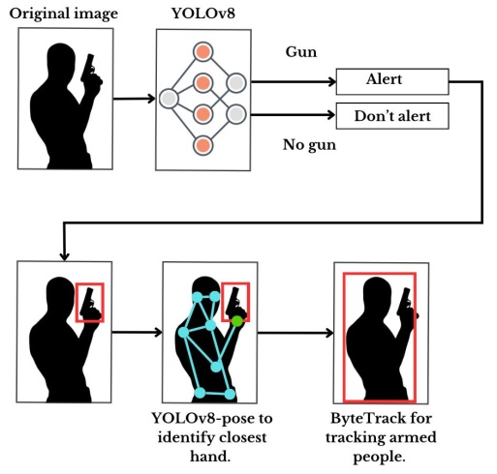

Description :
The system architecture consists of a camera capturing live video, which is processed by the YOLO model. Detected weapons trigger alert mechanisms including buzzer activation and email notifications. The system also stores captured images for further analysis.

B. Flowchart of Proposed System
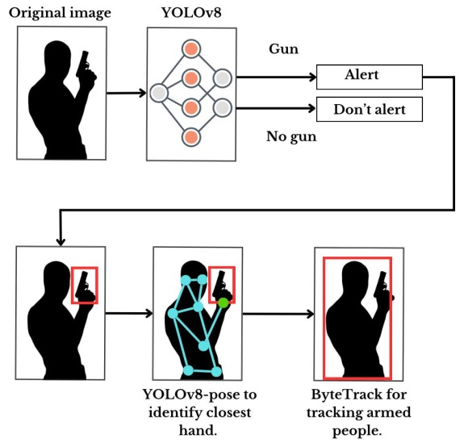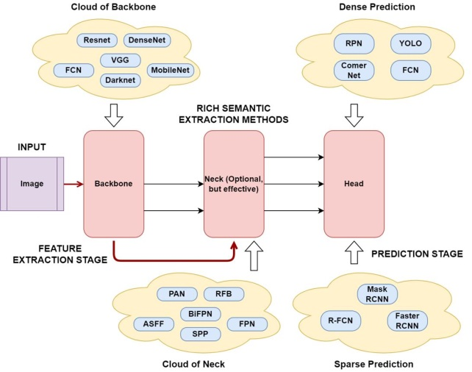
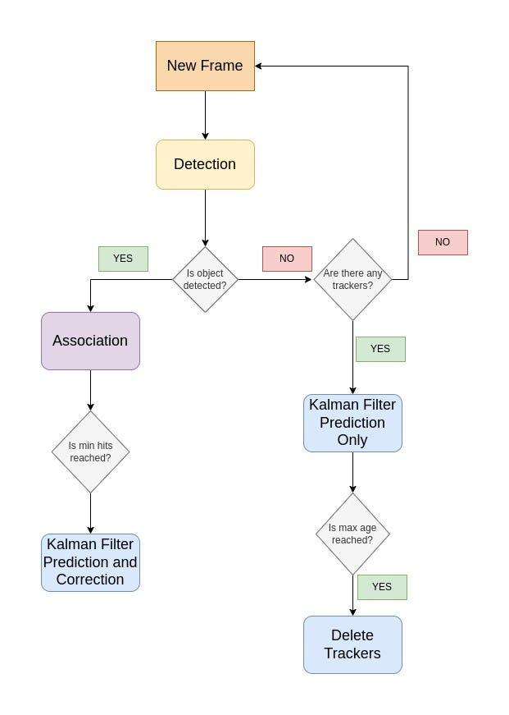

Description:
The flowchart illustrates the step-by-step process:
- Start system
- Capture video frames
- Load YOLO model
- Detect weapon
- If detected → Trigger alert & send email
- Else → Continue monitoring

C. Data Flow Diagram (DFD)
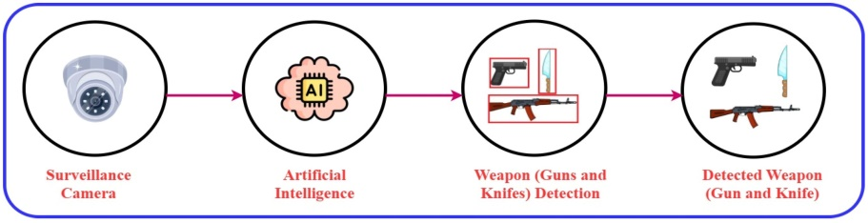
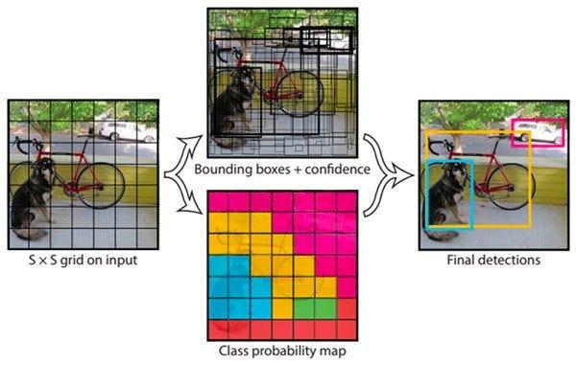
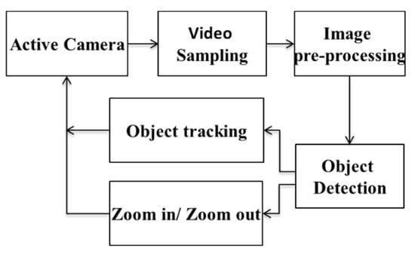

Description:
The DFD shows how input frames from the camera are converted into feature maps, processed by the YOLO model, and output as detected weapon classes with alerts.

V. METHODOLOGY

A. YOLO Algorithm
YOLO (You Only Look Once) is a real-time object detection algorithm that treats detection as a regression problem. It divides images into grids and predicts bounding boxes and class probabilities.

B. Key Techniques
- Bounding Box Detection: Identifies object location
- Intersection over Union (IoU): Measures detection accuracy
- Residual Blocks: Improve deep learning performance

C. CNN Integration
Convolutional Neural Networks (CNNs) extract image features and improve detection accuracy by identifying patterns such as edges and shapes.
SYSTEM DESIGN

A. Architecture
- Camera captures live feed
- Frames processed using YOLO model
- Weapon detection performed
- Alert system triggered
- Image sent via email

B. Workflow
- Start system
- Capture video frames
- Load trained YOLO model
- Detect weapon
- If detected:
- Trigger buzzer
- Capture image
- Send email alert
- Stop system

D. YOLO Detection Process
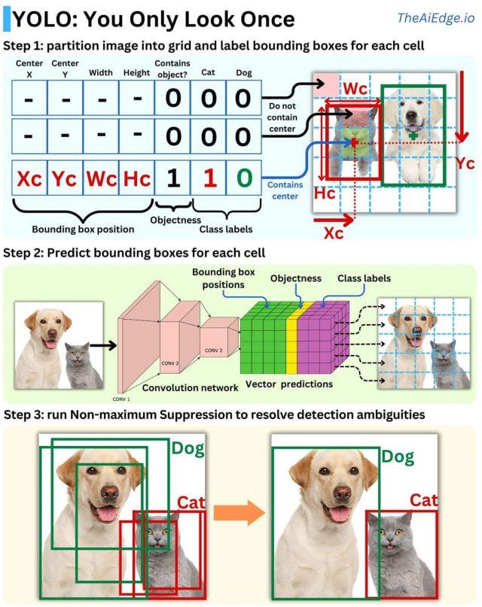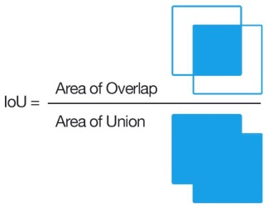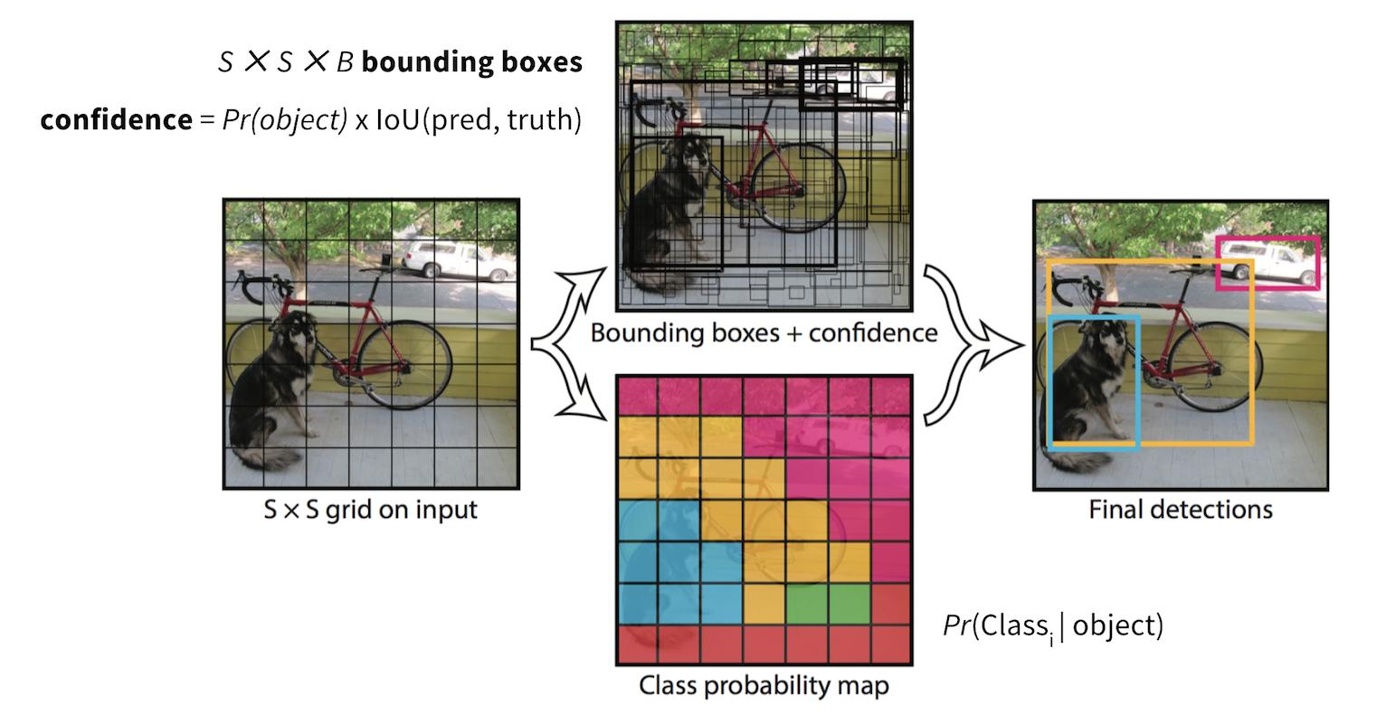

Description:
YOLO divides an image into grids and predicts bounding boxes with confidence scores. Intersection over Union (IoU) ensures accurate localization of detected objects.

VIII. RESULTS AND DISCUSSION

E. Performance Graphs
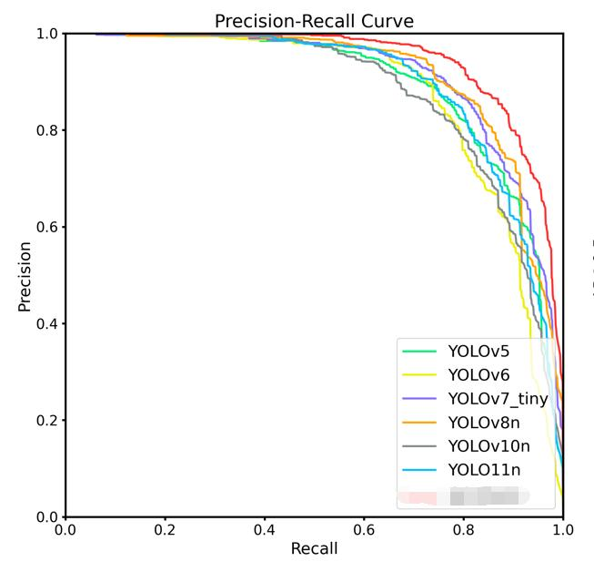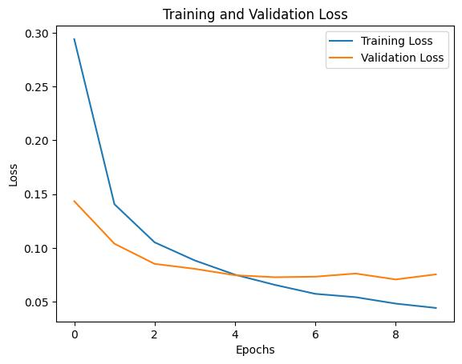
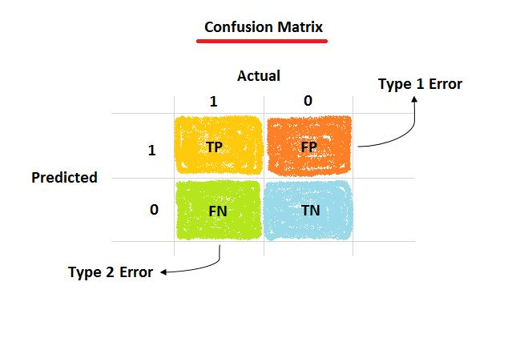
Description:
- Precision-Recall Curve: Shows trade-off between detection accuracy and recall
- mAP Graph: Evaluates overall model performance
- Loss vs Epochs: Demonstrates training convergence
- Confusion Matrix: Displays classification accuracy

III. RESULTS AND DISCUSSION
The system successfully detects weapons in real-time with high accuracy. The integration of alert mechanisms ensures immediate response, reducing potential threats.

Key observations:
- Fast detection speed
- Reliable alert system
- Reduced human dependency

IX. ADVANTAGES
- Real-time monitoring
- Automated alerts
- High accuracy
- Reduced human error
- Scalable for large systems

X. LIMITATIONS
- Performance depends on lighting conditions
- Requires computational resources
- Possible false positives

I. CONCLUSION
This paper presents a YOLO-based weapon detection and alert system that enhances security by automating surveillance processes. The system detects weapons in real-time and alerts authorities instantly, reducing response time and improving safety. Future work can focus on improving accuracy, reducing false positives, and integrating advanced models like YOLOv8.

XII. FUTURE WORK
- Integration with IoT devices
- Deployment on edge devices
- Use of advanced YOLO versions
- Improved dataset training

REFERENCES
- B. Pandey, “Weapon Detection Using YOLO V3 for Smart Surveillance System,” 2021.
- A. Belurkar, “Weapon Detection using YOLOv4 and CNN,” 2022.
- R. M., “Real-Time Weapon Detection using YOLOv8,” 2024.

