EFFECTS OF FATIGUE AMONG PILOTS’ PERFORMANCE TO SHORT-HAUL AND LONG-HAUL OPERATIONS

Acknowledgment

This study is the result of diligent data gathering, organization, and analysis. The researchers extend their sincere gratitude to the following individuals and institutions:
To PATTS College of Aeronautics, for its unwavering support in pursuing excellence in education. The institution has inspired the researchers to maintain strong academic performance and provided guidance that reinforced their commitment to completing this study with focus and dedication.
To Dr. Marianne Shalimar G. Del Rosario, for her invaluable guidance, support, and insight. Her leadership helped the researchers navigate each phase of the work with clarity and deepened their understanding of the study.
To the validators, for their thorough review and expertise. Their constructive feedback enhanced the accuracy, quality, and clarity of this work.
To the respondents and informants, especially the late Captain Paulie B. Dumagan of the Philippine Air Force. Their participation was vital in achieving the study’s objectives and their input enriched the data supporting the analysis and findings.
Most of all, the researchers give thanks to the Almighty for being their source of inspiration and strength throughout times of hardship.

Table of Contents
Page

COVER PAGE………………………………………………………………………..…………………..i

ACKNOWLEDGEMENT…………………………………………………………..……...……………ii

TABLE OF CONTENTS…………………………………………………..…………………..………..iii

ABSTRACT ……………………………………………………………………...……………………....1

I. INTRODUCTION..................................................................................................................................1
1.1. Background of the Study..................................................................................................................3
1.2. Theoretical Framework....................................................................................................................4
1.3. Conceptual Framework....................................................................................................................4
1.4. Statement of the Problem.................................................................................................................5
1.5. Hypothesis........................................................................................................................................6
1.6. Significance of the Study..................................................................................................................6
II. METHODOLOGY............................................................................................................................... 6
2.1. Research Design ..............................................................................................................................6
2.2. Respondents......................................................................................................................................6
2.3. Settings.............................................................................................................................................8
2.4. Instrumentation ................................................................................................................................9
2.5. Data Analysis ...................................................................................................................................9
2.6. Ethical Considerations....................................................................................................................10
III. RESULT AND ANALYSIS .............................................................................................................. 11
3.1. Table of SOP 1................................................................................................................................11
3.2. Table of SOP 2................................................................................................................................13
3.3. Table of SOP 3................................................................................................................................14
3.4. Table of SOP 4................................................................................................................................17
3.5. Table of SOP 5............................................................................................................................... 18
3.6. Table of Master Themes and Superordinate Themes .................................................................... 19
IV. DISCUSSION..................................................................................................................................... 22
4.1. Conclusions.................................................................................................................................... 22
4.2. Recommendations.......................................................................................................................... 24
References:............................................................................................................................................ 26
APPENDIX A........................................................................................................................................31
APPENDIX B........................................................................................................................................40
APPENDIX C........................................................................................................................................44
APPENDIX D........................................................................................................................................46
APPENDIX E .......................................................................................................................................61
APPENDIX F.........................................................................................................................................66
APPENDIX G........................................................................................................................................69
APPENDIX H........................................................................................................................................71

EFFECTS OF FATIGUE AMONG PILOT’S PERFORMANCE TO SHORT-HAUL AND LONG-HAUL OPERATIONS
John Carlos D. Agbayani, Jiro G. Bayang, Mark Andre Y. Belenson, Christian Ray C. Concepcion, Jeremy S. Pelobello
BS Air Transportation, PATTS College of Aeronautics
Lombos Avenue, Brgy.San Isidro, Parañaque City
ATRN 417- 1A Group 4
This research examined how fatigue affects pilot performance in short-haul and long-haul operations. The discussion included aviation safety issues connected to sleep loss, workload, schedule patterns, and cockpit conditions. These factors shaped alertness and decision-making in daily flight operations. The researchers collected data from 42 pilots from commercial, general aviation, predominantly as charter pilots, and military groups. Three informants added operational details that helped explain real fatigue management challenges. Descriptive statistics and ANOVA were used to measure differences in Fatigue across age, sex, years of service, and flight type. The findings showed strong links between irregular schedules, circadian rhythm disruption, limited sleep, and high workloads. These factors increased fatigue in both short-haul and long-haul conditions. Short-haul pilots described quick fatigue buildup due to multiple legs, tight turnarounds, and repeated takeoffs and landings. Long-Haul pilots described extended wakefulness, night operations, and circadian misalignment during long duty periods. Both groups highlighted reduced alertness, slower reactions, and difficulty maintaining situational awareness. These effects were common during approach, landing, and operations in complex airspace, showing clear risks to aviation safety. The results also showed differences in how pilots respond to fatigue. Older pilots reported stronger physical tiredness. Younger pilots were less consistent with fatigue management habits. Pilots with more years of service understood fatigue effects better due to broader flight operations experience. All respondents agreed that fatigue affects pilot performance and aviation safety. They emphasized the need for stronger fatigue management strategies within airline systems. The researchers concluded that better scheduling, strict rest compliance, and stronger organizational support improve safety outcomes. The researchers recommended improved duty-time planning, stronger fatigue risk management systems, and better personal readiness practices. These steps help maintain pilot performance and protect both short-haul and long-haul operations.
Keywords: Aviation Safety, Fatigue, Fatigue Risk Management, Flight Operations, Long-Haul, Pilot Performance, Short-Haul.

- INTRODUCTION
Fatigue is a major issue in aviation that directly affects flight safety and performance. Pilots often face long duty hours, irregular schedules, and demanding workloads that reduce alertness and reaction time. These conditions increase the risk of errors during flight operations. Fatigue impairs decision-making, coordination, and situational awareness, which are essential for safe flight. Managing fatigue is a major focus in aviation safety programs, as understanding its causes and effects helps in developing strategies to protect pilots and passengers.
Fatigue produces measurable declines in both physiological and psychological functions. Research shows that reaction time, coordination, and cognitive processing speed degrade during extended or continuous flight duty periods (Hanakova et al., 2019; Hanáková et al., 2021). Studies using physiological sensors found significant variations in heart rate, attention, and eye activity linked to fatigue buildup (Thomas et al., 2015; Zhang et al., 2022). These findings confirm that fatigue is not only subjective but also quantifiable through psychophysiological markers that influence pilot alertness and safety (Quental et al., 2021; Kim & Choi, 2021).
Fatigue is shaped by multiple factors, including workload, environmental conditions, and individual sleep patterns. High workload intensity and poor sleep quality predict greater fatigue severity, particularly in multi-leg flight operations (Arsintescu et al., 2020; Keller et al., 2021). Studies show that caffeine intake can provide temporary alertness benefits, but long-term fatigue reduction depends on rest management and structured sleep opportunities (Utamatanin & Pariwatcharakul, 2022). Work schedule design, duty-time limitations, and pilot well-being programs have become essential components of modern fatigue risk management systems (Venus, 2021; Lee & Kim, 2018).
Pilot fatigue remains a global safety issue that impacts all types of aviation operations. Long and irregular duty periods cause sleep loss, circadian disruption, and slower cognitive performance, increasing the likelihood of operational errors (Caldwell, 2016; Arsintescu et al., 2020). Short-haul pilots often experience compressed schedules and limited rest opportunities, while long-haul pilots struggle with time zone shifts and extended wakefulness (Hilditch et al., 2023; Venus, 2021). These operational differences create distinct fatigue profiles that demand tailored management strategies (Schmid & Stanton, 2019; Jun-Ya & Rui-Shan, 2023).
Pilot surveys consistently reveal that fatigue management systems are not fully effective in operational settings. Pilots report inadequate recovery times, unpredictable rosters, and organizational barriers that discourage open fatigue reporting (Gander et al., 2018; Zaslona et al., 2018). Focus group research also highlights pilot concerns about workload intensity and limited rest breaks during short-haul operations (Hilditch et al., 2023; Gaines et al., 2023). Shared responsibility between airlines and flight crews remains essential for improving fatigue mitigation policies and ensuring compliance in real-world operations (Jun-Ya & Rui-Shan, 2023; Keller et al., 2021).
Recent developments focus on predictive modeling and technology-based fatigue detection. Algorithms using physiological and behavioral data aim to estimate fatigue coefficients and predict alertness levels under varying flight durations (Zhang et al., 2022; Schmid & Stanton, 2019). These tools help operators evaluate pilot performance and align fatigue thresholds with safety margins (Morris et al., 2020; Morris et al., 2023). Studies show that integrating these models with existing fatigue risk management systems improves monitoring accuracy and reduces performance variability caused by sleep loss (Gaines et al., 2023; Quental et al., 2021). Continuous research combining human factors, physiology, and scheduling science remains critical to enhancing aviation safety through effective fatigue control (Hanáková et al., 2021; Caldwell & Caldwell, 2016).
In aviation, one of the key challenges is fatigue since it affects the pilots' alertness and slows their mental processes, which in turn increases the probability of errors. Studies reveal that the outcome of fatigue is the reduction of the pilots' reaction time, loss of coordination, and cognitive processing. The demonstration of the impact of fatigue on performance has been made possible by the adoption of physiological indicators like heart rate and eye movement. The degree of fatigue is highly determined by factors such as demanding tasks, insufficient sleep, and extreme environments, while drugs might temporarily help; however, the most effective ways of fighting fatigue are still getting proper sleep and smartly organizing work hours. Even though there are fatigue management systems in place, many pilots still express their dissatisfaction over the amount of recovery time, erratic work schedules, and lack of support from management in cases of reporting fatigue. New technologies and predictive models are being used to more accurately define fatigue risks; however, pilots, airlines, and researchers' collaboration is still the best way to improve monitoring, enlarge safety margins, and guarantee the overall safety of the flight.
1.1. Background of the Study

Pilot fatigue had been recognized in global aviation for many years, and the concern continued to grow as flight operations expanded. Airlines increased domestic and international routes, and pilots faced tighter schedules with changing duty patterns. Many pilots still reported high fatigue levels even with rest rules in place (Brezonakova et al., 2023). Short-haul pilots experienced heavy workload from repeated takeoffs and landings. Long-haul pilots faced extended duty periods, irregular sleep, and circadian disruption. Personal routines, long commutes, and lifestyle patterns added further strain.

In the Philippines, concerns about fatigue became more noticeable as the aviation sector grew. Manila became a major hub for domestic and international flights. Pilots dealt with irregular schedules, heavy air traffic, weather challenges, and delays that increased workload. Many pilots traveled long distances to reach duty stations due to traffic congestion and housing conditions around the city. These local issues added pressure on alertness and sleep patterns. Philippine carriers followed PCAR requirements and international standards, yet pilots continued to report high fatigue across short-haul and long-haul operations.

Fatigue affected the physical and cognitive capacity of pilots. Reaction time slowed, alertness dropped, and decision-making accuracy decreased. Sleep-deprived pilots performed poorly in simulation studies, which showed the direct link between fatigue and reduced flight safety (Quental et al., 2021). Pilots who lacked rest were more prone to communication errors and loss of situational awareness during demanding phases of flight.

Aviation organizations introduced strategies to manage fatigue. These included fatigue risk management systems, roster adjustments, structured rest opportunities, and programs that encouraged proper sleep habits. These measures supported safety, yet they managed fatigue rather than removing it.

Studying fatigue in the Philippine context was important because local working conditions influenced how pilots experienced workload, rest, and daily stress. A clear understanding of these factors supported recommendations that strengthened safety, improved pilot performance, and guided future improvements within Philippine aviation.

1.2. Theoretical Framework

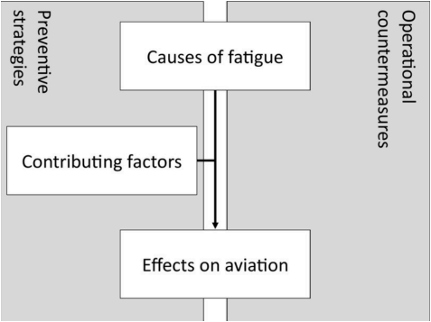

Fig. 1: Root Cause Analysis of Fatigue and Areas of Influence of Fatigue Management in Aviation
This study draws its foundation from the framework “Root Cause Analysis of Fatigue and Areas of Influence of Fatigue Management in Aviation” developed by Wingelaar-Jagt, Wingelaar, Riedel, and Ramaekers (2021). Their work provides a comprehensive overview of fatigue in aviation, identifying its primary causes, contributing factors, and management strategies to reduce its negative impact on flight operations. The framework describes fatigue as a complex phenomenon rooted in physiological limitations such as sleep deprivation, extended wakefulness, circadian disruption, and workload. These causes are further influenced by operational and environmental conditions, including flight scheduling, time-zone changes, and rest settings, which make fatigue a continuing challenge for pilots.

The framework is relevant to the present study, which aims to assess the causes of pilot fatigue, its contributing factors, and potential mitigation strategies. By applying this model, the study gains a structured perspective on how fatigue develops, how it surfaces in pilot performance, and which responses are most effective in minimizing its risks. The inclusion of both preventive measures, such as regulations, optimized rostering, and education on sleep hygiene, and operational countermeasures such as controlled rest, bunk rest, and pharmacological aids, makes the framework practical and adaptable to real-world aviation scenarios.

The decision to use this framework is grounded in its direct alignment with the objectives of the research. Since pilot fatigue is recognized as one of the most critical human factors affecting aviation safety, the framework of Wingelaar-Jagt et al. (2021) provides not only a theoretical basis but also an operationally relevant guide. It allows the study to connect the physiological realities of fatigue with practical strategies for mitigation, ensuring that the findings contribute both academically and practically to the improvement of aviation safety standards.

1.3. Conceptual Framework

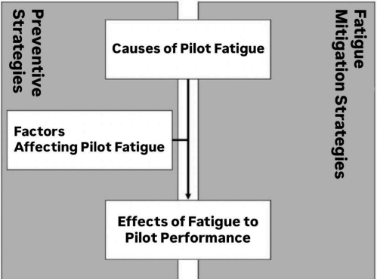

Fig. 2: Adapted diagram of fig. 1 of Root Cause Analysis of Fatigue and Areas of Influence of Fatigue Management in Aviation

This research's conceptual model is based on the model "Root Cause Analysis of Fatigue and Areas of Influence of Fatigue Management in Aviation" by Wingelaar-Jagt, Wingelaar, Riedel, and Ramaekers (2021). It was then adjusted to suit this research's objectives, which aim to study pilot fatigue causes and contributing factors, as well as preventive and mitigation measures. By basing the research on this model, there is a systematic framework through which to interpret how fatigue emerges, affects pilot performance, and may be treated with effective interventions.

Within this model, the independent variables are the main causes of pilot fatigue, which are influenced by operations and environment, and the dependent variable is pilot performance, which captures the effects of fatigue in reality. The model also contains two main components: preventive strategies, which are the practices-in-use found in aviation today, and fatigue mitigation strategies, which are study-based and research-supported recommendations for mitigation countermeasures.

The conceptual framework documents the interplay among the causes of fatigue, contributing factors, and their impact on pilot performance, as well as presents precautionary measures and proposed mitigation strategies. This framework directs the study to bridge the gap between the physiological and operational facts of fatigue with pragmatic solutions so that its conclusions may help improve aviation safety.

1.4. Statement of the Problem

The study aimed to assess the causes and factors contributing to pilot fatigue and examine its effects on pilot performance in short-haul and long-haul operations. The study sought to explore and interpret pilots’ personal experiences, perceptions, and insights regarding fatigue during flight operations. Furthermore, it aimed to evaluate respondents’ opinions on the differences in fatigue between short-haul and long-haul flights.

Specifically, the study sought the answers to the following questions:

- What are the specific causes and factors that contribute to pilot fatigue?

- What are the impacts of fatigue on pilots’ performance during short-haul and long-haul flights?

- What are the different types of fatigue mitigation strategies applicable to pilots?

- Sleep and Fatigue Mitigation Strategies
- Fatigue Risk Management and Regulatory Perspectives
- Impact of Fatigue on Flight Operations and Individual Differences

- Is there a significant difference between pilot fatigue and the performance of pilots?

- Is there a significant difference impacts of fatigue on pilots’ performance during short-haul and long-haul flights based on their profile:

- Age
- Sex
- Years Of Service

- How does monitoring Fatigue Risk Indicators support safer flight operations?

1.5. Hypothesis

Null Hypothesis:

There is no significant difference between the effects of pilot fatigue on pilots’ performance, whether it is short-haul or long-haul operations.

1.6. Significance of the Study

- Student Pilots: They will benefit from understanding how fatigue affects performance, decision making, and safety during training. This awareness will guide them to adopt healthier sleep habits, manage workload, and practice safer flying behavior early in their careers.

- Teachers: Educators will gain evidence-based insights on how fatigue influences learning and operational performance. This will help them adjust teaching strategies, schedule training more effectively, and emphasize safety practices that reduce fatigue risks.

- Schools: Aviation-related schools will benefit by integrating fatigue awareness and management into their training curriculum. This strengthens the quality of aviation education, produces more safety-conscious graduates, and aligns programs with international safety standards.

- Future Researchers: The study will serve as a reference for future research in aviation human factors. It will provide localized data on fatigue in the Philippine context, which future researchers can build on to explore interventions, policy improvements, and advanced fatigue monitoring methods.

- METHODOLOGY

2.1. Research Design

The study used a mixed-method design combining descriptive analysis with a snowball sampling method to examine how fatigue affects pilots’ performance on short-haul and long-haul flights. The quantitative component measured relationships between fatigue levels and performance indicators, while the qualitative component explored pilots’ experiences and perceptions of fatigue. Snowball sampling was used to reach pilots through referrals, ensuring access to participants with relevant flight experience. This approach provided both statistical insight and contextual understanding of pilots’ daily fatigue experiences. The researchers analyzed reported fatigue types and assessed whether these patterns were linked to performance differences across flight durations. Using this design, the study presented a comprehensive view of pilot fatigue and performance, identifying practical areas for improving flight schedules, safety, and pilot well-being.

2.2. Respondent

The majority of respondents are male, representing 88.10% of the total sample, while females account for 11.90%. Most participants are general aviation pilots who fly on-demand flights using smaller aircraft. They are usually under non-airline operators, comprising 50% of the respondents. This shows that general aviation pilots were more active in responding to the survey than those in commercial or military service. The survey was limited to pilots based in the Philippines to maintain focus and accuracy in data collection. There are an estimated 3,000 pilots in the country. Slovin's Formula was used to produce a sample size of 353 respondents, with an error margin of 5%. Slovin's formula is used to ensure that the selected sample accurately represents the opinions and experiences of all pilots in the sector. However, due to time constraints, the researcher only collected 37 male pilots and 5 female pilots, which is an acceptable rate of 10% to 15% of the total population. With 42 responses in total, the researchers achieved an acceptable rate of 11%. After the survey, the researcher conducts an interview and asks qualitative questions. Three respondents were interviewed: two who completed the survey and one who served as a validator.

SEX | FREQUENCY | PERCENTAGE
Male | 37 | 88.10
Female | 5 | 11.90
Total | 42 | 100.00

Table 1: Frequency Distribution of Respondents by Gender

The data shows that it is mostly composed of male pilots, accounting for 88.10% or 37 of the 42 respondents. Female pilots make up 11.90%, representing only 5 participants. This distribution reflects the gender imbalance common in the aviation industry, where male pilots still dominate the workforce. The high male participation supports the study’s reliability since it mirrors the actual demographic trend in aviation.
AGE | FREQUENCY | PERCENTAGE
30 Below | 31 | 73.80
31 Above | 11 | 26.20
Total | 42 | 100.00

Table 2: Frequency Distribution of Respondents by Age

Most respondents are 30 years old and below, totaling 31 or 73.80% of the participants. Only 11 pilots, or 26.20%, are aged 31 and above. This pattern shows that the majority of the respondents are young professionals, likely in the early stages of their flying careers. Their age profile is relevant since younger pilots often experience higher workload exposure and irregular schedules that can influence fatigue levels.

TYPE OF SERVICE | FREQUENCY | PERCENTAGE
Commercial Airline Pilot | 17 | 40.50
General Aviation Pilot (Charter pilots under non - airline operators) | 21 | 50.00
Military Pilot | 4 | 09.50
Total | 42 | 100.00
Table 3: Frequency Distribution of Respondents by Type of Service

The analysis of service types among the 42 respondents reveals notable demographic trends, particularly the predominance of general aviation pilots serving as charter pilots, who represent 21 participants (50.00% of the total).In comparison, commercial airline pilots account for 17 participants (40.50%), while military pilots make up only 4 participants (9.50%). This distribution shows that general aviation pilots were more engaged in the study, suggesting greater accessibility or willingness to participate compared to those in commercial and military operations.

YEARS IN SERVICE | FREQUENCY | PERCENTAGE
5 Below | 31 | 73.80
6 Above | 11 | 26.20
Total | 42 | 100.00

Table 4: Frequency Distribution of Respondents by Years in Service

The analysis of years in service among the 42 respondents shows that a majority of pilots, totaling 31 participants (73.80%), have been in the profession for 5 years or less. Only 11 participants (26.20%) have more than 6 years of service. This pattern indicates that most respondents are relatively new to aviation, likely still building their flight experience. The higher participation of less experienced pilots suggests stronger research engagement among those in the early stages of their careers.
The respondent profile shows a young, male-dominated group, primarily composed of general aviation pilots serving in charter operations, with generally limited years of service. This composition enhances the study’s credibility by aligning with actual workforce trends while also providing insight into how fatigue affects less experienced pilots. The diversity in service type and years of experience ensures that the findings reflect a balanced view of pilot fatigue across different aviation sectors.
To gather in-depth insights, this study employed a mixed research approach that combined survey questionnaires with semi-structured interviews involving three key informants. Two of these informants were experienced aviation professionals who provided expert insights into pilot fatigue, while the third was a survey participant who shared firsthand experiences and perspectives. This combination allowed for the validation of survey data through both expert opinion and real-world experience.
2.3. Settings
The study was conducted in a recognized aviation school located in Parañaque City, which served as the primary research site due to its accessibility to aviation professionals and its specialized role as a training hub for aspiring pilots. Survey participants were recruited through a combination of judgment sampling and the snowball sampling method. This dual approach allowed the researchers to identify initial participants based on their qualifications and relevance to the study, while also enabling referrals to additional participants who met the inclusion criteria. To ensure that diverse perspectives from pilots at different stages of their careers were fairly represented, the classification of respondents was structured according to age, type of pilot (e.g., general aviation pilot, commercial airline pilot, military pilot), and years of professional experience. This stratification helped establish a balanced representation of the aviation community, thereby contributing to a more comprehensive and equitable assessment of pilot experiences.
The total number of respondents formed the sampling frame, from which participants within each stratum were carefully identified and included through the combined sampling techniques. Although judgment and snowball sampling inherently involve non-random selection, the researchers incorporated randomization within each identified stratum to reduce potential bias and to provide participants with equal opportunities to be included. This methodological choice was designed to enhance fairness, proportionality, and representativeness across various segments of the aviation industry.
Furthermore, the selection of the aviation school in Parañaque City as the research setting was strategic, as it provided access to a highly specialized pool of respondents and relevant institutional resources. This context not only ensured the feasibility of the data-gathering process but also underscored the importance of evaluating the availability and effectiveness of such resources in producing reliable and valid research outcomes.
The scope of this study is to examine pilot fatigue, its contributing factors, and its operational impacts among pilots in different aviation sectors in the Philippines through self-report surveys and qualitative interviews. This scope aligns with research showing that sleep loss, extended wakefulness, circadian misalignment, and workload drive fatigue in flight operations (Wingelaar Jagt et al., 2021). ICAO guidance states that fatigue studies need to consider organizational context, safety performance, and science-based risk management processes (Fatigue Management Approaches, 2025). The study focuses on workload patterns, rest patterns, and pilot perceptions across flight types. This approach captures subjective fatigue experiences and the operational factors linked to them.
Several limitations influence how the findings should be interpreted. Self-report tools reduce precision because subjective fatigue scores do not always match true cognitive decline. Pilots on ultra-long flights reported higher fatigue levels even when objective concentration stayed stable (Gläsener et al., 2023). The cross-sectional design limits the ability to observe cumulative fatigue that develops across duty cycles and shifting circadian phases. The sampling is context-specific because the respondents come from one aviation school and its partner network. This limits generalizability because pilots in other airlines follow different roster structures, rest facilities, and fatigue risk systems. ICAO notes that fatigue risk varies with operational context, so the results apply only to the sampled environment (Fatigue Management Approaches, 2025). The study also excludes objective monitoring tools such as actigraphy, fatigue modeling, or reaction time testing. These tools detect subtle fatigue patterns that subjective ratings miss.
Fatigue mechanisms differ between flight types. Long-haul pilots face circadian disruption, long duty periods, and reduced sleep. These factors raise subjective fatigue in ultra-long operations (Gläsener et al., 2023). Short-haul pilots face intense workload from frequent takeoffs and landings, short turnarounds, and repeated task demands. High workload strains cognitive resources and increases error risk (Wingelaar Jagt et al., 2021). These differences show the need for targeted mitigation, with circadian-based strategies for long haul and workload-based strategies for short haul. ICAO supports this through performance-based FRMS tailored to each operation (Fatigue Management Approaches, 2025).
The findings align with human factors theory. Fatigue reduces vigilance, situational awareness, and decision accuracy (Wingelaar Jagt et al., 2021). ICAO identifies fatigue as a safety hazard that requires systematic monitoring and management (Fatigue Management Approaches, 2025). The results support the need for fatigue education, better rostering, rest optimization, and stronger FRMS practices in aviation training and professional environments.
2.4. Instrumentation
The study used a self-survey questionnaire that included questions about the effects of fatigue on pilots' performance during short and long-haul flights. To know if the respondents can relate to the questions on the survey, the researchers used a 4-point Likert scale in which (4 - Strongly Agree, 3 - Agree, 2 - Disagree, 1 - Strongly Disagree). The choice of a 4-point scale, rather than one with a neutral midpoint, was intentional to encourage the respondents to take a definitive stance on each item.
The questionnaire's content was validated by 3 experts in their fields of aviation. Based on the validator's corrections and suggestions, the questionnaires were revised. Additionally, a pilot test was conducted with a small sample of respondents to identify any mistakes or inconsistencies in the questionnaire. The instrument was designed to effectively measure the impact of fatigue on pilot performance.
The researchers used Cronbach’s alpha to assess the questionnaire's consistency, which resulted in 0.898, within the acceptable threshold of 0.7. The final survey was conducted via Google Forms, which was answered by a Military Pilot, a Commercial Licensed Pilot, and a Private Licensed Pilot in Manila. With their answer, the researchers gained insight into how pilot fatigue affects pilot performance from the pilot's perspective. The researchers were able to conduct an online interview with two (2) active pilot respondents and one (1) validator. To gather the experiences and perspectives of the respondents and validators, four semi-structured interview questions were asked. The interview questions were as follows:
1. How does pilot fatigue during short-haul and long-haul operations affect flight performance, and what measures could airlines implement to reduce its impact on safety and operational efficiency?
2. In what ways could managing pilot fatigue in short-haul and long-haul operations improve performance and ensure safer, more efficient flights, especially during demanding flight conditions?
3. How could effective fatigue management programs support pilots with varying experience levels and flight schedules in both short-haul and long-haul operations, while ensuring consistent performance and safety standards across all flight conditions?
4. What recommendations would you propose for airlines and aviation authorities to effectively manage and prevent pilot fatigue in both short-haul and long-haul operations to maintain safety and performance standards?

2.5. Data Analysis

The collected data were systematically arranged, encoded, and analyzed to determine the effects of fatigue on pilot performance in both short-haul and long-haul flight operations. The study utilized a quantitative research approach, supported by descriptive and inferential statistical methods, to ensure that the results were interpreted accurately and objectively. The primary research instrument was a validated self-survey questionnaire designed to assess the relationship between fatigue and performance, using a 4-point Likert scale (4 – Strongly Agree, 3 – Agree, 2 – Disagree, 1 – Strongly Disagree).

Before conducting the main data collection, a pilot test was administered to verify the clarity and consistency of the questionnaire. The results were evaluated through Cronbach’s Alpha reliability testing, which confirmed the internal consistency of the items. Based on expert validators’ feedback, necessary revisions were made to ensure that the instrument effectively measured the intended variables.

After validation, the final questionnaire was distributed to licensed pilots representing various sectors of the aviation industry, including commercial, general aviation, and military service. The sample size was determined using Slovin’s Formula to maintain representativeness within the pilot population. Respondents were identified through a combination of judgment and snowball sampling methods, allowing access to participants with appropriate qualifications and experience.

The gathered data were processed and analyzed using the Statistical Package for the Social Sciences (SPSS) software. Descriptive statistics, such as frequency, percentage, mean, and standard deviation, were used to summarize demographic data and describe general patterns of fatigue and performance responses. To explore the relationships between fatigue-related factors and pilot performance, inferential statistics were applied. Specifically, correlation analysis was used to identify the strength and direction of association between variables, while Analysis of Variance (ANOVA) tested whether significant differences existed between fatigue levels in short-haul and long-haul operations. The level of significance was set at 0.05 (α = 0.05) to determine whether to reject or fail to reject the null hypothesis.

The transcript of open-ended responses from participants was analyzed using thematic analysis to identify recurring patterns and common themes. This systematic process ensured that the data were thoroughly examined, allowing for both statistical accuracy and interpretive depth. The findings derived from these analyses provided the foundation for addressing the study’s research questions and evaluating the difference between fatigue and pilot performance in various flight operations.
2.6. Ethical Considerations

This research is committed to ensuring the safety and privacy of all respondents. All collected information will be securely stored and treated with strict confidentiality. In the process of validating the questionnaires and the statement of the problem, the researchers sought approval from a professional validator through a formal letter signed by the thesis advisor. The validators were contacted at their convenience to avoid disruptions to their professional responsibilities. During the validation process, the researchers thoroughly explained the study's objectives to enhance the quality of the questionnaire and key research variables. Based on the validators’ feedback, revisions were made, and the research proceeded to the pilot testing phase. The revised questionnaire was tested on students from aviation schools. The researchers explained the purpose of the study and respectfully requested the participants' time to complete the pilot test questionnaire. Insights and feedback from this phase were used to further refine the questionnaire for the actual survey, addressing any identified gaps.

For the actual survey, all procedures were conducted with the permission of the relevant institutions and under the guidance of the research advisor. The study adhered to strict guidelines to ensure that the objectives were communicated and that every aspect of the research was handled with care. The researchers also studied and complied with the airbase’s protocols, providing a formal letter of consent for the study. All respondents' personal information will be protected, and their identities will remain anonymous throughout the research. Participation is entirely voluntary, and care was taken to ensure that the respondents experienced no inconvenience or discomfort during the process. Respondents were politely asked for their consent and were surveyed in well-ventilated, comfortable settings to ensure their confidence and ease.

III. RESULT AND ANALYSIS

3.1. The different factors that contribute to pilot fatigue during short-haul and long-haul flights

Statement | S.D. | W.M. | Remarks
Can irregular schedules and circadian rhythm disruption be considered specific causes of pilot fatigue? | 0.69677 | 3.38 | Strongly Agree
Does lack of sleep and heavy workload significantly contribute to pilot fatigue? | 0.65020 | 3.67 | Strongly Agree
Can differences between domestic and international flights influence the level of pilot fatigue? | 0.93207 | 2.90 | Agree
Do student pilots face a higher chance of fatigue compared to commercial pilots? | 1.06251 | 2.57 | Agree
Does the aircraft environment affect the fatigue levels of airline pilots? | 0.76243 | 3.17 | Agree
Would stricter duty and rest limits fail to reduce fatigue risks in short-haul flights? | 0.79378 | 2.83 | Agree
Can your duty hours and schedules negatively impact pilot performance? | 0.82075 | 3.10 | Agree
SOP 1 | 0.81693 | 3.09 | Agree

Legend: 3.25-4.00 - strongly agree 2.50-3.24 - agree 1.75-2.49 - disagree 1.00-1.74 - strongly disagree

Table 5: Mean and Standard Deviation in different factors that contribute to pilot fatigue during short-haul and long-haul flights

Table 5 references various causes of pilot fatigue during short-haul flights and long-haul flights. Respondents strongly agreed that both irregular schedules and disruption of circadian rhythms are the specific causes of pilot fatigue (Weighted Mean = 3.38, SD = 0.69677). Respondents strongly agreed that lack of sleep or a heavy workload contributes to fatigue in pilots (Weighted Mean = 3.67, SD = 0.65020). These findings concluded that sleep deprivation and demanding schedules are viewed as significant contributors to fatigue in the aviation setting.
Respondents rated several factors, including the differences between domestic and international flights (Weighted Mean = 2.90, SD = 0.93207) and the aircraft environment (Weighted Mean = 3.17, SD = 0.76243), with general agreement, which suggests both the conditions created during a flight and the operational environment contribute to factors that determine or contribute to fatigue. Respondents also agreed that duty hours and schedules are negatively affected by a pilot's performance (Weighted Mean = 3.10, SD = 0.82075), which also infers that fatigue is a factor associated with or related to workload and time off.
On the other hand, the lowest mean weighted score was evident with students having a greater chance of fatigue on a flight compared with commercial pilots (Weighted Mean = 2.57, SD = 1.06251). This score had the greatest than all statements and suggests respondents had more variability in their opinions on this mechanism. This variability could be due to the differing training environments, flight hour expectations, and operational responsibilities between each group.
The overall average weighted mean of 3.09 indicates that respondents tended to agree that various factors, including scheduling, workload, and environmental conditions, contributed to pilot fatigue. These results underscore the importance of effective fatigue risk management programs for both short-haul and long-haul operations that will preserve pilot performance and flight safety.
The research suggests that both irregular work hours and circadian rhythm disruptions are the two most common causes of fatigue in the aviation environment (Caldwell & Caldwell, 2016; Gander et al., 2021). The strong agreement from respondents is consistent with research that indicated that long duty days, along with not getting enough sleep, were both proportional to decreased alertness and cognitive performance of pilots. Environmental factors such as noise, cabin pressure, and temperature were also noted in the research as being likely cumulative fatigue factors that reduce situational awareness.
Overall, it is clear that managing fatigue from a holistic perspective will include work schedules, sleep quality, and environmental factors. Implementing evidence-based fatigue management initiatives can mitigate some of the associated risk factors pilots face toward fatigue and encourage safer flight operations across flight duration.

3.2 The impacts of fatigue on pilots’ performance during short-haul and long-haul flights

Statement | S.D. | W.M. | Remarks
Does physical performance decline after extended periods of wakefulness? | 0.70340 | 3.43 | Strongly Agree
Do pilots experience slower reaction times by the end of a long duty period? | 0.81258 | 3.21 | Agree
Do long periods of continuous duty cause measurable changes in pilots’ body response related to fatigue? | 0.66478 | 3.40 | Strongly Agree
Do physical activity and overall energy levels decrease significantly during periods of pilot fatigue on long flights? | 0.72615 | 3.24 | Agree
Can body monitoring systems give accurate information about pilot fatigue during different flight types? | 0.69551 | 2.83 | Agree
SOP 2 | 0.72048 | 3.22 | Agree

Legend: 3.25-4.00 - strongly agree 2.50-3.24 - agree 1.75-2.49 - disagree 1.00-1.74 - strongly disagree

Table 6: Mean and Standard Deviation in the impacts of fatigue on pilots’ performance during short-haul and long-haul flights

Table 6 illustrates pilots' perceptions regarding the impact of fatigue on their physical performance. The inquiry, "Does physical performance decline after extended periods of wakefulness?" yielded a weighted mean of 3.43 with a standard deviation of 0.70340, which is interpreted as a strong agreement. This suggests that a significant number of pilots recognize a noticeable reduction in physical capability when remaining awake for prolonged hours. A comparable response was noted for the question, "Do long periods of continuous duty cause measurable changes in pilots’ body response related to fatigue?" which also achieved a strongly agree rating, with a weighted mean of 3.40 and a standard deviation of 0.66478.
Other statements received an agree rating, such as the observation of slower reaction times following extended duty periods (Weighted Mean = 3.21, SD = 0.81258) and diminished energy levels during fatigue on lengthy flights (Weighted Mean = 3.24, SD = 0.72615). The assessment of body monitoring systems for fatigue detection garnered a lower mean of 2.833 (SD = 0.69551), indicating some uncertainty among pilots regarding the dependability of these technologies. The calculated total mean of 3.22 (SD = 0.72048) reflects a consistent consensus that fatigue significantly affects physical performance.
These results align with previous studies indicating that prolonged wakefulness and extended flight duties impair alertness, coordination, and reaction time in pilots (Caldwell & Caldwell, 2016). Fatigue restricts physical endurance and situational awareness, both of which are crucial for safe flight operations. The mixed confidence in body monitoring systems underscores the necessity for further technological validation to ensure precise fatigue detection. The findings emphasize the importance of structured rest schedules, effective workload management, and the implementation of reliable monitoring tools to uphold pilot performance and ensure flight safety.

3.3 The different types of fatigue mitigation strategies applicable to pilots:

3.3.1. Sleep and Fatigue Mitigation Strategies

Statement | S.D. | W.M. | Remarks
Do you believe that in-flight sleep is less restorative compared to sleep obtained on the ground? | 0.81114 | 3.02 | Agree
Do you agree that using results from one airline or fleet to guide another can lead to inaccurate conclusions about fatigue? | 0.69217 | 2.64 | Agree
Do you believe that morning-duty pilots are less likely to use fatigue mitigation strategies compared to evening-duty pilots? | 0.91606 | 2.55 | Agree
Do you avoid using supplements such as energy vitamins to help manage rest and recovery during or after missions? | 0.89683 | 2.69 | Agree
SOP 3 (Sleep and Fatigue Mitigation Strategies) | 0.82905 | 2.73 | Agree

Legend: 3.25-4.00 - strongly agree 2.50-3.24 - agree 1.75-2.49 - disagree 1.00-1.74 - strongly disagree

Table 7: Mean and Standard Deviation in terms of Sleep and Fatigue Mitigation Strategies.

This table looks into how pilots manage fatigue through rest and sleep-related practices. It discusses how different habits, schedules, and operational settings affect the quality of rest and how these factors shape overall fatigue management in flight operations. The goal is to understand how pilots view sleep as part of their strategy to maintain alertness and performance, despite demanding and irregular flight conditions.

The results show that respondents generally recognize the importance of proper rest in managing fatigue, with an overall weighted mean of 2.73 and a standard deviation of 0.82905. Many agreed that sleep during flight is far less restorative than sleep on the ground (WM = 3.02), supporting the observations of Zaslona et al. (2018), who found that in-flight rest is often disturbed by turbulence, cabin noise, and limited space. Pilots also believed that fatigue patterns and management practices vary between airlines and fleets (WM = 2.64), a point emphasized by Gander et al. (2018), who argued that each operator’s flight schedules and duty structures demand tailored fatigue programs. Furthermore, pilots assigned to morning duties were reported to use fewer fatigue mitigation strategies (WM = 2.55), echoing Morris et al. (2020), who linked early shifts to reduced rest opportunities and disrupted body rhythms. Lastly, most respondents avoided using supplements or stimulants (WM = 2.69), instead choosing more natural ways to recover, such as proper sleep, hydration, and balanced rest routines (Utamatanin & Pariwatcharakul, 2022).

These insights suggest that pilots are well aware of the importance of rest but continue to face barriers to achieving quality sleep while on duty. Their shared responses reflect a strong sense of realism, an acknowledgment that while fatigue can be managed, it cannot always be fully avoided due to operational constraints and the demanding nature of the aviation field.

Given these findings, it is recommended that airline operators enhance or amend their Fatigue Risk Management Systems (FRMS) by supporting more flexible scheduling and structured rest opportunities. Providing fatigue awareness and sleep management training can help pilots recognize early signs of fatigue and apply effective countermeasures. Encouraging open dialogue about rest challenges and implementing continuous fatigue monitoring will not only improve pilot alertness but also contribute to a safer, more reliable, and sustainable aviation environment.

3.3.2. Fatigue Risk Management and Regulatory Perspectives

Statement | S.D. | W.M. | Remarks
Do you agree that airlines should be free from the requirement to implement a Fatigue Risk Management System (FRMS)? | 0.79378 | 1.83 | Disagree
Do you believe that airlines with an approved Fatigue Risk Management System (FRMS) should be free from the requirement to carry out fatigue safety assurance processes? | 0.79487 | 2.05 | Disagree
SOP 3 (Fatigue Risk Management and Regulatory Perspectives) | 0.79433 | 1.94 | Disagree

Legend: 3.25-4.00 - strongly agree 2.50-3.24 - agree 1.75-2.49 - disagree 1.00-1.74 - strongly disagree

Table 8: Mean and Standard Deviation in terms of Fatigue Risk Management and Regulatory Perspectives.

Table 8 shows the average responses and variation among participants regarding the importance of fatigue risk management systems and the rules that govern them. This section aims to explain how pilots view the role of these systems and regulations in keeping flight operations safe and reducing fatigue-related risks.
Based on the findings, the statement “Airlines should be free from the requirement to implement a Fatigue Risk Management System (FRMS)” received a weighted mean of 1.83 and a standard deviation of 0.79, interpreted as Disagree. Similarly, the statement “Airlines with an approved Fatigue Risk Management System (FRMS) should be free from the requirement to carry out fatigue safety assurance processes” obtained a weighted mean of 2.05 with a standard deviation of 0.79487, also interpreted as Disagree. The overall average for this part, “Fatigue Risk Management and Regulatory Perspectives,” resulted in a weighted mean of 1.94 and a standard deviation of 0.79433, falling within the same interpretation.

These results suggest that most respondents firmly believe fatigue risk management should remain a mandatory practice in the aviation industry. The general disagreement with exempting airlines from FRMS obligations shows that pilots recognize the value of continuous oversight and structured safety programs in preventing fatigue-related problems. It also reflects their trust in existing regulatory measures as essential safeguards that protect both flight crew and passengers.

The small differences in responses, as shown by the low standard deviation values, indicate that participants share similar views on this matter. This consensus highlights a collective understanding that effective fatigue management is not only a matter of company policy but also a shared responsibility among pilots, airlines, and aviation authorities.

Considering these insights, it is recommended that aviation organizations continue to enforce and refine their fatigue management policies. Regular evaluations, safety audits, and refresher training on fatigue awareness should be carried out to ensure that all personnel remain informed and compliant. Encouraging open communication between pilots and management about fatigue concerns can also help strengthen FRMS practices, leading to safer, more reliable, and well-managed flight operations.
3.3.3. Impact of Fatigue on Flight Operations and Individual Differences

Statement | S.D. | W.M. | Remarks
Do you agree that fatigue can lead to slower and less accurate responses in flight operations? | 0.71711 | 3.50 | Strongly Agree
Do you think personal characteristics like age, rank, and experience affect how fatigue is managed? | 0.69677 | 3.38 | Strongly Agree
SOP 3 (Impact of Fatigue on Flight Operations and Individual Differences) | 0.70194 | 3.44 | Strongly Agree

Legend: 3.25-4.00 - strongly agree 2.50-3.24 - agree 1.75-2.49 - disagree 1.00-1.74 - strongly disagree

Table 9: Mean and Standard Deviation in terms of Impact of Fatigue on Flight Operations and Individual Differences

Table 9 shows the average and the variation among the respondents' perceptions concerning the influence of tiredness on the operations of flights and the differences among the individuals. The purpose of this part is to discuss the outcomes with respect to the pilot's performance degradation because of fatigue and the factors that can affect the management of fatigue in the operations area. According to the findings, the question “Do you agree that fatigue can lead to slower and less accurate responses in flight operations?” was given a weighted mean of 3.50 with a standard deviation of 0.71711, which was interpreted as Strongly Agree. The second question, “Do you think personal characteristics like age, rank, and experience affect how fatigue is managed?” got a weighted mean of 3.38 and a standard deviation of 0.69677, which also belongs to the range of Strongly Agree. The weighted mean of 3.44 with a standard deviation of 0.70194, interpreted as Strongly Agree, was given to the general statement under SOP 3, “Impact of Fatigue on Flight Operations and Individual Differences.”

The suggestions made by the results are that the respondents have a very strong opinion when it comes to the issue of fatigue, and they consider it as a major factor in influencing the flight operations, in the first place, the response time and accuracy. This strong agreement between the groups of respondents indicates that the pilots and the people working in the aviation industry are conscious of the fact that fatigue is not only a performance reducer but also a risk factor for accidents in the operating areas. Besides, the fact that the person's characteristics, like age, position, and experience, are recognized shows that different people respond to fatigue in different ways. Probably these factors contribute to the way fatigue is viewed, allowed, and even managed, thus stressing the need for tailored approaches in fatigue management programs. The low standard deviation values are indicative of the fact that there is a consensus among the respondents, meaning that their views on this subject are quite close to each other.

In light of these findings, it has been advised that the aviation companies should make their Fatigue Risk Management Systems (FRMS) stronger by taking into account the individual differences in their policies. The training sessions and the pilots' operational hours should be rearranged in such a way that the variations in pilots' experience, physiological limitations, and workloads are taken into account. Moreover, constant monitoring and providing the pilots with education regarding fatigue awareness can help in minimizing the negative effects of fatigue on flight operations, which will eventually result in safer and more efficient aviation practices.

3.4 Significant difference impacts of fatigue on pilots’ performance during short-haul and long-haul flights

ANOVA
Sum of Squares |  |  | df | Mean Square | F | Sig. | Decision
Can body monitoring systems give accurate information about pilot fatigue during different flight types? | Between Groups | 3.739 | 2 | 1.869 | .4.530 | 0.017 | Reject
 | Within Groups | 16.095 | 39 | .413 | .4.530 | 0.017 | Reject
 | Total | 19.833 | 41 |  |  |  | Reject

Legend:
$↓ 0.05$ is significant difference/relation - Reject, $↑ 0.05$ is no significant difference/relation - Accept, $↓ 0.01$ - very significant

Table 10: Significant difference impacts of fatigue on pilots’ performance during short-haul and long-haul flights

Statement | Significant | Decision
Body monitoring systems give accurate information about pilot fatigue during different flight types.  *Commercial Airline Pilot, Military Pilot | 0.023 | Reject
Body monitoring systems give accurate information about pilot fatigue during different flight types.  *General Aviation Pilot, Military Pilot | 0.014 | Reject

Legend:
$↓ 0.05$ is significant difference/relation - Reject, $↑ 0.05$ is no significant difference/relation - Accept, $↓ 0.01$ - very significant

Table 11: Significant difference impacts of fatigue on pilots’ performance during short-haul and long-haul flights
The current part of the study is focused on measuring the difference in the impact of fatigue on pilots' performance based on the flight length, whether it is short-haul or long-haul. The employed method for this research is carrying out ANOVA, which is a statistical technique that assesses the accuracy of the results obtained from body monitoring systems in terms of their reliability for screening pilots for fatigue across different types of flights. ANOVA analysis has yielded an F-value of 4.530 and a significance level (Sig.) of 0.017, which is below the usually accepted 0.05 level. Since the 0.05 level is the cut-off for null hypothesis rejection, the null hypothesis is rejected, and this result indicates the presence of a significant difference.

The results of the study indicate that depending on the type of flight, fatigue would still affect the pilots, but in different ways. The significant result could mean that there is a difference in the amount of fatigue and its effect between short-haul and long-haul operations, which is probably the result of the different factors, like flight duration, workload, and rest opportunities. The result also points out that body monitoring systems would be capable of making the differentiation of fatigue levels among flight types, thus, highlighting their potential role in fatigue management. It is suggested that airlines and aviation authorities should adapt their fatigue management strategies according to the type of flight. The application of body monitoring systems in both short- and long-haul operations would increase the accuracy of the data, thus helping to identify the patterns of fatigue and taking preventive measures so that the performance would not decline during the flight operations.

3.5 Significant difference impacts of fatigue on pilots’ performance during short-haul and long-haul flights based on their profiles

3.5.1 Age

Statements | Sig. Dif | Decision
Physical performance declines after extended periods of wakefulness.  *30 Below, 31 Above | 0.023 | Reject
Morning-duty pilots are less likely to use fatigue mitigation strategies compared to evening-duty pilots  *30 Below, 31 Above | 0.027 | Reject
Legend:
$↓ 0.05$ is significant difference/relation - Reject, $↑ 0.05$ is no significant difference/relation - Accept, $↓ 0.01$ - very significant

Table 12: Significant difference impacts of fatigue on pilots’ performance during short-haul and long-haul flights based on their profile: Age

These results demonstrate a significant difference by age between pilots ≤30 years and those ≥31 years in decline of physical performance (p = 0.023) and use of fatigue-mitigation strategies (p = 0.027). In that respect, older pilots suffered more from physical fatigue, while younger pilots were less likely to apply any coping strategies. This would point to the fact that age influences physiological vulnerability and behavior alike and therefore, calls for age-specific intervention programs in fatigue management.

3.5.2 Sex

In the sex, it shows the results of the 20 statement questions included in the survey questionnaires, and the values were at least 0.05. All the statement questions were accepted, and there were no significant differences in the impacts of fatigue on pilots’ performance during short-haul and long-haul flights based on the age of the respondents. Prior research reports similar outcomes, noting that fatigue affects pilot performance across age groups in a consistent pattern (Caldwell, 2005).

3.5.3 Years of Service

Statements | Sig. Dif | Decision
Physical performance declines after extended periods of wakefulness.  *30 Below, 31 Above | 0.005 | Reject
Legend:
$↓ 0.05$ is significant difference/relation - Reject, $↑ 0.05$ is no significant difference/relation - Accept, $↓ 0.01$ - very significant

Table 13: Significant difference impacts of fatigue on pilots’ performance during short-haul and long-haul flights based on their profile: Year of Service

The table shows a big difference (p = 0.005) in perception of physical performance decline after long wakefulness among pilots with different years of service. It can be concluded that experience is a major factor in spotting fatigue. The implication is that experienced pilots might be more aware of the effect of fatigue on their performance as the exposure to operational demands is higher, while the opposite may be the case for inexperienced pilots, who might be less aware of the effect of fatigue because they have not experienced it much, or maybe they have more physiological resilience. The findings indicate that the null hypothesis is rejected and thus the need for different fatigue management strategies according to different levels of experience, which involve different rest policies, monitoring, and training for different service years, ultimately leading to safer and more effective flight operations.

3.6 Fatigue Risk Indicators and Operational Safety Assessment

MASTER THEMES | SUPERODRIDINATE THEMES
Effects of Pilot Fatigue on Flight Performance and Operational Safety | - Physical and Mental Impairment  - Reduced Pilot Performance in Demanding Conditions
Importance of Managing Pilot Fatigue to Enhance Flight Safety and Efficiency | - Teamwork, Communication, and Situational Awareness  - Improved Operational Stability and Safety  - Established Teamwork and Communication
Role of Fatigue-Management Programs in Supporting Pilots With Diverse Experience and Schedules | - Structured SOPs and Regulatory Compliance  - Pilot Preparedness and Anticipation of Workload  - Ensuring Consistent Performance Across Pilots
Recommended Measures to Enhance Fatigue Management among pilots | - Regulatory Enhancements and Duty-Time Adjustments  - Organizational Improvements and Safety Management  - Individual Pilot Responsibility and Fitness to Fly

Table 14: Fatigue Risk Indicators and Operational Safety Assessment

Master Theme 1: Effects of Pilot Fatigue on Flight Performance and Operational Safety
Superordinate Theme

1.1: Physical and Mental Impairment

Informant 1: “Fatigue directly affects a pilot’s alertness, decision-making, and reaction time. In short-haul operations, fatigue accumulates due to multiple legs in one day, early starts, late finishes, frequent takeoffs and landings, and quick turnarounds.”

Informant 2: “Being in the air is stressful, humidity decreases, breathing becomes slightly harder, and the body tires more quickly.”

Informant 3: “Regardless of the distance, fatigue always kicks in especially if you're flying with strong winds. The sound (for propeller aircraft), the turbulence, and traffic stress overall aids the fatigue.”

The informants consistently described fatigue as a direct threat to pilot functioning, highlighting both cognitive decline (slower reaction time, reduced situational awareness, impaired decision-making) and physical strain (body fatigue, respiratory effort, dizziness). Fatigue accumulates differently across operations; short-haul pilots experience rapid, workload-driven exhaustion due to repeated legs and compressed schedules, while long-haul pilots encounter deeper, circadian-related fatigue aggravated by turbulence and prolonged cruise time. These testimonies confirm that fatigue compromises pilots’ ability to maintain stable performance, especially in critical phases such as takeoff, approach, and landing.

Superordinate Theme 1.2: Reduced Pilot Performance in Demanding Conditions

Informant 1: “Maintaining situational awareness (SA) is essential. As instructors say: ‘It's okay to lose many things—just not your situational awareness.’”

Informant 2: “Once airborne, workload increases, so talking with co-pilots, eating properly, and staying hydrated helps avoid dizziness or discomfort.”

Informant 3: “Managing pilot fatigue has multiple upside. It mainly helps improve the pilot's decision-making, situational awareness, and critical thinking during demanding flight conditions.”

All informants emphasized that fatigue undermines the very skills required during high-workload segments of flight. Reduced alertness and slower cognitive processing increase the likelihood of performance lapses, especially when handling turbulence, weather changes, or heavy traffic. Managing fatigue through communication, coordination, hydration, and workload awareness helps maintain operational precision and prevents cognitive overload during demanding scenarios. The insights illustrate that performance quality is closely tied to a pilot’s ability to sustain mental clarity under fatigue pressure.

Master Theme 2: Importance of Managing Pilot Fatigue to Enhance Flight Safety and Efficiency

Superordinate Theme 2.1: Teamwork, Communication, and Situational Awareness

Informant 1: “Pilots must maintain situational awareness, decision-making capability, communication, and comprehension. Teamwork in the cockpit is essential.”

Informant 2: “we review flight plans, assess weather, stay mentally engaged, hydrate (but not excessively… ), and keep ourselves comfortable.”

Informant 3: “Managing pilot fatigue… helps improve the pilot's decision-making, situational awareness and critical thinking.”

The interviews show that effective cockpit teamwork and communication are essential in offsetting fatigue-induced performance decline. Pilots rely on CRM to distribute workload, reinforce awareness, and maintain clear communication channels. Proactive preparation, such as reviewing plans, staying hydrated, and monitoring one’s own condition, helps maintain vigilance and prevent mistakes. These practices indicate that managing fatigue is not just an individual task but a coordinated effort that enhances operational safety and efficiency throughout a flight.

Superordinate Theme 2.2: Improved Operational Stability and Safety

Informant 1: “In long-haul operations… the primary issue is circadian rhythm disruption… Pilots must report 1–2 hours before a flight, which adds to the fatigue.”

Informant 2: “we keep ourselves mentally prepared and comfortable… helps avoid dizziness or discomfort.”

Informant 3: “Having ample breaks for long-haul flights and strictly following ICAO/PCAR rest protocols can greatly improve safety.”

The informants highlight that fatigue management enhances overall flight stability by preventing physiological and cognitive decline. Long-haul pilots face circadian misalignment, while short-haul pilots face intense workload cycles; both require structured rest and adherence to regulatory limits. Fatigue control helps pilots maintain stable performance, avoid sensory overload, and remain responsive during complex operations. This leads to safer flights, reduced operational errors, and smoother task execution regardless of flight type.

Master Theme 3: Role of Fatigue-Management Programs in Supporting Pilots With Diverse Experience and Schedules

Superordinate Theme 3.1: Structured SOPs and Regulatory Compliance

Informant 1: “Effective fatigue management relies on strong company SOPs… These programs do not remove fatigue fully but help reduce it.”

Informant 2: “Airlines have SOPs that we must follow closely.”

Informant 3: “operations must remain within prescribed limits established by the regulator for flight time, flight duty periods, duty periods and rest periods.”

The informants uniformly agree that structured SOPs, regulatory limits, and rest policies form a critical foundation for fatigue mitigation. Adhering to PCAR, CAAP, and ICAO standards ensures that pilots, regardless of experience, operate under safe, regulated fatigue thresholds. These systems standardize operational limits, reduce overexertion, and ensure that fatigue hazards are systematically addressed across all flight schedules.

Superordinate Theme 3.2: Pilot Preparedness and Anticipation of Workload

Informant 1: “Pilots must also prepare for their duties by anticipating workloads and risks… Faster aircraft require faster reaction times, so workload management is crucial.”

Informant 2: “we keep ourselves mentally prepared and comfortable… to cope with stress and fatigue.”

The informants emphasized the importance of self-management and preparation. Pilots must anticipate task demands, adjust rest patterns, and prepare mentally and physically before flight. This personal responsibility complements organizational fatigue systems and ensures consistent performance during high-intensity tasks. The interviews highlight that fatigue resilience is strengthened when pilots actively manage their own readiness.
Superordinate Theme 3.3: Ensuring Consistent Performance Across Pilots

Informant 1: “Pilots must be physically, mentally, and emotionally fit… We also follow the IMSAFE checklist… Pilots must leave personal issues on the ground.”

Informant 3: “An operator should manage fatigue hazards using the SMS processes that are in place for managing other types of hazards.”

The informants reinforce that consistent performance requires both standardized safety management systems and personal pilot discipline. Tools like IMSAFE ensure pilots assess their condition before flight, while SMS helps organizations monitor and manage fatigue-related risks. Combined, these strategies ensure that pilots, whether experienced or new, maintain a safe and consistent level of performance across all operations.

Master Theme 4: Recommended Measures to Enhance Fatigue Management among pilots

Superordinate Theme 4.1: Regulatory Enhancements and Duty-Time Adjustments

Informant 2: “Rest periods provided are minimums… airlines could reduce actual flight duty periods… Reducing flight duty periods to 6–7 hours could help minimize fatigue.”

Informant 3: “Strictly following ICAO/PCAR rest protocols can greatly improve safety.”
Informants recommend strengthening regulatory enforcement, optimizing duty periods, and ensuring full compliance with international fatigue management standards. Reducing duty hours and strictly following ICAO and PCAR guidance such as requiring 9 to 11 consecutive hours of rest for pilots depending on the preceding 24-hour flight time helps reduce cumulative fatigue and supports safer operations. These adjustments prevent excessive workload, protect pilots’ physiological limits, and enhance overall flight safety.
Superordinate Theme 4.2: Organizational Improvements and Safety Management

Informant 1: “Companies may modify allowable flight hours but must still follow regulatory minimums.”

Informant 3: “Airlines and aviation authorities should hire proven Safety Management consultants… and strictly implement it ASAP.”

Pilots advocate for organizational investment in structured fatigue programs, SMS integration, and expert consultation. Tailored strategies help airlines address route-specific fatigue risks, improve scheduling systems, and create sustainable practices aligned with their operational environment. Effective company-level policies reinforce safety and reduce risk exposure.

Superordinate Theme 4.3: Individual Pilot Responsibility and Fitness to Fly

Informant 1: “Pilots must be physically, mentally, and emotionally fit… Pilots must leave personal issues on the ground.”

Informant 2: “We keep ourselves mentally prepared and comfortable.”

Personal readiness plays an essential role in fatigue prevention. Pilots must assess their physical and emotional condition using tools like IMSAFE and ensure they are fit for duty before entering the cockpit. Proper rest, emotional stability, and mental clarity are essential for minimizing fatigue-related errors. The informants highlight that pilot self-discipline directly contributes to safer and more efficient flight operations.

IV. DISCUSSION

4.1. Conclusions

Based on the results and analysis, the following were concluded:
4.1.1 The results show that irregular schedules and circadian rhythm disruption are the strongest fatigue factors in both short-haul and long-haul operations. Respondents strongly agreed that lack of sleep and heavy workload intensify fatigue, which supports research linking reduced sleep with lower alertness and poorer performance. Agreement ratings also showed that differences between domestic and international flights influence fatigue levels, and that the aircraft environment adds to stress and physical strain during duty periods. Duty hours and schedule design were viewed as responsible for performance decline, which highlights the operational pressures in aviation settings. The lower agreement on student pilots experiencing more fatigue reflects differences in training, experience, and exposure to flight schedules. The overall mean shows that respondents consistently viewed scheduling, workload, and environmental factors as primary fatigue contributors that influence pilot safety and operational readiness.
4.1.2. The findings confirm that extended wakefulness reduces physical performance and body response, especially during long duty periods. Strong agreement shows that pilots experience measurable changes in alertness after prolonged waking hours. Respondents also agreed that slower reaction times appear near the end of duty periods, which aligns with documented reductions in coordination and concentration under fatigue. Energy levels were reported to decrease during long flights, indicating sustained workload pressure throughout operations. Pilots expressed mixed confidence in body monitoring systems, which suggests that these tools need further refinement to support fatigue assessment. The overall mean reflects a shared view that fatigue undermines physical capability and must be addressed through structured rest schedules and consistent workload planning.
4.1.3. The results show that pilots recognize the value of sleep as a fatigue mitigation approach, but they face limits when rest occurs during flight. Respondents agreed that in-flight sleep is less restorative, reflecting constraints linked to cabin noise, turbulence, and limited rest facilities. They also agreed that using data from one airline to guide another creates misleading fatigue conclusions due to different schedules and operational demands. Pilots assigned to morning duties were seen as less likely to use mitigation strategies, which matches findings that early report times disrupt sleep and reduce recovery opportunities. Respondents avoided supplements for fatigue management, showing preference for rest-based approaches instead of stimulants. The overall mean indicates that pilots understand the role of sleep in fatigue control but continue to encounter operational barriers that limit consistent recovery.
4.1.4. The results show strong disagreement with exempting airlines from Fatigue Risk Management System requirements. Respondents disagreed that airlines should operate without FRMS and disagreed that approved FRMS programs should function without safety assurance processes. The overall low mean values show firm support for continued oversight, consistent evaluation, and regulatory involvement. The small variation in scores shows that pilots share the same views across groups. These findings indicate that pilots value structured fatigue programs and consider them essential for safe and orderly operations. They also recognize that continuous FRMS monitoring protects both crew and passengers by keeping fatigue risk at manageable levels.
4.1.5. The findings show that pilots strongly agree that fatigue leads to slower and less accurate responses during flight operations. Respondents also strongly agreed that age, rank, and experience influence how fatigue is handled, indicating that personal factors affect performance and coping strategies. The overall mean reflects high agreement on the role of fatigue in reducing accuracy and response speed, which is critical in high-demand environments. These results show that pilots view fatigue as a direct operational risk that changes how individuals perform under pressure. They also acknowledge that differences in physiological tolerance and operational experience influence how fatigue is felt and managed.
4.1.6. The findings show that fatigue affects pilot performance through physical strain, slower reactions, and reduced alertness during short-haul and long-haul operations, with workload cycles, turbulence, and environmental discomfort adding to mental pressure. Informants described how teamwork, communication, and situational awareness help maintain safety, supported by crew resource management (CRM), preparation, and hydration. They emphasized the value of structured standard operating procedures (SOPs) and compliance with Philippine Civil Aviation Regulations (PCAR), Civil Aviation Authority of the Philippines (CAAP), and International Civil Aviation Organization (ICAO) limits to maintain stable performance across different schedules. They also highlighted the need for pilots to prepare for workload demands, assess their own fitness, and manage stress before duty. The insights point to practical measures that involve adjusting duty-time limits, improving rest opportunities, strengthening SMS, and reinforcing personal responsibility so operational safety stays consistent despite fatigue pressures.

4.2. Recommendations

Based from the discussed conclusions, the recommendations are as follows:

4.2.1. Based on the finding that irregular schedules, circadian disruption, and workload are the strongest contributors to fatigue, the researchers recommend that airlines enhance schedule design by reducing duty compression in short-haul operations and improving circadian-friendly roster patterns for long-haul operations. It is advised that operators incorporate scientific principles of fatigue physiology into scheduling, including protected sleep opportunities, optimized rest windows, and minimizing early-morning reporting times. This will help reduce cumulative fatigue and support safer pilot performance.

4.2.2. Given that pilots experience slower reaction times, reduced alertness, and measurable physiological decline during long duty periods, the researchers recommend that airlines strengthen structured rest policies and implement pre-flight and in-flight fatigue countermeasures, such as controlled rest protocols, hydration guidelines, and proactive workload distribution. Operators should also reinforce briefings on early identification of fatigue cues to promote timely self-assessment and maintain performance during demanding phases of flight.

4.2.3. Since in-flight sleep was found to be less restorative and recovery is limited by operational constraints, the researchers recommend that operators enhance rest facilities, provide sleep-hygiene training, and tailor fatigue mitigation programs to specific duty types. Morning-duty pilots and those with frequent schedule transitions should receive targeted interventions, such as circadian-aligned rest planning. Airlines should discourage reliance on stimulants and instead promote evidence-based recovery strategies that support sustained performance.

4.2.4. As respondents strongly disagreed with removing or relaxing FRMS requirements, the researchers recommend that airlines maintain strict compliance with ICAO, CAAP, and PCAR fatigue-related standards, including regular safety assurance activities. Continuous fatigue reporting, trend analysis, and periodic FRMS audits should be implemented to ensure that fatigue hazards are accurately monitored. Encouraging a non-punitive reporting culture will also improve system effectiveness and support safer flight operations.

4.2.5. With strong agreement that fatigue affects response accuracy and interacts with personal variables such as age, experience, and rank, the researchers recommend that airlines develop differentiated fatigue management training and duty planning, considering pilots’ experience levels and physiological limitations. More experienced pilots may benefit from advanced workload-anticipation programs, while less experienced pilots require greater guidance in fatigue recognition and self-management. Tailored interventions will help ensure consistent performance across all pilot groups.

4.2.6. Given the significant differences found between flight types and pilot groups regarding the usefulness of body-monitoring systems, the researchers recommend that airlines cautiously integrate validated fatigue-monitoring technologies, such as biometrics, alertness tracking, or wearable sensors, while continuing to refine their accuracy through operational testing. These tools should supplement, not replace, established FRMS procedures. Additionally, operators should review short-haul and long-haul duty limits, adjust rest policies when needed, and adopt continuous improvement practices to minimize fatigue-related risks.

References:

Arsintescu, L., Chachad, R., Gregory, K. B., Mulligan, J. B., & Flynn-Evans, E. E. (2020). The relationship between workload, performance and fatigue in a short-haul airline. Chronobiology International, 37(9–10), 1492–1494. https://doi.org/10.1080/07420528.2020.1804924

Caldwell, J. A., & Caldwell, J. L. (2016). Fatigue in aviation: A guide to staying awake at the stick. Fatigue in Aviation: A Guide to Staying Awake at the Stick (pp. 1–167). CRC Press. https://doi.org/10.4324/9781315582030

Fatigue Management Approaches. (2025). Icao.int. https://www.icao.int/safety/fatigue-management/fatigue-management-approaches

Gander, P., Mangie, J., Phillips, A., Santos-Fernandez, E., & Wu, L. J. (2018). Monitoring the effectiveness of fatigue risk management: A survey of pilots’ concerns. Aerospace Medicine and Human Performance, 89(10), 889–895. https://doi.org/10.3357/AMHP.5136.2018

Gaines, A. R., Jantscher, H. L., Morris, M. B., Veksler, B. Z., Krusmark, M. A., & Gunzelmann, G. (2023). Mobility Aircrew Fatigue Perceptions and Mitigation Strategies. Aviation Psychology and Applied Human Factors, 13(2), 108–117. https://doi.org/10.1027/2192-0923/a000254

Gläsener, D., Post, J., Cyrol, D., & Sammito, S. (2023). Fatigue among Air crews on (Ultra)-Long-Range flights – A comparison of subjective fatigue with objective concentration ability. Heliyon, e21669–e21669. https://doi.org/10.1016/j.heliyon.2023.e21669

Gonzales, I. (2023, January 21). Of pilots and passengers. Philstar.com; Philstar.com. https://www.philstar.com/opinion/2023/01/22/2239278/pilots-and-passengers

Hanáková, L., Socha, V., Snížková, K., Gavura, T., Olexa, P., & Matyáš, R. (2021). Influence of fatigue on pilot’s physical activity during 24-hour experiments. Mendeley. https://www.mendeley.com/catalogue/24230581-861b-397a-a66f-ee320ded03ad/

Hanakova, L., Socha, V., Socha, L., Lalis, A., Kraus, J., & Malich, T. (2019). The influence of fatigue on psychophysiological indicators during 24 hours testing of pilots. In SAMI 2019 - IEEE 17th World Symposium on Applied Machine Intelligence and Informatics, Proceedings (pp. 181–186). Institute of Electrical and Electronics Engineers Inc. https://doi.org/10.1109/SAMI.2019.8782724
Hilditch, C. J., Gregory, K. B., Arsintescu, L., Bathurst, N. G., Nesthus, T. E., Baumgartner, H. M., … Flynn-Evans, E. E. (2023). Perspectives on fatigue in short-haul flight operations from US pilots: A focus group study. Transport Policy, 136, 11–20. https://doi.org/10.1016/j.tranpol.2023.03.004
Jun-Ya, S., & Rui-Shan, S. (2023). Pilot fatigue survey: A study of the mutual influence among fatigue factors in the “work” dimension. Frontiers in Public Health, 11. https://doi.org/10.3389/fpubh.2023.1014503
Kim, H. J., & Choi, Y. Y. (2021). Fatigue and Associated Factors among Airline Pilots. The Korean Journal of Aerospace and Environmental Medicine, 31(2), 38–44. https://doi.org/10.46246/kjasem.210009

Keller, J., Mendonca, F. A. C., & Adjekum, D. (2021). Contributory factors of fatigue among collegiate aviation pilots: An ordinal regression analysis. Collegiate Aviation Review, 39(2), 63–93. https://doi.org/10.22488/okstate.22.100233

Lee, S., & Kim, J. K. (2018). Factors contributing to the risk of airline pilot fatigue. Journal of Air Transport Management, 67, 197–207. https://doi.org/10.1016/j.jairtraman.2017.12.009

Morris, M. B., Howland, J. P., Amaddio, K. M., & Gunzelmann, G. (2020). Aircrew fatigue perceptions, fatigue mitigation strategies, and circadian typology. Aerospace Medicine and Human Performance, 91(4), 363–368. https://doi.org/10.3357/amhp.5396.2020

Morris, M. B., Veksler, B. Z., Krusmark, M. A., Gunzelmann, G., Gaines, A. R., & Jantscher, H. L. (2023). Mobility Aircrew Fatigue Perceptions and Mitigation Strategies. Aviation Psychology and Applied Human Factors, 13(2), 108–117. https://doi.org/10.1027/2192-0923/a000254

Quental, N., Rocha, J., Silva, J., Menezes, L., & Santos, J. (2021). The impact of cognitive fatigue on airline pilots' performance. Journal of Airline and Airport Management, 11(1), 16. https://doi.org/10.3926/jairm.183

Schmid, D., & Stanton, N. A. (2019). Considering Single-Piloted airliners for different flight durations: An issue of fatigue management. In Advances in intelligent systems and computing (pp. 683–694). https://doi.org/10.1007/978-3-030-20503-4_61

Thomas, L. C., Gast, C., Grube, R., & Craig, K. (2015). Fatigue detection in commercial flight operations: Results using physiological measures. Procedia Manufacturing, 3, 2357–2364. https://doi.org/10.1016/j.promfg.2015.07.383
Utamatanin, N., & Pariwatcharakul, P. (2022). The Effect of Caffeine and Sleep Quality on Military Pilot Students’ Flight Performance-Related Cognitive Function. International Journal of Aerospace Psychology, 32(2–3), 152–164. https://doi.org/10.1080/24721840.2022.2034505
Venus, M. (2021). Short and Long Haul Pilots’ Rosters, Stress, Sleep Problems, Fatigue, Mental Health, and Well-Being. Aerospace Medicine and Human Performance, 92(10), 786–797. https://doi.org/10.3357/AMHP.5812.2021

Wingelaar-Jagt, Y. Q., Wingelaar, T. T., Riedel, W. J., & Ramaekers, J. G. (2021). Fatigue in aviation: safety risks, preventive strategies and pharmacological interventions. Frontiers in Physiology, 12, 712628. https://doi.org/10.3389/fphys.2021.712628

Zhang, P., Zhao, W., Shi, L., Wang, Y., Sun, H., & Sun, Z. (2022). Study on Fatigue Coefficient of Airline pilots. Frontiers in Psychology, 13. https://doi.org/10.3389/fpsyg.2022.865342

Zaslona, J. L., O’Keeffe, K. M., Signal, T. L., & Gander, P. H. (2018). Shared responsibility for managing fatigue: Hearing the pilots. PLoS ONE, 13(5). https://doi.org/10.1371/journal.pone.0195530

APPENDIX

APPENDIX A: RRL MATRIX

Related Literature and Studies | Statement of the Problem | Statement in the Survey
RRL 1: According to Zhang et al. (2022), fatigue among airline pilots is strongly influenced by workload intensity, flight duration, and circadian rhythm disruption. Their study stressed the importance of measuring fatigue through a coefficient to design safer schedules and reduce risks in operations.  RRL 2: Kim and Choi (2021) found that irregular work hours, limited rest, and high job demands contribute to increased fatigue among pilots. They reported that fatigue decreases cognitive performance and raises health risks such as sleep problems and stress, pointing to the need for stronger organizational measures for rest and health monitoring.  RRL 3: Venus (2021) explained that both short- and long-haul pilots experience fatigue in different ways. Long-haul pilots often face circadian misalignment and poor sleep quality, while short-haul pilots experience cumulative fatigue due to frequent duty cycles. Both conditions were linked to poorer mental health and reduced well-being, showing the importance of better roster design for pilot safety.  RRL 4: According to Keller et al. (2019), collegiate aviation pilots face the highest fatigue risks, specifically student pilots and instructors. These risks are due to high academic workload, flight training, and the demands of work. Unlike commercial pilots, collegiate aviation students and instructors are exposed to greater fatigue-related safety risks as their duty hours and rest periods do not cover them within the guidelines of the governing regulations. The study revealed that specific recommendations for fatigue management needed to be drafted for collegiate aviation programs.  RRL 5: Lee and Kim (2017) categorized airlines pilots fatigue into three categories: Physical Decline, mental decline, rest defects. Their study, based on 929 pilot responses, found that factors such as flight direction, crew scheduling, partnership, aircraft environment, job assignment, ethnic difference, and hotel environment significantly contribute to fatigue.  RRL 6: Hilditch et al. (2023) investigated pilot fatigue on short-haul flights in the United States in accordance with 14 CFR Part 117. Irregular sleep patterns, challenging duties, opportunities for relaxation, schedule-changing hassles, regulatory barriers, and long waits between flights are the six main contributors to fatigue. They went on to find that the existing regulations do not adequately address fatigue hazards for short-haul operations and will benefit from further mitigation strategies.  RRL 7: Sun and Sun(2022) were concerned with the "work" dimension and found that fatigue is strongly influenced by an entity dependent on interacting variables such as working status, working conditions, and working schedules. Their study revealed that workload had a strong correlation with working schedules but weaker interactions with working status and conditions. This emphasizes the necessity of a thorough examination of the interactions between work-related factors, offering useful empirical information for enhancing aviation fatigue risk management systems. | - What are the specific causes and factors that contribute to pilot fatigue? | RRL 1:  - Can irregular schedules and circadian rhythm disruption be considered specific causes of pilot fatigue?  - Does workload intensity affect the fatigue levels of airline pilots?  RRL 2:  - Does poor sleep quality and heavy workload significantly contribute to pilot fatigue? [**]  - Does lower seniority make pilots more vulnerable to fatigue due to less control over schedules?  RRL 3:  - Can differences between short-haul and long-haul flights influence the level of pilot fatigue? [**]  - Do frequent takeoffs and landings in short-haul flights lead to higher stress and fatigue?  RRL 4:  - Do collegiate aviation pilots face higher fatigue risks compared to commercial pilots? [**]  - Can heavy academic loads and flight training increase fatigue among student pilots?  - Does the absence of strict duty/rest regulations make collegiate aviation pilots more vulnerable to fatigue?  RRL 5:  - Do scheduling practices contribute significantly to pilot fatigue?  - Can job assignments and workload intensity increase the risk of fatigue in pilots?  - Does the aircraft environment affect the fatigue levels of airline pilots?  RRL 6:  - Are short-haul pilots more prone to fatigue compared to long-haul pilots?  - Do current 14 CFR Part 117 regulations fail to fully address fatigue in short-haul operations?  - Would stricter duty and rest limits fail to reduce fatigue risks in short-haul flights?  RRL 7:  - Does your current working conditions increase fatigue levels among airline pilots?  - Can your duty hours and schedules negatively impact pilot performance?  - Are fatigue levels strongly influenced by the interaction of work status, conditions, and schedules?
RRL 8: According to Hanáková et al. (2021) pilot fatigue increases significantly over time, particularly during night hours, and physical ability weakens as the duration of being awake increases. This is relevant especially during long-haul flights, wherein pilots tend to be on duty for a long period of time and operate across multiple time zones.  RRL 9: Quental et al. (2021) explained how pilots cognitive performance changed throughout their flight duty periods. Pilots experienced a significant increase in fatigue by the end of their duty period, resulting in slower reaction time and higher subjective fatigue ratings. Long-haul flights tend to experience fatigue due to continuous wakefulness and duties.  RRL 10: Arsintescu et al. (2020) examined the factors such as number of flight sectors, sleep time, flight duration affected pilot fatigue and performance. Short-haul flights tend to have multiple flights resulting in pilot fatigue. Pilots during long-haul flights obtain their fatigue due to long hours of flights.  RRL 11: Hanáková et al. (2019) examined how prolonged wakefulness affects pilots' physiological responses over a 24-hour period. This study about long-haul operations tends to explain that long-haul flights result in more pilot fatigue because of circadian rhythm disruptions and continuous wakefulness rather than short-haul flights who have shorter duty cycles and more frequent breaks.  RRL 12: According to Thomas, Gast, Grube, and Craig (2015) they focused on fatigue detection in commercial flight operations through using physiological measures such as eye movement, heart rate, and brain activity. Their results demonstrated the potential of real-time monitoring systems in identifying fatigue before it compromises flight safety. This approach provided evidence for integrating technology into fatigue risk management systems. | - In what ways does the level of pilot fatigue differ between long-haul and short-haul flights? | RRL 8:  - Is pilot cognitive fatigue greater during longer flight duty periods compared to shorter ones?  - Does physical performance decline after extended periods of wakefulness?  - Do long-haul flights lead to more fatigue due to extended duty hours?  RRL 9:  - Does fatigue increase as the number of flights increases during short-haul operations?  - Do pilots experience slower reaction times by the end of a long duty period?  - Are long-haul flights commonly associated with increased fatigue?  RRL 10:  - Do long periods of continuous duty cause measurable changes in pilots’ physiological indicators related to fatigue? [**]  - Does limited sleep time before or during duty affect pilot performance?  - Do long-haul flights cause fatigue due to continuous duty without frequent breaks?  RRL 11:  - Do physical activity and overall energy levels decrease significantly during periods of pilot fatigue on long flights?  - Does disruption of the circadian rhythm during long-haul flights increase fatigue?  - Do short-haul flights allow for more rest opportunities compared to long-haul flights?  RRL 12:  - Can physiological monitoring systems be insufficient in providing reliable insights on pilot fatigue across different flight types? [**]  - Can fatigue detection technology be ineffective in contributing to overall improvements in aviation safety?
RRL 13: According to Zaslona, J. L., O’Keeffe, K. M., Signal, T. L., & Gander, P. H. (2018). The primary fatigue mitigation strategy recommended for long haul operations in this guidance material is the use of in-flight sleep. As a result, although in-flight sleep is known to be of poorer quality than sleep obtained on the ground, the use of in-flight sleep to mitigate fatigue risk has become well-accepted as an effective mitigation strategy in this environment. A more recent study investigated the use of informal fatigue management strategies in a group of defense aviation personnel, but the study was not specific to pilots and a number of the strategies used by participants (such as task slowing, task rotation and load shedding/delegation) are not applicable on the flight deck. Most individuals familiar with the aviation environment are aware that in-flight sleep can be disrupted by different factors and that pilots may use additional fatigue mitigation strategies, but evidence in this area remains mainly anecdotal.  RRL 14: According to Gander, P., Mangie, J., Phillips, A., Santos-Fernandez, E., & Wu, L. J. (2018). Their findings identify possible improvements in fatigue risk management and highlight that care is needed when extrapolating from one operational context to another. As a safety assurance exercise, The authors recommend repeating the survey biannually, or sooner if warranted by specific circumstances.  RRL 15: According to Morris, M. B., Howland, J. P., Amaddio, K. M., & Gunzelmann, G. (2020). Personal fatigue concerns and perceptions of pressure to continue missions despite fatigue were associated with increased use of the strategy of limiting light exposure during sleep, and their results suggested that morning duty pilots might be more likely to utilize specific fatigue mitigation strategies when there are concerns of fatigue compared to evening pilots.  RRL 16: According to Morris, M. B., Veksler, B. Z., Krusmark, M. A., Gunzelmann, G., Gaines, A. R., & Jantscher, H. L. (2023). Aircrew member characteristics were associated with differences in fatigue-related perceptions and mitigation strategies. Crews used various personal fatigue mitigation strategies and had habitual stimulant and depressant consumption during missions based on daily routines. We discuss implications of these findings for FRM tools.  RRL 17: According to Schmid, D., & Stanton, N. A. (2019), with the increase of in-flight length and duration, long-haul and ultra-long-haul flights require a comprehensive fatigue management approach in order to minimize risk. Currently, regulators manage fatigue with strategies such as duty time limits and minimum number of crew. All airlines have to implement a Fatigue Risk Management System. When considering Single Pilot Operations (SPO) for commercial airliners an approach for fatigue management has not yet been developed. It is argued that flight duration will become more important in SPO but the basics of fatigue management especially can be adapted. Nonetheless, the application of in-flight mitigation strategies will have to be reconsidered and tailored directly to the concept of SPO with respect to its future advanced automation tools and their reliability.  RRL 18: Pilot fatigue is a recognized safety issue in commercial aviation. The International Civil Aviation Organization(ICAO) requires airlines to monitor the effectiveness of their processes and procedures for managing pilot fatigue risk. For operations covered by an approved fatigue risk management system (FRMS), this task is a required part of the FRM processes and FRM safety assurance processes. For operations compliant with prescriptive requirements, this safety assurance task should be carried out as part of an airline’s safety management processes. Despite these regulatory requirements, published examples of safety assurance processes are rare.  A fundamental ICAO principle is that fatigue risk management is a shared responsibility among regulators, operators, and individual pilots, but pilots’ views are not often sought. This paper describes an online survey of all Delta Air Lines pilots that was undertaken to follow up on fatigue issues raised by pilots involved in Line Oriented Safety Audits (LOSA) in 2010 and 2015, and the 2016 Line Audit by the Flight Operations Quality Assurance Department (Gander, P., Mangie, J., Phillips, A., Santos-Fernandez, E., & Wu, L. J. 2018).  RRL 19: Pilot fatigue is an insidious threat throughout aviation, but especially in operations involving sleep loss from circadian disruptions, increased sleep pressure from extended duty, and impaired alertness associated with night work (Akerstedt, 1995).  Aviator fatigue is associated with degradations in response accuracy and speed, the unconscious acceptance of lower standards of performance, impairments in the capacity to integrate information, and narrowing of attention that can lead to forgetting or ignoring important aspects of flight tasks (Perry, 1974).  Fatigued pilots tend to decrease their physical activity, withdraw from social interactions, and lose the ability to effectively divide mental resources among different tasks. As sleepiness levels increase, performance becomes less consistent and vigilance deteriorates (Dinges, 1990).  RRL 20: Mobility aircrew operate in unique, high-tempo environments resulting in susceptibility to fatigue. In the current study we examined fatigue perceptions and mitigation strategies before and during mission execution with questionnaires from 44 volunteers from a US Air Force air mobility squadron. Results suggest that fatigue is a serious safety-of-flight concern for the community; however, crews generally did not reference the available fatigue risk management (FRM) tool for missions. Aircrew member characteristics were associated with differences in fatigue-related perceptions and mitigation strategies. Crews used various personal fatigue mitigation strategies and had habitual stimulant and depressant consumption during missions based on daily routines. We discuss implications of these findings for FRM tools (Morris, M. B., Veksler, B. Z., Krusmark, M. A., Gunzelmann, G., Gaines, A. R., & Jantscher, H. L. 2023). | - How does pilot fatigue affect the overall performance of pilots? | RRL 13:  - Have you personally experienced disruption of your in-flight sleep due to operational or environmental factors (noise, turbulence, workload, etc.)?  - Do you believe that in-flight sleep is less restorative compared to sleep obtained on the ground?  - Do you consider in-flight sleep an important strategy to reduce fatigue during long-haul operations?  RRL 14:  - Do you agree that using results from one airline or fleet to guide another can lead to inaccurate conclusions about fatigue?  - Do you think repeating fatigue surveys improves the overall effectiveness of fatigue management programs?  RRL 15:  - Do you believe that morning-duty pilots are less likely to use fatigue mitigation strategies compared to evening-duty pilots?  - Do you think circadian preference has no influence on how pilots cope with fatigue?  RRL 16:  - Do you think personal characteristics such as age, experience, or habits have no influence on how pilots perceive and manage fatigue?  - Do you lack personal fatigue mitigation strategies outside of your airline’s Fatigue Risk Management?  - Do you avoid using supplements such as energy vitamins to help manage rest and recovery during or after missions?  RRL 17:  - Do you agree that airlines should be free from the requirement to implement a Fatigue Risk Management System (FRMS)?  - Do you believe that long-haul and ultra-long-haul flights require less comprehensive fatigue management approaches than shorter flights?  - Do you think current fatigue management strategies are insufficient for long-haul flights?  RRL 18:  - Do you consider pilot fatigue a serious safety issue in commercial aviation?  - Do you believe that airlines with an approved Fatigue Risk Management System (FRMS) should be free from the requirement to carry out fatigue safety assurance processes?  - Do you believe that pilot feedback should play a smaller role in shaping fatigue risk management policies?  RRL 19:  - Do you agree that fatigue can lead to slower and less accurate responses in flight operations?  - Are you concerned that fatigue impairs a pilot’s ability to integrate important information?  - Do you believe that fatigued pilots are more likely to forget or overlook critical flight tasks?  RRL 20:  - Do you consume stimulants such as caffeine to mitigate fatigue during working hours?  - Do you think personal characteristics like age, rank, experience affect how fatigue is managed?  - Do you believe your daily routines influence how you manage fatigue during missions?

Legend:
[*] - Revised
[**] - Changed the Statement
[***] - Removed the Statement
APPENDIX B: VALIDATION AND PILOT TEST RESULTS
4 - Very Useful 3 - Useful with revision 2 - Change statement 1 - Remove statement
QUESTIONS | 4 | 3 | 2 | 1
SOP 1: What are the different factors that contribute to pilot fatigue during short-haul and long-haul flights?

Causes and Contributors to Pilot Fatigue
Can irregular schedules and circadian rhythm disruption be considered specific causes of pilot fatigue? | 2 | 1
Does lack of sleep and heavy workload significantly contribute to pilot fatigue? [**] | 2 |  | 1
Can differences between domestic and international flights influence the level of pilot fatigue? [**] | 2 | 1
Do student pilots face a higher chance of fatigue compared to commercial pilots? [**] | 1 | 1 |  | 1
Does the aircraft environment affect the fatigue levels of airline pilots? | 2 |  |  | 1
Would stricter duty and rest limits fail to reduce fatigue risks in short-haul flights? | 2 |  | 1
Can your duty hours and schedules negatively impact pilot performance? | 2 | 1
SOP 2: What are the impacts of fatigue on pilots’ performance during short-haul and long-haul flights

Physiological and Performance Effects of Fatigue
Does physical performance decline after extended periods of wakefulness? | 2 |  | 1
Do pilots experience slower reaction times by the end of a long duty period? | 2 | 1
Do long periods of continuous duty cause measurable changes in pilots’ body response related to fatigue? [**] | 1 | 1 | 1
Do physical activity and overall energy levels decrease significantly during periods of pilot fatigue on long flights? | 2 | 1
Can body monitoring systems give accurate information about pilot fatigue during different flight types? [**] | 1 | 2
SOP 3: What are the different types of fatigue mitigation strategies applicable to pilots?

Sleep and Fatigue Mitigation Strategies
Do you believe that in-flight sleep is less restorative compared to sleep obtained on the ground? | 1 | 1 |  | 1
Do you agree that using results from one airline or fleet to guide another can lead to inaccurate conclusions about fatigue? | 1 | 1 | 1
Do you believe that morning-duty pilots are less likely to use fatigue mitigation strategies compared to evening-duty pilots?? | 2 | 1
Do you avoid using supplements such as energy vitamins to help manage rest and recovery during or after missions? | 3
Fatigue Risk Management and Regulatory Perspectives
Do you agree that airlines should be free from the requirement to implement a Fatigue Risk Management System (FRMS)? | 1 | 1 |  | 1
Do you believe that airlines with an approved Fatigue Risk Management System (FRMS) should be free from the requirement to carry out fatigue safety assurance processes? | 1 | 1 |  | 1
Impact of Fatigue on Flight Operations and Individual Differences
Do you agree that fatigue can lead to slower and less accurate responses in flight operations? | 2 | 1
Do you think personal characteristics like age, rank, and experience affect how fatigue is managed? | 2 |  |  | 1

4 - Strongly Agree 3 - Agree 2 - Disagree 1 - Strongly Disagree
QUESTIONS | 4 | 3 | 2 | 1
SOP 1: What are the different factors that contribute to pilot fatigue during short-haul and long-haul flights?

Causes and Contributors to Pilot Fatigue
Can irregular schedules and circadian rhythm disruption be considered specific causes of pilot fatigue? | 25 | 14 | 1
Does lack of sleep and heavy workload significantly contribute to pilot fatigue? | 21 | 19
Can differences between domestic and international flights influence the level of pilot fatigue? | 17 | 21 | 2
Do student pilots face a higher chance of fatigue compared to commercial pilots? | 12 | 18 | 9 | 1
Does the aircraft environment affect the fatigue levels of airline pilots? | 15 | 21 | 4
Would stricter duty and rest limits fail to reduce fatigue risks in short-haul flights? | 12 | 26 | 2
Can your duty hours and schedules negatively impact pilot performance? | 16 | 21 | 2 | 1
SOP 2: What are the impacts of fatigue on pilots’ performance during short-haul and long-haul flights

Physiological and Performance Effects of Fatigue
Does physical performance decline after extended periods of wakefulness? | 20 | 18 | 2
Do pilots experience slower reaction times by the end of a long duty period? | 21 | 14 | 4 | 1
Do long periods of continuous duty cause measurable changes in pilots’ body response related to fatigue? | 23 | 16 |  | 1
Do physical activity and overall energy levels decrease significantly during periods of pilot fatigue on long flights? | 25 | 13 | 2
Can body monitoring systems give accurate information about pilot fatigue during different flight types? | 13 | 22 | 5
SOP 3: What are the different types of fatigue mitigation strategies applicable to pilots?

Sleep and Fatigue Mitigation Strategies
Do you believe that in-flight sleep is less restorative compared to sleep obtained on the ground? | 17 | 15 | 7 | 1
Do you agree that using results from one airline or fleet to guide another can lead to inaccurate conclusions about fatigue? | 10 | 25 | 5
Do you believe that morning-duty pilots are less likely to use fatigue mitigation strategies compared to evening-duty pilots?? | 14 | 17 | 9
Do you avoid using supplements such as energy vitamins to help manage rest and recovery during or after missions? | 13 | 17 | 8 | 2
Fatigue Risk Management and Regulatory Perspectives
Do you agree that airlines should be free from the requirement to implement a Fatigue Risk Management System (FRMS)? | 17 | 16 | 4 | 3
Do you believe that airlines with an approved Fatigue Risk Management System (FRMS) should be free from the requirement to carry out fatigue safety assurance processes? | 19 | 14 | 6 | 1
Impact of Fatigue on Flight Operations and Individual Differences
Do you agree that fatigue can lead to slower and less accurate responses in flight operations? | 26 | 13 |  | 1
Do you think personal characteristics like age, rank, and experience affect how fatigue is managed? | 21 | 14 | 5

APPENDIX C: FINAL INSTRUMENTS

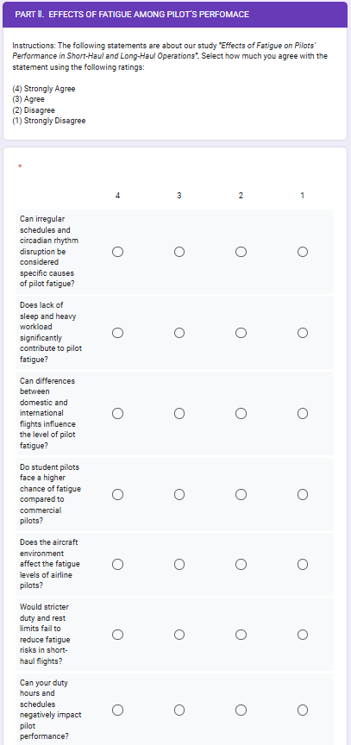
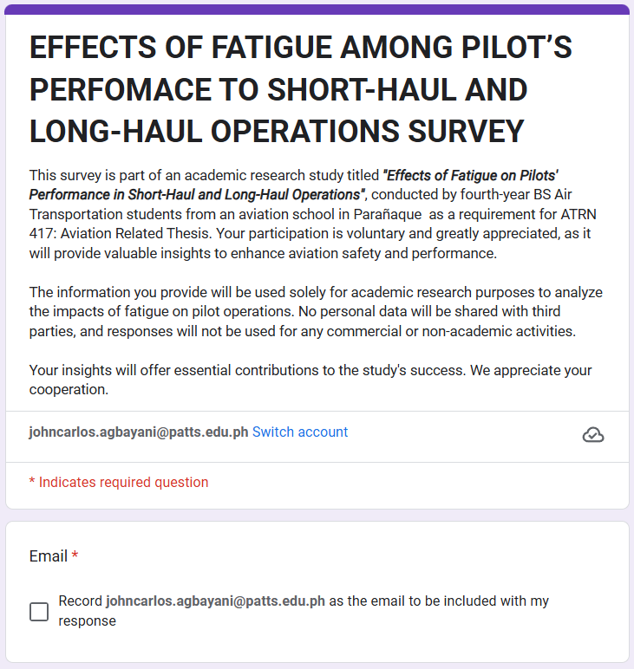

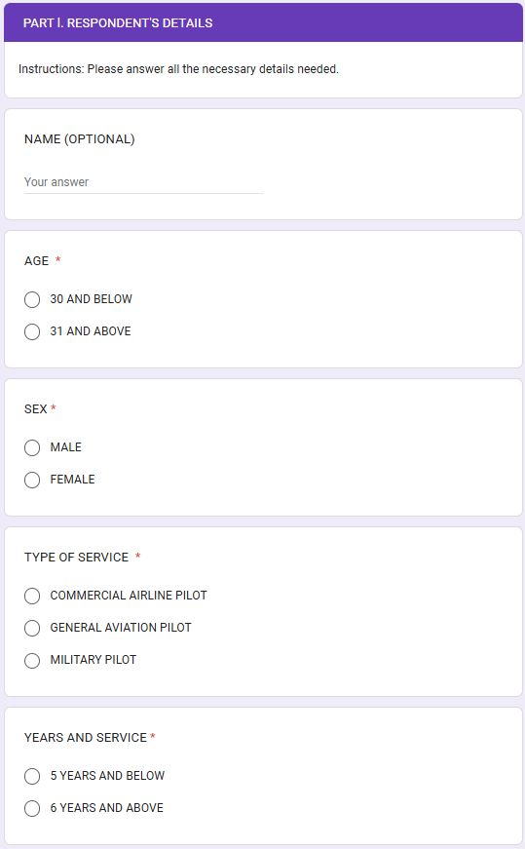
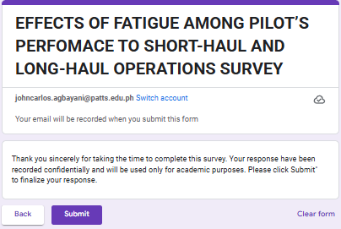
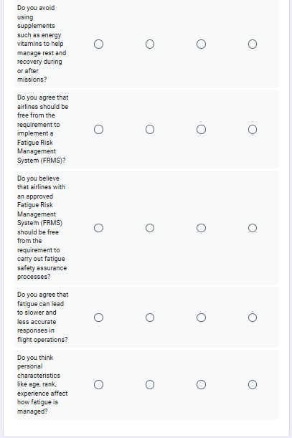
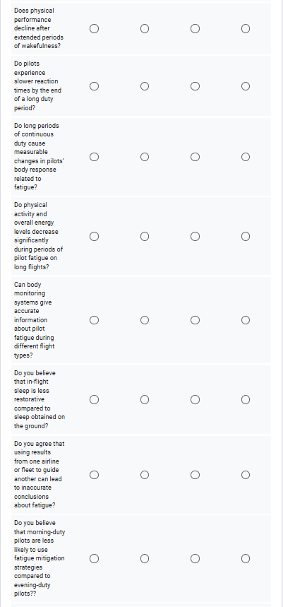
APPENDIX D: LETTER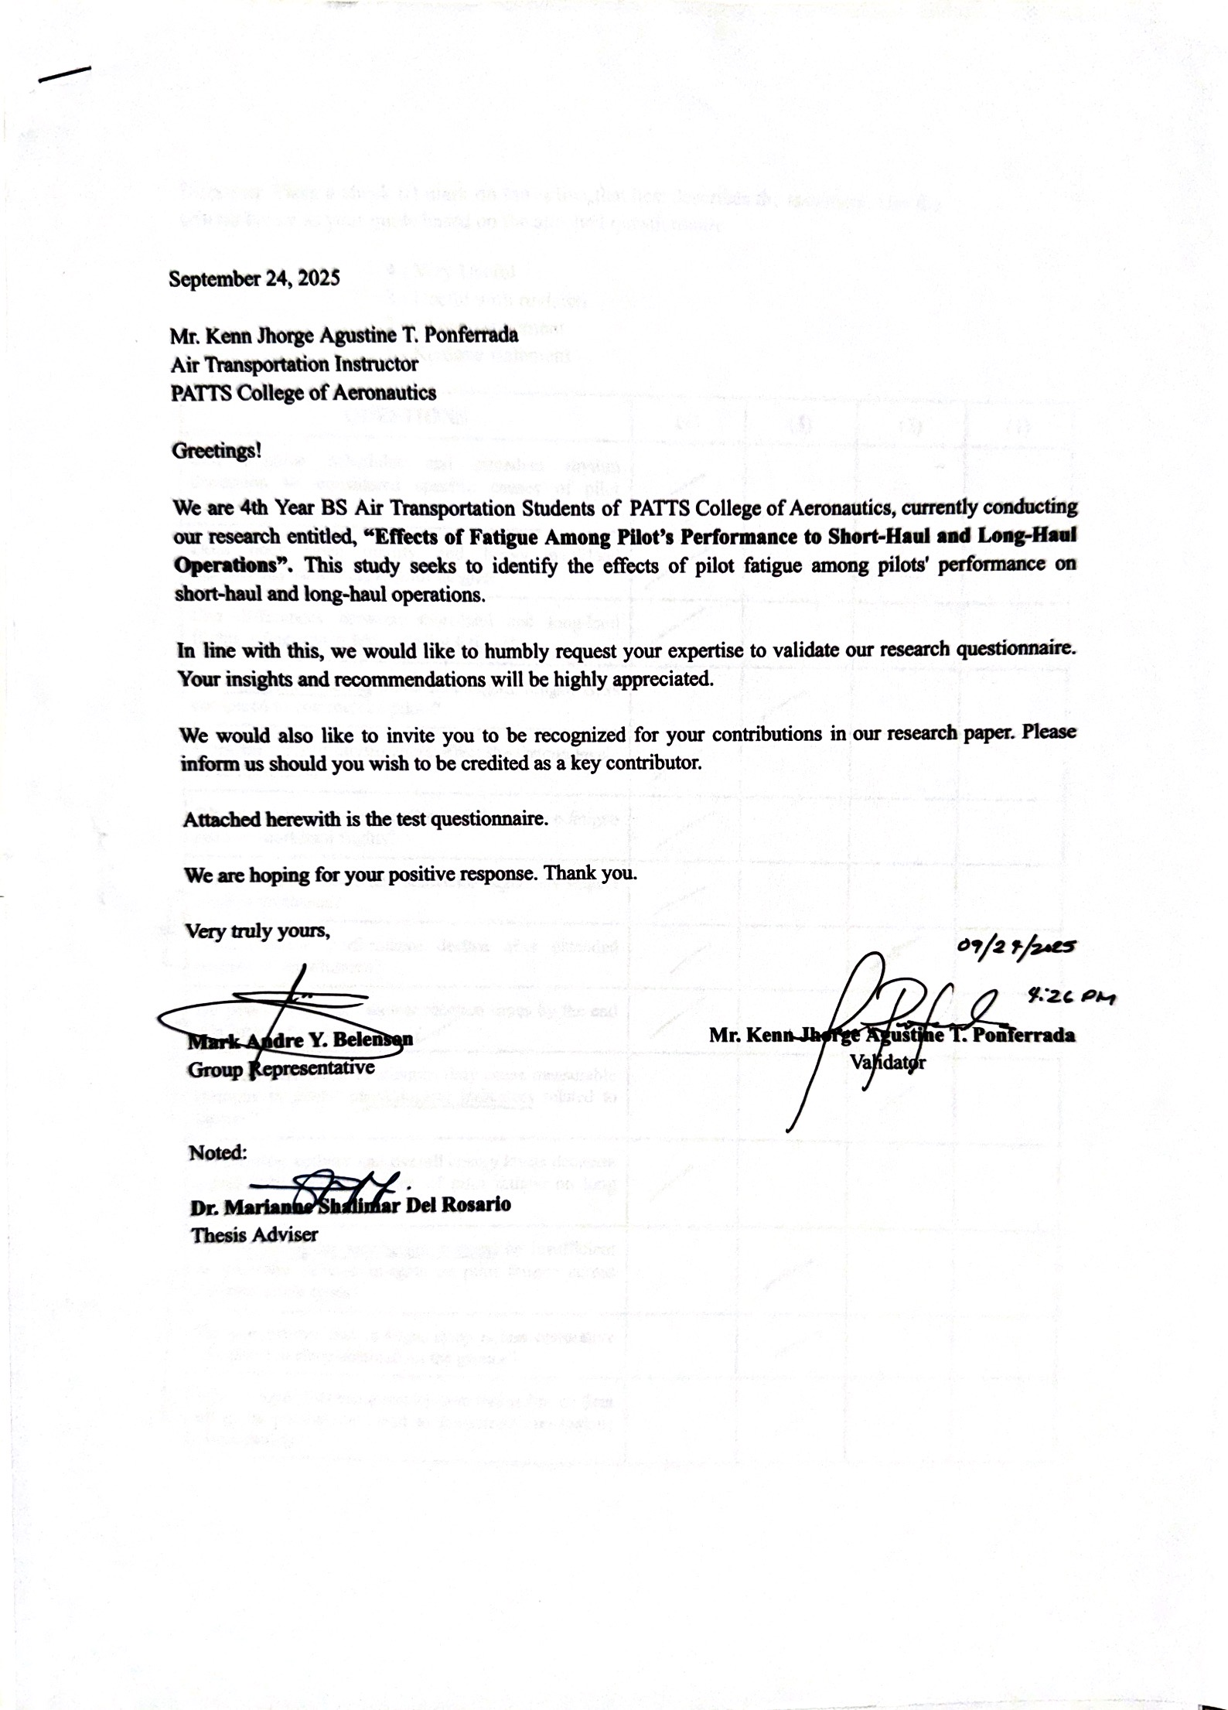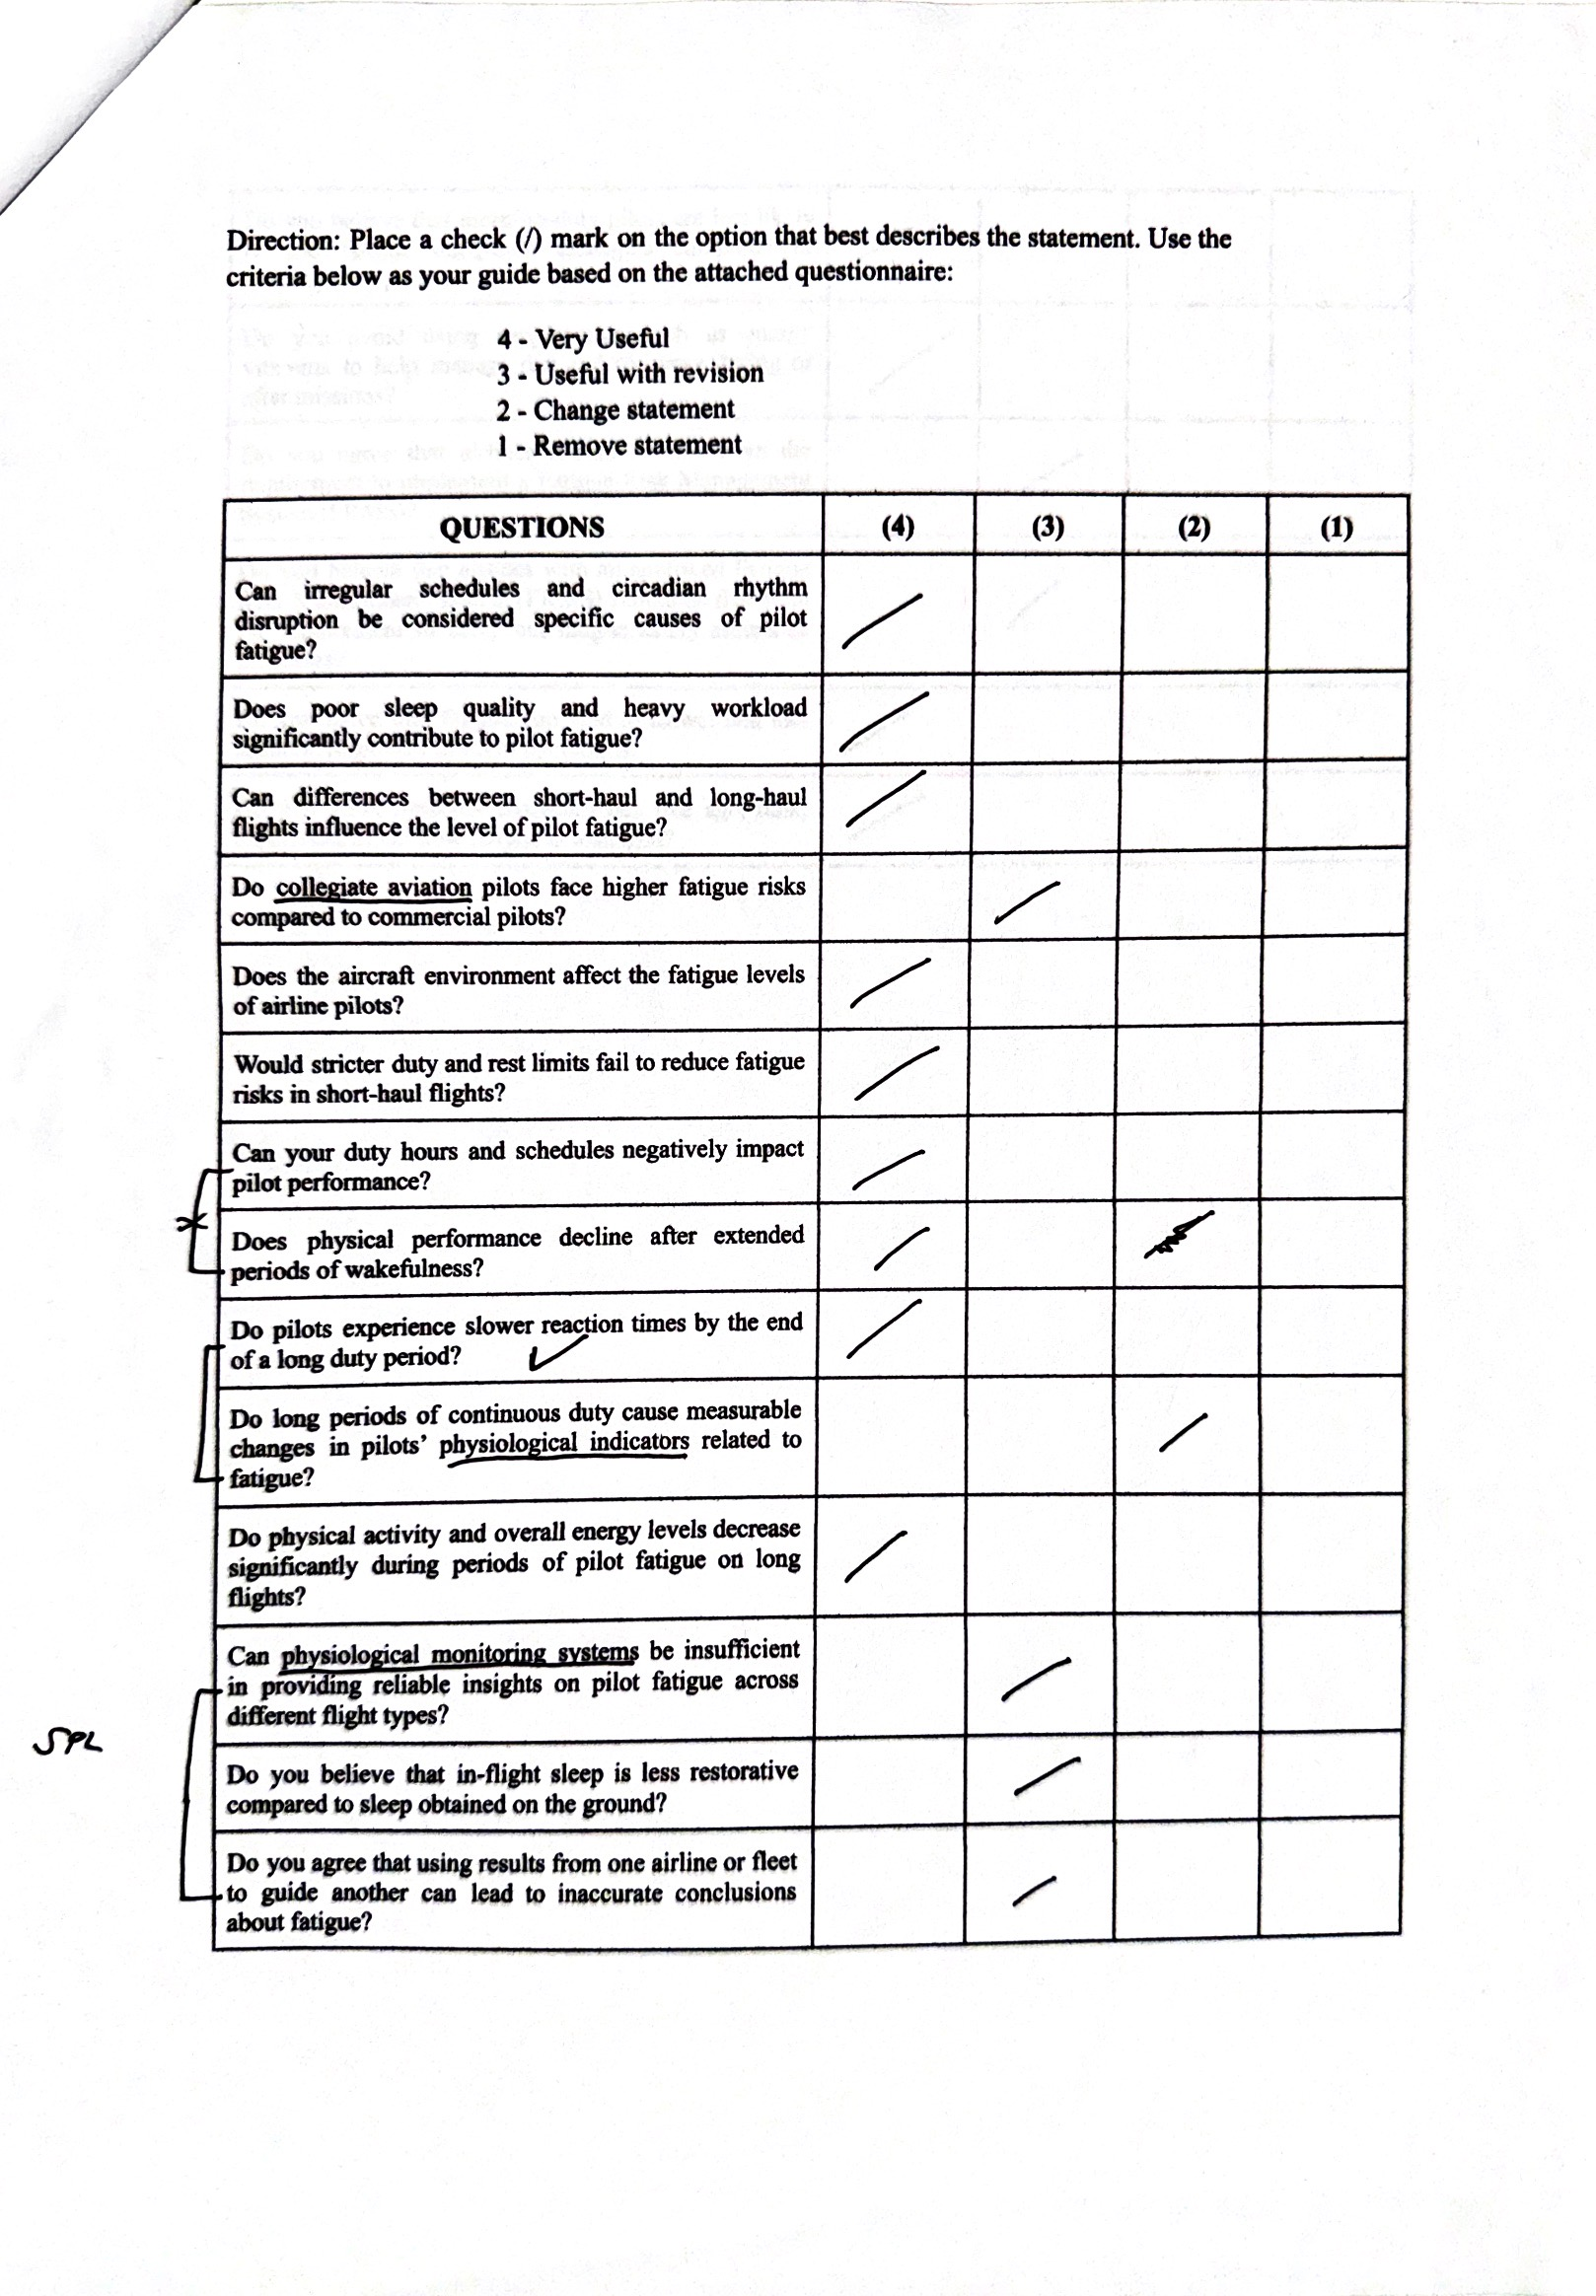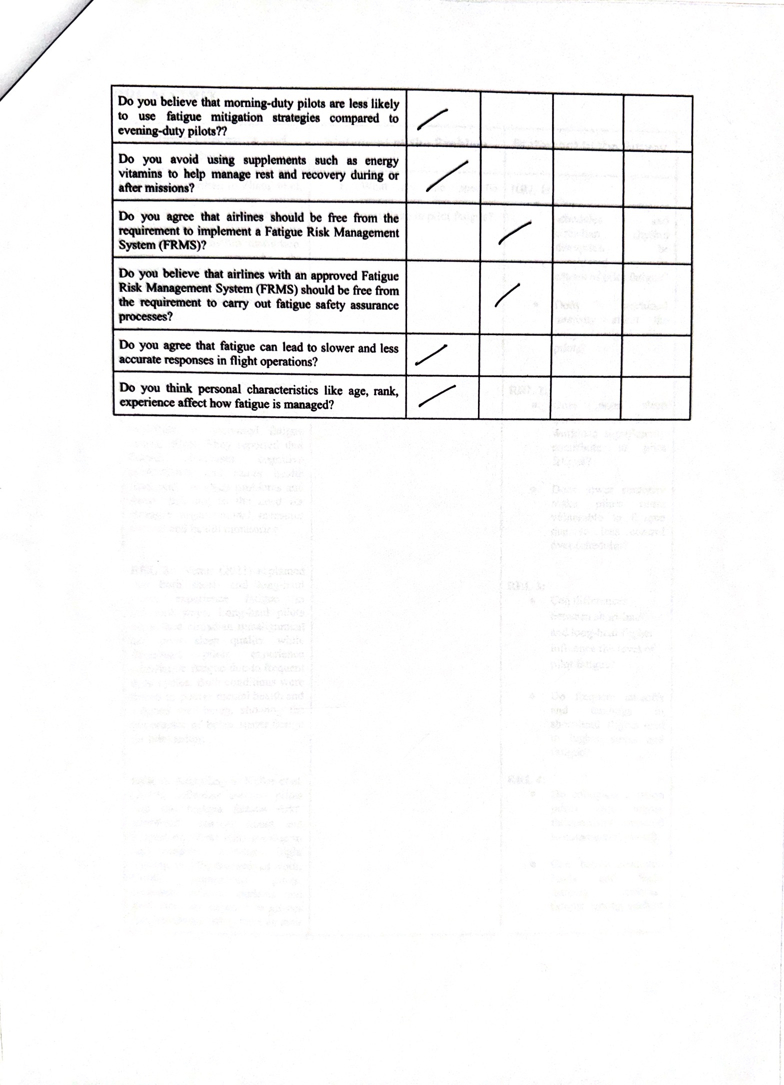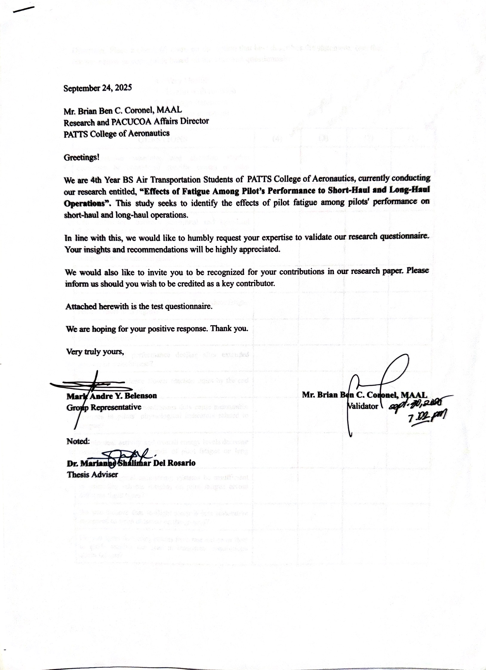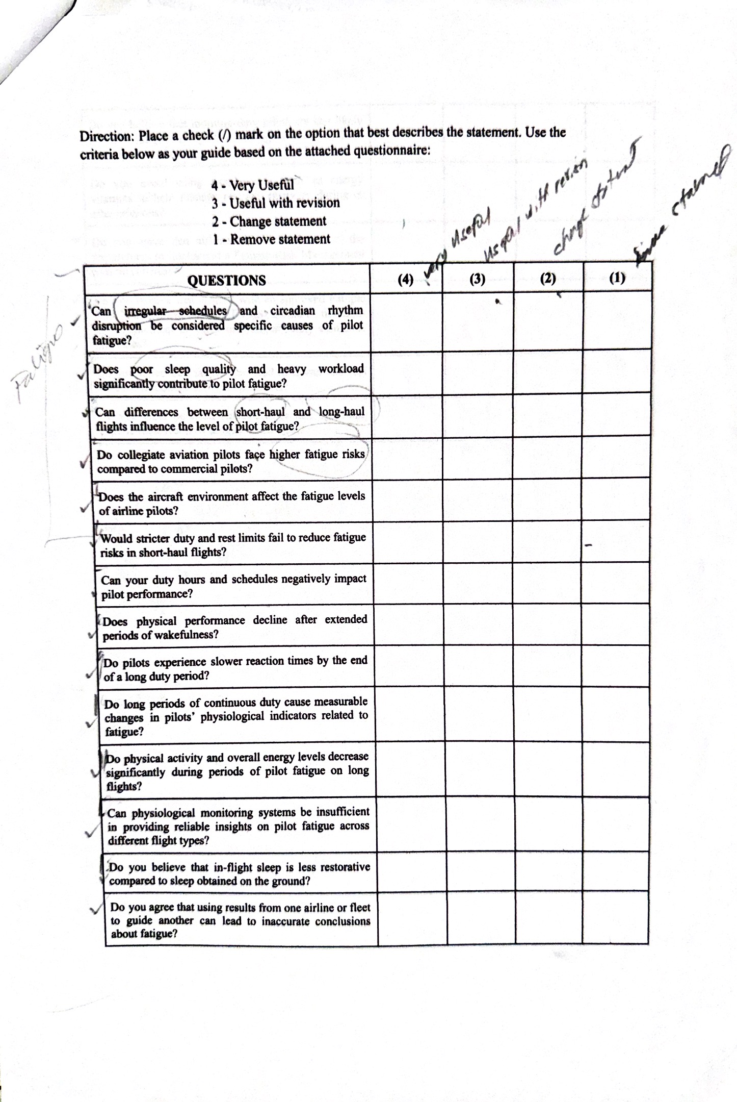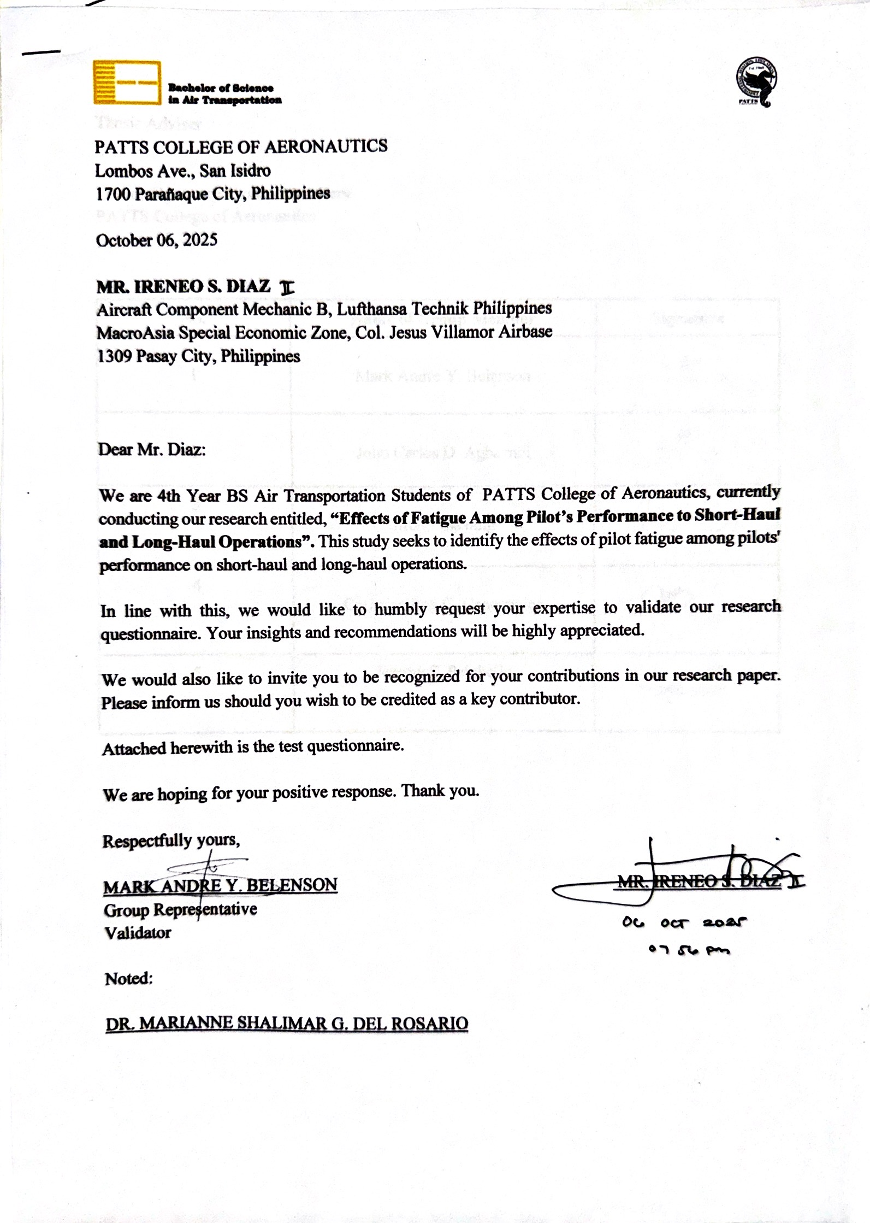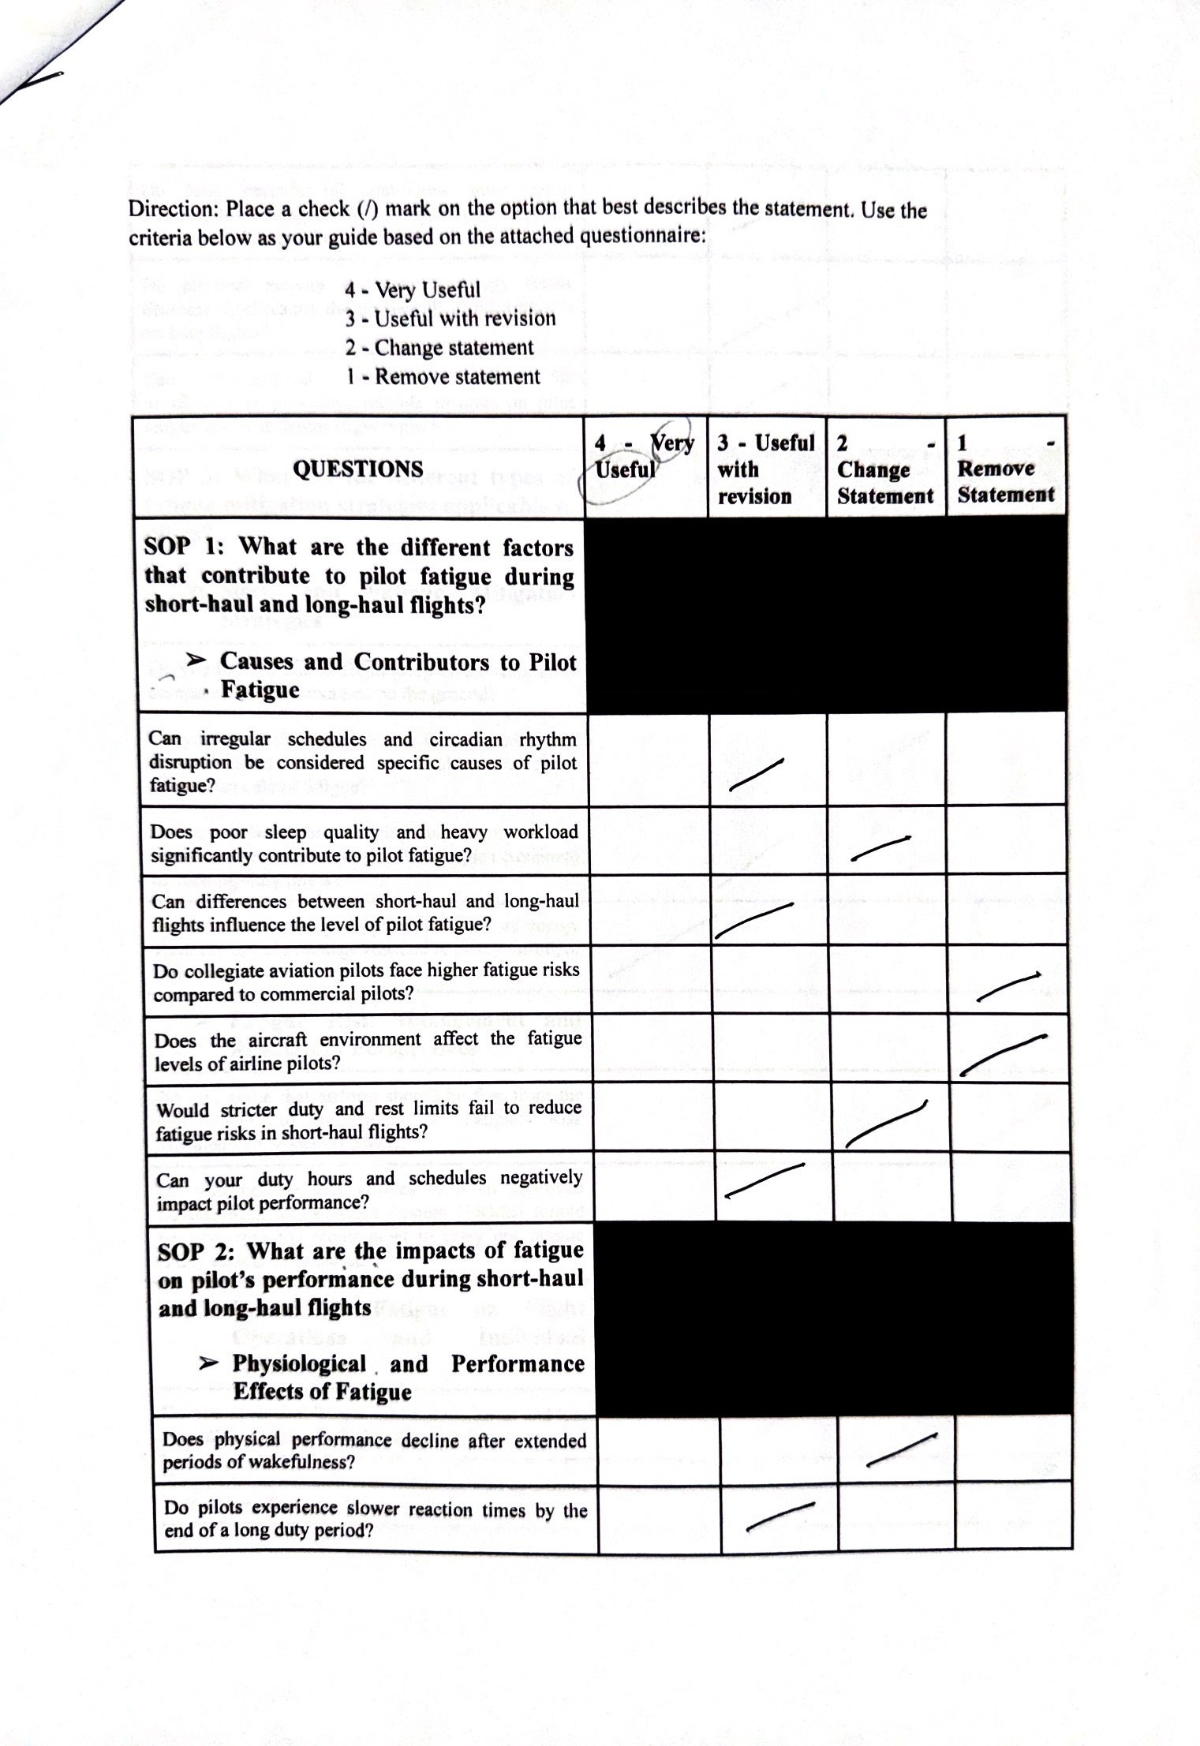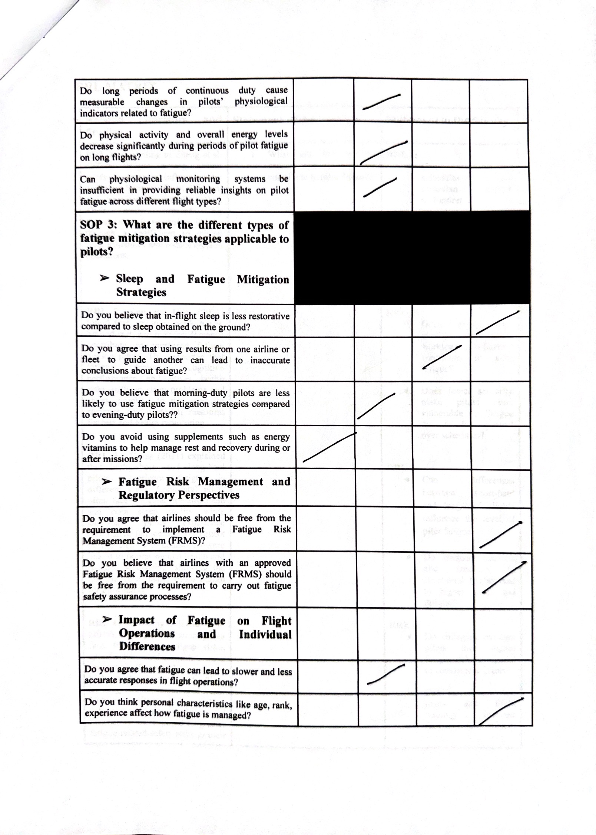
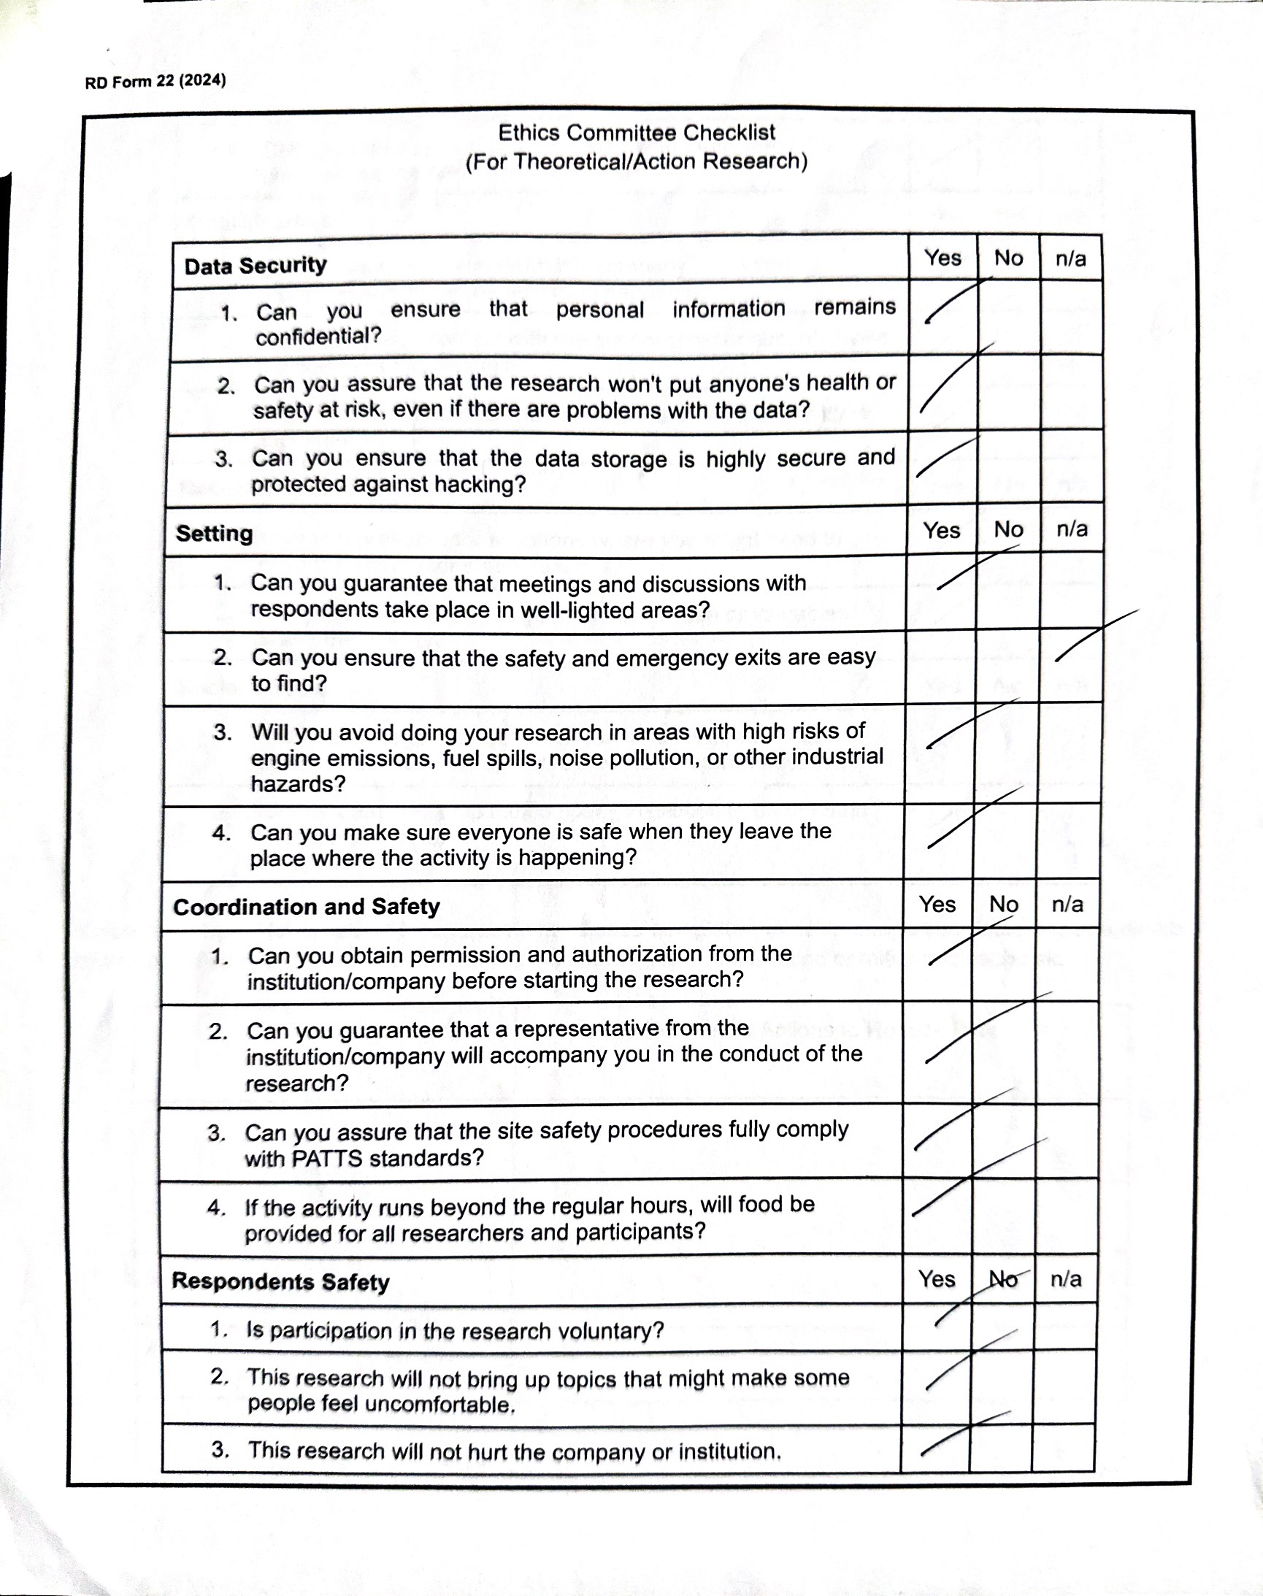
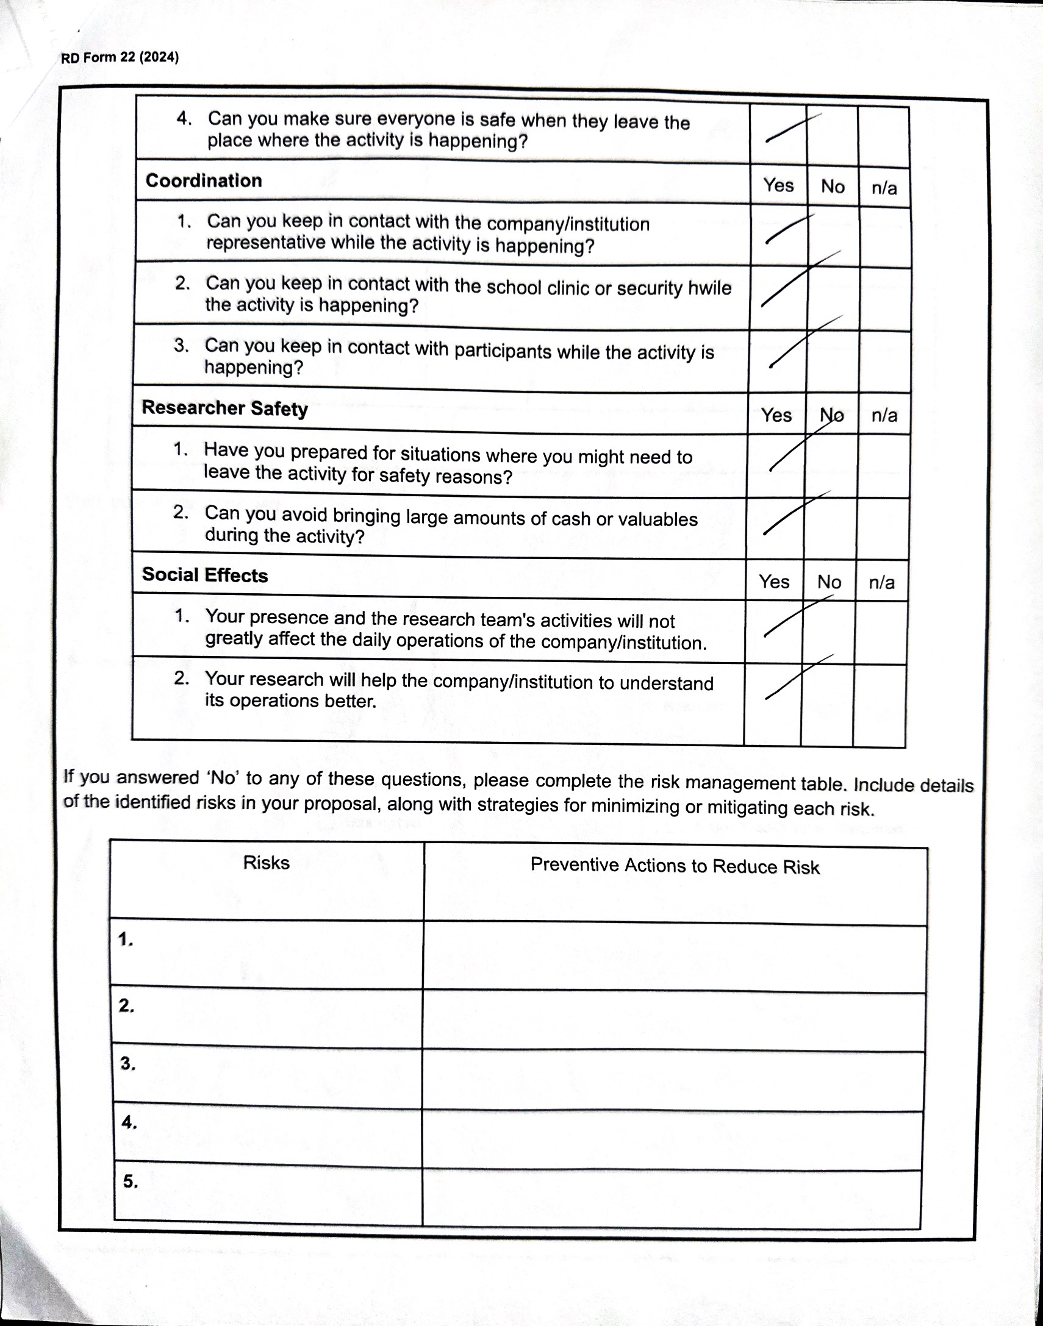
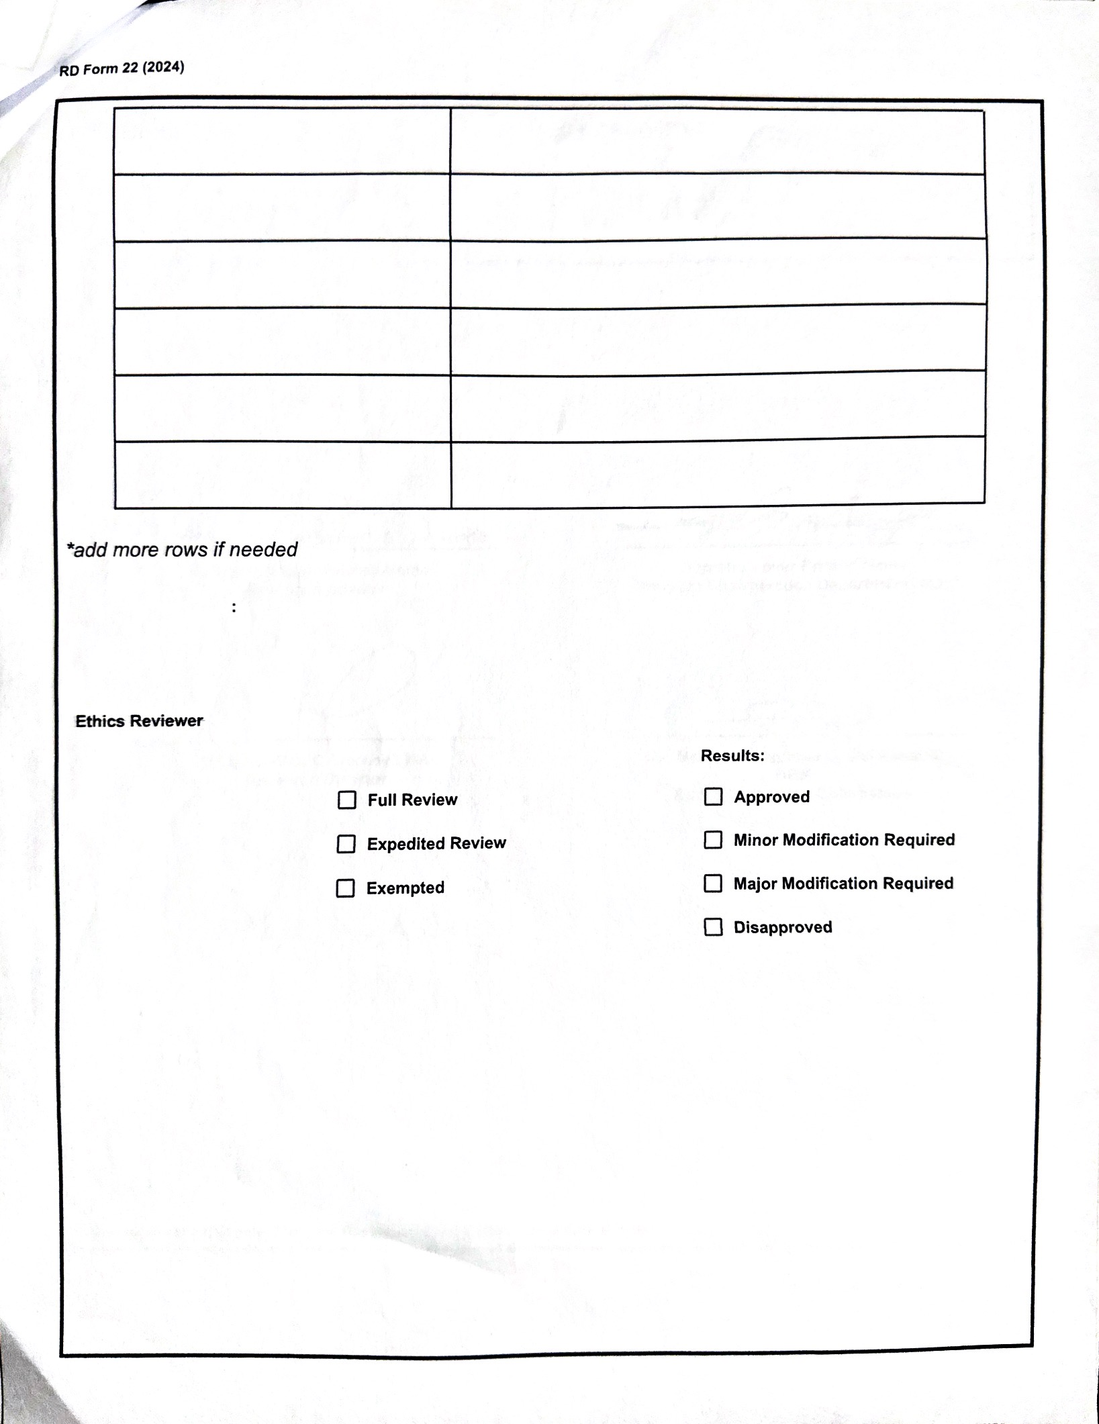
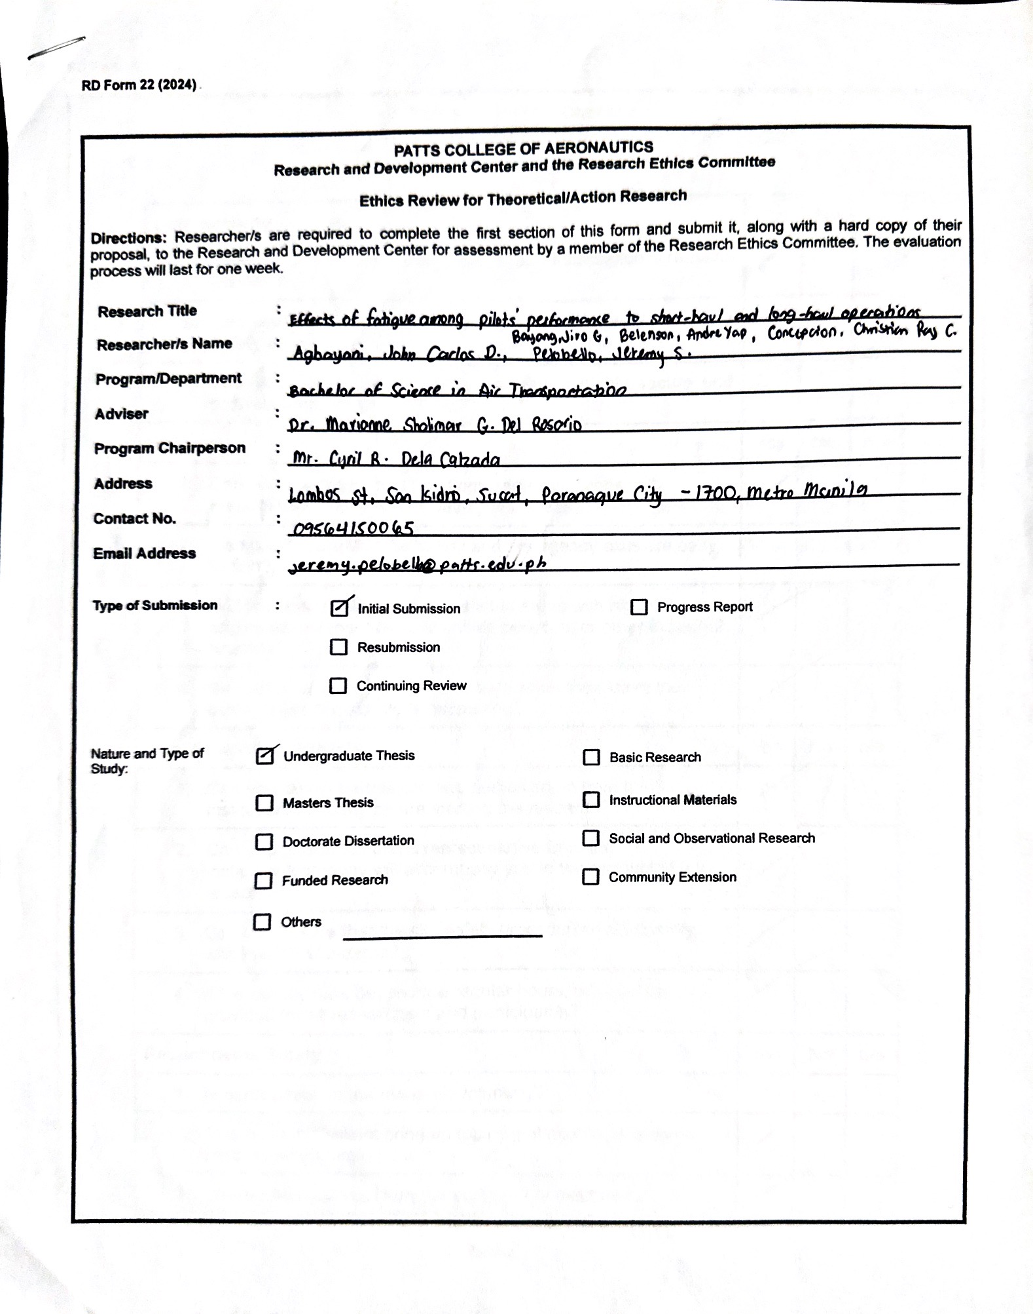

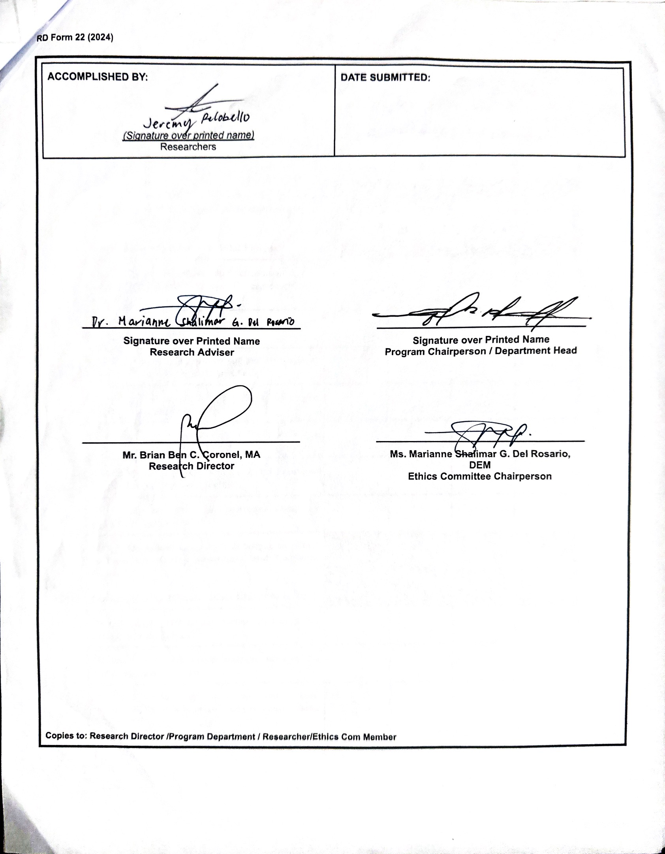
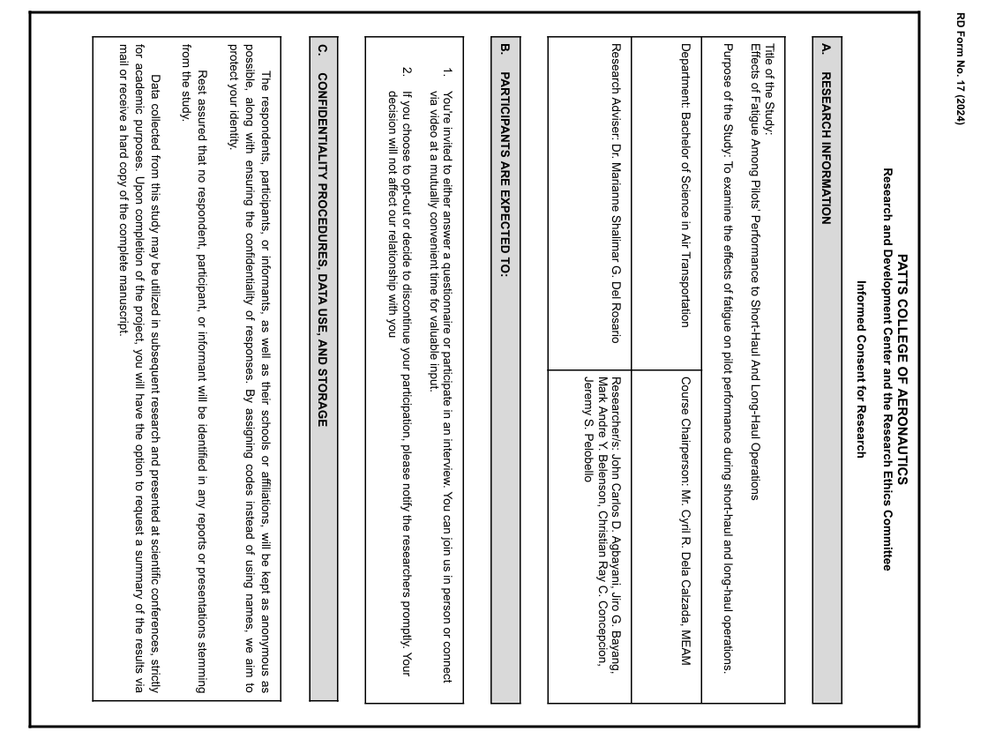
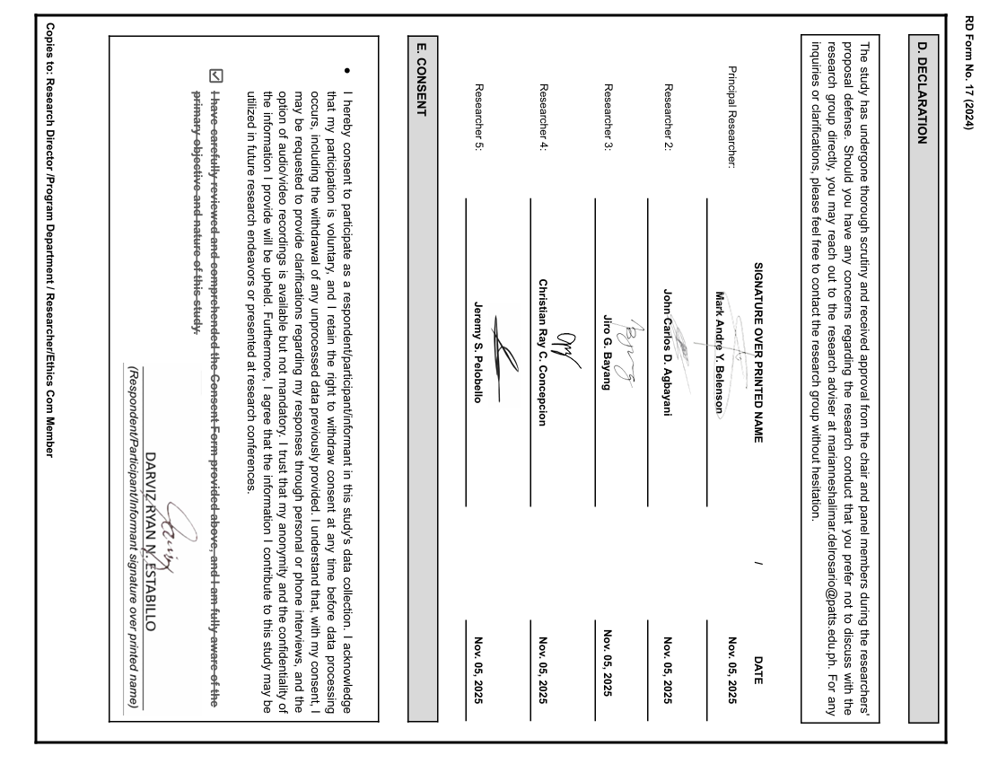
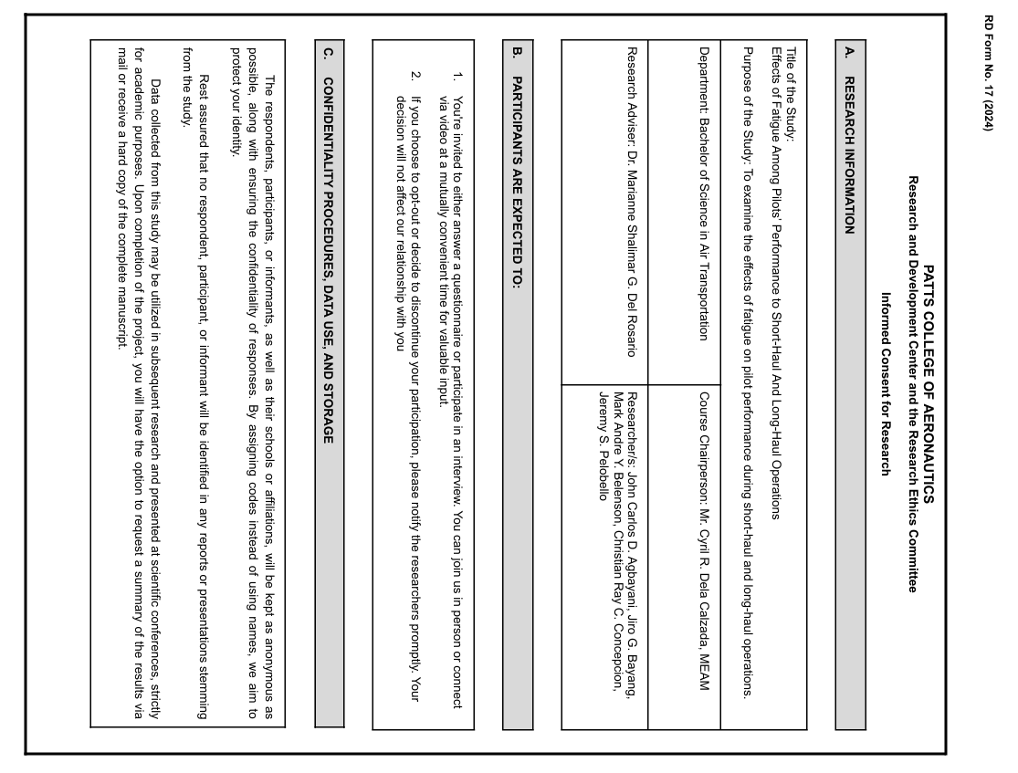
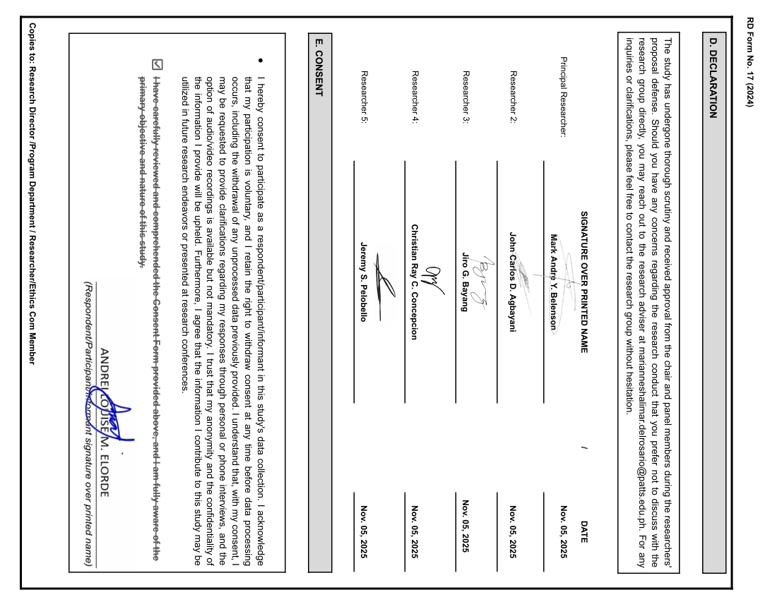
APPENDIX E: SPSS TABLES/META-ANALYSIS TABLES
AGE
 |  | FREQUENCIES | PERCENT | VALID PERCENT | CUMMULATIVE PERCENT
VALID | 30 AND BELOW | 31 | 73.8 | 73.8 | 73.8
VALID | 31 AND ABOVE | 11 | 26.2 | 26.2 | 100.0
VALID | TOTAL | 42 | 100.0 | 100.0

SEX
 |  | FREQUENCIES | PERCENT | VALID PERCENT | CUMMULATIVE PERCENT
VALID | MALE | 37 | 88.1 | 88.1 | 88.1
VALID | FEMALE | 5 | 11.9 | 11.9 | 100.0
VALID | TOTAL | 42 | 100.0 | 100.0

TYPE OF SERVICE
 |  | FREQUENCIES | PERCENT | VALID PERCENT | CUMMULATIVE PERCENT
VALID | COMMERCIAL AIRLINE PILOT | 17 | 40.5 | 40.5 | 40.5
VALID | GENERAL AVIATION PILOT | 21 | 50.0 | 50.0 | 90.5
VALID | MILITARY PILOT | 4 | 9.5 | 9.5 | 100.0
VALID | TOTAL | 42 | 100.0 | 100.0

YEARS OF SERVICE
 |  | FREQUENCIES | PERCENT | VALID PERCENT | CUMMULATIVE PERCENT
VALID | 5 YEARS AND BELOW | 31 | 73.8 | 73.8 | 73.8
VALID | 6 YEARS AND ABOVE | 11 | 26.2 | 26.2 | 100.0
VALID | TOTAL | 42 | 100.0 | 100.0

DESCRIPTIVE STATISTICS
 | N | Minimum | Maximum | Mean | Std. Deviation
Can irregular schedules and circadian rhythm disruption be considered specific causes of pilot fatigue? | 42 | 2.00 | 4.00 | 3.3810 | .69677
Does lack of sleep and heavy workload significantly contribute to pilot fatigue? | 42 | 1.00 | 4.00 | 3.6667 | .65020
Can differences between domestic and international flights influence the level of pilot fatigue? | 42 | 1.00 | 4.00 | 2.9048 | .93207
Do student pilots face a higher chance of fatigue compared to commercial pilots? | 42 | 1.00 | 4.00 | 2.5714 | 1.06251
Does the aircraft environment affect the fatigue levels of airline pilots? | 42 | 2.00 | 4.00 | 3.1667 | .76243
Would stricter duty and rest limits fail to reduce fatigue risks in short-haul flights? | 42 | 1.00 | 4.00 | 2.8333 | .79378
Can your duty hours and schedules negatively impact pilot performance? | 42 | 1.00 | 4.00 | 3.0952 | .82075
Does physical performance decline after extended periods of wakefulness? | 42 | 2.00 | 4.00 | 3.4286 | .70340
Do pilots experience slower reaction times by the end of a long duty period? | 42 | 1.00 | 4.00 | 3.2143 | .81258
Do long periods of continuous duty cause measurable changes in pilots’ body response related to fatigue? | 42 | 2.00 | 4.00 | 3.4048 | .66478
Do physical activity and overall energy levels decrease significantly during periods of pilot fatigue on long flights? | 42 | 2.00 | 4.00 | 3.2381 | .72615
Can body monitoring systems give accurate information about pilot fatigue during different flight types? | 42 | 2.00 | 4.00 | 2.8333 | .69551
Do you believe that in-flight sleep is less restorative compared to sleep obtained on the ground? | 42 | 1.00 | 4.00 | 3.0238 | .81114
Do you agree that using results from one airline or fleet to guide another can lead to inaccurate conclusions about fatigue? | 42 | 1.00 | 4.00 | 2.6429 | .69217
Do you believe that morning-duty pilots are less likely to use fatigue mitigation strategies compared to evening-duty pilots?? | 42 | 1.00 | 4.00 | 2.5476 | .91606
Do you avoid using supplements such as energy vitamins to help manage rest and recovery during or after missions? | 42 | 1.00 | 4.00 | 2.6905 | .89683
Do you agree that airlines should be free from the requirement to implement a Fatigue Risk Management System (FRMS)? | 42 | 1.00 | 4.00 | 1.8333 | .79378
Do you believe that airlines with an approved Fatigue Risk Management System (FRMS) should be free from the requirement to carry out fatigue safety assurance processes? | 42 | 1.00 | 4.00 | 2.0476 | .79487
Do you agree that fatigue can lead to slower and less accurate responses in flight operations? | 42 | 1.00 | 4.00 | 3.5000 | .70711
Do you think personal characteristics like age, rank, and experience affect how fatigue is managed? | 42 | 1.00 | 4.00 | 3.3810 | .69677
Valid N (listwise) | 42

TYPE OF SERVICE
Sum of Squares |  |  | df | Mean Square | F | Sig.
Can irregular schedules and circadian rhythm disruption be considered specific causes of pilot fatigue? | Between Groups | .235 | 2 | .126 | .251 | .775
 | Within Groups | 19.652 | 39 | .504
 | Total | 19.905 | 41
Does lack of sleep and heavy workload significantly contribute to pilot fatigue? | Between Groups | .539 | 2 | .269 | .625 | .540
 | Within Groups | 16.795 | 39 | .431
 | Total | 17.333 | 41
Can differences between domestic and international flights influence the level of pilot fatigue? | Between Groups | 2.737 | 2 | 1.368 | 1.623 | .210
 | Within Groups | 32.882 | 39 | .843
 | Total | 35.619 | 41
Do student pilots face a higher chance of fatigue compared to commercial pilots? | Between Groups | 3.812 | 2 | 1.906 | 1.750 | .187
 | Within Groups | 42.473 | 39 | 1.089
 | Total | 46.286 | 41
Does the aircraft environment affect the fatigue levels of airline pilots? | Between Groups | 2.025 | 2 | 1.012 | 1.810 | .177
 | Within Groups | 21.809 | 39 | .559
 | Total | 23.833 | 41
Would stricter duty and rest limits fail to reduce fatigue risks in short-haul flights? | Between Groups | 1.965 | 2 | .982 | 1.605 | .214
 | Within Groups | 23..868 | 39 | .612
 | Total | 25.833 | 41
Can your duty hours and schedules negatively impact pilot performance? | Between Groups | 1.917 | 2 | .958 | 1.454 | .246
 | Within Groups | 25.702 | 39 | .659
 | Total | 27.619 | 41
Does physical performance decline after extended periods of wakefulness? | Between Groups | .511 | 2 | .255 | .503 | .608
 | Within Groups | 19.775 | 39 | .507
 | Total | 20.286 | 41
Do pilots experience slower reaction times by the end of a long duty period? | Between Groups | 2.884 | 2 | 1.442 | 2.325 | .111
 | Within Groups | 24.188 | 39 | .620
 | Total | 27.071 | 41

Do long periods of continuous duty cause measurable changes in pilots’ body response related to fatigue? | Between Groups | .848 | 2 | .424 | .957 | .393
 | Within Groups | 17.271 | 39 | .443
 | Total | 18.199 | 41
Do physical activity and overall energy levels decrease significantly during periods of pilot fatigue on long flights? | Between Groups | 1.160 | 2 | .580 | 1.106 | .341
 | Within Groups | 20.459 | 39 | .525
 | Total | 21.619 | 41
Can body monitoring systems give accurate information about pilot fatigue during different flight types? | Between Groups | 3.739 | 2 | 1.869 | 4.530 | 0.17
 | Within Groups | 16.095 | 39 | .413
 | Total | 19.833 | 41
Do you believe that in-flight sleep is less restorative compared to sleep obtained on the ground? | Between Groups | 1.024 | 2 | .512 | .769 | .470
 | Within Groups | 25.952 | 39 | .665
 | Total | 26.976 | 41
Do you agree that using results from one airline or fleet to guide another can lead to inaccurate conclusions about fatigue? | Between Groups | .094 | 2 | .047 | .094 | .911
 | Within Groups | 19.549 | 39 | .501
 | Total | 19.643 | 41
Do you believe that morning-duty pilots are less likely to use fatigue mitigation strategies compared to evening-duty pilots? | Between Groups | .299 | 2 | .150 | .171 | .843
 | Within Groups | 34.106 | 39 | .875
 | Total | 34.405 | 41
Do you avoid using supplements such as energy vitamins to help manage rest and recovery during or after missions? | Between Groups | .161 | 2 | .081 | .096 | .909
 | Within Groups | 32.815 | 39 | .841
 | Total | 32.976 | 41
Do you agree that airlines should be free from the requirement to implement a Fatigue Risk Management System (FRMS)? | Between Groups | .999 | 2 | .499 | .784 | .464
 | Within Groups | 24.835 | 39 | .637
 | Total | 25.833 | 41
Do you believe that airlines with an approved Fatigue Risk Management System (FRMS) should be free from the requirement to carry out fatigue safety assurance processes? | Between Groups | .404 | 2 | .202 | .309 | .736
 | Within Groups | 25.501 | 39 | .654
 | Total | 25.905 | 41

Do you agree that fatigue can lead to slower and less accurate responses in flight operations? | Between Groups | 680 | 2 | .340 | .669 | .518
 | Within Groups | 19.820 | 39 | .508
 | Total | 20.500 | 41
Do you think personal characteristics like age, rank, and experience affect how fatigue is managed? | Between Groups | .232 | 2 | .116 | .230 | .795
 | Within Groups | 19.672 | 39 | .504
 | Total | 19.905 | 41

APPENDIX F: INTERVIEW TRANSCRIPT

Informant 1:
Interviewer: Good afternoon, sir. Thank you for participating in our interview for our study titled “Effects of Fatigue Among Pilots’ Performance in Short-haul and Long-haul Operations.” For our first question: How does pilot fatigue during short-haul and long-haul operations affect flight performance, and what measures could airlines implement to reduce its impact on safety and operational efficiency?

Informant 1: Good evening, and thank you for having us as part of your study. Pilot fatigue is a very important topic. In aviation accidents, about 70% involve human factors. Fatigue directly affects a pilot’s alertness, decision-making, and reaction time. In short-haul operations, fatigue accumulates due to multiple legs in one day, early starts, late finishes, frequent takeoffs and landings, and quick turnarounds. This reduces situational awareness, especially in critical phases of flight such as takeoff, approach, and landing. In long-haul operations, the workload can feel lighter because of longer cruise periods, but the primary issue is circadian rhythm disruption. Crossing multiple time zones causes jet lag, affecting both passengers and pilots. Pilots must report 1–2 hours before a flight, which adds to the fatigue. Airlines address this through Standard Operating Procedures (SOPs) and strict adherence to air laws such as PCAR Part 8. These regulations set limits on pilot duty periods and rest requirements. Companies may modify allowable flight hours but must still follow regulatory minimums. Ultimately, maintaining situational awareness (SA) is essential. As instructors say: “It's okay to lose many things—just not your situational awareness.” Pilots also assess themselves before flight using self-checklists to ensure they are fit to fly.

Interviewer: In what ways could managing pilot fatigue in short-haul and long-haul operations improve performance and ensure safer, more efficient flights, especially during demanding flight conditions?

Informant 1: Stress is always present, but it contributes to fatigue. To manage fatigue, pilots must maintain situational awareness, decision-making capability, communication, and comprehension. Workload during flight is heavy, and pilots must monitor many parameters. Teamwork in the cockpit is essential.

Interviewer: How could effective fatigue management programs support pilots with varying experience levels and flight schedules in both short-haul and long-haul operations, while ensuring consistent performance and safety standards across all flight conditions?

Informant 1: Effective fatigue management relies on strong company SOPs. These programs do not remove fatigue fully but help reduce it. On short-haul flights, which are especially tiring, I rely heavily on these programs. Pilots must also prepare for their duties by anticipating workloads and risks. Faster aircraft require faster reaction times, so workload management is crucial.

Interviewer: What recommendations would you propose for airlines and aviation authorities to effectively manage and prevent pilot fatigue in both short-haul and long-haul operations to maintain safety and performance standards?

Informant 1: For me, the focus should also be on individual pilots. Pilots must be physically, mentally, and emotionally fit. We also follow the IMSAFE checklist: I for Illness; M for Medication; S for Stress; A for Alcohol, we use breathalyzer that must not exceed 0.04% meaning no alcohol for 8 hours before flight; F for Fatigue; E for Eating and Emotion, Pilots must leave personal issues on the ground, be in stable condition, and avoid irritability, which affects performance. Crew Resource Management (CRM) reinforces proper delegation and teamwork in the cockpit. Safety is the top priority, pilots and airlines must avoid anything that could jeopardize it.

Interviewer: This concludes our interview. Thank you for your insights. Your perspectives are greatly appreciated.

Informant 2

Interviewer: Good afternoon, sir. Thank you for participating in our interview for our study titled “Effects of Fatigue Among Pilots’ Performance in Short-haul and Long-haul Operations.” For our first question: How does pilot fatigue during short-haul and long-haul operations affect flight performance, and what measures could airlines implement to reduce its impact on safety and operational efficiency?

Informant 2: During my training, stress significantly contributed to fatigue. Being in the air is stressful—humidity decreases, breathing becomes slightly harder, and the body tires more quickly. To cope, we review flight plans, assess weather, stay mentally engaged, hydrate (but not excessively due to lack of lavatories in small aircraft), and keep ourselves comfortable.

Informant 2: (Agrees with Informant 1, specifically this statement): “Fatigue directly affects a pilot’s alertness, decision-making, and reaction time.”

Interviewer: In what ways could managing pilot fatigue in short-haul and long-haul operations improve performance and ensure safer, more efficient flights, especially during demanding flight conditions?

Informant 2: To manage stress and fatigue effectively, we keep ourselves mentally prepared and comfortable. Once airborne, workload increases, so talking with co-pilots, eating properly, and staying hydrated helps avoid dizziness or discomfort.

Informant 2: (Agrees with Informant 1, specifically this statement): “Teamwork in the cockpit is essential.”

Interviewer: How could effective fatigue management programs support pilots with varying experience levels and flight schedules in both short-haul and long-haul operations, while ensuring consistent performance and safety standards across all flight conditions?

Informant 2: These questions are better suited for highly experienced pilots, but yes, airlines have SOPs that we must follow closely.

Informant 2: (Agrees with Informant 1, specifically this statement): “Effective fatigue management relies on strong company SOPs.”

Interviewer: What recommendations would you propose for airlines and aviation authorities to effectively manage and prevent pilot fatigue in both short-haul and long-haul operations to maintain safety and performance standards?

Informant 2: ICAO standards influence PCAR and CAAP regulations. Rest periods provided are minimums and cannot be reduced unless new regulations are proposed. From my perspective, airlines could reduce actual flight duty periods. For instance, an 8-hour flight time becomes a 10-hour duty period when preflight and postflight briefings are included. Reducing flight duty periods to 6–7 hours could help minimize fatigue while still complying with regulations.

Informant 2: (Agrees with Informant 1 — specifically this statement): “Companies may modify allowable flight hours but must still follow regulatory minimums.”

Interviewer: This concludes our interview. Thank you for your insights. Your perspectives are greatly appreciated.

Informant 3:

Interviewer: Good afternoon, Sir, thank you for participating in our interview for our study entitled: “Effects of Fatigue Among Pilots’ Performance to Short-haul and Long-haul Operations" to start this interview, here is your first question: how does pilot fatigue during short-haul and long-haul operations affect flight performance, and what measures could airlines implement to reduce its impact on safety and operational efficiency?

Informant 3: Regardless of the distance, fatigue always kicks in especially if you're flying with strong winds. The sound (for propeller aircraft), the turbulence, and traffic stress overall aids the fatigue. Having ample breaks for long-haul flights and strictly following ICAO/PCAR rest protocols can greatly improve safety.

Interviewer: Okay, Sir, for your second question: in what ways could managing pilot fatigue in short-haul and long-haul operations improve performance and ensure safer, more efficient flights, especially during demanding flight conditions?

Informant 3: Managing pilot fatigue has multiple upside. It mainly helps improve the pilot's decision-making, situational awareness and critical thinking during demanding flight conditions.

Interviewer: Understood Sir, for the third question, How could effective fatigue management programs support pilots with varying experience levels and flight schedules in both short-haul and long-haul operations, while ensuring consistent performance and safety standards across all flight conditions?

Informant 3: Fatigue Management programs would usually vary between companies and preference, but generally these operations must remain within prescribed limits established by the regulator for flight time, flight duty periods, duty periods and rest periods. In addition, an operator should manage fatigue hazards using the SMS processes that are in place for managing other types of hazards.

Interviewer: And Sir, for your last question, what recommendations would you propose for airlines and aviation authorities to effectively manage and prevent pilot fatigue in both short-haul and long-haul operations, thereby maintaining safety and performance standards?

Informant 3: Airlines and aviation authorities should hire proven Safety Management consultants, formulate an appropriate approach/system that is suited to their workplace schedules and environment and strictly implement it ASAP.

Interviewer: Thank you for all the insights and viewpoints you give us. Your answers are much appreciated. Have a wonderful day! Sir.

APPENDIX G: PLAGIARISM CHECK
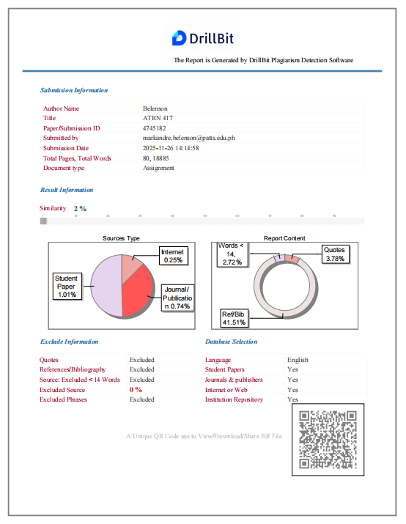
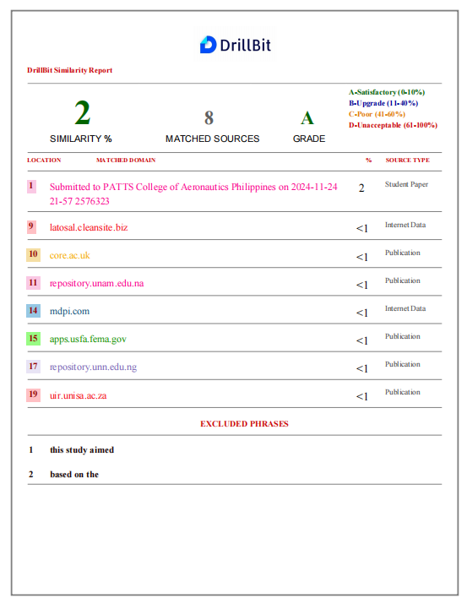
APPENDIX H: BIONOTE


John Carlos D. Agbayani, a 22-year-old fourth-year Bachelor of Science in Air Transportation student at PATTS College of Aeronautics. Born on July 25, 2003, in Quezon City and currently residing in Sucat, Parañaque City, he aspires to become the first pilot in his family. John skillfully balances his academic pursuits with his life as a student-athlete. He has consistently demonstrated academic excellence, maintaining honor student status from junior high at Salcedo Vocational High School to senior high at Saint Mary’s Academy of Guiuan under the STEM strand. His aviation training encompasses flight planning, meteorology, weight and balance computations, and air traffic operations. He further developed his expertise through seminars focusing on airport processes, cargo operations, human factors, and air traffic flow management. Among these are “Flying Forward: A Comprehensive Exploration of Human Factors and Passenger Assistance in Aviation,” “Cleared for Departure: Mastering the Art of Efficient Airport Operations,” and “Cargo Operations Unveiled: Mastering the Flow in Aviation,” which he attended during his sophomore and junior years. From 2023 to 2024, he completed Visual Vectoring Enroute Training (VVET) levels 1 and 2, where he gained knowledge in air traffic flow management and standard communication commands. Additionally, he currently participated in seminars for career and leadership programs such as “Global Aviation Career Pathways: Preparing Life After College,” “Beyond the Hangar: Lead with Purpose, Fly with Safety, Own the Future,” “Dreams in Flight: Aviation Safety and Career Insights,” and “Words That Matter: Effective Research Writing Techniques,” which enriched his understanding of aviation careers, leadership, safety, and research writing.


Mark Andre Y. Belenson was born on December 26, 2003, in Legazpi City, Albay. He completed senior high school with a STEM curriculum at the University of Santo Tomas, Legazpi, and then pursued a Bachelor of Science in Air Transportation. He has a good foundation in air traffic operations thanks to his practical experience and training at PATTS College of Aeronautics. He excels in flight planning, meteorology, and weight and balance calculations. In addition to his academic background, he completed several seminars and specialized programs, such as Visual Vector Enroute Training (VVeT), Maintenance and Repair, and Overhaul Technical Training. He is a team player who believes in continuous learning and cooperation, and he is excited to contribute his talents and expertise to a dynamic team. He also hopes to further develop his skills and expertise while contributing to the safety and efficiency of aviation operations.


Jiro Guinaat Bayang, born on June 13, 2004, in Lagawe, Ifugao, is a Bachelor of Science in Air Transportation student at PATTS College of Aeronautics, where he has been continually developing his technical foundation in aviation operations since 2022. Throughout his studies, he has gained extensive knowledge in flight operations, building a strong theoretical base that complements his growing operational skills. His academic experience is further strengthened by practical exposure to various aspects of flight operations, including Meteorology, Visual Vectoring procedures, ground handling, and basic aircraft run-up and taxiing, particularly on the Cessna 172 platform. He has completed multiple aviation trainings focusing on flight planning and crew resource management, alongside workshops on Maintenance, Repair, and Overhaul processes, aviation safety awareness, and computer-aided drafting and design. Beyond technical competencies, he has enhanced his communication and interpersonal skills through speech laboratory courses and continuous involvement in both campus and off-campus organizations. With a solid foundation in both operational and support areas of aviation, as well as additional experience in the automotive industry, he aims to contribute to safe and efficient flight operations. His work is guided by a commitment to continuous learning, professionalism, and service, shaped by comprehensive academic training and community-based engagement.


Christian Ray C. Concepcion is a 4th-year Bachelor of Science in Air Transportation student from San Mateo, Rizal. Born on June 19, 2004, he developed a strong passion for aviation early in life. He completed the STEM strand at Our Lady of Perpetual Succor College, where he gained a solid foundation in mathematics and science. He has accomplished both Visual Vectoring Enroute Training and Maintenance Repair Enroute Training, giving him practical experience in aircraft navigation and systems. He also enhanced his communication abilities through a specialized training program that strengthened his clarity, teamwork, and interpersonal skills. He is good at handling multiple responsibilities efficiently while staying calm under pressure, a quality he considers his greatest strength. He is open-minded and eager to learn. He also completed the seminar "TO/GA: Taking Off to Greater Altitudes with Flight Planning and Crew Resource Management Excellence", where he further developed his communication, decision-making, and situational awareness, all of which help his readiness for a professional aviation career.


Jeremy S. Pelobello, born on August 4, 2003, in Nabitasan, Iloilo City, is a committed Air Transportation student at PATTS College of Aeronautics. He completed his early education at Assumption Iloilo and pursued the STEM track at PAREF Westbridge, where he strengthened his analytical and communication skills. Since entering PATTS in 2022, he has built a solid foundation in aviation operations, airport management, and air transportation economics, developing competencies in demand forecasting, cost-benefit analysis, airport activity management, and the application of the Philippine Civil Aviation Regulations (PCAR). He has enhanced his technical knowledge through seminars and trainings such as Visual Vector Enroute Training, Speech Laboratory sessions, and various workshops focusing on aviation safety, emergency preparedness, and flight operations. These experiences, along with coursework on aviation planning and airport efficiency, have contributed to his growing operational awareness. His interpersonal and leadership abilities were further strengthened through involvement in student organizations, including the PATTS Guild of Air Transportation, PATTS Red Cross Youth, and B-EPIC. Motivated by a strong passion for aviation. With continuous effort and dedication, he strives to become a competent aviation professional ready to serve the industry.

