Antidandruff Activity of Poly Herbal Extracts on Malassezia globosa Isolated from Human Scalp
Abstract:
At present, more than quasi of the worldwide people deal with the major skin problem with dandruff. The presence of the Malassezia fungus suggestively subsidizes this condition by potentially generating the production of cytokines in keratinocytes, the cells responsible for synthesizing keratin and activating provocative alleyways. Antifungal activity of selected Indian medicinal plant extracts against the dandruff causing pathogen. The present work assigned the four experimental plants named Eclipta alba, Hibiscus rosasinensis, Lawsonia inermis and Muraya koenigii and its polyherbal mixed composition of these four herbal extracts. The prepared aqueous poly herbal extracts were added to the wells of Malassezia globossa inoculated plates. From the present antifungal result was clearly expressed all the four individual plant extract showed minimum to maximum antidandruff activity among the four M.koeningi possessed maximum antifungal activity than other three extracts. Even though, a mixed composition of these four herbal extracts (aqueous) contains the maximum potential antidandruff effect than the individual extracts of E.alba, H. rosasinensis, L. inermis. Hence, the present experimental four herbal extract was definitely depicted for great potential against the dandruff and skin pathogenic fungal organism of M. globossa.
Keywords: Herbal Extract, M.globossa, Eclipta alba, Hibiscus rosasinensis, Lawsonia inermis and Muraya koenigii.

Introduction
Microorganisms affect the people in different ways. Fungi had been recognized as causative agent of human disease earlier than bacteria, fungal infection had been described as early (Sanflippo. 2006). Mycotic infections are encountered unequally and ubiquitously all over the world with varied manifestations (Dulta Asis, 1994). Although they are members of the normal skin flora, yeasts of the genus Malassezia have been known for many years to play a role in human skin diseases, including dandruff, seborrheic dermatitis, (Naveen et al., 2012). Malassezia globosa (Pityrosporum ovale), a lipophilic fungus, affects the hair and cause diseases called dandruff (Ranganathan et al., 2001) and also called Pityriasis versicolar, Tinea circinata, Seborrheic dermatitis (Tollesson, 1997). Previously Clayton, (1967) proposed the strong view about the dandraff is a condition, which causes small white flakes of skin that separate and fall from the scalp.
Henna (Lawsonia inermis L., Family- Lythraceae) has been a staple in cosmetic practices over centuries, renowned for its natural dyeing properties used in body art, hair dyeing, and various cultural rituals. Henna, historically revered as a cultural emblem, has been extensively utilized in the Arabian Peninsula, Indian Subcontinent, Southeast Asia, and parts of North Africa (Barani et al., 2018). The dye molecule lawsone, predominantly concentrated in henna leaves, imparts significant value to skin, hair, and textile dyeing practices, as well as in Ayurveda, where it is recognized as Mehndi (Sousa et al., 2022). Crude extracts of henna and its ingredients have been reported to exhibit various biological activities, including antibacterial, antioxidant, anti-inflammatory, and anticancer properties (Almeida et al., 2012). Pure henna is generally considered safe, with minimal reports of allergic reactions despite its widespread. Drawing from previous studies on purity analysis of pharmaceuticals (Al Nasr et al., 2019) the occurrence of counterfeit plant drugs (Jordão et al., 2015) and the potential nutraceutical properties of plant extracts [9], this research aims to evaluate the chemical composition of henna samples. By utilizing organoleptic characteristics, physicochemical properties, preliminary phytochemical analysis (Rashmi et al., 2017).
Eclipta alba (L.) belongs to Asteraceae family and is an annual herb commonly found as weed along roadside in India. The plant is called as Bhringraj in Indian medicine.it is used in the treatment of gall bladder problems, liver cirrhosis, jaundice and hepatitis (Neeti, 2013). Several components such as coumestans, flavonoids, polyacetylenes, alkaloids, thiophenes and triterpenes have been extracted from this plant (Roy et al., 2008). The leaves of the plant have since a long time been used as hair rejuvenation in Ayurveda (Wagner et al., 1986). The plant is commonly used in hair oil all over India for healthy black and long hair (Kapoor, 2001). It has been reported to show protective effect on experimental liver damage in rats and mice. The plant has been reported for the treatment of liver cirrhosis and infective hepatitis (Pradhan et al., 2012). In Ayurveda, the root powder is used for treating hepatitis, enlarged spleen and skin disorders. Mixed with a little oil when applied to the head, the herb relieves headache (Jordão et al., 2015). The extract of its leaves is mixed with honey and given to infants, for the expulsion of worms. Eclipta alba is also given to children in case of urinary tract infections (Khare, 2004). Hibiscus or ‘gudhal’ is the most beneficial ingredient for hair (Gholve et al., 2015). It is used for the growth of hair, its regrowth, and hair loss. Hibiscus carries amino acids, Vitamin A, C and alpha hydroxyl acids along with other nutrients that are highly beneficial for hair and scalp (Kumar et al., 2007). They keep scalp healthy and minimize the chances of dandruff from hair (Diana Pearline et al., 2015). Bhringraj or false daisy is a medicinal herb that promotes hair growth. It is a popular ayurvedic ingredient used for hair growth. It helps to empower blood circulation to the scalp by stimulating and triggering hair growth, which has been lost due to any cause, probably, dandruff, etc. It also prevents scalp problems, caused by dandruffs and irritation, in order to make sure that hair growth remains unaffected (Uma Agarwal et al., 2009).
Materials and Methods
Collection and preparation of Plant Material:
The leaves of E.alba, L.inermis and M.koenigii then flower of H. rosasinensis were collected during the month of December from the natural habitats of Mulagumoodu, Thengapattinum in Kanyakumari district, Tamil nadu, India. The plant material was identified and authenticated by Crop Protection Research Centre, St Xaviers College, Palay, Tirunelveli, India. The leaves were washed with running tap water and finally washed with distilled water to remove the dirt and dried under shade for two weeks. Preparation of Leaf Extracts: The leaf was powdered in electric grinder, and 100 gm was extracted in soxhlet. apparatus using methanol for 6 hours. The methanolic extracts were dried under reduced pressure using rotary evaporator to get the crude and were stored at 4ºC until further used and 3μl of the sample of the solutions was employed in GC-MS analysis of different compounds.

Estimation of Phytochemicals
Preliminary phytochemical screening: Ethanolic extracts (80%) of the polyherbal drug was screened for various phytoconstituents such as Steroids, Tannin, Saponin, Alkaloid, Flavonoid Glycoside, Anthraquinone, Terpenoid, Phenols, Phlobatannins Coumarins, and triterpenoids (Ahonsi et al., 2023).
ANTIOXIDANT ACTIVITY
Ferric Reducing Power Assay
The Ferric Reducing Antioxidant Power (FRAP) assay was used to determine the antioxidant activity of the test samples. Different concentrations of the sample (0.2, 0.4, 0.6, 0.8, and 1 mL) were prepared, and the volume was adjusted using distilled water. To each sample, 2.5 mL ofphosphate buffer (pH 6.6, 0.2 M) and 3 mL of potassium ferricyanide (1%) were added. The mixture was then incubated in a water bath at 50°C for 20 minutes to facilitate the reduction reaction. After incubation, 2.5 mL of trichloroacetic acid (TCA, 10%) was added to each tube to precipitate proteins. The samples were then centrifuged at 1500 rpm for 10 minutes, and the upper Phase was carefully collected. To the collected phase, 2.5 mL of distilled water and 0.5 mL of ferric chloride (FeCl3, 0.1%) were added to initiate the color reaction. The absorbance of the resulting solution was measured at 700 nm using a spectrophotometer. A higher absorbance indicated a stronger antioxidant potential, as the ferric ions (Fe3+) were reduced to ferrous ions (Fe2+) in the presence of antioxidants. This method assesses the reducing power of the extracts, providing insight into their potential antioxidant properties. To calculate the antioxidant activity, compare the absorbance of sample to the absorbance of a known antioxidant standard.
​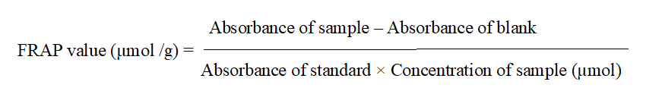
Antifungal assay
Potato Dextrose Agar medium was sterilized and then cooled. The media was poured into petriplates and the Malassezia culture was spreaded onto the petriplates. Then, 5 mm wells were made. The prepared different concentrations of aqueous plant extracts were added to the wells M.furfur inoculated plates and placed without disturbance for the diffusion of the extracts. Control plates without the plant extracts were also maintained. Then, the plates were incubated at 28°C for 4 days. The extent of inhibition was observed and measured in mm. All data on the antifungal activity were the average of triplicate analysis.
GC-MS Analysis:
GC-MS analysis of the methanol extract mixed combination of experimental sample was performed in a Perkin–Elmer GC Clarus 500 system comprising an AOC-20i auto-sampler and a Gas Chromatograph interfaced to a Mass Spectrometer (GC-MS) equipped with a Elite-5MS (5% diphenyl/95% dimethyl poly siloxane) fused a capillary column (30 × 0.25 μm ID × 0.25 μm df). For GC-MS detection, an electron ionization system was operated in electron impact mode with ionization energy of 70 eV. Helium gas (99.999%) was used as a carrier gas at a constant flow rate of 1 ml/min, and an injection volume of 2μl was employed (a split ratio of 10:1). The injector temperature was maintained at 250°C, the ion-source temperature was 200°C, the oven temperature was programmed from 110°C (isothermal for 2 min), with an increase of 10°C/min to 200°C, then 5 °C/min to 280°C, ending with a 9 min isothermal at 280°C. Mass spectra were taken at 70 eV; a scan interval of 0.5 s and fragments from 45 to 450 Da. The solvent delay was 0 to 2 min, and the total GC-MS running time was 36 min. The relative percentage amount of each component was calculated by comparing its average peak area to the total areas. The mass-detector used in this analysis was Turbo-Mass Gold-Perkinelmer, and the software was adopted to handle mass spectra and chromatograms. Identification of compounds: Interpretation on mass spectrum GC-MS was conducted using the database of National Institute Standard and Technology (NIST) having more than 62,000 patterns. The spectrum of the known component was compared with the spectrum of the known components stored in the NIST library. The name, molecular weight and structure of the components of the test materials were ascertained.
Identification of fungal organism by 18srRNA sequence analysis.
The experimental organisms Lactobacillus (LAB) strains used in this study were isolated from the citric juices comined with butter milk. LAB were isolated on MCC, Mariagiri Biotech Lab PCR amplification was performed in a volume of 50 μl consisting of 5 μl of concentrated lysate or 10 μl of 1:10 and 1:100 dilutions of the lysate in sterile MilliQ-grade water (Millipore, Boston, Mass.). The remainder of the reaction mixture contained 1× PCR buffer (50 mM KCl, 10 mM Tris-HCl [pH 9.0], 0.1% Triton X-100, 1.5mM MgCl₂), 0.4mM each of the four deoxynucleoside triphosphates (dATP, dCTP, dGTP, and dTTP), 1.0 U of Taq DNA polymerase (Promega UK Ltd., Southampton, United Kingdom) and 0.2 μM (each) PCR primer. Thirty-five microliters of DyNAwax was used to separate the primers and lysate from the rest of the reaction mixture to reduce the incidence of nonspecific PCR products and also improve the yield of the desired DNA fragments. The PCR was performed in an Omni-Gene thermal cycler (Hybaid, Teddington, United Kingdom). The cycling conditions were as follows: (i) an initial denaturation step at 94°C for 5 min; (ii) 35 cycles, with 1 cycle consisting of denaturation at 94°C for 1 min, annealing at 55°C for 1 min, and extension at 72°C for 1.5 min; and (iii) a final extension step at 72°C for 10 min.
RESULT
Phytochemical analysis
The pharmacological effects of all these experimental herbal extracts are mainly due to the presence of bioactive chemical constituents. Alkaloids, flavonoids, Tannin and Saponin were present in all plants but terpenoids are absent in all the experimental extracts. However, Steroids and Phlobatannin are absent in all the extracts. Though, anthraquinone and saponins are maximum present on both extracts of L. inermis and E.alba.

Table-1:- Preliminary phytochemical analysis of poly herbal (four plant) extracts (Aqueous)
S.No | Name of the test | E. alba | L .nermis | H. rosasinensis | M. koenigii
1. | Tannin | - | + | + | +
2. | Steroid | - | - | - | -
3. | Phenol | + | + | ++ | +
4. | Phlobatannin | - | - | - | -
5. | Flavonoid | + | + | ++ | +
6. | Saponin | +++ | + | + | +
7. | Terpenoid | + | ++ | + | -
8. | Alkaloid | ++ | + | - | +
9. | Anthraquinone | - | +++ | - | -

Note: (+) mildly positive, (++) moderately Positive, and (+++) highly positive (significantly visible color change).
Quantitative determination of phytochemicals by GCMS Analysis.
The identification of phytochemical compounds is based on their retention time (RT), molecular formula, molecular weight (MW), chemical structure and concentration (peak area %). GC-MS chromatogram of leaves of E. alba one, 4a-dimethly-[20R] (retention time 20.3), 10-Octadecenoic acid, methyl ester (retention time 17.07), 1,2 Benzenedicarboxylic acid, butyl octy ester (retention time 15.93), Dodecanoic acid,10 methyl, methyl ester (retention time 15.33) (Table-1) and (Figure-1). The GC-MS analysis of the mixed extract revealed several bioactive compounds with varying relative abundance. The compound Phthalic acid showed the highest relative abundance (109.25) at a retention time of (50.2 min), indicating it as the dominant constituent in the extract. This was closely followed by Heptanoic acid, 2-ethyl- (109.12) at (80.4 min), suggesting another major component with significant presence. The next identified the predominant compound named as 5,5-(tetrahydro-1H,3H-furo[3,4-c] furan-1,4-diyl) bis with a relative abundance of (83.53) at (50.4 min), followed by Myristic acid (72.11) at (60.4 min). Geranyl acetone also showed considerable abundance (68.31) at (20.7 min), indicating moderate presence in the extract. Further, diisooctyl ester (63.25) at (40.1 min) and Palmitic acid (58.10) at (30.8 min) were observed as moderately abundant compounds. Hexanedioic acid, bis(2-ethylhexyl) ester (41.50) at (70.5 min) and Alpha-caryophyllene benzene derivative (40.12) at (20.4 min) showed relatively lower but notable presence. Moreover, Compounds such as Limonene (39.82) at (40.5 min), Squalene (37.12) at (40.3 min), Phenyl-4-quinolinecarboxamide (36.10) at (70.8 min), Carvol (36.57) at (70.1 min), and 1,3-Benzodioxole (36.04) at (50.9 min) exhibited moderate to low abundance. The least abundant compounds included Phenanthrene, 9,10-diethyl-3,6-dimethoxy (24.71) at (90.1 min) and Dimethylamino-4-(2-cyano-2-phenylvinyl) (15.34) at (30.5 min), indicating minimal contribution to the extract composition (Table-2).
Apart from the current result combined polyherbal formulation showed that the maximum peak was observed for Phthalic acid at retention time (50.2 min), indicating it as the most dominant compound in the extract. The second most peak was Heptanoic acid, 2-ethyl- at (80.4 min), which also shows nearly equal abundance. However, optimum level occurrenced compound also been observed Geranyl acetone at (20.7 min) along with its lowest peak was Dimethylamino-4-(2-cyano-2-phenylvinyl) at (30.5 min), indicating very low concentration in the extract and minimal contribution to biological activity. Moreover, Phthalic acid (50.2 min), Heptanoic acid, 2-ethyl- (80.4 min) and 5,5′-(tetrahydro-1H,3H-furo[3,4-c] furan-1,4-diyl) bis (50.4 min) are the three peak compounds. The Geranyl acetone (20.7 min) was the optimum or Moderate Peak and the lowest Peak Dimethylamino-4-(2-cyano-2-phenylvinyl) (30.5 min) are the pharmaceutical value compound (Fig-1).
Fig:-1- Ellucidation of GCMS Chromatogram from the bioactive components in the experimental sample of Polyherbal extracts

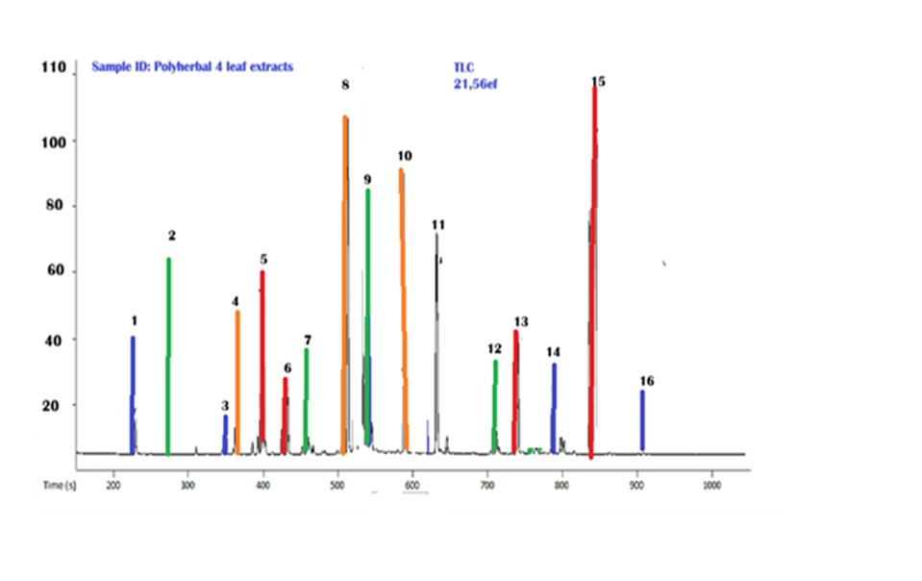
Table-2:- Bioactive Compounds of Mixed Extract from The Four Experimental Herbal Samples by GCMS Analysis

S.No | Analytes | Retention Time | Relative Abundance
1. | Alpha.-caryophyllene Benzene, 1- 2- 45.52 294 | 20.4 | 40.12
2. | geranyl acetone | 20.7 | 68.31
3 | Dimethylamino-4-(2-Cyano-2-Phenylethenyl, | 30.5 | 15.34
4 | Palmitic acid | 30.8 | 58.10
5 | diisoocytl ester | 40.1 | 63.25
6 | Squalene | 40.3 | 37.12
7 | limonene | 40.5 | 39.82
8 | Phthalic acid | 50.2 | 109.25
9 | 5.5’- (tetrahydro-1H,3H-furo  {3,4-c)furan-1,4-diyl) bis | 50.4 | 83.53
10 | 1,3-Benzodioxole | 50.9 | 36.04
11 | Myristic acid | 60.4 | 72.11
12 | Carvol | 70.1 | 36.57
13 | Hexanedioic acid, bis(2-ethylexyl) ester | 70.5 | 41.50
14 | Phenyl-4-Quinolinecarboxamide | 70.8 | 36.10
15 | Heptanoic acid, 2-ethyl- | 80.4 | 109.12
16 | Phenanthrene, 9,10-Diethyl-3,6-Dimethoxy | 90.1 | 24.71

Fig-2 ;- Microscopic view of experimental dandruff causative agent of M. globosa
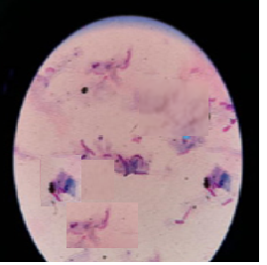
Table-3:- Antibacterial activity of four herbal extract against the dandruff causative agent of M. globosa

Name of the sample | Zone of inhibition (mm-cm)
Name of the sample | 50% | 100%
E. alba | 0.681* | 0.674
Lawsonia inermis | 0.634** | 0.726**
H. rosasinensis | 0.663 | 0.793
M. koenigii | 0.886 | 1.512*
Mixed Extract | 1.843 | 2.348**
Positive control  ( Ketoconazole) | 2.782 | 2.782

From the table-3 shows that the antifungal activity of tested four different experimental individual extracts and mixed polyherbal extracts against the identified dandruff causative agent of Malessezia globossa. Apart from the present result clearly showed that the maximum antifungal activity has been noticed on the individual extract of M. koenigii 1,512cm followed by more or less similar activity also noticed on both extract of H. Rosasinensis and L. inermis, Though, least zone of inhibition was observed on E. alba leaf extract. However, tested samples mixed extract was definitely denoted to the highest activity 2.348cm against the dandruff agent of M. globossa. From the present result it was clearly expressed all the four individual plant extract showed minimum to maximum antidandruff activity among the four M.koeningi possessed maximum antifungal activity than other three extracts. Even though, a mixed composition of these four herbal extracts (aqueous) consists more potential antidandruff effect than the individual extracts of E.alba, H. rosasinensis, L. inermis and M.koenigii.
Fig-3;- Antioxidant activity of four experimental herbal extract
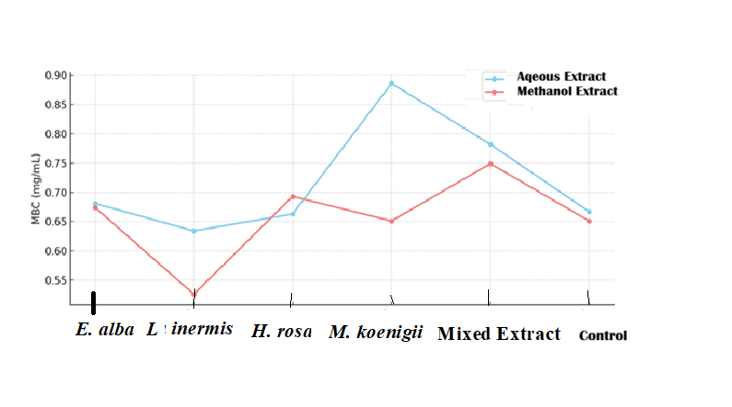
The antioxidant activity of aqueous and methanol extract of individual four experimental extracts and its mixed polyherbal composition has been represented in fig-3. From the present result it was clearly revealed that the highest antioxidant activity represents the following order, foremost maximum antioxidant activity has been noticed M.koenigi, secondly, polyherbal mixed composition followed by E.alba showed that the thirdmost activity, furthermore, similar activity observed on both extract of L.inermis and H.rosasinensis. Apart from the present result depicted that when compared with methanol extract of all these samples clearly expressed maximum significantly potential antioxidant activity noticed on aqueous extract than methanol extract.

SEQUENCE ANALYSIS
Name of the Identified Experimental Organism (S;ID:3 MCC B.SC-DCO-7) of the Dandruff causative agent is “Malassezia globosa”
Fig-4a:-PCR Ethidium Bromide Amplified product view of Malessezia globosa
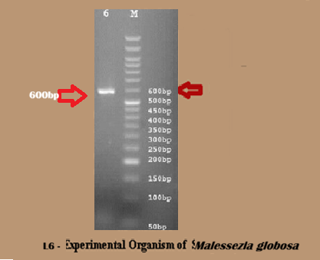
Fig-4b:-Analyzed sample file in Sequencing Analysis Software of Electropherogram

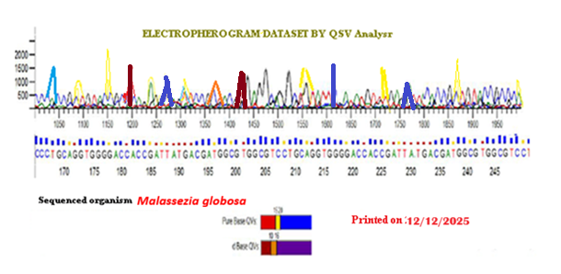
Fig-4c:-Graphic view for authentication of Experimental Sample organism
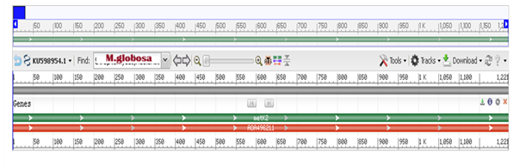
The present study has been identified the major dandruff causative agent of fungal organism such as Malassezia globosa is the most likely initiating organism by virtue of its high lipase activity, and it was expressed lipase on human scalp region. Considering the importance of M. globosa in D/SD (and the overall importance of commensal fungi), hence the have sequenced the M. globosa and M. restricta genomes. Genomic analysis indicates key adaptations to the skin environment, several of which yield important clues to the role Malassezia plays in human disease. This work offers the promise of defining new treatments to D/SD that are targeted at changing the level or activities of Malassezia genes. The experimental fungal organism has been identified through subsequent sequence analysis techniques like ethidium bromide gel view of pcr product gel view and it has been expressed the typical 600bp and electropherogram representing conformation of the dandruff agent was M.globossa (Fig 2 and Fig 4a-c).
DISCUSSION
Malassezia yeasts are lipophilic normal microbial flora (Clayton et al., 1967) needing specific lipids, such as oleic acid, for their growth. Colony formation begins quickly after birth and remarkably increases with the increase of neonatal age (Ayhan et al., 2007). Skin colonization by Malassezia species is increased from 7% at the first week to 40% at 3-5 weeks of life (Ayhan et al., 2007). The medicinal plants employed in this study all include the phytochemicals that make up, and these phytochemicals have a variety of important biological roles, according to a preliminary phytochemical analysis. According to research, alkaloids have pharmacological effects such antibacterial, antiarrhythmic, analgesic, and antihyperglycemic properties. Flavonoids were recognised to have alpha glucosidase activity (Al Nasret al., 2019), antioxidant activity (Amat-ur-Rasool et al., 2020). Glycosides are well-known for their effects on the contractile forces of cardiac muscle, whereas saponins are renowned for their antifungal, antibacterial, anti-protozoal, and lipid lowering properties (Arora pooja et al 2023). Ascorbic acid has been found in various. Flavonoids can also reduce the activity of many enzymes, including those suspected to be involved in the production of free radicals such xanthine oxidase, peroxidase, and nitric oxide synthases as a result, macromolecules experience less oxidative damage previously agreed by Almeida, et al., (2012). The zone of inhibition tests of mixed poly herbal extract revealed distinct antifungal activity against the M. globossa with a larger zone of inhibition (2.348 cm), whereas individual exract of M. koenigi demonstrated significant antifungal activity with a zone of inhibition of 1.512 cm.
Crude herbal drugs have been included in traditional medicine and household remedies for a long time. There are measgre studies on the effect of plant extracts on these fungi (Ronald et al., 2001). In an attempt to determine the benefits of various herbal extracts, effect of different plant extracts against Malassezia globosa an yeast associated with dandruff were evaluated. Previously, several researchers were agreed the current result of the selected herbal plant extracts of E.alba, H. rosasinensis, L. inermis and M.koenigii (Arora et al., 2011; Almeida et al., 2012; Yu et al ., 2017).
Antidandruff activities of three different branded antidandruff shampoos were also studied and their zone of inhibitions noted. These results were considered as standard reference and compared the results of the extracts with that of the shampoos (Gholve et al., 2015). On comparison one can say that the plant extracts showed a considerable activity against dandruff causing organism Malassezia furfur and can be used to treat dandruff which cause no side effects (Lee, Jeong-Hyun and Jae-Sug Lee, 2010). Bhringraj prevents scalp issues as irritation due to dandruff, so that hair growth remains unhindered (Ronald et al., 2001). It acts as an antioxidant to cleanse the scalp due to sebum deposition, opens blocked pores, kills bacteria and promotes hair growth (Piepard et al., 1997; Lee et al., 2012). It conditions hair and also removes dandruff. It has antimicrobial and antifungal properties that can help reduce dandruff, which can help psoriasis or other skin irritations on the scalp. It is also said to improve circulation to the scalp (Singla et al., 2011).
Hibiscus or ‘gudhal’ is the most beneficial ingredient for hair (Gholve et al., 2015). It is used for the growth of hair, its regrowth, and hair loss. Hibiscus carries amino acids, Vitamin A, C and alpha hydroxyl acids along with other nutrients that are highly beneficial for hair and scalp. They keep scalp healthy and minimize the chances of dandruff from hair (Diana et al., 2015). Hibiscus carries amino acids, Vitamin A, C and alpha hydroxyl acids that are extremely nice for scalp and healthy scalp is a must for the removal of dandruff from hair. Hibiscus has astringent properties, which help reduce the oil gland secretions and excessive oil secretion of the scalp opined the similar view by Almeida et al. (2012). This property of the flower helps cool and soothe scalp providing relief from itchy scalp and dandruff (Rashmi et al., 2017).
Conclusion
Plant extracts showed good activity against dandruff causing organism Malassezia globosa. From the research it was concluded that four herbal plant extracts have antifungal activity and could be safely used for treating dandruff causative fungal organism of Malassezia globossa. It was a lipophilic yeast that are part of the normal human cutaneous commensal flora; they are isolated from sebaceous gland-rich areas of the skin, particularly on the chest, back, and head. They are also associated with several cutaneous diseases, including atopic dermatitis, folliculitis, pityriasis versicolor, and seborrheic dermatitis. The current research focused the poly herbal experimental aqueous extract of Eclipta alba, Hibiscus rosasinensis, Lawsonia inermis and Muraya koenigii has significant antibacterial and antifungal properties, construction it better, harmless, and additional actual in reducing and treating dandruff. The future scope of herbal anti-dandruff hair gel is promising because of the rising demand for natural solutions and research-backed formulas by consumers. This can be capitalized to drive greater market success and sustainable use of resources. Further studies can be made on the active molecules of plant extracts responsible for antidandruff activity. Recurrence of dandruff up on usage of these plant extracts can also be explored.
REFERENCES
Abhijeet pandey, Jui V. Jagpat, S. A. ,2011. Polshettiwar. “Formulation and Evaluation of in-vitro Antimicrobial activity of gel containing essential oils and effect of polymer on their antimicrobial activity” International Journal of Pharmacy and Pharmaceutical Sciences. vol3: 1, pg: 234-237.
Ahonsi, C.O, Ovobovwori, S.U. and Etatuvie, S.O. 2023. Phytochemical and Antioxidant Activities of a Polyherbal Formulation from Selected Medicinal Herbs. IJCMCR. 25(5):01-08.
Al Nasr, I. Jentzsch, J. Winter, I. Schobert, R. Ersfeld, K. Koko, W. S. Mujawah, A. A Khan, T. A.and Biersack, B. 2019. Antiparasitic Activities of New Lawsone Mannich Bases. Arch. Pharm. (Weinheim), 552 (11), 1900128.
Almeida, P. J., Borrego, L., Pulido-Melián, E., and González-Díaz, O. 2012. Quantification of Phenylenediamine and 2-Hydroxy-1,4- Naphthoquinone in Henna Tattoos. Contact Dermatitis, 66 (1), 33-37.
Amat-ur-Rasool, H. Symes, F. Tooth, D. Schaffert, L. N Elmorsy, E. Ahmed, M Hasnain, S. Carter, W. G.2020. Potential Nutraceutical Properties of Leaves from Several Commonly Cultivated Plants. Biomolecules, 10 (11), 1556.
Arora P., Nanda A. and Karan M. 2011. Plants used in management of Dandruff”. The Indian Pharmacist. March, pg: 28-31.
Arora pooja, Nanda Arun, Karan M. 2013, “Screening of plant essential oils for antifungal activity against malassezia furfur” Int.journal of pharmacy & pharmaceutical sciences. Vol.5, issue2, 37-39
Ayhan M, Sancak B, Karaduman A, Arikan S, Sahin S. 2007. Colonization of neonate skin by Malassezia species: relationship with neonatal cephalic pustulosis. J Am Acad Dermatol.; 57(6):1012–8.
Clayton T. Shaw, Raymond W. Vanderwyk 1967. “The Human Scalp as a Habitat for Molds”. J.Soc.Cosmetic Chemists. 18(): 563-568.
Diana P., Nandita K. and Padma T. 2015. Hibiscus Rosa Sinensis -a versatile Indian origin plant. J . Chem Pharma Sci, 8(4): 567-79.
Diana Pearline, Nandita Kamat, and Padma Thiagarajan. 2015. Hibiscus Rosa Sinensis -a versatile Indian origin plant. J Chem Pharma Sci, 8(4): 567-79.
Dikshit A, Tiwari A.K, Mishra R.K, Kamra A, Pandey A, Kumar A, and Bajaj A.K. 2012. Medicinal Plants, 4 (2): 55-64.
Gholve S, Nadarge S, Hindole S, Bhusnure O, Bhosale P, Thonte S. 2015. Formulation and Evaluation Of Polyherbal Antidandruff Powder Shampoo. World J Pharma Res, 4 (10): 1714-31.
Jahan R, Al-Nahain A, Majumder S, Rahmatullah M. 2014. Ethnopharmacological significance of Eclipta alba (L.) Hassk. (Asteraceae). Int Sch Res Notices; 2014385969.
Jordão A.K, Vargas M.D, Pinto A.C, da Silva F.D, Ferreira V.F. 2015. Lawsone in organic synthesis. RSC Adv., 5 (83),67909-67943.
Khare C.P, 2004. Encyclopedia of Indian Medicinal Plants, Springer-verlag Berlin Heidelberg, New York, 197- 198.
Kumar G.S, Jayaveera, K.N, Ashok kumar C.K, Umachigi Sanjay, Vrushabendra Swamy B.M, 2007Kishore Kumar.. Tropical J Pharm Res;6 (2) :717-723.
Lee, Jeong-Hyun and Jae-Sug Lee. 2010. Chemical composition and Antifungal Activity of Plant Essential Oils Against Malassezia furfur” Kor. J. Microbiol. Biotechnol. 38: 3, 315-321.
Naveen S, Karthika S, Sentila R, Mahenthiran R, Michael A. 2012. In-vitro evaluation of herbal and chemical agents in the management of dandruff; 2 (6):916-921.
Piepard, J. E. Arrese, C. Pierard Franchimont, P. De Doncker 1997. Prolonged effects of antidandruff shampoos – time to recurrence of Malassezia ovalis colonization of skin”. Int J Cosmet Sci. 3: 111-117.
Rashmi S. Pal Open Modal D Nikita Saraswat1 Pranay Wal Ankita Wal and Yogendra Pal. 2017. Preparation & Assessment of Poly-Herbal Anti-Dandruff Formulation,
TODJ-14-22
Ronald R. Warner, James R, Schwartz, Ying Boissy BS, and L Dawson Jr, Ross, Ohio. 2001. American academy of dermatology;45 (6):897-903.
Roy RK, Thakur M, Dixit V.K, 2008. Arch Dermatology Res, 300(7), 357-364
Sanflippo A. 2006, An overview of medicated shampoos used in dandruff treatment J Ethnopharmacol, 31(7):396-400.
Singla chhavi, Drabu Sushma and Ali Mohammad 2011. “Potential of herbals as antidandruff agents”. International Research journal of Pharmacy. 2: 3, pg:16-18.
Uma Agarwal, Prajakta S Pande, Pralhad S Patki, Mitra SK. 2009. Evaluation of the c linical efficacy and safety of "hair cream for dandruff"in the treatment of dandruff granted specifically for"the antiseptic”.:106 (1):37-39.
Vijayakumar R., C. Muthukumar, T. Kumar, R. Saravanamuthu 2006. “Characterization of Malassezia furfur and its control by using plant extracts”. Indian Journal of Dematology. vol 51 2, 2006 145-148.
Wagner H, Geyer B, 1986 . Coumestans as the main active principles of the liver drugs Eclipta alba an`d Wedelia calendulaceae, Planta Med, , 52:370-374.
Yu J.Y, Gupta B, Park, H.G, 2017. Preclinical and Clinical Studies Demonstrate That the Proprietary Herbal Extract DA-5512 Effectively Stimulates Hair Growth and Promotes Hair Health. Evid Based Complement Alternat Med, 20174395638.

