Experimental study on the Mechanical Performance of Concrete paver by Partial Replacement of sand with steel slags

Abstract
The study investigated the use of steel slag as a partial replacement for natural sand in cement-sand paver blocks to promote sustainable construction and reduce environmental pollution caused by steel industry waste. Due to the increasing demand and scarcity of natural sand, steel slag was explored as an alternative fine aggregate material. Steel slag contains heavy metals that may pollute soil and groundwater if not properly managed; therefore, its reuse in construction can help reduce environmental hazards.A mortar mix ratio of 1:3 (cement:sand) was used, and steel slag was ground and sieved to meet fine aggregate standards. Paver blocks were produced with 0%, 25%, 50%, 75%, and 100% replacement of sand by steel slag and tested after 7, 14, and 28 days. Laboratory tests included sieve analysis, specific gravity, water absorption, durability, and compressive strength tests.The 28-day compressive strengths obtained were 32.9 MPa, 37.7 MPa, 41.5 MPa, 35.4 MPa, and 30.3 MPa for 0%, 25%, 50%, 75%, and 100% replacement respectively. The highest strength was achieved at 50% replacement with 41.5 MPa, corresponding to Grade 3 (M40) pavers according to BIS IS 15658:2006 standards. Such pavers are suitable for heavy traffic areas like bus stops, industrial floors, and service roads. The findings indicate that steel slag can effectively and sustainably replace natural sand partially in paver block production.

Keywords: Steel Slag, Concrete, Mechanical properties

INTRODUCTION
The construction industry in Rwanda faces growing challenges related to environmental sustainability, resource depletion, and climate resilience, particularly in the overexploitation of natural sand for concrete production, which contributes to ecosystem degradation and carbon emissions. At the same time, industrial by-products such as steel slag remain underutilized, often accumulating as unmanaged waste that poses environmental and health risks. A notable example is the SteelRwa plant in Rwamagana District, where slag waste has led to land degradation, dust pollution, and community concern. This research investigates the mechanical performance of concrete pavers incorporating steel slag as a partial replacement for natural sand, offering a sustainable solution that promotes recycling, reduces reliance on virgin materials, and supports Rwanda’s Vision 2050 goals of green growth and climate protection. By valorizing steel slag in cement-sand paver production, the study contributes to the circular economy and aligns with key Sustainable Development Goals Including: Industry, Innovation and Infrastructure, Sustainable Cities and Communities, Responsible Consumption, Production and Climate Action while addressing local environmental challenges and informing eco-friendly construction practices.

OBJECTIVE
During sand extraction from rivers the depth of rivers is increasing, this creates the increase of depth of water table around that region, hence the environment around the region meets with the problems of losing the water and reduces dependency on natural sand, Therefore, it is essential that much research must be conducted to get other construction materials that can replace sand. Steel slags can be one of materials that can replace sand in sand cement paver. However, these steel slags to be used are wastes from industries, which would be pollutants to environment causing land pollution [1].
The Steel slags are a waste product from steel production, so using them in construction can help reduce waste and minimize environmental pollution. So, the purpose of this study is to analyses if the steel slag can be used in cement sand paver as partial replacement of sand. And these aiming to promote sustainability and reduce waste [2].

Material and Methods
Research design

The study adopts an experimental study on the mechanical performance of concrete paver by partial replacement of sand with steel slags. The design enables the exploration of the manufacturing process and provides an explanatory framework for understanding the relationships between the chosen materials and the properties of the pavers. In the study on the mechanical performance of concrete paver by partial replacement of sand with steel slags, the research design serves as the foundational strategy for conducting the investigation.

Material Preparation
Sample preparation and Sieving

Sieve analysis was performed in order to know the particle or graine size distribution of steel slags and sand. The procedure has done according to IS 383-1970, the sample weight was 1920g for sand and 21600g for steel slag. The mass of steel slags was measured and recorded and placed into set of sieves of 4.75mm to 0.075mm sieves and Pan. And then shake appropriately each sample in 6 minutes. After each sieve removed and the mass retained of sample weighed.

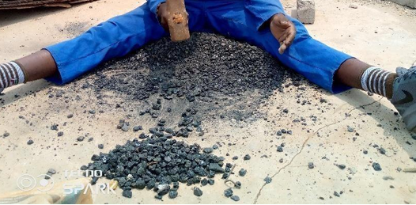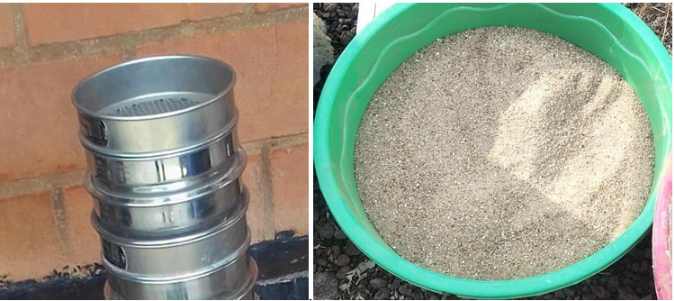

Preparation of steel slags

Mixing process
The materials were mixed in a manual mix to achieve a homogeneous blend. Mixing was conducted for a predetermined duration of 15minutes to ensure even distribution of all components. 0% of steel slag and 100% sand. 2. 25% of steel slag and 75% sand. 3. 50% of steel slag and 50% sand. 4. 75% of steel slag and 25% sand. 5. 100% of steel slag and 0% sand were used.
Molds were constructed from high-density polyethylene to ensure durability and ease of use. A release agent (hydraulic oil) was applied to facilitate the removal of the pavers after curing. The Mold sizes were 200mm*100mm*80mm to provide the desired volume.
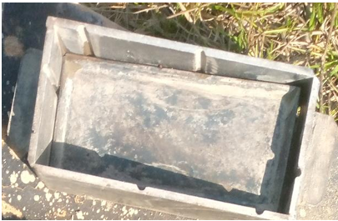
Rectangular Mold

Filling Molds
The mixed material was poured into the prepared molds, and a compaction process was applied using tamping rods to eliminate air pockets and achieve desired density.
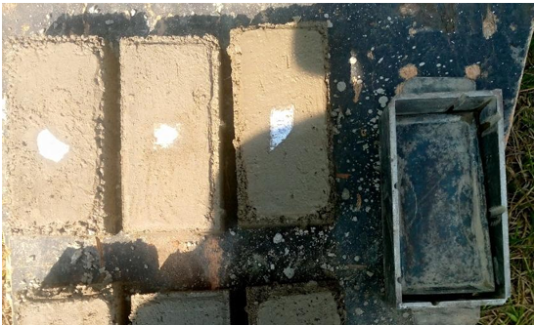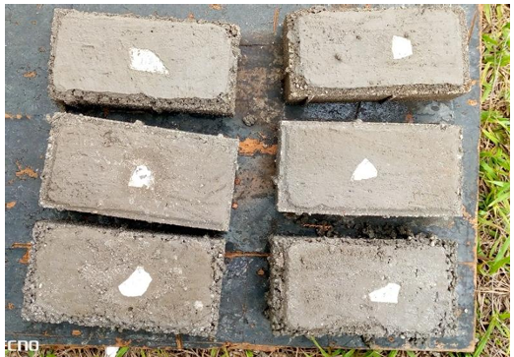
Molding Curing

Post-initial curing, the pavers were demolded and transferred to a shaded area for final curing, allowing them to strengthen over a period of 48 hours.

Testing and quality control

The pavers underwent a series of tests to evaluate compressive strength, water absorption, and flexural strength and density and specific gravity test following relevant standards.
Compressive Strength Test was performed according to ASTM C140/C140M-20, which specifies the testing procedures for masonry units.
Water Absorption Test was carried out according to ASTM C140 standards Test
Flexural Strength (Bending) was permed according ASTM C78/C78M-18 for flexural strength testing of concrete materials. Density Test was performed following ASTM C140 and C642 standards for determining the density of masonry units.
The specific gravity used: 1. Specific gravity of cement: 3.15 2. Specific gravity of fine aggregate: 2.65 3. Specific gravity of water: 1.0 4. Specific gravity of steel slags: 3.4 5. Standard deviation: 4

RESULTS AND DISCUSSION

The sand equivalent test was utilized to control the amount of clay material present. The sand equivalent test done ASTM D2419 is a quick on-site test that demonstrates the relative proportions of fine dust or clay-like substances in fine aggregate (or granular soils.

Table 1: The volume of aggregates and steel slags used in 20 pieces of paver
SNO | SAND (%) | VOLUME(m3) | STEEL SLAGS (%) | VOLUME(m3)
1 | 100 | 0.007392 | 0 | 0
2 | 75 | 0.005544 | 25 | 0.001848
3 | 50 | 0.003696 | 50 | 0.003696
4 | 25 | 0.001848 | 75 | 0.005544
5 | 0 | 0 | 100 | 0.007392

Sample Curing
The samples were placed in a controlled environment at a temperature of 23°C and relative humidity of 60% for 7,14, and 28 days. Ensure that the samples are not exposed to direct sunlight or extreme temperatures during the curing period.

Table 2: Compressive strengths at 28th day
NO | Steel slag % | Crushing load (N) | Area(mm²) | Average compressive strength (N/mm²)
1 | 0 | 658000 | 20000 | 32.9
2 | 25 | 754000 | 20000 | 37.7
3 | 50 | 830000 | 20000 | 41.5
4 | 75 | 708000 | 20000 | 35.4
5 | 100 | 606000 | 20000 | 30.3

SUMMARY
This study investigated the mechanical performance of concrete paver blocks when natural sand was partially replaced by steel slag. Materials used included cement, fine aggregates (sand), steel slags, and water. The mix ratio adopted for the pavers was 1:3 (cement:sand) with a water-cement ratio of 0.4. Steel slag was used as a partial replacement for sand at proportions of 0%, 25%, 50%, 75%, and 100%. Tests conducted included sieve analysis, specific gravity, water absorption, and compressive strength at 7, 14, and 28 days. Results showed that: - The maximum compressive strength was achieved at 50% steel slag replacement, reaching 41.5 MPa after 28 days. - Strength improved progressively up to 50% replacement but decreased beyond that point. - The water absorption rate for 50% slag pavers was 2.14%, which is within the IS 15658:2006 standard (less than 6%). - Steel slag exhibited a higher specific gravity (3.4) compared to sand (2.65), contributing to denser and stronger pavers. The findings demonstrated that steel slag can effectively replace sand up to 50% without compromising quality, strength, or durability. This substitution not only enhances mechanical properties but also promotes environmental sustainability and reduces construction costs.

CONCLUSION

The study concluded that: - Steel slag is a viable alternative to natural sand for concrete paver production, 50% replacement of sand with steel slag provides the optimum compressive strength and satisfies standard paving requirements, Beyond 50%, strength begins to decline due to excessive slag content affecting the bonding and workability of the mix, Steel slag utilization contributes to environmental conservation, waste reduction, and sustainable construction practices, The project objectives were fully achieved, proving that pavers with 50% slag replacement perform within the range of standard M40 grade pavers. Thus, steel slag can be successfully used as a partial sand replacement in concrete pavers, providing both structural and environmental benefits.

RECOMMENDATIONS
The study recommends using steel slag as a partial replacement for sand in paver block production at an optimum level of up to 50%, since higher replacement percentages negatively affect strength and durability. It also emphasizes the importance of quality control through tests such as sieve analysis and specific gravity to ensure the steel slag meets construction standards. Construction industries are encouraged to adopt steel slag in paver manufacturing to reduce dependence on natural sand and support sustainable waste management practices. Additionally, the utilization of steel slag contributes to environmental protection by reducing industrial waste disposal challenges and supporting Rwanda’s Vision 2050 objectives for green growth and sustainability.

References

[1] | N. Gunathilaka, "Feasibility Analysis of Partial Replacement of Coarse and Fine Aggregates by Waste Steel Slag in Concrete Interlocking Paving Blocks," 2024.
[2] | M. E. Mitwally, "Utilization of steel slag as partial replacement for coarse aggregate," 2024.

