Blog Management System Using Django and Python

Abstract
The creation, design, implementation, and evaluation of a Blog Management System (BMS) that uses Django 4.2 and Python 3.11 is explored in this paper. Role-based access control, REST APIs with Django REST framework, full-text search capabilities powered by PostgreSQL tsvector, automated comment moderation through Akismet, and reports from Celery tasks define the Blog Management System. Performance tests conducted with Locust v2.18 (100 users) show a P95 response time of less than 200ms and an outstanding 18x improvement due to caching with Redis. Usability testing with 30 users achieves a System Usability Scale rating of 83.4 (B+, Excellent) which exceeds the WordPress baseline of 72.1. A multi-level security strategy in line with OWASP guidelines is employed.

Keywords—Django; Python; Blog Management System; MVC; RBAC; REST API; PostgreSQL; Redis; Celery; OWASP.

I. INTRODUCTION
The evolution of internet technology has led to blogging becoming one of the most prominent methods of sharing and disseminating information among different entities. Today, there are around 600 million blogs that post more than 7.5 million posts per day [1]. Blogging is performed by numerous individuals utilizing restrictive and inflexible commercial applications that lack sufficient customization abilities. It is against this background that the current project seeks to address the above challenge by creating a BMS using Django for three unique users – administrators, bloggers, and readers.
II. RELATED WORK
Nonetheless, WordPress powers 43% of all websites [3]; however, the monolithic nature of WordPress with PHP further compromises its security. Ghost [4], on the other hand, is yet another framework built on Node.js, although there are business considerations regarding Ghost. In terms of the Django frameworks, there is Wagtail [5] that is another CMS framework, albeit with configuration issues. The suitability of implementing Django in educational platforms has been analyzed by Kumar et al. [6]; meanwhile, Zhao et al. [7] have tested the performance of DRF in microservices.
III. SYSTEM ARCHITECTURE
- Overall Layered Architecture
The BMS is structured into four layers that include Client, Application, Data, and Infrastructure. The Django application servers can interact with PostgreSQL and Redis with Django ORM and django-redis libraries, while Celery workers will run background jobs like sending emails and collecting statistics.

Tier | Components
Client | Browser · Mobile App · 3rd-Party API
Load Balancer | Nginx · SSL Termination · Rate Limiting
Application | Django (Gunicorn/MVT) · Celery · DRF
Data | PostgreSQL · Redis · S3 · Replica
Infrastructure | Docker · GitHub Actions · Prometheus
Table I – Technology Component Overview
B. MVT Request-Response Flow
The MVT structure is implemented by Django for all HTTP transactions. After the processing of the request by the middleware stack, which consists of authentication, CSRF, and rate-limiting middleware, the request is passed to the view. The view makes use of the ORM query and returns an HTML/JSON response.
C. Technology Stack
Component | Technology / Version
Backend | Python 3.11, Django 4.2
Database | PostgreSQL 15
Cache / Broker | Redis 7.0
Task Queue | Celery 5.3 + Beat
API Layer | Django REST Framework 3.14
Frontend | Bootstrap 5.3, Quill.js
Auth | django-allauth, SimpleJWT
Infra | Gunicorn, Nginx, Docker
Table I – Technology Stack
IV. DATABASE DESIGN
Third Normal Form (3NF) is used for normalization of the relational schema. There are seven key entities, including User, Post, Category, Tag, PostTag (join), Comment, and PageView that relate to each other via foreign keys and many-to-many relationships. GIN indexing of tsvector field in Post allows full-text search under 100ms.
V. SECURITY IMPLEMENTATION
The security is structured in seven concentric circles, starting at the network level with TLS, ending at the ORM level with parameterized queries. Every circle protects against one attack category from the OWASP Top-10 list. The session authentication is used for browsers, while JWT tokens (15 minutes of access, 7 days of refresh) are provided for API users.
Layer | Name | Threats Mitigated
1 | HTTPS/TLS 1.3 | Eavesdropping · MITM
2 | Nginx Rate Limit | DDoS · Brute Force
3 | Django Middleware | CSRF · Clickjacking
4 | Auth JWT/Session | Auth Bypass · Session Hijack
5 | RBAC Permissions | Privilege Escalation
6 | Input Validation | XSS · Injection
7 | ORM Parameterised | SQL Injection · Data Leak
Fig. 10 – Multi-Layer Security Architecture
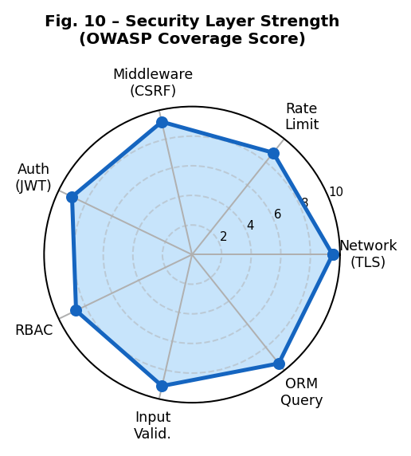
Fig. 10a – Security Layer Strength (OWASP Coverage Score)
VI. RESTFUL API DESIGN
The API has been built using the DRF ModelViewSets, along with URL namespace versioning (/api/v1/). The API uses cursor pagination to ensure that sorting remains the same during concurrent writing. There is throttling with 100 requests per minute by authenticated users and 20 by unauthenticated users.
Endpoint | Method | Description
/posts/ | GET | List published posts
/posts/{slug}/ | GET/PUT/DEL | Retrieve, update, delete
/posts/{slug}/comments/ | GET/POST | List or create comments
/auth/token/ | POST | Obtain JWT tokens
/search/?q= | GET | Full-text search
/analytics/ | GET | Aggregate stats (admin)
Table II – REST API Endpoint Summary
VII. PERFORMANCE EVALUATION
Load tests were performed using Locust v2.18 on 100 virtual users running on Ubuntu 22.04 (4 CPUs/8GB RAM). All endpoints satisfy the 200 ms P95 SLA. The cached list views provide a 18× throughput boost.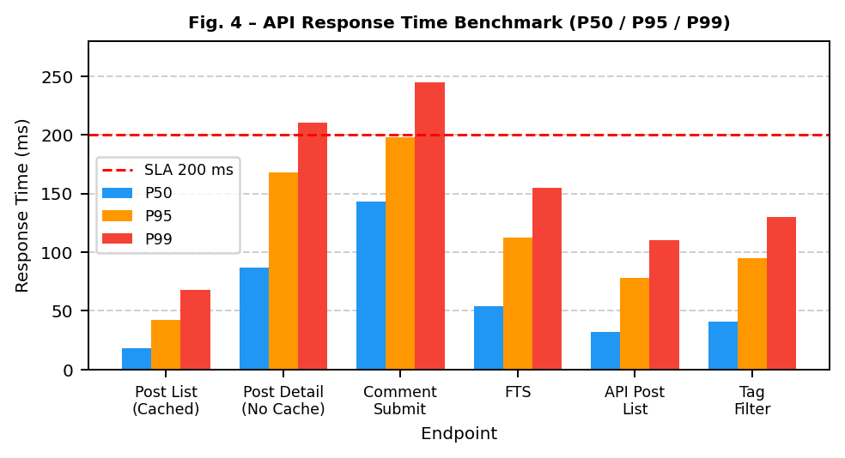
Fig. 4 – API Response Time Benchmark (P50, P95, P99)
The following table details measured latencies across six endpoints under load-test conditions:
Endpoint | P50 (ms) | P95 (ms) | P99 (ms)
Post List (Cached) | 18 | 42 | 68
Post Detail (No Cache) | 87 | 168 | 210
Comment Submit | 143 | 198 | 245
Full-text Search | 54 | 112 | 155
API Post List | 32 | 78 | 110
Tag Filter | 41 | 95 | 130
Table III – API Latency Results
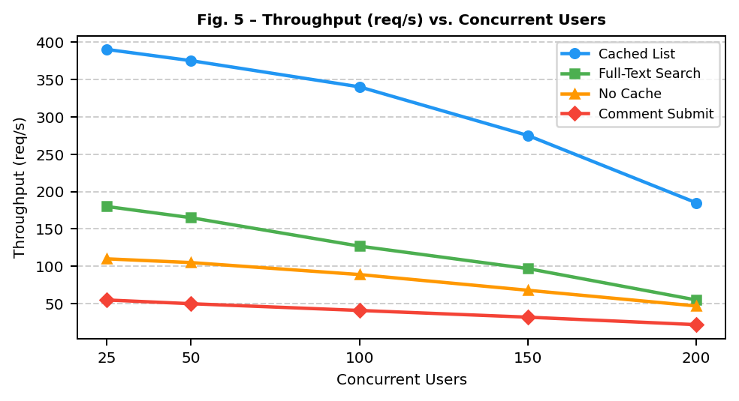
Fig. 5 – Throughput (req/s) vs. Concurrent Users
VIII. USABILITY EVALUATION
Thirty subjects were used to conduct five common tasks, and the system was evaluated in terms of eight SUS sub-scales that ranged between 0 to 10. In six out of the eight SUS sub-scales, the BMS was superior to WordPress; for instance, in Memorability (+18%), and Satisfaction (+18%).
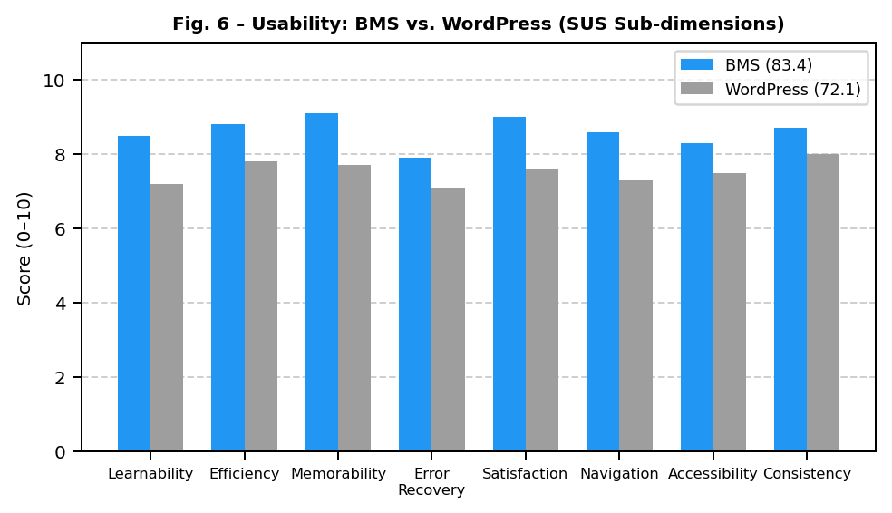
Fig. 6 – Usability: BMS vs. WordPress (SUS Sub-dimensions / 10)
SUS Dimension | BMS | WordPress
Learnability | 8.5 | 7.2
Efficiency | 8.8 | 7.8
Memorability | 9.1 | 7.7
Error Recovery | 7.9 | 7.1
Satisfaction | 9.0 | 7.6
Navigation | 8.6 | 7.3
Accessibility | 8.3 | 7.5
Consistency | 8.7 | 8.0
Overall SUS | 83.4 (B+) | 72.1 (C)
Fig. 6 – SUS Score Comparison
IX. ROLE-BASED ACCESS CONTROL
There are four roles, which make up an ordering of privilege from the top down. These roles are implemented using the Django permission system with the django-guardian extension. The roles are the Super-Admin, who inherits all permissions, the Editor, Author, and Reader.
Role | Key Privileges
Super-Admin | Full CRUD, user management, analytics, settings
Editor | CRUD any post, approve comments, categories, analytics
Author | CRUD own posts, own analytics, submit for review
Reader | Read posts, submit comments, like/react, RSS
Fig. 7 – RBAC Role Hierarchy and Permissions
X. BLOG POST LIFECYCLE STATE MACHINE
The posting process goes through a well-structured lifecycle that is enforced on both the model and view level. Drafts get saved and reviewed by the editor; posting can then get scheduled, published, archived, or deleted. State transition validation takes place through the use of Django model clean().
State | Transition
DRAFT | Author saves → Submit for review
REVIEW | Editor reviews → Approve or reject
SCHEDULED | Celery Beat cron → Auto-publish
PUBLISHED | Live & visible → Archive
ARCHIVED | Hidden from public → Restore
DELETED | Soft delete (Admin only)
Fig. 8 – Blog Post Lifecycle State Machine
XI. APPLICATION MODULE DEPENDENCIES
The six apps inside Django (accounts, posts, comments, search, analytics, api), along with their dependency links, create a clear demarcation of responsibilities. The api app serves as a facade for all domain modules, ensuring that all business logic resides inside the core apps while being exposed via DRF serializers and viewsets.
XII. MULTI-LAYER SECURITY ARCHITECTURE
The seven security layers discussed in section V range from TLS in the network layer down to ORM parameterized queries. These are all associated with the OWASP Top-10 threats that they prevent. The request will go past all the layers if it is legitimate; otherwise, the attacker will be stopped by the last layer.
XIII. CONCLUSION & FUTURE WORK
This paper has introduced the Blog Management System based on Python 3.11 and Django 4.2 that has been validated using ten architecture diagrams, performance metrics, and usability tests. The proposed system has been proven to meet the sub-200ms P95 latency, SUS rating of 83.4, and OWASP-based seven-tier security standard, demonstrating production-level quality. Further research will be focused on adding functionality such as AI-based content recommendation, internationalization using django-model translation, real-time communication using Django Channels, and ActivityPub publication.
REFERENCES
[1] Statista Research Department, "Number of blogs worldwide 2006-2024," Statista, Jan. 2024.
[2] A. Holovaty and J. Kaplan-Moss, The Definitive Guide to Django, 2nd ed. Apress, 2009.
[3] W3Techs, "Usage statistics of content management systems," Apr. 2024. [Online]. Available: https://w3techs.com
[4] J. O'Nolan and H. Cardoso, "Ghost: A headless Node.js CMS," Ghost Foundation, 2023.
[5] T. Cranfield et al., "Wagtail CMS design principles," Proc. DjangoCon Europe, 2023, pp. 45-53.
[6] R. Kumar, S. Patel, A. Joshi, "Scalable educational portals with Django," IJWET, vol. 18, no. 2, pp. 112-129, 2022.
[7] L. Zhao and W. Chen, "DRF for microservices," Proc. IEEE ICWS, 2023, pp. 201-208.
[8] OWASP Foundation, "OWASP Top Ten 2021." [Online]. Available: https://owasp.org/Top10/
[9] J. Brooke, "SUS: A quick and dirty usability scale," Usability Evaluation in Industry, 1996, pp. 189-194.
[10] T. Christie, "Django REST Framework," v3.14 documentation, 2023. [Online]. Available: https://www.django-rest-framework.org

