EVALUATING HABITAT QUALITY IN MT. LATIAN KEY BIODIVERSITY AREA
ABSTRACT
This study aims to assess the habitat quality of Mt. Latian Key Biodiversity Area through geospatial analysis and InVEST. Key biodiversity areas hosts unique species considering its vulnerability and irreplaceability. Due to the lacking legal basis, several KBA’s experience faster degradation and exploitation. The habitat quality model of InVEST analyzes several parameters such as threats, threat table, sensitivity table, and LULC. The LULC analysis revealed that forest comprises the majority of Mt. Latian covering 56.01% of the area, followed by shrubland (27.22%), grassland (11.50%), agriculture (4.89%), water, built-up, and barren (0.4%). Habitat quality assessment ahowed that very high quality areas covered 24.06% of the area, while low and very low quality collectively accounted for 39.99%, indicating significant pressure from anthropogenic disturbances. Habitat degradation revealed that very low degradation dominated with 80.37% of the area, though moderate to high degradation revealed 3.96%. Spatial autocorrelation showed high-high quality clusters which are small and scattered indicating fragmentation, while high-high degradation clusters form extensive continuous areas suggesting systemic degradation. Findings suggest that there should be immediate protection of areas with high habitat quality, restoration of degraded zones, and establish wildlife corridors to maintain ecosystem resilience in Mt. Latian Key Biodiversity Area.
Keywords: Habitat quality, InVEST, Key Biodiversity Area, Mt. Latian
INTRODUCTION
Biodiversity plays a vital role in stabilizing ecosystems and providing services that support life (Prakash & Verma, 2022). It connects all living things in the ecosystem causing dependence to one another for survival. Despite its value, it is threatened by anthropogenic factors such as land conversion, pollution, exploitation, and more which exacerbates the rapid decline in habitat quality (Agduma, et al., 2023). This affects species survival and ecosystem functioning (Daipan, 2021), which underscores the urgency in protection and conservation of sites that are ecologically significant and hosts significant species. Key biodiversity areas are defined as sites critical for conservation due to it hosting unique species and ecosystems that occur in important number or extent (Sun, et al., 2022). These areas are identified through criteria wherein it involves determining the presence of species that are vulnerable and threatened or are irreplaceable and supports several ecosystem processes. However, classifying an area as a key biodiversity area does not guarantee its conservation as it lacks an established legal basis and some areas are unprotected or partially protected (Cruz, 2025). Although there are sites that are protected due to it overlapping with sites that are identified as protected areas, majority of KBA’s still experience disturbance and anthropogenic activities causing fragmentation and exploitation (Yang, et al., 2025).
The Philippines is home to 228 terrestrial, marine, and freshwater KBA’s and is considered as a biodiversity hotspot (Daipan, 2021). As a megadiverse country, the Philippines is recognized to have unique species and have a high rate of endemism which is a product of its archipelagic geography and diverse habitats that support its distinctive flora and fauna (Kittelberger, et al., 2021). Among these is the Mt. Latian Key Biodiversity Area. This is located in Mindanao and encompasses approximately 949.7 km² of terrestrial area with an elevation ranging from 490 to 1,853 masl. It supports large parcels of forests and watersheds which sustain life. Despite its status as a key biodiversity area, it still faces threats which affects the habitat quality of the area. Habitat quality is defined as the capability of an ecosystem to provide suitable conditions necessary for species survival and reproduction (Sun et al., 2024). It reflects the condition of biodiversity and provision of ecosystem services in an area (Zhou et al., 2022). Habitat quality declines due to several factors such as climate change, high population growth, and rapid economic development which leads to environment degradation and biodiversity loss (Yohannes et al., 2021). Evaluating the habitat quality of an area improves conservation planning by providing the information needed for targeted and specific strategies to mitigate threats.
The habitat quality model of the Integrated Valuation of Ecosystem Services and Tradeoff (InVEST) is utilized as a tool to evaluate the habitat quality of an area. This model integrates data on present threats in the area and land use land cover to assess the level of degradation and habitat quality. Several studies have applied the InVEST habitat quality model across global sites, however its application in the key biodiversity areas in the Philippines is limited. Thus, this study aims to evaluate the habitat quality of Mt. Latian key biodiversity area. Specifically, it aims to (i) analyze the land use land cover of Mt. Latian; (ii) quantify habitat quality through InVEST habitat quality model; and (iii) map the spatial distribution of habitat quality and habitat degradation of the study site.
MATERIALS AND METHODS
Study Area
Mt. Latian is a key biodiversity area located at Malita, Davao Occidental, Philippines with a longitude of 125° 30' 26" E and latitude of 6° 12' 33" N. It has an elevation of 490 to 1853 masl and characterized by mountain ranges having forests classified as tropical upper montane rain forest and tropical lowland evergreen rain forest. Located at Davao Occidental, the area experiences type IV climate which is characterized by even rainfall and distributed throughout the year. As a key biodiversity area, it hosts various critically endangered, endangered and vulnerable fauna and flora species.
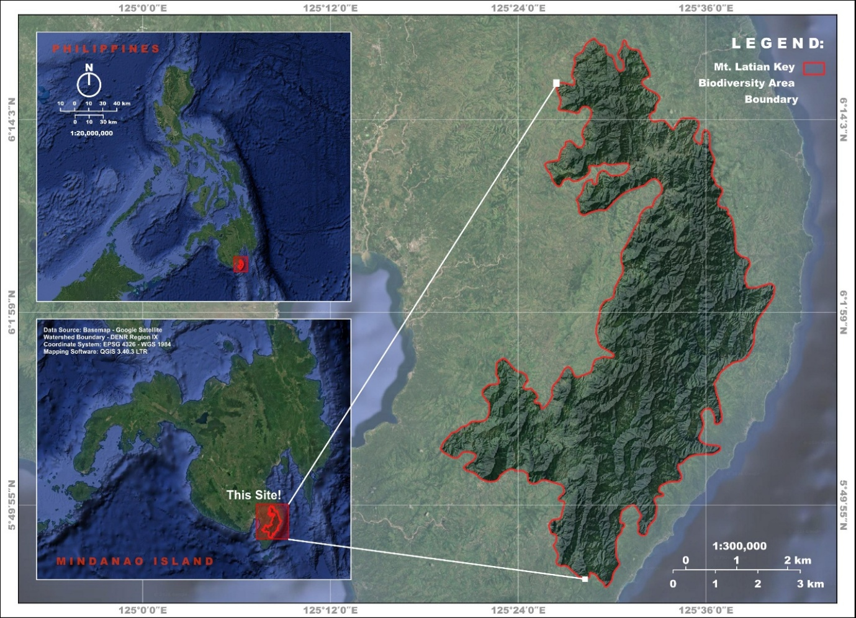

Figure 2. Location map of the study area
A descriptive quantitative design is utilized in this study applying GIS-based and remote sensing techniques as well as InVEST modeling approaches. Analyzing the habitat quality of an area involves the nearby threats and land use land cover (LULC) of the area (Otgonbayar et al., 2021). This spatial quantitative assessment would result to the degree of degradation and biodiversity in the study area (Wu et al., 2024).
Figure 1 shows the methodological framework of the study adapted from Umprasoet et al., 2023. The datasets utilized by the InVEST habitat quality model includes the land use land cover (LULC), threats, habitat types, and sensitivity of each habitat (Otgonbayar et al., 2021). The land use land cover of Mt. Latian will be analyzed. Then, a habitat compatibility score ranging from 0 to 1 is assigned for each land cover type, with higher values indicating better biodiversity support.
Another input parameter utilized by the model is the threats. This refers to the factors that are usually anthropogenic and causes habitat fragmentation, edge, and degradation in neighboring areas (Huo, et al., 2023). The threats are acquired with reference to existing studies and data, and the weight, impact distance, and attenuation type of each threat source are set, respectively, as well as the sensitivity of each land use type to a threat source (Sahle, et al., 2025).
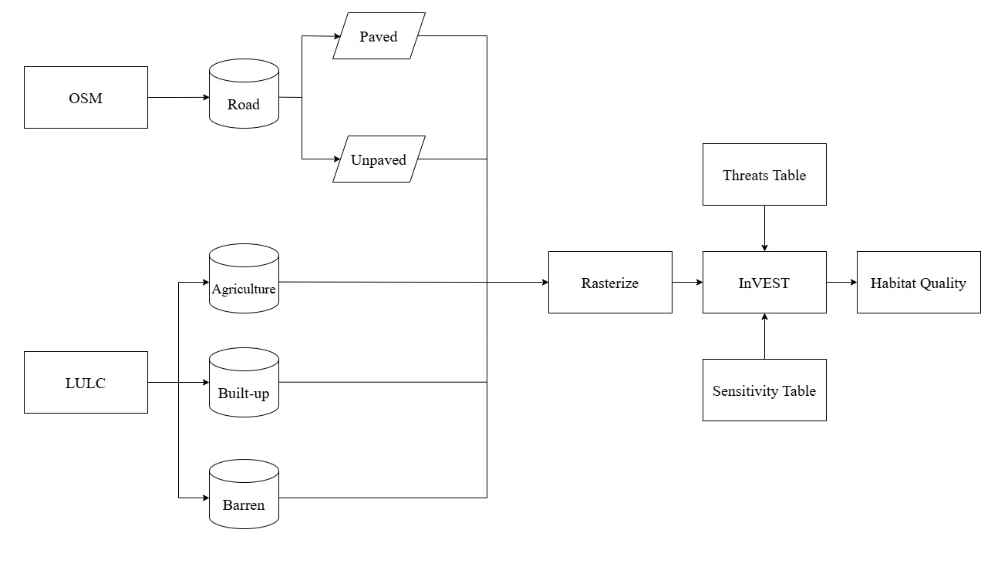

Figure 1. Methodological framework of the study
Table 1 shows the threats utilized in the study as well as the weights adapted from reference studies. While table 2 shows the values utilized for the sensitivity table which reflects the sensitivity of each land use to the threats.
Table 1. Threat factors and their attributes.
Threat | Maximum Distance (km) | Weight | Decay Type
Built-up | 3 | 0.9 | exponential
Agriculture | 2 | 0.6 | linear
Unpaved road | 1 | 0.2 | linear
Paved road | 2 | 0.5 | exponential
Barren | 1 | 0.3 | linear

Table 2. Sensitivity of land use types to threat factors.
Land use Type | Habitat Suitability | built-up | agriculture | unpaved road | paved road | barren
Forest | 1 | 1 | 0.9 | 0.5 | 0.8 | 0.6
Water | 0.9 | 0.9 | 0.9 | 0.3 | 0.5 | 0.3
Shrubland | 0.6 | 0.8 | 0.1 | 0.63 | 0.78 | 0.5
Grassland | 0.5 | 0.7 | 0.5 | 0.63 | 0.8 | 0.5
Agriculture | 0.4 | 0.4 | 0 | 0.3 | 0.5 | 0
Barren | 0.2 | 0 | 0.1 | 0.1 | 0.1 | 0
Built-up | 0 | 0.5 | 0.3 | 0.46 | 0.56 | 0
RESULTS AND DISCUSSIONS
Land Use Land Cover
Figure 2 shows the analyzed land use land cover of Mt. Latian. The analysis revealed that forest comprises the majority of Mt. Latian covering 54,956.43 ha or 56.01% of the area. Followed by shrubland with 26,705.27 ha or 27.22% of the area, grassland with 11,287.41 ha or 11.50%, and agriculture with 4,796.37 ha or 4.89%. Water, barren land, and built-up areas collectively accounted for less than 0.4%.
The dominance of forest cover implicates that Mt. Latian experiences minimal disturbances and still has sufficient vegetation which supports various flora and fauna. This strengthens its role as a key biodiversity area that host critical species, serve as good carbon sinks, and contribute to various ecosystem services.
Shrubland is the second class that dominates the area. This usually indicates transitional or re-growth zones wherein previous disturbances have occurred and is currently experiencing regeneration (Gupta et al, 2025). The notable proportion of shrubland alongside forest cover shows that the area is still actively recovering however if disturbances persist, this transitional stage would become stagnant preventing further ecological recovery (Amodeo et at, 2024). Grassland follows as the third class dominating the area. Similar with the shrubland, this indicates recovery from disturbances, only that the disturbances experienced in this class is more recent and frequent. Herbaceous plants and grasses typically first dominate disturbed areas and are important for the next stage of succession (Sansevero et al., 2020).
Agriculture is the next dominant class in the area. The presence of agriculture in the area serves as a threat as one of the primary drivers of land use change and environmental degradation (Chaurasia, 2025). Even though its extent is relatively small than other classes, the fact that it is present within a key biodiversity area may indicate that disturbance is indeed present in the area. Not only the presence of agriculture poses risks for the area but including also the built-ups and barren classes. The extent of these classes are also small but they are situated near the forest areas. Its close proximity makes it a serious threat to the area. Presence of built-ups and barren classes in an area increases risk for altered microclimatic conditions, increased levels of anthropogenic disturbance, and changes in soil and water chemistry. These can cause reduced forest diversity, decreases regeneration capability, and further habitat loss (Haddad et al., 2015).
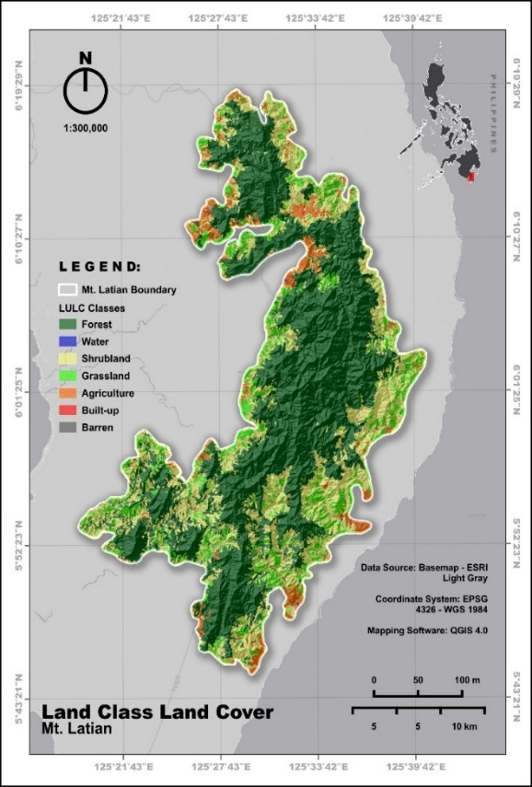

Figure 2. Map showing the land use land cover of Mt. Latian
Table 3. Analyzed land use land cover of Mt. Latian
Class number | Class description | Area | %
1 | Forest | 54956.4324 | 56.01
2 | Water | 225.1204 | 0.23
3 | Shrubland | 26705.2666 | 27.22
4 | Grassland | 11287.4086 | 11.50
5 | Agriculture | 4796.3713 | 4.89
6 | Barren | 107.6121 | 0.11
7 | Built-up | 32.0934 | 0.03
Habitat Quality
Figure 3 and table 3 shows the analyzed results for habitat quality of Mt. Latian. Results revealed that very high habitat quality areas covered the largest proportion with 24.06% of the area or 23,603.32 ha, followed by low (20.96%, 20,565.89 ha) and moderate (20.01%, 19,631.82 ha) quality classes. Very low and high quality classes accounted for 19.03% (18,669.13 ha) and 15.94% (15,640.14 ha), respectively.
The substantial extent of very high and moderate habitat quality suggests that large portions of Mt. Latian remain relatively intact, potentially supporting native biodiversity and ecosystem functions. However, the combined area of very low and low habitat quality (39.99%) indicates significant pressure from anthropogenic or natural disturbances. These findings align with Agduma et al. (2023), who noted that southern Philippine KBAs face increasing threats from land use conversion and habitat fragmentation.
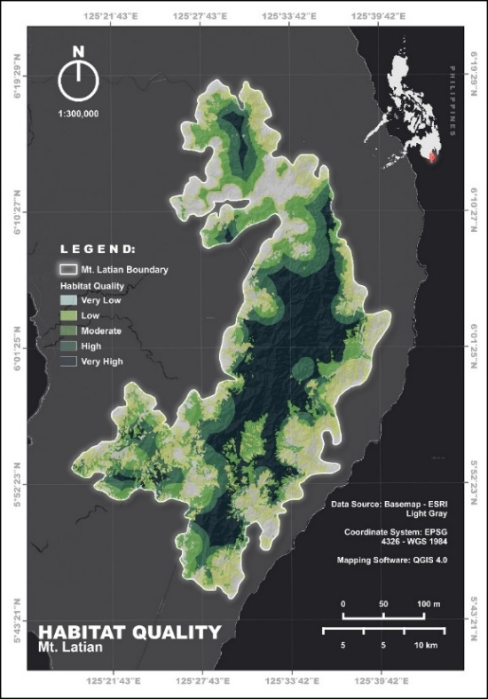
The dominance of forest cover strongly supports the observed very high habitat quality class (24.06%). Forests typically provide superior habitat conditions, including structural complexity, microclimate regulation, and resources for endemic and threatened species (Kittelberger et al., 2021). Shrubland and grassland, while still providing moderate habitat quality, are likely transitional or degraded forest areas. Their combined extent suggests historical or ongoing disturbance. This corresponds with the 39.99% of the area classified as very low to low habitat quality. Agricultural areas and built-up areas are strongly associated with very low habitat quality, as intensive land management reduces native vegetation, fragments habitats, and introduces edge effects (Sun et al., 2022; Sahle et al., 2025).

Figure 3. Map showing the habitat quality of Mt. Latian
Table 4. Analyzed habitat quality of Mt. Latian
Class number | Class description | Area (ha) | %
1 | Very low | 18669.13 | 19.03
2 | Low | 20565.89 | 20.96
3 | Moderate | 19631.82 | 20.01
4 | High | 15640.14 | 15.94
5 | Very high | 23603.32 | 24.06
Habitat Degradation
Figure 4 shows the habitat degradation analysis of Mt. Latian. It showed that the vast majority of the area experienced very low degradation which covers 80.37% or 78,848.18 ha. While low degradation covered 15.64% (15,344.33 ha). Moderate, high, and very high degradation classes collectively accounted for only 4.00% (3,917.79 ha), with very high degradation being negligible (0.04%, 39.02 ha).
The presence of moderate to high degradation which is 3.96% combined, is likely driven by agricultural expansion and human settlements, even though they occupy small areas. Edge effects from these land uses can disproportionately degrade adjacent forest and shrubland habitats (Wu et al., 2024). The very small built-up area (0.03%) indicates that urbanization is not yet a major driver of degradation in Mt. Latian, but proactive land use planning is needed to prevent future expansion (Zhou et al., 2022).
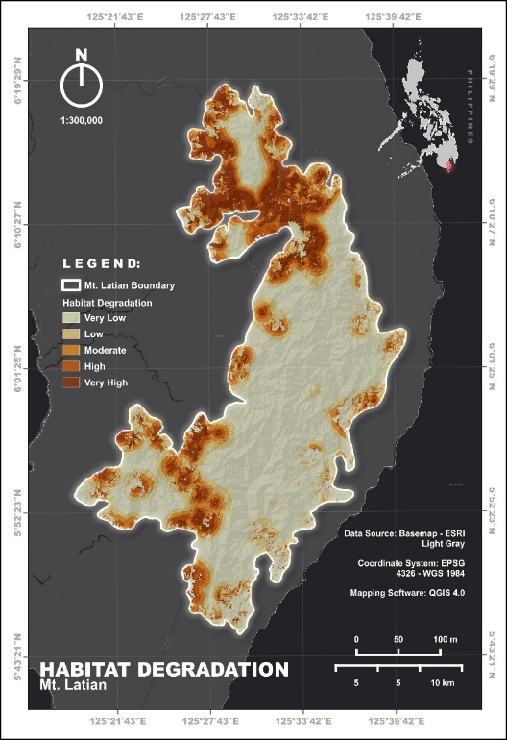
The low overall degradation is a positive indicator for conservation, suggesting that current human activities have not yet caused widespread habitat deterioration. However, the presence of moderate to very high degradation in localized areas (approximately 4%) warrants targeted intervention. As noted by Prakash & Verma (2022), even small areas of intense degradation can serve as hotspots for biodiversity loss and should be prioritized for restoration.

Figure 4. Map showing the habitat degradation of Mt. Latian

Table 5. Analyzed habitat degradation of Mt. Latian
Class number | Class description | Area (ha) | %
1 | Very low | 78848.18 | 80.37
2 | Low | 15344.33 | 15.64
3 | Moderate | 3322.64 | 3.39
4 | High | 556.13 | 0.57
5 | Very high | 39.02 | 0.04
Spatial Distribution of Habitat Quality
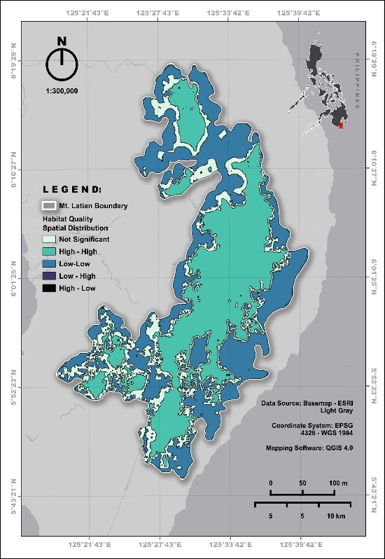
The habitat quality spatial distribution map for Mt. Latian reveals statistically significant clustering patterns that have important implications for conservation planning. The analysis shows that High-High clusters, representing areas of good habitat surrounded by other good habitat, appear as small, scattered patches throughout the landscape. This fragmentation indicates that high-quality habitats are becoming isolated rather than forming large, continuous conservation zones. In contrast, the Low-Low clusters, representing poor habitat surrounded by poor habitat, form a large, connecting zone, suggesting that degradation is systemic and widespread within a significant portion of the study area. The scarcity of High-Low and Low-High outliers indicates a sharp ecological boundary between good and poor habitat, rather than a gradual transition. This abrupt change is often caused by human-made barriers such as roads, agricultural expansion, or settlements rather than natural ecological gradients. For conservation, the isolated High-High clusters should be designated as immediate protection zones due to their vulnerability to edge effects and isolation. Meanwhile, the large Low-Low zone requires urgent restoration interventions, with priority given to creating wildlife corridors that connect the scattered high-quality patches across the degraded and non-significant areas to maintain genetic flow and ecosystem resilience.

Figure 5. Map showing the spatial distribution of habitat quality

Table 6. Spatial distribution of habitat quality
Class number | Class description | Area (ha) | %
0 | Not Significant | 19494.53 | 19.87
1 | High – High | 40171.81 | 40.95
2 | Low - Low | 38256.93 | 39
3 | Low – High | 106.289 | 0.11
4 | High - Low | 66.228 | 0.07
Spatial Distribution of Habitat Degradation
The habitat degradation spatial autocorrelation map for Mt. Latian reveals a distinctly different pattern compared to the habitat quality analysis, with important implications for understanding landscape processes. Unlike the habitat quality map which showed scattered High-High clusters of good habitat quality, the degradation map displays a much more extensive and continuous distribution of High-High clusters, representing areas of high degradation surrounded by high degradation. This pattern suggests that habitat degradation is not occurring in isolated patches but rather as a widespread, systemic process affecting large connecting portions of the study area. The Low-Low clusters, representing low degradation surrounded by low degradation, appear as small, scattered patches, essentially the showing the opposite of what was observed in the habitat quality analysis. The minimal presence of High-Low and Low-High outliers indicates that the transition between degraded and intact areas is sharp, suggesting that degradation is driven by discrete anthropogenic activities such as clear-cutting, road construction, or agricultural conversion rather than gradual ecological processes. The dominant High-High degradation zones require immediate intervention to halt further deterioration, while the scattered Low-Low clusters—representing the last remaining intact areas—must be prioritized for strict protection. The spatial continuity of the degradation pattern is particularly concerning because it implies that negative edge effects, invasive species, and human pressures can easily propagate across the landscape. Without urgent corridor protection and buffer zone establishment around the Low-Low clusters, these last intact areas are likely to be assimilated into the broader degradation zone.
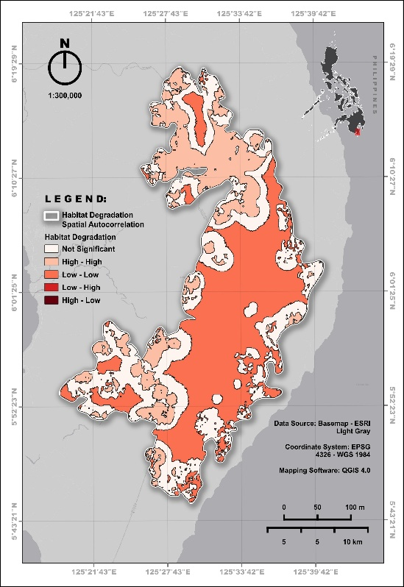

Figure 6. Map showing the spatial distribution of habitat degradation

Table 7. Spatial distribution of habitat quality
Class number | Class description | Area (ha) | %
0 | Not Significant | 34491.07 | 35.16
1 | High – High | 21446.46 | 21.86
2 | Low – Low | 42013.74 | 42.83
3 | Low – High | 118.906 | 0.12
4 | High - Low | 25.613 | 0.026

CONCLUSIONS AND RECOMMENDATION
The findings of this study provide critical insights for conservation planning in one of the Philippines' important but vulnerable key biodiversity sites.
The land use land cover analysis revealed that the forest land cover remains the dominant class, covering 56.01% of the study area, which is a positive indicator for biodiversity conservation. However, the presence of shrubland (27.22%), grassland (11.50%), and agriculture (4.89%) suggests that historical and ongoing disturbances have altered the landscape. The proximity of agricultural, built-up, and barren areas to forest zones poses a serious threat, as edge effects can degrade adjacent high-quality habitats even when their spatial extent remains small.
The habitat quality assessment showed that very high and moderate quality areas collectively account for 44.07% of Mt. Latian, indicating that large portions remain relatively intact and capable of supporting native biodiversity. However, the combined area of very low and low habitat quality (39.99%) reveals significant pressure from anthropogenic disturbances. The habitat degradation analysis provided a more encouraging picture, with very low degradation covering 80.37% of the area. This indicates that widespread, severe degradation has not yet occurred in Mt. Latian. Nevertheless, the presence of moderate to high degradation (3.96%), though small in area, represents localized hotspots of intense pressure that warrant immediate attention.
The spatial distribution analysis revealed contrasting patterns between habitat quality and habitat degradation. For habitat quality, High-High clusters (good habitat surrounded by good habitat) appeared as small, scattered patches covering 40.95% of the area, indicating fragmentation of high-quality habitats. In contrast, Low-Low clusters (poor habitat surrounded by poor habitat) formed a large, connecting zone covering 39%, suggesting systemic degradation in a significant portion of the study area. For habitat degradation, the pattern was reversed. High-High clusters (high degradation surrounded by high degradation) were extensive and continuous (21.86%), while Low-Low clusters (low degradation surrounded by low degradation) appeared as small, scattered patches (42.83%). The scarcity of High-Low and Low-High outliers in both analyses indicates sharp ecological boundaries between good and poor habitat quality, as well as between degraded and intact areas. This abrupt transition suggests that degradation is driven by discrete anthropogenic activities—such as agricultural conversion, road construction, or clearing—rather than gradual ecological processes.
In conclusion, Mt. Latian Key Biodiversity Area presents a dual conservation challenge. On one hand, the dominance of forest cover and very low degradation suggests that the area retains significant conservation value and has not yet experienced widespread habitat collapse. On the other hand, the fragmented nature of high-quality habitat patches, the connecting zone of poor habitat quality, and the extensive continuous area of high degradation indicate that without urgent intervention, the remaining intact forest is vulnerable to being disturbed and encroachment of degraded areas will occur.
Ethical Approval: Ethical approval was not required for this study. The research involved only publicly available, anonymized statistical data from open sources, e.g., government databases with no direct interaction with human or animal subjects.
Conflict of Interest: The authors declare that they have no known competing financial interests or personal relationships that could have appeared to influence the work reported in this paper.

REFERENCES
- Agduma, A. R., Garcia, F. g., Cabasan, M. T., Pimentel, J., Ele, R. J., Rubio, M., . . . Tanalgo, a. K. (2023). Overview of priorities, threats, and challenges to biodiversity conservation in the southern Philippines. Regional Sustainability, 4(2), 203-213. doi:https://doi.org/10.1016/j.regsus.2023.05.003
- Amodeo, M., Martínez-López, V., Zapata-Pérez, V., & Robledano-Aymerich, a. F. (2024). Bridging the gap between ecological succession of fleshy-fruited shrubs and restoration frameworks in semiarid oldfields. Journal of Environmental Management, 370, 122480. doi:https://doi.org/10.1016/j.jenvman.2024.122480
- Chaurasia, R. K. (2025). AGRICULTURE AS A DRIVER OF BIODIVERSITY LOSS. In Vanishing Biodiversity: Global Threats to Flora and Fauna (pp. 401-420). Lucknow, India: M/S Academic Publishers & Distributors. doi: https://doi.org/10.5281/zenodo
- Cruz, M. A. (2025, July 10). A Geospatial Approach for the Assessment and Management Prioritization of Philippine Terrestrial Key Biodiversity Areas: Towards Meeting Global Sustainability Targets. ISPRS Annals of the Photogrammetry, Remote Sensing and Spatial Information Sciences, X(G), 205-212. doi:https://doi.org/10.5194/isprs-annals-X-G-2025-205-2025
- Daipan, B. P. (2021). Patterns of forest cover loss in the terrestrial Key Biodiversity Areas in the Philippines: critical habitat conservation priorities. Journal of Threatened Taxa, 13(13). doi:https://doi.org/10.11609/jott.6904.13.13.20019-20032
- Gupta, A., Eppinga, M. B., Furrer, R., & Santos, a. M. (2025). The Effect of Dominant Land-Cover Transitions in Shaping Trajectories of Global Forest Change. Environmental Management, 75, 2826-2840. doi:https://doi.org/10.1007/s00267-025-02245-8
- Haddad, N. M., Brudvig, L. A., Clobert, J., Davies, K. F., Gonzalez, A., Holt, R. D., Lovejoy, T. E., Sexton, J. O., Austin, M. P., Collins, C. D., Cook, W. M., Damschen, E. I., Ewers, R. M., Foster, B. L., Jenkins, C. N., King, A. J., Laurance, W. F., Levey, D. J., Margules, C. R., . . . Townshend, J. R. (2015). Habitat fragmentation and its lasting impact on Earth’s ecosystems. Science Advances, 1(2), e1500052. https://doi.org/10.1126/sciadv.1500052
- Huo, A., Liu, Q., Zhao, Z., Elbeltagi, A., Abuarab, M. E.-S., & Ganjidoust, a. H. (2023). Habitat Quality Assessment and Driving Factor Analysis of Xiangyu in Feng River Basin Based on InVEST Model. Water, 15(23), 4046. doi:https://doi.org/10.3390/w15234046
- Kittelberger, K. D., Neate-Clegg, M. H., Blount, J. D., Posa, M. R., McLaughlin, J., & ¸Sekercioglu˘, a. Ç. (2021). Biological Correlates of Extinction Risk in Resident Philippine Avifauna. Frontiers in Ecology and Evolution, 9. doi:https://doi.org/10.3389/fevo.2021.664764
- Otgonbayar, M., Tseveengerel, B., Munkhtur, P., Tuyagerel, D., & Chambers, a. J. (2021). Assessment of Habitat Quality in the Western Region of Mongolia Using the InVEST-Based Model. Advances in Engineering Research, 206. doi:10.2991/aer.k.211029.018
- Prakash, S., & Verma, a. A. (2022, April 13). Anthropogenic Activities and Biodiversity Threats. International Journal of Biological Innovations, 4(1), 94-103. doi:https://doi.org/10.46505/IJBI.2022.4110
- Sahle, M., Almarines, N. R., Lahoti, S. A., Cristino L. Tiburan, J., Pulhin, J. M., & Saito, a. O. (2025, March 7). Exploring the Interplay Between Food Provision and Habitat Quality Assessment for Sustainable Coexistence in the Bioproduction Systems of the Philippines. resources, 14(3), 45. doi:DOI:10.3390/resources14030045
- Sansevero, J. B., Garbin, M. L., Sánchez-Tapia, A., Valladares, F., & Scarano, a. F. (2020). Fire drives abandoned pastures to a savanna-like state in the Brazilian Atlantic Forest. Perspectives in Ecology and Conservation, 18(1), 31-36. doi:https://doi.org/10.1016/j.pecon.2019.12.004
- Sun, X., Li, Y., Li, Y., Hu, Y., & Li, a. Y. (2024, November). Human and natural factors affect habitat quality in ecologically fragile areas: evidence from Songnen Plain, China. Frontiers in Plant Science, 15. doi:https://doi.org/10.3389/fpls.2024.1444163
- Sun, Z., Behrens, P., Tukker, A., Bruckner, M., & Scherer, a. L. (2022, May 5). Global Human Consumption Threatens Key Biodiversity Areas. Environmental Science and Technology, 56(12), 9003-9014. doi:https://doi.org/10.1021/acs.est.2c00506
- Wu, J., Hou, Y., & Cui, a. Z. (2024). Coupled InVEST–MGWR modeling to analyze the impacts of changing landscape patterns on habitat quality in the Fen River basin. Scientific Reports, 14. doi:https://doi.org/10.1038/s41598-024-64012-9
- Yang, R., Dong, X., Xu, S., Li, X., Wang, K., Ye, Y., & Xiao, a. W. (2025). Key Biodiversity Areas: Assessing disturbance and fragmentation to inform conservation strategies. Geography and Sustainability, 6(3), 100259. doi:https://doi.org/10.1016/j.geosus.2024.100259
- Yohannes, H., Soromessa, T., Argaw, M., & Dewan, a. A. (2021). Spatio-temporal changes in habitat quality and linkage with landscape characteristics in the Beressa watershed, Blue Nile basin of Ethiopian highlands. Journal of Environmental Management, 281, 111885. doi:https://doi.org/10.1016/j.jenvman.2020.111885
- Zhou, S., Song, Y., Li, Y., Wang, J., & Zhang, a. L. (2022). Construction of Ecological Security Pattern for Plateau Lake Based on MSPA–MCR Model: A Case Study of Dianchi Lake Area. Sustainability, 14(21), 14532. doi:https://doi.org/10.3390/su142114532

