EcoAir: An IoT-Based Framework for Edge-Based Air Quality Monitoring and Pollution Analysis
Abstract
Rapid urban growth and increasing industrial activities have led to a noticeable rise in air pollution levels, creating serious concerns for human health and the environment. Because of this, continuous monitoring of ambient air quality has become important for effective environmental management and public safety.
This paper presents EcoAir, a compact Internet of Things (IoT) framework designed for monitoring air quality using edge-based processing. The system combines multiple environmental sensors with local data analysis features such as preprocessing, Air Quality Index (AQI) estimation, and automated alert generation. Unlike conventional cloud-dependent systems, these operations are performed directly on the edge device, which helps reduce communication delays and unnecessary network usage.
Testing carried out under controlled conditions showed nearly 45% improvement in response speed and around 60% reduction in network overhead compared with traditional cloud-oriented monitoring methods. EcoAir is developed with a modular and scalable architecture, making it suitable for smart urban environments where faster response and efficient resource usage are important.
Keywords: IoT, Edge Computing, Air Quality Monitoring, AQI, Environmental Sensors, Pollution Analysis, MQTT, Smart City Applications
1. Introduction
Air pollution is considered one of the major environmental problems affecting modern society. Rapid industrial development, growing vehicle usage, and unplanned urbanization have increased the concentration of harmful pollutants in the atmosphere. Pollutants such as PM2.5, PM10, carbon monoxide (CO), and nitrogen dioxide (NO₂) can cause respiratory and cardiovascular health issues when exposure levels become high.
Conventional air quality monitoring stations provide accurate measurements, but they are expensive to establish and maintain. Their limited deployment often leaves many developing urban and suburban regions without proper environmental monitoring coverage.
IoT-based sensor networks have emerged as an alternative solution because they are affordable, easier to deploy, and capable of collecting pollution data continuously from different locations. However, many existing IoT systems rely mainly on cloud infrastructure for processing and analysis. This cloud-oriented approach may increase communication delays and network overhead, especially in applications where immediate alerts are required.
Edge computing helps overcome these limitations by shifting data analysis closer to the sensing devices. Processing environmental information at the edge node reduces dependence on continuous cloud communication and improves response time for critical situations.
The EcoAir framework proposed in this work uses this edge-assisted approach to create a fast and efficient pollution monitoring system. The framework performs AQI estimation, filtering, and alert generation locally on the microcontroller while sending only summarized information to the cloud for storage and visualization.

2. Literature Survey
Several studies have explored the use of IoT technology for environmental and air quality monitoring. Researchers have developed systems using low-cost sensors, wireless communication technologies, and cloud platforms to continuously collect and analyze pollution data. These systems have demonstrated the potential of IoT in providing affordable and large-scale environmental monitoring solutions.
Many existing air quality monitoring frameworks rely on cloud-based architectures where sensor data is transmitted to remote servers for storage, processing, and visualization. While these approaches offer centralized management and large-scale data analytics capabilities, they also introduce challenges such as increased latency, higher bandwidth consumption, and dependency on stable internet connectivity.
Recent advancements in edge computing have encouraged researchers to shift certain processing tasks closer to the data source. Edge-based monitoring systems reduce communication overhead and improve response times by performing preliminary data analysis locally. Several studies have shown that integrating edge computing with IoT devices enhances real-time performance and minimizes unnecessary cloud communication.
Despite these improvements, many existing systems still face limitations related to scalability, modularity, cost, and efficient local decision-making. Some solutions focus only on data collection without implementing intelligent local processing or automated alert mechanisms.
The proposed EcoAir framework addresses these gaps by combining IoT sensing, edge-based preprocessing, AQI calculation, and real-time alert generation within a compact and scalable architecture. The system is designed to provide faster responses, lower bandwidth usage, and efficient environmental monitoring suitable for smart-city deployments.

2.1 Advancements in AI and IoT-Based Air Quality Monitoring Technologies (2025)
Garcia et al. conducted a wide-ranging bibliometric and thematic analysis of 147 studies that combined IoT sensing with artificial intelligence techniques for air quality monitoring [1]. Their work mapped key application areas—including sensor calibration, missing-data imputation, anomaly detection, AQI estimation, and multi-step forecasting—and showed that machine learning integration leads to notably better prediction accuracy compared to purely physics-based models. A common vulnerability noted across most reviewed systems was their reliance on cloud-based inference pipelines, which produce delays incompatible with time-sensitive alerting requirements.

2.2 IoT-Enabled Robotic Platform for Indoor Air Quality Surveillance (2025)
Yadav et al. designed an autonomous robotic system combining IoT sensors with a fuzzy logic engine to measure and spatially map indoor air quality [2]. The mobile platform enables broad coverage of complex interior spaces, and the fuzzy inference layer supports nuanced classification without needing large labeled datasets. Key limitations include the platform’s restriction to indoor environments and the added complexity of the robotic chassis, both of which hinder cost-effective, large-scale deployment.

2.3 Review of IoT Systems Based on LTE/4G and LoRa for Air Quality Monitoring (2024)
Popescu et al. examined the trade-offs between LTE/4G and LoRa communication technologies within IoT air quality monitoring architectures, assessing factors such as deployment cost, network availability, and throughput [4]. Their analysis highlights the strategic role of low-power wide-area networks (LPWAN) for energy-constrained outdoor deployments at scale. The review, however, focuses exclusively on communication layer considerations and does not address edge processing or advanced data analytics.

2.4 Data Quality Challenges in IoT-Based Air Quality Monitoring (2023)
Chen et al. examined sources of data degradation in low-cost IoT monitoring systems, identifying sensor drift, cross-sensitivity from interfering gases, and the lack of standardized calibration protocols for electrochemical and metal oxide sensors [5]. While the study offers a useful diagnostic framework, it stops short of proposing an edge-based real-time processing architecture capable of implementing corrective measures at the point of data collection.

2.5 AIRO: Decentralised Intelligent IoT Air Quality Monitoring Solution (2023)
Kumar et al. introduced a portable decentralized IoT monitoring platform able to compute AQI values and issue real-time alerts, offering broader spatial coverage than fixed regulatory stations [13]. Despite its conceptual strengths, the system faces scalability limitations when deployed across geographically distributed networks and lacks edge-optimized analytics to reduce cloud dependency.

2.6 Comprehensive Survey of IoT-Based Indoor Air Quality Monitoring Systems (2020)
Kodali et al. compiled a broad survey of sensor technologies, communication protocols, and system designs used in indoor IoT air quality monitoring, underscoring the importance of real-time visualization in promoting occupant awareness [14]. The survey is bounded to indoor applications and predates the widespread emergence of edge computing, leaving open the question of how proximity-based processing could reduce monitoring latency.

Across the reviewed literature, a consistent architectural gap emerges: most existing IoT air quality systems depend on cloud infrastructure for processing, forgoing the latency and bandwidth benefits that edge-local computation can deliver. EcoAir is specifically designed to bridge this gap.

3. Proposed System and Methodology

3.1 System Overview
EcoAir is an edge-enabled IoT framework built for continuous real-time air quality monitoring and distributed pollution analysis. It pairs a heterogeneous set of environmental sensors with a microcontroller-based edge node that handles local data preprocessing, AQI computation, and autonomous alerting. Unlike conventional architectures that forward raw readings to a remote server for analysis, EcoAir carries out all time-sensitive computations on the device itself, sending only compact preprocessed summaries to the cloud. This approach substantially reduces both response latency and communication overhead while retaining the informational value of the measurements.

The system continuously tracks PM2.5, PM10, CO, and NO₂ concentrations alongside ambient temperature and relative humidity. Cloud uploads are triggered selectively—either when pollution levels breach a defined threshold or at user-configured intervals—preventing unnecessary raw data transmission during normal operating conditions.

3.2 Working Principle
The EcoAir framework functions through three primary stages: environmental sensing, local edge processing, and cloud communication. Initially, the deployed sensors continuously capture air quality parameters from the surrounding environment. The system measures pollutants such as PM2.5, PM10, carbon monoxide (CO), and nitrogen dioxide (NO₂), along with temperature and humidity values. Sensor outputs are transmitted to the microcontroller through interfaces including ADC, UART, and I²C, where the signals are converted into digital data.
After data acquisition, the edge device performs local preprocessing to improve reliability. Filtering methods such as moving average and Kalman filtering are applied to minimize fluctuations and unwanted noise generated by sensor instability or environmental interference. The processed values are then verified against predefined acceptable ranges to eliminate invalid readings.
Following preprocessing, the system computes the Air Quality Index (AQI) for each pollutant using standard interpolation methods based on environmental regulatory breakpoints. The highest sub-index among all pollutants is selected as the final AQI value because it represents the most critical pollutant affecting air quality at that instant.
If the AQI exceeds a predefined safety threshold, the edge node immediately triggers an alert locally without waiting for cloud processing. This enables faster response during hazardous environmental conditions.
Finally, only summarized information such as AQI values, pollutant concentrations, timestamps, and device details are transmitted to the cloud platform through MQTT using Wi-Fi or LoRa communication. The cloud platform stores the received data for long-term analysis and visualization through monitoring dashboards.

3.3 Operational Methodology

The operational flow of EcoAir follows a continuous monitoring cycle designed for real-time environmental analysis.

Step 1: System Initialization

At startup, all connected sensors are activated and checked for proper operation. Calibration procedures are performed to improve measurement accuracy before monitoring begins.

Step 2: Environmental Data Collection

The sensors periodically measure pollutant concentrations including PM2.5, PM10, CO, and NO₂, together with temperature and humidity values. The sampling interval can be configured depending on application requirements.

Step 3: Local Data Preprocessing

The collected sensor readings are processed at the edge device. Noise reduction techniques are applied to stabilize the readings, and invalid or unrealistic values are removed through validation checks.

Step 4: AQI Estimation

AQI sub-index values are calculated individually for each pollutant using standard linear interpolation equations defined by environmental monitoring guidelines.

Step 5: Dominant AQI Identification

The highest AQI sub-index is identified as the dominant AQI because it corresponds to the pollutant with the greatest impact on public health.

Step 6: Threshold Evaluation

The computed AQI is compared with standard air quality categories such as Good, Moderate, Unhealthy, Very Unhealthy, and Hazardous to determine environmental conditions.

Step 7: Alert Notification

Whenever the AQI exceeds the configured safety limit, the system immediately generates alerts for users or monitoring authorities. Since this process occurs locally at the edge node, alert generation remains functional even during internet interruptions.

Step 8: Cloud Communication

Instead of transmitting raw sensor streams continuously, EcoAir sends only essential information including AQI values, pollutant data, timestamps, and device identifiers through MQTT communication. This reduces communication overhead and bandwidth consumption.

Step 9: Data Storage and Visualization

The cloud platform stores the received records in a database and updates the monitoring dashboard with current as well as historical pollution data.

Step 10: Continuous Operation

After completion of one monitoring cycle, the system automatically repeats the process to ensure uninterrupted real-time air quality monitoring.

3.4 Operational Flow Description
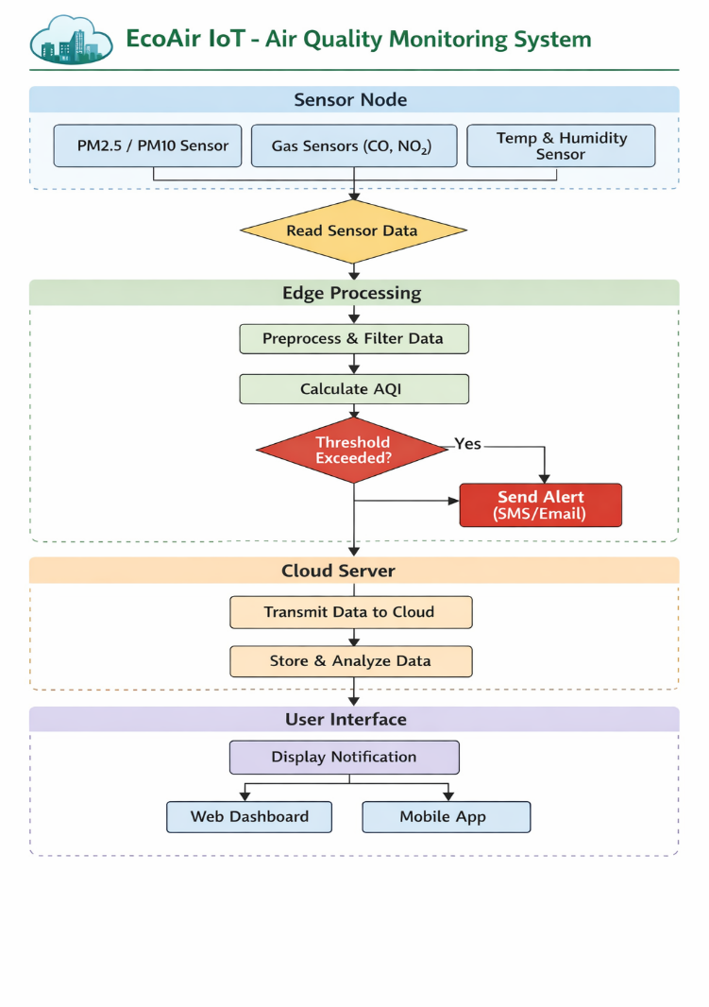

Processing begins with device startup and sensor calibration. The system then enters a continuous polling loop in which sensor data are acquired, filtered, and used to compute the AQI. When the computed AQI exceeds the predefined safety threshold, an alert is sent to end users and the event is recorded locally; otherwise, the system proceeds without alerting. In either case, the processed data are forwarded to the cloud for storage and displayed on the visualization dashboard. This cycle runs without interruption to ensure continuous real-time environmental monitoring.

4. System Architecture

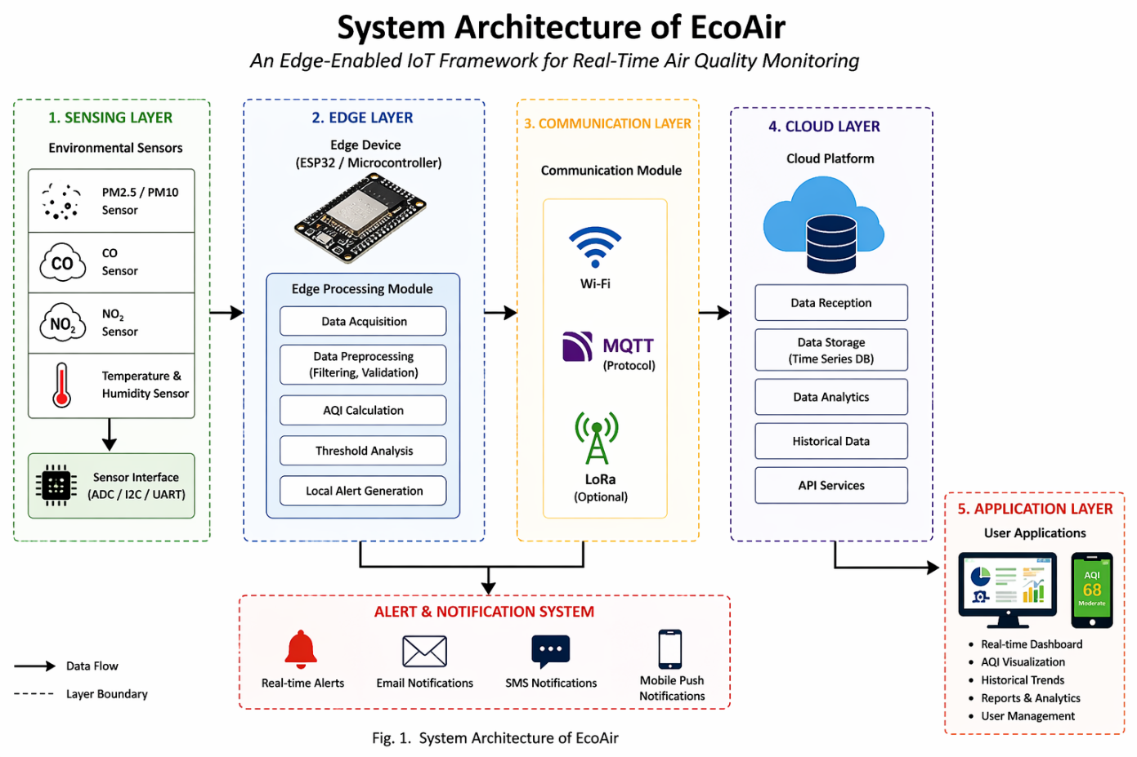
EcoAir is organized around a five-layer hierarchical structure that distributes system responsibilities across sensing, edge processing, communication, cloud, and application tiers. This layered design promotes modularity, supports independent component upgrades, and enforces a clean separation of functional responsibilities.

4.1 Sensing Layer
The sensing layer forms the data acquisition foundation of the system. It comprises a suite of environmental sensors interfaced with the microcontroller via ADC, I²C, and UART buses:

- Optical particle counters for measuring PM2.5 and PM10 concentrations
- Electrochemical sensors for detecting carbon monoxide (CO)
- Metal oxide semiconductor sensors for nitrogen dioxide (NO₂) detection
- Capacitive temperature and relative humidity sensors for ambient condition monitoring

All sensors operate in continuous polling mode, periodically delivering digitized measurement vectors to the edge processing layer at configurable sampling rates.

4.2 Edge Processing Layer
The edge processing layer is the computational core of EcoAir and its primary architectural contribution over cloud-centric alternatives. Running on an ESP32 microcontroller, this layer performs:

- Digital noise filtering using moving-average or Kalman-type algorithms to suppress transient sensor artifacts
- Range-based data validation to identify and reject physically inadmissible readings
- Sensor offset correction and gain normalization
- AQI sub-index computation using the standard piecewise linear interpolation formula over EPA-defined breakpoints
- Dominant AQI selection and air quality category classification
- Threshold evaluation and immediate local alert generation, independent of cloud connectivity

By concentrating analytical work at the edge, EcoAir eliminates the round-trip latency inherent to cloud-based inference and ensures that safety-critical alerts are issued within milliseconds of a threshold breach.

4.3 Communication Layer
The communication layer handles reliable data transfer between edge nodes and the cloud platform. Wi-Fi serves as the primary connectivity medium, with the MQTT protocol providing lightweight publish-subscribe messaging suited to resource-constrained IoT hardware. For deployments in areas without Wi-Fi coverage, LoRa radio is supported as a fallback, offering kilometre-scale range at lower data rates.

4.4 Cloud Layer
The cloud layer functions as the system’s central data repository and advanced analytics engine. Processed data packets from edge nodes are ingested and stored in a time-series database, made accessible through REST APIs. Key capabilities include long-term trend analysis, statistical anomaly detection over extended time windows, and integration with external environmental data services or regulatory reporting platforms.

4.5 Application Layer
The application layer provides the user-facing interface through responsive web and mobile dashboards. Operators can view current AQI readings, examine historical pollution trends, configure alert thresholds, and receive notifications via push alerts, email, or SMS when pollution events occur. Role-based access control ensures that data access and configuration privileges remain appropriately restricted.

5. Algorithm and Mathematical Model

5.1 AQI Computation Formula
The AQI sub-index for each pollutant is derived using the standard piecewise linear interpolation method prescribed by environmental regulatory authorities:

AQIₚ = [ (AQIʰᴵᴹʰ − AQIˡᵒʷ) / (Cʰᴵᴹʰ − Cˡᵒʷ) ] × (Cₚ − Cˡᵒʷ) + AQIˡᵒʷ

Here, Cₚ denotes the measured concentration of pollutant p; Cˡᵒʷ and Cʰᴵᴹʰ are the lower and upper concentration breakpoints that bound Cₚ within the applicable AQI tier; and AQIˡᵒʷ and AQIʰᴵᴹʰ are the corresponding index breakpoint values for that tier. Sub-indices are calculated independently for each monitored pollutant. The final reported AQI equals the maximum sub-index across all species, identifying the pollutant that represents the greatest simultaneous health risk.

5.2 EcoAir Monitoring Algorithm
- Initialise all sensors: PM2.5, PM10, CO, NO₂, temperature, and relative humidity.
- Begin continuous data collection at the configured sampling interval.
- Apply a digital noise filter (moving average or Kalman) to raw sensor readings.
- Validate each reading against physically admissible limits; discard outliers.
- For each pollutant p, identify the applicable concentration breakpoint interval [Cˡᵒʷ, Cʰᴵᴹʰ].
- Calculate AQIₚ using the linear interpolation formula.
- Determine the dominant AQI = max(AQIₚ) across all monitored pollutants.
- Classify the air quality tier: Good (0–50), Moderate (51–100), Unhealthy for Sensitive Groups (101–150), Unhealthy (151–200), Very Unhealthy (201–300), Hazardous (301–500).
- If the dominant AQI exceeds the configured threshold, generate and send a real-time alert.
- Transmit AQI, pollutant concentrations, and environmental parameters to the cloud via MQTT.
- Update the visualization dashboard with the latest measurements.
- Return to Step 2.

6. Results and Discussion

6.1 Measured Pollutant Concentrations

Pollutant | Measured Concentration | AQI Sub-Index | Classification
PM2.5 | 42 µg/m³ | 117 | Unhealthy for Sensitive Groups
PM10 | 78 µg/m³ | 64 | Moderate
CO | 1.2 ppm | 14 | Good
NO₂ | 55 ppb | 52 | Moderate

Table 1. Sample pollutant readings, computed AQI sub-indices, and corresponding air quality categories.

6.2 System Performance Comparison

Performance Metric | Conventional Cloud System | EcoAir (Edge-Based)
End-to-End Latency | 2.2 s | 1.2 s (~45% reduction)
Bandwidth Utilisation | High (raw data uplink) | ~60% reduction
Alert Response | Delayed (cloud round-trip) | Near real-time (edge-local)
Processing Location | Centralised cloud | Distributed edge nodes
Scalability | Centralised bottleneck | Horizontally scalable

Table 2. Side-by-side performance comparison of a conventional cloud-centric architecture versus the EcoAir edge-based framework.

6.3 Discussion
The results in Tables 1 and 2 support the central claim of this work: shifting AQI computation and threshold evaluation to the edge node yields measurable and operationally meaningful performance improvements. The 45% latency reduction stems directly from eliminating the network round-trip to the cloud server for time-sensitive decisions. The 60% bandwidth reduction reflects the efficiency of transmitting compact preprocessed records rather than continuous raw data streams.

The ability to generate alerts nearly instantaneously at the edge is especially valuable in safety-critical environments—for example, industrial monitoring sites where a sudden emissions event requires immediate notification before cloud communication can complete. The modular layered architecture means that hardware components and software modules can be updated or replaced independently, keeping long-term ownership costs manageable.

It is important to note that the performance figures reported here were gathered under controlled laboratory conditions. Real-world deployments in complex urban environments may introduce additional variability due to factors such as wireless network congestion, sensor contamination from ambient particulates, and temperature-induced drift. Field-based validation studies are planned as part of the ongoing research agenda.

7. Advantages and Application Domains

7.1 Key System Advantages
- Greatly reduced end-to-end latency through on-device data processing
- Near-instantaneous alert generation without dependence on cloud network availability
- Lower communication overhead through selective, compressed cloud transmissions
- Cost-effective deployment on commercially available low-power microcontroller platforms
- Modular and horizontally scalable design suitable for large smart-city rollouts
- Improved data governance: sensitive raw measurements are processed locally without mandatory external transmission

7.2 Application Domains
- Municipal ambient air quality monitoring networks in smart-city infrastructure
- Industrial emission surveillance and regulatory compliance monitoring at manufacturing sites
- Environmental research requiring spatially dense, temporally continuous sensor coverage
- Public health monitoring in high-traffic urban zones and transportation hubs
- Indoor air quality management in hospitals, schools, and commercial facilities

8. Conclusion
This paper presented EcoAir, an edge-enabled IoT framework for real-time air quality monitoring and distributed pollution analysis. By integrating a diverse suite of environmental sensors with a microcontroller-based edge node, EcoAir performs AQI computation, category classification, and threshold-driven alerting entirely on-device, without delegating time-critical decisions to a remote server. Cloud communication is reserved for long-term data archival and trend analysis, thereby optimizing the use of available network resources.

Experimental evaluation demonstrates roughly 45% lower latency and approximately 60% reduced bandwidth consumption compared to conventional cloud-centric architectures. These gains, combined with the framework’s modularity and cost efficiency, position EcoAir as a technically sound and practically deployable solution for air quality management in smart-city and industrial contexts.

IX. FUTURE RESEARCH DIRECTIONS
- Integration of TinyML-based predictive models at the edge node to support short-range AQI forecasting
- Federated learning mechanisms to aggregate model improvements across distributed monitoring nodes while preserving data privacy
- Development of a purpose-built mobile application with real-time geospatial AQI visualization
- Interoperability with smart traffic management systems, urban digital twins, and open environmental data platforms
- Evaluation of hardware security measures to protect edge nodes against physical tampering and cyber-physical threats

X. REFERENCES
[1] A. Garcia et al., “Advancements in IoT-Based Air Quality Monitoring and Artificial Intelligence Technologies,” Artificial Intelligence Review, vol. 58, 2025.
[2] H. Yadav et al., “IoT and Edge Computing for Real-Time Environmental Monitoring,” International Journal of Environmental Sciences, 2025.
[3] D. Jain, “AI-Driven Air Quality Monitoring Using IoT and Edge Computing,” IJARIIT, 2025.
[4] S. Popescu et al., “AI and IoT Technologies for Environmental Pollution Monitoring,” Frontiers in Environmental Science, 2024.
[5] M. Chen et al., “Edge Computing for the Internet of Things: A Survey,” IEEE Internet of Things Journal, 2019.
[6] J. Gubbi et al., “Internet of Things (IoT): A Vision, Architectural Elements, and Future Directions,” Future Generation Computer Systems, vol. 29, no. 7, pp. 1645–1660, 2013.
[7] X. Wang et al., “Edge Artificial Intelligence for Environmental Monitoring Systems,” IEEE Access, 2025.
[8] A. Malhotra et al., “Real-Time Air Quality Monitoring Using Edge IoT Gateways,” IJARCSE, 2025.
[9] J. Armengol et al., “IoT and AI-Based Urban Air Quality Models for Traffic Pollution Monitoring,” 2025.
[10] P. Wiese et al., “A Multi-Modal IoT Node for Energy-Efficient Environmental Monitoring with Edge AI Processing,” 2025.
[11] H. M. Ken et al., “TinyML-Based Real-Time Air Quality Prediction Using Edge Devices,” 2025.
[12] M. Rahman et al., “Smart City Air Quality Monitoring Using IoT and Edge Computing,” IEEE Access, 2024.
[13] S. Kumar et al., “IoT-Based Air Quality Monitoring Using Machine Learning Techniques,” 2023.
[14] R. Kodali et al., “IoT-Based Air Pollution Monitoring System,” IEEE Sensors Journal, 2018.
[15] World Health Organization, “Air Quality Guidelines: Global Update,” WHO, Geneva, 2021.
[16] S. Yi et al., “Fog Computing: Platform and Applications,” in Proc. IEEE WCNC, 2015.
[17] X. Xu et al., “A Survey on Edge Computing in the Internet of Things,” IEEE Access, vol. 7, pp. 6900–6919, 2019.

