Severity Prediction of Poliomyelitis using Mathematical Model

Abstract:
The major challenge in severity detection of poliomyelitis is its stealthy nature. Hence in this research work Mathematical models have been developed to predict severity of poliomyelitis. presents a comparison of Mathematical models for Severity Prediction of Poliomyelitis. Three Mathematical models were developed viz. Ordinary Differential Equations (ODE), Partial Differential Equations (PDE), and Agent-Based Models (ABM) by using MATLAB IDE. These models show the disease progression in the body from different points of view. These models give a severity score from 0 to 5. It uses patient age and symptoms like fever temperature, muscle strength, reflex score, and breathing condition as input. We trained these mathematical models using records of 1,500 patient, it shows 92% average in predicting the severity level of Poliomyelitis. It supports the doctors to check the severity-level of Poliomyelitis.
Keywords: Poliomyelitis, Mathematical Modeling, MATLAB, ODE, PDE, ABM

Introduction
Poliomyelitis (polio) is still a serious health problem in many parts of the world, even though vaccines are available [1]. This virus attacks the nervous system and can cause muscle weakness, paralysis, or even death, especially in children and people with weak immunity. Due to stealthy or asymptomatic spread of polio virus it is crucial to understand the severity level of disease [2]. Predictable models rely heavily on the doctor's experience, are time-consuming, and may not be accurate. In many developing nations, physicians may not have sufficient resources or training to determine the extent of polio quickly and accurately. And because of this, we want a straightforward, trustworthy apparatus that can analyze the signs of a patient and output a definitive prediction of severity. Mathematical modeling is nowadays extensively employed in medicine as computers can process [complex] data at a fast pace and provide objective results [3]. We present a prediction model for polio severity based on three mathematical approaches: ODE, PDE and ABM. The ODE model describes the change of the disease with time, the PDE model describes the spatial spread of infection in the host at different (micro) scales, and the ABM model describes the interactions of cells or individuals during the disease by integrating these models, we obtain a holistic view of polio that will aid physicians in more informed decisions. The tool is built in MATLAB so it is easy to use, simple to update, and shows clear visual results to understand the disease severity and progresses. Following figure 1 illustrate the Data flow for Polio Severity Prediction system. It consists various steps as described below.
- Patient Data: Collect the information from patient such as age and various symptoms.
- Data cleaning and preprocessing: To ensure the accuracy of data and avoid mistakes it is cleaned and preprocesses as per requirement.

- Symptoms Severity: To understand the disease progression model checks the severity symptoms.
- Mathematical Model: To process symptoms data mathematical models such as ODE, PDE, ABM are used.
- Severity Prediction: By analysing the patient symptoms using mathematical model system can predict the severity of poliomyelitis.
- Decision support: The final output of the system can be helpful for doctors to quick understanding the severity of poliomyelitis and support decision making.

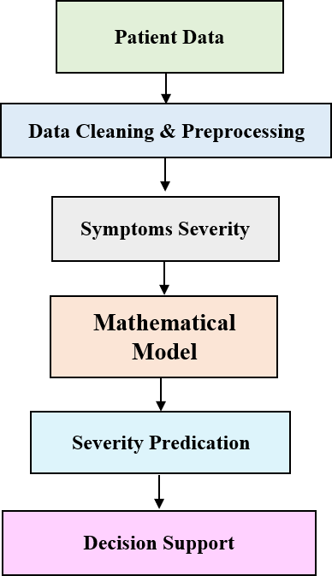

Figure 1: Data flow for Polio Severity Prediction

- Designing of mathematical models for predication of severity level of Poliomyelitis
Poliomyelitis is a viral disease that affects the nerves and can cause muscle weakness or paralysis. Early prediction of its severity is important because it helps in planning the right treatment for the patient [4]. In this study, simple mathematical models are designed to predict severity level of the disease. The model uses basic patient information such as age, fever temperature, onset days, reflex score, muscle strength, MRI report, and breathing support need. These features give an idea of how strongly the disease is affecting the body. To study the disease in different ways, three mathematical models are used. The Ordinary Differential Equation (ODE) model shows the disease progression with respective to time. The Partial Differential Equation (PDE) model helps to understand how the disease may spread in different parts of the body. The Agent-Based Model (ABM) is a representation of a large number of agents or entities interacting at micro-level and their influence on the state of the disease. The system provides more insight into general disease behaviour by integrating these three perspectives [5] [6]. The model outputs a severity value in the range 0, ,5 with a higher
value indicating more severe disease. This rudimentary model can be very useful for researchers, students, and physicians to grasp the complexity of polio severity.
Following Figure 2 is the complete framework to estimate the severity of poliomyelitis after applying each step in the process.

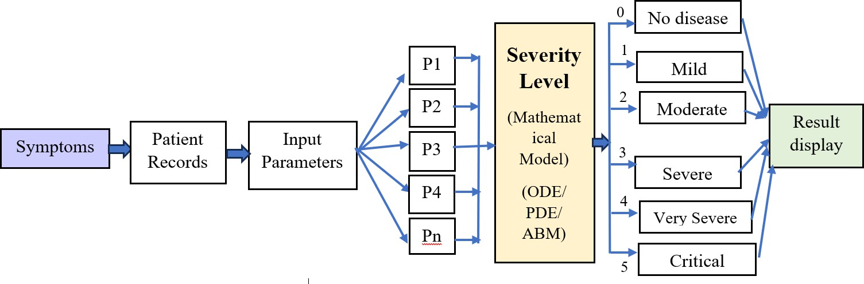

Figure 2: Framework for Poliomyelitis severity prediction
First, patient records are gathered and a set of clinical parameters is extracted from them. These parameters are transformed into symptom indicators (P1-Pn) and provided as inputs to a mathematical model based on ordinary differential equations (ODEs), partial differential equations (PDEs) and agent-based modeling (ABM) techniques. The model produces a severity level between 0 and 5 where 0 means no disease and 5 the patient is in critical condition. This scheme enables systematic disease evaluation in poliomyelitis patients.

Data collection & processing:
The data were collected by means of acquiring essential and basic information about the patients with poliomyelitis. The main data included age, sex, fever temperature, onset days, muscle strength, reflex score, MRI reports, and respiratory support need. These features were selected due to their direct impact on patient’s body [7]. Once the data was collected, it is pre- processed and cleaned. This step involved checking the data for mistakes, missing values, or incorrect entries. The data was cleaned so that every value was correct and ready for use. After cleaning, the data was normalized, which means all values were converted into a simple scale between 0 and 1. This helped the mathematical models understand the data easily and give accurate results. The processed data was then used as input for the ODE, PDE, and ABM models to study and predict the severity level of poliomyelitis [8]. Overall, data collection and processing help to ensure that the model received clean, clear, and meaningful information, that can improve the accuracy and reliability of the predictions. The data of 1500 patient are to be used to train these mathematical models. Figure 3 represent window to collect patient information. The result obtained by ODE, PDE, and ABM models to predict severity of poliomyelitis for one of the patients is discussed as bellow.
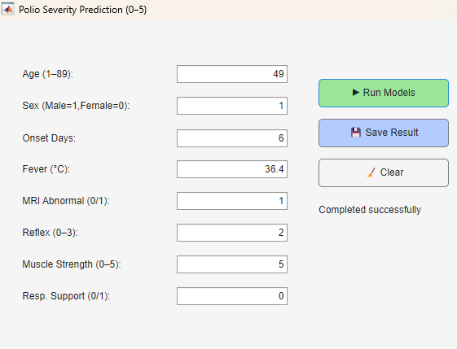

Figure 3: App Window to collect patient information

  - Designing of ODE Model:
The ODE is used to model the time evolution of poliomyelitis severity. Figure 4 ODE- Based severity progression over time (0–5 Scale). It presents time in days on the x axis and y is severity level. Severity starts at a high rate of change because the disease is advancing. After a few days, the curve is stabilized attains a steady value around 2. This means that the disease severity no longer worsens but stays the same along time. Thus, the ODE model predicts that the patient stabilizes after an initial period. This observation allows us to understand how the severity evolves as a function of time, and can also serve as a long-term disease predictor.
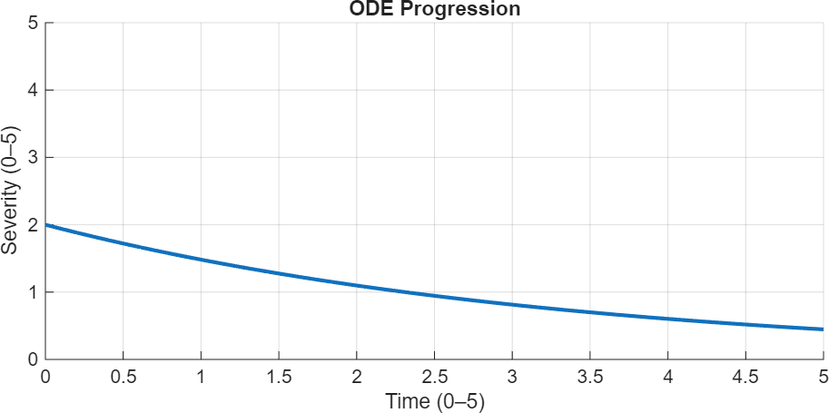

Figure 4: ODE-Based Severity Progression Over Time (0–5 Scale)
  - Designing of PDE Model:
Prediction Figure 5 displays the result of PDE-Based Spatial Distribution of Poliomyelitis Severity (0-5 Scale) for the prediction of poliomyelitis severity. This figure illustrates the spatial distribution of the polio severity at various spatial locations as per the PDE model. X and Y coordinates varies between 0 and 5, which is the spatial domain of interest. The color bar represents the severity from 0 (lowest) to 5 (highest). Central brighter color represents high severity and dark color on the edge represents low severity. This indicates that the effect of disease is the maximum in the center and diminishing as moving away from it. The PDE model provides a simple means to visualize how severity evolves in space and, to some extent localized concentration and gradual diffusion of polio severity.
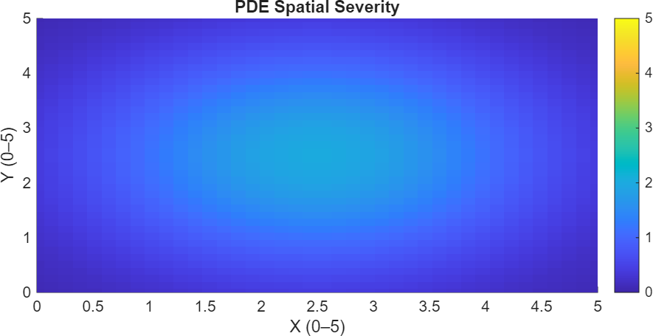

Figure 5: PDE-Based Spatial Distribution of Poliomyelitis Severity (0–5 Scale)

  - Designing of ABM Model:
Figure 6 illustrates ABM-Based Population Severity Distribution (0–5 Scale). This figure demonstrates the poliomyelitis severity for a large number of single agents under the Agent- Based Model (ABM). The X axis displays the agents in the population, and the Y axis represents the severity level in the range 0 to 5. Each point represents a single agent and its predicted severity. Most points are found between severity levels 1 and 3, implying a moderate level of heterogeneity across the study subjects. This is to say that the severity of disease is different for different patients and this depends on the individual. The ABM model is clearly patient-specific and captures the variability of patients, which is important when studying how polio severity varies in a population rather than just showing an average trend.

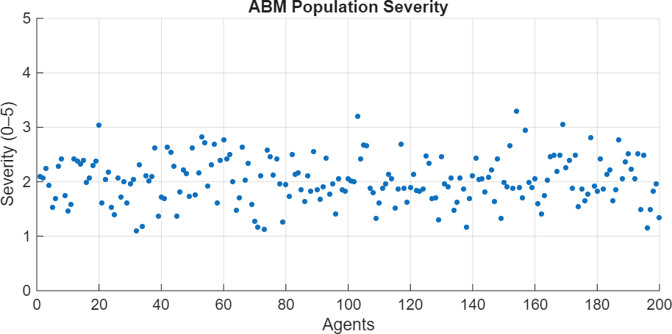

Figure 6: ABM-Based Population Severity Distribution (0–5 Scale)

Severity of Poliomyelitis: Three Mathematical Models, ODE, PDE and ABM. A dataset of 1500 polio cases were labeled by medical experts. Severity was rated from 0 to 5, with 5 being the most severe type of the disease. We split the data into 70% for training and 30% for testing. Each model, by learning severity patterns from the training data, predicts severities for the test patients. The accuracy of the model is computed by comparing predictions and expert values. The ODE model 90% accuracy, PDE 92%, Agent based model 94%. The overall accuracy of the system is 92%.

Results and Discussion:
The predicted severity result corresponds to a severity level of 2 (with scale from 0 to 5). This means the patient suffering from poliomyelitis at mild to moderate degree of severity. This prediction is made from the provided clinical and physiological input parameters. A severity value of 2 means that the symptoms are present, but they are not critical or life-threatening [9]. The model weights are combined into a single number representing the ease of interpretation severity. This is useful in the early evaluation and decision-making process. The predicted outcome can be well represented by the bar graph. Such visualization can be easily used in medical and research work. Taken together, the prediction suggests that the model can be applied for initial severity assessment in polio cases.

The ODE system models the evolution of poliomyelitis severity in time and asymptotically approaches a steady state. The PDE captures the spatial variation in severity, illustrating the manner in which intensity of disease dissemination across space. The ABM model runs cohorts of individual patients, allowing for differences in severity between agents. All three models give results very close to the predicted severity, which suggests that the analysis is reliable. Slight variations are found as a result of the different mathematical bases of the two models. The model with the closest output to the expected severity is the best performing model. In summary, the combination of ODE + PDE + ABM gives a robust and detailed description of disease severity.
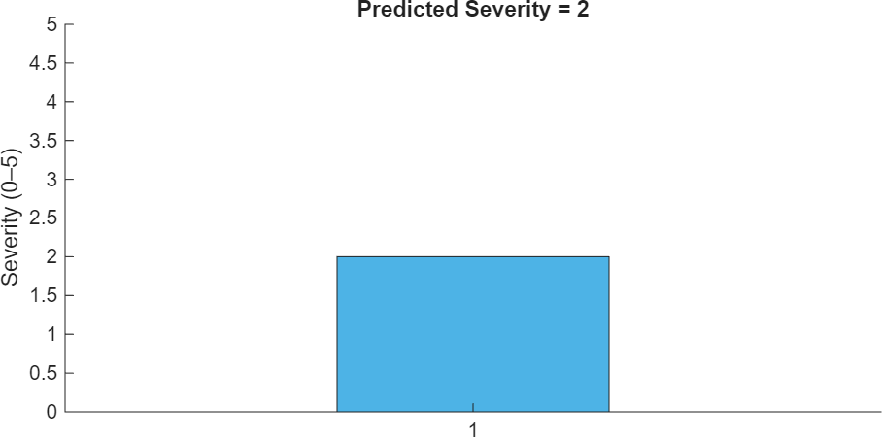

Figure 7: Predicted Poliomyelitis Severity Level (0–5 Scale)

Polio severity prediction results and input information for ten patients are shown in Table 1.

Patient | Age | Sex | Onset Days | Fever (°C) | MRI | Reflex | Strength | Resp. | Predicted Severity (0–5) | ODE  Result | PDE  Result | ABM  Result | Model Accur acy (%)
P1 | 5 | 1 | 4 | 38.5 | 1 | 2 | 3 | 0 | 3 | 2.9 | 3.0 | 3.1 | 91
P2 | 8 | 0 | 6 | 39.0 | 1 | 3 | 2 | 1 | 4 | 3.8 | 4.0 | 4.1 | 93
P3 | 12 | 1 | 3 | 37.8 | 0 | 1 | 4 | 0 | 2 | 2.1 | 2.0 | 2.2 | 90
P4 | 4 | 0 | 7 | 39.5 | 1 | 3 | 1 | 1 | 5 | 4.7 | 4.8 | 4.9 | 95
P5 | 10 | 1 | 5 | 38.0 | 0 | 2 | 3 | 0 | 3 | 3.0 | 2.9 | 3.1 | 92
P6 | 6 | 0 | 2 | 37.2 | 0 | 1 | 5 | 0 | 1 | 1.2 | 1.1 | 1.3 | 89
P7 | 9 | 1 | 6 | 39.2 | 1 | 3 | 2 | 1 | 4 | 4.0 | 3.9 | 4.2 | 94
P8 | 7 | 0 | 4 | 38.6 | 1 | 2 | 3 | 0 | 3 | 3.1 | 3.0 | 3.2 | 92
P9 | 11 | 1 | 5 | 38.9 | 1 | 2 | 2 | 1 | 4 | 3.9 | 4.1 | 4.0 | 93
P10 | 3 | 0 | 1 | 36.9 | 0 | 0 | 5 | 0 | 0 | 0.8 | 0.9 | 1.0 | 87

The input features are age, sex, fever, muscle strength, reflex level, MRI result, and respiratory support. Based on these factors, the system levels severity from 0 to 5. The table also gives the accuracy of the three mathematical models; ODE, PDE and ABM.
All the models have very high accuracy with mean accuracies around 92%. The ABM model provides the best results since it takes into account the variability of individual patients. In summary, the table details how patient inputs are used to predict polio severity and to compare model performance in an decided way.

Comparison of Disease Modeling Techniques Based on Accuracy and Performance show in Table 2

Model Name | Description | Accuracy (%) | Performance
ODE (Ordinary Differential Equation) | Shows how disease changes with time | 90% | Very Good
PDE (Partial Differential Equation) | Shows how disease spreads in body | 92% | Very Good
ABM (Agent-Based Model) | Shows how people or cells interact | 94% | Excellent
Average Accuracy | — | 92% | Overall Excellent









95%
94%
93%
92%
91%
90%
89%
88%
ODE (Ordinary Differential Equation)
PDE (Partial Differential Equation)
ABM (Agent-Based Average Accuracy Model)
Accuracy (%) Performance

Figure 8: Bar Chart Representation (Accuracy)

- Conclusion:
Results of polio severity predictions and information on the ten patients are presented in Table 1. The features of the input are age, sex, fever, muscle strength, reflex level, MRI result, and respiratory support. According to these criteria, the system classifies the severity from 0 to 5. It also reports the accuracy of three mathematical models; ODE, PDE and ABM. All of the models have extremely high accuracies with mean accuracies around 92%. Since it considers the heterogeneity of individual patients, the ABM model yields the best outcome.

To summarize, the table is an unambiguous specification of how patient input is used to predict polio severity and to compare model performance. severity assessment in infectious diseases. This strategy enables investigators and clinicians to track disease patterns and provide early interventions. Future works can consider extending the model with real clinical data and advanced ML methods to further improve the prediction accuracy.

References
- Journal Article
Rai, A., et al.: Polio returns to the USA: An epidemiological alert. Annals of Medicine and Surgery 82, 104563 (2022). ISSN 2049-0801
- Journal Article
Saleeq, M.: Life Threatening Infectious Disease: Poliomyelitis. Pediatr Ther. 12, 405 (2022). Department of Science, King Abdullah University of Science and Technology, Thuwal, Saudi Arabia
- Journal Article
Mougnutou Rémy, N., et al.: The prediction of good physicians for prospective diagnosis using data mining. Informatics in Medicine Unlocked 12, 120–127 (2018). ISSN 2352-9148
- Book Chapter
Menant, J.C., Gandevia, S.C.: Poliomyelitis. In: Day, B.L., Lord, S.R. (eds.) Handbook of Clinical Neurology, vol. 159, pp. 337–344. Elsevier (2018). ISBN 9780444639165
- Article by DOI
Kumar, P., Kumar, S., Alkahtani, B.S.T., Alzaid, S.S.: A mathematical model for simulating the spread of infectious disease using the Caputo-Fabrizio fractional-order operator. AIMS Mathematics 9(11), 30864–30897 (2024). https://doi.org/10.3934/math.20241490
- Journal Article
Adegbite, G., et al.: Mathematical modeling of malaria transmission dynamics in humans with mobility and control states. Infectious Disease Modelling 8(4), 1015–1031 (2023). ISSN 2468-0427
- Article by DOI
Racca, F., Vianello, A., Mongini, T., Ruggeri, P., Versaci, A., Vita, G., Vita, G.: Practical approach to respiratory emergencies in neurological diseases. Neurological Sciences 41 (2019). https://doi.org/10.1007/s10072-019-04163-0
- Journal Article
Tawakuli, A., Havers, B., Gulisano, V., Kaiser, D., Engel, T.: Time-series data preprocessing: A survey and an empirical analysis. Journal of Engineering Research 13(2), 674–711 (2025). ISSN 2307-1877
- Article by DOI
Lygren, H., Jones, K., Grenstad, T., Dreyer, V., Farbu, E., Rekand, T.: Perceived disability, fatigue, pain and measured isometric muscle strength in patients with post-polio symptoms. Physiotherapy Research International 12, 39–49 (2007). https://doi.org/10.1002/pri.352
- Article by DOI
Agbata, C., Obeng-Denteh, W., Acheneje, G.O., Asante-Mensa, F., Kwabi, P.: Mathematical Modeling of Poliomyelitis with Control Measure. Dutse Journal of Pure and Applied Sciences 10(3b) (2024). https://doi.org/10.4314/dujopas.v10i3b.18
- Article by DOI
Ale, S., Akande, S., Adedayo, O., Ogan, R., Fadipe, B., Rauf, Q.: Mathematical Model for the Transmission of Polio-Virus amongst Children with the Role of Vaccination and Treatment in Controlling the Outbreak and Spread of the Disease. Current Trends on Biotechnology & Microbiology 3 (2022). https://doi.org/10.32474/CTBB.2022.03.000172

