Title: “Formulation and Evaluation of a Jyotishmati- Enriched Herbal
Medicated Tablet for Memory Enhancement"

ABSTRACT

It is a study on the formulation and pre-clinical evaluation of herbal-medicated tablets enriched with Jyotishmati (Celastandus paniculatus). It generally has many therapeutic benefits such as reputed memory enhancing, learning ability and memory enhancing properties.^{[1,5]}
There most essential enrichments used in this formulation are believed to have nootropic and neuroprotective properties. In this point of view of these results, it is encouraged that Jyotishmati herbal-medicated enriched tablets will be a good natural alternative for commercial brain enhancing drugs with no or minimum side effects.^{[1,2,5]}
The main aim of this research project work was to formulate a stable, potential and effective dosage form by enriching Jyotishmati with the other herbal constituents with essential ability which improve concentration ability, and memory enhancement.^{[2,4]}
Jyotishmati tablets were formulated by conventional pharmaceutical techniques formulation and pre compression studies such as (flow properties, tapped density, bulk density, etc) and post compression studies such as (disintegration time, friability, weight variation, hardness, etc) were done and the results were found to be within acceptable pharmacopoeial limits successfully. The presence of various essential bioactive phytochemicals can be advantageous by improving memory and neuronal protection of brain.^{[1,5,8]}
Along with its dissolution studies are also performed for confirmation that the tablets were satisfactory in all the parameters investigated. It is evaluated that if the tablets could prove safe and effective for long-term use in the clinical situation it may help in improving the ability of humanized brain function.^{[1,4,5]}
Therefore, Jyotishmati based herbal-medicated tablet has emerged as a potential and vital herbal formulation for memory enhancement.^{[2,3]}

KEYWORDS
Jyotishmati (Celastrus paniculatus), Herbal tablet formulation, Memory enhancement, Nootropic activity, Phytochemical evaluation, Neuroprotective effect.

AIM
To develop and evaluate a Jyotishmati-based herbal medicated tablet by analyzing its physio-chemical characteristics, stability, and potential to enhance cognitive function, with the main goal of offering a safe, natural, and effective solution for improving memory and mental performance.^{[3,8]}

OBJECTIVES^{[1,6,7,8]}
- To design a herbal tablet formulation Jyotishmati as a main ingredient.
- To select and standardize suitable and essential herbal excipients for tablet preparation.
- To evaluate and study the pre-compression parameters of the powder blend.
- To assess post-compression characteristics such as weight variation, friability, hardness.
- To determine the disintegration time and dissolution properties of the formulated tablets.
- To analyze the stability studies of the formulation under different storage conditions.
- To study the phytochemical constituents present in the overall formulation.
- To explore the potential cognitive-enhancing properties of the herbal combination.
- To ensure that the safety and quality of the formulation are as per standard guidelines.
- To develop a natural and effective alternative for supporting memory and brain function.

GOALS
To develop and assess a Jyotishmati-based herbal tablet aimed at enhancing memory by selecting suitable natural ingredients and evaluating its physicochemical characteristics, quality attributes, stability, safety, consistency, and cognitive-supportive potential.^{[7,8]}

INTRODUCTION
Memory and brain functioning is defined as an essential cognitive function that enables humans to store, collect, retain and retrieve information from experience and is an essential element in the process of learning, making decisions and functioning daily normally. With today's generation of modernization lifestyle factors, such as poor diet, inadequate sleep, stress and increased amounts of screen time exposure, many people of all ages are experiencing a decrease in cognitive performance levels and memory weakening behavior.^{[5,6]}
Allopathic medications that are currently prescribed in allopathic treatment for cognitive enhancement typically provide only temporary relief of symptoms but it can lead to side effects and are not often used for longer-duration. This has resulted in an increased interest in herbal treatments for cognitive enhancement because they are seen as safe and sustainable alternatives as compared to other medications.^{[2,4]}
The herbal products becoming increasingly popular, especially those used in traditional systems of medicine (e.g., Ayurveda, Siddha, Unani, Homeopathy), there has been a growing interest in using these products to enhance cognitive function due to their overall "holistic" nature, low incidence or minimize of side effects and possible neuroprotective effects by natural ingredients method.^{[2,4,9]}
One of the most effective medicinal plants with immense potential is Jyotishmati (Celastrus paniculatus), which is traditionally recognized for its cognitive-enhancing and neuroprotective activities. Jyotishmati is also called the “intellect tree” because it was traditionally used to enhance brain functions like memory, concentration, and learning ability.^{[1,6,9]}
The seeds and oil of Jyotishmati contain essential bioactive compounds such as antioxidants, fatty acids and alkaloids, that are believed to give some therapeutic benefits such as by enhancing neuronal functions, prevent oxidation stress synaptic activities in the brain.^{[1,4,5]}
Although Jyotishmati possesses beneficial potential as a herbal drug for improving brain functions, but there direct use of herbal extracts in drug form can face challenges situation like taste problems due to its unpleasant taste, instability, dosing difficulties, and low patient compliance.^{[1,7,8]}
To overcome these problems or challenges in the direct use of herbal extracts in drug formulation, the development of a standardized dosage form in the form of a medicated tablet is essential.^{[6,8]}
Tablets are more beneficial in drug form because they provide better dosing accuracy, better stability, ease of administration, and better patient compliance.^{[1,7]}
The present research work aims to develop a Jyotishmati-rich herbal medicated tablet with potential to enhance memory and cognitive functions. The formulation process involving selecting suitable excipients, optimizing the tablet composition, and incorporating Jyotishmati in an effective and stabilized form.^{[5,7,8]}
The Ayurvedic system of medicine recognizes Celastrus paniculatus which people commonly call Jyotishmati or Malkangani as a medicinal herb that provides Medhya Rasayana benefits. The term "medhya rasayana" describes a category of drugs which researchers show that can enhance cognitive abilities.^{[2,4,6,9]}
Jyotishmati seeds of this herb contain alkaloids which include celastrine and paniculatine as essential bioactive compounds. The herb also possesses sesquiterpenes and fatty acids as additional active components. The substances illustrated protective effects on neurons while also enhancing cognitive functions.^{[6,8]}
A herbal-medicated tablet made from Jyotishmati has been developed to help patients use the herb more effectively and scientifically. The tablet improves overall patient compliance for using jyotismati herb to enhance memory while also providing greater advantages to targeted patients.^{[1,6]} In addition to this, the evaluation studies of the herbal-medicated formulated tablets is also an essential part of this study. This involves the evaluation of physicochemical properties such as disintegration time, dissolution time, hardness, friability and weight variation. These evaluation tests are essential to establish the quality of the formulation.^{[5,7,8]}
In conclusion, the main aim of this study seeks to fill the gap between traditional herbal practices and modern developmental pharmaceutical practices by developing a scientifically proven, safe, and effective herbal tablet for memory enhancement.^{[8,9]}

- Drug Profile of Selected Herbal Drugs for Memory Enhancement

- Jyotishmati^{[1,2,4]}
- Biological source of Jyotishmati is generally obtained from the seeds of Celastrus paniculatus, which belongs to the family Celastraceae.
- Synonyms or common name of Jyotishmati is known as Malkangani in Hindi and Jyotishmati in Sanskrit.
- Jyotishmati is a woody climber that grows throughout all regions of India. The seeds are said to have cognitive benefits.
- It contains phytochemical compositions such as alkaloids, celastrine, Sequiterpenes and paniculatine.
- Jyotishmati has many therapeutic benefits such as nootropic activity. In addition, it has been shown to have antioxidant, neuroprotective CNS stimulant activity, increased concentration of brain function, Anti-rheumatic and relieve joint pain.
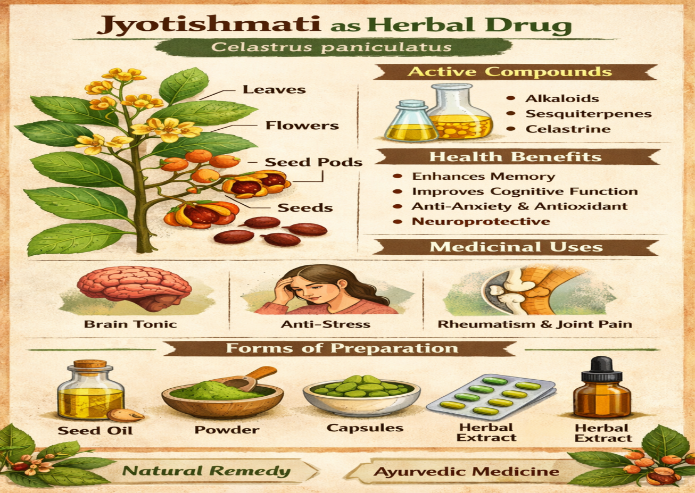
Fig.01 Jyotishmati as Herbal Drug

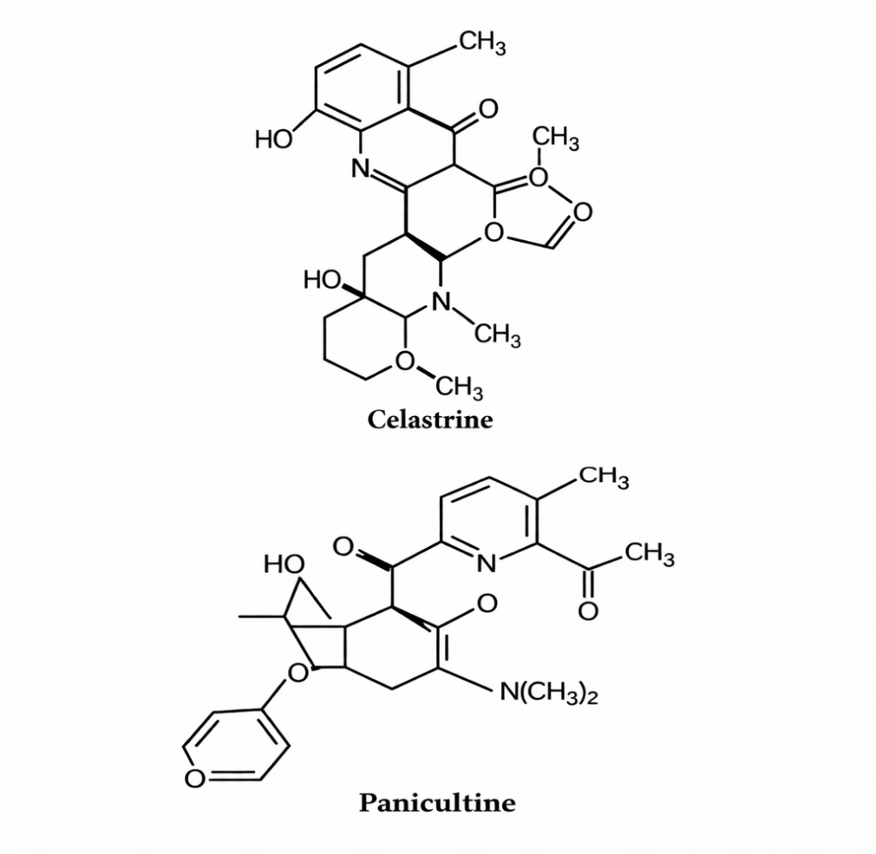
Fig.02 Chemical Structure of Celastrine & Paniculatine
which is present in Jyotishmati

B) Brahmi^{[2,4,10]}
- The botanical source of Brahmi is the whole plant of Bacopa monnieri which belongs to the family Plantaginaceae.
- Brahmi is a creeping plant that is often found in wetland areas. It has been traditionally used as a brain tonic.
- The phytochemical constituents of Brahmi are bacosides A and bacosides B, along with other constituents such as saponins, flavonoids and alkaloids.
- cognitive-enhancing activity.
- The pharmacological therapeutic benefits of Brahmi is memory enhancement, antioxidant anti-anxiety and neuroprotection.

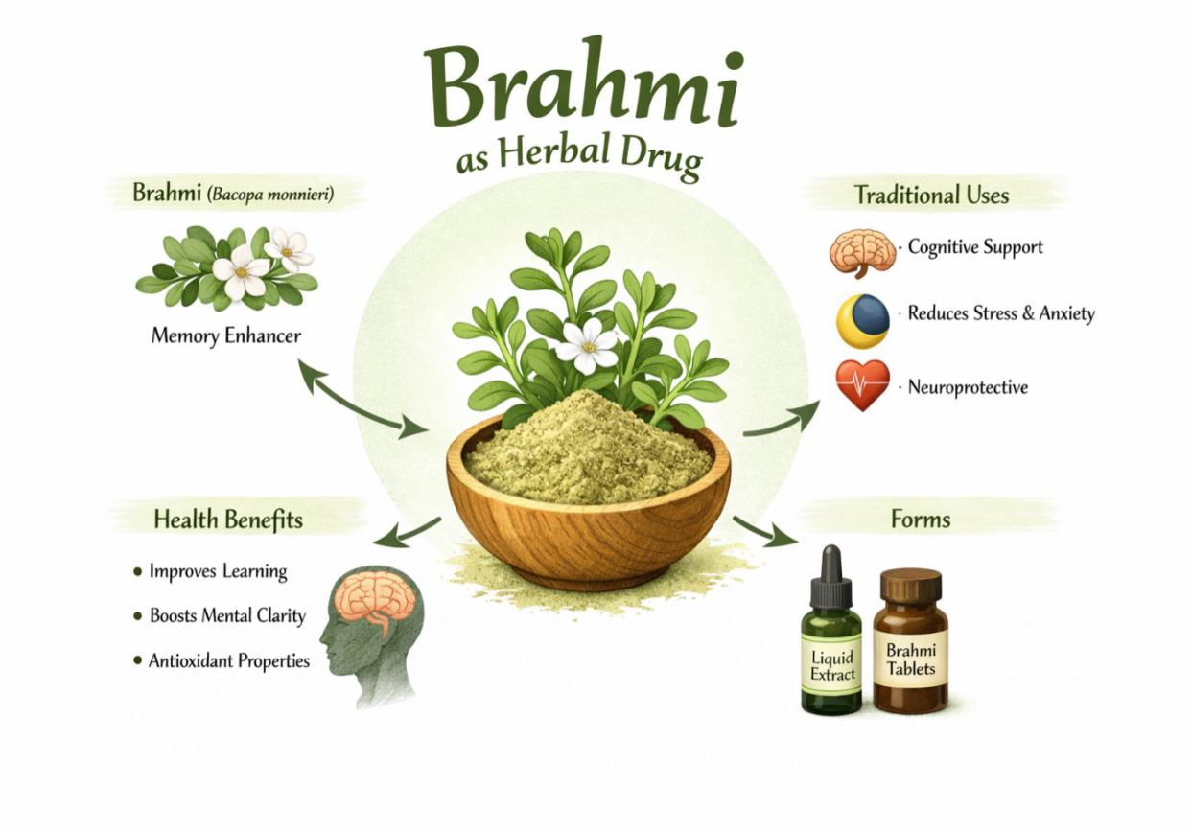
Fig.03 Brahmi as Herbal Drug
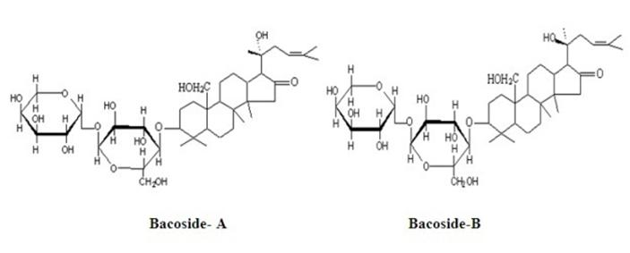
Fig.04 Chemical Structure of Bacosides A & Bacosides B
which one present in Brahmi

C) Shankhpushpi^{[2,4,11]}
- Shankhpushpi is obtained from the plant known as Convolvulus pluricaulis, which belongs to the family Convolvulaceae.
- The plant is known for its sedating properties on the mind and is commonly used in formulations to increase brain power, stress reliever and act as anti-anxiety agent.
- The phytochemical analysis, which has shown the presence of various constituents like alkaloids, glycosides, saponins, coumarins and flavonoids.

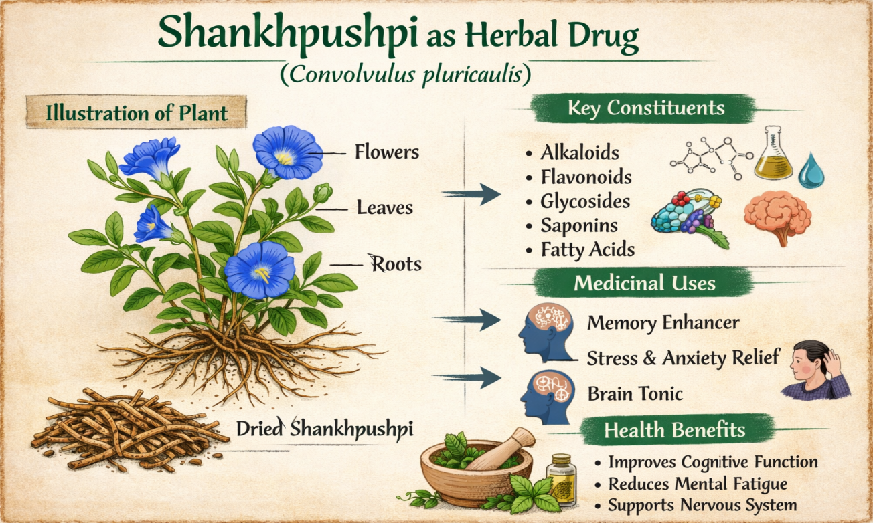
Fig.05 Shankhpushpi as Herbal Drug
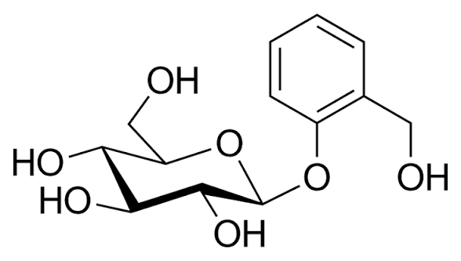
Fig.06 Chemical Structure of Glycosides which is present in Shankhpushpi

D) Ashwagandha^{[2,4,12]}
- Ashwagandha is obtained from the roots of the plant called Withania somnifera, which belongs to the family known as Solanaceae.
- The plant is known by its common names like Indian Ginseng and Winter Cherry.
- The plant is known to increase physical and mental stamina, helping the body to relieve stress and act as cognitive-enhancing properties.
- The plant shows phytochemical properties by presence of withanolides, alkaloids, and sitoindosides, which contribute to its neuroprotective properties.
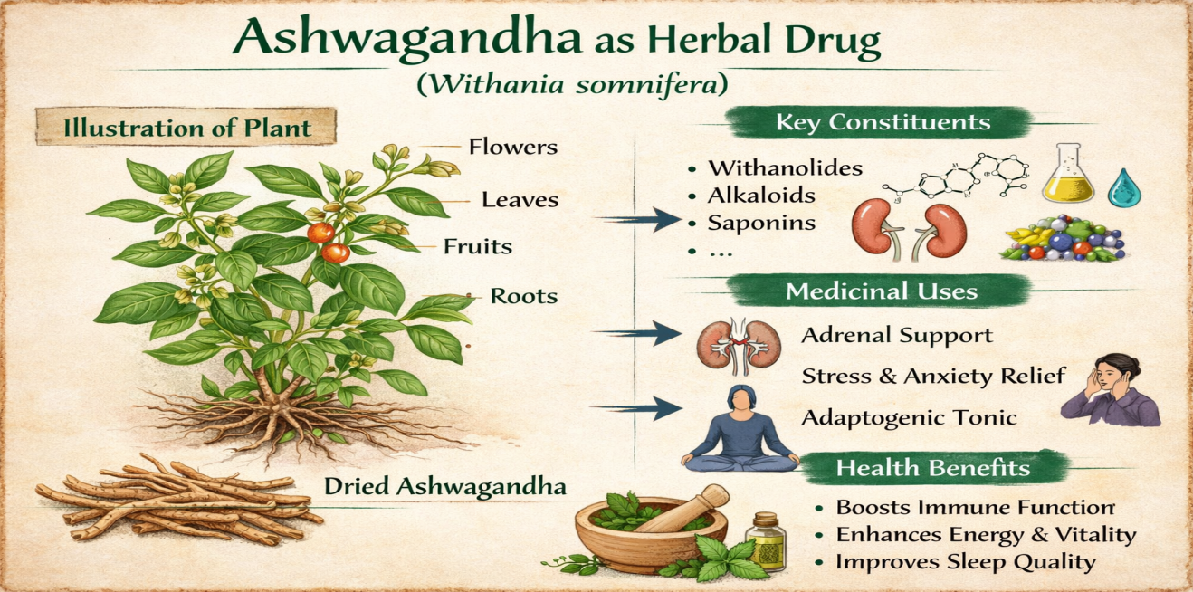
Fig.07 Ashwagandha as Herbal Drug 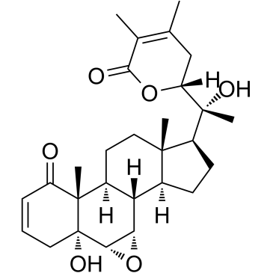
Fig.08 Chemical Structure of Withanolides which is present in Ashwagandha

E) Guduchi^{[2,4]}
- Guduchi is scientifically named as Tinospora cordifolia, which belongs to the family Menispermaceae.
- The phytochemical compounds present are lactones, glycosides, alkaloids, steroids, and polysaccharides.
- The pharmacological therapeutic benefits are immunomodulatory activity, antioxidant action, anti-inflammatory action, and slight memory enhancement.

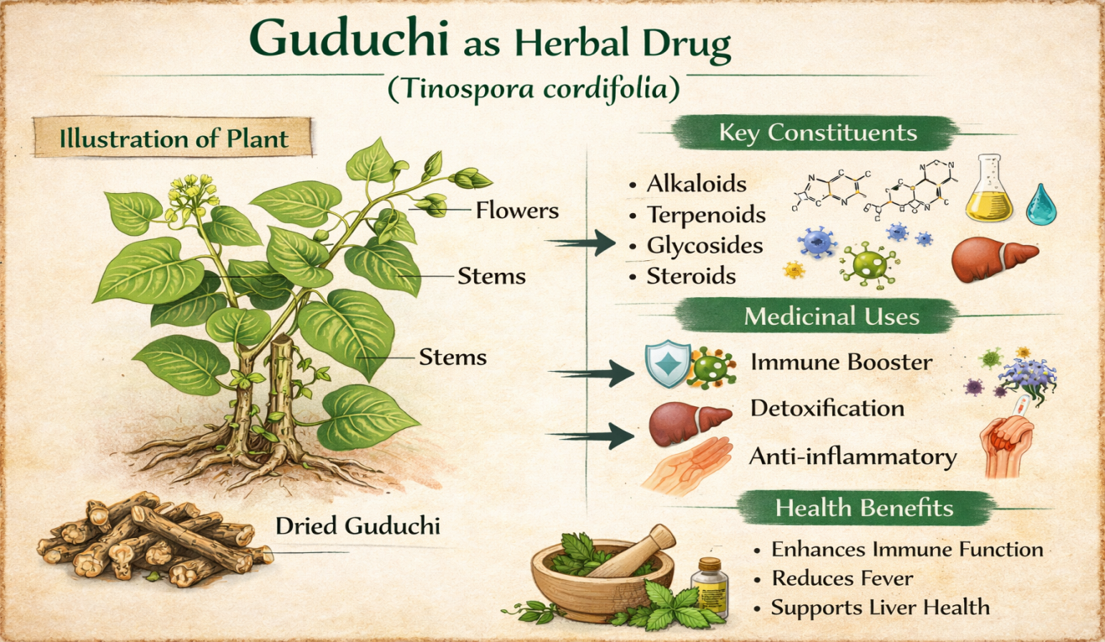
Fig.09 Guduchi as Herbal Drug
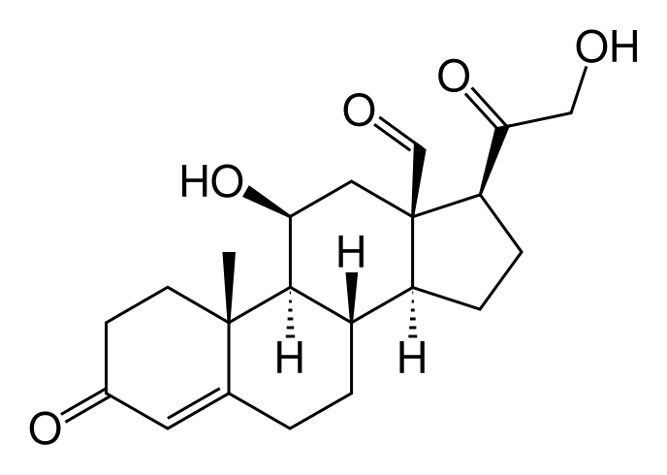
Fig.10 Chemical Structure of Steroids which is present in Guduchi

- Mechanism of Action:
Jyotishmati tablet as a herbal supplement containing Jyotishmati (Celastrus paniculatus) and other plants increase memory relies on the effects of many bioactive compounds which generally working together. The main active ingredients or primary ingredients in this formulation is Jyotishmati (Celastrus paniculatus), but it will also include major herbal ingredients such as Brahmi (Bacopa monnieri), Shankhpushpi (Convolvulus pluricaulis), Ashwagandha (Withania somnifera), and Guduchi (Tinospora cordifolia) which all work in different ways to improve memory, focus, and mental function ability of the brain.^{[1,2,4,9]}
The major mechanism of action of Jyotishmati-based herbal preparation aids in memory enhancement through a wide varieties of processes, which include improved neurotransmission, antioxidant activity, enhancing synaptic activity of the brain, reducing stress or anxiety, and neuroprotection of neuronal functions. Because of its multi-herbal content, it can address not only about the biological aspects but also the psychological aspects of cognition or memory enhancement. Overall, it is a sound, effective, and natural alternative to improve cognitive function of the human physiological body.^{[1,9]}

- Support of Cholinergic Activity:
The main work of mechanism of action for improving memory is through increasing the levels of the neurotransmitter acetylcholine which is present in brain. This neurotransmitter is an important essential component of learning or recalling information.^{[3,5]}
The Jyotishmati seeds have the ability to contain natural compounds that stimulate the release of acetylcholine in the brain; meanwhile, Brahmi has a slowing effect on the breakdown of acetylcholine, due to it being an acetylcholinesterase inhibitor. The result is that when we use this in combined effects of these two herbal plants, the overall level of acetylcholine remains higher or elevated for a longer duration of time period, allowing enhanced communication between nerve cells in the body.^{[3,14]}
Therefore, they enhancing the communication between nerve cells which been associated with improved learning, improved memory enhancement, and improved overall processing speed of the brain.^{[1,5]}

- Antioxidant Protection for Brain Function:
Brain is very susceptible affected by free radicals from oxidation damage. Over time, this can lead to a decline or delayed in the function of brain.^{[5]}
The formulation of herbal tablet provides powerful antioxidant which protecting through helping with varieties types of phytochemicals such as flavonoids and phenolic compounds contained in Jyotishmati and Guduchi herbs; as well as bacosides chemical compound found in Brahmi.These phytochemicals better work together to neutralize the damaging effects of the free radicals which provide a protective behaviour for nerve cell in the human
brain. ^{[9,10,14]}
In addition to providing with antioxidant support the preservation of human brain, there formulation reducing oxidation damage to neurons, which are most vital for preserving overall ability to remember and maintain memory enhancement ability.^{[1,5]}

- Enhancing Synaptic Function:
There main ability of neurons to communicate or transmitted from one another is vital for memory formation of brain neuronal function, as this process also relies heavily on processes such as synaptic plasticity that allow the neurons to change the way they functioning and their connection between each other.^{[10,14]}
Brahmi has been shown wide importance in promoting the growth of dendrites and subsequently improve the connectivity of the synapses nerves, while Jyotishmati is also thought to have a similar effect in that it promotes the effectiveness of the transmission of signals by neurons. When we have both of these herbs together, they can work together to facilitate the transmission of nerve impulses which act as a synergistic action.^{[1,5,10,14]}
As a result, brain will be able to work more efficiently store and retrieve memories; therefore, overall ability to learn new things and access previously learned information will also be improved.^{[5]}

- Reduction of Stress or Anxiety and Its Impact on Memory:
Stress or anxiety is a major contributor to memory problems because it disrupts brain functioning, especially in the hippocampus region. Ashwagandha has adaptogenic characteristics properties that are critical use in regulating the body's reaction to stress, hence balancing the hypothalamic-pituitary-adrenal axis region, lowering cortisol levels and minimizing overall stress and anxiety. This, will help enhance or improve concentration, focus/mental clarity and brain function performance as per the formulation would improve overall concentration, focus and clarity needed for better memory performance of the brain.^{[12,16]}

- Regulatory Mechanisms Regarding the Functionality of Neurotransmitters of Brain:
GABA (Gamma–aminobutyric acid) , such as serotonin and dopamine which are primary inhibitory neurotransmitter receptors in the Central Nervous System (CNS), play major roles in brain enhancement function and affective the overall state, in addition to acetylcholine in the brain.^{[3]}
Shankhpushpi an herbal extract has been shown to possess a calming effect on the nervous system of the body, probably mediated through modulation of GABA activity. Having a more relaxed mental state is vital when attempting in both about how to concentrate and how to learn. Furthermore, it may also moderate in maintaining a balance of mood-related neurotransmitters, all which are contributing in memory enhancement function.^{[6,11,15]}

- Anti-inflammatory Effects in Brain:
Chronic inflammation in the nervous system has progressively negative impact on cognition behavior. Herbs such as Guduchi and Ashwagandha as herbs have been naturally occuring posed anti-inflammatory properties which help to reduce or decrease the number of inflammatory mediators present in the brain. Therefore they acts as a protective effect about these herbs provide can help to minimize or preventing long-term neurons damage, and promoting healthy aging of the overall brain function.^{[2,12,17]}

- Improving Brain Circulation Ability:
For human brain to work correctly and accurately, it requires a continuous supply of oxygen and nutrients to be able to function properly. Jyotishmati is an herbal agent which also help with improving flow and supply of blood to the Brain, which is responsible for providing neurons enough amount of fuel or nourishment to function properly. Enhancing blood movement allows for increased metabolic rate of Brain Cells, thus increasing the overall efficiency of brain memory enhancement ability.^{[1,5,6,9]}

- Synergistic Polyherbal Effect:
In jyotishmati-enriched herbal medicated tablets, there overall formulation make it more effective and stable is the way the various herbs work together in synergy with each other to achieve their desire results which a brain needed^{[5,6]}
Jyotishmati is the primary memory enhancing herb; Brahmi and Shankhpushpi both assist in enhancing learning and calming the mind behavior. As a stress reliever and strengthener of resilience, ashwagandha has a protective and restorative effect on the body as well as on the mind via its action. Guduchi consists of both protection and restoration of function of the brain and human body. This formulation acts on multiple brain functioning by not limiting its action to just one pathway as each of the herbs work together in this way to improve optimal brain neuronal function.^{[1,5,10,11,12]}

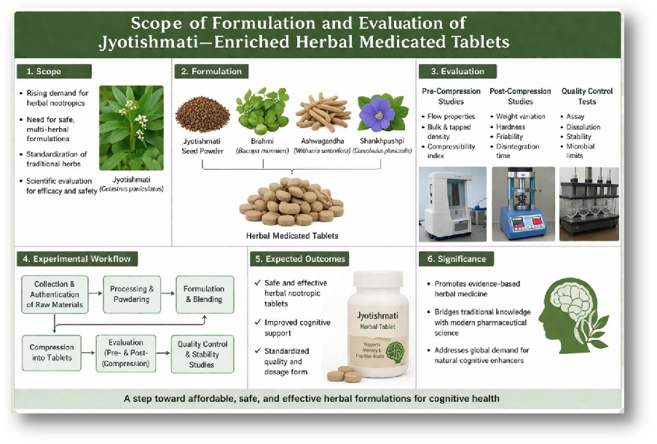Fig. 11. Scope of Formulation and Evaluation of Jyotishmati – Enriched Herbal Medicated Tablets.

- Advantages / Benefits / Merits:
- Safe and Natural Therapy:
It is derived from Jyotishmati (Celastrus paniculatus), this plant-based formulation is much less likely to cause any serious side effects as compared to allopathic modern synthetic medication, when taken as prescribed dose used for memory enhancement.^{[6]}
- Enhancement of Memory:
The bioactive phytoconsitutents compounds present in Jyotishmati could help improve overall learning ability, memory enhancement, focus/attention span, and mental clarity of brain.^{[6]}
- Neuro-protective Action:
The formulation has neuroprotective action as well as antioxidant activities and should help in protecting the brain from developing oxidative stress and damage to its nerve cells.^{[5]}
- Synergistic Effects with Other Herbs:
When combined with other herbs such as, Brahmi or Shankhpushpi, there formulation will likely to producing enhanced therapeutic ooutcome through their combined synergistic effects.^{[2,4]}
- Consistent Dosage:
Due to tablet dosage form, the drug content of the formulation is uniformly adjusted compared to different forms (e.g., herbal extract) leading to consistent therapeutic effects and stability consistence as it producing by taking the same amount of the medication each time it is taken.^{[18,19,20]}
- Easy for Patients to Use:
Because of this tablets are easy to use, easily transported, and very convenient for the patient, the patient will be much more likely to adhere or compliance to taking the tablets regularly compared with other forms of natural plant-based medicines (e.g., oils, tinctures).^{[2,18]}
- Improved Stability:
The tablet also keeps the active/polyherbal ingredients safe from becoming less stable by environmental factors such as humidity, sunlight, and excessive heat; thus, providing greater stability of the herbal medicated product.^{[7,8]}

- Long Shelf Life:
Because of the tablets are properly formulated and packaged, they have a long shelf life and do not lose their effectiveness or potency after a long time period compared to other methods of processing/economically preparing herbs.^{[7,8]}
- Multi-functional Benefits:
The formulation may help in enhancing memory along with possibly providing anti-inflammatory effects, adaptogenic effects, and/or neuroprotective effects.^{[5,11]}
- Cost-effective:
The use of herbs allows for lower costs to produce the final product as compared to branded synthetic drugs and makes it affordable and available for consumers to use.^{[9]}

- Disadvantages / Limitations / Demerits:
- Adverse effects of Jyotishmati:
Jyotishmati herbs usually at higher doses could cause any unwanted physical effects, although Jyotishmati (or any herbal compound) are generally considered to be safe medication usually at a controlled form of dosage. But because of there narrow therapeutic window of many herbal compounds, consuming them in excess or overuse may lead to effect unevenly in normal body physiological function.^{[6,18]}
- Gastrointestinal Disturbance:
Some people may have mild gastritis, nausea, or bloating after intake of Jyotishmati, due to its strong and pungent effect, particularly if they are consumed on an empty stomach or in the concentrated tablet form it may cause gastrointestinal disturbance.^{[1,6,19]}
- CNS overstimulation:
Jyotishmati is a major CNS stimulant drug hence, therefore they are very effective nootropic agent. However, because of the impact of Jyotishmati on neural pathways, it is possible for some people to become restless, overly stimulated, or may have difficulty in sleeping.^{[1,9,20]}

- Small sample size and limited studies in humans subjects:
The majorly research done before upto date on Jyotishmati and its pharmacological effects have been conducted mainly in animal studies as pre-clinical studies, and the human studies as clinical trials on human subjects have been very limited and small. As a result, we didn’t fully understand the potential long-term effects and there safety of Jyotishmati as a medication drug.^{[9,18]}
- Variability of herbal composition:
The phytochemical composition of Jyotishmati (i.e., its various active ingredients) can vary widely depending on it geographic location where it is harvested, the climatic conditions at the time of harvesting, and how it is extracted. Because of the variability in chemical composition, the therapeutic effects of Jyotishmati can also may vary widely from one lot to another.^{[8,9]}
- Potential for drug-herb stimulation interaction:
There is a potential for drug-herb stimulation interaction with Jyotishmati, particularly with medications that interact with the CNS, including sedatives and/or antidepressant drugs.^{[5,6]}
- Allergic Reactions are Possible:
Jyotishmati tablets may cause hypersensitivity in people to have some allergy reactions (e.g., skin rashes, skin irritation).^{[6,8]}
- Lack of Standardized Quality:
It is very difficult to create an herbal tablet that is identical in dosage and there quality; therefore, when there is no way to assure uniformity of an herbal tablet that is easy to replicate, then it is very likely that the safety, reproducibility, and/or therapeutic effects of an herbal product will not be assured easily as compared to synthetic drugs.^{[7,8,9]}
- Delayed Therapeutic Benefit:
In general, an herbal product like Jyotishmati will take longer than a synthetic nootropic product to observe a therapeutic effect; therefore, patients may exhibit poor patient compliance.^{[6]}

- Storage & Stability Problems:
Because of humidity, heat, and light, an herbal tablet is prone to deterioration at a greater rate than any other kinds of tablets; therefore, because of there potency may diminish or change as the tablet degrades, it is important to store them properly in well closed container.^{[6,7,8]}

- Applications / Uses:
- Memory Enhancement:
Jyotishmati tablets are extensive use to enhance the retention power of the memory, recall capacity, and learning capacity, they also supports neuronal function and better cognitive processing of the brain and the tablets are also useful for students and even elder people.^{[1,2,5]}
- Management of Neurodegenerative Disorders:
This herbal formulation may also be helpful in slowing down the progression of neurodegenerative conditions such as Alzheimer’s disease and other types of dementia by protecting the nervous cells from oxidative stress and maintaining synaptic support in the brain and neuronal function.^{[5]}
- Stress and Anxiety Reduction:
Because of the presence of adaptogenic herbs like Ashwagandha, these tablets help regulate the stress hormones, reduce anxiety levels, and help maintain a calm down of mental state without causing any sedation.^{[16]}
- Support in Mental Fatigue and Burnout:
These herbal tablets are useful in the reduction of mental exhaustion that results from extended mental or cognitive activity, thus they helps individuals to maintain productivity and mental alertness over longer durations of time.^{[18,20]}
- Adjunct Therapy in Epilepsy and Neurological Imbalancing:
Traditionally, Jyotishmati has been used in the management of neurological disorders, including epilepsy, because of its neuroprotective and stabilizing effects on brain activity.^{[1,5]}
- Mood Stabilization and Emotional Well-being:
The herbal combination helps in balancing neurotransmitters, thus improving overall mood and emotional stability in mild depressive states of behavior.^{[6,7]}

- Neuroprotective Action Against Oxidative Stress:
Besides being rich in antioxidants, the herbal formulation also helps in fighting against the free radicals, thereby protecting brain cells from oxidative damage and age-related issues of brain function.^{[5,18,19]}
- Improvement in Sleep Quality:
By reducing stress and calming the nervous system, these tablets indirectly promote better sleep patterns, which is essential for memory restoration and mental wellbeing.^{[9]}
- Support in Rehabilitation After Brain Injury:
The neuroregenerative properties of the herbs may assist recovery and rehabilitation following brain injuries or neurological trauma, as opposed to enhanced neuronal repair mechanisms.^{[5]}
- General Brain Tonic for Preventive Healthcare:
These tablets can be taken as a prophylactic brain supplement to retain overall brain health, increase mental ability, and postpone the advent of cognitive decline in healthy individuals.^{[2,20]}

REVIEW OF LITERATURE
Nowadays major problems related to memory loss and cognitive retardation are becoming more common due to unhealthy lifestyle, stress, uneven schedule. Although modern allopathic dosage form of medicines are available to improve brain function, but they may come with some side effects and may be not too effective for long-term use. Therefore, this has increased interest in natural herbal alternatives, especially herbal nootropics described in Ayurveda as Medhya Rasayana.^{[2,4,9]}
Celastrus paniculatus (Jyotishmati) is one of the herb known for its memory-enhancing properties. Its seeds mainly contain important compounds that help improve learning and memory enhancing by supporting the brain vital chemicals and reducing oxidative stress. Similarly, Bacopa monnieri (Brahmi) is widely recommodated for improving memory and concentration, there active components such as bacosides A & bacosides B helps in better communicating between brain cells and protecting them from overall damage of the nerve.^{[1,5,10]}
Convolvulus pluricaulis (Shankhpushpi) is known for reducing stress and improving overall mental performance and behavior by balancing brain neurotransmitters. Withania somnifera (Ashwagandha) helps the body to manage stress, supports brain health, and improves memory by reducing the level of cortisol. Tinospora cordifolia (Guduchi) plays an vital role in protecting brain cells and acts as an antioxidant, further supporting cognitive function.^{[11,16]}
Using these herbs together in a combination form of polyherbal formulation can provide better results than using them individually. Their combined action helps improve memory through multiple pathways like reducing inflammation, protecting neurons, and enhancing brain signaling.
From a pharmaceutical point of view of herbal dosage form, converting these herbal extracts into tablet form is giving more beneficial.^{[7,9]}
Tablets are selected because it provide accurate dosing, better stability, and are easy to use administrative drug. However, proper formulation is important to ensure good quality of the final product. This includes selecting suitable excipients, and pre & post-evaluating parameters such as flow properties, hardness, friability, dissolution test and disintegration time.^{[8,19]}

Overall, combining traditional knowledge of herbal with formulation techniques can help develop a safe, effective, and reliable polyherbal tablet for memory enhancement and memory boosting.
Even though Jyotishmati (Celastrus paniculatus) and other nootropic herbs have been widely used in traditional medicine and supported by scientific studies, but a there are still several important gaps in research.^{[1,6,9]}
One major issue is the lack of standardized formulations and evaluation techniques. Many studies focus only on crude extracts or oils without fixing proper doses or consistent levels of active medicated compounds. Because of differences in plant sources and preparation methods, the results are often not reliable or reproducible as per excepted.^{[9,18,19]}
Another limitation is the poor development of stable tablet formation. While these herbs show good results in studies, there is limited work on converting them into proper pharmaceutical tablets. Problems like poor flow properties, moisture sensitivity, and difficulty in compression are often not properly addressed.^{[8,19]}
There is also a lack of well-studied polyherbal combinations. Although herbs like Jyotishmati, Brahmi, and Ashwagandha are effective individually, their combined effects are not fully explored with proper scientific validation and defined satisfactory ratios.^{[2,4,18]}
In many cases in this study important formulation parameters such as hardness, disintegration time, dissolution studies, uniformity are not thoroughly evaluated and tested. This affects the quality and performance of the overall final product. Additionally, advanced techniques such as HPLC and TLC are not always used or carried out due to its equipment requirements. Which may leading to poor standardization and difficulty in identifying active compounds.^{[6,8,9]}
Stability studies are often missing in some cases, which raises concerns about shelf life and safety of dosage form, Clinical evidence is also limited, as most studies are based on laboratory or animal research rather than human trials which may not be possible at some levels.^{[18,19]}
Overall, there is a clear need to develop a well-standardized, stable, and scientifically validated Jyotishmati-based polyherbal medicated tablet. Addressing these gaps will help in creating a safer, effective, and reliable natural solution for memory enhancement and memory booster.^{[18,20]}

Table. 01. Some Relevant Author and their Study of Formulations and Evaluation of aJyotishmati-enriched Herbal Medicated Tablet for Memory Enhancement.^{[3,5,8,9,20,23,30]}
Sr.No. | Author(s) / Year | Study / Topic | Key Findings | Relevance to Present Study
1 | Bhattacharya et al. (1995) | Memory and learning studies | Significant improvement in learning and memory in experimental models. | Confirms nootropic activity.
2 | Mukherjee et al. (2002) | Phytochemical analysis of herbal drugs | Presence of alkaloids, flavonoids, saponins in herbal drugs. | Explains active constituents responsible for activity.
3 | Kumar and Gupta et al. (2002) | Antioxidant properties of Celastrus paniculatus | Demonstrated antioxidant activity and protecting brain cells from oxidative stress. | Supports neuroprotective role of Jyotishmati.
4 | WHO (2003) | Herbal drug guidelines | Emphasizes quality control, safety, and standardization. | Ensures formulation safety and quality.
5 | Sharma et al. (2003); Nadkarni et al. (2007) | Traditional use of Jyotishmati | Jyotishmati traditional used as used Medhya Rasayana for improving memory, and concentration. | Supported as selection of Jyotishmati as a memory enhancer.
6 | Singh (2008) | Herbal medicine for memory enhancement. | Herbal drugs like Bacopa, Ashwagandha improve cognitive function. | Supports use of polyherbal formulations.
7 | Lachman and Lieberman et al. (2009) | Industrial pharmacy | Tablets are stable, convenient, and provide accurate dosing. | Supports tablet dosage form selection.
8 | Patel et al. (2012) | Nootropic activity of herbal drugs | Herbal formulations show effective cognitive enhancement with fewer side effects. | Justifies herbal tablet development.
9 | OECD Guidelines | Experimental testing. | Provides protocols for cognitive and behavioral studies. | Useful for memory evaluation studies.
10 | Indian Pharmacopoeia (Latest) | Standard evaluation methods | Defines tests like hardness, friability, disintegration. | Guides evaluation of formulated tablets.

MATERIALS & METHODS FORMULATION
- MATERIALS
  - Active Herbal Ingredients
A combination of major herbal rich ingredients of well-established Medhya Rasayana herbs was selected for the formulation based on their traditional use and scientifically evidence based on supporting cognitive enhancement or memory enhancement.^{[2,18]}

A) Jyotishmati seed extract (Celastrus paniculatus)
It is widely recommended due to its versatile role in improving memory retention,
Learning capability and overall memory enhancement ingredients which is generally because of it basic principal of nootropic component.^{[1,6]}
- Brahmi extract (Bacopa monnieri)
Basically know for it enhance neuronal communication, and it supports memory consolidation and cognitive performance.^{[10,14]}
- Shankhpushpi extract (Convolvulus pluricaulis)
It is traditionally used to promote mental clarity, concentration, and relaxation of the nervous system.^{[11,15]}
- Ashwagandha extract (Withania somnifera)
It acts as an adaptogen, and helps the body to decreases with stress while also providing neuroprotective benefits.^{[12,16]}
- Guduchi extract (Tinospora cordifolia)
They exhibits antioxidant properties and contributes to maintaining neuronal health and immune support.^{[13,17]}

1.2. Excipients^{[21,23,29]}
All materials employed in the formulation were of pharmaceutical or analytical grade to maintain quality and consistency.
- Diluent: Lactose monohydrate.
- Binder: Starch paste.
- Disintegrant: Isabgol
- Lubricant: Castor oil.
- Glidant: Talc.

- Preservatives (if needed): Turmeric extract.
- Flavoring/Sweetening agent (optional): Peppermint oil.

1.3. Equipment Required^{[7,8,21,23,29]}
The formulation and evaluation of the herbal medicated tablets required standard laboratory and pharmaceutical equipment.
- Analytical balance for precise weighing.
- Mortar and pestle for mixing.
- Sieve sets (mesh numbers 40, 60) for particle size uniformity.
- Mechanical blender or mixer for homogenous blending.
- Granulator for granule formation.
- Hot air oven for drying.
- Tablet compression machine (single punch or rotary type) for compressing tablets.
- Hardness tester (Monsanto or Pfizer type) to check hardness of tablets.
- Friabilator (Roche type) to test the mechanical strength of tablets.
- Disintegration test apparatus to determine the time required for a tablet to break down into
smaller particles.
- Dissolution test apparatus (USP Type II) to measure the rate and extent of drug release of the tablets.
- Vernier calipers for dimensional analysis.
- UV-Visible spectrophotometer for analytical studies.

Table. 02. Active Ingredients 10 Trials of Jyotisthmati Herbal Medicated Tablets.
Sr no. | Active ingredient | T1 | T2 | T3 | T4 | T5 | T6 | T7 | T8 | T9 | T10
1. | Jyotishmati  Powder | 110 | 120 | 100 | 115 | 105 | 110 | 120 | 100 | 115 | 110
2. | Brahmi  Powder | 30 | 25 | 35 | 30 | 25 | 30 | 20 | 35 | 30 | 25
3. | Shankhpushpi  Powder | 25 | 20 | 30 | 25 | 20 | 25 | 20 | 30 | 25 | 20
4. | Ashwagandha  Powder | 25 | 20 | 25 | 20 | 25 | 20 | 20 | 25 | 20 | 25
5. | Guduchi  Powder | 20 | 15 | 20 | 15 | 20 | 15 | 15 | 20 | 15 | 20
Total (mg) |  | 210 | 200 | 210 | 205 | 195 | 200 | 195 | 210 | 205 | 200

Table 03. Pre-formulation Test of 10 Trials of Active Ingredients.
Trial | Total Active Ingred-  ients | Angle  of  Repose | Bulk Density | Tapped Density | Carr’s  Index | Hausner Ratio | Alkaloids (Dregndo  rff’s Test) | Flavanoids  (Shinoda Test) | Saponin  (Foam Test) | Glycosides  (Keller-Killiani Test)
T1 | 210 | 28 | 0.45 | 0.52 | 13.4 | 1.15 | Strong Presence | Moderate Presence | Moderate Presence | Moderate Presence
T2 | 200 | 30 | 0.44 | 0.51 | 13.7 | 1.16 | Moderate Presence | Moderate Presence | Moderate Presence | Moderate Presence
T3 | 210 | 27 | 0.46 | 0.53 | 13.2 | 1.15 | Strong Presence | Strong Presence | Moderate Presence | Moderate Presence
T4 | 205 | 29 | 0.45 | 0.52 | 13.5 | 1.15 | Moderate Presence | Moderate Presence | Moderate Presence | Moderate Presence
T5 | 195 | 31 | 0.43 | 0.50 | 14.0 | 1.17 | Moderate Presence | Slight Presence | Slight Presence | Moderate Presence
T6 | 200 | 30 | 0.44 | 0.51 | 13.7 | 1.16 | Moderate Presence | Moderate Presence | Moderate Presence | Moderate Presence
T7 | 195 | 32 | 0.42 | 0.49 | 14.2 | 1.18 | Slight Presence | Slight Presence | Slight Presence | Slight Presence
T8 | 210 | 27 | 0.46 | 0.53 | 13.2 | 1.15 | Strong Presence | Strong Presence | Moderate Presence | Moderate Presence
T9 | 205 | 29 | 0.45 | 0.52 | 13.5 | 1.15 | Moderate Presence | Moderate Presence | Moderate Presence | Moderate Presence
T10 | 200 | 30 | 0.44 | 0.51 | 13.7 | 1.16 | Moderate Presence | Moderate Presence | Moderate Presence | Moderate Presence

METHOD OF PREPARATION

Table. 02. Formulation Table of Jyotishmati-Enriched Herbal Medicated Tablet for Memory Enhancement.^{[21,23,29]}
Sr. No. | Ingredient | Category / Role | Quantity per Tablet (mg or mL) | Quantity for 20 Tablets (mg or mL) | Quantity for 20 Tablets (g or mL)
1 | Jyotishmati seed powder | Active ingredient | 90 mg | 1800 mg | 1.8 g
2 | Brahmi powder | Active ingredient | 40 mg | 800 mg | 0.8 g
3 | Shankhpushpi powder | Active ingredient | 30 mg | 600 mg | 0.6 g
4 | Ashwagandha powder | Active ingredient | 35 mg | 700 mg | 0.7 g
5 | Guduchi powder | Active ingredient | 30 mg | 600 mg | 0.6 g
6 | Lactose monohydrate | Diluent | 18 mg | 360 mg | 0.36 g
7 | Maize Starch paste | Binder | 8 mg | 160 mg | 0.16 g
8 | Isabgol | Disintegrant | 5 mg | 100 mg | 0.10 g
9 | Talc | Glidant | 3 mg | 60 mg | 0.06 g
10 | Castor oil | Lubricant | 0.002 mL | 0.04 mL | 0.04 mL
11 | Turmeric extract | Preservative | 2 mg | 40 mg | 0.04 g
12 | Peppermint oil | Flavoring agent | 0.002 mL | 0.04 mL | 0.04 mL

2.1. Ingredients and Quantity^{[21,23,29]}
- Jyotishmati seed powder = 100 mg × 20 = 2000 mg = 2.0 g
- Brahmi powder = 35 mg × 20 = 700 mg = 0.7 g
- Shankhpushpi powder = 30 mg × 20 = 600 mg = 0.6 g
- Ashwagandha powder = 25 mg × 20 = 500 mg = 0.5 g
- Guduchi Powder = 20 mg × 20 = 400 mg = 0.4 g
- Lactose monohydrate (Diluent) = 18 mg × 20 = 360mg = 0.36 g
- Maize Starch Paste (Binder) = 8 mg × 20 = 160 mg = 0.16 g
- Isabgol (Disintegrant) = 5 mg × 20 = 100 mg = 0.10 g
- Talc (Glidant) =3 mg × 20 = 60 mg = 0.06 g
- Castor oil (Lubricant) = 0.002 mL × 20 = 0.04 mL = 0.04 mL
- Turmeric extract (Preservative) = 2 mg × 20 = 40 mg = 0.04 g
- Peppermint oil (Flavoring agents) = 0.002 mL × 20 = 0.04 mL = 0.04 mL

Calculation :
Batch Size = 20 Tablets
Total weight of Active Ingredients = 4500 mg = 4.5 gram
Total weight of Herbal Excipients = 500 mg = 0.5 gram
Total weight of batch = 250 mg × 20 = 5000 mg = 05 Gram

2.2. Pre-formulation Studies^{[7,8,27]}
Prior to formulation preparation all herbal extracts ingredients were subjected to preliminary evaluation test to assess their suitability.
- Examination of organoleptic characteristics such as color, odor, and taste.^{[7]}
  - Color = Brownish green powder
  - Odor = Characteristic herbal odor
  - Taste =Bitter and slightly pungent

- Determination of solubility behavior by performing solubility test.^{[8]}
Solubility test is performed to determine their solubility behavior of Jyotishmati herbal-medicated tablet in different medium of solvents.

Procedure:
Powder the Jyotishmati herbal-medicated tablet finely with the help of mortar and pestle.
Take a small quantity of it (approx. about 100 mg).
Now add it separately to different medium solvents such as water, ethanol, and chloroform.
Shake well and allow to stand for a few minutes to become it stable.
Now observe whether the sample dissolves completely or partially, or remains insoluble in the medium solvents.
Result:
Water = Slightly soluble / partially soluble.
Ethanol = Moderate soluble.
Chloroform = Soluble.

- Estimation of moisture content.^{[27]}
Moisture content is performed to determine the amount of moisture present in jyotishmati herbal medicated tablet for there stability and shelf – life of the product.
Procedure:
Weigh a known quantity of powdered form of tablet by finely make it in powder form (W₁₎
Place it in a dried and clean petri dishes.
Now dry them in a hot air oven at 105°C for 1 – 2 hours.
Now cool down in a desiccator and reweigh it by using weighing balance (W₂)
Repeat this procedure until constant weight is obtained.
Formula:
Moisture content (%) = W₁ – W₂ / W₁ × 100
Result:
The percentage of loss in weight is 2.5% indicates the moisture content, Therefore, lower moisture content ensure better stability and prevent microbial growth.

2.3. Preparation of Granules (Wet Granulation Technique)^{[18,19,20,21,29]}
- Weighing of Active Ingredients:
All herbal ingredients such as Jyotishmati, Brahmi, Shankhpushpi, Ashwagandha, Guduchi were accurately weighed by using analytical balance / weighing Balance.
Primarily Jyotishmati is main ingredients it is available in seeds which contain oil so it must be passed firstly into sieve no. 40 and 60 to achieve uniform particle size.
- Blending of Active Ingredients:
The herbal extracts such as Jyotishmati, Brahmi, Shankhpushpi, Ashwagandha, and
Guduchi were thoroughly mix uniformly in a mortar and pestle or blender to ensure
uniform distribution.
- Seiving:
They are all are passed through sieve number 60 to achieve uniform particle size distribution.
- Addition of Diluent:
Lactose monohydrate was incorporated into the mixture to improve bulk properties and compressibility of the formulation.
- Preparation of Binder Solution:
A suitable binder solution was prepared by using Maize Starch Paste which is dissolved in water.
- Granulation:
The above prepared binder solution was gradually added to the powder to blend with continuous mixing until a cohesive damp wet mass was formed.
- Screening of Wet Mass:
The damp mass was passed through sieve number 40 to produce granules of desired size.
- Drying:
The granules were dried in a hot air oven maintained at 40–50°C until appropriate moisture levels is removed and are achieved.
- Screening:
The dried granules were again passed through sieve number 60 to obtain uniformly sized granules.

- Lubrication:
Castor oil , Isabgol and Talc were added to the dried granules and mixed gently to avoid excessive lubrication.
- Compression of Tablets:
The lubricated granules were compressed into tablets using a tablet compression machine. Proper punch size and compression force were selected to produce tablets with uniform weight, adequate hardness, and acceptable physical characteristics.

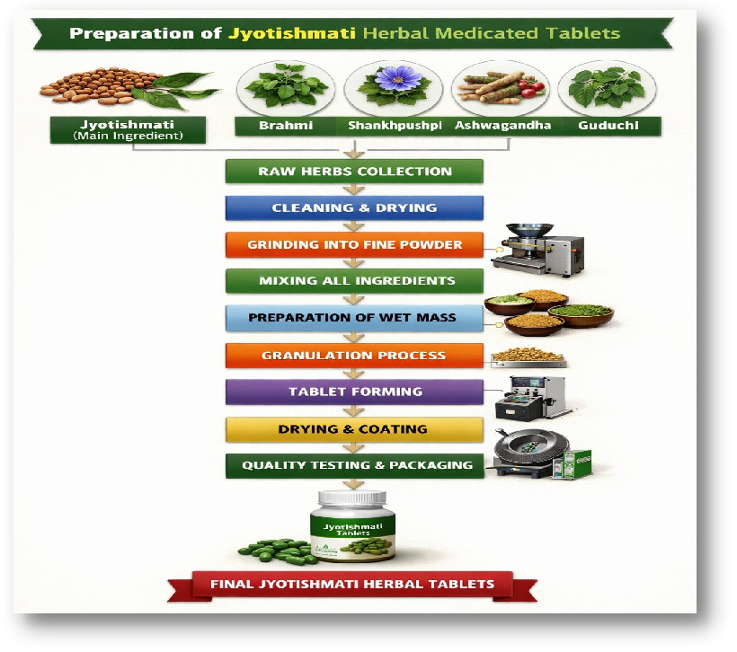Fig.11. Method of Preparation of Jyotishmati Herbal Medicated Tablet

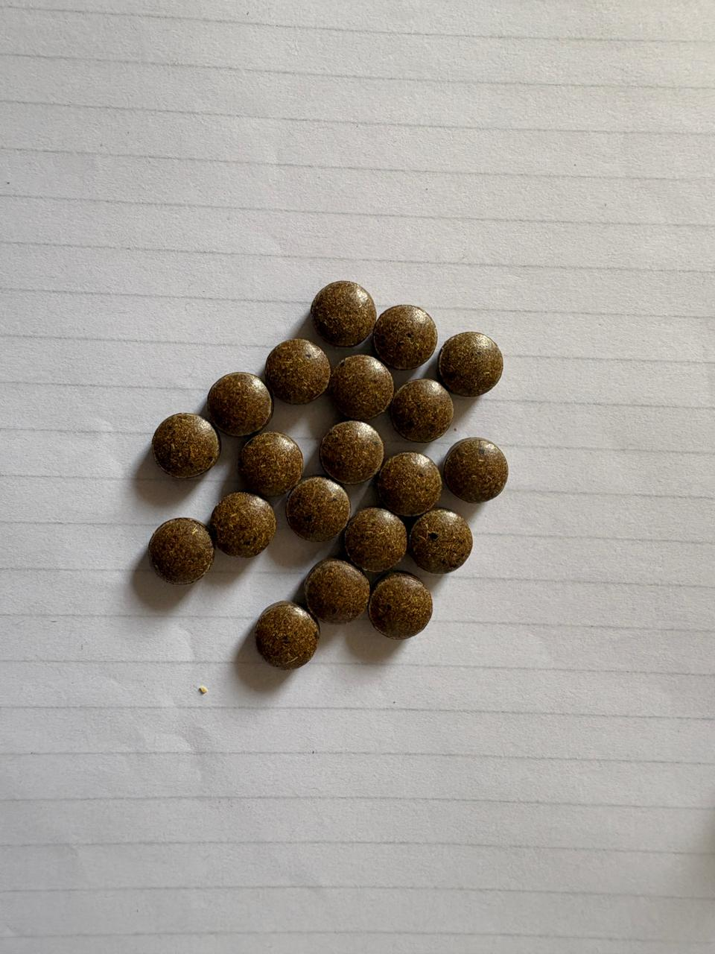

Fig.12. Preparation of Jyotishmati-Enriched Herbal Medicated Tablets

EVALUATION PARAMETERS TEST
- Pre-compression Parameters (Before Tablet Formation)^{[19,31,32,33,34]}
These tests are performed on the powder blend to check whether it is suitable for
compression.
It is performed to ensure smooth and consistency Of the tablets production which results in
reducing defects and batch failures.

- Angle of Repose:^{[19]}
Angle of repose is the maximum angle formed between the surface of a pile of powder and the horizontal plane.
This test indicates the flow property of powder or granules.
Procedure: Powder is allowed to flow through a funnel to form a cone.
Calculate using formula:
tan θ = h / r
tan θ = 4.8 /10 = 28°
Result = Angle of Repose of Herbal medicated tablet is 28° which indicates
Excellent flow.
Interpretation:
< 25° → Excellent flow (Smaller angle = Excellent flow
30-40° → Good flow (Medium angle = Good flow)
>40° → Poor flow (Larger angle = Poor flow)

- Bulk Density:^{[19]}
Bulk density is the ratio of the mass of a powder to the total volume it occupies,
including
the spaces (voids) between particles.
Bulk density is done before tapping the measuring cylinder.
These help in understanding powder packing behavior.
Calculate using formula:
Bulk Density = Mass / bulk volume
Bulk Density = 48 /100 = 0.45g/cm³
Result = Bulk Density of Herbal medicated tablet is 0.48g/cm³
- Tapped Density:^{[19]}
Tapped Density is the density of a powder measured after mechanically tapping a
container until the volume become constant.
Tapped Density is after tapping the cylinder.
Calculate using formula:
Tapped Density = Mass / Tapped Volume
Tapped Density = 55 / 100 = 0.55g/cm³
Result = Tapped Density of Herbal medicated tablet is 0.55g/cm³

- Carr’s Index (Compressibility Index):^{[32]}
Carr’s index measures the flowability of a powder based on the difference between
Bulk
density and Tapped density divided by Tapped density.
Indicates powder flow and compressibility.
Calculate using formula:
Carr’s Index = [(Tapped Density − Bulk Density) / Tapped Density] × 100
Carr’s Index = [ (0.55 - 0.47 ) / 0.55 ] × 100 = 14.5 %
Result = Carr’s Index of Herbal medicated tablet is 14.5 % which indicates
Excellent flow.
Interpretation:
5–15% → Excellent (lower value = Excellent flow)
15–25% → Good (Medium value = Good flow)
25% → Poor (Higher value = Poor flow

- Hausner’s Ratio:^{[33]}
Hausner Ratio is a measure of powder flowability based on the relationship between tapped density and bulk density.
It is generally dimensionless or unitless.
Calculate using formula:
Hausner’s Ratio = Tapped Density / Bulk Density
Hausner’s Ratio = 0.55 /0.48= 1.15
Result = Hausner’s Ratio of Herbal medicated tablet is 1.15 which indicates Excellent flow.
Interpretation:< 1.11→ Excellent flow, 1.25 → Poor flow.

- Post-compression Parameters (After Tablet Formation):^{[19,21,22,23]}
Post-compression parameters are the tests which are conducted on tablets after their formation to evaluate it physical quality, organoleptic properties, strength, uniformity, and drug release profile characteristics.

- General Appearance / Organoleptic properties:^{[21]}
Tablet generally shows it’s general Appearance or organoleptic properties refer to it visual and sensory characteristics such as it’s color, shape, size, odor, taste, and also it’s surface textures, which helps in assessing the overall quality and acceptability of the tablets.
Herbal medicated tablets often show slight color variation due to natural extracts like Jyotishmati and Brahmi.
  - Color = Brownish green
  - Shape = Round
  - Size = 8 mm diameter
  - Odor = Characteristic herbal odor
  - Taste = Bitter and slightly pungent
  - Surface texture = Smooth and uniform surface with slight roughness due to herbal extracts

- Weight Variation Test:^{[22]}
It is a evaluation parameters test which is used to check whether individual tablet in a batch have uniform weight to ensure it uniformity drug content and their dose accuracy.
Procedure: Weigh 20 herbal medicated tablets individually in weighing balance.
Calculate their average weight.
Compare each individual weights with there average weight by obtain it mean.
Solution:
Take 20 tablets
Total weight = 5000 mg
Average weight = 5000 ÷ 20 = 250 mg
Now weigh individual tablets:
Obtained tablets weight =248 mg
%deviation = (248 - 250 ) / 250 × 100 = 0.8 %
Result = Since 0.8% is within ±5% for tablets > 250 mg, the tablet passes the weight variation test as it is not more than 2 tablets are outside limits and nor exceeds double their limit.
Limit (as per pharmacopeia):
±10 for tablets < 80 mg
±7.5 for tablets 80-250 mg
±5% for tablets > 250 mg

- Hardness Test:^{[19]}
It is a quality control test which is used to measure the mechanical strength of a each individual tablets to withstand it handling, packaging, and their transportation ability without breaking it structure.
It done to ensure about the tablets are not too soft or not too hard which may affect disintegration or dissolution studies.
Procedure: Place the herbal medicated tablet in a hardness tester ( E.g. Monsanto or Pfizer hardness tester)
Apply the force until the tablet breaks.
Record the force required by reading the value which is present in hardness tester.
It is generally expressed in kg/cm², or Newton (N).
There Ideal range of hardness must be range between 4–6 kg/cm²
Solution:
Take 20 tablets randomly for the batch.
Test each tablet using a hardness tester.
Each individual value obtained in ( kg/cm² ) are
Result = Calculated average hardness is 5.0 kg/cm² therefore, all herbal medicated tablets are fall within acceptable range so they pass the hardness test.

- Friability Test:^{[8]}
It is post-compression test used to measure the actual mechanical strength of tablets and their ability to resist abrasion and shock during packaging, handling, and transportation.
Conducted using a friabilator ( e.g. Roche friabilator )
Usually 20 herbal medicated tablets are weighed and rotated at 25 rpm ( revolution per minute ) (25 × 4 = 100 revolutions) for 4 minutes ( 240 seconds )
Calculate by formula:
% Friability = (Initial weight – Final weight) / Initial weight × 100
% Friability = (5000 - 4955) / 5000 × 100 = 1 %
Result = Friability of 20 herbal medicated tablets are less than 1% therefore, acceptable limit < 1%
so they pass the Friability test.

- Thickness and Diameter:^{[31]}
It is a post-compression evaluation test which is used to check the uniformity of shape and size of the herbal medicated tablets, and also ensure proper compression during die filling.
They are measured using Vernier calipers or micrometer screw gauge.
They are done to ensure their dose uniformity, and uniform overall appearance, and their packaging durability.
Solution:
Thickness = Distance between upper and lower surface of herbal medicated tablet
Thickness ( mm ) = 3.8, 3.9, 4.0, 3.7, 3.9 mm
Average thickness = 3.9 mm
Diameter = Width across the tablet
Diameter ( mm ) = 8.0, 8.1, 8.0, 7.9, 8.0 mm
Average Diameter = 8.0 mm
Result = Thickness of herbal medicated tablet are 3.9mm & Diameter of herbal
medicated tablet are 8.0mm, therefore they are within ±5% vibration of standard value.

- Disintegration Test:^{[27]}
It is post-compression evaluation test which are used to determine the time required for a herbal medicated tablets to break down into smaller particles under specific conditions.
It ensures that the dosage form disintegrates properly for drug release and absorption. Performed using disintegration apparatus in water at 37°C.
Procedure:
Firstly we required disintegration Test apparatus to perform this test.
Take randomly any 6 herbal medicated tablet (or as per standard procedure).
The herbal medicated tablet are placed in Tubes with a mesh bottom.
The assembly of disintegration apparatus are move up and down in a medium (usually distilled water or simulated gastric fluid accordingly to body pH) at 37° C (98.6°F) because it is a normal human body temperature.
Solution:
Take 20 herbal medicated tablet (each of 250 mg).
Randomly select 6 herbal medicated tablets for the test (as per procedure).
Use distilled water at 37°C.
Ideal time for herbal tablets: 15–30 minutes
Result: The herbal medicated tablets are disintegrate completely within 15-25 minutes, therefore they pass the disintegration test.

- Dissolution Test:^{[27]}
It is a scientifically evaluated test which is related to it pharmacological active constituents present in a drug substances.
It is conducted to measure the rate of extent of release of active constituents from herbal tablets into a dissolution medium apparatus.
It ensures proper drug are release for active therapeutic effect.
Here medium are selected usually simulated gastric simulate fluid which generally have acidic pH 1.2 or intestinal fluid which generally have slightly acidic pH 6.8.
Procedure:
Use dissolution medium apparatus (USP type I – Basket or USP type II – Paddle ).
Place herbal medicated tablet in 900 ml dissolution medium [e.g, Distilled water or phosphate buffer (pH 6.8) ].
Maintain temperature at 37°C ± 0.5°C as per human body temperature.
Now rotated the dissolution apparatus at 50 – 100 rpm (revolution per minute).
Withdrawal or remove the sample at a specific time intervals.
Given:
Randomly select any 6 herbal medicated tablets ( each of 250 mg ).
Use USP type II (Paddle) dissolution medium apparatus.
Here we taken 900 ml of Phosphate buffer (pH 6.8) as dissolution medium.
Now adjust the apparatus temperature at 37°C ± 0.5°C.
Start the revolution of apparatus at 75 rpm (revolution per minute).
Steps:
Now the amount of drug released is generally Calculated using UV spectrophotometer absorbance.
Measure the absorbance (A) of the active sample.
Use standard calibration curves to find concentration (C).
Calculate by formula:
Percentage Drug Release (%) = Amount of drug in sample × 100
Total drug in herbal tablet
Now Calculate the amount of actual drug released:
Amount = C × Volume of dissolution medium
Solution:
Concentration from calibration curve = 0.22 mg/ml
Volume taken in apparatus = 900 ml.
Amount released = 0.22 × 900 =198 mg
Total drug content in the herbal tablet = 250 mg
Percentage Drug Release (%) = 198 / 250 × 100 = 79.2%
Result = Amount of drug released are 79.2% therefore, since not more than 80% of drug release is occurred, the herbal tablet pass the dissolution test.

- Chemical and Phytochemical Evaluation:^{[18,19,20,35]}
Chemical and Phytochemical evaluation is the analysis test of chemical constituents which is present in crude drugs or herbal formulations to identify and quantify bioactive compounds.
There main purpose is to detect phytoconstituents such as Alkaloids, Saponins, Flavonoids, Withanolides, Glycosides, etc.

- Alkaloids Test ( for Jyotishmati Tablet ):^{[35]}
Alkaloids are nirogen-containing phytoconstituents present in Jyotishmati seeds. Their presence of alkaloids in herbal tablet is confirmed by performing qualitative chemical tests.
- Common Test for Alkaloids:
- Drangendorff’s Test:
Take powdered Jyotishmati Tablet (about 1 to 2 gm)
Add 10 ml of dilute HCL and warm gently for 2 to 3 minutes in burner heat.
Then cool down and filter the solution.
Take 2 ml of filtrate in a Test tube and add few drops of Drangendorff’s reagent.
(Orange or Reddish-brown precipitate.)
Result = Presence of Reddish-brown precipitate precipitate confirms presence of alkaloids in Jyotishmati tablet.

- Saponins Test [ for Brahmi (Bacopa monnieri) ]:^{[17,18]}
Saponins test are the test which is glycosides known for their foaming property as Brahmi contains triterpenoid saponins ( mainly contain Bacosides A & B).
- Common Test for Saponins:
1) Foam Test:
Take 1 gm of pondered Brahmi.
Add 10-20 ml distilled water in a Test tube.
Shake vigorously continously for 10-15 minutes.
Allow it to stand for a few minutes.
Result = Formation of Persistent froth (foam) of about 1 cm height or more
lasting for nearly 10 minutes, which confirms presence of Saponins in Brahmi.

- Froth Stability Test:
After foam formation for above foam Test, add 1-2 drops of olive oil.
Shake vigorously continously for 10-15 minutes.
Result = Formation of Stable emulsion ( oil+ water + foam), which confirms presence of Saponins in Brahmi.

- Flavonoids Test: [ for Shankhpushpi ( Convolvulus pluricaulis) ]:^{[19]}
For Shankhpushpi, flavonoids are commonly detected using standard phytochemicals tests.
- Common Test for Flavonoids:
1) Shinoda Test:
Take 2 – 3 ml of ethanolic extract of Shankhpushpi.
Add a small piece of magnesium ribbon into Test tube.
Add few drops of concentrated HCL.
Result = Development of Orange Colour is observed. which confirms presence.
of flavonoids in Shankhpushpi.

- Lead Acetate Test:
Take 2 – 3 ml of ethanolic extract of Shphankhpushi.
Add few drops of lead acetate solution to Shankhpushpi extract.
Result = Development of Yellow precipitate is observed, which confirms presence of flavonoids in Shankhpushpi.

- Withanolides Test [ for Ashwagandha (Withania somnifera ) ]:^{[20,31]}
Withanolides are steroidal lactones, which are present as the major active constituents of Ashwagandha, their identification or evaluation are detected usually by general steroid tests and confirmatory chromatographic methods.
1) Salkowski Test:
Take alcoholic extract of Ashwagandha root.
Add few drops of chloroform ( CHCl₃ ).
Carefully add concentrated Sulfuric acid ( H₂SO₄ ) along the side of the test tube.
Result = Development of Reddish-brown or Golden yellow color at the interface of the Test tube is observed, which confirms presence of withanolides (steroids) in Ashwagandha.

- Libermann-Burchard Test:
Take alcoholic extract of Ashwagandha root.
Add few drops of chloroform ( CHCl₃ ).
Add acetic anhydride in test tube.
Add few drops of concentrated Sulfuric acid ( H2SO4 ) slowly along the side of the test tube.
Result = Development of Blue – green or Green color at the interface of the test tube is observed, which confirms presence of withanolides (steroids) in Ashwagandha.

- Glycosides Test [ Guduchi (Tinospora cordifolia) ]:^{[33]}
Glycosides are important phytoconstituents which are present in Guduchi, their identification or evaluation are detected typically by using specific qualitative chemical tests.
1) Keller – Killani Test:
Take the alcoholic extract of Guduchi in a test tube.
Add 2 ml of glacial acetic acid containing a trace of ferric chloride in a test tube.
Carefully add 1 ml of concentrated Sulfuric acid along with the side of the test tube.
Result = Development of Brown ring at the interface & Bluish – Green color may upper in the upper layer of the test tube, which confirms presence of glycosides in guduchi.

- Borntrager’s Test:
Take Guduchi extract and boil with few ml of dilute Sulfuric acid.
Now cool down the filter out the extract.
Now add some Benzene or Chloroform in the extract.
Add some Ammonia solution to the organic layer.
Result = Formation of Pink to Red color in the organic ammoniacal layer, which confirms presence of glycosides in guduchi.
4) Assay of Active Constituents:^{[35,36,37,38]}
Assay is a quantiative analytical procedure which are used to determine or identify the exact amount ( purity or concentration ) of active constituents present in a active drug, formulation, or herbal medicated tablet of Jyotishmati.
It is an essential Standardized test which are used for it standardization, safety, and efficacy of pharmaceutical and herbal products.

- UV Spectroscopy:^{[36,38]}
Ultraviolet spectroscopy is an analytical technique based on the absorption of ultraviolet light ( range for 200 – 400 nm ) by constituents.
In Jyotishmati ( Celastrus paniculatus ) herbal medicated tablet, they are used to estimated active constituents such as alkaloids and sesquiterpenes.
The absorbance is directly proportional to their concentration as per Beer-Lambert Law.
Procedure:
- Sample Preparation:
Firstly to obtained a sample preparation, Weigh the powdered form of tablet.
Take a known quantity and dissolve in suitable solvent of methanol.
Sonicate or shake the extract for 15 – 20 minutes.
Now filter out to obtained a clear solution by whatman filter paper.
- Standard Preparation:
Prepare the standard solution of known marker compounds ( e.g., celastrine ).
- Instruments Calibration:
Now operate the UV spectrophotometer by switching on it and allow it to stabilize.
Use solvent agent as blank for baseline correction.
- Scanning:
Scan the sample medium in the UV range ( range between 200 – 400 nm).
Record in the absorbance spectrum and note down the λmax (maximum absorption) which is obtained during scanning.
- Result:
The obtained scanned sample 278 nm value shows characteristic absorption peak (λmax), indicating the presence of active phytoconstituents in Jyotishmati-Enriched Herbal Medicated tablets.
- HPLC:^{[37,38]}
High Performance Liquid Chromatography (HPLC) is an advanced form of instrumental analytical technique used for separation, identification, and quantification of active phytoconstituents.
In Jyotishmati-enriched herbal medicated tablet, HPLC plays an major role which is commonly used to detect marker compounds such as paniculatine, celastrine, and other alkaloids.
Procedure:
- Sample Preparation:
Firstly to obtained a sample preparation, Weigh the powdered form of tablet.
Take a known quantity and dissolve in suitable solvent of methanol.
Sonicate or shake the extract for 15 – 20 minutes.
Now filter out to obtained a clear solution by whatman filter paper.
- Standard Preparation:
Prepare the standard solution of known active constituents ( e.g., celastrine ) in methanol
- Chromatographic conditions:
Column: In this chromatographic C18 reverse – phase Column.
Mobile phase: Methanol : Water in suitable ratio.
Flow Rate: ~1.0 mL/min
Detection: UV detector (typically 220–280 nm depending on compound)
Injection Volume: ~20 µL
- Analysis:
Inject out the standard and sample into system.
Record their chromatogram.
Identify their peak based accordingly to retention time (Rt).
- Result:
Presence of Sharp and Well Definite Peaks at specific retention time confirms active constituents in Jyotishmati-based herbal medicated tablet.

5) Stability Studies:^{[39,40]}
Stability studies is evaluation test studies which is conducted as per ICH guidelines, to ensure about how their quality, safety, and efficacy of Jyotishmati tablet may change over time duration under environmental factors like temperature, humidity, and light.
These studies are conducted to determine how shelf – life and proper storage conditions of a product are studied.
Procedure:
To study the stability test of herbal medicated tablets they are packed in suitable containers (e.g., airtight bottle container).
They are stored under different conditions accordingly as per International Council for Harmonisation (ICH) guidelines.
Long term condition: 25°C ± 2°C / 60% RH ± 5%
Acceleration condition: 0°C ± 2°C / 75% RH ± 5%
Duration:
Long term: Up to 12 months or 1 year.
Accelerated: Up to 1–6 months.
Parameters checked:
After stability studies certain parameters are checked to ensure their good stability conditions of the herbal tablets.
- Physical Appearance (color, odor, texture):
- Hardness:
- Friability :
- Drug content:
- Disintegration time:
- Moisture content:
Result:
By performing stability studies No significant change in physical and chemical properties indicating good and proper stability.
Therefore, they Ensures Jyotishmati tablet remain safe, effective, and of standard quality throughout their shelf-life conditions.

- In vitro cognitive activity:^{[41,42]}
In vitro cognitive activity refers to evaluation studies of memory – enhancing (nootropic) potential of Jyotishmati tablet using laboratory – based assays which can perform or conducted in controlled laboratory environments outside a living organism, such as we can perform in test Tubes, cell culture, petri dishes.
- Acetylcholinesterase (AChE) Inhibition Assay:^{[41]}
Acetylcholinesterase enzyme are generally break down acetylcholine.
By applying this inhibitor as acetylcholinesterase inhibitor they reduce this activity of break down, which is overseen which improved memory and cognitive function.
Procedure:
Firstly prepare the sample extract of Jyotishmati tablet.
Add Acetylcholinesterase (AChE) enzyme + substrate (acetylcholine).
Add DTNB [5,5’ – Dithiobis (2-nitrobenzoic acid)] (Ellman’s) reagent in the medium.
Now by using UV-Vis spectrophotometer measure the absorbance at 412 nm.
Result:
By obtaining the measure of absorbance we observed Decreases in yellow color (absorbance) it indicated AChE Inhibition is seen.
Therefore,Higher Inhibition = Stronger Anti – cholinesterase (cognitive enhancing activity ).

- DPPH Antioxidant Assay:^{[42]}
DPPH [ 2,2 – diphenyl – 1 – picrylhydrazyl ] is a stable free radical which shows a deep voilet color in appearance.
When an antioxidant donates their hydrogen atom or electron, DPPH is reduced to a yellow – colored compound in color is appeared.
Procedure:
First to obtained the DPPH solution, we will prepared usually in methanol Solution.
Now prepare the sample solution of Jyotishmati tablet.
Mix DPPH solution with the above prepared sample solution.
They are incubated in dark medium for 20 – 30 minutes at normal room temperature (25°C).

By using UV-Vis spectrophotometer measure the absorbance at 517 nm.
Use methanol + DPPH as a controller agent medium.
Calculation:
% Inhibition = A_{c} – A_{s} / A_{c} × 100
Where,
A_{c} = Absorbance of control
A_{s} = Absorbance of sample
Result:
Therefore, by performing DPPH Antioxidant Assay, the % Inhibition is obtained as
IC₅₀ value is often calculated.
Lower IC₅₀ = Better antioxidant.
Higher % Inhibition = Stronger antioxidant activity.

RESULTS & DISCUSSION
The current study are focused on the formulation and evaluation of Jyotishmati-enriched herbal medicated tablets containing Jyotishmati, Brahmi, Shankhpushpi, Ashwagandha, and Guduchi. Therefore, the results obtained from formulation and evaluation of pre-compression and post-compression parameters confirmed about the successful development of a stable and effective herbal formulation of Jyotishmati tablets.^{[1,7,8,27,39,40]}

- Pre-Compression Parameters
  - Angle of Repose^{[27]}
The angle of repose of the powder blend of Jyotishmati was found to be in the range of 25°–30° which indicating good flow properties of powder.
This suggests that the powder blend had minimal interparticle friction and was suitable for tablet compression without any flow-related issues.

  - Bulk Density and Tapped Density^{[31]}
Bulk density: 0.42–0.48 g/cm³
Tapped density: 0.50–0.58 g/cm³
The slight difference between bulk and tapped density indicated good packing ability of the powder, which is essential for uniform die filling during tablet formation of Jyotishmati tablet.

  - Carr’s Index and Hausner Ratio^{[32,33]}
Carr’s Index: 12–16%
Hausner Ratio: 1.12–1.18
These values confirmed that the blend possessed excellent to good flowability, reducing the chances of weight variation and ensuring consistency in herbal tablet production.

- Post-Compression Parameters
  - General Appearance^{[20,21,28]}
The prepared tablets were uniform in color, smooth in texture, and free from cracks or defects.
The herbal composition imparted a natural brownish-green color, indicating proper mixing of ingredients.

  - Weight Variation Test^{[33]}
The average tablet weight was within the acceptable pharmacopoeial limits.
The percentage deviation was found to be less than ±5%, confirming uniform die filling and consistent formulation.

  - Hardness Test^{[36]}
The hardness of tablets ranged between 4–6 kg/cm², indicating adequate mechanical strength.
The tablets were strong enough to withstand handling, packaging, and transportation without breaking.

  - Friability Test^{[34]}
The friability was found to be less than 1%, which complies with standard limits. This result confirmed that the herbal tablets had good resistance to abrasion and mechanical stress.

  - Thickness^{[36]}
The thickness of tablets was found to be uniform, ranging from 3.5–4.2 mm, indicating consistent compression force during tablet punching.

  - Disintegration Time^{[31]}
The tablets showed disintegration within 15–25 minutes, which falls within acceptable limits for herbal tablets.
This ensures that the active constituents are released effectively after administration.

- Drug Content Uniformity^{[38]}
The drug content was found to be within 95–98% , indicating uniform distribution of active herbal ingredients throughout the formulation.

- Stability Studies^{[39,40]}
The formulation was subjected to short-term stability studies under controlled environmental conditions.
No significant changes were observed in Color, Odor, Hardness, Drug content.
This confirmed that the formulation is stable and retains its efficacy over time.

Overall Interpretation^{[7,8,21,27,31,38]}
The evaluation results clearly demonstrate that the formulated tablets possess:
- Good flow properties before compression.
- Adequate mechanical strength after compression.
- Uniformity in weight and drug content.
- Acceptable disintegration time.
- High stability of the tablets.
The combination of Jyotishmati with other Medhya Rasayana herbs showed a synergistic or positive effect, making the formulation suitable for cognitive and memory enhancement applications.

SUMMARY & CONCLUSION
This current research study work has been successfully established a complete formulation and analysis of a polyherbal enriched medicated tablet using the herb Jyotishmati as the key active component. The primary purpose of this formulation was for improving cognition and supporting memory which enhancing the brain function^{[1,4]}
In order to make this herbal combination of traditional Medhya rasayana herbs; Jyotishmati, Brahmi, Shankhpushpi, Guduchi and Ashwagandha, we utilized documented neuroprotective and neurogenerative adaptogenic qualities of the herbals product to create a powerful combination of herbal medicine which acts as a synergistic behavior.^{[6,10,28,43]}
The formulation and manufacturing process has been standardized to provide uniformity, stability, compressibility, and compatibility of the product by following all appropriate pharmaceutical processes in preparing the raw materials prior to manufacturing.^{[7,27]}
The pre-tablet manufacturing parameters such as angle of repose; bulk density; tapped density; Carr’s index; and Hausner ratio demonstrated that there were a good flow properties and compressibility for the powder combination. The results of these pre-manufacturing tests allowed for a smooth tablet manufacturing process with little problems due to design of tablet manufacturing procedures.^{[23,27]}
The post-manufacturing evaluation demonstrated all quality control measurements were within official pharmacopoeial limits. The manufactured tablets showed adequate hardness; low friability; Similar weights of each tablet; and appropriate thickness of the tablet demonstrating the mechanical strength and durability of the tablets were acceptable for use. The disintegration time of the tablets was within the acceptable limits for providing a quick release of active ingredients after the tablet is taken for evaluation tests.^{[8]}
The formulation exhibited acceptable organoleptic properties and stability at room temperature, therefore rendering it eligible for use^{[40]}
It is anticipated that the phytoconstituents of Jyotishmati and other herbal sources will work together to improve memory ability, increase concentration, and decrease mental retards.^{[6]}
In general, findings from the current investigation support the establishment of a safe, potent, and natural alternative to chemically modify synthetic cognition-enhancing products.^{[6]}
This formulation has been prepared according to both traditional and modern pharmacopoeias, thus demonstrating compliance with both methodologies.^{[9,26]}
Further study will provide confirmation of the potential therapeutic efficacy and prolonged safety of this formulation when conducted through in vitro dissolution tests, pharmacological behaviour, and approximate clinical trials.^{[27]}
In summary, the Jyotishmati-based medicated tablet has the potential to be a viable and scientifically proven means of improving both cognitive and memory functions and has significant potential for future research, development, and commercialization.^{[44]}

Table. 3. Aspects, Observation and Conclusion of the Formulation and Evaluation of Jyotishmati-Enriched Herbal Medicated Tablet.^{[7,8,21,27,40]}
Aspect | Observation | Conclusion
Formulation Process | Tablets prepared using herbal powders of Jyotishmati, Brahmi, Shankhpushpi, Ashwagandha, and Guduchi with suitable herbal excipients. | The formulation method was simple, reproducible, and suitable for herbal tablet preparation.
Pre-compression Parameters | They shows good flow properties (angle of repose < 25°, Carr’s index within limits range, Hausner ratio acceptable). | Powder blend showed excellent flowability, ensuring uniform die filling.
Tablet Appearance | Uniform color, smooth surface, no visible defects. | Tablets were aesthetically acceptable and consistent in quality.
Weight Variation Test | All tablets within pharmacopeial limits. | Uniform distribution of ingredients are achieved successfully.
Hardness Test | Adequate hardness (4–6 kg/cm² range). | Tablets possessed sufficient mechanical strength for handling.
Friability Test | Less than 1% weight loss. | Tablets showed good resistance to abrasion.
Disintegration Test | Tablets disintegrated within acceptable time (≤15 min). | Suitable for proper drug release in the body.
Dissolution Study | Gradual and consistent release of active constituents. | Formulation ensured effective release profile.
Phytochemical Evaluation | Presence of alkaloids, flavonoids, saponins, glycosides are confirmed. | Active constituents retained after formulation study.
Stability Studies | No significant changes in physical and chemical properties are observed. | Formulation remained stable over suitable storage period.
Overall Performance | All evaluation parameters complied with standards procedure. | Jyotishmati enriched herbal tablets are safe, effective, and suitable for therapeutic use.

CURRENT TRENDS & FUTURE PROSPECTIVE

At presently the formulation of Jyotishmati-enriched herbal medicated tablets is evolving as a meaningful combination of traditional Ayurvedic wisdom and modern pharmaceutical science. Jyotishmati (Celastrus paniculatus), known for its natural ability to support memory and brain function, is now being used along with other well-known Medhya Rasayana herbs like Brahmi, Shankhpushpi, Guduchi, and Ashwagandha.^{[45,49]}
Instead of relying on a single herb, researchers are creating polyherbal formulations so that these ingredients can work together in a synergistic way. This approach helps in improving memory, enhancing concentration, reducing stress, and promoting overall mental well-being in a more natural and balanced manner.^{[6,47]}
With the help of modern technology, the process of preparing these herbal tablets has become more refined and reliable.^{[49]}
Improved extraction methods are used to carefully obtain the active components from the herbs without damaging their therapeutic properties. At the same time, advanced analytical techniques such as High-Performance Liquid Chromatography (HPLC) are used to ensure that each batch of tablets maintains consistent quality, purity, and safety. This step is especially important because it builds trust in herbal medicines and makes them more acceptable in scientific and medical communities.^{[37]}
The evaluation of these tablets is also given great importance to ensure their effectiveness.
Before compression, parameters like flow properties of the powder are checked to make sure the material is suitable for tablet formation. After the tablets are prepared, they are tested for hardness, friability, weight variation, disintegration time, and dissolution behavior.^{[38]}
These tests may seem technical tougher, but they play a key role in ensuring that each tablet is strong enough to handle packaging, yet able to break down properly in the body to release its active ingredients at the right time.^{[47]}
Looking ahead, the future of Jyotishmati-based herbal tablets appears very promising. Today, more people are becoming aware of the benefits of natural and plant-based
treatments, especially for long-term health conditions. As a result, there is a growing demand for safer alternatives to synthetic medicines.^{[49]}
Jyotishmati formulations have potential to play an important role in managing cognitive problems such as memory loss, lack of focus, and even age-related neurological conditions.^{[48]}
In the coming years, the use of advanced drug delivery systems like sustained-release tablets and nanoformulations may further improve how these herbal medicines work in the body.^{[47,49,50]}
These innovations can help in better absorption and longer-lasting effects. At the same time, more clinical studies will be needed to scientifically prove their effectiveness, which will help in gaining wider acceptance across the world.^{[49,51]}
Overall, Jyotishmati-enriched herbal medicated tablets represent a thoughtful and promising step forward.^{[6]}
By combining the depth of traditional knowledge with the precision of modern science, these formulations offer a natural, safer, and effective way to support brain health and improve quality of life.^{[40]}
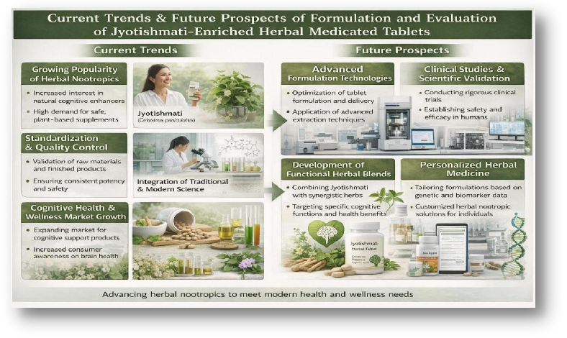Fig. 12. Current Trends & Future Prospects of Formulation and Evaluation of Jyotishmati-Enriched Herbal Medicated Tablets.

BIBLIOGRAPHY
Vikrant Ashok Shirke, Ved Sutare, and Kanifnath Sonawane are currently pursuing their final year of the Bachelor of Pharmacy (B. Pharm) program at Genba Sopanrao Moze College of Pharmacy, Wagholi, Pune. As a part of their academic curriculum, they are collaboratively working on a research project titled “Formulation and Evaluation of Jyotishmati-Enriched Herbal Medicated Tablets for Memory Enhancement.”
Their project highlights their main interest in the field of herbal and Ayurvedic formulations. By focusing on Jyotishmati, a well-known traditional herb for cognitive support, they are attempting to bridge classical medicinal knowledge with modern pharmaceutical formulation techniques. Throughout this work, they are gaining hands-on experience in tablet formulation, quality evaluation, and the scientific validation of herbal medicines.
The team is enthusiastic about exploring innovative and natural approaches to healthcare, particularly in enhancing memory and brain function. Their academic efforts reflect a commitment to learning, research, and contributing to the development of safe and effective herbal therapeutic options.

]

REFERENCES

- Kulkarni YA, Agarwal S, Garud MS. Celastrus paniculatus Willd.: A review on its ethnobotany, pharmacology and phytochemistry. Pharmacognosy Rev. 2015;9(18):132–138.
- Nadkarni KM. Indian Materia Medica. 3rd ed. Mumbai: Popular Prakashan; 2007. P. 300–305.
- Mukherjee PK, Kumar V, Mal M, Houghton PJ. Acetylcholinesterase inhibitors from plants. Phytomedicine. 2007;14(4):289–300.
- Sharma PV. Dravyaguna Vijnana (Materia Medica – Vegetable Drugs). Varanasi: Chaukhambha Bharati Academy; 2006. P. 450–455.
- Patel SS, Udayabanu M, Manchanda RK, Pillai KK. Neuroprotective effects of Celastrus paniculatus against cognitive impairment: An experimental study. J Ethnopharmacol. 2012;144(2):398–405.
- Kulkarni YA, Garud MS. Pharmacological evaluation of Celastrus paniculatus as a nootropic agent. Int J Pharm Sci Res. 2013;4(5):1761–1768.
- Mukherjee PK. Quality control and evaluation of herbal drugs: Evaluating natural products and traditional medicine. Amsterdam: Elsevier; 2019. P. 45–78.
- World Health Organization. Quality control methods for herbal materials. Geneva: WHO Press; 2011. P. 1–46.
- World Health Organization. WHO traditional medicine strategy 2014–2023. Geneva: WHO Press; 2013. P. 1–76.
- Aguiar S, Borowski T. Neuropharmacological review of Bacopa monnieri. Rejuvenation Res. 2013;16(4):313–326.
- Nahata A, Patil UK, Dixit VK. Effect of Convolvulus pluricaulis on memory enhancement. Pharm Biol. 2008;46(10-11):729–735.
- Kulkarni SK, Dhir A. Withania somnifera: An Indian ginseng. Prog Neuropsychopharmacol Biol Psychiatry. 2008;32(5):1093–1105.
- Russo A, Borrelli F. Bacopa monniera: A reputed nootropic plant. Phytomedicine. 2005;12(4):305–317.
- Dhingra D, Parle M. Memory enhancing activity of Convolvulus pluricaulis in rodents. J Ethnopharmacol. 2004;91(2-3):361–365.
- Chandrasekhar K, Kapoor J, Anishetty S. A prospective study on safety and efficacy of Ashwagandha in stress and anxiety. Indian J Psychol Med. 2012;34(3):255–262.
- Saha S, Ghosh S. Tinospora cordifolia: One plant, many roles in immunomodulation and neuroprotection. J Ethnopharmacol. 2012;141(3):918–926.
- Khandelwal KR. Practical Pharmacognosy: Techniques and Experiments. 23rd ed. Pune: Nirali Prakashan; 2015. P. 149–172.
- Aulton ME, Taylor KMG. Aulton’s Pharmaceutics: The Design and Manufacture of Medicines. 5th ed. London: Elsevier; 2018. P. 441–468.
- Evans WC. Trease and Evans Pharmacognosy. 16th ed. London: Saunders Elsevier; 2009. P. 15–40.
- Kokate CK, Purohit AP, Gokhale SB. Pharmacognosy. 56th ed. Pune: Nirali Prakashan; 2019.
- Indian Pharmacopoeia Commission. Indian Pharmacopoeia. Vol I–III. Ghaziabad: IPC; 2018.
- United States Pharmacopeial Convention. USP 43–NF 38. Rockville: USP Convention; 2020.
- Lachman L, Lieberman HA, Kanig JL. The Theory and Practice of Industrial Pharmacy. 3rd ed. Mumbai: Varghese Publishing House; 2009.
- Tripathi KD. Essentials of Medical Pharmacology. 8th ed. New Delhi: Jaypee Brothers; 2019.
- Sharma PV. Dravyaguna Vijnana. Vol II. Varanasi: Chaukhambha Bharati Academy; 2013.
- Singh RH. Exploring Larger Evidence-base for Contemporary Ayurveda. New Delhi: CCRAS; 2010.
- Mukherjee PK. Quality Control of Herbal Drugs. 2nd ed. New Delhi: Business Horizons; 2019.
- Satoskar RS, Bhandarkar SD, Rege NN. Pharmacology and Pharmacotherapeutics. 25th ed. Mumbai: Popular Prakashan; 2017.
- Kulkarni SK. Handbook of Experimental Pharmacology. 4th ed. New Delhi: Vallabh Prakashan; 2012.
- OECD. Guidelines for the Testing of Chemicals. Paris: Organisation for Economic Co-operation and Development; 2008.
- Lieberman HA, Lachman L, Schwartz JB. Pharmaceutical Dosage Forms: Tablets. Vol. 1. 2nd ed. New York: Marcel Dekker; 1989.
- Carr RL. Evaluating flow properties of solids. Chem Eng. 1965;72:163–168.
- Hausner HH. Friction conditions in a mass of metal powder. Int J Powder Metall. 1967;3(4):7–13.
- Wells J. Pharmaceutical preformulation. In: Aulton ME, editor. Pharmaceutics. London: Churchill Livingstone; 2013. P. 355–382.
- Harborne JB. Phytochemical Methods: A Guide to Modern Techniques of Plant Analysis. 3rd ed. London: Chapman & Hall; 1998.
- Skoog DA, Holler FJ, Crouch SR. Principles of Instrumental Analysis. 6th ed. USA: Cengage Learning; 2007.
- HPLC 28. Snyder LR, Kirkland JJ, Dolan JW. Introduction to Modern Liquid Chromatography. 3rd ed. USA: Wiley; 2010.
- Chatwal GR, Anand SK. Instrumental Methods of Chemical Analysis. Mumbai: Himalaya Publishing; 2007.
- ICH Harmonised Guideline. Stability Testing of New Drug Substances and Products Q1A(R2). Geneva: ICH; 2003.
- WHO. Stability testing of active pharmaceutical ingredients and finished products. Geneva: WHO; 2009.
- AChE Inhibition Assay 32. Ellman GL, Courtney KD, Andres V Jr, Featherstone RM. A new rapid colorimetric determination of acetylcholinesterase activity. Biochem Pharmacol. 1961;7(2):88–95.
- DPPH Antioxidant Assay 33. Blois MS. Antioxidant determinations by the use of a stable free radical. Nature. 1958;181:1199–1200.

- Howes MJ, Perry NS, Houghton PJ. Plants with traditional uses and activities relevant to the management of Alzheimer’s disease. Phytother Res. 2003;17(1):1–18.
- Sahoo N, Manchikanti P, Dey S. Herbal drugs: standards and regulation. Fitoterapia. 2010;81(6):462–471.
- Kamboj VP. Herbal medicine. Curr Sci. 2000;78(1):35–39.
- Vyas SP, Khar RK. Controlled Drug Delivery: Concepts and Advances. New Delhi: Vallabh Prakashan; 2012.
- Bent S. Herbal medicine in the United States: review of efficacy, safety, and regulation. J Gen Intern Med. 2008;23(6):854–859.
- Ahmad A, Husain A, Mujeeb M, Khan SA, Najmi AK, Siddique NA, et al. A review on therapeutic potential of medicinal plants. J Pharm Res. 2013;6(3):354–364.
- Goyal M, Sasmal D, Nagori BP. Review on herbal drug standardization. Int J Pharm Sci Rev Res. 2011;6(2):62–67.
- Bonifácio BV, da Silva PB, dos Santos Ramos MA, Negri KM, Bauab TM, Chorilli M. Nanotechnology-based drug delivery systems and herbal medicines. Int J Nanomedicine. 2014;9:1–15.
- Kumar S, Pandey AK. Chemistry and biological activities of flavonoids: an overview. ScientificWorldJournal. 2013;2013:162750.
- Arya A, Kaushik D, Almeer R, et al. Application of green technologies in design-based extraction of Celastrus paniculatus seeds and evaluation for memory enhancing potential. Front Nutr. 2022;9:871183.
- Debnath M, Biswas M, Shukla VJ, Nishteswar K. Phytochemical and analytical evaluation of Celastrus paniculatus leaf extracts. AYU. 2014;35(1):54–57.
- Raut SB, Parekar RR, Jadhav KS, et al. Effect of Celastrus paniculatus seed oil on spatial and fear memory using scopolamine-induced amnesia in mice. J Pharmacol Ther. 2015.
- Valecha R, Dhingra D. Behavioral and biochemical evidences for antidepressant-like activity of Celastrus paniculatus seed oil in mice. Basic Clin Neurosci. 2016;7(1):49–56.
- Kulkarni YA, Agarwal S, Garud MS. Effect of Celastrus paniculatus seeds in animal models of pain and inflammation. J Ayurveda Integr Med. 2015;6(2):82–88.
- Bhagya V. Neuropharmacological and cognitive effects of Celastrus paniculatus: A comprehensive review. Int J Pharm Sci Rev Res. 2020;65(1):92–97.
- Celastrus paniculatus in naturally occurring chemicals against Alzheimer’s disease. In: Bioactive Natural Products for Neurological Disorders. Elsevier; 2021.
- Arya A, et al. Microwave and ultrasound-assisted extraction optimization of Celastrus paniculatus and evaluation of cognitive activity. Pharmacological Research Studies. 2022.

ABBREVIATION

Sr. No. | Abbreviation | Full Form
1. | API | Active Pharmaceutical Ingredient
2. | ANOVA | Analysis of Variance
3. | BCS | Biopharmaceutics Classification System
4. | CNS | Central Nervous System
5. | CMC | Carboxymethyl Cellulose
6. | DLS | Dynamic Light Scattering
7. | DPPH | Diphenylpicrylhydrazyl
8. | DSC | Differential Scanning Calorimetry
9. | DT | Disintegration Time
10. | FTIR | Fourier Transform Infrared Spectroscopy
11. | GMP | Good Manufacturing Practices
12. | HPLC | High Performance Liquid Chromatography
13. | ICH | International Council for Harmonisation
14. | IP | Indian Pharmacopoeia
15. | IR | Infrared Radiation
16. | LOD | Loss on Drying
17. | NLT | Not Less Than
18. | NMT | Not More Than
Sr. No. | Abbreviation | Full Form
19. | NMR | Nuclear Magnetic Resonance
20. | PK | Pharmacokinetics
21. | QC | Quality Control
22. | QbD | Quality by Design
23. | RSD | Relative Standard Deviation
24. | RH | Relative Humidity
25. | SEM | Scanning Electron Microscopy
26. | SOP | Standard Operating Procedure
27. | SD | Standard Deviation
28. | TLC | Thin Layer Chromatography
29. | UV | Ultraviolet
30. | USP | United States Pharmacopeia
31. | WHO | World Health Organization
32. | XRD | X-Ray Diffraction
33. | ZP | Zeta Potential

