LAND-USE/LAND-COVER CHANGE, RAINFALL ANOMALY AND VEGETATION RESPONSE IN NORTHERN JIGAWA STATE, NIGERIA: IMPLICATIONS FOR CLIMATE VARIABILITY AND SUSTAINABLE BUILT-ENVIRONMENT PLANNING

ABSTRACT
Land-use and land-cover change (LULCC) in semi-arid environments is an important pathway through which human activities modify vegetation condition, surface moisture, local temperature, rainfall response and environmental sustainability. This article, derived from a doctoral thesis on Northern Jigawa State, Nigeria, examines the relationship between land-cover change patterns and climate variability indicators, with particular attention to Normalized Difference Vegetation Index (NDVI), rainfall, temperature and drought frequency. The study used multi-temporal satellite-derived vegetation evidence, rainfall and temperature records, rainfall-temperature regression outputs and socio-economic land-use indicators for selected reference years between 1986 and 2022. Results show that population increased from 2.1 million in 1986 to 5.4 million in 2022, while agricultural land use expanded from 5,200 km2 to 7,850 km2 and infrastructure projects increased from 12 to 67 over the same period. These pressures coincided with a decline in mean NDVI from 0.34 in 1986 to 0.25 in 2015, before a modest recovery to 0.29 in 2022. Rainfall declined from 720 mm in 1986 to 610 mm in 2015, followed by partial recovery to 650 mm in 2022, while average temperature rose from 28.1 deg C to 29.6 deg C in 2015 and stood at 29.1 deg C in 2022. Correlation results indicate strong negative relationships between NDVI and population (r = -0.91), agricultural land use (r = -0.88) and infrastructure projects (r = -0.85), while NDVI remained positively associated with rainfall (r = 0.70) and negatively associated with temperature (r = -0.79). Annual rainfall-temperature regression produced a moderately strong inverse relationship (R2 = 0.5475). The article concludes that vegetation decline, agricultural expansion and infrastructure growth are closely linked to climate-sensitive land-surface stress in Northern Jigawa State. It recommends NDVI- and rainfall-anomaly-informed land-use zoning, afforestation, green infrastructure, permeable surface protection and climate-sensitive built-environment planning.

Keywords: land-use/land-cover change; NDVI; rainfall anomaly; temperature variability; sustainable built environment; climate resilience

1. Introduction
Land use and land cover change (LULCC) constitutes one of the most visible and measurable indicators of human pressure on environmental systems. It reflects the ways in which natural and semi-natural landscapes are transformed into new land-use states through human activities such as agricultural expansion, settlement growth, road construction, irrigation, fuelwood extraction, grazing, sand mining, infrastructure development and other land-management practices. These changes may involve the conversion of natural vegetation, grasslands, wetlands, croplands, bare surfaces and settlement areas from one category to another. Although land conversion is an unavoidable part of socio-economic development, its environmental importance becomes more pronounced when it reduces vegetation cover, exposes soil surfaces, modifies surface roughness, alters infiltration and runoff pathways, and changes the exchange of energy and moisture between the land surface and the atmosphere. These processes are especially critical in semi-arid regions, where rainfall is naturally variable, vegetation productivity is seasonal, soil moisture is fragile, and the ecological system is highly sensitive to drought and temperature stress (Bonan, 2008; Mahmood et al., 2014; Pielke et al., 2011).
The relationship between LULCC and climate variability is mediated through several biophysical processes. Vegetation cover plays a regulatory role by shading the land surface, reducing land surface temperature, supporting evapotranspiration, enhancing soil moisture retention, promoting infiltration and reducing erosive runoff. Vegetation also contributes to atmospheric moisture recycling and helps maintain ecological stability in dryland environments. When vegetation is cleared or degraded and replaced by bare soil, compacted surfaces, roads, buildings or intensively cultivated land, the land surface becomes warmer, drier and less capable of moderating climatic stress. Such transformations can affect rainfall response, drought exposure, wind erosion, flood generation, thermal comfort and the overall resilience of settlements. In dryland and semi-arid landscapes, even relatively small reductions in vegetation cover can generate significant environmental consequences because the threshold between ecological stability and degradation is often narrow (Seneviratne et al., 2010; Tucker, 1979).
Northern Jigawa State provides a particularly relevant setting for examining these interactions because it lies within the Sudan–Sahel ecological transition zone of northern Nigeria, where climatic variability and land-use pressure are strongly interconnected. The study area comprises Gumel, Garki, Gagarawa, Sule Tankarkar and Maigatari Local Government Areas, representing a semi-arid land system characterized by seasonal rainfall, high temperature, sandy-to-loamy soils, agricultural dependence, grazing activities, settlement growth and expanding infrastructure. The area falls broadly within latitudes 11°N–13°N and longitudes 8°E–10°E, with rainfall concentrated mainly between July and September and temperatures commonly ranging between about 26°C and 42°C. The wider landscape is dominated by agriculture, bare surfaces, sparse savanna vegetation and expanding built-up areas, while population growth and land-based livelihoods continue to intensify pressure on the natural resource base. The attached article describes the study area as a semi-arid environment where agriculture, pastoralism and petty trade are dominant, and where vulnerability is increased by low adaptive capacity, exposure to climatic extremes and weak land governance.
The thesis from which this article is derived identifies LULCC, rainfall anomalies, temperature trends and vegetation response as central components of environmental sustainability in Northern Jigawa State. Its aim is to assess the influence and interaction of land-cover change dynamics and regional climate variability on environmental sustainability outcomes, while one of its specific objectives is to determine the relationships between land-use and land-cover change patterns and climate variability indicators, particularly rainfall anomalies and vegetation responses. This objective provides a strong empirical foundation for a focused journal article because it links measurable land-surface change with climatic behaviour and planning implications. The thesis also emphasizes that sustainable built-environment analysis should be grounded in measurable environmental indicators such as NDVI, rainfall anomaly indices, temperature trends and socio-economic information, rather than treating buildings and infrastructure as isolated physical assets.
Empirical evidence from the thesis demonstrates that vegetation dynamics in Northern Jigawa State have changed considerably over the study period. The analysis of Normalized Difference Vegetation Index (NDVI) shows a decline in mean NDVI from approximately 0.34 in 1986 to 0.25 in 2015, indicating a reduction in vegetation vigour, density and ecological buffering capacity. A modest recovery to about 0.29 was recorded in 2022, suggesting some improvement in vegetation condition, possibly associated with selective afforestation, irrigation and environmental restoration interventions. However, this recovery does not fully offset the long-term decline in vegetation cover. Since NDVI is a widely used remote-sensing indicator of vegetation health and photosynthetic activity, the observed decline points to increasing vegetation stress and potential degradation of land-surface functions (Tucker, 1979). In practical terms, declining NDVI implies reduced shading, weaker soil protection, lower evapotranspiration, greater surface exposure and reduced ecological support for climate-sensitive settlements.
The climatic evidence also points to an increasingly stressed regional environment. The thesis reports that rainfall displayed a declining or highly variable pattern, while temperature showed a generally increasing trend. It further indicates that the relationship between rainfall and temperature varied seasonally, with weak inverse relationships in some months and stronger negative relationships during the peak wet season months. The overall rainfall–temperature model produced an R² value of approximately 0.5475, suggesting that about 54.75% of rainfall variability may be statistically associated with temperature and land-surface dynamics, while the remaining variation may be explained by broader atmospheric processes. This finding is important because it supports the argument that land-cover conditions, vegetation response and climate variability are not separate environmental concerns but interlinked processes that shape regional sustainability outcomes.
The implications for sustainable built-environment planning are significant. Built-environment sustainability is often discussed in relation to building materials, architectural design, energy efficiency and infrastructure quality. However, in semi-arid environments such as Northern Jigawa State, the sustainability of buildings and settlements also depends on the ecological condition of the surrounding land system. A settlement located within a degraded landscape with declining vegetation, exposed soil, poor drainage and rising temperature is likely to experience higher heat stress, increased runoff, lower groundwater recharge, more erosion and greater infrastructure vulnerability. The thesis recognizes this connection by linking land-cover change trajectories with indicators such as green infrastructure footprint, energy-efficiency characteristics and permeable surface distribution. It further notes that built-up expansion has implications for permeable surface share, meaning that development can increase physical infrastructure while simultaneously reducing the land’s capacity to absorb rainfall and provide ecosystem services.
This integrated perspective is important because previous research often treats LULCC, climate variability and built-environment performance as separate fields of analysis. Remote-sensing studies may identify vegetation decline, while climate studies may assess rainfall or temperature trends, and built-environment studies may focus on infrastructure design without linking these issues. Such separation limits the usefulness of environmental research for planning and policy. In reality, settlement resilience depends on the interaction among land cover, climate behaviour and infrastructure performance. The thesis explicitly addresses this gap by examining land-cover change dynamics, regional climate variability and built-environment sustainability within a unified analytical framework. It argues that previous studies remain too technically focused and disconnected from project-level decision-making, especially in fragile semi-arid contexts such as Northern Jigawa State.
The earlier article draft framed the study largely around windstorm occurrence and intensity. While windstorm risk may be a relevant environmental hazard associated with vegetation loss, bare-surface expansion, soil exposure and changing atmospheric conditions, the available thesis evidence more strongly supports a journal article centred on the relationship between LULCC, NDVI, rainfall anomaly, temperature variability and sustainable built-environment outcomes. Windstorm should therefore be treated as a possible planning or disaster-risk implication rather than the principal dependent variable, unless detailed windstorm event records, measured wind speeds, damage inventories and spatial storm-risk data are added. This adjustment strengthens the academic defensibility of the article because the thesis provides direct empirical evidence for vegetation-climate-land use relationships, while the windstorm-specific claims require additional event-based validation.
The central argument of the revised article is that land-cover change is not merely a background environmental process; it is a planning variable that influences regional climate exposure, settlement resilience and long-term environmental sustainability. In semi-arid Northern Jigawa State, declining vegetation and expanding agricultural, settlement and infrastructural land uses can increase heat stress, reduce infiltration, accelerate runoff, expose soils, weaken ecological services and heighten the vulnerability of buildings and communities. Conversely, vegetation restoration, green infrastructure, shelterbelts, permeable surfaces, climate-sensitive land-use zoning and continuous environmental monitoring can strengthen resilience. The article is therefore guided by the thesis objective of analysing the relationship between land-use/land-cover change patterns and climate variability indicators, particularly rainfall anomalies and vegetation responses. Its purpose is to interpret how these relationships affect sustainable built-environment planning in Northern Jigawa State and to provide evidence for climate-responsive land management, infrastructure planning and environmental sustainability policy.

2. MATERIALS AND METHODS

2.1 Study Area
The study was conducted in Northern Jigawa State, Nigeria, covering the five LGAs of Gumel, Garki, Gagarawa, Sule Tankarkar and Maigatari. The area lies broadly within latitudes 11 deg N to 13 deg N and longitudes 8 deg E to 10 deg E. It is bordered within the wider regional context by Kano State to the southwest, Yobe State to the northeast and the Republic of Niger to the north. The selected LGAs are located within a semi-arid Sudan-Sahel environment with rainfall concentrated mainly between June and September. Annual rainfall is variable, while temperatures are generally high, especially before and during the early wet season.
The area is dominated by agriculture, pastoralism, petty trade and land-based livelihood systems. Common crops include millet, sorghum, cowpea and groundnut. The dominance of agriculture and the expansion of settlements and infrastructure make the region suitable for studying the interaction between LULCC, vegetation response and climate variability. The soils are generally susceptible to erosion and moisture stress, while vegetation cover is seasonally variable and vulnerable to fuelwood extraction, land clearing, overgrazing and drought.

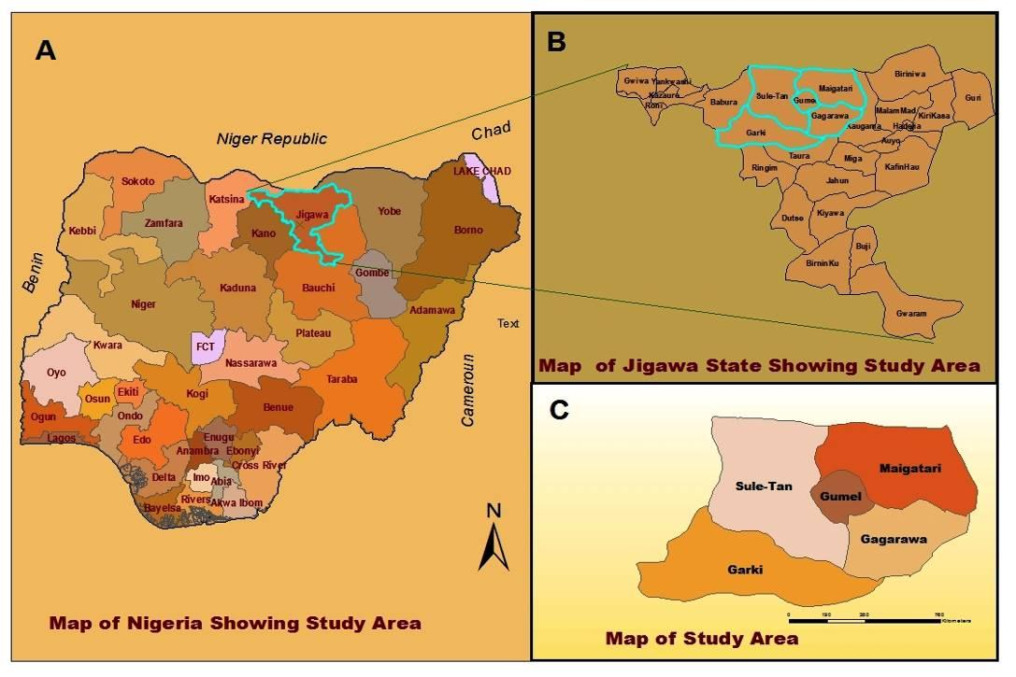

Figure 1: Map of Nigeria insert map of Jigawa state and the study area

2.2 Research Design and Data Sources
The article adopts a thesis-derived quantitative and interpretive design. It combines satellite-based vegetation indicators, climate variables and socio-economic land-use indicators to explain how land-cover change is linked with rainfall and temperature variability. The analysis is based on selected reference years between 1986 and 2022. This period is long enough to capture major land-use pressure, vegetation decline, partial vegetation recovery and climatic variation in Northern Jigawa State.
The method was organized around four analytical components: (i) socio-economic land-use pressure analysis; (ii) NDVI-based vegetation change analysis; (iii) rainfall, temperature and drought-frequency analysis; and (iv) interpretation of implications for sustainable built-environment planning. The original windstorm-centred methods in the draft article were reduced because they require additional event-based storm data that are not central to the thesis objective used for this article.
To clarify the analytical direction of the study, Figure 1 presents the conceptual linkage among socio-economic drivers, land-use/land-cover change, biophysical processes, climate variability indicators and sustainable built-environment outcomes. The framework shows that land conversion influences environmental sustainability through changes in vegetation cover, surface roughness, albedo, evapotranspiration, infiltration, runoff and soil moisture. The study adopted an integrated methodological approach involving satellite image acquisition, image preprocessing and classification, NDVI computation, rainfall anomaly analysis, temperature trend analysis and statistical interpretation. The methodological sequence used for the analysis is presented in Figure 2.

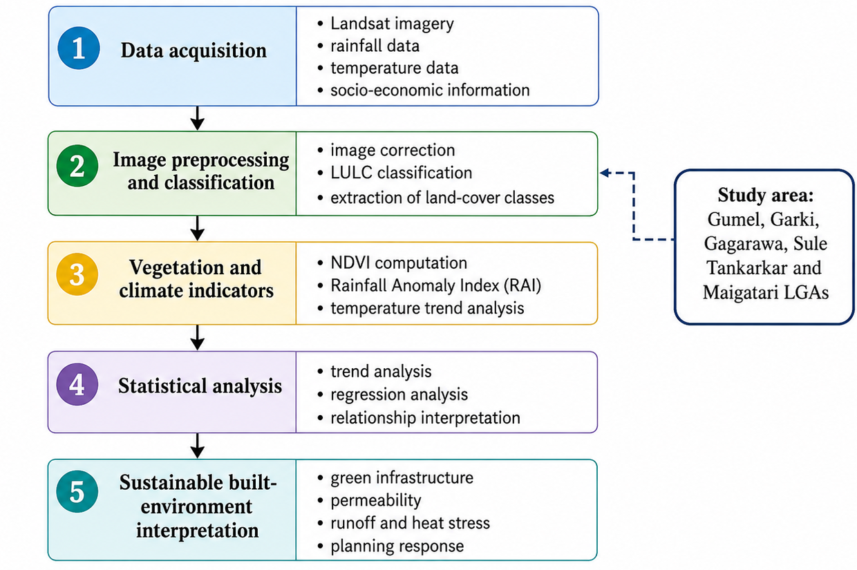
Figure 2: Methodological framework for analysing LULCC, NDVI, rainfall anomaly, temperature variability and sustainable built-environment planning implications.
Figure 2 shows that the study combines remote-sensing analysis with climate and socio-economic interpretation. This approach makes it possible to examine land-cover change not only as a spatial phenomenon but also as a driver of vegetation response, climate variability and sustainable built-environment planning.

Table 1. Data sources, indicators and analytical purpose.
Data/indicator | Variables | Reference period | Purpose in article
Socio-economic drivers | Population, agricultural land use, infrastructure projects, livelihood dependence | 1986-2022 | To assess land-use pressure
Vegetation condition | Mean NDVI and vegetation dynamics | 1986-2022 | To measure vegetation response
Climate variability | Annual rainfall, average temperature, drought frequency | 1986-2022 | To evaluate hydroclimatic stress
Rainfall-temperature regression | Monthly and annual regression slope and R2 | Monthly/annual outputs in thesis | To assess rainfall-temperature linkage
Built-environment implication | Green infrastructure, thermal comfort, runoff, drainage, permeability and planning response | Interpretive synthesis | To translate results into planning recommendations

2.3 NDVI, Climate and Statistical Analysis
Vegetation condition was assessed using mean NDVI values. NDVI is a widely used remote-sensing index for estimating vegetation greenness and photosynthetic activity. It is computed from the near-infrared and red bands of satellite imagery as NDVI = (NIR - Red) / (NIR + Red). Higher positive NDVI values indicate healthier or denser vegetation, while lower values indicate sparse vegetation, exposed surfaces, stressed vegetation or degraded land (Tucker, 1979).
Climate variability was examined using annual rainfall, average temperature and drought frequency. The rainfall-temperature relationship was summarized using monthly and annual regression outputs from the thesis. The annual model produced an inverse relationship between temperature and rainfall, indicating that higher average temperatures were associated with lower annual rainfall in the study period. Socio-economic drivers and environmental indicators were interpreted using descriptive trend analysis and Pearson correlation coefficients reported in the thesis.

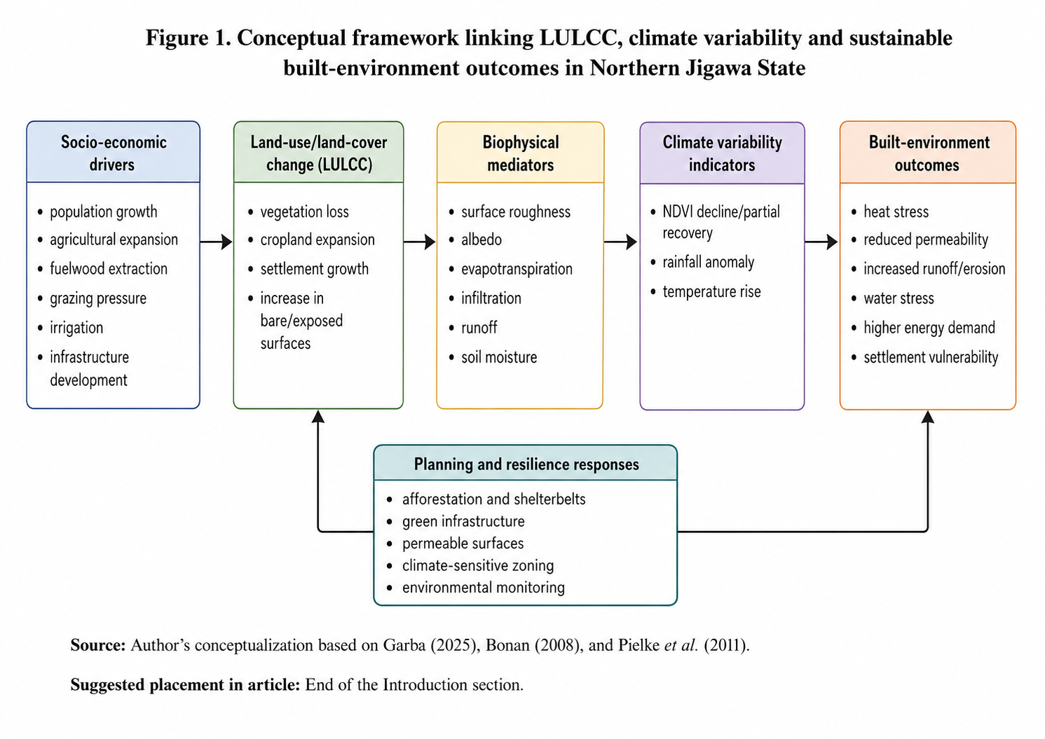
Author’s conceptualization based on Bonan (2008), and Pielke et al. (2011).
Figure 3. Conceptual framework linking socio-economic drivers, LULCC, climate indicators and sustainable built-environment outcomes.

3. RESULTS

3.1 Socio-Economic Land-Use Pressure
The socio-economic data indicate increasing pressure on land resources between 1986 and 2022. Population increased from 2.1 million in 1986 to 5.4 million in 2022, representing an approximate increase of 157.1%. Agricultural land use expanded from 5,200 km2 to 7,850 km2, an increase of about 51.0%. Infrastructure projects increased from 12 to 67, representing an increase of about 458.3%. Livelihood dependence on land also increased from 78% to 88%.
These trends show that population growth, agricultural expansion and infrastructure development are important land-use pressures in Northern Jigawa State. In a semi-arid environment, these pressures may intensify vegetation clearance, reduce ecological buffering, increase bare/exposed surfaces and heighten vulnerability to climate variability. The issue is not development itself, but the manner in which development proceeds without adequate ecological safeguards, green infrastructure and land-use control.

Table 2. Socio-economic drivers of land-use pressure in Northern Jigawa State, 1986-2022.
Year | Population (millions) | Agricultural land use (km2) | Infrastructure projects | Livelihood dependence on land (%)
1986 | 2.1 | 5,200 | 12 | 78.0
1995 | 2.9 | 5,850 | 24 | 81.0
2005 | 3.7 | 6,500 | 37 | 84.0
2015 | 4.6 | 7,100 | 52 | 86.0
2022 | 5.4 | 7,850 | 67 | 88.0
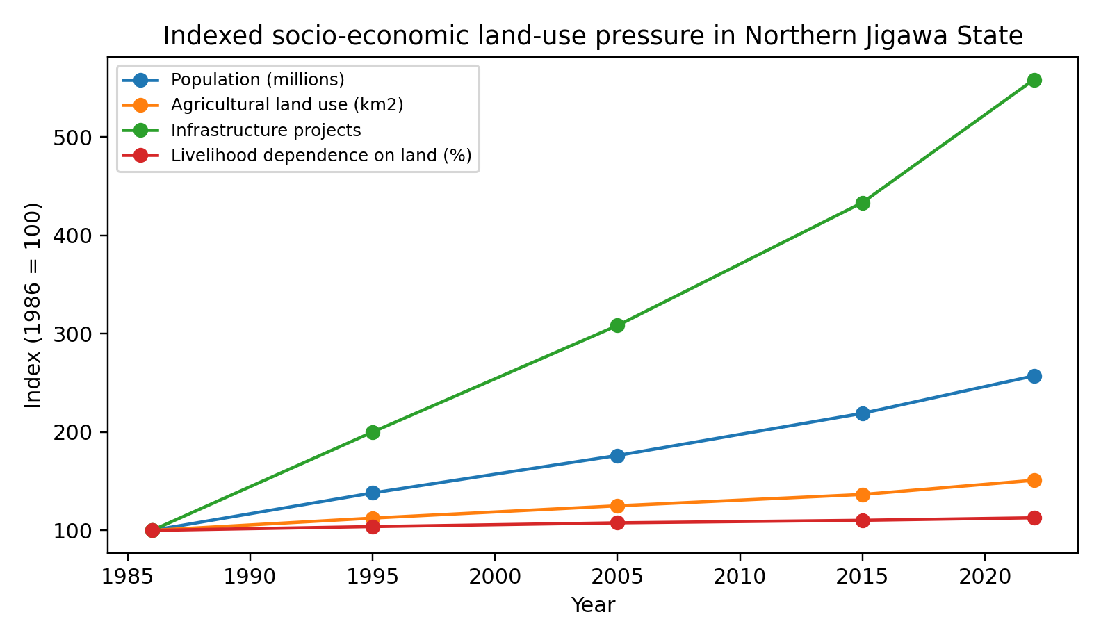
Figure 4. Indexed socio-economic land-use pressure in Northern Jigawa State, 1986-2022.

3.2 Vegetation and Climate Indicators
Mean NDVI declined from 0.34 in 1986 to 0.25 in 2015, representing a decline of approximately 26.5% over the period of greatest vegetation stress. By 2022, mean NDVI improved to 0.29, suggesting partial recovery, but the 2022 value remained about 14.7% below the 1986 level. This indicates that vegetation restoration or improved land management may have had some positive effect, but not enough to fully restore the earlier vegetation condition. The Normalized Difference Vegetation Index was used to assess vegetation response over time. Figure 3 presents the mean NDVI trend for selected years and provides evidence of vegetation decline and partial recovery within the study area.

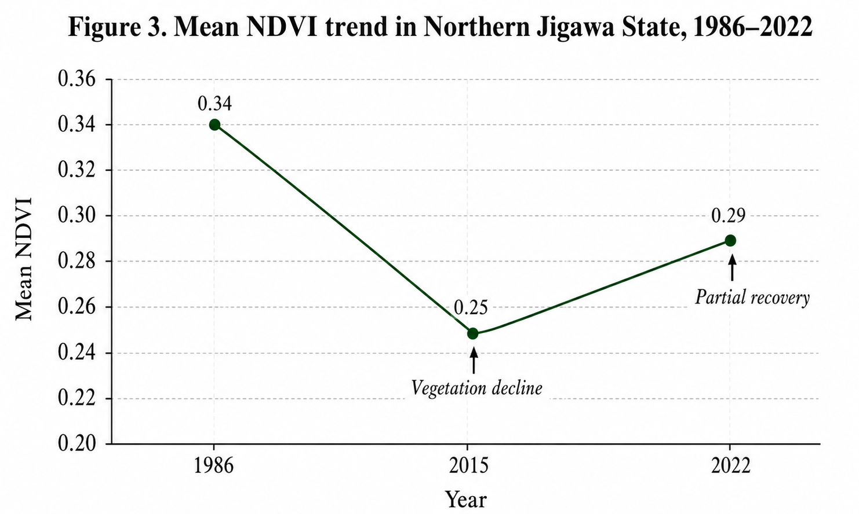
Figure 3 shows that mean NDVI declined from 0.34 in 1986 to 0.25 in 2015, indicating a reduction in vegetation vigour and increased land-surface exposure. The partial recovery to 0.29 in 2022 suggests some improvement in vegetation condition, possibly associated with afforestation, irrigation and restoration interventions. However, the recovery remains below the 1986 level, indicating that vegetation stress remains a major environmental concern.
Rainfall decreased from 720 mm in 1986 to 610 mm in 2015, a decline of approximately 15.3%, before increasing to 650 mm in 2022. Average temperature increased from 28.1 deg C in 1986 to 29.6 deg C in 2015, a rise of 1.5 deg C, before declining slightly to 29.1 deg C in 2022. Drought frequency increased from one event per decade in 1986 to four events per decade in 2015, before decreasing to three events per decade in 2022. Together, these results suggest a land-climate system under stress, with 2015 representing the most degraded reference year among the data points. The major land-cover conditions identified in the study area are visually represented in Plate 1. The plate illustrates typical landscape features associated with rainfed cultivation, exposed bare surfaces, sparse savanna vegetation and settlement expansion, which are central to understanding land-cover transformation in Northern Jigawa State.

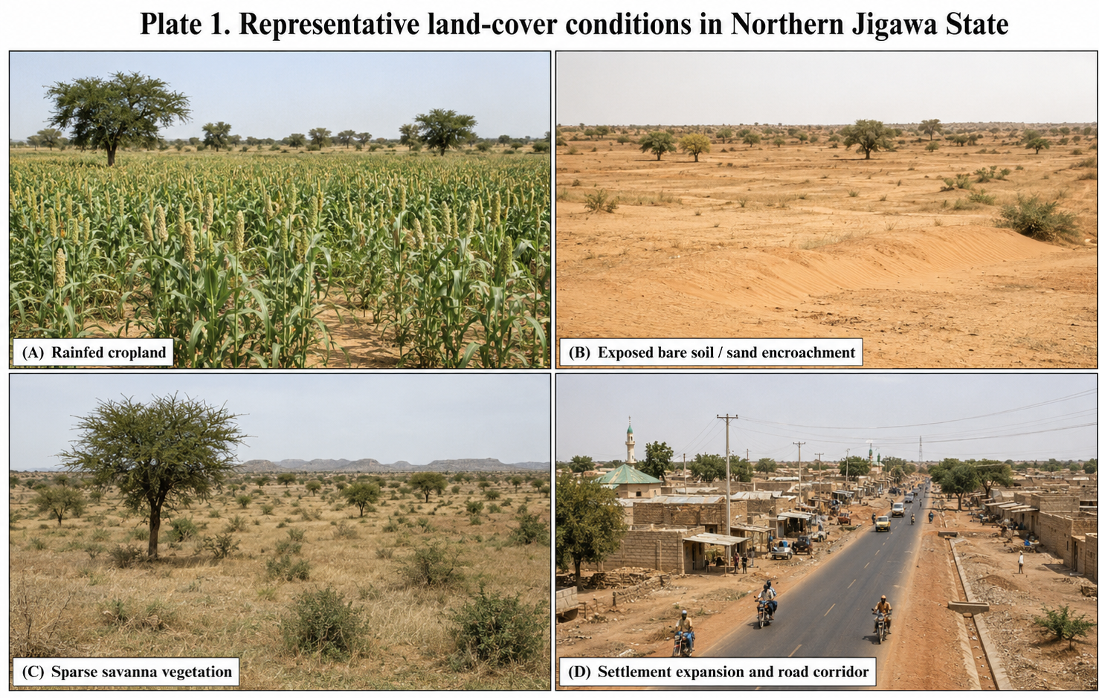
Plate 1 supports the satellite-based interpretation by showing the physical expressions of land-cover change in the study area. The presence of cultivated land, exposed soil, sparse vegetation and expanding road-settlement corridors indicates the interaction of agriculture, settlement growth, infrastructure development and environmental stress within the semi-arid landscape

Table 3. Vegetation and climate indicators in Northern Jigawa State, 1986-2022.
Year | Mean NDVI | Annual rainfall (mm) | Average temperature (deg C) | Drought frequency (events/decade)
1986 | 0.34 | 720 | 28.1 | 1
1995 | 0.31 | 680 | 28.6 | 2
2005 | 0.27 | 640 | 29.2 | 3
2015 | 0.25 | 610 | 29.6 | 4
2022 | 0.29 | 650 | 29.1 | 3
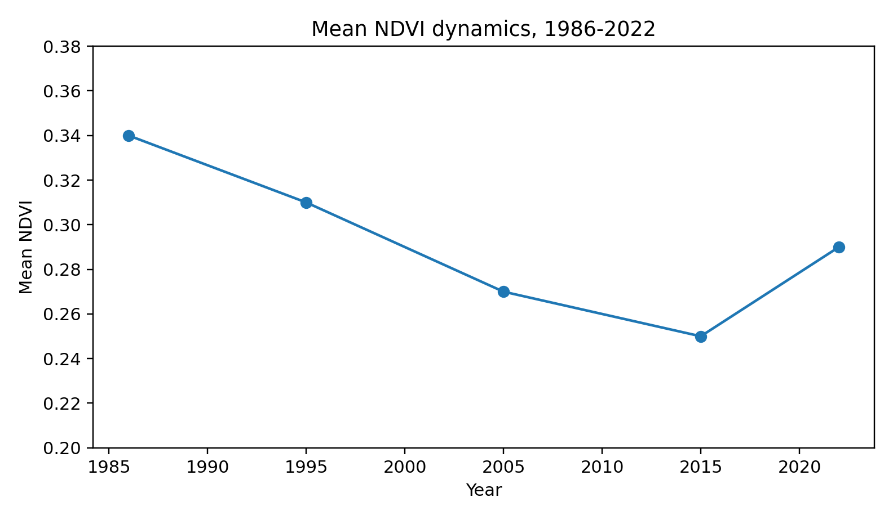
Figure 4. Mean NDVI dynamics in Northern Jigawa State, 1986-2022.

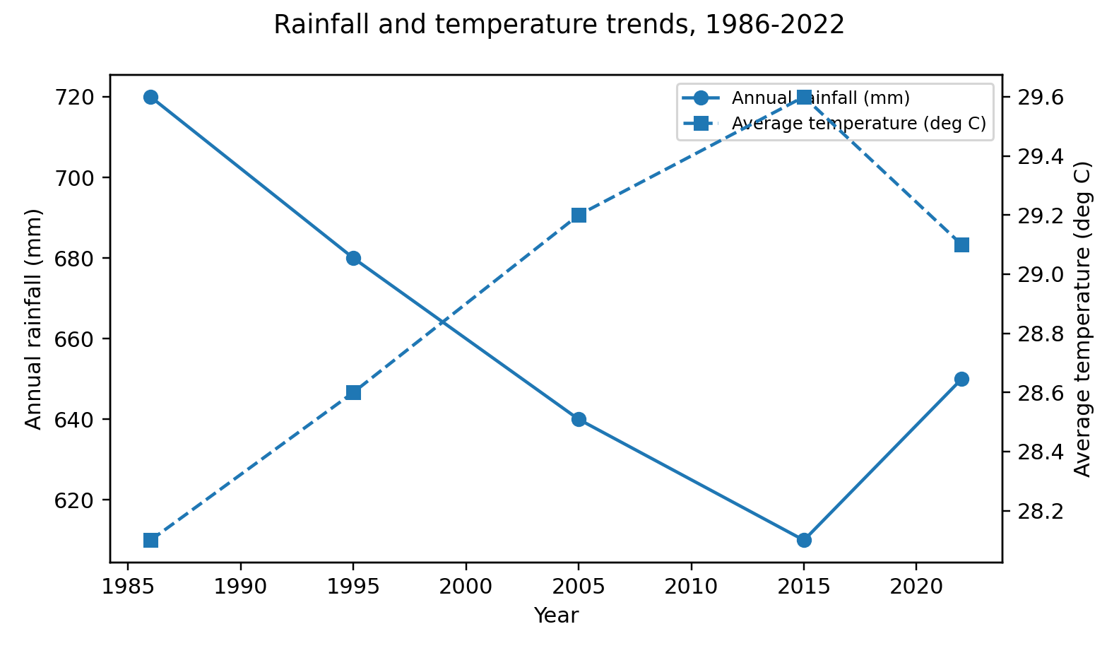
Figure 5. Annual rainfall and average temperature trends in Northern Jigawa State, 1986-2022.

3.3 Rainfall-Temperature Regression Pattern
The rainfall-temperature regression outputs show seasonal differences in the strength and direction of the relationship. Early dry-season and transitional months such as January, March and April show weak or negligible relationships, suggesting that temperature alone does not explain rainfall behaviour in these months. May shows a moderate inverse relationship, while June records a moderate positive relationship. The peak wet-season months of July, August and September show stronger inverse relationships, indicating that temperature increase during the wet season is associated with reduced rainfall response. To further explain the interaction between rainfall and temperature, Table 1 summarises the seasonal rainfall–temperature relationships identified in the thesis-derived analysis. The table highlights the direction of relationship across selected months and the annual model.

Table 4: Summary of Rainfall- Temperature Relationship in Northern Jigawa State
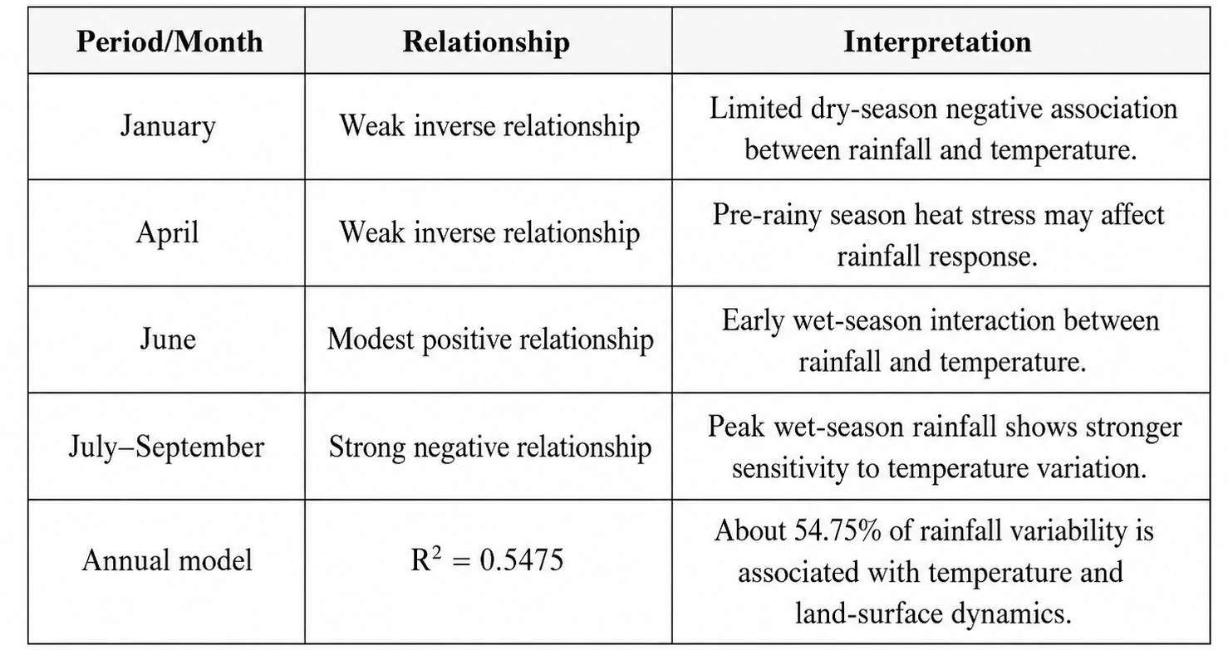
Table 1 indicates that rainfall–temperature relationships vary across seasons. Weak inverse relationships in January and April suggest limited dry-season and pre-rainy season interactions, while the strong negative relationship during July–September indicates that peak wet-season rainfall is more sensitive to temperature variation. The annual model, with R² = 0.5475, suggests that about 54.75% of rainfall variability is associated with temperature and land-surface dynamics, while the remaining variation may be influenced by wider atmospheric and regional climatic factors.
The annual regression model produced y = -201.42x - 3E-08 with R2 = 0.5475. This means that about 54.75% of the variation in annual rainfall is explained by temperature in the annual model. The negative slope indicates that an increase in average temperature is associated with a decrease in annual rainfall. This does not mean temperature is the only driver of rainfall variation; rather, it indicates that temperature is an important explanatory factor, while the remaining variation may be associated with atmospheric circulation, humidity, land-surface moisture, wind patterns and broader climate-system drivers.

Table 5. Summary of rainfall-temperature regression outputs.
Scale/month | Regression slope | R2 | Interpretation
January | -0.8989 | 0.1116 | Weak inverse relationship
March | 0.9408 | 0.0045 | Very weak positive relationship
April | -0.5613 | 0.0067 | Very weak inverse relationship
May | -12.6100 | 0.3697 | Moderate inverse relationship
June | 25.7850 | 0.4968 | Moderate positive wet-season relationship
July | -33.2620 | 0.4419 | Strong inverse wet-season relationship
August | -55.3580 | 0.5997 | Very strong inverse wet-season relationship
September | -35.7750 | 0.3761 | Strong inverse wet-season relationship
October | -2.7903 | 0.1276 | Weak inverse relationship
Annual | -201.4200 | 0.5475 | Moderately strong annual inverse relationship

3.4 Relationship between Land-Use Pressure, Vegetation and Climate Indicators
The correlation matrix indicates strong links between socio-economic land-use pressure and vegetation change. Population, agricultural land use and infrastructure projects all show strong negative correlations with NDVI, with r-values of -0.91, -0.88 and -0.85, respectively. This suggests that vegetation condition declined as demographic pressure, agricultural land use and infrastructure expansion increased. The relationship does not prove causation by itself, but it provides strong evidence of an association between human land-use pressure and vegetation degradation.
NDVI is positively associated with rainfall (r = 0.70), meaning that improved rainfall conditions tend to support vegetation greenness. NDVI is negatively associated with temperature (r = -0.79), showing that higher temperature is associated with reduced vegetation condition. These relationships are consistent with semi-arid ecological processes, where vegetation productivity depends strongly on rainfall and can be weakened by heat stress, moisture loss and drought frequency. The strong positive correlations between population, agricultural land use and infrastructure also suggest that land-use pressure is cumulative rather than isolated.

Table 6. Correlation matrix of socio-economic drivers, vegetation and climate indicators.
Variables | NDVI | Rainfall | Temperature | Agricultural land | Infrastructure
Population | -0.91 | 1 | 0.8 | 1 | 0.96
Agricultural land use | -0.88 | 1 | 0.8 | 1 | 0.93
Infrastructure projects | -0.85 | 1 | 0.8 | 1 | 1.00
NDVI (vegetation index) | 1.00 | 1 | -0.8 | -1 | -0.85
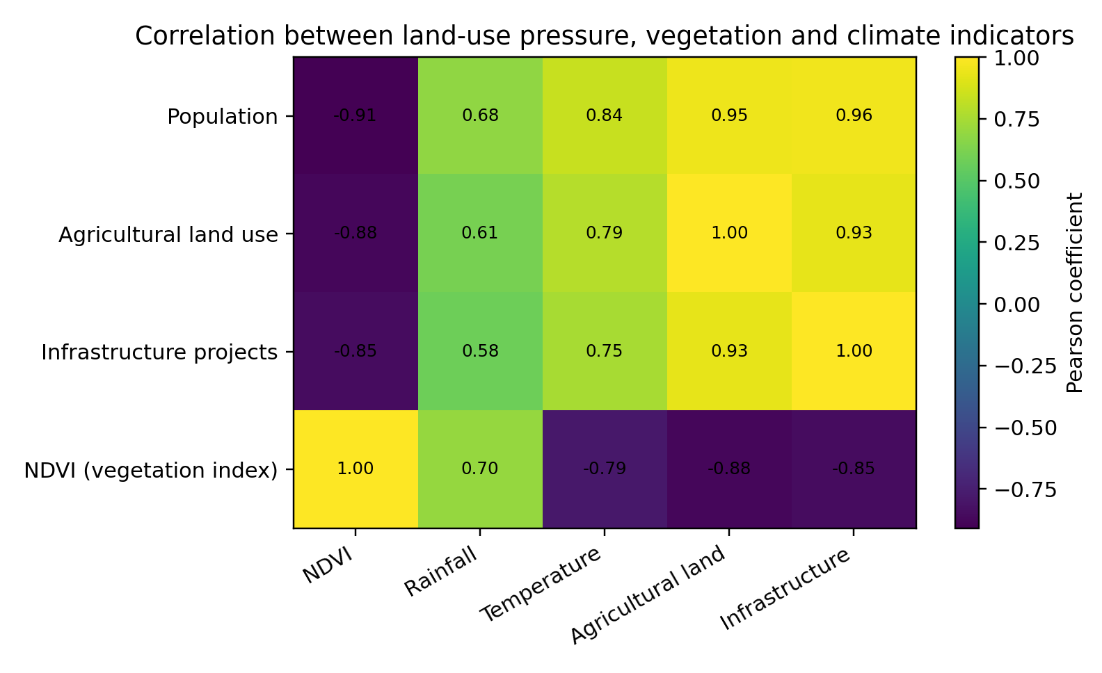
Figure 6. Correlation heatmap for land-use pressure, vegetation and climate indicators.

Table 7. Implications of land-climate trends for sustainable built-environment planning.
Observed pattern | Built-environment implication | Recommended planning response
Population and settlement pressure increased | Greater demand for housing, roads, water and services | Climate-sensitive settlement zoning and compact growth management
Agricultural land expanded | Possible reduction in vegetation buffers and open land | Protection of green belts, agroforestry and controlled conversion
Mean NDVI declined then partially recovered | Reduced shading, cooling, infiltration and ecological protection | Urban greening, shelterbelts, tree planting and landscape restoration
Rainfall declined to 2015 then partially recovered | Higher uncertainty for water-sensitive planning and drainage design | Rainwater harvesting, drainage improvement and watershed-sensitive design
Temperature increased, especially by 2015 | Higher thermal discomfort and potential energy demand | Passive cooling, reflective materials, tree shading and heat-sensitive building codes
Drought frequency increased to 2015 | Greater stress on water supply, soil stability and settlement resilience | Drought-resilient landscaping, water conservation and early warning systems

4. DISCUSSION

4.1 LULCC as a Driver of Vegetation Stress
The findings confirm that vegetation decline in Northern Jigawa State is closely associated with increasing land-use pressure. Population growth increases demand for farmland, fuelwood, housing, infrastructure, water and transport corridors. Agricultural expansion directly transforms natural or semi-natural vegetation into cultivated land, while infrastructure development may fragment habitats, seal soil surfaces and open new corridors for further settlement expansion. The strong negative correlations between NDVI and the socio-economic variables indicate that vegetation has been exposed to cumulative human pressure during the study period.
The decline in NDVI from 0.34 to 0.25 by 2015 is environmentally significant. In a semi-arid landscape, vegetation performs key regulating functions: it protects soil from wind and water erosion, supports evapotranspiration, improves infiltration, moderates heat and sustains ecological habitats. A reduction in vegetation greenness therefore affects more than plant cover; it weakens the ecological foundation upon which agriculture, water availability and settlements depend. The partial NDVI recovery in 2022 suggests that restoration measures, irrigation schemes or improved land management may have contributed positively, but the recovery remains incomplete.

4.2 Rainfall, Temperature and Vegetation Response
The rainfall and temperature trends provide evidence of climate stress. Rainfall decline up to 2015, combined with rising temperature and increasing drought frequency, created conditions that could reduce vegetation productivity and increase land degradation. The positive relationship between NDVI and rainfall confirms the importance of water availability for vegetation response. The negative relationship between NDVI and temperature indicates that heat stress may contribute to vegetation decline, especially where rainfall is insufficient to offset evapotranspiration demand.
The annual rainfall-temperature regression result, with R2 = 0.5475, suggests a moderately strong inverse association between temperature and annual rainfall. However, the monthly results show that the relationship is not uniform throughout the year. The stronger inverse relationships during July, August and September are important because these months coincide with the main rainy season. A reduction in rainfall response during the peak wet season could have serious implications for farming, water storage, soil moisture, vegetation recovery and settlement water security. The observed land-cover changes in Northern Jigawa State are influenced by socio-economic activities such as agricultural expansion, settlement growth, fuelwood extraction, grazing pressure and irrigation-related interventions. Table 2 links these drivers with their land-cover effects, environmental implications and planning responses.

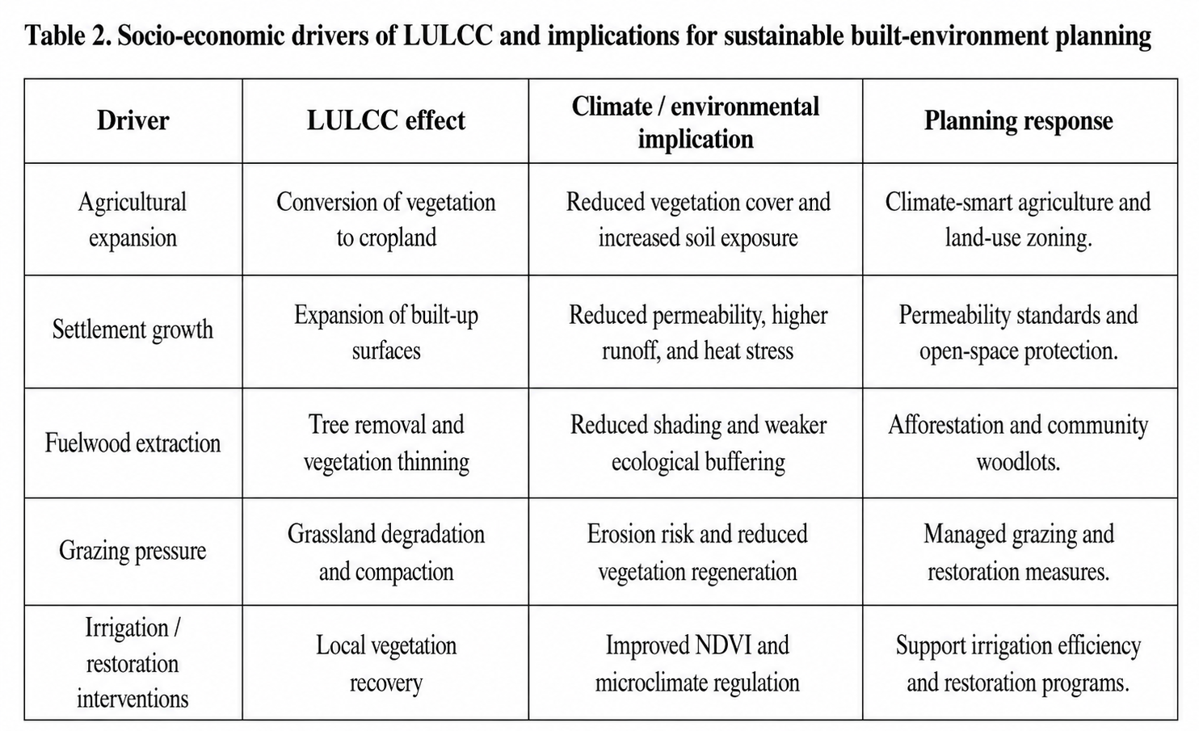
Table 2 shows that socio-economic activities have both degrading and restorative effects on the landscape. Agricultural expansion, fuelwood extraction, grazing pressure and settlement growth contribute to vegetation loss, soil exposure, reduced permeability and increased heat stress. In contrast, irrigation and restoration interventions can support vegetation recovery and improve microclimate regulation. These findings suggest that built-environment planning in Northern Jigawa State should be linked with land-use zoning, afforestation, managed grazing, open-space protection and climate-smart agriculture.

4.3 Implications for Sustainable Built-Environment Planning
The sustainable built environment is often discussed in terms of building materials, energy efficiency, design quality and infrastructure standards. While these are important, the findings of this article show that settlement sustainability also depends on surrounding land-cover condition and climate behaviour. Buildings and infrastructure in a degraded, hotter and less vegetated landscape may face higher heat exposure, greater runoff, weaker soil stability, lower groundwater recharge and greater drainage stress. Therefore, the sustainability of buildings in Northern Jigawa State cannot be separated from vegetation condition, land permeability, water availability and climate-sensitive land-use planning.
For this reason, NDVI and rainfall-anomaly information should be treated as planning tools. Areas with declining NDVI and high land-use pressure should be prioritized for green infrastructure, afforestation, shelterbelts, controlled land conversion and drainage-sensitive development. Areas with increasing temperature and recurrent drought should be considered for passive cooling strategies, climate-sensitive building orientation, reflective materials, tree shading and water-conservation measures. The same evidence can support environmental impact assessment, development control and local climate adaptation planning.

4.4 Position of Windstorm Risk in The Revised Article
The original article emphasized windstorm occurrence and intensity. The revised article does not remove windstorm risk entirely, but it treats it as a secondary environmental implication rather than the central result. This is important because a windstorm-centred article requires detailed storm-event data such as date, location, recorded wind speed, duration, damage type and verified meteorological source. The thesis evidence used here is stronger for analysing land-cover change, vegetation response, rainfall anomaly, temperature variability and sustainable built-environment implications.
Vegetation loss and bare-surface expansion can still be discussed as factors that may increase exposure to wind-related hazards by reducing natural windbreaks, increasing soil exposure and weakening ecological buffers. However, such claims should be framed cautiously unless additional windstorm event records are collected and statistically analysed. This improves the credibility of the article and reduces the possibility of reviewer criticism. The findings indicate that land-cover degradation can be addressed through practical restoration and climate-resilient planning interventions.

5. MAJOR FINDINGS
- Population increased by approximately 157.1% between 1986 and 2022, indicating rising demographic pressure on land resources.
- Agricultural land use increased by approximately 51.0%, while infrastructure projects increased by about 458.3%, showing a clear intensification of land-use pressure.
- Mean NDVI declined by approximately 26.5% between 1986 and 2015, before partially recovering in 2022.
- Rainfall declined by about 15.3% between 1986 and 2015, while average temperature rose by 1.5 deg C over the same period.
- NDVI showed strong negative correlations with population, agricultural land use and infrastructure projects, indicating that vegetation decline is associated with socio-economic land-use pressure.
- NDVI was positively correlated with rainfall and negatively correlated with temperature, confirming the climate sensitivity of vegetation response in the semi-arid study area.
- The annual rainfall-temperature regression result shows a moderately strong inverse relationship, with temperature explaining about 54.75% of annual rainfall variation in the model.
- The built-environment implication is that vegetation loss, rising temperature and rainfall variability may increase heat stress, runoff, erosion, drainage burden and infrastructure vulnerability.

6. CONCLUSION
This article has redrafted and refocused the earlier manuscript by aligning it with the strongest thesis evidence. The analysis demonstrates that land-use and land-cover change in Northern Jigawa State is closely associated with vegetation decline, rainfall variability and temperature increase. The empirical data show that population growth, agricultural expansion and infrastructure development intensified between 1986 and 2022, while mean NDVI declined substantially up to 2015 and recovered only partially by 2022. Rainfall also declined up to 2015, while temperature and drought frequency increased, indicating a climate-sensitive land system under stress.
The article concludes that sustainable built-environment planning in Northern Jigawa State must be based on an integrated understanding of land cover, vegetation condition, rainfall behaviour, temperature trends and infrastructure development. Built-environment sustainability cannot be achieved only through building design; it also requires ecological land management, green infrastructure, permeable surfaces, restoration of vegetation and data-driven land-use control. NDVI, RAI and rainfall-temperature analysis should therefore be incorporated into development planning, environmental assessment and climate adaptation policy.

7. RECOMMENDATIONS
- Integrate NDVI and rainfall-anomaly monitoring into land-use planning, development control and environmental impact assessment in Northern Jigawa State.
- Protect existing vegetation buffers and establish shelterbelts, woodlots, green corridors and community-managed restoration areas, especially in zones with declining NDVI.
- Promote climate-sensitive agricultural practices, including agroforestry, conservation agriculture, controlled grazing, soil-moisture conservation and drought-resilient cropping systems.
- Adopt green infrastructure and permeable-surface planning in settlements to reduce runoff, improve infiltration and moderate local heat stress.
- Use rainfall-temperature trend information to guide drainage design, water harvesting, settlement expansion and infrastructure maintenance planning.
- Strengthen local environmental governance by requiring land-clearing approval, tree-replacement obligations and community participation in land management.
- Develop a geospatial environmental monitoring system that links LULCC maps, NDVI trends, rainfall anomaly, temperature records and built-environment sustainability indicators.
- If the author still wishes to publish a separate windstorm-focused paper, additional event-based windstorm data should be collected from NiMet, NEMA, local emergency records and field surveys before modelling windstorm occurrence and intensity.

REFERENCES

Bonan, G. B. (2008). Forests and climate change: Forcings, feedbacks, and the climate benefits of forests. Science, 320(5882), 1444-1449. https://doi.org/10.1126/science.1155121
Bonan, G. B. (2008). Forests and climate change: Forcings, feedbacks, and the climate benefits of forests. Science, 320(5882), 1444–1449. https://doi.org/10.1126/science.1155121
Duveiller, G., Caporaso, L., Abad-Vinas, R., Perugini, L., Grassi, G., Arneth, A., & Cescatti, A. (2020). Local biophysical effects of land use and land cover change: Towards an assessment tool for policy makers. Land Use Policy, 91, 104382. https://doi.org/10.1016/j.landusepol.2019.104382

Intergovernmental Panel on Climate Change. (2022). Climate change 2022: Impacts, adaptation and vulnerability. Cambridge University Press. https://doi.org/10.1017/9781009325844

Mahmood, R., Pielke, R. A., Hubbard, K. G., Niyogi, D., Dirmeyer, P. A., McAlpine, C., Carleton, A. M., Hale, R., Gameda, S., Beltran-Przekurat, A., Baker, B., McNider, R., Legates, D. R., Shepherd, M., Du, J., Blanken, P. D., Frauenfeld, O. W., Nair, U. S., & Fall, S. (2014). Land cover changes and their biogeophysical effects on climate. International Journal of Climatology, 34(4), 929-953. https://doi.org/10.1002/joc.3736
Mahmood, R., Pielke, R. A., Sr., Hubbard, K. G., Niyogi, D., Dirmeyer, P. A., McAlpine, C., Carleton, A. M., Hale, R., Gameda, S., Beltrán-Przekurat, A., Baker, B., McNider, R., Legates, D. R., Shepherd, M., Du, J., Blanken, P. D., Frauenfeld, O. W., Nair, U. S., & Fall, S. (2014). Land cover changes and their biogeophysical effects on climate. International Journal of Climatology, 34(4), 929–953. https://doi.org/10.1002/joc.3736
Pielke, R. A., Sr., Pitman, A., Niyogi, D., Mahmood, R., McAlpine, C., Hossain, F., Klein Goldewijk, K., Nair, U., Betts, R., Fall, S., Reichstein, M., Kabat, P., & de Noblet, N. (2011). Land use/land cover changes and climate: Modeling analysis and observational evidence. WIREs Climate Change, 2(6), 828-850. https://doi.org/10.1002/wcc.144
Pielke, R. A., Sr., Pitman, A., Niyogi, D., Mahmood, R., McAlpine, C., Hossain, F., Klein Goldewijk, K., Nair, U., Betts, R., Fall, S., Reichstein, M., Kabat, P., & de Noblet, N. (2011). Land use/land cover changes and climate: Modeling analysis and observational evidence. WIREs Climate Change, 2(6), 828–850. https://doi.org/10.1002/wcc.144
Seneviratne, S. I., Corti, T., Davin, E. L., Hirschi, M., Jaeger, E. B., Lehner, I., Orlowsky, B., & Teuling, A. J. (2010). Investigating soil moisture-climate interactions in a changing climate: A review. Earth-Science Reviews, 99(3-4), 125-161. https://doi.org/10.1016/j.earscirev.2010.02.004
Seneviratne, S. I., Corti, T., Davin, E. L., Hirschi, M., Jaeger, E. B., Lehner, I., Orlowsky, B., & Teuling, A. J. (2010). Investigating soil moisture–climate interactions in a changing climate: A review. Earth-Science Reviews, 99(3–4), 125–161. https://doi.org/10.1016/j.earscirev.2010.02.004
Tucker, C. J. (1979). Red and photographic infrared linear combinations for monitoring vegetation. Remote Sensing of Environment, 8(2), 127-150. https://doi.org/10.1016/0034-4257(79)90013-0
Tucker, C. J. (1979). Red and photographic infrared linear combinations for monitoring vegetation. Remote Sensing of Environment, 8(2), 127–150. https://doi.org/10.1016/0034-4257(79)90013-0

