Confidence cuff for providing safety and health monitoring using Machine Learning and IOT

Abstract. It's becoming difficult for women in these days to go to the office or college without feeling uncomfortable, and alone leave the house. Equal pay and gender equality have progressed significantly, yet women's security is still behind. The rise in numbers of harassment incidents and medical emergencies further underlines the need for reliable personal safety gadgets. The innovative solution offered in this project is the Confident Cuff, which is a smart, affordable personal gadget to ensure real-time security. The device operates independently without relying on manual interventions or requiring integration with the user's phone. Instead, it combines health monitoring, GPS, and cellular connectivity in one wearable wristband. It constantly monitors vital parameters such as heart rate, blood pressure, and oxygen saturation. In case of an anomaly or emergency, it sends automatic or manual alerts to pre-selected contacts including the individual's location and health status to facilitate timely rescue efforts. In addition, being equipped with sensitive personal health information, the device ensures confidentiality through encryption and authorized access mechanisms. Moreover, with integrated GSM and GPS modules, it works independently without the need for the user's smartphone. In the future, integrating machine learning would enable the system to predict medical emergencies. Overall, Confident Cuff provides not only a technological innovation but also a practical and scalable approach to promoting personal safety among women, children, the elderly, and other vulnerable segments of society.

INTRODUCTION
Women's safety has always been a top priority and is everyone's most essential responsibility. Until the situation of women is rectified, there is no opportunity for the welfare of the entire globe. Women have always held the highest regard in society, yet on a daily basis, certain women from all walks of life—including girls, women, and infants—are harassed, molested, attacked, and raped in different parts of the world. An estimated 35% of women have at some point in their life been victims of physical or sexual abuse [1]. The goal of the IoT enabled smart band for women's security is to improve the safety and security of women. The band tracks and keeps an eye on the user's whereabouts using Internet of Things technology [2][3]. The band sends out alerts to authorized contacts or authorities in the event of an emergency or distress situation. Other features of the device include automatic position sharing, GPS tracking, and a panic button. This research suggests a minor change that enhances the functionality of these devices and improves women's safety. In order to establish their worth and gain equality with men in the workplace, women have had to overcome numerous obstacles. Prior to World War II, men and children were supposed to "bring home the bacon," while women were expected to take care of the family at home. Women who joined the labour force after the war wanted to stay in the workforce, thus ideologies started to change. Today, women are still fighting for equal pay and working conditions [4]. All genders' personal security is a major concern in today's society, and security is heavily invested in, particularly in technological frameworks and devices. At various points in this oblate spheroid globe, several poor people are being subjected to assault, badgering, capture, and other awful violations. The prevalence of the following is higher than previously thought: In a survey, 8.1% of females and 2.2% of men said they had been followed at some point in their lives. In the United States, about one million women, 371,000 men, and one million women are victims of stalking each year. Many studies have been conducted on the benefits of IoT in the medical field.

Our Idea
We have decided to prepare a “safety band” that can be easy to wear at an affordable price so that everyone can buy for their family and friends. also, the harassment can be happened with anyone irrespective of the gender, it can be happened with anyone either children, teenagers or old people. security is a must for all either a man or woman.
“Confident Cuff” the name of our band, this band is safety band which will generate the instant alert and send the message to the emergency contacts whenever a person is in danger, also our band will detect the heart rate and spo2 level of a person [5] and send health vitals at the time of threat. the reason of sending the health vitals is that it can give the clear indication of the person health.
HOW OTHER Bands Are Working?
The core of every tracker is its sensing layer collecting a whole volume of data about our body and movements. The layer often includes speed sensors, heart rate monitors, temperature detectors, being a fitness tracker constant observer, saving your beats, steps, and breath. The booming wearable technology, which is now increasingly finding inroads into the market due to health and fitness concerns as well as growing personal security awareness, has also become a result of increased demand for wearable technology. In an effort towards this, many companies are manufacturing IoTenabled wearables geared for specific applications, such as personal safety bands, mainly geared for women. In this category, devices are now integrating GPS tracking, health monitoring, and SOS alert systems nearly a lifeline during emergency situations. Table 1. Shows the Comparative analysis of other existing products.

Table 1. Comparative analysis of other existing products.
Brand | Product Name | Price Range (INR) | Availability in India | Drawbacks
Safelet | Safelet Bracelet | ₹5,727-₹8,217 | Not widely available.  May need to order internationally. | Requires Bluetooth connection to a smartphone;  Limited features (no health tracking); lacks robust ecosystem support.
Revolar | Revolar Instinct | ₹3,237-₹8,217 | Not officially available.  Need to be purchased through international shipping. | Limited to basic safety alerts.  Doesn’t provide health monitoring.  May experience connectivity issues with app.
Apple | Apple Watch (Series 4+) | ₹23,157-₹66,417 | Widely available through Apple stores, Amazon India, and other ecommerce platforms. | High cost;  Shorter battery life compared to simpler wearables.  Requires regular charging.  May feel complex for users primarily needing safety features.
Nimb | Nimb Ring | ₹10,707-₹12,387 | Limited availability.  May need to order internationally. | Primarily designed for safety alerts, lacking health monitoring. Requires smartphone connectivity.  Limited battery life.

Challenges in Existing Solutions
User Interaction: Devices like Nimb and Safer Smart jewellery utilize the concept of manual button presses to raise an SOS alert. For instance, if the victim is incapacitated or cannot utilize this device properly, SOS assistance would not be achievable in such a case.
Limited Functionality: Most products only rely on location tracking or SOS alert services. They usually lack features like health monitoring (heart rate and blood pressure, for example). Automatic detection of emergencies is also missing in most of these products.
Dependency on Smart Phones: They are so reliant upon a smartphone for communicating that in those cases, when the user's phone is not near them or is unavailable, they become unusable.
False Positives: Technology that depends on accelerometers or simple sensors (like Fitbit) tends to have accuracy issues where false positives occur because sometimes the device will detect strange movement and alert its owner that there is danger when there isn't.
This Band "Confident Cuff" stands out in the market due to its integrated approach to both personal safety and health monitoring. Table 2. Shows a comparison that highlights its unique features.
Table2. Comparison between our band with other devices
Features | Other Devices | Confident Cuff
Emergency Alert (SOS) | Manual button press required | Automatic and manual SOS options
Location tracking | Location Tracking Standard GPS location only | Realtime GPS with enhanced GSM communication for wider coverage
Accuracy of Detection | False positives regularly occurring | Advanced sensors identifying real emergencies, AI enabled
Ease of Use | Must be paired with a smartphone using Bluetooth | Independent operation with GSM and GPS tracking
Data Privacy and Security. | Data has minimal encryption Data | Privacy is ensured by GSM modules and encrypted communication

How Our Band Will Work?
Our band will detect the heart rate, blood pressure and spo2 level of a person and have two options to send alert to emergency contacts:
- Automatically once a vital level is crossed.
- We will give an option to manually send the emergency message.

The notification sent was a text message that the victim is in danger and these are vital levels of him. So, in this way this band will also work for those who were suffering from problem of high or low blood pressure. Another catches we have that bands in the market detects the heartbeat and bp even of a wooden object so we will work to fix this issue using advanced sensors and Ai techniques. So, this band gives the convenience to parents and caretakers to:

- Quickly respond to the emergency.
- Track the victim's location and provide immediate assistance.
- To contact emergency services directly.

Methodology:
Hardware Used:
The “Confident Cuff” uses a group of hardware elements with the aim of guaranteeing functionality and reliability.
Flowchart representing the flow of data for Confident Cuff is shown in Fig1. Flowchart. The ESP32 or Arduino Nano microcontroller is the heart of the device as it governs everything: processing sensor data to communication. The MAX30100/MAX30102 pulse sensor will measure heart rate as well as SpO2 of users in real time with health-related information. The Neo6M GPS module is utilized for position tracking, while the SIM800L GSM module is used to send out SOS alerts and health data through cellular networks. The device is powered by a 3.7V Li-ion/LiPo battery that has the capacity for a 500mAh to 1000mAh long-lasting performance. The battery is charged efficiently and safely by a TP4056 charging module. Thirdly, a tactile push button can be used by the user for manual issuance of an emergency alert whenever necessary. All elements are packed into a 3D printed or prebuilt case, ensuring durability along with ease of use. List of all the components used in Confident Cuff is shown in Table 3. Hardware Components and connection of all the hardware components is shown in Fig2. Circuit Diagram.
Table 3. Hardware Components
Component | Model/Type
Microcontroller | ESP32 or Arduino Nano
Pulse Sensor | MAX30100/MAX30102
GPS Module | Neo6M GPS
GSM Module | SIM800L GSM
Li-ion/LiPo Battery | 3.7V 500mAh–1000mAh
Battery Charging Circuit | TP4056 Charging Module
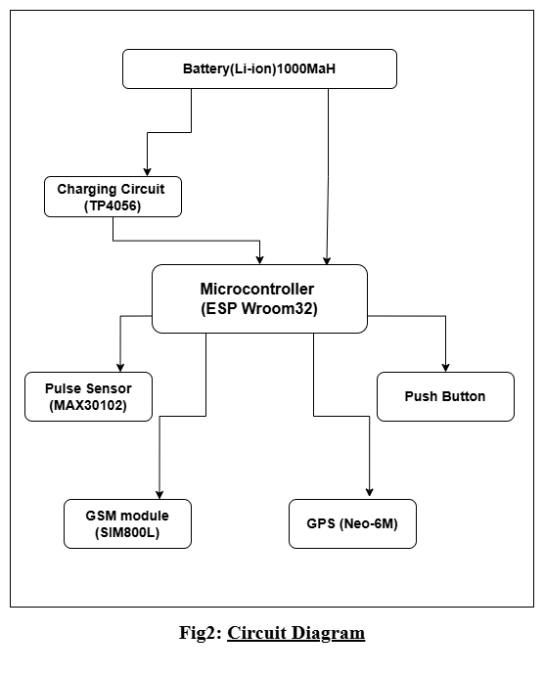
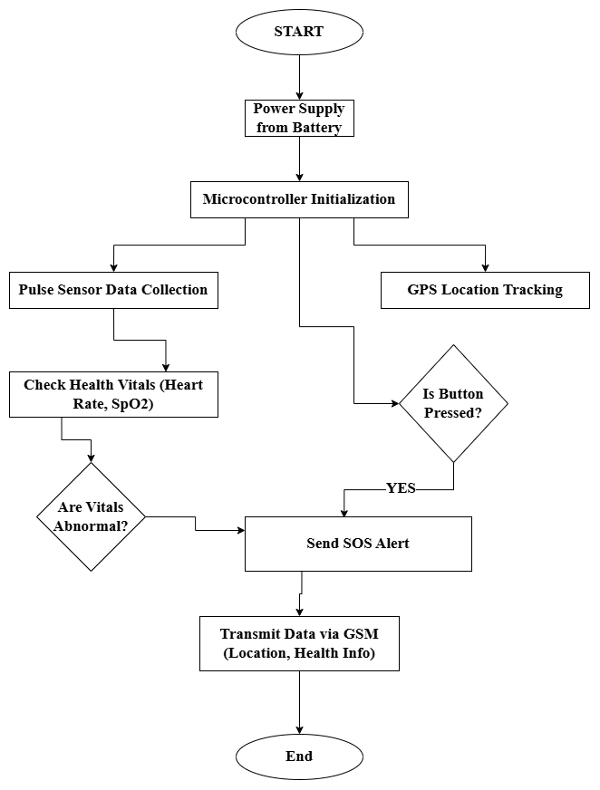
Fig 2. Circuit Diagram
Fig 1. Flow Chart

Software and Languages Used:
The development process for the software components of the safety band involves Embedded Firmware Development for the microcontroller and ML Model.
Embedded Firmware Development:
Arduino IDE: It will be used to write and upload code to microcontrollers.
Add ESP32 Board: In the Arduino IDE, add the ESP32 board by including the appropriate board manager URL under preferences.
Libraries: Install necessary libraries for the sensors and modules:
- Max30100 library for the pulse sensor.
- Tinygps++ or neogps for the gps module.
- Software serial for gsm module communication.
Application Development for Confident Cuff smart band:
PyCharm IDE: It will be used for app development.
Libraries: Install necessary libraries for the application:
- Kivy framework for the application development in python.
- Pybluez library for the Bluetooth integration of the band with application.
- Twilio API this will be used for generating SOS alert

Designing ML Model:
Designing an ML model to detect normal and abnormal pulse rates and SpO2 and to determine whether a situation is an emergency or not involves several key steps [6]. Below is a structured approach to develop such a model:
Problem Definition and Objective:
Objective: To build a machine learning (ML) model that distinguishes between normal and abnormal conditions based on a user's pulse rate and SpO2 data and detects emergency conditions that may require medical intervention.
Output: A binary or multiclass classification model that determines whether the Condition is:

- Bradycardia
- Tachycardia
- Hypoxemia
- Severe Bradycardia & Hypoxemia
- Tachycardia & Low Oxygen
- Normal

Algorithm Used The decision tree is a supervised learning technique and can be applied for classification as well as for regression problems, though it is mostly used for classification.
According to the features used in the data, decisions or tests are made.
Various algorithms are there in machine learning, but the point to remember while creating the machine learning model is to choose the best algorithm for the dataset concerned and the condition involved. Below are the two reasons for using the Decision tree:
o Decision trees typically reflect human thought processes while making a decision; hence, they are easily understood.
o The rationale behind a decision tree can be understood quite easily, as it reveals a treelike structure.

Key steps include in the algorithm:
o Pre-processing the data
o Fitting the Decision Tree algorithm into the Training Set
o Predicting the Test Result
o The Testing of the Result's Accuracy (Creation of Confusion Matrix)
o Visualizing the Test Set Results.

Data Pre-processing: Pre-processing is crucial to prepare the data for ML modelling. Key steps include:
Data Cleaning: Handle missing data, outliers, and errors in sensor readings. For example, remove data points that are physically impossible or outside the expected range (e.g., heart rate above 300 bpm).
Data Normalization: Since heart rate data is numerical, normalization or standardization may be needed to ensure all input features (if there are more) are on the same scale.
Handling Imbalance: Heart rate datasets might have more normal cases than emergency cases.
Feature Transformers: Different feature transformer techniques applied on the dataset are shown, such as the univariate feature selection.
Pipelines: This part mentions the variety of machine learning algorithm developed within the pipeline, which also contains Decision Tree Classifier.
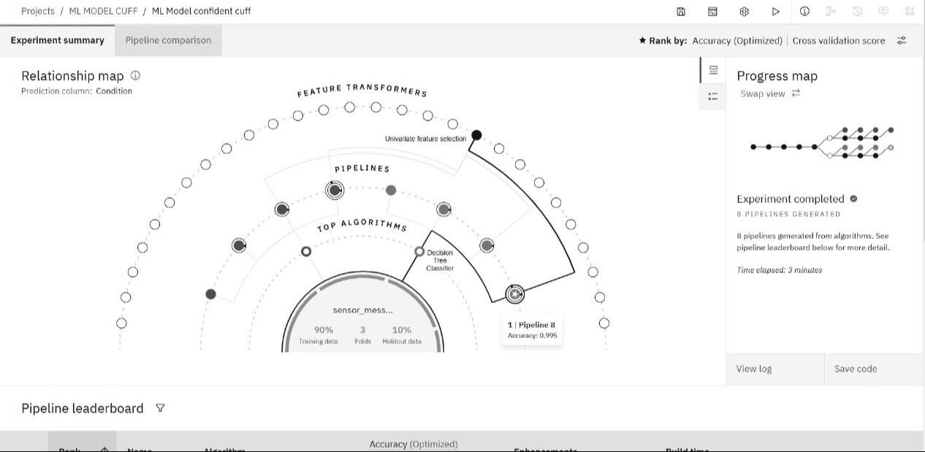
Progress Map: This chart is a timeline of the experiment showing what steps were taken and the time that had passed.
Fig 3. Relationship Map
Relationship Map: This section plots the relationship between the prediction column (Condition) and different features included in the pipeline. Fig 3. Relationship Map will show the relationship map of the confident cuff.
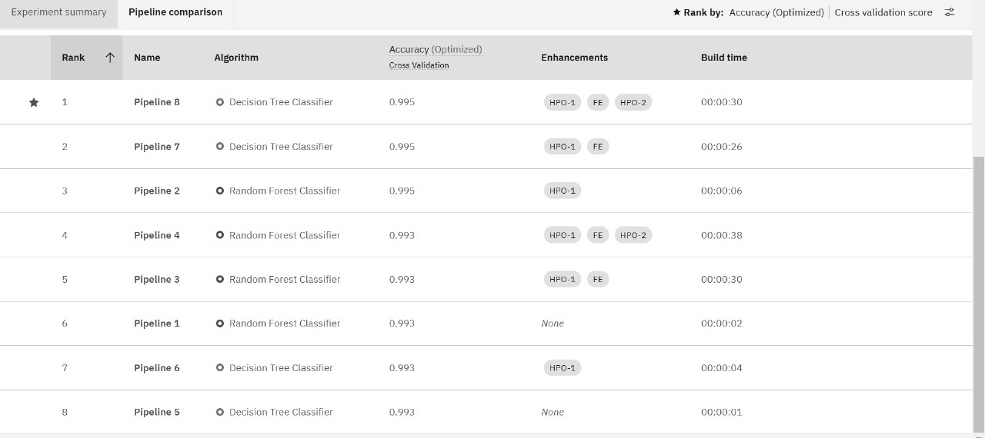
Fig 4. Comparison Chart

Pipeline Comparison chart:
This chart is used to evaluate and compare the performance of multiple pipelines (models or workflows) across various metrics. The Fig 4. shows the metric chart of two algorithms.
Below are the key points of pipeline comparison:
- Pipelines (p1, p2, p3,.….., p8.): the chart compares different pipelines labelled as p1, p2, p3,…..,p8, for their performance on the prediction column named "condition."
- Metrics evaluated: accuracy, f1score (macro, micro, weighted), log loss, precision (macro, micro, weighted), and recall (macro, micro, weighted) are all plotted per pipeline.
- Performance trends: accuracy: almost all pipelines perform very close to each other, at an accuracy value close to 1.000 for all pipelines.
- F1score: the macro, micro, and weighted variants of the f1score are consistent but show minor variations across pipelines.
- Log loss: there is a notable variance in this metric; lower values are better, indicating the confidence of predicted probabilities.
- Precision and recall: both metrics, in all their variants, are close to perfect (1.000) for many pipelines, but there are slight differences.
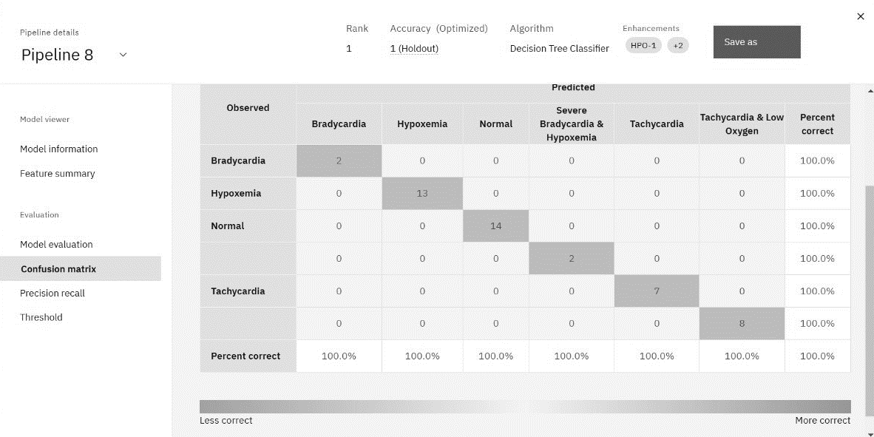
- Ranking: the pipelines are ranked by accuracy (optimized) and cross validation score, as shown at the top of the graph.
Fig5. Confusion Matrix

Confusion Matrix:
This section provides information about the model and the features used in the pipeline.
It shows the distribution of the different classes (Bradycardia, Hypoxemia, Normal, etc.) in the dataset.
Confusion Matrix can be seen in Fig 5. This matrix portrays the way well the classifier categorized each class. The correct predictions are on the diagonal element and off diagonal ones show wrong predictions.

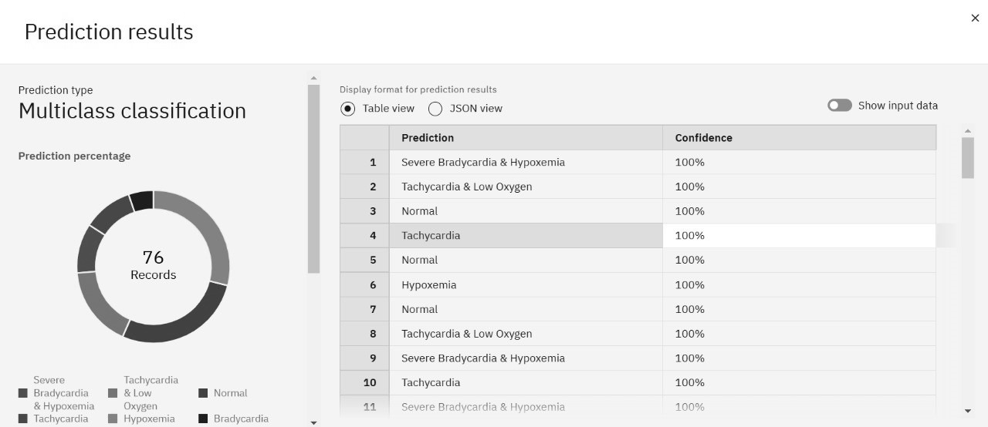
Fig 6. Prediction Results

Precision, Recall, and Threshold: These three measures the success rates of a classifier in determining its accuracy at correctly specifying the positive cases (precise), to correctly ascertain all the positive cases recall and threshold used when calling an instance as positive.
Model Evaluation: Fig 6. Shows the prediction results of the model after testing with test data. Test data consist of nearly 76 test cases and the evaluation results are nearly 99.99 % accurate.

CONCLUSION
The "Confident Cuff" smart band introduces a ground-breaking approach to personal safety and health monitoring, leveraging cutting-edge technologies to address pressing societal challenges. By integrating Internet of Things (IoT) capabilities, Machine Learning algorithms, and advanced sensor technologies, this innovative device delivers features such as real-time location tracking, health vitals monitoring, and dual-mode SOS alerting (manual and automatic). These features help distressed individuals quickly notify emergency contacts and others, thus shortening the time that is taken to respond, which can even save lives. Unlike many of the existing wearable safety devices reliant on smartphone connectivity and susceptible to throwing false alarms, the Confident Cuff is significantly different. With advanced sensors and AI-enabled algorithms, they are able to distinguish accurately between a true emergency or normal conditions with minimal risk of false positives. Consequently, this provides increased comfort and trust on the behalf of the users, whereby the device could be placed reliance on in those critical events.
The gadget uses robust data encryption to protect sensitive information, like health metrics and location data. Multi- factor authentication and tight authorization controls ensure that access to settings or data of the gadget is restricted only to authorized individuals. Such measures ensure that the Confident Cuff not only serves as a useful tool for security but is also secure in a world increasingly concerned with breaches and access in connected devices. Besides this, the safety device is designed with customer convenience in mind. Due to its ergonomic and accessible design, the product is meant for everybody, and so safety will not be an exclusive privilege but a universal right. Be it for the woman, the child, or the aged, the Confident Cuff is a convenient solution that caters for different needs for safety. The Confident Cuff marks a meaningful step forward in an increasingly unsafe and unhealthy world. By bringing advanced technology and user-centred design together, it delivers a comprehensive and reliable safety solution. This innovation may help transform personal security and contribute to safer, more resilient communities while establishing a new standard for future developments in wearable technology.
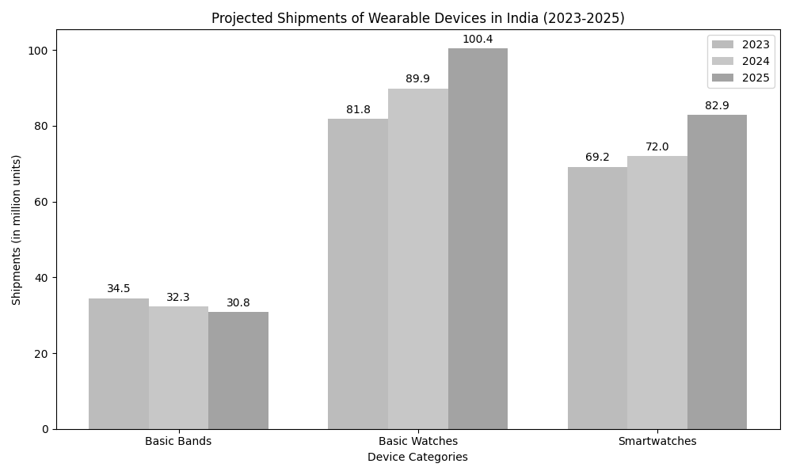
REFERENCES

- Health Organization. (2013). Global and regional estimates of violence against women: prevalence and health effects of intimate partner violence and nonpartner sexual violence.
https://www.who.int/reproductivehealth/publications/violence/9789241564625/en/

- Internet of Things in industries: A survey. IEEE Transactions on Industrial Informatics, 10(4), 22332243 Da Xu, & Li, S. (2014). https://doi.org/10.1109/TII.2014.2300753

- Khan, M. A., & Salah, K. (2018). IoT security: Review, blockchain solutions, and open challenges. Future Generation Computer Systems, 82, 395411. https://doi.org/10.1016/j.future.2017.11.022

- Misra, S., Maheswaran, M., & Hashmi, S. (2016). Security Challenges and Approaches in Internet of Things. Springer.
https://doi.org/10.1007/9783319442399

- A wearable device for continuous monitoring of heart rate and body temperature. (CONECCT) (pp.15) Kumar, N., Rajasekaran, & Sujatha(2018). https://doi.org/10.1109/CONECCT.2018.8482456

- A deep learning approach to onnode sensor data analytics for mobile or wearable devices. IEEE Journal of Biomedical and Health Informatics, 21(1), 5664
Ravi Wong, C. Lo, B., & Yang, G. Z. (2017). https://doi.org/10.1109/JBHI.2016.2633287

- Sicari, S., Rizzardi, A., Grieco, L. A., & CoenPorisini, A. (2015). Security, privacy, and trust in Internet of Things: The road ahead. Computer Networks, 76, 146164. https://doi.org/10.1016/j.comnet.2014.11.008

- A comprehensive study of security of InternetofThings. IEEE Transactions on Emerging Topics in Computing, 5(4), 586602 Mosenia, A., & Jha, N. K. (2016). https://doi.org/10.1109/TETC.2016.2606384

- AlRawi, M., & Qadir, J. (2018). An IoTenabled realtime GPS tracking system. In Proceedings of 2018 4th International Conference on Emerging Technologies (ICET)(pp.16). https://doi.org/10.1109/ICET.2018.8502411

