Development, Validation, and Acceptability of an Interactive Educational Presentation Slides in Teaching Solstice and Equinox for Grade 7 Students
ABSTRACT
Teaching abstract astronomical concepts such as solstice and equinox remains a persistent challenge in secondary science education due to learners’ misconceptions, limited spatial understanding, and the inadequacy of conventional instructional materials to demonstrate Earth–Sun relationships clearly. These difficulties often hinder students’ conceptual comprehension and engagement in science classes, particularly among Grade 7 learners who are introduced to basic astronomy concepts for the first time. In response to this educational concern, the present study aimed to develop and validate Interactive Educational Presentation Slides (IEPS) designed specifically for teaching solstice and equinox in Grade 7 science. The study sought to evaluate the developed instructional material in terms of design, presentation, content quality, and student activity integration.
Using a descriptive-developmental research design, the study involved fifteen (15) science teachers from selected public secondary schools in Bongao who were purposively selected based on established professional qualifications and teaching experience. The developed IEPS served as the primary instructional intervention, while a researcher-made and expert-validated questionnaire was utilized to determine the material’s validity and acceptability. Data gathered from the respondents were analyzed using weighted mean and standard deviation through Microsoft Excel.
Findings revealed that the developed IEPS received highly positive ratings across all evaluation dimensions, indicating strong validity, usability, and alignment with instructional design standards. The results further suggest that the integration of interactive and multimedia-based features enhanced the presentation of abstract astronomical concepts and promoted learner engagement. Consequently, the developed IEPS demonstrates strong potential as a classroom-ready instructional material that can support more meaningful science instruction in diverse educational settings.
Keywords: Interactive educational presentation slides, astronomical events, visual representations
INTRODUCTION
Science education uses visual images to communicate ideas, making scientific literacy crucial. This involves effectively communicating scientific concepts through various representational abilities, including the ability to interpret and create visual images, making it closely related to visual literacy. Technology has improved science education by making it more interesting, interactive, and accessible. It provides a variety of tools and resources to help students study more effectively, gain a better knowledge of scientific concepts, and raise a new generation of scientifically literate people. For instance, Massive Open Online Courses (MOOCs), assist students in visualizing complicated scientific concepts, gaining access to research articles, instructive videos, and interactive websites, and developing a more in-depth grasp of scientific subjects.
Technology also promotes a culture of lifetime learning by encouraging curiosity and developing a culture of lifelong learning. Another powerful tool used in science education is the PowerPoint presentations. It enhances student engagement, organization and multimedia integration. Moreover, it also aids in understanding and retention of scientific information by providing visual representation such as diagrams, charts, and graphs, and reinforcing key points.
Further, using presentation slides, complex concepts such as solstices and equinoxes can be simplified. Along with the equinox, there are two seasons on the solstice. The longest day occurs on the summer solstice in June, the winter solstice in December, the spring equinox in March, and the fall equinox in September. Filipino students often have misconceptions about seasons due to cultural and educational factors, highlighting the importance of understanding the natural world's rotational axis.
Nonetheless, no matter how far technology has advanced, there are times when we do not use it effectively. Most lecturers poorly prepared PowerPoint presentations, for example, are viewed as a barrier to effective classroom teaching and learning. A presentation in science, especially in astronomy, is crucial. It should avoid using small text, tiny fonts, and dull background designs because it needs to explain more than just planets, stars, galaxies, and other space phenomena. Solstice and Equinox are two astronomical concepts that describe the location of the sun and the earth, resulting in the different seasons on Earth. However, because solstices and equinoxes are rarely discussed for a variety of reasons, this leads to students' misconceptions.
The use of interactive presentation slides for teaching solstices and equinoxes to grade 7 students in Tawi-Tawi are a valuable educational initiative. These slides enhance visual learning, simplify explanations, and engage students through interactive elements like quizzes and activities. Moreover, it can be customized to suit various learning styles and abilities, making them accessible to students in remote areas and enhancing teachers’ effectiveness. Also, digital resources can be reused and updated over time, reducing the need for physical resources and minimizing environmental impact. This initiative contributes to a more informed and inspired generation of students in Tawi-Tawi. Digital resources facilitate collaboration, community building, and enhance learning experiences by incorporating multimedia elements like videos and quizzes, catering to diverse learners.
This study aimed to improve science presentation slides for Grade 7 students using interactive educational presentation slides to create a collaborative atmosphere, allowing students to participate in lessons and achieve desired outcomes.
Research Questions
This study aimed to improve science presentation slides for Grade 7 students using interactive educational presentation slides to create a collaborative atmosphere, allowing students to participate in lessons and achieve desired outcomes. Specifically, it sought to answer the following questions:
1. What presentation slides were developed for solstice and equinox for grade 7 students?
2. What is the established validity level of the developed interactive educational presentation slides in teaching solstice and equinox, in terms of:
- Design;
- Presentation;
- Student’s activity; and
- Content?
3. What is the level of acceptability of the teachers towards the interactive educational presentation slides in terms of the above-mentioned variables?
Literature Review
Interactive Education Presentation Slides
Contemporary educational research consistently emphasizes the importance of improving instructional practices to enhance student learning outcomes. Learner-centered and technology-supported pedagogies have been widely recognized as effective approaches for increasing engagement and improving academic performance. Knowles, Holton, and Swanson (2011) highlight that meaningful learning is optimized when instruction aligns with learners’ needs, experiences, and readiness, particularly in adult and adolescent learning contexts. In parallel, the Higher Education Academy (2015) emphasizes that innovative pedagogical approaches, including technology-enhanced learning, blended learning, and flipped classroom models, contribute to improved student engagement and motivation.
Across these instructional innovations, a common principle emerges: the integration of digital tools and multimedia resources facilitates more active and student-centered learning environments. However, while these approaches are widely promoted, their effectiveness is highly dependent on instructional design quality and pedagogical implementation rather than technology alone.
Instructional presentation tools such as PowerPoint and other multimedia platforms have become central teaching-learning materials (TLMs) in modern classrooms. Kapur (2019) and Bušljeta (2013) emphasize that well-designed instructional materials are essential in achieving academic objectives and supporting conceptual understanding. Presentation slides, when properly structured, serve as cognitive scaffolds that bridge abstract concepts and learner comprehension. Susskind (2005) found that PowerPoint-supported instruction improves student attitudes and self-efficacy, while Park (2013) noted that such tools assist instructors in organizing and delivering content more effectively for cognitive processing.
Similarly, Agbevivi (2018), Gordani and Khajavi (2019), and Iskrenovic-Momčilović (2016) reported that multimedia presentation tools positively influence student engagement and academic performance across various disciplines. Students also tend to prefer structured digital presentations over traditional board-based instruction (Birnbaum & Frey, cited in Nwangwu, 2018). These findings collectively suggest that presentation slides, when effectively designed, can enhance both instructional delivery and learner experience.
However, contrasting evidence highlights limitations in the use of such tools. Garner and Alley (2013), Nwangwu (2018), and Nwangwu and Obi (2014) argue that ineffective slide design, excessive textual information, and lack of instructor competence often reduce instructional effectiveness. Hertz (2015) further identifies poor visual organization, inappropriate slide quantity, and ineffective presenter behavior as factors that negatively affect learning outcomes. These findings suggest that the effectiveness of presentation slides depends not merely on their use but on adherence to sound instructional design principles.
From a theoretical perspective, Mayer’s Cognitive Theory of Multimedia Learning (2020) explains these outcomes by emphasizing the importance of coherence and cognitive load management. According to Mayer, learning is hindered when extraneous cognitive processing is introduced through irrelevant visuals, excessive text, or poorly designed animations. This reinforces the need for carefully designed multimedia instruction that supports meaningful cognitive processing.
Collectively, the literature indicates that multimedia presentation tools are most effective when grounded in sound pedagogical and cognitive design principles. While they can enhance engagement and achievement, their impact is contingent upon how they are structured and implemented within instructional settings. Despite extensive research on multimedia learning, there remains a need for context-specific instructional materials that are systematically developed and validated for particular subject areas and learner needs.
Teaching Astronomy in Secondary School
Astronomy education at the secondary level presents persistent conceptual challenges for learners, particularly in understanding abstract spatial and temporal phenomena. Research has consistently shown that students often hold misconceptions about fundamental astronomical concepts. Radhakrishnan (2013) found widespread misunderstandings among high school students regarding basic astronomy concepts. Similarly, Anantasook, Yuenyong, and Hume (2015) reported that students’ interpretations of celestial motion are influenced by sociocultural contexts, suggesting that prior beliefs significantly shape scientific understanding.
Further studies reinforce the complexity of conceptual change in astronomy learning. Turk, Kalkan, Iskeleli, and Kiroğlu (2015) found that students develop multiple and often conflicting mental models regarding seasonal changes. Aydin, Keleş, and Hafizoğlu (2018) further revealed that learners demonstrate limited understanding of the Earth–Moon–Sun system and struggle to accurately represent these relationships.
These findings indicate that astronomy concepts such as solstice and equinox are particularly difficult for students due to their reliance on spatial reasoning, abstract visualization, and understanding of Earth’s axial tilt and orbital motion. Eldridge (2018) explains that solstices and equinoxes occur due to the Earth’s tilt and revolution around the Sun, resulting in variations in daylight distribution across hemispheres throughout the year.
Despite their scientific importance, these concepts remain difficult to teach using traditional instructional methods alone. Conventional approaches often fail to adequately support students’ mental model construction, leading to persistent misconceptions. In response, multimedia and interactive instructional approaches have been suggested as more effective alternatives. Moreno and Mayer (2007) argue that interactive multimedia learning environments promote active cognitive engagement by allowing learners to construct and manipulate mental representations of complex phenomena.
Collectively, the literature suggests that astronomy education requires instructional approaches that enhance visualization, conceptual clarity, and learner engagement. However, there is still limited research focusing on the development and validation of interactive, context-specific instructional materials tailored for teaching solstice and equinox in secondary science education, particularly in geographically and resource-constrained settings.
Across the reviewed literature, two key themes emerge. First, multimedia and technology-enhanced instructional tools improve student engagement and learning outcomes when grounded in effective instructional design principles. Second, astronomy education remains conceptually challenging for learners due to persistent misconceptions and difficulties in visualizing abstract spatial relationships.
However, despite extensive research on multimedia learning and astronomy education separately, there is a noticeable gap in the development of validated, topic-specific interactive instructional materials that integrate multimedia principles with astronomy content. In particular, limited studies have focused on the design and validation of Interactive Educational Presentation Slides (IEPS) tailored for teaching solstice and equinox in secondary science education contexts.
This gap highlights the need for the present study, which focuses on the development, validation, and acceptability of Interactive Educational Presentation Slides designed to enhance conceptual understanding of solstice and equinox among secondary school learners in context-specific educational settings.
METHODOLOGY
Research Design
This study employed a Descriptive Developmental Research Design to develop, validate, and determine the acceptability of Interactive Educational Presentation Slides (IEPS) in teaching solstice and equinox among Grade 7 students. This research design was deemed appropriate because the study involved both the systematic creation of an instructional product and the empirical evaluation of its quality, usability, and educational relevance. Descriptive developmental research is commonly used in educational technology and instructional design studies where the primary objective is to produce, refine, and validate educational materials intended to improve teaching and learning outcomes.
The developmental component of this study is grounded in the framework of Richey and Klein (2005), who defined developmental research as the systematic study of the design, development, and evaluation of instructional products, tools, and processes intended to establish empirical foundations for effective instructional practices. Specifically, this study aligns with Type 1 developmental research, also referred to as product and tool research, which focuses on the design, development, and validation of instructional materials in authentic educational contexts. This framework was appropriate because the present study aimed to produce an instructional innovation in the form of interactive educational presentation slides that was designed to support the teaching of abstract astronomical concepts commonly associated with learner misconceptions.
To further guide the development process, the study adopted principles commonly associated with the ADDIE instructional design framework—Analysis, Design, Development, Implementation, and Evaluation—which is widely used in the development of instructional materials and educational technologies. During the analysis phase, the researchers identified the instructional needs and common misconceptions related to the concepts of solstice and equinox. This was followed by the design and development of the interactive slides, integrating multimedia elements such as animations, visual representations, videos, and interactive assessments. The implementation phase involved presenting the developed material to selected respondents, while the evaluation phase focused on expert validation and user acceptability assessment. According to Molenda (2015), the ADDIE model provides a structured and iterative process that ensures instructional materials are pedagogically sound, learner-centered, and aligned with educational objectives.
The descriptive aspect of the study complemented the developmental process by systematically collecting, analyzing, and interpreting quantitative evaluation data from validators and respondents. As noted by Richey, Klein, and Nelson (2004), descriptive developmental studies not only document the process of instructional product development but also generate evidence regarding the effectiveness, usability, and quality of the developed intervention. In this study, descriptive statistical measures such as mean and standard deviation were utilized to determine the validity and acceptability levels of the developed IEPS in terms of design, presentation, students’ activity, and content.
The application of developmental research has been supported in previous instructional material studies. For instance, Van den Akker (1999) emphasized that educational product development requires iterative design, expert validation, and continuous refinement to ensure contextual relevance and instructional effectiveness. Similarly, Plomp (2013) argued that design-based and developmental approaches are particularly appropriate for creating educational interventions intended to solve real classroom problems and enhance learning experiences.
Taken together, the use of a descriptive developmental research design provided a rigorous and systematic methodological foundation for the creation and validation of the Interactive Educational Presentation Slides. Through iterative development, expert evaluation, and empirical assessment, this design enabled the researchers to produce an instructional material that is pedagogically sound, technically appropriate, and responsive to learners’ needs. Ultimately, this methodological approach supports the study’s goal of improving the teaching and learning of complex astronomical concepts such as solstice and equinox in secondary science education.
Participants
The participants of this study consisted of fifteen (15) Secondary Science teachers from three (3) selected public secondary schools in Bongao who were actively teaching during the Academic Year 2023–2024. These teacher-participants served as expert validators in the evaluation of the developed Interactive Educational Presentation Slides (IEPS) for teaching solstice and equinox. Their participation provided professional judgments regarding the instructional material’s content validity, design quality, usability, and classroom acceptability within authentic educational settings.
Prior to the main validation phase, one (1) additional public secondary school in Bongao was utilized exclusively for pilot testing of the research instrument. The pilot-testing participants were not included in the final validation and acceptability analysis. Data gathered during the pilot phase were used solely for instrument refinement, clarity checking, and reliability testing prior to the actual implementation of the study.
This study employed purposive sampling in identifying qualified teacher-participants for the expert validation phase and total enumeration in including all teachers who met the established inclusion criteria within the selected schools. According to Michael Quinn Patton (2015), purposive sampling enables researchers to intentionally select information-rich participants capable of providing credible and meaningful evaluations based on professional expertise.
To ensure the rigor and credibility of the validation process, participants were required to meet the following specific criteria: (a) graduate of a Science-related education program or Science major; (b) Licensed Professional Teacher who passed the Licensure Examination for Teachers administered by the Professional Regulation Commission; (c) at least five (5) years of Science teaching experience at the secondary level; (d) currently teaching Science during the conduct of the study; and (e) demonstrated competence in integrating information and communication technology in instruction.
Limitations of the Study
This study was deliberately bounded to fifteen (15) Secondary Science teachers from selected public secondary schools in Bongao during the Academic Year 2023–2024. The pilot-testing participants were excluded from the final dataset to preserve the independence of the main validation process. Although the pilot test involved only five respondents from one school, this was considered appropriate within a developmental research context where the primary purpose of pilot testing is to evaluate item clarity and preliminary reliability rather than population-level generalization. In instructional development studies, pilot testing is typically conducted with a limited number of expert participants due to the small accessible population in geographically constrained contexts such as Bongao. Thus, the reliability result was interpreted as part of the instrument refinement process rather than as a statistical inference to a broader population. These participants were selected based on specific professional qualifications to ensure the credibility and rigor of the validation process. To be included in the study, participants were required to meet the following criteria: (a) must be a graduate of a Science-related education program or a Science major; (b) must be a Licensed Professional Teacher (LPT) who passed the Licensure Examination for Teachers administered by the Professional Regulation Commission; (c) must have at least five (5) years of experience teaching Science at the secondary level; (d) must be currently teaching Science during the conduct of the study; and (e) must demonstrate functional knowledge and experience in the use of information and communication technology (ICT) relevant to instructional delivery.
The number of participants was intentionally limited to fifteen qualified teacher-validators, as developmental research prioritizes the quality of expert evaluation over the quantity of respondents. According to Richey and Klein (2007), design and developmental research focuses on the systematic development, refinement, and validation of instructional products through expert feedback gathered from individuals who possess relevant pedagogical and content expertise. In product validation studies, a smaller group of highly qualified evaluators is often methodologically more appropriate than a larger sample of general respondents, as expert participants are better positioned to identify instructional, technical, and content-related issues that may affect the effectiveness of the developed material.
The limited number of participants was also influenced by the specific geographical and professional context of Bongao, Tawi-Tawi. As a geographically isolated educational setting, the availability of Science teachers who simultaneously met the established criteria—professional licensure, specialized academic preparation in Science education, substantial teaching experience, and ICT competence—was naturally limited. Thus, the selection of fifteen expert participants reflected the actual accessible population of qualified teacher-validators within the identified schools.
Despite the relatively small sample size, the participants provided sufficient evaluative feedback necessary for the objectives of developmental research. Creswell and Creswell (2018) emphasized that in studies involving expert judgment and specialized evaluation, the adequacy of participants is determined by the depth, relevance, and consistency of the information obtained rather than by numerical representation alone. Similarly, Richey and Klein (2007) noted that developmental research seeks iterative improvement and refinement of instructional products through expert validation until major design, pedagogical, and usability concerns have been adequately addressed. In the context of this study, the collective expertise of the selected teacher-participants generated sufficient evaluative data to identify critical areas for revision, thereby achieving methodological adequacy for product validation.
Furthermore, this study was limited to the development and validation of Interactive Educational Presentation Slides (IEPS) specifically designed for teaching the Grade 7 Science concepts of solstice and equinox. As such, the findings are contextually grounded within the instructional realities, curriculum demands, and educational needs of secondary schools in Tawi-Tawi. While the results may not be directly generalizable to all schools or regions in the Philippines, the findings provide context-specific insights that are highly relevant to similar educational environments, particularly those in geographically remote or underserved communities. These deliberate boundaries strengthen the contextual validity and practical applicability of the developed instructional material within its intended educational setting.
Research Instrument
The primary data-gathering instrument used in this study was a researcher-made questionnaire, specifically designed to assess the validity and acceptability of the developed Interactive Educational Presentation Slides (IEPS) in teaching solstice and equinox for Grade 7 students. In developmental research, the use of a researcher-constructed instrument is considered appropriate when existing standardized tools do not adequately capture the specific characteristics of the instructional product being evaluated. According to Creswell and Creswell (2018), researcher-made instruments are particularly useful in educational studies where data collection must be aligned with the unique objectives, variables, and contextual demands of the investigation. Similarly, Fraenkel, Wallen, and Hyun (2019) emphasized that researcher-developed instruments allow investigators to directly measure constructs relevant to the study while maintaining alignment with the established research questions.
The questionnaire was structured using a five-point Likert scale, which enabled the respondents to rate the developed IEPS based on their level of agreement and perceived acceptability. The instrument was designed to measure four major dimensions of the developed instructional material: design, presentation, students’ activity, and content. These dimensions were selected based on the objectives of the study and the essential instructional characteristics necessary in evaluating multimedia educational materials. The scale ranged from 1 (Strongly Disagree) to 5 (Strongly Agree), with corresponding interpretations used to determine the overall validity and acceptability of the developed instructional material.
In addition to the questionnaire, the Interactive Educational Presentation Slides (IEPS) served as the instructional intervention or product under evaluation. The IEPS consisted of multimedia-enhanced learning materials integrating animations, visual illustrations, interactive games, embedded videos, and formative assessments intended to facilitate the teaching of solstice and equinox. However, it is important to distinguish that while the IEPS served as the developed instructional product, the researcher-made questionnaire remained the principal research instrument used to gather empirical evaluation data.
Prior to the main data collection, the research instrument underwent pilot testing in one selected public secondary school in Bongao, Tawi-Tawi. One pilot school yielded five qualified Science teachers who met the inclusion criteria and participated in the pilot administration of the instrument. The results of this phase were used to assess clarity, refine item structure, and establish preliminary reliability before the actual validation phase. A panel of experts composed of Science educators and instructional technology specialists reviewed each item to determine whether the instrument adequately measured the intended evaluation criteria. Suggestions and revisions provided by the validators were incorporated to improve the precision, comprehensibility, and appropriateness of the questionnaire items. Similarly, the developed IEPS also underwent expert validation to evaluate its instructional design, multimedia presentation, students’ activity integration, and scientific content accuracy.
Following expert validation, both the researcher-made questionnaire and the developed IEPS underwent pilot testing prior to the actual conduct of the study. The pilot testing phase was conducted to determine the reliability and usability of the instrument and to identify any ambiguities or technical issues that may affect data collection. In particular, the pilot test aimed to establish the internal consistency of the questionnaire through reliability analysis, commonly measured using Cronbach’s alpha coefficient. According to Fraenkel et al. (2019), pilot testing is essential in educational research as it helps establish the consistency, clarity, and practicality of a newly developed instrument before its actual implementation.
In compliance with ethical research standards, all data collected through the questionnaire were handled with strict confidentiality and in accordance with Data Privacy Act of 2012. Prior to participation, respondents were provided with an informed consent form outlining the purpose of the study, procedures involved, voluntary nature of participation, and the intended use of the gathered data. No personally identifiable information was disclosed in any part of the study, and participants were assigned identification codes to ensure anonymity during data processing, analysis, and reporting.
Furthermore, all accomplished questionnaires, validation forms, and related research documents were securely managed throughout the research process. Digital research files were stored in password-protected and encrypted storage devices accessible only to the researchers and the research adviser. Physical copies of completed questionnaires, if applicable, were kept in secured storage cabinets. Following institutional ethical guidelines and responsible data management practices, all research data shall be retained for a period of three (3) to five (5) years for academic verification purposes and will thereafter be permanently disposed of through secure digital deletion and shredding of physical documents.
Taken together, the researcher-made questionnaire served as a reliable and valid instrument that effectively captured expert and practitioner evaluations of the developed IEPS. By systematically measuring the quality, usability, instructional relevance, and acceptability of the developed presentation slides, the instrument provided the empirical evidence necessary to support the development, refinement, and validation of an instructional material designed to improve the teaching and learning of solstice and equinox in secondary science education.
Statistical Treatment
The data gathered from the expert validation and acceptability evaluation of the developed Interactive Educational Presentation Slides (IEPS) were analyzed using descriptive and reliability statistics. The weighted mean was used to determine the level of validity and acceptability of the instructional material in terms of design, presentation, students’ activity, and content. The standard deviation was computed to determine the variability and consistency of the expert evaluators’ responses. Internal consistency reliability of the research instrument was established using Cronbach's alpha during the pilot testing phase. The instrument obtained a Cronbach’s alpha coefficient of 0.905, indicating excellent internal consistency. All statistical analyses were performed using IBM SPSS Statistics.
Data Gathering Procedure
The data gathering procedure of this study was conducted systematically during the Academic Year 2023–2024 to ensure the validity, reliability, and ethical integrity of the research process. The procedure was divided into three major phases: Phase I: Preliminary Activities, Phase II: Implementation and Data Collection, and Phase III: Post-Data Collection and Statistical Treatment.
Phase I: Preliminary Activities
Prior to the actual conduct of the study, the researchers first developed the Interactive Educational Presentation Slides (IEPS) intended for teaching solstice and equinox among Grade 7 students. Following the development stage, the instructional material underwent expert validation to establish its instructional and technical quality. Specifically, Information Technology (IT) experts evaluated the developed IEPS in terms of design, presentation, and students’ activity, focusing on multimedia integration, technical functionality, user navigation, and interactive features. Meanwhile, Science educators from the College of Education (COED) evaluated the instructional material in terms of content accuracy, curriculum alignment, scientific correctness, and appropriateness for Grade 7 Science instruction. Suggestions, recommendations, and revisions provided by the validators were carefully incorporated to improve the overall quality of the instructional material.
Similarly, the researcher-made questionnaire underwent expert validation to establish its content validity, relevance, and clarity before its use in the actual study. After expert validation, both the developed IEPS and the questionnaire were pilot-tested to identify potential technical issues, item ambiguities, and concerns related to usability and reliability.
Upon completion of the validation and pilot-testing phases, the researchers formally secured approval from the Department Chairperson and the Dean of the College of Education of Mindanao State University – Tawi-Tawi College of Technology and Oceanography. Official letters of request were then submitted to the school heads of the identified public secondary schools in Bongao to obtain permission for the conduct of the study.
Phase II: Implementation and Data Collection
After securing all necessary approvals, the researchers coordinated with the selected Science teacher-participants regarding the schedule of data collection. Considering the professional responsibilities and varied schedules of the teacher-respondents, the researchers adopted a one-on-one administration approach. This procedure was intentionally employed to ensure convenience, minimize external distractions, and maintain the integrity of individual responses. In developmental research, individualized administration is particularly beneficial as it allows immediate clarification of technical, procedural, or conceptual concerns encountered by participants while interacting with the developed instructional material. Furthermore, this approach enabled the researchers to observe participants’ interaction with the IEPS more closely and identify usability concerns that may not be captured through written responses alone.
During each scheduled session, respondents were first oriented regarding the purpose of the study, the nature of their participation, and their rights as research participants. They were then provided with an informed consent form prior to participation. Each respondent was given approximately 40 to 50 minutes to interact with the developed Interactive Educational Presentation Slides and complete the researcher-made questionnaire. During this period, respondents evaluated the IEPS based on its design, presentation, students’ activity, and content.
Throughout the data collection process, the study strictly adhered to the ethical principles outlined under Data Privacy Act of 2012. Participation was entirely voluntary, and respondents were informed of their right to withdraw at any stage without any form of penalty. To maintain confidentiality and anonymity, no personally identifiable information was included in the research database. Instead, participants were assigned corresponding identification codes for data recording and analysis purposes. All accomplished questionnaires and validation forms were securely handled by the researchers.
Phase III: Post-Data Collection and Statistical Treatment
After the completion of all data collection sessions, the accomplished questionnaires were immediately retrieved, checked for completeness, and tallied for data encoding. The collected data were encoded in Microsoft Excel for initial organization and subsequently prepared for statistical analysis.
To determine the validity and acceptability levels of the developed Interactive Educational Presentation Slides, descriptive statistical measures such as mean and standard deviation were computed. To determine the validity and acceptability levels of the developed Interactive Educational Presentation Slides (IEPS), descriptive statistical measures such as weighted mean and standard deviation were computed. These descriptive measures were deemed appropriate because the primary objective of the study was to obtain expert evaluations regarding the instructional quality, usability, and acceptability of the developed material rather than to test differences between respondent groups. According to John W. Creswell and J. David Creswell (2018), descriptive statistics are appropriate for summarizing and interpreting quantitative evaluation data in developmental and educational product validation studies.
Following statistical treatment and completion of the study, all research data were securely stored in password-protected digital storage accessible only to the researchers and the research adviser. Physical copies of research documents, if any, were kept in secured storage cabinets. In compliance with institutional research ethics and responsible data management practices, all collected data shall be retained for a period of three (3) to five (5) years for academic verification purposes and shall thereafter be permanently disposed of through secure digital deletion and shredding of physical documents.
Through this systematic, ethical, and methodologically grounded procedure, the researchers ensured that the gathered data were credible, reliable, and sufficient for evaluating the validity, acceptability, usability, and instructional suitability of the developed Interactive Educational Presentation Slides. Through this systematic, ethical, and methodologically grounded procedure, the researchers ensured that the gathered data were credible, reliable, and sufficient for evaluating the validity, acceptability, usability, and instructional suitability of the developed Interactive Educational Presentation Slides in teaching solstice and equinox.
Data Analysis
The data gathered in this study were analyzed using appropriate descriptive statistical tools to determine the validity and acceptability of the Interactive Educational Presentation Slides (IEPS) in teaching solstice and equinox. The primary statistical measures used were the weighted mean and standard deviation (SD). All computations were facilitated using Microsoft Excel, which enabled systematic encoding, computation, and interpretation of the responses of the teacher-experts.
Use of the 5-Point Likert Scale
The study employed a five-point Likert scale, originally developed by Rensis Likert (1932), to measure the perceptions of teacher-validators regarding the IEPS in terms of design, presentation, students’ activity, and content. The Likert scale is widely recognized in educational and social science research for its ability to quantify subjective judgments into measurable data. According to Best and Kahn (2006), Likert-type scales are particularly effective in educational evaluation studies because they allow respondents to express degrees of agreement rather than forced binary choices, thereby capturing more nuanced professional judgments.
In this study, the 5-point scale was considered most appropriate because teacher-experts needed to evaluate instructional materials based on degrees of quality, relevance, and usability rather than simple categorical responses. The scale provided sufficient sensitivity to distinguish varying levels of acceptability while remaining simple and efficient for expert respondents.
Determination of Mean Ranges and Interval Width
To ensure statistical consistency and interpretability of results, the study utilized a structured interval classification for interpreting weighted mean scores. The interval width was computed using the formula:
$Interval Width =\frac{Highest Value - Lowest Value }{Number of Levels} = \frac{5-1}{5} = 0.80$
This formula ensures that each descriptive category has an equal numerical range, making the interpretation of results objective and statistically balanced. Vagias (2006) emphasized that equal interval distribution in Likert-scale interpretation enhances reliability and prevents subjective bias in qualitative labeling of quantitative data. Similarly, Best and Kahn (2006) supported the use of fixed interval ranges in educational research to maintain consistency in interpreting weighted means.
The resulting scale interpretation is presented below:
Scale | Mean Ranges | Interpretation (Agreement) | Acceptability Level
5 | 4.20 - 5.00 | Strongly Agree (SA) | Highly Acceptable (HA)
4 | 3.40 - 4.19 | Agree (A) | Acceptable (A)
3 | 2.60 - 3.39 | Undecided (U) | Neutral (N)
2 | 1.80 - 2.59 | Disagree (D) | Unacceptable (U)
1 | 1.00 - 1.79 | Strongly Disagree (SD) | Highly Unacceptable (HU)

Dual Interpretation Framework: Agreement and Acceptability

This study adopted a dual interpretation system to provide a more comprehensive evaluation of the IEPS. The first dimension, Agreement, reflects the extent to which respondents concur with specific statements regarding the design, content accuracy, interactivity, and pedagogical value of the slides. The second dimension, Acceptability, provides an overall judgment of the instructional material as a complete educational tool.
This dual framework is essential in developmental research because it allows for both item-level analysis (specific features) and global evaluation (overall quality). While agreement scores identify strengths and weaknesses in specific components, acceptability ratings synthesize these judgments into a holistic assessment of whether the IEPS is suitable for classroom implementation.
Measures of Central Tendency and Variability
The weighted mean was used to determine the average evaluation of the teacher-respondents for each indicator and overall construct. This measure is appropriate for Likert-scale data as it summarizes central tendency across multiple evaluative items.
In addition, the standard deviation (SD) was computed to determine the degree of variability or consensus among the respondents’ ratings. A lower SD indicates a high level of agreement among experts, suggesting strong consensus regarding the quality of the IEPS. Conversely, a higher SD indicates variability in expert judgment, which may signal differing perspectives on specific instructional features. In educational validation studies, a low SD (typically below 1.00) is generally interpreted as evidence of strong inter-rater consistency and stability of evaluation results.
Interpretation of Descriptive Levels
Each mean range corresponds to a descriptive interpretation that reflects the quality and usability of the developed instructional material:
4.20 – 5.00 (Strongly Agree / Highly Acceptable): The IEPS is considered highly acceptable, instructionally sound, and suitable for classroom implementation with minimal or no revisions required.
3.40 – 4.19 (Agree / Acceptable): The IEPS is considered acceptable and suitable for instructional use, although minor revisions may further improve its quality.
2.60 – 3.39 (Undecided / Moderately Acceptable): The IEPS demonstrates moderate acceptability and requires revisions in specific instructional or design components.
1.80 – 2.59 (Disagree / Unacceptable): The IEPS is considered instructionally inadequate and requires major revisions prior to implementation.
1.00 – 1.79 (Strongly Disagree / Highly Unacceptable): The IEPS is deemed unacceptable and unsuitable for instructional implementation in its current form.

Summary of Analytical Approach
Overall, the statistical treatment employed in this study ensures that the evaluation of the IEPS is both quantitatively rigorous and pedagogically meaningful. By combining weighted mean analysis with standard deviation and applying a theoretically grounded Likert-scale interpretation framework, the study provides reliable evidence of the validity and acceptability of the developed instructional material. This analytical approach ensures that the findings are not only statistically sound but also aligned with established standards in educational research methodology.
Ethical Considerations
This study was conducted in accordance with the research policies, ethical standards, and academic guidelines of the Mindanao State University - Tawi-Tawi College of Technology and Oceanography, as well as the provisions of the Republic Act No. 10173, otherwise known as the Data Privacy Act of 2012. Compliance with R.A. 10173 was operationalized through the core principles of transparency, legitimate purpose, and proportionality, ensuring that all stages of data collection, processing, and storage were ethically and legally grounded.
In terms of transparency, the teacher-respondents were fully informed about the nature and purpose of the study prior to participation. They were provided with a detailed informed consent form that clearly explained the objectives of the research, the procedures involved, the expected duration of participation, the type of data to be collected, and how such data would be used. In line with the principle of legitimate purpose, all collected information was used strictly for academic research purposes, specifically for the development, validation, and acceptability assessment of the Interactive Educational Presentation Slides (IEPS). No data were used beyond the scope of the study or shared with unauthorized individuals or institutions. Furthermore, the principle of proportionality was observed by ensuring that only data directly relevant to the research objectives were collected, avoiding unnecessary or excessive gathering of personal or sensitive information.
Prior to data collection, the researchers secured formal approval from the Dean of the College of Education, the Department Chairperson, and the school heads of the selected public secondary schools in Bongao. This ensured that the implementation of the study was properly authorized and aligned with institutional research protocols.
The study participants consisted of Science teachers who were professionally qualified and capable of providing independent expert judgment regarding the developed instructional material. Since the participants were not considered part of a vulnerable population, standard ethical safeguards were implemented to protect their rights, dignity, and professional integrity. Participation was entirely voluntary, and respondents were explicitly informed of their right to refuse participation or withdraw from the study at any point without penalty or adverse consequences. In addition, the researchers ensured that no coercion or undue influence occurred during the one-on-one data collection sessions, thereby maintaining objectivity and ethical neutrality throughout the process.
To ensure confidentiality and anonymity, all personal identifiers were removed from the dataset in compliance with R.A. 10173. The identities of respondents, their schools, and any other potentially identifying information were not disclosed in any part of the study. Instead, anonymization procedures were strictly implemented by assigning codes such as Teacher 1, Teacher 2, and so on during data recording, analysis, and presentation. This coding system ensured that the respondents were treated as “data subjects” protected under the Data Privacy Act, thereby preventing unauthorized identification or disclosure.
In accordance with end-to-end data protection principles, all research data were securely managed throughout the research lifecycle. During the collection phase, informed consent forms were obtained and securely stored. During the storage phase, digital data files were encrypted and password-protected, accessible only to the researchers and the research adviser. Physical documents, such as accomplished questionnaires and validation forms, were stored in locked cabinets with restricted access. Only authorized personnel had access to the dataset, and all information was used solely for academic analysis and reporting purposes.
In compliance with the storage limitation principle of R.A. 10173, all research data will be retained only for a period of three (3) to five (5) years after the completion of the study or final defense, whichever is applicable. After this retention period, all identifiable data will be permanently destroyed through secure digital deletion of electronic files and shredding of physical documents to prevent unauthorized access or future misuse.
Finally, throughout the conduct of the study, the researchers maintained a high level of professional integrity and objectivity to ensure that the data collection process remained unbiased and ethically sound. Continuous consultation with the research adviser was observed to ensure adherence to institutional and national ethical standards. Furthermore, the developed Interactive Educational Presentation Slides (IEPS) were carefully reviewed to ensure that all content was age-appropriate, culturally sensitive, and academically accurate for Grade 7 Science learners.
Overall, these ethical safeguards ensured that the study not only complied with institutional requirements but also fully adhered to the legal and ethical mandates of the Data Privacy Act of 2012, thereby protecting the rights, privacy, and welfare of all research participants.
RESULTS AND DISCUSSION
This chapter presents the results and discussions. It is presented in tabular form followed by its interpretation and implications
Interactive Presentation Slides in Teaching Solstice and Equinox for Grade 7 Students: 1.0
In version 1.0, this was developed prior to the validation by experts. These interactive presentation slides present an innovative method for teaching intricate scientific concepts, like solstice and equinox, to students. These slides serve as dynamic tools that engage learners through interactive elements, thereby promoting deeper comprehension and active engagement in the learning process.
Navigation Hub
The first slide of the 1.0 presentation serves as a center for navigation, with graphical icons that allow users to interact with and access different sections. These icons serve several roles and improve the presentation's usability. The search bar icon takes students to a Google search page, allowing them to find more information on the subject. Meanwhile, the information icon provides a brief overview of the presentation's themes.
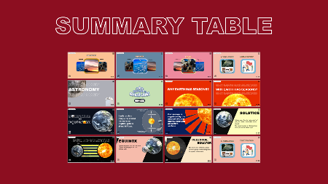
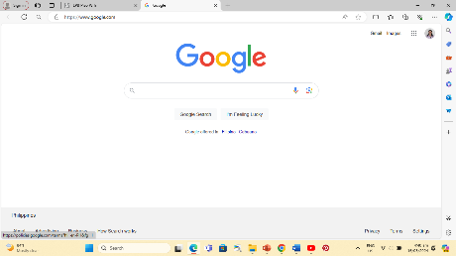
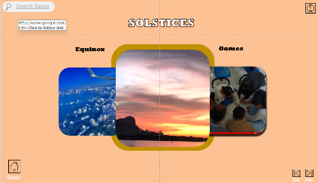

and research objectives to help users comprehend the material. The previous icon allows users to return to the previous slide, while the next icon facilitates movement to the next slide, ensuring a consistent viewing experience.
Activity Section
The activity "4 Pics and 1 Word" serves as the motivation part of the presentation upon which engages participants in guessing words based on provided images, fostering critical thinking and vocabulary skills. Interactive features accompany this activity to enhance user experience and facilitate learning. The clear icon allows participants to reset the word, providing them with a fresh opportunity to make an accurate guess. In cases where additional assistance is needed, the hint icon offers hints by revealing one letter of the word at a time, aiding participants in their deduction process. For immediate feedback, the reveal icon displays the correct word, promoting comprehension and reinforcing learning outcomes. Upon successfully guessing the word, participants can proceed to the next question using the check icon. Conversely, the wrong icon signals an incorrect guess, encouraging participants to make another attempt until the correct answer is found.
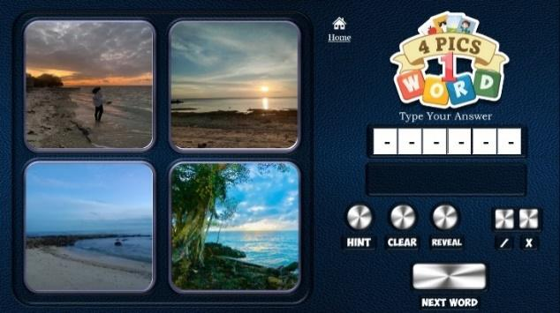

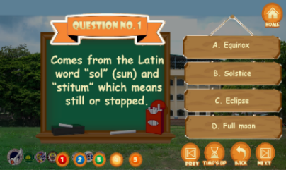
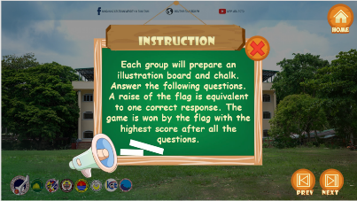
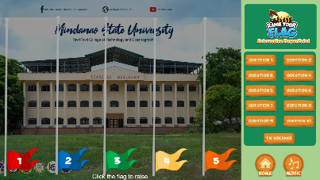

Additionally, the collaborative activity "Raise Your Flag" promotes teamwork and cooperation among participants. To streamline navigation within the activity, icons for question numbers guide users to different questions, while the choices icon presents multiple-choice selections for each question, ensuring clarity and ease of participation. These features collectively contribute to an engaging and interactive learning environment, fostering both individual skill development and collaborative learning experiences.
Lecture Section
This section offers a detailed explanation of the solstice and equinox, highlighting their significance in astronomical events. The solstice occurs when the sun reaches its highest or lowest point in the sky, with summer and winter solstices. The equinox occurs twice a year, with day and night equal, and the sun crossing the celestial equator. Understanding these events is crucial for understanding the progression of seasons, with 3D animations illustrating the seasons of spring, summer, autumn, and winter.
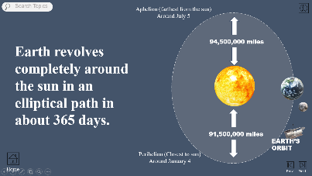
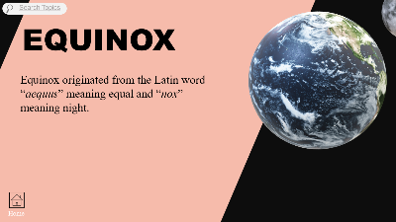
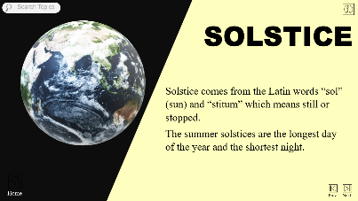

Interactive Presentation Slides in Teaching Solstice and Equinox for Grade 7 Students: 2.0
The 2.0 version of the interactive educational presentation slides was developed after validation by experts on the following variables: design, presentation, students’ activity, and content. Their suggestions and comments were meticulously taken into consideration to enhance the overall quality and effectiveness of the slides. This iterative process ensured that the final product not only met educational standards but also maximized student engagement and learning outcomes. It is a significant upgrade from 1.0, with better backgrounds, games, and content. While keeping familiar icons, it offers an improved learning experience. New features like an upgraded search bar for online searches and revamped games enhance the interactive learning environment. The slides are divided into three main categories—solstice, equinox, and games—covering various topics with clear diagrams and animations. Engaging game formats like "4 Pics and 1 Word" and Kahoot-inspired assessments boost student participation and learning outcomes. This introduction previews the structure and features of the 2.0 slides, emphasizing their potential to enhance learning and encourage active engagement in scientific topics.
Activity Section: Group Activity
The development of the 2.0 version of the interactive educational presentation slides followed a rigorous validation process by experts, focusing on variables such as design, presentation, student activities, and content. Their suggestions and comments were meticulously incorporated to enhance the overall quality and effectiveness of the slides.
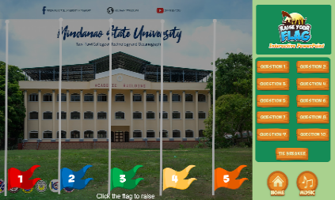
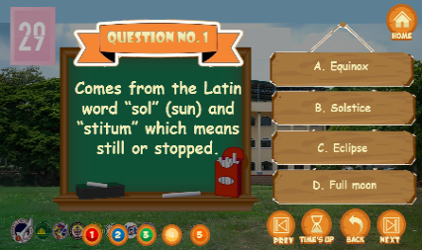
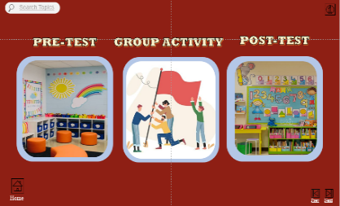
One significant upgrade in version 2.0 is the enhancement of the "Raise your flag" feature. Compared to version 1.0, where students needed to return home before raising the flag, the new version allows flags to be raised more easily and includes a 30-second timer to add urgency and excitement. This is one of the many games in the presentation. That intends to measure students' abilities to work effectively together, as well as their understanding and recall of the material presented.

Activity Section: Pre-Test and Post-Test Assessment
Another feature added to the interactive educational presentation slides is the pre-test and post-test assessment, as suggested by the experts. These assessments help gauge students' prior knowledge and measure their learning progress. By comparing pre-test and post-test results, educators can identify areas of improvement and ensure that learning objectives are met.
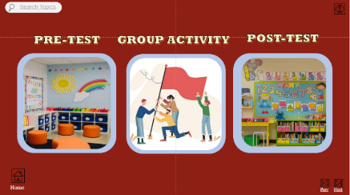
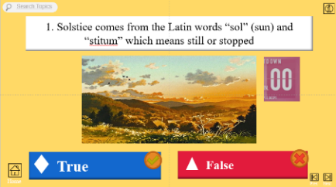
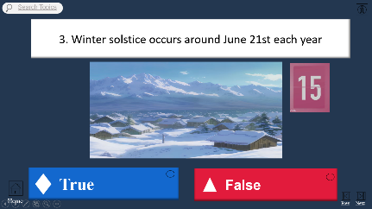
The pre-test evaluation is modeled after the Kahoot platform and consists of a true or false questionnaire designed to assess participants' previous knowledge. This assessment method is designed to be simple to use, with a 15-second timer and image clues for added clarity.

Subsequently, the post-test assessment includes fill-in-the-blank questions to assess information retention. Notably, the period for this phase is increased to 30 seconds to give participants enough time to think, while illustration hints remain to help comprehension. Furthermore, the presentation includes navigational cues in the form of previous and next icons, allowing for smooth flow through the slides.
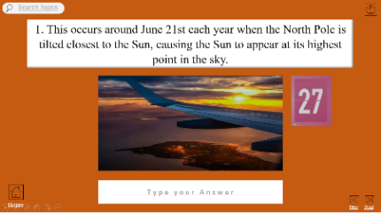
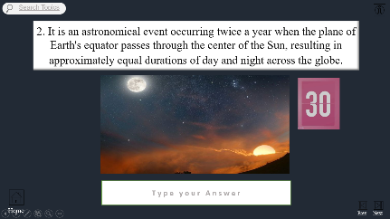

These interactive elements are designed to promote active participation and reinforce learning outcomes in a stimulating and engaging manner.
Lecture Section
The presentation is divided into two sections: "Solstice" and "Equinox," which discuss the winter and summer solstices, as well as the Vernal and Autumnal Equinoxes.
Solstice
Based on the suggestions and comments of the validators and experts. The "Solstice" undergone expansion, incorporating multiple presentations comprising diagrams, illustrations, and 3D animations, aimed at enhancing understanding. The solstice denotes moments in the year when the Sun reaches its highest or lowest point in the sky at noon, with two notable occurrences: the Summer Solstice, typically around June 21st, marking the longest day of the year, and the Winter Solstice, usually around December 21st, marking the shortest. These additions were absent in the previous version of the Interactive Educational Presentation Slides (IEPS) and was added to further aid the students to fully understand the concept behind the astronomical event. Through our 3D animation, we illustrate how the Earth's tilt and orbit around the Sun give rise to these phenomena, facilitating visualization and comprehension of the concept.
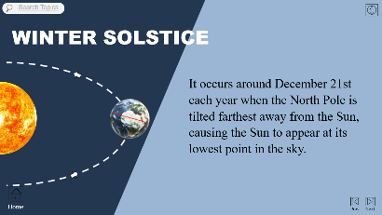
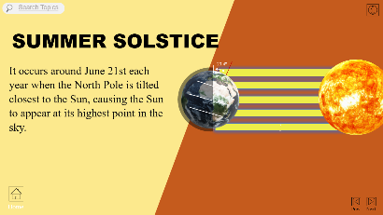
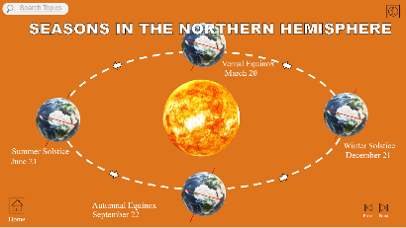

Equinox
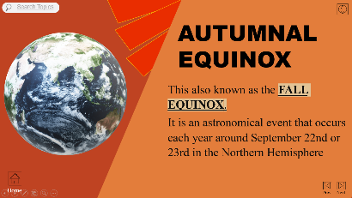

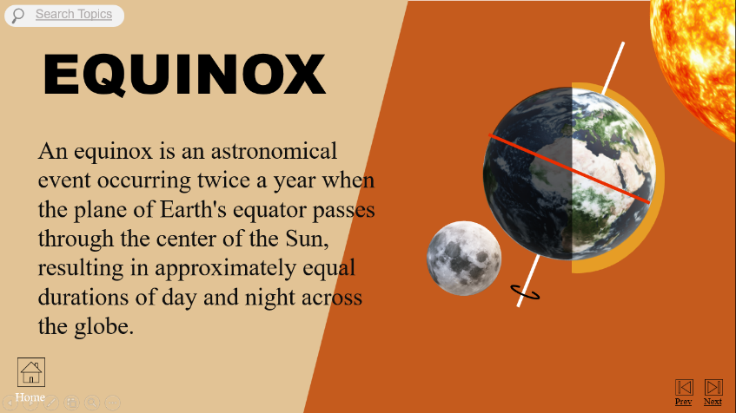
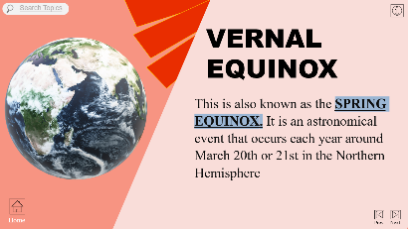
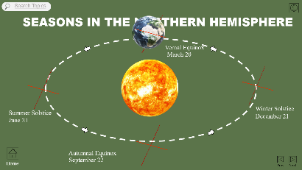

Similarly, the section discussing 'Equinox' has also seen upgrades, ranging from the addition of information to improvements in organization and iteration, all aimed at aiding student comprehension. Equinoxes occur twice a year, typically around March 21st and September 23rd, when day and night are of equal duration. Our presentation now offers a clearer and more organized explanation of these events, supplemented with relevant visuals and interactive elements. This iterative approach ensures that students have ample opportunity to engage with and grasp the complexities of the topic.

Educators should prioritize the development of teaching-learning materials. As such, teaching and learning materials are the resources that teachers and instructors in schools utilize to aid students in learning and comprehending concepts (Teaching Learning Materials, n.d.). According to Kapur (2019) and Bušljeta (2013), the TLMs should be given greater attention as a major aspect that would promote students' learning and help in the realization of academic goals and objectives. Presentation slides, like PowerPoint presentations, are common teacher learning materials.
With this in mind, the researchers developed interactive educational presentation slides that incorporate multimedia elements such as videos, images, and interactive quizzes to enhance student engagement and understanding. By utilizing these advanced teaching materials, educators can create a more dynamic and interactive learning experience for their students, ultimately leading to improved academic performance and achievement.
However, criticism regarding the ineffective utilization of PowerPoint presentations in educational settings has been articulated by Garner & Alley (2013) and Nwangwu (2018). They argue that many educators often exhibit poor design practices in their presentations, characterized by the indiscriminate inclusion of dense textual information, a lack of multimedia integration, and a disregard for principles of effective design.
In contrast, the newly developed interactive presentation slides, specifically the interactive elements of the presentation, were widely accepted by teachers. The technical issues were minimal, and efforts were made to ensure accessibility for all users. Users highly praised the interactive educational presentation slides for their engaging design and effectiveness in facilitating learning and student participation.
Similarly, Nwangwu and Obi (2014) highlight the incompetence of lecturers in crafting engaging presentations, attributing the inefficacy of PowerPoint to issues such as slide quantity, distracting design elements, and overloading information. On the other hand, the developed interactive presentation slides feature balanced content, visual aids, and clear narratives, which are consistent with the RRL's discussion on the effectiveness of multimedia presentations in enhancing learning outcomes. Furthermore, the presentation slides highlight the use of specific fonts for readability and the inclusion of accessibility features, such as saving and resuming presentations. This aligns with the RRL's discussion on the importance of creating teaching-learning materials that are accessible to all students, including those with disabilities.
To some extent, PowerPoint is widely utilized in educational settings to transform complex information into organized, visually accessible formats. As noted by Lari (2014) and supported by Savoy, Proctor, and Salvendy (2009), students often express a strong preference for technology-aided lectures, reporting that the structured delivery helps them better categorize and recall verbal information compared to traditional blackboard methods. In congruence with this study and the newly developed interactive presentation slides, all evaluators, including both students and teachers, strongly agreed that the design of the interactive presentation slides was highly acceptable. Specific fonts were used to enhance readability, and the inclusion of images, audio, and interactive elements contributed to engagement and understanding.
Following this, Park (2013) indicated that PowerPoint presentation materials help instructors design and deliver contents effectively for students to successfully process cognitively. This emphasized the significance of well-designed content. Similarly, the slides feature balanced content, visual aids, and clear narratives, which are consistent with the RRL's discussion on the effectiveness of multimedia presentations in enhancing learning outcomes.
Meanwhile, according to Pappas (2013a), irrespective of the fact that there are many other presentation tools like SlideShare, Prezi, iSpring, and Interactive PDF, 95 percent of decks are still made using PowerPoint software because it has a lot of benefits, including multimedia handling, infographics, and e-learning development, among others. This highlights the importance of incorporating interactive elements to engage students actively in the learning process. In similarity, the developed interactive presentation slides feature specific activities, collaboration opportunities, and quizzes, which correlate with the RRL's emphasis on making lectures more active and student-centered through interactive elements.
Research by Kintu, Zhu, and Kagambe (2017) and Shah and Khan (2015) have shown that multimedia instructions with high interaction levels lead to increased learner satisfaction, academic achievement, engagement, and a positive attitude toward teaching and learning.
On the other hand, teachers acknowledged the effectiveness of specific activities designed to encourage student participation. Opportunities for collaboration and interaction among students were present in the presentation, contributing to its overall engagement. However, there were some concerns about accessibility for students with disabilities and the provision of post-presentation resources.
Level of Validity of The Developed Interactive Educational Presentation Slides in Teaching Solstice and Equinox
Table 1: Descriptive analysis of validity of the developed educational presentation slides
Table 1 presents the validity ratings of the developed Interactive Educational Presentation Slides (IEPS) in teaching solstice and equinox as evaluated by expert validators. Four dimensions were assessed, namely design, presentation, students’ activity, and content, using weighted mean and standard deviation.
VARIABLES | MEAN | SD | INTERPRETATION
Design | 4.4 | 0.57 | Strongly Agree
Presentation | 4.24 | 0.55 | Strongly Agree
Students’ activity | 4.2 | 0.68 | Strongly Agree
Content | 4.44 | 0.59 | Strongly Agree
Overall Mean | 4.32 | 0.60 | Strongly Agree
As shown in Table 1, the developed IEPS obtained an overall validity rating of M = 4.32 (SD = 0.60), interpreted as Strongly Agree, indicating that the instructional material was perceived as highly valid by the expert evaluators. Among the evaluated dimensions, content received the highest mean rating (M = 4.44, SD = 0.59), suggesting strong expert agreement regarding the scientific accuracy, relevance, and alignment of the material with the intended learning competencies. Likewise, the design dimension obtained a high rating (M = 4.40, SD = 0.57), indicating that the visual organization, readability, and multimedia integration were considered appropriate for classroom instruction. The presentation (M = 4.24, SD = 0.55) and students’ activity (M = 4.20, SD = 0.68) dimensions also received strong agreement, reflecting positive expert perceptions regarding instructional delivery and learner engagement features. Overall, the consistently high ratings across all dimensions indicate strong expert consensus on the instructional quality and pedagogical suitability of the developed IEPS.
Level of Acceptability of the Teachers towards the Interactive Educational Presentation Slides
Table 2: Descriptive Analysis of Teachers’ Acceptability of the Developed Interactive Educational Presentation Slides

Variables | Mean | SD | Interpretation
Design | 4.77 | 0.39 | Highly Acceptable
Presentation | 4.57 | 0.66 | Highly Acceptable
Students’ Activity | 4.35 | 0.60 | Highly Acceptable
Content | 4.56 | 0.62 | Highly Acceptable
Overall Acceptability | 4.32 | 0.63 | Highly Acceptable
As presented in Table 2, the developed Interactive Educational Presentation Slides obtained an overall acceptability rating of M = 4.32 (SD = 0.63), interpreted as Highly Acceptable, indicating that the participating Science teachers viewed the instructional material as appropriate for classroom implementation. Among the evaluated dimensions, design received the highest rating (M = 4.77, SD = 0.39), suggesting strong teacher agreement regarding the readability, visual appeal, multimedia integration, and ease of navigation of the material. The presentation dimension likewise obtained a high mean score (M = 4.57, SD = 0.66), indicating that the sequencing, clarity, and delivery structure of the material were well received. Similarly, content (M = 4.56, SD = 0.62) and students’ activity (M = 4.35, SD = 0.60) were both rated highly acceptable, reflecting positive perceptions of the material’s instructional relevance, learner engagement features, and classroom applicability. The relatively low standard deviation values across dimensions further indicate consistency in teachers’ evaluations. Overall, the findings demonstrate strong teacher acceptance of the developed IEPS as an instructional intervention for teaching solstice and equinox.
CONCLUSION
The teaching of astronomical concepts such as solstice and equinox continues to present instructional challenges in basic science education due to the abstract nature of these phenomena and the persistent conceptual difficulties experienced by learners. Conventional instructional materials, particularly static and text-heavy resources, often provide limited support for visualizing the dynamic relationships among the Earth, the Sun, and seasonal changes. In response to this instructional need, this study focused on the development and validation of Interactive Educational Presentation Slides (IEPS) designed to support the teaching of these complex scientific concepts among Grade 7 learners.
Using a descriptive-developmental research design, the study systematically developed the instructional material and evaluated its quality through expert validation and teacher acceptability assessment across four instructional dimensions: design, presentation, students’ activity, and content. The findings revealed that the developed IEPS obtained high ratings in both validity and acceptability, indicating strong expert consensus regarding its instructional quality, pedagogical appropriateness, technical usability, and alignment with intended science learning competencies.
The consistently high evaluations suggest that the developed instructional material possesses the essential characteristics of a classroom-ready educational resource. The integration of multimedia elements, interactive activities, visual representations, and learner-centered features was positively perceived by expert validators and participating science teachers, supporting the material’s appropriateness for instructional implementation.
The findings also support established instructional theories. The multimedia design features of the developed IEPS are consistent with the principles proposed by Richard E. Mayer, which emphasize the importance of meaningful multimedia integration in facilitating cognitive processing. Likewise, the learner-centered and interactive features of the material align with the educational principles of Malcolm Knowles and Manu Kapur, which highlight the value of active learner engagement in knowledge construction.
In conclusion, the developed Interactive Educational Presentation Slides demonstrated high levels of validity and acceptability and show strong potential as a technology-supported instructional resource for teaching solstice and equinox in secondary science education. While this study did not measure student learning outcomes or instructional effectiveness through experimental implementation, the findings provide empirical support for the pedagogical suitability and classroom applicability of the developed material. Future studies may further examine its impact on learners’ conceptual understanding, academic performance, and misconception reduction through classroom-based implementation and experimental evaluation.
Implications, Recommendations, and Future Directions
Science teachers implementing interactive educational presentation slides in classroom instruction are encouraged to adopt technology-enhanced, learner-centered, and concept-focused teaching approaches that promote active participation and meaningful learning. Instructional activities should be designed to simplify abstract scientific concepts through the use of multimedia elements such as animations, videos, interactive quizzes, and collaborative learning tasks, allowing learners to better understand complex topics such as solstice and equinox. Teachers are likewise encouraged to strengthen their competencies in instructional design, multimedia integration, and classroom technology use through continuous professional development and collaborative lesson planning. Equally important is the creation of engaging, inclusive, and supportive learning environments that accommodate diverse learning styles and encourage student curiosity, confidence, and scientific inquiry.
School administrators and educational leaders are encouraged to provide stronger institutional support for technology-integrated science instruction by allocating adequate instructional resources, improving access to digital tools, and facilitating collaborative training opportunities between teachers and technology experts. Educational institutions, particularly those in geographically remote and underserved areas such as Tawi-Tawi, are encouraged to invest in accessible and sustainable digital learning resources that can support equitable and quality science education. Such institutional support may help address instructional challenges related to limited teaching materials, student misconceptions, and unequal access to innovative learning opportunities.
Curriculum developers and teacher education institutions are encouraged to design contextualized, culturally relevant, and interactive teaching-learning materials that respond to the needs of diverse learners across different educational settings. Multimedia-based instructional approaches may also be integrated into other science topics and subject areas to promote deeper conceptual understanding, learner engagement, and interdisciplinary learning. At the policy level, continued support for instructional innovation, teacher training, and technology integration is necessary to strengthen science education and promote inclusive learning opportunities in both urban and rural schools.
Future research may further examine the effectiveness of interactive educational presentation slides on students’ academic achievement, conceptual change, critical thinking skills, and long-term knowledge retention. Longitudinal studies may also investigate the sustained impact of multimedia instructional materials on learner performance over time. In addition, future researchers may explore the development of similar instructional materials for other scientific concepts or investigate the integration of emerging technologies such as virtual reality, augmented reality, and simulation-based learning environments to further enhance student engagement and learning outcomes.
REFERENCES
- Banagbanag, R. C. (2020). ESL teachers’ attitudes and competence on communicative language teaching (CLT) methodology. International Journal of English Language Teaching, 8(3), 15–27. https://www.eajournals.org/journals/international-journal-of-english-language-teaching-ijelt/
- Barcelona, M. L., & Protacio, M. S. (2025). English language teaching in the contexts of Alternative Learning System (ALS) in South Cotabato: A phenomenological inquiry. Journal of Alternative Education Studies, 4(1), 22–38.
- Bartlett, R. (2020). Teachers’ and students’ experiences within the communicative language course of study in Japanese high schools: An instrumental case study. Asian EFL Journal, 24(2), 45–63. https://asian-efl-journal.com/
- Canale, M., & Swain, M. (1980). Theoretical bases of communicative approaches to second language teaching and testing. Applied Linguistics, 1(1), 1–47. https://doi.org/10.1093/applin/1.1.1
- Cebu Community Academy Research Group. (2024). Attitudes of Alternative Learning System learners toward learning the English language. Philippine Journal of Educational Research, 9(1), 60–74.
- Chang, M. Y., & Suparmi, S. (2020). The implementation of communicative language teaching and factors hindering teachers from implementing it in high school. Al-Ta’dib: Journal of English Education, 13(2), 110–123. https://doi.org/10.31332/atdb.v13i2.1784
- Creswell, J. W., & Poth, C. N. (2018). Qualitative inquiry and research design: Choosing among five approaches (4th ed.). Sage Publications. https://us.sagepub.com/en-us/nam/qualitative-inquiry-and-research-design/book246896
- Department of Education. (2019). Alternative Learning System (ALS) K to 12 basic education curriculum. Department of Education. https://www.deped.gov.ph/k-to-12/about/k-to-12-basic-education-curriculum/
- Francisco, J. P., & Buri, A. R. (2024). The lived experiences of Alternative Learning System teachers in English literacy instruction. Philippine Social Science Journal, 7(2), 89–104. https://doi.org/10.52006/main.v7i2.750
- Gloriez, L. P. (2022). Communicative language teaching and its implementation in online learning: The teachers’ voice. Journal of English Language Teaching and Linguistics, 7(1), 33–48. https://doi.org/10.21462/jeltl.v7i1.834
- Hymes, D. (1972). On communicative competence. In J. B. Pride & J. Holmes (Eds.), Sociolinguistics (pp. 269–293). Penguin.
- IAFOR ACLL Research Team. (2016). Teachers’ beliefs, practices, and challenges in using communicative language teaching in an ESL context in the Philippines. In Asian Conference on Language Learning proceedings (pp. 215–228). https://papers.iafor.org/
- Kvale, S., & Brinkmann, S. (2015). InterViews: Learning the craft of qualitative research interviewing (3rd ed.). Sage Publications. https://us.sagepub.com/en-us/nam/interviews/book239402
- Nguyen, T. M. H., & Ngo, T. H. (2021). Teachers’ beliefs and practices in communicative language teaching: A contextual analysis. TESOL Quarterly, 55(3), 906–930. https://doi.org/10.1002/tesq.3032
- Republic Act No. 9155. (2001). Governance of Basic Education Act of 2001. Official Gazette of the Republic of the Philippines. https://www.officialgazette.gov.ph/2001/08/11/republic-act-no-9155/
- Republic Act No. 10173. (2012). Data Privacy Act of 2012. Official Gazette of the Republic of the Philippines. https://www.officialgazette.gov.ph/2012/08/15/republic-act-no-10173/
- Sato, M., & Loewen, S. (2020). Do teachers practice what they preach? A study on communicative language teaching. Modern Language Journal, 104(1), 168–187. https://doi.org/10.1111/modl.12618
- Sitoy, J. S., & Sonsona, P. M. (2023). Investigating the use of communicative language teaching (CLT) strategies to promote innovative teaching and learning approach. Journal of Pedagogical Innovations, 5(2), 77–92.
- Smith, J. A. (1996). Beyond the divide between cognition and discourse: Using interpretative phenomenological analysis in health psychology. Psychology and Health, 11(2), 261–271. https://doi.org/10.1080/08870449608400256
- Smith, J. A., & Fieldsend, M. (2021). Interpretative phenomenological analysis. In P. M. Camic (Ed.), Qualitative research in psychology: Expanding perspectives in methodology and design (2nd ed., pp. 147–166). American Psychological Association. https://doi.org/10.1037/0000252-008
- Smith, J. A., Flowers, P., & Larkin, M. (2009). Interpretative phenomenological analysis: Theory, method and research. Sage Publications. https://us.sagepub.com/en-us/nam/interpretative-phenomenological-analysis/book232496
- Smith, J. A., & Nizza, I. E. (2022). Interpretative phenomenological analysis (2nd ed.). American Psychological Association. https://doi.org/10.4135/9781529798055

