Attention-Enhanced YOLOv8 for Real-time Milkfish Disease Detection with Synthetic Data Augmentation

ABSTRACT
Milkfish (Chanos chanos) aquaculture faces persistent challenges due to disease outbreaks that are difficult to detect at early stages using traditional manual monitoring methods. Varied underwater lighting conditions, turbidity, and fish movement further complicate visual assessment and may reduce detection reliability. This study proposes an automated disease detection framework that combines YOLOv8m object detection and the Convolutional Block Attention Module (CBAM) with CycleGAN-based synthetic data augmentation. CycleGAN is employed to generate additional diseased samples from unpaired image domains, addressing dataset imbalance and improving training diversity. CBAM is integrated into the YOLOv8m feature extraction pipeline to enhance spatial and channel attention while preserving real-time inference capability. Multiple experimental training configurations were evaluated, including raw-image training, traditional augmentation techniques, CycleGAN-augmented datasets, and attention-enhanced detection models. Performance was assessed using precision, recall, mAP@0.50, and mAP@0.50–0.95 metrics. The proposed YOLOv8m with CBAM and CycleGAN framework achieved the best overall performance, with a precision of 0.940, a recall of 0.910, mAP@0.50 of 0.945, and mAP@0.50–0.95 of 0.725. These results indicate that the combined use of GAN-based augmentation and attention mechanisms significantly improves detection performance under a realistic aquatic environment.

Keywords: Milkfish disease detection, YOLOv8, CycleGAN, CBAM, Synthetic data augmentation

INTRODUCTION
Milkfish (Chanos chanos) is an important aquaculture species in Southeast Asia and plays a major role in the region's food security and the livelihoods of people living around coastal areas (Martínez, Tseng, & Yeh, 2006). Nevertheless, despite its great importance, outbreaks of the disease continue to be one of the most prevalent problems since they spread rapidly and can lead to great losses in terms of economic benefits. On the other hand, diseases in aquaculture are often difficult to detect at an early stage because of subtle symptoms that can only be identified when the disease is in the advanced stage. In most fish pens, especially in the Philippines, monitoring health has been done through manual observation, which is labour-intensive and is mostly based on the experience of the fish farmers.
Several technological advances, particularly in the field of computer imagery, have been adopted to perform this task. Non-intrusive technologies such as sensors, cameras, and IoT have been used in some regions to assist fish farmers in managing their pens (Chang, et al., 2022). However, despite of these advances, disease detection still poses an ever-existing challenge especially when working in the underwater environments, such as unfavourable water turbidity, varying light conditions, the movement of the fish, and the angles of view from the camera, which usually tend to lower the quality of the images taken and make it hard even for the trained observer to make accurate judgments about the image data being observed. Relatively, manual inspection is inconsistent and may detect subtle abnormalities, especially when monitoring a large number of fish. These difficulties highlight the importance of automating the methods of monitoring and the conduct of around-the-clock observation to provide objective, reproducible analysis of fish health.
Advancements in computer vision models, particularly deep learning models, made it possible to automate the analysis of underwater images. Tasks such as fish counting, species identification, and behaviour monitoring have been successfully assisted by Convolutional Neural Networks (CNNs). One of these approaches is the family of You Only Look Once (YOLO) detectors that has become popular for its architecture of fast, accurate detection. Unlike traditional models, which need two-stage processing, making them relatively slower, the YOLO approach treats the detection as a single regression problem, and it can detect the objects with bounding boxes and class probabilities at the same time at over 45 frames per second (FPS) (Deepika, Raghuveer shetty, & G N, 2020). This reason makes this model a powerful tool for early signs of fish disease detection underwater in real time.
However, the performance of deep learning models strongly depends on the availability and diversity of training data (Alfred, Leo, & Kaijage, 2025). In the case of detecting milkfish diseases, it is often impractical and difficult to collect large numbers of diseased samples, thus leading to an imbalance across classes; that is, the margin between the number of healthy fish and diseased fish can be too wide. Therefore, models trained only on raw images might find it hard to generalize to new environments or to new disease manifestations (Komori & Eguchi , 2019). Although some traditional data augmentation techniques can partially address this problem, they usually introduce limited variations and may not be able to sufficiently reflect the complexity of real-world visual conditions (Prova, 2024). An alternative way of increasing the number of diseased samples is through the use of the Generative Adversarial Network, or GAN. Among these, the CycleGAN has gained popularity due to its unpaired image-to-image translation framework. This is particularly helpful when dealing with a limited class in the dataset, where controlled acquisition of a paired dataset is rarely feasible (Chen, Pan, & Wu, 2023). For instance, if the diseased fish sample is relatively small in number compared to the healthy fish sample, generating synthetic data would significantly help balance the dataset.
Furthermore, several studies have demonstrated that a model’s performance can be further improved by architectural refinements. Several studies have demonstrated improved model performance by integrating attention mechanisms, particularly the Convolutional Block Attention Model (CBAM). Doing so allows neural networks to highlight the informative spatial and channel-wise information and reduce the influence of background noise. Attention-based refinement of features can prove useful, especially in underwater imaging, where disease indicators can cover only small parts of the fish body ( Khabusi, Huang, & Lee, 2023) (Biswal, Kumar, & Punuri, 2024). The YOLOv8m model typically looks at all the parts of the image equally in detection; however, an underwater image may contain a lot of unimportant information, such as water background, reflection, and light noises, floating particles, shadows, and fish parts that are not affected by disease. CBAM will help pay attention to the important areas where physical abnormalities are, and pay less attention to irrelevant regions.
This paper will provide a systematic evaluation of milkfish disease detection using YOLOv8-based models in the context of varying data augmentation and model architecture configurations. Different experimental setups were performed using raw data, traditional augmentations, GAN-based dataset augmentation, and finally, the integration of the Convolutional Block Attention Model to the YOLOv8 medium variant. The performance is evaluated using the standard detection metrics, such as precision, recall, mAP (0.50), mAP (0.50-0.95), and processing speed.
The novelty of this study lies in the integration of CycleGAN-based augmentation coupled with YOLOv8 model enhancement with CBAM design for real-time disease detection implementation. It mainly addresses the challenges of the underwater detection task by improving the focusing mechanism of YOLOv8 and addresses the limitation of disease samples through synthetic data augmentation.

RELATED WORKS
The application of deep learning techniques to improve detection accuracy and operational efficiency has been thoroughly studied in recent years. These research efforts can generally be categorized into two directions: (1) Enhancement and modification of YOLO-Based Object Detection in Aquatic and Real-Time Applications, and (2) GAN-Based Data Augmentation for Limited and Imbalanced Datasets. YOLO object detectors have been shown to have great potential in applications related to real-time fish monitoring, whereas generative models like GANs have been explored as a solution to class imbalance and small training samples. Simultaneously, attention mechanisms have been presented to improve the work of neural networks by prioritizing information and minimizing the background. This section reviews relevant studies related to the three categories to determine the technical foundation of the proposed approach, as well as the existing gaps in the research that motivate the design of the YOLOv8m with CycleGAN and CBAM framework.

Enhancement and modification of YOLO-Based Object Detection in Aquatic and Real-Time Applications
YOLO-based models have become increasingly prominent in object detection tasks, particularly in a real-time monitoring setup. Unlike the traditional two-stage detectors, such as R-CNN, Faster R-CNN, Feature Pyramids, etc., which are characterized by modular architectures that separate the detection processes and classification phase, YOLO processes the entire image in a single forward pass, enabling high detection accuracy while maintaining high detection performance ( Bharti, 2024). This architecture makes YOLO practically suitable for real-time, underwater object detection tasks.
This section explores studies that show the continuous improvements in YOLO performance, particularly in an aquatic environment. The DyAqua-YOLO achieved a mAP@50 of 0.918 on a Dense Underwater Objects (DUO) public dataset at 21 FPS on an embedded hardware (Li & Peng, 2025). The CEH-YOLO, an enhanced YOLOv8 which incorporates high-order deformable attention (HDA) to enhance spatial feature extraction, enhanced spatial pyramid pooling-fast (ESPPF) for extraction of object attributes, and customized composite detection (CD) to improve accuracy and inclusivity, reached 88.4% mAP at 156 FPS (Feng & Jin, 2024) . On the other hand, the UOD-YOLO, a framework based on YOLO11n integrates three components: (1) the RepVit for feature representation, (2) a scale-sequence feature fusion (SSFF), and a triple feature encoding (TFE) to enhance multi-scale feature extraction and representation, and (3) attention mechanism (CPAM) in the head layer to strengthen small-object detection. This model improved the mAP@50 of its baseline model by 3.5% while reducing parameters by 36.3% and achieving 279.8 FPS (Xi & Yin, 2025). The RTL-YOLOv8n, with a modified head (LCD-Head), computational requirements by 31.6%, and an enhanced Focaler–MPDIoU loss function, showed a 1.5% increase in mAP@0.5 and a 5.2% improvement in precision compared to other models (Guanbo, et al., 2024). The AOD-YOLO, another improved model based on YOLOv11s, with four enhancements: first, incorporating Sobel operators and pooling operations (SPFE) to effectively extract features, particularly edges and global structural features. Second, the integration of RGL (RepConv and Ghost Lightweight) for feature mapping, decreasing parameter size, and reducing computational costs. Third, the MDCS (Multiple Dilated Convolution Sharing Module) for improved multi-scale target recognition. And lastly, C2PSA module to C2PSA-M (Cascade Pyramid Spatial Attention—Mona) by integrating the Mona mechanism to enhance visual signal processing and information distribution. The model achieved an accuracy of 2.6% improvement over YOLOv11s URPC2020 dataset and 2.4% improvement on RUOD dataset.
Despite of these significant improvements on the YOLO architecture for underwater detection, most of these enhancements focus on the architectural components such as feature fusion, attention mechanisms, and multi-scale representation to improve accuracy and speed. The models such as DyAqua-YOLO, CEH-YOLO, and UOD-YOLO exhibited strong performance on public datasets; however, these enhancements generally assumes the availability of large and balanced datasets. One of the major limitations of these studies is the lack of emphasis on class imbalance and scarcity of data, especially in mapping subtle information relevant to fish diseases. Additionally, many of the modified YOLO architecture have increased computational cost due to the complexity of the architecture, thereby potentially limiting the real-time deployment.
In contrast, this study addresses these gaps by integrating a more light-weight CBAM attention mechanism to enhance feature representation. Moreover, the limitation in dataset and class imbalance was addressed through the introduction of a GAN-based data augmentation. This approach provides a more practical solution for detecting subtle disease information in underwater environment.

GAN-Based Data Augmentation for Limited and Imbalanced Datasets

As previously mentioned, data scarcity has been a major challenge in fish disease detection, particularly in training a detection model due to it potentially leading to class imbalance. Data scarcity and class imbalance are two distinct challenges but are often co-occurring (Minouei, Soheili, & Stricker, 2024). Traditional techniques such as flipping, rotation, colour adjustments, etc. may be used to augment the limited samples, however, these techniques might not capture essential visual information in real-time settings (Gong, Wang, Li, Chandra, & Liu, 2021). To address these limitations, Generative Adversarial Network (GAN) has been widely explored as an alternative approach in data augmentation.
This sections explores studies that demonstrates how GAN-based augmentation effectively improves object detection performance and address class imbalance and scarcity of dataset. In a study of Deng et al., 2025 (Deng, Ryu, & Lee, 2025), an image generation method was developed to create synthetic fish disease images from healthy fish, improving the performance of ResNet50 by 6.0% in precision, 4.4% in recall, 3.8% in F1-score, and 4.4% inaccuracy (Deng, Ryu, & Lee, 2025). The IDA-GAN, a GAN-based augmentation method introduced a variational autoencoder coupled with GAN to learn minority and majority classes. The generative model later learned useful features of to generate samples for the minority class. Compared to the traditional GAN, their experimental results show that the model can generate more diverse minority samples to benefit the imbalanced classification task (Yang & Zhou, 2021). Another variant of GAN, the StyleGAN2-ADA, has demonstrated 17.9% detection performance improvement on all algal genera and 32.1% on rare genera by enhancing algal image instance segmentation and generating an artificial single-algal images to address data scarcity and imbalance (Fung, Chan, Lo, & Tsang, 2023). R. Yuwana et al., 2020, used GAN and DCGAN for data augmentation to detect tea leaves diseases demonstrating DenseNet accuracy improvement by 88.84% compared to the baseline model (Yuwana, et al., 2020). Similar studies like the balancing GAN (BAGAN) which pragmatically applied autoencoders to initialize GAN, and collaborative discrimination-enabled GAN (CoD-GAN) which employed collaborative discrimination framework to improve discrimination robustness, both studies aim to address class imbalance through GAN-base data augmentation (G. Mariani, F. Scheidegger, R. Istrate,, C. Bekas, & A. Malossi, 2018) (Zhang, Li, & Liu, 2022).
Despite the effectiveness of these methods, IDA-GAN, StyleGAN2-ADA, BAGAN, and CoD-GAN in improving model performance and addressing class imbalance by generating synthetic images, these approaches are often evaluated in a controlled environments and do not fully consider real-world challenges such as noise, blur, motion blur, and lighting variability. Additionally, integration of GAN-based data augmentation with real-time detection remains limited. On the other hand, this study proposes the use of CycleGAN for unpaired data augmentation and utilize the generated data into an attention-based YOLOv8m model to improve detection and localization of milkfish disease features in a complex underwater environments.

PROPOSED WORK

This study proposes a hybrid deep learning framework for the real-time, early detection of milkfish disease in an underwater environment through visual analysis. The proposed method utilized the object detection capability of YOLOv8, medium variant, enhanced with the Convolutional Block Attention Module (CBAM) for improved feature representation by emphasizing relevant spatial and channel information of the image input. The objective of this modification is for the model to focus on disease-relevant regions, such as subtle lesions and abnormal texture patterns in the milkfish. To address dataset scarcity and class imbalance for the diseased fish samples, a CycleGAN data augmentation was implemented to produce synthetic diseased milkfish images used for the model training.
The experimental implementation of the system follows four major stages: dataset preparation, data augmentation, model enhancement, and model training and evaluation.

System Architecture

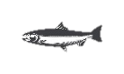


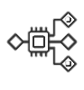

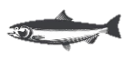
The system architecture of the proposed model follows a sequential pipeline that transforms underwater video input data into detection output using a modified YOLOv8m model. As shown in Figure 1, the process begins with gathering video footage of milkfish in an actual underwater environment using an underwater camera. The video recordings are then processed to extract individual frames using computer vision tools such as OpenCV. After the extraction, the images undergo data annotation in YOLO format where each frames are labelled with bounding boxes as diseased fish and healthy fish. To generate more data and to balance the two classes, CycleGAN augmentation is applied, improving model generalization. The augmented dataset is used to train the YOLOv8m and CBAM. The attention module will help the model focus on regions of the images that are relevant to milkfish diseases, such as lesions and abnormal texture patterns on the fish scales. Finally, the trained model performs real-time, early detection of milkfish disease, producing bounding box predictions and classification outputs assessing whether the milkfish in frame is diseased or healthy.
Figure 1. Proposed system workflow for real-time milkfish disease detection using YOLOv8m with CBAM and CycleGAN-based data augmentation.
Underwater Video Capture
Frame Extraction
Dataset Annotation
CycleGAN Augmentation
YOLOv8m with CBAM Training
Real-time Milkfish Disease Detection

Dataset Preparation
The dataset used in this study is self-collected and was acquired from a real aquaculture environment and is not publicly available. The use of real-world underwater milkfish data ensures that the model performance will be evaluated under realistic environmental conditions, including turbidity, lighting variation, and fish movement. The milkfish video footages were collected from a fish pen in Dagupan City, Pangasinan, Philippines, containing mainly milkfish. A single fish pen was used for gathering the video data used for the training process. A GoPro Hero 11 Black camera was used, taken approximately 2 feet below the water surface. The footages were recorded within a 30-minute length range, at 30 frames per second (fps) under a typical underwater environment in natural daylight. In order to use the videos as training data, an OpenCV Python script was used to extract individual frames at 2 frames per second, thus converting them to 17,211 images.
Water turbidity is a major issue in acquiring quality images underwater. Aquatic environments, especially fish pens, usually have high turbidity because of several factors. Fish pens have many suspended particles from unconsumed fish food, fish wastes, soil erosion, algae, planktons, and decaying organic matter. These cause images to be cloudy and noisy because the light penetrating the water is being scattered (Gaude & Borkar, 2020). This also lessens the contrast of the images, resulting in low transparency and reduced visibility.
The continuous fish movements of fish likewise blur to most of the images, especially with fish moving fast within the camera frame. Blurriness can cause loss of crucial details, creating confusion in a model’s algorithm in its classification performance (Garcia, Alvarez, & Marcia, 2023). Blurred images obstruct definitive characteristics, making it difficult for a model to classify, identify, and localize important information that we are trying to detect, that is, subtle physical abnormalities.
Another problem encountered when extracting video data is generating too many repetitive frames, as shown in Figure 2, because of the movement of the fish, which may cause model overfitting. Model overfitting may lower its ability to generalize to new data. The model treats these duplicate images as highly important patterns, causing it to memorize and specialize in them rather than learn the general pattern, leading to performance bias, overconfidence, and inaccurate performance on unseen details. Moreover, removing repetitive data helps reduce data redundancy and while preserving temporal diversity. And since the images were extracted in 2 fps, many of the consecutive frames showed almost the same position, angle, lighting condition, and background. These near duplicates were removed to prevent the model to memorize repeated patterns.
To ensure that the dataset to be used for the training of the model is optimal, the researchers manually filtered the 17,211 images, carefully removing the unwanted images such as blurry, repeated, and noisy, thus the finalized dataset consisted of 1,232 healthy images and 172 diseased images. The filtering process considered image quality, visual usefulness, and image uniqueness. Frames were discarded if the image is severely blurred, have excessive noise, very low contrast, or when consecutive frames showed almost the same fish position. Blurry and low contrast images were removed because the lesions, discolorations, and abnormal patterns are almost indistinguishable. Repetitive images were discarded to avoid training model to almost identical images. The resulting 1,404 dataset poses another challenge: class imbalance, which may cause the model to be biased towards the majority class.
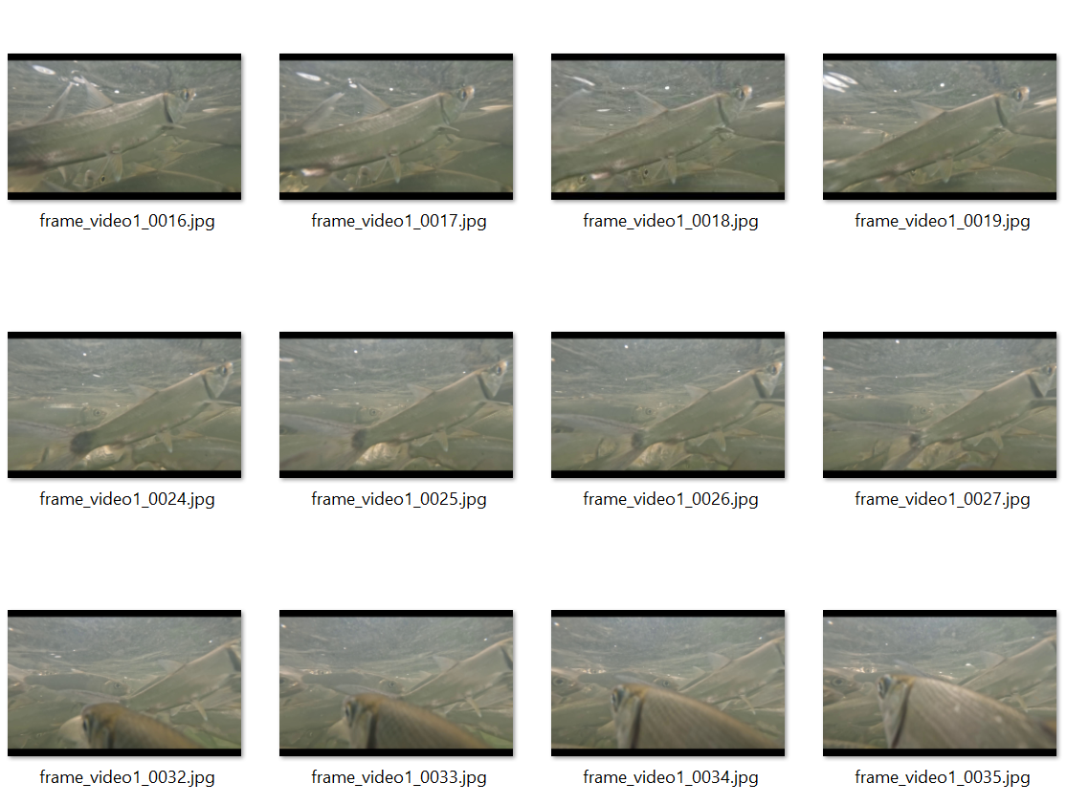
The dataset was organized into detection classes: healthy milkfish and diseased milkfish. The healthy class refers to samples with normal physical appearance, no visible lesions, and have clear scale patterns. The diseased class on the other hand, refers to milkfish having visible physical abnormalities such as lesions, discoloration, wounds, pale or dark patches, and abnormal scale patterns. Since the model is intended to be deployed in real-time setup, the disease category was based on observable external manifestations rather than laboratory-confirmed disease types. Therefore, the model was trained to detect whether the fish appeared healthy or diseased based on visible physical indicators. The dataset was annotated and labelled in Roboflow.
Figure 2. Sample Repetitive images extracted from the underwater footage. Fish motion captured and extracted at 2 fps resulted in repetitive images that needed to be manually discarded during the selection process.

CycleGAN Dataset Augmentation
In order to address class imbalance due to the limitation of diseased fish samples, a variant of Generative Adversarial Network, the CycleGAN, has been employed in order to augment the disease samples for training. CycleGAN, as previously mentioned, is a deep learning framework designed for image-to-image translation, without requiring paired training data, making it an ideal model to generate and add more realistic diseased fish samples to be used in training the modified YOLOv8m model (Zhu, Park, Isola, & Efros, 2017). This augmentation approach improves dataset diversity, reduces class imbalance, and enhances model generalization.
The CycleGAN training process starts with the careful selection of 359 healthy and 323 diseased milkfish images. The initial dataset, containing only 172 diseased samples, was augmented with traditional augmentation techniques such as saturation adjustments, background removal, increased sharpness, cropping, flipping, and additional public images from the web to improve diversity, thus normalizing the sample size to around 300 images across the two domains. This pre-processing step ensures that the visual features relevant to milkfish disease detection, e.g., physical abnormalities such as lesions and discolorations, are clear and consistent, and will enable CycleGAN to accurately map the variations between healthy and diseased samples.
The transformation of healthy samples into visually realistic diseased variants starts by learning a mapping between two domains – healthy (X) and diseased (Y) – without requiring pixel-level correspondences (Zhu, Park, Isola, & Efros, 2017).
The adversarial loss for the mapping $G:X⟶Y$ with discriminator $D_{Y}$ is defined as (Zhu, Park, Isola, & Efros, 2017):
$L_{GAN}\left(G, D_{Y}, X, Y\right)={{E_{y}}_{Pdata}}_{(y)}[\log{D_{y}\left(y\right)]+E_{x}{\sim _{Pdata}}_{(x)}[\log{(1-D_{Y}\left(G\left(x\right)\right))]}}$ (1)
On the other hand, drawing the adversarial loss for $F:Y⟶X$ with discriminator${ D}_{X}$, we get the equation (Zhu, Park, Isola, & Efros, 2017):
$L_{GAN}\left(F, D_{X}, X, Y\right)=E_{x}{\sim _{Pdata}}_{(x)}[\log{D_{x}(x)]+} E_{y}{\sim _{Pdata}}_{(y)}[\log{(1-D_{Y}\left(G\left(y\right)\right))]}$ (2)
To ensure that the translated image from one domain and back remains close to the original, CycleGAN uses cycle consistency loss (Zhu, Park, Isola, & Efros, 2017):
$L_{cyc}\left(G, F\right)=E_{x}{\sim _{Pdata}}_{x}[\left\|F(G\left(x\right)-x\right\|1]+E_{y}{\sim _{Pdata}}_{y}[\left\|G\left(F\left(y\right)\right)-y\right\|1]$ (3)
The objective is to combine all the loss functions, weighted by a factor λ for cycle consistency (Zhu, Park, Isola, & Efros, 2017):
$L\left(G,F, D_{X}, D_{Y}\right)=L_{GAN}\left(G, D_{Y},X, Y\right)+L_{GAN}\left(F, D_{X}, Y, X\right)+ λL_{CYC}(G, F)$ (4)
Where:
- $G$Represents the generator that maps images from the healthy domain $(X)$ to the diseased domain$(Y)$,
- $F$Represents the inverse generator that maps images from the diseased domain $(Y)$ back to the healthy domain $(X)$,
- $D_{X}$ and $D_{Y}$ Represents the discriminators that distinguishes between real and generated images in the two domains,
- $E_{x}{\sim _{Pdata}}_{\left(x\right)}$ Represents an image sampled from the healthy domain,
- ${{E_{y}}_{Pdata}}_{(y)}$ Represents an image sampled from the diseased domain,
- $λ$is the weighting parameter that controls the importance of the cycle consistency loss.
The cycle consistency loss ensures that the generated image, when translated back to its original domain, remains structurally similar to the input image. This is particularly important in this study, as it preserves key visual features such as fish shape and texture while introducing realistic disease characteristics.
The CycleGAN training process was conducted for 100 epochs to give the model time to move past its initial random guessing and settle into a decent level of accuracy. A learning rate of 0.0002 was used to provide a balance between convergence speed and training stability. This small learning rate allows the Generator to gradually learn realistic disease patterns, such as lesions and discolorations, with less distortion and noise in the generated images. Additionally, a learning rate decay was applied after 50 epochs, which meant that for the first 50 epochs, the learning rate was constant at 0.0002, allowing strong mapping between the two domains. After that, a gradual reduction in the learning rate is employed in a linear manner to enable fine-tuning in the later stage of the training. Gradually, reducing the learning rate allows the model to make subtle and more precise updates, preventing overfitting. Moreover, an Adaptive Moment Estimation (Adam) Optimizer was used in the training process, which is widely adopted in machine learning due to its efficiency and stability. The Adam optimizer basically provides adaptive learning rates and stabilizes training. It helps manage noisy gradients from small batches by combining momentum and variance-based updates to improve convergence. The use of the Adam optimizer was used to adjust the learning rate during the training process.

Augmented Dataset
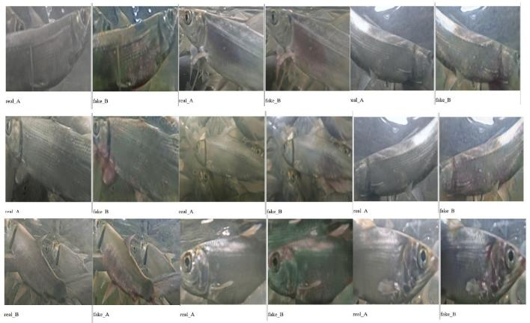
The CycleGAN implementation produced an additional 700 synthetic diseased images. These images were then combined with the original raw images extracted from the video data. This created a more balanced dataset to be used in the YOLOv8mCBAM training. This phase significantly improved the representation of the diseased class due to the aforementioned limitation. To further diversify the dataset, the additional CycleGAN training samples were combined with the original, bumping the dataset to 2,647 images. The dataset was divided into training, validation, and testing using 70:20:10 ratio respectively. The model learning was based on the training set, the validation set was used for hyperparameter tuning, and the final evaluation was applied on the test set.
Figure 3. Sample output of CycleGAN milkfish dataset augmentation
Figure 3 shows original (real) and generated (fake) images generated by CycleGAN, where healthy fish variants were translated into synthetic diseased images. The generated images show visible lesion-like patterns and color variations, demonstrating the capability of the model to generate synthetic disease features that will be used in training the proposed model.

Dataset Versions | Healthy | Diseased | Total
Raw Dataset | 1,232 | 172 | 1,404
Raw + Basic Augmentation | 1,710 | 658 | 2,368
After CycleGAN Augmentation | 1,232 | 700 | 1,932
With CycleGAN training dataset | 1,232 | 1,415 | 2,647
Final Dataset (with CycleGAN augmentation & selection) | 1,232 | 1,415 | 2,647
Table 1: Dataset Versions. Number of datasets used and their distribution. Source: Dataset collected and processed by the researchers.
To evaluate the quality of the CycleGAN generated images, the Fréchet Inception Distance (FID) was computed between the real diseased images and the generated synthetic images. The computed FID score was 89.93 indicating a noticeable distribution difference between the real diseased images and the CycleGAN-generated diseased images. The result may be attributed to the limited number of the real samples, along with the other environmental factors such as noise, blur, lighting variations, and the difficulty of generating consistent disease-related patterns in underwater fish images. Despite the distribution difference, the generated dataset was still useful for the model since it was used for data augmentation to improve data diversity and address class imbalance.

The Proposed Attention-Enhanced YOLOv8m Architecture
The proposed model is based on the YOLOv8 medium variant, enhanced with the Convolutional Block Attention Module (CBAM) to improve feature representation. The YOLOv8 model has been widely adopted as an efficient object detection model, a single-stage detector that is ideal for detecting objects even in real-time settings, providing a well-balanced detection accuracy and computational efficiency. However, in an underwater setting where the environment can be noisy, turbid, and has varying lighting, a standard convolutional layer may not be able to capture subtle physical patterns associated with a fish disease.
To address this limitation, the CBAM is integrated into the original YOLOv8m architecture to enable the model to specifically detect relevant spatial regions and informative feature channels to improve disease detection, especially in an underwater environment.

The Baseline YOLOv8m Architecture


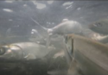
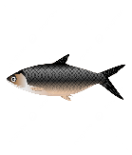
The proposed model builds on the YOLOv8m architecture, a state-of-the-art single-stage object detection model that offers a superior balance between computational efficiency and precision, making it ideal for real-time detection tasks.
Figure 4. The YOLOv8 Architecture
Backbone
Feature Extraction
C2f Modules
C3
C4
C5
Neck
Feature Fusion
P5
P4
P3
FPN/PAN
Head
Prediction Layer
Anchor-Free Head
Bounding Boxes
Class Scores
Object Confidence
Backbone Neck Head
The YOLO architecture consists of three primary components: the backbone, the neck, and the head. Each of these components plays a crucial role in the detection tasks. The backbone is responsible for feature extraction. It consists of a convolutional layer combined with advanced modules such as the C2f (Cross-Stage Partial Bottleneck with 2 convolutions) blocks to improve gradient flow and reduce computational redundancy. These mechanisms progressively transform the input image into feature maps, capturing features such as edges, textures, object shapes, and structures. In milkfish disease detection, these modules are essential for identifying fish in the frame as well as some of the subtle physical abnormalities, such as discoloration and texture irregularities. The neck outputs a set of feature maps, commonly denoted as C3, C4, and C5, which represent different levels of abstraction. The neck, on the other hand, collects the different feature maps from the backbone using Feature Pyramid Network (FPN) and Path Aggregation Network (PAN), allowing the model to detect objects in varying sizes by combining high-resolution spatial information with deep semantic features. The aggregated feature maps are denoted as P3, P4, and P5, which correspond to small, medium, and large object scales. This is important in addressing the distance, orientation, and size of an object in a given frame. Finally, the detection head of the YOLOv8 is responsible for the prediction tasks. For each of the feature maps, the head outputs bounding box coordinates, class probabilities, and object coordinate scores. The detection head produces a real-time prediction based on the refined feature maps.

The Integration of CBAM
To enhance the feature representation of the baseline model YOLOv8, this study proposes the integration of the Convolutional Block Attention Module (CBAM) block, a lightweight attention mechanism that applies channel attention and spatial attention to refine the feature map extracted from the backbone module. This will enable the model to focus on, or “pay more attention” to the regions and features relevant to milkfish disease detection, particularly in the challenging underwater environment.
The proposed model particularly integrates CBAM into the neck layer (feature fusion), specifically in the P3, P4, and P5, after they were generated by the neck layer. These layers corresponds to layer 15 (small-scale layer), layer 18 (medium-scale layer), and layer 21 (large-scale layer). This placement is strategically selected because in this layer, the neck aggregates features from different scales and sizes, and disease patterns may appear at varying sizes and different locations, and refining these aggregated features will improve detection performance.
Layer | Feature Level | Purpose
15 | P3 | Detect small objects (tiny lesions)
18 | P4 | Detect medium features
21 | P5 | Detect large objects (whole fish context)
Table 2. P3, P4, and P5 layer representation and their purpose.
The CBAM uses two linear sub-modules, the channel-attention and the spatial attention. The channel-attention sub-module assigns weights to each of the channels depending on what features are important. The feature map is first processed using the Global Average Pooling (GAP)$AvgPool(F)$, and Global Max Pooling (GMP)$MaxPool(F)$. The output of this process will then be passed through a shared multi-layer perception (MLP). The results will then be combined with a sigmoid function σ. The generated channel attention map will then be multiplied by the input feature map (Woo, Park, Lee, & Kweon, 2018). The equation below demonstrates this process:
$M_{c}\left(F\right)=σ(MLP\left(AvgPool\left(F\right)\right)+(MLP\left(MaxPool\left(F\right)\right))$ (5)
The spatial attention module, on the other hand, focuses on where the important features are located within the input image. The process starts with the compression of the feature map along with the channel axis using average pooling $AvgPool(F)$ and max pooling $MaxPool(F)$. The compressed feature map will then be passed through convolutional layers to generate a spatial feature map using a sigmoid function. The result will then be multiplied by the input feature map. This process will highlight the regions where disease is present and improve the localization of the infected areas (Woo, Park, Lee, & Kweon, 2018). The equation below demonstrates the whole process of generating the spatial feature map:
$M_{s}\left(F\right)= σ(f^{7x7}\left(\left[AvgPool\left(F\right);MaxPool\left(F\right)\right]\right))$ (6)
The final output of the combination of these two sub-modules will be (Woo, Park, Lee, & Kweon, 2018):
$F^{'}=M_{s}(M_{c}(F)∙f)$ (7)
Where:
- $F ∈ R^\{C×H×W\}$ Represents the input feature map, where C is the number of channels, H is height, and W is width;
- $AvgPool(·)$ and $MaxPool(·)$ denote global average pooling and global max pooling operations, respectively;
- MLP denotes a shared multi-layer perceptron used to compute channel attention;
- σ denotes the sigmoid activation function;
- f^{7×7} represents a convolution operation with a 7×7 kernel;
- $M_{c}(F)$ is the channel attention map;
- $M_{s}(F)$ is the spatial attention map;
- $F'$ is the intermediate feature map after channel attention;
In the underwater environment, fish disease can be small, subtle, and can blend into the background, along with other factors that may impair the quality of the image. The integration of the CBAM to the baseline model will enable it to focus on fine-grained information and ignore irrelevant visual information, thereby improving the detection accuracy in the real world.

The figure shows the process of detecting milkfish disease using the proposed model. A feature map is created from the YOLOv8 backbone, denoted as C3, C4, and C5. This feature map is then refined in the neck layer, where CBAM is integrated through channel attention and spatial attention. The attention-enhanced feature map is then forwarded to the detection head to predict bounding boxes, class labels, and confidence scores for the healthy and diseased milkfish.
Figure 5. The proposed YOLOv8-CBAM architecture
YOLOv8 Backbone
Feature Extraction
CBAM
Channel Attention Spatial Attention
Detection Head
Bounding Boxes
Class Scores
Object Confidence
Feature Maps (C3, C4, C5)
Attention-enhanced Feature Map
Healthy_fish
diseased_fish

Experimental Backbone Modification using ResNet50
To further evaluate the impact of architectural modification, this study explored an alternative backbone modification by replacing the CSPDarknet53 backbone of the YOLOv8m with a ResNet-based feature extractor. ResNet, or the Residual Network, is a deep convolutional neural network model that is known for its ability to solve the vanishing gradient problem using “skip-connections” to bypass layers, allowing training of deeper networks (Liu & Goh, 2025) (He, Zhang, Ren, & Sun, 2016). This modification was performed to enable deeper feature extraction capability of the YOLOv8m model and potentially improve its ability to represent complex visual patterns and capture subtle disease-related features such as lesions, discolorations, and abnormal texture patterns. However, integrating ResNet with the YOLOv8 architecture introduces several challenges, particularly the compatibility of the modified backbone’s output with the neck and the detection head layers. The difference in the resulting feature maps and channel sizes requires additional adjustments, which adds to model complexity and computational costs.
This modification is included as part of the experimental analysis for comparison with the performance of the proposed model. While the ResNet-based modification demonstrates improvement in feature extractions, the attention-focused CBAM-based enhancement offers a more efficient and stable solution to the real-time detection without significantly increasing computation cost and model complexity.

Hardware and Software details
All the experiments conducted non this study were executed on an Acer Predator Helios 16 laptop equipped with an Intel Core i9 processor, NVIDIA RTX 4070 GPU with 8GB VRAM, and 16GB of RAM. This for the computational requirements of the training runs. The YOLOv8 model, especially, requires significant processing power for object detection, and CBAM, although considered as lightweight, adds to the computational load with its convolutional operations. The models were implemented using Python and trained using the Ultralytics YOLOv8 framework.

Experimental Setup
The experimental setup was designed to evaluate the performance of the proposed YOLOv8 based models under different configurations. All models were trained using the same baseline parameters to ensure fair comparison.
The YOLOv8m model was used as the base architecture, with an input image size of 640×640 pixels. The models were trained for 100 epochs using the Adam optimizer with a learning rate of 0.001. A batch size of 16 was used during training. The evaluation metrics include precision, recall, mean Average Precision at IoU threshold 0.50 (mAP@0.50), and mean Average Precision across multiple IoU thresholds from 0.50 to 0.95 (mAP@0.50–0.95).
Different training configurations (T1–T8) were designed to analyze the impact of dataset augmentation and model enhancement. These include training on raw data, traditional augmentation, CycleGAN-based augmentation, and the integration of CBAM into the YOLOv8m architecture.
The performance of the attention-enhanced YOLOv8m was evaluated using four key metrics commonly used in object detection: precision, recall, mAP50, and mAP50-95. The experiments were conducted to evaluate the impact of data augmentation techniques and model enhancement and modification, particularly GAN-based synthetic augmentation and attention-based model enhancement.

OVERVIEW OF THE RESULTS
As shown in Table 3, the baseline YOLOv8m model in T1, trained on raw images, achieved a precision of 0.817, a recall of 0.906, and a mAP@50 of 0.925. This indicates that the baseline model has a strong detection capability; however, it also shows a low precision score due to false positive detection in a complex underwater environment. The introduction of ResNet in the backbone of the baseline model, as shown in T2 to T3, improved the precision score to 0.882, demonstrating the better feature extraction capability of ResNet; however, recall decreased slightly, indicating reduced detection coverage, which means that there are missed subtle cases of disease detection. This also did not consistently improved the object detection performance because deeper feature extraction alone does not always guarantee improved performance, especially in the underwater and with limited and imbalance dataset. This was evident in T2 to T8, where the model became more selective but missed more disease samples. The result also suggests that the ResNet-based modification improved feature discrimination but reduced detection coverage. The addition of basic dataset augmentation as shown in T3, improved recall to 0.885 and mAP@50 to 0.930. This demonstrates the benefit of increased data variability. However, improvements in mAP@50–95 remained minimal, indicating that there is a limited gain in terms of localization accuracy.
The use of CycleGAN-based augmentation indicated in T4 to T7 showed a more remarkable impact. While T4 produced modest improvements, combining CycleGAN with raw images and traditional augmentation, as shown in T5, resulted in a more balanced performance with a precision score of 0.902 and a recall of 0.898, demonstrating the importance of dataset variability and class balance. However, excessive augmentation led to performance degradation, particularly in recall of 0.862 and mAP@50–95 of 0.679, indicating that over-augmentation introduces noise and redundancy as seen in T6. This meant that instead of effectively augmenting the dataset, excessive augmentation may introduce redundant, noisy, or less realistic visual patterns, which reduced the model’s ability to generalize. The larger dataset also have likely increased deviation that was not fully representative of real underwater disease features, causing lower recall and localization accuracy. T7 demonstrated the best performance among the ResNet-based configurations, achieving a precision of 0.910, recall of 0.865, mAP@0.50 of 0.936, and mAP@0.50–0.95 of 0.710, suggesting that a well-balanced augmented dataset improves both detection and localization. The proposed model in T8, which integrates CBAM into YOLOv8m neck, demonstrated the highest overall performance with a precision score of 0.940, a recall of 0.910, a mAP@50 score of 0.945, and a mAP@50–95 of 0.725. Compared to T7, the improvements in precision, recall, and mAP@50 confirms that CBAM enhances feature discrimination by focusing on disease-relevant regions.
This results are considered to be satisfactory because the proposed model achieved remarkable improvement compared to the baseline YOLOv8m’s performance. The baseline in T1 obtained precision of 0.817, recall of 0.906, mAP@0.50 of 0.925, and mAP@0.50–0.95 of 0.682. In comparison, the proposed T8 model achieved an improvement of 0.123 in precision, 0.02 in mAP@0.50, and 0.043 in mAP@0.50–0.95 over the baseline.
Overall, the results demonstrate that while backbone modification provides moderate improvements, the combination of CycleGAN-based augmentation and CBAM attention yields the most consistent and significant performance gains. The proposed YOLOv8m-CBAM model effectively balances detection accuracy and localization performance, making it suitable for real-time milkfish disease detection in underwater environments. The results also show that the performance improvement was not caused by augmentation alone but by the controlled combination of CycleGAN-based augmentation and CBAM attention. While T5 achieved balanced results, T6 showed performance degradation after excessive augmentation, indicating that increasing dataset size without careful selection can reduce generalization. Therefore, the final T8 result supports the effectiveness of the proposed approach in improving disease detection under challenging underwater conditions.
Training | Dataset Description | Model | Images | P | R | mAP50 | mAP50-95
T1 | Raw Images only | YOLOv8m | 1,404 | 0.817 | 0.906 | 0.925 | 0.682
T2 | Raw Images | YOLOv8mRN50 | 1,404 | 0.882 | 0.865 | 0.922 | 0.684
T3 | Raw image with Basic Augmentation | YOLOv8mRN50 | 2,368 | 0.882 | 0.885 | 0.930 | 0.686
T4 | Raw images with CycleGAN | YOLOv8mRN50 | 1,932 | 0.885 | 0.863 | 0.920 | 0.685
T5 | Raw images with Basic Augmentation, and CycleGAN Augmentation | YOLOv8mRN50 | 3,364 | 0.902 | 0.898 | 0.928 | 0.693
T6 | Raw images with Extended augmentation (3×), and CycleGAN Augmentation | YOLOv8mRN50 | 4,749 | 0.882 | 0.862 | 0.921 | 0.679
T7 | CycleGAN and CycleGAN Training images | YOLOv8mRN50 | 2,647 | 0.910 | 0.865 | 0.936 | 0.710
T8 | CycleGAN and CycleGAN Training images | YOLOv8m-CBAM | 2,647 | 0.940 | 0.910 | 0.945 | 0.725
Table 3. Comparative Performance Table. This table shows the comparative performance of YOLOv8-based models under different training configurations (T1-T8).
The next table, Table 4, reflects the speed-related metrics of the three models such as the processing time of each model during preprocessing, inference, and post-processing. Based on the results, the proposed model YOLOv8m-CBAM maintained real-time inference capability while improving detection accuracy. Compared with YOLOv8mRN50 he YOLOv8m-CBAM model was faster and more accurate. Therefore, the inclusion latency confirms that the proposed model is suitable for real-time milkfish disease detection.
Version | P | R | mAP50 | mAP50-95 | Preprocess (ms) | Inference (ms) | Postprocess (ms)
YOLOv8m | 0.90 | 0.88 | 0.93 | 0.69 | 0.2 | 6.8 | 0.9
YOLOv8mRN50 | 0.91 | 0.87 | 0.94 | 0.71 | 0.3 | 12.32 | 0.5
YOLOv8m-CBAM | 0.94 | 0.91 | 0.95 | 0.73 | 0.3 | 6.3 | 0.6
Table 4. Accuracy and speed performance comparison of the evaluated YOLO-based models using the T8 dataset version.

Detailed Performance Analysis
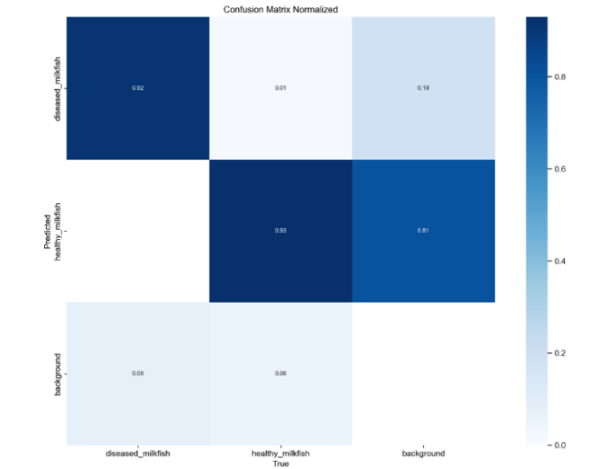
A detailed performance analysis as shown in the following figures was conducted to further evaluate the effectiveness of the proposed model YOLOv8-CBAM using confusion matrix, precision-recall, and qualitative detection analysis
Figure 6. Confusion matrix of the proposed YOLOv8m-CBAM model showing classification performance for healthy and diseased milkfish.
As shown in Figure 6, the normalized confusion matrix indicates a strong classification performance with high true positive rates for both healthy and diseased milkfish. It was included to evaluate how well the proposed YOLOv8m-CBAM model distinguished between healthy and diseased milkfish. This matrix shows minimal misclassification between classes, confirming that the model effectively distinguishes subtle visual differences. This improvement can be attributed to the integration of CBAM, which enhances feature discrimination, and CycleGAN augmentation, which improves class balance. Compared to the baseline YOLOv8m model, the proposed YOLOv8m with CBAM demonstrates improved classification consistency and reduced false positives
Figure 7. The Precision-recall curve of the proposed model demonstrating high detection performance across varying thresholds.
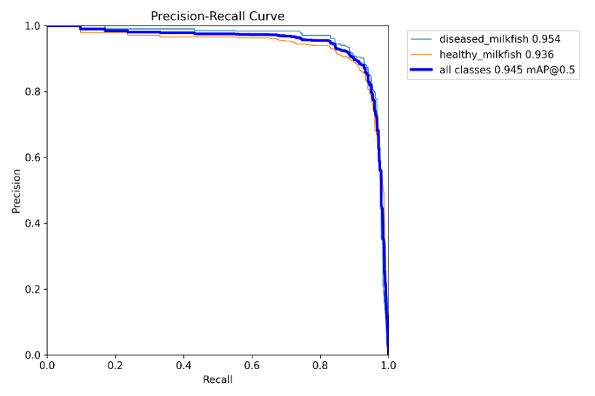
The precision-recall (PR) curve further validates the robustness of the proposed model. The curve maintains high precision across a wide range of recall values, indicating that the model successfully detects diseased fish while minimizing false positives. The F1-score curve shows a strong peak, demonstrating an optimal balance between precision and recall, which is critical for real-time detection systems.
Qualitative evaluation of the detection results reveals that the model accurately localizes milkfish and identifies disease-related features such as lesions and discolorations under varying underwater conditions. The model performs well even in the presence of turbidity, lighting variation, and fish movement. However, minor limitations were observed in highly blurred frames and low-contrast conditions, where disease features are less distinguishable.
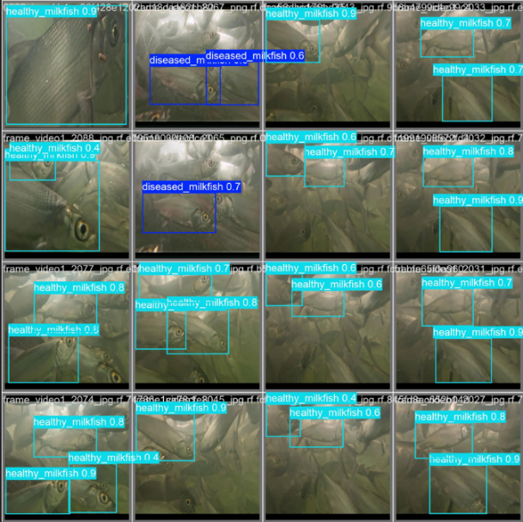
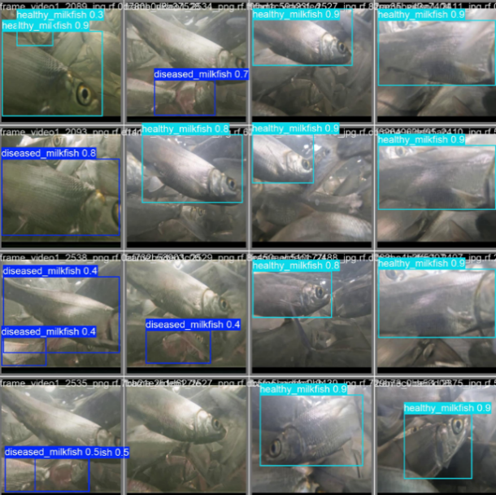
Overall, the results confirm that the proposed YOLOv8m-CBAM model, combined with CycleGAN-based augmentation, achieves robust and reliable detection performance in real-world underwater environments, outperforming baseline configurations.
Figure 8. Sample detection outputs of the YOLOv8m-CBAM model showing accurate detection of healthy and diseased milkfish under varying underwater conditions.

CONCLUSION
This study explores a YOLOv8m-based framework integrated with a Convolutional Block Attention Mechanism (CBAM) for real-time detection of milkfish diseases. The hybrid model was trained with an augmented milkfish dataset containing traditional and GAN-augmented datasets. This approach addresses key challenges in aquaculture environments, including limited diseased milkfish samples, class imbalance, and other complexities of underwater imaging conditions such as water turbidity, motion, and varied lighting.
The results directly support the effectiveness of combining GAN-based synthetic data augmentation and CBAM-based feature refinement on the milkfish disease detection task. The baseline YOLOv8m already shows a promising performance, achieving a precision of 0.817, a recall of 0.906, an mAP@0.50 of 0.925, and an mAP@0.50–0.95 of 0.682. However, its low precision indicates its false positive detections. On the other hand, the ResNet modification improved precision in some runs, but did not consistently improve the overall performance of the model, which suggests that deeper feature extraction alone was not sufficient for detecting subtle indicators of milkfish diseases, especially in the underwater environment.
CycleGAN-based data augmentation improved the diversity and reduced class imbalance, which was reflected in T7 having an improved precision of 0.910, recall of 0.865, mAP@0.50 of 0.936, and mAP@0.50–0.95 of 0.710. The performance drop in T6 indicates that excessive augmentation may introduce redundant or unrealistic patterns that reduce model generalization.
The integration of the attention mechanism, CBAM, into the YOLOv8m architecture achieved the best overall performance, with a precision of 0.940, a recall of 0.910, mAP@50 of 0.945, and mAP@50–95 of 0.725. These results confirm that enhancing the YOLOv8m model with an attention-based mechanism effectively improves feature discrimination by enabling the model to focus on relevant diseased regions, which is particularly challenging in underwater environments.
The findings of this study demonstrate that combining model enhancement and balancing data through synthetic augmentation provides a robust and efficient solution for milkfish disease detection, especially in an underwater environment. The proposed YOLOv8m-CBAM model improves detection performance while maintaining real-time capability, making it suitable for practical deployment in underwater monitoring systems, such as those in fish pens. However, future work may include the exploration of segmentation-based approaches, multi-species disease detection, and deployment on edge devices to further enhance real-time monitoring capabilities.

Ethical Considerations
This study used video recordings of milkfish from a selected fish pen in a non-intrusive manner. No human participants were involved. The dataset was used only for research purposes, and the model is intended only as an early detection support tool rather than a conclusive diagnostic system.

Conflict of Interest
The authors declare no conflict of interest.

Dataset Availability
The dataset used in this study was collected from a selected fish pen and is not publicly available due to ownership and privacy considerations. The dataset contains research-specific underwater milkfish image data. However, selected sample images, processed outputs, or related information may be made available from the corresponding author upon reasonable request and subject to research-use limitations.

REFERENCES

- Alfred, R., Leo, J., & Kaijage, S. (2025). Optimizing dataset diversity for a robust deep-learning model in rice blast disease identification to enhance crop health assessment across diverse conditions. Smart Agricultural Technology, 10. doi:https://doi.org/10.1016/j.atech.2024.100726.
- Bharti, A. (2024). Object Detection Using YOLO Algorithm. International Research Journal of Modernization in Engineering Technology and Science, 06(08). doi:DOI : https://www.doi.org/10.56726/IRJMETS60812
- Biswal, S., Kumar, A., & Punuri, S. (2024). 2024 International Conference on Integrated Intelligence and Communication Systems (ICIICS). 2024 International Conference on Integrated Intelligence and Communication Systems (ICIICS). Kalaburagi, India: IEEE. doi:10.1109/ICIICS63763.2024.10860112
- Chang, C.-C., Ubina, N. A., Cheng, S.-C., Lan, H.-Y., Chen, K.-C., & Huang, C.-C. (2022, October 7). A Two-Mode Underwater Smart Sensor Object for Precision Aquaculture Based on AIoT Technology. Development and Application of Methods and Algorithms to Smart Objects and Smart Sensors, 22(19)(7603). doi:https://doi.org/10.3390/s22197603
- Chanos chanos, Milkfish : fisheries, aquaculture, gamefish, bait. (n.d.). Retrieved from https://www.fishbase.se/search.php: https://www.fishbase.se/summary/chanos-chanos.html
- Chen, Y., Pan, J., & Wu, Q. (2023). Apple leaf disease identification via improved CycleGAN and Convolutional Neural Network. Soft Comput, 27, 9773–9786. doi:https://doi.org/10.1007/s00500-023-07811-y
- Deepika, H., Raghuveer shetty, V., & G N, S. (2020, June). An Overview of You Only Look Once: Unified,Real-Time Object Detection . International Journal for Research in Applied Science & Engineering Technology (IJRASET), 8(VI). doi:https://doi.org/10.22214/ijraset.2020.6098
- Deng, Q., Ryu, J., & Lee, D. (2025). A Novel Rare Image Data Augmentation Method for Fish Diseases Classification. Journal of the Korean Society of Multimedia, 28(2), 137 - 148 (12 pages). doi:10.9717/kmms.2025.28.2.137
- Feng, J., & Jin, T. (2024). CEH-YOLO: A composite enhanced YOLO-based model for underwater object detection. Ecological Informatics, 82. doi:https://doi.org/10.1016/j.ecoinf.2024.102758
- Fung, B. S., Chan, W., Lo, I. M., & Tsang, D. H. (2023). Freshwater Microscopic Algae Detection Based on Deep Neural Network with GAN-Based Augmentation for Imbalanced Algal Data. ACS EST Water 2024 (pp. 982–990). American Chemical Society. doi:https://doi.org/10.1021/acsestwater.3c00150
- G. Mariani, F. Scheidegger, R. Istrate,, C. Bekas, & A. Malossi. (2018). BAGAN: Data Augmentation with Balancing GAN. ArXiv. doi:abs/1803.09655
- Garcia, R., Alvarez, J., & Marcia, R. (2023). Machine Learning for Classifying Images with Motion Blur. 2022 21st IEEE International Conference on Machine Learning and Applications (ICMLA). IEEE. doi:10.1109/ICMLA55696.2022.00079
- Gaude, G. S., & Borkar, S. (2020). Fish Detection And Tracking For Turbid Underwater Video. Madurai, India: IEEE. doi:10.1109/ICCS45141.2019.9065425
- Gong, C., Wang, D., Li, M., Chandra, V., & Liu, Q. (2021). KeepAugment: A Simple Information-Preserving Data Augmentation Approach. 2021 IEEE/CVF Conference on Computer Vision and Pattern Recognition (CVPR). IEEE. doi:10.1109/CVPR46437.2021.00111
- Guanbo, F., Xiong, Z., Pang, H., Gao, Y., Zhang, Z., Yang, J., & Ma, Z. (2024). RTL-YOLOv8n: A Lightweight Model for Efficient and Accurate Underwater Target Detection. Fishes. 2024, 8. doi: https://doi.org/10.3390/fishes908029
- He, K., Zhang, X., Ren, S., & Sun, J. (2016). Deep Residual Learning for Image Recognition. 2016 IEEE Conference on Computer Vision and Pattern Recognition (CVPR), 770-778. doi:DOI:10.1109/cvpr.2016.90
- Khabusi, S., Huang, Y.-P., & Lee, M.-F. (2023). Attention-Based Mechanism for Fish Disease Classification in Aquaculture. 2023 International Conference on System Science and Engineering (ICSSE). Ho Chi Minh, Vietnam: IEEE. doi:10.1109/ICSSE58758.2023.10227224
- Komori , O., & Eguchi , S. (2019, July 3). Introduction to Imbalanced Data. In: Statistical Methods for Imbalanced Data in Ecological and Biological Studies. Statistical Methods for Imbalanced Data in Ecological and Biological Studies . doi:https://doi.org/10.1007/978-4-431-55570-4_1
- Li, S., & Peng, X. (2025). DyAqua-YOLO: a high-precision real-time underwater object detection model based on dynamic adaptive architecture. (Y. Ju, Ed.) Front. Mar. Sci., 12:1678417. doi:doi: 10.3389/fmars.2025.1678417
- Liu, X., & Goh, K. (2025). ResNet: Enabling Deep Convolutional Neural Networks through Residual Learning. arXiv.org. doi:DOI:10.48550/arXiv.2510.24036
- Martínez, F. S., Tseng, M., & Yeh, S.-P. (2006, September 1). Milkfish (Chanos chanos) Culture: Situations and Trends. Environmental Science, Agricultural and Food Sciences, Biology. doi:DOI:10.29822/JFST.200609.0004
- Minouei, M., Soheili, M., & Stricker, D. (2024). Multimodal approach for imbalanced document classification. Proceedings Volume 13517, Seventeenth International Conference on Machine Vision (ICMV 2024). Edinburg, United Kingdom: Proc. SPIE 13517. doi:https://doi.org/10.1117/12.3055119
- Prova, N. (2024, December 3). Enhancing Fish Disease Classification in Bangladeshi Aquaculture through Transfer Learning, and LIME Interpretability Techniques. 2024 4th International Conference on Sustainable Expert Systems (ICSES). doi:10.1109/ICSES63445.2024.10763350
- Woo, S., Park, J., Lee, J.-Y., & Kweon, I. (2018). CBAM: Convolutional Block Attention Module. Computer Vision – ECCV 2018, 11211. doi:https://doi.org/10.1007/978-3-030-01234-2_1
- Xi, Y., & Yin, J. (2025). UOD-YOLO: a lightweight real-time model for detecting marine organisms. Front. Mar. Sci., 12. doi:https://doi.org/10.3389/fmars.2025.1728563
- Yang, H., & Zhou, Y. (2021). IDA-GAN: A Novel Imbalanced Data Augmentation GAN. 2020 25th International Conference on Pattern Recognition (ICPR). Milan, Italy: IEEE. doi:10.1109/ICPR48806.2021.9411996
- Yuwana, R., Fauziah, F., Heryana, A., Krisnandi, D., Kusumo, R., & Pardede, H. (2020, August 31). Data Augmentation using Adversarial Networks for Tea Disesse Detection. Jurnal Elektronika dan Telekomunikasi, 20. doi:http://dx.doi.org/10.14203/jet.v20.29-35
- Zhang, Z., Li, Y., & Liu, C. (2022). Collaborative Discrimination-Enabled Generative Adversarial Network (CoD-GAN) for the Data Augmentation in Imbalanced Classification. 2022 IEEE 18th International Conference on Automation Science and Engineering (CASE). Mexico City, Mexico: IEEE. doi:10.1109/CASE49997.2022.9926707
- Zhu, J.-Y., Park, T., Isola, P., & Efros, A. A. (2017). Unpaired Image-to-Image Translation Using Cycle-Consistent Adversarial Networks. 2017 IEEE International Conference on Computer Vision (ICCV). Venice, Italy: IEEE. doi:10.1109/ICCV.2017.244

