ADAPTABILITY AND INNOVATION OF ARTIFICIAL INTELLIGENCE IN EDUCATIONAL CONTEXTS: A CONCEPTUAL FRAMEWORK

Abstract
Artificial Intelligence (AI) is transforming the education sector at a radical pace by providing personalized instruction and by providing simulations to enhance the visualization skills of learners so that teaching-learning process become a fruitful experience. AI in education encompasses Intelligent Tutoring Systems (ITS), AI-based tests and administrative automation. India has started integrating AI into education policies through the efforts of the All-India Council for Technical Education (AICTE) and the National Education Policy (National Education Policy 2020 Ministry of Human Resource Development Government of India, 2020). This research paper aims to analyze AI’s impact on education; innovative practices incorporated in educational scenarios as a part of AI-Integration across various disciplines and to design a conceptual framework based on the adaptability and innovation of Artificial Intelligence in educational contexts.
Keywords: Adaptability, Innovation, Artificial Intelligence, Educational Contexts, Conceptual Framework
INTRODUCTION
Information technologies, particularly artificial intelligence (AI), are revolutionizing modern education. AI algorithms and educational robots are now integral to learning management and training systems, providing support for a wide array of teaching and learning activities (Costa et al., 2017, García et al., 2007).Artificial Intelligence (AI) has the potential to address some of the biggest challenges in education today, innovate teaching and learning practices, and accelerate progress towards SDG 4 (Artificial Intelligence in Education, 2026). The field of education especially lends itself to AI technologies since educational activities, including learning and teaching, are knowledge-intensive cognitive activities, and AI applications, which are created for cognition and problem-solving based on algorithms and knowledge base, can effectively support and augment educators’ and learners’ abilities in teaching and learning. Since the advent of AI in the mid-1950 s, AI technologies have been increasingly applied to facilitate education and training in various subjects, including language, STEM, and medicine (Perrotta & Selwyn, 2020). To date, AIED applications are developed to support teaching and learning activities such as content preparation and dissemination, interactions and collaboration, and performance assessment (Chassignol et al., 2018, Perrotta and Selwyn, 2020). This paper explores the dual dimensions of adaptability—the capacity of AI systems to adjust to individual learner needs—and innovation—the systemic redesign of pedagogy facilitated by AI. We propose the "Integrated Socio-Technical Adaptability Framework" (ISTAF), which categorizes AI integration into three layers: the Micro (Learner), Meso (Institutional), and Macro (Societal).

RESEARCH QUESTION
While AI technologies offer unprecedented "personalization," there is a significant gap between technical capability and pedagogical effectiveness. Many AI implementations focus on "automated instruction"—simply delivering content faster—rather than fostering "cognitive autonomy."). While AI offers efficiency, it risks eroding critical thinking through excessive cognitive offloading, where tasks are transferred to AI, weakening individual cognitive skills. Without a conceptual framework, innovation remains fragmented, leading to issues of digital inequity and the erosion of critical thinking.

OBJECTIVES
- To analyze AI’s impact on education;
- To examine innovative practices incorporated in educational scenarios as a part of AI-Integration across various disciplines.
- To develop a conceptual framework (ISTAF) for the ethical and effective deployment of AI.
- To evaluate the shift from AI-assisted teaching to AI-integrated pedagogy.

LITERATURE REVIEW
IMPACT OF AI ON EDUCATION
AI in student learning
AI-based environments have been used to personalize tasks for student learning. For example, Hirankerd and Kittisunthonphisarn (2020) built an AI-integrated management system with augmented, virtual, and mixed reality technologies to monitor student learning progress for assigning adaptive tasks; Kong et al. (2021) developed a virtual patient for medical student training; Munawar et al. (2018) created and developed an intelligent virtual laboratory to cater for students' needs by assigning laboratory tasks at an appropriate level; and Yang and Shulruf (2019) used an AI-enhanced skin to provide real-time feedback and adaptive tasks to medical students.
Most of the studies implemented AI chatbots and interactive books that allowed students to have conversations with machines about their learning. AI techniques emulate the processes of human thought using structures that contain the knowledge and experience of human experts. AI chatbots and books built with these techniques have been applied to language learning to help students develop their communication abilities through ongoing dialogue (Chew & Chua, 2020; Kim et al., 2021; Koc-Januchta et al., 2020; Palasundram et al., 2019; Vazquez-Cano et al., 2021). Another common use of AI has been to give students timely guidance and feedback by analyzing their work and learning process (Fu et al., 2020; Porter & Grippa, 2020). For example, Bonneton-Botte et al. (2020) used an AI application for notebooks to recognize and acquire kindergarten students' handwriting and then analyze its spatiotemporal characteristics (i.e., the shape, order, and direction of the segments). The application gave feedback to the students at the end of each writing session. Vahabzadeh et al. (2018) used AI-enabled smart glasses to improve the attention of autistic students by monitoring their socially aware emotions and behavior.
AI technologies have been implemented to capture student learning data and facilitate interactions for more adaptive digital environments. For instance, Samarakou et al. (2015) developed an advanced e-learning enviroment for engineering students. Kickmeier-Rust and Holzinger (2019) designed and developed a combinatorial optimization algorithm (the MAXMIN ant system) that was useful and effective in adaptive games. Westera et al. (2020) used techniques, such as facial emotion recognition, automatic difficulty adaptation, and stealth assessment, to profile students and applied techniques, such as non-verbal bodily motion and lip-synchronized speech, to develop non-playing characters. The student profiles and characters enhanced the adaptability and interactivity of learning.
Intelligent tutoring systems aim to recommend teaching content and tasks that are appropriate for teaching needs (Aldeman et al., 2021; Bellod et al., 2021; McCarthy et al., 2016; Weragama & Reye, 2014). For example, Luo (2018) and Standen et al. (2020) adopted AI systems using multimodal sensor data to identify students' affective statuses and help teachers determine the optimal presentation of content, teaching methods, and communication strategies. Lampos et al. (2021) used an AI classifier to recommend effective communication strategies for teachers to teach autistic students by analyzing student responses and attributes. In the study of Crowe et al. (2017), teachers adjusted their teaching strategies based on the instant feedback provided by an academic writing software package on individual and whole class processing of learning material.
The combination of computer assisted instruction and AI technologies has been applied to helping teachers manage their classroom teaching (D. Yang, Oh, & Wang, 2020; Jaiswal & Arun, 2021; Nabiyev et al., 2013; Wang & Zheng, 2020; Zhang, 2021a, Zhang, 2021b). AI technologies have been used to support teaching in different subject classrooms (e.g., physical and language education) by efficiently uploading, assigning, and distributing learning materials and assignments and by speaking out text-based problems. These applications have greatly improved the efficiency of classroom management for teachers (Gupta & Bhaskar, 2020; Huang et al., 2021; Jarke & Macgilchrist, 2021; Rapanta & Walton, 2016).
AI technologies have been applied not only to support teaching but also to support the professional development of teachers (Gunawan et al., 2021; Lampos et al., 2021). In these studies, teachers were given suggestions and comments on their teaching by AI agents that analyzed real-time data in classrooms, such as behavior and questioning skills, and teachers' responses to diagnostic tests of their pedagogical content knowledge. Teaching evaluation models have also been built from teaching data (Hu, 2021; Li & Su, 2020).
Analysis showed that the use of AI to enhance and automate assessment resulted in more effective grading (Aebi & Karal, 2017; Alghamdi et al., 2020; Fu et al., 2020; Kumar & Boulanger, 2020; Ma & Slater; 2015). AI-enhanced grading systems for language writing and speaking and mathematics provided more accurate, fast, and secure grading in tests and examinations than teachers. The systems were also able to return immediate marks for formative feedback in online learning.
AI technologies appear to have assisted in predicting student performance, particularly in online education (Akmese et al., 2021; Costa-Mendes et al., 2021; Yu, 2021). They have shown a capacity to predict students' performance in online courses by assessing the extent and quality of their participation in learning activities, such as discussion forums. This functionality is very important for distance education and MOOCs due to the absence of teachers. However, selecting data for prediction is challenging. Costa-Mendes et al. (2021) argued that the student data used for classic statistics may not fit AI predictive models.
CONCEPTUAL FRAMEWORK (ISTAF) FOR THE ETHICAL AND EFFECTIVE DEPLOYMENT OF AI.
With a strong theoretical base on Socio-Technical Systems Theory, Integrated Socio-Technical Adaptability Framework" (ISTAF) categorizes AI integration into three layers: the Micro (Learner), Meso (Institutional), and Macro (Societal). Within a socio-technical systems perspective, any organisation, or part of it, is made up of a set of interacting sub-systems, as shown in the diagram below.

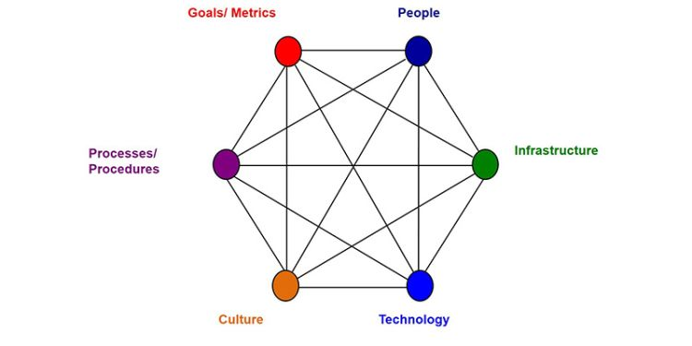

Socio-technical theory has at its core the idea that the design and performance of any organisational system can only be understood and improved if both ‘social’ and ‘technical’ aspects are brought together and treated as interdependent parts of a complex system. Socio-Technical Systems Theory (STST) offers such a perspective by conceptualizing organizations as dynamic configurations of interacting technical and social subsystems whose ongoing negotiation and adaptation fundamentally shape the outcomes of technological innovation (Bostrom & Heinen, 1977; Mumford, 2006; Pasmore et al., 2019; Trist & Bamforth, 1951). Rather than treating technology and organization as isolated variables, STST views innovation as an emergent, processual phenomenon in which changes to AI systems are intertwined with evolving work routines, governance mechanisms, data infrastructures, and decision-making practices (Akter et al., 2022; Cannas, 2023; Chaudhuri et al., 2024; Pfaff et al., 2023).
Integrated Socio-Technical Adaptability Framework (ISTAF) categorizes AI integration into three layers: the Micro (Learner), Meso (Institutional), and Macro (Societal). The Integrated Socio-Technical Adaptability Framework (ISTAF) conceptualizes AI as a multi-layered socio-technical ecosystem in which successful integration depends on the adaptive alignment of human, technical, institutional, and systemic elements across micro, meso, and macro layers.


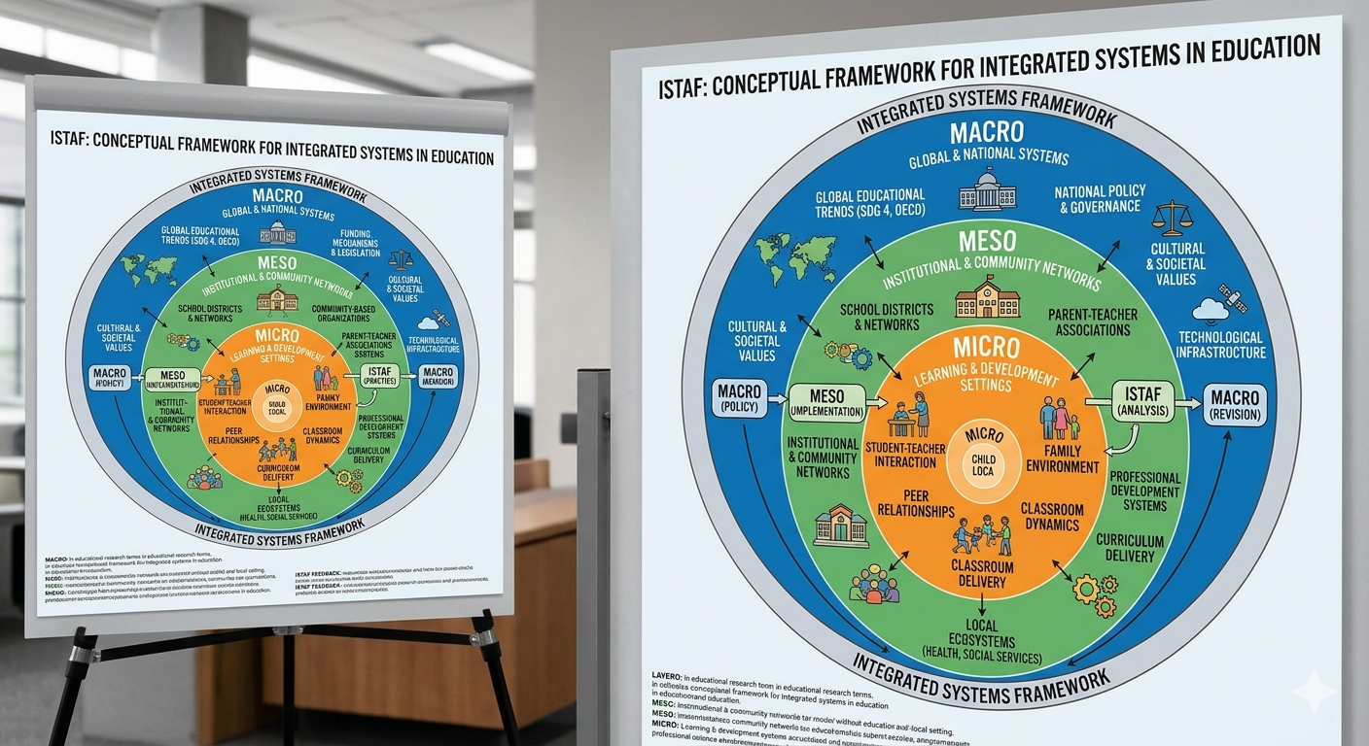
Layer 1: Micro AI Layer (User level)
This layer points to the use of various AI tools, personalized tutoring AI, AI writing support, AI feedback systems, AI productivity tools, AI for problem-solving by students, teachers, faculty, administrators and learners across various disciplines. Adaptability Constructs at this layer encompasses cognitive adaptability, digital adaptability, AI self-efficacy and ethical adaptability.
Layer 2: Meso AI Layer (Institutional/Organizational Level)
This layer emphasizes upon AI as embedded in institutional structures and practices. The core focus at this layer includes LMS-Integrated AI, AI-enabled assessment systems, institutional chatbots, AI-supported teaching design and AI analytics for student monitoring. Socio-technical focus at this layer happens in the form of interaction between institutional culture, infrastructure, governance, and pedagogical integration. Adaptability Constructs at this layer consists of institutional adaptability, curriculum adaptability and organizational readiness.
Layer 3: Macro AI Layer (Provider/ Policy/Ecosystem Layer)
AI as part of a broader ecosystem shaped by providers, regulation and policy. AI at this layer act as a large AI platform and policy-guided AI ecosystems. At this layer, socio-technical focus specially points to the interaction between regulation, accessibility, affordability, sustainability and equity. Adaptability Constructs at this layer includes systematic adaptability, policy adaptability and ecosystem resilience.
RESULTS/DISCUSSION
Even though AI has far and wide- reaching applications as mentioned in the Review of Related Literature across student learning, teaching and assessment, there are certain points to be addressed as selecting appropriate data for student performance predictive models remains challenging as the data are not the same as those used in traditional educational research, without a grasp of the mechanism of task assignment and teaching strategy recommendations, teachers have reported feeling that their control was diminished and that they were working with a black box. The resulting decline in self-efficacy may discourage teachers from using AI to support their classroom teaching. The study throws light into a conceptual framework (ISTAF) through which AI -integration across disciplines become sustainable and educationally meaningful when AI is understood as a three-layer socio-technical ecosystem in which adaptability operates across individual, institutional, and provider-policy levels.
REFERENCES
Akter, S., Michael, K., Uddin, M. R., McCarthy, G., & Rahman, M. (2022). Transforming business using digital innovations: The application of AI, blockchain, cloud and data analytics. Annals of Operations Research 308, 1–33. https://doi.org/10.1007/s10479-020-03620-w .
Aldeman, N. L. S., de Sá Urtiga Aita, K. M., Machado, V. P., da Mata Sousa, L. C. D., Coelho, A. G. B., da Silva, A. S., ... & do Monte, S. J. H. (2021). Smartpathk: a platform for teaching glomerulopathies using machine learning. BMC medical education, 21(1), 248.
Aldeman, N. L. S., de Sá Urtiga Aita, K. M., Machado, V. P., da Mata Sousa, L. C. D., Coelho, A. G. B., da Silva, A. S., ... & do Monte, S. J. H. (2021). Smartpathk: a platform for teaching glomerulopathies using machine learning. BMC medical education, 21(1), 248.
Artificial intelligence in education. (2026, March 25). AI. UNESCO https://www.unesco.org/en/digital-education/artificial-intelligence
Bellod, H. C., Ramón, V. B., Fernández, E. C., & Luján, J. F. G. (2021). Analysis of stress and academic-sports commitment through Self-organizing Artificial Neural Networks (Análisis del estrés y el compromiso académico-deportivo mediante Redes Neuronales Artificiales Auto-organizativas). Retos, 42, 136-144.
Bonneton-Botté, N., Fleury, S., Girard, N., Le Magadou, M., Cherbonnier, A., Renault, M., ... & Jamet, E. (2020). Can tablet apps support the learning of handwriting? An investigation of learning outcomes in kindergarten classroom. Computers & Education, 151, 103831.
Bostrom, R. P., & Heinen, J. S. (1977). Mis- problems and failures: A socio-technical perspective. Part I: The causes. MIS Quarterly, 1(3), 17–32. https://doi.org/10.2307/248710
Cannas, R. (2023). Exploring digital transformation and dynamic capabilities in agrifood SMEs. Journal of Small Business Management, 61(4), 1611–1637. https://doi.org/ 10.1080/00472778.2020.1844494
Chassignol, M., Khoroshavin, A., Klimova, A., & Bilyatdinova, A. (2018). Artificial Intelligence trends in education: A narrative overview. Procedia Computer Science 136, 16–24.
Chaudhuri, R., Chatterjee, S., Vrontis, D., & Thrassou, A. (2024). Adoption of robust business analytics for product innovation and organizational performance: The mediating role of organizational data-driven culture. Annals of Operations Research, 339(3), 1757–1791. https://doi.org/ 10.1007/s10479-021-04407-3
Chew, E., & Chua, X. N. (2020). Robotic Chinese language tutor: personalising progress assessment and feedback or taking over your job? On the Horizon, 28(3), 113-124.
Costa, E. B., Fonseca, B., Santana, M. A., Araújo, F. F. d., & Rego, J. (2017). Evaluating the effectiveness of educational data mining techniques for early prediction of students' academic failure in introductory programming courses. Computers in Human Behavior, 73, 247–256.
Crowe, D., LaPierre, M., & Kebritchi, M. (2017). Knowledge based artificial augmentation intelligence technology: Next step in academic instructional tools for distance learning. TechTrends, 61(5), 494-506.
Fu, S., Gu, H., & Yang, B. (2020). The affordances of AI‐enabled automatic scoring applications on learners’ continuous learning intention: An empirical study in China. British Journal of Educational Technology, 51(5), 1674-1692.
García, P., Amandi, A., Schiaffino, S., & Campo, M. (2007). Evaluating Bayesian networks’ precision for detecting students’ learning styles. Computers & Education, 49(3), 794–808.
Gupta, K. P., & Bhaskar, P. (2020). Inhibiting and motivating factors influencing teachers’ adoption of AI-based teaching and learning solutions: Prioritization using analytic hierarchy process. Journal of Information Technology Education. Research, 19, 693.
Hirankerd, K., & Kittisunthonphisarn, N. (2020). E-learning management system based on reality technology with AI. International Journal of Information and Education Technology, 10(4), 259-264.
Holstein, K., McLaren, B. M., & Aleven, V. (2019). Co-designing a real-time classroom orchestration tool to support teacher-AI complementarity. Grantee Submission.
Huang, J., Shen, G., & Ren, X. (2021). Connotation analysis and paradigm shift of teaching design under artificial intelligence technology. International Journal of Emerging Technologies in Learning (iJET), 16(5), 73-86.
Jaiswal, A. (2021). Potential of artificial intelligence for transformation of the education system in India. International Journal of Education and Development using Information and Communication Technology (IJEDICT).
Karal, H., Nabiyev, V., Erümit, A. K., Arslan, S., & Çebi, A. (2014). Students’ opinions on artificial intelligence -based distance education system (Artimat). Procedia-Social and Behavioral Sciences, 136, 549-553.
Kickmeier-Rust, M., & Holzinger, A. (2019). Interactive ant colony optimization to support adaptation in serious games. International Journal of Serious Games, 6(3), 37-50.
Kim, H. S. (2021). Is it beneficial to use AI chatbots to improve learners' speaking performance? Journal of Asia TEFL, 18(1), 161-178.
Koć-Januchta, M. M., Schönborn, K. J., Tibell, L. A., Chaudhri, V. K., & Heller, H. C. (2020). Engaging with biology by asking questions: Investigating students’ interaction and learning with an artificial intelligence-enriched textbook. Journal of Educational Computing Research, 58(6), 1190-1224.
Kong, J. S., Teo, B. S., Lee, Y. J., Pabba, A. B., Lee, E. J., & Sng, J. C. (2021). Virtual integrated patient: An AI supplementary tool for second-year medical students. The Asia Pacific Scholar, 6(3), 87.
Lampos, V., Mintz, J., & Qu, X. (2021). An artificial intelligence approach for selecting effective teacher communication strategies in autism education. npj Science of Learning, 6(1), 25.
Luo, D. (2018). Guide teaching system based on artificial intelligence. International Journal of Emerging Technologies in Learning (Online), 13(8), 90.
McCarthy, T., Rosenblum, L. P., Johnson, B. G., Dittel, J., & Kearns, D. M. (2016). An artificial intelligence tutor: A supplementary tool for teaching and practicing braille. Journal of Visual Impairment & Blindness, 110(5), 309-322.
Mumford, E. (2006). The story of socio-technical design: Reflections on its successes, failures and potential. Information Systems Journal, 16(4), 317–342. https://doi. org/10.1111/j.1365-2575.2006.00221.x
Munawar, S., Toor, S. K., Aslam, M., & Hamid, M. (2018). Move to smart learning environment: Exploratory research of challenges in computer laboratory and design intelligent virtual laboratory for eLearning technology. EURASIA Journal of Mathematics, Science and Technology Education, 14(5), 1645-1662.
Palasundram, K., Sharef, N. M., Nasharuddin, N., Kasmiran, K., & Azman, A. (2019). Sequence to sequence model performance for education chatbot. International journal of emerging Technologies in Learning (iJET), 14(24), 56-68.
Pasmore, W., Winby, S., Mohrman, S. A., & Vanasse, R. (2019). Reflections: Sociotechnical systems design and organization change. Journal of Change Management, 19 (2), 67–85. https://doi.org/10.1080/14697017.2018.1553761
Perrotta, C., & Selwyn, N. (2020). Deep learning goes to school: Toward a relational understanding of AI in education. Learning, media and technology, 45(3), 251-269.
Pfaff, Y. M., Wohlleber, A. J., Münch, C., Küffner, C., & Hartmann, E. (2023). How digital transformation impacts organizational culture-a multi-hierarchical perspective on the manufacturing sector. Computers & Industrial Engineering, 183, 109432. https://doi.org/10.1016/j.cie. 2023.10943
Porter, B., & Grippa, F. (2020). A platform for AI-enabled real-time feedback to promote digital collaboration. Sustainability, 12(24), 10243.
Samarakou, M., Fylladitakis, E., Fruh, W. G., Hatziapostolou, A., & Gelegenis, J. J. (2015). An advanced eLearning environment developed for engineering learners. International Journal of Emerging Technologies in Learning, 10(3), 22-33.
Standen, P. J., Brown, D. J., Taheri, M., Galvez Trigo, M. J., Boulton, H., Burton, A., ... & Hortal, E. (2020). An evaluation of an adaptive learning system based on multimodal affect recognition for learners with intellectual disabilities. British Journal of Educational Technology, 51(5), 1748-1765.
Trist, E. L., & Bamforth, K. W. (1951). Some social and psychological consequences of the longwall method of coal-getting: An examination of the psychological situation and defences of a work group in relation to the social structure and technological content of the work system. Human Relations, 4(1), 3–38. https://doi.org/10.1177/ 001872675100400101
Vahabzadeh, A., Keshav, N. U., Abdus-Sabur, R., Huey, K., Liu, R., & Sahin, N. T. (2018). Improved socio-emotional and behavioral functioning in students with autism following school-based smartglasses intervention: Multi-stage feasibility and controlled efficacy study. Behavioral Sciences, 8(10), 85.
Vázquez-Cano, E., Mengual-Andrés, S., & López-Meneses, E. (2021). Chatbot to improve learning punctuation in Spanish and to enhance open and flexible learning environments. International Journal of Educational Technology in Higher Education, 18(1), 33.
Wang, Y., & Zheng, G. (2020). Application of artificial intelligence in college dance teaching and its performance analysis. International Journal of Emerging Technologies in Learning (iJET), 15(16), 178-190.
Weragama, D., & Reye, J. (2013, July). The PHP intelligent tutoring system. In International Conference on Artificial Intelligence in Education (pp. 583-586). Berlin, Heidelberg: Springer Berlin Heidelberg.
Westera, W., Prada, R., Mascarenhas, S., Santos, P. A., Dias, J., Guimarães, M., ... & Ruseti, S. (2020). Artificial intelligence moving serious gaming: Presenting reusable game AI components. Education and Information Technologies, 25(1), 351-380.
Yang, D., Oh, E. S., & Wang, Y. (2020). Hybrid physical education teaching and curriculum design based on a voice interactive artificial intelligence educational robot. Sustainability, 12(19), 8000.
Yang, Y. Y., & Shulruf, B. (2019). An expert-led and artificial intelligence system-assisted tutoring course to improve the confidence of Chinese medical interns in suturing and ligature skills: a prospective pilot study. Journal of Educational Evaluation for Health Professions, 16.
Zhang, J. (2021). Computer assisted instruction system under artificial intelligence technology. International Journal of Emerging Technologies in Learning (iJET), 16(5), 4-16.
Zhang, L. (2021). A New Machine Learning Framework for Effective Evaluation of English Education. International Journal of Emerging Technologies in Learning, 16(12).

