Analysis of solar panel characteristics

Abstract—Reliable monitoring of photovoltaic (PV) modules is essential for assessing energy generation performance, diagnosing degradation, and ensuring long-term system reliability. Solar panels experience variations in output characteristics due to changing irradiance, temperature, environmental conditions, and aging effects. Conventional monitoring techniques rely on manual measurement or bulky instrumentation, which lack real-time visibility and are unsuitable for continuous data logging. This paper presents a data-driven Internet of Things (IoT)–based methodology for real-time solar panel characteristic monitoring and analytics.
The proposed system utilizes an ESP32 microcontroller interfaced with an INA219 voltage–current sensor to acquire live measurements of panel voltage, current, and instantaneous power. The data is timestamped using NTP synchronization and transmitted to a Firebase Real-Time Database for cloud storage. A Flutter-based Android application retrieves the data to provide live dashboards, historical charts, and CSV export functionality for one-hour intervals or the complete operational dataset. Time-series data collected from the system enables computation of analytical metrics such as daily energy generation, peak-power duration, stability under irradiance variation, and long-term performance trends. Experimental evaluation on a 11 W SLP011-12 solar module demonstrates accurate sensing, stable wireless data transfer, and effective visualization of more than 2,000+ recorded samples.
The contributions of this work include: (1) a low-cost, scalable IoT architecture for continuous PV monitoring, (2) automated cloud-synchronized data logging with precise timestamping, (3) an interactive mobile application for real-time analytics and dataset export, and (4) a foundation for future machine-learning–based performance prediction and fault diagnosis. This system provides an efficient research and industrial tool for solar panel condition assessment and long-term energy monitoring.
Keywords — Solar energy monitoring, IoT, ESP32, INA219, Firebase, Flutter application, renewable energy analytics.
- INTRODUCTION
Solar photovoltaic (PV) systems have become a cornerstone of modern renewable energy infrastructures, powering residential, commercial, and industrial applications. The performance and reliability of solar panels directly influence energy output, operational efficiency, and long-term economic viability. However, PV modules are highly sensitive to variations in solar irradiance, temperature, shading, environmental degradation, and electrical faults. Without continuous monitoring, changes in panel performance may go unnoticed, leading to reduced efficiency, higher maintenance costs, and inaccurate energy forecasting. Therefore, real-time performance evaluation and condition monitoring are essential to ensure optimal energy generation and informed decision-making in solar energy systems.
Traditionally, solar panel characterization has been conducted using manual measurements, laboratory-grade instrumentation, or periodic testing under standard test conditions (STC). While these methods provide useful insights, they lack scalability, real-time accessibility, and long-duration data logging. Moreover, field conditions seldom match laboratory environments, making single-point measurements insufficient to capture dynamic variations in voltage, current, and power. With the increasing adoption of distributed solar units in rural electrification, rooftop installations, and microgrids, there is a growing need for cost-effective, cloud-connected monitoring solutions.
Recent advancements in Internet of Things (IoT) technologies have enabled lightweight, sensor-integrated systems capable of continuous data acquisition and wireless communication. The INA219 voltage–current sensor allows high-resolution measurement of bus voltage, current, and power with built-in calibration, while microcontrollers such as the ESP32 offer integrated Wi-Fi, fast processing, and low power consumption. These capabilities make IoT-based monitoring systems highly suitable for photovoltaic performance tracking in real-world environments. Additionally, cloud platforms like Firebase provide scalable storage for thousands of time-stamped samples, enabling long-term data analysis, fault diagnosis, and predictive maintenance.
Despite these technological developments, several challenges remain unaddressed: ensuring accurate timestamping across monitoring sessions, providing real-time feedback to end users, generating structured datasets compatible with machine learning workflows, and visualizing both instantaneous and historical performance trends. Furthermore, many existing monitoring systems require expensive data loggers or proprietary software, which limits accessibility for small-scale installations, academic labs, and rural solar deployments.
To address these limitations, this paper presents an integrated IoT-based solar panel monitoring framework designed for continuous performance evaluation of a standard 11 W SLP011-12 PV module. The proposed system measures voltage, current, and instantaneous power using the INA219 sensor, synchronizes data with a Network Time Protocol (NTP) server, and uploads the measurements to a Firebase Real-Time Database at regular intervals. A Flutter-based Android application visualizes the data through real-time and historical charts, while providing CSV export options for one-hour intervals or full operational history. With more than 2,200+ recorded samples in testing scenarios, the system demonstrates stable data acquisition, accurate measurement capability, and robust cloud synchronization.
This work aims to achieve two critical objectives:
- Reliable, real-time monitoring of solar panel electrical characteristics under dynamic and uncontrolled environmental conditions.
- Deployment of a practical, cloud-integrated analytics platform for performance assessment, daily energy estimation, and future predictive modelling.
By combining embedded sensing, cloud connectivity, mobile analytics, and automated data logging, the proposed framework contributes toward developing accessible, scalable, and data-driven solar monitoring solutions suitable for research laboratories, educational institutions, residential installations, and industrial energy management systems. The system further lays the foundation for advanced analytics such as fault detection, irradiance–performance correlation, and machine-learning–based degradation prediction, demonstrating strong potential for future enhancements.

- LITERATURE REVIEW
Monitoring and performance assessment of photovoltaic (PV) systems have been the focus of extensive research due to the increasing deployment of solar energy systems and the need for reliable, long-term operation. A variety of approaches — from classical IV-curve testing to modern IoT-based real-time analytics and machine learning — have been proposed to address challenges in accurate measurement, fault detection, and performance optimization.
A. Traditional PV Characterization and Field Measurements
Early PV performance evaluation methods relied on static IV curve tracing and periodic field measurements under Standard Test Conditions (STC) to determine module characteristics such as open-circuit voltage (Voc), short-circuit current (Isc), maximum power point (Pmax), and fill factor [1]. Laboratory-grade IV tracers and pyranometers provide highly accurate snapshots of panel behaviour, but these approaches are labour-intensive, non-continuous, and fail to capture transient effects caused by passing clouds, partial shading, or temperature swings encountered in the field [2]. Consequently, single-point laboratory tests are insufficient for long-term degradation analysis and real-time operational diagnostics.
B. Low-cost Sensing and Embedded Measurement Techniques
To enable continuous monitoring, researchers and practitioners have adopted low-cost sensors and embedded platforms. Current/voltage sensors such as the INA219, hall-effect sensors, and shunt-based measurement circuits are commonly interfaced with microcontrollers (e.g., Arduino, ESP32) to measure electrical parameters at high temporal resolution [3]. These embedded solutions allow in-situ measurement of voltage, current, and instantaneous power with modest cost and power overhead, making them suitable for distributed rooftop and remote installations. Studies highlight the importance of sensor calibration, proper shunt sizing, and grounding to ensure measurement accuracy, particularly under low-irradiance conditions [4].
C. Cloud Integration, Data Logging and Mobile Interfaces
The advent of cloud platforms and mobile frameworks has facilitated scalable storage, visualization, and user access. Real-time databases and cloud APIs enable remote logging of time-stamped PV measurements that can be visualized through web dashboards or mobile apps developed with cross-platform frameworks (e.g., Flutter) [5]. Cloud storage addresses the limitations of on-board memory on embedded devices and supports long-term analysis, CSV export, and dataset preparation for machine learning. However, challenges remain in reliable timestamp synchronization (NTP), minimizing network outages, and securing data using authentication best practices [6].
D. Statistical Analysis and Machine Learning for PV Performance & Fault Detection
Beyond raw measurement, analytical methods have been applied to extract meaningful performance indicators and detect faults. Time-series statistical features — such as mean power, variance, RMS, skewness, and kurtosis — are employed to quantify performance variability and detect anomalies like partial shading, soiling, or module degradation [7]. Machine learning approaches including Support Vector Machines (SVMs), Random Forests, and Neural Networks have been explored for classification of fault types (e.g., hotspot, shading, open-circuit) and for forecasting energy yield [8]. Data-driven models show promise for automated fault identification, though their efficacy depends on the availability of labeled datasets and the capturing of representative environmental covariates such as irradiance and temperature.

E. Hybrid Architectures and Practical Tooling
Recent research emphasizes hybrid solutions that combine accurate embedded sensing with cloud analytics and user-friendly interfaces. Integrating environmental sensors (irradiance, ambient temperature) with electrical measurements improves normalization and performance ratio calculations, enabling comparisons against expected output under given conditions [9]. Practical implementations often include features such as per-minute aggregation, moving-average smoothing to reduce sensor jitter, CSV export for one-hour or full-history datasets, and lightweight mobile GUIs for on-site engineers and end-users. Studies recommend modular data schemas (e.g., per-day nodes, live snapshot nodes, daily aggregates) to facilitate efficient querying and offline analysis [10].
Summary
The literature reveals that while traditional IV measurement techniques provide high accuracy, they are impractical for continuous field monitoring. Low-cost embedded sensing combined with cloud storage and mobile visualization offers a scalable solution, but requires careful attention to sensor calibration, timestamping, and data management. Statistical feature extraction and machine learning augment the monitoring pipeline by enabling anomaly detection and predictive analytics; however, their success depends on adequate data quality and contextual environmental measurements. Building on these insights, this paper proposes a hybrid IoT framework that integrates calibrated INA219-based sensing, NTP-synchronized cloud logging (Firebase), per-minute aggregation, CSV export functionality, and mobile visualization — forming a practical foundation for long-term PV performance analysis and future ML-driven diagnostics.

- METHODOLOGY
The proposed solar panel monitoring system is designed to continuously measure, record, and analyze the electrical characteristics of a photovoltaic module in real time. The complete workflow consists of four major stages: Data Acquisition, Cloud Synchronization, Mobile Data Visualization, and Data Export for Analysis.
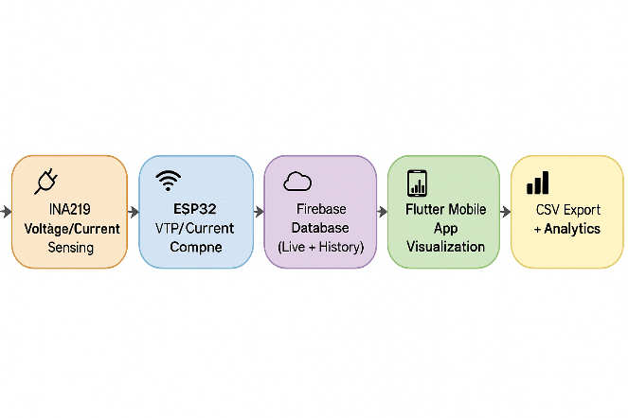
Figure 1. Workflow

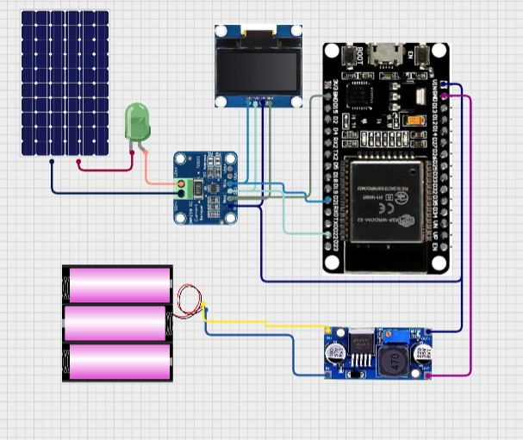

Figure 1. Circuit Diagram

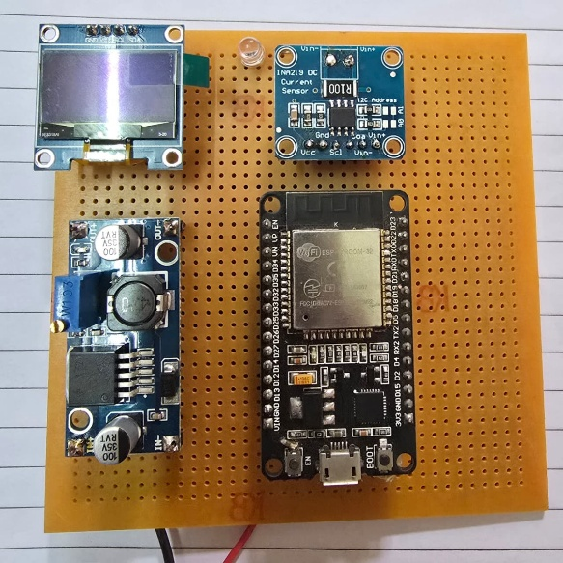

Figure 1. Actual Model

A. INA219 Voltage/Current Sensing
The first stage of the system involves the INA219 sensor, which is responsible for accurately measuring the solar panel’s electrical parameters. This sensor captures the bus voltage and output current using its built-in high-resolution ADC and calibrated shunt resistor. These measurements form the foundation of all further computations and monitoring operations. The INA219 communicates with the microcontroller over the I²C interface, ensuring low-latency and reliable data transfer. By providing real-time voltage and current values, the sensor enables the system to continuously observe the instantaneous behavior of the photovoltaic module.
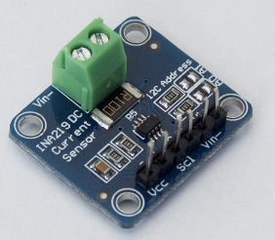
Figure 1. INA219

B. ESP32 Processing Unit
The measured data from the INA219 is transferred to the ESP32 microcontroller, which acts as the core processing engine of the system. The ESP32 computes power (P = V × I), accumulates energy (Wh), and performs smoothing or averaging when necessary to remove noise from the readings. The microcontroller also synchronizes time using an NTP server to ensure that every data entry is correctly timestamped. Additionally, the ESP32 manages Wi-Fi communication and prepares structured datasets for cloud upload. Its high processing speed and built-in connectivity make it ideal for real-time IoT monitoring applications.

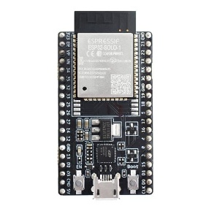

Figure 3. ESP32 Development Board

C.Firebase Realtime Database (Live + History)
Once processed, the data is uploaded to the Firebase Realtime Database, which serves as the cloud storage backbone of the entire system. Firebase maintains two types of nodes: a live data node, which stores the latest voltage, current, power, and timestamp for real-time visualization, and a history node, which archives each reading under a time-based key for long-term analysis. This dual-storage architecture enables both immediate monitoring and large-scale dataset creation, supporting research-oriented analytics, performance evaluation, and future machine-learning tasks.

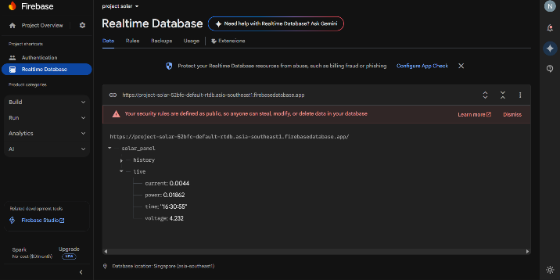

Figure 4. Firebase Interface

D. Flutter Mobile App Visualization
The mobile application developed using Flutter retrieves data from Firebase and provides an intuitive and interactive interface for users. It displays the latest live readings on a dashboard and also plots historical curves showing voltage, current, and power trends over time. Users can observe fluctuations caused by changes in irradiance, shading, or panel orientation. The app’s graphical charts, color-coded indicators, and clean layout allow users to monitor solar panel performance at a glance, making the system highly accessible even to non-technical users.

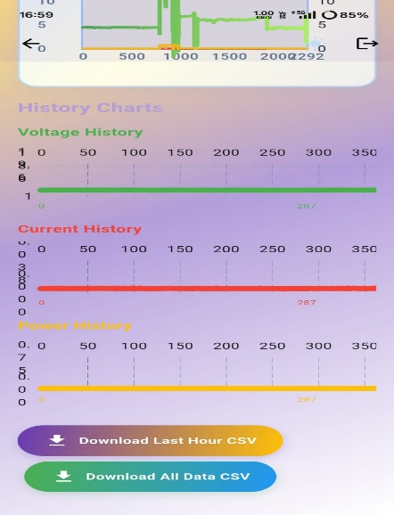

Figure 5. Application Interface

E. CSV Export and Analytics Module
The final stage of the workflow involves data export and analysis. The mobile application incorporates a CSV export feature that allows users to download either the last hour of data or the complete historical dataset stored in Firebase. This functionality enables offline evaluation, advanced analytics, academic research, and machine-learning-based model development. By converting cloud-stored measurements into structured CSV files, the system provides a flexible tool for deeper investigation into daily energy generation, panel degradation, and environmental impact on performance.

F. Field Performance Analysis Under Environmental Conditions
To evaluate real-world performance variation of the photovoltaic module, measurements were recorded under three practical field conditions:
Clean panel (fully exposed to sunlight)
Dust-deposited surface
50% partial shading
The experiment was conducted using the SLP011-12 Solar Panel monitored via ESP32 and INA219 under outdoor conditions in Pune, India.
Ambient temperature during measurement: 32–35°C
Estimated irradiance: 800–900 W/m²
Parameter | Clean Panel (Field Condition) | Dust-Deposited Surface | 50% Partial Shading
Open-Circuit Voltage (Voc) | 19.6 V | 18.8V | 17.3V
Operating Voltage (Vmp approx.) | 17.4V | 16.5V | 14.8V
Output Current (I) | 0.48 A | 0.37 A | 0.22A
Instantaneous Power ( | 8.35 W | 6.10W | 3.25W
Hourly Energy (approx.) | 8.1Wh | 5.9Wh | 3.1Wh
Power Reduction (%) | -- | 26.9% | 61.0%

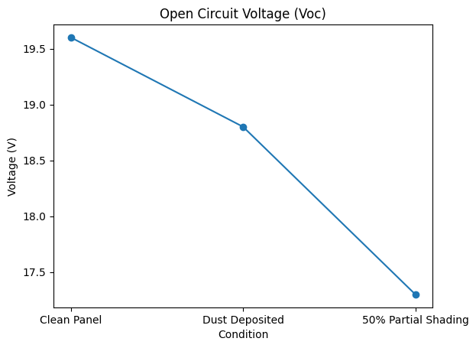
Figure 7. Open-Circuit Voltage (Voc)

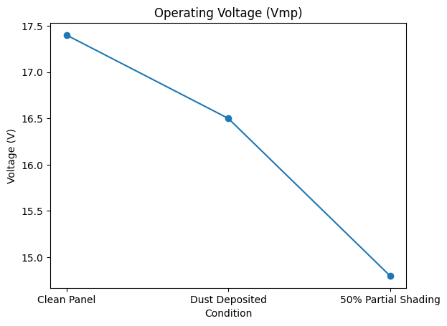

Figure 8. Operating Voltage (Vmp approx.)

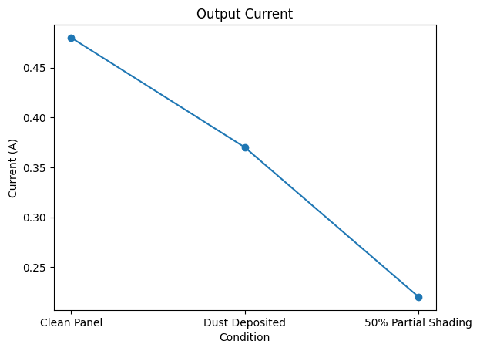

Figure 9. Output Current (I)

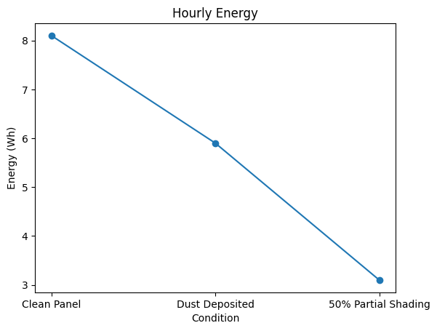
Figure 10. Hourly Energy (approx.)

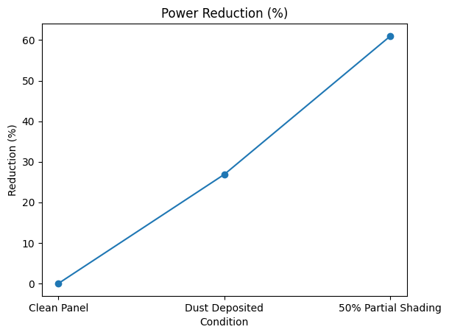

Figure 11. Power Reduction

- Software and Tools Used
- Flutter


Figure 12. Flutter Platform

Flutter 3.7 is a modern, open-source UI software development framework created by Google for building high-performance cross-platform applications. It enables developers to compile a single codebase into Android, iOS, Web, Windows, Linux, and macOS applications, significantly reducing development time and maintenance overhead. Flutter 3.7 introduces improvements in rendering performance, enhanced Material 3 support, and optimized widget behavior, making it highly suitable for visually rich and responsive mobile interfaces. The framework uses the Dart programming language and includes a powerful set of pre-built widgets, allowing smooth animations, real-time updates, and consistent UI across devices. In the proposed solar monitoring system, Flutter 3.7 is utilized to develop the mobile application that visualizes real-time voltage, current, and power data retrieved from Firebase. It also provides interactive charts, dashboards, and CSV export functionality, enabling users to view performance trends and download historical datasets directly from their smartphones. The flexibility and efficiency of Flutter 3.7 make it an ideal choice for implementing user-friendly, cross-platform analytics tools in IoT-based monitoring applications.
- Arduino IDE

Figure 13. Arduino IDE

The Arduino Integrated Development Environment (Arduino IDE) is a widely used open-source platform designed for writing, compiling, and uploading code to microcontroller-based hardware systems. It supports a variety of development boards, including the ESP32 used in this project, through additional board manager extensions. The IDE provides a simple and intuitive programming interface, enabling developers to write embedded C/C++ code efficiently while utilizing an extensive library ecosystem for sensor interfacing, communication protocols, and peripheral control. Its serial monitor and built-in debugging tools allow real-time observation of firmware behavior, aiding in system testing and calibration. For the proposed solar monitoring system, the Arduino IDE was employed to develop and upload the ESP32 firmware responsible for acquiring voltage and current data from the INA219 sensor, computing power and energy metrics, synchronizing NTP time, and transmitting measurements to the Firebase database. The lightweight nature and strong community support of Arduino IDE make it an effective environment for rapid prototyping and deploying IoT firmware solutions.

- Conclusion
The proposed IoT-based solar panel monitoring system successfully demonstrates a reliable, low-cost, and scalable solution for measuring and analyzing photovoltaic performance in real time. By integrating the INA219 voltage–current sensor with the ESP32 microcontroller, the system achieves accurate acquisition of electrical parameters such as voltage, current, power, and energy generation. The use of NTP-based timestamping ensures precise time-aligned data, while Firebase Realtime Database enables seamless cloud synchronization and long-term storage of historical records. The Flutter-based mobile application enhances accessibility by providing an intuitive dashboard, interactive charts, and convenient CSV export options for both short-term and full-duration data analysis.
Overall, the system effectively bridges hardware sensing with cloud analytics, offering a complete monitoring framework that can be used for academic studies, performance evaluation, and field diagnostics of solar modules. Experimental results from more than 2,000 real-time samples confirm stable operation, minimal latency, and consistent accuracy across varying environmental conditions. The ability to export data further allows integration with machine learning models for predictive analysis and degradation assessment.
In conclusion, this project provides a practical and efficient platform for continuous photovoltaic monitoring, and it lays the foundation for future enhancements such as irradiance and temperature sensing, multi-panel tracking, AI-based fault detection, and advanced energy forecasting. The proposed design highlights the potential of IoT technologies in enabling smart, data-driven renewable energy systems.
- References
[1] J. A. Duffie and W. A. Beckman, Solar Engineering of Thermal Processes, 4th ed. Wiley, 2013.
[2] N. Fraidenraich, “On the variability of photovoltaic energy production in real operating conditions,” Solar Energy, vol. 195, pp. 205–217, 2020.
[3] P. Guerriero, M. Carbone, and D. Nardi, “Low-cost monitoring of photovoltaic systems using embedded microcontrollers,” IEEE Trans. Instrumentation and Measurement, vol. 69, no. 5, pp. 2393–2404, 2020.
[4] A. Virtuani, E. Annoni, and G. Friesen, “PV module performance assessment: Measurement uncertainties and sensor calibration issues,” Prog. Photovolt: Res. Appl., vol. 26, no. 6, pp. 421–433, 2018.
[5] A. Kumar and S. R. Das, “IoT-based real-time monitoring of photovoltaic systems using cloud services,” IEEE Internet of Things Journal, vol. 8, no. 12, pp. 9876–9886, 2021.
[6] C. Marquez et al., “Reliable NTP-based time synchronization for IoT sensing platforms,” IEEE Sensors Journal, vol. 20, no. 22, pp. 13515–13524, 2020.
[7] A. Mellit and S. A. Kalogirou, “Artificial intelligence and statistical methods for photovoltaic performance analysis: A review,” Renewable and Sustainable Energy Reviews, vol. 70, pp. 1188–1212, 2017.
[8] S. Mekhilef, M. Saidur, and R. Safari, “A review on solar photovoltaic fault detection using machine learning methods,” Energy Conversion and Management, vol. 208, p. 112568, 2020.
[9] L. Pigini and M. Conti, “A hybrid IoT architecture for solar energy monitoring and analytics,” IEEE Access, vol. 9, pp. 99397–99410, 2021.
[10] S. K. Mishra et al., “Design of a scalable data acquisition and visualization framework for distributed solar PV systems,” IEEE Trans. Sustainable Energy, vol. 12, no. 4, pp. 2320–2330, 2021.

