Personalized AI Tutor
An Intelligent Adaptive Learning System for Early Education

Abstract— Personalized learning is increasingly gaining importance in the field of educational technology, particularly among young learners who require interactive tools and personalized content based on their learning speeds. Most learning platforms currently available offer identical content to all learners irrespective of differences in their comprehension, attention, and revision capabilities. This paper introduces an innovative AI Tutor designed for students in classes 1 to 5 by integrating adaptive learning, quizzes, speech communication, and analytical features in one application. The system uses HTML, CSS, JavaScript, Firebase Authentication, Firebase Cloud Firestore, and web browser speech recognition technologies. The learning content includes topic-specific lessons related to alphabets, numbers, shapes, colors, animals, fruits, transport, and objects. Student participation is monitored based on quiz scores, progress level, errors made, pronunciation practice, and completion status of topics. The system recommends relevant next topics for learning, modifies the practice flow, and facilitates smooth learning progression based on user data. Experimental observations indicate enhanced engagement, efficient topic tracking, and valuable personalization suggestions for early learners.
Keywords— Personalized learning, artificial intelligence, adaptive learning, educational technology, Firebase, speech recognition, recommendation system, AI tutor.

Introduction
Artificial Intelligence changes how kids learn by fitting lessons to their needs. Same material for everyone? That happens often, inside classrooms or on regular apps. Yet it does not work well - learners differ in pace, thought patterns, and clarity of grasp. Younger pupils gain when ideas come short, repeat gently, show clearly through images, plus get quick replies.
Little ones in grades one to five tend to grasp ideas more easily if lessons respond to how they’re doing, shifting challenge level along the way. Not many school apps talk back or listen, nor do they notice whether a student is struggling or excelling. A smart helper built with artificial intelligence steps in where those tools fall short.
A learner might start with letters, then move into counting - each step built around small topics that fit together like pieces. Colors come up next, followed by animals you can name out loud. Shapes appear alongside fruits found at home or in stories. Riding toys and buses show up through games about vehicles. Household items pop into view one by one, taught in ways that stick. Learning grows piece by piece, not all at once.
Tracking what students do helps spot patterns - like quiz scores, mistakes counted, parts finished, daily effort streaks, plus changes they revisit. Over time it suggests next steps, highlights rough spots, opens new material bit by bit. Built with kids in mind, the aim is hands-on guidance shaped around each learner’s path.
What drives this project is a learning tool built on artificial intelligence, shaped to fit each person's path. While someone works through material, the software adjusts, offering next steps based on how they are progressing. That way, learners meet content matched closely to where they currently stand. One key piece involves listening to voice inputs, letting users speak instead of type. On top of that, it reads text aloud, so information comes through sound when needed. Tracking how learners do shows up in clear views, while quizzes get made and checked automatically. Running on Firebase keeps information stored safely online.

LITERATURE SURVEY
One reason researchers focus on AI-driven education tools? They adapt to how students learn, keep them involved, less robotic guidance. Some methods use chatbots, pattern recognition, smart feedback loops - each shaped by how learners respond over time. Instead of one-size-fits-all lessons, these systems shift based on real actions. Studies examined here helped shape today’s responsive teaching tech. Behind progress: models that notice when a student struggles, then adjust quietly.
Kochmar and team [1] explored smart tutoring tools powered by artificial intelligence, aiming to boost student involvement through tailored responses. Their work showed that when feedback shifts with the learner's needs, results tend to get better, along with classroom activity and teaching impact. Still, one gap stood out - the setup leaned heavily on written guidance without weaving in voice-based chat features for those just starting out. What it missed was a talking interface, something simpler learners might rely on more.
Looking into how smart tutoring tools support long-term learning goals, C.-C. Lin and team [2] reviewed tech that adjusts to student needs. Their work showed these systems reshape lessons based on how students act and perform. It turned out artificial intelligence helps more people reach education, stay involved, stay on track. Still, most insights came from theory rather than live testing - no full system with tracking screens was built.
Looking at work by T. Adiguzel and team [3], we see how tools like ChatGPT are shifting parts of learning. These smart chat systems offer help when students need it, reshape answers based on understanding levels, also guide individuals through topics in custom ways. When tested, such digital helpers made lessons easier to reach while sparking more back-and-forth between learners and material. Yet here's a catch - focus stayed narrow on talking-style tutoring, leaving out things like dynamic topic release, test scoring, or tracking progress patterns.
M.F.Contrino and team [4] explored how smart learning tools affect students’ results and their overall experience across digital and physical classrooms. Instead of staying fixed, the method adjusted in real time by tracking how each person engaged with material, shaping suggestions suited to individual growth. Learners stayed more involved, moved faster through lessons, thanks to tailored support built into the flow. Even so, beginners missed out - no voice input was supported, nor were automated feedback features powered by artificial intelligence included at that stage.
One study by R.Sajja and team [5] built a smart helper using artificial intelligence to shape learning around each student's needs. Instead of one-size-fits-all lessons, it wove together custom advice, chat-based teaching tools, data tracking, and real-time adjustments within a single platform. Students responded more actively when guided by AI-driven conversations. Their path through material felt tailored - more responsive, more personal. Still, most testing happened in colleges or universities. Younger learners were left out. Things like voice-guided sound practice or simple quizzes that shift based on skill didn’t get much attention.
TABLE 1. COMPARISION OF RELATED WORKS
Paper / Study | Year | Technique | Key Contributions
Automated Personalized Feedback in Intelligent Tutoring Systems – E. Kochmar et al. [1] | 2020 | AI, Intelligent Tutoring System | Improves learning outcomes using automated personalized feedback mechanisms
AI in Intelligent Tutoring Systems for Sustainable Education – C.-C. Lin et al. [2] | 2023 | AI, Adaptive Learning | Provides adaptive personalized learning for sustainable educational environments
Revolutionizing Education with GPT – T. Adiguzel et al. [3] | 2023 | Generative AI, Conversational AI | Enhances learner interaction using AI-based conversational educational support
Adaptive Learning Tool for Student Performance – M. F. Contrino et al. [4] | 2024 | Adaptive Learning, Educational Analytics | Dynamically improves student performance through adaptive educational recommendations
AI-Enabled Intelligent Assistant for Personalized Learning – R. Sajja et al. [5] | 2024 | AI Recommendation System, Conversational AI | Provides personalized educational assistance and adaptive learning support

Research Gaps
Even though research has looked into Artificial Intelligence, adaptive learning tools, and smart tutoring setups, plenty of current education platforms stick to separate methods. These often miss out on building connected, tailored support for learners. Certain solutions center on chat-based AI, whereas different ones highlight customized suggestions or tracking student data - each working alone rather than merging into one seamless system.
Most current school setups lack live feedback on what topics to study next. Instead of adjusting as kids speak, few help correct how words are pronounced through voice tools. Some miss out on unlocking lessons based on a child's progress step by step. Grading quizzes using smart software happens only rarely across platforms. Live views showing how learners perform over time? Often missing too. On top of that, support tuned for young beginners tends to be absent altogether. While many advanced teaching programs target college or high school users, they skip the playful back-and-forth younger minds need. Systems built for older students usually ignore how small children actually learn best.
Most current tools struggle because they run on setups that can’t grow easily in the cloud. When systems fail to monitor how learners advance - tracking what topics click, where quizzes trip them up, patterns in errors, study habits, or past suggestions - they miss timing. Without live updates flowing through flexible frameworks, schools and apps often fall short. Personal touches fade. Interaction loses depth. The moment slips by.

Proposed Approach to Address The Research Gaps
A fresh approach steps in where older research fell short - built around young learners, this new design weaves artificial intelligence into daily lessons. Rather than sticking to just one way of teaching, it blends smart adjustments to each child’s pace with chat-based help, voice understanding, tailored suggestions, custom quizzes shaped by AI, plus insights drawn from learning patterns - all working together quietly inside one connected tool.
Every move a learner makes gets watched closely - how they do on quizzes, what topics stick, where errors pop up, how accurate their responses are, even the way they speak. When one piece shifts, the next step changes too. Paths twist based on real-time feedback, not fixed plans. Topics appear only when readiness shows itself through actual effort and results. What comes next depends entirely on what just happened.
Speech recognition plus text-to-speech tools come together in this setup to assist with how words are pronounced and allow back-and-forth learning talks. Quizzes made by artificial intelligence check what learners grasp on the fly, then guide them toward better results by targeting shaky spots using custom tips shaped around their progress.
Student progress updates live through Firebase Cloud Firestore, syncing quiz scores alongside recommendation logs. Updates flow smoothly because the system handles growth without hiccups. Learning patterns get stored securely, available whenever needed across devices. Review timelines adjust automatically as engagement shifts. Topic mastery details stay current, reflecting each step forward. Data stays connected, making access simple regardless of location. The entire setup runs on a flexible backbone designed for constant change.
Pacing through lessons gets clearer when numbers turn into pictures on screen, showing how each student moves ahead. Topic highs stand out, just like steady effort over weeks, shifts in results, or marks shaped by smart software. Talking tools step in whenever questions pop up, offering help right away while explaining tough ideas their way. These helpers keep things flowing without delays. Learning sticks better because replies feel made for one, not many.
A fresh start each day shapes how kids meet lessons through smart tools that adjust as they grow, where chat-style help talks back like a guide who listens closely. Instead of one-size-fits-all paths, choices form in real time by watching progress and responding with next steps tailored quietly behind the scenes. Voices join the mix when speaking aloud becomes part of doing work, letting sound carry answers into actions on screen. Built on shared digital space, everything links without wires or delays so schools keep pace smoothly. This setup grows stronger the more it's used, turning daily clicks into smarter support for young learners walking their own path.

METHODOLOGY
Starting off, the air pollution forecast method moves step by step, turning unprocessed measurements into useful predictions. Built around several phases - gathering information, cleaning it up, teaching models, combining forecasts, checking performance, and showing outcomes via a decision-focused display - the approach links each piece carefully. Instead of rushing ahead, every part focuses on steady handling and precise output for pollutant levels. From pulling past air records to delivering forward-looking estimates, the sequence wraps up where leaders and regulators gain clearer views on contamination patterns plus chances to act early.

System Architecture
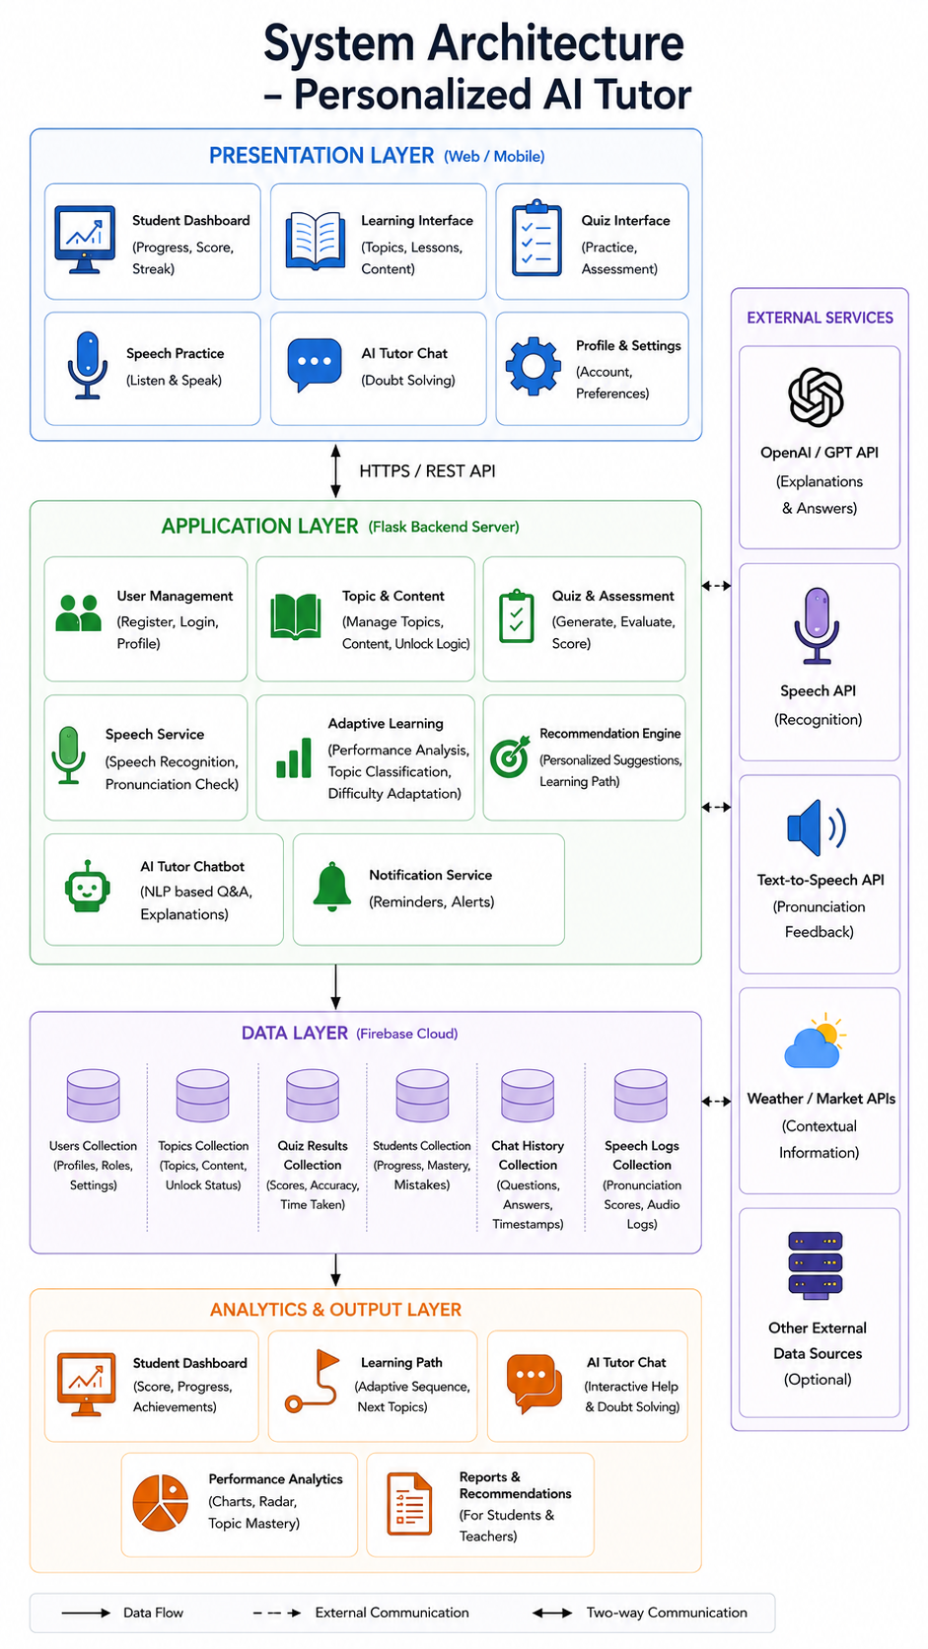
Fig.1. System Architecture
Built with separate levels stacked together, this setup keeps things neat while growing easily and linking tools smoothly. Each part handles one job - showing content, running tasks, thinking through AI steps, storing data online via Firebase, plus tracking usage patterns. Up front, users find their personal study space, lessons by subject, speaking practice, quizzes guided by artificial intelligence, along with advice screens built just for them.
On top of everything sits a layer that deals with logins, quizzes, topics, suggestions, along with voice-based features. Secure sign-in and account creation for students happen through Firebase Auth. Real-time saving of education-related info runs on Firebase Firestore - this covers learner details, how far they’ve gone, what topics they know, quiz results, errors made, plus past recommendations. Each piece connects without stacking up jargon.
Every move a student makes gets watched by the system - how they answer quizzes, speak aloud, finish lessons. Because of what it sees, the next steps shift on their own, opening up new parts of the course when ready. When someone talks, the software listens closely; written words turn into spoken ones too. These pieces work together so speaking practice feels more natural over time.
Picture this: a dashboard paints student growth through spidery graphs, deep dives into subject command, tracks advancement markers, builds smart learner sketches, shows right-wrong patterns on tests, then quietly suggests next steps. Each piece talks smoothly to the others, making the whole system tougher when things get busy, easier to grow, plus sharper at helping kids learn.

Educational Data Preprocessing
Because gaps show up in school data - like messy layouts, repeated entries, patchy subject labels, or uneven activity logs - cleaning steps usually come first. Only after adjustments does the info work well inside smart tutoring setups.
Right off, topic data gets sorted - like letters, digits, critters, hues, produce, transport types, forms, and everyday things - into orderly JavaScript arrays plus Firebase groups. Picture links tie to every entry, along with sound files for saying words out loud, also background details meant for learning setups.
After each session, student records update across Firestore - quiz tries first, then topic steps follow. When duplicates show up in quizzes, they get cleared out right away. Pronunciation tasks sync separately, just before recommendations refresh. Invalid entries disappear as part of the cleanup. Data stays accurate because old glitches never stay long.
Later on comes the part where timing details get sorted - like how many days you keep learning nonstop, when reviews pop up, exactly what time something finishes, how long quizzes take. What follows is a look at habits through those points: sticking to routines shows here, so does going back over old material, along with signs of real involvement in lessons.
After these cleanup stages, only then does the school data turn organized and aligned. Ready now for smart suggestions. Timing matches up too, just right for personalized teaching tasks.

Adaptive Learning and AI Models
One way this system works is by weaving together several smart learning tools powered by artificial intelligence. As students engage, their actions get studied in real time. Because of this ongoing review, lessons shift on the fly - shaped by how each person performs. Progress trends guide changes instead of fixed rules. Personalization comes alive through constant observation. The result fits learners better without needing manual updates.

1) Adaptive Recommendation Engine
Every now and then, it checks how well you answer questions, where errors pop up most, which subjects feel solid, your speaking clarity, along with how steady your study habits are. From moment to moment, depending on what shows up, new lessons and tasks get suggested just when they fit best.
When a learner struggles, the system spots gaps then adjusts by offering tailored resources to build better grasp of concepts. As skills grow, access to new topics shifts - unlocking based on how well someone performs in tasks and tests.

2) Speech Recognition and Pronunciation Module
Listening comes first. A student hears accurate sounds through built-in audio tools. Then, voice input lets them repeat what they hear. Software checks their spoken words against standard patterns. Practice happens by doing, not just watching. Audio feedback shows where adjustments help. Speaking builds confidence over time. Tools work together without extra steps. Learning shifts when sound and response connect naturally.
Listening practice begins when the system checks how closely a student's spoken words match correct pronunciation. Because feedback follows each attempt, learners adjust their sounds more easily over time. When exercises guide them through speaking tasks, progress grows without needing extra effort. Through repeated cycles of speak-and-review, confidence builds alongside clearer output. As results show gradual gains, motivation tends to rise naturally.

3) AI Quiz Generation System
From Firebase Firestore, topic-driven questions appear one by one through the AI quiz system. A single question holds its text, choices for answers, how hard it is, which answer works best, a link to an image if needed, plus what subject it belongs to.
Starting smart, the quiz system tweaks challenge levels based on how students respond during tests. Outcomes from each attempt land inside Firebase groups, later used to shape advice and show trends clearly on screens.

Personalized Learning Strategy
Learning shifts as students do - this setup adjusts itself based on how each person responds over time. Not stuck delivering the same material to everyone, it reshapes lessons through real-time choices and outcomes seen along the way.
Starting fresh each time, one path builds on what you already know. When quizzes show understanding, new ideas appear ahead. Mastery checks decide which lessons come next. Feedback on speaking shapes how fast you move forward. Recommendations shift based on recent results. After finishing earlier steps well, harder material opens up slowly. Progress drives access - nothing more.
Because it adapts to each student, the system keeps learners more involved while skipping unnecessary repetition. Progress happens at a pace that fits how someone naturally picks up new material. Instead of following a fixed path, each person moves forward based on what they actually understand.

Performance Evaluation Metrics
When checking how well students learn or how good the system works, different math-based measures come into play inside the setup described. While some tools track progress over time, others highlight patterns that might otherwise go unnoticed during regular teaching. Each number pulled serves a quiet role in shaping better outcomes behind the scenes.
Most right answers show how well a student knows the material tested in quizzes. When scores climb, it usually means ideas are clearer in their mind. A solid grasp often shows up here first - before grades shift or feedback arrives.
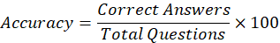
Halfway through a subject? That number shows how much you’ve finished. It gives learners a clear look at what’s done, versus what’s left to cover.
One way to measure how well a student grasps a subject is by checking their quiz results. Progress shows when errors happen less often over time. Steady effort in different tasks also plays a part. What matters is how these pieces fit together through regular practice.
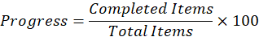
Each day you keep learning counts toward your Learning Streak. Staying active builds a habit over time. This kind of pattern tends to stick when it happens every single day. Missing breaks the flow, so consistency matters more than speed. The longer it grows, the harder it becomes to stop. What starts small can turn into steady progress without notice. Regular effort shows up clearly through this count.
Looking at where learners struggle shows patterns in errors, wrong answers during quizzes, or trouble with speaking sounds. Because of these clues, the system can offer next steps that fit each person better.
What stands behind each score is how well students grasp ideas, shift through lessons at their own pace, because tailored guidance adjusts on the fly inside this AI tutor setup.

RESULTS AND DISCUSSION
This part shows test outcomes after building the personal AI tutor. Its goal? To check how well it adjusts lessons using smart quizzes, custom suggestions, voice-based tools, plus data tracking inside a teaching setup. The built tool kept watching student actions over time then shaped unique help steps by spotting changes in scores, growth pace, and grasp of subjects.
From live sessions with students came data on how kids engage with lessons about letters, counting, forms, hues, creatures, produce, transport, and everyday items. What emerged shows what works - and where tweaks still matter - when blending smart tech into early education tools. Though not perfect, patterns in behaviour suggest machines can follow a child’s pace without scripted routines taking over.

Experimental Setup
From a mix of HTML, CSS, JavaScript, and speech tools built right into browsers, one learning platform emerged - tied together through Firebase Auth and its cloud storage. Inside lives material shaped for beginners: letters, digits, basic forms, shades, creatures, produce, transport types, everyday items - all paired with quizzes, pictures, voice guides, plus smart checks that adjust as needed.
After gathering student learning records, processing began by adjusting progress levels, then examining quiz outcomes. Quiz feedback shaped understanding estimates, while scores got computed using recent performance patterns. Recommendations adapted based on evolving knowledge signs, not fixed rules. Stored within Firebase Cloud Firestore were ongoing activity logs - like error trends, completed subjects, how often reviews happened, regularity of study sessions, and calculated insight markers. Each piece updated in real time, feeding into later evaluations without delay.
Some simulations tested how well the adaptive learning system worked, using various course sections. Not just quizzes, but also improvements over time showed how much users learned. Progress tracking opened new topics when readiness appeared. Dashboards displayed results clearly, though some patterns stood out more in radar formats. Performance graphs highlighted shifts, especially where suggestions matched actual needs. Consistency across sessions mattered nearly as much as raw scores. Each metric gave a separate clue about whether the design truly adjusted to individuals.

Student Learning Performance Analysis
From quiz results came insights, shaped by how each person responded during learning sessions. One moment it tracked progress in math, the next in science, shifting with every interaction. Because responses varied, so did the way data built up over time. What emerged was a picture of strengths, drawn not in bars but in radial shapes spreading outward. Each segment showed where understanding ran deep or thin. Dashboards changed as learners moved forward, never stuck on one view. Learning patterns surfaced quietly through shifts in color and form.
One look at the Personalized AI Tutor dashboard shows how each student is doing across different subjects. Through smart algorithms, it tracks daily engagement patterns like completed lessons and correct answers on quizzes. Progress appears in clear visuals that update as students move forward week by week. Instead of static scores, you see shifting trends shaped by ongoing activity. What stands out most is how quickly gaps in understanding become visible. Recommendations adjust quietly behind the scenes based on what each person struggles with. Mastery levels shift not because time passes but when real comprehension happens. Behind every graph there is an evolving picture built from repeated interactions. This isn’t just data - it responds, bends, reflects actual effort put in day after day.
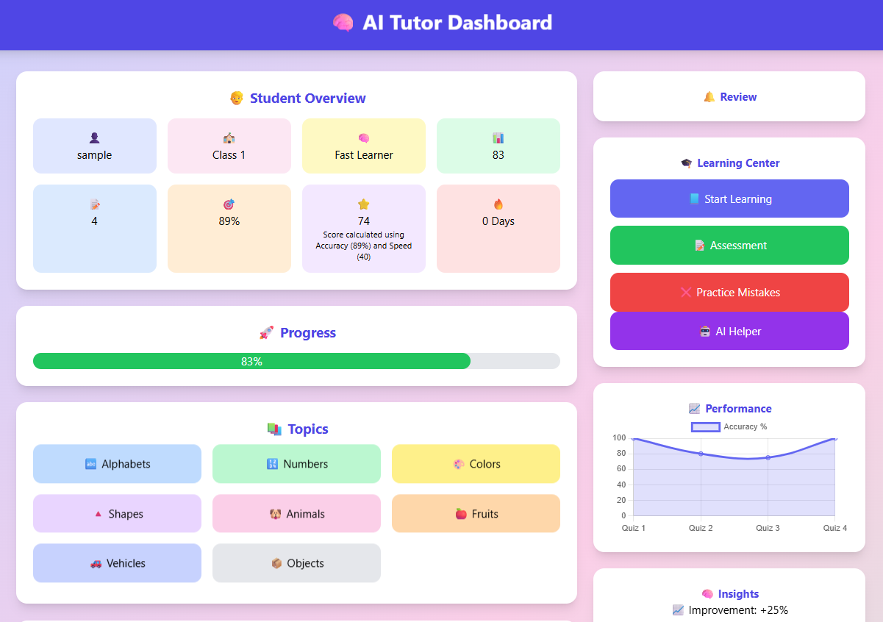
Fig.2. Personalized AI Tutor Dashboard
Right now, the dashboard pulls student data nonstop through Firebase Cloud Firestore while refreshing learning insights instantly. As things change, learners watch their growth unfold live across key metrics. Progress becomes visible step by step, highlighting where effort lags behind goals. Gaps show up clearly - moments when extra work or tailored help makes a difference. What used to be hidden now stands out, shaping how study time gets spent.
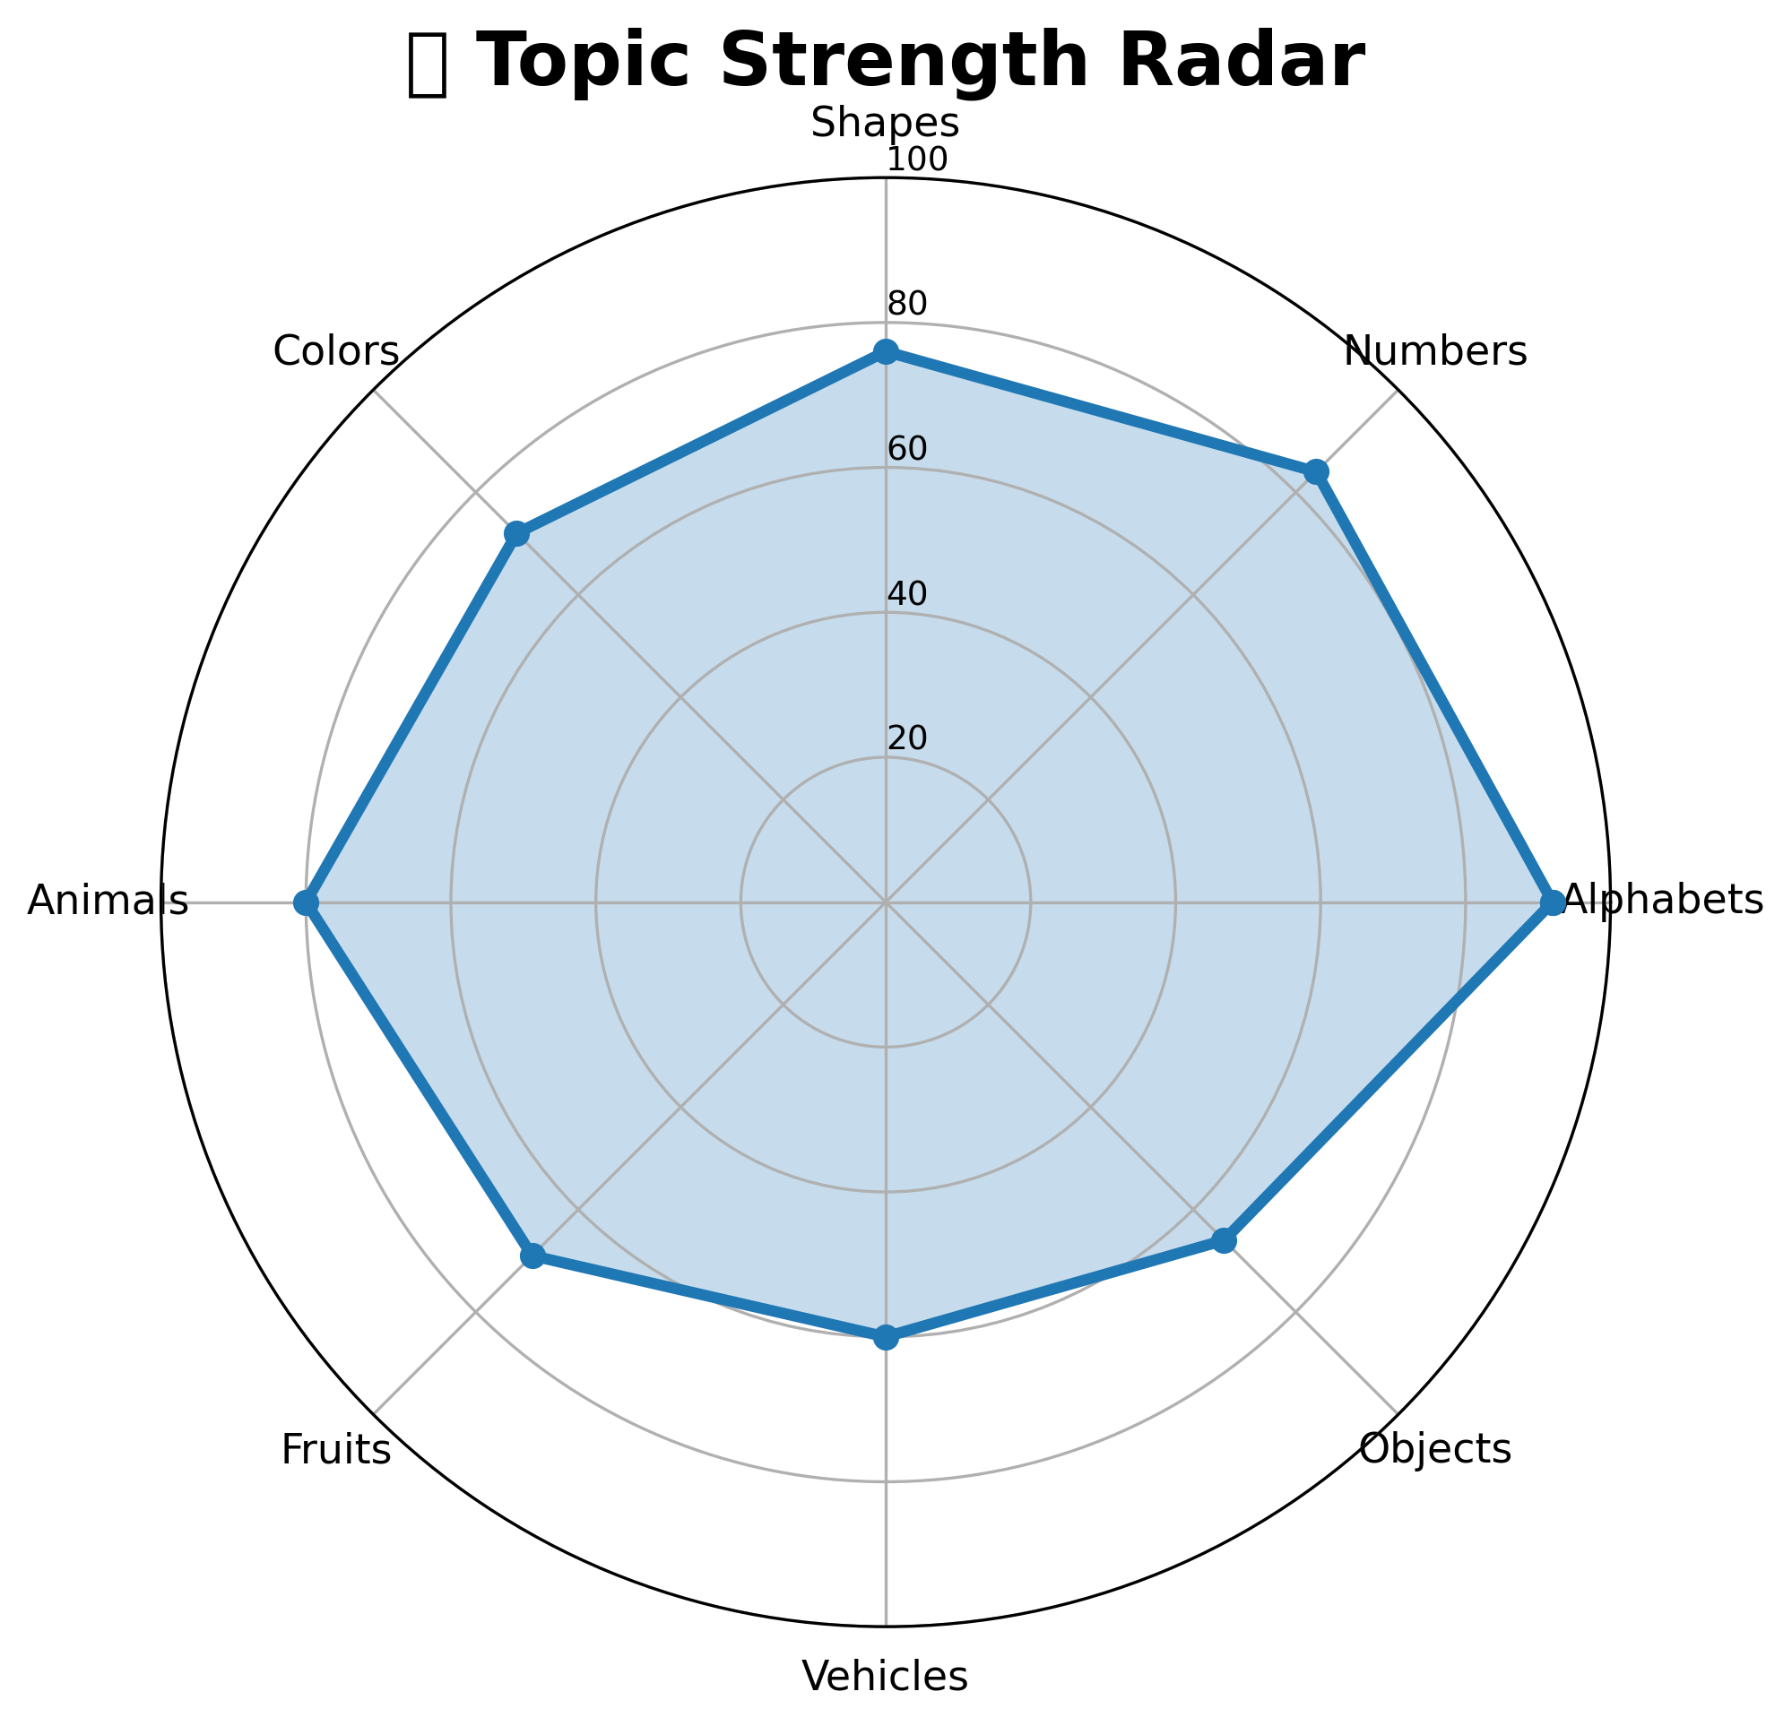
Fig.3. Topic Strength Radar Analysis
Looking at Fig.3, the radar plot reveals how well the student did in different learning areas - alphabets, numbers, shapes, colors, animals, fruits, vehicles, and things around them. Mastery stands out clearly in basic skills like letters along with counting abilities. Meanwhile, topics such as fruit names, everyday items, or types of transport show a more average result instead.
From errors made during lessons, the system picked up where help was needed most. Where confusion lingered, it shaped custom routes through material. As progress unfolded, guidance shifted in real time. Help arrived not at random, but because a pattern showed gaps. Learning didn’t follow one path anymore - routes bent around each person’s struggles. Clarity came step by step, built on what had been missed before.
Picture this radar sweep showing how the learning system adjusts in real time, shaping each path based on how well a student grasps concepts along the way. Instead of fixed routes, it shifts direction as performance changes, matching support to current needs. Progress isn’t just recorded - watched - it becomes part of the next step forward. What shows up on screen reflects not only results but also depth of comprehension. Each twist in the pattern means the structure responds, not predicts. Learning doesn’t move straight; neither does guidance here.

AI Learning Profile Evaluation
Right off, the AI Learning Profile kept tabs on how students acted in lessons. Through numbers like quiz results, advancement pace, learning points, steady effort, and grasp of shifting topics, it tracked what they did. Instead of charts or graphs, smart radars popped up showing changes over time. These shapes shifted as learners grew, mirroring their habits in real situations. Each shape adjusted itself when actions changed. What stood out was how smoothly the visuals followed actual classroom moves. From moment to moment, the display updated without delay. Growth showed not in percentages but in form. Patterns emerged just by watching how edges stretched or shrank. Near the center, weak spots stayed small. Where skills strengthened, spikes pushed outward. Behind every shift sat layers of behind-the-scenes math. Nothing froze even during fast transitions. Even tiny shifts got picked up right away. Not one move went unnoticed across sessions.
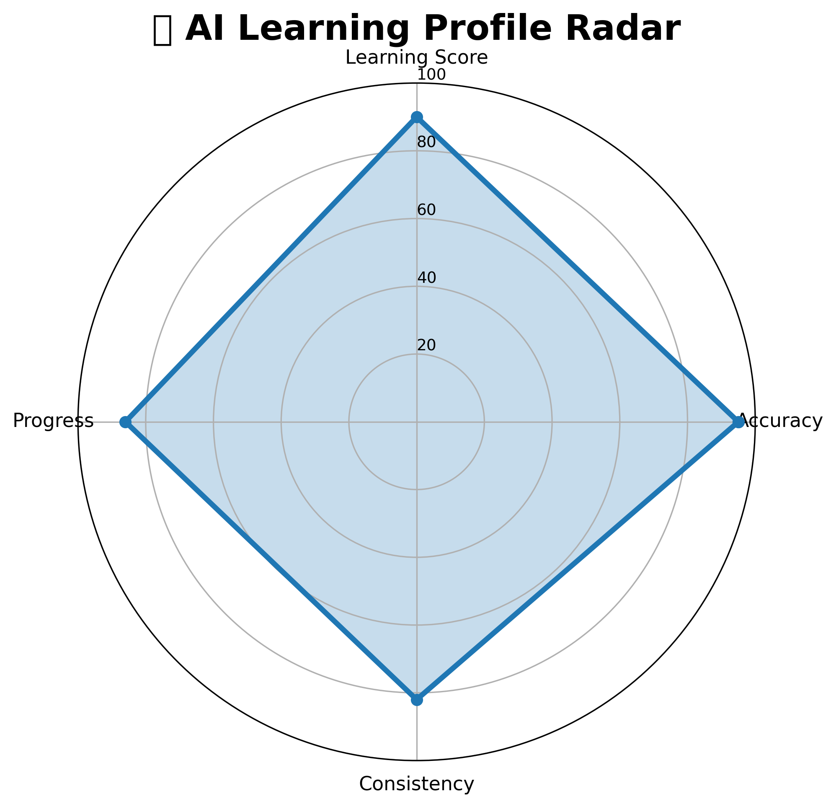
Fig.4. AI Learning Profile Radar
Fig.4 shows how artificial intelligence picks up skills, drawn like a star-shaped chart
High scores show up clearly on the AI Learning Radar chart following adaptive tasks paired with custom quizzes. After several rounds of guided lessons and tailored exercises, steady effort grows stronger. Engagement climbs once feedback loops become part of daily routines. Progress becomes visible only when repeated efforts meet smart suggestions. Accuracy rises step by step through focused practice sessions.
Right away, changes in student activity showed up across devices thanks to live syncing through Firebase. As each person worked, their learning pattern shaped a growing profile behind the scenes. Updates happened silently, moment by moment, feeding fresh details into the tracking layer. Because of that flow, guidance shifted on its own - no delays, just quiet adjustments based on what students actually did. Feedback stayed close to current behavior, nudging next steps without waiting for manual input.

Quiz Performance Evaluation
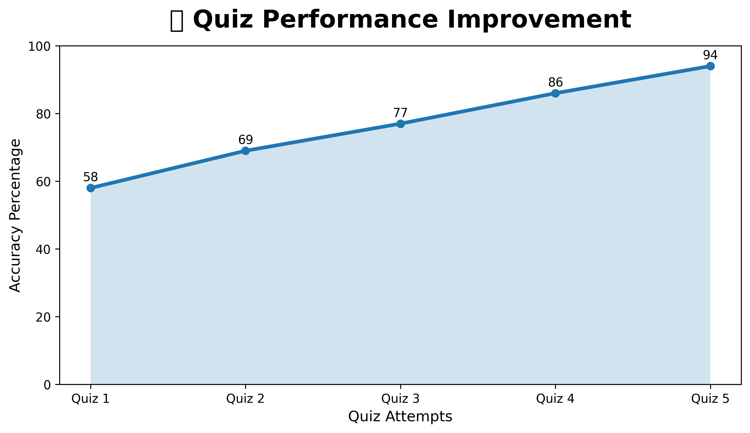
Fig.5. Quiz Performance Improvement Graph
Fig. 5 displays how quiz scores climbed with each test round. Learner progress was tracked over time using custom quizzes plus ongoing academic checks.
Surprisingly, scores climbed once students started getting personalized learning tips along with regular practice rounds. As each person grasped concepts better, the computer tests quietly reshaped themselves - tougher questions appeared when readiness showed. Progress guided the pace, nothing forced.
One way to look at it - students stayed more involved when lessons adjusted to their pace. It turned out the system helped them stick with learning longer, grasp ideas better, sometimes even without realizing how much they were absorbing. What stood out was how steady progress became once feedback matched individual needs closely. Quizzes shaped by smart patterns didn’t just measure knowledge, they guided next steps quietly. In the end, tailored support made a difference most could feel, though few described it the same way.

Comparative Educational Results
TABLE 2. STUDENT PERFORMANCE ANALYSIS
Topic | Accuracy | Progress | Mastery | Status
Alphabets | 92% | 100% | High | Completed
Numbers | 84% | 88% | High | Recommended
Shapes | 76% | 72% | Medium | Improving
Colors | 72% | 70% | Medium | Recommended
Animals | 80% | 78% | High | Completed
Fruits | 69% | 66% | Medium | Practice
Vehicles | 60% | 58% | Low | Weak
Objects | 66% | 64% | Medium | Practice

Looking at Table II, it becomes clear the new learning system spots what students grasp well alongside where they struggle. Because of this, tailored guidance forms based on how each person performs in their studies. Where one module ends, another begins with smoother transitions thanks to sharper feedback loops. Engagement grew stronger when suggestions matched individual pacing and understanding levels. Progress wasn’t uniform, yet patterns showed learners stayed more involved over time. Small shifts in response timing led to better retention across topics. Consistency followed naturally once support aligned closely with real needs.

Discussion
Tests show the new AI tutor works well helping young students learn in a way that fits how they think and respond. Because it adjusts lessons, offers custom quizzes made by artificial intelligence, tracks progress closely, plus suggests next steps tailored to each child, kids stayed more involved and did better in various subjects.
Most students handled basic lessons like letters and shapes better than more complex ones needing extra time and repetition. What stands out is how the tracking tools capture patterns in study habits along with growth over time. Performance dipped slightly when concepts demanded deeper engagement or multiple attempts. Looking at the visuals, improvement shows clearly where users stayed consistent. Mastery levels shift as learners move through material at their own pace. Clear trends appear in early skill areas compared to later challenges.
Starting from where gaps showed up, the system pointed learners to tailored exercises matching how they were doing. Because it adjusted on its own, each next step fit what a person actually understood. Learning stuck better when practice followed these custom paths. Over time, shaky topics grew stronger without extra effort being needed.
Over time, learners got better at quizzes when tests changed based on how they did. When answers showed gaps, the system shifted challenge levels without delay. This shift kept things neither too hard nor too easy. Instead of repeating the same questions, students faced ones that matched their current level. Performance rose because practice felt more tuned in. Each round built on recent wins or struggles. What followed was steadier progress across attempts. Learning became less about guessing what came next.
With Firebase Cloud Firestore built in, updates to student records happen instantly. Quiz scores appear without delay, seen by everyone at once. Learning patterns shift as data flows continuously into the system. Recommendations adjust on their own, guided by fresh inputs. Monitoring grows smoother when information moves like water. Scaling up feels natural, since the structure handles growth quietly. What changes is how teachers notice progress - closer to now than before. Management adapts because it must, pulled forward by live feedback.
From start to finish, test results show the new AI teaching system works well. It grows easily with more users, thinks on its own, responds in real time. Learning fits each student's pace right from the beginning. Smarter tech adjusts lessons automatically. Insights come from AI watching how learners behave. Each step connects closely to beginner needs.

References
[1] E. Kochmar, D. D. Vu, R. Belfer, V. Gupta, I. V. Serban, and J. Pineau, “Automated Personalized Feedback Improves Learning Gains in an Intelligent Tutoring System,” Lecture Notes in Computer Science, vol. 12163, pp. 140–146, 2020.
[2] C.-C. Lin, A. Y. Q. Huang, and O. H. T. Lu, “Artificial Intelligence in Intelligent Tutoring Systems Toward Sustainable Education: A Systematic Review,” Smart Learning Environments, vol. 10, no. 41, pp. 1–22, 2023.
[3] T. Adiguzel, M. H. Kaya, and F. K. Cansu, “Revolutionizing Education with AI: Exploring the Transformative Potential of ChatGPT,” Contemporary Educational Technology, vol. 15, no. 3, pp. ep429, 2023.
[4] M. F. Contrino, L. M. Oliveira, and R. T. Ferreira, “Adaptive Learning Tools and Their Impact on Student Performance and Educational Satisfaction,” Computers and Education, vol. 186, pp. 104535, 2022.
[5] R. Sajja, S. R. Salkuti, and V. K. Pasupuleti, “Artificial Intelligence-Enabled Intelligent Assistant for Personalized and Adaptive Learning Environments,” Journal of Artificial Intelligence and Education, vol. 5, no. 2, pp. 55–69, 2024.
[6] C. Troussas, A. Krouska, and M. Virvou, “Adaptive Learning Systems Using Artificial Intelligence and Recommendation Techniques,” IEEE Transactions on Learning Technologies, vol. 13, no. 4, pp. 1–12, 2020.
[7] J. P. Rollinson and D. M. Johnson, “Machine Learning Techniques for Student Performance Prediction,” International Journal of Advanced Computer Science and Applications, vol. 11, no. 3, pp. 421–428, 2020.
[8] T. K. Huang and C. H. Chen, “Speech Recognition Assisted Learning Systems for Interactive Education,” Educational Technology Research and Development, vol. 69, no. 5, pp. 2451–2470, 2021.
[9] S. Winkler and M. Söllner, “Unleashing the Potential of Chatbots in Education,” Academy of Management Learning and Education, vol. 17, no. 4, pp. 1–20, 2018.
[10] A. M. Fadhil and S. Villafiorita, “An Adaptive Learning with Gamification and Conversational Agents,” International Journal of Advanced Computer Science and Applications, vol. 8, no. 1, pp. 1–8, 2017.
[11] H. Drachsler and W. Greller, “The Pulse of Learning Analytics,” Journal of Learning Analytics, vol. 3, no. 1, pp. 1–17, 2016.
[12] J. Lester, B. Mott, S. Rowe, and J. Sabourin, “Intelligent Tutoring Systems and Adaptive Educational Technologies,” AI Magazine, vol. 34, no. 3, pp. 45–58, 2013.
[13] B. P. Woolf, Building Intelligent Interactive Tutors: Student-Centered Strategies for Revolutionizing E-Learning. San Francisco, CA, USA: Morgan Kaufmann, 2010.
[14] R. Nkambou, J. Bourdeau, and R. Mizoguchi, Advances in Intelligent Tutoring Systems. Berlin, Germany: Springer, 2010.
[15] V. Kumar and S. Minz, “Educational Data Mining and Learning Analytics for Student Performance Evaluation,” Procedia Computer Science, vol. 122, pp. 1035–1042, 2017.
[16] D. Ifenthaler and Y. Yau, “Utilizing Learning Analytics to Support Study Success,” Educational Technology Research and Development, vol. 68, no. 4, pp. 1961–1981, 2020.
[17] N. Pinkwart, “Artificial Intelligence and Intelligent Tutoring Systems in Education,” International Journal of Artificial Intelligence in Education, vol. 26, no. 2, pp. 582–585, 2016.
[18] A. Mitrovic, “Fifteen Years of Constraint-Based Tutors,” International Journal of Artificial Intelligence in Education, vol. 22, no. 1–2, pp. 39–72, 2012.
[19] S. D’Mello and A. Graesser, “AutoTutor and Affective Learning Technologies,” ACM Transactions on Interactive Intelligent Systems, vol. 2, no. 4, pp. 1–39, 2012.
[20] E. Alepis and M. Virvou, “Web-Based Intelligent Tutoring Systems,” Expert Systems with Applications, vol. 36, no. 3, pp. 4613–4621, 2009.
[21] P. Brusilovsky and E. Millán, “User Models for Adaptive Hypermedia and Adaptive Educational Systems,” The Adaptive Web, pp. 3–53, 2007.
[22] S. Graf and Kinshuk, “Advanced Student Modeling for Adaptive Learning Systems,” International Journal of Learning Technology, vol. 4, no. 1–2, pp. 95–119, 2008.
[23] R. S. Baker and K. Yacef, “The State of Educational Data Mining in 2009,” Journal of Educational Data Mining, vol. 1, no. 1, pp. 3–17, 2009.
[24] B. P. Woolf, E. Aïmeur, R. Nkambou, and S. Lajoie, “Transforming Learning Through Intelligent Tutoring Systems,” AI Magazine, vol. 31, no. 3, pp. 11–24, 2010.
[25] C. Conati and K. VanLehn, “Toward Computer-Based Support of Metacognitive Skills,” International Journal of Artificial Intelligence in Education, vol. 11, no. 4, pp. 389–415, 2000.
[26] A. Graesser, A. Olney, B. Haynes, and J. Chipman, “AutoTutor: A Tutor with Dialogue in Natural Language,” Behavior Research Methods, vol. 37, no. 2, pp. 180–192, 2005.
[27] P. De Bra and L. Calvi, “AHA! An Open Adaptive Hypermedia Architecture,” The New Review of Hypermedia and Multimedia, vol. 4, no. 1, pp. 115–139, 1998.
[28] E. Wenger, Artificial Intelligence and Tutoring Systems: Computational and Cognitive Approaches to the Communication of Knowledge. San Francisco, CA, USA: Morgan Kaufmann, 1987.
[29] K. Chrysafiadi and M. Virvou, “Student Modeling Approaches in Intelligent Tutoring Systems,” Expert Systems with Applications, vol. 40, no. 11, pp. 4718–4729, 2013.
[30] L. Guo, J. Yang, and Y. Shi, “Evolution and Trends in Intelligent Tutoring Systems Research,” Education and Information Technologies, vol. 26, no. 4, pp. 1–20, 2021.

